**Chapter Four: In the Field**

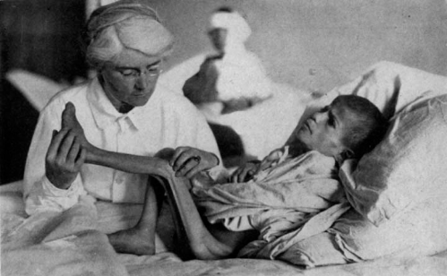

Mabel Elliott and patient

This chapter focuses on the creation of publicity media in the midst of humanitarian aid operations in the Near East from 1919-1923. Up until this point, the advocacy efforts remained largely separate from the actual work of giving humanitarian aid. With the establishment of field operations the publicity media transformed from posters into photographs; stilted diplomatic dispatches turned into descriptive personal accounts from NER personnel working with the refugees. Together, photography and literary reportage altered the personae of Armenians into starving, diseased orphans.

Horrific images of the Armenian orphans were made palatable by portraying Americans as saviors whose contributions brought redemption. This dynamic is clearly displayed in this photograph of an American physician and one such starveling. In Figure 1, Dr. Mabel Elliott is examining a patient suffering from malnutrition and contracted tendons for a publicity still. The doctor's correspondence offers insight into the pressure placed upon Elliott to contribute to publicity efforts. All NER staff were asked repeatedly to participate in the ‘selling’ of Armenian relief to the folks back home. Our protagonist may be the most historically visible due to her published memoirs—*Beginning Again At Ararat* (1924)—and the papers preserved at Drexel University's Special Collection of Women in Medicine in Philadelphia, Pennsylvania. When coupled with these sources, the interpretation of the photograph moves from sheer pathos to a deeper perspective on humanitarian aid, philanthropy, and media.

The photograph of Mabel Elliott and her patient became an iconic image for Armenian relief efforts in the U.S. First published in the November 1922 issue of *New Near East*, this photograph went on to appear in some of the fundamental works on American relief efforts in the Near East. Dr. Elliott included the picture in *Beginning Again At Ararat,* perhaps the most well-known personal account of Armenian relief. The same photograph reappears in Esther Pohl Lovejoy's 1927 account of the American Woman's Hospitals, *Certain Samaritans*, an important text in the history of women in medicine and the Great War. However, the image truly gained immortality in *The Story of Near East Relief* by NER Chairman Rev. James L. Barton. Scholars have since appropriated the photograph to document subjects such as the Armenian Genocide, American International Humanitarianism, and contemporary women's literature on Armenian orphanages.

This visual image depicts a cooperative effort between the American Women's Hospitals and the Near East Relief as well as their shared mission. At the same time, its creation and subsequent use betrays the underlying inequities between the two organizations. As detailed in earlier chapters, publicity experts were an integral part of the Armenian relief movement due to the many philanthropic demands on the American public. Successful fundraising required concerted efforts and appealing material to gain public support and solicit donations. Without a publicity department to orchestrate the annual fundraising campaigns, such organizations as Near East Relief, the American Red Cross, and other large-scale humanitarian agencies would have been unable to send much-needed aid to Armenian refugees. Therefore, the proffered photograph points to the impact of NER's professionalized publicity on affiliated organizations without such resources.

Smaller, more specialized humanitarian relief groups struggled to find their place in a philanthropic scene dominated by veritable publicity factories. The American Woman's Hospitals (AWH), an organization of female physicians that coordinated medical care for the Near East Relief, exemplifies such agencies. This organization had a peculiar relationship with the NER in that it was both an independent agency and one working under the auspices of the NER. It both was and was not part of the NER. While the organization enjoyed many opportunities as part of NER work, the AWH received limited financial support from NER and had to do its own fundraising. As one David among a phalanx of Goliaths, AWH successfully raised funds to support their medical relief missions in the Near East. While professional “publicity men” trolled the region to find material for stylized accounts of suffering, the AWH chairwoman gathered tidbits from correspondence with physicians and nurses in the field. Rather than maintaining an entire department of artists, writers, photographers, and public relations experts, the AWH employed a few professional consultants and interested medical women. This allows for a reconstruction of the process of making publicity in the field. Despite these enormous differences in publicity operations, the AWH held its own in the competitive philanthropic scene and continued their humanitarian work long after the Near Eastern crisis ended.

|  |  |  |
| --- | --- | --- |
| Name | City | State/Country |
| Mabel Elliott | Benton Harbor | Michigan |
| Ruth Parmelee | Harpoot | Turkey |
| Caroline Rosenberg | San Francisco | California |
| Elsie Mitchell | Berkeley | California |
| Clara Williams | Berkeley | California |