# Kelsey Hammer [khammer19@gmail.com](mailto:khammer19@gmail.com) @kel_hammer

1st year MSLS

Kelsey holds a B.A. in English from UNC-Chapel Hill with a “CRADL” minor (Composition, Rhetoric, and Digital Literacy). She spent the past year selling athletic apparel and applying to graduate schools. During her undergraduate career, Kelsey had the pleasure of working for UNC-Chapel Hill in several different capacities including fundraising for university academics, working on the house staff at Carolina Performing Arts, and traveling the campus and meeting students as a SafeWalker. Kelsey currently works for the Undergraduate Library at the Research and Design desk. She also enjoys working on the CUAB Film Committee which plans weekly film events and showings for UNC students. Kelsey is an avid TV fan with some of her current favorites including *Stranger Things*, *12 Monkeys*, *The Man in the High Castle*, and *Playing House*. She also enjoys picking up new comics every Wednesday at Chapel Hill Comics. Her favorites include *Spider-Gwen*, *Paper Girls*, *Mockingbird*, and *Spider-Woman*.

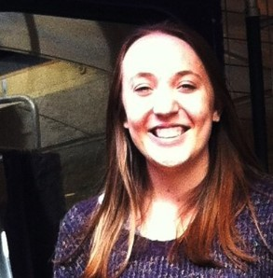

Research Interests

|  |  |  |
| --- | --- | --- |
| Libraries | Pop Culture | Media |
| Undergraduate | GIFS | Social |
| Overnight | TV | Digital |