Federalist Paper

Reagan Cline

April 29.2015

Written for POLI 409 with Dr. Michael MacKuen

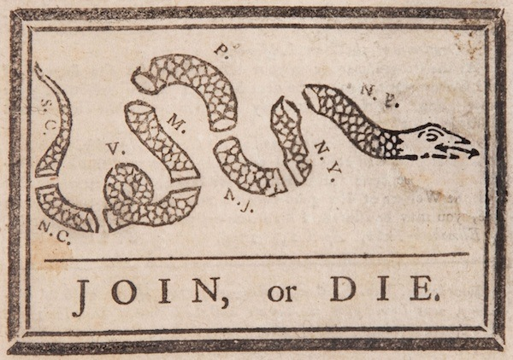

# The Federalist:

## An Esssay Written in Favor of the

## New Constitution

### As Agreed Upon by the

## Constitutional Convention

### April 22, 2015

In this Federalist paper, I argue for the adoption of the Constitution set forth by the delegates of this convention. I will examine the gun rights clause, which reads as follows: “The right of all citizens, after proving both proficiency and mental soundness, to own and operate firearms of a civilian nature for lawful purposes, shall not be infringed.”

This section makes the right to own and operate a gun an individual right. By making it an individual right, this Constitution ensures citizens’ right to self-defense and allows for lawful recreational gun use. It codifies the modern shift away from the current US Constitution’s militia interpretation and prevents civilian access to military-style weapons that have no reasonable civilian purpose.

The current Constitution’s Second Amendment reads: “A well regulated Militia, being necessary to the security of a free State, the right of the people to keep and bear Arms, shall not be infringed.” Initially, the right for American citizens to bear arms was inherently tied to citizens’ obligation to defend their rights from government tyranny. Leading up to the Revolutionary War, King George III attempted to take away colonists’ firearms along with their rights. Ultimately, the colonies’ militias defeated the largest standing army at the time and reclaimed the peoples’ autonomy. It follows that the founding fathers viewed the right to bear arms as a collective right in juncture with militia service, and secondarily as an individual right to self-defense.

Before globalization, an armed and trained citizen militia could effectively take the place of professional soldiers, as Machiavelli argues in *The Art of War.* Ideally, this both deters foreign aggressors and eliminates the need for a potentially oppressive standing army. Furthermore, as part of social contract theory, people have the responsibility to rebel against a tyrannical government, especially if a military state develops and the standing army oppresses individual rights. If that were to occur, heavily armed civilians could theoretically defeat their oppressors and reclaim freedom, as the colonists did in the American Revolution.

However, moving away from theoretical arguments, as the government stands today, no citizen militia could realistically defeat US armed forces if the government decided to declare a military state. The level of technology and resources available to the US government is far beyond what any citizen militia could gather or create. This level of power enables the US government to stand strong against foreign threats so citizens can continue to live freely within the country.

In reflection of modern times, interpretation of the Second Amendment has changed to understand it as an individual right to lawfully defend oneself, disconnected from service in a militia, which was marked most recently with the Supreme Court’s decision in the 2008 case, *DC v. Heller*. As an individual right, it does not allow for citizens to be heavily armed in military style. The way our government functions makes it near impossible for a military state to develop. All members of government are citizens first and return to being an ordinary citizen when their service ends. Furthermore, unlike with a king or dictator, our government lacks an all-powerful head of state. Any military action ordered by the executive branch requires funding supported by the legislative branch, and all actions must follow the Constitution as interpreted by the judicial branch. Military action, particularly against citizens of the state, would require an impossible level of cooperation among government officials.

This Constitution ensures that militant rebellion is not the outlet through which to express discontent with the government. Locke argues in *Two Treatises of Government* that the people have a right to revolution in the circumstance of a tyrannous government. However, the Constitution before us today does not outline the right to revolution. Instead it provides peaceful means for citizens to check and revise government power: the government derives all power from the people pursuant to the constitution, Article Four provides two paths for citizens to amend the Constitution, and multiple checks across the three branches of government. It would even possible for citizens to discard the current constitution and write a new one better suited to modern times, as we are doing today.

A prosperous and advanced society cannot be upheld by violence. Ideally, all conflicts of free will can be resolved without violence, and individuals’ free will can reasonably be restrained without restricting individual freedom. One’s rights only extend so far that they don’t infringe on another’s rights. Among all first-world countries, the US has more violent culture that plagues our cities and prevents forward progress. Increasingly, weapons in the American market are more dangerous. Casual violent culture in movies, TV shows, and video games glorify violent activity; the US code permits some level of interpersonal violence with stand your ground laws and true man defense.

It is the hope of this convention that the gun rights clause provides the tools and framework for the legislature to curb violence moving forward. The phrase “firearms of a civilian nature” allows some ambiguity for where the civilian-military line shall be drawn. This could allow for bans on assault weapons, including all automatic and semi-automatic firearms. Most citizens who own semi-automatic firearms use them solely for lawful recreational purposes; however, when in the wrong hands these weapons can kill (and have killed) a large number of people in just a minute. Therefore, under this Constitution, the legislature would be justified in banning civilian use of military-grade weapons as a danger reduction strategy. That exercise of the right can be so unusually dangerous that it justifies restricting the right.

Most gun deaths occur from firearms of a civilian nature, but by requiring proof of both proficiency and mental soundness, this Constitution intends for better regulation on who can own and operate firearms. Guns are not inherently bad, but today’s gun culture is.

One final point to consider, historically, the right to bear arms has been essential for minority groups. The increased regulations for obtaining firearms should not be applied in a discriminatory manner, pursuant to the Equal Protection section of Article Five. Shortly after the Civil War’s end, the Ku Klux Klan established black codes that prevented African Americans from owning guns. Later during the Civil Rights Movement, the Black Panthers turned focus to fighting for their right to bear arms and fight the ‘standing army’ of police who used guns and violence to keep African Americans enslaved. This marks the beginning of modern gun rights interpretation with a focus on the right to bear arms for self-defense and protection of liberties.

To reflect modern times, this Constitution intends to protect an individual’s right to own and operate firearms for both self-defense and recreational use, within reasonable limits and operating under a danger reduction strategy. The right to defend oneself is an individual, rather than a collective right. This discards connection of the right with service in a citizen militia.

The right to bear arms is an essential right to American liberty, both historically and today. Citizens have the right to lawful self-defense and security in their home. The Gun Rights section of the new Constitution explicitly allows increased government regulation of the right to bear arms. Gun rights and regulations is a complicated issue, but this Constitution provides the best compromise that allows for self-defense and recreational gun use, and increased regulation to move towards a safer society.

|  |  |
| --- | --- |
| Delegate | Position |
| Reagan Cline | Signed |
| Tabitha Bauguess | Contested |
| Manish Sreevatsava | Signed |
| Ryan Bullard | Signed |
| Logan Nicholas Johnson | Contested |
| Audrey Wells | Signed |
| Matt Newman | Signed |
| Adam McCoy | Signed |
| Mary-Katherine Dunn | Signed |
| Alexander Paschal | Signed |
| Robert Kawecki | Signed |
| Joey DeVito | Contested |
| Jill Neville | Signed |
| Graham Morgan | Signed |