Tools for Information Literacy | Syllabus

[](/) [Tools for Information Literacy](/) [Syllabus](/syllabus/) [Schedule](/schedule/) [Quiz](/quiz/) [Assignments](/assignments/) [Reference](/refsheets/)

# Syllabus

## About the Course

⊕ COURSE INFO  
  
  **Instructor:** [John D. Martin III](http://johndmart.in)  
  **Email:** [[email protected]](/cdn-cgi/l/email-protection#81ebeee9efafe5afece0f3f5e8efafe8e8e8c1f4efe2afe4e5f4)

 **Office hours:** I will be available for help in the lab starting at 10:30 on Fridays. Email me to meet any other weekday. I will also be on [Slack](https://inls161.slack.com) so you can contact me for questions.  
  
  **Time:** 11:30-13:00  
  **Days:** MoTuWeThFr  
  **Location:** 117 Manning Hall

**Dates:** 26 June 2017 - 27 July 2017  
  **Exam period:** 11:30-14:00 31 July 2017

INLS161 focuses on concepts and tools necessary for communicating information to users. This is a critical component of information literacy, which involves seeking, evaluating, and utilizing information. INLS151, titled "Retrieving and Analyzing Information," is focused on the seeking and evaluating components of information literacy. This course is about effective use and communication.

## Tools and Concepts

The course introduces some basic technology tools as an essential component of information literacy training. We will cover the following:

* Operating on a remote system
* Using version control software to maintain your workflow
* Manipulating and formatting text-based documents
* Processing data using spreadsheets
* Processing and storing data in databases
* Developing presentation materials to communicate your work effectively
* Beyond!

Some of the tools used may be familiar to you already while others may not.  
 We will introduce concepts and practice skills relevant to effective use and understanding of the power built into the tools listed above. If you already know how to use a given set of tools, you will have the opportunity to deepen or expand your existing skills. We will use exclusively Free and Open Source Software (F/OSS) when possible and conduct and submit most of our work in open repositories online.

## Information Literacy

From the [American Library Association](http://www.ala.org/ala/mgrps/divs/acrl/standards/informationliteracycompetency.cfm#ildef):

Information literacy is a set of abilities requiring individuals to 'recognize when information is needed and have the ability to locate, evaluate, and use effectively the needed information.'

The technological component of information literacy is [also defined](http://www.ala.org/ala/mgrps/divs/acrl/standards/informationliteracycompetency.cfm#iltech):

Information literacy is related to information technology skills, but has broader implications for the individual, the educational system, and for society. Information technology skills enable an individual to use computers, software applications, databases, and other technologies to achieve a wide variety of academic, work-related, and personal goals. Information literate individuals necessarily develop some technology skills.

A full information literacy curriculum would include:

* Tool literacy - The ability to use print and electronic resources including software
* Resource literacy - The ability to understand the form, format, location and access methods of information resources
* Social-structural literacy - Knowledge of how information is socially situated and produced. It includes understanding the scholarly publishing process
* Research literacy - The ability to understand and use information technology tools to carry our research including discipline-related software
* Publishing literacy - The ability to produce a text or multimedia report of the results of research

[About](/syllabus/#) > [Structure](/syllabus/#class-structure) > [Reading](/syllabus/#reading-materials) > [Evaluation](/syllabus#evaluation) > [Grading](/syllabus#grading) > [Policies](/syllabus#course-policies)

# Reading materials

There will be something to read for each session, but they are intended as reference materials for the task- and skill-sets we are working with.

Most readings will be available either on the open web or through the univerity's proxy.

## Other readings

### Interfaces

Harris, Tristan. ⊕This is an interesting and insightful piece about how design choices in interfaces affect how we think and interact. “How Technology Hijacks People’s Minds — from a Magician and Google’s Design Ethicist.” Medium. Last modified May 18, 2016. <https://medium.com/swlh/how-technology-hijacks-peoples-minds-from-a-magician-and-google-s-design-ethicist-56d62ef5edf3>.

### The Linux Command Line

Shotts, William E. ⊕This book will give you everything you need to be able to operate in a command shell. It is a good reference for everything command line. If you like books in physical form, you can also get it [on Amazon](http://www.amazon.com/Linux-Command-Line-Complete-Introduction/dp/1593273894/). The Linux Command Line: A Complete Introduction. San Francisco, California: No Starch Press, 2013. <http://linuxcommand.org/tlcl.php>.

### Pro Git

Chacon, Scott, and Ben Straub. ⊕The definitive guide to using git. This will come in handy. Pro Git. 2nd ed. Apress, 2014. <https://git-scm.com/book/en/v2>.

Wynn, Joseph. ⊕These resources for using git will be very helpful. They may be used in class for reference. “A Hacker’s Guide to Git.” Wildly Innacurate. Last modified May 25, 2014. <http://wildlyinaccurate.com/a-hackers-guide-to-git/>.

Dudler, Roger. “Git: The Simple Guide.” Git: The Simple Guide. Last modified 2015. <http://rogerdudler.github.io/git-guide/>.

### How to Code in HTML5 and CSS3

Wielgosik, Damian. ⊕Good introduction to HTML and CSS. We will be referring to this and other guides. How to Code in HTML5 and CSS3, 2015. <http://howtocodeinhtml.com/index.html#toc>.

### The Cognitive Style of PowerPoint

Tufte, Edward R. ⊕We will use this to unlearn what we have learned and then reorient our minds to create better visual presentation aides. Definitely read the whole thing. The Cognitive Style of Powerpoint: Pitching Out Corrupts Within. Cheshire, Connecticut: Graphics Press, 2011. [Available in Sakai, [open web](http://users.ha.uth.gr/tgd/pt0501/09/Tufte.pdf), or on [Amazon](https://www.amazon.com/Cognitive-Style-PowerPoint-Pitching-Corrupts/dp/0961392169).]

### What is Code?

Ford, Paul. ⊕This is an excellent piece about the need for people at all levels in industries both technologically-focused and otherwise to have a better understanding of how software is developed and implemented. I will refer to this piece occasionally and sections of it will be assigned throughout the course. It is probably a good idea to read the whole thing. “What Is Code? If You Don’t Know, You Need to Read This.” Bloomberg.com. Last modified June 11, 2015. <http://www.bloomberg.com/graphics/2015-paul-ford-what-is-code/>.

[About](/syllabus/#) > [Structure](/syllabus/#class-structure) > [Reading](/syllabus/#reading-materials) > [Evaluation](/syllabus#evaluation) > [Grading](/syllabus#grading) > [Policies](/syllabus#course-policies)

# Class structure

## Session notes

Session notes will be posted prior to each class and you would do well to look over the links before coming to class. If there is something that you should before coming to class, it will be included on the session notes for the session prior to the class you will be preparing for.

Class sessions will have online notes (which will include links to supplementary readings). The notes will also include practical exercises that we will work through in class. Some session notes will be very detailed and loaded with images; some session notes will be spare and loaded with hyperlinks (be aware that links may change over time).

It is a really, really good idea to go over these and try them on your own before class in order to familiarize yourself with the commands and generate questions about techniques. It is also a really, really good idea to go over these after class, once we have worked through them together.

See the [schedule](/schedule/) for links to lecture notes.

## A Note on Computers

This is a (mostly) paper-free course. There will be no paper products generated in this class and there is no printing requirement.

All work done in INLS161 will be done on computers either on your personal laptop or on the desktop systems in the SILS lab. In most cases, work will be done using web applications in such a way that you might access your workspace from any computer, anywhere.

## Daily Plan

This is a pretty fast, intensive class, because we have a lot of material to cover and about 23 sessions over five weeks in which to cover it. You are expected to come to class on time (read: get here early) and ready to review what we covered in the last session.

* The first 5 to 10 minutes will be reviewing the material from the previous session. This will be mostly done by you. You will talk about what you learned and I will listen and ask questions.
* The next 50 to 60 minutes will consist of lecture (some); examples (a lot); discussion (a fair amount); and practice (some).
* The last 20 to 30 minutes will be for practice (more) when we have the time and hands-on-keyboards activities (most days).

[About](/syllabus/#) > [Structure](/syllabus/#class-structure) > [Reading](/syllabus/#reading-materials) > [Evaluation](/syllabus#evaluation) > [Grading](/syllabus#grading) > [Policies](/syllabus#course-policies)

## Lab days

Several days throughout the semester will be reserved as lab sessions. ⊕I will also make myself available in the computer lab beginning at 10:30 on Fridays. If you need any extra help or wish to talk about anything, that is a good time to do it. We will spend these days working in groups or individually on your ongoing projects so that you will have some in-class time to troubleshoot issues with help from your instructor.

[About](/syllabus/#) > [Structure](/syllabus/#class-structure) > [Reading](/syllabus/#reading-materials) > [Evaluation](/syllabus#evaluation) > [Grading](/syllabus#grading) > [Policies](/syllabus#course-policies)

# Evaluation

This class has no exams, but there are 6 major tasks that will correspond to one of the major objectives in the course. These include a final presentation which will be made during the scheduled final exam period. All of the tasks are interconnected, so it is important to complete the tasks in succession by the due dates listed in the chart below.

## Grade contract

⊕[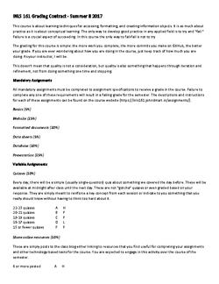](/syllabus/inls161-suii2017-gradecontract.pdf)  
  
[The breakdown of grades in the contract is also available here](/syllabus/evaluation/).

Evaluation for this course will be based on your agreement to a specific set of tasks at the beginning of the semester and successful completion thereof. This will happen in the form of a contract between you and me which you will sign on the first day of class.

A detailed breakdown of how your grade will be rendered based on participation and contribution is included in the [contract](/syllabus/inls161-suii2017-gradecontract.pdf) and [on the course website](/syllabus/evaluation/).

## Assignment Tasks

There are 6 major assignments for the course. Assignment tasks are broken down in the grade contract. They build on one another, so it is impossible to do one without first having completed the one before. You will find descriptions and instructions for the assignments on the [/schedule](schedule%20page).

# Assignment Breakdown

⊕*Table 1*: List of required course tasks

|  |  |  |  |
| --- | --- | --- | --- |
| **Task** | **Components** | **%** | **Due date** |
| Basics | [Set up GitHub, introduce yourself, read syllabus](/assignments/2017/06/30/assignment-1-basics/) | 5 | Jun 30 at 23:59 |
| Web | [Build a website hosted on GitHub Pages](/assignments/2017/07/10/assignment-2-build-a-website/) | 15 | Jul 10 at 23:59 |
| Text | [Write a script to convert text files](/assignments/2017/07/16/assignment-3-text-conversion/) | 10 | Jul 17 at 23:59 |
| Data | [Write a script to collect and manipulate data](/assignments/2017/07/19/assignment-4-data/) | 5 | Jul 19 at 23:59 |
| Database | [Write a script to interact with a database](/assignments/2017/07/23/assignment-5-database/) | 10 | Jul 23 at 23:59 |
| Present | [Create a presentation using HTML](/assignments/2017/07/27/assignment-6-presentation/) | 15 | Jul 27 at 23:59 |

### Due Dates

Each task is due at the date and time specified in the schedule. It would be a good idea to complete assignments before that deadline so that you can get a jump on the next section.

The last assignment (the recorded/narrated presentation) will be due on the last regular day of class for evaluation, but will be presented during the exam day session in place of a final exam. You will have the chance to make changes after submission before the final presentation.

### Submitting Assignments

All of your assignments will be submitted using GitHub, as this is where you will store your course materials and personal website. ⊕[](https://github.com/inls161/) Learning how to use this system is built into the first assignment. Particular requirements and instructions for assignments and submission will be discussed in class and included in the lecture notes.

If you do not have a GitHub account, [please sign up for one](https://github.com).

A snapshot of your work will be automatically collected from your GitHub repositories at the time the assignment is due. You do not have to submit anything manually. You just have to make sure that your assignment is ready and pushed to a repository in your GitHub account. Given this, it is important to pay attention to how I have instructed you to name your repositories in the assignment text. If the name is incorrect, the assignment will not be collected on time.

[Information about individual assignments is listed here](/assignments/).

## Participation

In addition to the 6 tasks, participation will be evaluated and included in the evaluation scheme. Participation, of course, means coming to class: that is mandatory. It also means bringing something to the class by way of discussion or links shared with the rest of the class. Since we are a small class this summer, we will decide on the first day how best to accomplish the sharing of resources.

## Linked Resources

Part of your responsibility for this class is investigating and sharing resources that you find on the web or elsewhere that you think might be helpful to us. The best and most current resources for using technology tools are not going to be found between the pages of books. Rather, they will be on forums, blogs, and in ebooks like some of those listed above. They best way to keep abreast of current techniques is to keep up with the resources and tutorials available online.

## Attendance

Attendance is mandatory. Absence will affect your grade in the class. There is no way to make up for this.

[About](/syllabus/#) > [Structure](/syllabus/#class-structure) > [Reading](/syllabus/#reading-materials) > [Evaluation](/syllabus#evaluation) > [Grading](/syllabus#grading) > [Policies](/syllabus#course-policies)

# Grading

⊕*Table 2*: Course grades  
  
Explanation of UNC grading systems: <http://registrar.unc.edu/academic-services/grades/explanation-of-grading-system/>.

|  |  |  |  |
| --- | --- | --- | --- |
| Percentage | Grade UG | Grade G | What it means |
| 95> | A | H | Highest level mastery of course content |
| 92-94 | A- | H |  |
| 87-91 | B+ | P |  |
| 83-86 | B | P | Totally acceptable performance |
| 80-82 | B- | P |  |
| 77-79 | C+ | P |  |
| 73-76 | C | P |  |
| 70-72 | C- | L | Marginal performance in course requirements |
| 67-69 | D+ | L |  |
| 60-66 | D | L |  |
| <60 | F | F | For whatever reasons, an unacceptable performance |

## Grades and Progress

We will use the standard UNC grading scale for this course. Assignment tasks are rubricated and points will be assigned by the instructor after the completion of each task. Rubrics are not published, but are based on the assignment descriptions.

Grades will be made available on a rolling basis.

[About](/syllabus/#) > [Structure](/syllabus/#class-structure) > [Reading](/syllabus/#reading-materials) > [Evaluation](/syllabus#evaluation) > [Grading](/syllabus#grading) > [Policies](/syllabus#course-policies)

# Course Policies

Instructors and students at the University of North Carolina at Chapel Hill adhere to the Code of Student Conduct. Accordingly, you all should recognize that most software applications available in the computer lab are copyrighted and cannot be copied. We will primarily use open source software for this course, which does allow for copying. It is important to know the difference and heed the terms of software licences.

We can learn much from each other and we will do that. I expect each of you to help each other. We'll discuss what we expect in terms of cooperative, collaborative, shared work and the honor code.

## Honor Code

⊕  
 It shall be the responsibility of every student at The University of North Carolina at Chapel Hill to obey and support the enforcement of the [Honor Code](http://studentconduct.unc.edu/), which prohibits lying, cheating, or stealing when these actions involve academic processes or University, student or academic personnel acting in an official capacity.

## Campus Code

It shall be the further responsibility of every student to abide by the [philosophy of the code](http://studentconduct.unc.edu/honor-system/philosophy); namely, to conduct oneself so as not to impair significantly the welfare or the educational opportunities of others in the University community.

## Instructor Responsibilities

I have a role to play as well, and I will fulfill [these responsibilities](http://studentconduct.unc.edu/instructors).

## Shared Responsibilities

The system rests on several central tenets:

The university community, including faculty and students, share a commitment to the pursuit of truth, and the dissemination of knowledge to succeeding generations of citizens devoted to the high ideals of personal honor and respect for the rights of others.

These goals can only be achieved in a setting in which intellectual honesty and personal integrity are highly valued; other individuals are trusted, respected, and fairly treated; and the responsibility for articulating and maintaining high standards is widely shared.

Both students and faculty must play active roles in fostering a culture in which honor is prized and acting to remedy violations of community norms relating to academic misconduct, injuries to members of the University community, and conduct that adversely affect University operations and resources.

The principles of academic honesty, integrity, and responsible citizenship govern the performance of all academic work and student conduct at the University as they have during the long life of this institution.

Your acceptance of enrollment in the University presupposes a commitment to the principles embodied in the Code of Student Conduct and a respect for the most significant Carolina tradition.

Your reward is in the practice of these principles.

**Your participation in this course comes with the expectation that your work will be completed in full observance of the Honor Code.**

*You are encouraged to work together with your fellow students and to share knowledge and learning.*

However, academic dishonesty in any form is unacceptable, because any breach in academic integrity, however small, strikes destructively at the University's life and work.

## Plagiarism

⊕  
 Plagiarism is not tolerated in this or any course or academic context. Your work for this course will be your own, though almost everything that we do in class will be collaborative.

We will also be using and writing open source software and documentation in this class. Proper crediting of work and adherence to open licensing requirements is an important part of this course and will help us to better understand and avoid plagiarism and license violation.

Please go through this tutorial and then [email me](/cdn-cgi/l/email-protection#1d77727573337933707c6f697473337474745d68737e33787968226e687f77787e69204d717c7a747c6f746e703d496869726f747c71) the result: [UNC LIbraries Plagiarism Tutorial](http://www.lib.unc.edu/plagiarism/).

## Diversity and Inclusion

⊕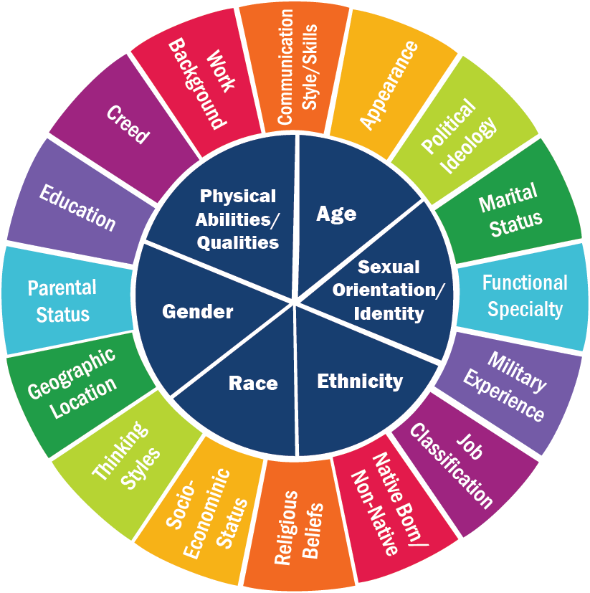  
 In support of the University's diversity goals and the mission of the School of Information and Library Science, SILS embraces diversity as an ethical and societal value.

We broadly define diversity to include race, gender, national origin, ethnicity, religion, social class, age, sexual orientation and physical and learning ability.

As an academic community committed to preparing our graduates to be leaders in an increasingly multicultural and global society we strive to:

* Ensure inclusive leadership, policies and practices;
* Integrate diversity into the curriculum and research;
* Foster a mutually respectful intellectual environment in which diverse opinions are valued;
* Recruit traditionally underrepresented groups of students, faculty and staff; and
* Participate in outreach to underserved groups in the State.

The statement represents a commitment of resources to the development and maintenance of an academic environment that is open, representative, reflective and committed to the concepts of equity and fairness.

## Class conduct and expectations

This class is not a safe space, but a brave space. Here you are encouraged to be your most authentic self, take intellectual chances, make mistakes. Our social contract in this class requires that we respect the above guidelines regarding inclusion and expand them. So, be brave enough to make the spaces around you safe for people who are different than you.

People are complex. Our identities are fluid and performative. It is incumbent upon each of us to remember that, particularly if we come from a place of privilege which allows us to think that everyone has the same advantages and opportunities that we have. Try to recognize privilege and work to break the structural inequalities that accompany it, even in this class.

None of us are perfect. We all make mistakes. But: if you don't know what you're doing, you can't make mistakes. You don't have any parameters for understanding what is and isn't a mistake. We are learning together and that entails accepting our ignorance and working through it toward something better: knowledge.

Think, before you speak or act, about how your words and actions affect those around you. Symbolic violence is real and can be committed very easily. It is usually not recognized as such by those committing it. Take care that your words and actions are not marginalizing those who find themselves regularly marginalized. Instead, use your words and actions to empower and avocate for each other.

## Dinosaurs

⊕  
 Once you have read this syllabus in full, please [click here](/cdn-cgi/l/email-protection#0963666167276d2764687b7d606727606060497c676a276c6d7c367a7c6b636c6a7d344d6067667a687c7b) and email me a picture of a dinosaur.

[About](/syllabus/#) > [Structure](/syllabus/#class-structure) > [Reading](/syllabus/#reading-materials) > [Evaluation](/syllabus#evaluation) > [Grading](/syllabus#grading) > [Policies](/syllabus#course-policies)

Syllabus -

* [John D. Martin III](http://johndmart.in)
* [[email protected]](/cdn-cgi/l/email-protection#5933363137773d7734382b2d303777303030192c373a773c3d2c)
* 11:30-13:00
* MoTuWeThFr
* 117 Manning Hall

TOOLS FOR INFORMATION LITERACY   |   INLS161-001 (Summer II)   
 Tools and concepts for information literacy. Includes software use and maintenance, computer applications, and networked information systems.   
  
 All content licensed under a [Creative Commons Attribution-NonCommercial-NoDerivatives 4.0 International License](https://creativecommons.org/licenses/by-nc-sa/4.0/).   
 [Content © 2017 John D. Martin III](credits/)