About Sound Management

Stop the constant beeping, the kids are sleeping !

There are four sources to control the various sounds, indents of instruments and voice.

First up the operating systems sound control to set the volume or mute for the PC which varies from OS to OS.

Second, there is the aircrafts Sound Configuration Dialog as shown below...

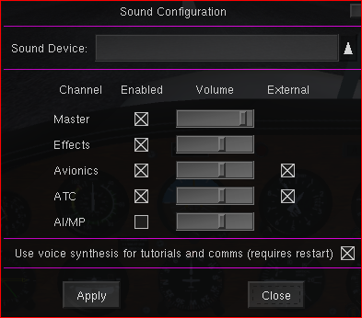
Do not disable master or set the volume to 0 because if you crash, reset or close the simulator incorrectly, there will be no sound if you start Flightgear again, no matter which aircraft.

If that happens, the only way to restore the sound is to use the property browser to change the sim/sound/enabled property to true.

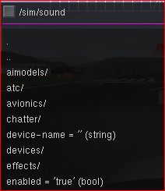

Thirdly, various instruments have their own sound control, which means you can set different volumes for different instruments if you so desire. e.g. Nav[0] as below...

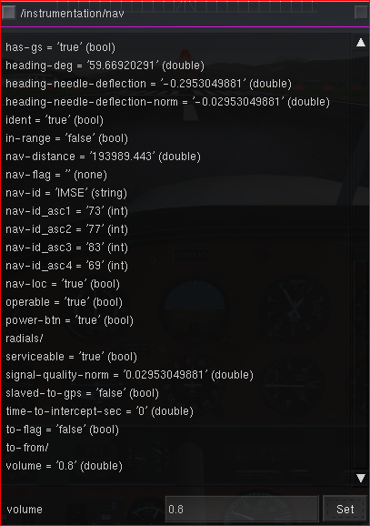

And lastly the ultimate control is the KMA20

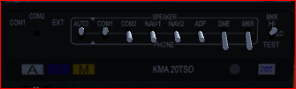
Here you decide where the sound is to be heard (Speaker or Headphones) and when by flipping the relevant lever to either Off, up or down. The tooltip will tell you which is which.

You can also adjust the intensity of the OMI (German for granny!), no really short for outer, inner and middle marker of the Marker Beacon indicator once on the ILS glideslope
For a reason unknown to me some aircrafts Marker Beacon Indicator show AMI, no idea wht the A stands for.

Once you set or change the frequency of a particular radio, you need to first check if there is a signal and if so you need to identify the station by listening to its morse code, because different airports may use the same frequency, but have a different ident or you may have entered the frequency incorrectly.
The correct morse code is shown on relevant charts.

To avoid beeing blasted continously by simultaneous multiple morse music you may want to

- tune in to a frequency/radial
- set the relevant lever to speaker or phone
- once you have identified the station by listening to the morse code flip the switch to the off position

If using multiplayer and or communicating with the ATC the microphone can be switched between com1 and com2

For the hearing impaired:

If you tune in to an ADF station, the HUD will only show the frequency if in range, the frequency will blink if the signal is weak
In the same fashion one could add the nav frequencies as well.

