Quick Start-up Options/Nav Scenarios

Yes, flying and practising approaches can become a little time consuming. As such in order to practise ILS, VOR, NDB, VASI, PAPI approaches one can actually start the Navigator in the air based on certain parameters. These are contained in batch-files which you may wish to copy to your desktop as discussed below.

Unfortunately the original functionality of the menu option “Position In Air” has a few setbacks, such as the aircraft positioned where you want it, however with no configuration like engines running, etc. Moreover it starts unpaused, immediately taking a dive. Not much fun at all.

None the less the menu feature can still be useful if you want to start 3 nm out of a VOR or NDB or at a specific location by specifying GPS co ordinates rather then just 10 nm out of airport x runway y.

The work around s below have been designed for the Navigator and may not work on other aircraft's.

For Non Windows 10 Operating systems you can resort to the option described below, alternatively search for the equivalent of batch files for your operating system.

NOTE: Ensure you have the relevant scenery installed prior to running any of these files, at minimum you need LSZH -Switzerland, Honolulu, YMML-Australia, EGKK-UK, Austria and Gibraltar

Make sure your Launcher does not contain the option start paused.

Windows10

In order to start the Navigator in the dark, in the air or at an airport you desire bypassing the Launcher you need to extract the folder contained in PA28-Warrior/Quick Starts to your desktop.

Having done that, you will find some batch files inside, namely:

Patterns, LPR17, SelectApproach and StartAtNight, EngineFail, EL-Failure, …

Using these scenarios you might want to display the HUD as well as the Presets Bar.

Important: If you use a FG version other then 2018.3.2 you need to adjust for that in the first line of all files.

Patterns and Procedure Turns

This QuickStart command line file is designed to allow you to practise flying a variety of procedure turns, ILS, VOR, Vasi, Papi and VFR approaches.

To make things a little easier there is zero wind in this scenario.

Guidelines for a particular scenario are:

- From your desktop or folder start the Patterns batch file
- Once the Paused message pops up just set your parameters if any.
- Frequencies are preset, hence no prompt (Exception Patterns, just hit p to go)
- Press p to unpause and you are on the way just short of Gatwick airport
- Decide whether to fly hands on or by means of the AP
- If by way of autopilot ensure you are in HDG mode
- Monitor the DME distance at the top left of your HUD
- At exactly 2nm out turn 45 degrees left to a heading of 213 and start the stopwatch and fly this heading exactly for 40 seconds
- Turn a 180 degrees to the right to the reciprocal of the original heading tracking the radial
- Open the radio dialogue and change the radial of NAV1 to 078 (The frequency is the same for both runways)
- Once passing the runway, start the timer for 2 minutes and change the Nav1 radial back to 258
- After 45 seconds turn 45 degrees left, timer for 45 secs and then
- immediately turn right to the heading of 258 to approach runway 26
You can either land or keep going round and round... practising the 45/225 procedure turn and a variation of circling.
In the same fashion you can do a 30 degree teardrop on one end and a 20 degree teardrop at the other end, etc, etc

You can view your accuracy by looking at the map displaying your flight history and of course replay and or save your flight using the recorder.

ShortFieldObstacleTakeOff

You are positioned at EDRW rwy 07 about 1900ft long with a bit of high terrain at the end of the runway.
Checkout the checklists section T/O ShortField …

EDRW reciprocal rwy 25 can be used for approach shortfield
This airport has no facilities, no whatsoever and does not even show up on the map

Enjoy

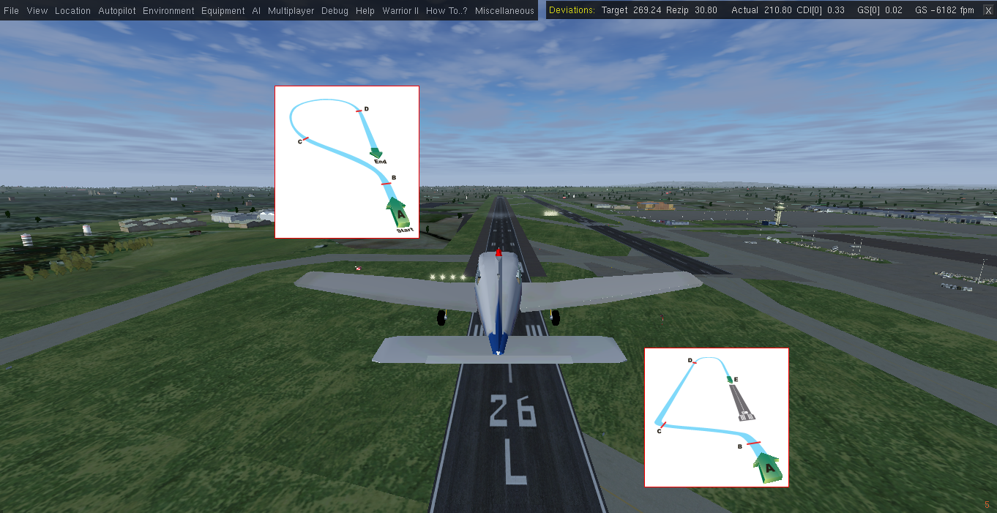

LPR17 is designed as a demo illustrating how to use SelectApproach.

Run the file and follow the procedure below to the point...
FG will start up bypassing any launcher.
Flightgear will position the aircraft frozen at about 3000 feet 10 nm out of YMML (Melbourne,AU), at a heading of 263 degrees and at 110 IAS.

While still frozen, press F11 to display the ITAF which will be in HDG mode.

In the radio dialog type 109.3 for frequency (Nav1) and 263 for radial, in the ADF box type 377 for the Epping NDB, then close the dialog.

The normal start-up routine is now complete, lights come on, mixture full, throttle set …

Unpause by pressing p, display the map and you will see you are on the way to runway 027 of YMML just before the NDB, once the Glideslope is in range (green light) switch the AP to approach, reduce your speed , flaps out one notch or go down by hand if you prefer.

SelectApproach

This file will prompt you to nominate airport, then runway (if airport input is incorrect the file will not run, if the runway entered does not exist, FG will put you on an alternate one, either based on wind or more often the longest runway.), next specify required altitude and distance from airport.
If the selected runway has ILS facilities, the Platypus will preset Nav1 with the corresponding frequency and radial.
Do not use the route manager to change the runway, instead call-up the Nav Scenario again and change the runway there.
Exception, you can use the route manager if you want to deviate to another airport.

Same applies for the command line starts (QuickStarts)

On Normal flights you can use the route manager to nominate destination airport and runway, which also will preset Nav1 provided the runway has ILS.
You will see a message after activating the route. You can change the runway in the dialog to find a runway with ILS and then you need to reactivate the route.

Flightgear starts up, and the Navigator sits frozen where ever you wanted it to be.
You need to set your relevant parameters like NDB, GPS, speed etc. before you press p to unpause..

If not visible, display the ITAF Autopilot, unpause and you are on your way.....

StartAtNight

This will simply prompt you for your airport and runway of choice and put the Navigator there sitting in the dark with the flashlight illuminating part of the panel.
Press Shift ! And CTRL L to bring a little light in the cockpit, run through the cold and dark procedure or press w for Config, do your set-up and off you go...
The panel light will turn off the flashlight.

EL_Failure

This is a scenario about partial electrical failure.
Startup frozen in air, set your parameters and press p for unpause.

You have just taken off PHNL (Honolulu RWY 08L) and about 2 mins into your climb an electrical fault has occurred or is happening rendering all avionics non functional.
The engine runs on its magnetos, the battery has a little juice left and the autopilot may be unreliable.
As such identify your position and navigate back to the airport using visual reference and the magnetic compass.

Happy landing !

EngineFail

En Route your engine stops, how to get down safely ?
Roughly 6nm 3 mins out of LSZH rwy 34
Once frozen aloft, enter the localiser frequency in Nav1 as 110.75 335, close
Press p to unfreeze and you find yourself at about 4500ft. Your engine has or will stop very shortly. Turn off the AP and continue the approach gliding
Good Luck

NoAltNoASI

You are approx 14nm out of approaching runway 14 of LXGB (Gibraltar).
Altitude 3600 ft Speed 90 kts
If not already your ASI and Altimeter will fail.

Delicate adjustment of Throttle and Pitch will bring you down safely.

Dont forget about wind bracketing.
NoCompNoDG
Combined Heading Indicator and Magnetic Compass Failure
An Island trip turning sour
Your destination is PHNL runway 08L following a predescribed route.
As you are cruising, both the heading indicator as well as the magnetic compass fail. As such nav and approach mode of the ap are not available
Once you are aware that those vital instruments are out of action you can go by visual reference or get your bearings and distance from the onboard GPS.
The GPS is located on the Cadet Panel and you need to search for the airport to get the info you need.
The last reliable heading-indication showed we are on heading 261
Either way you need to find your way to PHNLrwy 08LTurning left or turning right and you are heading towards hills, so watch your descent.
Be careful as there are two airport close to each other, you want to get down on the second one on the left runway and you will need to adjust your course as you go, hence the GPS gives direction to the airport, not the runway!If the approach becomes iffy, circle or fly the standard traffic pattern prior to landing
Ap elevation is 13 ft
BankTurns_ZeroWind

This file can be used to practise turning and banking, flying 8 s , circles and other patterns at various degrees of bank angles.
At startup you are about 7 nm away from the WGM Vor 112.2 which can be used as a fix to commence turns at various speeds and angles...

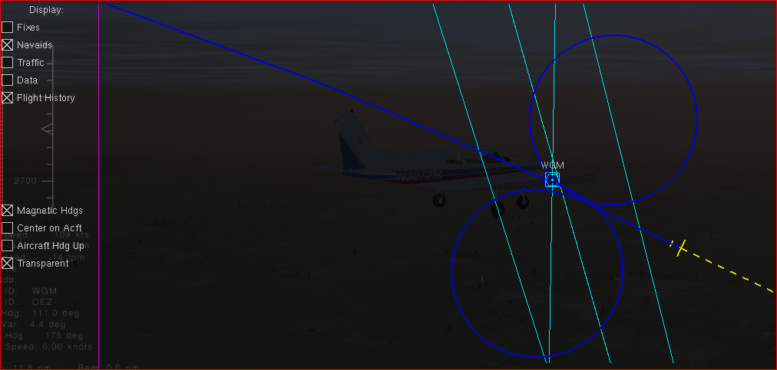

Aborting a Takeoff Roll

It may be due to some malfunction, a passenger suffering a heart attack or other reasons why a takeoff may need to be aborted.
To evaluate accellerate stop data you can run multiple sessions using different configs such as
weight
wind
airport elevation
weather conditions
slopeing runways
With the engine añready running on startup , once you have decided on your parameters, commence the takeoff roll full throttle or rev up with brakes on before releasing the brake and decide at what speed to terminate the Take Off Roll by setting the throttle to 0 and initiating braking action.
Once the aircraft comes to a full stop, a popup will provide details about runway usuage, time, speed and so on.
Please remember, fuel and payloads can only be adjusted with the engine off.
<f> toggles throttle between full and zero
<o> displays or hides the IAS info
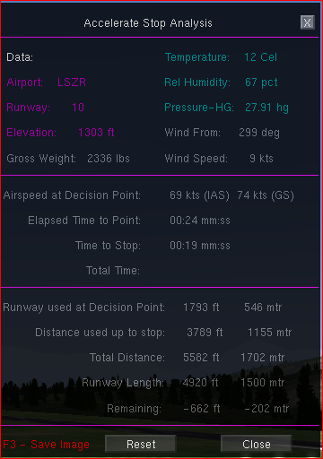

Other OS ?

Use the command lines contained in the batch files and put them into the equivalent of your OS exactly as they are, I.e the same sequence.

Alternatively with the exception of the LPR17, go to the Location menu and select Position Aircraft in air, nominate
airport, runway, altitude, distance and speed (set it a bit higher then you need) and click ok.

If you use this option on other aircrafts - Quickly hit p for pause as the engine is not running and reset the VS to 0 + or you go into a dive.

Add your frequencies as required, turn on AP in HDG mode, unpause, ensure mixture lever and throttle are set to full and turn the key (or press S) to turn on the engine.

ALL OS

you can start at a VOR, NDB or GPS coordinates in which case you also have to provide the heading and you need to start the engine manually.

THIS is still experimental, use at your own risk...

Nav Scenarios

Some of the quick-starts can also be found on the NAV Scenario Menu, which also features stuff like takeoff practise, night ifr, taxiing etc

The the current selection of Nav Scenarios are available from the menu-bar.

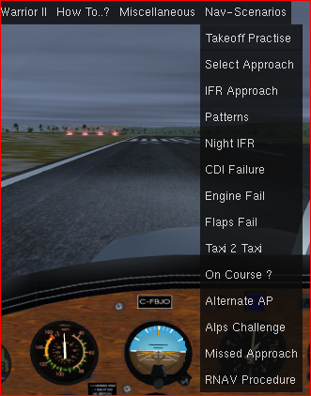

Any given scenario can be called from any other at any time, however you may end up in the dark when switching to a location at another continent. If this happens just press Ctrl d which will take you back to day settings.

If at any time you need to review the description and or instructions of the scenario dialog, just call it up again from the menu and then click the Close button (X) to continue the session or alternatively change your parameters and restart the session by clicking the Run button.

Some of the scenarios are still work in progress.

