Fundamentals (Draft only/OUTDATED).

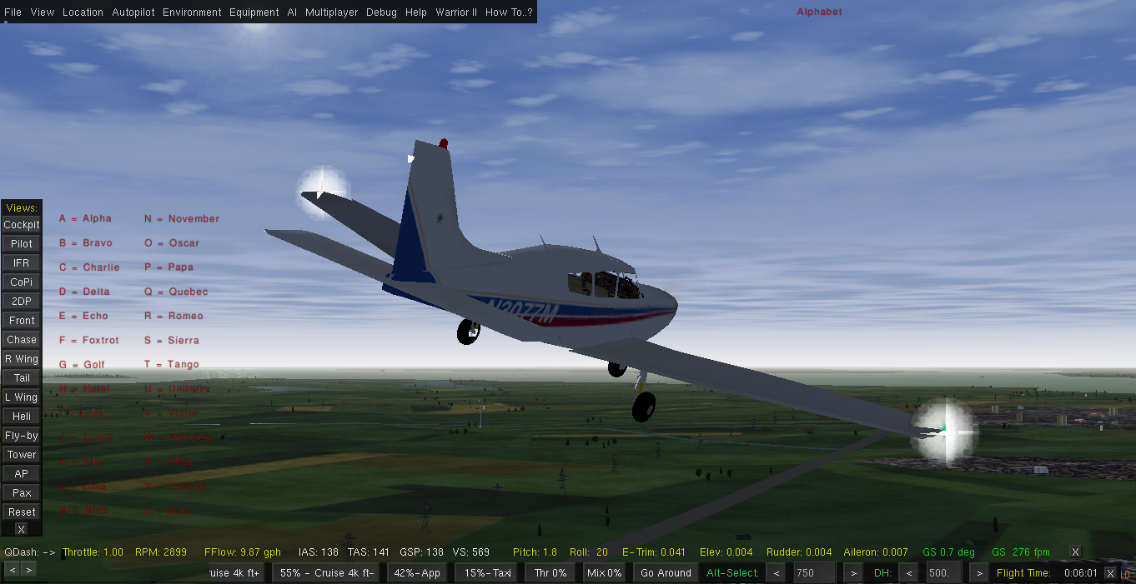

Topic List:

Charts

Weather Settings

Calculations

Ground Navigation

Patterns/Procedure Turns

ADF/NDB

VOR/DME/Holds

ILS/PAPI/VASI

GPS/RNAV

SIDS & STARS

The Grand Final

Charts

Aviation Navigation

How did they do it? The Inkas at Machu Pichu knew exactly where North was. Navigation mishaps today are as common as they used to be in the past like the discovery of America(The continents x 3, not the USA) being thought of having landed in India, or more recently some Pilots on a commercial airliner getting completely lost and ending up in the Amazonas jungle.
Everyday in our live we navigate by asking the same questions, where am I now, where do I want to be, how do I get there?
The answer of course is, we need a map or for the purpose of air navigation a chart.
The sky is full of airways, they have numbers and names, different altitudes, pointing in different directions and the traffic light is basically the ATC (Air Traffic Control). You also will find if flying VFR you need charts to find out headings, radio frequencies, ground elevations, distances etc.
Unlike the poor cousin -roadmaps for cars or hiking, aviation charts contain a lot more information and you will come across a myriad of acronyms/abbreviations. . Study them well, because there are subtleties like for instance DH is measured in ft AGL whereas DA is assumed to be MSL like MDA. At other times you may confront terms like IAS versus KIAS versus TAS and of course there also is ground speed.
Confusing at first, yet it will all fall into place once you take the time to study the charts. Here we have some resources to get you started:

An excellent introduction is found in the chapter AIR Navigation of Charles Wood
http://www.navfltsm.addr.com/ or the pdf version on page 14
http://www.anaspides.net/documents/flight_simulator_documents/Instrument%20course.pdf
Plain English, easy to follow with a bit of humour every now and then.
--------------------------------------------------
Alternativeley, if you are already familiar with the terminology, had some previous exposure to reading charts you may wish to visit the Delta Airlines Virtual Flight Academy at
http://www.dc3airways.com/technical/files/dva%20How%20to%20Read%20Charts.pdf
providing a good run down on different types of charts from Airport diagrams to SID, STAR, Approach Plates and more.
--------------------------------------------------
Now you may also want to get hold of two pdfs from Jeppesen
1. chart-examples http://ww1.jeppesen.com/documents/aviation/business/ifr-paper-services/chart-examples.pdf
2. glossary-legends http://ww1.jeppesen.com/documents/aviation/business/ifr-paper-services/glossary-legends.pdf
amongst other detail contains a nice listing of abbreviations, symbols, etc. The Jeppesen site also offers tons of other material and tips for free. (Just do your research)
Print out a couple of charts of your liking and study the details
All of the above is more likely then sufficient for casual use.
--------------------------------------------------
Ok, in case you want more try the FAA publications
Flight Navigator Handbook chapter 1
https://www.faa.gov/regulations_policies/handbooks_manuals/aviation/media/FAA-H-8083-18.pdf
Aeronautical Chart Users Guide
https://www.faa.gov/air_traffic/flight_info/aeronav/digital_products/aero_guide/media/Chart_Users_Guide_12thEd.pdf
--------------------------------------------------
All good and fine, but where from do we get the charts we need for our flights?
Number one source for the aspiring Flight Simmer is most likely Skyvector offering an online worldwide IFR chart, airport info and more. Spend a bit of time to get to know the site.
https://skyvector.com/
Depending on the country you want to fly in and out, charts can vary a bit in layout and detail, charts also happen to have an expiry date as things like frequencies or procedures change. Be aware that some detail may not match with the internal nav database of FG, in which case you can use the inbuilt map to find the frequencies to be used for the sim.
Other free sources of charts include Vatsim, VACC and many other organisations. (You may need to subscribe or become a member to have access to a range of good materials, not only charts.)
Flightgear also has a nice mp map (multiplayer). Likewise there is the option of a moving map found in the Equipment menu(for those with multiple monitors) but make sure your browser is not going to be hijacked.
http://wiki.flightgear.org/MPMap#NAV
http://mpmap02.flightgear.org/?key1=value1&key2=value2
http://wiki.flightgear.org/Phi#Map
In case you need more, there is lots of material available from FAA and other institutions relevant to your home country.

NOTE:
The charts you download for simulation purposes are just that, for simulation only, more often then not completely outdated, frequencies may have changed or there might be another runway or perhaps they shifted the runway as you land in the grass or worse.

Weather Settings

There will be times when you want to start FG with some customised settings such as wind direction, better visibility, or simply turn off what you dont need. Memory hungry stuff like 3 d clouds for example. It may improve your framerate.
This can be accomplished by setting command line options. A full list of these is found here:
http://wiki.flightgear.org/Command_line_options
Lets say you want no wind at all, no clouds and a visibility of 20 miles you need to start FG from the menu, select your aircraft, select the airport and then click the Settings tab and add whatever command line option you wish, be it enable or disable.

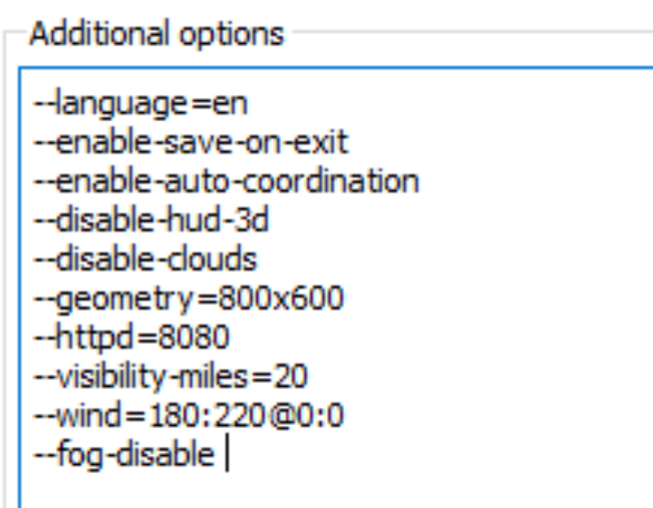
be very careful with the wind settings, easy to get blown off the runway..... the above specifies no wind 0:0 from either direction
Having selected your options choose run and see the result shown in the Hud. If you quit, your settings will not be saved unless you terminate the session with the file exit or ESC sequence.
The official manual also covers how to start FG direct from the commandline or how to start using different configs like midair etc depending on your installed operating system.
Some of the command line options vary from FG version to another.
------------------------

Specific weather related details are found under Environment,Weather, Basic Weather, Manual Configuration and Advanced Configuration.
There you can make it rain, set cloud ceiling to a specific altitude (very nice expierence to see the runway as you get below the cloud cover)
For instance for a solid cloud cover at msl 2000 and 700m thick you would set the bottom layer like this:
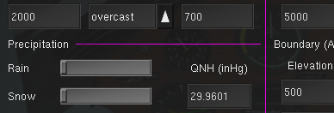

Then of course you also can use real weather fetch once online, or you might prefer to make up your own fake metar string to suit your liking.
METAR and advanced weather resources can be found in various wikis.
Where does the wind come from ?
First there is ATIS, then perhaps a windhose next to the runway, ATC may tell you and in addition to that the HUD bottom left tells you where its coming from and speed, looking at the compass rose you can tell very quickly if its head, tail, or from the side (cross)
On more info on how to deal with it refer to section 8.9 of the official manual available under the Help menu.
You will find further info here:
https://en.wikipedia.org/wiki/Crosswind_landing

Wind Configuration
The Navigator also comes with a Wind Configuration option which one can use to practise takeoffs and landings in whatever scenario of head, tail and or crosswinds
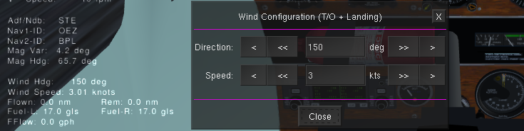
You can use the buttons or type the desired value straight into the box. For large increments or reductions watch the HUD as it may take some seconds for the wind heading and speed to adjust.
Needless to say that the direction is limited between 1 and 360 degrees, whereas the wind velocity has a ceiling of 60 knots.
Calculations/Formulaes for General Aviation

To work out the details associated with your flightplan are a number of calculations such as traveltime, fuel consumption, estimated time of arrival just to name a few. Needless to say these calculaions need to be as accurate as possible. (Just recently a small commuter aircraft with a football team crashed into the mountains in Bolivia due to empty tanks in mid air).
(Your aircraft is always fuelled up at startup) Normally the tanks are filled to the brim at the end of day to prevent condensation.
So just lets review chapter one of your instrument course.pdf by Charles Wood...
PRE FLIGHT CALCULATIONS
Distance:
Firstly we need to know the trip distance in nautical miles. For that you use an appropriate chart, a plotter and a pen. You measure the length of the lines drawn and add up all the legs. Done!
For your planning you might want to use some sort of worksheet to keep track of all the details.

Wind:
No wind conditions are extremely rare as such one might encounter headwind, tailwind, crosswind, winds and gusts from any direction at different velocities. You obtain the relevant info from METAR, or tune in to ATIS at Com1 or in your case both windspeed and direction are displayed at the bottom left of your HUD. (press h to activate, h to change colour, h to turn it off or <Shift>I to toggle between different HUDs.
Once you know the current/forecasted wind and direction you need to calculate the impact of it to your proposed course unless the autopilot does all your work. You can do this by using a wind triangle which is well and good to do on the ground, but you dont want to mess around with ruler and paper in midflight because all of a sudden the wind has changed.
However, in the sim you just hit p for pause, do your calcs, hit p again and resume.
An alternative is a tool called the E6B(usualy plastic). For our purposes we want to use a virtual E6B. Download links are found online, instructions how to use it on page 54 of Charles Wood from now on refered to as IC.pdf
Armed with this gadget you can now calculate the WCA short for wind correction angle.
To change wind patterns, things like cloud ceilings, turbulence, rain etc you can change startup command lines or in midair use the Environment/Weather settings dialog.
The dialog boxes may vary in appearance depending on FG version and your operating system.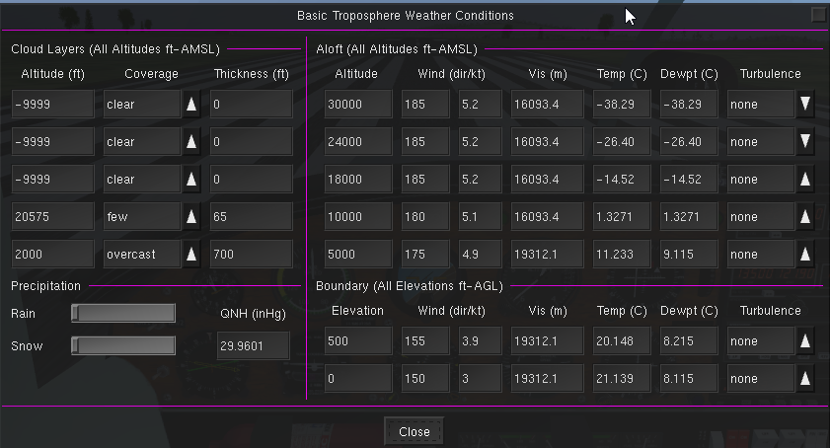
To keep it simple, you might find a commandline in the startup option or batchfile will do. Of course if you are an expierenced pilot, you might want to use real weather online, good fun in winter in places like northern Canada or in the tropics.
But back to calcs.
ETE (Estimated time en-route)
You need to calculate this to obtain the parameters for the ETA as well as fuel consumption which ultimately translates into money for your leisurely activity. Thanks to FG you are flying gratis.
Firstly we need the total trip distance, lets say just a to b =75 nm according to your chart.
Secondly you need to establish your proposed climb and descend rates and the cruising altitude as well as the cruising speed. For example you might decide to cruise at 110 knots @ 4000 feet you first need to climb to 4000 at lets say 500ft/m
Time to climb therefor will be round about 8 mins = 0.1 of an hour without wind consideration.
Distance covered by climb (using ground speed)
= 0.1 hrs x 95 kts = 9.5 nm
Time to descend lets say 400ft/m @ 100 kts will take about 10 mins or 0.13 of an hour
Distance covered by descend
= 0.13 hrs x 100 kts = 13 nm
Time to cruise
= 52.5 nm/110 kts = 0.47 hrs = 28 min
Our ETE is the total of climb, cruise and descend = 46 minutes or 0.76 hrs
Next on the agenda are
Fuel Calcs
There are many variables to fuel consumption (fuel burn rate) such as wind, engine efficiency, climb, descend, mixture adjustments between rich and lean. For small aircraft you base the calculation on your ETE and cruise speed. Perhaps add a margin of 10% for climb/descend...
So you look at the calculated ETE = 0.76 plus 10% = 0.84 hrs and assuming your engine needs 20 gallons per hour then total fuel consumption for the trip will be 20 x 0.84 = 16.8 gallons at $$$
Thats probably too simplistic as one should also factor in some contingencies for deviation to an alternate airport and a little extra for that extra sightseeing, or perhaps a full load and strong headwind.

Then of course the nerv wrecking calc once airborne realising the tank has less fuel then we thought there ought to be due to error, leaking tubes or other reasons. Probably boils down to a rough estimate like ok the needle shows 1/4 = x gallons, average burn rate is y so at best we have x minutes before we run dry.
------------------------------------------------------------------------
You may be familiar with the Gimly glider, if not check it out on YouTube.
https://www.youtube.com/watch?v=rfn6z6tjIq0

IN FLIGHT CALCULATIONS
What speed are we talking abut? Groundspeed, Indicated Airspeed, True Airspeed, Calibrated Airspeed ?
https://en.wikipedia.org/wiki/Ground_speed
https://en.wikipedia.org/wiki/Indicated_airspeed
https://en.wikipedia.org/wiki/True_airspeed
Most of the in flight calculations are associated with change of altitude, approach type requirements in particular.
Calculating descent rates, distance and time to station, etc.

Rules of thumb
http://www.planeandpilotmag.com/article/top-10-rules-of-thumb/

Descend Speed and Vertical Speed on the Glide Slope
Speed VS Rate
60 -300 fpm (easy to calculate as half the groundspeed and a 0 added)
90 -450 fpm (another way just multiply the gs x 5)
100 -500 fpm
110 -550 fpm
and so on

Strayed off course
Use the 1 in 60 rule
http://aviationknowledge.wikidot.com/aviation:60-to-1-rule
Ground Navigation

The instrument flying aspects aside there are also a variety of systems and procedures applicable to the smooth movement of aircrafts on the ground.
The following links provide you with a good overview of airport markings, airport lighting etc ...

https://www.faa.gov/regulations_policies/handbooks_manuals/aviation/phak/media/pilot_handbook.pdf
Module 4 Airport Operations 2016
http://gizmodo.com/a-beginners-guide-to-the-secret-language-of-airport-run-1689493625
https://www.youtube.com/watch?v=mWMo5WiP4vs
https://www.youtube.com/watch?v=ghz8FaJYuZ8 (black & white)
https://www.youtube.com/watch?v=FSl8iIpeHEk

Airport info kits aka Melbourne -Australia
https://www.casa.gov.au/sites/g/files/net351/f/_assets/main/pilots/download/melbourne.pdf

Although most of the practise flight contained herein start either on the departing runway or somewhere in the air (somewhat not realistic) - tutorial 38 will guide you through the process of navigating on the ground from a parking spot, cold and dark to the runway.
Needless to say and repeat the entire purpose of this guide is to learn about instruments and how to use them.
As such you also might want to know about ATC and Communication as well later on.
Flightgear also has an ATC simulator which allows you to partake as a Controller in a multiplayer environment and or simulate live communications with ATC in the cockpit.
The Navigator comes with a set of Practise Flights. To access the relevant documentation you either follow the hyperlink within a topic or click the link at the bottom left of every page.
The entire documentation is located within your PA28-Warrior/Docs folder.
To get a feel of how your Navigator responds to your commands lets go for a Taxi ride ....
T038 Taxiing
Patterns /Holds & Procedure Turns

A bit of reading

https://community.infinite-flight.com/t/how-to-fly-a-visual-pattern/5568

https://en.wikipedia.org/wiki/Holding_(aeronautics)

http://www.cfidarren.com/r-holding.htm

Unpublished Holds

These may be self imposed or more likely to be instructed by ATC to ease traffic flow.

https://www.youtube.com/watch?v=Eb69iTNXmJ8

https://www.youtube.com/watch?v=fMhHIheUskM
https://www.youtube.com/watch?v=waAdGCVa_Bo
https://www.youtube.com/watch?v=w-UwET53pTQ
https://www.youtube.com/watch?v=DIXzWGjrZn0&list=PLthUARlELoUUUo7cGvXKTTTu-JuSIosFX&index=41
Now we know about Direct, Parallel and Tear-drop entries, time to explore them in the air...

Practise Flights:

For the following exercises it may be beneficial to turn off any wind using the command line --wind=180:220@0:0 or similar in your launchers settings tab.

You also need to use the stopwatch for timing your legs. Equipment Menu, Stopwatch or just click the clock-face on the right of the aircraft panel.

T021 – Instrument Flight Patterns

Get yourself a copy of the FAA Instrument Flying Handbook

https://www.faa.gov/regulations_policies/handbooks_manuals/aviation/media/FAA-H-8083-15B.pdf edition 2012 page 191

and work through the patterns starting on page 191 to page 193. Once comfortable fly each pattern again by mirror image. ( a left turn becomes a right one, etc. …..)

Once you have completed a pattern (pause) and check out your map and display the Flight History !!!

T022 – Another Practise Pattern

Grab the IC.pdf and turn to page 318. The instructions are pretty self explanatory

http://www.anaspides.net/documents/flight_simulator_documents/Instrument course.pdf
Prior to attempting the flights below you may wish to check out the ADF/NDB and VOR topics beforehand.
T023_ Unpublished Holds
T024_TOuch_and_GO (TOGO)

ADF/NDB (Automatic Direction Finder/Non Directional Beacon)

Although this mode of radio navigation is gradually being phased out, it will still be found and used for some time to come at smaller airport lacking other infrastructure.
The following links will provide you with the basics. As always a good starting point maybe the IC.pdf, page 59 NDB Navigation/ADF Basics
Here are are couple of videos reinforcing what you may have read so far and adding some more illustration.
https://www.youtube.com/watch?v=nVDn32zDhKo
https://www.youtube.com/watch?v=I6RXFonFzo0
Now your Cherokee Navigator is equipped with a kr87 ADF receiver
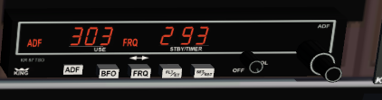
and a ki227-228 RMI. (Radio Magnetic Indicator)
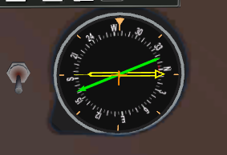
This instrument can be configured to show a yellow needle for the selected ADF frequency or the standby frequency.
To the left of the instrument there is a switch which will toggle a green needle representing VOR1 on or off.
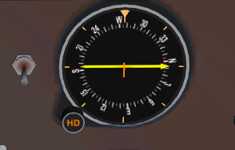

Also at the top left corner to the right of the Altimeter is the Nav1/2 switch, which allows you to switch the RMI, the HSI and the DME as well as the GPS between nav1 and nav2.
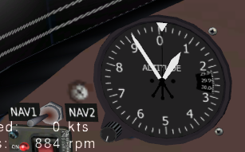
Another option of working through the ADF navigation practise flights is to use the standard pa28-161 Cherokee which features a fixed card.
The most common ADF procedures are
ADF Time/Distance tracking
Intercepting bearings in or outbound
Tracking a bearing
NDB approach
Flying a DME Arc with the RMI

Most practise flights will take you about half an hour or less, so make sure you have the time to work without interruption.
Have the instructions found in the docs/practise folder handy, fire up FG, choose a daytime option as we navigate around the globe and you don´t want to find yourself sitting on a runway in the dark. (for now)
The practise flights available from the folder above or you can open them using the hyperlinks as below:
The footer of every page also contains a link to a listing of all available flights. It maybe useful to have a hardcopy or alternatively display the instructions on a second monitor.
T001_ADF_Time_Distance
T002_ADF_Intercept_Play
T003_ADF_Tracking
T004_ADF_NDB_Approach_OffField
T005_ADF_NDB_Approach_OnField
enjoy and have fun..
n.b You may wish to fly each practise flight more then just once until it clicks and then proceed to the next.

VOR(TAC) VOR DME Navigation
If the term VOR does not mean a thing to you, one of the best ways to get started is the free ebook (PDF) titled Instrument Course by Charles Wood chapter VOR Navigation page 118.
http://www.anaspides.net/documents/flight_simulator_documents/Instrument%20course.pdf
http://www.emmerich-j.de/HB/EN/RNAV
You also might find useful information on the following websites to get you right into it.
http://krepelka.com/fsweb/lessons/private/privatelessons03.htm
http://www.scottsasha.com/aviation/handbook/vor/VOR_navigation.html
http://simfliteminnesota.blogspot.cl/2006/09/using-hsi.html
And obviously there is excellent literature out there such as various publications from the FAA.
https://www.faa.gov/regulations_policies/handbooks_manuals/aviation/
Should you hit some mindblock with some of the concepts, you might want to try some of the online VOR simulators to aid the visual understanding.
There s tons of other info out there, but its a bit like finding a needle in a hay stack, but persistance usually pays off.
Here is a nice video (ignore the voice..)
https://www.youtube.com/watch?v=4pTbb0puo1Y

Your NAVIGATOR cockpit and VOR instrumentation
In the real world an aircraft may have one, perhaps two or no VOR (CDI) instrument on board. You are having the luxury of three units ie
VOR(CDI)1 tied to Nav1
VOR(CDI)2 tied to Nav2
A HSI (Horizontal Situation Indicator) being a slave to Nav1 interchangeable with a standard Gyro.
Moreover the CDI s differ in design which you will come across in different aircraft
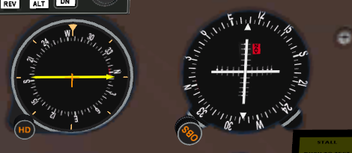 VOR1(CDI 1) to the right of the RMI

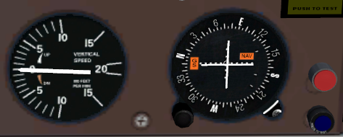 VOR2(CDI 2) to the right of the VSI

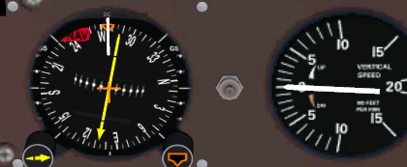 The HSI left to VSI

The units also show digital readouts to indicate which radial or bearing you are on.

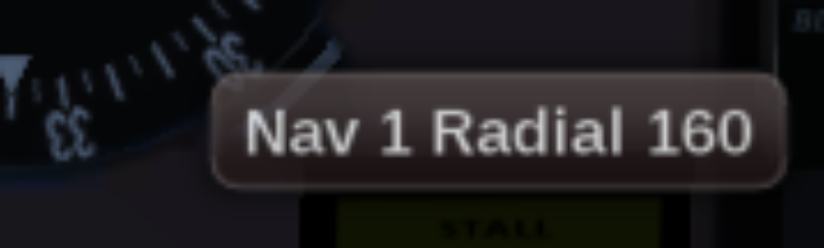
Most of the hotspots will display the actual values and you can also crossreference readings with the compass found in the HUD at the top centre of the screen.
Note: The HUD shows magnetic bearings.

To help you putting the wealth of new knowledge acquired by your reading and research into practise, you will find the following flights in the practise folder:

T006 Outbound radial intercepts
T007 Tracking radials and bearings
T008 VOR DME Approach
T009 VOR intersections
T010 VOR DME ARC (with VOR or RMI or HSI)
T011 VOR Radial Hopping
T012 VOR intersection at NDB
T013 VOR_LOC_(NDB) Approach wiithout DME
T014 VOR DME Hold

Note:
Precision approaches like ILS cat I, II, III in conjunction with Glideslope, Back Course, PAPI and VASI are covered separately...

Have fun and enjoy!

ILS/PAPI/VASI

The world of aviation has a large number of different precision and non-precision approaches available given the variety and different classes of aircrafts as well as different technology in terms of navigation equipment on board and or on the ground.
With the exception of smaller airports and poorer regions of the world the most common approach type is the precision ILS – Instrument Landing System approach executed in one of three categories.
Depending on the infrastructure of a particular airport the ILS setup may also see the installation of either a PAPI – Precision Approach Path Indicator or a VASI – Visual Approach Slope Indicator.
Both systems offer vertical guidance complementing the lateral guidance of the ILS.
PAPI and VASI can also be used for other approaches such as non precision approaches as well as VFR.
The following links will provide you with a good understanding of VASI and PAPI
http://wiki.flightgear.org/Precision_Approach_Path_Indicator
http://www.anaspides.net/documents/flight_simulator_documents/Instrument%20course.pdf p207
https://aviation.stackexchange.com/questions/5170/how-do-papi-lights-work
https://en.wikipedia.org/wiki/Precision_approach_path_indicator
https://www.youtube.com/watch?v=4pTbb0puo1Y
https://www.faa.gov/regulations_policies/handbooks_manuals/aviation/media/FAA-H-8083-15B.pdf
https://www.youtube.com/watch?v=4pTbb0puo1Y
https://www.faa.gov/regulations_policies/handbooks_manuals/aviation/phak/media/pilot_handbook.pdf Chapter 14
After all that reading you may want to practise a little flying by hand just using throttle and pitch, in case you prefer the AP to take you down turn it off prior to landing.
015_PAPI_Approach
016_VASI_Approach
ILS Approaches
http://www.caa.co.za/Documents/CNS/ILS%20Categories.pdf
http://www.anaspides.net/documents/flight_simulator_documents/Instrument%20course.pdf p178
https://aviation.stackexchange.com/questions/35264/what-is-the-purpose-of-having-different-ils-categories
https://en.wikipedia.org/wiki/Instrument_landing_system
https://www.youtube.com/watch?v=KVtEfDcNMO8 (turn the volume down!)
https://www.youtube.com/watch?v=wxFVoTPVhYs
Interesting to note is that once on the glide slope the VOR needles are 4 times as sensitive!!!
Although small aircrafts generally are restricted to Cat I for the purpose of the practise flights we just assume we are a big iron.
There will be times when pilots need to abandon the approach for a number of reasons. For precision approaches like ILS the decision must be made at DH (Decision Height) for non precision approaches the point is the MAP (Missed approach point)
Missed Approach Procedures
https://en.wikipedia.org/wiki/Missed_approach
http://www.skybrary.aero/index.php/Missed_Approach
FAA Instrument Flying Handbook - Section Missed Approach

The following practise flights are available from the Navigation menu or can be found in the Docs folder, enjoy...

017_ILS_1_Or_Localiser_Approach_(No_DME)
018_ILS_Cat II_Approach
019_ILS_Cat III_Approach
020_Missed Approach procedure
GPS/RNAV – Route Manager

On modern airliners these days you will hardly come across a VOR or an ADF if at all. Instead navigation is accomplished by means of sophisticated glass cockpits, FMC and or CDU basically being dedicated computer systems which draw on a constantly up to date Navaid database.
The navaid database contains waypoints i.e. arbitary points on the globe, a waypoint can be a VOR, an NDB, a Localiser or in most instances a set of GPS co ordinates given a name and an altitude.
Once a route has been keyed in or defined and activated, the auto pilot with LNAV VNAV capabilities will do the rest.
Obviously systems like these are not found on GA Aircrafts due to costs, however more and more small aircrafts come equipped with basic and or handheld GPS units.
As the Flightgear Simulator has no antennas and subsequently can not hook up to satellites GPS functionality is simulated by way of using the inbuilt Route manager drawing way-point information from the FG navaid database.
Some aircrafts in FG featuring the KAP140 autopilot do not have the route-manager enabled, yet you still can simulate basic hand-held GPS navigation using the GPS dialog.
http://wiki.flightgear.org/Global_Positioning_System

025_Using_GPS_Basics

RNAV

Classic VOR and NDB navigation means flying to and from or overflying stations en route. RNAV by contrast uses way points which allow straight line navigation thus reducing mileage, time and fuel cost.
RNAV requires dedicated instrumentation such as GPS or integrated Navigation Systems like the KNS81 which allows the creation of phantom stations based on a VOR, its radial and distance.
Here is an excerpt of the KNS81 Pilots Handbook:

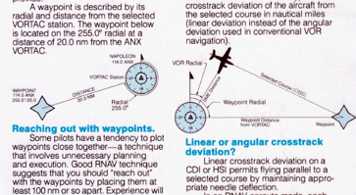
The Flightgear Lancair 235 has such an instrument.
Today with the majority of SID and STAR charts showing GPS co ordinates as well as airports providing GNSS approach charts, GPS systems have more or less made the above redundant.
More info on RNAV SID & STAR can be found here and of course a ton more on the web.
https://www.skybrary.aero/index.php/SIDs_and_STARs
https://www.icao.int/airnavigation/sidstar/Documents/New%20SID%20n%20STAR%20Phraseologies%20Scenarios.pdf
http://www.thisaviationlife.com/instrument-ground-school-understanding-rnav-approaches/
https://www.ivao.aero/training/documentation/books/SPP_APC_Arrival_Approach_procedure.pdf

The Route Manager

The route manager is used to define routes using existing way points or creating custom way points and also allows flying straight from one airport to another.
You also have the option to choose default SIDs and STARS or alternatively import downloaded Navigraph files or make up your own using a standard text file editor.
Of course you can save and retrieve your routes. You can also simply add departure and destination airports, then select the destination row and click the create route button, but you might find that more often then not this will take you around the world before arriving where you want to go.

http://wiki.flightgear.org/Route_manager

026 – using Route Manager
The following is an illustration of how to create your own waypoints, make up a custom route for later retrieval, etc. Provided the relevant info is known this also can be useful to program flying holds and DME arcs.
027_Adding_Custom_Waypoints
027a_RNAV_Procedoure

Note:

As waypoint names contained in the navaid database are not unique, at times there might be a conflict. This can be overcome by assigning a different name. This can occur when using info from a STAR listing a specific waypoint yet the Gps coordinates may be different then those contained in the FG database.

SIDS & STARS

are standard procedures at busy airports to funnel the constant flow of traffic arriving and departing in an orderly and secure fashion, thus reducing workload for pilots as well as ATC.
Below you find a link to a VATSIM page explaining what’s it all about.
https://www.vatsim.net/pilot-resource-centre/ifr-specific-lessons/sids-and-stars

For more information use your search engine as there are tons of videos out there covering the topic.
A flight-plan will generally commence with a SID, continue with en route and terminate with a STAR.
As such we need to know where we can obtain the relevant procedures. Common resources are paid subscriber services such as Navigraph, Jeppesen etc. and of course materials made available through VATSIM, SkyVector and similar.
Standard PDF s of airport charts usually start of with a collection of published SIDS.
Flightgear has the capability of importing downloaded versions of these procedures, however those need to be converted in a readable format first.
An alternative is to create the relevant procedure manually via entering waypoints, fixes into the Route Manager or by creating an xml file using a xml or text processor.
Flightgear ships with a navaid database containing most airports, VOR s, fixes, however on occasions you will find that a particular fix on a SID or STAR is not contained in the database.
In such a case and often the procedures may give you a name for a fix but not always the gps coordinates, you then can search for it on SkyVector.
Once you have found the Coordinates, you will need to convert those into decimal format which you then can enter into Route Manager or your xml file.

The following will provide you with examples of how you can go about it:

027_Adding_Custom_Waypoints
027a_RNAV_Procedure
028_Standard_Terminal_Arrival_Route STAR
029_Standard_Instrument_Departure SID

The Grand Final

036_IFR_at_Night

037_The_Final_Tour

3 leg journey with one stop over for refuel, one touch and go, heading to final destination and deviation to alternate combining all or most topics

duration max 2 hours

038_Ground_Navigation
Where to go from here

You have come a long way and we hope you enjoyed getting to know the Navigator.
Of course you can explore the wonderful world of Flightgear a bit more, experiment a little, try other aircrafts, hop on the big birds or helicopters, the options are almost endless.
However as we pointed out at the beginning, navigation is just one aspect of many when it comes to aviation. A very important part is Air Traffic Control and luckily you can learn about this aspect on Flightgear as well.
Once you have the basics of this under your belt you then may wish to proceed on to multiplayer, fly tours with people from all over the world, communicate live and with ATC as well following the rules and procedures applicable to real world pilots.
Checkout the Flightgear Forum, have a look around the various FGMembers websites for additional resources

Most of all enjoy...

Tutorial # 001

Category: ADF -How far the distance to the station and how long to get there
Prerequisites: ADF/RMI
Useful: Reading Charles Wood s chapter on NDB
Duration: 25-30 mins depending on speed and wind
This workshop is adapted from an exercise of Charles Wood

How about a fine Wiener Schnitzel and a Sacher Torte for dessert
Fire up your Cherokee Navigator at LOAG (Krems Langenlois) Runway 11 and turn off your DME.
Press k to display the map and resize it until you can see LOWW. Select the data and Navaids checkboxes, enlarge the chart (drag the corners) and notice there is a nice NDB by the name of WO(Schwechat) in front of runway 11.
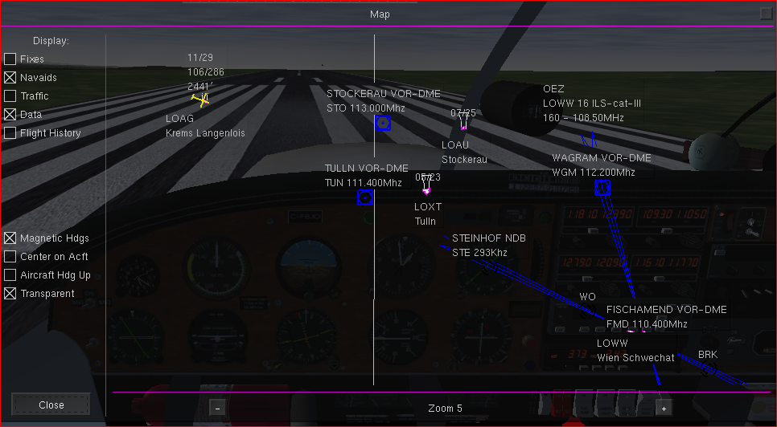

Close the map and click on the clock face to display the stopwatch at the bottom right corner but do not yet start it.
Next click the face of any radio to show the frequencies dialog and enter 303 into the ADF field, then close the dialog.
The yellow RMI ADF needle should now be pointing to about 110degrees and a bearing of 10. You also should hear the Morse code. You might want to turn the volume down a bit using the volume knob at the ADF receiver or perhaps easier turn down your speakers, but do not turn it off.
Checking the HUD you will notice the ADF/NDB showing WO as the correct ident. However it is blinking indicating the signal is a bit flacky.
Depending the time of day and position of the sun the cockpit may be a little dark. To turn on the panel lights simply press CTRL L
Before flying to Vienna, we need to figure out how much time we need to get to the beacon as well as the distance to be covered.
To find out, all we need to do is turn the plane so that the station is either to the left or the right wing.
As such set your heading bug to 25 degrees, take off and turn to the heading while climbing to 2400 feet at roughly 500fpm. As you climb the beeping should become more frequent. Set your speed to 100kts TAS
Once nicely established and stable on your heading, at about 2500 ft the needle should point to the right wing. 3 o clock
Note the bearing, set the timer and stop the timer once the needle has moved by 10 degrees.
Pause the simulator for a moment by pressing p
Now simply divide the elapsed time (total seconds) by the change of degrees
e.g. 215/10=22 minutes to station
To translate our findings into an estimate of distance you use the formula:
(TAS(True airspeed(kts)x minutes flown)/change of degrees) e.g. Pointing to the Altimeter will give you the TAS, the needle shows IAS
(100kts(assuming no wind)x3.5min)/10 = 35nm
Reset the timer, unpause the simulator and restart the timer. Now turn your heading to the right until the yellow needle points to N (orth) and track the bearing to Vienna airport. Keep the needle pointing North to adjust for wind.
Maintaining your speed and hold at 3000. Adjust your heading if necessary to counter act drift, the needle shows the way.
At about 25 minutes the ADF needle will flip a 180 degrees to indicate that you have passed the beacon and are now flying outbound. You may also have noticed the blue outer marker light blinking. This is only relevant for an ILS approach covered in another session.
You may wish to terminate the session or decide to fly a bit further, turn round and bring her down VFR freestyle on the opposite end of the runway you are crossing.

Tutorial # 002

Category: ADF bearing and station intercepts
Prerequisites: ADF/RMI with VOR needle turned off
Useful: http://iaip.iaa.ie/iaip/Published%20Files/AIP%20Files/AD/Chart%20Files/EIDW/EI_AD_2_EIDW_24-28_en.pdf
http://iaip.iaa.ie/iaip/Published%20Files/AIP%20Files/AD/Chart%20Files/EIDW/EI_AD_2_EIDW_24-1_en.pdf
Duration: 24 mins

How about a little NDB hopping. Ireland here we come for some cool Guinness on St.Patricks day.
The specifics:
- We will start at Dublin (EIDW) runway 28 with the heading set to 278 degrees, climbing at 500fpm to 1500 and hold while tracking the outbound bearing 004 of the Dublin NDB OE 316. We also set the standby frequency to Garristown NDB GAR 407.
- Take off and maintain the outbound brg 004, once the ADF needle drops down south after station passage initate a right turn to 60 degrees. Throughout the 4 station circuit maintain cruise speed at 100kts, distances being short and sharp turns.
- Watch the needle and at about brg 112 left turn to intercept and track outbound brg 185, switch to the standby frequency and stir the needle to the North.
- On station passage as the needle starts to drop, change the active NDB to Rush RSH 326 and turn to the nose to the station, maintain your heading and switch back to Dublin 316 and add NDB OP 397 as standby. Leave Dublin active.
- Once the needle passes brg 135 switch to standby and turn the needle to the north and maintain heading to the station. Reduce your speed to 80 knots. Commence descent at 200fpm and adjust as you go.
- At the slightest drop of the needle switch back to 316 and turn to the Dublin station and land the plane. It maybe a little tight, can be done, however perhaps better to do a missed approach, maintain heading, do a procedure turn and come back from the other side.

Your map should look something like this...
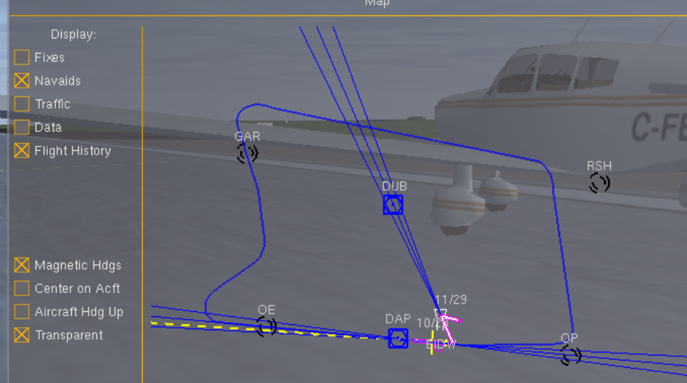

Ready for a pint? Well done...

Tutorial # 003
Category: ADF - Track Intercept
Prerequisites: ADF/RMI
Useful: https://www.crc.id.au/xplane/charts/DAPS-2017-Mar-02/Launceston%20(YMLT).pdf

Duration: approx 25 mins
Launceston, Tasmania, Australia
============================================================================
The journey starts off at Launceston Airport YMLT Runway 32L and will take us to the East tracking the 360 BRG (bearing) of the St. Helens ADF. We will then return to base by turning South, then to the West followed by a final turn to intercept the 181 BRG and lining up with the runway we departed from.
This flight can be executed in three different scenarios, first with no wind at all, then with wind and if you dare at night time.
For the first scenario under settings add the command line option --wind=359:291@0:0
For the second time round chose something like --wind=97:133@8:3
----------------------------------------------------------------------------------------
- Once ready to go, sitting on runway 32L open the comms menu by clicking the face of the comm1 radio and tune the ADF frequencies in to the Launceston NDB called Nile (NIE) 230 , then add the St.Helens NDB STH 392 into standby. The NIE station should give you an earful of morse loud and clear, the HUD (press h) shows the station ID. Notice the BRG the ADF needle points to (181).
- Switch the frequencies, deadly silence. We will get the signal about 3 minutes into the trip. As a quick glance at the FG map reveals, the St.Helens station is roughly 60 degrees to the right or 107 from the runway heading, so set the heading bug to 62.
- On take off quickly turn to that heading or let the ap do the work. Climb to 4500 at 700fpm, then hold.Make sure the active frequency is set to 392. The initial signal will be flaky as there are mountains around. Reduce your climb speed gradually and adjust your mixture.
- Once stable at 60 degrees and altitude hold of 4500 point reduce your speed to 120kts. Point over the RMI to check the bearing. Should be around 2 or 361, watch it for a few seconds as to whether it stays that way, set your timer for one minute and check again, the BRG should still be the same as we have not changed heading nor is there any wind. We are tracking the bearing in a straight line to the station.
- Now lets turn, first switch the frequency back to 230 Nile. We should get the morse signal. Now turn to a heading of 160. The ADF needle swings to about brg 40. As you prod along, notice the needle slowly dropping as we cross several bearings. Once at the 100 mark change your heading to 210 to the right. The needle will rise,
- Once the needle drops down again to the 100 mark (just let the mouse pointer sit in the face of the RMI), start your descent at 500fpm and turn right to 320 degrees. Reduce speed to about 85kts. Adjust your heading one notch at a time until your bearing shows 360 or 361 and no change. On passing the station keep the heading aligned with the bearing now being 181 flying away from the station and towards the runway.
- Depending on the timing of your turns you may need to adjust the runway lineup.
PAUSE the simulator
Display the map, place a check into show navaids and history
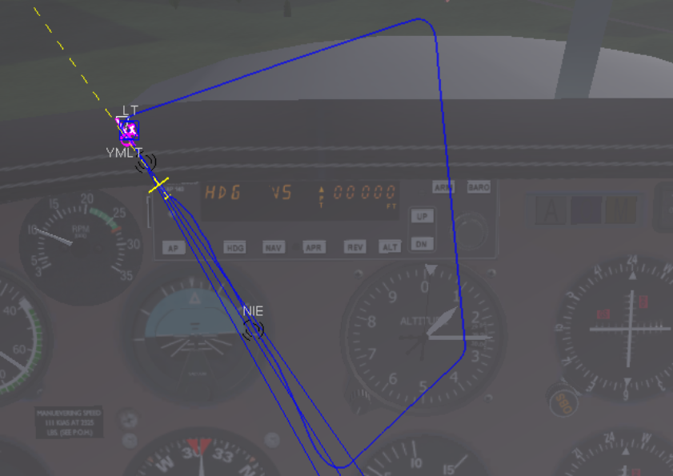
This is your flown route. Now you can take her down or do a missed approach starting through and go sightseeing. Do the usual... approach speed descent, flaps....
You may want to try this with wind and make corrections by way of bracketing and then of course there is also the option to fly this at night.

Tutorial # 004
Category: ADF Approach NDB Off Field
Prerequisites: ADF/RMI with VOR needle turned off
Useful: https://www.czyz.ca/files/charts/class-c/CYKF_All.pdf
Duration: 20 mins depending on speed and wind
Ok, Our journey today takes us from Guelph - CNC3 runway 26 to Waterloo CYKF runway 25 in Canada. CNC3 is close to Toronto, Ontario, a beautiful, vibrant and clean city, good time to visit in autumn when all the maples display their beautiful colours
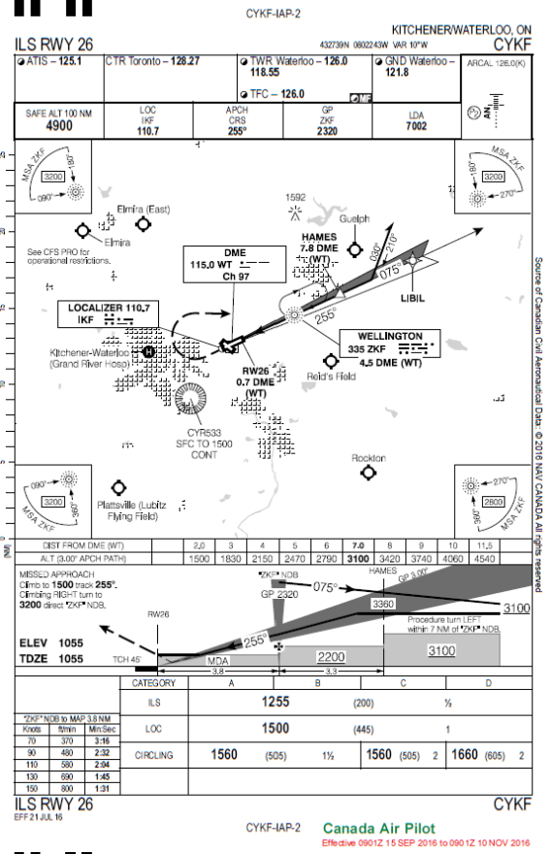
Looking at the charts (Airport Diagram and NDB/DME RWY26) we notice the runway elevation at Waterloo on the approach side is 1055, at the other end 1023, that means its going slightly downhill and In case of a missed approach there are are some trees around.
ATIS is 125.1, NDB =ZKF 335
MSA is 3200 as we are coming in between 180 and 270, however we need to be at 2200 just before passing the station and commence our descent.
ZKF to MAP 2.32 minutes based on 90kts and VS of -480fpm
You have been cleared for a straight in, no need for the pattern. So lets do this, fire up FG, choose whatever weather settings you fancy.Once on the runway, point to the face of the compass and note the heading, point to the face of the HI, the headings should be the same. Set the heading bug to 210 degrees as we want to intercept the NDB at an angle of close to 45 degrees.
- Tune in ATIS at COM1 125.1 and listen to the recorded message, then turn down the volume or just click the headphones to mute.
- Set your ADF to 335, you should immediately hear the morse code, turn on the HUD by pressing h, the ADF ident is displayed is ZKF (not blinking) so we are tuned in to the correct station.The ADF needle points to bearing 339 . Hold your altitude once at 3200.
- Now lets take off and turn to our heading while climbing at 500 fpm to 3200 ft.
- Cruise at 115 knots, once steady on 210 degrees the ADF needle(Yellow) will now point to a bearing between 31 and 35, once it drops to 45 turn right to 253 degrees.
- Now you have about 9 minutes to descend to 2200 then hold and adjust your heading for wind and follow the ADF needle nicely pointing to the North. Reduce your speed gradually to about 85kts once reaching the station.
- On station passage, needle head falling, immedeately start descent at 500fpm , adjust both pitch and vs to match the VASI and bring her down in one piece. Once the runway in sight youmay need to make some adjustment to line up.
Annotation:
Why change the heading once the ADF needle points to bearing 45?
At Brampton the needle pointed to 339, with our inital heading of 210 the needle points to 31, a deviation of 52 bearings and as we turn at 45 our approximate intercept angle we bring the needle back.
Inbound we follow the head, outbound the tail.
Recommended additional Flight: Charles Wood pdf page 10

KAIY to KMIV, contains a nice procedure turn
Tutorial # 005
Category: ADF Approach NDB On Field
Prerequisites: ADF/RMI with VOR needle turned off
Useful: decent charts
Duration: 10 mins plus the most
Tropical settings, Cozumel, Playa Del Carmen Mexico. Ancient Maya ruins nearby, great food. The FG airport PlayaCa at the moment is a bit under developed to put it mildly as you are literally starting off with the gear in the sand, so its a flaps job to get up. Rev her up with brakes on. (Unless the scenery has changed for the better)
This is your challenge, good luck ...
Start at MMPY (Playa Del Carmen) runway 11 (no need to worry about snow here)Tune in Cozumel (MMCZ) NDB - CZM 330 and or use the VOR DME - CZM 112.600
Here s a chart
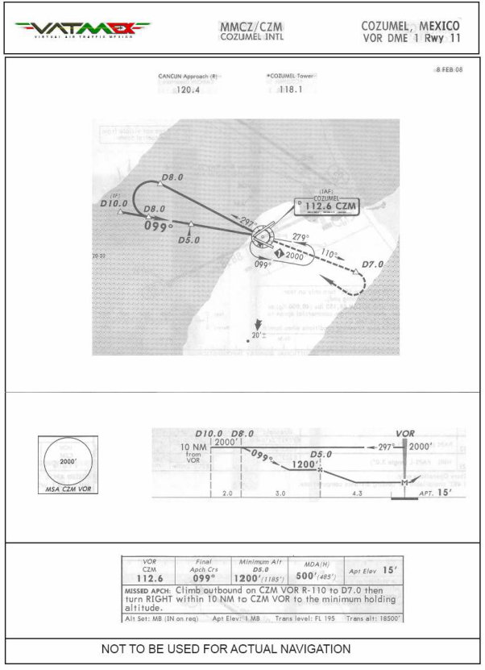
Tutorial # 006
Category: Outbound radial intercept
Prerequisites: VOR and patience
Useful: Reading Charles Wood s chapter on VOR
http://www.emmerich-j.de/HB/EN/RNAV
Duration: as long as desired
This is a two part activity designed to demonstrate how to intercept radials and bearings but please do not fly these online or connected to multiplayer.
Location: KJFK 32L and 13R
Nav1 JFK VOR-DME 115.9
In both scenarios we are aiming to intercept radial 330 at an intercept angle of 30 degrees, in part one we intercept from the right, in part two we intercept from left.
Part 1
Position yourself at KJFK runway 31L
Tune in the VOR frequency and radial to 300, set the hading bug to runway heading of 314 and the CDI is positioned at the far right.
takeoff climbing 500 fpm to 1500 fly a couple of minutes then turn right to heading 360 to intercept radial 330 at a 30 degree angle.
Note the position of the CDI and the OBS showing you are flying from the station - As the needle turns close to the center turn to heading 330 for intercept.
If the needle does not center, make a correction some 10 degrees and come back again to 330. Continue bracketing until the needle sticks to the center, your track resembling something like this: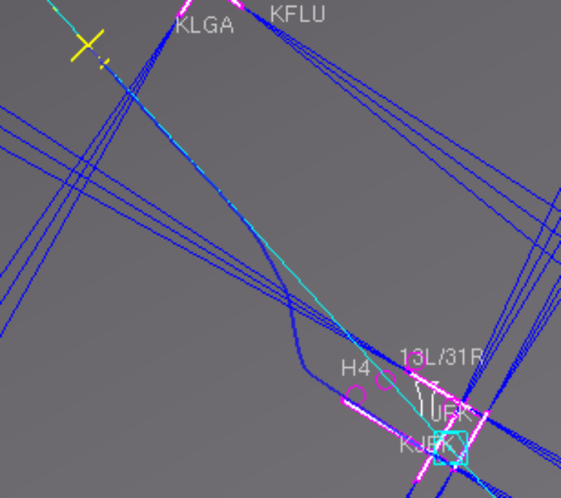
Track the radial for a couple of minutes then terminate the session or do a u turn and land VFR style...
Part 2
Restart(restart, not RESET) on runway 13R same runway opposite direction. Set the heading bug to runway heading of 134.
Takeoff flying straight climbing 500fpm to 1500 and stay on the runway heading for a minute or two.Notice you are flying from(away) from the station.
Again we want to intercept radial 330 at a 30 degree angle. But now we need to subtract our intercept angle, thus turn to a hading of 300.
The CDI is now at the right and we are flying to the station.
Take a left turn to 300 and watch the needle, as its close to center steer to 330 and track the radial for a couple of minutes making adjustments to stay on the radial.
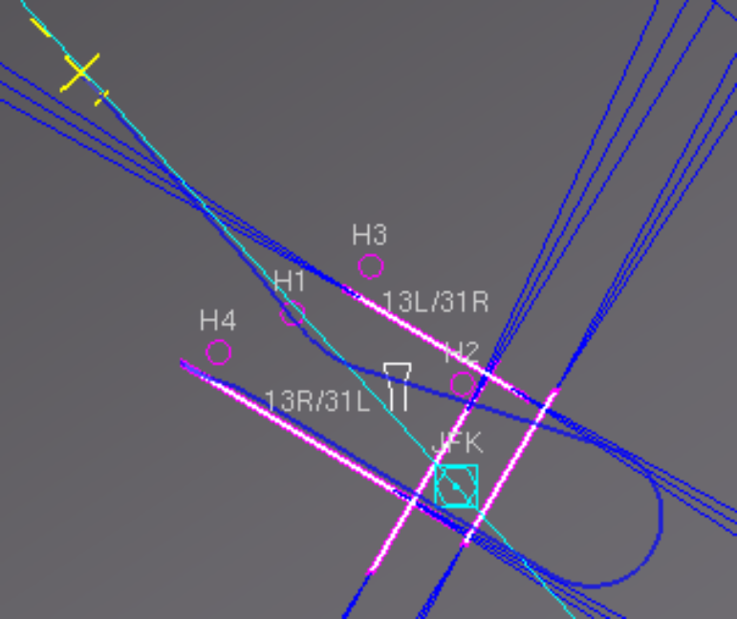
Terminate the session or go sight seeing above the big apple.
Practise intercepts at an airport nearby you with a VOR, try intercepts at 30, 45,60, 75 degree angles.
Additional demo and exercises can be found in
http://www.anaspides.net/documents/flight_simulator_documents/Instrument%20course.pdf
Nice demo found in emmerichs http://www.emmerich-j.de/HB/EN/RNAV
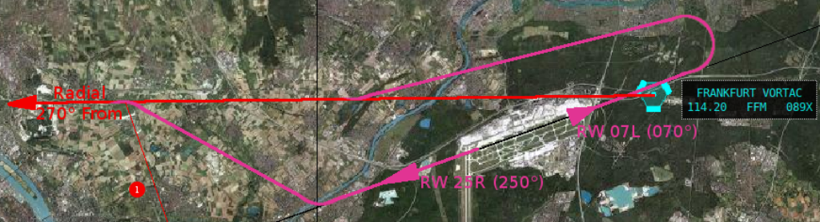
Radial and Bearing intercepts are a fundamental navigation skill not only for IFR.
Tutorial # 007
Category: Tracking Radials and Bearings &WCA
Prerequisites: VOR and Virtual E6-B
Useful: Reading Charles Wood s chapter on VOR
http://www.emmerich-j.de/HB/EN/RNAV
Duration: as long as desired

The following is a demonstration of how wind will push a plane of its nominated heading. It is assumed that by now you are familiar with the concept of bracketing and also have a copy of the Virtual E6-B installed on your computer.
The first part is flown on autopilot followed by flying the same route with different wind parameters without the aid of the AP.
To further practise the skill of maintaining track of radials and or bearings, just select an airport near you and experiment with all sorts of settings.
The scene
London Gatwick (EGKK) runway 08R, destination EGXH
VOR DME (MID) 114
Open your Virtual E6-B and let it sit in the background.
- Get your self on the runway and turn on the HUD by pressing h. Then open the map by pressing k. Use the Minus button to zoom until you can see EGSH in the upper part of the map and move the map to the top left.
- Click the Nav Radioface or go to Equipment, Radiosettings to open the Frequencies dialog and position it top right as shown below
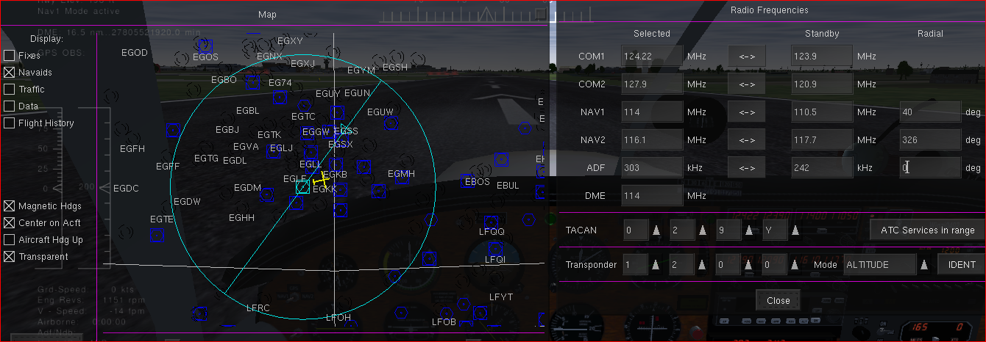
- As we want to head towards EGSH, we want to follow the outbound radal of the MID VOR-DME. Enter 114 for NAV1 and 40 into the radial box. Click of the field then close the radio dialog. Your map should now display your selected radial as a blue line
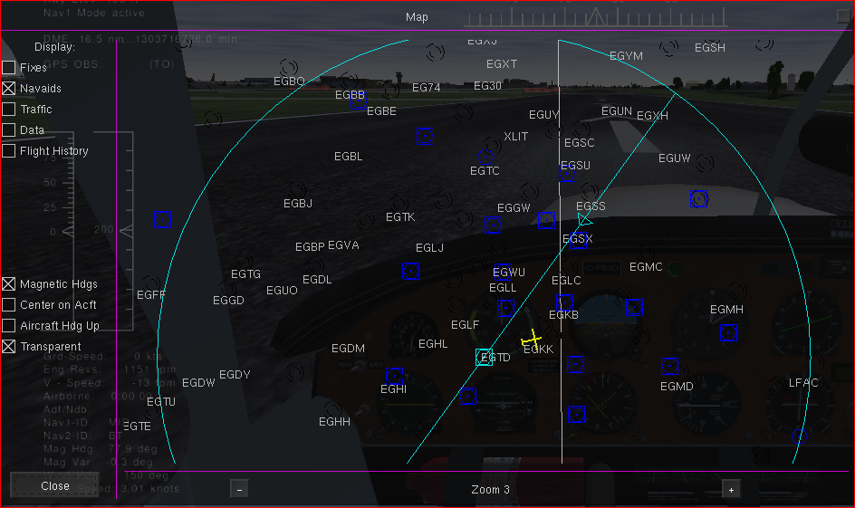
- We need to intercept radial 040 at an angle of 30 degrees, as such set the heading bug to 10 degrees, move the map to the left so you can observe your flightpath.
- Takeoff straight climbing 500 feet then turn on the AP to turn left to heading 10 in order to intercept radial 40. About 11 mins away. Preset and arm altitude of 5000ft.
- As the CDI centers turn right and track the radial some 3 to 5 mins (or use Nav mode of the AP) before intercepting the readial)
- Magnify your map to zoom level 5, it should look something like this
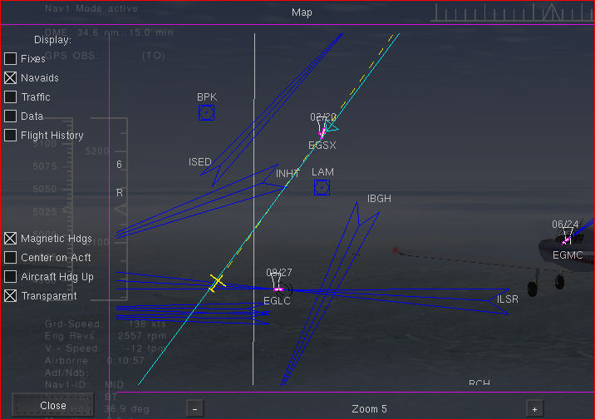
- Go to Environment, Weather, Manual Config and change the windsettings to 10 knots coming from 130 degrees, then close the dialogs and watch your map.
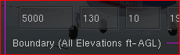
Almost imediately your are blown off course. Now reduce your speed to 8o knots and you are drifting even further to the left...
- Go back to your weather settings and increase wind to 15 knots, then observe. Next bring the E6-B to the foreground, enter the data as shown, but use your data as it may differ, then click compute..
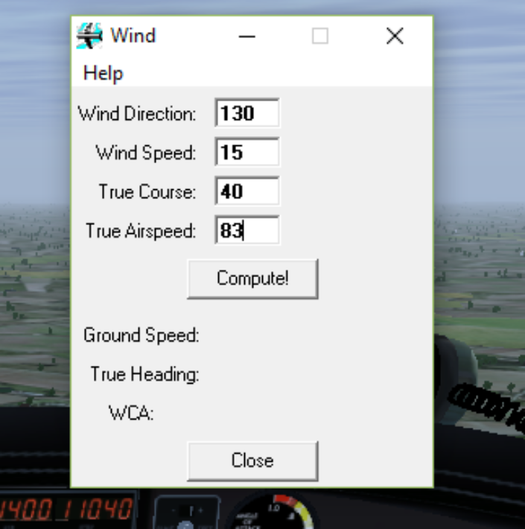
- Adjust your heading in line with the computed WCA
- As we are sort of parallel to the radial we need to re intercept and then return to the 40 +wca
- Once again back on track 40 plus wca, the plane points to the right into the wind yet is actually flying straight to 40 degrees.
If you magnify the map a bit more and put a check into flight history you should be able to see your curved path.
Terminate the session or return to base or do a little sightseeing.

Now you may wish to practise this without AP with different wind speeds and directions and without the map of course going from airport a to aitport b of your choice.

Tutorial # 008
Category: Inbound radial intercept and VOR DME Approach
Prerequisites: VOR/RMI (optional HSI)
Useful: Reading Charles Wood s chapter on VOR Approaches
Chart: LOWI_Approach_LOC DME West_19012016
Duration: 35 mins

VOR DME Approach Innsbruck, Austria (LOWI), a famous airport in the alps, get the chart as it might be helpful..
Innsbruck LOWI VOR LOC 109.7 radial 261
Rattenberg NDB RTT 303 9500ft
bring woolly jumper and oxygen bottle
Place yourself on runway 31 of St.Johann (LOIJ), set the frequencies and altimeter.
- Take off straight, turn left to 230+ and track to the Rattenberg station climbing to 9500 feet at 700 fpm gradually reducing to 500, adjust mixture as you climb and keep the yellow needle pointing north.
- Enjoy the scenery outside as it will be some 10 mins, the VOR should be alive by now, set the OBS to 226
- Once at the station make a 180 degree right turn to 46, set the timer, fly one minute then make a right turn to 226 and track this radial.
- Once crossing the station second time round turn left to 210 and start watching the DME and gradually reduce your speed to 100kts and set the OBS to 255
- At DME 23nm gradually turn right to intercept and track radial 255 and keep the needle centered.
- At DME 20 nm commence your final descent...
Note airport elevation 1900 and a bit this, means you have to loose 7600 in 10 minutes this glideslope being steeper then the usual 3%, keep your speed at 100kts
Keep an eye on the CDI, remember once on the glidepath the needle is 4 times more sensitive.
Happy landing
Your flight path should resemble something like this
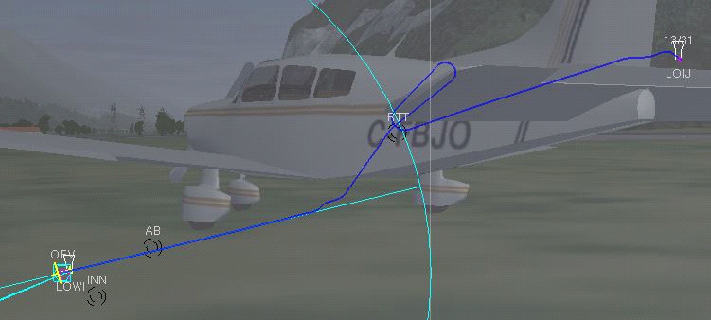

Now try this with a cloud ceiling of 3500 Overcast 3000
and then again at night.

Tutorial # 009
Category: VOR Intersections
Prerequisites: VOR /Reading Charles Wood s chapter on VOR
Useful: Hardcopy of the flight instructions
Duration: na

A very good example of how to navigate using two VORs to intersecting radials is found on page 133 of the Instrumentcourse.pdf
A flight from KGDM to KEEN and you also might enjoy the narrative style.
Have fun

Tutorial # 010
Category: VOR DME ARC
Prerequisites: VOR/Chart, quick reactions, forward planning
Useful: vatca.net/files/MGGT.pdf
Duration: na
VOR DME ARCS are commonly found in highly build up areas being part of a STAR and or mountaineous regions or other obstacles endangering aircraft.
There are many ways to fly an arc, be it a left one or a right one. You may wish to do a little research on the web on this particular topic and we would recommend to download and study the pdf found here
bob-cfi.weebly.com/uploads/7/6/9/3/7693240/flying_dme_arcs2.pptx
http://www.anaspides.net/documents/flight_simulator_documents/Flying%20a%20DME%20arc.pdf
https://www.nashvillecfi.com/instrument/dmearc.html
http://www.flightlearnings.com/2017/07/21/distance-measuring-equipment-dme/
http://avstop.com/ac/instument/8-7.html
The following will be 3 demonstrations of flying an ARC, firstly by using a VOR coupled with the DME and working the OBS, secondly a little easier to use the green VOR needle of your RMI to determine your turns and thirdly you can also use the HSI.
You will find arcs take a little practise and the real trick is to have it all worked out beforehand when and where to turn and of course you definately need to study the approachplate very careful.
Arcs are flown by steering consecutive turns between 10 and 20 degrees.
LA Aurora Intl airport MGGT , Guatemala City here we come
Chart: VOR DME Rwy 19 ... get this pack
Part 1
- Get yourself ready on runway 19 and enter VOR DME 114.5 radial 125 into NAV1 (For some unknown reason the runway heading is actually 16 degrees and a magnetic variation of just one degree.
- Takeoff on runway heading 016, climb at 500fps to 11000 using preset altitude and arm, you might lose your right wing on the VOR in the middle of the runway...
Dont forget about leaning the mixture on the way up.
- Fly for 2 mins, then turn right to heading 125 and fly to outbound to dme 14.6 nm, do a sharp right turn to 210 to cross radial 305
- Once the CDI is centered turn 15 degrees right to 225, adjust the radial for VOR1 to 140 and commence a descent to 8500 at -500fpm (arm!!!)
- Once the needle centers Hdg 240 OBS 155 255 170
270 185
280 190
- Finally turn to heading 016 and roll out and track radial 016
On the way in we need to descend in stages, we need to be at 7500 at DME 11 nm out, at 6300 at DME 5, TDZE is 4958 feet.
- As you exit the arc at 8500, descend to 7500/500fpm(arm!!!) for DME 11, arrive at Dme 5 at 6300 and final descent to the runway elevation of 4958

Happy Landing...
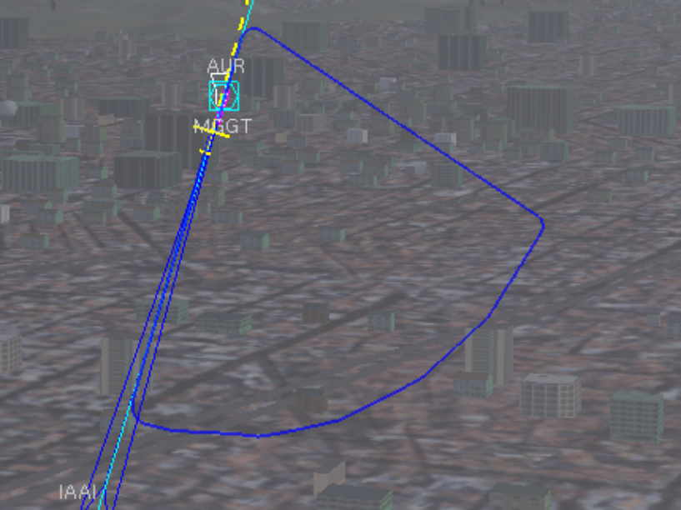

Bring her in safely, watch the mountains !!!

Part 2
Flying the example of http://www.altairva-fs.com/training/ava_training_ifr_dmearc.htm first using the RMI method apply the method to fly a rather unusual approach as mentioned first up in https://airfactsjournal.com/2013/09/7-instrument-approaches-you-have-to-see-to-believe/
The airport code in Flightgear is KMTN

Part 3
DME Arc with HSI
First up a primer on HSI (if already familiar just jump down to the flight...
A basic HSI Primer

You might want to get yourself a copy of the Bendix King KCS55 Pilots Guide here --

https://www.bendixking.com/HWL/media/Pilot-Guides/006-08256-0004_4.pdf

Straight out of this publication when and how to use this great instrument, a combination of a VOR and a Digital Gyro. One of the beauties of this instrument is that regardless if you are flying to or from the station, there is no reverse sensing IE. if the needle is to the left you steer left, if the needle is right you steer right.

Radial Intercept with HSI

Get on to runway 03 of KMKC

Open Route Manager and nominate KSTL as destination, press the enter key and close the dialog.

Set Nav1 to the Napoleon (ANX) VOR 114mhz radial 060

Turn the Course Knob (OBS) to 110 degrees

Take off then either manually or with AP steer to the selected heading of 60 degrees. Once stable you will notice the PMI (Pictorial Navigation Indicator) displaying the intercept angle:

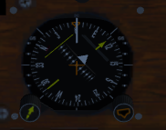

Notice the angle between the yellow aircraft and the top of the CDI !

As you get closer to the intercept, the PNI makes it possible to intercept the course smoothly without overshooting or bracketing.
This is done by adjusting your heading to keep the top of the CDI lined up with the lubber line gradually decreasing the angle of intercept.

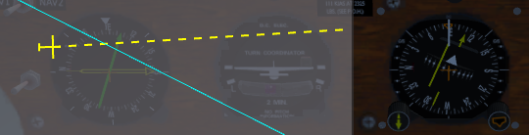

On passing the station the Flag will change to From. You also need to adjust for wind drift

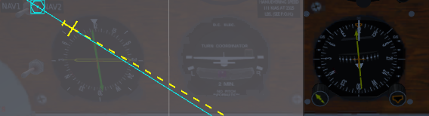
Here we have a heading of 120 and a course of 115 degrees Wind 5kts from 105 degrees.

Now you can do a little sightseeing or abort the flight.

Here s a nice little HSI simulator:

http://www.pilotfriend.com/training/flight_training/fxd_wing/hsi.htm

Flying a hold and ILS approach with HSI

http://www.aviationchatter.com/2009/05/holding-pattern-entries-made-easy/

A bit of a crude example ignoring relevant entry pattern, simply demonstrating HSI usage and behavior.

Startup position at runway 25 at LOAU

Set Nav1 to Tulln VOR DME (TUL ) 111.4 radial 051, standby to OEW Localiser LOWW rwy11
110.3 ( we set the radial on switch 112)

Take off straight, intercept and track the bearing

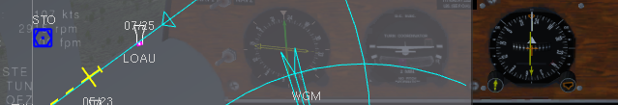
On passing the station set the course to 114, then turn right to the reciprocal of 294 and fly the outbound holding leg for 1 minute (Timer or DME), Turn right 180 to 114 and pass the station

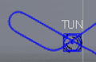
After station passage switch to the standby frequency and set the course to the 112 radial, intercept and track.
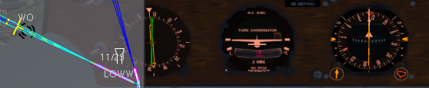
Once the glide slope in range light lights up, watch the CDI and the yellow GS indicator wedges to check whether you are right, above or below the glideslope.

Complete the ILS Cat III approach and land

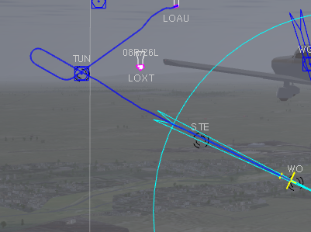
Here s your flight path and you are down right on center line..
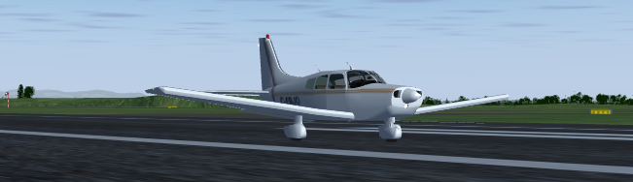

Flying a DME ARC with the HSI

= work in progress

Tutorial # 011
Category: VOR Radial Hopping
Prerequisites: VOR and very good timing
Useful: Well developed intercept skills
Chart KSMX - ILS or Loc RWY 12
Duration: approx 40 minutes

This flight is a round trip around a VOR-DME intercepting and tracking a number of outbound and inbound radials eventually returning to base by way of a VOR approach.
Starting point is Santa Maria, California KSMX runway 12.
- On Nav1 we need to enter the VOR_DME Guadelupe GLJ 111.0 and in the standby we need the Localiser SMX 108.9
- Take off straight, climbing to alt hold at 3300ft (300fpm), once at 500ft AGL turn to a heading of 195 to intercept outbound radial 160 at about 45 degree angle. Once the CDI centers turn and roll out on bearing 160, set the timer and track it for 2 minutes.
- Then turn your OBS to 10 (or use the radio dialog to set radial 10), after 2 mins on 160 turn right to heading 320 to intercept inbound radial 10, once the CDI centers roll out and track the radial for 3minutes (use the timer).
- Next we want to intercept outbound radial 300 by turning left to 330 and roll out smoothly. (you may need to be quick)Set your OBS accordingly and track 300 for 3 minutes.
- Turn 90 degress to the right to intercept and track radial outbound 340 for 1 minute.
- Turn left to heading 195 to cross inbound radial 320. As you pass this radial (CDI center) retaining heading and switch to the standby frequency and adjust the radial settings to 120.
- Once the CDI is close to center turn left to 125 and track the 120 radial and reduce your speed to 90 knots.
- Your initial approach IAF is DME 15.4nm out, 8 mins for final descent, descend at a rate of 440 fpm, in case you are closer use the time on the DME to determine your VS and make adjustments as needed.
- Happy landing and you may wish to review your flight using the map history and or replay the flight this time enjoying the scenery outside.

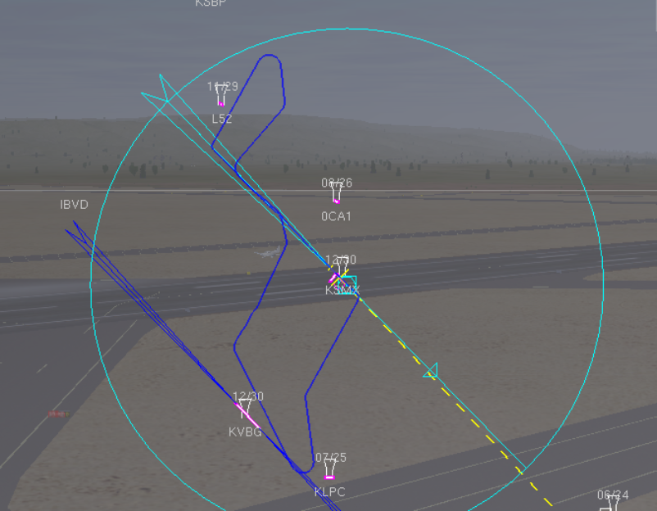

Tutorial # 012
Category: VOR Tracking a radial or bearing inbound/outbound
Prerequisites: VOR or HSI
Useful: Reading Charles Wood s chapter on VOR
http://www.vatnz.net/airspace/airport/NZWN
http://www.aip.net.nz/pdf/NZWN_41.1_41.2.pdf
Duration: 35 mins

This flight will take us from NZWB Woodbourne runway 24L to NZWN Wellington runway 34. The Skyvector Chart shows the Woodbourne VOR/DME WB 115.6, the Wellington VOR/DME Localiser IMP 109.9. You may wish to study the chart online and you will find that radials of both VOR s intersect at an NDB down south, Cape Campbell CC 286.

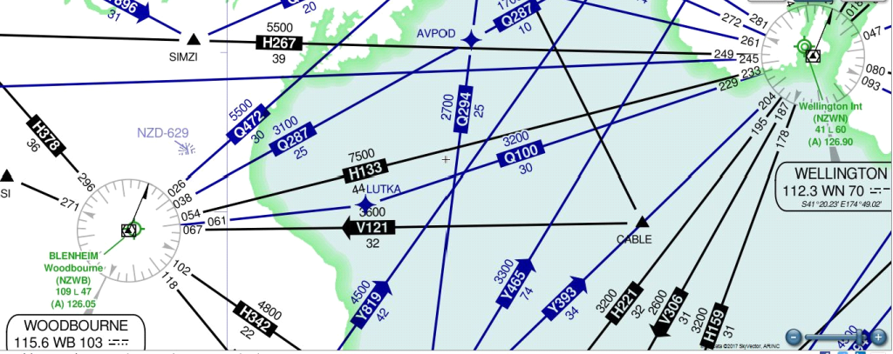

Once sitting on the runway 24L NZWB tune in the VORs in Nav1, the outbound radial to be interepted is 102. Also add the NDB frequency into ADF.
Set the heading bug to 72 as the runway heading points to 243 and we want to intecept 102 at a 30 degree angle. (243-141-30)
Take off turning to your heading while climbing to 3100 feet at 500fpm. As the CDI is close to center adjust the heading to 102 and track and hold the radial towards the NDB.
On station crossing as the ADF needle flips down South turn left to a heading of 50 degrees to intercept the inbound radial 340 of the Wellington VOR.
Click the radio face and swap the frequencies changing the radial to 340. The DME should indicate approx 27 nm out.
Once the CDI start moving towards the centre turn left to 340 (the reciprocal of 160) and track the radial.
Reduce your speed to 90kts and at 15 DME descend to 2200 start the final descent or ARM the AP by pressing the app button at DME 7.
Land safely as there is water on the other side as well.

Tutorial 013
Category: VOR_LOC_(NDB)_ Approach_Without_DME
Prerequisites: Charts: https://download.diegolima.org/Cartas%20Aereas/app_dep/sbsp.pdf
Useful: No distractions, situational awareness and speedy reactions.
Duration: about 40 minutes

This particular approach also contains a holding pattern as well as a standard 45 degree procedure turn.
Brazil, here we come to learn about samba, our destination Sao Paulo SBSP runway 017R (2600 feet)
Getting started:
- Get yourself positioned at SBST runway 35
- Set Nav1 to VOR CGO 116.9 and 166 (reciprocal)
- Set ADF to NDB DAD 200 standby to NDB IS 290
- QNH = 1021
- Turn off your DME
- Click the clock face to display the timer
- Display the ITAF AP, enter a preset of 6000 feet and move it to the top right
- Turn on your lights and takeoff straight
- Activate the autopilot, select heading mode, set the VS to 600fpm and ARM the preset
- Turn left to intercept the bearing leading directly to the DAD NDB
- As the RMI needle starts to drop turn right to intercept the VOR station at 346 (reciprocal)
- Once stabilized throttle back to 2100 rpm or roughly 90kts
- On station passage of the VOR (flag change to To) turn left a 180 degree to roll out and track radial 166 (adjust hdg to 170 +/- for wind) on the outbound leg of the hold, on completion of the turn start the timer.
- After exactly 1 minute make a left 180 turn to intercept and track 346 and preceed towards the IS NDB. Stop the timer and reset it, then switch o the IS NDB and ensure the needle points to north.
- Once the RMI needle drops (station passage) start the timer and one minute out of the station turn left to heading 300 and on rollout start the timer
- Descend to 4700 and hold and set mixture and carburetor heat as you descend.
- After exactly 40 seconds turn right to 166 and track to the station
- On station passage descend at 500fpm and maintain a ground speed of 90
- Adjust your descent as needed and happy landing.
- Before you go you might wish to view your flight history in your map.
The chart:
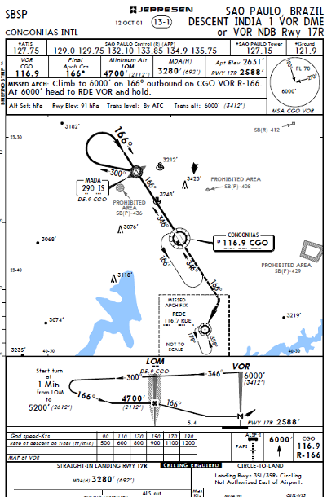

Tutorial 014
Category: VOR DME Hold
Prerequisites: DME on
Useful: LEBL charts rwy 7L and 25R
Duration: 30 minutes
Starting point is Barcelona LEBL runway 07L, flying outbound seven minutes then returning to runway 25R performing a non published left hand VOR DME Hold before approaching ILS.
- Position the aircraft t LEBL 07L in TakeOff mode with or without wind
- Set VOR1 to BCN 116.7
- Set VOR1 Standby to BCA 109.5 245
- Heading bug to 65 degrees
- Take off straight, start timer once airborne, arm pre set altitude of 2000 ft
- Throttle back to 110kts once at 2000 ft
- After six minutes turn left 45 degrees to heading 20, reset the timer and start on rollout
- After one minute turn right 180 degrees, switch VOR1 to standby and intercept radial 245
- At DME 7nm turn left to 65 degrees and turn left to 245 once DME reads 9 nm
- ARM ap for approach and happy landing!
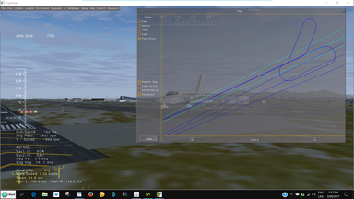
- Review your flightpath in the map
Bienvenidos a Barcelona otra vez

Tutorial 015
Category: PAPI
Prerequisites: Instrument Course by Charles Wood Page 207
http://www.anaspides.net/documents/flight_simulator_documents/Instrument course.pdf
Useful: lots of practise
Duration: until perfect...

As a starting point we suggest, first of all get to know your aircraft intimately, that is get the Flight Settings Reference table form found in the Cockpit Documentation page 16, take the Navigator up in the air and annotate the relevant characteristics.
You may wish to have one set for the 160hp and another for the 180hp version at hands.
To save you the hassle of finding airports which happen to have VASI or PAPI facilities you may wish to study and hand-fly the examples found in Charles Woods Instrument course.

Option 2
Run LPR017, (refer to the menu option Practise Approaches) which will place the Navigator 15nm out of YMML Melbourne AU at 3000 feet on a heading of 263 degrees towards runway 27 at 120 IAS.
The runway is equipped with PAPI. As you are hand flying, no further prep is needed, just press p to unfreeze and you are on your way.
You may need to be quick to stabilise her though.

Option 3
Search for airports which have runways with PAPI and practise free style.
Whether an airport has PAPI or not is usually indicated on the approach charts

Tutorial 016
Prerequisites: Instrument Course by Charles Wood Page 207
http://www.anaspides.net/documents/flight_simulator_documents/Instrument course.pdf
Useful: lots of practise
Duration: until perfect...

Same as PAPI more or less

As a starting point we suggest, first of all get to know your aircraft intimately, that is get the Flight Settings Reference table form found in the Cockpit Documentation page 16, take the Navigator up in the air and annotate the relevant characteristics.
You may wish to have one set for the 160hp and another for the 180hp version at hands.
To save you the hassle of finding airports which happen to have VASI or PAPI facilities you may wish to study and hand-fly the examples found in Charles Woods Instrument course.

Option 2
Search for airports which have runways with PAPI and practise free style.
Whether an airport has PAPI or not is usually indicated on the approach charts

Tutorial 017
Category: ILS I or Localiser Approach without DME
Prerequisites: A bit of preparation as below:
Useful: http://www.fly-sea.com/charts/YMML.pdf
Out of the collection you want ILS or LOC RWY 27
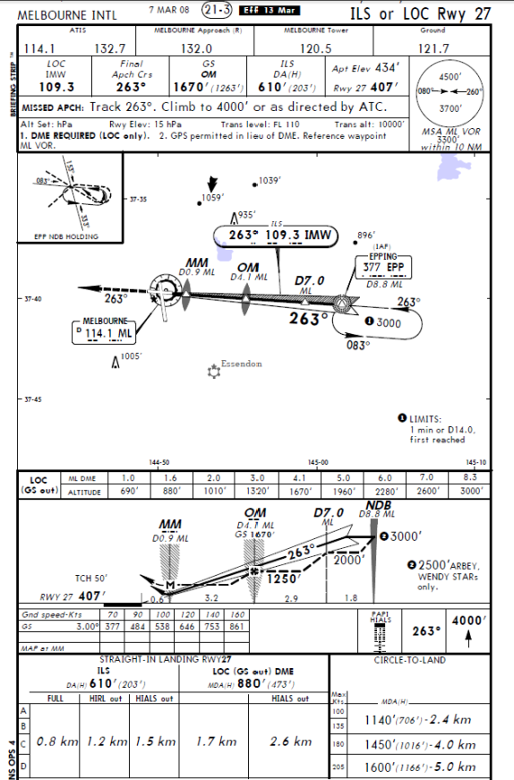
Category I (CAT I) operation means a precision instrument approach and landing with a decision height not lower than 200 feet (60 meters) and with either a visibility of not less than 800 meters or a RVR of not less than 550 meters

- Position the aircraft at YMEN(Essendon) runway 08 in take-off mode
- Select Zero Wind and IFR Scenario, close the dialog
- Set Nav1 to 109.3 263
- Set Nav2 to ML VOR DME 114.1 and set the DME switch to N2
- Set the ADF to Plenty NDB(PLE) 218, standby to Epping(EPP) 377
- Click the Altimeter and enter 1016 as QNH and close the box.
- On your radio altimeter turn the knob to move the dial to the 200 mark.
- Take off straight, press F11 to open ITAF, preset and arm altitude of 3000 feet and place AP in HDG mode.
- If necessary make course adjustments to keep the NDB needle North
- If you wish, show the map with navaids, history and transparent option selected and move it sideways.
- Press H to change the Hud colour
- Press Ctrl L to turn on the instrument lights
- On station passage (ADF needle drops) turn left to heading 300 and intercept and track radial 263 once the CDI starts moving.
- Prepare for descent at passing the Epping station if hand flying the approach or arm Approach on the AP once the GS capture light comes on.
- Reduce and maintain your ground speed to roughly 90kts
- For now focus on the speed and the radar altimeter, once at 200 a yellow warning light will come up indicating our MAP. (If you wouldn’t see the runway we would immediately need to initiate a missed approach, but all is fine for now...Once the middle marker (yellow) starts flashing and the radio altimeter warning comes on, throttle to idle, turn off the AP, do a nice flare and hit the brakes..
Here is some movie about the Flare:
https://www.youtube.com/watch?v=4v5tOtdx7xs

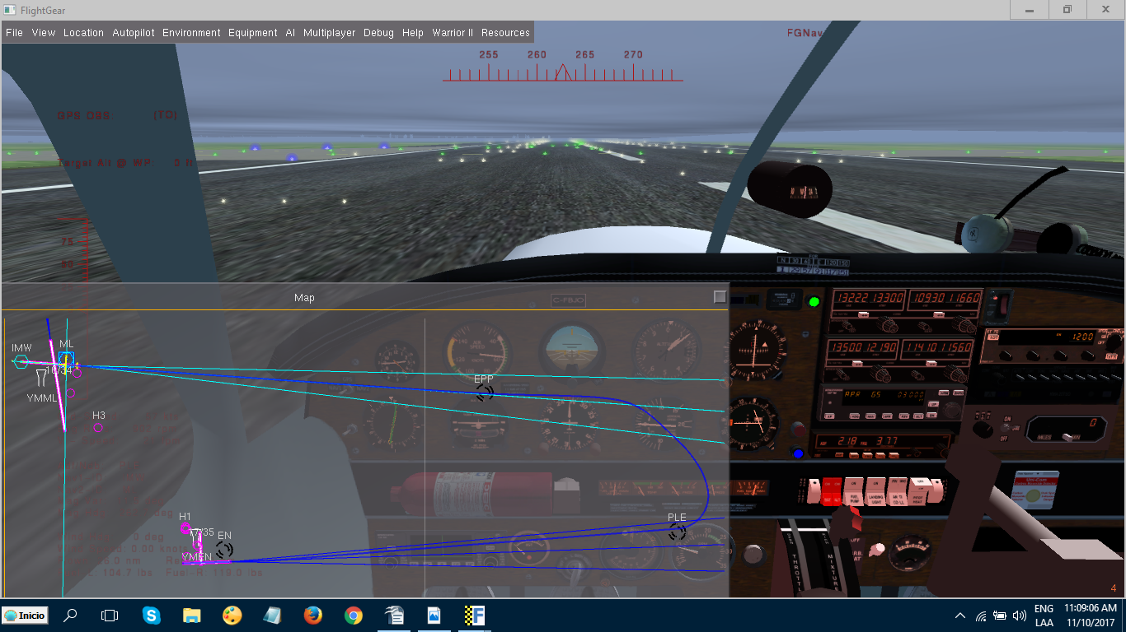

Part of this approach is replicated in the LPR17 quick-start file.
Quick start options allow you to practise approaches be it ILS, VOR, NDB, Papi, Vasi, practise patterns and holds, fly with different weather scenarios and the like.
To find out more go to the Resources menu and select Practise Approaches from the options.
Tutorial 018
Category: ILS Cat II approach
Prerequisites: https://charts.vacc-austria.org/LOWL/LOWL_Arrival_ILS%20CAT%20II%20&%20III%20or%20LOC%20RWY26_10112016.pdf
Useful:
Duration: 40 mins
“Category II (CAT II) operation” means a precision instrument approach and landing with a
decision height lower than 200 feet (60 meters) but not lower than 100 feet (30 meters) and a
RVR of not less than 350 meters
Source: http://www.caa.co.za/Documents/CNS/ILS%20Categories.pdf
Our Route: Wels (LOLW) 09 to Linz (LOWL) 026 Austria
Here s the run of the mill ....
- position yourself at runway 09 of LOLW takeoff mode no wind IFR scenario
- Set Nav1 to VOR LNZ 116.6 83 Standby to ILS DME OEL 109.3 83
- Set ADF to NDB LNZ 327
- SET QNH to 1021
- Set the heading bug to 60 degree to intercept radial 83
- Set the radio altimeter knob to 100 feet
- Take off straight, turn to your heading and climb to 4000 feet and hold
- As the CDI starts to move towards the center switch to standby and steer to intercept radial 83 and center the ADF needle.
- At station passage (NDB) turn left to 70 degree and fly to DME 11nm, reduce your spped slightly
- At 11 nm DME turn right complete the turn at DME 11.2 to heading 263
- At NDB passage turn 180 to the right, fly the hold and once again at the NDB descend in line with the chart. (Or arm Ap for approach once the green light comes on.)
- Dont forget flaps and carburetor heat.
- If the runway is visible at 150 feet (check radio altimeter) land, else do a go around.

Tutorial 019
Category: VOR intercept & ILS III approach
Prerequisites: DG/VOR1 (optional HSI)
Useful: Approach Plate EHAM 27 ILS Cat III
Duration: some 15 to 20 mins
Starting point EHLE Lelystad airport runway 23
Short trip this one, only some 31 nm heading to Amsterdam Schiphol Airport. And our runway is under water so to speak, no joke. Lots of the Netherlands is below sea level, our runway has an elevation of - 12 feet.
Amsterdam, the Venice of the North, worthwhile to spend some time to explore. Ok, you know the ins and outs, does and donts, rules and regulations associated with approach plates and we ignore STARS and circles and procedure turns for now.
The chart tells us the EHAM VOR for runway 27 is BVB 111.55 radial 266, and at DME 6.2 we find the NDB station WP frequency 376. That’s exactly the point where we start the final descent, both GS and VS up to your decision or arm the autopilot for approach.
We want to be at 2000 feet by the time we reach DME 9. DH for missed approach is 50' and RVR is specified as 200mtrs.
- Place yourself on runway 23 of EHLE at default weather settings and tune in Nav1 and the ADF as above. You should have a clear signal and an earful of Morse for the VOR, the NDB coming alive once airborne.
- Leave the heading bug where it is, pointing to the runway heading of 226 degrees.
- Take-off climbing to 2100 at 500fpm to see the windmills turn, keep your heading and hold altitude at 2100.
- After a minute or two the NDB is alive telling us the airport is to the left. The DME telling us we are some 20 plus miles out.
- Still climbing keep an eye on both the RMI and the VOR needles. At about 18 DME there is some movement towards the centre, straight away turn right to a heading of 266 and make slight adjustments to centre the needle to track radial 266.
- At 14 miles out looking at the CDI the glide slope is alive. Turn on your landing lights and decide autopilot or hands on approach.
- Using the Autopilot press the ARM button and adjust throttle and speed, manual approach start your descent at DME 6.2 using the chart info or use half the groundspeed with a zero added for VS.
If you come in to fast, there´s lots of runway. Get off the runway quick, park somewhere and go for a cool Amstel

Tutorial 020
Category: Missed Approach Procedure
Prerequisites: DME on, reading the chart
Useful: Chart for Brussels EBBR/BRU ILS Rwy 02
Duration: na

Brussels, here we come...

(Did you know French Fries were actually invented by the cook of a Belgium king and have nothing to do with France or Freedom)

The itinerary:
- Get yourself on runway 07 of EBCI Charleroi Brussel South
- Set Nav1 to the Localiser IBX 109.9 Radial 016
- Set the heading bug to heading 330, take off straight, engage AP in heading mode, climb to 2000ft and hold.
- Once the CDI centres intercept and track radial 016 and gradually reduce speed to 90kts (GS)
- At DME 7.0nm commence descent at 500fpm, make adjustments as needed
- At the middle marker (yellow flashing light and ident) apply full throttle, flaps in and AP to hdg mode to perform a missed approach.
- Climb to 1500, set the standby NAV1 to AFI VOR 114.9, switch to standby then turn left heading to the station while climbing to 4000ft.
- Follow the instructions as per chart switching VORs as required, performing a left hand hold and reducing altitude to 2000 and land the plane on runway 16

Chart overleaf ./.
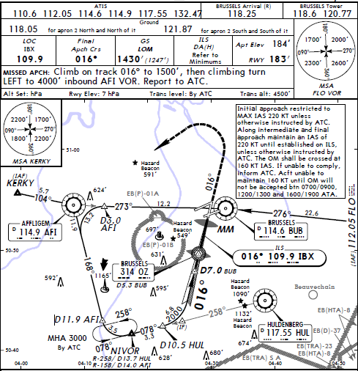
Tutorial 023
Category: Unpublished and published Holds
Prerequisites: Brush-up on standard patterns
Useful: Chart http://www.uvairlines.com/admin/resources/charts/GCXO.pdf
Very good illustrations: http://www.pilotflightmaneuvers.com/user/IN%20Holding.pdf

There are three flights, namely:
First NDB Hold using a tear drop entry and diversion to alternate airport
Second NDB Hold using direct entry
Third Right and Left Hold Pattern Entries

NDB Hold using a tear drop entry and diversion to alternate airport

Start FG with no wind at EDNL runway 07
- Set ADF to NDB Memmingen ALG 341
- Take off straight climb to 4000 ft and hold
- Steer towards the station the needle pointing North
- Turn on the Stopwatch
- On station passage (needle starts to drop), turn left 30 degrees and start timer for exactly one minute on roll out.
- Turn right 180 degrees to 237 set the timer for one minute and turn another 180 to the right after one minute or when the RMI needle starts dropping
- Set the timer on roll out for one minute and turn another 180 to the fix
- On station passage press o to pause, the map should show your flightpath like this or perhaps a little different.
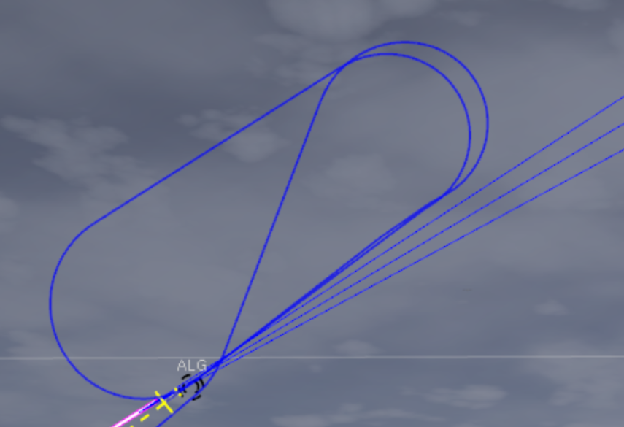
We just learned from ATC that the runway is not available and we should divert to Munich.
...proceed with instructions of how to use Route Manager to deviate or use the map to find out how to get there to a runway of your choice...
- To use the Route Manager in conjunction with the auto pilot press r or click the carbon monoxide sticker or go to Autopilot Route Manager
- add EDDM into To: then select which runway you would like to use for your approach,
- Open the drop list for approach and click standard, then click activate and close
- Next in the AP place a check into slave mode and click the NAV button.
The Navigator should turn around and head towards Munich.
- In the absence of a chart you may select to approach VFR style
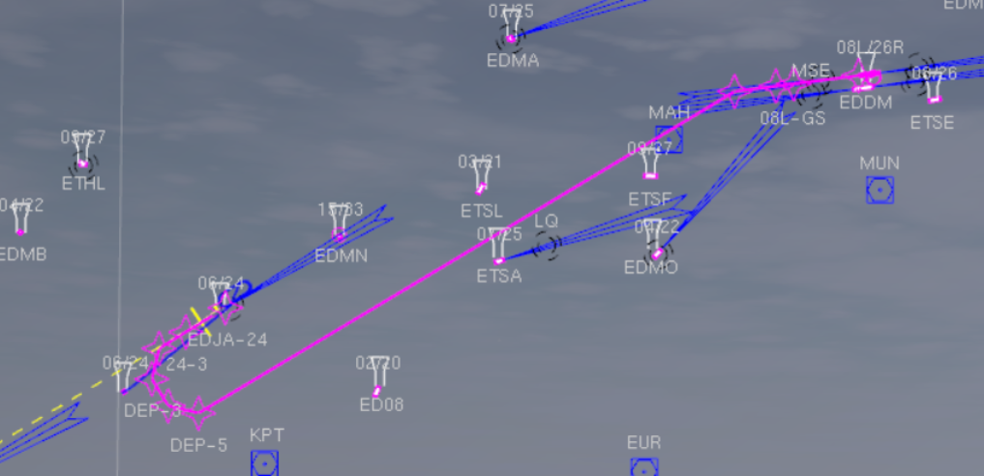

Happy Landing and have fun in Bavaria

NDB Hold using direct entry
This flight will take us from GCLP Gran Canaria Runway 21L to GCXO Tenerife Norte Runway 30
The Canary Islands are ideal for island hopping and practising all kinds of instrument approaches due to the close proximity of the islands.
Coming in from the East towards the IAF and NDB Fix for a standard right holding pattern we use the direct entry into the hold.
You might prefer to take the 180HP model for this flight as there is a bit of a climb involved.

- Ensure wind is turned off (command-line or batch-file)
- Start FG and place the Navigator on runway 21L of GCPL in ready for take off mode
- Set NAV1 to the Loc 110.3 297
- Set ADF to NDB TX 410 (this is also the IAF for ILS – altitude 3290 ft
- Display the ITAF dialog and enter altitude preset of 5000 ft
- Display the stop watch
- Take off straight, at the end of the runway activate the AP in heading mode
- Set VS to 700fpm and ARM the pre-set
- Turn right to heading 305
- Once the RMI comes to live and the signal is steady, slightly adjust your heading to center the RMI needle pointing North
- Having passed the mountain ridge and all looking good, set pre set a new altitude of 3300 VS at -200fpm and arm, throttle back to about 110kt IAS.
- Get yourself some coffee or another drink, time for enjoying the view
- Keep an eye on the RMI and VOR needles with the RMI pointing to the station
- Once the RMI needle drops initiate a 180 degree right turn to 117
- On roll-out start the timer and after exactly 1 minute turn another 180 to the right to 297
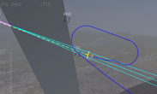
- Once stabilised throttle back to a groundspeed of 90 kts, one notch of flaps and arm approach on the AP

Happy Landing !
Right and Left Hold Pattern Entries
Flying Holds at times can be a little tricky with or without differing wind conditions. Identifying the correct entry can also be a slight challenge at times, however a little practise and the concepts will fall into place pretty quickly.
For the purpose of free style practise just look for a specific fix on the map and fly a standard right direct entry, then select another fix and fly a parallel entry and another or the same fix fly a tear-drop entry.
Here is an example of a parallel entry:
Airport LFGA, set ADF to Colmar NDB AP 348, track to the station and fly a parallel entry with 1 minute legs radials 228 48
Then you also might want to practise non standard left holds.
Use the map flight history to check on accuracy.

Tutorial 024
Category: TOUCH AND GO (TOGO)
Prerequisites: DG Panel, DME turned on, dual VOR s Charts LSZR and EDNY
Useful: Practise without and then with wind
Duration: 90 minutes plus
This particular flight will take you from Duebendorf LSMD runway 029 near Zurich to Sankt Gallen Altenrhein LSZR runway 010 for a touch and go and will see a deviation across Lake Constanz to Friedrichshafen EDNY runway 06.
The flight will involve a couple of standard holding patterns and a procedure turn.
Friedrichshafen was the original home of both the Zeppelin as well as Dornier prior to WW1. After the treaty of Versailles, production and operations were shifted across the lake to Switzerland which later saw the establishment of FFA producing parts for military aircraft, tanks, sailboats and a nice small aircraft, the AS202 Bravo https://en.wikipedia.org/wiki/FFA_AS-202_Bravo
Ok, an overview of the approaches involved
LSZR
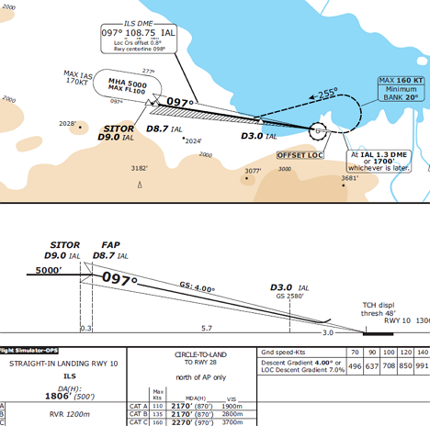
EDNY
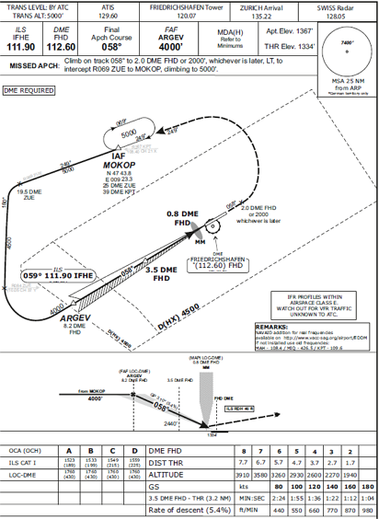
Interesting here are DME fixes for turns using German and Swiss VOR DMEs
Lets get started:
- Fire up your Navigator with the DG Panel selected, sitting on runway 29 of LSMD
- Set VOR1 to ZUE VOR/DME 110.050 radial 040
- Set VOR1 standby to VOR/DME IAL 108.75 radial 097 to be switched later
- Set VOR2 to VOR/DME FH 112.6 radial 058
- Set ADF to FHA NDB 473
- Set wind as you like
- Take-off straight turn right to a heading of 10 degrees to intercept and track radial 40 of ZUE
- Pre-set altitude to 5000 and arm
- Watch the CDI, on station passage hold east on your radial for three nm DME then turn left 180 degree and complete the hold once abeam.
- Switch VOR1 to the standby frequency (IAL) and set the radial to 097
- Once arriving at the holding fix after completion of the turn turn to a heading of 110 to intercept radial 097 and track it.
- As the IAF is at DM 8.7, slow down and prepare for landing going down the glide path, but only touch the ground, flaps up, full throttle, autopilot to heading and pre-set altitude to 5000.
- At 1.3 DME turn left to 255, intercept and track outbound 277
- At DME 4.0 turn towards the FHA NDB station
- Set VOR1 back to ZUE 110.05 , VOR2 to 112.6 058 and switch the DME to Nav2
- On station passage turn to heading 059 and track for 2nm.
- At DME 3 turn left to 249 and switch the DME back to Nav1
- At DME 25 ZUE turn right to 069 leg 1 minute turn back to 249 and continue to DME 19.5
- At DME 19.5 turn left to heading 180 and descend to 4500 and set the radial for ZUE to 084
- Once the CDI centres turn left to heading 058, change VOR1 to the ILS Localiser 111.9 059
- Descend to 4000 and make necessary adjustments to track the beam.
- Commence your descent and execute your VOR Loc approach
Happy landing

You may wish to review your flight history in the map or replay your flight for analysis.

Tutorial 025
Category: Using GPS on small aircraft
Prerequisites: Reading up on the topic /VOR DME knowledge
Useful: Knowing what way points and fixes are
Duration: na

GPS has become more and more widely adapted throughout all categories of aircrafts as more accurate and less subjected to errors like VOR and NDB technology. The big birds use GPS by default using a single or multiple units of either a FMC or CDU box, basically a computer.
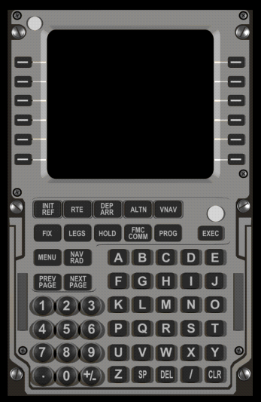
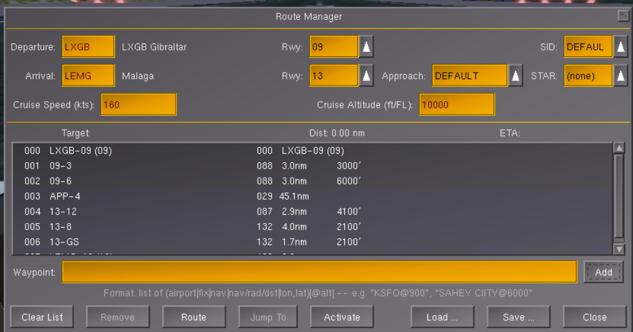

In FG most of these are not fully functional and as such way point navigation is performed via the Route Manager Dialogue.
Small aircraft’s using not using the generic autopilot do not have this option available like the Cessna, the Seneca, the Cherokee and others.
Now take a look at this cockpit - Pilatus Porter PC-6
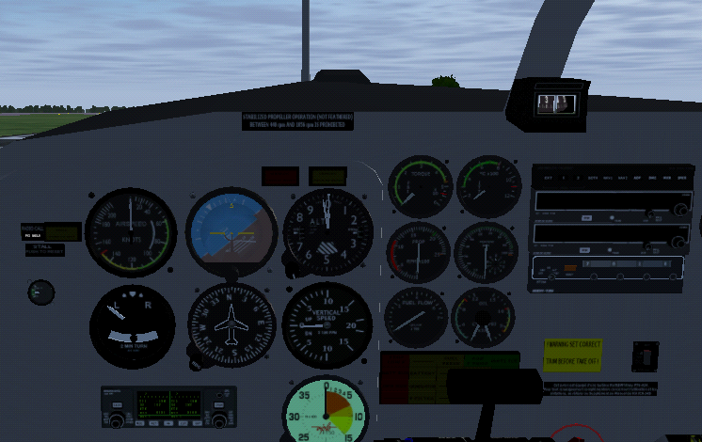
No VOR, no ADF, not even an auto pilot, however a GPS box at the bottom left, the same as in your Navigator. There are a handful of GPS units on Flight gear, most of them limited in scope or mere decoration.
So how does GPS navigation work in FG? You go to Equipment, GPS settings
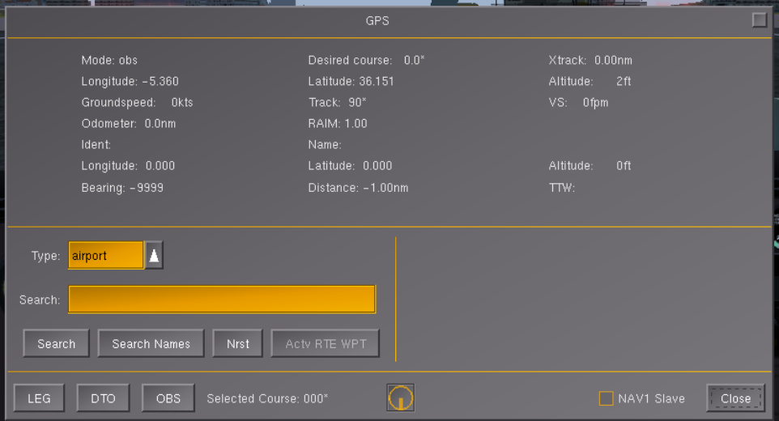
It is assumed you have read the Wiki and have seen this dialog before.
The dialog provides options such as searching for an airport, a VOR, an NDB, a Fix etc and will display the corresponding information you need to get there.
The only mode option relevant for or needs is the DTO (Direct to) option, since for multiple legs we would need some FMC or Route manager.
Another useful option is the ability to make NAV1 a slave to the GPS allowing you to stay on course more easily.
Lets explore some of the options which may come in handy.

- Get yourself positioned on runway 04L of LFMN (Nice) and click the GPS box at the bottom left to open the GPS dialog.
- Search for the airport EDDF (Frankfurt)
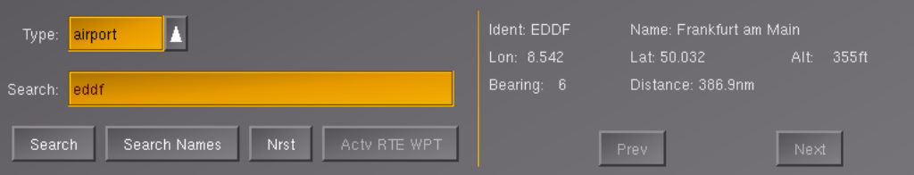
Distance a bit tight for our two small tanks
- Search for type Any for Marseilles.... plenty of fuel for that destination. Examine the info on the dialog:
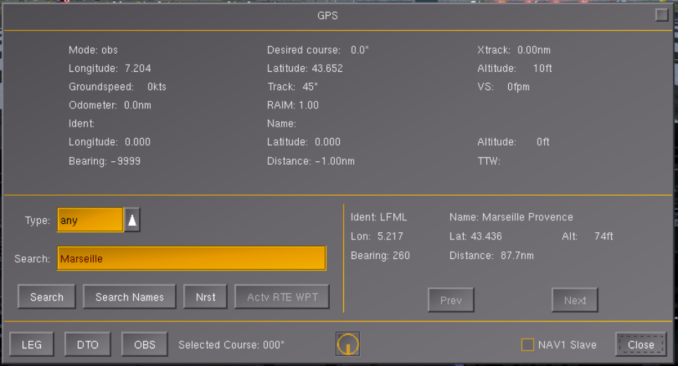Airport Code is LFML, Altitude 74 feet Distance 87.7 nm. OK lets fly there for some nice seafood platter to be washed down with a bottle of Pinot Gris.
- Click the DTO button and place a check into NAV1 Slave
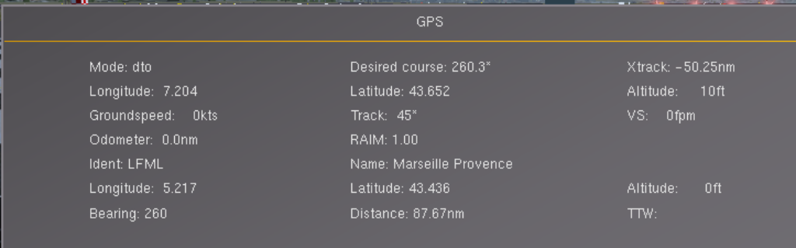
The desired course indicated is 260.3 degrees and is also shown in the FG map as a pink line.
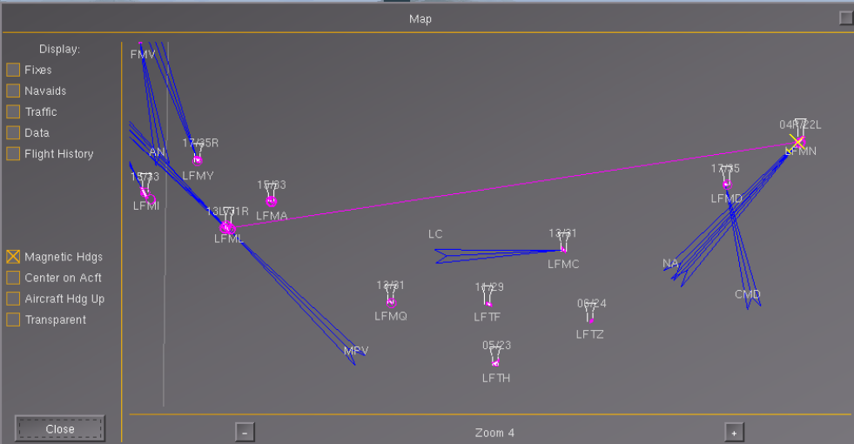
- Lets try this, set your heading bug to 260 and take off, climbing at 500fpm to 3000ft but have a look at your CDI needle first and keep an eye on it
- Turn left to 210 and back to 265 once the VOR needle moves to the centre.
- Make very small adjustment until the needle stays centred, you may need to do some bracketing to stay on course.
- Open up your GPS dialog and you will find info on groundspeed, time to way-point TTW and distance flown as well as remaining.
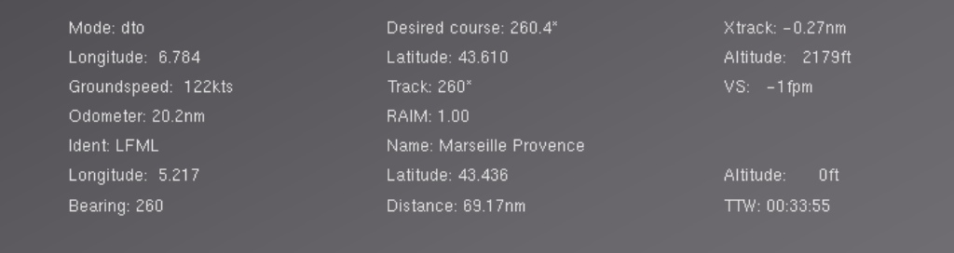
all good and fine, the course will lead us straight to the airport, but not align us with a runway. Therefore we need to find some fix and change our heading accordingly. Stop your sim for a moment.
Looking at the map, if we head up north to a fix called Etoma followed by a sharp right hand turn we can do an ILS I approach to runway 15 VOR IST 111.3 radial 151
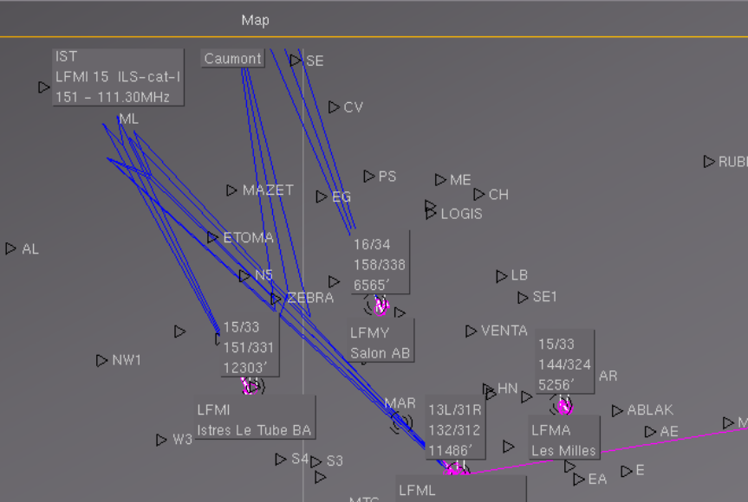
- Search the GPS dialog for type Fix name Etoma, notice the desired course and de check the slave box and close the dialog.
- Resume the sim and turn to heading 260, then add VOR IST 111.3 radial 151 for Nav1 and NDB MAR 382 for ADF. Climb to 3500 to clear the mountains. After a minute or two check GPS again and you might find you need to adjust your heading to something like 274 or similar. Make the adjustment. By now both ADF and CDI are alive.
- With some 25 mins to go or whatever your GPS indicates, time for a coffee or something...
- Reviewing the map we can shorten the trip a little by changing direction straight to the NDB station followed by a sharp right hand turn. So turn to the left until the RMI needle is pointing to 360 up North. Keep the needle up there.
After some time the DME starts blinking.
Here s your path so far, about 10 to go...
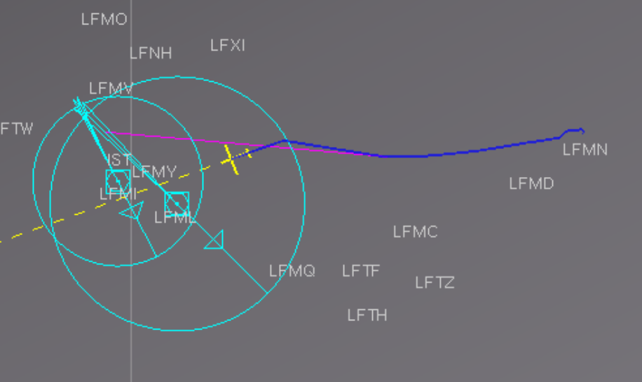
- Get yourself into approach configuration, speed down to 80kts, one notch of flaps perhaps, once the RMI needle starts dropping turn right to a heading of 130 and you should have the runway in front of you. Lets call it a missed approach, keep your heading for seven mins, turn round and approach from the other side using VFR and the ADF still pointing to the runway as a guide.

That completes the basic run-down of how to use GPS on a small aircraft in FG.

Tutorial 026
Category: Using Route manager
Prerequisites: Read Route manager Wiki
Useful:
Duration: na

Our proposed route takes us from KBED Laurence G Hanscom Rwy 11 to KNZW via Boston Logan KBOS
Getting started:
- Fire up the Navigator at runway 11 of KBED in take off mode
- Select Autopilot, Route Manager from the menu (or click the carbon monoxide sticker) to open route manager
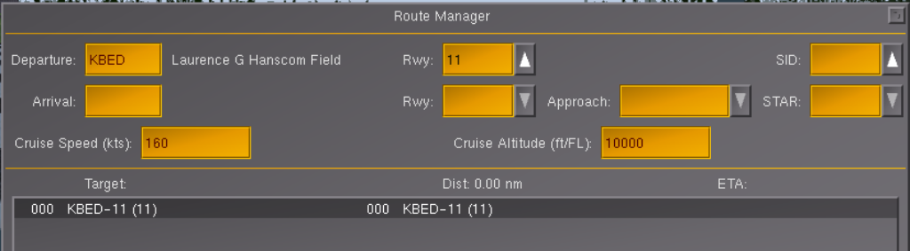
The departure airport and ruway are already selected.
- Click the Arrival field below KBED and enter KNZW, then press the enter key
Runway 35 is selected as a default, we accept this for now. But since we would like to pass Boston en route we have to add this as a waypoint.
- Click the first row to select (highlight) the KBED entry, then click the yellow waypoint prompt below and enter KBOS, then click the add button.
- As there might be some noise restrictions select the droplist at the top right for SIS and select default, just below open the droplist next to Star and selct default.
- Change the arrival runway to 26, then open the approach arrow and choose deault
- Your route manager will now show these waypoints. Click the activate button to activate the route then close the dialog.
If you fly a route frquently of course you can save and retrieve routes using the corresponding buttons.
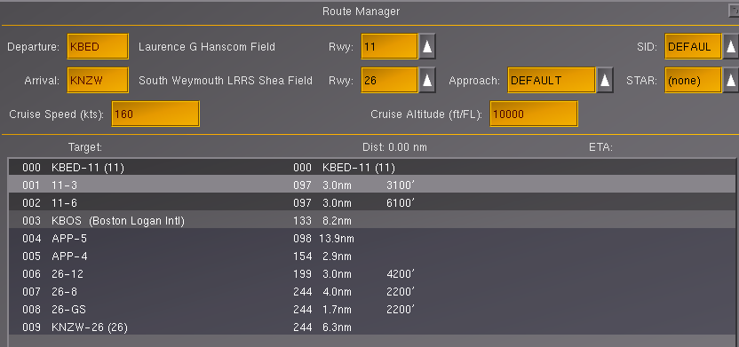
- Open your map and you will see your route depicted in some reddish pink colour.
- Close the map.
- If not already ready for takeoff go to the Warrior Menu select Aircraft Config and choose ready for take off.
- Click the KAP140 face to display the ITAF dialog, then click the Switch button to enable GPS/Routemanager mode.
Alternatively you can use the Nav Switch at the top left of the panel.
- Take off straight, climb to 500ft and activate the autopilot and press the Nav button. The AP will now follow the route, you however need to control altitude as the simulated GPS has no VNAV capability.
- Hold altitude at 4200 - You can monitor your flightpath using the map.

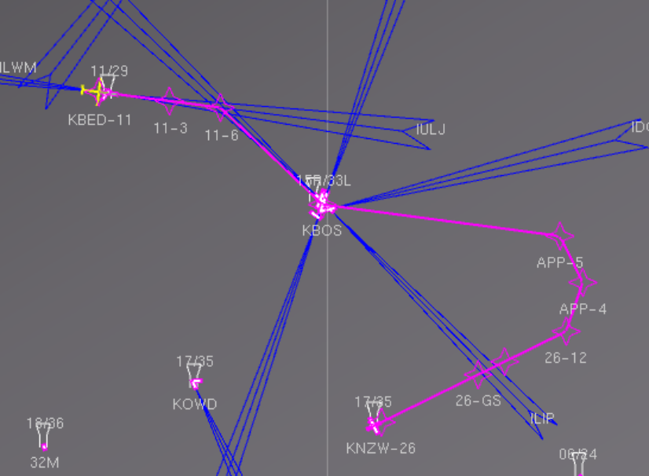

The top right of the screen will also show GPS and waypoint info like distance and time to the waypoint.
KNZW happens to be a closed military airport with literally no facilities, but for the purpose of the exercise we will just conduct a visual approach and landing.
After passing KBOS you have about 32 miles to destination, calculate and commence your descent accordingly based on your speed.
Turn off the AP well before touch down as the runway is offset a fair bit and you need to correct for this. In case you see the runway to late just do a go around and try again.
Enjoy your flight !

Tutorial 027
Category: Creating custom way points, saving and retrieving routes
Prerequisites: LSGG IAP s, some text or xml reader

Ok, right into the nuts and bolts of it...
- Position the Navigator at runway 05 of LSGG (Geneva) in take off mode.
- Open the map, check navaids and transparent and move it to the left
- Open the Route Manager from the Autopilot Menu or click the CO sticker
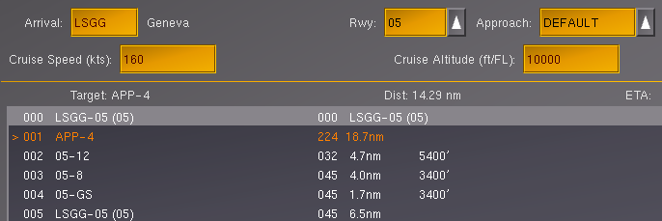
- Add LSGG into arrival and change the runway to 05 and set approach to default
- Below at the waypoint prompt type GVA/042/5 and then click the add button.
FG will promptly change the 42 to 44 as we seem to have a 1.7 degree magnetic variance as shown in the HUD. With the above we are telling FG our first waypoint is to be 5nm away from the GVA VOR on radial 044.
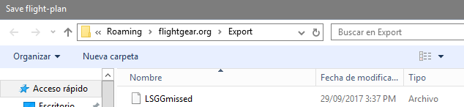
- At the waypoint prompt add an existing fix by the name of Salev and click the add button followed by the Save button and save the route as follows accepting default location.
- Activate the route by clicking the activate button and close the route manager.
- Minimise FG and return to your desktop. While in route manager, FG created an xml file in the background. This file in Windows is stored in a hidden folder. As such to open this file you need to run %appdata% from the run command, then choose the Flightgear.org folder and the Export subfolder.
If you use another OS you need to explore your relevant file structure.
- Once you have found the file you saved before as LSGGmissed open it with any text processor or xml reader
<?xml version="1.0"?>

<PropertyList>
<version type="int">2</version>
<departure>
<airport type="string">LSGG</airport>
<runway type="string">05</runway>
</departure>
<destination>
<airport type="string">LSGG</airport>
<approach type="string">DEFAULT</approach>
<runway type="string">05</runway>
</destination>
<route>
<wp>
<type type="string">runway</type>
<departure type="bool">true</departure>
<ident type="string">05</ident>
<icao type="string">LSGG</icao>
</wp>
<wp n="1">
<type type="string">offset-navaid</type>
<ident type="string">GVA</ident>
<lon type="double">6.132222</lon>
<lat type="double">46.253917</lat>
<radial-deg type="double">43.70899423</radial-deg>
<distance-nm type="double">5</distance-nm>
</wp>
<wp n="2">
<type type="string">navaid</type>
<ident type="string">SALEV</ident>
<lon type="double">6.065833</lon>
<lat type="double">46.073889</lat>
</wp>
<wp n="3">
<type type="string">basic</type>
<approach type="bool">true</approach>
<generated type="bool">true</generated>
<ident type="string">APP-4</ident>
<lon type="double">5.885702219</lon>
<lat type="double">46.03531361</lat>
</wp>
<wp n="4">
<type type="string">basic</type>
<approach type="bool">true</approach>
<generated type="bool">true</generated>
<alt-restrict type="string">at</alt-restrict>
<altitude-ft type="double">5410</altitude-ft>
<ident type="string">05-12</ident>
<lon type="double">5.886240841</lon>
<lat type="double">46.08529759</lat>
</wp>
<wp n="5">
<type type="string">basic</type>
<approach type="bool">true</approach>
<generated type="bool">true</generated>
<alt-restrict type="string">at</alt-restrict>
<altitude-ft type="double">3410</altitude-ft>
<ident type="string">05-8</ident>
<lon type="double">5.954357956</lon>
<lat type="double">46.13217075</lat>
</wp>
<wp n="6">
<type type="string">basic</type>
<approach type="bool">true</approach>
<generated type="bool">true</generated>
<alt-restrict type="string">at</alt-restrict>
<altitude-ft type="double">3410</altitude-ft>
<ident type="string">05-GS</ident>
<lon type="double">5.983671865</lon>
<lat type="double">46.15230538</lat>
</wp>
<wp n="7">
<type type="string">runway</type>
<approach type="bool">true</approach>
<ident type="string">05</ident>
<icao type="string">LSGG</icao>
</wp>
</route>
</PropertyList>
- For now we accept all as is however we could add, delete and modify way point information as we will demonstrate in the SID and STAR activities later on.
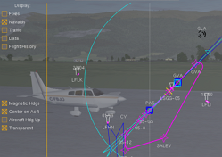
- For now close the file and return to FG
- Close the map.
- Set NAV1 to 115.75 and standby to 110.9 radial 044
- Open the ITAF dialog and set the Nav Switch to GPS/RM
- Release the brake, take off straight and activate AP in Nav mode
- Climb at 400 fpm
- Set altitude to 3400 and arm
- On passing Salev switch to the standby frequency and at DME 8nm get yourself into approach config for a ILS CatIII approach.

Welcome back to Geneva, second capital of the UN

Tutorial 027a
Category: RNAV Procedure
Prerequisites: Chart: SVMI RNAV (GNSS)Rwy 28
http://www.uvairlines.com/admin/resources/charts-caribbean.htm
https://www.latlong.net/degrees-minutes-seconds-to-decimal-degrees
Duration: na
SVPC to SVMI (Caracas, Venezuela)
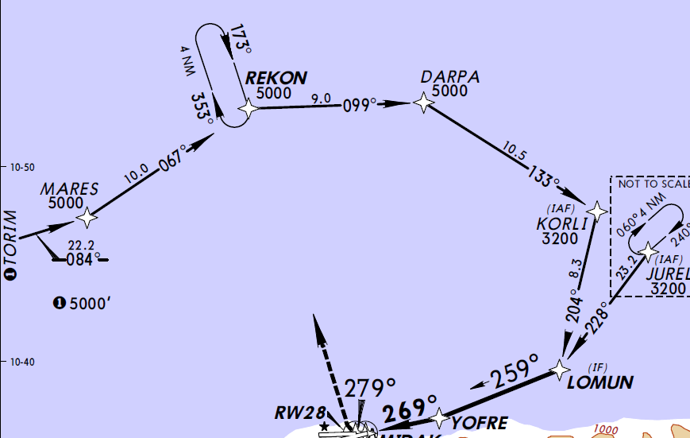
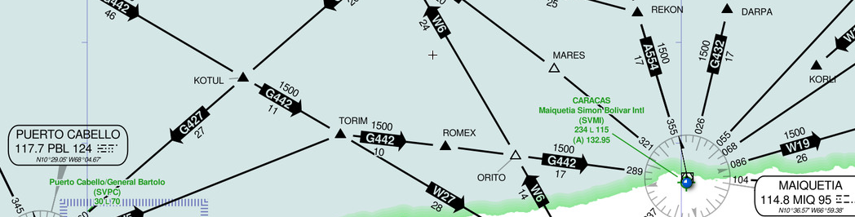
Route to be established:
SVPC TORIM MARES REKON DARPA KORLI LOMUN YOFRE SVMI

- Get yourself positioned on runway 020 of SPVC in take off mode and select IFR Scenario
- Open the Route Manager Dialog
- Nominate SVMI runway 28 for destination and then select the first row (SPVC) in the list
- At the waypoint prompt type TORIM@5000, then click the add button.
- Add MARES@5000, REKON@5000, DARPA@5000, KORLI@3200, and LOMUN@3200 in the same fashion
oops, LOMUN doesnt seem to be contained in our navaid database, as such we have to add the fixes details manually in our flightplan, however looking at the chart, we do not have any info on the GPS coordinates.
Well Skyvector is just a couple of clicks away...
- Click the resource menu and select go to Skyvector
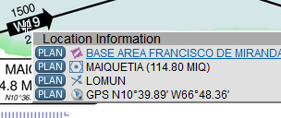
- Type LOMUN into the search box on the left then click Go
...a little hard to see there is a small black crosshair pointer in the middle of W19, point and right click on the cross.
- Now we need to convert the GPS coordinates into decimal format which can be done easily using any online converter like https://www.latlong.net/degrees-minutes-seconds-to-decimal-degrees
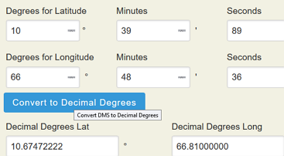
- Open the converter add details as per above and hit Convert
- Open the approach list , choose default, then click the Save button and save your route as SVMI_RNAV_RWY28 and make a note of the storage location which may vary depending your FG installation and OS in use.
- Close the routemanager, then using a text or xml editor open the saved file. (usually a hidden folder called Export)
- Modify wp6 and seven as below:
<wp n="6">
<type type="string">navaid</type>
<alt-restrict type="string">at</alt-restrict>
<altitude-ft type="double">3200</altitude-ft>
<ident type="string">LOMUN</ident>
<lon type="double">-66.81000</lon>
<lat type="double">10.67422</lat>>
</wp>
<wp n="7">
<type type="string">navaid</type>
<alt-restrict type="string">at</alt-restrict>
<altitude-ft type="double">1600</altitude-ft>
<ident type="string">YOFRE</ident>
<lon type="double">-66.91444444</lon>
<lat type="double">10.62527778</lat>
</wp>
- Delete waypoints 8 to 11 and rename wp 12 to 8
- Close and save the file and return to FG
- Open Route Manager and open SVMI_RNAV_RWY28
- Click the activate button and then close the dialog.
- Using the NavSwitch at the left change it to the middle position for GPS/RM
- Now take off straight, activate the AP in Nav mode and arm a preset altitude of 5000 feet
- Check out the chart for descent rates depending on your speed and prepare before reaching LOMUN.
Enjoy the ride!
Note: Rather then entering fixes, waypoints into the route manager or modifying xml files you can of
course purchase SIDs, STARs and RNAV procedures from Navigraph, yet the raw data then still needs
to be converted to a format FG can read.
You also have seen that one can specify altitudes to waypoints, however as at the time of writing
VNAV in FG is not supported, there is little use of doing so. Nonetheless, if an altitude is specified
it will show up in the HUD as Target Altitude for the way point.
On big birds you use FLCH or VS, on small crafts use VS on AP or biceps when hand flying.
Tutorial 028
Category: STAR (Standard Terminal Arrival Routine)
Prerequisites: Chart(s): http://www.uvairlines.com/admin/resources/charts-asia.htm
RJTT STAR Dream Night North Arrival
RJTT/HND -ILS Rwy 22
Duration: na
Shushi or Sashimi ?

Our route will take us from RJAH Rwy 021 to RJTT Tokyo Haneda Rwy 022.
On departure we will follow the default FG SID, continue along the Dream Night North STAR and conclude our trip with an ILS approach.
First up we need to create our route including all the STAR way points...
- Place the Navigator on runway 21 of RJAH (Hyakuri)
- At the Aircraft Config dialog place a check into Zero Wind and IFR scenario and select ready for take off, then click ok once the state is loaded.
- Turn on the instrument lights
- Open the Route Manager and add RJTT and runway 22 as destination
- Change the RJAH SID to default
- Select the row of waypoint 002 and in the waypoint prompt below type TLE@8000 than click the add button.
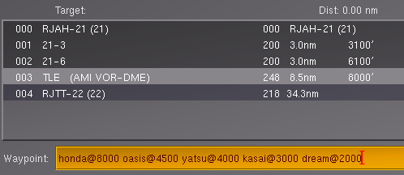
- With 003 still selected add the following waypoints separated by a single space as shown below:
- Click the add button, then save the route as RJAH21RJTT22 , activate the route and close the dialog box.
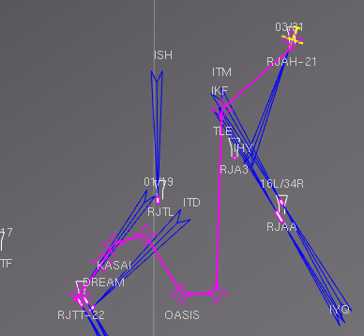
- Open your map and view the route, then close the map.
- Set Nav1 to the localiser frequenz of 108.1 222
- Flip the Nav Switch to GPS/RM, take off straight, climb at 700fpm to 8000 feet
- Fly the route and land safely as you will see the runway very late.

Tutorial 029
Category: SID (Standard Instrument Departure)
Prerequisites: Chart(s): http://www.vacc-sag.org/airport/EDDW
http://www.vacc-sag.org/airport/eddv
EDDW SID RWY 27R/EDDV STAR RWY27R/Approach ILS 27R
Duration: flight time ca 45 mins
Northern Germany, flat like a pancake, however Bremen is lovely.
Our trip takes us from EDDW to EDDV (Hannover).
First up we need to create our flightplan incorporating the Bremen SID, en route waypoints and the Hannover STAR based on what we can find on the charts.
- Get yourself engine running at rwy27 EDDW
- Open Route Manager
- Add EDDV and runway 27R as departure and select standard approach from the droplist
- Delete appr 12,6,5, and 4 from the list and select the EDDW row but leave 8.
- At the waypoint prompt below enter BMN/266/2.1 and click add
(The chart says turn after 1.7nm, but FG does not like that and would turn at 1.3, so we have to fiddle the book, guess has to to with DME slant distance...)
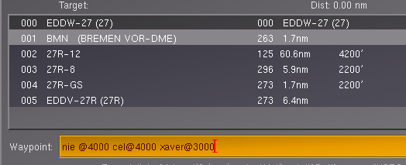
- Using the way point prompt add the fixes as shown and click add
with the last entry again we fiddle, because the chart says ODINI, however in FG xaver relates to runway 27R.
- Select Xaver and add the HA NDB as additional fix
- Activate the route and save it if you wish to re use it again.
- Flip the Nav Switch to the center to select GPS/RM mode
- Ensure your lights are on
- Set Nav1 to IHNW 108.9 270 for the Hannover localiser and HA 320 as ADF
- Take off straight, climb at 400fpm, activate the ap in NAV mode.
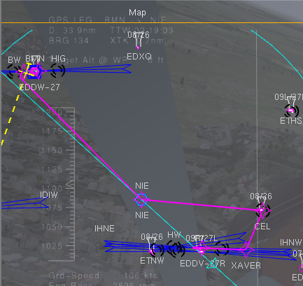
- Display the map with the options navaids, transparent checked and move it out of the way
- Fly the route and enjoy....

Tutorial 030
Category: IFR at night
Prerequisites: Chart: LFPO RWY 06 ILS III
http://www.pentekesti.com/sites/default/files/charts/lfpo.pdf
Duration: roughly half an hour

LFOX Rwy 24L to LFPO Rwy 06
Here is the story: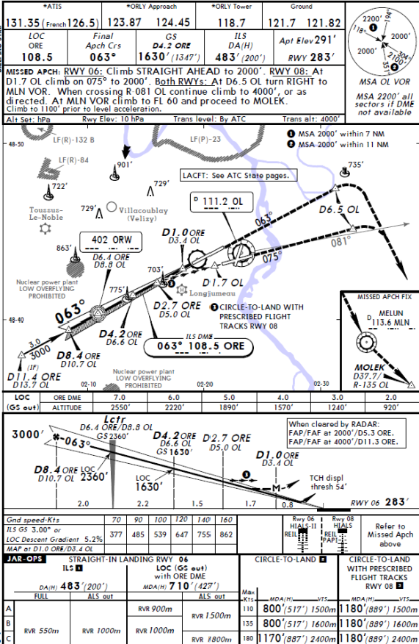

- Startup FG using the NightAARS.bat file or use your launcher
- Aircraft is pa28-161 or via launcher FGNavigator1
- Departure airport is LFOX runway 24L
- Once on runway shift ( to turn on the instrument lights and outside lights.
- Set your qnh to 1012
- Open the ITAF AP and preset altitude to 2000
- Set nav1 to 108.5 063
- Set nav2 to 114.7 and set ADF to ORW NDB 402
- Twist the obs of vor2 until it displays the To flag and the needle is centred, note the radial and set your Hdg bug on the Dg to this radial plus 30 degrees for the intercept angle.
- Set the Radio Altimeter dial to 500 in line with the DH required for ILS III
- Takeoff straight climbing at 400fpm, engage the ap, press the heading button and arm the preset altimeter of 2000ft.
- Once the CDI of VOR2 nears the center, turn and roll out on you radial and track it. Once at 2000 throttle back to 2100rpm or a speed of roughly 90 knots.
- Now observe VOR 1, once that needle starts moving turn to and track radial 63 and monitor your DME
- At DME 10.7 Flaps out one notch, adjust and maintain a groundspeed of 90 kts
- A few seconds later the green ILF in Range light comes on.
- The CDI indicating that we are below the beam, set your Ap to approach.
- At roughly DME 5.5 the horizontal CDI needle is center, we are on the beam.
- Maintain your speed, watch the radio altimeter, once the yellow light comes on and the runway is in sight, continue and prepare for touchdown, turn the ap off reduce your speed, do a nice flare, taxi to a nice parking spot and head off to the Eiffeltower.
- Once on the ground you may want to do a quick replay, just go to the View menu and select Instant replay and look at your flight from the outside.

Tutorial 031
Category: The Final Tour
Prerequisites: Establishment of Flight Plans, read
https://www.caa.govt.nz/safety_info/GAPs/Mountain_Flying.pdf

Useful: Relevant Charts, NOTAMs
Duration: Depending on chosen routes and depending on Legs flown combined with stop overs
with refuelling or
Switzerland and Italy Tour – Buendner Fleisch, Pizza, Pasta and Seafood.....
Preparation:
Leg 1
Using Sky-vector or some other planning application find the most practical, not necessarily the shortest route from LSZS ( Samedan ) to LSZA ( Lugano ). Prepare your flight plan, calculate your fuel requirements and adjust the fuel on board accordingly. Take off, watch the mountains and enjoy the views and end the trip by means of a VOR approach. Weather condition default.
Leg 2
Plan and fly the journey from Lugano to LIML (Milano ) terminating with a ILS Cat III approach.
Weather condition Cat II minimum.
Leg 3
Plan and fly the final leg from Milano to LIPZ (Venice ) with LIPX ( Villafranca ) as en route way-point.
Environment settings season = winter
Fly LIPZ to LIPX in IFR conditions, LIPX to LIPZ in VFR conditions without the aid of the autopilot.
----------------------------------------------------------------------------------------------------------------------------------------
Mountain Flying sure has its own challenges -
http://www.flightgear.org/tours/mountain-flying-in-the-french-alps/
Where to go from here....
The options are sheer endless, yet for sake of the reality factor you may wish to look into
http://wiki.flightgear.org/ATC-pie
http://wiki.flightgear.org/OpenRadar
http://wiki.flightgear.org/Mumble
http://wiki.flightgear.org/Howto:Multiplayer

or hop on big birds or give helicopters a go, most important enjoy !!!
Tutorial 032
Category: Ground Navigation
Duration: as long as you have fun

Taxi (thats driving instead of flying...)

First things first
- Start Flightgear from your launcher
- Select the 160hp or the 180 hp version
- Select EDDF (Frankfurt) as airport
- Place the radio button into Parking (or you end up on a default runway)
- Select V95 as parking spot
- By default FG should download the scenery in the background, it may take a little
- From the aircraft config choose Ready for taxi
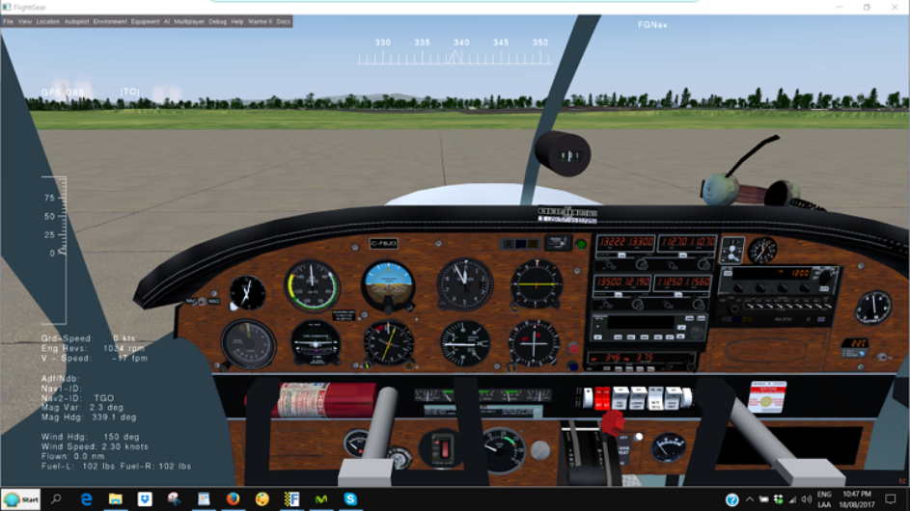
Familiarise yourself with the surroundings by switching between views
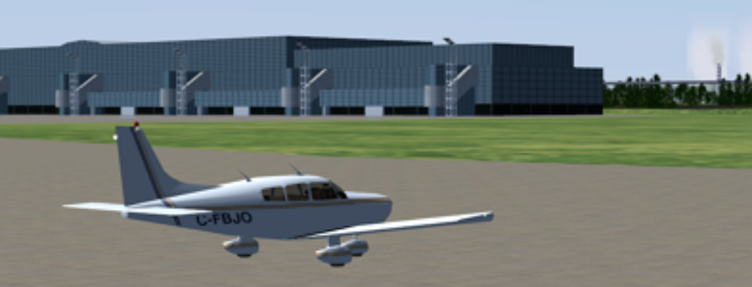
Checkout the airport layout and work out how to get to any particular runway

Important:
Either make sure you are offline or go to the Multiplayer Menu and ensure you are disconnected
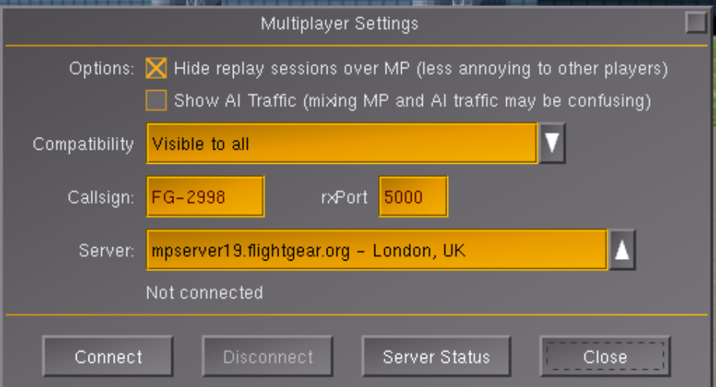
Now ready for exploring, lets roll, for steering you can either use your joystick or the arrow keys on the keyboard provided you have enabled auto co ordination in your settings.
Note:
You can also use mouse mode (Tab) for steering. If getting stuck in the mud press F for full throttle followed by Y to return to taxi rpms (about 1100 rpms)
If all over the place, press 5 to straighten up and continue. It may take a little practise.
If not, you do the real thing and steer by way of differential braking that is if you want to go left you brake the left wheel, want to go right, brake the right wheel, want to stop brake both wheels.
The , and the . keys simulate the brake pedals
b for full brake Shift b to release or set the parking brake
The engine runs at about 1050 rpms enough to get moving, to speed up or down use pgdn or pgup, thats it folks, release the park brake and taxi to a runway near you and try to stay on the yellow taxi center line.
If you are getting to fast , first brake with b and throttle down a bit, if you are getting stuck in the grass apply more throttle and reduce it once rolling again.
Oooops, we did not see that
---------------------------------------------------------------------------------------------
Or you might want to try this...
Taxi2Taxi
Start at LSZR parkpos Hangar 2
taking off on a short round trip departing from runway 28 and returning on runway 10 ILS approach Localiser 108.75 radial 98
First we need to taxi to the start of rwy 28 using the taxi way to the left, on our return we will taxi back to the Hangar but turn right after the Hangar to fill up with some Avgas.
Set the route default SID, arrival LSZR 10 default approach, start the engine, taxi to the runway, full throotle and fly the route.
You also might want to check out Taxi2Taxi from the Nav-Scenario menu

Practise Flights
001_ADF_Time_Distance | 021_Instrument_Flight_Patterns
002_ADF_Bearing_Intercept | 022_Flying_Another_Circuit
003_ADF_Tracking_Bearings | 023 – Flying a VOR/DME_or_NDB_Hold
004_ADF_Approach_NDB_Off_Field | 024_ Touch_and_Go
005_ADF_NDB_On_Field
 | 025_GPS_Simulation
006_VOR_Outbound_Radial_Intercept | 026_Route_Manager
007_VOR_Tracking_Radials_and_Bearings | 027_Adding_Custom_Waypoints
008_VOR_DME_Approach | 027a_RNAV_Procedure
009_VOR_Intersections | 028_Standard_Terminal_Arrival_Route STAR
010_VOR_DME_Arc | 029_Standard_Instrument_Departure SID
011_VOR_Radial_Hopping
012_VOR_Radial_Intercept_To NDB_Fix | 030_IFR_at_Night
013_VOR LOC (NDB) Approach without DME | 031_The_Final_Tour
014_VOR_DME_Hold | 032_Ground_Navigation
015_PAPI_Approach
016_VASI_Approach
017_ILS_1_Or_Localiser_Approach_(No_DME)
018_ILS_Cat II_Approach
019_ILS_Cat III_Approach
020_ILS CAT I_Missed_Approach_Procedure
Interesting Routes...

Loij 31 to Lowi 26 via RTT Ndb and Absam AB NDB
localiser no good, runway offset slightly

LSZS 21 to LIMC 17L - takeoff with engine leaned for max rpm

NZNS 20 to NZWN 34 via Woodbourne NZWB and Cape Campbell NDB (CC) PAPI approach

LOGM 15 to LOWG 35C

missed approach abd go around...

Approach – MHTG 02 start 8nm out at 6200 ft 120kts , set altimeter to 30.38 hg VOR/DME 112.3 13 heading 20

