Welcome Aboard your FG-Platypus

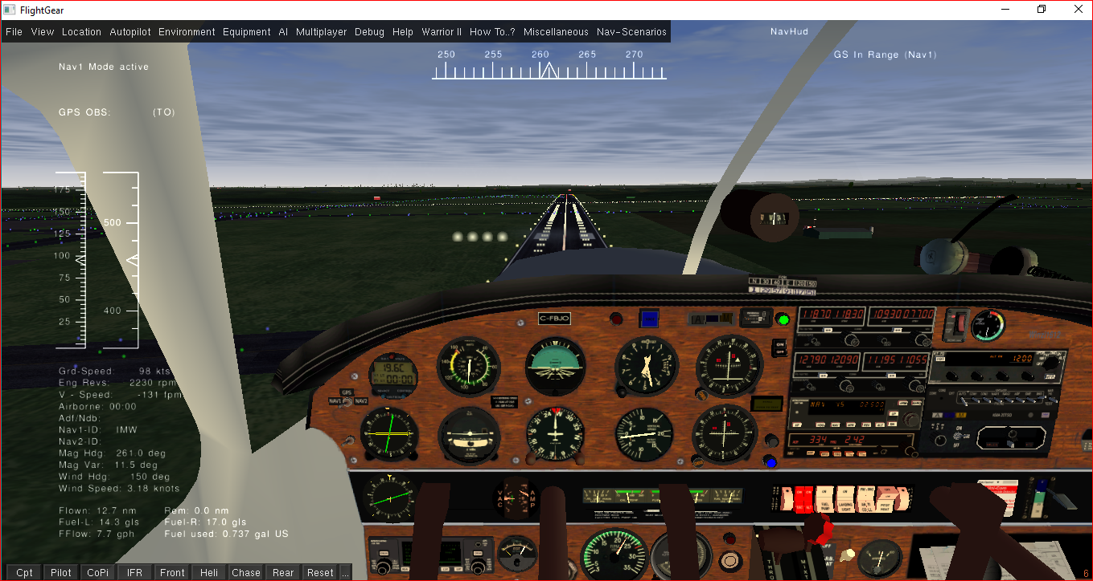
The purpose of this Flightgear aircraft is to provide you with a selection of resources relevant to aerial navigation. Throughout the documentation we will just refer to to it as - the Navigator.
Next to links to online text, audio and video resources you will also find a collection of hands on navigation practise flights as well as Nav Scenarios.
These practise flights assume a somewhat comfortable level of flying your aircraft with or without auto pilot and a basic knowledge of aviation.
No consideration has been given to real world aspects such as communication with ATC, nor restrictions of any other kind or multiplayer environment.
All of the practise flights can be performed offline provided one has access to pen, paper, ruler, copies of charts , etc.
You may need to download additional scenery from Terrasync, alternatively Terragit, as the flights more or less span around the globe.

Furthermore it is assumed that you are familiar with putting together a flightplan, how to calculate ETA and fuel consumption
The instructional material is by no means to be used for real world aviation and no guarantee of completelyness or correctness can be given, the sole purpose being to provide examples of instrument usage and procedures within the context of the flight simulator.
Online links and references are valid at the time of writing, however should a link be broken you may find the relevant info by means of your favourite search engine. If you don't happen to have a dual monitor setup or expierence internet connection problems you might wish to print what is important to you as a fall back position. We certainly recommend to have at least hardcopies of the practise flights handy.
To commence your journey we would recommend a leisurely read of Charles Wood's comprehensive yet easy to read Flight Simulator Navigation, www.navfltsm.addr.com or the downloadable pdf at
www.anaspides.net/documents/flight_simulator_documents/Instrument%20course.pdf
The practical side of it leans heavily on Microsoft FS, however most of the practise flights work in FG as well.
For instrument related info and usage here is another comprehensive online FG manual
www.emmerich-j.de/HB/EN/RNAV
You also find topics like pilotage and dead reckoning in there or you may wish to check out www.experimentalaircraft.info/flight-planning/pilotage-dead-reckoning.php
The FG-Platypus is based on David Megginson`s original Piper Cherokee Warrior II (1979 model).For relevant details such as technical specification or info on how to fly look up Help and consult the online Wikis. If completely new to the world of aviation you may wish to start with Chapter 8 of the official Flightgear manual titled A Basic Flight Simulator Tutorial using the default aircraft a Cessna.
The focus of the Navigator however purely rests on navigational aspects and practical guidance of how to do it.
Topics like flightplanning, ATC comms, pertinent rules and regulations as such form no part of this package.
Enjoy your journey and enjoy the world of Flightgear as much as we do.

Getting Started

Installation and Updates

Chances are you already have the FG-Platypus or you would not be reading this. On the other hand you might have found it on GitHub and are browsing the repository.
Either way from time to time you may want to check if there is a newer version. To do so navigate to
https://github.com/inmavi/FG-Platypus and click the download ZIP link, then unzip the lot into your Flightgear xxxx x.x/Aircraft folder or alternatively unzip it first to a folder of your choice as a backup and then move it to the Flightgear xxxx.x.x/Aircraft folder. (or a custom folder FG knows about)
Important : Rename the directory to FG-Platypus or you end up with a funny looking glider.
If familiar with GIT you can instead choose to clone the repository. To do so cd/ to your aircraft folder,
and follow the instructions on the GIHub site.

Starting Flightgear with the FG-Platypus

After having nominated your Navigator and generic start-up parameters in your FG Launcher be it QT, FGRUN, FFGO or other, the FG-Platypus will open with a Welcome Message.
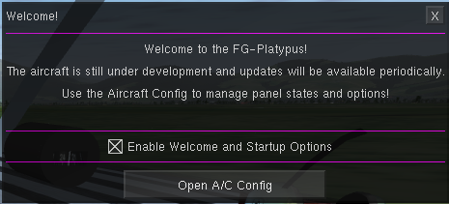

Clicking the Open A/C Config button will take you straight to the Aircraft Configuration Dialog.
You can de-check Enable Welcome and Startup Options as the A/C Config Dialog can also be opened from the FG-Platypus menu or pressing the letter w or by clicking the hotspot on the headphones.

Aircraft Configuration
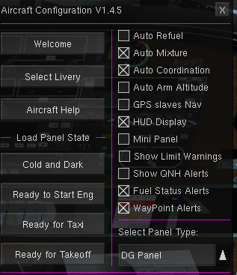

The dialog contains four sections i.e on the left you can go back to Welcome, Select a Livery and access Aircraft Help. The lower part of the left allows you to nominate in what kind of state you wish to start.On the right side you fine various options/preferences you may want to set permanently or toggle whenever needed. At the bottom right the droplist allows you to switch between three panel configurations.

Panel States
Ready to Start Engine
Avionics, Battery, Alternator are on, all you need to do is fire up the engine using the primer and magnetos and the starter after having set Mixture to full and throttle to 20%.
Ready to Taxi
Use this mode to proceed from a parking position to the assigned runway or for practising movement on the ground. You start with park brake set and the engine idling at about 1050 rpm, enough to start moving once the brake is released.
Ready for Take Off
pretty self explanatory, normal take-off roll or ref up prior to releasing the brake with or without flaps depending runway length.…
Once you select a panel state, a warning message will appear prompting you to wait until configuration is completed, just wait and do not touch keyboard or mouse or joystick.

Setting Options
Auto Refuel
By default the Navigator starts up with two full tanks. However its good practise to calculate fuel consumption for each flight as part of the flight plan and carry only what’s needed plus reserves for an alternate airport etc. If you refuel at a stopover, ideally the fuel load between tanks should be balanced as the aircraft has no cross feed unlike the Cessna.
If Auto Refuel is checked fuel replenishment is up to you in line with your flight requirements.
Auto Mixture
If selected this option controls the fuel/air mix ratio depending on altitude as the air is less dense, in other words you don't have to worry about the mixture lever or the engine dying because´of too much juice and too little oxygen.
Auto Coordination
invokes automatic co ordination of rudder and ailerons. Should be checked in the absence of pedals hardware and or joystick.
Auto Arm Altitude
If using the Auto Pilot and setting the vertical speed, setting the desired altitude is also useful. However instead of relying on memory to click the Arm button, auto arm will do just that.
GPS slaves Nav
A way of honing those radial intercept and tracking skills. The route manager supplies waypoint info to the gps and the gps in turn provides that info to VOR1. The HUD will display the bearing and you just need to keep the needle centered.
This option will disable Nav and Approach mode of the Auto Pilot.
HUD Display
Will toggle a HUD - Head Up Display on or off. State can also be overridden by pressing the h key.
Mini Panel
Currently in development, allows access to stuff like moving map(if online), the standard map, keyboard mapping and heading selector dialogue if flying via external view, etc.
Show Limit Warnings
If checked, this will display warnings once defined limits are breached like maximum flap extension speed, engine rpms, VNE, VSO,....
Show QNH Alerts
If checked this option will alert you to reset your altimeter on the ground in line with ATIS or the present ground elevation. If altitude reaches more then 7000 feet, the altimeter will reset to the generic AMSL of 29.92.On descend you will get another prompt to reset the altimeter with the correct QNH for landing.
Fuel Status Alerts
Popup displaying info like below:
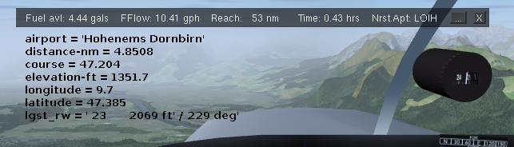
The button with the three dots will show or hide airport info as above. If the longest runway has ILS then the frequency and radial will also be displayed.

Way Point Alerts
Once you have defined your route(flight plan) and you fly this route by means of the auto pilot gps/nav mode or you fly in ap heading mode or perhaps without the aid of the autopilot, then this options will show popups whenever you are near a waypoint, which allows you to prepare for relevant maneuvers.
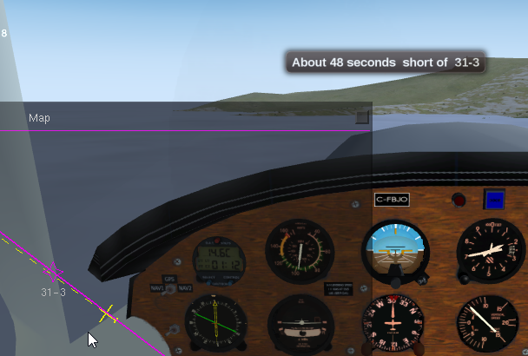

All of these options can be activated or deactivated at any time from the Config menu, however some will only take effect after a restart like auto refuel.
Whether on the ground or aloft you can revisit the AC Config Dialog any time by pressing the <w> key or clicking the hotspot on the headphones at the top right corner of the instrument panel.
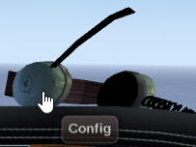

If you have disabled the Welcome Dialog you can reinstate it by selecting Toggle AC Config from the Miscellaneous menu.

Panels
The FG-Platypus ships with three different panel configurations namely a Cadet, a DG and a HSI panel.

You can switch between panel whenever by either using AC Config or by clicking the hotspot on the microphone of the headset or using the switch panel button.
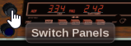
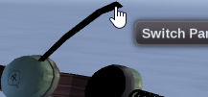

The default Cadet Panel features the classic analog instruments configuration and is more or less identical with the DG Panel which onlydiffers with a different AI Attitude Indicator model.

The HSI Panel sports a Horizontal Situation Indicator (HSI) namely the Bendix King KI525 and a selection of Digital Indicators in place of the radio panel. The Nav1 and Com1 radio set is located at the bottom left of the panel near the yoke.

The DG Panel is a placeholder for a planned glass panel in the near future.

The Platypus will remember what panel was used at the previous flight and restart with this panel.

The section below on instrumentation will detail all the instruments, levers, lights and switches making up the Cadet Panel and also will illustrate the differences found on the HSI Panel.

Instrumentation

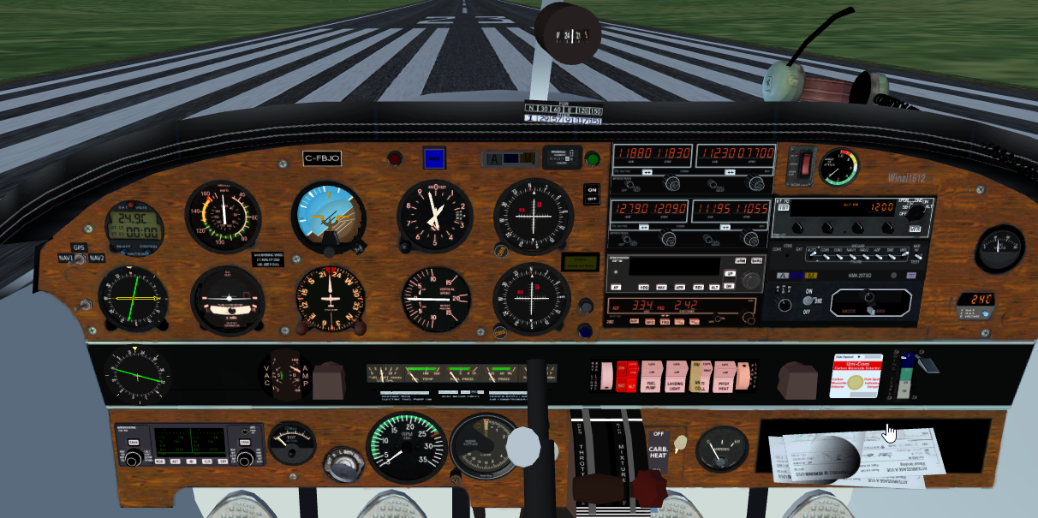
Use the bookmark links of your PDF reader to view an abridged instrument description. For more detailed info refer to the Fundamentals document located under the How To menu option.
1
2
3
4
5
6
7
8
9
10
11
12
13
14
15
15
16
17
18
19
20
21
22
23
24
25
26
27
28
29
30
0
31
32
33
34
35
36
37
38
39
40
41
42
43
44
45
46
47
48

0 – Magnetic Compass
One of the oldest aviation instruments, simple in design. The compass points to the magnetic north rather than true north. The variation varies depending on location and may be found on charts.
The compass is also susceptible to errors due to acceleration, turns or some magnetic interference.

1 – Nav Source Switch
This tiny switch will toggle between Nav1, Nav2 and GPS mode.
If the Nav Source Switch is set to GPS/Route Manager Nav mode the autopilot will fly the route as defined in the Route Manager.
Nav1 or Nav2 selection will be reflected in either Vor1 or VOR2 being active and as such selecting the Nav Source for the DME and ADF/RMI as well.
The Nav Source can alternatively be set via the AP Control Bar
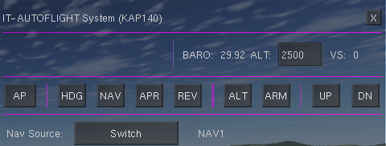
or via the autopilot popup

2 – Combined Clock/Timer/OAT
The Davtron 803 (adapted from the c182T) is a combination of clock, Timers and OAT (Outside Air Temperature). The instruments flight timer activates once airborne and logs your flight time as well as accumulated airtime in the aircraft statistics. The flighttime is also shown in the HUD as well as the Presets bar.
The red button at the top allows you to switch the display to show either Voltage, Fahrenheit or Celsius. The bottom left button toggles local time or UTC, Flight timer and Stopwatch, the right button lets you turn the stopwatch on and off. The Platypus will remember your settings between sessions.

3 – Airspeed Indicator
This instrumment also referred to as ASI displays the airspeed in knots. The colour markings vary between different models to show speed range for extending flaps, VNE etc.
The tooltip on the face shows K(IAS) whereas the tooltip on the needle shows TAS.

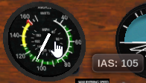
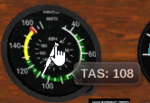

4 – Attitude Indicator (AI)
The attitude indicator (AI) also referred to as artificial horizon depicts the orientation of the aircraft in relation to level flight, providing a consistent reference when visibility is next to 0.
The small knob at the bottom allows for calibration of the instrument. The Platypus figures two different AI models on different panels.

5 – Altimeter
Shows the altitude of the aircraft above mean sea level (amsl) provided the instrument has been set correctly. You can use the Equipment Instrument Settings dialog or the little knob to set the altimeter to the correct local air pressure or ground elevation.

6 – OoF
The Out of Fuel light will be lit once both tanks are dry.

7 – Door Warning
Will be lit if the door is open or not locked properly.

8 – O M I
O M I Outer, Middle, Inner marker beacon indicators. The corresponding lights will be lit and accompanied by aural alert when passing over one of the markers at airports equipped with ILS or RF facilities.

9 – CDI VOR1
VHF Omnidirectional Range (CDI – Course Deviation Indicator) refer to the Fundamentals documentation for more info.

10 – Hobbs
Counts engine hours, can be reset only with the reset function of the statistics dialog. The Hobbs also features a hot-spot to initiate a go around.

11 – GS Alert
The green light will come on when the glideslope is in range of Nav1. Clicking the lamp will also reset the heading bug of the digital gyro as well as the HSI.

12 – Avionics Master
Master Switch to turn all Navigation Instruments on or off. Should only be turned on after engine start i.e. alternator producing current to avoid depleting the battery.
The Platypus will set the switch to off once the battery switch is in the off position.

13 – Com Nav Receivers
Right at the top of the radio panel are two sets of com nav receivers used to tune in relevant frequencies for communication with the ground as well as frequencies for navigation instruments. Rather then twisting those tiny knobs simply click the hotspot on either to open the radio dialog where you can enter frequencies, radials etc more easily.

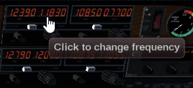

14 – ELT
The ELT (Emergency Location Transmitter) transmits a message in the cash of a crash. There is nothing to configure, just make sure the switch is in the on position.

15 – AOA
Displays the current angle of attack and also serves as an indicator of an impending stall.

16 – Transponder
Helps ATC to identify aircraft position along with altitude info and call sign

17 – Battery Voltsmeter
In case of a alternator malfunction all electrical loads are placed on the battery. The Voltmeter indicates remaining Voltage. If the engine refuses to start check this gauge first, then fuel....

18 – VOR Needle Switch
Shows a green VOR Needle on top of the RMI Needle, the Nav Source switch above determines whether the needle represents VOR1 or VOR2.

19 – RMI/ADF
No matter what heading you are on, the needle of the automatic direction finder will always point to the station provided the relevant frequency has been entered in the ADF receiver. You also have the option to toggle a VOR needle as mentioned above.

20 – Turn Coordinator
Represents ROC (Rate of Turn) and sideway forces. More detail in the get started document.

21 – Digital Gyro
The digital compass rotates to whatever heading you are steering the aircraft. The heading bug can be set as a reference or used in conjunction with the auto pilot.
The digital compass (DG) will be out of sync with the magnetic compass and needs to be re-calibrated at regular intervals.

22 – Vertical Speed Indicator
As the name implies will give you an indication of your vertical speed while climbing or descending. The instrument usually lags a fair bit until providing reliable info.

23 – CDI VOR2
Nav2 - VHF Omnidirectional Range (CDI – Course Deviation Indicator) refer to the Fundamentals documentation for more info.

24 – Stall Warning
This indicator will be lit whenever you encounter a stall situation

25 – Instrument Panel Switch
Allows you to switch between the three instrument panels

26 – Flaps Indicator
This light is lit whenever the flaps are extended

27 – AutoPilot
Refer to the auto pilot section below for details

28 – ADF/NDB
Receiver for the NDB signal, source for the RMI, also has a timer as well as lets you enter a standby frequency.

29 – KMA20
You might call this your sound mixer to manage all the beebs. Refer to the How to tame the beebs document for more info.

30 – DME
Provided an airport has the relevant infrastructure this instrument will give you an indication of distance, time and groundspeed. However the distance displayed happens to be slant distance which varies with altitude. Moreover the station may be located well ahead or behind a runway.

31 – Secondary OAT
The primary function of this instrument is to display the outside temperature in celsius or fahrenheit degrees.

32 – WindRose
This is not a real instrument, but only an indicator in which direction the wind is pushing the aircraft to. Maybe useful on approaches featuring cross, head or tail wind.

33 – Vac Amp
Displays status of suction in hg and battery amps

34 – OilFuel Gauges
Oil and Fuel Gauges, Fuel contents of both tanks is also displayed in the HUD. For info on fuel management and how to switch between tanks refer to the Fuel Management documntation.
The gauge bar also contains a hotspot which will open the weight and balance dialog to adjust fuel and or passenger/cargo weights.

35 – Switch Panel

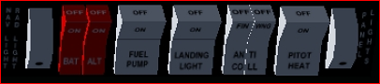

Probably pretty self explanatory – all the switches can also be operated via the keyboard (refer to Keyboard section in this document for more info).

36 – CO2 Detector
In a real aircraft this sticker will change colour in the event of carbon monoxide is present in the cabin.
For the Platypus the sticker serves as a hotspot to open the route manager dialog.

37 – Flaps Lever
The real PA28-Warrior has a flaps lever between pilot and copilot seat, in the simulator a little difficult to operate without moving the view. Therefor the Flaps Lever on the panel acts as a replacement for operating the flaps with the mouse. You can also use a keyboard shortcut instead.

38 – GPS Unit
Used by the route manager and autopilot to navigate between waypoints, but can also be used to determine headings in conjunction with slaving Nav1 i.e. the CDI will show wether on course or not.
Has a hotspot to open the GPS dialog

39 – EGT
Measures exhaust gas temperature

40 – Magneto Switch
Toggles between off, left, right, both and starter, should be on off once the aircraft is stationary to avoid inadvertant engine start.

41 – Tacho
Displays the engines rpm and also features a hotspot to toggle the throttle between naught and 100 percent.

42 – Radio Altimeter
Shows altitude above ground as opposed to AMSL

43 – Park Brake
The equivalent of the handbrake in the car

44 – Throttle Lever
Regulates engine rpms and subsequently airspeed

45 – Mixture Lever
Adjusts the fuel air ratio for the carburetor

46 – Carburetor Heat
Turns the carburetor heater on off to avoid icing

47 – Battery Gauge
Shows if the alternator is charging, the needle will flicker a fair bit

48 – Chart Hotspot
This hotspot is just another means of opening the standard map

General: - knobs work in both directions using scroll or left mousebutton
- mouse buttons on knobs advance or regress one degree or unit at a time
- mouse wheel depending on instrument between 3 and ten degrees
- to match the Compass with HI/DG heading look at the tooltips

For general information on instruments refer to http://wiki.flightgear.org/Avionics_and_instruments , and for more specific info on navigation instrument usage we recommend the reading of www.emmerich-j.de/HB/EN/RNAV

HSI Panel

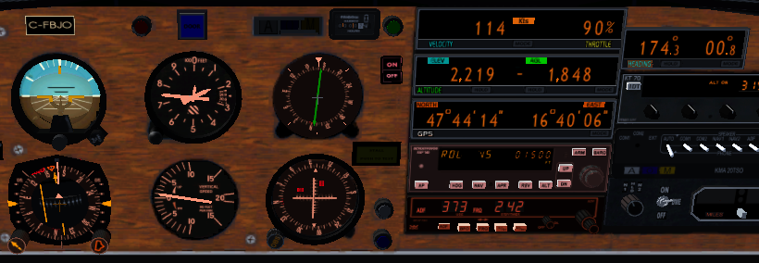
1
2
3
4
5
The HSI panel only differs with a few instruments:
1 – The Horizontal Situation Indicator (Bendix King ki525) adapted from the SenecaII
You might want to get yourself a copy of the Bendix King KCS55 Pilots Guide here --

https://www.bendixking.com/HWL/media/Pilot-Guides/006-08256-0004_4.pdf

Straight out of this publication when and how to use this great instrument, a combination of a VOR and a Digital Gyro. One of the beauties of this instrument is that regardless if you are flying to or from the station, there is no reverse sensing IE. if the needle is to the left you steer left, if the needle is right you steer right.

The following instruments have been adapted from the BlueBird, a fantastic futuristic craft.

2 –Digital Velocity Indicator showing airspeed and throttle settings, display can be changed to view knots, km/h or mph
3 –Digital Altitude Indicator showing both AMSL and AGL, display can be toggled between metric and imperial
4 –Digital GPS Indicator displaying longitude and latitude
5 –Digital Heading Indicator

The only other difference is the location of the com1/nav1 receiver now found underneath the Turn Coordinator.

Hot Spots
Hotspots in general are used to make an object clickable for some action to occur. If you want to see what is clickable on any aircraft within Flightgear simply press <CTRL> C (toggle)
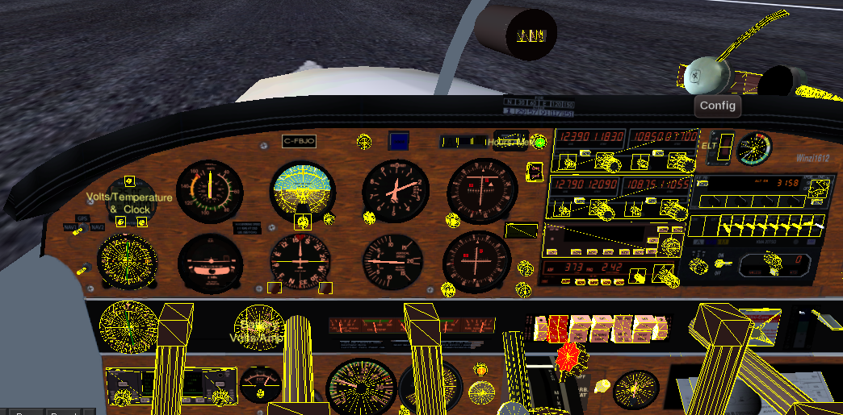

Hotspots & Digital Readouts(Tool tips)
Most of the hotspots are used to display instrument related properties such as speeds, rpm, radials, bearings etc. A select few however will invoke some action such as opening a dialog, turning knobs, pushing buttons and so forth.
Actions can be invoked by means of using the menu, shortcut (hotkeys) or alternatively hotspots

Hotspots for displaying static or dynamic information are:
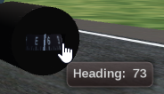
Some examples below: (old screen dumps)
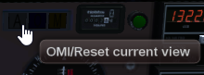
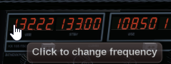 | 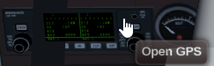

HUDS – Head Up Display
Realistically GA crafts don’t come equipped with HUDS, but because the Navigator was designed also taking the needs of the visually and hearing impaired into consideration we have included a set of Huds that can be easily turned on or off as desired.
At times given the size of monitors instruments may be hard to read, on other occasions a view may be zoomed to a degree hiding a specific instrument like for example the DME.As such important data is displayed in the HUD which also allows to fly the aircraft from the outside.
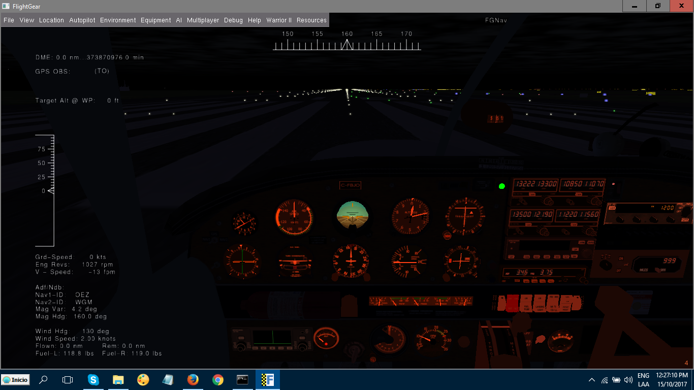
Pressing the letter h will toggle between colours as at times the outside may be too bright or to dark, after cycling through all available colours pressing h again will turn it off and on.
Pressing Shift I will toggle between the available HUD versions
The check box within Acconfig will allow to toggle the Huds on/off without the need to cycle through the colours.

Autopilot

KAP140 / ITAF

The Navigator comes equipped with an auto pilot namely a modified version of the Bendix King KAP140.
Whilst the unit looks the same as the standard version, its core functionality has been modified and extended by the seemless integration of the more sophisticated IT_Autoflight (ITAF) Autopilot developed by Joshua Davidson.
This means the Hybrid now supports waypoint navigation via Route Manager/GPS resulting in two NAV modes, one to follow the Route Manager and one for the original VOR Lock mode.
The auto pilot can be activated from either the panel embedded KAP140 unit as shown below
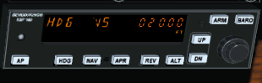

or alteratively from the ITAF dialog
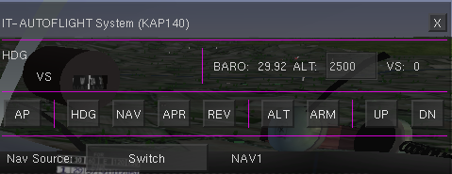

which provides both more functionality and a much friendlier interface. By default the dialog will open at the bottom left corner thus not obscuring the pilots view. To display the ITAF press F11 or click the face of the Kap140 or choose the menu or press <i > to toggle.
The AP Control Bar offers another interface
KAP140
If not already familiar with the operation of the generic KAP140, the following link will take you to a Wiki explaining its basic modus operandi. It is vital to be familiar with the equipment, its shortcomings in particular, as otherwise you might be in for some rather nasty surprises.
http://wiki.flightgear.org/Bendix/King_KAP140_Autopilot
Prior to examining the extended functionality the interface of the ITAF provides, a brief recap of the various modes:
AP turns the auto pilot on with ROL and VS modes activated, that is wings level and current pitch maintained be it level, ascent or descent.
WARNING
Pressing AP again will turn the autopilot off, however not immedeately. It will flash for a little while prior to receeding control to the pilot.
Due to that delay in release the auto pilot should not be used at take off and turned off well before touch down.
HDG the AP will follow the direction of the heading bug of either the digital gyro or the HSI
CAUTION
The Autopilot will always turn the shortest way to the left or right. A turn must not exceed 180 degrees or the autopilot will suddenly turn in the opposite direction midturn because the other side now has less degrees to turn to.
In order to turn more than 180 degrees you need to break up the turn into phases like the first turn to 120 and just before there turn another 90.

VS the AP will ascend or descend continuously at the fpm rate specified using the UP/DN buttons.
(Increments/Decrements are in 100ft lots)
One problem with VS may occur just after takeoff, when the AP senses the required VS based on pitch, air pressure and other parameters and sets your VS at 1500fpm or more. Your low powered engine can not sustain that and you will stall.

ALT activates the altitude control. Pressing ALT will stop the plane from its current climb or descend by levelling out provided no desired altitude has been preset.
If a wanted (preset) altitude has been set and armed, ALT will automatically activate with at first the plane slightly overshooting the target and levelling out on target.
Subtleties
If the armed preset altitude differs from the current altitude you are going to climb or descend based on the +/-fpm (UP/DN) settings.
preset/armed 6000 current 3000 +600fpm result altitude hold in 5 minutes preset/ armed 4000 current 4200 +500fpm result climb until out of fuel
preset/armed 5000 current 3000 -300fpm result crash in 10 minutes
Clicking ALT again will cancel altitude hold whereas pressing (UP/DN) will take you back into VS mode.
Note:
To set the desired altitude using KAP140 use the wheel to increment/decrement setting by 100ft lots, using ITAF you simply nominate the wanted altitude in the ALT: box and then press the ARM button.

NAV switches from ROL or HDG mode to follow the course set in "NAV1“ or "NAV2". The AP will then attempt to intercept the radial set in the OBS and track it following the VOR CDI. The intercept angle however should be less than 60 degrees.
If the Nav Source Switch is set to GPS/Route Manager Nav mode will fly the route as defined in the Route Manager.
APR arms the approach mode and activates the ILS/GS-Approach once the Nav receiver senses the Glide-slope in range.
REV switches to LOC Back Course mode (refer to the ILS topic) NOT IMLEMENTED YET

Note:
Other FG aircrafts come with their own KAP140 Version, original or modified, so if you fly another aircraft with a KAP140 check the documentation, if there is no doco.....
The autopilot also has been set up to not activate on ground and deactivate on touchdown!
Once airborne, the ap can be toggled on/off using the spacebar

Keyboard
The standard Flightgear keys apply in addition to aircraft specific shortcut keys. These are listed in the Help Menu or can be looked at by pressing Shift K
Most of the custom key bindings are identical with the original Piper Cherokee Warrior. However the Platypus has a lot more custom keys...
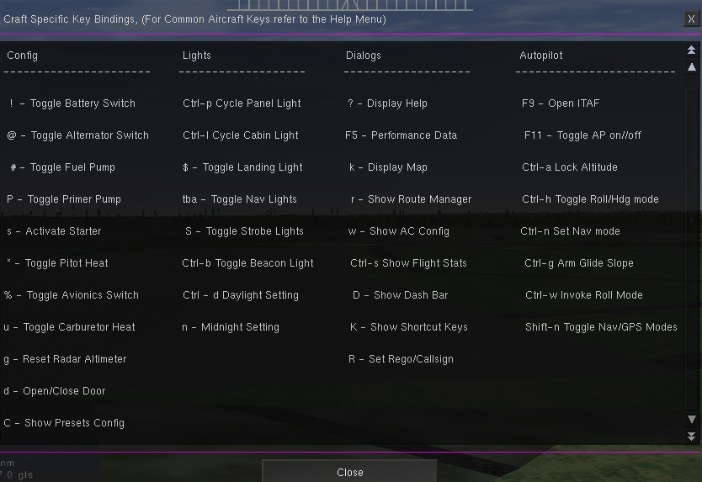
If however you wish to use the standard keyboard for sake of consistency with other aircrafts you will need to remove the include keyboard line in the WarriorII-main.xml file
<input>
<mice include="mice.xml"/>
<keyboard include="Systems/pa28-keyboard.xml"/>
</input>

Menu's
= work in progress

How To’s..

Work in progress

