Generic and aircraft adapted multi key functionality.

The FG Platypus comes with a generic implementation of multi key and also has an optional custom version. The standard version offers a variety of commands applicable for aircrafts using the generic auto pilot which will not work an aircrafts with other auto pilots.
Although one can have an option A to be configured for aircraft specific key commands, the standard command list will be displayed below.
The multi-key feature has its use whenever an aircraft needs more shortcut keys then available from the alphabet, complex instrumentation or simply if keyboard operation is preferred to mouse ops.

To install the custom version follow the steps below:

Copy the file FG-Platypus-multikey.xml from the resources folder to the root (data)/input folder.
Rename the file multikey.xml like original_multikey
Rename the FG-Platypus-multikey file to just multikey.xml and you are set.

How to use ?

The colon key (:) will open up the multikey menu, just press the <Tab> key to access the key categories

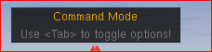
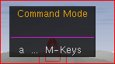

press the key <a> to view the available options

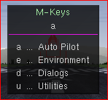

The a above the line stands for aircraft
Press <e> to open the Environment options, the a e above stands for aircraft, environment
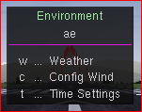

press <w> for Weather Conditions followed by <s> for
scenario
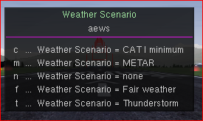
select c for CAT I minimum and it should start to rain provided precipitation is checked in the rendering options found in the Environment Menu

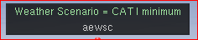

Often the chosen command will execute straight away, sometimes like in the above example you may need to press <Enter> to ex
ecute the command.

To step back from a command option just press the <Backspace> key, to close multi key simply press the <Esc> key.

For more information on the multi-key feature checkout the corresponding wiki

wiki.flightgear.org/Howto_Add_multi-key_commands_to_an_aircraft.html

The FG-Platypus version is highly experimental, so use at your own risk.

