Fuel Management

For detailed technical specs you may wish to refer to the authentic Pilot Handbook (POH). A fuel system schematic can be seen on page 136.

http://www.sfcaero.com.au/pdf/PA-28-161%20Warrior%20II.pdf
Although the total fuel capacity is stated as 2 x 24 gallons US, by default, the aircraft is loaded with 2 x 17 gallons US, known as fuel to tabs. This is because 17 gallons is marked inside the tank with a small tab, visible from the opening inside the fuel cap.

However, excess fuel translates into excess weight, causing more consumption, and higher costs.

To change the amount of fuel in the aircraft, select Fuel and Payload from the Equipment menu.
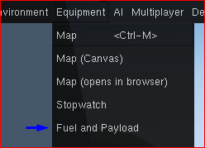

You will be greeted with the following dialog:

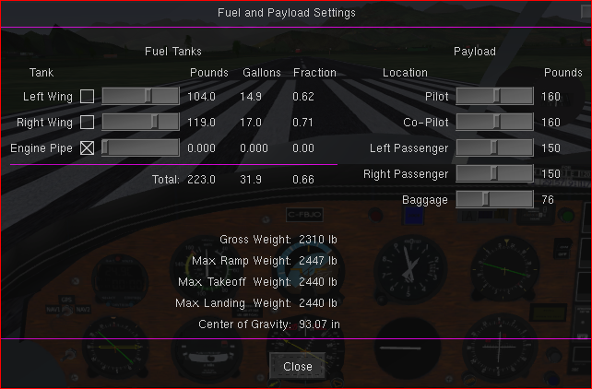

Here you can adjust the fuel in the left and right tanks.

Do not adjust the fuel in the Engine Pipe, it will do nothing. This pipe is only here to transfer fuel from the tanks, to the engine. This is done by the fuel system in the aircraft, and does not need any user interaction.

Do not touch the check boxes besides the tanks. They will not do anything, because this aircraft has a custom fuel system. To change tanks, you need to switch the tanks via the lever in the cockpit.

When the fuel in the fuel gauge becomes low, you will need to switch the tanks. You may want to also switch them if the capacity difference in the left and right tanks is more than 5 gallons, to keep the tanks balanced.

Be aware that the fuel tank indicators may not be fully accurate. This is true to the real aircraft. Always check the fuel level on the ground, and do not fully rely on the indicators!

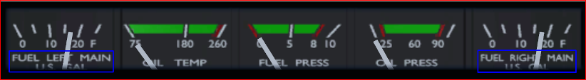

There are 3 ways to switch the tank. You can use the fuel knob located on the left side panel, the Fuel Tank slider in the Control Panel dialog, or the “j” key on the keyboard.
The fuel selector is visible in IFR view (if your view bar is displayed – Toggle ViewBar menu)

Warning: Switching the fuel tank selector to the “OFF” position will cause the fuel feed to the engine to be cut off!
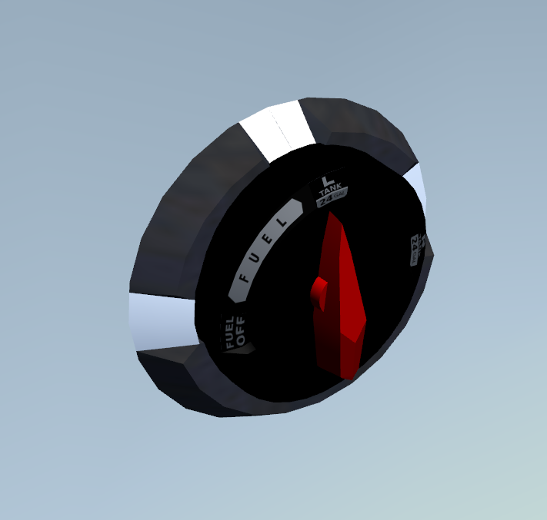

Fuel can be adjusted with more accuracy using the Mass Weight Balance Dialog as shown on the next page.

Please note that you can not refuel with the engine running, neither on the ground or in air.

This means always check, adjust your fuel while the engine is off, because otherwise if you have de checked Auto Refuel in Config and a previous flight left little in the tanks you may run out of fuel once aloft.

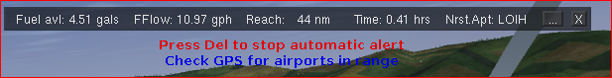

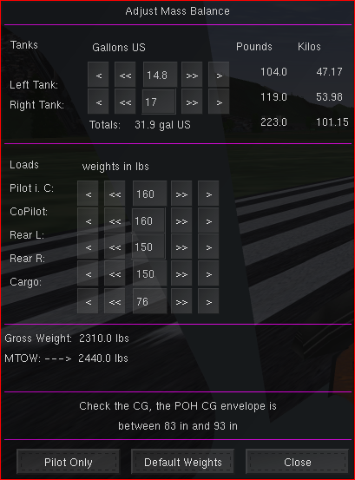

Apart from defining exact fuel quantities, this dialogue also allows you to specify the weight placed onto each seat and baggage. The weight distribution is used to calculate the CG which should be within the CG envelope to avoid balance problems resulting in nose heavy or tail heavy etc.

Also you can switch tanks manually, if you forget the Navigator will switch from the left to the right tank if the left has just 1 gallon left which is considered unusable.

Moreover if you have checked Fuel Staus Alerts in the Aircraft Config, you will be notified if and when running low or dry.

Such incidents are also registered in the flight statistic.

Use this dialogue also before flights involving steep climbs and or high altitudes as you may wish to keep the weight down by adjusting or eliminating backseat and baggage load or perhaps fly with pilot only.

These settings can not be changed once airborne.

