Lexmini: share what the translator needs

A translator needs a document without private client details
A legal translator must translate a document for a law firm. She wants to use a translation tool such as DeepL, but the document contains names, addresses, birthdays and confidential case information. She needs a useful copy without those details.
The law firm needs to identify the sensitive fields, review them on the document and approve what stays visible. The translator receives a copy with placeholders such as [PARTY_00001] and [DATE_00002]. The firm keeps the original values separately.
Sometimes the translator needs a particular detail to finish the work. She asks the lawyer, who can grant access to that field for a limited time and revoke future access. The firm also wants its approved labels to improve the screening of later documents.

The firm reviews, then shares
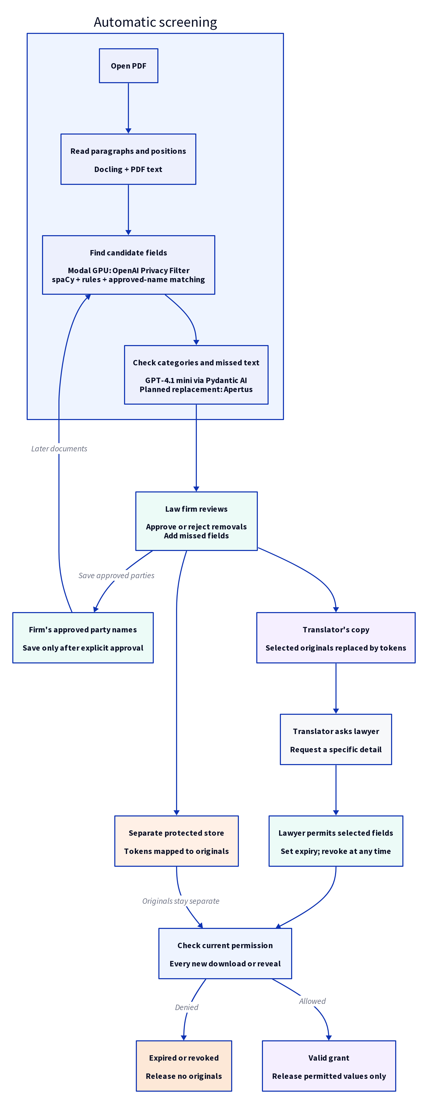
Diagram 1. From the firm’s PDF to a reviewed copy and controlled release of originals.
- Load the document. The firm opens a PDF. Lexmini reads its paragraphs and finds candidate names, dates, addresses, medical details and legal references.
- Review the findings. The interface highlights the text and groups findings by category. The lawyer approves or rejects removals and adds anything missed. Changing a value changes equivalent mentions in the document.
- Save approved parties. The lawyer explicitly saves recognised clients and aliases for future screening within the firm. Other findings remain specific to the document.
- Send a useful copy. The translator receives the reviewed document with selected details replaced by tokens. Legal wording and approved context remain readable.
- Allow a targeted reveal. If the translator needs a detail, she asks the lawyer in conversation. The lawyer changes the permission and she downloads a new copy containing only the permitted originals.
- Expire or revoke access. The server checks permission on every new release. The lawyer can stop future releases before the grant expires.
Open the real French Swiss document.

Three tiers: public, personal and legal-risk
Each finding has a field type and a sensitivity tier. The field type says what it is, such as a name, date or medical detail. The tier says how we handle it in the shared document.
Tier | What belongs here | Starting action
1. Public | Published laws, legal citations and general information that does not reveal the client or their matter. | Keep visible.
2. Personal | Private information about a person. | Select for removal; the reviewer decides.
3. Legal-risk | Confidential information about a client, their case, the firm or their business. | Select for removal; the reviewer decides.

1. Public
- Legislation: published laws and regulations.
- Legal reference: references to legislation and published judgments, such as ATAF 2015/11.
- General concept: legal terms such as appeal, contract or jurisdiction.
- Public event: published events and ordinary dates, unless they reveal confidential case information.
Published personal names still need review. A public source does not automatically make a client’s identity safe to share.

2. Personal
- Identity: names, birthdays, home addresses and identity numbers.
- Contact: email addresses and telephone numbers.
- Financial: personal bank accounts, payments and invoices.
- Health: illnesses, diagnoses, medication and treatment.
- Beliefs: religion and philosophical beliefs.
- Criminal history: accusations, convictions and previous criminal cases.

3. Legal-risk
- Party: clients, companies, other parties and their relationships.
- Matter detail: sensitive case dates, locations, business addresses and financial details. An ordinary date is not sensitive just because it appears in a case.
- Legal work: advice, case facts, strategy, defence preparation and drafts.
- Related proceeding: previous cases and other cases still in progress that reveal confidential context.
- Business secret: trade secrets, inventions and private technical information.
- Firm record: time records and information about the firm’s work.
- Access secret: passwords, recovery answers and login codes.

How the tiers control reveal
Personal and legal-risk can both apply. A client’s name identifies a person and links them to a confidential matter. Revealing it requires both permissions. Permission for one tier does not grant the other. Access to the document itself is also required.
Public and protected do not apply together. If a public fact reveals confidential information in this document, use the relevant protected tier and record why.
The stored category names are personal-private and professional-secrecy. The guide calls them personal and legal-risk.

Real French Swiss example
The demonstration uses Federal Administrative Court judgment E-1088/2022, 7 November 2022, which is already published with some identities concealed.
- Legal reference - public: ATAF 2015/11 links the reasoning to a published judgment.
- Health - personal: the medical-history paragraph describes a diagnosis and medication. The reviewer can also mark it legal-risk when it reveals confidential case facts.
- Identity - review required: names of judges or lawyers need a role check. Their professional title does not automatically exempt every mention.
- Date - context decides: a routine procedural date can stay visible; a birthday or a date that identifies confidential events may need removal.

Approved labels improve the next document
The firm may start with a collection of PDFs and no client database. A model can recognise a name but cannot reliably decide whether it belongs to a client, colleague or judge. Staff make that decision in the review interface.
Save only approved party information. Explicitly approved names and aliases become screening memory for that organisation. Model guesses and temporary selections do not become permanent rules. Later documents are checked against the approved names as well as the models.
Keep uncertain matches reviewable. Close spellings help find repeated names, but matching text does not prove that two people are the same person. A lawyer can also be a client. A professional title must not automatically cancel an approved sensitive classification.
Keep the registry small. Store the approved party, aliases, organisation and approval record needed for future checks. Dates and unrelated terms stay within their document. The recipient does not receive the firm’s registry.
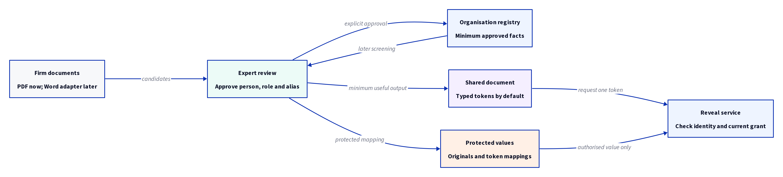
Diagram 2. Approved facts improve later screening; recipients receive tokens, not the registry.

Separate tokens from the permission to reveal
The document contains placeholders. The protected store holds the original values. An access key or link gives the recipient permission to request particular originals; it does not contain the full lookup list or an offline decryption key.
The intended service checks the recipient’s identity, organisation, document version, required tiers, expiry and revocation before releasing a value. A login session does not preserve an old permission after it has been revoked.
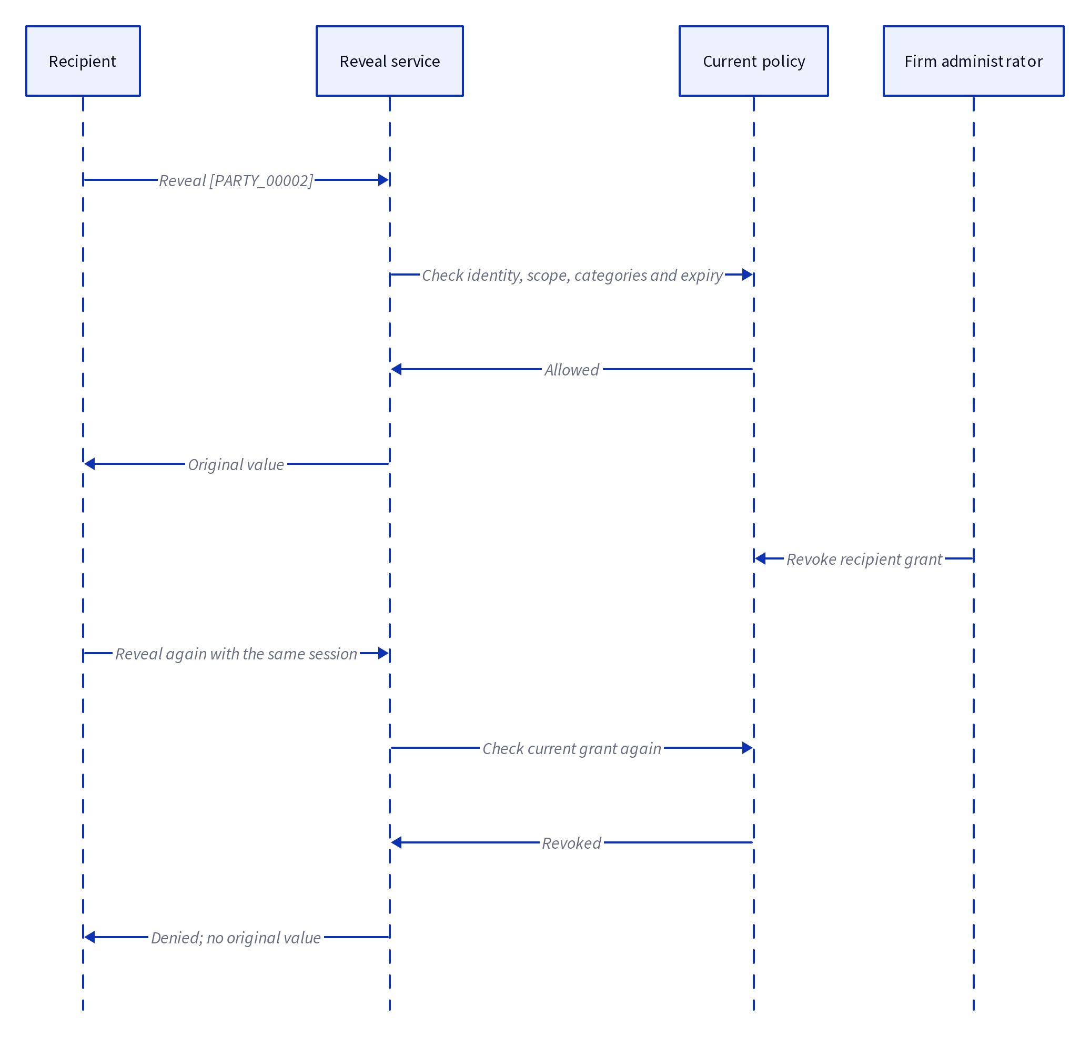
Diagram 3. Revocation changes the next server decision even when the recipient keeps the same document and session.
Revocation controls the next release. It cannot erase a value already downloaded, copied or remembered. This is why original values stay behind the service and each new release requires an online check.

Overall governance design
The firm controls the original values. Recipients work with a tokenised document and receive only the values they are permitted to reveal.

Data ownership and scope
- Organisation: keep each firm’s documents, approved party names, original values and access records separate. A match in one firm must not expose another firm’s client list.
- Document and version: review a specific document version. Bind sharing permissions to that version so changes do not silently inherit an earlier approval.
- Field: record the field type, sensitivity tiers, token and review decision. A field marked personal and legal-risk requires both permissions.

People and approval
- Reviewer: a member of the firm approves removals and permitted reveals. For this prototype, anyone with access to the curator interface can make those changes.
- Recipient: the translator receives the tokenised copy. They ask the reviewer for a specific reveal in conversation; the reviewer changes the grant and the translator downloads a new copy.

Access, expiry and revocation
- Permission: limit a grant to the recipient, document version and permitted fields. Permission to reveal one value does not grant the full key map or a fully restored document.
- Expiry: prototype grants last 60 seconds by default. Record the expiry with the grant and allow earlier revocation.
- Release: check the grant on the server whenever a recipient requests a new copy. Release only the permitted values. Expired, revoked or wrong-version grants are denied.
- Revocation: stop future releases immediately after revocation. A value already seen or downloaded cannot be taken back.

Audit and retained records
- Audit: record who issued or changed a grant, its permitted fields and expiry, and allowed or denied release attempts. Keep original values out of routine audit messages.
- Approved memory: save party names and aliases only after explicit approval. Use them to flag later documents within the same organisation. Dates and other ordinary values remain document-specific.
- Retention: the organisation sets how long to keep source documents, original values, approved aliases and audit records. Automatic retention enforcement remains implementation work.

Firm policy
- Conflicts of interest: keep company restrictions in the firm’s governance policy. A Swisscom/Sunrise restriction needs an explicit rule; recognising the names alone does not create a conflict. Conflict checking is on the roadmap.

Hosting and prototype limits
- Hosting: use the same boundaries for a managed service or a company-hosted installation. New reveals require the service to be online.
Prototype boundary: the real-document sharing flow uses temporary bearer links and in-memory grants. Verified recipient sign-in, durable organisation isolation and a persistent audit store are still needed for the full design. The curator interface is trusted and must not be given to outside recipients.

How the current processing works
- Paragraphs and positions: Docling identifies document structure; PDF text positions place findings over the original words. This helps the detector read a medical sentence across line breaks.
- Privacy detection: OpenAI’s Privacy Filter runs on a graphics processing unit (GPU) on Modal to identify potentially sensitive spans.
- Language checks: spaCy natural language processing (NLP) models, date rules and legal-reference rules add candidates. Exact and close-spelling matching check for repeated approved names.
- Final quality check: GPT-4.1 mini runs through Pydantic AI using the OpenAI API. It checks bounded groups of text and findings, suggests changes to existing candidates and adds missed exact quotations. It does not rewrite the document.
- Human review: the lawyer reviews the proposed removals. The quality check cannot override confirmed human choices or automatically save party memory.
Model choice: GPT-4.1 mini and GPT-4.1 both passed six targeted checks on excerpts from the real French Swiss judgment after the instructions were clarified. This small comparison supports using mini for the prototype; it is not a full detection-quality evaluation.
Planned model change: replace the final OpenAI language-model check with Apertus. Keep the same structured edits, exact-quotation checks and human review when evaluating that replacement.

How this meets the data-minimisation challenge
The flow is document intake, field review, translation and controlled reveal. The reviewer decides which fields the translator needs, replaces unnecessary details and keeps useful context. The three tiers explain how fields are handled. Separate originals and checked releases show where data goes and who can receive it.
The prototype demonstrates this flow with real documents. Verified recipient sign-in, durable storage and organisation enforcement remain part of the deployment work described above.

