**TEST 2: 45 min**

**New feature** – ability to import tables into Earnix program using additional and new file format – CSV

See the example:

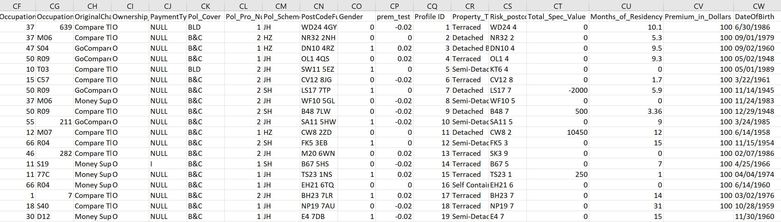

**Requirements:**

1. Columns of the table can contain data of different type: Date/Integer/Nominal/Binary/Text/Real/Money
2. The import can be done from different Data Bases.
3. The limitation of number of columns – 100
4. The limitation of Nominal Values per table – 2.000.000 and per total of tables – 50.000.000
5. Upon import, there is a mechanism of “type guessing” which will identify the type of column automatically, however, this can be changed manually if needed.
6. Empty cells (missing values) can be automatically changed upon import to a specific value chosen by the user. This feature will change all the missing values of the table at once.

**Questions:**

1. Identify a few missing requirements and make them up.
2. Write as many tests as possible for the new feature above. Try to make them as detailed as possible, but no need to write them as detailed as test cases. 1-2 sentences of the test and 1 sentence of expected result will suffice.
3. Put each test you have written in one or more of these categories:
4. Sanity testing
5. Positive testing
6. Negative testing
7. Regression testing
8. Integration or Compatibility testing
9. How will you check the correctness of the file?
10. How much time do you think you will need to write the entire test plan, test cases, and execute them?