12/17/2019

Smart Dev Worldwide

Website Development Proposal

Inna Soldatkina

The university of Winnipeg, PACE

Web Development Diploma

**From**: Inna Soldatkina, Project Manager, Smart Dev Worldwide (SDW)

**Email**: soldatkina-i@webmail.uwinnipeg.ca

**To**: Brent Scott, Instructor at PACE, The University of Winnipeg

**Re**: Proposal – Capstone Project

**Date**: December 17, 2019

**Executive Summary**

Dear Brent Scott,

Thank you for offering to participate in the travel website creation project. It is a great idea to develop a travel blog, as traveling becomes quite popular due to the popularity of social media where people are sharing their experiences with others. Advising people what countries to visit, how to save money, or how to adapt to a specific culture plays and will continue to play a vital role in the future of our society, as today’s world is becoming more globalized than ever.

Together with that, the days when we knew for certain that everyone was viewing the web on a desktop or laptop computer are gone. Increasingly, people are accessing the web on a variety of devices – tablets, smartphones, for example. If a website doesn’t support those devices, this can negatively affect how users interact with the business it presents. The Smart Dev Worldwide team can turn this problem around using responsive design. We will develop the website to adapt and scale to whatever kind of device the user is viewing from. We’ll test it on a variety of devices - mobile and non-mobile - to ensure the experience is consistent and the website is easy to use.

Also, our content creators and designers will make sure that the travel blog stands out from other competitors’ websites with the help of unique color scheme, layout, Photoshop effects, and CSS3 technologies.

We are looking forward to working with you.

Sincerely,

Inna Soldatkina

Project Manager

Smart Dev Worldwide

**Contents**

**1. Background** 4

**2. Goals and Objectives** 4

**3. Project Requirements and Deliverables** 4

**4. Target Audience** 5

**5. Project Scope** 6

**6. Company Description** 7

**7. Budget and Timesheet** 8

**7.1 Planning/Exploration** 9

**7.2 Design/Content** 9

**7.3 Coding/Programming** 10

**7.4 Launch/Maintenance** 10

**8. Conclusion** 10

**9. Appendixes** 11

**9.1 Content Outline** 11

**9.2 Sitemap** 12

**9.3 Wireframe** 15

**9.4 Mock-ups** 16

**9.4.1 Home Page** 16

**9.4.2 About Me Page** 17

**9.4.3 Destinations Page** 18

**9.4.4 Ukraine Page** 19

**9.4.5 Turkey Page** 20

**9.4.6 UAE Page** 21

**9.5 Workback Schedule** 22

**9.6 Invoice** 24

# **1.0 Background**

The project is about creating a travel website, which is expected to gain a big audience and bring income with the help of advertising and participating in affiliating programs in the future. Inna Soldatkina is a young individual who likes to travel while working and studying abroad. She has a valuable experience of leaving in foreign countries and can share it with the public. Originally, she is from Ukraine. She lived in the USA for 5 months, worked and lived in the UAE and Turkey, visited Egypt, Oman. Currently, she is in Canada and has a lot of information to share about this beautiful country. As in the future the number of countries visited by her is expected to grow, it is high time to create a fully-functional and appealing website to store her posts, pictures, videos and other data that others may find interesting.

# **2.0 Goals and Objectives**

Inna is expecting that her new website will help her to gain website visitors, as well as followers for her Instagram profile. The website should stand out from the other travel blogs and present original content. The ultimate goal is to increase the website traffic to make the additional income on adds and affiliate marketing, as well as selling digital products in the future.

# **3.0 Project Requirements and Deliverables**

The website should meet the following requirements:

* Social media icons are present and found easily to link the blog with Instagram, Facebook, Twitter and Pinterest profiles.
* Clear “call to action” on the main page that redirects a user to About Me page where the information about the Instagram account is found, together with a form allowing website visitors to contact Inna.
* Each page contains appealing visual content; however, the size of each page doesn’t exceed 150KB.
* The design of website pages looks professional, modern and presents Inna’s unique personality.
* The website pages are easy to navigate and have good contrast for the content to be readable.
* Each page should be visually appealing, follow similar design patterns, and use modern technologies to attract the user’s attention.
* The support of all major browsers is required; however, it is not necessary for the website to be fully supported in older versions of Internet Explorer as the main audience is using more popular browsers.

# **4.0 Target Audience**

The main travel website audience consists of mostly young people who enjoy traveling and exploring the world. With the creation of social media, the new generation is trying to stand out from the crowd, while traveling to new countries. This helps them to create unique content for their blogs and social media profiles.

The secondary audience includes people who are looking for advice while planning a vacation and deciding where to go. Also, there are many other travel-bloggers around the Web who may occasionally visit Inna’s Travels website once it is launched and its traffic is increased. It is important to follow the win-win strategy that exists in the bloggers’ community, which is about supporting and promoting posts of other bloggers, as they will do it for you in the future directing traffic to your blog. Besides that, Inna’s Travels website should be unique and have interesting content to compete with numerous travel-blogs.

Since the primary audience is a young generation, they will access the website via different devices. It is crucial for the project success to develop an appealing and responsive mobile version, as young people are usually searching for everything on their smartphones.

# **5.0 Project Scope**

To fulfill the needs of Inna’s travel website Smart Dev Worldwide is proposing implementation of the following:

1. Each page will have the same main navigation which is user-friendly and well-structured. It will also be responsive as the screen size gets smaller.
2. The website design will have some similarities on each page showing the website’s own style and image. The color scheme will be maintained.
3. The logo will be created by Smart Dev Worldwide and we assume that there are no special requirements for the logo itself. It will be placed on the upper left corner on each page.
4. The main page will have a “Start” button of bright color in the header redirecting to the About Me page where the contact form will be located, together with the description of the blog. It is assumed by Smart Dev Worldwide that the form is not expected to get any secure information, so the additional security will not be implemented on the website.
5. Social media icons will be present and stand out from the rest of the content to be noticed by visitors. Also, About Me page will contain the recent Instagram posts.
6. The website content will be presented clearly, and it is assumed that all the images and text will be provided by Inna; however, Smart Dev Worldwide will have a right to edit the provided visuals if needed.
7. In order to maintain the desired page size, Smart Dev Worldwide will not cut the amount of visual content, which could affect the design. We will just adjust images in Photoshop in order to make the file size smaller.
8. The website will use the latest technologies like CSS3 and HTML5, for example, animations and transforms to catch the user’s eye. Our company will make sure that the older versions of some browsers and Internet Explorer are showing the website properly. It is assumed that other effects that can be implemented by Java Script or different programming languages are not expected for the project.
9. The website footer will duplicate some menu options; however, it is assumed that there are no particular requirements for the footer content.

# **6.0 Company Description**

Smart Dev Worldwide is a website designing and development company providing services to clients across the world. We have 8 years of experience in small and medium website development. Our company is driven on the enthusiasm and skills of young experienced people who strive for innovation and perfection. You can find some examples of our recent projects, accomplishments, and awards on our company website https://www.smartdevworldwide.ca.

Our team consists of 5 creative professionals who focus on different web development stages:

1. Inna Soldatkina – Project Manager (Bachelor of Science in Information Technology / IT Project Management, 5 years with the company)
2. Dawn Baker - UX designer and copywriter (holds a Bachelor of Science in Web Design & Development, 8 years with the company, 15 years of experience in total)
3. Milad Darani - Full-stack web developer (holds a bachelor’s degree in computer science, 7 years of experience)
4. Sooryun Yoon - Assistant developer (holds a Bachelor of Science in Information Technology, 1 year of work experience, a very promising and creative developer)
5. Mykyta Gazul - Quality Assurance specialist (holds a Bachelor of Science in Network Operations and Security, 5 years with the company)

# **7.0 Budget and Timesheet**

The workback plan and timeline are presented in the appendixes. It includes all the benchmarks, deliverables and the corresponding date of the completion of each stage, and shows what part is responsible for each project action. Below is an estimated budget and timeframe of the website development project:

|  |  |  |  |
| --- | --- | --- | --- |
| **Date** | **Total Hours Spent** | **Phase of Development** | **Budget** |
| **Dec 12 – Dec 15** | **24** | **Planning/Exploration** | **$360** |
| **Dec 20 – Dec 24** | **30** | **Design/Content** | **$450** |
| **Dec 27 – Jan 2** | **36** | **Coding/Programming** | **$540** |
| **Jan 3 – Jan 7** | **16** | **Launch/Maintenance** | **$240** |
|  | **106** | **Total** | **$1,590** |

To complete the work outlined in the project scope, we'll need approximately 4 weeks from beginning to end, depending on when we receive feedback at each milestone. Upon signing the proposal, we are prepared to start work immediately.

## **7.1 Planning/Exploration**

Main deliverables. The content is organized, and the content outline is created and approved by both parties. Sitemap and wireframes are approved, the scope of the work is defined.

Assumptions. The client is allowing to reorganize the content as suggests the vendor. However, no content should be erased.

## **7.2 Design/Content**

Main deliverables. Website design is developed, the logo is created, and it is matching the overall color scheme. PSD files are created, a new look and feel is showing the company’s brand and image.

Assumptions. All the content including text, photographs, videos will be provided by the client.

## **7.3 Coding/Programming**

Main deliverables. The coding is done according to all the requirements and the website is not showing any errors or warnings.

Assumptions. The vendor can use any technology or programming languages to make sure that the website is running smoothly with the needed functionality. However, the usage of program languages is not required.

## **7.4 Launch/Maintenance**

Main deliverables. The website is hosted, with the ability to upgrade to a better server in case if the traffic increases. It is running smoothly without any delays or errors.

Assumptions. The client is not requiring any specific hosting provider and it can be chosen by the vendor.

# **8.0 Conclusion**

Smart Dev Worldwide would like to thank Brent Scott for giving us the opportunity to work on such a significant project. We are excited to apply all our experience and knowledge to achieve the project goals and to help the blog stand out from the rest of the competitors’ websites.

# **9. Appendixes**

## **9.1 Content Outline**

1. Home
2. About Me
3. Destinations
4. Countries

* Turkey
* The UAE
* Egypt
* Ukraine
* The USA
* Canada

1. Contact Me
2. Blog
3. Privacy Policy

## **9.2 Sitemap**

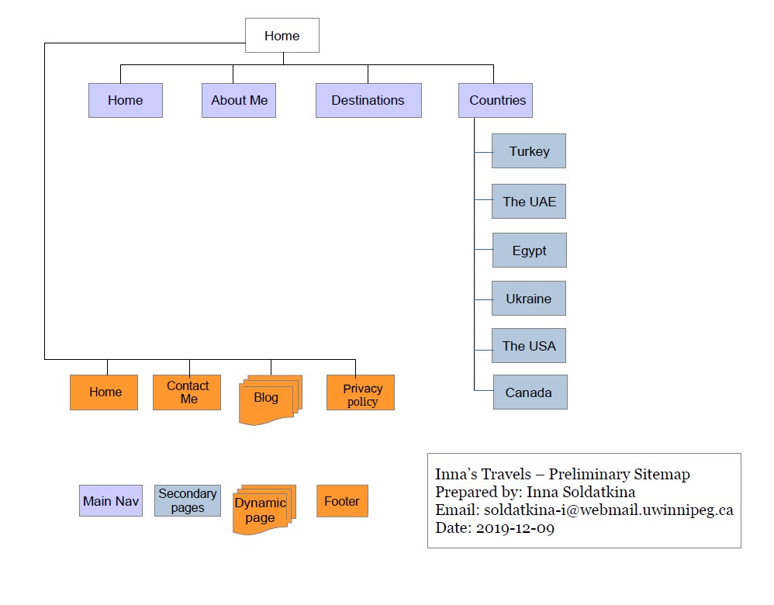

### **Home Page**

This is the main page of the website. It contains the navigation linking this page with other pages. There is a hero image in the website header and a call to action on the top of it that redirects a user to About Me page. In the body of the Home page, there will be a short description of the blog and the reasons why its content is different from other information available on the Internet. Also, this page will contain the featured pictures from recent travels to attract users’ attention. Social media icons should be visible and found easily by clients.

### **About Me Page**

The page describes the author of the blog, her travel experience and the reasons why she is starting the blog. Also, this page should contain a form with several fields to be filled by users in order to contact Inna via email, and featured posts from the Instagram account.

### **Destinations Page**

A table with some important information about each country will be located here, as well as the most visited posts.

### **Turkey Page**

The page will contain general information about Turkey, and a short description of the best places to visit in this country.

### **The UAE Page**

The general information about the UAE and Dubai in particular. Some links to the featured posts about Dubai and Abu Dhabi life and travel experiences.

### **Egypt Page**

The page will describe Egypt briefly and host some visual content and links to the blog posts about this country.

### **Ukraine**

The most interesting information about Inna’s home country, a bit of history, images and the list of the best places to visit.

**The USA Page**

General description of the country, some posts about the North part of the USA, pictures and travel experiences.

### **Canada Page**

The page will contain only the general description of the country as there is not so much content available yet.

### **Contact Me Page**

Information about Inna, a contact form, and social media links will be located on this page.

### **Blog Page**

All the blog posts will be located here. The latest ones will be at the top of the page.

### **Privacy Policy Page**

The page where the Privacy Policy Agreement is located.

## **9.3 Wireframe**

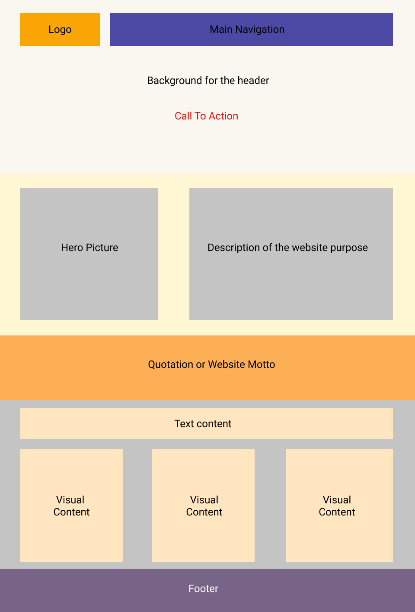

## **9.4 Mock-ups**

### **9.4.1 Home Page**

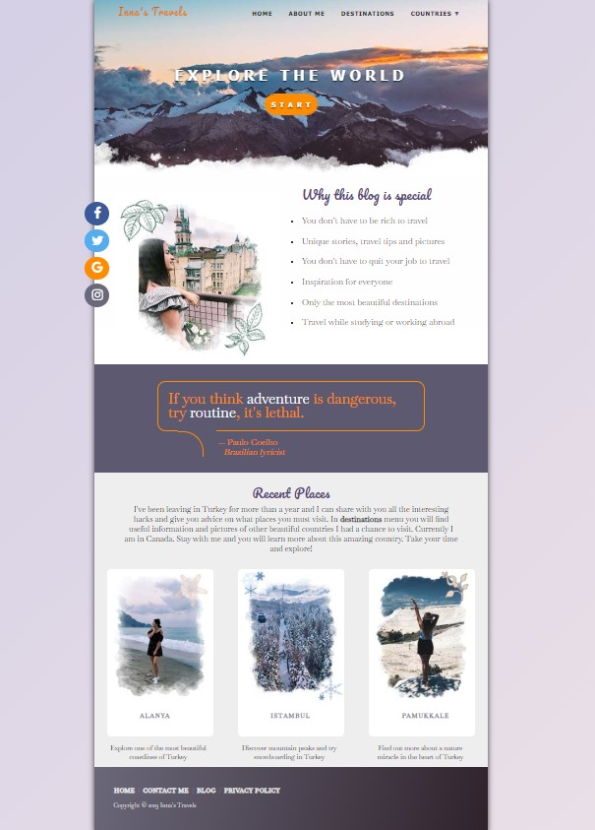

### **9.4.2 About Me Page**

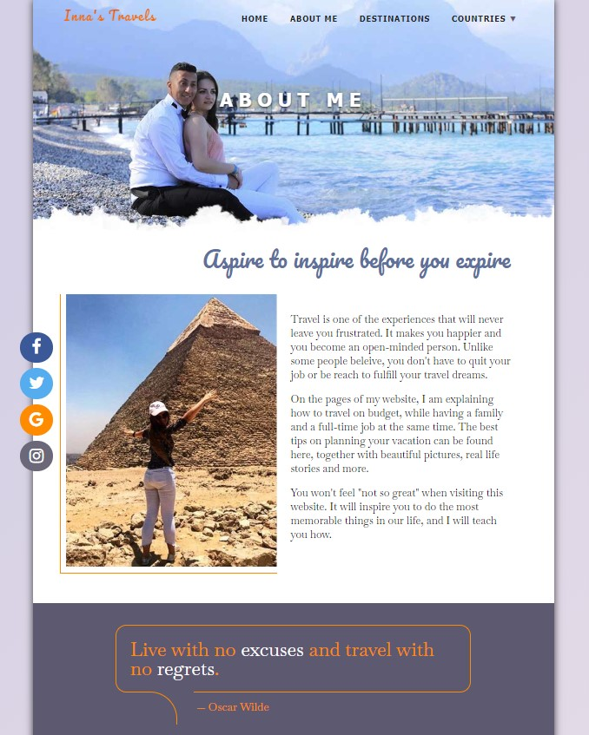

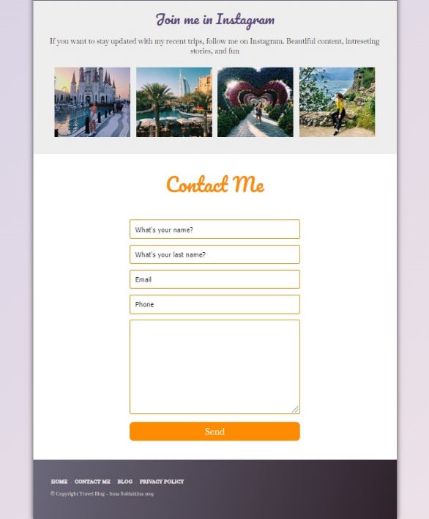

### **9.4.3 Destinations Page**

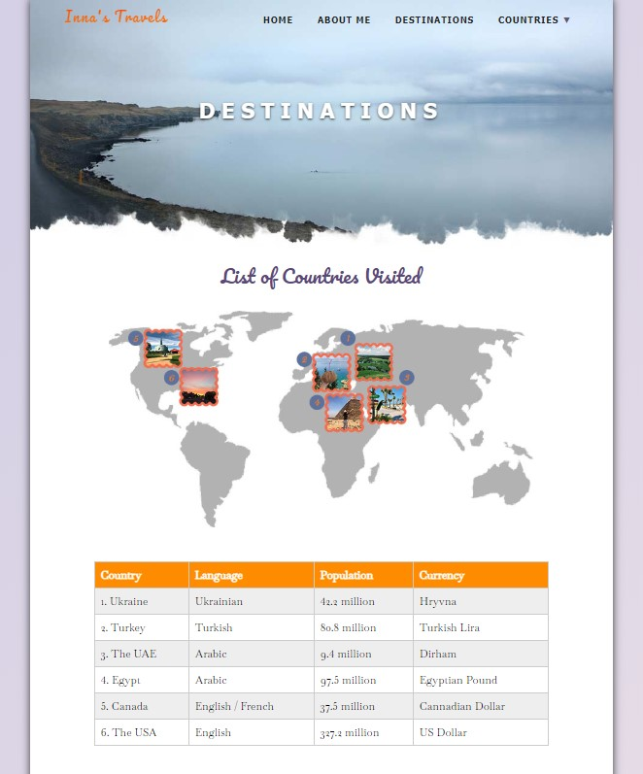

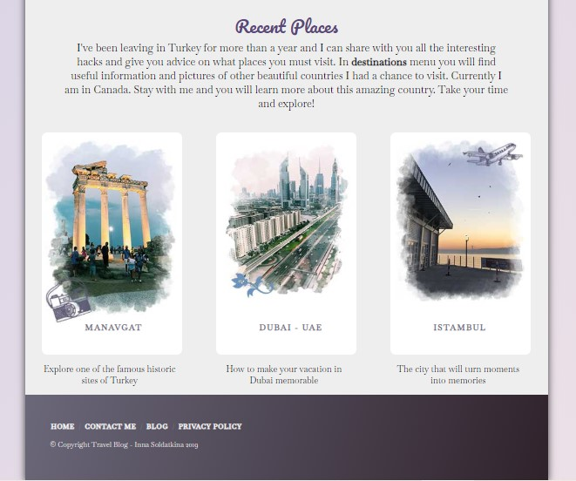

### **9.4.4 Ukraine Page**

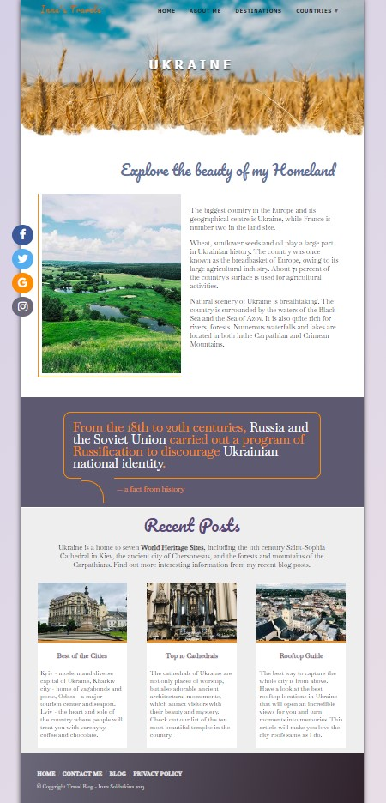

### **9.4.5 Turkey Page**

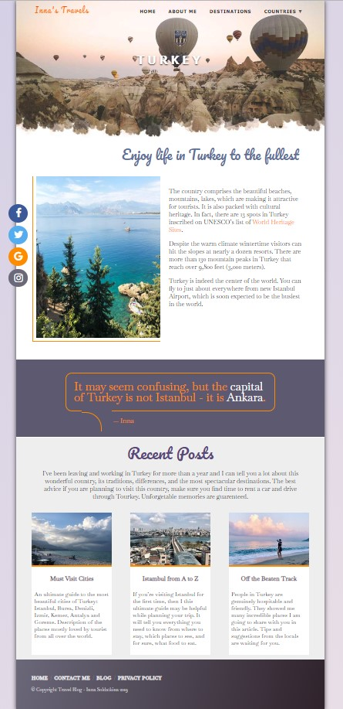

### **9.4.6 UAE Page**

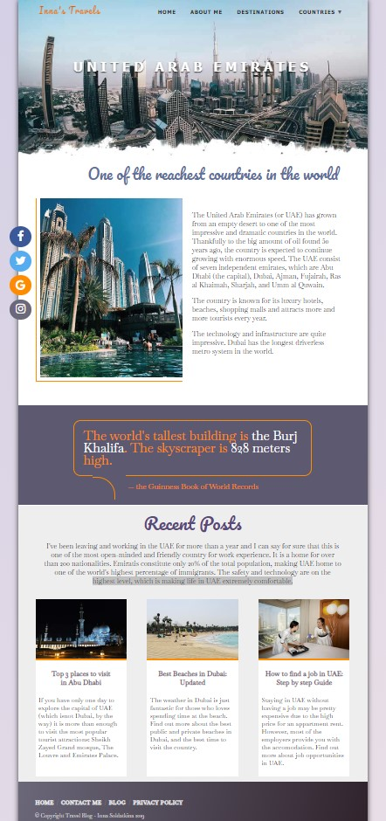

## **9.5 Workback Schedule**

|  |  |  |
| --- | --- | --- |
| **Task** | **Responsible Part** | **Date of Completion** |
| **Planning/Exploring Phase (total hours spent: 24)** | | |
| Project Launch | SDW | Dec 12 |
| Content types are assembled and classified, the content hierarchy is defined | SDW | Dec 12 |
| The competitors’ websites are examined | SDW | Dec 13 |
| Research and brainstorming session, meeting | SDW | Dec 13 |
| Content outline and sitemap are created | SDW | Dec 13 |
| The outline and sitemap are approved by the client, corrections are made | Inna, SDW | Dec 14 |
| The technical scope and required technical functionality are defined | SDW | Dec 14 |
| The scope document is confirmed with the client | Inna | Dec 15 |
| Visual hierarchy and content placement are established, wireframes are created. | SDW | Dec 15 |
| Content organization is confirmed with the client | SDW | Dec 15 |
| **Design/Content Phase (total hours spent: 30)** | | |
| New color scheme and typography created | SDW | Dec 20 |
| The logo is created | SDW | Dec 20 |
| Visual assets are created, such as buttons, calls-to-action, pictures are edited and ready for use. | SDW | Dec 21 |
| Text content is corrected and Web/SEO optimized | SDW | Dec 22 |
| The new design is confirmed by the client, the needed corrections are made | Inna | Dec 23 |
| PSD files are created. | SDW | Dec 24 |
| PSDs confirmed with the client, the necessary changes are made. | Inna | Dec 24 |
| A usability test is successfully performed | SDW | Dec 24 |
| **Coding/Programming Phase (total hours spent: 36)** | | |
| PSD files are reviewed, sliced, coding approach is planned | SDW | Dec 27 |
| The HTML and CSS code is created and validated | SDW | Dec 29 |
| The website is responsive and shown correctly on different screens and in all browsers | SDW | Jan 1 |
| Code testing | SDW | Jan 1 |
| The website functionality is approved with the client | Inna | Jan 2 |
| **Launch/Maintenance Phase (total hours spent: 16)** | | |
| Backup of the website is made | SDW | Jan 3 |
| The files are hosted on the server, DNS settings are modified | SDW | Jan 3 |
| Functional testing is performed. | SDW | Jan 4 |
| Confirming the website work with the client | Inna | Jan 5 |
| Soft Launch | SDW | Jan 5 |
| The advertising campaign has started | Inna | Jan 5 |
| All the bugs and errors are fixed | SDW | Jan 6 |
| Final project team meeting | SDW | Jan 7 |
| **Hard Launch** | SDW, Inna | Jan 8 |

## **9.6 Invoice**

