AES (Advanced Encryption Standard)

Introduction to AES
AES (Advanced Encryption Standard), also known as Rijndael encryption method in cryptography, is a block encryption standard adopted by the federal government of the United States. This standard is used to replace the original DES, which has been widely used all over the world and has become one of the most popular symmetric key algorithms.
Before the advent of AES, the most commonly used symmetric key algorithm was DES Encryption Algorithms It's in In 1977, it was published as the commercial encryption standard of the U.S. government. The main problem of DES is that the key length is short, and it is not suitable for the requirement of data encryption security in distributed open network. Therefore, in 1998, the U.S. government decided not to continue using DES as the federal encryption standard, and launched a campaign to solicit AES candidate algorithms. The basic requirements for AES are: faster than triple DES, at least as secure as triple DES, 128 bits of data packet length and 128/192/256 bits of key length.
After more than three years of selection, the Rijndael algorithm designed by Belgian cryptographers finally emerged as a new generation of advanced encryption standards, which was published by the National Institute of Standards and Technology (NIST) in 2001. FIPS PUB 197.

Working
- KeyExpansions—round keys are derived from the cipher key using Rijndael’s key schedule. AES requires a separate 128-bit or 192- bit or256-bit key block for each round plus one more.
- InitialRound
  - AddRoundKey—each byte of the state is combined with a block of the round key using bitwise xor.
- Rounds
  - SubBytes—a non-linear substitution step where each byte is replaced with another according to a lookup table.
  - ShiftRows—a transposition step where the last three rows of the state are shifted cyclically a certain number of steps.
  - MixColumns—a mixing operation which operates on the columns of the state, combining the four bytes in each column.
  - AddRoundKey
- Final Round (no MixColumns)
  - SubBytes
  - ShiftRows
  - AddRoundKey.
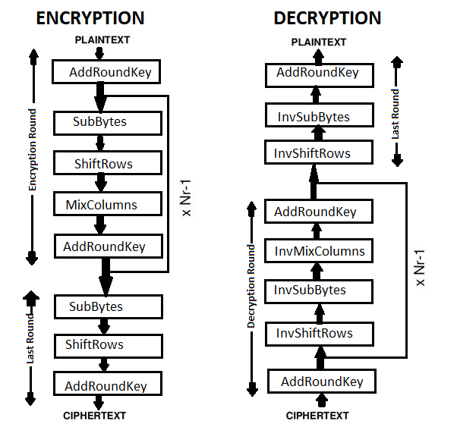
The AES algorithm is divided into three parts: key expansion, block encryption and block decryption.
- Key Extension
AES algorithm generates Nb(Nr+1) words by extending the key K input by the user through Key Expansion, and stores them in a linear array w[Nb*(Nr+1)]. Specifically as follows:

- The position transformation function RotWord() accepts a word [a0, A1, a2, a3] as input, and output [a1, a2, a3, a0] after moving one byte to the left of the loop.
- S-box transformation function SubWord(), accepts a word [a0, a1, a2, a3] as input. The S box is a 16x16 table, with each element being a byte. For each byte input, the first four bits constitute the hexadecimal number x as the line number, and the last four bits constitute the hexadecimal number y as the column number to find the corresponding values in the table. Finally, the function outputs a 32-bit word consisting of four new bytes.
- Wheel constant Rcon [], how to calculate, let alone directly regard it as a constant array.
- The first Nk elements of the extended key array w [] are external keys K, the subsequent element w[i] is equal to the previous element w[i-1] and the previous element w[i-1]. The exclusive or of the Nk elements w[i-Nk], i.e. w[i] = w[i-1] XOR w[i-Nk]; but if I is a multiple of Nk, w[i] = w[i-Nk] XOR SubWord(RotWord(w[i-1]) XOR Rcon[i/Nk-1].
2) encryptionAccording to the overall flow chart of AES encryption (at the beginning )

① S-box transformation-SubBytes()
As already mentioned in the key extension section, the S-box is a table of 16 rows and 16 columns, in which each element is a byte. The S-box transformation is simple: the function SubBytes() accepts one The byte matrix of 4x4 is used as input. For each byte, the first four bits constitute the hexadecimal number x as the line number, and the last four bits constitute the hexadecimal number y as the column number. The corresponding values in the lookup table replace the bytes in the original position.

② Line transformation - ShiftRows()
Line transformation is also very simple. It simply shifts each row of the matrix in bytes: the first row remains unchanged, the second row moves one bit to the left, the third row moves two to the left, and the fourth row moves three to the left.

③ Column transformation - MixColumns()
The function MixColumns() also accepts a 4x4 byte matrix as input and transforms the matrix column by column

④ XOR-AddRoundKey() with Extended Key
Extended keys are only involved in this step. According to the number of rounds currently encrypted, four extended keys in w [] are bitwise exclusive or with four columns of the matrix.

3) decryption

① Inverse transformation - InvShiftRows()

② Inverse S-box transformation-InvSubBytes()

③ Inverse transformation - InvMixColumns()
Advantages
- As it is implemented in both hardware and software, it is most robust security protocol.
- It uses higher length key sizes such as 128, 192 and 256 bits for encryption. Hence it makes AES algorithm more robust against hacking.
- It is most common security protocol used for wide various of applications such as wireless communication, financial transactions, e-business, encrypted data storage etc.
- For 128 bit, about 2128 attempts are needed to break. This makes it very difficult to hack it as a result it is very safe protocol.
Disadvantages
- It uses too simple algebraic structure.
- Every block is always encrypted in the same way.
- AES in counter mode is complex to implement in software taking both performance and security into considerations.
Conclusion
AES provides security from intrusion attacks and the usage of AES technique allows the encryption and decryption process to be more secure and faster. Thus this system provides security in storage and transmission.

Reference

- https://programmer.group/c-implementation-of-aes-encryption-algorithms.html

- https://www.rfwireless-world.com/Terminology/Advantages-and-disadvantages-of-AES.html

