Supplementary Material
When Does Zero-Day Alert Triage Help? Leakage-Averse Evaluation of Detection, Calibration and Prioritisation
This supplement gives the data details, training settings, complete statistical output, the calibration and decision analysis, all triage settings and the robustness checks of the revised manuscript. Every table is generated from the files in the code repository (code/tables and code/results) by manuscript/build_supp.py, and the generating experiment or analysis script is named in each section.

S1. Data preparation
The first table gives the effect of the two cleaning steps of Eqs. (1) and (2) per class of the merged UNSW-NB15 release (analysis/data_details.py; the boolean masks are in repro/masks_unsw.npz). Neither UNSW-NB15 nor NSL-KDD contains missing values or negative numeric inputs to log(1 + x) (code/tables/s_table_missing_invalid.csv). In NF-UNSW-NB15-v3, 4,144 flows carry infinite byte-rate values (SRC_TO_DST_SECOND_BYTES and DST_TO_SRC_SECOND_BYTES), which were replaced by the largest finite January value of the feature.
Table S1. Per-class cleaning counts of UNSW-NB15 (training and testing partitions merged)
Class | Release | After exact de-duplication | Final | Removed (exact) | Removed (conflict) | Removed share
Normal | 93,000 | 85,722 | 85,308 | 7,278 | 414 | 0.083
Generic | 58,871 | 7,599 | 7,283 | 51,272 | 316 | 0.876
Exploits | 44,525 | 27,434 | 25,451 | 17,091 | 1,983 | 0.428
Fuzzers | 24,246 | 20,960 | 18,749 | 3,286 | 2,211 | 0.227
DoS | 16,353 | 5,500 | 3,624 | 10,853 | 1,876 | 0.778
Reconnaissance | 13,987 | 9,991 | 8,419 | 3,996 | 1,572 | 0.398
Analysis | 2,677 | 2,032 | 450 | 645 | 1,582 | 0.832
Backdoor | 2,329 | 1,880 | 350 | 449 | 1,530 | 0.850
Shellcode | 1,511 | 1,456 | 1,446 | 55 | 10 | 0.043
Worms | 174 | 171 | 159 | 3 | 12 | 0.086
Total | 257,673 | 162,745 | 151,239 | 94,928 | 11,506 | 0.413

Label conflicts (results/e15_conflicts_overlap.json). After exact de-duplication, 2,445 groups of records shared all feature values but carried different labels. In 414 groups (829 records) benign and attack labels collided, and in 2,031 groups (10,677 records) two or more attack families collided; the largest numbers of conflicting records were removed from Fuzzers (2,211), Exploits (1,983), DoS (1,876), Analysis (1,582), Reconnaissance (1,572) and Backdoor (1,530). Removing every record of a conflicting group is the conservative choice; the alternative of keeping the majority label is evaluated in Section S5. In NSL-KDD, the official files are used without cleaning so that P3 stays comparable with earlier work; 664 of the 22,544 KDDTest+ records have a feature vector that also occurs in KDDTrain+.
The next three tables list the complete feature sets. Identifiers (the id column of UNSW-NB15) were removed before cleaning, numeric features were clipped at zero and transformed with log(1 + x), and categorical features were one-hot encoded with the listed vocabulary plus an 'other' category. Standardisation statistics were fitted on the training split of each fold.
Table S2. The 60 UNSW-NB15 features
Feature | Source | Transformation | Vocabulary
dur | dur | max(x, 0) then log(1 + x)
spkts | spkts | max(x, 0) then log(1 + x)
dpkts | dpkts | max(x, 0) then log(1 + x)
sbytes | sbytes | max(x, 0) then log(1 + x)
dbytes | dbytes | max(x, 0) then log(1 + x)
rate | rate | max(x, 0) then log(1 + x)
sttl | sttl | max(x, 0) then log(1 + x)
dttl | dttl | max(x, 0) then log(1 + x)
sload | sload | max(x, 0) then log(1 + x)
dload | dload | max(x, 0) then log(1 + x)
sloss | sloss | max(x, 0) then log(1 + x)
dloss | dloss | max(x, 0) then log(1 + x)
sinpkt | sinpkt | max(x, 0) then log(1 + x)
dinpkt | dinpkt | max(x, 0) then log(1 + x)
sjit | sjit | max(x, 0) then log(1 + x)
djit | djit | max(x, 0) then log(1 + x)
swin | swin | max(x, 0) then log(1 + x)
stcpb | stcpb | max(x, 0) then log(1 + x)
dtcpb | dtcpb | max(x, 0) then log(1 + x)
dwin | dwin | max(x, 0) then log(1 + x)
tcprtt | tcprtt | max(x, 0) then log(1 + x)
synack | synack | max(x, 0) then log(1 + x)
ackdat | ackdat | max(x, 0) then log(1 + x)
smean | smean | max(x, 0) then log(1 + x)
dmean | dmean | max(x, 0) then log(1 + x)
trans_depth | trans_depth | max(x, 0) then log(1 + x)
response_body_len | response_body_len | max(x, 0) then log(1 + x)
ct_srv_src | ct_srv_src | max(x, 0) then log(1 + x)
ct_state_ttl | ct_state_ttl | max(x, 0) then log(1 + x)
ct_dst_ltm | ct_dst_ltm | max(x, 0) then log(1 + x)
ct_src_dport_ltm | ct_src_dport_ltm | max(x, 0) then log(1 + x)
ct_dst_sport_ltm | ct_dst_sport_ltm | max(x, 0) then log(1 + x)
ct_dst_src_ltm | ct_dst_src_ltm | max(x, 0) then log(1 + x)
is_ftp_login | is_ftp_login | max(x, 0) then log(1 + x)
ct_ftp_cmd | ct_ftp_cmd | max(x, 0) then log(1 + x)
ct_flw_http_mthd | ct_flw_http_mthd | max(x, 0) then log(1 + x)
ct_src_ltm | ct_src_ltm | max(x, 0) then log(1 + x)
ct_srv_dst | ct_srv_dst | max(x, 0) then log(1 + x)
is_sm_ips_ports | is_sm_ips_ports | max(x, 0) then log(1 + x)
proto=tcp | proto | one-hot | tcp, udp, unas, arp, ospf, other (any value outside the list)
proto=udp | proto | one-hot | tcp, udp, unas, arp, ospf, other (any value outside the list)
proto=unas | proto | one-hot | tcp, udp, unas, arp, ospf, other (any value outside the list)
proto=arp | proto | one-hot | tcp, udp, unas, arp, ospf, other (any value outside the list)
proto=ospf | proto | one-hot | tcp, udp, unas, arp, ospf, other (any value outside the list)
proto=other | proto | one-hot | tcp, udp, unas, arp, ospf, other (any value outside the list)
service=- | service | one-hot | -, dns, http, smtp, ftp, ftp-data, pop3, ssh, other (any value outside the list)
service=dns | service | one-hot | -, dns, http, smtp, ftp, ftp-data, pop3, ssh, other (any value outside the list)
service=http | service | one-hot | -, dns, http, smtp, ftp, ftp-data, pop3, ssh, other (any value outside the list)
service=smtp | service | one-hot | -, dns, http, smtp, ftp, ftp-data, pop3, ssh, other (any value outside the list)
service=ftp | service | one-hot | -, dns, http, smtp, ftp, ftp-data, pop3, ssh, other (any value outside the list)
service=ftp-data | service | one-hot | -, dns, http, smtp, ftp, ftp-data, pop3, ssh, other (any value outside the list)
service=pop3 | service | one-hot | -, dns, http, smtp, ftp, ftp-data, pop3, ssh, other (any value outside the list)
service=ssh | service | one-hot | -, dns, http, smtp, ftp, ftp-data, pop3, ssh, other (any value outside the list)
service=other | service | one-hot | -, dns, http, smtp, ftp, ftp-data, pop3, ssh, other (any value outside the list)
state=FIN | state | one-hot | FIN, INT, CON, REQ, RST, other (any value outside the list)
state=INT | state | one-hot | FIN, INT, CON, REQ, RST, other (any value outside the list)
state=CON | state | one-hot | FIN, INT, CON, REQ, RST, other (any value outside the list)
state=REQ | state | one-hot | FIN, INT, CON, REQ, RST, other (any value outside the list)
state=RST | state | one-hot | FIN, INT, CON, REQ, RST, other (any value outside the list)
state=other | state | one-hot | FIN, INT, CON, REQ, RST, other (any value outside the list)

Table S3. The 68 NSL-KDD features (num_outbound_cmds, which is constant, is not used)
Feature | Source | Transformation | Vocabulary
duration | duration | max(x, 0) then log(1 + x)
src_bytes | src_bytes | max(x, 0) then log(1 + x)
dst_bytes | dst_bytes | max(x, 0) then log(1 + x)
land | land | max(x, 0) then log(1 + x)
wrong_fragment | wrong_fragment | max(x, 0) then log(1 + x)
urgent | urgent | max(x, 0) then log(1 + x)
hot | hot | max(x, 0) then log(1 + x)
num_failed_logins | num_failed_logins | max(x, 0) then log(1 + x)
logged_in | logged_in | max(x, 0) then log(1 + x)
num_compromised | num_compromised | max(x, 0) then log(1 + x)
root_shell | root_shell | max(x, 0) then log(1 + x)
su_attempted | su_attempted | max(x, 0) then log(1 + x)
num_root | num_root | max(x, 0) then log(1 + x)
num_file_creations | num_file_creations | max(x, 0) then log(1 + x)
num_shells | num_shells | max(x, 0) then log(1 + x)
num_access_files | num_access_files | max(x, 0) then log(1 + x)
is_host_login | is_host_login | max(x, 0) then log(1 + x)
is_guest_login | is_guest_login | max(x, 0) then log(1 + x)
count | count | max(x, 0) then log(1 + x)
srv_count | srv_count | max(x, 0) then log(1 + x)
serror_rate | serror_rate | max(x, 0) then log(1 + x)
srv_serror_rate | srv_serror_rate | max(x, 0) then log(1 + x)
rerror_rate | rerror_rate | max(x, 0) then log(1 + x)
srv_rerror_rate | srv_rerror_rate | max(x, 0) then log(1 + x)
same_srv_rate | same_srv_rate | max(x, 0) then log(1 + x)
diff_srv_rate | diff_srv_rate | max(x, 0) then log(1 + x)
srv_diff_host_rate | srv_diff_host_rate | max(x, 0) then log(1 + x)
dst_host_count | dst_host_count | max(x, 0) then log(1 + x)
dst_host_srv_count | dst_host_srv_count | max(x, 0) then log(1 + x)
dst_host_same_srv_rate | dst_host_same_srv_rate | max(x, 0) then log(1 + x)
dst_host_diff_srv_rate | dst_host_diff_srv_rate | max(x, 0) then log(1 + x)
dst_host_same_src_port_rate | dst_host_same_src_port_rate | max(x, 0) then log(1 + x)
dst_host_srv_diff_host_rate | dst_host_srv_diff_host_rate | max(x, 0) then log(1 + x)
dst_host_serror_rate | dst_host_serror_rate | max(x, 0) then log(1 + x)
dst_host_srv_serror_rate | dst_host_srv_serror_rate | max(x, 0) then log(1 + x)
dst_host_rerror_rate | dst_host_rerror_rate | max(x, 0) then log(1 + x)
dst_host_srv_rerror_rate | dst_host_srv_rerror_rate | max(x, 0) then log(1 + x)
protocol_type=tcp | protocol_type | one-hot | tcp, udp, icmp, other
protocol_type=udp | protocol_type | one-hot | tcp, udp, icmp, other
protocol_type=icmp | protocol_type | one-hot | tcp, udp, icmp, other
protocol_type=other | protocol_type | one-hot | tcp, udp, icmp, other
service=http | service | one-hot | http, private, domain_u, smtp, ftp_data, ecr_i, eco_i, other, ftp, telnet, finger, urp_i, auth, imap4, pop_3, other
service=private | service | one-hot | http, private, domain_u, smtp, ftp_data, ecr_i, eco_i, other, ftp, telnet, finger, urp_i, auth, imap4, pop_3, other
service=domain_u | service | one-hot | http, private, domain_u, smtp, ftp_data, ecr_i, eco_i, other, ftp, telnet, finger, urp_i, auth, imap4, pop_3, other
service=smtp | service | one-hot | http, private, domain_u, smtp, ftp_data, ecr_i, eco_i, other, ftp, telnet, finger, urp_i, auth, imap4, pop_3, other
service=ftp_data | service | one-hot | http, private, domain_u, smtp, ftp_data, ecr_i, eco_i, other, ftp, telnet, finger, urp_i, auth, imap4, pop_3, other
service=ecr_i | service | one-hot | http, private, domain_u, smtp, ftp_data, ecr_i, eco_i, other, ftp, telnet, finger, urp_i, auth, imap4, pop_3, other
service=eco_i | service | one-hot | http, private, domain_u, smtp, ftp_data, ecr_i, eco_i, other, ftp, telnet, finger, urp_i, auth, imap4, pop_3, other
service=other | service | one-hot | http, private, domain_u, smtp, ftp_data, ecr_i, eco_i, other, ftp, telnet, finger, urp_i, auth, imap4, pop_3, other
service=ftp | service | one-hot | http, private, domain_u, smtp, ftp_data, ecr_i, eco_i, other, ftp, telnet, finger, urp_i, auth, imap4, pop_3, other
service=telnet | service | one-hot | http, private, domain_u, smtp, ftp_data, ecr_i, eco_i, other, ftp, telnet, finger, urp_i, auth, imap4, pop_3, other
service=finger | service | one-hot | http, private, domain_u, smtp, ftp_data, ecr_i, eco_i, other, ftp, telnet, finger, urp_i, auth, imap4, pop_3, other
service=urp_i | service | one-hot | http, private, domain_u, smtp, ftp_data, ecr_i, eco_i, other, ftp, telnet, finger, urp_i, auth, imap4, pop_3, other
service=auth | service | one-hot | http, private, domain_u, smtp, ftp_data, ecr_i, eco_i, other, ftp, telnet, finger, urp_i, auth, imap4, pop_3, other
service=imap4 | service | one-hot | http, private, domain_u, smtp, ftp_data, ecr_i, eco_i, other, ftp, telnet, finger, urp_i, auth, imap4, pop_3, other
service=pop_3 | service | one-hot | http, private, domain_u, smtp, ftp_data, ecr_i, eco_i, other, ftp, telnet, finger, urp_i, auth, imap4, pop_3, other
flag=SF | flag | one-hot | SF, S0, REJ, RSTR, SH, RSTO, S1, RSTOS0, S3, S2, OTH, other
flag=S0 | flag | one-hot | SF, S0, REJ, RSTR, SH, RSTO, S1, RSTOS0, S3, S2, OTH, other
flag=REJ | flag | one-hot | SF, S0, REJ, RSTR, SH, RSTO, S1, RSTOS0, S3, S2, OTH, other
flag=RSTR | flag | one-hot | SF, S0, REJ, RSTR, SH, RSTO, S1, RSTOS0, S3, S2, OTH, other
flag=SH | flag | one-hot | SF, S0, REJ, RSTR, SH, RSTO, S1, RSTOS0, S3, S2, OTH, other
flag=RSTO | flag | one-hot | SF, S0, REJ, RSTR, SH, RSTO, S1, RSTOS0, S3, S2, OTH, other
flag=S1 | flag | one-hot | SF, S0, REJ, RSTR, SH, RSTO, S1, RSTOS0, S3, S2, OTH, other
flag=RSTOS0 | flag | one-hot | SF, S0, REJ, RSTR, SH, RSTO, S1, RSTOS0, S3, S2, OTH, other
flag=S3 | flag | one-hot | SF, S0, REJ, RSTR, SH, RSTO, S1, RSTOS0, S3, S2, OTH, other
flag=S2 | flag | one-hot | SF, S0, REJ, RSTR, SH, RSTO, S1, RSTOS0, S3, S2, OTH, other
flag=OTH | flag | one-hot | SF, S0, REJ, RSTR, SH, RSTO, S1, RSTOS0, S3, S2, OTH, other
flag=other | flag | one-hot | SF, S0, REJ, RSTR, SH, RSTO, S1, RSTOS0, S3, S2, OTH, other

Table S4. The 18 shared features used for cross-dataset transfer (P4)
Feature | UNSW-NB15 source | NSL-KDD source | Transformation
log_duration | dur | duration | max(x, 0) then log(1 + x)
log_src_bytes | sbytes | src_bytes | max(x, 0) then log(1 + x)
log_dst_bytes | dbytes | dst_bytes | max(x, 0) then log(1 + x)
log_conn_count | ct_dst_ltm | count | max(x, 0) then log(1 + x)
log_srv_count | ct_srv_src | srv_count | max(x, 0) then log(1 + x)
proto=tcp | proto | protocol_type | one-hot (tcp, udp, icmp, other)
proto=udp | proto | protocol_type | one-hot (tcp, udp, icmp, other)
proto=icmp | proto | protocol_type | one-hot (tcp, udp, icmp, other)
proto=other | proto | protocol_type | one-hot (tcp, udp, icmp, other)
svc=http | service ('-' -> other, ftp-data -> ftp) | service (ftp_data -> ftp, domain_u/domain -> dns) | one-hot
svc=ftp | service ('-' -> other, ftp-data -> ftp) | service (ftp_data -> ftp, domain_u/domain -> dns) | one-hot
svc=smtp | service ('-' -> other, ftp-data -> ftp) | service (ftp_data -> ftp, domain_u/domain -> dns) | one-hot
svc=dns | service ('-' -> other, ftp-data -> ftp) | service (ftp_data -> ftp, domain_u/domain -> dns) | one-hot
svc=ssh | service ('-' -> other, ftp-data -> ftp) | service (ftp_data -> ftp, domain_u/domain -> dns) | one-hot
svc=other | service ('-' -> other, ftp-data -> ftp) | service (ftp_data -> ftp, domain_u/domain -> dns) | one-hot
state=established | state (FIN, CON -> established; RST, CLO, ACC -> reset; else incomplete) | flag (SF -> established; REJ, RSTO, RSTR, RSTOS0 -> reset; else incomplete) | one-hot
state=incomplete | state (FIN, CON -> established; RST, CLO, ACC -> reset; else incomplete) | flag (SF -> established; REJ, RSTO, RSTR, RSTOS0 -> reset; else incomplete) | one-hot
state=reset | state (FIN, CON -> established; RST, CLO, ACC -> reset; else incomplete) | flag (SF -> established; REJ, RSTO, RSTR, RSTOS0 -> reset; else incomplete) | one-hot

S2. Splits, overlap checks and validation priors
Table S5. Training, validation and test sizes of the five protocols (analysis/supp_tables.py; split indices in repro/splits_p1.npz, splits_p2.npz and splits_p3.npz)
Protocol | Folds | Train | Validation | Test | Note
P1 (UNSW-NB15, i.i.d.) | 5 (stratified) | 16320 | 2880 | 4800 | 24,000-record stratified sample; same sizes in every fold
P2 (UNSW-NB15, family hold-out) | 9 (one per family) | 19,682 to 21,571 | 3,561 to 3,837 | 6,159 to 9,000 | test: up to 3,000 benign, 3,000 known-family and 3,000 unseen-family records
P3 (NSL-KDD, unseen types) | 3 seeds | 19589 | 3458 | 22544 | official KDDTest+ file; 664 test records have an identical feature vector in KDDTrain+
P4 (cross-dataset, 18 features) | 2 directions x 3 seeds | 10,000 benign + up to 2,500 per class | 15% of the source sample | 10,000 | target sample drawn with the same seed
P5 (NF-UNSW-NB15-v3, January to February) | 10 (none held out, and each family) | 14,781 to 16,781 | 2,787 to 3,087 | 6,000 to 9,000 | training and validation from January, test from February

Table S6. P2 split sizes and overlap checks per held-out family (replayed from seed 1; 'shared vectors' counts records whose encoded 60-feature vector also occurs in the other split, which can happen after log(1 + x) and one-hot encoding of distinct raw records)
Family | Train | Validation | Test | Test benign | Test known | Test unseen | Index overlap | Shared vectors tr/va | Shared vectors tr/te | Shared vectors va/te | Unseen in train or val | Matches stored scores
Generic | 19,682 | 3,561 | 9,000 | 3,000 | 3,000 | 3,000 | 0 | 5 | 10 | 2 | 0 | yes
Exploits | 19,682 | 3,561 | 9,000 | 3,000 | 3,000 | 3,000 | 0 | 3 | 3 | 1 | 0 | yes
Fuzzers | 19,682 | 3,561 | 9,000 | 3,000 | 3,000 | 3,000 | 0 | 5 | 5 | 2 | 0 | yes
DoS | 19,682 | 3,561 | 9,000 | 3,000 | 3,000 | 3,000 | 0 | 2 | 6 | 2 | 0 | yes
Reconnaissance | 19,682 | 3,561 | 9,000 | 3,000 | 3,000 | 3,000 | 0 | 3 | 6 | 2 | 0 | yes
Analysis | 21,367 | 3,794 | 6,450 | 3,000 | 3,000 | 450 | 0 | 4 | 7 | 1 | 0 | yes
Backdoor | 21,438 | 3,808 | 6,350 | 3,000 | 3,000 | 350 | 0 | 3 | 6 | 3 | 0 | yes
Shellcode | 20,670 | 3,644 | 7,446 | 3,000 | 3,000 | 1,446 | 0 | 6 | 4 | 3 | 0 | yes
Worms | 21,571 | 3,837 | 6,159 | 3,000 | 3,000 | 159 | 0 | 10 | 4 | 4 | 0 | yes

Table S7. Validation attack prior and test attack share per P2 fold (the simulated deployment prior is 0.03)
Family | Validation records | Validation attacks | Validation attack prior | Test attack share (benign and unseen records)
Generic | 3,561 | 1,561 | 0.438 | 0.500
Exploits | 3,561 | 1,561 | 0.438 | 0.500
Fuzzers | 3,561 | 1,561 | 0.438 | 0.500
DoS | 3,561 | 1,561 | 0.438 | 0.500
Reconnaissance | 3,561 | 1,561 | 0.438 | 0.500
Analysis | 3,794 | 1,794 | 0.473 | 0.130
Backdoor | 3,808 | 1,808 | 0.475 | 0.104
Shellcode | 3,644 | 1,644 | 0.451 | 0.325
Worms | 3,837 | 1,837 | 0.479 | 0.050

S3. Training details and use of the validation split
Table S8. Detector training details (neural detectors use AdamW with learning rate 0.001, weight decay 0.0001, batch 512 and gradient clipping at 5 unless stated otherwise)
Detector | Settings | Class weighting | Training records | Epochs and stopping
LR | L2, C = 1, lbfgs, 2,000 iterations | none | all records | -
RF | 200 trees, unlimited depth, min leaf 1 | none | all records | -
XGBoost | 300 trees, depth 6, learning rate 0.1, subsample 0.9, column subsample 0.9, hist | none | all records | -
LightGBM | 300 trees, 31 leaves, learning rate 0.05, subsample 0.9, column subsample 0.9 | none | all records | -
SVM | RBF, C = 1, gamma = scale | none | random subsample of 6,000 (kernel cost) | -
DNN | 256-128-64, batch norm, dropout 0.2 | benign/attack ratio | all records | 20 epochs, patience 3
ResSE-CNN1D | channels 32/64, kernel 3, SE ratio 8, dropout 0.15/0.2 | benign/attack ratio | all records | 20 epochs, patience 3
LSTM, GRU | embedding 16, hidden 64, one layer | benign/attack ratio | all records | 12 epochs, patience 3
FT-Transformer | token 32, 2 layers, 4 heads, dropout 0.1, batch 1,024 | benign/attack ratio | all records | 10 epochs, patience 3
FG-GNN | node 16, 2 GIN layers, edges |r| > 0.3 | benign/attack ratio | all records | 20 epochs, patience 3
B-ProtoMeta | encoder 128-128-64, dropout 0.2, Adam 0.001, 1,500 episodes, 5-way, 10-shot, 20 queries, T = 10 | episodes balanced by class | classes with at least 15 records | fixed episodes
CLAD | MLP width 128 or 256, 2 or 3 blocks, embedding 32, dropout 0 or 0.2, AdamW with learning rate 0.001 or 0.0003, batch 512, warm-up 4 epochs, cosine decay | class-balanced batches | all records | 40 epochs (200 in Section S5)
Isolation Forest | 200 trees, score = negative isolation score | - | benign training records | -
Autoencoder | d-64-16-64-d, AdamW 0.001, batch 256, score = log reconstruction error | - | benign training records | 30 epochs, no early stopping
Energy MLP | multi-class MLP 256-128 over benign and known families, dropout 0.2; novelty = -logsumexp of the logits | inverse class frequency | all records | 20 epochs, no early stopping

The validation split of each fold was used for four purposes, namely early stopping of the neural detectors, Platt scaling of every detector and hybrid member, recalibration of the hybrid, and selection of the 1% FPR threshold on its benign records. The independent calibration check of Section S6 uses test benign and known-family records, which were never used for fitting, early stopping or calibration. CLAD hyperparameters, and the tuned tree ensembles of Section S5, were chosen by holding out, in turn, the first two known families (in the order Generic, Exploits, Fuzzers, DoS, ...) of the training data and maximising the validation AUROC between benign records and the held-out family, so the outer unseen family never influenced the choice. In P3, B-ProtoMeta episodes use the five NSL-KDD categories; the scarcest category, U2R, has 44 training records, which exceeds the minimum of 15, so every episode contains all five categories and samples up to 30 records per class without replacement. The SVM is trained on a random subsample of 6,000 records because kernel training scales quadratically; on P1 its AUROC was 0.954 against 0.959 for logistic regression trained on all records.

S4. Complete P2 statistics
Table S9. Paired per-fold values of all thirteen detectors in P2 (unseen-family AUROC)
Held-out family | LR | RF | XGBoost | LightGBM | SVM | DNN | ResSE-CNN1D | LSTM | GRU | FT-Transformer | FG-GNN | B-ProtoMeta | CZT-Hybrid
Analysis | 0.848 | 0.835 | 0.835 | 0.831 | 0.718 | 0.836 | 0.846 | 0.784 | 0.935 | 0.828 | 0.883 | 0.853 | 0.839
Backdoor | 0.955 | 0.992 | 0.994 | 0.995 | 0.975 | 0.991 | 0.988 | 0.964 | 0.896 | 0.989 | 0.987 | 0.992 | 0.996
DoS | 0.964 | 0.991 | 0.993 | 0.994 | 0.973 | 0.987 | 0.989 | 0.960 | 0.921 | 0.988 | 0.981 | 0.980 | 0.992
Exploits | 0.973 | 0.991 | 0.992 | 0.992 | 0.966 | 0.990 | 0.984 | 0.934 | 0.820 | 0.978 | 0.978 | 0.984 | 0.993
Fuzzers | 0.845 | 0.858 | 0.865 | 0.875 | 0.733 | 0.867 | 0.862 | 0.771 | 0.758 | 0.863 | 0.855 | 0.865 | 0.877
Generic | 0.851 | 0.975 | 0.993 | 0.991 | 0.909 | 0.985 | 0.971 | 0.847 | 0.795 | 0.960 | 0.884 | 0.896 | 0.971
Reconnaissance | 0.969 | 0.983 | 0.989 | 0.991 | 0.975 | 0.980 | 0.975 | 0.953 | 0.965 | 0.975 | 0.978 | 0.979 | 0.986
Shellcode | 0.965 | 0.985 | 0.983 | 0.982 | 0.978 | 0.986 | 0.988 | 0.974 | 0.935 | 0.985 | 0.980 | 0.988 | 0.991
Worms | 0.989 | 0.997 | 0.998 | 0.998 | 0.990 | 0.994 | 0.993 | 0.983 | 0.954 | 0.995 | 0.995 | 0.996 | 0.998

Table S10. Paired per-fold values of all thirteen detectors in P2 (ZDR at the validation threshold)
Held-out family | LR | RF | XGBoost | LightGBM | SVM | DNN | ResSE-CNN1D | LSTM | GRU | FT-Transformer | FG-GNN | B-ProtoMeta | CZT-Hybrid
Analysis | 0.027 | 0.100 | 0.149 | 0.133 | 0.016 | 0.158 | 0.153 | 0.029 | 0.007 | 0.098 | 0.056 | 0.036 | 0.147
Backdoor | 0.417 | 0.757 | 0.834 | 0.866 | 0.471 | 0.780 | 0.686 | 0.423 | 0.123 | 0.609 | 0.666 | 0.660 | 0.857
DoS | 0.611 | 0.805 | 0.842 | 0.881 | 0.428 | 0.780 | 0.777 | 0.538 | 0.365 | 0.785 | 0.649 | 0.675 | 0.864
Exploits | 0.729 | 0.838 | 0.915 | 0.915 | 0.460 | 0.814 | 0.746 | 0.409 | 0.089 | 0.646 | 0.641 | 0.639 | 0.859
Fuzzers | 0.036 | 0.079 | 0.095 | 0.097 | 0.062 | 0.121 | 0.109 | 0.091 | 0.066 | 0.083 | 0.057 | 0.131 | 0.119
Generic | 0.123 | 0.209 | 0.731 | 0.686 | 0.118 | 0.665 | 0.147 | 0.057 | 0.051 | 0.139 | 0.150 | 0.138 | 0.245
Reconnaissance | 0.228 | 0.632 | 0.738 | 0.706 | 0.511 | 0.633 | 0.488 | 0.242 | 0.455 | 0.509 | 0.498 | 0.589 | 0.661
Shellcode | 0.084 | 0.740 | 0.692 | 0.632 | 0.532 | 0.828 | 0.708 | 0.385 | 0.280 | 0.656 | 0.600 | 0.757 | 0.828
Worms | 0.805 | 0.950 | 0.962 | 0.956 | 0.774 | 0.899 | 0.887 | 0.730 | 0.459 | 0.924 | 0.887 | 0.912 | 0.950

Table S11. Paired per-fold values of all thirteen detectors in P2 (TPR at 1% test FPR)
Held-out family | LR | RF | XGBoost | LightGBM | SVM | DNN | ResSE-CNN1D | LSTM | GRU | FT-Transformer | FG-GNN | B-ProtoMeta | CZT-Hybrid
Analysis | 0.022 | 0.096 | 0.144 | 0.124 | 0.018 | 0.158 | 0.151 | 0.020 | 0.004 | 0.044 | 0.073 | 0.036 | 0.136
Backdoor | 0.429 | 0.774 | 0.857 | 0.880 | 0.463 | 0.809 | 0.680 | 0.469 | 0.211 | 0.734 | 0.637 | 0.714 | 0.917
DoS | 0.548 | 0.801 | 0.853 | 0.878 | 0.430 | 0.763 | 0.767 | 0.489 | 0.343 | 0.740 | 0.664 | 0.622 | 0.841
Exploits | 0.686 | 0.838 | 0.897 | 0.909 | 0.435 | 0.798 | 0.719 | 0.335 | 0.081 | 0.622 | 0.550 | 0.571 | 0.849
Fuzzers | 0.031 | 0.084 | 0.097 | 0.097 | 0.040 | 0.100 | 0.104 | 0.070 | 0.060 | 0.070 | 0.049 | 0.098 | 0.103
Generic | 0.116 | 0.207 | 0.769 | 0.771 | 0.113 | 0.746 | 0.151 | 0.079 | 0.057 | 0.139 | 0.141 | 0.149 | 0.261
Reconnaissance | 0.332 | 0.604 | 0.708 | 0.715 | 0.467 | 0.633 | 0.405 | 0.233 | 0.220 | 0.489 | 0.450 | 0.565 | 0.630
Shellcode | 0.104 | 0.673 | 0.635 | 0.528 | 0.586 | 0.676 | 0.687 | 0.456 | 0.278 | 0.679 | 0.541 | 0.722 | 0.814
Worms | 0.855 | 0.950 | 0.962 | 0.950 | 0.780 | 0.918 | 0.887 | 0.717 | 0.459 | 0.924 | 0.880 | 0.912 | 0.950

Table S12. Two-sided Wilcoxon signed-rank tests of CZT-Hybrid against each detector over the nine P2 folds (zeros discarded; exact null distribution without zeros or ties, normal approximation otherwise; Holm correction over the twelve comparisons of each metric)
Metric | Comparison | Median difference | Wins | Losses | Zeros | Non-zero pairs | Null distribution | Raw p | Holm p | Smallest attainable p (exact test)
AUROC | CZT-Hybrid vs LR | 0.0261 | 8 | 1 | 0 | 9 | exact | 0.0117 | 0.1055 | 0.0039
AUROC | CZT-Hybrid vs RF | 0.0031 | 8 | 1 | 0 | 9 | exact | 0.0391 | 0.3125 | 0.0039
AUROC | CZT-Hybrid vs XGBoost | 0.0008 | 5 | 4 | 0 | 9 | exact | 0.5703 | 1.0000 | 0.0039
AUROC | CZT-Hybrid vs LightGBM | 0.0010 | 5 | 4 | 0 | 9 | exact | 0.7344 | 1.0000 | 0.0039
AUROC | CZT-Hybrid vs SVM | 0.0214 | 9 | 0 | 0 | 9 | exact | 0.0039 | 0.0469 | 0.0039
AUROC | CZT-Hybrid vs DNN | 0.0047 | 8 | 1 | 0 | 9 | exact | 0.1289 | 0.4883 | 0.0039
AUROC | CZT-Hybrid vs ResSE-CNN1D | 0.0048 | 8 | 1 | 0 | 9 | exact | 0.0391 | 0.3125 | 0.0039
AUROC | CZT-Hybrid vs LSTM | 0.0330 | 9 | 0 | 0 | 9 | exact | 0.0039 | 0.0469 | 0.0039
AUROC | CZT-Hybrid vs GRU | 0.0709 | 8 | 1 | 0 | 9 | exact | 0.0391 | 0.3125 | 0.0039
AUROC | CZT-Hybrid vs FT-Transformer | 0.0109 | 9 | 0 | 0 | 9 | exact | 0.0039 | 0.0469 | 0.0039
AUROC | CZT-Hybrid vs FG-GNN | 0.0111 | 8 | 1 | 0 | 9 | exact | 0.0977 | 0.4883 | 0.0039
AUROC | CZT-Hybrid vs B-ProtoMeta | 0.0072 | 8 | 1 | 0 | 9 | exact | 0.0977 | 0.4883 | 0.0039
ZDR (validation threshold) | CZT-Hybrid vs LR | 0.1447 | 9 | 0 | 0 | 9 | exact | 0.0039 | 0.0469 | 0.0039
ZDR (validation threshold) | CZT-Hybrid vs RF | 0.0397 | 8 | 0 | 1 | 8 | approx | 0.0117 | 0.0469 | 0.0078
ZDR (validation threshold) | CZT-Hybrid vs XGBoost | -0.0022 | 4 | 5 | 0 | 9 | exact | 0.8203 | 0.9922 | 0.0039
ZDR (validation threshold) | CZT-Hybrid vs LightGBM | -0.0086 | 3 | 6 | 0 | 9 | exact | 0.4961 | 0.9922 | 0.0039
ZDR (validation threshold) | CZT-Hybrid vs SVM | 0.1761 | 9 | 0 | 0 | 9 | exact | 0.0039 | 0.0469 | 0.0039
ZDR (validation threshold) | CZT-Hybrid vs DNN | 0.0280 | 5 | 3 | 1 | 8 | approx | 0.3270 | 0.9810 | 0.0078
ZDR (validation threshold) | CZT-Hybrid vs ResSE-CNN1D | 0.0987 | 8 | 1 | 0 | 9 | exact | 0.0078 | 0.0469 | 0.0039
ZDR (validation threshold) | CZT-Hybrid vs LSTM | 0.3260 | 9 | 0 | 0 | 9 | exact | 0.0039 | 0.0469 | 0.0039
ZDR (validation threshold) | CZT-Hybrid vs GRU | 0.4906 | 9 | 0 | 0 | 9 | exact | 0.0039 | 0.0469 | 0.0039
ZDR (validation threshold) | CZT-Hybrid vs FT-Transformer | 0.1063 | 9 | 0 | 0 | 9 | exact | 0.0039 | 0.0469 | 0.0039
ZDR (validation threshold) | CZT-Hybrid vs FG-GNN | 0.1630 | 9 | 0 | 0 | 9 | exact | 0.0039 | 0.0469 | 0.0039
ZDR (validation threshold) | CZT-Hybrid vs B-ProtoMeta | 0.1070 | 8 | 1 | 0 | 9 | exact | 0.0078 | 0.0469 | 0.0039
TPR at 1% test FPR | CZT-Hybrid vs LR | 0.1623 | 9 | 0 | 0 | 9 | exact | 0.0039 | 0.0469 | 0.0039
TPR at 1% test FPR | CZT-Hybrid vs RF | 0.0391 | 8 | 0 | 1 | 8 | approx | 0.0117 | 0.0586 | 0.0078
TPR at 1% test FPR | CZT-Hybrid vs XGBoost | -0.0123 | 3 | 6 | 0 | 9 | exact | 0.4258 | 1.0000 | 0.0039
TPR at 1% test FPR | CZT-Hybrid vs LightGBM | 0.0000 | 4 | 4 | 1 | 8 | approx | 0.5754 | 1.0000 | 0.0078
TPR at 1% test FPR | CZT-Hybrid vs SVM | 0.1698 | 9 | 0 | 0 | 9 | exact | 0.0039 | 0.0469 | 0.0039
TPR at 1% test FPR | CZT-Hybrid vs DNN | 0.0314 | 6 | 3 | 0 | 9 | exact | 0.3594 | 1.0000 | 0.0039
TPR at 1% test FPR | CZT-Hybrid vs ResSE-CNN1D | 0.1093 | 7 | 2 | 0 | 9 | exact | 0.0195 | 0.0781 | 0.0039
TPR at 1% test FPR | CZT-Hybrid vs LSTM | 0.3523 | 9 | 0 | 0 | 9 | exact | 0.0039 | 0.0469 | 0.0039
TPR at 1% test FPR | CZT-Hybrid vs GRU | 0.4906 | 9 | 0 | 0 | 9 | exact | 0.0039 | 0.0469 | 0.0039
TPR at 1% test FPR | CZT-Hybrid vs FT-Transformer | 0.1217 | 9 | 0 | 0 | 9 | exact | 0.0039 | 0.0469 | 0.0039
TPR at 1% test FPR | CZT-Hybrid vs FG-GNN | 0.1767 | 9 | 0 | 0 | 9 | exact | 0.0039 | 0.0469 | 0.0039
TPR at 1% test FPR | CZT-Hybrid vs B-ProtoMeta | 0.1000 | 9 | 0 | 0 | 9 | exact | 0.0039 | 0.0469 | 0.0039

Friedman tests over the thirteen detectors: AUROC chi-square 69.93 (p = 3.3e-10), ZDR 83.15 (p = 1.0e-12), TPR at 1% FPR 83.22 (p = 1.0e-12); Nemenyi critical difference 6.08 ranks (alpha = 0.05, k = 13, N = 9). The nine folds share benign records and most training families, so they are not independent, and the tests describe the consistency of differences over these folds rather than a sample from a population of attack families.

S5. Refit, TTL-free detection, contrastive comparator, novelty scores and detection robustness
Table S13. ZDR of the refitted leading detectors and CLAD per held-out family, with all features and without sttl, dttl and ct_state_ttl (experiments/exp_p2_refit.py)
Held-out family | B-ProtoMeta full | B-ProtoMeta no TTL | CLAD full | CLAD no TTL | CZT-Hybrid full | CZT-Hybrid no TTL | DNN full | DNN no TTL | LightGBM full | LightGBM no TTL | ResSE-CNN1D full | ResSE-CNN1D no TTL | XGBoost full | XGBoost no TTL
Analysis | 0.033 | 0.022 | 0.209 | 0.176 | 0.136 | 0.127 | 0.158 | 0.149 | 0.133 | 0.113 | 0.131 | 0.142 | 0.144 | 0.129
Backdoor | 0.606 | 0.703 | 0.731 | 0.629 | 0.857 | 0.797 | 0.717 | 0.680 | 0.866 | 0.866 | 0.666 | 0.609 | 0.834 | 0.860
DoS | 0.683 | 0.651 | 0.783 | 0.783 | 0.856 | 0.827 | 0.768 | 0.779 | 0.881 | 0.860 | 0.717 | 0.753 | 0.865 | 0.847
Exploits | 0.641 | 0.663 | 0.836 | 0.820 | 0.853 | 0.840 | 0.773 | 0.824 | 0.915 | 0.895 | 0.746 | 0.723 | 0.908 | 0.906
Fuzzers | 0.120 | 0.106 | 0.113 | 0.127 | 0.112 | 0.111 | 0.106 | 0.130 | 0.097 | 0.084 | 0.112 | 0.102 | 0.098 | 0.089
Generic | 0.136 | 0.124 | 0.332 | 0.280 | 0.242 | 0.186 | 0.270 | 0.213 | 0.686 | 0.803 | 0.142 | 0.138 | 0.673 | 0.579
Reconnaissance | 0.576 | 0.582 | 0.650 | 0.576 | 0.666 | 0.679 | 0.619 | 0.502 | 0.706 | 0.703 | 0.522 | 0.590 | 0.740 | 0.695
Shellcode | 0.734 | 0.779 | 0.611 | 0.757 | 0.823 | 0.842 | 0.784 | 0.787 | 0.632 | 0.728 | 0.692 | 0.737 | 0.774 | 0.617
Worms | 0.893 | 0.881 | 0.818 | 0.906 | 0.937 | 0.931 | 0.887 | 0.912 | 0.956 | 0.931 | 0.893 | 0.874 | 0.969 | 0.937

Table S14. CLAD configuration selected by the inner search on training families
Variant | Family | Learning rate | Width | Blocks | Dropout | Inner families | Best inner AUROC
full | Analysis | 0.001 | 128 | 2 | 0.000 | Generic, Exploits | 0.995
full | Backdoor | 0.001 | 128 | 2 | 0.000 | Generic, Exploits | 0.991
full | DoS | 0.001 | 256 | 3 | 0.200 | Generic, Exploits | 0.982
full | Exploits | 0.001 | 256 | 3 | 0.200 | Generic, Fuzzers | 0.924
full | Fuzzers | 0.001 | 128 | 2 | 0.000 | Generic, Exploits | 0.987
full | Generic | 0.001 | 128 | 2 | 0.200 | Exploits, Fuzzers | 0.933
full | Reconnaissance | 0.001 | 256 | 3 | 0.200 | Generic, Exploits | 0.989
full | Shellcode | 0.001 | 128 | 2 | 0.000 | Generic, Exploits | 0.988
full | Worms | 0.001 | 256 | 3 | 0.000 | Generic, Exploits | 0.984
nottl | Analysis | 0.001 | 128 | 2 | 0.000 | Generic, Exploits | 0.993
nottl | Backdoor | 0.001 | 256 | 3 | 0.000 | Generic, Exploits | 0.979
nottl | DoS | 0.0003 | 256 | 3 | 0.200 | Generic, Exploits | 0.967
nottl | Exploits | 0.0003 | 128 | 2 | 0.000 | Generic, Fuzzers | 0.869
nottl | Fuzzers | 0.001 | 128 | 2 | 0.000 | Generic, Exploits | 0.986
nottl | Generic | 0.001 | 256 | 3 | 0.200 | Exploits, Fuzzers | 0.928
nottl | Reconnaissance | 0.001 | 256 | 3 | 0.200 | Generic, Exploits | 0.966
nottl | Shellcode | 0.0003 | 128 | 2 | 0.000 | Generic, Exploits | 0.984
nottl | Worms | 0.0003 | 256 | 3 | 0.200 | Generic, Exploits | 0.964

Table S15. AUROC of each label-free novelty score for separating unseen-family from known-family test records, on all test attack records and on escalated alerts at the 1% FPR threshold (proto = prototype distance, disagree = member disagreement, epistemic = MC-dropout spread, knn = nearest training attacks, combined = mean of the ECDF-mapped proto, disagree and knn scores; the epistemic score is reported but not part of the combined score)
Held-out family | combined (alerts) | disagree (alerts) | epistemic (alerts) | knn (alerts) | proto (alerts) | combined (all) | disagree (all) | epistemic (all) | knn (all) | proto (all)
Analysis | 0.677 | 0.540 | 0.252 | 0.816 | 0.428 | 0.844 | 0.513 | 0.561 | 0.817 | 0.830
Backdoor | 0.637 | 0.459 | 0.363 | 0.672 | 0.626 | 0.623 | 0.490 | 0.406 | 0.635 | 0.602
DoS | 0.626 | 0.404 | 0.529 | 0.670 | 0.619 | 0.622 | 0.456 | 0.552 | 0.654 | 0.592
Exploits | 0.797 | 0.418 | 0.658 | 0.799 | 0.775 | 0.774 | 0.531 | 0.666 | 0.735 | 0.742
Fuzzers | 0.687 | 0.495 | 0.475 | 0.654 | 0.684 | 0.865 | 0.557 | 0.407 | 0.788 | 0.890
Generic | 0.658 | 0.567 | 0.424 | 0.749 | 0.482 | 0.869 | 0.727 | 0.571 | 0.926 | 0.634
Reconnaissance | 0.367 | 0.235 | 0.381 | 0.419 | 0.595 | 0.408 | 0.238 | 0.380 | 0.402 | 0.679
Shellcode | 0.381 | 0.281 | 0.334 | 0.366 | 0.624 | 0.413 | 0.353 | 0.329 | 0.342 | 0.621
Worms | 0.564 | 0.288 | 0.459 | 0.581 | 0.694 | 0.553 | 0.325 | 0.525 | 0.531 | 0.731

Detection robustness (experiments/exp_detection_robust.py, analysis/robust_report.py). The next tables add benign-only anomaly detectors (Isolation Forest and an autoencoder), an energy-based open-set score from a multi-class MLP, XGBoost and LightGBM tuned with the same inner known-family search as CLAD (eight configurations each), and CLAD trained for the published 200 epochs. They also repeat the leading detectors after removing every feature whose single-feature AUROC on the training split exceeds 0.95, after cleaning with majority-label resolution of conflicts instead of removal, and on P5 with the same training-data feature filter.
Table S16. Additional P2 comparators: mean over the nine held-out families (unseen-family AUROC, ZDR at the validation threshold, TPR at 1% test FPR and realised test FPR)
Detector | Source | AUROC | ZDR | TPR at 1% FPR | Test FPR
XGBoost | refit (main text) | 0.960 | 0.667 | 0.650 | 0.012
LightGBM | refit (main text) | 0.961 | 0.652 | 0.650 | 0.011
CZT-Hybrid | refit (main text) | 0.959 | 0.609 | 0.608 | 0.011
CLAD | refit (main text) | 0.955 | 0.565 | 0.548 | 0.011
IsolationForest | added | 0.683 | 0.001 | 0.000 | 0.010
Autoencoder | added | 0.754 | 0.127 | 0.131 | 0.009
EnergyMLP | added | 0.946 | 0.470 | 0.484 | 0.009
XGBoost-tuned | added | 0.960 | 0.644 | 0.640 | 0.011
LightGBM-tuned | added | 0.959 | 0.683 | 0.669 | 0.011
CLAD-200 | added | 0.947 | 0.433 | 0.393 | 0.011

Table S17. P2 leading detectors with all features, after the training-data feature filter and after majority-label cleaning (means over the nine folds; removed features listed per fold in results/e18_detection_robust.json)
Variant | Detector | AUROC | ZDR | TPR at 1% FPR | Test FPR
conflict removal (main text) | XGBoost | 0.960 | 0.667 | 0.650 | 0.012
conflict removal (main text) | LightGBM | 0.961 | 0.652 | 0.650 | 0.011
conflict removal (main text) | DNN | 0.946 | 0.565 | 0.554 | 0.011
conflict removal (main text) | ResSE-CNN1D | 0.951 | 0.513 | 0.502 | 0.011
conflict removal (main text) | B-ProtoMeta | 0.947 | 0.491 | 0.484 | 0.011
conflict removal (main text) | CZT-Hybrid | 0.959 | 0.609 | 0.608 | 0.011
majority-label cleaning | XGBoost | 0.954 | 0.599 | 0.613 | 0.011
majority-label cleaning | LightGBM | 0.957 | 0.629 | 0.619 | 0.012
majority-label cleaning | DNN | 0.951 | 0.567 | 0.561 | 0.012
majority-label cleaning | ResSE-CNN1D | 0.949 | 0.510 | 0.487 | 0.013
majority-label cleaning | B-ProtoMeta | 0.950 | 0.457 | 0.463 | 0.011
majority-label cleaning | CZT-Hybrid | 0.957 | 0.602 | 0.577 | 0.012

Table S18. P5 after removing features with training single-feature AUROC above 0.95 (fitted on January data only)
Held-out family | Removed features | XGBoost AUROC | XGBoost test FPR | LightGBM AUROC | LightGBM test FPR | CZT-Hybrid AUROC | CZT-Hybrid test FPR | CLAD AUROC | CLAD test FPR
Analysis | 4 | 1.000 | 0.008 | 1.000 | 0.007 | 1.000 | 0.009 | 1.000 | 0.004
Backdoor | 4 | 1.000 | 0.012 | 1.000 | 0.010 | 1.000 | 0.009 | 0.999 | 0.016
DoS | 4 | 1.000 | 0.006 | 1.000 | 0.007 | 1.000 | 0.003 | 1.000 | 0.007
Exploits | 4 | 1.000 | 0.012 | 1.000 | 0.008 | 1.000 | 0.008 | 1.000 | 0.007
Fuzzers | 4 | 1.000 | 0.014 | 1.000 | 0.008 | 1.000 | 0.010 | 1.000 | 0.009
Generic | 4 | 1.000 | 0.009 | 1.000 | 0.011 | 0.999 | 0.010 | 1.000 | 0.012
Reconnaissance | 4 | 1.000 | 0.009 | 1.000 | 0.011 | 1.000 | 0.003 | 1.000 | 0.005
Shellcode | 4 | 1.000 | 0.010 | 1.000 | 0.007 | 1.000 | 0.003 | 1.000 | 0.007
Worms | 4 | 1.000 | 0.012 | 1.000 | 0.010 | 1.000 | 0.005 | 1.000 | 0.007
none | 4 |  | 0.013 |  | 0.012 |  | 0.010 |  | 0.010

CLAD with a wider learning-rate grid (experiments/exp_clad_wide.py): learning rates 0.01, 0.003, 0.001 and 0.0003 with the same widths, depths and dropout values (16 configurations) and the same inner hold-out of two known training families.
Table S19. CLAD with the wider grid on the original P2 splits: selected configuration and results for each held-out family
Family | Learning rate | Width | Depth | Dropout | AUROC | ZDR | TPR at 1% FPR | Test FPR
Analysis | 0.001 | 128.000 | 2.000 | 0.000 | 0.839 | 0.209 | 0.189 | 0.013
Backdoor | 0.001 | 128.000 | 2.000 | 0.000 | 0.979 | 0.731 | 0.689 | 0.013
DoS | 0.003 | 256.000 | 3.000 | 0.200 | 0.981 | 0.783 | 0.777 | 0.012
Exploits | 0.003 | 256.000 | 3.000 | 0.000 | 0.987 | 0.830 | 0.828 | 0.010
Fuzzers | 0.001 | 128.000 | 2.000 | 0.000 | 0.868 | 0.113 | 0.128 | 0.008
Generic | 0.001 | 128.000 | 2.000 | 0.200 | 0.981 | 0.332 | 0.315 | 0.011
Reconnaissance | 0.003 | 128.000 | 2.000 | 0.200 | 0.979 | 0.637 | 0.616 | 0.014
Shellcode | 0.001 | 128.000 | 2.000 | 0.000 | 0.980 | 0.611 | 0.565 | 0.013
Worms | 0.001 | 256.000 | 3.000 | 0.000 | 0.991 | 0.818 | 0.824 | 0.008
Mean |  |  |  |  | 0.954 | 0.563 | 0.548 | 0.011

Training-seed variability (experiments/exp_detector_seeds.py): the leading detectors refitted on the same P2 splits with two further training seeds per fold (fold index plus 100 and 200), together with the refit of Table S13 as the first seed.
Table S20. Mean over the nine held-out families for each training seed, and the range over the three seeds
Detector | AUROC, fold index | ZDR, fold index | AUROC, fold index + 100 | ZDR, fold index + 100 | AUROC, fold index + 200 | ZDR, fold index + 200 | AUROC mean | AUROC range | ZDR mean | ZDR range
XGBoost | 0.960 | 0.667 | 0.959 | 0.647 | 0.959 | 0.632 | 0.959 | 0.000 | 0.649 | 0.035
LightGBM | 0.961 | 0.652 | 0.961 | 0.671 | 0.961 | 0.657 | 0.961 | 0.000 | 0.660 | 0.019
DNN | 0.946 | 0.565 | 0.954 | 0.584 | 0.954 | 0.576 | 0.951 | 0.008 | 0.575 | 0.020
ResSE-CNN1D | 0.951 | 0.513 | 0.954 | 0.532 | 0.950 | 0.505 | 0.952 | 0.003 | 0.517 | 0.027
B-ProtoMeta | 0.947 | 0.491 | 0.953 | 0.505 | 0.944 | 0.514 | 0.948 | 0.010 | 0.504 | 0.022
CZT-Hybrid | 0.959 | 0.609 | 0.961 | 0.613 | 0.958 | 0.606 | 0.959 | 0.003 | 0.609 | 0.008

S6. Calibration under the deployment prior and cost-sensitive decisions
Tables in this section come from analysis/calibration_prior.py. Test records are re-weighted to the simulated deployment mixture of 97% benign, 2% known-family and 1% unseen-family events. 'Prior-corrected' multiplies the odds by the ratio of the deployment prior odds (0.03) to the validation prior odds of the fold; 'recalibrated' refits Platt scaling on the validation split re-weighted to the 97/3 benign/attack ratio, which uses no zero-day label. The misspecified rows apply the same correction with an assumed prior of 0.3% or 10% while the true deployment prior stays 3%.
Table S21. Calibration of the leading detectors and CLAD on the deployment mixture (means over the nine P2 folds; the independent check uses test benign and known-family records at the validation mixture)
Detector | Scores | ECE (deployment) | Log-loss | Brier | Mean probability, benign | 1 - mean probability, attack | ECE, independent check
B-ProtoMeta | corrected, assumed prior 0.003 | 0.0232 | 0.1012 | 0.0229 | 0.0025 | 0.8451
B-ProtoMeta | corrected, assumed prior 0.10 | 0.0275 | 0.0832 | 0.0227 | 0.0395 | 0.4033
B-ProtoMeta | prior-corrected | 0.0080 | 0.0686 | 0.0172 | 0.0165 | 0.5626
B-ProtoMeta | recalibrated | 0.0084 | 0.0693 | 0.0172 | 0.0158 | 0.5654
B-ProtoMeta | uncorrected | 0.1123 | 0.2106 | 0.0629 | 0.1223 | 0.2088 | 0.0472
CLAD | corrected, assumed prior 0.003 | 0.0233 | 0.0970 | 0.0235 | 0.0031 | 0.8742
CLAD | corrected, assumed prior 0.10 | 0.0255 | 0.0834 | 0.0232 | 0.0355 | 0.3360
CLAD | prior-corrected | 0.0126 | 0.0675 | 0.0171 | 0.0175 | 0.5098
CLAD | recalibrated | 0.0132 | 0.0675 | 0.0168 | 0.0158 | 0.5451
CLAD | uncorrected | 0.1018 | 0.1948 | 0.0451 | 0.1109 | 0.1940 | 0.0633
CZT-Hybrid | corrected, assumed prior 0.003 | 0.0218 | 0.0889 | 0.0201 | 0.0016 | 0.7756
CZT-Hybrid | corrected, assumed prior 0.10 | 0.0210 | 0.0642 | 0.0166 | 0.0296 | 0.3488
CZT-Hybrid | prior-corrected | 0.0070 | 0.0561 | 0.0135 | 0.0116 | 0.4895
CZT-Hybrid | recalibrated | 0.0073 | 0.0572 | 0.0134 | 0.0114 | 0.4567
CZT-Hybrid | uncorrected | 0.0890 | 0.1620 | 0.0514 | 0.0960 | 0.1802 | 0.0280
DNN | corrected, assumed prior 0.003 | 0.0186 | 0.0874 | 0.0183 | 0.0019 | 0.6810
DNN | corrected, assumed prior 0.10 | 0.0216 | 0.0699 | 0.0181 | 0.0318 | 0.3618
DNN | prior-corrected | 0.0060 | 0.0600 | 0.0146 | 0.0127 | 0.4774
DNN | recalibrated | 0.0059 | 0.0599 | 0.0146 | 0.0128 | 0.4872
DNN | uncorrected | 0.0963 | 0.1755 | 0.0557 | 0.1038 | 0.1947 | 0.0224
LightGBM | corrected, assumed prior 0.003 | 0.0201 | 0.0835 | 0.0182 | 0.0014 | 0.7151
LightGBM | corrected, assumed prior 0.10 | 0.0176 | 0.0588 | 0.0146 | 0.0256 | 0.3262
LightGBM | prior-corrected | 0.0058 | 0.0529 | 0.0124 | 0.0099 | 0.4504
LightGBM | recalibrated | 0.0057 | 0.0542 | 0.0124 | 0.0100 | 0.4247
LightGBM | uncorrected | 0.0808 | 0.1447 | 0.0451 | 0.0868 | 0.1736 | 0.0226
ResSE-CNN1D | corrected, assumed prior 0.003 | 0.0228 | 0.0974 | 0.0221 | 0.0020 | 0.8207
ResSE-CNN1D | corrected, assumed prior 0.10 | 0.0244 | 0.0749 | 0.0202 | 0.0348 | 0.3854
ResSE-CNN1D | prior-corrected | 0.0068 | 0.0638 | 0.0158 | 0.0143 | 0.5449
ResSE-CNN1D | recalibrated | 0.0073 | 0.0644 | 0.0158 | 0.0142 | 0.5193
ResSE-CNN1D | uncorrected | 0.0980 | 0.1859 | 0.0590 | 0.1057 | 0.1913 | 0.0260
XGBoost | corrected, assumed prior 0.003 | 0.0199 | 0.0841 | 0.0182 | 0.0014 | 0.7099
XGBoost | corrected, assumed prior 0.10 | 0.0182 | 0.0595 | 0.0147 | 0.0261 | 0.3301
XGBoost | prior-corrected | 0.0061 | 0.0535 | 0.0126 | 0.0100 | 0.4550
XGBoost | recalibrated | 0.0058 | 0.0550 | 0.0125 | 0.0103 | 0.4191
XGBoost | uncorrected | 0.0819 | 0.1473 | 0.0464 | 0.0881 | 0.1743 | 0.0224

Table S22. Expected cost of the Bayes escalation rule (escalate when p >= 1/(1 + r)) on the deployment mixture, for cost ratios r of a missed attack to a false escalation
Detector | Scores | Cost ratio | Cost per 1,000 events | Escalated share
B-ProtoMeta | corrected, assumed prior 0.003 | 10 | 166.000 | 0.018
B-ProtoMeta | corrected, assumed prior 0.003 | 30 | 366.000 | 0.034
B-ProtoMeta | corrected, assumed prior 0.003 | 100 | 852.000 | 0.063
B-ProtoMeta | corrected, assumed prior 0.10 | 10 | 146.000 | 0.121
B-ProtoMeta | corrected, assumed prior 0.10 | 30 | 250.000 | 0.209
B-ProtoMeta | corrected, assumed prior 0.10 | 100 | 336.000 | 0.301
B-ProtoMeta | prior-corrected | 10 | 123.000 | 0.064
B-ProtoMeta | prior-corrected | 30 | 247.000 | 0.109
B-ProtoMeta | prior-corrected | 100 | 419.000 | 0.202
B-ProtoMeta | recalibrated | 10 | 122.000 | 0.062
B-ProtoMeta | recalibrated | 30 | 249.000 | 0.104
B-ProtoMeta | recalibrated | 100 | 430.000 | 0.192
B-ProtoMeta | uncorrected | 10 | 258.000 | 0.278
B-ProtoMeta | uncorrected | 30 | 423.000 | 0.445
B-ProtoMeta | uncorrected | 100 | 836.000 | 0.857
CLAD | corrected, assumed prior 0.003 | 10 | 135.000 | 0.029
CLAD | corrected, assumed prior 0.003 | 30 | 254.000 | 0.045
CLAD | corrected, assumed prior 0.003 | 100 | 699.000 | 0.056
CLAD | corrected, assumed prior 0.10 | 10 | 104.000 | 0.074
CLAD | corrected, assumed prior 0.10 | 30 | 202.000 | 0.111
CLAD | corrected, assumed prior 0.10 | 100 | 463.000 | 0.338
CLAD | prior-corrected | 10 | 99.000 | 0.056
CLAD | prior-corrected | 30 | 217.000 | 0.071
CLAD | prior-corrected | 100 | 484.000 | 0.107
CLAD | recalibrated | 10 | 99.000 | 0.054
CLAD | recalibrated | 30 | 219.000 | 0.069
CLAD | recalibrated | 100 | 500.000 | 0.101
CLAD | uncorrected | 10 | 207.000 | 0.214
CLAD | uncorrected | 30 | 893.000 | 0.914
CLAD | uncorrected | 100 | 970.000 | 1.000
CZT-Hybrid | corrected, assumed prior 0.003 | 10 | 140.000 | 0.018
CZT-Hybrid | corrected, assumed prior 0.003 | 30 | 315.000 | 0.028
CZT-Hybrid | corrected, assumed prior 0.003 | 100 | 746.000 | 0.052
CZT-Hybrid | corrected, assumed prior 0.10 | 10 | 118.000 | 0.104
CZT-Hybrid | corrected, assumed prior 0.10 | 30 | 238.000 | 0.207
CZT-Hybrid | corrected, assumed prior 0.10 | 100 | 362.000 | 0.273
CZT-Hybrid | prior-corrected | 10 | 101.000 | 0.053
CZT-Hybrid | prior-corrected | 30 | 198.000 | 0.094
CZT-Hybrid | prior-corrected | 100 | 380.000 | 0.199
CZT-Hybrid | recalibrated | 10 | 101.000 | 0.052
CZT-Hybrid | recalibrated | 30 | 201.000 | 0.088
CZT-Hybrid | recalibrated | 100 | 397.000 | 0.168
CZT-Hybrid | uncorrected | 10 | 253.000 | 0.269
CZT-Hybrid | uncorrected | 30 | 273.000 | 0.279
CZT-Hybrid | uncorrected | 100 | 292.000 | 0.296
DNN | corrected, assumed prior 0.003 | 10 | 148.000 | 0.018
DNN | corrected, assumed prior 0.003 | 30 | 347.000 | 0.029
DNN | corrected, assumed prior 0.003 | 100 | 827.000 | 0.050
DNN | corrected, assumed prior 0.10 | 10 | 128.000 | 0.108
DNN | corrected, assumed prior 0.10 | 30 | 273.000 | 0.250
DNN | corrected, assumed prior 0.10 | 100 | 350.000 | 0.275
DNN | prior-corrected | 10 | 108.000 | 0.050
DNN | prior-corrected | 30 | 223.000 | 0.096
DNN | prior-corrected | 100 | 397.000 | 0.244
DNN | recalibrated | 10 | 107.000 | 0.050
DNN | recalibrated | 30 | 222.000 | 0.099
DNN | recalibrated | 100 | 395.000 | 0.250
DNN | uncorrected | 10 | 256.000 | 0.273
DNN | uncorrected | 30 | 271.000 | 0.280
DNN | uncorrected | 100 | 287.000 | 0.288
LightGBM | corrected, assumed prior 0.003 | 10 | 130.000 | 0.019
LightGBM | corrected, assumed prior 0.003 | 30 | 303.000 | 0.026
LightGBM | corrected, assumed prior 0.003 | 100 | 679.000 | 0.046
LightGBM | corrected, assumed prior 0.10 | 10 | 110.000 | 0.096
LightGBM | corrected, assumed prior 0.10 | 30 | 227.000 | 0.190
LightGBM | corrected, assumed prior 0.10 | 100 | 373.000 | 0.265
LightGBM | prior-corrected | 10 | 88.000 | 0.047
LightGBM | prior-corrected | 30 | 189.000 | 0.086
LightGBM | prior-corrected | 100 | 380.000 | 0.183
LightGBM | recalibrated | 10 | 88.000 | 0.047
LightGBM | recalibrated | 30 | 189.000 | 0.082
LightGBM | recalibrated | 100 | 392.000 | 0.168
LightGBM | uncorrected | 10 | 242.000 | 0.255
LightGBM | uncorrected | 30 | 277.000 | 0.275
LightGBM | uncorrected | 100 | 295.000 | 0.284
ResSE-CNN1D | corrected, assumed prior 0.003 | 10 | 163.000 | 0.017
ResSE-CNN1D | corrected, assumed prior 0.003 | 30 | 351.000 | 0.032
ResSE-CNN1D | corrected, assumed prior 0.003 | 100 | 782.000 | 0.059
ResSE-CNN1D | corrected, assumed prior 0.10 | 10 | 130.000 | 0.116
ResSE-CNN1D | corrected, assumed prior 0.10 | 30 | 257.000 | 0.225
ResSE-CNN1D | corrected, assumed prior 0.10 | 100 | 366.000 | 0.277
ResSE-CNN1D | prior-corrected | 10 | 111.000 | 0.060
ResSE-CNN1D | prior-corrected | 30 | 211.000 | 0.105
ResSE-CNN1D | prior-corrected | 100 | 398.000 | 0.218
ResSE-CNN1D | recalibrated | 10 | 111.000 | 0.059
ResSE-CNN1D | recalibrated | 30 | 212.000 | 0.098
ResSE-CNN1D | recalibrated | 100 | 410.000 | 0.191
ResSE-CNN1D | uncorrected | 10 | 257.000 | 0.273
ResSE-CNN1D | uncorrected | 30 | 283.000 | 0.287
ResSE-CNN1D | uncorrected | 100 | 326.000 | 0.323
XGBoost | corrected, assumed prior 0.003 | 10 | 134.000 | 0.019
XGBoost | corrected, assumed prior 0.003 | 30 | 308.000 | 0.026
XGBoost | corrected, assumed prior 0.003 | 100 | 684.000 | 0.046
XGBoost | corrected, assumed prior 0.10 | 10 | 115.000 | 0.102
XGBoost | corrected, assumed prior 0.10 | 30 | 227.000 | 0.190
XGBoost | corrected, assumed prior 0.10 | 100 | 365.000 | 0.260
XGBoost | prior-corrected | 10 | 89.000 | 0.047
XGBoost | prior-corrected | 30 | 193.000 | 0.091
XGBoost | prior-corrected | 100 | 381.000 | 0.183
XGBoost | recalibrated | 10 | 88.000 | 0.048
XGBoost | recalibrated | 30 | 193.000 | 0.086
XGBoost | recalibrated | 100 | 393.000 | 0.164
XGBoost | uncorrected | 10 | 235.000 | 0.249
XGBoost | uncorrected | 30 | 276.000 | 0.275
XGBoost | uncorrected | 100 | 300.000 | 0.285

Further calibration diagnostics (analysis/calibration_extra.py) on the same deployment mixture: the calibration intercept and slope from a weighted logistic regression of the label on the log-odds of the probability, the mean probability given to each class, and the deployment prior estimated from unlabelled deployment scores with the EM procedure of Saerens et al., followed by the prior correction with this estimate ('EM').
Table S23. Calibration intercept and slope, class-wise mean probabilities and label-free prior estimation (means over the nine P2 folds; true deployment prior 0.03)
Detector | Validation prior | EM prior estimate | ECE uncorrected | ECE corrected | ECE corrected (EM) | Intercept uncorrected | Slope uncorrected | Intercept corrected | Slope corrected | Mean probability benign (corrected) | Mean probability known (corrected) | Mean probability unseen (corrected)
CLAD | 0.452 | 0.033 | 0.102 | 0.013 | 0.013 | -3.190 | 0.889 | -0.267 | 0.890 | 0.018 | 0.519 | 0.432
CZT-Hybrid | 0.452 | 0.024 | 0.089 | 0.007 | 0.008 | -3.057 | 0.999 | 0.225 | 0.997 | 0.012 | 0.561 | 0.410
DNN | 0.452 | 0.026 | 0.096 | 0.006 | 0.006 | -2.930 | 0.843 | -0.157 | 0.845 | 0.013 | 0.573 | 0.421
LightGBM | 0.452 | 0.024 | 0.081 | 0.006 | 0.007 | -2.970 | 0.993 | 0.291 | 0.991 | 0.010 | 0.606 | 0.436
XGBoost | 0.452 | 0.024 | 0.082 | 0.006 | 0.007 | -2.977 | 0.998 | 0.297 | 0.995 | 0.010 | 0.603 | 0.429

S7. Temporal protocol P5 on NF-UNSW-NB15-v3
The release contains 2,365,424 flows captured on 2015-01-22 (1,095,574), 2015-01-23 (39,778), 2015-02-18 (1,230,072). Cleaning within each period left 539,853 January and 590,651 February flows. Removed identifiers: IPV4_SRC_ADDR, IPV4_DST_ADDR, L4_SRC_PORT, L4_DST_PORT, FLOW_START_MILLISECONDS, FLOW_END_MILLISECONDS, DNS_QUERY_ID. Benign flows almost all have TTL values of 31 or 32 and attack flows 62 to 64 or 254 to 255, so MIN_TTL and MAX_TTL alone separate attacks from benign traffic with AUROC 0.9999 in February; P5 is therefore reported with and without these features (experiments/exp_nfv3_temporal.py, analysis/nfv3_artefacts.py).
Table S24. NF-UNSW-NB15-v3 class counts after cleaning, by capture period
Class | January | February
Benign | 526,207 | 508,742
Exploits | 5,340 | 34,582
Fuzzers | 5,038 | 21,608
Reconnaissance | 1,526 | 10,109
DoS | 604 | 4,677
Generic | 561 | 4,960
Analysis | 267 | 959
Shellcode | 248 | 1,462
Backdoor | 43 | 3,430
Worms | 19 | 122

Table S25. P5 unseen-family AUROC (February benign versus February flows of the family held out of January training)
Variant | Held-out family | B-ProtoMeta | CLAD | CZT-Hybrid | DNN | LightGBM | ResSE-CNN1D | XGBoost
full | Analysis | 1.000 | 1.000 | 1.000 | 1.000 | 1.000 | 1.000 | 1.000
full | Backdoor | 1.000 | 1.000 | 1.000 | 1.000 | 1.000 | 1.000 | 1.000
full | DoS | 0.996 | 1.000 | 1.000 | 1.000 | 1.000 | 0.998 | 1.000
full | Exploits | 0.999 | 1.000 | 1.000 | 1.000 | 1.000 | 0.999 | 1.000
full | Fuzzers | 1.000 | 1.000 | 1.000 | 1.000 | 1.000 | 1.000 | 1.000
full | Generic | 1.000 | 1.000 | 1.000 | 0.999 | 1.000 | 1.000 | 1.000
full | Reconnaissance | 1.000 | 1.000 | 1.000 | 1.000 | 1.000 | 1.000 | 1.000
full | Shellcode | 1.000 | 1.000 | 1.000 | 1.000 | 1.000 | 1.000 | 1.000
full | Worms | 1.000 | 1.000 | 1.000 | 1.000 | 1.000 | 1.000 | 1.000
nottl | Analysis | 1.000 | 1.000 | 1.000 | 1.000 | 1.000 | 1.000 | 1.000
nottl | Backdoor | 1.000 | 1.000 | 1.000 | 0.999 | 1.000 | 1.000 | 1.000
nottl | DoS | 0.999 | 1.000 | 1.000 | 1.000 | 1.000 | 0.998 | 1.000
nottl | Exploits | 1.000 | 1.000 | 1.000 | 1.000 | 1.000 | 1.000 | 1.000
nottl | Fuzzers | 1.000 | 1.000 | 1.000 | 1.000 | 1.000 | 1.000 | 1.000
nottl | Generic | 1.000 | 1.000 | 1.000 | 0.999 | 1.000 | 1.000 | 1.000
nottl | Reconnaissance | 1.000 | 1.000 | 1.000 | 1.000 | 1.000 | 0.999 | 0.999
nottl | Shellcode | 1.000 | 1.000 | 1.000 | 1.000 | 1.000 | 1.000 | 1.000
nottl | Worms | 1.000 | 1.000 | 1.000 | 1.000 | 1.000 | 1.000 | 1.000

Table S26. P5 ZDR at the January validation threshold
Variant | Held-out family | B-ProtoMeta | CLAD | CZT-Hybrid | DNN | LightGBM | ResSE-CNN1D | XGBoost
full | Analysis | 1.000 | 1.000 | 1.000 | 1.000 | 1.000 | 1.000 | 1.000
full | Backdoor | 1.000 | 1.000 | 1.000 | 1.000 | 1.000 | 1.000 | 1.000
full | DoS | 0.995 | 1.000 | 1.000 | 1.000 | 1.000 | 0.997 | 1.000
full | Exploits | 1.000 | 1.000 | 1.000 | 1.000 | 1.000 | 0.999 | 1.000
full | Fuzzers | 1.000 | 1.000 | 1.000 | 1.000 | 1.000 | 1.000 | 1.000
full | Generic | 1.000 | 1.000 | 1.000 | 1.000 | 1.000 | 1.000 | 1.000
full | Reconnaissance | 1.000 | 1.000 | 1.000 | 1.000 | 1.000 | 1.000 | 1.000
full | Shellcode | 1.000 | 1.000 | 1.000 | 1.000 | 1.000 | 1.000 | 1.000
full | Worms | 1.000 | 1.000 | 1.000 | 1.000 | 1.000 | 1.000 | 1.000
nottl | Analysis | 1.000 | 1.000 | 1.000 | 1.000 | 1.000 | 1.000 | 1.000
nottl | Backdoor | 1.000 | 1.000 | 1.000 | 1.000 | 1.000 | 1.000 | 1.000
nottl | DoS | 0.996 | 1.000 | 1.000 | 1.000 | 1.000 | 0.996 | 1.000
nottl | Exploits | 1.000 | 1.000 | 1.000 | 1.000 | 1.000 | 1.000 | 1.000
nottl | Fuzzers | 1.000 | 1.000 | 1.000 | 1.000 | 1.000 | 1.000 | 1.000
nottl | Generic | 1.000 | 1.000 | 1.000 | 1.000 | 1.000 | 1.000 | 1.000
nottl | Reconnaissance | 1.000 | 1.000 | 1.000 | 1.000 | 1.000 | 1.000 | 1.000
nottl | Shellcode | 1.000 | 1.000 | 1.000 | 1.000 | 1.000 | 1.000 | 1.000
nottl | Worms | 1.000 | 1.000 | 1.000 | 1.000 | 1.000 | 1.000 | 1.000

Table S27. P5 realised February FPR at the January 1% validation threshold
Variant | Held-out family | B-ProtoMeta | CLAD | CZT-Hybrid | DNN | LightGBM | ResSE-CNN1D | XGBoost
full | Analysis | 0.008 | 0.003 | 0.006 | 0.007 | 0.015 | 0.007 | 0.011
full | Backdoor | 0.010 | 0.012 | 0.008 | 0.009 | 0.011 | 0.007 | 0.006
full | DoS | 0.008 | 0.010 | 0.006 | 0.004 | 0.009 | 0.005 | 0.010
full | Exploits | 0.008 | 0.011 | 0.007 | 0.004 | 0.004 | 0.012 | 0.012
full | Fuzzers | 0.013 | 0.008 | 0.010 | 0.007 | 0.009 | 0.006 | 0.009
full | Generic | 0.011 | 0.008 | 0.007 | 0.009 | 0.008 | 0.007 | 0.012
full | Reconnaissance | 0.007 | 0.010 | 0.004 | 0.007 | 0.006 | 0.005 | 0.008
full | Shellcode | 0.007 | 0.006 | 0.002 | 0.006 | 0.007 | 0.004 | 0.004
full | Worms | 0.006 | 0.010 | 0.003 | 0.006 | 0.011 | 0.005 | 0.005
full | none | 0.016 | 0.008 | 0.011 | 0.011 | 0.011 | 0.006 | 0.015
nottl | Analysis | 0.009 | 0.008 | 0.008 | 0.008 | 0.007 | 0.003 | 0.011
nottl | Backdoor | 0.011 | 0.013 | 0.009 | 0.013 | 0.009 | 0.006 | 0.014
nottl | DoS | 0.007 | 0.008 | 0.004 | 0.006 | 0.010 | 0.002 | 0.011
nottl | Exploits | 0.007 | 0.006 | 0.006 | 0.011 | 0.011 | 0.012 | 0.010
nottl | Fuzzers | 0.009 | 0.010 | 0.010 | 0.009 | 0.009 | 0.009 | 0.011
nottl | Generic | 0.007 | 0.010 | 0.008 | 0.011 | 0.009 | 0.005 | 0.010
nottl | Reconnaissance | 0.009 | 0.008 | 0.004 | 0.006 | 0.010 | 0.005 | 0.006
nottl | Shellcode | 0.006 | 0.006 | 0.005 | 0.005 | 0.007 | 0.006 | 0.011
nottl | Worms | 0.003 | 0.008 | 0.007 | 0.005 | 0.009 | 0.006 | 0.013
nottl | none | 0.014 | 0.007 | 0.015 | 0.012 | 0.012 | 0.012 | 0.013

Site-disjoint protocol P6 (experiments/exp_site_disjoint.py, analysis/site_report.py). NF-CICIDS2018-v3 (SHA-1 ddcad6d826b73a128a447a0189137efd6c8f70c9) was reduced with tools/sample_nfv3.py (seed 20261109) to 998,423 benign flows and at most 60,000 flows per attack class (all flows of the five smallest classes). Training on one corpus with the P5 caps, test on 5,000 benign flows and at most 500 flows of each attack class of the other; threshold from the source validation set; means over seeds 0, 1 and 2. The single-feature filter removed SERVER_TCP_FLAGS, MIN_TTL, MAX_TTL, SHORTEST_FLOW_PKT and MIN_IP_PKT_LEN from NF-UNSW-NB15-v3 and no feature from NF-CICIDS2018-v3.
Table S28. Site-disjoint and within-corpus results of protocol P6 (means over three seeds)
Protocol | Direction | Features | Detector | AUROC | TPR at 1% FPR | Detection at source threshold | Target FPR | Removed features
cross | CIC to UNSW | filtered | B-ProtoMeta | 0.268 | 0.002 | 0.210 | 0.507 | 0.000
cross | CIC to UNSW | filtered | CLAD | 0.341 | 0.018 | 0.483 | 0.660 | 0.000
cross | CIC to UNSW | filtered | CZT-Hybrid | 0.224 | 0.006 | 0.302 | 0.733 | 0.000
cross | CIC to UNSW | filtered | DNN | 0.265 | 0.001 | 0.262 | 0.483 | 0.000
cross | CIC to UNSW | filtered | LightGBM | 0.235 | 0.025 | 0.048 | 0.180 | 0.000
cross | CIC to UNSW | filtered | ResSE-CNN1D | 0.380 | 0.010 | 0.565 | 0.613 | 0.000
cross | CIC to UNSW | filtered | XGBoost | 0.260 | 0.014 | 0.054 | 0.136 | 0.000
cross | CIC to UNSW | full | B-ProtoMeta | 0.268 | 0.002 | 0.210 | 0.507 | 0.000
cross | CIC to UNSW | full | CLAD | 0.341 | 0.018 | 0.483 | 0.660 | 0.000
cross | CIC to UNSW | full | CZT-Hybrid | 0.224 | 0.006 | 0.302 | 0.733 | 0.000
cross | CIC to UNSW | full | DNN | 0.265 | 0.001 | 0.262 | 0.483 | 0.000
cross | CIC to UNSW | full | LightGBM | 0.235 | 0.025 | 0.048 | 0.180 | 0.000
cross | CIC to UNSW | full | ResSE-CNN1D | 0.380 | 0.010 | 0.565 | 0.613 | 0.000
cross | CIC to UNSW | full | XGBoost | 0.260 | 0.014 | 0.054 | 0.136 | 0.000
cross | CIC to UNSW | nottl | B-ProtoMeta | 0.479 | 0.013 | 0.202 | 0.353 | 3.000
cross | CIC to UNSW | nottl | CLAD | 0.366 | 0.022 | 0.526 | 0.733 | 3.000
cross | CIC to UNSW | nottl | CZT-Hybrid | 0.308 | 0.011 | 0.218 | 0.538 | 3.000
cross | CIC to UNSW | nottl | DNN | 0.373 | 0.001 | 0.354 | 0.547 | 3.000
cross | CIC to UNSW | nottl | LightGBM | 0.196 | 0.014 | 0.036 | 0.154 | 3.000
cross | CIC to UNSW | nottl | ResSE-CNN1D | 0.475 | 0.025 | 0.468 | 0.507 | 3.000
cross | CIC to UNSW | nottl | XGBoost | 0.261 | 0.013 | 0.033 | 0.040 | 3.000
cross | UNSW to CIC | filtered | B-ProtoMeta | 0.408 | 0.022 | 0.462 | 0.633 | 5.000
cross | UNSW to CIC | filtered | CLAD | 0.339 | 0.002 | 0.760 | 0.887 | 5.000
cross | UNSW to CIC | filtered | CZT-Hybrid | 0.344 | 0.022 | 0.896 | 0.988 | 5.000
cross | UNSW to CIC | filtered | DNN | 0.347 | 0.005 | 0.479 | 0.738 | 5.000
cross | UNSW to CIC | filtered | LightGBM | 0.329 | 0.051 | 0.967 | 1.000 | 5.000
cross | UNSW to CIC | filtered | ResSE-CNN1D | 0.385 | 0.005 | 0.810 | 0.939 | 5.000
cross | UNSW to CIC | filtered | XGBoost | 0.413 | 0.017 | 0.960 | 0.993 | 5.000
cross | UNSW to CIC | full | B-ProtoMeta | 0.321 | 0.009 | 0.908 | 0.903 | 0.000
cross | UNSW to CIC | full | CLAD | 0.338 | 0.000 | 1.000 | 0.999 | 0.000
cross | UNSW to CIC | full | CZT-Hybrid | 0.331 | 0.029 | 0.999 | 1.000 | 0.000
cross | UNSW to CIC | full | DNN | 0.354 | 0.023 | 0.910 | 0.892 | 0.000
cross | UNSW to CIC | full | LightGBM | 0.440 | 0.101 | 0.994 | 0.998 | 0.000
cross | UNSW to CIC | full | ResSE-CNN1D | 0.404 | 0.017 | 0.923 | 0.997 | 0.000
cross | UNSW to CIC | full | XGBoost | 0.463 | 0.096 | 0.993 | 0.996 | 0.000
cross | UNSW to CIC | nottl | B-ProtoMeta | 0.350 | 0.033 | 0.587 | 0.806 | 3.000
cross | UNSW to CIC | nottl | CLAD | 0.311 | 0.002 | 0.956 | 0.989 | 3.000
cross | UNSW to CIC | nottl | CZT-Hybrid | 0.247 | 0.009 | 0.902 | 1.000 | 3.000
cross | UNSW to CIC | nottl | DNN | 0.330 | 0.006 | 0.636 | 0.841 | 3.000
cross | UNSW to CIC | nottl | LightGBM | 0.331 | 0.029 | 0.827 | 1.000 | 3.000
cross | UNSW to CIC | nottl | ResSE-CNN1D | 0.370 | 0.011 | 0.895 | 0.998 | 3.000
cross | UNSW to CIC | nottl | XGBoost | 0.273 | 0.021 | 0.859 | 0.999 | 3.000
within | CIC to CIC | full | B-ProtoMeta | 0.952 | 0.852 | 0.858 | 0.014 | 0.000
within | CIC to CIC | full | CLAD | 0.975 | 0.896 | 0.895 | 0.009 | 0.000
within | CIC to CIC | full | CZT-Hybrid | 0.978 | 0.895 | 0.896 | 0.011 | 0.000
within | CIC to CIC | full | DNN | 0.976 | 0.894 | 0.894 | 0.011 | 0.000
within | CIC to CIC | full | LightGBM | 0.981 | 0.902 | 0.904 | 0.012 | 0.000
within | CIC to CIC | full | ResSE-CNN1D | 0.975 | 0.892 | 0.892 | 0.012 | 0.000
within | CIC to CIC | full | XGBoost | 0.981 | 0.902 | 0.901 | 0.009 | 0.000
within | UNSW to UNSW | full | B-ProtoMeta | 1.000 | 1.000 | 1.000 | 0.008 | 0.000
within | UNSW to UNSW | full | CLAD | 1.000 | 1.000 | 1.000 | 0.010 | 0.000
within | UNSW to UNSW | full | CZT-Hybrid | 1.000 | 1.000 | 1.000 | 0.011 | 0.000
within | UNSW to UNSW | full | DNN | 0.999 | 1.000 | 1.000 | 0.010 | 0.000
within | UNSW to UNSW | full | LightGBM | 1.000 | 1.000 | 1.000 | 0.009 | 0.000
within | UNSW to UNSW | full | ResSE-CNN1D | 0.999 | 1.000 | 1.000 | 0.008 | 0.000
within | UNSW to UNSW | full | XGBoost | 1.000 | 1.000 | 1.000 | 0.009 | 0.000

Table S29. P6 with all features: detection rate of each target attack class at the source threshold (mean over three seeds)
direction | cls | B-ProtoMeta | CLAD | CZT-Hybrid | DNN | LightGBM | ResSE-CNN1D | XGBoost
CIC to UNSW | Analysis | 0.579 | 0.647 | 0.305 | 0.631 | 0.000 | 0.345 | 0.000
CIC to UNSW | Backdoor | 0.073 | 0.335 | 0.225 | 0.123 | 0.030 | 0.589 | 0.025
CIC to UNSW | DoS | 0.211 | 0.475 | 0.299 | 0.266 | 0.045 | 0.486 | 0.045
CIC to UNSW | Exploits | 0.161 | 0.375 | 0.333 | 0.201 | 0.044 | 0.577 | 0.046
CIC to UNSW | Fuzzers | 0.033 | 0.329 | 0.184 | 0.068 | 0.077 | 0.492 | 0.065
CIC to UNSW | Generic | 0.246 | 0.495 | 0.368 | 0.269 | 0.079 | 0.536 | 0.082
CIC to UNSW | Reconnaissance | 0.114 | 0.413 | 0.219 | 0.134 | 0.063 | 0.659 | 0.070
CIC to UNSW | Shellcode | 0.296 | 0.767 | 0.469 | 0.429 | 0.061 | 0.761 | 0.116
CIC to UNSW | Worms | 0.077 | 0.577 | 0.357 | 0.167 | 0.007 | 0.838 | 0.000
UNSW to CIC | Bot | 0.997 | 1.000 | 1.000 | 0.995 | 1.000 | 1.000 | 1.000
UNSW to CIC | Brute_Force_-Web | 0.702 | 1.000 | 0.989 | 0.732 | 0.940 | 0.951 | 0.931
UNSW to CIC | DDOS_attack-HOIC | 0.979 | 1.000 | 1.000 | 0.962 | 1.000 | 1.000 | 1.000
UNSW to CIC | DDOS_attack-LOIC-UDP | 1.000 | 1.000 | 1.000 | 1.000 | 1.000 | 1.000 | 1.000
UNSW to CIC | DDoS_attacks-LOIC-HTTP | 0.699 | 1.000 | 1.000 | 0.699 | 1.000 | 1.000 | 1.000
UNSW to CIC | DoS_attacks-GoldenEye | 0.907 | 1.000 | 1.000 | 0.950 | 1.000 | 0.992 | 1.000
UNSW to CIC | DoS_attacks-Hulk | 0.999 | 1.000 | 1.000 | 0.995 | 1.000 | 0.998 | 1.000
UNSW to CIC | DoS_attacks-Slowloris | 0.953 | 1.000 | 1.000 | 0.949 | 1.000 | 0.951 | 1.000
UNSW to CIC | Infilteration | 0.838 | 0.997 | 1.000 | 0.807 | 0.998 | 0.994 | 0.997
UNSW to CIC | SQL_Injection | 0.980 | 1.000 | 1.000 | 0.973 | 1.000 | 0.980 | 1.000
UNSW to CIC | SSH-Bruteforce | 1.000 | 1.000 | 1.000 | 1.000 | 1.000 | 0.333 | 1.000

S8. Triage results in all catalogue settings
Tables in this section come from experiments/exp_triage_v2.py, analysis/triage_v2_report.py and analysis/supp_tables.py. The grid has 37 entries, of which two repeat the original and the imperfect setting, so 35 settings are distinct; the duplicates are listed below for completeness and counted once in the text. Differences are paired over 40 replications (20 per family group) with common random numbers, and the brackets are 95% t-intervals. 'Information AUROC' is the AUROC of the information used by the policy for separating unseen-family alerts from other alerts at the 1% FPR threshold and the 97/2/1 event mix.
Table S30. Paired difference from untuned Risk of each tuned policy using the catalogue no-match flag (dZCV with 95% interval; dKCV mean)
Setting | m_k | m_z | m_b | Bias sd | Unseen share | Information AUROC | Index dZCV | Index dKCV | Tuned Risk dZCV | Tuned Risk dKCV | Linear dZCV | Linear dKCV | PG dZCV | PG dKCV
original | 1.000 | 0.000 | 0.500 | 0.000 | 0.010 | 0.894 | +0.092 [+0.077, +0.108] | -0.057 | +0.087 [+0.072, +0.103] | -0.047 | +0.092 [+0.076, +0.109] | -0.067 | +0.063 [+0.052, +0.074] | -0.033
mk0.6_mz0.0_mb0.2 | 0.600 | 0.000 | 0.200 | 0.000 | 0.010 | 0.715 | +0.046 [+0.036, +0.056] | -0.044 | +0.049 [+0.039, +0.060] | -0.059 | +0.057 [+0.045, +0.069] | -0.045 | -0.020 [-0.036, -0.004] | +0.007
mk0.6_mz0.0_mb0.5 | 0.600 | 0.000 | 0.500 | 0.000 | 0.010 | 0.779 | +0.085 [+0.069, +0.101] | -0.038 | +0.086 [+0.068, +0.104] | -0.053 | +0.089 [+0.072, +0.105] | -0.043 | +0.062 [+0.049, +0.074] | -0.032
mk0.6_mz0.0_mb0.8 | 0.600 | 0.000 | 0.800 | 0.000 | 0.010 | 0.842 | +0.112 [+0.092, +0.132] | -0.020 | +0.116 [+0.094, +0.137] | -0.032 | +0.120 [+0.098, +0.142] | -0.010 | +0.103 [+0.084, +0.122] | -0.026
mk0.6_mz0.2_mb0.2 | 0.600 | 0.200 | 0.200 | 0.000 | 0.010 | 0.615 | +0.023 [+0.015, +0.030] | -0.026 | +0.020 [+0.014, +0.027] | -0.037 | +0.032 [+0.025, +0.040] | -0.036 | +0.005 [-0.005, +0.014] | -0.001
mk0.6_mz0.2_mb0.5 | 0.600 | 0.200 | 0.500 | 0.000 | 0.010 | 0.679 | +0.055 [+0.045, +0.064] | -0.028 | +0.055 [+0.044, +0.067] | -0.040 | +0.061 [+0.050, +0.072] | -0.042 | -0.001 [-0.021, +0.019] | -0.008
mk0.6_mz0.2_mb0.8 | 0.600 | 0.200 | 0.800 | 0.000 | 0.010 | 0.742 | +0.078 [+0.064, +0.091] | +0.007 | +0.079 [+0.064, +0.094] | -0.020 | +0.093 [+0.077, +0.109] | -0.024 | +0.064 [+0.051, +0.076] | -0.007
mk0.6_mz0.4_mb0.2 | 0.600 | 0.400 | 0.200 | 0.000 | 0.010 | 0.515 | -0.004 [-0.014, +0.007] | -0.004 | +0.011 [+0.004, +0.018] | +0.011 | +0.011 [+0.000, +0.022] | +0.009 | +0.013 [+0.001, +0.024] | +0.010
mk0.6_mz0.4_mb0.5 | 0.600 | 0.400 | 0.500 | 0.000 | 0.010 | 0.579 | +0.020 [+0.010, +0.030] | +0.016 | +0.017 [+0.011, +0.024] | +0.012 | +0.026 [+0.015, +0.037] | -0.002 | +0.012 [+0.005, +0.020] | +0.007
mk0.6_mz0.4_mb0.8 | 0.600 | 0.400 | 0.800 | 0.000 | 0.010 | 0.642 | +0.053 [+0.041, +0.065] | +0.021 | +0.048 [+0.037, +0.058] | +0.003 | +0.065 [+0.051, +0.079] | -0.004 | +0.036 [+0.026, +0.046] | +0.007
mk0.8_mz0.0_mb0.2 | 0.800 | 0.000 | 0.200 | 0.000 | 0.010 | 0.773 | +0.056 [+0.044, +0.068] | -0.049 | +0.057 [+0.046, +0.067] | -0.062 | +0.060 [+0.048, +0.072] | -0.044 | +0.033 [+0.024, +0.041] | -0.030
mk0.8_mz0.0_mb0.5 | 0.800 | 0.000 | 0.500 | 0.000 | 0.010 | 0.837 | +0.090 [+0.072, +0.107] | -0.044 | +0.092 [+0.073, +0.110] | -0.067 | +0.096 [+0.077, +0.115] | -0.045 | +0.071 [+0.057, +0.085] | -0.039
mk0.8_mz0.0_mb0.8 | 0.800 | 0.000 | 0.800 | 0.000 | 0.010 | 0.900 | +0.115 [+0.093, +0.137] | -0.028 | +0.117 [+0.094, +0.140] | -0.048 | +0.121 [+0.097, +0.144] | -0.024 | +0.105 [+0.085, +0.124] | -0.032
mk0.8_mz0.2_mb0.2 | 0.800 | 0.200 | 0.200 | 0.000 | 0.010 | 0.673 | +0.039 [+0.032, +0.046] | -0.032 | +0.036 [+0.028, +0.044] | -0.058 | +0.040 [+0.031, +0.049] | -0.045 | -0.052 [-0.063, -0.040] | +0.029
mk0.8_mz0.2_mb0.5 | 0.800 | 0.200 | 0.500 | 0.000 | 0.010 | 0.737 | +0.059 [+0.049, +0.070] | -0.022 | +0.060 [+0.047, +0.074] | -0.053 | +0.072 [+0.058, +0.087] | -0.055 | +0.031 [+0.021, +0.041] | -0.005
mk0.8_mz0.2_mb0.8 | 0.800 | 0.200 | 0.800 | 0.000 | 0.010 | 0.800 | +0.080 [+0.067, +0.094] | -0.022 | +0.084 [+0.067, +0.101] | -0.030 | +0.095 [+0.077, +0.113] | -0.027 | +0.077 [+0.061, +0.093] | -0.015
mk0.8_mz0.4_mb0.2 | 0.800 | 0.400 | 0.200 | 0.000 | 0.010 | 0.573 | -0.003 [-0.016, +0.010] | -0.023 | +0.012 [+0.008, +0.017] | -0.021 | +0.011 [+0.002, +0.020] | +0.015 | -0.004 [-0.018, +0.009] | +0.019
mk0.8_mz0.4_mb0.5 | 0.800 | 0.400 | 0.500 | 0.000 | 0.010 | 0.637 | +0.040 [+0.031, +0.049] | -0.012 | +0.035 [+0.027, +0.042] | -0.025 | +0.056 [+0.045, +0.066] | -0.021 | +0.016 [+0.009, +0.024] | +0.004
mk0.8_mz0.4_mb0.8 | 0.800 | 0.400 | 0.800 | 0.000 | 0.010 | 0.700 | +0.063 [+0.049, +0.076] | -0.015 | +0.058 [+0.046, +0.070] | -0.007 | +0.075 [+0.060, +0.090] | -0.019 | +0.050 [+0.040, +0.060] | -0.002
mk1.0_mz0.0_mb0.2 | 1.000 | 0.000 | 0.200 | 0.000 | 0.010 | 0.831 | +0.062 [+0.052, +0.073] | -0.048 | +0.053 [+0.044, +0.063] | -0.053 | +0.062 [+0.050, +0.073] | -0.042 | +0.029 [+0.022, +0.037] | -0.017
mk1.0_mz0.0_mb0.5 | 1.000 | 0.000 | 0.500 | 0.000 | 0.010 | 0.894 | +0.092 [+0.077, +0.108] | -0.057 | +0.087 [+0.072, +0.103] | -0.047 | +0.092 [+0.076, +0.109] | -0.067 | +0.063 [+0.052, +0.074] | -0.033
mk1.0_mz0.0_mb0.8 | 1.000 | 0.000 | 0.800 | 0.000 | 0.010 | 0.958 | +0.122 [+0.099, +0.145] | -0.041 | +0.124 [+0.100, +0.149] | -0.055 | +0.129 [+0.105, +0.153] | -0.030 | +0.110 [+0.089, +0.132] | -0.040
mk1.0_mz0.2_mb0.2 | 1.000 | 0.200 | 0.200 | 0.000 | 0.010 | 0.731 | +0.043 [+0.035, +0.051] | -0.046 | +0.041 [+0.034, +0.047] | -0.041 | +0.040 [+0.032, +0.047] | -0.039 | +0.014 [+0.007, +0.020] | -0.002
mk1.0_mz0.2_mb0.5 | 1.000 | 0.200 | 0.500 | 0.000 | 0.010 | 0.794 | +0.070 [+0.058, +0.082] | -0.050 | +0.068 [+0.055, +0.081] | -0.053 | +0.077 [+0.064, +0.091] | -0.053 | +0.054 [+0.046, +0.063] | -0.027
mk1.0_mz0.2_mb0.8 | 1.000 | 0.200 | 0.800 | 0.000 | 0.010 | 0.858 | +0.097 [+0.078, +0.116] | -0.026 | +0.095 [+0.077, +0.113] | -0.045 | +0.106 [+0.087, +0.125] | -0.020 | +0.088 [+0.072, +0.105] | -0.029
mk1.0_mz0.4_mb0.2 | 1.000 | 0.400 | 0.200 | 0.000 | 0.010 | 0.631 | +0.026 [+0.017, +0.036] | -0.014 | +0.019 [+0.014, +0.025] | -0.061 | +0.009 [-0.002, +0.019] | +0.004 | +0.010 [+0.003, +0.017] | +0.021
mk1.0_mz0.4_mb0.5 | 1.000 | 0.400 | 0.500 | 0.000 | 0.010 | 0.694 | +0.036 [+0.028, +0.044] | -0.022 | +0.041 [+0.033, +0.049] | -0.040 | +0.058 [+0.047, +0.070] | -0.043 | +0.016 [+0.008, +0.023] | +0.007
mk1.0_mz0.4_mb0.8 | 1.000 | 0.400 | 0.800 | 0.000 | 0.010 | 0.758 | +0.076 [+0.062, +0.091] | -0.007 | +0.066 [+0.054, +0.079] | -0.016 | +0.085 [+0.070, +0.101] | -0.026 | +0.064 [+0.051, +0.077] | -0.020
uninformative_0.5 | 0.500 | 0.500 | 0.500 | 0.000 | 0.010 | 0.500 | +0.030 [+0.017, +0.042] | +0.001 | +0.009 [+0.000, +0.018] | +0.002 | +0.025 [+0.012, +0.038] | -0.000 | +0.023 [+0.007, +0.038] | -0.024
uninformative_0.8 | 0.800 | 0.800 | 0.800 | 0.000 | 0.010 | 0.500 | +0.032 [+0.019, +0.045] | +0.007 | +0.022 [+0.016, +0.028] | +0.021 | +0.035 [+0.023, +0.046] | +0.013 | +0.025 [+0.016, +0.034] | +0.004
central_bias0.1 | 0.800 | 0.200 | 0.500 | 0.100 | 0.010 | 0.737 | +0.062 [+0.048, +0.076] | -0.028 | +0.055 [+0.041, +0.068] | -0.047 | +0.070 [+0.055, +0.085] | -0.046 | +0.048 [+0.036, +0.061] | -0.021
central_bias0.2 | 0.800 | 0.200 | 0.500 | 0.200 | 0.010 | 0.737 | +0.064 [+0.049, +0.080] | -0.024 | +0.060 [+0.045, +0.075] | -0.050 | +0.068 [+0.052, +0.084] | -0.039 | +0.057 [+0.040, +0.074] | -0.027
original_zd0.005 | 1.000 | 0.000 | 0.500 | 0.000 | 0.005 | 0.894 | +0.105 [+0.088, +0.122] | -0.027 | +0.106 [+0.088, +0.124] | -0.043 | +0.101 [+0.084, +0.117] | -0.025 | +0.108 [+0.090, +0.126] | -0.039
central_zd0.005 | 0.800 | 0.200 | 0.500 | 0.000 | 0.005 | 0.737 | +0.067 [+0.054, +0.081] | -0.021 | +0.063 [+0.051, +0.074] | -0.023 | +0.070 [+0.058, +0.082] | -0.037 | +0.063 [+0.049, +0.077] | -0.023
original_zd0.02 | 1.000 | 0.000 | 0.500 | 0.000 | 0.020 | 0.894 | +0.040 [+0.034, +0.047] | -0.039 | +0.037 [+0.031, +0.043] | -0.033 | +0.036 [+0.031, +0.042] | -0.040 | -0.070 [-0.081, -0.059] | +0.068
central_zd0.02 | 0.800 | 0.200 | 0.500 | 0.000 | 0.020 | 0.737 | +0.027 [+0.019, +0.036] | -0.021 | +0.026 [+0.021, +0.031] | -0.019 | +0.033 [+0.027, +0.039] | -0.029 | -0.038 [-0.048, -0.028] | +0.038
central | 0.800 | 0.200 | 0.500 | 0.000 | 0.010 | 0.737 | +0.059 [+0.049, +0.070] | -0.022 | +0.060 [+0.047, +0.074] | -0.053 | +0.072 [+0.058, +0.087] | -0.055 | +0.031 [+0.021, +0.041] | -0.005

Table S31. Paired difference from untuned Risk of each tuned policy using the label-free novelty score (dZCV with 95% interval; dKCV mean)
Setting | m_k | m_z | m_b | Bias sd | Unseen share | Information AUROC | Index dZCV | Index dKCV | Tuned Risk dZCV | Tuned Risk dKCV | Linear dZCV | Linear dKCV | PG dZCV | PG dKCV
original | 1.000 | 0.000 | 0.500 | 0.000 | 0.010 | 0.559 | -0.040 [-0.054, -0.027] | +0.016 | -0.009 [-0.013, -0.004] | +0.003 | -0.009 [-0.018, +0.001] | +0.003 | -0.020 [-0.028, -0.012] | +0.014
mk0.6_mz0.0_mb0.2 | 0.600 | 0.000 | 0.200 | 0.000 | 0.010 | 0.559 | -0.020 [-0.029, -0.010] | +0.005 | +0.002 [-0.003, +0.008] | -0.006 | -0.015 [-0.026, -0.005] | -0.001 | -0.003 [-0.013, +0.006] | -0.012
mk0.6_mz0.0_mb0.5 | 0.600 | 0.000 | 0.500 | 0.000 | 0.010 | 0.559 | -0.007 [-0.018, +0.004] | +0.007 | +0.006 [-0.004, +0.017] | -0.011 | +0.001 [-0.014, +0.017] | -0.018 | +0.011 [-0.000, +0.023] | -0.002
mk0.6_mz0.0_mb0.8 | 0.600 | 0.000 | 0.800 | 0.000 | 0.010 | 0.559 | +0.012 [-0.002, +0.025] | +0.010 | +0.010 [+0.001, +0.019] | +0.004 | +0.023 [+0.007, +0.040] | -0.023 | +0.025 [+0.011, +0.039] | -0.010
mk0.6_mz0.2_mb0.2 | 0.600 | 0.200 | 0.200 | 0.000 | 0.010 | 0.559 | -0.026 [-0.037, -0.016] | -0.005 | +0.006 [+0.001, +0.011] | +0.005 | +0.007 [-0.005, +0.020] | -0.033 | +0.012 [+0.003, +0.021] | -0.004
mk0.6_mz0.2_mb0.5 | 0.600 | 0.200 | 0.500 | 0.000 | 0.010 | 0.559 | +0.015 [+0.004, +0.026] | +0.015 | +0.009 [+0.002, +0.016] | +0.002 | +0.012 [+0.000, +0.023] | -0.026 | +0.017 [+0.007, +0.026] | +0.001
mk0.6_mz0.2_mb0.8 | 0.600 | 0.200 | 0.800 | 0.000 | 0.010 | 0.559 | +0.032 [+0.018, +0.047] | +0.016 | +0.018 [+0.010, +0.027] | +0.002 | +0.031 [+0.016, +0.047] | -0.029 | +0.031 [+0.018, +0.044] | -0.003
mk0.6_mz0.4_mb0.2 | 0.600 | 0.400 | 0.200 | 0.000 | 0.010 | 0.559 | +0.016 [+0.005, +0.027] | +0.003 | +0.016 [+0.008, +0.023] | -0.005 | +0.028 [+0.015, +0.041] | -0.021 | +0.024 [+0.013, +0.034] | -0.004
mk0.6_mz0.4_mb0.5 | 0.600 | 0.400 | 0.500 | 0.000 | 0.010 | 0.559 | +0.028 [+0.015, +0.041] | +0.009 | +0.017 [+0.010, +0.025] | -0.005 | +0.033 [+0.020, +0.045] | -0.014 | +0.026 [+0.016, +0.036] | +0.000
mk0.6_mz0.4_mb0.8 | 0.600 | 0.400 | 0.800 | 0.000 | 0.010 | 0.559 | +0.038 [+0.023, +0.052] | +0.020 | +0.028 [+0.016, +0.039] | +0.002 | +0.036 [+0.021, +0.051] | -0.019 | +0.034 [+0.020, +0.048] | -0.009
mk0.8_mz0.0_mb0.2 | 0.800 | 0.000 | 0.200 | 0.000 | 0.010 | 0.559 | -0.039 [-0.049, -0.029] | +0.004 | -0.005 [-0.008, -0.001] | +0.003 | -0.017 [-0.026, -0.009] | -0.008 | -0.012 [-0.020, -0.004] | +0.000
mk0.8_mz0.0_mb0.5 | 0.800 | 0.000 | 0.500 | 0.000 | 0.010 | 0.559 | -0.017 [-0.028, -0.006] | +0.015 | -0.004 [-0.008, +0.001] | +0.004 | +0.002 [-0.011, +0.015] | -0.027 | -0.013 [-0.023, -0.004] | +0.005
mk0.8_mz0.0_mb0.8 | 0.800 | 0.000 | 0.800 | 0.000 | 0.010 | 0.559 | -0.010 [-0.022, +0.001] | +0.010 | +0.000 [-0.009, +0.009] | -0.006 | +0.015 [-0.000, +0.031] | -0.030 | +0.010 [-0.003, +0.022] | +0.003
mk0.8_mz0.2_mb0.2 | 0.800 | 0.200 | 0.200 | 0.000 | 0.010 | 0.559 | -0.007 [-0.016, +0.002] | +0.021 | -0.001 [-0.006, +0.004] | +0.009 | +0.004 [-0.008, +0.016] | -0.040 | -0.002 [-0.010, +0.006] | +0.011
mk0.8_mz0.2_mb0.5 | 0.800 | 0.200 | 0.500 | 0.000 | 0.010 | 0.559 | -0.017 [-0.031, -0.003] | +0.008 | +0.004 [-0.003, +0.011] | +0.005 | +0.006 [-0.006, +0.017] | -0.025 | +0.001 [-0.009, +0.011] | +0.003
mk0.8_mz0.2_mb0.8 | 0.800 | 0.200 | 0.800 | 0.000 | 0.010 | 0.559 | +0.012 [+0.003, +0.022] | +0.017 | +0.002 [-0.003, +0.008] | +0.004 | +0.024 [+0.011, +0.037] | +0.006 | +0.015 [+0.005, +0.026] | +0.006
mk0.8_mz0.4_mb0.2 | 0.800 | 0.400 | 0.200 | 0.000 | 0.010 | 0.559 | -0.003 [-0.012, +0.007] | +0.008 | +0.015 [+0.009, +0.020] | +0.006 | +0.010 [-0.001, +0.020] | -0.010 | +0.018 [+0.008, +0.028] | +0.006
mk0.8_mz0.4_mb0.5 | 0.800 | 0.400 | 0.500 | 0.000 | 0.010 | 0.559 | +0.019 [+0.006, +0.033] | +0.016 | +0.016 [+0.009, +0.024] | +0.006 | +0.017 [+0.004, +0.031] | -0.024 | +0.017 [+0.007, +0.028] | +0.002
mk0.8_mz0.4_mb0.8 | 0.800 | 0.400 | 0.800 | 0.000 | 0.010 | 0.559 | +0.033 [+0.020, +0.047] | +0.021 | +0.022 [+0.012, +0.032] | +0.008 | +0.022 [+0.009, +0.034] | -0.009 | +0.024 [+0.013, +0.034] | +0.003
mk1.0_mz0.0_mb0.2 | 1.000 | 0.000 | 0.200 | 0.000 | 0.010 | 0.559 | -0.034 [-0.042, -0.025] | +0.025 | -0.004 [-0.008, -0.001] | +0.005 | -0.020 [-0.029, -0.011] | -0.007 | -0.029 [-0.038, -0.020] | +0.012
mk1.0_mz0.0_mb0.5 | 1.000 | 0.000 | 0.500 | 0.000 | 0.010 | 0.559 | -0.040 [-0.054, -0.027] | +0.016 | -0.009 [-0.013, -0.004] | +0.003 | -0.009 [-0.018, +0.001] | +0.003 | -0.020 [-0.028, -0.012] | +0.014
mk1.0_mz0.0_mb0.8 | 1.000 | 0.000 | 0.800 | 0.000 | 0.010 | 0.559 | -0.008 [-0.020, +0.004] | +0.018 | -0.009 [-0.017, -0.001] | +0.010 | +0.041 [+0.021, +0.060] | -0.040 | -0.004 [-0.013, +0.005] | +0.008
mk1.0_mz0.2_mb0.2 | 1.000 | 0.200 | 0.200 | 0.000 | 0.010 | 0.559 | -0.014 [-0.024, -0.005] | +0.029 | +0.000 [-0.005, +0.006] | +0.013 | -0.014 [-0.025, -0.003] | -0.005 | -0.008 [-0.018, +0.001] | +0.011
mk1.0_mz0.2_mb0.5 | 1.000 | 0.200 | 0.500 | 0.000 | 0.010 | 0.559 | -0.001 [-0.011, +0.010] | +0.022 | +0.003 [-0.000, +0.007] | +0.002 | -0.014 [-0.024, -0.004] | -0.001 | -0.007 [-0.016, +0.002] | +0.012
mk1.0_mz0.2_mb0.8 | 1.000 | 0.200 | 0.800 | 0.000 | 0.010 | 0.559 | +0.012 [+0.001, +0.024] | +0.024 | +0.000 [-0.007, +0.007] | +0.011 | +0.041 [+0.023, +0.059] | -0.032 | +0.006 [-0.002, +0.015] | +0.008
mk1.0_mz0.4_mb0.2 | 1.000 | 0.400 | 0.200 | 0.000 | 0.010 | 0.559 | +0.002 [-0.009, +0.012] | +0.013 | +0.011 [+0.005, +0.018] | +0.013 | +0.006 [-0.005, +0.018] | -0.003 | +0.008 [-0.002, +0.017] | +0.010
mk1.0_mz0.4_mb0.5 | 1.000 | 0.400 | 0.500 | 0.000 | 0.010 | 0.559 | +0.015 [+0.002, +0.028] | +0.021 | +0.005 [-0.002, +0.013] | +0.008 | +0.021 [+0.008, +0.034] | -0.014 | +0.007 [-0.002, +0.017] | +0.007
mk1.0_mz0.4_mb0.8 | 1.000 | 0.400 | 0.800 | 0.000 | 0.010 | 0.559 | +0.020 [+0.007, +0.033] | +0.013 | +0.017 [+0.007, +0.027] | +0.013 | +0.028 [+0.013, +0.044] | -0.015 | +0.011 [+0.002, +0.019] | +0.007
uninformative_0.5 | 0.500 | 0.500 | 0.500 | 0.000 | 0.010 | 0.559 | +0.039 [+0.026, +0.052] | +0.001 | +0.026 [+0.017, +0.035] | -0.004 | +0.031 [+0.018, +0.043] | -0.028 | +0.033 [+0.021, +0.044] | -0.012
uninformative_0.8 | 0.800 | 0.800 | 0.800 | 0.000 | 0.010 | 0.559 | +0.034 [+0.022, +0.046] | +0.014 | +0.029 [+0.020, +0.038] | -0.000 | +0.042 [+0.028, +0.056] | -0.011 | +0.037 [+0.027, +0.046] | +0.004
central_bias0.1 | 0.800 | 0.200 | 0.500 | 0.100 | 0.010 | 0.559 | +0.007 [-0.005, +0.019] | +0.014 | +0.002 [-0.005, +0.010] | +0.005 | +0.006 [-0.008, +0.021] | -0.020 | +0.001 [-0.009, +0.011] | +0.003
central_bias0.2 | 0.800 | 0.200 | 0.500 | 0.200 | 0.010 | 0.559 | +0.013 [+0.000, +0.026] | +0.020 | +0.007 [+0.000, +0.014] | +0.008 | +0.012 [-0.002, +0.026] | -0.026 | +0.008 [-0.000, +0.016] | +0.007
original_zd0.005 | 1.000 | 0.000 | 0.500 | 0.000 | 0.005 | 0.559 | +0.010 [-0.007, +0.028] | +0.018 | +0.009 [-0.003, +0.022] | +0.012 | +0.028 [+0.008, +0.047] | -0.028 | -0.005 [-0.018, +0.007] | +0.014
central_zd0.005 | 0.800 | 0.200 | 0.500 | 0.000 | 0.005 | 0.559 | +0.012 [-0.006, +0.030] | +0.001 | +0.004 [-0.005, +0.013] | +0.010 | +0.025 [+0.008, +0.041] | -0.017 | +0.016 [+0.003, +0.028] | +0.008
original_zd0.02 | 1.000 | 0.000 | 0.500 | 0.000 | 0.020 | 0.559 | -0.002 [-0.008, +0.004] | +0.034 | -0.005 [-0.010, +0.001] | +0.022 | +0.017 [+0.010, +0.025] | -0.009 | -0.006 [-0.010, -0.003] | +0.020
central_zd0.02 | 0.800 | 0.200 | 0.500 | 0.000 | 0.020 | 0.559 | +0.016 [+0.010, +0.022] | +0.028 | +0.014 [+0.007, +0.021] | +0.027 | +0.022 [+0.016, +0.028] | +0.002 | +0.004 [+0.000, +0.008] | +0.015
central | 0.800 | 0.200 | 0.500 | 0.000 | 0.010 | 0.559 | -0.017 [-0.031, -0.003] | +0.008 | +0.004 [-0.003, +0.011] | +0.005 | +0.006 [-0.006, +0.017] | -0.025 | +0.001 [-0.009, +0.011] | +0.003

Table S32. Paired difference between the tuned index and tuned Risk in the 35 distinct settings
Setting | Information | Information AUROC | Index minus tuned Risk, ZCV | KCV | Critical SLA | ZCV verdict
original | flag | 0.894 | +0.005 [+0.002, +0.008] | -0.010 [-0.014, -0.006] | -0.006 | better
mk0.6_mz0.0_mb0.2 | flag | 0.715 | -0.003 [-0.008, +0.001] | +0.015 [+0.011, +0.020] | 0.002 | no detected difference
mk0.6_mz0.0_mb0.5 | flag | 0.779 | -0.001 [-0.006, +0.004] | +0.015 [+0.005, +0.026] | -0.025 | no detected difference
mk0.6_mz0.0_mb0.8 | flag | 0.842 | -0.003 [-0.008, +0.001] | +0.012 [+0.007, +0.017] | -0.016 | no detected difference
mk0.6_mz0.2_mb0.2 | flag | 0.615 | +0.002 [-0.004, +0.009] | +0.011 [+0.007, +0.015] | -0.009 | no detected difference
mk0.6_mz0.2_mb0.5 | flag | 0.679 | -0.001 [-0.008, +0.007] | +0.013 [+0.005, +0.021] | -0.021 | no detected difference
mk0.6_mz0.2_mb0.8 | flag | 0.742 | -0.001 [-0.008, +0.005] | +0.027 [+0.014, +0.040] | -0.026 | no detected difference
mk0.6_mz0.4_mb0.2 | flag | 0.515 | -0.015 [-0.026, -0.004] | -0.014 [-0.020, -0.009] | -0.004 | worse
mk0.6_mz0.4_mb0.5 | flag | 0.579 | +0.003 [-0.007, +0.013] | +0.004 [-0.000, +0.008] | 0.027 | no detected difference
mk0.6_mz0.4_mb0.8 | flag | 0.642 | +0.005 [-0.002, +0.013] | +0.017 [+0.011, +0.024] | -0.002 | no detected difference
mk0.8_mz0.0_mb0.2 | flag | 0.773 | -0.001 [-0.005, +0.003] | +0.013 [+0.009, +0.017] | 0.003 | no detected difference
mk0.8_mz0.0_mb0.5 | flag | 0.837 | -0.002 [-0.005, +0.001] | +0.023 [+0.014, +0.032] | -0.027 | no detected difference
mk0.8_mz0.0_mb0.8 | flag | 0.900 | -0.002 [-0.004, +0.000] | +0.020 [+0.015, +0.025] | -0.011 | no detected difference
mk0.8_mz0.2_mb0.2 | flag | 0.673 | +0.003 [-0.002, +0.008] | +0.026 [+0.019, +0.034] | -0.008 | no detected difference
mk0.8_mz0.2_mb0.8 | flag | 0.800 | -0.004 [-0.010, +0.003] | +0.008 [+0.004, +0.011] | -0.025 | no detected difference
mk0.8_mz0.4_mb0.2 | flag | 0.573 | -0.015 [-0.029, -0.001] | -0.002 [-0.009, +0.005] | -0.018 | worse
mk0.8_mz0.4_mb0.5 | flag | 0.637 | +0.005 [-0.001, +0.011] | +0.013 [+0.010, +0.017] | -0.007 | no detected difference
mk0.8_mz0.4_mb0.8 | flag | 0.700 | +0.005 [-0.000, +0.010] | -0.007 [-0.013, -0.002] | -0.001 | no detected difference
mk1.0_mz0.0_mb0.2 | flag | 0.831 | +0.009 [+0.006, +0.012] | +0.005 [-0.000, +0.009] | 0.011 | better
mk1.0_mz0.0_mb0.8 | flag | 0.958 | -0.002 [-0.006, +0.001] | +0.013 [+0.009, +0.017] | -0.015 | no detected difference
mk1.0_mz0.2_mb0.2 | flag | 0.731 | +0.002 [-0.002, +0.007] | -0.005 [-0.013, +0.003] | -0.014 | no detected difference
mk1.0_mz0.2_mb0.5 | flag | 0.794 | +0.002 [-0.002, +0.006] | +0.003 [-0.002, +0.008] | -0.022 | no detected difference
mk1.0_mz0.2_mb0.8 | flag | 0.858 | +0.002 [-0.001, +0.005] | +0.019 [+0.015, +0.023] | -0.008 | no detected difference
mk1.0_mz0.4_mb0.2 | flag | 0.631 | +0.007 [-0.002, +0.016] | +0.046 [+0.032, +0.060] | -0.009 | no detected difference
mk1.0_mz0.4_mb0.5 | flag | 0.694 | -0.005 [-0.014, +0.004] | +0.017 [+0.012, +0.022] | -0.015 | no detected difference
mk1.0_mz0.4_mb0.8 | flag | 0.758 | +0.010 [+0.004, +0.015] | +0.010 [+0.007, +0.012] | 0.009 | better
uninformative_0.5 | flag | 0.500 | +0.021 [+0.009, +0.032] | -0.001 [-0.006, +0.005] | 0.024 | better
uninformative_0.8 | flag | 0.500 | +0.010 [-0.002, +0.022] | -0.014 [-0.023, -0.004] | 0.032 | no detected difference
central_bias0.1 | flag | 0.737 | +0.007 [+0.003, +0.012] | +0.019 [+0.014, +0.024] | 0.002 | better
central_bias0.2 | flag | 0.737 | +0.004 [-0.000, +0.008] | +0.026 [+0.020, +0.033] | -0.010 | no detected difference
original_zd0.005 | flag | 0.894 | -0.001 [-0.004, +0.001] | +0.016 [+0.011, +0.020] | -0.008 | no detected difference
central_zd0.005 | flag | 0.737 | +0.005 [-0.002, +0.012] | +0.002 [-0.001, +0.005] | -0.014 | no detected difference
original_zd0.02 | flag | 0.894 | +0.003 [+0.000, +0.006] | -0.007 [-0.013, -0.000] | -0.004 | better
central_zd0.02 | flag | 0.737 | +0.001 [-0.004, +0.007] | -0.002 [-0.009, +0.004] | 0.012 | no detected difference
central | flag | 0.737 | -0.001 [-0.006, +0.005] | +0.031 [+0.019, +0.042] | -0.019 | no detected difference
original | novelty score | 0.559 | -0.032 [-0.045, -0.018] | +0.013 [+0.008, +0.018] | 0.023 | worse
mk0.6_mz0.0_mb0.2 | novelty score | 0.559 | -0.022 [-0.031, -0.013] | +0.012 [+0.003, +0.020] | 0.033 | worse
mk0.6_mz0.0_mb0.5 | novelty score | 0.559 | -0.013 [-0.022, -0.004] | +0.018 [+0.011, +0.025] | 0.032 | worse
mk0.6_mz0.0_mb0.8 | novelty score | 0.559 | +0.001 [-0.009, +0.011] | +0.006 [+0.001, +0.011] | 0.019 | no detected difference
mk0.6_mz0.2_mb0.2 | novelty score | 0.559 | -0.033 [-0.044, -0.022] | -0.010 [-0.016, -0.003] | -0.012 | worse
mk0.6_mz0.2_mb0.5 | novelty score | 0.559 | +0.005 [-0.005, +0.016] | +0.013 [+0.007, +0.020] | 0.036 | no detected difference
mk0.6_mz0.2_mb0.8 | novelty score | 0.559 | +0.014 [+0.001, +0.027] | +0.014 [+0.009, +0.020] | 0.044 | better
mk0.6_mz0.4_mb0.2 | novelty score | 0.559 | +0.001 [-0.009, +0.010] | +0.008 [+0.002, +0.014] | 0.007 | no detected difference
mk0.6_mz0.4_mb0.5 | novelty score | 0.559 | +0.011 [-0.002, +0.024] | +0.015 [+0.007, +0.023] | 0.027 | no detected difference
mk0.6_mz0.4_mb0.8 | novelty score | 0.559 | +0.010 [+0.001, +0.020] | +0.019 [+0.012, +0.025] | 0.037 | better
mk0.8_mz0.0_mb0.2 | novelty score | 0.559 | -0.034 [-0.044, -0.025] | +0.000 [-0.004, +0.004] | -0.002 | worse
mk0.8_mz0.0_mb0.5 | novelty score | 0.559 | -0.013 [-0.024, -0.002] | +0.011 [+0.007, +0.015] | 0.037 | worse
mk0.8_mz0.0_mb0.8 | novelty score | 0.559 | -0.011 [-0.022, +0.001] | +0.016 [+0.011, +0.021] | 0.025 | no detected difference
mk0.8_mz0.2_mb0.2 | novelty score | 0.559 | -0.006 [-0.014, +0.003] | +0.013 [+0.009, +0.016] | 0.020 | no detected difference
mk0.8_mz0.2_mb0.8 | novelty score | 0.559 | +0.010 [-0.001, +0.021] | +0.013 [+0.008, +0.018] | 0.022 | no detected difference
mk0.8_mz0.4_mb0.2 | novelty score | 0.559 | -0.017 [-0.026, -0.008] | +0.003 [-0.001, +0.007] | -0.001 | worse
mk0.8_mz0.4_mb0.5 | novelty score | 0.559 | +0.003 [-0.007, +0.013] | +0.010 [+0.005, +0.015] | 0.022 | no detected difference
mk0.8_mz0.4_mb0.8 | novelty score | 0.559 | +0.011 [+0.002, +0.020] | +0.013 [+0.007, +0.019] | 0.032 | better
mk1.0_mz0.0_mb0.2 | novelty score | 0.559 | -0.030 [-0.038, -0.021] | +0.020 [+0.017, +0.024] | 0.033 | worse
mk1.0_mz0.0_mb0.8 | novelty score | 0.559 | +0.002 [-0.011, +0.014] | +0.008 [+0.004, +0.012] | 0.010 | no detected difference
mk1.0_mz0.2_mb0.2 | novelty score | 0.559 | -0.015 [-0.023, -0.006] | +0.016 [+0.013, +0.019] | 0.011 | worse
mk1.0_mz0.2_mb0.5 | novelty score | 0.559 | -0.004 [-0.014, +0.007] | +0.020 [+0.016, +0.024] | 0.037 | no detected difference
mk1.0_mz0.2_mb0.8 | novelty score | 0.559 | +0.012 [+0.000, +0.024] | +0.013 [+0.009, +0.017] | 0.015 | better
mk1.0_mz0.4_mb0.2 | novelty score | 0.559 | -0.010 [-0.021, +0.001] | -0.000 [-0.003, +0.003] | -0.004 | no detected difference
mk1.0_mz0.4_mb0.5 | novelty score | 0.559 | +0.010 [-0.001, +0.021] | +0.013 [+0.009, +0.017] | 0.026 | no detected difference
mk1.0_mz0.4_mb0.8 | novelty score | 0.559 | +0.003 [-0.008, +0.014] | -0.000 [-0.005, +0.004] | 0.019 | no detected difference
uninformative_0.5 | novelty score | 0.559 | +0.013 [+0.005, +0.021] | +0.005 [+0.000, +0.009] | 0.016 | better
uninformative_0.8 | novelty score | 0.559 | +0.005 [-0.005, +0.014] | +0.015 [+0.009, +0.020] | 0.034 | no detected difference
central_bias0.1 | novelty score | 0.559 | +0.004 [-0.007, +0.016] | +0.009 [+0.003, +0.014] | 0.035 | no detected difference
central_bias0.2 | novelty score | 0.559 | +0.006 [-0.006, +0.018] | +0.013 [+0.006, +0.019] | 0.022 | no detected difference
original_zd0.005 | novelty score | 0.559 | +0.001 [-0.011, +0.013] | +0.006 [+0.003, +0.009] | 0.006 | no detected difference
central_zd0.005 | novelty score | 0.559 | +0.008 [-0.009, +0.026] | -0.008 [-0.012, -0.004] | 0.026 | no detected difference
original_zd0.02 | novelty score | 0.559 | +0.003 [-0.002, +0.007] | +0.012 [+0.005, +0.019] | 0.024 | no detected difference
central_zd0.02 | novelty score | 0.559 | +0.002 [-0.004, +0.007] | +0.001 [-0.003, +0.004] | 0.009 | no detected difference
central | novelty score | 0.559 | -0.021 [-0.032, -0.009] | +0.003 [-0.001, +0.007] | 0.007 | worse

Table S33. Group-specific and pooled paired differences from untuned Risk in the three anchor settings
Setting | Policy | Group | ZCV difference | KCV difference | Critical SLA difference
Original | CZT-T/flag | pooled | +0.092 [+0.077, +0.108] | -0.057 [-0.067, -0.047] | +0.012
Original | CZT-T/flag | G1 | +0.106 [+0.081, +0.130] | -0.075 [-0.090, -0.061] | +0.016
Original | CZT-T/flag | G2 | +0.079 [+0.060, +0.099] | -0.039 [-0.049, -0.029] | +0.009
Original | Risk-T/flag | pooled | +0.087 [+0.072, +0.103] | -0.047 [-0.056, -0.039] | +0.019
Original | Risk-T/flag | G1 | +0.104 [+0.079, +0.129] | -0.058 [-0.070, -0.045] | +0.032
Original | Risk-T/flag | G2 | +0.071 [+0.053, +0.088] | -0.037 [-0.046, -0.029] | +0.005
Original | Linear-T/flag | pooled | +0.092 [+0.076, +0.109] | -0.067 [-0.083, -0.051] | +0.021
Original | Linear-T/flag | G1 | +0.115 [+0.089, +0.142] | -0.099 [-0.121, -0.077] | +0.042
Original | Linear-T/flag | G2 | +0.070 [+0.053, +0.086] | -0.035 [-0.048, -0.022] | -0.000
Original | PG-T/flag | pooled | +0.063 [+0.052, +0.074] | -0.033 [-0.039, -0.028] | +0.001
Original | PG-T/flag | G1 | +0.060 [+0.045, +0.075] | -0.033 [-0.039, -0.027] | +0.006
Original | PG-T/flag | G2 | +0.066 [+0.048, +0.084] | -0.033 [-0.043, -0.024] | -0.004
Original | CZT-T/nov | pooled | -0.040 [-0.054, -0.027] | +0.016 [+0.010, +0.022] | +0.028
Original | CZT-T/nov | G1 | -0.059 [-0.077, -0.041] | +0.003 [-0.003, +0.010] | +0.003
Original | CZT-T/nov | G2 | -0.022 [-0.038, -0.005] | +0.029 [+0.022, +0.035] | +0.053
Original | Risk-T/nov | pooled | -0.009 [-0.013, -0.004] | +0.003 [+0.001, +0.005] | +0.005
Original | Risk-T/nov | G1 | -0.007 [-0.012, -0.002] | -0.001 [-0.003, +0.001] | +0.008
Original | Risk-T/nov | G2 | -0.011 [-0.018, -0.003] | +0.007 [+0.004, +0.010] | +0.001
Original | Linear-T/nov | pooled | -0.009 [-0.018, +0.001] | +0.003 [-0.003, +0.009] | +0.045
Original | Linear-T/nov | G1 | -0.017 [-0.027, -0.008] | +0.012 [+0.008, +0.015] | +0.025
Original | Linear-T/nov | G2 | +0.000 [-0.015, +0.016] | -0.006 [-0.016, +0.004] | +0.065
Original | PG-T/nov | pooled | -0.020 [-0.028, -0.012] | +0.014 [+0.011, +0.017] | +0.015
Original | PG-T/nov | G1 | -0.025 [-0.036, -0.013] | +0.010 [+0.007, +0.014] | +0.017
Original | PG-T/nov | G2 | -0.015 [-0.026, -0.004] | +0.018 [+0.013, +0.023] | +0.013
Uninformative | CZT-T/flag | pooled | +0.030 [+0.017, +0.042] | +0.001 [-0.004, +0.007] | +0.033
Uninformative | CZT-T/flag | G1 | +0.038 [+0.019, +0.057] | +0.004 [-0.005, +0.014] | +0.034
Uninformative | CZT-T/flag | G2 | +0.021 [+0.005, +0.038] | -0.001 [-0.009, +0.006] | +0.033
Uninformative | Risk-T/flag | pooled | +0.009 [+0.000, +0.018] | +0.002 [-0.004, +0.008] | +0.010
Uninformative | Risk-T/flag | G1 | +0.019 [+0.010, +0.029] | +0.016 [+0.010, +0.021] | +0.005
Uninformative | Risk-T/flag | G2 | -0.001 [-0.016, +0.013] | -0.012 [-0.017, -0.007] | +0.015
Uninformative | Linear-T/flag | pooled | +0.025 [+0.012, +0.038] | -0.000 [-0.006, +0.005] | +0.039
Uninformative | Linear-T/flag | G1 | +0.032 [+0.014, +0.051] | +0.003 [-0.005, +0.010] | +0.035
Uninformative | Linear-T/flag | G2 | +0.017 [-0.001, +0.035] | -0.004 [-0.011, +0.004] | +0.042
Uninformative | PG-T/flag | pooled | +0.023 [+0.007, +0.038] | -0.024 [-0.032, -0.016] | +0.044
Uninformative | PG-T/flag | G1 | +0.022 [-0.003, +0.047] | -0.034 [-0.047, -0.022] | +0.042
Uninformative | PG-T/flag | G2 | +0.023 [+0.002, +0.044] | -0.014 [-0.023, -0.006] | +0.047
Uninformative | CZT-T/nov | pooled | +0.039 [+0.026, +0.052] | +0.001 [-0.005, +0.006] | +0.023
Uninformative | CZT-T/nov | G1 | +0.045 [+0.024, +0.065] | +0.005 [-0.003, +0.013] | +0.034
Uninformative | CZT-T/nov | G2 | +0.034 [+0.017, +0.050] | -0.004 [-0.011, +0.004] | +0.012
Uninformative | Risk-T/nov | pooled | +0.026 [+0.017, +0.035] | -0.004 [-0.009, +0.000] | +0.007
Uninformative | Risk-T/nov | G1 | +0.023 [+0.011, +0.035] | +0.000 [-0.004, +0.004] | -0.004
Uninformative | Risk-T/nov | G2 | +0.029 [+0.015, +0.042] | -0.009 [-0.018, -0.000] | +0.018
Uninformative | Linear-T/nov | pooled | +0.031 [+0.018, +0.043] | -0.028 [-0.036, -0.020] | +0.034
Uninformative | Linear-T/nov | G1 | +0.025 [+0.006, +0.044] | -0.015 [-0.024, -0.006] | +0.047
Uninformative | Linear-T/nov | G2 | +0.036 [+0.017, +0.055] | -0.041 [-0.052, -0.031] | +0.022
Uninformative | PG-T/nov | pooled | +0.033 [+0.021, +0.044] | -0.012 [-0.017, -0.006] | +0.026
Uninformative | PG-T/nov | G1 | +0.030 [+0.011, +0.050] | -0.010 [-0.017, -0.002] | +0.027
Uninformative | PG-T/nov | G2 | +0.035 [+0.020, +0.049] | -0.014 [-0.022, -0.005] | +0.026
Imperfect | CZT-T/flag | pooled | +0.059 [+0.049, +0.070] | -0.022 [-0.029, -0.016] | +0.028
Imperfect | CZT-T/flag | G1 | +0.071 [+0.054, +0.088] | -0.015 [-0.023, -0.007] | +0.043
Imperfect | CZT-T/flag | G2 | +0.048 [+0.035, +0.061] | -0.030 [-0.039, -0.020] | +0.012
Imperfect | Risk-T/flag | pooled | +0.060 [+0.047, +0.074] | -0.053 [-0.064, -0.042] | +0.047
Imperfect | Risk-T/flag | G1 | +0.077 [+0.055, +0.099] | -0.073 [-0.090, -0.056] | +0.069
Imperfect | Risk-T/flag | G2 | +0.043 [+0.030, +0.056] | -0.033 [-0.042, -0.024] | +0.024
Imperfect | Linear-T/flag | pooled | +0.072 [+0.058, +0.087] | -0.055 [-0.066, -0.045] | +0.049
Imperfect | Linear-T/flag | G1 | +0.093 [+0.070, +0.116] | -0.073 [-0.087, -0.059] | +0.080
Imperfect | Linear-T/flag | G2 | +0.052 [+0.037, +0.066] | -0.038 [-0.048, -0.027] | +0.018
Imperfect | PG-T/flag | pooled | +0.031 [+0.021, +0.041] | -0.005 [-0.010, -0.000] | +0.006
Imperfect | PG-T/flag | G1 | +0.045 [+0.030, +0.060] | -0.017 [-0.022, -0.012] | +0.008
Imperfect | PG-T/flag | G2 | +0.017 [+0.007, +0.026] | +0.006 [+0.003, +0.010] | +0.003
Imperfect | CZT-T/nov | pooled | -0.017 [-0.031, -0.003] | +0.008 [+0.003, +0.014] | +0.016
Imperfect | CZT-T/nov | G1 | +0.002 [-0.018, +0.021] | +0.002 [-0.003, +0.008] | +0.031
Imperfect | CZT-T/nov | G2 | -0.035 [-0.053, -0.017] | +0.014 [+0.005, +0.023] | +0.001
Imperfect | Risk-T/nov | pooled | +0.004 [-0.003, +0.011] | +0.005 [+0.002, +0.008] | +0.009
Imperfect | Risk-T/nov | G1 | +0.009 [+0.000, +0.018] | +0.002 [-0.001, +0.004] | +0.003
Imperfect | Risk-T/nov | G2 | -0.002 [-0.013, +0.010] | +0.008 [+0.003, +0.014] | +0.014
Imperfect | Linear-T/nov | pooled | +0.006 [-0.006, +0.017] | -0.025 [-0.031, -0.019] | +0.056
Imperfect | Linear-T/nov | G1 | +0.007 [-0.011, +0.025] | -0.017 [-0.023, -0.010] | +0.056
Imperfect | Linear-T/nov | G2 | +0.004 [-0.013, +0.021] | -0.033 [-0.043, -0.023] | +0.056
Imperfect | PG-T/nov | pooled | +0.001 [-0.009, +0.011] | +0.003 [-0.000, +0.006] | +0.021
Imperfect | PG-T/nov | G1 | -0.003 [-0.019, +0.014] | +0.001 [-0.003, +0.006] | +0.028
Imperfect | PG-T/nov | G2 | +0.005 [-0.008, +0.018] | +0.004 [-0.001, +0.009] | +0.015

Table S34. Mean outcomes of every policy in the three anchor settings (zero-day wait in minutes; critical SLA misses as a share of critical alerts)
Setting | Policy | ZCV | KCV | CV | Zero-day wait (min) | Critical SLA misses | Alerts per shift
Original | FIFO | 0.463 | 0.491 | 0.482 | 41.728 | 0.358 | 214.275
Original | Severity | 0.512 | 0.665 | 0.615 | 35.407 | 0.002 | 214.275
Original | EDF | 0.483 | 0.649 | 0.594 | 41.201 | 0.000 | 214.275
Original | Risk | 0.583 | 0.670 | 0.642 | 27.676 | 0.007 | 214.275
Original | CZT-default | 0.541 | 0.679 | 0.633 | 48.755 | 0.009 | 214.275
Original | Risk[prior] | 0.565 | 0.695 | 0.651 | 40.319 | 0.026 | 214.275
Original | CZT-T/flag | 0.675 | 0.613 | 0.637 | 5.409 | 0.019 | 214.275
Original | CZT-T/flag[orig] | 0.675 | 0.613 | 0.637 | 5.409 | 0.019 | 214.275
Original | Risk-T/flag | 0.670 | 0.623 | 0.642 | 5.767 | 0.025 | 214.275
Original | Risk-T/flag[orig] | 0.670 | 0.623 | 0.642 | 5.767 | 0.025 | 214.275
Original | Linear-T/flag | 0.675 | 0.603 | 0.630 | 4.796 | 0.027 | 214.275
Original | Linear-T/flag[orig] | 0.675 | 0.603 | 0.630 | 4.796 | 0.027 | 214.275
Original | PG-T/flag | 0.646 | 0.637 | 0.643 | 15.876 | 0.008 | 214.275
Original | PG-T/flag[orig] | 0.646 | 0.637 | 0.643 | 15.876 | 0.008 | 214.275
Original | CZT-T/flag no severity (beta=0) | 0.563 | 0.687 | 0.645 | 53.548 | 0.040 | 214.275
Original | CZT-T/flag no score (gamma=0) | 0.674 | 0.601 | 0.629 | 5.069 | 0.030 | 214.275
Original | CZT-T/flag no decay | 0.676 | 0.592 | 0.624 | 4.218 | 0.010 | 214.275
Original | CZT-T/flag no deadline (kappa=0) | 0.679 | 0.613 | 0.639 | 4.147 | 0.050 | 214.275
Original | CZT-T/flag no imputation (s_u=0.5) | 0.564 | 0.687 | 0.646 | 47.652 | 0.017 | 214.275
Original | CZT-T/flag[prior] | 0.598 | 0.673 | 0.649 | 29.421 | 0.019 | 214.275
Original | CZT-T/nov | 0.542 | 0.686 | 0.637 | 54.890 | 0.034 | 214.275
Original | CZT-T/nov[orig] | 0.542 | 0.686 | 0.637 | 54.890 | 0.034 | 214.275
Original | Risk-T/nov | 0.574 | 0.673 | 0.641 | 29.835 | 0.011 | 214.275
Original | Risk-T/nov[orig] | 0.574 | 0.673 | 0.641 | 29.835 | 0.011 | 214.275
Original | Linear-T/nov | 0.574 | 0.673 | 0.641 | 47.153 | 0.052 | 214.275
Original | Linear-T/nov[orig] | 0.574 | 0.673 | 0.641 | 47.153 | 0.052 | 214.275
Original | PG-T/nov | 0.563 | 0.684 | 0.644 | 50.203 | 0.022 | 214.275
Original | PG-T/nov[orig] | 0.563 | 0.684 | 0.644 | 50.203 | 0.022 | 214.275
Original | CZT-T/nov no severity (beta=0) | 0.551 | 0.676 | 0.635 | 53.534 | 0.038 | 214.275
Original | CZT-T/nov no score (gamma=0) | 0.537 | 0.663 | 0.621 | 55.957 | 0.048 | 214.275
Original | CZT-T/nov no decay | 0.543 | 0.680 | 0.634 | 41.412 | 0.017 | 214.275
Original | CZT-T/nov no deadline (kappa=0) | 0.561 | 0.691 | 0.647 | 56.806 | 0.054 | 214.275
Original | CZT-T/nov no imputation (s_u=0.5) | 0.543 | 0.687 | 0.639 | 53.055 | 0.034 | 214.275
Original | CZT-T/nov[prior] | 0.547 | 0.688 | 0.640 | 46.559 | 0.022 | 214.275
Uninformative | FIFO | 0.463 | 0.491 | 0.482 | 41.728 | 0.235 | 214.275
Uninformative | Severity | 0.526 | 0.609 | 0.582 | 47.180 | 0.009 | 214.275
Uninformative | EDF | 0.509 | 0.582 | 0.558 | 42.897 | 0.000 | 214.275
Uninformative | Risk | 0.552 | 0.666 | 0.628 | 46.062 | 0.012 | 214.275
Uninformative | CZT-default | 0.557 | 0.654 | 0.622 | 47.163 | 0.014 | 214.275
Uninformative | Risk[prior] | 0.574 | 0.683 | 0.646 | 37.039 | 0.025 | 214.275
Uninformative | CZT-T/flag | 0.581 | 0.668 | 0.639 | 45.500 | 0.046 | 214.275
Uninformative | CZT-T/flag[orig] | 0.566 | 0.657 | 0.627 | 47.575 | 0.042 | 214.275
Uninformative | Risk-T/flag | 0.561 | 0.668 | 0.633 | 42.065 | 0.022 | 214.275
Uninformative | Risk-T/flag[orig] | 0.553 | 0.664 | 0.627 | 46.557 | 0.049 | 214.275
Uninformative | Linear-T/flag | 0.577 | 0.666 | 0.636 | 46.028 | 0.051 | 214.275
Uninformative | Linear-T/flag[orig] | 0.564 | 0.652 | 0.623 | 46.973 | 0.047 | 214.275
Uninformative | PG-T/flag | 0.574 | 0.642 | 0.620 | 45.991 | 0.057 | 214.275
Uninformative | PG-T/flag[orig] | 0.564 | 0.665 | 0.631 | 48.689 | 0.025 | 214.275
Uninformative | CZT-T/flag no severity (beta=0) | 0.587 | 0.676 | 0.646 | 44.407 | 0.061 | 214.275
Uninformative | CZT-T/flag no score (gamma=0) | 0.576 | 0.638 | 0.618 | 44.754 | 0.063 | 214.275
Uninformative | CZT-T/flag no decay | 0.564 | 0.666 | 0.632 | 38.956 | 0.012 | 214.275
Uninformative | CZT-T/flag no deadline (kappa=0) | 0.583 | 0.668 | 0.640 | 44.638 | 0.049 | 214.275
Uninformative | CZT-T/flag no imputation (s_u=0.5) | 0.577 | 0.674 | 0.642 | 48.393 | 0.042 | 214.275
Uninformative | CZT-T/flag[prior] | 0.585 | 0.691 | 0.655 | 39.014 | 0.042 | 214.275
Uninformative | CZT-T/nov | 0.591 | 0.667 | 0.642 | 39.328 | 0.035 | 214.275
Uninformative | CZT-T/nov[orig] | 0.569 | 0.664 | 0.632 | 44.084 | 0.027 | 214.275
Uninformative | Risk-T/nov | 0.578 | 0.662 | 0.635 | 37.728 | 0.020 | 214.275
Uninformative | Risk-T/nov[orig] | 0.563 | 0.664 | 0.631 | 41.630 | 0.014 | 214.275
Uninformative | Linear-T/nov | 0.582 | 0.638 | 0.621 | 43.105 | 0.047 | 214.275
Uninformative | Linear-T/nov[orig] | 0.572 | 0.672 | 0.638 | 47.385 | 0.054 | 214.275
Uninformative | PG-T/nov | 0.584 | 0.655 | 0.632 | 43.864 | 0.039 | 214.275
Uninformative | PG-T/nov[orig] | 0.579 | 0.665 | 0.636 | 45.037 | 0.032 | 214.275
Uninformative | CZT-T/nov no severity (beta=0) | 0.582 | 0.673 | 0.643 | 42.492 | 0.039 | 214.275
Uninformative | CZT-T/nov no score (gamma=0) | 0.581 | 0.636 | 0.619 | 40.779 | 0.044 | 214.275
Uninformative | CZT-T/nov no decay | 0.569 | 0.658 | 0.629 | 36.026 | 0.003 | 214.275
Uninformative | CZT-T/nov no deadline (kappa=0) | 0.591 | 0.672 | 0.645 | 41.584 | 0.054 | 214.275
Uninformative | CZT-T/nov no imputation (s_u=0.5) | 0.584 | 0.673 | 0.644 | 42.430 | 0.032 | 214.275
Uninformative | CZT-T/nov[prior] | 0.572 | 0.679 | 0.643 | 39.773 | 0.027 | 214.275
Imperfect | FIFO | 0.463 | 0.491 | 0.482 | 41.728 | 0.310 | 214.275
Imperfect | Severity | 0.525 | 0.641 | 0.603 | 38.217 | 0.005 | 214.275
Imperfect | EDF | 0.497 | 0.622 | 0.581 | 40.828 | 0.000 | 214.275
Imperfect | Risk | 0.570 | 0.669 | 0.637 | 35.489 | 0.008 | 214.275
Imperfect | CZT-default | 0.551 | 0.668 | 0.629 | 48.216 | 0.011 | 214.275
Imperfect | Risk[prior] | 0.570 | 0.690 | 0.650 | 38.712 | 0.025 | 214.275
Imperfect | CZT-T/flag | 0.629 | 0.647 | 0.643 | 24.797 | 0.035 | 214.275
Imperfect | CZT-T/flag[orig] | 0.633 | 0.628 | 0.632 | 21.270 | 0.030 | 214.275
Imperfect | Risk-T/flag | 0.630 | 0.616 | 0.623 | 19.960 | 0.054 | 214.275
Imperfect | Risk-T/flag[orig] | 0.626 | 0.639 | 0.637 | 20.161 | 0.030 | 214.275
Imperfect | Linear-T/flag | 0.642 | 0.614 | 0.626 | 17.811 | 0.056 | 214.275
Imperfect | Linear-T/flag[orig] | 0.634 | 0.623 | 0.629 | 20.331 | 0.036 | 214.275
Imperfect | PG-T/flag | 0.601 | 0.664 | 0.644 | 33.998 | 0.013 | 214.275
Imperfect | PG-T/flag[orig] | 0.611 | 0.650 | 0.639 | 31.950 | 0.014 | 214.275
Imperfect | CZT-T/flag no severity (beta=0) | 0.580 | 0.680 | 0.646 | 44.907 | 0.055 | 214.275
Imperfect | CZT-T/flag no score (gamma=0) | 0.632 | 0.619 | 0.626 | 23.306 | 0.069 | 214.275
Imperfect | CZT-T/flag no decay | 0.626 | 0.634 | 0.634 | 20.818 | 0.025 | 214.275
Imperfect | CZT-T/flag no deadline (kappa=0) | 0.630 | 0.647 | 0.644 | 24.956 | 0.055 | 214.275
Imperfect | CZT-T/flag no imputation (s_u=0.5) | 0.573 | 0.684 | 0.647 | 47.836 | 0.025 | 214.275
Imperfect | CZT-T/flag[prior] | 0.599 | 0.683 | 0.655 | 32.396 | 0.034 | 214.275
Imperfect | CZT-T/nov | 0.553 | 0.677 | 0.635 | 52.083 | 0.024 | 214.275
Imperfect | CZT-T/nov[orig] | 0.556 | 0.676 | 0.636 | 49.770 | 0.029 | 214.275
Imperfect | Risk-T/nov | 0.574 | 0.674 | 0.641 | 36.135 | 0.017 | 214.275
Imperfect | Risk-T/nov[orig] | 0.574 | 0.669 | 0.638 | 34.492 | 0.011 | 214.275
Imperfect | Linear-T/nov | 0.576 | 0.644 | 0.623 | 49.021 | 0.064 | 214.275
Imperfect | Linear-T/nov[orig] | 0.575 | 0.674 | 0.641 | 47.154 | 0.051 | 214.275
Imperfect | PG-T/nov | 0.571 | 0.672 | 0.639 | 49.026 | 0.029 | 214.275
Imperfect | PG-T/nov[orig] | 0.578 | 0.673 | 0.642 | 45.840 | 0.026 | 214.275
Imperfect | CZT-T/nov no severity (beta=0) | 0.565 | 0.670 | 0.634 | 46.774 | 0.039 | 214.275
Imperfect | CZT-T/nov no score (gamma=0) | 0.551 | 0.657 | 0.622 | 53.360 | 0.031 | 214.275
Imperfect | CZT-T/nov no decay | 0.544 | 0.673 | 0.629 | 41.306 | 0.002 | 214.275
Imperfect | CZT-T/nov no deadline (kappa=0) | 0.568 | 0.686 | 0.646 | 52.809 | 0.054 | 214.275
Imperfect | CZT-T/nov no imputation (s_u=0.5) | 0.549 | 0.680 | 0.636 | 54.346 | 0.026 | 214.275
Imperfect | CZT-T/nov[prior] | 0.559 | 0.685 | 0.642 | 44.717 | 0.023 | 214.275

Table S35. Ablations of the tuned index in the anchor settings: mean and, in brackets, paired difference from the tuned index with 95% half-width
Setting | Information | Variant | ZCV | KCV | Critical SLA misses | Zero-day wait (min)
Original | flag | tuned index | 0.675 | 0.613 | 0.019 | 5.409
Original | flag | no severity term | 0.563 (-0.112 ± 0.017) | 0.687 (+0.074 ± 0.010) | 0.040 (+0.021 ± 0.009) | 53.548 (+48.139 ± 11.147)
Original | flag | no score term | 0.674 (-0.000 ± 0.003) | 0.601 (-0.012 ± 0.003) | 0.030 (+0.011 ± 0.005) | 5.069 (-0.340 ± 0.697)
Original | flag | no evidence decay | 0.676 (+0.001 ± 0.002) | 0.592 (-0.020 ± 0.006) | 0.010 (-0.008 ± 0.006) | 4.218 (-1.191 ± 1.342)
Original | flag | no deadline term | 0.679 (+0.004 ± 0.002) | 0.613 (-0.000 ± 0.002) | 0.050 (+0.031 ± 0.011) | 4.147 (-1.262 ± 0.741)
Original | flag | imputed severity 0.5 | 0.564 (-0.111 ± 0.017) | 0.687 (+0.074 ± 0.011) | 0.017 (-0.001 ± 0.006) | 47.652 (+42.243 ± 11.616)
Original | flag | prior-corrected score | 0.598 (-0.077 ± 0.012) | 0.673 (+0.060 ± 0.007) | 0.019 (+0.000 ± 0.007) | 29.421 (+24.012 ± 5.774)
Original | novelty score | tuned index | 0.542 | 0.686 | 0.034 | 54.890
Original | novelty score | no severity term | 0.551 (+0.009 ± 0.010) | 0.676 (-0.010 ± 0.005) | 0.038 (+0.004 ± 0.005) | 53.534 (-1.356 ± 3.884)
Original | novelty score | no score term | 0.537 (-0.005 ± 0.010) | 0.663 (-0.023 ± 0.008) | 0.048 (+0.014 ± 0.010) | 55.957 (+1.066 ± 4.601)
Original | novelty score | no evidence decay | 0.543 (+0.000 ± 0.011) | 0.680 (-0.006 ± 0.004) | 0.017 (-0.017 ± 0.009) | 41.412 (-13.479 ± 4.766)
Original | novelty score | no deadline term | 0.561 (+0.019 ± 0.010) | 0.691 (+0.005 ± 0.004) | 0.054 (+0.019 ± 0.008) | 56.806 (+1.916 ± 3.878)
Original | novelty score | imputed severity 0.5 | 0.543 (+0.001 ± 0.008) | 0.687 (+0.001 ± 0.002) | 0.034 (-0.001 ± 0.003) | 53.055 (-1.835 ± 3.170)
Original | novelty score | prior-corrected score | 0.547 (+0.005 ± 0.012) | 0.688 (+0.002 ± 0.004) | 0.022 (-0.012 ± 0.007) | 46.559 (-8.332 ± 4.816)
Imperfect | flag | tuned index | 0.629 | 0.647 | 0.035 | 24.797
Imperfect | flag | no severity term | 0.580 (-0.049 ± 0.013) | 0.680 (+0.034 ± 0.007) | 0.055 (+0.019 ± 0.008) | 44.907 (+20.109 ± 6.365)
Imperfect | flag | no score term | 0.632 (+0.002 ± 0.004) | 0.619 (-0.027 ± 0.008) | 0.069 (+0.034 ± 0.013) | 23.306 (-1.492 ± 2.622)
Imperfect | flag | no evidence decay | 0.626 (-0.003 ± 0.004) | 0.634 (-0.013 ± 0.004) | 0.025 (-0.011 ± 0.005) | 20.818 (-3.980 ± 2.829)
Imperfect | flag | no deadline term | 0.630 (+0.001 ± 0.002) | 0.647 (+0.001 ± 0.003) | 0.055 (+0.020 ± 0.010) | 24.956 (+0.159 ± 0.896)
Imperfect | flag | imputed severity 0.5 | 0.573 (-0.057 ± 0.009) | 0.684 (+0.037 ± 0.007) | 0.025 (-0.010 ± 0.009) | 47.836 (+23.039 ± 7.862)
Imperfect | flag | prior-corrected score | 0.599 (-0.031 ± 0.008) | 0.683 (+0.036 ± 0.006) | 0.034 (-0.001 ± 0.007) | 32.396 (+7.599 ± 5.273)
Imperfect | novelty score | tuned index | 0.553 | 0.677 | 0.024 | 52.083
Imperfect | novelty score | no severity term | 0.565 (+0.011 ± 0.009) | 0.670 (-0.007 ± 0.004) | 0.039 (+0.015 ± 0.008) | 46.774 (-5.310 ± 5.570)
Imperfect | novelty score | no score term | 0.551 (-0.002 ± 0.010) | 0.657 (-0.021 ± 0.005) | 0.031 (+0.007 ± 0.005) | 53.360 (+1.276 ± 3.747)
Imperfect | novelty score | no evidence decay | 0.544 (-0.010 ± 0.011) | 0.673 (-0.004 ± 0.004) | 0.002 (-0.022 ± 0.009) | 41.306 (-10.777 ± 6.387)
Imperfect | novelty score | no deadline term | 0.568 (+0.014 ± 0.009) | 0.686 (+0.008 ± 0.005) | 0.054 (+0.030 ± 0.010) | 52.809 (+0.726 ± 3.051)
Imperfect | novelty score | imputed severity 0.5 | 0.549 (-0.004 ± 0.008) | 0.680 (+0.003 ± 0.003) | 0.026 (+0.002 ± 0.005) | 54.346 (+2.263 ± 2.961)
Imperfect | novelty score | prior-corrected score | 0.559 (+0.006 ± 0.013) | 0.685 (+0.008 ± 0.005) | 0.023 (-0.001 ± 0.008) | 44.717 (-7.366 ± 5.447)
Uninformative | flag | tuned index | 0.581 | 0.668 | 0.046 | 45.500
Uninformative | flag | no severity term | 0.587 (+0.006 ± 0.007) | 0.676 (+0.008 ± 0.006) | 0.061 (+0.015 ± 0.010) | 44.407 (-1.094 ± 3.444)
Uninformative | flag | no score term | 0.576 (-0.005 ± 0.010) | 0.638 (-0.030 ± 0.006) | 0.063 (+0.017 ± 0.008) | 44.754 (-0.746 ± 5.082)
Uninformative | flag | no evidence decay | 0.564 (-0.017 ± 0.009) | 0.666 (-0.002 ± 0.006) | 0.012 (-0.034 ± 0.009) | 38.956 (-6.545 ± 4.577)
Uninformative | flag | no deadline term | 0.583 (+0.002 ± 0.002) | 0.668 (-0.000 ± 0.001) | 0.049 (+0.003 ± 0.003) | 44.638 (-0.862 ± 1.226)
Uninformative | flag | imputed severity 0.5 | 0.577 (-0.004 ± 0.007) | 0.674 (+0.007 ± 0.004) | 0.042 (-0.004 ± 0.006) | 48.393 (+2.893 ± 3.860)
Uninformative | flag | prior-corrected score | 0.585 (+0.003 ± 0.009) | 0.691 (+0.023 ± 0.005) | 0.042 (-0.004 ± 0.010) | 39.014 (-6.486 ± 5.020)
Uninformative | novelty score | tuned index | 0.591 | 0.667 | 0.035 | 39.328
Uninformative | novelty score | no severity term | 0.582 (-0.009 ± 0.010) | 0.673 (+0.006 ± 0.005) | 0.039 (+0.003 ± 0.006) | 42.492 (+3.164 ± 5.131)
Uninformative | novelty score | no score term | 0.581 (-0.010 ± 0.009) | 0.636 (-0.031 ± 0.006) | 0.044 (+0.009 ± 0.010) | 40.779 (+1.451 ± 4.586)
Uninformative | novelty score | no evidence decay | 0.569 (-0.022 ± 0.010) | 0.658 (-0.009 ± 0.006) | 0.003 (-0.032 ± 0.008) | 36.026 (-3.302 ± 4.075)
Uninformative | novelty score | no deadline term | 0.591 (+0.000 ± 0.007) | 0.672 (+0.005 ± 0.003) | 0.054 (+0.019 ± 0.007) | 41.584 (+2.256 ± 4.240)
Uninformative | novelty score | imputed severity 0.5 | 0.584 (-0.007 ± 0.008) | 0.673 (+0.006 ± 0.004) | 0.032 (-0.004 ± 0.005) | 42.430 (+3.102 ± 5.081)
Uninformative | novelty score | prior-corrected score | 0.572 (-0.019 ± 0.013) | 0.679 (+0.012 ± 0.004) | 0.027 (-0.008 ± 0.008) | 39.773 (+0.445 ± 5.444)

Table S36. Selected parameter vectors in the three anchor settings, with their tuning-stream outcomes (all 592 vectors are in code/tables/s_table_e9_tuned.csv)
Setting | Information | Policy | Evaluated on | Tuned on | Selected parameters | ZCV (tuning) | KCV (tuning) | Critical SLA (tuning) | KCV of Risk (tuning) | Feasible candidates
central | flag | CZT | G1 | G2 | {"kappa": 0.0, "gamma": 3.4129, "beta": 0.5459, "s_u": 0.9902, "info": "flag"} | 0.686 | 0.690 | 0.012 | 0.693 | 52
central | flag | CZT | G2 | G1 | {"kappa": 0.0315, "gamma": 1.7531, "beta": 1.2291, "s_u": 0.9835, "info": "flag"} | 0.607 | 0.714 | 0.001 | 0.730 | 51
central | flag | Linear | G1 | G2 | {"w": [0.9465, 0.1243, 0.4651, -0.5826, 0.9824], "info": "flag"} | 0.691 | 0.673 | 0.014 | 0.693 | 44
central | flag | Linear | G2 | G1 | {"w": [0.9779, 0.7915, 0.4875, -0.1325, 0.7476], "info": "flag"} | 0.606 | 0.710 | 0.005 | 0.730 | 43
central | flag | PG | G1 | G2 | {"w": [10.9408, 10.738, 3.1119, -3.2807, 7.9847], "info": "flag"} | 0.677 | 0.688 | 0.000 | 0.693 | 10
central | flag | PG | G2 | G1 | {"w": [14.2898, 7.9842, 0.8938, -1.4332, 9.1339], "info": "flag"} | 0.587 | 0.734 | 0.001 | 0.730 | 10
central | flag | Risk | G1 | G2 | {"gamma": 0.3247, "beta": 0.2829, "s_u": 0.949, "info": "flag"} | 0.687 | 0.676 | 0.009 | 0.693 | 49
central | flag | Risk | G2 | G1 | {"gamma": 2.7145, "beta": 1.1025, "s_u": 0.9745, "info": "flag"} | 0.604 | 0.713 | 0.013 | 0.730 | 45
central | nov | CZT | G1 | G2 | {"kappa": 0.0106, "gamma": 1.0539, "beta": 0.5348, "s_u": 0.5696, "info": "nov"} | 0.675 | 0.696 | 0.004 | 0.693 | 36
central | nov | CZT | G2 | G1 | {"kappa": 0.154, "gamma": 3.7201, "beta": 0.2649, "s_u": 0.5918, "info": "nov"} | 0.591 | 0.735 | 0.000 | 0.730 | 34
central | nov | Linear | G1 | G2 | {"w": [-0.0018, 0.6635, 0.5943, -0.9971, -0.4791], "info": "nov"} | 0.678 | 0.687 | 0.006 | 0.693 | 22
central | nov | Linear | G2 | G1 | {"w": [0.6054, -0.1096, 0.5285, -0.1064, 0.4998], "info": "nov"} | 0.600 | 0.716 | 0.011 | 0.730 | 21
central | nov | PG | G1 | G2 | {"w": [6.4492, 9.8504, 1.1711, -3.6914, 6.1534], "info": "nov"} | 0.671 | 0.696 | 0.000 | 0.693 | 10
central | nov | PG | G2 | G1 | {"w": [8.4208, 8.9638, 3.9703, -1.9871, 6.8346], "info": "nov"} | 0.583 | 0.730 | 0.003 | 0.730 | 10
central | nov | Risk | G1 | G2 | {"gamma": 0.8596, "beta": 0.6707, "s_u": 0.4871, "info": "nov"} | 0.673 | 0.693 | 0.000 | 0.693 | 41
central | nov | Risk | G2 | G1 | {"gamma": 2.4531, "beta": 0.9263, "s_u": 0.9379, "info": "nov"} | 0.589 | 0.732 | 0.001 | 0.730 | 34
original | flag | CZT | G1 | G2 | {"kappa": 0.0354, "gamma": 2.2402, "beta": 1.4563, "s_u": 0.9932, "info": "flag"} | 0.701 | 0.673 | 0.002 | 0.690 | 57
original | flag | CZT | G2 | G1 | {"kappa": 0.018, "gamma": 3.8508, "beta": 1.6239, "s_u": 0.995, "info": "flag"} | 0.619 | 0.712 | 0.006 | 0.732 | 59
original | flag | Linear | G1 | G2 | {"w": [0.9718, 0.2074, 0.5227, -0.0713, 0.9884], "info": "flag"} | 0.704 | 0.672 | 0.000 | 0.690 | 57
original | flag | Linear | G2 | G1 | {"w": [0.9999, 0.1618, 0.1194, -0.1471, 0.9919], "info": "flag"} | 0.616 | 0.714 | 0.003 | 0.732 | 66
original | flag | PG | G1 | G2 | {"w": [8.6511, 9.4684, 2.8539, -2.9436, 8.8097], "info": "flag"} | 0.691 | 0.682 | 0.000 | 0.690 | 10
original | flag | PG | G2 | G1 | {"w": [10.2531, 7.8835, 2.9549, -2.1367, 9.2453], "info": "flag"} | 0.610 | 0.717 | 0.000 | 0.732 | 10
original | flag | Risk | G1 | G2 | {"gamma": 1.5763, "beta": 0.3466, "s_u": 0.995, "info": "flag"} | 0.696 | 0.678 | 0.010 | 0.690 | 50
original | flag | Risk | G2 | G1 | {"gamma": 0.7174, "beta": 0.1759, "s_u": 0.9285, "info": "flag"} | 0.616 | 0.715 | 0.010 | 0.732 | 50
original | nov | CZT | G1 | G2 | {"kappa": 0.142, "gamma": 1.6779, "beta": 1.5223, "s_u": 0.7083, "info": "nov"} | 0.673 | 0.696 | 0.000 | 0.690 | 44
original | nov | CZT | G2 | G1 | {"kappa": 0.0068, "gamma": 3.5961, "beta": 0.0092, "s_u": 0.6626, "info": "nov"} | 0.591 | 0.738 | 0.010 | 0.732 | 43
original | nov | Linear | G1 | G2 | {"w": [0.4256, 0.9694, 0.003, -0.1401, -0.1301], "info": "nov"} | 0.679 | 0.695 | 0.000 | 0.690 | 8
original | nov | Linear | G2 | G1 | {"w": [0.9533, -0.1111, 0.0164, -0.073, 0.205], "info": "nov"} | 0.597 | 0.724 | 0.019 | 0.732 | 15
original | nov | PG | G1 | G2 | {"w": [7.7881, 14.1776, 3.0461, -3.4561, 8.1139], "info": "nov"} | 0.673 | 0.696 | 0.000 | 0.690 | 10
original | nov | PG | G2 | G1 | {"w": [7.5769, 7.5612, 1.2144, -1.6903, 6.7073], "info": "nov"} | 0.577 | 0.740 | 0.003 | 0.732 | 10
original | nov | Risk | G1 | G2 | {"gamma": 0.606, "beta": 1.3251, "s_u": 0.4942, "info": "nov"} | 0.677 | 0.691 | 0.000 | 0.690 | 35
original | nov | Risk | G2 | G1 | {"gamma": 1.7668, "beta": 1.5169, "s_u": 0.6003, "info": "nov"} | 0.583 | 0.735 | 0.003 | 0.732 | 34
uninformative_0.5 | flag | CZT | G1 | G2 | {"kappa": 0.0004, "gamma": 1.7139, "beta": 0.1818, "s_u": 0.409, "info": "flag"} | 0.681 | 0.695 | 0.004 | 0.697 | 24
uninformative_0.5 | flag | CZT | G2 | G1 | {"kappa": 0.018, "gamma": 1.2899, "beta": 0.2703, "s_u": 0.3094, "info": "flag"} | 0.602 | 0.722 | 0.006 | 0.729 | 42
uninformative_0.5 | flag | Linear | G1 | G2 | {"w": [0.9449, 0.1127, 0.0011, -0.5398, 0.5648], "info": "flag"} | 0.681 | 0.694 | 0.002 | 0.697 | 30
uninformative_0.5 | flag | Linear | G2 | G1 | {"w": [0.9834, 0.0846, -0.1296, -0.1762, 0.723], "info": "flag"} | 0.599 | 0.726 | 0.006 | 0.729 | 19
uninformative_0.5 | flag | PG | G1 | G2 | {"w": [0.8256, 2.115, -2.1647, -0.3956, 3.406], "info": "flag"} | 0.662 | 0.684 | 0.010 | 0.697 | 10
uninformative_0.5 | flag | PG | G2 | G1 | {"w": [2.2426, 3.0518, -2.1938, -1.0117, 3.124], "info": "flag"} | 0.595 | 0.718 | 0.007 | 0.729 | 10
uninformative_0.5 | flag | Risk | G1 | G2 | {"gamma": 2.4672, "beta": 0.3753, "s_u": 0.6453, "info": "flag"} | 0.668 | 0.701 | 0.006 | 0.697 | 24
uninformative_0.5 | flag | Risk | G2 | G1 | {"gamma": 0.7937, "beta": 1.1966, "s_u": 0.3296, "info": "flag"} | 0.592 | 0.726 | 0.003 | 0.729 | 22
uninformative_0.5 | nov | CZT | G1 | G2 | {"kappa": 0.0134, "gamma": 1.9412, "beta": 0.1412, "s_u": 0.4024, "info": "nov"} | 0.680 | 0.696 | 0.002 | 0.697 | 20
uninformative_0.5 | nov | CZT | G2 | G1 | {"kappa": 0.0579, "gamma": 3.9917, "beta": 1.7219, "s_u": 0.948, "info": "nov"} | 0.594 | 0.728 | 0.001 | 0.729 | 33
uninformative_0.5 | nov | Linear | G1 | G2 | {"w": [0.2856, 0.1178, -0.0058, -0.5534, 0.7947], "info": "nov"} | 0.681 | 0.684 | 0.006 | 0.697 | 30
uninformative_0.5 | nov | Linear | G2 | G1 | {"w": [0.3757, 0.1206, 0.7962, -0.133, 0.8308], "info": "nov"} | 0.603 | 0.714 | 0.006 | 0.729 | 45
uninformative_0.5 | nov | PG | G1 | G2 | {"w": [8.4142, 8.848, 3.4719, -3.0273, 6.7289], "info": "nov"} | 0.671 | 0.694 | 0.002 | 0.697 | 10
uninformative_0.5 | nov | PG | G2 | G1 | {"w": [8.5977, 8.3856, 5.7, -2.1943, 5.8454], "info": "nov"} | 0.591 | 0.723 | 0.003 | 0.729 | 10
uninformative_0.5 | nov | Risk | G1 | G2 | {"gamma": 2.1958, "beta": 1.4966, "s_u": 0.593, "info": "nov"} | 0.670 | 0.697 | 0.000 | 0.697 | 24
uninformative_0.5 | nov | Risk | G2 | G1 | {"gamma": 3.2719, "beta": 1.5837, "s_u": 0.9786, "info": "nov"} | 0.597 | 0.727 | 0.000 | 0.729 | 24

Table S37. Simulator-parameter sensitivity (no re-tuning): paired difference from untuned Risk; the linear rule and policy gradient are in code/tables/s_table_e9_simsens.csv
Catalogue | Simulator setting | Policy | ZCV difference | KCV difference
central | base (rho1.2, c4) | CZT-T/flag | +0.059 [+0.049, +0.070] | -0.022 [-0.029, -0.016]
central | base (rho1.2, c4) | CZT-T/nov | -0.017 [-0.031, -0.003] | +0.008 [+0.003, +0.014]
central | base (rho1.2, c4) | Risk-T/flag | +0.060 [+0.047, +0.074] | -0.053 [-0.064, -0.042]
central | base (rho1.2, c4) | Risk-T/nov | +0.004 [-0.003, +0.011] | +0.005 [+0.002, +0.008]
central | benign0.95 | CZT-T/flag | +0.070 [+0.059, +0.082] | -0.027 [-0.032, -0.022]
central | benign0.95 | CZT-T/nov | -0.014 [-0.027, -0.002] | +0.007 [+0.004, +0.011]
central | benign0.95 | Risk-T/flag | +0.071 [+0.059, +0.083] | -0.050 [-0.058, -0.042]
central | benign0.95 | Risk-T/nov | +0.002 [-0.003, +0.007] | +0.003 [+0.000, +0.005]
central | benign0.99 | CZT-T/flag | +0.044 [+0.033, +0.056] | -0.026 [-0.037, -0.015]
central | benign0.99 | CZT-T/nov | -0.010 [-0.022, +0.001] | +0.017 [+0.012, +0.023]
central | benign0.99 | Risk-T/flag | +0.040 [+0.029, +0.052] | -0.064 [-0.078, -0.049]
central | benign0.99 | Risk-T/nov | +0.007 [-0.001, +0.015] | +0.013 [+0.009, +0.017]
central | c3 | CZT-T/flag | +0.186 [+0.165, +0.207] | -0.067 [-0.078, -0.055]
central | c3 | CZT-T/nov | +0.007 [-0.015, +0.029] | -0.018 [-0.027, -0.009]
central | c3 | Risk-T/flag | +0.203 [+0.178, +0.227] | -0.144 [-0.160, -0.128]
central | c3 | Risk-T/nov | +0.027 [+0.016, +0.038] | -0.005 [-0.010, +0.000]
central | c6 | CZT-T/flag | +0.005 [+0.003, +0.006] | -0.002 [-0.003, -0.002]
central | c6 | CZT-T/nov | -0.001 [-0.003, +0.001] | +0.001 [+0.001, +0.002]
central | c6 | Risk-T/flag | +0.005 [+0.003, +0.007] | -0.004 [-0.005, -0.002]
central | c6 | Risk-T/nov | +0.000 [-0.001, +0.001] | +0.000 [+0.000, +0.001]
central | halflife120 | CZT-T/flag | +0.037 [+0.028, +0.047] | -0.015 [-0.020, -0.010]
central | halflife120 | CZT-T/nov | -0.024 [-0.033, -0.015] | +0.009 [+0.006, +0.012]
central | halflife120 | Risk-T/flag | +0.038 [+0.028, +0.048] | -0.035 [-0.044, -0.027]
central | halflife120 | Risk-T/nov | +0.001 [-0.005, +0.007] | +0.005 [+0.003, +0.008]
central | halflife30 | CZT-T/flag | +0.088 [+0.074, +0.102] | -0.026 [-0.033, -0.019]
central | halflife30 | CZT-T/nov | +0.006 [-0.009, +0.021] | +0.011 [+0.005, +0.017]
central | halflife30 | Risk-T/flag | +0.086 [+0.070, +0.103] | -0.071 [-0.084, -0.058]
central | halflife30 | Risk-T/nov | +0.008 [+0.000, +0.017] | +0.003 [-0.001, +0.007]
central | rho0.8 | CZT-T/flag | +0.008 [+0.005, +0.010] | -0.005 [-0.006, -0.003]
central | rho0.8 | CZT-T/nov | -0.000 [-0.002, +0.002] | +0.002 [+0.000, +0.003]
central | rho0.8 | Risk-T/flag | +0.009 [+0.006, +0.012] | -0.007 [-0.009, -0.004]
central | rho0.8 | Risk-T/nov | +0.001 [+0.000, +0.002] | +0.001 [+0.000, +0.001]
central | rho1.0 | CZT-T/flag | +0.031 [+0.023, +0.038] | -0.013 [-0.018, -0.008]
central | rho1.0 | CZT-T/nov | -0.007 [-0.016, +0.003] | +0.007 [+0.004, +0.011]
central | rho1.0 | Risk-T/flag | +0.029 [+0.023, +0.036] | -0.023 [-0.028, -0.018]
central | rho1.0 | Risk-T/nov | -0.001 [-0.008, +0.006] | +0.007 [+0.004, +0.010]
central | rho1.5 | CZT-T/flag | +0.141 [+0.123, +0.159] | -0.067 [-0.077, -0.056]
central | rho1.5 | CZT-T/nov | -0.019 [-0.046, +0.007] | -0.011 [-0.017, -0.005]
central | rho1.5 | Risk-T/flag | +0.147 [+0.128, +0.166] | -0.122 [-0.135, -0.110]
central | rho1.5 | Risk-T/nov | +0.014 [+0.005, +0.023] | +0.003 [-0.000, +0.006]
central | sla_x0.5 | CZT-T/flag | +0.056 [+0.045, +0.067] | -0.020 [-0.026, -0.015]
central | sla_x0.5 | CZT-T/nov | -0.028 [-0.043, -0.012] | +0.002 [-0.003, +0.007]
central | sla_x0.5 | Risk-T/flag | +0.060 [+0.047, +0.074] | -0.053 [-0.064, -0.042]
central | sla_x0.5 | Risk-T/nov | +0.004 [-0.003, +0.011] | +0.005 [+0.002, +0.008]
central | sla_x2 | CZT-T/flag | +0.059 [+0.048, +0.070] | -0.023 [-0.029, -0.016]
central | sla_x2 | CZT-T/nov | -0.005 [-0.017, +0.007] | +0.015 [+0.009, +0.021]
central | sla_x2 | Risk-T/flag | +0.060 [+0.047, +0.074] | -0.053 [-0.064, -0.042]
central | sla_x2 | Risk-T/nov | +0.004 [-0.003, +0.011] | +0.005 [+0.002, +0.008]
central | svc_attack20 | CZT-T/flag | +0.247 [+0.225, +0.269] | -0.079 [-0.092, -0.067]
central | svc_attack20 | CZT-T/nov | +0.055 [+0.031, +0.079] | -0.036 [-0.048, -0.023]
central | svc_attack20 | Risk-T/flag | +0.276 [+0.250, +0.302] | -0.167 [-0.182, -0.152]
central | svc_attack20 | Risk-T/nov | +0.038 [+0.024, +0.052] | -0.013 [-0.020, -0.007]
original | base (rho1.2, c4) | CZT-T/flag | +0.092 [+0.077, +0.108] | -0.057 [-0.067, -0.047]
original | base (rho1.2, c4) | CZT-T/nov | -0.040 [-0.054, -0.027] | +0.016 [+0.010, +0.022]
original | base (rho1.2, c4) | Risk-T/flag | +0.087 [+0.072, +0.103] | -0.047 [-0.056, -0.039]
original | base (rho1.2, c4) | Risk-T/nov | -0.009 [-0.013, -0.004] | +0.003 [+0.001, +0.005]
original | benign0.95 | CZT-T/flag | +0.104 [+0.086, +0.121] | -0.056 [-0.066, -0.047]
original | benign0.95 | CZT-T/nov | -0.024 [-0.036, -0.013] | +0.009 [+0.004, +0.014]
original | benign0.95 | Risk-T/flag | +0.096 [+0.079, +0.112] | -0.050 [-0.058, -0.042]
original | benign0.95 | Risk-T/nov | -0.006 [-0.010, -0.001] | +0.001 [-0.001, +0.003]
original | benign0.99 | CZT-T/flag | +0.070 [+0.054, +0.085] | -0.064 [-0.078, -0.050]
original | benign0.99 | CZT-T/nov | -0.022 [-0.037, -0.007] | +0.031 [+0.022, +0.040]
original | benign0.99 | Risk-T/flag | +0.065 [+0.050, +0.081] | -0.043 [-0.053, -0.033]
original | benign0.99 | Risk-T/nov | -0.002 [-0.007, +0.002] | +0.008 [+0.005, +0.011]
original | c3 | CZT-T/flag | +0.283 [+0.256, +0.311] | -0.152 [-0.168, -0.137]
original | c3 | CZT-T/nov | +0.007 [-0.019, +0.032] | -0.017 [-0.028, -0.005]
original | c3 | Risk-T/flag | +0.272 [+0.244, +0.301] | -0.133 [-0.147, -0.120]
original | c3 | Risk-T/nov | -0.003 [-0.011, +0.005] | +0.000 [-0.003, +0.003]
original | c6 | CZT-T/flag | +0.008 [+0.006, +0.010] | -0.005 [-0.007, -0.004]
original | c6 | CZT-T/nov | -0.002 [-0.003, -0.000] | +0.001 [+0.000, +0.002]
original | c6 | Risk-T/flag | +0.007 [+0.005, +0.009] | -0.004 [-0.004, -0.003]
original | c6 | Risk-T/nov | -0.000 [-0.001, +0.001] | -0.000 [-0.000, +0.000]
original | halflife120 | CZT-T/flag | +0.056 [+0.045, +0.068] | -0.041 [-0.050, -0.033]
original | halflife120 | CZT-T/nov | -0.042 [-0.051, -0.033] | +0.014 [+0.009, +0.020]
original | halflife120 | Risk-T/flag | +0.055 [+0.043, +0.067] | -0.030 [-0.037, -0.024]
original | halflife120 | Risk-T/nov | -0.006 [-0.010, -0.003] | +0.002 [+0.001, +0.004]
original | halflife30 | CZT-T/flag | +0.136 [+0.117, +0.155] | -0.070 [-0.080, -0.060]
original | halflife30 | CZT-T/nov | -0.014 [-0.029, +0.000] | +0.015 [+0.008, +0.023]
original | halflife30 | Risk-T/flag | +0.126 [+0.107, +0.144] | -0.067 [-0.076, -0.057]
original | halflife30 | Risk-T/nov | -0.010 [-0.016, -0.005] | +0.003 [+0.000, +0.005]
original | rho0.8 | CZT-T/flag | +0.013 [+0.009, +0.017] | -0.009 [-0.012, -0.006]
original | rho0.8 | CZT-T/nov | +0.000 [-0.002, +0.002] | +0.002 [+0.000, +0.004]
original | rho0.8 | Risk-T/flag | +0.013 [+0.009, +0.017] | -0.007 [-0.010, -0.005]
original | rho0.8 | Risk-T/nov | +0.000 [-0.001, +0.001] | +0.000 [-0.000, +0.001]
original | rho1.0 | CZT-T/flag | +0.044 [+0.037, +0.052] | -0.025 [-0.030, -0.020]
original | rho1.0 | CZT-T/nov | -0.011 [-0.019, -0.003] | +0.014 [+0.009, +0.019]
original | rho1.0 | Risk-T/flag | +0.041 [+0.033, +0.049] | -0.020 [-0.025, -0.016]
original | rho1.0 | Risk-T/nov | +0.000 [-0.002, +0.003] | +0.001 [-0.000, +0.003]
original | rho1.5 | CZT-T/flag | +0.212 [+0.190, +0.235] | -0.137 [-0.149, -0.124]
original | rho1.5 | CZT-T/nov | -0.021 [-0.041, -0.001] | -0.007 [-0.018, +0.004]
original | rho1.5 | Risk-T/flag | +0.203 [+0.180, +0.226] | -0.113 [-0.123, -0.103]
original | rho1.5 | Risk-T/nov | -0.001 [-0.007, +0.004] | +0.003 [+0.000, +0.005]
original | sla_x0.5 | CZT-T/flag | +0.085 [+0.070, +0.100] | -0.054 [-0.063, -0.045]
original | sla_x0.5 | CZT-T/nov | -0.048 [-0.061, -0.035] | +0.014 [+0.005, +0.022]
original | sla_x0.5 | Risk-T/flag | +0.087 [+0.072, +0.103] | -0.047 [-0.056, -0.039]
original | sla_x0.5 | Risk-T/nov | -0.009 [-0.013, -0.004] | +0.003 [+0.001, +0.005]
original | sla_x2 | CZT-T/flag | +0.096 [+0.080, +0.112] | -0.058 [-0.069, -0.048]
original | sla_x2 | CZT-T/nov | -0.023 [-0.034, -0.012] | +0.021 [+0.017, +0.025]
original | sla_x2 | Risk-T/flag | +0.087 [+0.072, +0.103] | -0.047 [-0.056, -0.039]
original | sla_x2 | Risk-T/nov | -0.009 [-0.013, -0.004] | +0.003 [+0.001, +0.005]
original | svc_attack20 | CZT-T/flag | +0.388 [+0.359, +0.418] | -0.180 [-0.193, -0.167]
original | svc_attack20 | CZT-T/nov | +0.064 [+0.040, +0.089] | -0.040 [-0.050, -0.029]
original | svc_attack20 | Risk-T/flag | +0.365 [+0.336, +0.395] | -0.180 [-0.195, -0.165]
original | svc_attack20 | Risk-T/nov | +0.007 [-0.001, +0.016] | -0.005 [-0.009, -0.001]
uninformative_0.5 | base (rho1.2, c4) | CZT-T/flag | +0.030 [+0.017, +0.042] | +0.001 [-0.004, +0.007]
uninformative_0.5 | base (rho1.2, c4) | CZT-T/nov | +0.039 [+0.026, +0.052] | +0.001 [-0.005, +0.006]
uninformative_0.5 | base (rho1.2, c4) | Risk-T/flag | +0.009 [+0.000, +0.018] | +0.002 [-0.004, +0.008]
uninformative_0.5 | base (rho1.2, c4) | Risk-T/nov | +0.026 [+0.017, +0.035] | -0.004 [-0.009, +0.000]
uninformative_0.5 | benign0.95 | CZT-T/flag | +0.027 [+0.017, +0.037] | -0.003 [-0.007, +0.001]
uninformative_0.5 | benign0.95 | CZT-T/nov | +0.034 [+0.026, +0.043] | -0.002 [-0.007, +0.003]
uninformative_0.5 | benign0.95 | Risk-T/flag | +0.001 [-0.009, +0.011] | -0.002 [-0.008, +0.004]
uninformative_0.5 | benign0.95 | Risk-T/nov | +0.025 [+0.017, +0.033] | -0.007 [-0.011, -0.003]
uninformative_0.5 | benign0.99 | CZT-T/flag | +0.035 [+0.022, +0.047] | -0.002 [-0.009, +0.005]
uninformative_0.5 | benign0.99 | CZT-T/nov | +0.038 [+0.028, +0.048] | -0.000 [-0.006, +0.006]
uninformative_0.5 | benign0.99 | Risk-T/flag | +0.021 [+0.011, +0.030] | +0.006 [-0.001, +0.013]
uninformative_0.5 | benign0.99 | Risk-T/nov | +0.029 [+0.019, +0.038] | +0.001 [-0.003, +0.005]
uninformative_0.5 | c3 | CZT-T/flag | +0.070 [+0.052, +0.088] | +0.006 [-0.005, +0.017]
uninformative_0.5 | c3 | CZT-T/nov | +0.074 [+0.059, +0.089] | -0.003 [-0.017, +0.011]
uninformative_0.5 | c3 | Risk-T/flag | +0.011 [-0.002, +0.025] | -0.002 [-0.018, +0.014]
uninformative_0.5 | c3 | Risk-T/nov | +0.056 [+0.042, +0.071] | -0.021 [-0.028, -0.013]
uninformative_0.5 | c6 | CZT-T/flag | +0.002 [+0.000, +0.004] | -0.000 [-0.001, +0.000]
uninformative_0.5 | c6 | CZT-T/nov | +0.001 [-0.001, +0.003] | +0.001 [-0.000, +0.002]
uninformative_0.5 | c6 | Risk-T/flag | +0.001 [-0.000, +0.002] | +0.001 [-0.000, +0.002]
uninformative_0.5 | c6 | Risk-T/nov | +0.001 [-0.000, +0.003] | +0.000 [-0.001, +0.001]
uninformative_0.5 | halflife120 | CZT-T/flag | +0.016 [+0.006, +0.025] | -0.003 [-0.007, +0.001]
uninformative_0.5 | halflife120 | CZT-T/nov | +0.021 [+0.011, +0.030] | -0.004 [-0.008, +0.001]
uninformative_0.5 | halflife120 | Risk-T/flag | +0.009 [+0.001, +0.016] | +0.002 [-0.002, +0.006]
uninformative_0.5 | halflife120 | Risk-T/nov | +0.020 [+0.012, +0.027] | -0.003 [-0.006, +0.001]
uninformative_0.5 | halflife30 | CZT-T/flag | +0.047 [+0.033, +0.060] | +0.004 [-0.002, +0.010]
uninformative_0.5 | halflife30 | CZT-T/nov | +0.055 [+0.040, +0.069] | +0.009 [+0.003, +0.016]
uninformative_0.5 | halflife30 | Risk-T/flag | +0.009 [-0.001, +0.019] | +0.003 [-0.006, +0.011]
uninformative_0.5 | halflife30 | Risk-T/nov | +0.031 [+0.021, +0.042] | -0.005 [-0.011, +0.001]
uninformative_0.5 | rho0.8 | CZT-T/flag | +0.002 [-0.001, +0.005] | +0.000 [-0.001, +0.001]
uninformative_0.5 | rho0.8 | CZT-T/nov | +0.003 [-0.000, +0.006] | +0.001 [-0.000, +0.002]
uninformative_0.5 | rho0.8 | Risk-T/flag | -0.000 [-0.003, +0.002] | +0.001 [+0.000, +0.002]
uninformative_0.5 | rho0.8 | Risk-T/nov | +0.003 [+0.001, +0.005] | +0.000 [-0.001, +0.001]
uninformative_0.5 | rho1.0 | CZT-T/flag | +0.014 [+0.006, +0.022] | +0.001 [-0.003, +0.004]
uninformative_0.5 | rho1.0 | CZT-T/nov | +0.018 [+0.011, +0.026] | -0.001 [-0.004, +0.003]
uninformative_0.5 | rho1.0 | Risk-T/flag | +0.006 [+0.000, +0.011] | +0.003 [-0.001, +0.006]
uninformative_0.5 | rho1.0 | Risk-T/nov | +0.011 [+0.006, +0.017] | -0.000 [-0.002, +0.002]
uninformative_0.5 | rho1.5 | CZT-T/flag | +0.060 [+0.046, +0.073] | -0.007 [-0.014, -0.000]
uninformative_0.5 | rho1.5 | CZT-T/nov | +0.063 [+0.051, +0.075] | -0.014 [-0.022, -0.007]
uninformative_0.5 | rho1.5 | Risk-T/flag | +0.008 [-0.002, +0.018] | -0.003 [-0.014, +0.008]
uninformative_0.5 | rho1.5 | Risk-T/nov | +0.048 [+0.038, +0.058] | -0.016 [-0.023, -0.010]
uninformative_0.5 | sla_x0.5 | CZT-T/flag | +0.031 [+0.017, +0.045] | +0.001 [-0.004, +0.007]
uninformative_0.5 | sla_x0.5 | CZT-T/nov | +0.032 [+0.018, +0.045] | -0.002 [-0.009, +0.005]
uninformative_0.5 | sla_x0.5 | Risk-T/flag | +0.009 [+0.000, +0.018] | +0.002 [-0.004, +0.008]
uninformative_0.5 | sla_x0.5 | Risk-T/nov | +0.026 [+0.017, +0.035] | -0.004 [-0.009, +0.000]
uninformative_0.5 | sla_x2 | CZT-T/flag | +0.031 [+0.018, +0.044] | +0.002 [-0.004, +0.008]
uninformative_0.5 | sla_x2 | CZT-T/nov | +0.042 [+0.029, +0.055] | +0.004 [-0.000, +0.009]
uninformative_0.5 | sla_x2 | Risk-T/flag | +0.009 [+0.000, +0.018] | +0.002 [-0.004, +0.008]
uninformative_0.5 | sla_x2 | Risk-T/nov | +0.026 [+0.017, +0.035] | -0.004 [-0.009, +0.000]
uninformative_0.5 | svc_attack20 | CZT-T/flag | +0.091 [+0.074, +0.108] | +0.014 [+0.002, +0.027]
uninformative_0.5 | svc_attack20 | CZT-T/nov | +0.089 [+0.074, +0.104] | +0.004 [-0.009, +0.018]
uninformative_0.5 | svc_attack20 | Risk-T/flag | +0.019 [+0.007, +0.032] | -0.011 [-0.028, +0.006]
uninformative_0.5 | svc_attack20 | Risk-T/nov | +0.066 [+0.053, +0.079] | -0.021 [-0.030, -0.013]

S9. Random family partitions
Eight partitions of the nine families into groups of five and four were drawn with seeds 100 + K (K = 0 to 7); draws 1 and 5 gave the same partition, which is counted once, so the table holds seven random partitions and the main G1/G2 split (analysis/partitions_report.py).
Table S38. Paired differences in ZCV and KCV for each family partition (95% intervals)
Partition | Groups | Setting | Information | index - Risk ZCV | index - Risk KCV | tuned Risk - Risk ZCV | tuned Risk - Risk KCV | index - tuned Risk ZCV | index - tuned Risk KCV
G1/G2 (main) | Generic, Fuzzers, Reconnaissance, Backdoor, Worms | Exploits, DoS, Analysis, Shellcode | Original | flag | +0.092 [+0.077, +0.108] | -0.057 [-0.067, -0.047] | +0.087 [+0.072, +0.103] | -0.047 [-0.056, -0.039] | +0.005 [+0.002, +0.008] | -0.010 [-0.014, -0.006]
G1/G2 (main) | Generic, Fuzzers, Reconnaissance, Backdoor, Worms | Exploits, DoS, Analysis, Shellcode | Original | nov | -0.040 [-0.054, -0.027] | +0.016 [+0.010, +0.022] | -0.009 [-0.013, -0.004] | +0.003 [+0.001, +0.005] | -0.032 [-0.045, -0.018] | +0.013 [+0.008, +0.018]
G1/G2 (main) | Generic, Fuzzers, Reconnaissance, Backdoor, Worms | Exploits, DoS, Analysis, Shellcode | Imperfect | flag | +0.059 [+0.049, +0.070] | -0.022 [-0.029, -0.016] | +0.060 [+0.047, +0.074] | -0.053 [-0.064, -0.042] | -0.001 [-0.006, +0.005] | +0.031 [+0.019, +0.042]
G1/G2 (main) | Generic, Fuzzers, Reconnaissance, Backdoor, Worms | Exploits, DoS, Analysis, Shellcode | Imperfect | nov | -0.017 [-0.031, -0.003] | +0.008 [+0.003, +0.014] | +0.004 [-0.003, +0.011] | +0.005 [+0.002, +0.008] | -0.021 [-0.032, -0.009] | +0.003 [-0.001, +0.007]
G1/G2 (main) | Generic, Fuzzers, Reconnaissance, Backdoor, Worms | Exploits, DoS, Analysis, Shellcode | Uninformative | flag | +0.030 [+0.017, +0.042] | +0.001 [-0.004, +0.007] | +0.009 [+0.000, +0.018] | +0.002 [-0.004, +0.008] | +0.021 [+0.009, +0.032] | -0.001 [-0.006, +0.005]
G1/G2 (main) | Generic, Fuzzers, Reconnaissance, Backdoor, Worms | Exploits, DoS, Analysis, Shellcode | Uninformative | nov | +0.039 [+0.026, +0.052] | +0.001 [-0.005, +0.006] | +0.026 [+0.017, +0.035] | -0.004 [-0.009, +0.000] | +0.013 [+0.005, +0.021] | +0.005 [+0.000, +0.009]
K=0 | Analysis, Exploits, Fuzzers, Generic, Shellcode | Backdoor, DoS, Reconnaissance, Worms | Original | flag | +0.081 [+0.062, +0.099] | -0.029 [-0.038, -0.020] | +0.077 [+0.057, +0.098] | -0.039 [-0.054, -0.023] | +0.003 [-0.001, +0.007] | +0.009 [+0.002, +0.016]
K=0 | Analysis, Exploits, Fuzzers, Generic, Shellcode | Backdoor, DoS, Reconnaissance, Worms | Original | nov | -0.018 [-0.027, -0.010] | +0.022 [+0.017, +0.027] | -0.007 [-0.013, -0.002] | +0.016 [+0.011, +0.020] | -0.011 [-0.020, -0.003] | +0.006 [+0.001, +0.011]
K=0 | Analysis, Exploits, Fuzzers, Generic, Shellcode | Backdoor, DoS, Reconnaissance, Worms | Imperfect | flag | +0.059 [+0.045, +0.074] | -0.021 [-0.029, -0.013] | +0.049 [+0.036, +0.061] | -0.027 [-0.037, -0.017] | +0.011 [+0.005, +0.016] | +0.006 [+0.001, +0.011]
K=0 | Analysis, Exploits, Fuzzers, Generic, Shellcode | Backdoor, DoS, Reconnaissance, Worms | Imperfect | nov | -0.000 [-0.008, +0.007] | +0.015 [+0.011, +0.020] | -0.008 [-0.015, -0.000] | +0.010 [+0.005, +0.014] | +0.008 [-0.001, +0.016] | +0.006 [+0.002, +0.009]
K=0 | Analysis, Exploits, Fuzzers, Generic, Shellcode | Backdoor, DoS, Reconnaissance, Worms | Uninformative | flag | +0.035 [+0.024, +0.045] | -0.007 [-0.012, -0.002] | +0.028 [+0.018, +0.039] | +0.017 [+0.013, +0.021] | +0.007 [-0.003, +0.016] | -0.024 [-0.031, -0.017]
K=0 | Analysis, Exploits, Fuzzers, Generic, Shellcode | Backdoor, DoS, Reconnaissance, Worms | Uninformative | nov | +0.044 [+0.032, +0.057] | -0.005 [-0.012, +0.001] | +0.037 [+0.025, +0.048] | +0.012 [+0.009, +0.014] | +0.007 [-0.001, +0.016] | -0.017 [-0.023, -0.011]
K=1 | Analysis, Exploits, Generic, Reconnaissance, Shellcode | Backdoor, DoS, Fuzzers, Worms | Original | flag | +0.082 [+0.067, +0.097] | -0.032 [-0.039, -0.026] | +0.067 [+0.056, +0.079] | -0.038 [-0.043, -0.032] | +0.014 [+0.009, +0.020] | +0.005 [+0.001, +0.010]
K=1 | Analysis, Exploits, Generic, Reconnaissance, Shellcode | Backdoor, DoS, Fuzzers, Worms | Original | nov | -0.008 [-0.016, -0.000] | +0.023 [+0.017, +0.028] | -0.016 [-0.022, -0.010] | +0.009 [+0.005, +0.014] | +0.008 [+0.000, +0.015] | +0.013 [+0.009, +0.018]
K=1 | Analysis, Exploits, Generic, Reconnaissance, Shellcode | Backdoor, DoS, Fuzzers, Worms | Imperfect | flag | +0.062 [+0.050, +0.075] | -0.032 [-0.038, -0.026] | +0.054 [+0.043, +0.065] | -0.040 [-0.047, -0.033] | +0.008 [+0.003, +0.013] | +0.008 [+0.004, +0.012]
K=1 | Analysis, Exploits, Generic, Reconnaissance, Shellcode | Backdoor, DoS, Fuzzers, Worms | Imperfect | nov | +0.004 [-0.005, +0.013] | +0.019 [+0.014, +0.025] | -0.005 [-0.013, +0.003] | +0.007 [+0.003, +0.012] | +0.009 [+0.002, +0.016] | +0.012 [+0.008, +0.016]
K=1 | Analysis, Exploits, Generic, Reconnaissance, Shellcode | Backdoor, DoS, Fuzzers, Worms | Uninformative | flag | +0.038 [+0.029, +0.048] | +0.013 [+0.009, +0.017] | +0.011 [+0.002, +0.021] | -0.001 [-0.008, +0.006] | +0.027 [+0.017, +0.036] | +0.014 [+0.006, +0.022]
K=1 | Analysis, Exploits, Generic, Reconnaissance, Shellcode | Backdoor, DoS, Fuzzers, Worms | Uninformative | nov | +0.025 [+0.015, +0.034] | +0.004 [-0.000, +0.008] | +0.004 [-0.005, +0.014] | -0.004 [-0.007, +0.000] | +0.020 [+0.011, +0.029] | +0.007 [+0.003, +0.012]
K=2 | Analysis, Backdoor, Fuzzers, Generic, Worms | DoS, Exploits, Reconnaissance, Shellcode | Original | flag | +0.100 [+0.080, +0.120] | -0.041 [-0.052, -0.030] | +0.104 [+0.084, +0.123] | -0.058 [-0.072, -0.044] | -0.004 [-0.007, -0.001] | +0.017 [+0.012, +0.022]
K=2 | Analysis, Backdoor, Fuzzers, Generic, Worms | DoS, Exploits, Reconnaissance, Shellcode | Original | nov | +0.002 [-0.010, +0.013] | +0.025 [+0.020, +0.029] | -0.007 [-0.017, +0.003] | +0.019 [+0.013, +0.024] | +0.009 [-0.003, +0.020] | +0.006 [+0.003, +0.009]
K=2 | Analysis, Backdoor, Fuzzers, Generic, Worms | DoS, Exploits, Reconnaissance, Shellcode | Imperfect | flag | +0.050 [+0.037, +0.063] | -0.001 [-0.006, +0.003] | +0.044 [+0.034, +0.055] | -0.017 [-0.025, -0.009] | +0.006 [-0.002, +0.013] | +0.015 [+0.010, +0.021]
K=2 | Analysis, Backdoor, Fuzzers, Generic, Worms | DoS, Exploits, Reconnaissance, Shellcode | Imperfect | nov | +0.019 [+0.007, +0.030] | +0.021 [+0.016, +0.026] | +0.011 [+0.001, +0.022] | +0.018 [+0.013, +0.023] | +0.007 [-0.001, +0.015] | +0.003 [-0.001, +0.007]
K=2 | Analysis, Backdoor, Fuzzers, Generic, Worms | DoS, Exploits, Reconnaissance, Shellcode | Uninformative | flag | +0.032 [+0.021, +0.043] | +0.014 [+0.009, +0.019] | +0.025 [+0.014, +0.036] | +0.018 [+0.014, +0.022] | +0.007 [-0.000, +0.014] | -0.004 [-0.009, +0.000]
K=2 | Analysis, Backdoor, Fuzzers, Generic, Worms | DoS, Exploits, Reconnaissance, Shellcode | Uninformative | nov | +0.051 [+0.038, +0.064] | +0.013 [+0.008, +0.018] | +0.030 [+0.018, +0.041] | +0.017 [+0.012, +0.021] | +0.021 [+0.012, +0.031] | -0.003 [-0.007, +0.001]
K=3 | Backdoor, Generic, Reconnaissance, Shellcode, Worms | Analysis, DoS, Exploits, Fuzzers | Original | flag | +0.099 [+0.082, +0.115] | -0.043 [-0.052, -0.034] | +0.088 [+0.073, +0.104] | -0.042 [-0.051, -0.034] | +0.010 [+0.007, +0.013] | -0.000 [-0.005, +0.004]
K=3 | Backdoor, Generic, Reconnaissance, Shellcode, Worms | Analysis, DoS, Exploits, Fuzzers | Original | nov | -0.005 [-0.015, +0.006] | +0.030 [+0.025, +0.035] | -0.003 [-0.010, +0.004] | +0.009 [+0.006, +0.012] | -0.001 [-0.010, +0.007] | +0.021 [+0.016, +0.026]
K=3 | Backdoor, Generic, Reconnaissance, Shellcode, Worms | Analysis, DoS, Exploits, Fuzzers | Imperfect | flag | +0.074 [+0.061, +0.088] | -0.031 [-0.039, -0.024] | +0.069 [+0.055, +0.083] | -0.042 [-0.052, -0.033] | +0.005 [+0.000, +0.011] | +0.011 [+0.004, +0.019]
K=3 | Backdoor, Generic, Reconnaissance, Shellcode, Worms | Analysis, DoS, Exploits, Fuzzers | Imperfect | nov | +0.016 [+0.005, +0.027] | +0.022 [+0.016, +0.027] | +0.014 [+0.006, +0.021] | +0.003 [-0.001, +0.006] | +0.002 [-0.007, +0.011] | +0.019 [+0.012, +0.026]
K=3 | Backdoor, Generic, Reconnaissance, Shellcode, Worms | Analysis, DoS, Exploits, Fuzzers | Uninformative | flag | +0.043 [+0.033, +0.054] | +0.008 [+0.004, +0.012] | +0.028 [+0.018, +0.037] | +0.011 [+0.006, +0.015] | +0.016 [+0.008, +0.024] | -0.003 [-0.007, +0.002]
K=3 | Backdoor, Generic, Reconnaissance, Shellcode, Worms | Analysis, DoS, Exploits, Fuzzers | Uninformative | nov | +0.049 [+0.038, +0.060] | +0.007 [+0.003, +0.011] | +0.045 [+0.033, +0.056] | +0.011 [+0.006, +0.016] | +0.004 [-0.002, +0.011] | -0.004 [-0.008, +0.000]
K=4 | Analysis, Exploits, Reconnaissance, Shellcode, Worms | Backdoor, DoS, Fuzzers, Generic | Original | flag | +0.088 [+0.071, +0.105] | -0.044 [-0.051, -0.036] | +0.091 [+0.074, +0.109] | -0.057 [-0.066, -0.048] | -0.003 [-0.006, -0.000] | +0.013 [+0.009, +0.017]
K=4 | Analysis, Exploits, Reconnaissance, Shellcode, Worms | Backdoor, DoS, Fuzzers, Generic | Original | nov | -0.006 [-0.018, +0.006] | +0.021 [+0.015, +0.028] | -0.013 [-0.022, -0.004] | +0.018 [+0.013, +0.023] | +0.007 [-0.003, +0.017] | +0.003 [-0.001, +0.007]
K=4 | Analysis, Exploits, Reconnaissance, Shellcode, Worms | Backdoor, DoS, Fuzzers, Generic | Imperfect | flag | +0.055 [+0.044, +0.066] | -0.022 [-0.033, -0.010] | +0.051 [+0.041, +0.062] | -0.023 [-0.033, -0.013] | +0.004 [-0.002, +0.009] | +0.002 [-0.002, +0.005]
K=4 | Analysis, Exploits, Reconnaissance, Shellcode, Worms | Backdoor, DoS, Fuzzers, Generic | Imperfect | nov | +0.010 [+0.001, +0.020] | +0.016 [+0.010, +0.023] | +0.003 [-0.006, +0.011] | +0.013 [+0.009, +0.017] | +0.008 [-0.001, +0.016] | +0.004 [-0.003, +0.010]
K=4 | Analysis, Exploits, Reconnaissance, Shellcode, Worms | Backdoor, DoS, Fuzzers, Generic | Uninformative | flag | +0.031 [+0.021, +0.041] | +0.015 [+0.011, +0.020] | +0.019 [+0.010, +0.027] | +0.017 [+0.013, +0.022] | +0.012 [+0.005, +0.020] | -0.002 [-0.006, +0.002]
K=4 | Analysis, Exploits, Reconnaissance, Shellcode, Worms | Backdoor, DoS, Fuzzers, Generic | Uninformative | nov | +0.037 [+0.026, +0.047] | +0.011 [+0.007, +0.016] | +0.022 [+0.013, +0.031] | +0.011 [+0.008, +0.015] | +0.015 [+0.007, +0.023] | +0.000 [-0.004, +0.005]
K=6 | Backdoor, DoS, Exploits, Generic, Worms | Analysis, Fuzzers, Reconnaissance, Shellcode | Original | flag | +0.083 [+0.069, +0.098] | -0.032 [-0.040, -0.024] | +0.083 [+0.069, +0.097] | -0.040 [-0.051, -0.030] | +0.001 [-0.004, +0.005] | +0.008 [+0.004, +0.013]
K=6 | Backdoor, DoS, Exploits, Generic, Worms | Analysis, Fuzzers, Reconnaissance, Shellcode | Original | nov | -0.031 [-0.043, -0.020] | +0.026 [+0.022, +0.030] | -0.021 [-0.031, -0.012] | +0.023 [+0.018, +0.029] | -0.010 [-0.023, +0.004] | +0.003 [-0.002, +0.007]
K=6 | Backdoor, DoS, Exploits, Generic, Worms | Analysis, Fuzzers, Reconnaissance, Shellcode | Imperfect | flag | +0.060 [+0.047, +0.073] | -0.030 [-0.037, -0.023] | +0.061 [+0.048, +0.073] | -0.046 [-0.054, -0.038] | -0.001 [-0.006, +0.005] | +0.016 [+0.011, +0.021]
K=6 | Backdoor, DoS, Exploits, Generic, Worms | Analysis, Fuzzers, Reconnaissance, Shellcode | Imperfect | nov | +0.001 [-0.009, +0.011] | +0.023 [+0.018, +0.028] | -0.015 [-0.028, -0.003] | +0.011 [+0.006, +0.016] | +0.016 [+0.000, +0.032] | +0.012 [+0.006, +0.019]
K=6 | Backdoor, DoS, Exploits, Generic, Worms | Analysis, Fuzzers, Reconnaissance, Shellcode | Uninformative | flag | +0.015 [+0.002, +0.028] | +0.011 [+0.003, +0.019] | +0.024 [+0.013, +0.035] | +0.021 [+0.016, +0.027] | -0.008 [-0.018, +0.002] | -0.011 [-0.016, -0.005]
K=6 | Backdoor, DoS, Exploits, Generic, Worms | Analysis, Fuzzers, Reconnaissance, Shellcode | Uninformative | nov | +0.015 [+0.002, +0.028] | +0.011 [+0.004, +0.018] | +0.017 [+0.006, +0.029] | +0.020 [+0.015, +0.025] | -0.002 [-0.013, +0.009] | -0.009 [-0.015, -0.003]
K=7 | DoS, Fuzzers, Generic, Shellcode, Worms | Analysis, Backdoor, Exploits, Reconnaissance | Original | flag | +0.092 [+0.077, +0.107] | -0.053 [-0.061, -0.046] | +0.088 [+0.073, +0.103] | -0.058 [-0.066, -0.049] | +0.004 [+0.000, +0.009] | +0.004 [-0.000, +0.009]
K=7 | DoS, Fuzzers, Generic, Shellcode, Worms | Analysis, Backdoor, Exploits, Reconnaissance | Original | nov | -0.016 [-0.026, -0.006] | +0.025 [+0.021, +0.030] | -0.015 [-0.025, -0.005] | +0.021 [+0.017, +0.024] | -0.001 [-0.009, +0.006] | +0.005 [+0.001, +0.008]
K=7 | DoS, Fuzzers, Generic, Shellcode, Worms | Analysis, Backdoor, Exploits, Reconnaissance | Imperfect | flag | +0.061 [+0.049, +0.074] | -0.019 [-0.026, -0.013] | +0.054 [+0.044, +0.065] | -0.022 [-0.028, -0.017] | +0.007 [-0.001, +0.015] | +0.003 [-0.005, +0.010]
K=7 | DoS, Fuzzers, Generic, Shellcode, Worms | Analysis, Backdoor, Exploits, Reconnaissance | Imperfect | nov | +0.004 [-0.006, +0.014] | +0.017 [+0.012, +0.021] | -0.005 [-0.014, +0.004] | +0.019 [+0.016, +0.023] | +0.009 [+0.000, +0.018] | -0.003 [-0.006, +0.001]
K=7 | DoS, Fuzzers, Generic, Shellcode, Worms | Analysis, Backdoor, Exploits, Reconnaissance | Uninformative | flag | +0.031 [+0.022, +0.040] | -0.001 [-0.007, +0.005] | +0.030 [+0.021, +0.038] | +0.018 [+0.014, +0.022] | +0.002 [-0.008, +0.011] | -0.019 [-0.024, -0.013]
K=7 | DoS, Fuzzers, Generic, Shellcode, Worms | Analysis, Backdoor, Exploits, Reconnaissance | Uninformative | nov | +0.030 [+0.019, +0.041] | +0.008 [+0.001, +0.014] | +0.037 [+0.029, +0.044] | +0.016 [+0.012, +0.020] | -0.006 [-0.017, +0.004] | -0.008 [-0.014, -0.002]

S10. Robustness of the triage comparison
Tables in this section come from experiments/exp_triage_robust.py and analysis/robust_report.py. Every check uses the selection rule, budget and evaluation streams of Section S8, and reports the tuned policy together with untuned Risk evaluated on the same streams. 'Upper bound' is the value captured when every escalated alert is served on arrival; at the main mixture it is 0.705 for ZCV and 0.763 for KCV, against 0.583 and 0.670 for Risk in the original setting. The no-novelty policies use the same rule families with the imputed severity fixed at 0.5 and the novelty weight of the linear rule fixed at 0. A check of common random numbers found that untuned Risk evaluated in this run equals the value of Section S8 in every replication (maximum absolute difference 0). In the precision check the attack share is split two to one between known and unseen families as in the main mixture.
Table S39. Gain of novelty information: each policy tuned with the flag or the novelty score against the same policy tuned without any novelty input, in the 35 distinct settings
Setting | Policy | Information | Information AUROC | ZCV gain over no-novelty tuning | KCV change | No-novelty tuned minus Risk (ZCV)
original | Index | flag | 0.894 | +0.127 [+0.103, +0.151] | -0.072 | -0.035
original | Index | novelty score | 0.559 | -0.006 [-0.016, +0.005] | 0.002 | -0.035
original | Tuned Risk | flag | 0.894 | +0.088 [+0.072, +0.104] | -0.046 | -0.001
original | Tuned Risk | novelty score | 0.559 | -0.008 [-0.013, -0.003] | 0.004 | -0.001
original | Linear rule | flag | 0.894 | +0.106 [+0.090, +0.121] | -0.070 | -0.013
original | Linear rule | novelty score | 0.559 | +0.005 [-0.001, +0.010] | -0.000 | -0.013
mk0.6_mz0.0_mb0.2 | Index | flag | 0.715 | +0.092 [+0.077, +0.106] | -0.034 | -0.045
mk0.6_mz0.0_mb0.2 | Index | novelty score | 0.559 | +0.026 [+0.014, +0.038] | 0.016 | -0.045
mk0.6_mz0.0_mb0.2 | Tuned Risk | flag | 0.715 | +0.052 [+0.041, +0.062] | -0.062 | -0.002
mk0.6_mz0.0_mb0.2 | Tuned Risk | novelty score | 0.559 | +0.005 [-0.001, +0.010] | -0.009 | -0.002
mk0.6_mz0.0_mb0.2 | Linear rule | flag | 0.715 | +0.054 [+0.044, +0.064] | -0.038 | 0.003
mk0.6_mz0.0_mb0.2 | Linear rule | novelty score | 0.559 | -0.019 [-0.029, -0.009] | 0.006 | 0.003
mk0.6_mz0.0_mb0.5 | Index | flag | 0.779 | +0.092 [+0.078, +0.106] | -0.042 | -0.007
mk0.6_mz0.0_mb0.5 | Index | novelty score | 0.559 | +0.000 [-0.006, +0.007] | 0.003 | -0.007
mk0.6_mz0.0_mb0.5 | Tuned Risk | flag | 0.779 | +0.092 [+0.075, +0.109] | -0.062 | -0.006
mk0.6_mz0.0_mb0.5 | Tuned Risk | novelty score | 0.559 | +0.013 [+0.003, +0.022] | -0.020 | -0.006
mk0.6_mz0.0_mb0.5 | Linear rule | flag | 0.779 | +0.086 [+0.071, +0.101] | -0.031 | 0.003
mk0.6_mz0.0_mb0.5 | Linear rule | novelty score | 0.559 | -0.001 [-0.012, +0.009] | -0.006 | 0.003
mk0.6_mz0.0_mb0.8 | Index | flag | 0.842 | +0.109 [+0.089, +0.128] | -0.021 | 0.004
mk0.6_mz0.0_mb0.8 | Index | novelty score | 0.559 | +0.008 [-0.003, +0.019] | 0.009 | 0.004
mk0.6_mz0.0_mb0.8 | Tuned Risk | flag | 0.842 | +0.114 [+0.094, +0.134] | -0.041 | 0.001
mk0.6_mz0.0_mb0.8 | Tuned Risk | novelty score | 0.559 | +0.009 [+0.002, +0.016] | -0.006 | 0.001
mk0.6_mz0.0_mb0.8 | Linear rule | flag | 0.842 | +0.047 [+0.037, +0.057] | 0.017 | 0.073
mk0.6_mz0.0_mb0.8 | Linear rule | novelty score | 0.559 | -0.050 [-0.068, -0.032] | 0.004 | 0.073
mk0.6_mz0.2_mb0.2 | Index | flag | 0.615 | +0.030 [+0.017, +0.042] | -0.034 | -0.007
mk0.6_mz0.2_mb0.2 | Index | novelty score | 0.559 | -0.019 [-0.030, -0.009] | -0.013 | -0.007
mk0.6_mz0.2_mb0.2 | Tuned Risk | flag | 0.615 | +0.017 [+0.010, +0.025] | -0.041 | 0.003
mk0.6_mz0.2_mb0.2 | Tuned Risk | novelty score | 0.559 | +0.003 [-0.001, +0.008] | 0.001 | 0.003
mk0.6_mz0.2_mb0.2 | Linear rule | flag | 0.615 | +0.046 [+0.035, +0.057] | -0.018 | -0.014
mk0.6_mz0.2_mb0.2 | Linear rule | novelty score | 0.559 | +0.021 [+0.010, +0.031] | -0.015 | -0.014
mk0.6_mz0.2_mb0.5 | Index | flag | 0.679 | +0.042 [+0.031, +0.053] | -0.042 | 0.013
mk0.6_mz0.2_mb0.5 | Index | novelty score | 0.559 | +0.002 [-0.005, +0.009] | 0.000 | 0.013
mk0.6_mz0.2_mb0.5 | Tuned Risk | flag | 0.679 | +0.052 [+0.039, +0.066] | -0.050 | 0.003
mk0.6_mz0.2_mb0.5 | Tuned Risk | novelty score | 0.559 | +0.006 [-0.001, +0.014] | -0.008 | 0.003
mk0.6_mz0.2_mb0.5 | Linear rule | flag | 0.679 | +0.060 [+0.047, +0.073] | -0.025 | 0.001
mk0.6_mz0.2_mb0.5 | Linear rule | novelty score | 0.559 | +0.011 [+0.000, +0.022] | -0.008 | 0.001
mk0.6_mz0.2_mb0.8 | Index | flag | 0.742 | +0.071 [+0.057, +0.085] | 0.008 | 0.007
mk0.6_mz0.2_mb0.8 | Index | novelty score | 0.559 | +0.026 [+0.013, +0.038] | 0.016 | 0.007
mk0.6_mz0.2_mb0.8 | Tuned Risk | flag | 0.742 | +0.073 [+0.057, +0.088] | -0.033 | 0.006
mk0.6_mz0.2_mb0.8 | Tuned Risk | novelty score | 0.559 | +0.012 [+0.003, +0.021] | -0.011 | 0.006
mk0.6_mz0.2_mb0.8 | Linear rule | flag | 0.742 | +0.072 [+0.060, +0.085] | -0.008 | 0.021
mk0.6_mz0.2_mb0.8 | Linear rule | novelty score | 0.559 | +0.011 [+0.001, +0.021] | -0.012 | 0.021
mk0.6_mz0.4_mb0.2 | Index | flag | 0.515 | -0.023 [-0.030, -0.015] | -0.016 | 0.019
mk0.6_mz0.4_mb0.2 | Index | novelty score | 0.559 | -0.003 [-0.009, +0.004] | -0.009 | 0.019
mk0.6_mz0.4_mb0.2 | Tuned Risk | flag | 0.515 | -0.002 [-0.007, +0.003] | 0.000 | 0.013
mk0.6_mz0.4_mb0.2 | Tuned Risk | novelty score | 0.559 | +0.003 [-0.004, +0.010] | -0.016 | 0.013
mk0.6_mz0.4_mb0.2 | Linear rule | flag | 0.515 | -0.001 [-0.006, +0.004] | 0.001 | 0.012
mk0.6_mz0.4_mb0.2 | Linear rule | novelty score | 0.559 | +0.016 [+0.006, +0.027] | -0.029 | 0.012
mk0.6_mz0.4_mb0.5 | Index | flag | 0.579 | +0.007 [+0.002, +0.012] | 0.004 | 0.013
mk0.6_mz0.4_mb0.5 | Index | novelty score | 0.559 | +0.015 [+0.007, +0.023] | -0.003 | 0.013
mk0.6_mz0.4_mb0.5 | Tuned Risk | flag | 0.579 | +0.014 [+0.007, +0.020] | 0.006 | 0.004
mk0.6_mz0.4_mb0.5 | Tuned Risk | novelty score | 0.559 | +0.014 [+0.006, +0.022] | -0.011 | 0.004
mk0.6_mz0.4_mb0.5 | Linear rule | flag | 0.579 | +0.006 [-0.005, +0.016] | 0.002 | 0.020
mk0.6_mz0.4_mb0.5 | Linear rule | novelty score | 0.559 | +0.012 [+0.002, +0.022] | -0.010 | 0.020
mk0.6_mz0.4_mb0.8 | Index | flag | 0.642 | +0.041 [+0.026, +0.057] | 0.017 | 0.012
mk0.6_mz0.4_mb0.8 | Index | novelty score | 0.559 | +0.026 [+0.013, +0.040] | 0.017 | 0.012
mk0.6_mz0.4_mb0.8 | Tuned Risk | flag | 0.642 | +0.037 [+0.026, +0.049] | -0.011 | 0.011
mk0.6_mz0.4_mb0.8 | Tuned Risk | novelty score | 0.559 | +0.017 [+0.007, +0.027] | -0.012 | 0.011
mk0.6_mz0.4_mb0.8 | Linear rule | flag | 0.642 | +0.036 [+0.027, +0.045] | -0.001 | 0.029
mk0.6_mz0.4_mb0.8 | Linear rule | novelty score | 0.559 | +0.007 [-0.005, +0.018] | -0.016 | 0.029
mk0.8_mz0.0_mb0.2 | Index | flag | 0.773 | +0.088 [+0.068, +0.107] | -0.047 | -0.032
mk0.8_mz0.0_mb0.2 | Index | novelty score | 0.559 | -0.007 [-0.016, +0.002] | 0.005 | -0.032
mk0.8_mz0.0_mb0.2 | Tuned Risk | flag | 0.773 | +0.058 [+0.047, +0.068] | -0.062 | -0.001
mk0.8_mz0.0_mb0.2 | Tuned Risk | novelty score | 0.559 | -0.004 [-0.007, -0.000] | 0.004 | -0.001
mk0.8_mz0.0_mb0.2 | Linear rule | flag | 0.773 | +0.075 [+0.063, +0.086] | -0.038 | -0.015
mk0.8_mz0.0_mb0.2 | Linear rule | novelty score | 0.559 | -0.003 [-0.008, +0.002] | -0.002 | -0.015
mk0.8_mz0.0_mb0.5 | Index | flag | 0.837 | +0.116 [+0.096, +0.136] | -0.048 | -0.026
mk0.8_mz0.0_mb0.5 | Index | novelty score | 0.559 | +0.009 [-0.000, +0.019] | 0.011 | -0.026
mk0.8_mz0.0_mb0.5 | Tuned Risk | flag | 0.837 | +0.092 [+0.074, +0.110] | -0.069 | -0.000
mk0.8_mz0.0_mb0.5 | Tuned Risk | novelty score | 0.559 | -0.004 [-0.009, +0.002] | 0.002 | -0.000
mk0.8_mz0.0_mb0.5 | Linear rule | flag | 0.837 | +0.106 [+0.089, +0.124] | -0.028 | -0.010
mk0.8_mz0.0_mb0.5 | Linear rule | novelty score | 0.559 | +0.012 [+0.003, +0.022] | -0.010 | -0.010
mk0.8_mz0.0_mb0.8 | Index | flag | 0.900 | +0.121 [+0.099, +0.143] | -0.035 | -0.007
mk0.8_mz0.0_mb0.8 | Index | novelty score | 0.559 | -0.004 [-0.011, +0.003] | 0.003 | -0.007
mk0.8_mz0.0_mb0.8 | Tuned Risk | flag | 0.900 | +0.123 [+0.100, +0.146] | -0.060 | -0.006
mk0.8_mz0.0_mb0.8 | Tuned Risk | novelty score | 0.559 | +0.006 [-0.004, +0.016] | -0.018 | -0.006
mk0.8_mz0.0_mb0.8 | Linear rule | flag | 0.900 | +0.108 [+0.090, +0.126] | -0.021 | 0.013
mk0.8_mz0.0_mb0.8 | Linear rule | novelty score | 0.559 | +0.002 [-0.008, +0.013] | -0.026 | 0.013
mk0.8_mz0.2_mb0.2 | Index | flag | 0.673 | +0.039 [+0.030, +0.049] | -0.052 | -0.001
mk0.8_mz0.2_mb0.2 | Index | novelty score | 0.559 | -0.006 [-0.011, -0.001] | 0.001 | -0.001
mk0.8_mz0.2_mb0.2 | Tuned Risk | flag | 0.673 | +0.039 [+0.030, +0.048] | -0.070 | -0.003
mk0.8_mz0.2_mb0.2 | Tuned Risk | novelty score | 0.559 | +0.002 [-0.002, +0.006] | -0.003 | -0.003
mk0.8_mz0.2_mb0.2 | Linear rule | flag | 0.673 | +0.047 [+0.036, +0.058] | -0.043 | -0.007
mk0.8_mz0.2_mb0.2 | Linear rule | novelty score | 0.559 | +0.011 [+0.000, +0.022] | -0.038 | -0.007
mk0.8_mz0.2_mb0.8 | Index | flag | 0.800 | +0.056 [+0.044, +0.069] | -0.041 | 0.024
mk0.8_mz0.2_mb0.8 | Index | novelty score | 0.559 | -0.012 [-0.020, -0.004] | -0.002 | 0.024
mk0.8_mz0.2_mb0.8 | Tuned Risk | flag | 0.800 | +0.082 [+0.067, +0.098] | -0.046 | 0.002
mk0.8_mz0.2_mb0.8 | Tuned Risk | novelty score | 0.559 | +0.001 [-0.006, +0.007] | -0.013 | 0.002
mk0.8_mz0.2_mb0.8 | Linear rule | flag | 0.800 | +0.069 [+0.056, +0.082] | -0.042 | 0.026
mk0.8_mz0.2_mb0.8 | Linear rule | novelty score | 0.559 | -0.002 [-0.012, +0.007] | -0.010 | 0.026
mk0.8_mz0.4_mb0.2 | Index | flag | 0.573 | +0.005 [-0.003, +0.013] | -0.029 | -0.008
mk0.8_mz0.4_mb0.2 | Index | novelty score | 0.559 | +0.005 [-0.007, +0.017] | 0.002 | -0.008
mk0.8_mz0.4_mb0.2 | Tuned Risk | flag | 0.573 | +0.004 [-0.000, +0.008] | -0.034 | 0.008
mk0.8_mz0.4_mb0.2 | Tuned Risk | novelty score | 0.559 | +0.006 [+0.002, +0.011] | -0.008 | 0.008
mk0.8_mz0.4_mb0.2 | Linear rule | flag | 0.573 | +0.007 [+0.000, +0.013] | 0.011 | 0.004
mk0.8_mz0.4_mb0.2 | Linear rule | novelty score | 0.559 | +0.006 [-0.001, +0.013] | -0.014 | 0.004
mk0.8_mz0.4_mb0.5 | Index | flag | 0.637 | +0.020 [+0.012, +0.028] | -0.026 | 0.020
mk0.8_mz0.4_mb0.5 | Index | novelty score | 0.559 | -0.001 [-0.007, +0.005] | 0.002 | 0.020
mk0.8_mz0.4_mb0.5 | Tuned Risk | flag | 0.637 | +0.028 [+0.020, +0.036] | -0.037 | 0.007
mk0.8_mz0.4_mb0.5 | Tuned Risk | novelty score | 0.559 | +0.009 [+0.004, +0.015] | -0.005 | 0.007
mk0.8_mz0.4_mb0.5 | Linear rule | flag | 0.637 | +0.044 [+0.035, +0.053] | -0.026 | 0.012
mk0.8_mz0.4_mb0.5 | Linear rule | novelty score | 0.559 | +0.006 [-0.005, +0.016] | -0.029 | 0.012
mk0.8_mz0.4_mb0.8 | Index | flag | 0.700 | +0.029 [+0.016, +0.041] | -0.033 | 0.034
mk0.8_mz0.4_mb0.8 | Index | novelty score | 0.559 | -0.001 [-0.008, +0.006] | 0.002 | 0.034
mk0.8_mz0.4_mb0.8 | Tuned Risk | flag | 0.700 | +0.052 [+0.041, +0.063] | -0.023 | 0.006
mk0.8_mz0.4_mb0.8 | Tuned Risk | novelty score | 0.559 | +0.016 [+0.008, +0.023] | -0.008 | 0.006
mk0.8_mz0.4_mb0.8 | Linear rule | flag | 0.700 | +0.045 [+0.032, +0.058] | -0.021 | 0.030
mk0.8_mz0.4_mb0.8 | Linear rule | novelty score | 0.559 | -0.008 [-0.020, +0.003] | -0.011 | 0.030
mk1.0_mz0.0_mb0.2 | Index | flag | 0.831 | +0.095 [+0.083, +0.108] | -0.072 | -0.033
mk1.0_mz0.0_mb0.2 | Index | novelty score | 0.559 | -0.001 [-0.008, +0.006] | 0.002 | -0.033
mk1.0_mz0.0_mb0.2 | Tuned Risk | flag | 0.831 | +0.051 [+0.042, +0.060] | -0.050 | 0.002
mk1.0_mz0.0_mb0.2 | Tuned Risk | novelty score | 0.559 | -0.006 [-0.009, -0.003] | 0.007 | 0.002
mk1.0_mz0.0_mb0.2 | Linear rule | flag | 0.831 | +0.071 [+0.059, +0.083] | -0.036 | -0.009
mk1.0_mz0.0_mb0.2 | Linear rule | novelty score | 0.559 | -0.011 [-0.020, -0.002] | -0.002 | -0.009
mk1.0_mz0.0_mb0.8 | Index | flag | 0.958 | +0.123 [+0.106, +0.140] | -0.062 | -0.001
mk1.0_mz0.0_mb0.8 | Index | novelty score | 0.559 | -0.007 [-0.013, +0.000] | -0.003 | -0.001
mk1.0_mz0.0_mb0.8 | Tuned Risk | flag | 0.958 | +0.133 [+0.110, +0.156] | -0.065 | -0.009
mk1.0_mz0.0_mb0.8 | Tuned Risk | novelty score | 0.559 | -0.001 [-0.005, +0.003] | -0.000 | -0.009
mk1.0_mz0.0_mb0.8 | Linear rule | flag | 0.958 | +0.125 [+0.106, +0.143] | -0.020 | 0.004
mk1.0_mz0.0_mb0.8 | Linear rule | novelty score | 0.559 | +0.037 [+0.022, +0.051] | -0.030 | 0.004
mk1.0_mz0.2_mb0.2 | Index | flag | 0.731 | +0.047 [+0.038, +0.056] | -0.063 | -0.004
mk1.0_mz0.2_mb0.2 | Index | novelty score | 0.559 | -0.010 [-0.018, -0.002] | 0.011 | -0.004
mk1.0_mz0.2_mb0.2 | Tuned Risk | flag | 0.731 | +0.045 [+0.036, +0.053] | -0.050 | -0.004
mk1.0_mz0.2_mb0.2 | Tuned Risk | novelty score | 0.559 | +0.004 [-0.000, +0.009] | 0.003 | -0.004
mk1.0_mz0.2_mb0.2 | Linear rule | flag | 0.731 | +0.040 [+0.030, +0.051] | -0.043 | -0.001
mk1.0_mz0.2_mb0.2 | Linear rule | novelty score | 0.559 | -0.014 [-0.023, -0.004] | -0.009 | -0.001
mk1.0_mz0.2_mb0.5 | Index | flag | 0.794 | +0.096 [+0.076, +0.116] | -0.063 | -0.026
mk1.0_mz0.2_mb0.5 | Index | novelty score | 0.559 | +0.025 [+0.013, +0.038] | 0.009 | -0.026
mk1.0_mz0.2_mb0.5 | Tuned Risk | flag | 0.794 | +0.071 [+0.059, +0.084] | -0.067 | -0.003
mk1.0_mz0.2_mb0.5 | Tuned Risk | novelty score | 0.559 | +0.006 [-0.000, +0.013] | -0.012 | -0.003
mk1.0_mz0.2_mb0.5 | Linear rule | flag | 0.794 | +0.081 [+0.069, +0.093] | -0.056 | -0.004
mk1.0_mz0.2_mb0.5 | Linear rule | novelty score | 0.559 | -0.010 [-0.020, -0.001] | -0.004 | -0.004
mk1.0_mz0.2_mb0.8 | Index | flag | 0.858 | +0.090 [+0.074, +0.105] | -0.048 | 0.007
mk1.0_mz0.2_mb0.8 | Index | novelty score | 0.559 | +0.005 [-0.001, +0.011] | 0.002 | 0.007
mk1.0_mz0.2_mb0.8 | Tuned Risk | flag | 0.858 | +0.094 [+0.079, +0.110] | -0.062 | 0.001
mk1.0_mz0.2_mb0.8 | Tuned Risk | novelty score | 0.559 | -0.001 [-0.006, +0.005] | -0.006 | 0.001
mk1.0_mz0.2_mb0.8 | Linear rule | flag | 0.858 | +0.061 [+0.050, +0.071] | -0.018 | 0.046
mk1.0_mz0.2_mb0.8 | Linear rule | novelty score | 0.559 | -0.005 [-0.013, +0.003] | -0.030 | 0.046
mk1.0_mz0.4_mb0.2 | Index | flag | 0.631 | +0.023 [+0.015, +0.032] | -0.038 | 0.003
mk1.0_mz0.4_mb0.2 | Index | novelty score | 0.559 | -0.001 [-0.011, +0.008] | -0.011 | 0.003
mk1.0_mz0.4_mb0.2 | Tuned Risk | flag | 0.631 | +0.013 [+0.006, +0.020] | -0.076 | 0.006
mk1.0_mz0.4_mb0.2 | Tuned Risk | novelty score | 0.559 | +0.005 [+0.000, +0.010] | -0.003 | 0.006
mk1.0_mz0.4_mb0.2 | Linear rule | flag | 0.631 | +0.012 [+0.003, +0.021] | 0.001 | -0.004
mk1.0_mz0.4_mb0.2 | Linear rule | novelty score | 0.559 | +0.010 [+0.000, +0.020] | -0.007 | -0.004
mk1.0_mz0.4_mb0.5 | Index | flag | 0.694 | +0.025 [+0.014, +0.036] | -0.036 | 0.012
mk1.0_mz0.4_mb0.5 | Index | novelty score | 0.559 | +0.003 [-0.005, +0.012] | 0.007 | 0.012
mk1.0_mz0.4_mb0.5 | Tuned Risk | flag | 0.694 | +0.042 [+0.033, +0.052] | -0.051 | -0.001
mk1.0_mz0.4_mb0.5 | Tuned Risk | novelty score | 0.559 | +0.006 [-0.000, +0.013] | -0.004 | -0.001
mk1.0_mz0.4_mb0.5 | Linear rule | flag | 0.694 | +0.057 [+0.046, +0.068] | -0.047 | 0.002
mk1.0_mz0.4_mb0.5 | Linear rule | novelty score | 0.559 | +0.020 [+0.011, +0.029] | -0.018 | 0.002
mk1.0_mz0.4_mb0.8 | Index | flag | 0.758 | +0.047 [+0.037, +0.056] | -0.027 | 0.029
mk1.0_mz0.4_mb0.8 | Index | novelty score | 0.559 | -0.009 [-0.017, -0.001] | -0.008 | 0.029
mk1.0_mz0.4_mb0.8 | Tuned Risk | flag | 0.758 | +0.064 [+0.052, +0.077] | -0.031 | 0.002
mk1.0_mz0.4_mb0.8 | Tuned Risk | novelty score | 0.559 | +0.015 [+0.008, +0.023] | -0.001 | 0.002
mk1.0_mz0.4_mb0.8 | Linear rule | flag | 0.758 | +0.071 [+0.059, +0.082] | -0.022 | 0.015
mk1.0_mz0.4_mb0.8 | Linear rule | novelty score | 0.559 | +0.014 [+0.003, +0.025] | -0.011 | 0.015
uninformative_0.5 | Index | flag | 0.500 | +0.006 [-0.000, +0.013] | -0.001 | 0.024
uninformative_0.5 | Index | novelty score | 0.559 | +0.016 [+0.007, +0.024] | -0.002 | 0.024
uninformative_0.5 | Tuned Risk | flag | 0.500 | -0.012 [-0.019, -0.005] | -0.011 | 0.021
uninformative_0.5 | Tuned Risk | novelty score | 0.559 | +0.005 [-0.003, +0.012] | -0.017 | 0.021
uninformative_0.5 | Linear rule | flag | 0.500 | +0.002 [-0.006, +0.009] | 0.007 | 0.023
uninformative_0.5 | Linear rule | novelty score | 0.559 | +0.007 [-0.004, +0.019] | -0.021 | 0.023
uninformative_0.8 | Index | flag | 0.500 | +0.003 [-0.003, +0.010] | -0.002 | 0.029
uninformative_0.8 | Index | novelty score | 0.559 | +0.005 [-0.004, +0.014] | 0.005 | 0.029
uninformative_0.8 | Tuned Risk | flag | 0.500 | +0.009 [+0.004, +0.013] | 0.004 | 0.013
uninformative_0.8 | Tuned Risk | novelty score | 0.559 | +0.016 [+0.007, +0.025] | -0.017 | 0.013
uninformative_0.8 | Linear rule | flag | 0.500 | +0.001 [-0.006, +0.008] | -0.003 | 0.034
uninformative_0.8 | Linear rule | novelty score | 0.559 | +0.009 [-0.002, +0.019] | -0.027 | 0.034
central_bias0.1 | Index | flag | 0.737 | +0.051 [+0.039, +0.063] | -0.041 | 0.011
central_bias0.1 | Index | novelty score | 0.559 | -0.004 [-0.014, +0.006] | 0.000 | 0.011
central_bias0.1 | Tuned Risk | flag | 0.737 | +0.058 [+0.044, +0.072] | -0.058 | -0.003
central_bias0.1 | Tuned Risk | novelty score | 0.559 | +0.006 [-0.002, +0.013] | -0.005 | -0.003
central_bias0.1 | Linear rule | flag | 0.737 | +0.067 [+0.057, +0.077] | -0.054 | 0.003
central_bias0.1 | Linear rule | novelty score | 0.559 | +0.003 [-0.008, +0.014] | -0.028 | 0.003
central_bias0.2 | Index | flag | 0.737 | +0.051 [+0.040, +0.061] | -0.054 | 0.013
central_bias0.2 | Index | novelty score | 0.559 | -0.000 [-0.008, +0.008] | -0.010 | 0.013
central_bias0.2 | Tuned Risk | flag | 0.737 | +0.060 [+0.045, +0.075] | -0.059 | 0.001
central_bias0.2 | Tuned Risk | novelty score | 0.559 | +0.007 [+0.001, +0.012] | -0.001 | 0.001
central_bias0.2 | Linear rule | flag | 0.737 | +0.059 [+0.047, +0.072] | -0.043 | 0.009
central_bias0.2 | Linear rule | novelty score | 0.559 | +0.003 [-0.010, +0.016] | -0.030 | 0.009
original_zd0.005 | Index | flag | 0.894 | +0.141 [+0.119, +0.162] | -0.041 | -0.036
original_zd0.005 | Index | novelty score | 0.559 | +0.046 [+0.028, +0.064] | 0.004 | -0.036
original_zd0.005 | Tuned Risk | flag | 0.894 | +0.102 [+0.086, +0.118] | -0.047 | 0.004
original_zd0.005 | Tuned Risk | novelty score | 0.559 | +0.005 [-0.004, +0.015] | 0.007 | 0.004
original_zd0.005 | Linear rule | flag | 0.894 | +0.082 [+0.066, +0.098] | 0.001 | 0.018
original_zd0.005 | Linear rule | novelty score | 0.559 | +0.009 [-0.005, +0.023] | -0.002 | 0.018
central_zd0.005 | Index | flag | 0.737 | +0.069 [+0.054, +0.084] | -0.039 | -0.001
central_zd0.005 | Index | novelty score | 0.559 | +0.014 [-0.002, +0.029] | -0.017 | -0.001
central_zd0.005 | Tuned Risk | flag | 0.737 | +0.062 [+0.051, +0.073] | -0.037 | 0.001
central_zd0.005 | Tuned Risk | novelty score | 0.559 | +0.003 [-0.006, +0.013] | -0.004 | 0.001
central_zd0.005 | Linear rule | flag | 0.737 | +0.062 [+0.043, +0.081] | 0.001 | 0.008
central_zd0.005 | Linear rule | novelty score | 0.559 | +0.017 [+0.000, +0.033] | 0.021 | 0.008
original_zd0.02 | Index | flag | 0.894 | +0.042 [+0.036, +0.047] | -0.072 | -0.001
original_zd0.02 | Index | novelty score | 0.559 | -0.001 [-0.004, +0.002] | 0.001 | -0.001
original_zd0.02 | Tuned Risk | flag | 0.894 | +0.041 [+0.035, +0.048] | -0.050 | -0.004
original_zd0.02 | Tuned Risk | novelty score | 0.559 | -0.001 [-0.002, +0.001] | 0.005 | -0.004
original_zd0.02 | Linear rule | flag | 0.894 | +0.021 [+0.014, +0.029] | -0.033 | 0.015
original_zd0.02 | Linear rule | novelty score | 0.559 | +0.002 [-0.002, +0.006] | -0.002 | 0.015
central_zd0.02 | Index | flag | 0.737 | +0.013 [+0.006, +0.020] | -0.048 | 0.015
central_zd0.02 | Index | novelty score | 0.559 | +0.001 [-0.002, +0.004] | 0.001 | 0.015
central_zd0.02 | Tuned Risk | flag | 0.737 | +0.013 [+0.007, +0.019] | -0.045 | 0.013
central_zd0.02 | Tuned Risk | novelty score | 0.559 | +0.001 [-0.001, +0.003] | 0.001 | 0.013
central_zd0.02 | Linear rule | flag | 0.737 | +0.011 [+0.006, +0.016] | -0.041 | 0.023
central_zd0.02 | Linear rule | novelty score | 0.559 | -0.001 [-0.005, +0.003] | -0.010 | 0.023
central | Index | flag | 0.737 | +0.060 [+0.051, +0.069] | -0.040 | -0.001
central | Index | novelty score | 0.559 | -0.016 [-0.027, -0.005] | -0.010 | -0.001
central | Tuned Risk | flag | 0.737 | +0.065 [+0.053, +0.078] | -0.067 | -0.005
central | Tuned Risk | novelty score | 0.559 | +0.009 [+0.002, +0.016] | -0.009 | -0.005
central | Linear rule | flag | 0.737 | +0.077 [+0.064, +0.090] | -0.057 | -0.005
central | Linear rule | novelty score | 0.559 | +0.010 [+0.001, +0.020] | -0.027 | -0.005

Table S40. Policy-gradient scheduler with 91 checkpoints (the NSGA-III population size) against untuned Risk and tuned Risk
Setting | Information | PG(91) minus Risk, ZCV | PG(91) minus tuned Risk, ZCV | PG(91) minus PG(10), ZCV | KCV change vs Risk
original | flag | +0.073 [+0.061, +0.086] | -0.014 [-0.021, -0.006] | +0.010 [+0.005, +0.015] | -0.044
original | nov | -0.018 [-0.025, -0.011] | -0.010 [-0.017, -0.002] | +0.001 [-0.001, +0.004] | 0.014
mk0.6_mz0.0_mb0.2 | flag | -0.026 [-0.044, -0.008] | -0.075 [-0.095, -0.055] | -0.006 [-0.013, +0.000] | 0.003
mk0.6_mz0.0_mb0.2 | nov | -0.006 [-0.016, +0.004] | -0.008 [-0.017, +0.000] | -0.003 [-0.007, +0.002] | -0.009
mk0.6_mz0.0_mb0.5 | flag | +0.064 [+0.051, +0.076] | -0.022 [-0.033, -0.011] | +0.002 [-0.002, +0.006] | -0.028
mk0.6_mz0.0_mb0.5 | nov | +0.008 [-0.003, +0.018] | +0.002 [-0.006, +0.009] | -0.003 [-0.007, +0.000] | 0.000
mk0.6_mz0.0_mb0.8 | flag | +0.103 [+0.084, +0.121] | -0.013 [-0.019, -0.007] | -0.001 [-0.005, +0.003] | -0.025
mk0.6_mz0.0_mb0.8 | nov | +0.025 [+0.012, +0.038] | +0.014 [+0.004, +0.025] | -0.000 [-0.007, +0.006] | -0.009
mk0.6_mz0.2_mb0.2 | flag | +0.001 [-0.011, +0.012] | -0.020 [-0.031, -0.009] | -0.004 [-0.007, -0.001] | -0.002
mk0.6_mz0.2_mb0.2 | nov | +0.012 [+0.002, +0.022] | +0.006 [-0.003, +0.014] | +0.000 [-0.005, +0.005] | -0.003
mk0.6_mz0.2_mb0.5 | flag | -0.001 [-0.021, +0.019] | -0.056 [-0.074, -0.038] | +0.000 [-0.003, +0.003] | -0.009
mk0.6_mz0.2_mb0.5 | nov | +0.012 [+0.001, +0.024] | +0.003 [-0.008, +0.015] | -0.004 [-0.012, +0.004] | -0.003
mk0.6_mz0.2_mb0.8 | flag | +0.069 [+0.057, +0.081] | -0.010 [-0.017, -0.002] | +0.006 [+0.000, +0.011] | -0.011
mk0.6_mz0.2_mb0.8 | nov | +0.030 [+0.019, +0.041] | +0.012 [+0.005, +0.019] | -0.001 [-0.006, +0.004] | -0.002
mk0.6_mz0.4_mb0.2 | flag | +0.015 [+0.004, +0.026] | +0.004 [-0.006, +0.014] | +0.002 [-0.001, +0.006] | 0.013
mk0.6_mz0.4_mb0.2 | nov | +0.023 [+0.012, +0.034] | +0.008 [-0.001, +0.016] | -0.000 [-0.005, +0.005] | -0.005
mk0.6_mz0.4_mb0.5 | flag | +0.017 [+0.008, +0.026] | -0.000 [-0.009, +0.009] | +0.005 [-0.003, +0.012] | 0.001
mk0.6_mz0.4_mb0.5 | nov | +0.022 [+0.012, +0.032] | +0.005 [-0.004, +0.014] | -0.003 [-0.006, -0.001] | 0.002
mk0.6_mz0.4_mb0.8 | flag | +0.049 [+0.038, +0.061] | +0.002 [-0.004, +0.007] | +0.013 [+0.005, +0.021] | -0.002
mk0.6_mz0.4_mb0.8 | nov | +0.031 [+0.019, +0.042] | +0.003 [-0.005, +0.012] | -0.003 [-0.008, +0.001] | -0.004
mk0.8_mz0.0_mb0.2 | flag | +0.040 [+0.032, +0.048] | -0.017 [-0.026, -0.007] | +0.007 [+0.003, +0.012] | -0.034
mk0.8_mz0.0_mb0.2 | nov | -0.015 [-0.023, -0.006] | -0.010 [-0.018, -0.001] | -0.002 [-0.009, +0.004] | 0.001
mk0.8_mz0.0_mb0.5 | flag | +0.071 [+0.058, +0.085] | -0.020 [-0.029, -0.011] | +0.000 [-0.002, +0.003] | -0.039
mk0.8_mz0.0_mb0.5 | nov | -0.014 [-0.025, -0.003] | -0.011 [-0.021, -0.001] | -0.001 [-0.005, +0.003] | 0.000
mk0.8_mz0.0_mb0.8 | flag | +0.106 [+0.087, +0.126] | -0.010 [-0.018, -0.003] | +0.002 [-0.001, +0.005] | -0.034
mk0.8_mz0.0_mb0.8 | nov | +0.009 [-0.004, +0.021] | +0.008 [-0.001, +0.018] | -0.001 [-0.005, +0.002] | 0.005
mk0.8_mz0.2_mb0.2 | flag | -0.053 [-0.065, -0.041] | -0.089 [-0.105, -0.073] | -0.001 [-0.006, +0.003] | 0.028
mk0.8_mz0.2_mb0.2 | nov | -0.003 [-0.009, +0.004] | -0.001 [-0.008, +0.005] | -0.001 [-0.005, +0.004] | 0.011
mk0.8_mz0.2_mb0.8 | flag | +0.081 [+0.066, +0.095] | -0.004 [-0.009, +0.002] | +0.003 [-0.001, +0.007] | -0.017
mk0.8_mz0.2_mb0.8 | nov | +0.018 [+0.008, +0.029] | +0.016 [+0.005, +0.027] | +0.003 [-0.002, +0.008] | 0.002
mk0.8_mz0.4_mb0.2 | flag | -0.003 [-0.015, +0.009] | -0.015 [-0.027, -0.004] | +0.002 [-0.002, +0.006] | 0.019
mk0.8_mz0.4_mb0.2 | nov | +0.015 [+0.005, +0.024] | +0.000 [-0.007, +0.007] | -0.003 [-0.007, +0.000] | 0.005
mk0.8_mz0.4_mb0.5 | flag | +0.021 [+0.013, +0.030] | -0.014 [-0.021, -0.006] | +0.005 [-0.000, +0.010] | 0.004
mk0.8_mz0.4_mb0.5 | nov | +0.017 [+0.008, +0.027] | +0.001 [-0.006, +0.008] | -0.000 [-0.006, +0.006] | 0.003
mk0.8_mz0.4_mb0.8 | flag | +0.048 [+0.038, +0.059] | -0.010 [-0.016, -0.004] | -0.002 [-0.006, +0.002] | -0.000
mk0.8_mz0.4_mb0.8 | nov | +0.025 [+0.014, +0.035] | +0.003 [-0.006, +0.011] | +0.001 [-0.002, +0.005] | 0.004
mk1.0_mz0.0_mb0.2 | flag | +0.038 [+0.030, +0.045] | -0.016 [-0.021, -0.010] | +0.008 [+0.005, +0.011] | -0.022
mk1.0_mz0.0_mb0.2 | nov | -0.020 [-0.028, -0.012] | -0.016 [-0.024, -0.008] | +0.009 [+0.003, +0.014] | 0.011
mk1.0_mz0.0_mb0.8 | flag | +0.114 [+0.092, +0.136] | -0.010 [-0.014, -0.006] | +0.004 [+0.001, +0.007] | -0.042
mk1.0_mz0.0_mb0.8 | nov | -0.002 [-0.013, +0.009] | +0.008 [-0.005, +0.020] | +0.002 [-0.003, +0.007] | 0.011
mk1.0_mz0.2_mb0.2 | flag | +0.014 [+0.008, +0.020] | -0.027 [-0.035, -0.019] | -0.000 [-0.002, +0.002] | -0.002
mk1.0_mz0.2_mb0.2 | nov | -0.014 [-0.023, -0.004] | -0.014 [-0.023, -0.005] | -0.005 [-0.012, +0.002] | 0.011
mk1.0_mz0.2_mb0.5 | flag | +0.058 [+0.049, +0.066] | -0.011 [-0.019, -0.002] | +0.003 [+0.001, +0.005] | -0.030
mk1.0_mz0.2_mb0.5 | nov | -0.002 [-0.008, +0.004] | -0.005 [-0.011, +0.000] | +0.005 [-0.004, +0.014] | 0.015
mk1.0_mz0.2_mb0.8 | flag | +0.094 [+0.077, +0.111] | -0.001 [-0.005, +0.003] | +0.006 [+0.003, +0.008] | -0.034
mk1.0_mz0.2_mb0.8 | nov | +0.003 [-0.007, +0.013] | +0.003 [-0.008, +0.013] | -0.003 [-0.009, +0.002] | 0.006
mk1.0_mz0.4_mb0.2 | flag | +0.014 [+0.007, +0.021] | -0.005 [-0.013, +0.003] | +0.004 [-0.000, +0.008] | 0.017
mk1.0_mz0.4_mb0.2 | nov | +0.004 [-0.005, +0.013] | -0.007 [-0.016, +0.001] | -0.004 [-0.008, +0.000] | 0.010
mk1.0_mz0.4_mb0.5 | flag | +0.017 [+0.010, +0.024] | -0.024 [-0.032, -0.016] | +0.001 [-0.003, +0.006] | 0.007
mk1.0_mz0.4_mb0.5 | nov | +0.008 [+0.001, +0.016] | +0.003 [-0.004, +0.010] | +0.001 [-0.006, +0.008] | 0.009
mk1.0_mz0.4_mb0.8 | flag | +0.055 [+0.044, +0.065] | -0.012 [-0.018, -0.005] | -0.009 [-0.016, -0.003] | -0.010
mk1.0_mz0.4_mb0.8 | nov | +0.011 [+0.003, +0.020] | -0.006 [-0.015, +0.004] | +0.001 [-0.003, +0.004] | 0.007
uninformative_0.5 | flag | +0.022 [+0.006, +0.038] | +0.013 [-0.003, +0.029] | -0.001 [-0.006, +0.004] | -0.031
uninformative_0.5 | nov | +0.035 [+0.024, +0.045] | +0.009 [+0.002, +0.016] | +0.002 [-0.000, +0.005] | -0.015
uninformative_0.8 | flag | +0.019 [+0.011, +0.028] | -0.003 [-0.012, +0.006] | -0.006 [-0.011, +0.000] | 0.008
uninformative_0.8 | nov | +0.039 [+0.030, +0.048] | +0.010 [+0.003, +0.016] | +0.002 [-0.001, +0.004] | 0.002
central_bias0.1 | flag | +0.051 [+0.039, +0.063] | -0.004 [-0.009, +0.001] | +0.002 [+0.001, +0.004] | -0.022
central_bias0.1 | nov | +0.002 [-0.008, +0.012] | -0.000 [-0.008, +0.008] | +0.002 [-0.002, +0.006] | 0.004
central_bias0.2 | flag | +0.048 [+0.033, +0.063] | -0.012 [-0.020, -0.004] | -0.009 [-0.017, -0.001] | -0.023
central_bias0.2 | nov | +0.008 [-0.000, +0.016] | +0.000 [-0.006, +0.007] | -0.000 [-0.004, +0.003] | 0.007
original_zd0.005 | flag | +0.105 [+0.087, +0.123] | -0.001 [-0.003, +0.001] | -0.003 [-0.004, -0.001] | -0.039
original_zd0.005 | nov | -0.007 [-0.020, +0.007] | -0.016 [-0.028, -0.004] | -0.002 [-0.008, +0.005] | 0.011
central_zd0.005 | flag | +0.070 [+0.056, +0.084] | +0.007 [-0.001, +0.015] | +0.006 [+0.002, +0.010] | -0.028
central_zd0.005 | nov | +0.015 [+0.001, +0.029] | +0.011 [-0.002, +0.025] | -0.000 [-0.007, +0.006] | 0.008
original_zd0.02 | flag | -0.072 [-0.083, -0.061] | -0.109 [-0.123, -0.095] | -0.002 [-0.005, +0.001] | 0.069
original_zd0.02 | nov | -0.010 [-0.014, -0.006] | -0.005 [-0.011, +0.000] | -0.004 [-0.007, -0.001] | 0.014
central_zd0.02 | flag | -0.038 [-0.048, -0.027] | -0.064 [-0.076, -0.052] | +0.000 [-0.004, +0.004] | 0.041
central_zd0.02 | nov | +0.007 [+0.004, +0.011] | -0.007 [-0.014, +0.000] | +0.003 [+0.000, +0.006] | 0.015
central | flag | +0.027 [+0.019, +0.035] | -0.033 [-0.043, -0.023] | -0.004 [-0.007, -0.001] | -0.005
central | nov | +0.005 [-0.006, +0.016] | +0.001 [-0.008, +0.010] | +0.004 [-0.001, +0.008] | 0.003

Table S41. Variability over optimiser seeds (7, 11, 13, 17) of the selected policies in the anchor settings
Setting | Policy | Information | seed 7 | seed 11 | seed 13 | seed 17 | Range
Original | Index | flag | 0.092 | 0.095 | 0.092 | 0.086 | 0.009
Original | Index | nov | -0.040 | -0.026 | -0.021 | -0.024 | 0.019
Original | Tuned Risk | flag | 0.087 | 0.091 | 0.086 | 0.084 | 0.007
Original | Tuned Risk | nov | -0.009 | -0.005 | -0.006 | -0.005 | 0.004
Original | Linear rule | flag | 0.092 | 0.095 | 0.094 | 0.093 | 0.003
Original | Linear rule | nov | -0.009 | 0.018 | -0.008 | -0.024 | 0.042
Original | Policy gradient (91 checkpoints) | flag | 0.073 | 0.078 | 0.071 | 0.082 | 0.010
Original | Policy gradient (91 checkpoints) | nov | -0.018 | -0.019 | -0.016 | -0.031 | 0.015
Original | Index, no novelty | flag | -0.035 | -0.035 | -0.035 | -0.034 | 0.001
Original | Tuned Risk, no novelty | flag | -0.001 | -0.001 | -0.001 | -0.001 | 0.000
Original | Linear, no novelty | flag | -0.013 | -0.013 | -0.007 | -0.012 | 0.006
Imperfect | Index | flag | 0.059 | 0.060 | 0.063 | 0.064 | 0.004
Imperfect | Index | nov | -0.017 | -0.012 | -0.023 | -0.002 | 0.021
Imperfect | Tuned Risk | flag | 0.060 | 0.060 | 0.060 | 0.059 | 0.001
Imperfect | Tuned Risk | nov | 0.004 | 0.002 | 0.003 | 0.001 | 0.003
Imperfect | Linear rule | flag | 0.072 | 0.069 | 0.068 | 0.066 | 0.006
Imperfect | Linear rule | nov | 0.006 | 0.001 | 0.008 | 0.004 | 0.007
Imperfect | Policy gradient (91 checkpoints) | flag | 0.027 | 0.049 | 0.051 | 0.043 | 0.024
Imperfect | Policy gradient (91 checkpoints) | nov | 0.005 | -0.003 | 0.006 | 0.003 | 0.009
Imperfect | Index, no novelty | flag | -0.001 | 0.002 | 0.003 | -0.001 | 0.005
Imperfect | Tuned Risk, no novelty | flag | -0.005 | -0.005 | -0.005 | -0.005 | 0.000
Imperfect | Linear, no novelty | flag | -0.005 | 0.013 | 0.008 | -0.005 | 0.018
Uninformative | Index | flag | 0.030 | 0.030 | 0.030 | 0.031 | 0.001
Uninformative | Index | nov | 0.039 | 0.031 | 0.027 | 0.025 | 0.015
Uninformative | Tuned Risk | flag | 0.009 | 0.019 | 0.016 | 0.023 | 0.014
Uninformative | Tuned Risk | nov | 0.026 | 0.027 | 0.027 | 0.027 | 0.001
Uninformative | Linear rule | flag | 0.025 | 0.022 | 0.022 | 0.033 | 0.011
Uninformative | Linear rule | nov | 0.031 | 0.038 | 0.032 | 0.030 | 0.007
Uninformative | Policy gradient (91 checkpoints) | flag | 0.022 | 0.027 | 0.027 | 0.031 | 0.009
Uninformative | Policy gradient (91 checkpoints) | nov | 0.035 | 0.030 | 0.034 | 0.033 | 0.005
Uninformative | Index, no novelty | flag | 0.024 | 0.016 | 0.027 | 0.015 | 0.012
Uninformative | Tuned Risk, no novelty | flag | 0.021 | 0.021 | 0.021 | 0.021 | 0.000
Uninformative | Linear, no novelty | flag | 0.023 | 0.030 | 0.029 | 0.028 | 0.006

Table S42. Tuned index minus tuned Risk (ZCV, mean and 95% interval) for each optimiser seed
setting | info | seed | d | lo | hi | kcv_d | kcv_lo | kcv_hi | cv_d | cv_lo | cv_hi
original | flag | 7 | 0.005 | 0.002 | 0.008 | -0.010 | -0.014 | -0.006 | -0.005 | -0.008 | -0.001
original | flag | 11 | 0.004 | 0.001 | 0.007 | 0.002 | -0.001 | 0.005 | 0.003 | 0.001 | 0.005
original | flag | 13 | 0.006 | 0.004 | 0.009 | -0.004 | -0.009 | 0.001 | -0.001 | -0.004 | 0.003
original | flag | 17 | 0.002 | -0.003 | 0.007 | -0.018 | -0.024 | -0.012 | -0.011 | -0.016 | -0.006
original | nov | 7 | -0.032 | -0.045 | -0.018 | 0.013 | 0.008 | 0.018 | -0.003 | -0.009 | 0.002
original | nov | 11 | -0.021 | -0.032 | -0.011 | 0.024 | 0.020 | 0.027 | 0.007 | 0.003 | 0.011
original | nov | 13 | -0.015 | -0.026 | -0.004 | 0.022 | 0.018 | 0.027 | 0.009 | 0.005 | 0.013
original | nov | 17 | -0.019 | -0.031 | -0.008 | 0.020 | 0.017 | 0.024 | 0.006 | 0.002 | 0.010
central | flag | 7 | -0.001 | -0.006 | 0.005 | 0.031 | 0.019 | 0.042 | 0.020 | 0.013 | 0.027
central | flag | 11 | 0.000 | -0.006 | 0.006 | 0.027 | 0.014 | 0.040 | 0.018 | 0.011 | 0.025
central | flag | 13 | 0.002 | -0.003 | 0.008 | 0.033 | 0.019 | 0.046 | 0.023 | 0.015 | 0.031
central | flag | 17 | 0.004 | -0.001 | 0.009 | 0.028 | 0.016 | 0.039 | 0.020 | 0.013 | 0.027
central | nov | 7 | -0.021 | -0.032 | -0.009 | 0.003 | -0.001 | 0.007 | -0.006 | -0.010 | -0.002
central | nov | 11 | -0.014 | -0.024 | -0.003 | 0.010 | 0.005 | 0.015 | 0.001 | -0.004 | 0.006
central | nov | 13 | -0.026 | -0.037 | -0.016 | -0.000 | -0.005 | 0.004 | -0.010 | -0.015 | -0.005
central | nov | 17 | -0.004 | -0.015 | 0.007 | 0.008 | 0.003 | 0.012 | 0.003 | -0.001 | 0.007
uninformative_0.5 | flag | 7 | 0.021 | 0.009 | 0.032 | -0.001 | -0.006 | 0.005 | 0.006 | 0.002 | 0.011
uninformative_0.5 | flag | 11 | 0.011 | -0.002 | 0.023 | -0.018 | -0.025 | -0.010 | -0.008 | -0.014 | -0.001
uninformative_0.5 | flag | 13 | 0.014 | 0.003 | 0.026 | 0.000 | -0.005 | 0.006 | 0.005 | -0.000 | 0.010
uninformative_0.5 | flag | 17 | 0.008 | -0.004 | 0.020 | -0.011 | -0.016 | -0.007 | -0.005 | -0.009 | -0.001
uninformative_0.5 | nov | 7 | 0.013 | 0.005 | 0.021 | 0.005 | 0.000 | 0.009 | 0.008 | 0.004 | 0.011
uninformative_0.5 | nov | 11 | 0.004 | -0.004 | 0.011 | -0.020 | -0.025 | -0.015 | -0.012 | -0.015 | -0.009
uninformative_0.5 | nov | 13 | 0.001 | -0.008 | 0.009 | -0.008 | -0.012 | -0.004 | -0.005 | -0.009 | -0.002
uninformative_0.5 | nov | 17 | -0.003 | -0.012 | 0.007 | 0.003 | -0.006 | 0.012 | 0.000 | -0.005 | 0.006

Table S43. Tuning at the evaluation load 1.2 on the other family group and on the tuning half of the same group
Setting | Policy | Information | Tuned at load 1.0, other group (main) | Tuned at load 1.0, other group (main), KCV | Tuned at load 1.2, other group | Tuned at load 1.2, other group, KCV | Tuned at load 1.2, same group | Tuned at load 1.2, same group, KCV
Original | Index | flag | +0.092 [+0.077, +0.108] | -0.057 | +0.060 [+0.047, +0.074] | -0.011 | +0.054 [+0.043, +0.064] | -0.007
Original | Index | nov | -0.040 [-0.054, -0.027] | 0.016 | -0.014 [-0.025, -0.002] | 0.022 | -0.015 [-0.028, -0.003] | 0.023
Original | Tuned Risk | flag | +0.087 [+0.072, +0.103] | -0.047 | +0.047 [+0.038, +0.056] | -0.018 | +0.051 [+0.041, +0.060] | -0.017
Original | Tuned Risk | nov | -0.009 [-0.013, -0.004] | 0.003 | -0.015 [-0.022, -0.007] | 0.007 | -0.006 [-0.012, +0.000] | 0.004
Original | Linear rule | flag | +0.092 [+0.076, +0.109] | -0.067 | +0.072 [+0.057, +0.086] | -0.023 | +0.062 [+0.051, +0.073] | -0.017
Original | Linear rule | nov | -0.009 [-0.018, +0.001] | 0.003 | -0.016 [-0.026, -0.006] | 0.008 | -0.002 [-0.010, +0.006] | 0.004
Original | Policy gradient (91 checkpoints) | flag | +0.073 [+0.061, +0.086] | -0.044 | +0.045 [+0.035, +0.054] | -0.020 | +0.038 [+0.027, +0.049] | -0.015
Original | Policy gradient (91 checkpoints) | nov | -0.018 [-0.025, -0.011] | 0.014 | -0.017 [-0.025, -0.009] | 0.010 | -0.012 [-0.020, -0.005] | 0.009
Imperfect | Index | flag | +0.059 [+0.049, +0.070] | -0.022 | +0.049 [+0.037, +0.060] | -0.009 | +0.044 [+0.034, +0.053] | -0.006
Imperfect | Index | nov | -0.017 [-0.031, -0.003] | 0.008 | +0.010 [-0.002, +0.022] | 0.013 | +0.010 [-0.001, +0.020] | 0.013
Imperfect | Tuned Risk | flag | +0.060 [+0.047, +0.074] | -0.053 | +0.034 [+0.027, +0.041] | -0.018 | +0.041 [+0.031, +0.051] | -0.017
Imperfect | Tuned Risk | nov | +0.004 [-0.003, +0.011] | 0.005 | +0.002 [-0.006, +0.010] | -0.000 | +0.008 [+0.000, +0.016] | -0.004
Imperfect | Linear rule | flag | +0.072 [+0.058, +0.087] | -0.055 | +0.049 [+0.038, +0.060] | -0.013 | +0.054 [+0.043, +0.065] | -0.012
Imperfect | Linear rule | nov | +0.006 [-0.006, +0.017] | -0.025 | +0.006 [-0.007, +0.018] | 0.000 | +0.009 [-0.002, +0.020] | -0.000
Imperfect | Policy gradient (91 checkpoints) | flag | +0.027 [+0.019, +0.035] | -0.005 | +0.039 [+0.030, +0.048] | -0.021 | +0.037 [+0.029, +0.045] | -0.019
Imperfect | Policy gradient (91 checkpoints) | nov | +0.005 [-0.006, +0.016] | 0.003 | +0.003 [-0.008, +0.014] | -0.002 | +0.005 [-0.004, +0.015] | -0.001
Uninformative | Index | flag | +0.030 [+0.017, +0.042] | 0.001 | +0.029 [+0.016, +0.042] | 0.012 | +0.027 [+0.016, +0.039] | 0.013
Uninformative | Index | nov | +0.039 [+0.026, +0.052] | 0.001 | +0.039 [+0.027, +0.050] | -0.002 | +0.039 [+0.027, +0.051] | -0.004
Uninformative | Tuned Risk | flag | +0.009 [+0.000, +0.018] | 0.002 | +0.020 [+0.011, +0.028] | 0.011 | +0.019 [+0.011, +0.027] | 0.007
Uninformative | Tuned Risk | nov | +0.026 [+0.017, +0.035] | -0.004 | +0.031 [+0.021, +0.042] | -0.014 | +0.031 [+0.020, +0.042] | -0.013
Uninformative | Linear rule | flag | +0.025 [+0.012, +0.038] | -0.000 | +0.027 [+0.018, +0.036] | 0.013 | +0.026 [+0.017, +0.036] | 0.014
Uninformative | Linear rule | nov | +0.031 [+0.018, +0.043] | -0.028 | +0.042 [+0.029, +0.055] | 0.000 | +0.046 [+0.033, +0.058] | 0.002
Uninformative | Policy gradient (91 checkpoints) | flag | +0.022 [+0.006, +0.038] | -0.031 | +0.007 [-0.001, +0.015] | 0.006 | +0.003 [-0.004, +0.010] | 0.005
Uninformative | Policy gradient (91 checkpoints) | nov | +0.035 [+0.024, +0.045] | -0.015 | +0.032 [+0.022, +0.042] | -0.013 | +0.035 [+0.024, +0.045] | -0.015

Table S44. Alert precision: benign event shares of 0.995 and 0.999, all policies re-tuned at that mix
Benign share | Setting | Risk ZCV | Upper bound ZCV | Alerts per shift | Analyst time on false positives | Index/flag | Index/nov | Tuned Risk/flag | Tuned Risk/nov | Linear/flag | Linear/nov | PG/flag | PG/nov | Index/none | Tuned Risk/none | Linear/none
0.995 | Original | 0.647 | 0.720 | 278.600 | 0.629 | +0.048 [+0.041, +0.056] | +0.012 [+0.002, +0.021] | +0.051 [+0.043, +0.059] | +0.012 [+0.004, +0.019] | +0.055 [+0.047, +0.064] | +0.020 [+0.010, +0.030] | +0.034 [+0.026, +0.042] | -0.014 [-0.021, -0.006] | +0.004 [-0.004, +0.012] | +0.014 [+0.007, +0.022] | +0.016 [+0.007, +0.025]
0.995 | Imperfect | 0.620 | 0.720 | 278.600 | 0.629 | +0.042 [+0.028, +0.056] | +0.036 [+0.020, +0.051] | +0.050 [+0.038, +0.062] | +0.041 [+0.029, +0.054] | +0.047 [+0.034, +0.060] | +0.045 [+0.030, +0.060] | +0.025 [+0.016, +0.034] | +0.024 [+0.011, +0.037] | +0.032 [+0.018, +0.047] | +0.040 [+0.026, +0.054] | +0.033 [+0.018, +0.048]
0.995 | Uninformative | 0.587 | 0.720 | 278.600 | 0.629 | +0.071 [+0.049, +0.094] | +0.068 [+0.047, +0.089] | +0.077 [+0.056, +0.097] | +0.076 [+0.056, +0.097] | +0.076 [+0.056, +0.096] | +0.068 [+0.047, +0.089] | +0.038 [+0.020, +0.055] | +0.042 [+0.026, +0.058] | +0.073 [+0.051, +0.094] | +0.076 [+0.055, +0.097] | +0.064 [+0.043, +0.085]
0.999 | Original | 0.635 | 0.677 | 312.800 | 0.898 | +0.005 [-0.005, +0.015] | +0.002 [-0.013, +0.017] | +0.027 [+0.016, +0.038] | +0.009 [+0.001, +0.017] | +0.030 [+0.019, +0.040] | +0.018 [+0.009, +0.026] | -0.051 [-0.089, -0.014] | -0.060 [-0.083, -0.036] | +0.007 [-0.004, +0.019] | +0.011 [+0.005, +0.017] | +0.016 [+0.009, +0.022]
0.999 | Imperfect | 0.617 | 0.677 | 312.800 | 0.898 | -0.007 [-0.027, +0.013] | +0.031 [+0.013, +0.048] | +0.017 [+0.002, +0.032] | +0.027 [+0.010, +0.045] | +0.017 [-0.003, +0.038] | +0.031 [+0.014, +0.048] | +0.005 [-0.013, +0.023] | -0.021 [-0.045, +0.003] | +0.034 [+0.017, +0.051] | +0.011 [+0.001, +0.021] | +0.028 [+0.013, +0.044]
0.999 | Uninformative | 0.575 | 0.677 | 312.800 | 0.898 | +0.076 [+0.045, +0.106] | +0.068 [+0.036, +0.099] | +0.076 [+0.046, +0.106] | +0.063 [+0.033, +0.093] | +0.056 [+0.022, +0.090] | +0.077 [+0.044, +0.110] | +0.005 [-0.040, +0.050] | +0.052 [+0.017, +0.087] | +0.076 [+0.045, +0.107] | +0.071 [+0.041, +0.102] | +0.076 [+0.044, +0.108]

Table S45. Tuned index minus tuned Risk and flag-informed minus no-novelty tuned Risk (ZCV) at benign shares of 0.995 and 0.999
benign | setting | info | index_minus_tuned | v | info_minus_noinfo_risk
0.995 | original | flag | -0.002 [-0.006, +0.001] | n.d. | +0.036 [+0.031, +0.042]
0.995 | original | nov | -0.000 [-0.008, +0.008] | n.d. | -0.003 [-0.007, +0.001]
0.995 | central | flag | -0.008 [-0.015, -0.002] | worse | +0.010 [+0.005, +0.016]
0.995 | central | nov | -0.006 [-0.013, +0.002] | n.d. | +0.001 [-0.002, +0.005]
0.995 | uninformative_0.5 | flag | -0.005 [-0.014, +0.003] | n.d. | +0.001 [-0.003, +0.004]
0.995 | uninformative_0.5 | nov | -0.009 [-0.017, -0.000] | worse | +0.000 [-0.003, +0.004]
0.999 | original | flag | -0.022 [-0.034, -0.009] | worse | +0.016 [+0.006, +0.026]
0.999 | original | nov | -0.007 [-0.020, +0.006] | n.d. | -0.002 [-0.007, +0.004]
0.999 | central | flag | -0.024 [-0.045, -0.003] | worse | +0.006 [-0.005, +0.017]
0.999 | central | nov | +0.004 [-0.005, +0.012] | n.d. | +0.016 [+0.001, +0.031]
0.999 | uninformative_0.5 | flag | +0.000 [-0.008, +0.008] | n.d. | +0.004 [-0.000, +0.008]
0.999 | uninformative_0.5 | nov | +0.004 [-0.008, +0.016] | n.d. | -0.008 [-0.021, +0.004]

Table S46. Prototype-distance novelty score (single component) instead of the combined score
Setting | Policy | Proto score minus Risk | Combined score minus Risk | Proto minus combined
Original | Index | -0.025 [-0.033, -0.016] | -0.040 [-0.054, -0.027] | +0.016 [+0.006, +0.025]
Original | Tuned Risk | -0.030 [-0.044, -0.017] | -0.009 [-0.013, -0.004] | -0.022 [-0.034, -0.009]
Original | Linear rule | +0.037 [+0.023, +0.051] | -0.009 [-0.018, +0.001] | +0.046 [+0.031, +0.061]
Original | Policy gradient (91 checkpoints) | -0.006 [-0.017, +0.005] | -0.018 [-0.025, -0.011] | +0.012 [+0.002, +0.022]
Imperfect | Index | +0.028 [+0.017, +0.039] | -0.017 [-0.031, -0.003] | +0.045 [+0.035, +0.054]
Imperfect | Tuned Risk | +0.001 [-0.007, +0.009] | +0.004 [-0.003, +0.011] | -0.003 [-0.009, +0.003]
Imperfect | Linear rule | +0.011 [-0.001, +0.023] | +0.006 [-0.006, +0.017] | +0.005 [-0.003, +0.013]
Imperfect | Policy gradient (91 checkpoints) | +0.009 [-0.001, +0.019] | +0.005 [-0.006, +0.016] | +0.004 [-0.004, +0.012]
Uninformative | Index | +0.052 [+0.040, +0.064] | +0.039 [+0.026, +0.052] | +0.013 [+0.005, +0.020]
Uninformative | Tuned Risk | +0.054 [+0.043, +0.064] | +0.026 [+0.017, +0.035] | +0.028 [+0.020, +0.035]
Uninformative | Linear rule | +0.054 [+0.042, +0.066] | +0.031 [+0.018, +0.043] | +0.024 [+0.015, +0.032]
Uninformative | Policy gradient (91 checkpoints) | +0.050 [+0.039, +0.060] | +0.035 [+0.024, +0.045] | +0.015 [+0.009, +0.021]

Table S47. Prior-corrected detector scores used for tuning and evaluation
Setting | Policy | Information | Tuned on corrected scores minus Risk (corrected scores) | Tuned on corrected scores minus tuned on uncorrected
Original | Index | flag | +0.086 [+0.074, +0.098] | -0.024 [-0.029, -0.018]
Original | Index | nov | +0.002 [-0.005, +0.009] | +0.025 [+0.013, +0.037]
Original | Tuned Risk | flag | +0.086 [+0.074, +0.099] | -0.018 [-0.022, -0.014]
Original | Tuned Risk | nov | +0.007 [-0.000, +0.015] | -0.002 [-0.006, +0.002]
Imperfect | Index | flag | +0.057 [+0.047, +0.066] | -0.003 [-0.006, +0.001]
Imperfect | Index | nov | +0.004 [-0.002, +0.010] | +0.021 [+0.011, +0.031]
Imperfect | Tuned Risk | flag | +0.050 [+0.042, +0.059] | -0.010 [-0.015, -0.005]
Imperfect | Tuned Risk | nov | -0.002 [-0.009, +0.004] | -0.006 [-0.011, -0.002]
Uninformative | Index | flag | +0.000 [-0.005, +0.006] | -0.007 [-0.015, +0.001]
Uninformative | Index | nov | +0.002 [-0.006, +0.010] | -0.014 [-0.025, -0.004]
Uninformative | Tuned Risk | flag | -0.004 [-0.009, -0.000] | +0.009 [+0.003, +0.015]
Uninformative | Tuned Risk | nov | -0.002 [-0.011, +0.006] | -0.005 [-0.009, -0.002]

Fresh evaluation streams (experiments/exp_triage_fresh.py, analysis/fresh_report.py). Every policy selected in the main run was evaluated without re-tuning on 20 new streams per family group (seeds 9,000 to 9,019) that no earlier analysis used, together with the candidate chosen from the same final population by the knee-point rule of the earlier design (smallest norm of the min-max normalised tuning objectives). Counts give settings with a positive / negative / equivalent result; equivalence means that the 90% interval lies within plus or minus 0.01; Holm correction is over the 35 settings of each comparison.
Table S48. Fresh streams, main selection rule: tuned index minus tuned Risk on ZCV, KCV and total value CV, index minus tuned linear rule on CV (95% intervals), and the change of the index ZCV from the main to the fresh streams
Setting | Information | Index minus tuned Risk, ZCV | KCV | CV | Index minus tuned linear, CV | Fresh minus main streams, index ZCV
central | flag | +0.005 [0.000, +0.010] | +0.036 [+0.025, +0.047] | +0.025 [+0.018, +0.033] | +0.021 [+0.015, +0.026] | 0.006
central | novelty score | -0.017 [-0.029, -0.004] | -0.001 [-0.005, +0.004] | -0.007 [-0.011, -0.003] | +0.012 [+0.007, +0.016] | -0.008
central_bias0.1 | flag | +0.010 [+0.006, +0.014] | +0.020 [+0.014, +0.027] | +0.017 [+0.012, +0.021] | +0.009 [+0.006, +0.012] | 0.007
central_bias0.1 | novelty score | +0.011 [-0.002, +0.024] | +0.009 [+0.003, +0.015] | +0.009 [+0.004, +0.013] | +0.024 [+0.017, +0.031] | -0.001
central_bias0.2 | flag | +0.003 [-0.002, +0.008] | +0.032 [+0.026, +0.038] | +0.022 [+0.018, +0.026] | +0.007 [+0.004, +0.010] | 0.006
central_bias0.2 | novelty score | +0.002 [-0.008, +0.012] | +0.013 [+0.004, +0.022] | +0.009 [+0.003, +0.014] | +0.029 [+0.020, +0.037] | -0.008
central_zd0.005 | flag | +0.006 [-0.001, +0.014] | +0.002 [-0.001, +0.005] | +0.003 [+0.000, +0.006] | +0.008 [+0.004, +0.011] | 0.016
central_zd0.005 | novelty score | +0.011 [-0.007, +0.029] | -0.005 [-0.008, -0.002] | -0.002 [-0.006, +0.001] | +0.016 [+0.009, +0.022] | -0.009
central_zd0.02 | flag | +0.002 [-0.003, +0.007] | +0.002 [-0.004, +0.008] | +0.002 [-0.001, +0.004] | 0.000 [-0.003, +0.003] | 0.004
central_zd0.02 | novelty score | +0.005 [+0.001, +0.009] | +0.004 [-0.001, +0.009] | +0.004 [+0.001, +0.008] | +0.005 [+0.001, +0.008] | 0.002
mk0.6_mz0.0_mb0.2 | flag | +0.002 [-0.002, +0.007] | +0.015 [+0.010, +0.020] | +0.011 [+0.007, +0.014] | -0.002 [-0.005, +0.000] | 0.012
mk0.6_mz0.0_mb0.2 | novelty score | -0.009 [-0.017, 0.000] | +0.007 [-0.002, +0.016] | +0.001 [-0.005, +0.008] | +0.002 [-0.001, +0.005] | 0.005
mk0.6_mz0.0_mb0.5 | flag | +0.003 [-0.003, +0.008] | +0.013 [+0.003, +0.022] | +0.010 [+0.005, +0.015] | +0.000 [-0.004, +0.005] | 0.005
mk0.6_mz0.0_mb0.5 | novelty score | +0.004 [-0.007, +0.016] | +0.011 [+0.004, +0.018] | +0.008 [+0.002, +0.015] | +0.016 [+0.010, +0.022] | 0.012
mk0.6_mz0.0_mb0.8 | flag | -0.002 [-0.005, +0.002] | +0.016 [+0.011, +0.021] | +0.010 [+0.006, +0.013] | -0.007 [-0.010, -0.004] | 0.006
mk0.6_mz0.0_mb0.8 | novelty score | +0.001 [-0.010, +0.013] | +0.003 [-0.002, +0.008] | +0.003 [-0.001, +0.006] | +0.018 [+0.012, +0.024] | 0.000
mk0.6_mz0.2_mb0.2 | flag | -0.004 [-0.012, +0.004] | +0.013 [+0.008, +0.017] | +0.007 [+0.003, +0.011] | +0.003 [-0.001, +0.007] | -0.002
mk0.6_mz0.2_mb0.2 | novelty score | -0.037 [-0.049, -0.026] | -0.018 [-0.025, -0.011] | -0.025 [-0.032, -0.018] | +0.000 [-0.007, +0.007] | -0.011
mk0.6_mz0.2_mb0.5 | flag | +0.009 [+0.002, +0.015] | +0.010 [+0.003, +0.016] | +0.009 [+0.005, +0.014] | +0.008 [+0.006, +0.011] | 0.008
mk0.6_mz0.2_mb0.5 | novelty score | +0.012 [+0.003, +0.022] | +0.009 [+0.003, +0.014] | +0.010 [+0.005, +0.014] | +0.027 [+0.020, +0.033] | -0.000
mk0.6_mz0.2_mb0.8 | flag | +0.009 [+0.002, +0.015] | +0.030 [+0.019, +0.041] | +0.023 [+0.016, +0.030] | +0.020 [+0.014, +0.025] | 0.008
mk0.6_mz0.2_mb0.8 | novelty score | +0.012 [+0.001, +0.024] | +0.008 [+0.002, +0.014] | +0.010 [+0.005, +0.014] | +0.024 [+0.020, +0.029] | -0.003
mk0.6_mz0.4_mb0.2 | flag | -0.019 [-0.030, -0.008] | -0.019 [-0.025, -0.013] | -0.019 [-0.024, -0.014] | -0.020 [-0.026, -0.013] | -0.017
mk0.6_mz0.4_mb0.2 | novelty score | +0.008 [-0.003, +0.019] | +0.006 [0.000, +0.013] | +0.007 [+0.003, +0.011] | +0.011 [+0.008, +0.014] | -0.002
mk0.6_mz0.4_mb0.5 | flag | +0.016 [+0.008, +0.024] | -0.002 [-0.006, +0.002] | +0.004 [+0.001, +0.007] | +0.008 [+0.005, +0.012] | 0.003
mk0.6_mz0.4_mb0.5 | novelty score | +0.025 [+0.016, +0.035] | +0.012 [+0.004, +0.021] | +0.016 [+0.011, +0.021] | +0.013 [+0.009, +0.018] | 0.004
mk0.6_mz0.4_mb0.8 | flag | +0.006 [-0.003, +0.014] | +0.024 [+0.016, +0.032] | +0.017 [+0.013, +0.021] | +0.013 [+0.008, +0.018] | -0.004
mk0.6_mz0.4_mb0.8 | novelty score | +0.013 [+0.003, +0.022] | +0.014 [+0.008, +0.020] | +0.014 [+0.010, +0.018] | +0.024 [+0.020, +0.029] | -0.002
mk0.8_mz0.0_mb0.2 | flag | -0.002 [-0.006, +0.002] | +0.020 [+0.015, +0.025] | +0.012 [+0.009, +0.015] | -0.006 [-0.008, -0.003] | 0.004
mk0.8_mz0.0_mb0.2 | novelty score | -0.030 [-0.040, -0.020] | +0.000 [-0.004, +0.005] | -0.010 [-0.015, -0.006] | 0.000 [-0.006, +0.006] | -0.008
mk0.8_mz0.0_mb0.5 | flag | -0.002 [-0.005, +0.001] | +0.026 [+0.017, +0.035] | +0.017 [+0.011, +0.022] | +0.001 [-0.003, +0.004] | 0.004
mk0.8_mz0.0_mb0.5 | novelty score | +0.005 [-0.005, +0.016] | +0.006 [+0.002, +0.011] | +0.006 [+0.002, +0.009] | +0.018 [+0.012, +0.025] | 0.010
mk0.8_mz0.0_mb0.8 | flag | -0.001 [-0.004, +0.001] | +0.024 [+0.018, +0.030] | +0.015 [+0.011, +0.019] | -0.006 [-0.009, -0.004] | 0.004
mk0.8_mz0.0_mb0.8 | novelty score | -0.003 [-0.015, +0.010] | +0.014 [+0.009, +0.019] | +0.008 [+0.002, +0.013] | +0.019 [+0.010, +0.029] | -0.000
mk0.8_mz0.2_mb0.2 | flag | +0.008 [+0.002, +0.014] | +0.029 [+0.022, +0.036] | +0.022 [+0.016, +0.028] | +0.009 [+0.005, +0.013] | 0.006
mk0.8_mz0.2_mb0.2 | novelty score | -0.001 [-0.009, +0.007] | +0.010 [+0.007, +0.013] | +0.006 [+0.003, +0.009] | +0.037 [+0.032, +0.042] | -0.003
mk0.8_mz0.2_mb0.8 | flag | -0.003 [-0.010, +0.005] | +0.011 [+0.007, +0.015] | +0.006 [+0.003, +0.009] | -0.001 [-0.005, +0.003] | 0.001
mk0.8_mz0.2_mb0.8 | novelty score | +0.014 [+0.002, +0.026] | +0.009 [+0.004, +0.013] | +0.010 [+0.005, +0.015] | +0.001 [-0.003, +0.004] | -0.003
mk0.8_mz0.4_mb0.2 | flag | -0.015 [-0.028, -0.002] | +0.001 [-0.007, +0.010] | -0.004 [-0.013, +0.005] | -0.030 [-0.036, -0.023] | -0.006
mk0.8_mz0.4_mb0.2 | novelty score | -0.017 [-0.029, -0.005] | -0.003 [-0.007, +0.001] | -0.008 [-0.013, -0.003] | +0.003 [-0.002, +0.007] | -0.014
mk0.8_mz0.4_mb0.5 | flag | +0.008 [+0.001, +0.015] | +0.015 [+0.011, +0.020] | +0.013 [+0.010, +0.016] | +0.003 [-0.002, +0.008] | -0.001
mk0.8_mz0.4_mb0.5 | novelty score | +0.011 [+0.002, +0.019] | +0.008 [+0.004, +0.013] | +0.009 [+0.005, +0.013] | +0.027 [+0.020, +0.033] | 0.001
mk0.8_mz0.4_mb0.8 | flag | +0.009 [+0.003, +0.015] | -0.005 [-0.012, +0.001] | -0.001 [-0.006, +0.004] | +0.001 [-0.003, +0.005] | -0.003
mk0.8_mz0.4_mb0.8 | novelty score | +0.015 [+0.006, +0.024] | +0.009 [+0.005, +0.013] | +0.011 [+0.008, +0.014] | +0.020 [+0.017, +0.024] | -0.001
mk1.0_mz0.0_mb0.2 | flag | +0.011 [+0.008, +0.014] | +0.007 [+0.003, +0.011] | +0.008 [+0.005, +0.011] | -0.003 [-0.005, -0.001] | 0.006
mk1.0_mz0.0_mb0.2 | novelty score | -0.025 [-0.033, -0.018] | +0.017 [+0.013, +0.021] | +0.002 [-0.001, +0.005] | +0.019 [+0.014, +0.024] | -0.002
mk1.0_mz0.0_mb0.8 | flag | 0.000 [-0.004, +0.003] | +0.017 [+0.013, +0.021] | +0.011 [+0.008, +0.013] | -0.011 [-0.014, -0.008] | 0.004
mk1.0_mz0.0_mb0.8 | novelty score | +0.009 [-0.003, +0.021] | +0.006 [+0.002, +0.011] | +0.007 [+0.003, +0.011] | +0.022 [+0.017, +0.027] | 0.005
mk1.0_mz0.2_mb0.2 | flag | +0.007 [+0.001, +0.013] | -0.004 [-0.014, +0.006] | -0.001 [-0.007, +0.005] | -0.002 [-0.007, +0.002] | 0.004
mk1.0_mz0.2_mb0.2 | novelty score | -0.005 [-0.014, +0.003] | +0.012 [+0.009, +0.016] | +0.006 [+0.003, +0.009] | +0.023 [+0.018, +0.028] | 0.001
mk1.0_mz0.2_mb0.5 | flag | +0.009 [+0.004, +0.014] | +0.004 [-0.001, +0.009] | +0.006 [+0.003, +0.009] | +0.000 [-0.002, +0.003] | 0.004
mk1.0_mz0.2_mb0.5 | novelty score | -0.001 [-0.010, +0.009] | +0.018 [+0.013, +0.023] | +0.011 [+0.007, +0.015] | +0.018 [+0.013, +0.024] | -0.001
mk1.0_mz0.2_mb0.8 | flag | +0.005 [+0.001, +0.010] | +0.020 [+0.015, +0.025] | +0.015 [+0.011, +0.018] | -0.007 [-0.010, -0.004] | 0.003
mk1.0_mz0.2_mb0.8 | novelty score | +0.017 [+0.005, +0.029] | +0.011 [+0.006, +0.015] | +0.013 [+0.008, +0.018] | +0.030 [+0.025, +0.034] | 0.004
mk1.0_mz0.4_mb0.2 | flag | +0.014 [+0.005, +0.022] | +0.053 [+0.037, +0.069] | +0.040 [+0.029, +0.051] | -0.007 [-0.011, -0.004] | 0.000
mk1.0_mz0.4_mb0.2 | novelty score | -0.011 [-0.021, -0.002] | +0.001 [-0.003, +0.005] | -0.003 [-0.008, +0.001] | +0.006 [-0.002, +0.015] | -0.012
mk1.0_mz0.4_mb0.5 | flag | -0.002 [-0.010, +0.006] | +0.017 [+0.011, +0.023] | +0.011 [+0.007, +0.014] | +0.007 [+0.004, +0.010] | -0.000
mk1.0_mz0.4_mb0.5 | novelty score | +0.014 [+0.003, +0.025] | +0.009 [+0.005, +0.014] | +0.011 [+0.006, +0.015] | +0.019 [+0.015, +0.022] | -0.003
mk1.0_mz0.4_mb0.8 | flag | +0.014 [+0.007, +0.022] | +0.011 [+0.007, +0.015] | +0.012 [+0.009, +0.015] | +0.009 [+0.004, +0.013] | -0.001
mk1.0_mz0.4_mb0.8 | novelty score | +0.000 [-0.009, +0.010] | +0.001 [-0.002, +0.005] | +0.001 [-0.002, +0.004] | +0.016 [+0.008, +0.023] | -0.005
original | flag | +0.004 [+0.001, +0.007] | -0.006 [-0.011, -0.001] | -0.003 [-0.006, +0.001] | +0.008 [+0.004, +0.011] | 0.004
original | novelty score | -0.028 [-0.040, -0.015] | +0.008 [+0.002, +0.014] | -0.004 [-0.010, +0.002] | -0.004 [-0.011, +0.004] | 0.003
original_zd0.005 | flag | -0.002 [-0.004, +0.001] | +0.014 [+0.011, +0.018] | +0.012 [+0.009, +0.014] | -0.001 [-0.004, +0.003] | 0.013
original_zd0.005 | novelty score | +0.004 [-0.010, +0.019] | +0.007 [+0.004, +0.010] | +0.007 [+0.003, +0.010] | +0.037 [+0.031, +0.043] | -0.019
original_zd0.02 | flag | +0.003 [+0.000, +0.006] | -0.005 [-0.012, +0.002] | +0.000 [-0.002, +0.003] | +0.004 [+0.001, +0.008] | 0.002
original_zd0.02 | novelty score | +0.011 [+0.006, +0.016] | +0.018 [+0.011, +0.025] | +0.013 [+0.010, +0.016] | +0.004 [+0.002, +0.007] | 0.004
uninformative_0.5 | flag | +0.030 [+0.019, +0.040] | -0.003 [-0.009, +0.003] | +0.008 [+0.003, +0.014] | +0.003 [-0.001, +0.006] | -0.005
uninformative_0.5 | novelty score | +0.012 [+0.004, +0.020] | +0.008 [+0.003, +0.013] | +0.009 [+0.006, +0.013] | +0.022 [+0.018, +0.026] | -0.009
uninformative_0.8 | flag | +0.017 [+0.006, +0.028] | -0.018 [-0.028, -0.008] | -0.006 [-0.014, +0.002] | -0.006 [-0.013, +0.000] | -0.005
uninformative_0.8 | novelty score | +0.006 [-0.003, +0.016] | +0.015 [+0.009, +0.022] | +0.012 [+0.007, +0.016] | +0.015 [+0.009, +0.022] | -0.002

Table S49. Fresh streams: counts over the 35 settings for every comparison and both selection rules (Holm correction over settings only, not across comparisons or outcomes)
Information | Rule | Comparison | ZCV | ZCV median | KCV | KCV median | CV | CV median | Both objectives (first/second/trade-off)
flag | main | CZT - Risk | 17/2/13 (Holm 6/1) | 0.005 | 23/3/6 (Holm 21/2) | 0.013 | 27/1/5 (Holm 25/1) | 0.010 | 29/2/2
flag | main | CZT - Linear | 2/14/12 (Holm 1/7) | -0.005 | 17/10/6 (Holm 12/8) | 0.006 | 13/9/12 (Holm 12/8) | 0.001 | 11/10/8
flag | main | Linear - Risk | 29/1/3 (Holm 23/1) | 0.009 | 15/8/8 (Holm 14/5) | 0.002 | 22/3/10 (Holm 17/1) | 0.006 | 25/2/7
flag | main | PG - Risk | 2/23/8 (Holm 1/21) | -0.013 | 28/3/3 (Holm 27/3) | 0.025 | 23/5/6 (Holm 21/3) | 0.009 | 7/3/23
flag | knee | CZT - Risk | 11/13/6 (Holm 6/7) | -0.002 | 19/4/12 (Holm 14/2) | 0.005 | 18/6/11 (Holm 12/3) | 0.003 | 13/2/14
flag | knee | CZT - Linear | 8/16/4 (Holm 6/10) | -0.007 | 10/12/13 (Holm 6/11) | -0.001 | 6/18/11 (Holm 2/9) | -0.003 | 3/12/14
flag | knee | Linear - Risk | 17/8/4 (Holm 14/7) | 0.008 | 19/5/10 (Holm 17/4) | 0.006 | 25/2/7 (Holm 18/2) | 0.006 | 21/1/12
flag | knee | PG - Risk | 3/24/5 (Holm 3/21) | -0.017 | 12/14/8 (Holm 9/11) | -0.002 | 2/25/8 (Holm 1/23) | -0.009 | 0/19/15
flag | main | CZT - untuned Risk | 33/0/0 (Holm 33/0) | 0.071 | 2/31/1 (Holm 2/28) | -0.026 | 19/10/6 (Holm 15/6) | 0.007 | 4/2/29
flag | main | Risk - untuned Risk | 35/0/0 (Holm 35/0) | 0.065 | 3/30/1 (Holm 3/30) | -0.044 | 12/18/5 (Holm 12/14) | -0.006 | 5/0/30
flag | main | Linear - untuned Risk | 35/0/0 (Holm 35/0) | 0.075 | 3/31/1 (Holm 2/29) | -0.033 | 19/11/3 (Holm 17/6) | 0.007 | 4/0/31
flag | main | PG - untuned Risk | 28/3/0 (Holm 26/3) | 0.041 | 8/22/4 (Holm 7/18) | -0.013 | 19/7/8 (Holm 18/5) | 0.006 | 8/1/24
flag | knee | CZT - untuned Risk | 28/2/2 (Holm 25/0) | 0.031 | 29/1/4 (Holm 26/1) | 0.014 | 33/0/2 (Holm 33/0) | 0.017 | 32/0/3
flag | knee | Risk - untuned Risk | 32/0/2 (Holm 31/0) | 0.032 | 24/5/5 (Holm 21/4) | 0.009 | 35/0/0 (Holm 35/0) | 0.016 | 30/0/5
flag | knee | Linear - untuned Risk | 26/1/1 (Holm 25/1) | 0.030 | 26/1/7 (Holm 23/1) | 0.013 | 35/0/0 (Holm 35/0) | 0.019 | 33/0/2
flag | knee | PG - untuned Risk | 18/10/0 (Holm 18/7) | 0.014 | 22/7/4 (Holm 18/6) | 0.007 | 24/5/6 (Holm 23/5) | 0.009 | 17/1/16
nov | main | CZT - Risk | 12/8/3 (Holm 2/4) | 0.005 | 24/2/7 (Holm 15/1) | 0.008 | 24/4/7 (Holm 20/4) | 0.007 | 23/7/2
nov | main | CZT - Linear | 0/18/0 (Holm 0/10) | -0.010 | 35/0/0 (Holm 35/0) | 0.034 | 28/0/6 (Holm 27/0) | 0.018 | 17/0/18
nov | main | Linear - Risk | 20/2/3 (Holm 15/1) | 0.011 | 0/32/3 (Holm 0/31) | -0.026 | 2/28/5 (Holm 2/27) | -0.013 | 1/13/19
nov | main | PG - Risk | 13/4/4 (Holm 7/1) | 0.006 | 6/11/18 (Holm 5/5) | -0.002 | 9/8/18 (Holm 5/2) | 0.001 | 14/11/3
nov | knee | CZT - Risk | 3/11/9 (Holm 2/4) | -0.003 | 24/0/11 (Holm 19/0) | 0.007 | 15/5/15 (Holm 8/1) | 0.002 | 18/4/7
nov | knee | CZT - Linear | 0/21/3 (Holm 0/16) | -0.011 | 25/3/7 (Holm 21/1) | 0.010 | 14/8/13 (Holm 9/4) | 0.002 | 9/5/16
nov | knee | Linear - Risk | 15/2/5 (Holm 9/0) | 0.006 | 4/15/16 (Holm 3/12) | -0.004 | 9/8/18 (Holm 6/3) | 0.001 | 8/6/10
nov | knee | PG - Risk | 7/3/9 (Holm 2/1) | 0.000 | 0/31/4 (Holm 0/25) | -0.008 | 0/25/10 (Holm 0/20) | -0.006 | 1/25/6
nov | main | CZT - untuned Risk | 17/5/2 (Holm 10/4) | 0.011 | 29/1/5 (Holm 25/0) | 0.014 | 27/2/4 (Holm 26/2) | 0.014 | 28/1/4
nov | main | Risk - untuned Risk | 16/5/7 (Holm 12/1) | 0.005 | 26/5/3 (Holm 24/3) | 0.007 | 28/1/6 (Holm 26/0) | 0.006 | 25/2/8
nov | main | Linear - untuned Risk | 24/3/0 (Holm 21/1) | 0.022 | 0/27/3 (Holm 0/24) | -0.020 | 6/19/10 (Holm 3/15) | -0.007 | 3/7/21
nov | main | PG - untuned Risk | 19/4/4 (Holm 16/1) | 0.011 | 18/4/13 (Holm 14/3) | 0.005 | 30/1/4 (Holm 26/1) | 0.008 | 24/1/7
nov | knee | CZT - untuned Risk | 18/7/1 (Holm 13/6) | 0.009 | 34/0/1 (Holm 33/0) | 0.023 | 33/1/1 (Holm 33/0) | 0.016 | 28/1/6
nov | knee | Risk - untuned Risk | 21/2/5 (Holm 15/2) | 0.009 | 35/0/0 (Holm 35/0) | 0.015 | 35/0/0 (Holm 35/0) | 0.012 | 33/0/2
nov | knee | Linear - untuned Risk | 26/2/0 (Holm 20/1) | 0.020 | 25/2/6 (Holm 20/2) | 0.010 | 29/2/4 (Holm 29/1) | 0.013 | 28/1/3
nov | knee | PG - untuned Risk | 20/3/3 (Holm 15/2) | 0.011 | 24/3/8 (Holm 14/0) | 0.006 | 30/0/5 (Holm 29/0) | 0.008 | 28/0/6

Matched-load tuning in all 35 settings (experiments/exp_triage_matched.py, analysis/matched_report.py): the index, tuned Risk and the tuned linear rule re-tuned at load 1.2 on the other family group, evaluated on the main streams; dzcv and dkcv are differences from untuned Risk, the _main columns repeat the main run tuned at load 1.0.
Table S50. Matched-load tuning: gains over untuned Risk and critical SLA misses per setting
setting | info | policy | dzcv | dkcv | sla | dzcv_main | dkcv_main
central | flag | Index | 0.049 | -0.009 | 0.024 | 0.059 | -0.022
central | flag | Tuned Risk | 0.034 | -0.018 | 0.014 | 0.060 | -0.053
central | flag | Tuned linear | 0.049 | -0.013 | 0.020 | 0.072 | -0.055
central | nov | Index | 0.010 | 0.013 | 0.030 | -0.017 | 0.008
central | nov | Tuned Risk | 0.002 | -0.000 | 0.015 | 0.004 | 0.005
central | nov | Tuned linear | 0.006 | 0.000 | 0.030 | 0.006 | -0.025
central_bias0.1 | flag | Index | 0.057 | -0.015 | 0.025 | 0.062 | -0.028
central_bias0.1 | flag | Tuned Risk | 0.044 | -0.012 | 0.019 | 0.055 | -0.047
central_bias0.1 | flag | Tuned linear | 0.057 | -0.018 | 0.022 | 0.070 | -0.046
central_bias0.1 | nov | Index | 0.017 | 0.014 | 0.028 | 0.007 | 0.014
central_bias0.1 | nov | Tuned Risk | 0.012 | 0.009 | 0.015 | 0.002 | 0.005
central_bias0.1 | nov | Tuned linear | 0.005 | 0.001 | 0.032 | 0.006 | -0.020
central_bias0.2 | flag | Index | 0.062 | -0.019 | 0.025 | 0.064 | -0.024
central_bias0.2 | flag | Tuned Risk | 0.051 | -0.020 | 0.025 | 0.060 | -0.050
central_bias0.2 | flag | Tuned linear | 0.057 | -0.018 | 0.023 | 0.068 | -0.039
central_bias0.2 | nov | Index | 0.012 | 0.020 | 0.030 | 0.013 | 0.020
central_bias0.2 | nov | Tuned Risk | 0.015 | 0.013 | 0.018 | 0.007 | 0.008
central_bias0.2 | nov | Tuned linear | 0.016 | 0.007 | 0.037 | 0.012 | -0.026
central_zd0.005 | flag | Index | 0.062 | -0.020 | 0.020 | 0.067 | -0.021
central_zd0.005 | flag | Tuned Risk | 0.054 | -0.014 | 0.021 | 0.063 | -0.023
central_zd0.005 | flag | Tuned linear | 0.065 | -0.009 | 0.019 | 0.070 | -0.037
central_zd0.005 | nov | Index | 0.004 | 0.008 | 0.023 | 0.012 | 0.001
central_zd0.005 | nov | Tuned Risk | 0.009 | 0.006 | 0.013 | 0.004 | 0.010
central_zd0.005 | nov | Tuned linear | 0.010 | 0.003 | 0.025 | 0.025 | -0.017
central_zd0.02 | flag | Index | 0.013 | 0.006 | 0.018 | 0.027 | -0.021
central_zd0.02 | flag | Tuned Risk | 0.013 | 0.010 | 0.010 | 0.026 | -0.019
central_zd0.02 | flag | Tuned linear | 0.023 | -0.005 | 0.018 | 0.033 | -0.029
central_zd0.02 | nov | Index | 0.000 | 0.026 | 0.021 | 0.016 | 0.028
central_zd0.02 | nov | Tuned Risk | 0.001 | 0.011 | 0.012 | 0.014 | 0.027
central_zd0.02 | nov | Tuned linear | -0.005 | 0.019 | 0.013 | 0.022 | 0.002
mk0.6_mz0.0_mb0.2 | flag | Index | 0.030 | -0.010 | 0.026 | 0.046 | -0.044
mk0.6_mz0.0_mb0.2 | flag | Tuned Risk | 0.028 | -0.018 | 0.011 | 0.049 | -0.059
mk0.6_mz0.0_mb0.2 | flag | Tuned linear | 0.031 | -0.016 | 0.016 | 0.057 | -0.045
mk0.6_mz0.0_mb0.2 | nov | Index | -0.004 | 0.008 | 0.028 | -0.020 | 0.005
mk0.6_mz0.0_mb0.2 | nov | Tuned Risk | 0.004 | -0.005 | 0.010 | 0.002 | -0.006
mk0.6_mz0.0_mb0.2 | nov | Tuned linear | -0.008 | -0.003 | 0.022 | -0.015 | -0.001
mk0.6_mz0.0_mb0.5 | flag | Index | 0.066 | -0.017 | 0.026 | 0.085 | -0.038
mk0.6_mz0.0_mb0.5 | flag | Tuned Risk | 0.057 | -0.020 | 0.013 | 0.086 | -0.053
mk0.6_mz0.0_mb0.5 | flag | Tuned linear | 0.061 | -0.018 | 0.012 | 0.089 | -0.043
mk0.6_mz0.0_mb0.5 | nov | Index | -0.006 | -0.002 | 0.027 | -0.007 | 0.007
mk0.6_mz0.0_mb0.5 | nov | Tuned Risk | 0.013 | -0.012 | 0.010 | 0.006 | -0.011
mk0.6_mz0.0_mb0.5 | nov | Tuned linear | 0.001 | -0.006 | 0.020 | 0.001 | -0.018
mk0.6_mz0.0_mb0.8 | flag | Index | 0.099 | -0.017 | 0.028 | 0.112 | -0.020
mk0.6_mz0.0_mb0.8 | flag | Tuned Risk | 0.101 | -0.013 | 0.029 | 0.116 | -0.032
mk0.6_mz0.0_mb0.8 | flag | Tuned linear | 0.104 | -0.005 | 0.024 | 0.120 | -0.010
mk0.6_mz0.0_mb0.8 | nov | Index | 0.012 | 0.001 | 0.030 | 0.012 | 0.010
mk0.6_mz0.0_mb0.8 | nov | Tuned Risk | 0.011 | -0.015 | 0.026 | 0.010 | 0.004
mk0.6_mz0.0_mb0.8 | nov | Tuned linear | 0.026 | -0.008 | 0.024 | 0.023 | -0.023
mk0.6_mz0.2_mb0.2 | flag | Index | 0.018 | -0.015 | 0.016 | 0.023 | -0.026
mk0.6_mz0.2_mb0.2 | flag | Tuned Risk | 0.013 | -0.017 | 0.014 | 0.020 | -0.037
mk0.6_mz0.2_mb0.2 | flag | Tuned linear | 0.027 | -0.011 | 0.020 | 0.032 | -0.036
mk0.6_mz0.2_mb0.2 | nov | Index | 0.014 | 0.007 | 0.022 | -0.026 | -0.005
mk0.6_mz0.2_mb0.2 | nov | Tuned Risk | 0.009 | -0.003 | 0.017 | 0.006 | 0.005
mk0.6_mz0.2_mb0.2 | nov | Tuned linear | 0.009 | -0.006 | 0.027 | 0.007 | -0.033
mk0.6_mz0.2_mb0.5 | flag | Index | 0.048 | -0.010 | 0.030 | 0.055 | -0.028
mk0.6_mz0.2_mb0.5 | flag | Tuned Risk | 0.044 | -0.016 | 0.024 | 0.055 | -0.040
mk0.6_mz0.2_mb0.5 | flag | Tuned linear | 0.044 | -0.003 | 0.025 | 0.061 | -0.042
mk0.6_mz0.2_mb0.5 | nov | Index | 0.013 | -0.000 | 0.022 | 0.015 | 0.015
mk0.6_mz0.2_mb0.5 | nov | Tuned Risk | 0.014 | -0.015 | 0.019 | 0.009 | 0.002
mk0.6_mz0.2_mb0.5 | nov | Tuned linear | 0.017 | -0.013 | 0.034 | 0.012 | -0.026
mk0.6_mz0.2_mb0.8 | flag | Index | 0.069 | -0.007 | 0.018 | 0.078 | 0.007
mk0.6_mz0.2_mb0.8 | flag | Tuned Risk | 0.076 | -0.009 | 0.042 | 0.079 | -0.020
mk0.6_mz0.2_mb0.8 | flag | Tuned linear | 0.076 | 0.001 | 0.021 | 0.093 | -0.024
mk0.6_mz0.2_mb0.8 | nov | Index | 0.029 | 0.003 | 0.028 | 0.032 | 0.016
mk0.6_mz0.2_mb0.8 | nov | Tuned Risk | 0.020 | -0.024 | 0.028 | 0.018 | 0.002
mk0.6_mz0.2_mb0.8 | nov | Tuned linear | 0.028 | 0.005 | 0.029 | 0.031 | -0.029
mk0.6_mz0.4_mb0.2 | flag | Index | 0.023 | 0.010 | 0.027 | -0.004 | -0.004
mk0.6_mz0.4_mb0.2 | flag | Tuned Risk | 0.011 | 0.014 | 0.015 | 0.011 | 0.011
mk0.6_mz0.4_mb0.2 | flag | Tuned linear | 0.013 | 0.013 | 0.031 | 0.011 | 0.009
mk0.6_mz0.4_mb0.2 | nov | Index | 0.026 | 0.001 | 0.020 | 0.016 | 0.003
mk0.6_mz0.4_mb0.2 | nov | Tuned Risk | 0.024 | -0.003 | 0.017 | 0.016 | -0.005
mk0.6_mz0.4_mb0.2 | nov | Tuned linear | 0.028 | -0.005 | 0.027 | 0.028 | -0.021
mk0.6_mz0.4_mb0.5 | flag | Index | 0.031 | 0.008 | 0.028 | 0.020 | 0.016
mk0.6_mz0.4_mb0.5 | flag | Tuned Risk | 0.017 | 0.008 | 0.025 | 0.017 | 0.012
mk0.6_mz0.4_mb0.5 | flag | Tuned linear | 0.027 | 0.008 | 0.026 | 0.026 | -0.002
mk0.6_mz0.4_mb0.5 | nov | Index | 0.024 | -0.006 | 0.020 | 0.028 | 0.009
mk0.6_mz0.4_mb0.5 | nov | Tuned Risk | 0.024 | -0.012 | 0.022 | 0.017 | -0.005
mk0.6_mz0.4_mb0.5 | nov | Tuned linear | 0.025 | -0.008 | 0.027 | 0.033 | -0.014
mk0.6_mz0.4_mb0.8 | flag | Index | 0.051 | 0.012 | 0.030 | 0.053 | 0.021
mk0.6_mz0.4_mb0.8 | flag | Tuned Risk | 0.039 | 0.002 | 0.023 | 0.048 | 0.003
mk0.6_mz0.4_mb0.8 | flag | Tuned linear | 0.057 | 0.002 | 0.029 | 0.065 | -0.004
mk0.6_mz0.4_mb0.8 | nov | Index | 0.038 | 0.006 | 0.031 | 0.038 | 0.020
mk0.6_mz0.4_mb0.8 | nov | Tuned Risk | 0.029 | -0.004 | 0.025 | 0.028 | 0.002
mk0.6_mz0.4_mb0.8 | nov | Tuned linear | 0.041 | -0.006 | 0.035 | 0.036 | -0.019
mk0.8_mz0.0_mb0.2 | flag | Index | 0.020 | -0.010 | 0.014 | 0.056 | -0.049
mk0.8_mz0.0_mb0.2 | flag | Tuned Risk | 0.028 | -0.016 | 0.013 | 0.057 | -0.062
mk0.8_mz0.0_mb0.2 | flag | Tuned linear | 0.034 | -0.011 | 0.013 | 0.060 | -0.044
mk0.8_mz0.0_mb0.2 | nov | Index | -0.015 | 0.018 | 0.022 | -0.039 | 0.004
mk0.8_mz0.0_mb0.2 | nov | Tuned Risk | 0.002 | -0.001 | 0.006 | -0.005 | 0.003
mk0.8_mz0.0_mb0.2 | nov | Tuned linear | -0.004 | 0.007 | 0.025 | -0.017 | -0.008
mk0.8_mz0.0_mb0.5 | flag | Index | 0.064 | -0.016 | 0.022 | 0.090 | -0.044
mk0.8_mz0.0_mb0.5 | flag | Tuned Risk | 0.059 | -0.017 | 0.015 | 0.092 | -0.067
mk0.8_mz0.0_mb0.5 | flag | Tuned linear | 0.068 | -0.022 | 0.019 | 0.096 | -0.045
mk0.8_mz0.0_mb0.5 | nov | Index | -0.009 | 0.014 | 0.032 | -0.017 | 0.015
mk0.8_mz0.0_mb0.5 | nov | Tuned Risk | -0.005 | -0.002 | 0.011 | -0.004 | 0.004
mk0.8_mz0.0_mb0.5 | nov | Tuned linear | -0.002 | 0.004 | 0.025 | 0.002 | -0.027
mk0.8_mz0.0_mb0.8 | flag | Index | 0.099 | -0.019 | 0.020 | 0.115 | -0.028
mk0.8_mz0.0_mb0.8 | flag | Tuned Risk | 0.096 | -0.009 | 0.023 | 0.117 | -0.048
mk0.8_mz0.0_mb0.8 | flag | Tuned linear | 0.111 | -0.023 | 0.029 | 0.121 | -0.024
mk0.8_mz0.0_mb0.8 | nov | Index | -0.009 | 0.003 | 0.022 | -0.010 | 0.010
mk0.8_mz0.0_mb0.8 | nov | Tuned Risk | -0.004 | -0.007 | 0.024 | 0.000 | -0.006
mk0.8_mz0.0_mb0.8 | nov | Tuned linear | -0.001 | -0.004 | 0.026 | 0.015 | -0.030
mk0.8_mz0.2_mb0.2 | flag | Index | 0.025 | -0.011 | 0.025 | 0.039 | -0.032
mk0.8_mz0.2_mb0.2 | flag | Tuned Risk | 0.023 | -0.019 | 0.020 | 0.036 | -0.058
mk0.8_mz0.2_mb0.2 | flag | Tuned linear | 0.031 | -0.020 | 0.024 | 0.040 | -0.045
mk0.8_mz0.2_mb0.2 | nov | Index | -0.002 | 0.018 | 0.021 | -0.007 | 0.021
mk0.8_mz0.2_mb0.2 | nov | Tuned Risk | 0.003 | 0.001 | 0.013 | -0.001 | 0.009
mk0.8_mz0.2_mb0.2 | nov | Tuned linear | 0.000 | 0.004 | 0.030 | 0.004 | -0.040
mk0.8_mz0.2_mb0.8 | flag | Index | 0.077 | -0.008 | 0.021 | 0.080 | -0.022
mk0.8_mz0.2_mb0.8 | flag | Tuned Risk | 0.079 | -0.009 | 0.020 | 0.084 | -0.030
mk0.8_mz0.2_mb0.8 | flag | Tuned linear | 0.094 | -0.011 | 0.035 | 0.095 | -0.027
mk0.8_mz0.2_mb0.8 | nov | Index | 0.023 | 0.011 | 0.032 | 0.012 | 0.017
mk0.8_mz0.2_mb0.8 | nov | Tuned Risk | 0.007 | 0.002 | 0.021 | 0.002 | 0.004
mk0.8_mz0.2_mb0.8 | nov | Tuned linear | 0.018 | 0.007 | 0.031 | 0.024 | 0.006
mk0.8_mz0.4_mb0.2 | flag | Index | 0.021 | -0.003 | 0.022 | -0.003 | -0.023
mk0.8_mz0.4_mb0.2 | flag | Tuned Risk | 0.010 | 0.010 | 0.014 | 0.012 | -0.021
mk0.8_mz0.4_mb0.2 | flag | Tuned linear | 0.026 | -0.006 | 0.022 | 0.011 | 0.015
mk0.8_mz0.4_mb0.2 | nov | Index | 0.025 | 0.010 | 0.020 | -0.003 | 0.008
mk0.8_mz0.4_mb0.2 | nov | Tuned Risk | 0.015 | 0.000 | 0.014 | 0.015 | 0.006
mk0.8_mz0.4_mb0.2 | nov | Tuned linear | 0.021 | 0.000 | 0.027 | 0.010 | -0.010
mk0.8_mz0.4_mb0.5 | flag | Index | 0.034 | -0.009 | 0.025 | 0.040 | -0.012
mk0.8_mz0.4_mb0.5 | flag | Tuned Risk | 0.026 | -0.022 | 0.020 | 0.035 | -0.025
mk0.8_mz0.4_mb0.5 | flag | Tuned linear | 0.033 | -0.009 | 0.018 | 0.056 | -0.021
mk0.8_mz0.4_mb0.5 | nov | Index | 0.024 | 0.011 | 0.031 | 0.019 | 0.016
mk0.8_mz0.4_mb0.5 | nov | Tuned Risk | 0.019 | 0.002 | 0.019 | 0.016 | 0.006
mk0.8_mz0.4_mb0.5 | nov | Tuned linear | 0.027 | -0.001 | 0.033 | 0.017 | -0.024
mk0.8_mz0.4_mb0.8 | flag | Index | 0.067 | -0.001 | 0.030 | 0.063 | -0.015
mk0.8_mz0.4_mb0.8 | flag | Tuned Risk | 0.056 | -0.012 | 0.037 | 0.058 | -0.007
mk0.8_mz0.4_mb0.8 | flag | Tuned linear | 0.072 | -0.007 | 0.028 | 0.075 | -0.019
mk0.8_mz0.4_mb0.8 | nov | Index | 0.031 | 0.012 | 0.028 | 0.033 | 0.021
mk0.8_mz0.4_mb0.8 | nov | Tuned Risk | 0.022 | 0.003 | 0.023 | 0.022 | 0.008
mk0.8_mz0.4_mb0.8 | nov | Tuned linear | 0.036 | -0.005 | 0.037 | 0.022 | -0.009
mk1.0_mz0.0_mb0.2 | flag | Index | 0.045 | -0.025 | 0.013 | 0.062 | -0.048
mk1.0_mz0.0_mb0.2 | flag | Tuned Risk | 0.030 | -0.021 | 0.004 | 0.053 | -0.053
mk1.0_mz0.0_mb0.2 | flag | Tuned linear | 0.046 | -0.022 | 0.020 | 0.062 | -0.042
mk1.0_mz0.0_mb0.2 | nov | Index | -0.022 | 0.022 | 0.026 | -0.034 | 0.025
mk1.0_mz0.0_mb0.2 | nov | Tuned Risk | -0.004 | 0.005 | 0.007 | -0.004 | 0.005
mk1.0_mz0.0_mb0.2 | nov | Tuned linear | -0.011 | 0.010 | 0.022 | -0.020 | -0.007
mk1.0_mz0.0_mb0.8 | flag | Index | 0.107 | -0.022 | 0.025 | 0.122 | -0.041
mk1.0_mz0.0_mb0.8 | flag | Tuned Risk | 0.091 | -0.018 | 0.011 | 0.124 | -0.055
mk1.0_mz0.0_mb0.8 | flag | Tuned linear | 0.110 | -0.018 | 0.028 | 0.129 | -0.030
mk1.0_mz0.0_mb0.8 | nov | Index | 0.002 | 0.017 | 0.031 | -0.008 | 0.018
mk1.0_mz0.0_mb0.8 | nov | Tuned Risk | -0.010 | 0.002 | 0.023 | -0.009 | 0.010
mk1.0_mz0.0_mb0.8 | nov | Tuned linear | -0.001 | 0.015 | 0.028 | 0.041 | -0.040
mk1.0_mz0.2_mb0.2 | flag | Index | 0.035 | -0.012 | 0.018 | 0.043 | -0.046
mk1.0_mz0.2_mb0.2 | flag | Tuned Risk | 0.025 | -0.018 | 0.016 | 0.041 | -0.041
mk1.0_mz0.2_mb0.2 | flag | Tuned linear | 0.021 | -0.007 | 0.026 | 0.040 | -0.039
mk1.0_mz0.2_mb0.2 | nov | Index | -0.004 | 0.025 | 0.022 | -0.014 | 0.029
mk1.0_mz0.2_mb0.2 | nov | Tuned Risk | 0.000 | 0.010 | 0.011 | 0.000 | 0.013
mk1.0_mz0.2_mb0.2 | nov | Tuned linear | -0.006 | 0.015 | 0.022 | -0.014 | -0.005
mk1.0_mz0.2_mb0.5 | flag | Index | 0.057 | -0.017 | 0.024 | 0.070 | -0.050
mk1.0_mz0.2_mb0.5 | flag | Tuned Risk | 0.054 | -0.019 | 0.021 | 0.068 | -0.053
mk1.0_mz0.2_mb0.5 | flag | Tuned linear | 0.045 | -0.010 | 0.014 | 0.077 | -0.053
mk1.0_mz0.2_mb0.5 | nov | Index | 0.001 | 0.015 | 0.024 | -0.001 | 0.022
mk1.0_mz0.2_mb0.5 | nov | Tuned Risk | -0.003 | 0.007 | 0.016 | 0.003 | 0.002
mk1.0_mz0.2_mb0.5 | nov | Tuned linear | 0.001 | 0.019 | 0.026 | -0.014 | -0.001
mk1.0_mz0.2_mb0.8 | flag | Index | 0.082 | -0.013 | 0.021 | 0.097 | -0.026
mk1.0_mz0.2_mb0.8 | flag | Tuned Risk | 0.084 | -0.019 | 0.017 | 0.095 | -0.045
mk1.0_mz0.2_mb0.8 | flag | Tuned linear | 0.092 | -0.024 | 0.022 | 0.106 | -0.020
mk1.0_mz0.2_mb0.8 | nov | Index | 0.017 | 0.021 | 0.027 | 0.012 | 0.024
mk1.0_mz0.2_mb0.8 | nov | Tuned Risk | 0.001 | 0.006 | 0.022 | 0.000 | 0.011
mk1.0_mz0.2_mb0.8 | nov | Tuned linear | 0.002 | 0.009 | 0.021 | 0.041 | -0.032
mk1.0_mz0.4_mb0.2 | flag | Index | 0.025 | -0.002 | 0.023 | 0.026 | -0.014
mk1.0_mz0.4_mb0.2 | flag | Tuned Risk | 0.016 | 0.000 | 0.018 | 0.019 | -0.061
mk1.0_mz0.4_mb0.2 | flag | Tuned linear | 0.031 | -0.008 | 0.017 | 0.009 | 0.004
mk1.0_mz0.4_mb0.2 | nov | Index | 0.009 | 0.022 | 0.022 | 0.002 | 0.013
mk1.0_mz0.4_mb0.2 | nov | Tuned Risk | 0.009 | 0.009 | 0.014 | 0.011 | 0.013
mk1.0_mz0.4_mb0.2 | nov | Tuned linear | 0.011 | 0.006 | 0.018 | 0.006 | -0.003
mk1.0_mz0.4_mb0.5 | flag | Index | 0.047 | -0.014 | 0.024 | 0.036 | -0.022
mk1.0_mz0.4_mb0.5 | flag | Tuned Risk | 0.032 | -0.012 | 0.014 | 0.041 | -0.040
mk1.0_mz0.4_mb0.5 | flag | Tuned linear | 0.052 | -0.018 | 0.029 | 0.058 | -0.043
mk1.0_mz0.4_mb0.5 | nov | Index | 0.021 | 0.019 | 0.026 | 0.015 | 0.021
mk1.0_mz0.4_mb0.5 | nov | Tuned Risk | 0.007 | 0.007 | 0.018 | 0.005 | 0.008
mk1.0_mz0.4_mb0.5 | nov | Tuned linear | 0.019 | 0.006 | 0.028 | 0.021 | -0.014
mk1.0_mz0.4_mb0.8 | flag | Index | 0.076 | -0.009 | 0.025 | 0.076 | -0.007
mk1.0_mz0.4_mb0.8 | flag | Tuned Risk | 0.056 | -0.019 | 0.013 | 0.066 | -0.016
mk1.0_mz0.4_mb0.8 | flag | Tuned linear | 0.081 | -0.017 | 0.034 | 0.085 | -0.026
mk1.0_mz0.4_mb0.8 | nov | Index | 0.028 | 0.020 | 0.028 | 0.020 | 0.013
mk1.0_mz0.4_mb0.8 | nov | Tuned Risk | 0.008 | 0.007 | 0.022 | 0.017 | 0.013
mk1.0_mz0.4_mb0.8 | nov | Tuned linear | 0.032 | -0.006 | 0.031 | 0.028 | -0.015
original | flag | Index | 0.060 | -0.011 | 0.022 | 0.092 | -0.057
original | flag | Tuned Risk | 0.047 | -0.018 | 0.008 | 0.087 | -0.047
original | flag | Tuned linear | 0.072 | -0.023 | 0.015 | 0.092 | -0.067
original | nov | Index | -0.014 | 0.022 | 0.032 | -0.040 | 0.016
original | nov | Tuned Risk | -0.015 | 0.007 | 0.017 | -0.009 | 0.003
original | nov | Tuned linear | -0.016 | 0.008 | 0.015 | -0.009 | 0.003
original_zd0.005 | flag | Index | 0.077 | -0.013 | 0.007 | 0.105 | -0.027
original_zd0.005 | flag | Tuned Risk | 0.078 | -0.016 | 0.012 | 0.106 | -0.043
original_zd0.005 | flag | Tuned linear | 0.075 | -0.008 | 0.016 | 0.101 | -0.025
original_zd0.005 | nov | Index | -0.013 | 0.018 | 0.037 | 0.010 | 0.018
original_zd0.005 | nov | Tuned Risk | -0.000 | 0.010 | 0.017 | 0.009 | 0.012
original_zd0.005 | nov | Tuned linear | 0.003 | 0.012 | 0.030 | 0.028 | -0.028
original_zd0.02 | flag | Index | 0.008 | 0.005 | 0.015 | 0.040 | -0.039
original_zd0.02 | flag | Tuned Risk | 0.011 | 0.004 | 0.007 | 0.037 | -0.033
original_zd0.02 | flag | Tuned linear | 0.024 | -0.012 | 0.012 | 0.036 | -0.040
original_zd0.02 | nov | Index | -0.016 | 0.033 | 0.021 | -0.002 | 0.034
original_zd0.02 | nov | Tuned Risk | -0.006 | 0.024 | 0.010 | -0.005 | 0.022
original_zd0.02 | nov | Tuned linear | -0.003 | 0.028 | 0.016 | 0.017 | -0.009
uninformative_0.5 | flag | Index | 0.029 | 0.012 | 0.029 | 0.030 | 0.001
uninformative_0.5 | flag | Tuned Risk | 0.020 | 0.011 | 0.021 | 0.009 | 0.002
uninformative_0.5 | flag | Tuned linear | 0.027 | 0.013 | 0.029 | 0.025 | -0.000
uninformative_0.5 | nov | Index | 0.039 | -0.002 | 0.030 | 0.039 | 0.001
uninformative_0.5 | nov | Tuned Risk | 0.031 | -0.014 | 0.023 | 0.026 | -0.004
uninformative_0.5 | nov | Tuned linear | 0.042 | 0.000 | 0.031 | 0.031 | -0.028
uninformative_0.8 | flag | Index | 0.036 | 0.017 | 0.029 | 0.032 | 0.007
uninformative_0.8 | flag | Tuned Risk | 0.024 | 0.020 | 0.025 | 0.022 | 0.021
uninformative_0.8 | flag | Tuned linear | 0.036 | 0.018 | 0.032 | 0.035 | 0.013
uninformative_0.8 | nov | Index | 0.047 | 0.015 | 0.023 | 0.034 | 0.014
uninformative_0.8 | nov | Tuned Risk | 0.034 | 0.001 | 0.026 | 0.029 | -0.000
uninformative_0.8 | nov | Tuned linear | 0.046 | 0.000 | 0.028 | 0.042 | -0.011

Grid-level estimates (analysis/grid_report.py): the mean paired difference over the 35 settings, with a 95% bootstrap interval from 4,000 resamples of whole replication streams within each family group, which keeps the dependence between settings that share streams. Rows are given for the main streams, the fresh streams, both pooled, and the knee-point rule on the fresh streams.
Table S51. Grid-level comparisons of tuned and untuned policies over the 35 settings
Comparison | Information | Streams | ZCV | KCV | CV
Index minus tuned Risk | flag | main | +0.002 [-0.001, +0.004] | +0.010 [+0.008, +0.013] | +0.007 [+0.006, +0.009]
Index minus tuned Risk | flag | fresh | +0.004 [+0.002, +0.007] | +0.012 [+0.009, +0.015] | +0.010 [+0.008, +0.011]
Index minus tuned Risk | flag | pooled | +0.003 [+0.001, +0.005] | +0.011 [+0.009, +0.013] | +0.009 [+0.007, +0.010]
Index minus tuned Risk | flag | fresh, knee rule | -0.001 [-0.005, +0.002] | +0.006 [+0.004, +0.008] | +0.002 [+0.001, +0.004]
Index minus tuned linear | flag | main | -0.006 [-0.008, -0.005] | +0.004 [+0.003, +0.006] | +0.001 [+0.000, +0.002]
Index minus tuned linear | flag | fresh | -0.005 [-0.007, -0.004] | +0.004 [+0.003, +0.005] | +0.001 [+0.000, +0.002]
Index minus tuned linear | flag | pooled | -0.006 [-0.007, -0.005] | +0.004 [+0.003, +0.005] | +0.001 [+0.000, +0.001]
Index minus tuned linear | flag | fresh, knee rule | -0.004 [-0.006, -0.002] | -0.001 [-0.002, -0.000] | -0.002 [-0.003, -0.002]
Tuned linear minus tuned Risk | flag | main | +0.008 [+0.005, +0.010] | +0.006 [+0.004, +0.008] | +0.007 [+0.005, +0.008]
Tuned linear minus tuned Risk | flag | fresh | +0.010 [+0.007, +0.012] | +0.008 [+0.005, +0.010] | +0.009 [+0.007, +0.010]
Tuned linear minus tuned Risk | flag | pooled | +0.009 [+0.007, +0.011] | +0.007 [+0.005, +0.009] | +0.008 [+0.007, +0.009]
Tuned linear minus tuned Risk | flag | fresh, knee rule | +0.002 [-0.001, +0.005] | +0.007 [+0.005, +0.008] | +0.005 [+0.003, +0.006]
Policy gradient minus tuned Risk | flag | main | -0.021 [-0.025, -0.018] | +0.026 [+0.023, +0.029] | +0.006 [+0.005, +0.008]
Policy gradient minus tuned Risk | flag | fresh | -0.020 [-0.024, -0.017] | +0.029 [+0.026, +0.032] | +0.008 [+0.006, +0.010]
Policy gradient minus tuned Risk | flag | pooled | -0.021 [-0.023, -0.018] | +0.027 [+0.025, +0.030] | +0.007 [+0.006, +0.008]
Policy gradient minus tuned Risk | flag | fresh, knee rule | -0.026 [-0.030, -0.021] | +0.002 [-0.000, +0.004] | -0.011 [-0.013, -0.010]
Index minus untuned Risk | flag | main | +0.059 [+0.051, +0.067] | -0.024 [-0.027, -0.021] | +0.005 [+0.004, +0.007]
Index minus untuned Risk | flag | fresh | +0.069 [+0.062, +0.076] | -0.027 [-0.031, -0.023] | +0.006 [+0.004, +0.009]
Index minus untuned Risk | flag | pooled | +0.064 [+0.058, +0.069] | -0.025 [-0.028, -0.023] | +0.006 [+0.004, +0.007]
Tuned Risk minus untuned Risk | flag | main | +0.057 [+0.050, +0.065] | -0.034 [-0.038, -0.030] | -0.002 [-0.003, -0.001]
Tuned Risk minus untuned Risk | flag | fresh | +0.064 [+0.057, +0.072] | -0.039 [-0.044, -0.034] | -0.003 [-0.005, -0.001]
Tuned Risk minus untuned Risk | flag | pooled | +0.061 [+0.055, +0.066] | -0.036 [-0.040, -0.033] | -0.003 [-0.004, -0.002]
Tuned linear minus untuned Risk | flag | main | +0.065 [+0.057, +0.074] | -0.028 [-0.032, -0.024] | +0.004 [+0.003, +0.006]
Tuned linear minus untuned Risk | flag | fresh | +0.074 [+0.066, +0.082] | -0.031 [-0.036, -0.027] | +0.005 [+0.003, +0.008]
Tuned linear minus untuned Risk | flag | pooled | +0.070 [+0.064, +0.076] | -0.030 [-0.033, -0.027] | +0.005 [+0.003, +0.006]
Index minus tuned Risk | nov | main | -0.004 [-0.009, +0.002] | +0.009 [+0.008, +0.011] | +0.004 [+0.002, +0.006]
Index minus tuned Risk | nov | fresh | +0.001 [-0.004, +0.006] | +0.007 [+0.005, +0.009] | +0.005 [+0.003, +0.007]
Index minus tuned Risk | nov | pooled | -0.001 [-0.005, +0.003] | +0.008 [+0.007, +0.010] | +0.005 [+0.003, +0.006]
Index minus tuned Risk | nov | fresh, knee rule | -0.003 [-0.009, +0.002] | +0.006 [+0.004, +0.009] | +0.003 [+0.001, +0.005]
Index minus tuned linear | nov | main | -0.010 [-0.015, -0.005] | +0.032 [+0.029, +0.035] | +0.016 [+0.014, +0.018]
Index minus tuned linear | nov | fresh | -0.012 [-0.017, -0.006] | +0.032 [+0.030, +0.035] | +0.016 [+0.014, +0.018]
Index minus tuned linear | nov | pooled | -0.011 [-0.015, -0.007] | +0.032 [+0.030, +0.034] | +0.016 [+0.015, +0.018]
Index minus tuned linear | nov | fresh, knee rule | -0.015 [-0.019, -0.011] | +0.013 [+0.011, +0.015] | +0.003 [+0.001, +0.004]
Tuned linear minus tuned Risk | nov | main | +0.007 [+0.001, +0.013] | -0.022 [-0.025, -0.020] | -0.012 [-0.014, -0.010]
Tuned linear minus tuned Risk | nov | fresh | +0.013 [+0.008, +0.018] | -0.025 [-0.028, -0.022] | -0.011 [-0.013, -0.010]
Tuned linear minus tuned Risk | nov | pooled | +0.010 [+0.006, +0.014] | -0.024 [-0.026, -0.022] | -0.012 [-0.013, -0.010]
Tuned linear minus tuned Risk | nov | fresh, knee rule | +0.012 [+0.007, +0.017] | -0.006 [-0.008, -0.004] | +0.000 [-0.002, +0.002]
Policy gradient minus tuned Risk | nov | main | +0.001 [-0.004, +0.006] | -0.001 [-0.003, +0.001] | -0.000 [-0.002, +0.002]
Policy gradient minus tuned Risk | nov | fresh | +0.005 [-0.000, +0.010] | -0.002 [-0.004, +0.001] | +0.001 [-0.001, +0.003]
Policy gradient minus tuned Risk | nov | pooled | +0.003 [-0.001, +0.006] | -0.001 [-0.003, +0.000] | +0.000 [-0.001, +0.002]
Policy gradient minus tuned Risk | nov | fresh, knee rule | +0.001 [-0.005, +0.007] | -0.009 [-0.012, -0.006] | -0.006 [-0.008, -0.004]
Index minus untuned Risk | nov | main | +0.004 [-0.003, +0.011] | +0.015 [+0.012, +0.017] | +0.010 [+0.007, +0.012]
Index minus untuned Risk | nov | fresh | +0.009 [+0.003, +0.015] | +0.014 [+0.011, +0.017] | +0.012 [+0.009, +0.014]
Index minus untuned Risk | nov | pooled | +0.007 [+0.002, +0.011] | +0.014 [+0.013, +0.016] | +0.011 [+0.009, +0.012]
Tuned Risk minus untuned Risk | nov | main | +0.008 [+0.004, +0.011] | +0.005 [+0.003, +0.007] | +0.005 [+0.004, +0.007]
Tuned Risk minus untuned Risk | nov | fresh | +0.008 [+0.005, +0.011] | +0.007 [+0.005, +0.008] | +0.007 [+0.006, +0.008]
Tuned Risk minus untuned Risk | nov | pooled | +0.008 [+0.005, +0.010] | +0.006 [+0.005, +0.007] | +0.006 [+0.005, +0.007]
Tuned linear minus untuned Risk | nov | main | +0.014 [+0.006, +0.023] | -0.017 [-0.021, -0.014] | -0.006 [-0.009, -0.004]
Tuned linear minus untuned Risk | nov | fresh | +0.021 [+0.014, +0.027] | -0.018 [-0.022, -0.015] | -0.005 [-0.007, -0.003]
Tuned linear minus untuned Risk | nov | pooled | +0.018 [+0.012, +0.023] | -0.018 [-0.020, -0.015] | -0.006 [-0.007, -0.004]

S11. Catalogue sensitivity of the earlier policy definitions
Before the selection rule and the novelty score were added, the policies of the earlier version (knee-point selection over four objectives, flag only) were re-tuned in the same 35 distinct settings (experiments/exp_triage_catalogue.py, results/e8_catalogue.json). The result in the original setting reproduced the earlier simulator (Risk 0.586, tuned index 0.675), and the tuned index captured 0.012 more zero-day value than tuned Risk (95% interval 0.006 to 0.017). Across the 35 settings it was better than tuned Risk in 6, worse in 18 and not different in 11 (code/tables/s_table_e8_paired.csv). This preliminary analysis motivated the selection rule of the main text; it was run before the rule was fixed, and its results were not used to choose the rule's thresholds. For reference, the parameter vectors selected in the submitted version (kappa, gamma, beta, s_u, q) were (0.011, 3.70, 1.62, 0.999, 0.997) for G1 and (0.104, 3.52, 1.62, 0.972, 0.993) for G2.

S12. Additional detection figures
The following figures are regenerated from the stored P1 and P2 results (analysis/supp_figures.py) and are unchanged from the earlier version.
The following table and figures were moved from the main text to shorten it (protocols P3 and P4).
Table S52. Comparison with representative prior work (NIDS = network intrusion detection system; Zero-day = unseen-attack protocol; Fixed FPR = operating-point reporting)
Study | Main method | Data | Zero-day | Temporal or cross-dataset | Calibration | Fixed FPR | Triage
Hindy et al. [@hindy2020] | Autoencoder vs one-class SVM | CICIDS2017, NSL-KDD | Yes | No | No | Partly | No
Apruzzese et al. [@apruzzese2022] | Cross-evaluation | Several NIDS sets | No | Yes | No | No | No
Sarhan et al. [@sarhan2023] | Zero-shot learning | NetFlow sets | Yes | Partly | No | No | No
Soltani et al. [@soltani2023] | DOC++ with clustering | CIC-IDS2017, CSE-CIC-IDS2018 | Yes | No | No | No | No
Talpini et al. [@talpini2024] | Bayesian neural network | NIDS sets | Partly | No | Yes | No | No
Souza et al. [@souza2025] | Open-set energy classifier | NIDS sets | Yes | No | No | No | No
Du et al. [@du2025] | Open recognition and inspection | NIDS sets | Yes | No | No | No | No
Wilkie et al. [@wilkie2026] | Contrastive loss (CLAD) | Lycos2017 | Yes | No | No | Partly | No
Li and Zhou [@li2026] | Budget-constrained alert streams | Three NIDS sets | No | Yes | Partly | Yes | No
Ganesan et al. [@ganesan2016] | RL analyst scheduling | Simulated SOC | No | No | No | No | Yes
Tong et al. [@tong2020] | Adversarial RL prioritisation | IDS alerts | No | No | No | No | Yes
This study | 14 detectors, two anomaly and one open-set baseline, tuned triage policies | UNSW-NB15, NSL-KDD, NF-UNSW-NB15-v3 | Yes | Yes | Yes | Yes | Simulated

Table S53. Detector settings, fixed before any experiment (moved from the main text)
Detector | Main settings
LR | L2 penalty, C = 1
RF | 200 trees, unlimited depth
XGBoost | 300 trees, depth 6, learning rate 0.1
LightGBM | 300 trees, 31 leaves, learning rate 0.05
SVM | RBF, C = 1, random subsample of at most 6,000 training records
DNN | 256-128-64 units, batch normalisation, dropout 0.2
ResSE-CNN1D | channels 32 and 64, kernel 3, SE ratio 8, dropout 0.15 and 0.2
LSTM, GRU | input embedding 16, hidden 64, one layer, at most 12 epochs
FT-Transformer | token size 32, 2 layers, 4 heads, at most 10 epochs, batch 1,024
FG-GNN | node size 16, 2 GIN layers
B-ProtoMeta | encoder 128-128-64, dropout 0.2, Adam 0.001, 1,500 episodes, T = 10
CZT-Hybrid | LightGBM, ResSE-CNN1D and B-ProtoMeta
CLAD | MLP width 128 or 256, 2 or 3 blocks, embedding 32, AdamW, 40 epochs
Neural training | AdamW, learning rate 0.001, weight decay 0.0001, batch 512, at most 20 epochs, patience 3, gradient clipping 5

Table S54. Protocol P3, KDDTrain+ to KDDTest+ (three seeds; DR = detection rate at the threshold fixed at 1% validation FPR)
Detector | AUROC (all) | F1 at 0.5 | Test FPR | DR seen types | DR unseen types | AUROC unseen
LR | 0.823 ± 0.010 | 0.732 | 0.072 | 0.712 | 0.210 ± 0.014 | 0.775
RF | 0.967 ± 0.001 | 0.793 | 0.041 | 0.857 | 0.708 ± 0.064 | 0.940
XGBoost | 0.962 ± 0.003 | 0.796 | 0.036 | 0.839 | 0.645 ± 0.096 | 0.949
LightGBM | 0.966 ± 0.002 | 0.792 | 0.048 | 0.864 | 0.710 ± 0.051 | 0.945
SVM | 0.957 ± 0.001 | 0.791 | 0.031 | 0.778 | 0.288 ± 0.023 | 0.922
DNN | 0.940 ± 0.019 | 0.782 | 0.077 | 0.851 | 0.452 ± 0.026 | 0.906
ResSE-CNN1D | 0.956 ± 0.002 | 0.793 | 0.077 | 0.849 | 0.506 ± 0.100 | 0.918
LSTM | 0.944 ± 0.017 | 0.841 | 0.006 | 0.219 | 0.080 ± 0.014 | 0.910
GRU | 0.921 ± 0.033 | 0.825 | 0.003 | 0.383 | 0.128 ± 0.137 | 0.891
FT-Transformer | 0.953 ± 0.002 | 0.778 | 0.031 | 0.805 | 0.319 ± 0.023 | 0.922
FG-GNN | 0.921 ± 0.015 | 0.771 | 0.029 | 0.767 | 0.237 ± 0.015 | 0.858
B-ProtoMeta | 0.938 ± 0.025 | 0.816 | 0.050 | 0.773 | 0.374 ± 0.146 | 0.912
CZT-Hybrid | 0.961 ± 0.004 | 0.801 | 0.081 | 0.873 | 0.591 ± 0.075 | 0.932

Table S55. Calibration error on benign and unseen-family P2 records (mean of nine folds) and cost on two CPU cores
Detector | ECE P1 | ECE P2 raw | ECE P2 Platt | Train (s) | Batch (µs/record) | Single p50 (ms) | Size (kB)
LR | 0.017 | 0.080 | 0.079 | 1.5 | 0.5 | 0.09 | 3
RF | 0.014 | 0.082 | 0.076 | 2.9 | 19.5 | 43.73 | 44,567
XGBoost | 0.013 | 0.069 | 0.073 | 1.0 | 2.1 | 0.31 | 852
LightGBM | 0.013 | 0.073 | 0.075 | 0.9 | 7.4 | 0.37 | 1,013
SVM | 0.038 | 0.160 | 0.086 | 0.8 | 140.7 | 0.26 | 909
DNN | 0.014 | 0.077 | 0.073 | 6.5 | 1.5 | 0.21 | 238
ResSE-CNN1D | 0.017 | 0.078 | 0.077 | 59.8 | 79.8 | 0.85 | 167
LSTM | 0.018 | 0.080 | 0.082 | 42.5 | 39.8 | 0.90 | 88
GRU | 0.042 | 0.094 | 0.106 | 47.2 | 57.6 | 1.35 | 68
FT-Transformer | 0.022 | 0.093 | 0.090 | 236.3 | 169.5 | 0.71 | 98
FG-GNN | 0.017 | 0.082 | 0.083 | 13.5 | 12.7 | 0.35 | 44
B-ProtoMeta | 0.039 | 0.537 | 0.076 | 6.0 | 30.7 | 1.18 | 999
CZT-Hybrid | 0.017 | 0.077 | 0.075 | 67.1 | 105.0 | 3.04 | 2,178

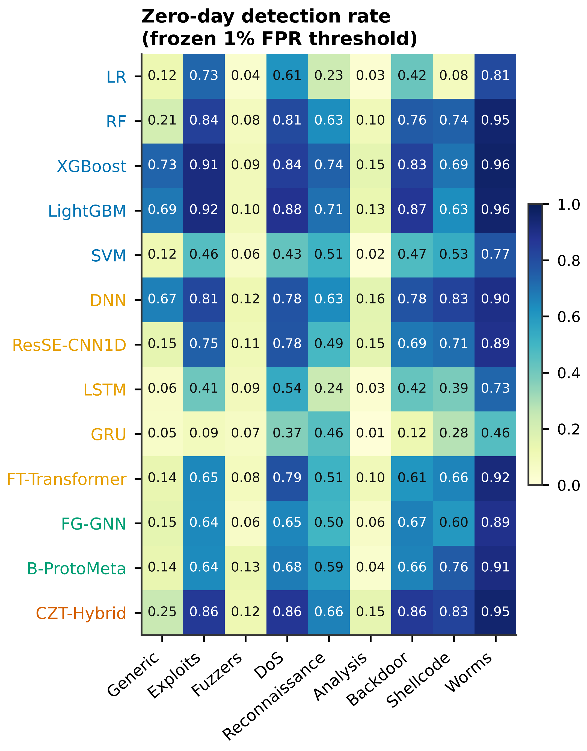
Figure S1. Results for each held-out family: (a) zero-day detection rate at the validation threshold and (b) AUROC between benign and unseen-family records (panel a)
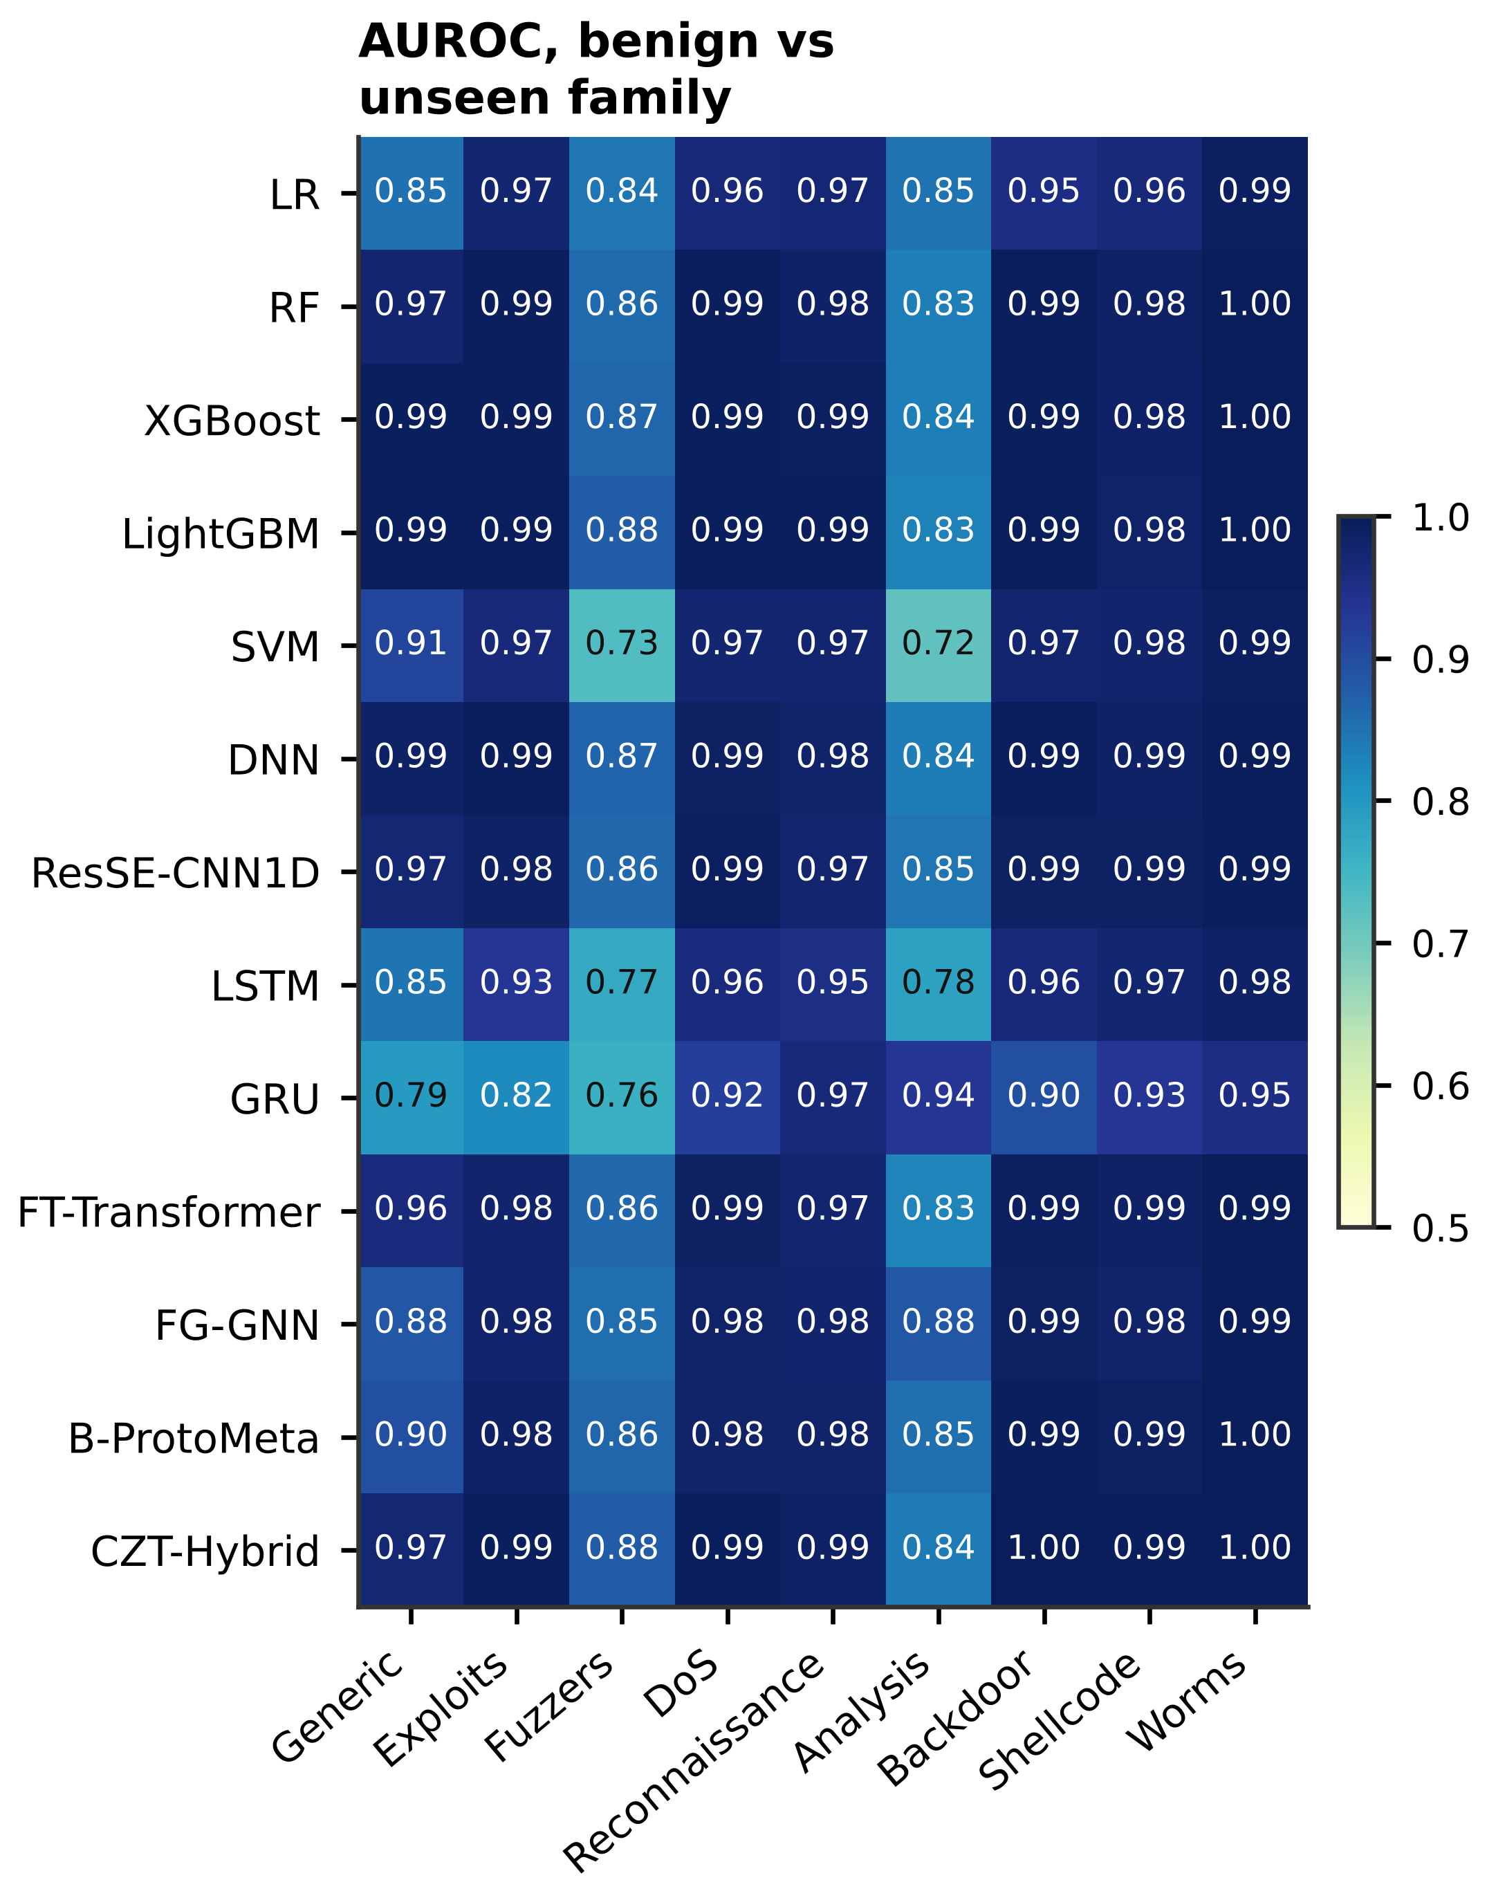
Figure S2. Results for each held-out family: (a) zero-day detection rate at the validation threshold and (b) AUROC between benign and unseen-family records (panel b)
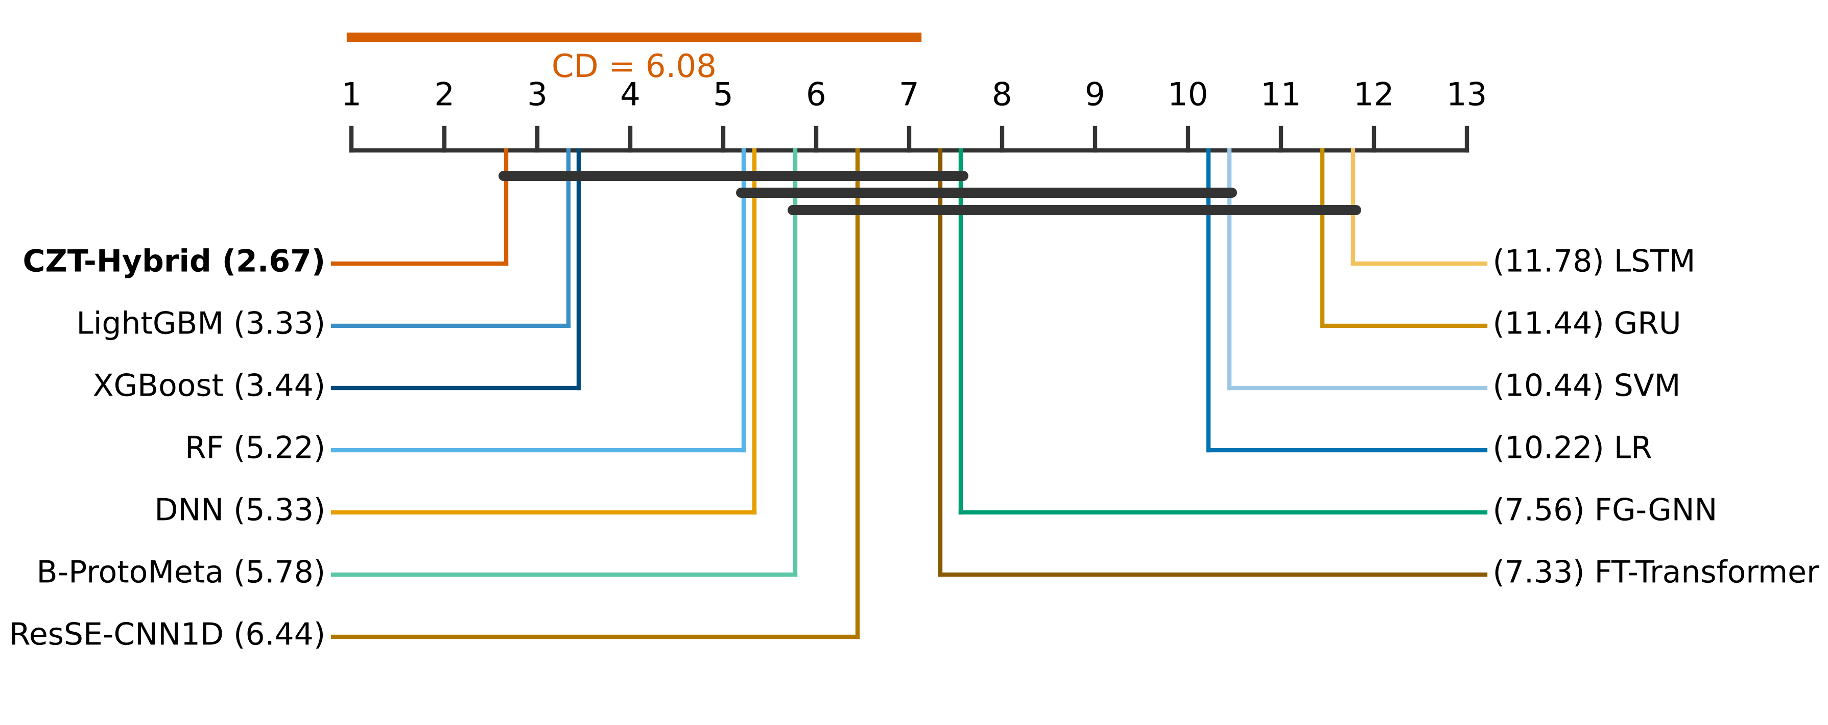
Figure S3. Critical-difference diagram of unseen-family AUROC ranks over nine folds (Nemenyi test, α = 0.05)
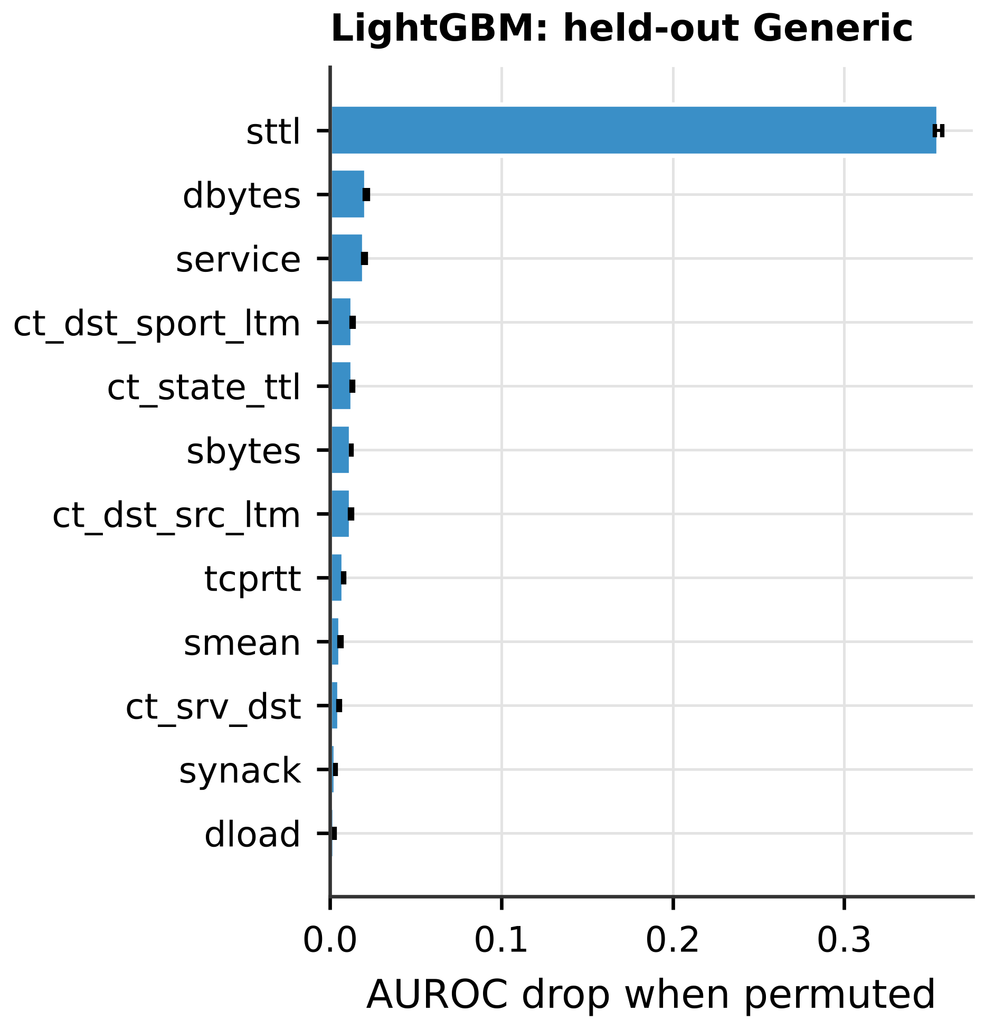
Figure S4. Permutation importance on the Generic hold-out fold: (a) LightGBM and (b) CZT-Hybrid (panel a)
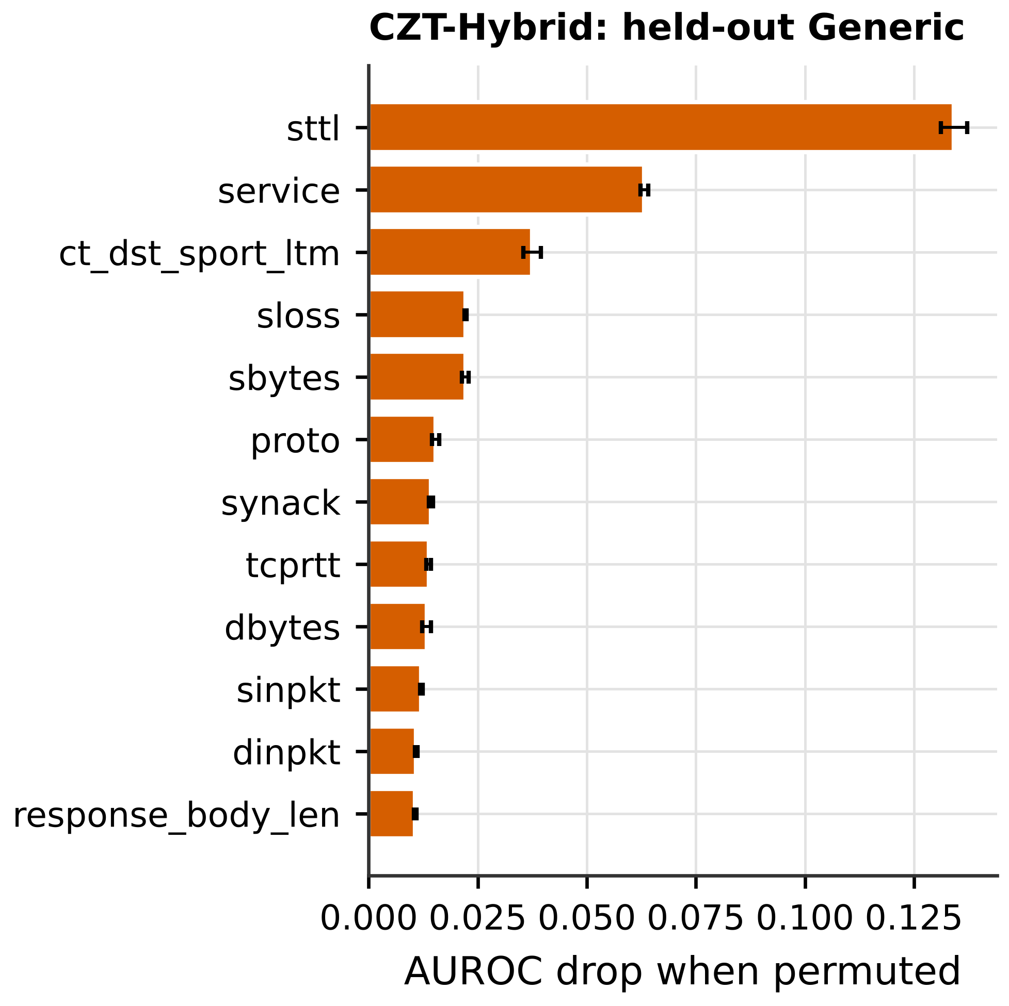
Figure S5. Permutation importance on the Generic hold-out fold: (a) LightGBM and (b) CZT-Hybrid (panel b)
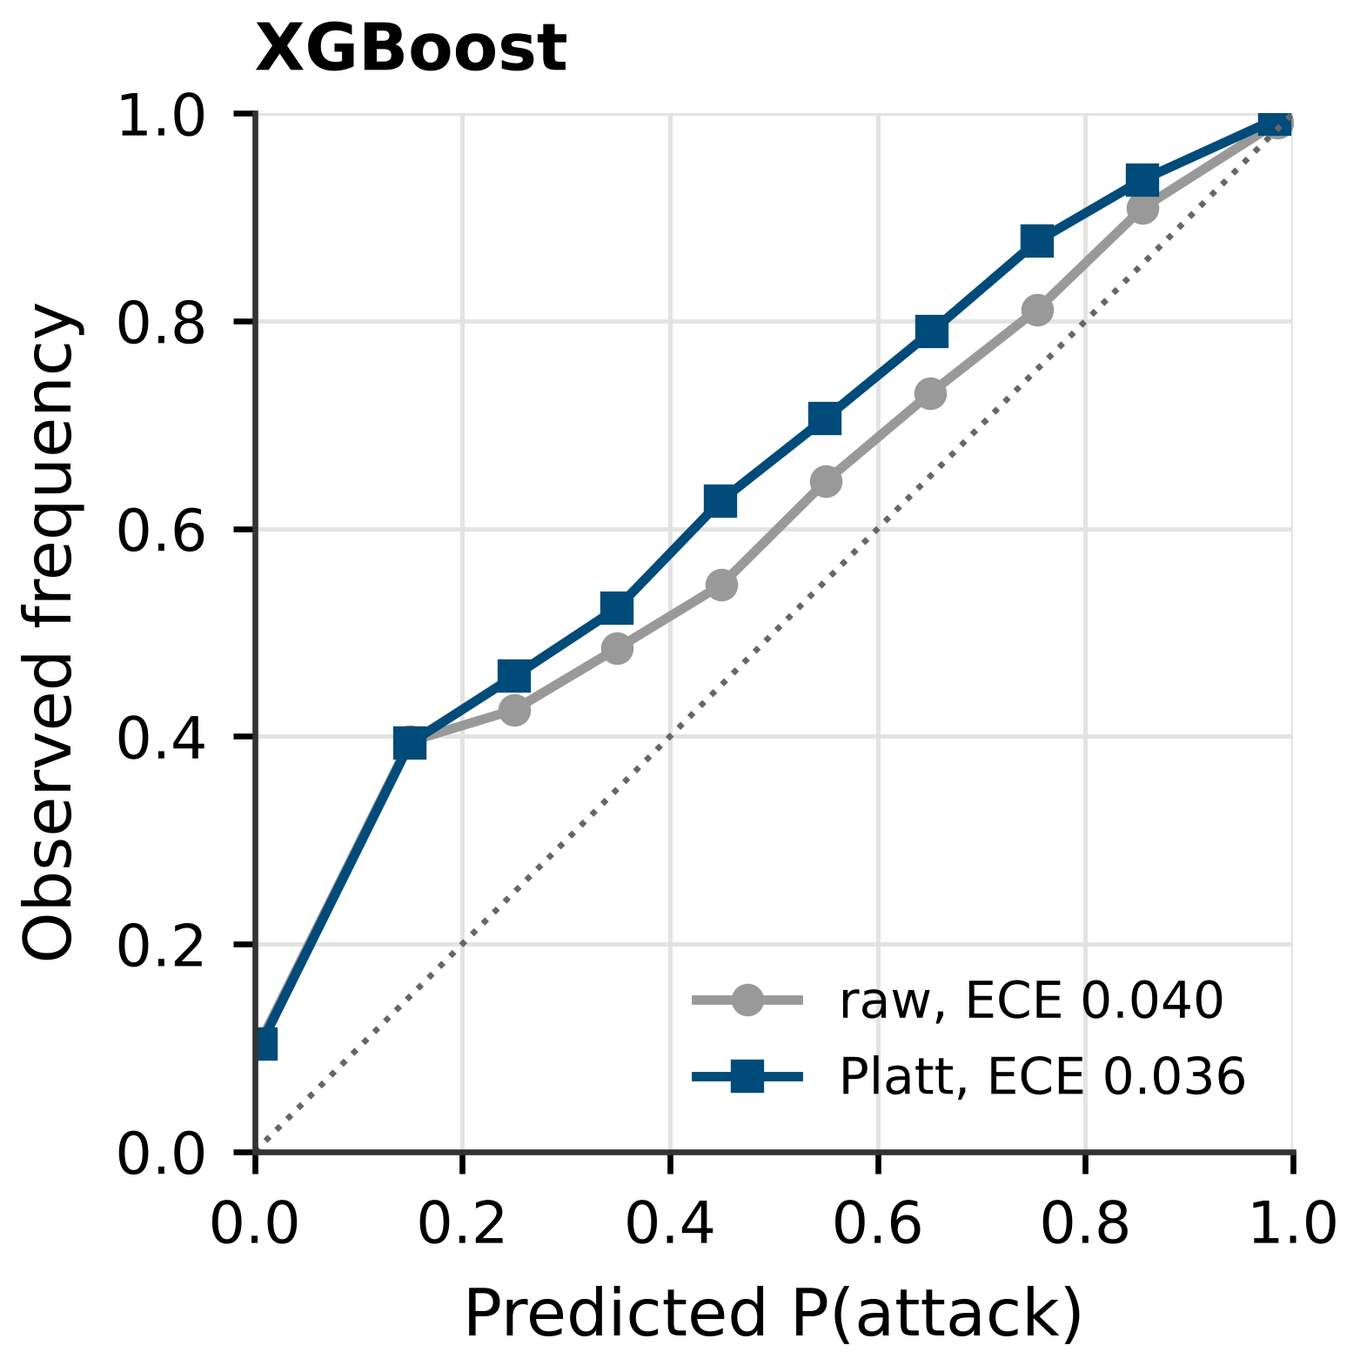
Figure S6. Reliability diagrams on pooled P2 test records before (grey) and after (colour) Platt scaling: (a) XGBoost, (b) ResSE-CNN1D, (c) B-ProtoMeta and (d) CZT-Hybrid (panel a)
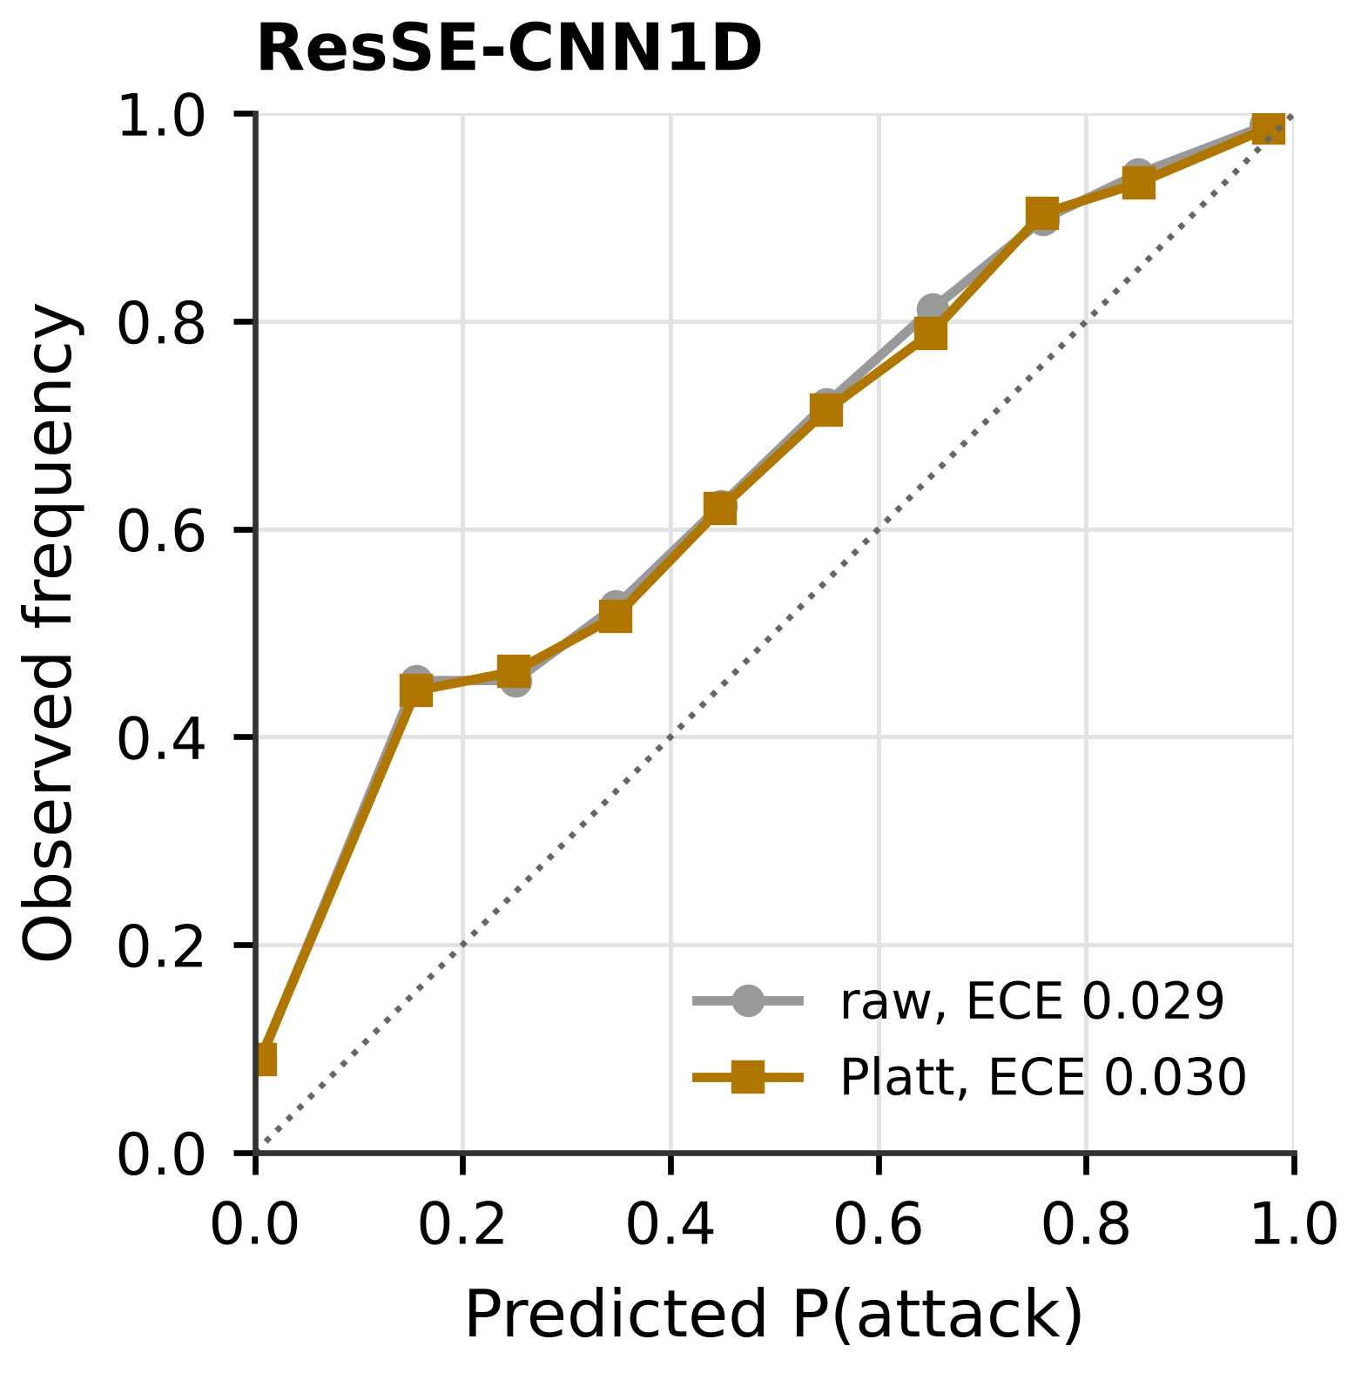
Figure S7. Reliability diagrams on pooled P2 test records before (grey) and after (colour) Platt scaling: (a) XGBoost, (b) ResSE-CNN1D, (c) B-ProtoMeta and (d) CZT-Hybrid (panel b)
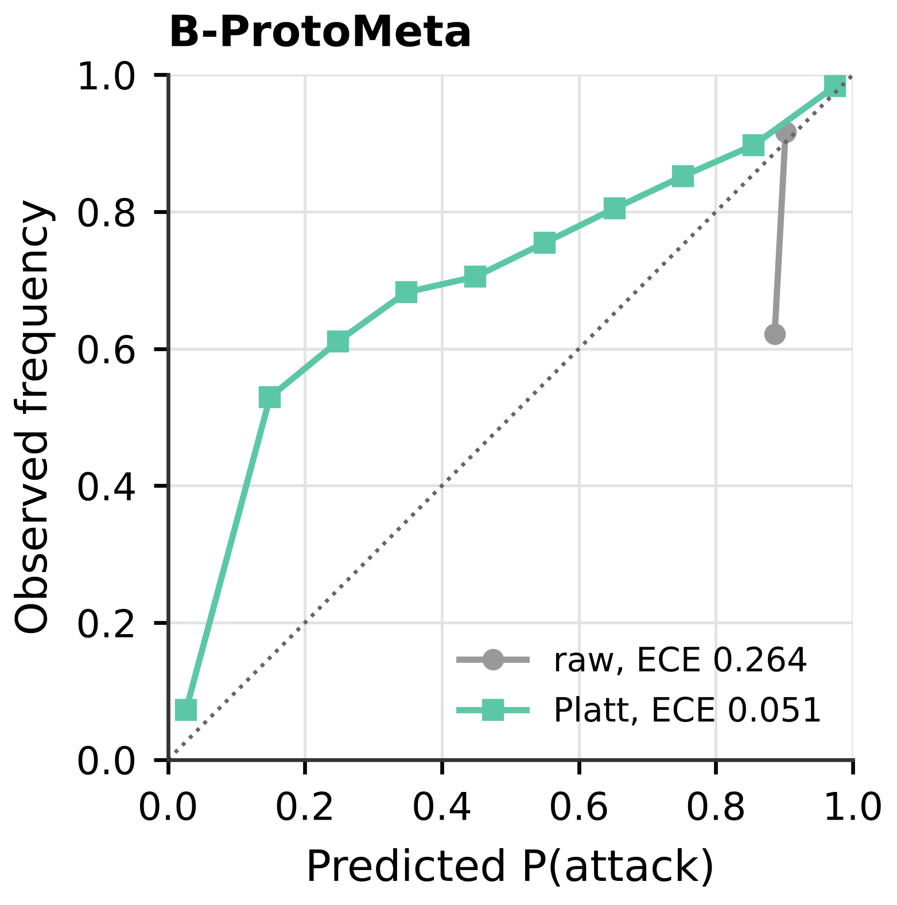
Figure S8. Reliability diagrams on pooled P2 test records before (grey) and after (colour) Platt scaling: (a) XGBoost, (b) ResSE-CNN1D, (c) B-ProtoMeta and (d) CZT-Hybrid (panel c)
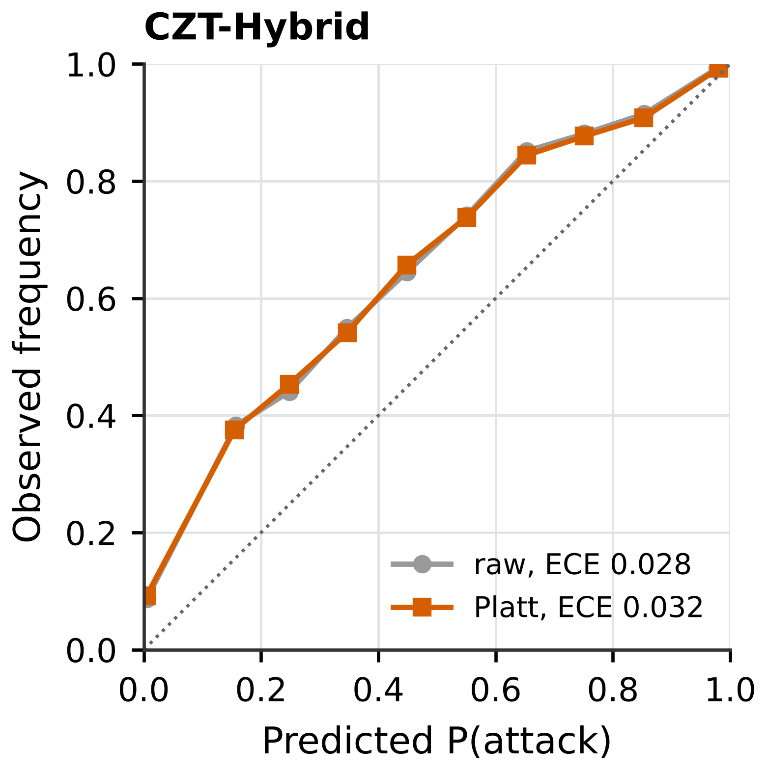
Figure S9. Reliability diagrams on pooled P2 test records before (grey) and after (colour) Platt scaling: (a) XGBoost, (b) ResSE-CNN1D, (c) B-ProtoMeta and (d) CZT-Hybrid (panel d)
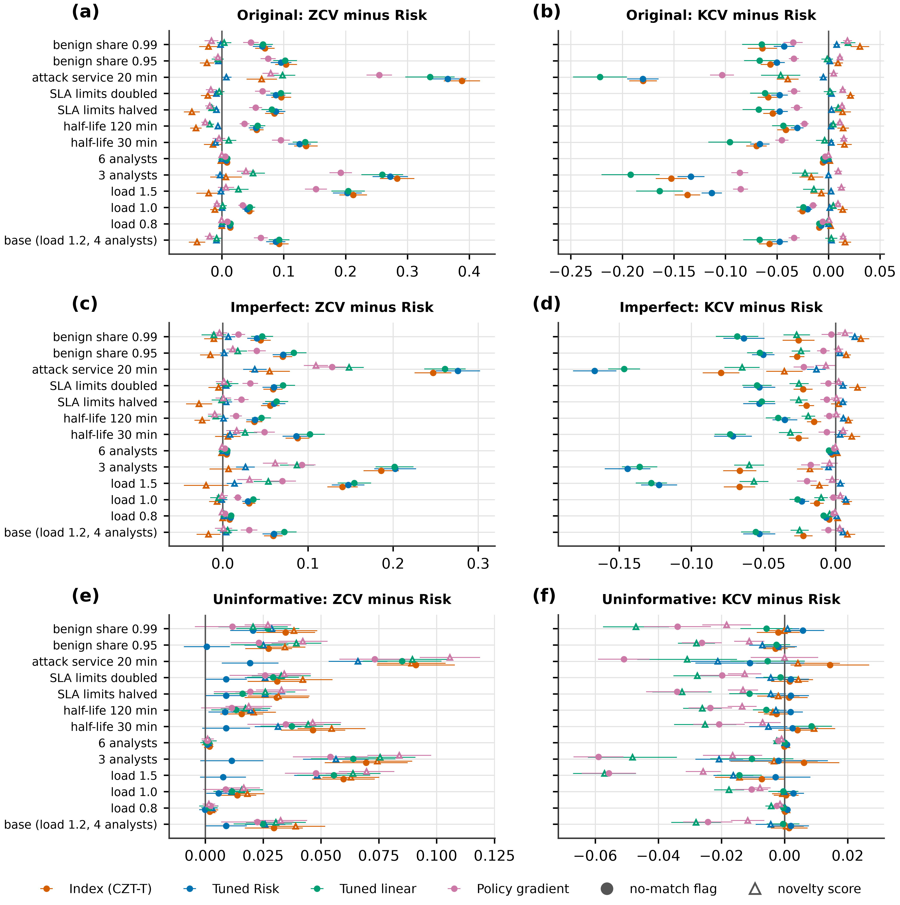
Figure S10. Paired difference from Risk in zero-day value (a, c, e) and known-attack value (b, d, f) when one simulator parameter is changed, for the original (a, b), imperfect (c, d) and uninformative (e, f) catalogue; bars are 95% intervals
Table S56. Protocol P4, target AUROC after adaptation with k labelled target records (U = UNSW-NB15, K = NSL-KDD; mean of three seeds)
Detector | U→K k=0 | U→K k=100 | U→K k=1000 | K→U k=0 | K→U k=100 | K→U k=1000
LR | 0.705 | 0.885 | 0.890 | 0.493 | 0.596 | 0.596
RF | 0.112 | 0.977 | 0.994 | 0.487 | 0.862 | 0.937
XGBoost | 0.138 | 0.980 | 0.996 | 0.447 | 0.861 | 0.946
LightGBM | 0.100 | 0.979 | 0.996 | 0.457 | 0.864 | 0.947
DNN | 0.499 | 0.941 | 0.982 | 0.458 | 0.693 | 0.864
ResSE-CNN1D | 0.467 | 0.952 | 0.989 | 0.434 | 0.752 | 0.891
B-ProtoMeta | 0.417 | 0.579 | 0.554 | 0.505 | 0.500 | 0.500
CZT-Hybrid | 0.288 | 0.967 | 0.995 | 0.469 | 0.853 | 0.943

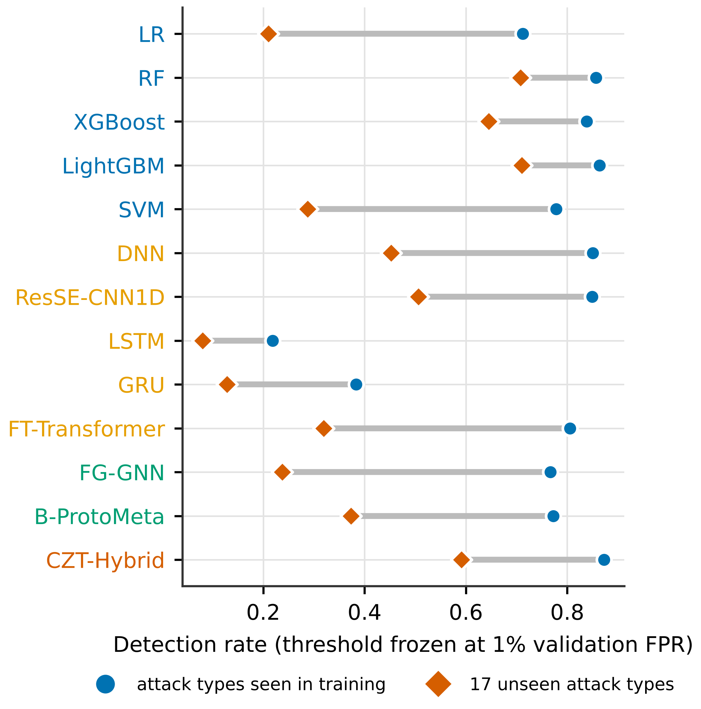
Figure S11. Detection of NSL-KDD attack types: (a) seen and unseen types
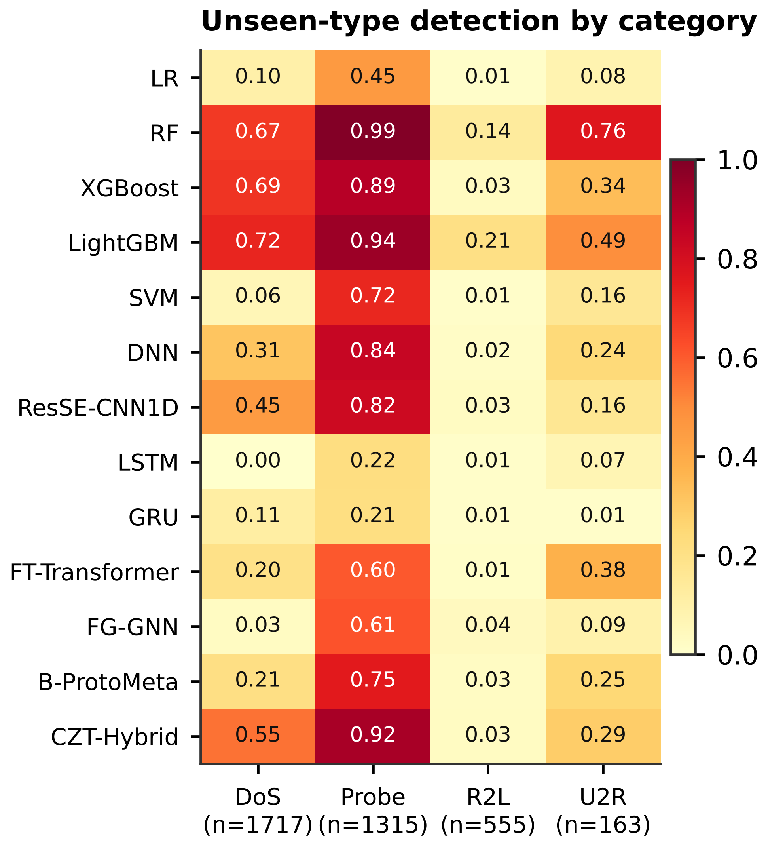
Figure S12. Detection of NSL-KDD attack types: (b) unseen types by category
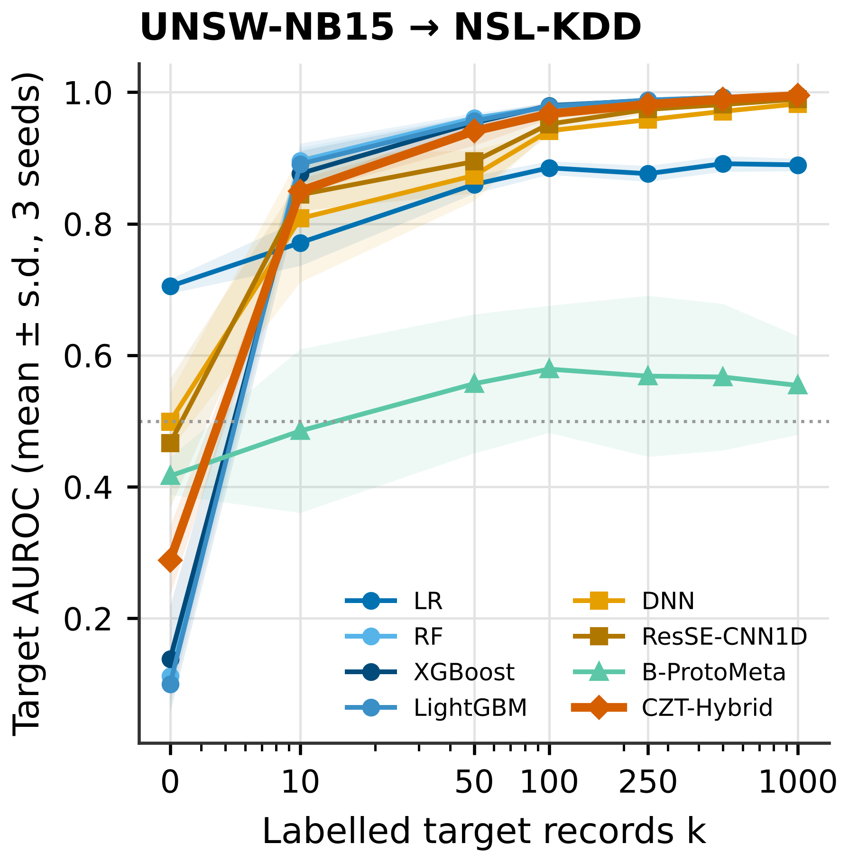
Figure S13. Target AUROC versus the number k of labelled target records: (a) UNSW-NB15 to NSL-KDD
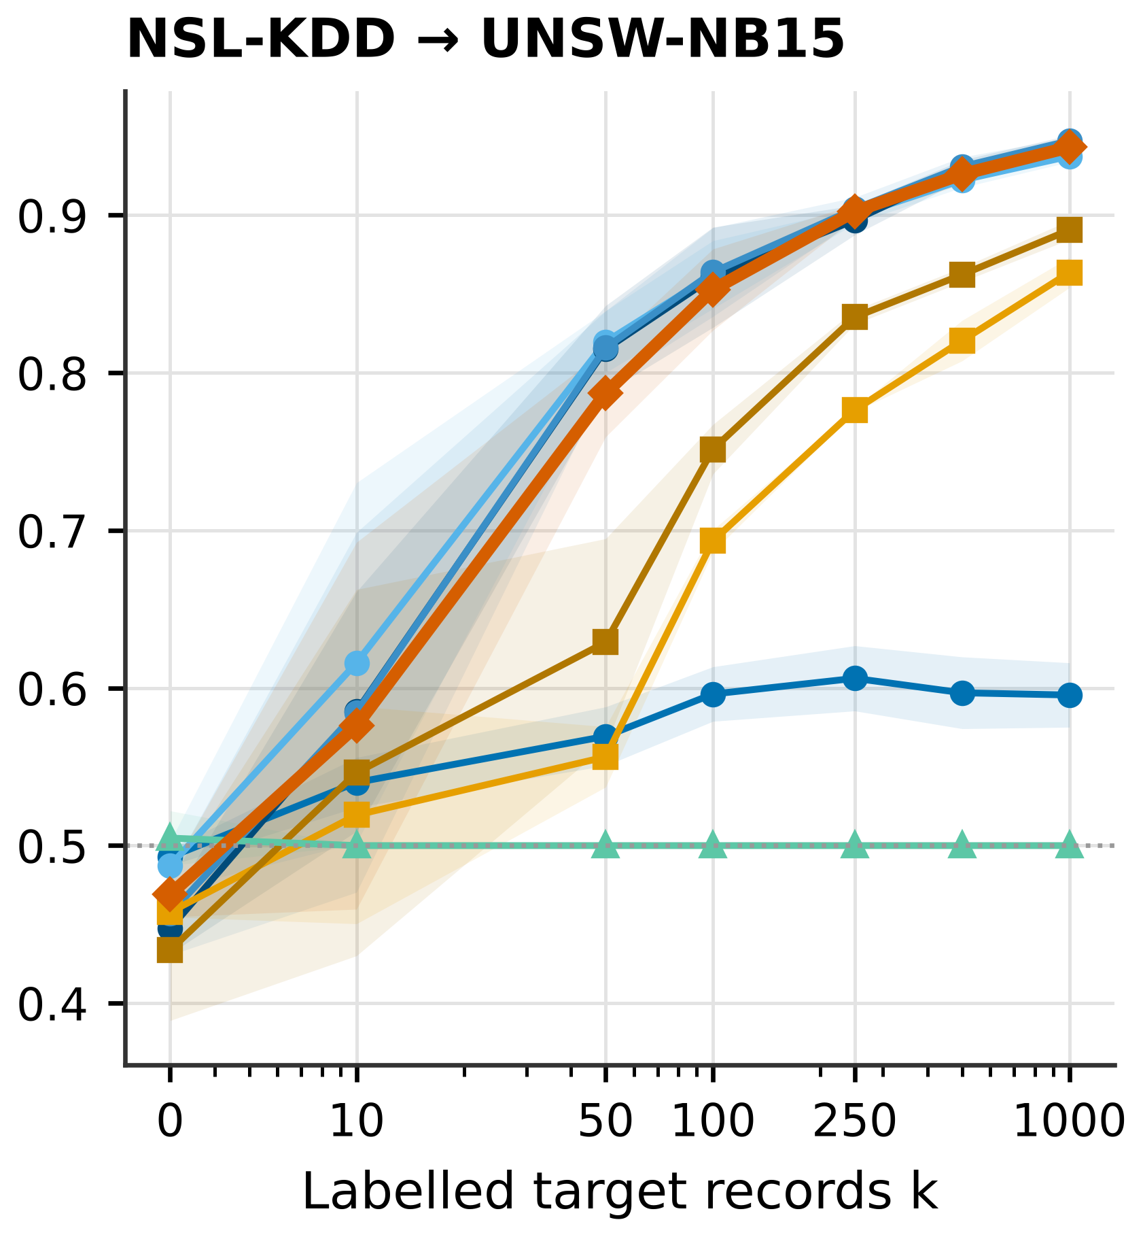
Figure S14. Target AUROC versus the number k of labelled target records: (b) NSL-KDD to UNSW-NB15
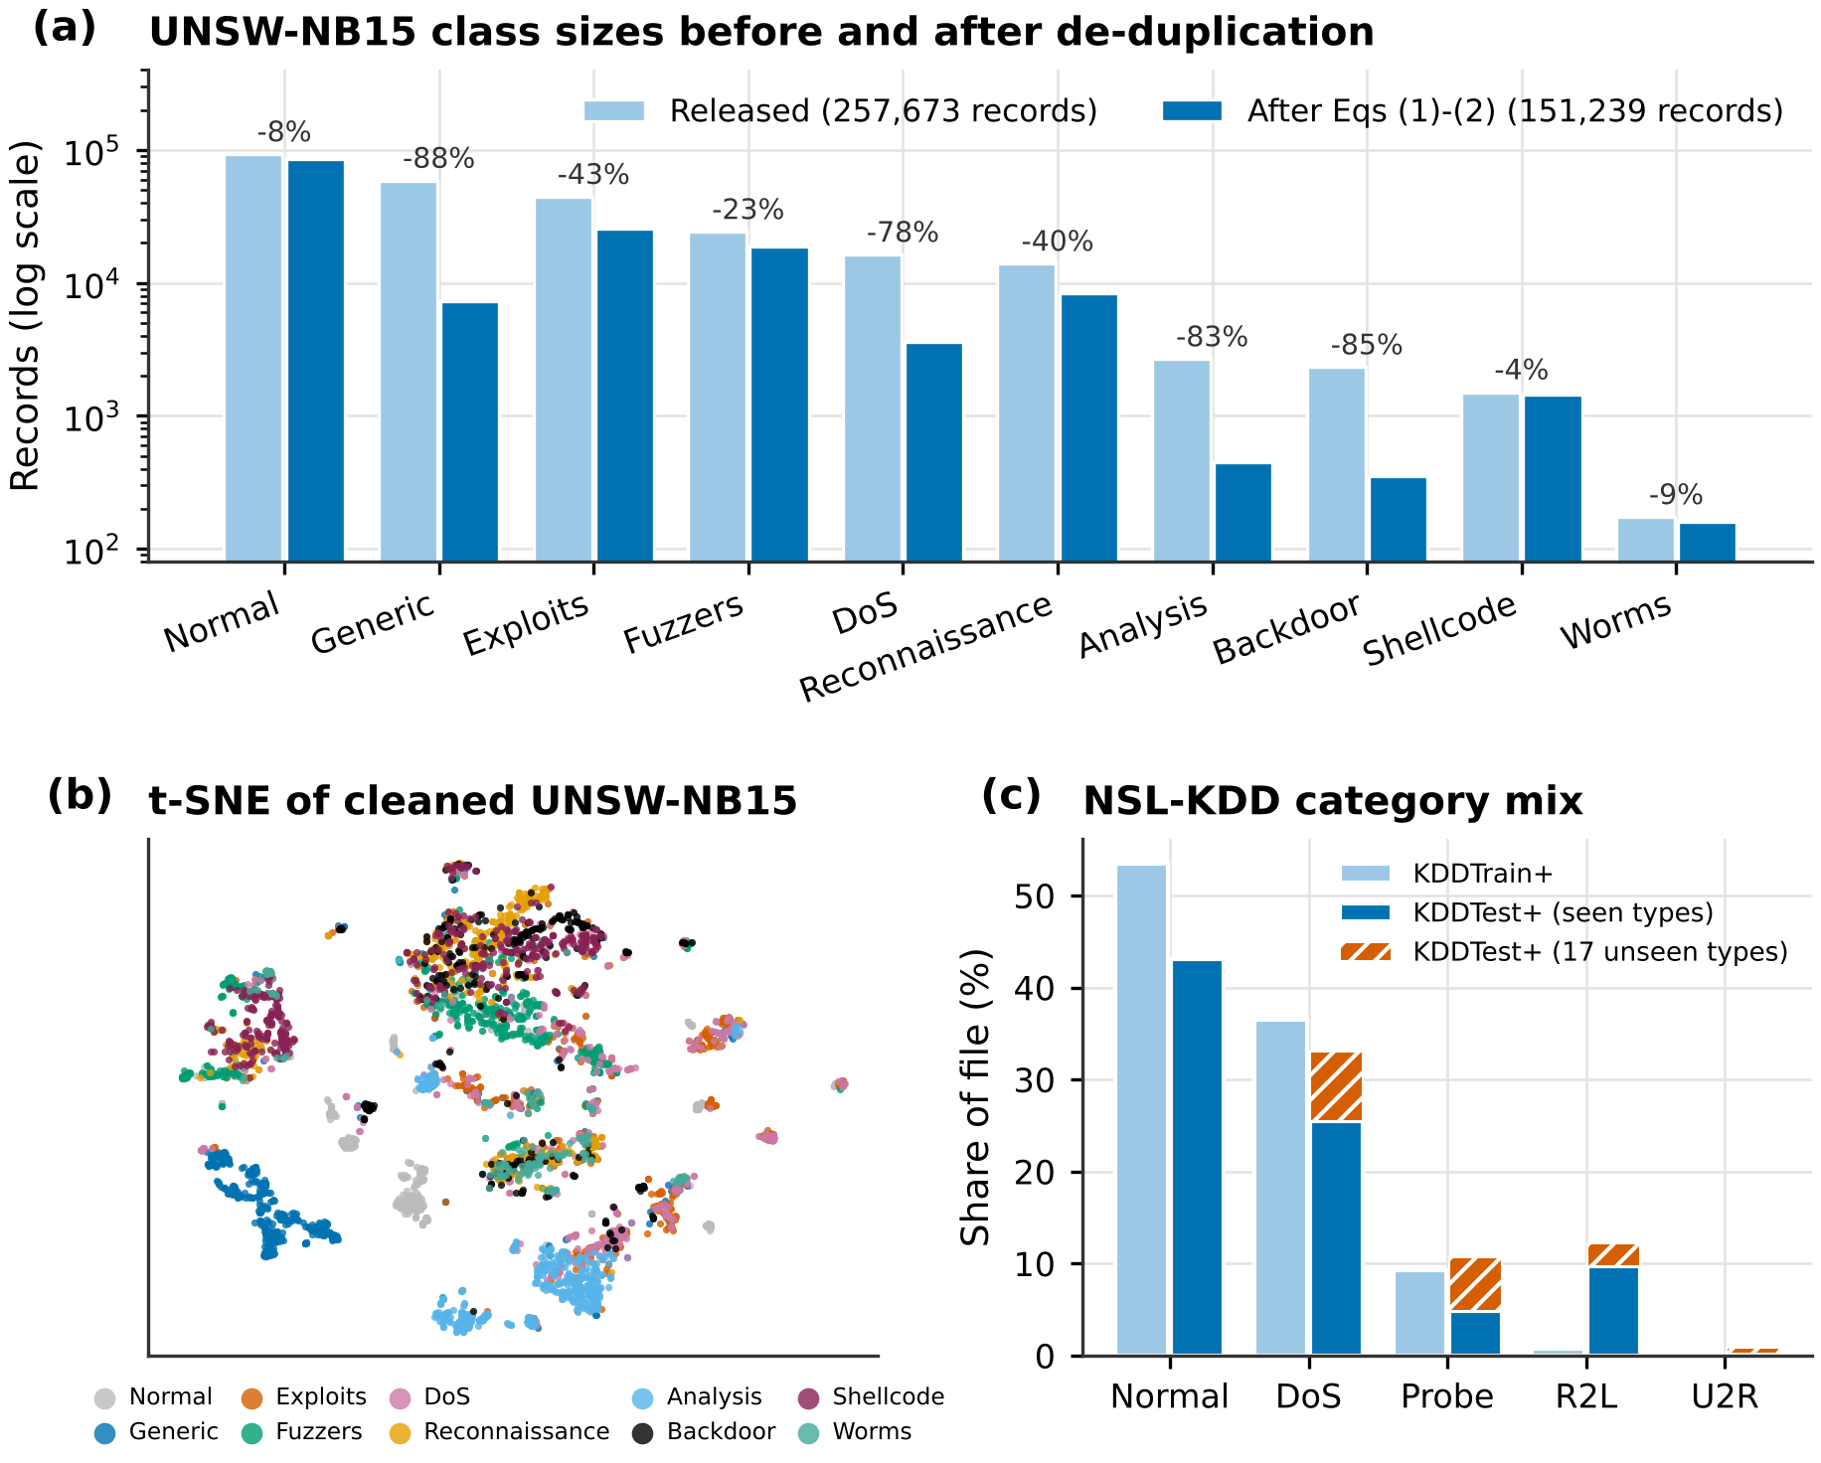
Figure S15. UNSW-NB15 class sizes before and after cleaning (a), t-SNE view of the cleaned data (b) and NSL-KDD category shares (c)
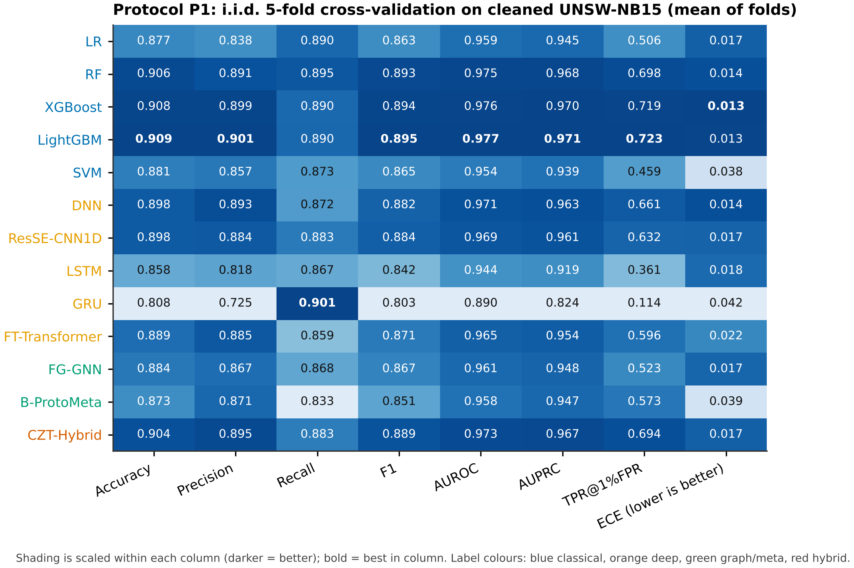
Figure S16. Protocol P1 metrics, shaded within each column (darker is better)
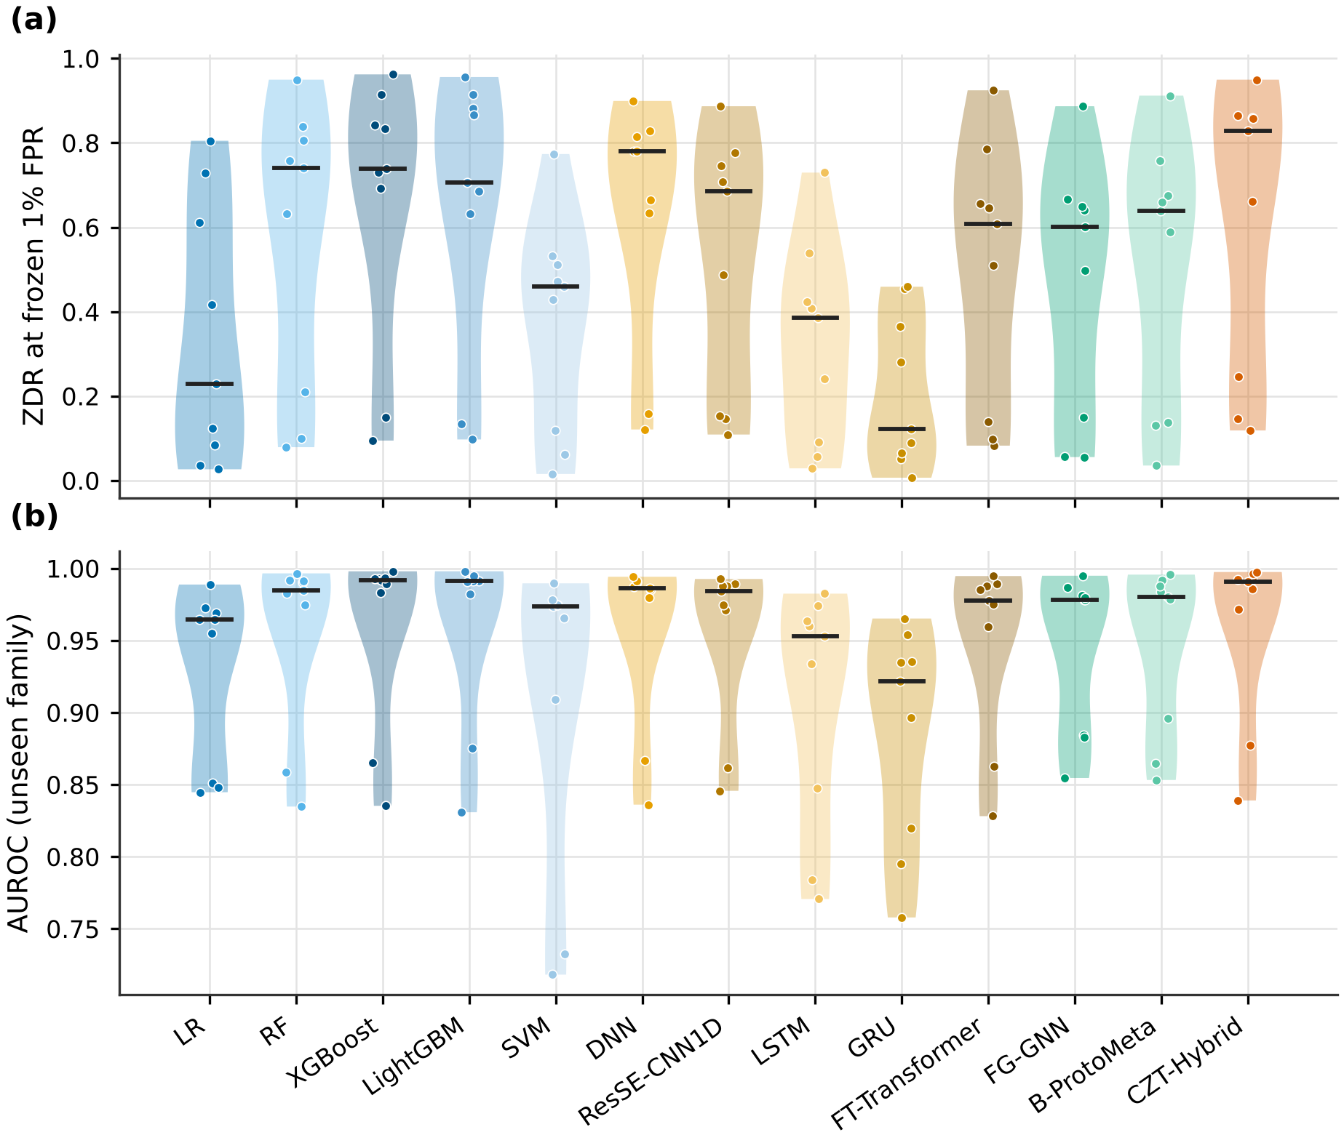
Figure S17. Distribution of ZDR (a) and unseen-family AUROC (b) over the nine held-out families
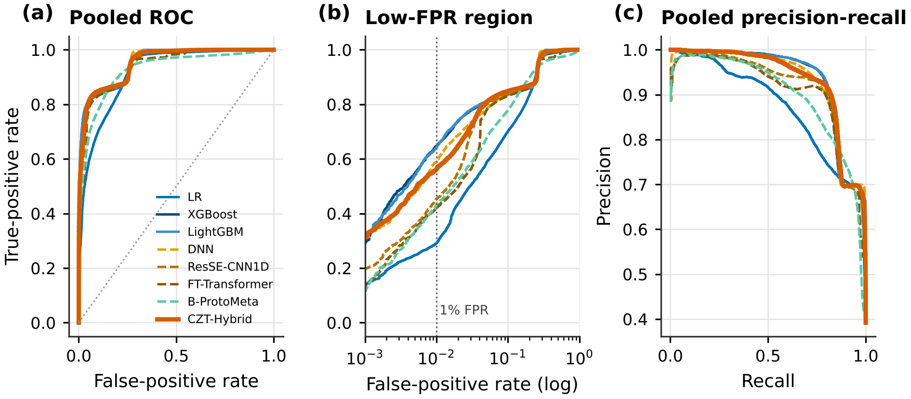
Figure S18. Pooled ROC (a), low-FPR ROC (b) and precision-recall (c) curves on benign and unseen-family P2 records
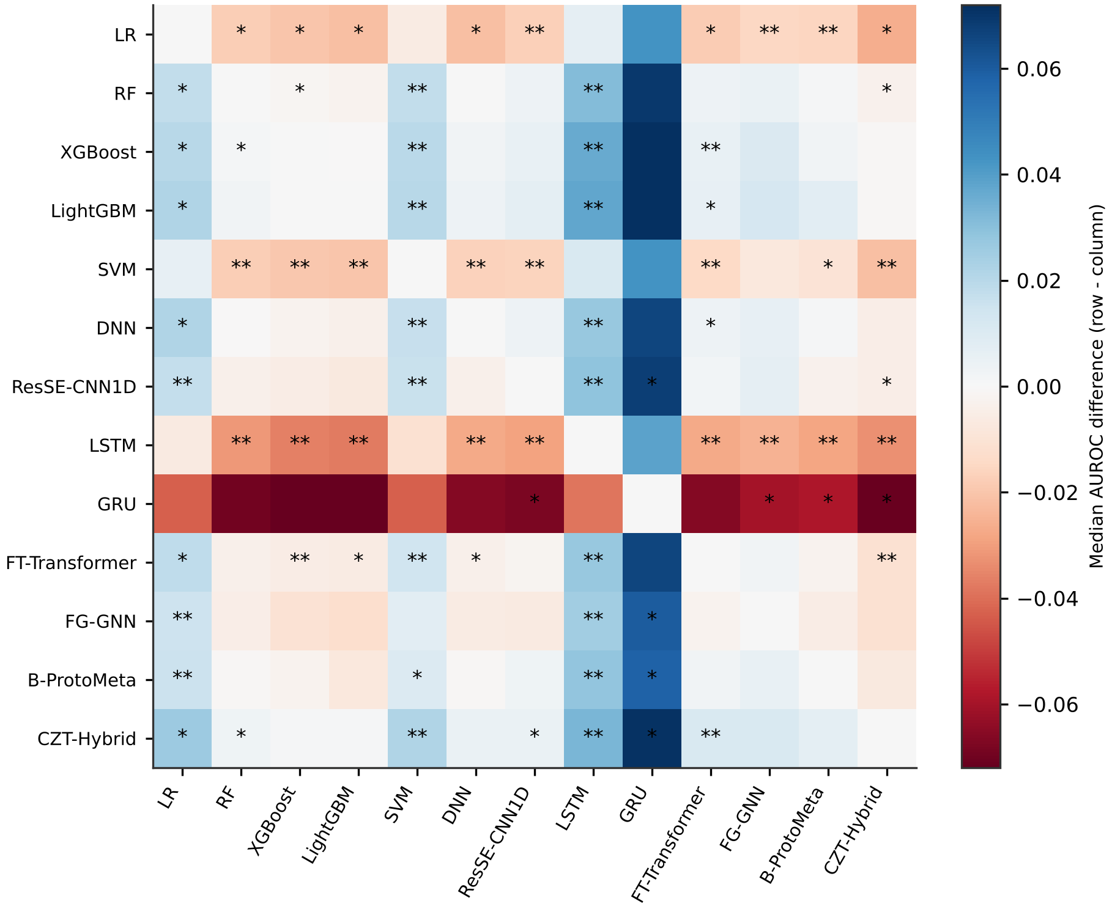
Figure S19. Median paired AUROC difference for every pair of detectors (uncorrected Wilcoxon p-values marked)
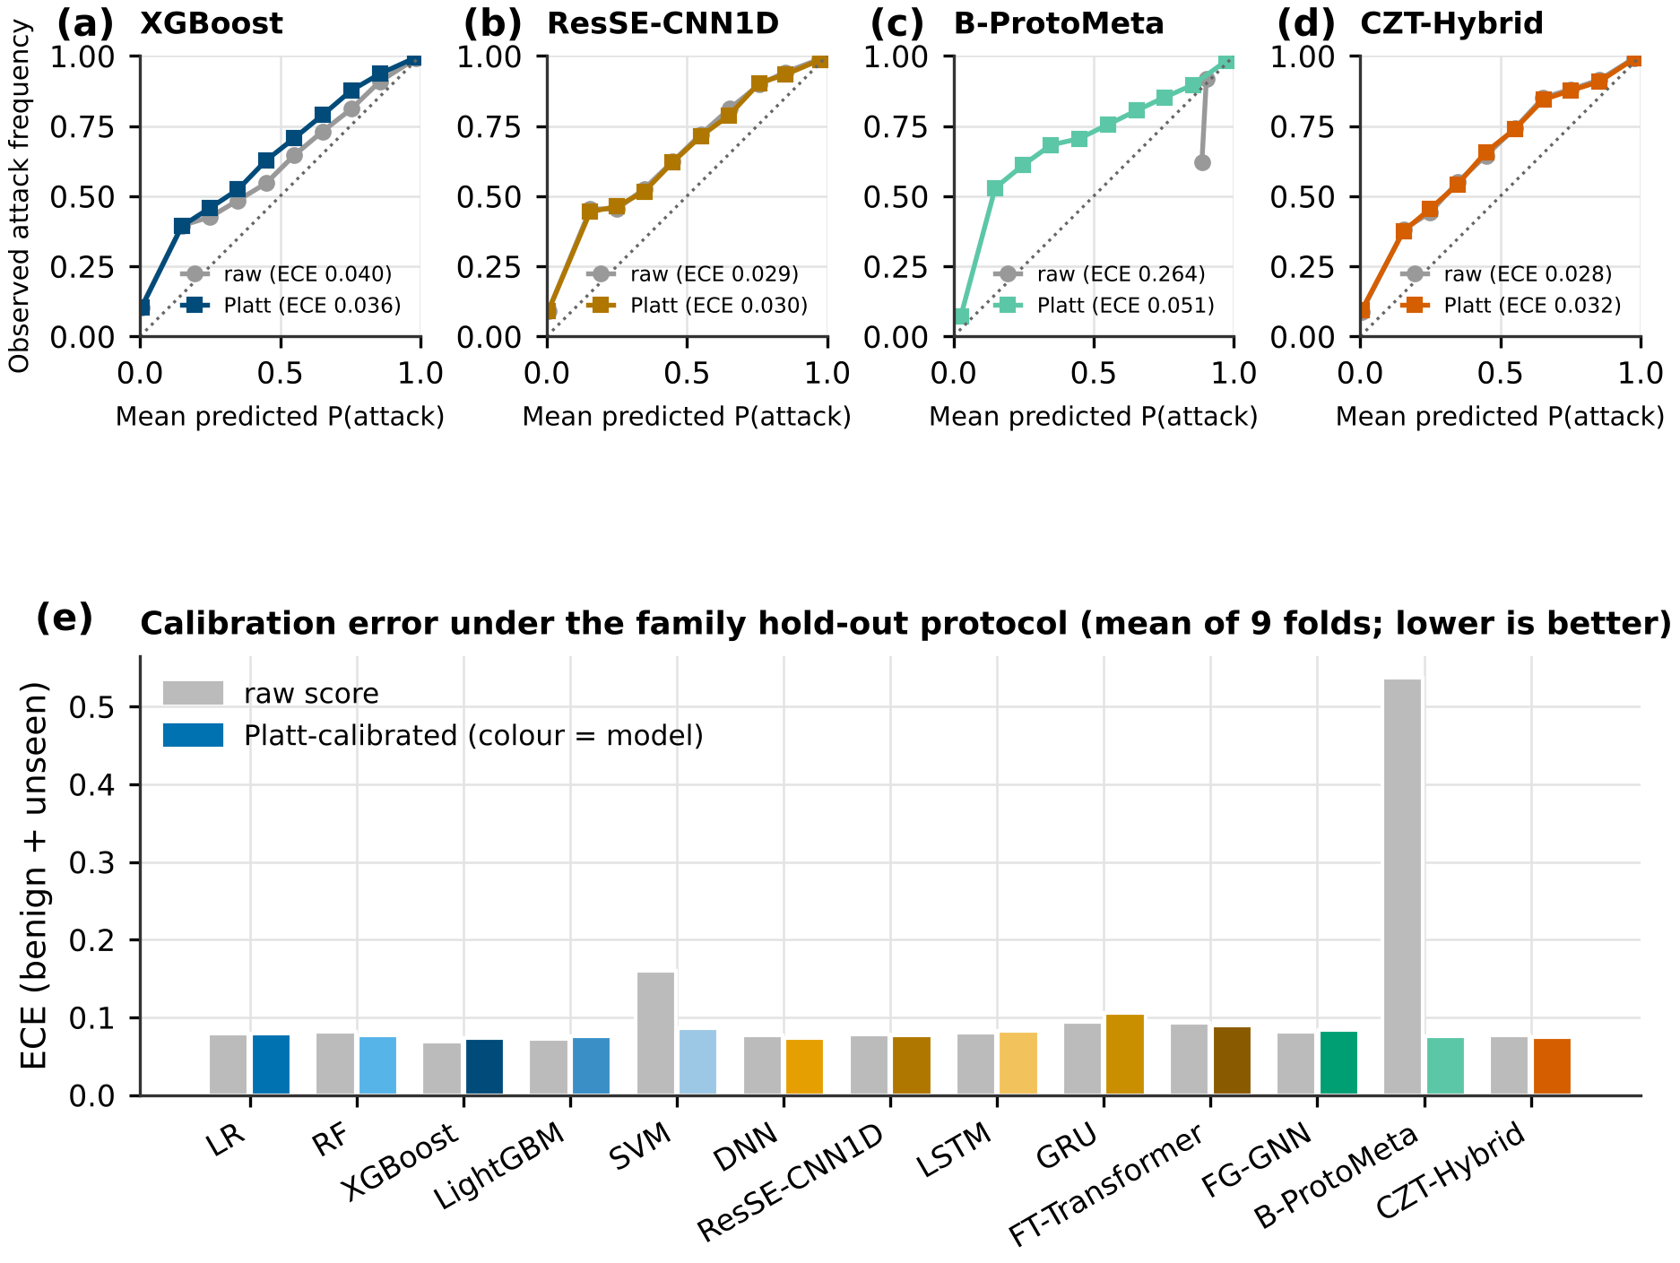
Figure S20. Reliability diagrams and mean ECE of every detector on benign and unseen P2 records, raw and after Platt scaling
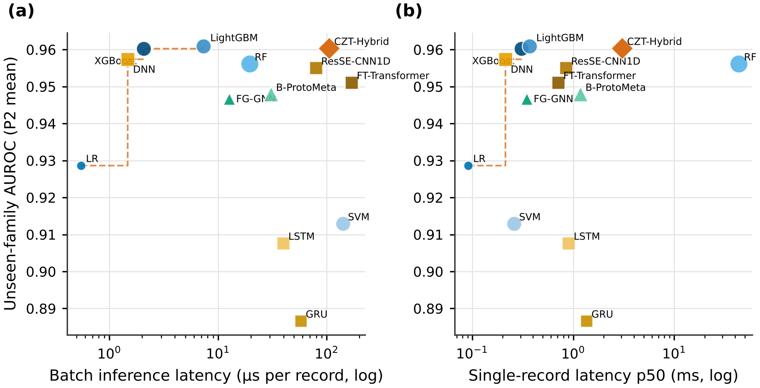
Figure S21. Unseen-family AUROC against batch (a) and single-record (b) latency
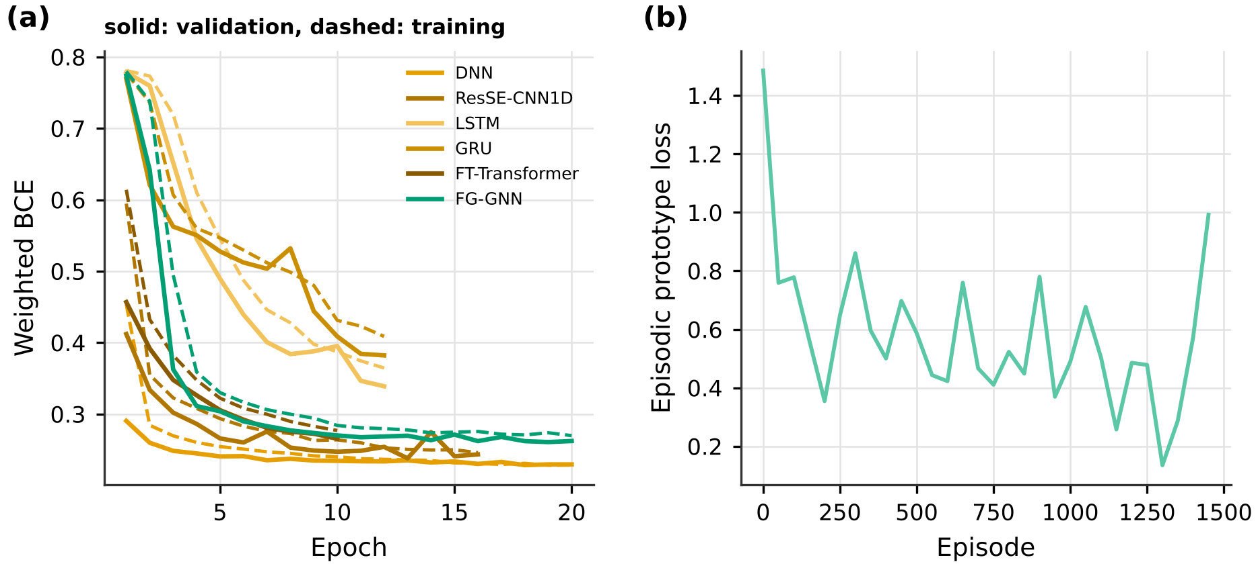
Figure S22. Training curves of the neural detectors in fold 0 of P1 (a) and episodic loss of B-ProtoMeta (b)

S13. Reproducibility package
Table S57. Reproducibility checklist
Item requested | Location
Duplicate and conflict masks | code/repro/masks_unsw.npz (two boolean masks over the merged release)
Feature mappings and vocabularies | Tables S2 to S4; code/zdt/data.py
Split indices | code/repro/splits_p1.npz, code/repro/splits_p2.npz, code/repro/splits_p3.npz; P4 and P5 seeds in code/repro/config.json
Detector and calibration configurations | code/repro/config.json; Table S8; code/zdt/models.py, clad.py, anomaly.py
Per-fold scores and labels | code/results/e2_scores.npz (13 detectors), code/results/e10_refit/*.npz (refit, no TTL, CLAD, novelty)
Optimiser seeds and selected weights | code/repro/config.json; code/tables/s_table_e9_tuned.csv; code/results/e9_triage.json (all candidates)
Simulator arrival and service streams | code/repro/streams_e9.npz (every tuning and evaluation replication of the main G1/G2 runs); all other triage runs (partitions, robustness checks, fresh streams) are regenerated exactly from the seeds recorded in their result files and scripts
Robustness and second-round runs | code/results/e17_robust.json, e18_detection_robust.json, e19_clad_wide.json, e20_fresh.json, e21_detector_seeds.json, with the scripts listed in code/README.md
Statistical output | code/tables/s_table_wilcoxon_full.csv, s_table_friedman_full.json, s_table_e9_paired.csv
Environment | code/requirements-lock.txt (Python 3.11.16); code/run_revision.sh, run_revision2.sh, run_revision3.sh
Immutable version | tagged release of the repository with a Zenodo DOI [to be added by the authors]

