Supplementary Material for “Calibrated Zero-Day Attack Detection and Whittle-Index Alert Triage under Leakage-Averse Evaluation”
This supplement gives the details behind the tables and figures of the main paper. Section, table, figure and equation numbers without the prefix S refer to the main paper. All values were produced by the public code repository that accompanies the paper.

S1. Data preparation details
This section lists the features and the mappings used in Section 3.1 of the main paper, so that the preprocessing can be repeated exactly.
After cleaning, the UNSW-NB15 matrix has 60 columns, namely dur, spkts, dpkts, sbytes, dbytes, rate, sttl, dttl, sload, dload, sloss, dloss, sinpkt, dinpkt, sjit, djit, swin, stcpb, dtcpb, dwin, tcprtt, synack, ackdat, smean, dmean, trans_depth, response_body_len, ct_srv_src, ct_state_ttl, ct_dst_ltm, ct_src_dport_ltm, ct_dst_sport_ltm, ct_dst_src_ltm, is_ftp_login, ct_ftp_cmd, ct_flw_http_mthd, ct_src_ltm, ct_srv_dst, is_sm_ips_ports, proto=tcp, proto=udp, proto=unas, proto=arp, proto=ospf, proto=other, service=-, service=dns, service=http, service=smtp, service=ftp, service=ftp-data, service=pop3, service=ssh, service=other, state=FIN, state=INT, state=CON, state=REQ, state=RST, state=other.
The NSL-KDD matrix has 68 columns, namely duration, src_bytes, dst_bytes, land, wrong_fragment, urgent, hot, num_failed_logins, logged_in, num_compromised, root_shell, su_attempted, num_root, num_file_creations, num_shells, num_access_files, is_host_login, is_guest_login, count, srv_count, serror_rate, srv_serror_rate, rerror_rate, srv_rerror_rate, same_srv_rate, diff_srv_rate, srv_diff_host_rate, dst_host_count, dst_host_srv_count, dst_host_same_srv_rate, dst_host_diff_srv_rate, dst_host_same_src_port_rate, dst_host_srv_diff_host_rate, dst_host_serror_rate, dst_host_srv_serror_rate, dst_host_rerror_rate, dst_host_srv_rerror_rate, protocol_type=tcp, protocol_type=udp, protocol_type=icmp, protocol_type=other, service=http, service=private, service=domain_u, service=smtp, service=ftp_data, service=ecr_i, service=eco_i, service=other, service=ftp, service=telnet, service=finger, service=urp_i, service=auth, service=imap4, service=pop_3, flag=SF, flag=S0, flag=REJ, flag=RSTR, flag=SH, flag=RSTO, flag=S1, flag=RSTOS0, flag=S3, flag=S2, flag=OTH, flag=other. KDDTrain+ contains 22 attack types and KDDTest+ contains 37. The 17 attack types found only in KDDTest+ are apache2, httptunnel, mailbomb, mscan, named, processtable, ps, saint, sendmail, snmpgetattack, snmpguess, sqlattack, udpstorm, worm, xlock, xsnoop, xterm.
Table S1 lists the shared schema used in protocol P4.
Table S1. Shared 18-feature schema for cross-dataset transfer
Shared feature | UNSW-NB15 source | NSL-KDD source
log_duration | dur | duration
log_src_bytes | sbytes | src_bytes
log_dst_bytes | dbytes | dst_bytes
log_conn_count | ct_dst_ltm | count
log_srv_count | ct_srv_src | srv_count
proto (tcp, udp, icmp, other) | proto | protocol_type
svc (http, ftp, smtp, dns, ssh, other) | service; ftp-data as ftp | service; ftp_data as ftp, domain_u as dns
state = established | FIN, CON | SF
state = incomplete | INT, REQ and others | S0 to S3, SH, OTH
state = reset | RST, CLO, ACC | REJ, RSTO, RSTR, RSTOS0
The two connection-count features in Table S1 are only approximate counterparts. UNSW-NB15 counts connections among the last 100 records, while NSL-KDD counts connections in the past two seconds. This mismatch is deliberate, because imperfect feature correspondence is part of the shift that a deployed model faces, and it contributes to the inverted zero-shot rankings reported in Section 5.4.
Table S2. True severities used to score triage outcomes
UNSW-NB15 class | Severity
Normal | 0.00
Generic | 0.55
Exploits | 0.85
Fuzzers | 0.45
DoS | 0.70
Reconnaissance | 0.35
Analysis | 0.40
Backdoor | 0.95
Shellcode | 0.90
Worms | 1.00
The severities in Table S2 were assigned according to the typical impact of each behaviour, so that a backdoor or a worm, which implies lasting compromise, ranks above reconnaissance. They are used only to score outcomes and to derive the catalogue severities of known families. They are never inputs to the detectors.
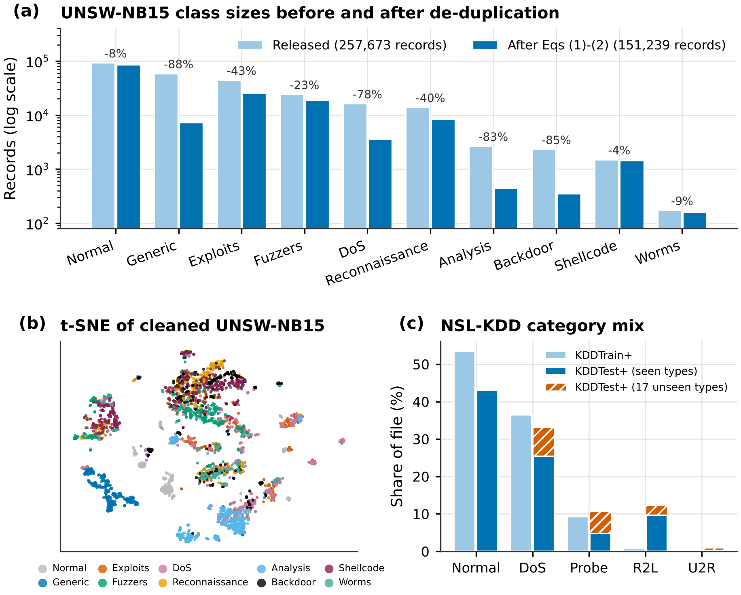
Figure S1. UNSW-NB15 class sizes before and after cleaning (a), t-SNE view of the cleaned data (b) and NSL-KDD category mix (c)
Fig. S1a shows that duplication is very uneven. Generic loses 88% of its records, Backdoor 85%, Analysis 83% and DoS 78%, whereas Normal loses 8% and Shellcode 4%. The t-SNE view [1] in panel (b) shows that Generic and Normal form compact clusters, while Exploits, Fuzzers, DoS, Analysis and Backdoor overlap, which anticipates the per-family differences of Fig. 2. Panel (c) shows that the NSL-KDD test file has a different category mix from the training file, and that unseen types make up about a quarter of the DoS and about half of the Probe test records.

S2. Complete i.i.d. results
This section extends Table 4 with all threshold and ranking metrics, and quantifies the effect of de-duplication on protocol P1.
Table S3. Protocol P1 with all metrics (mean ± standard deviation over five folds; threshold 0.5)
Detector | Accuracy | Precision | Recall | F1 | AUROC | AUPRC | TPR@1%FPR | ECE | Brier
LR | 0.877 ± 0.007 | 0.838 ± 0.014 | 0.890 ± 0.006 | 0.863 ± 0.007 | 0.959 ± 0.003 | 0.945 ± 0.005 | 0.506 ± 0.032 | 0.017 ± 0.003 | 0.081 ± 0.004
RF | 0.906 ± 0.002 | 0.891 ± 0.006 | 0.895 ± 0.003 | 0.893 ± 0.002 | 0.975 ± 0.001 | 0.968 ± 0.002 | 0.698 ± 0.019 | 0.014 ± 0.001 | 0.064 ± 0.001
XGBoost | 0.908 ± 0.001 | 0.899 ± 0.004 | 0.890 ± 0.006 | 0.894 ± 0.002 | 0.976 ± 0.001 | 0.970 ± 0.001 | 0.719 ± 0.014 | 0.013 ± 0.003 | 0.062 ± 0.001
LightGBM | 0.909 ± 0.003 | 0.901 ± 0.007 | 0.890 ± 0.005 | 0.895 ± 0.003 | 0.977 ± 0.001 | 0.971 ± 0.002 | 0.723 ± 0.017 | 0.013 ± 0.001 | 0.061 ± 0.001
SVM | 0.881 ± 0.007 | 0.857 ± 0.012 | 0.873 ± 0.010 | 0.865 ± 0.007 | 0.954 ± 0.004 | 0.939 ± 0.005 | 0.459 ± 0.044 | 0.038 ± 0.003 | 0.085 ± 0.004
DNN | 0.898 ± 0.006 | 0.893 ± 0.012 | 0.872 ± 0.002 | 0.882 ± 0.006 | 0.971 ± 0.002 | 0.963 ± 0.002 | 0.661 ± 0.019 | 0.014 ± 0.002 | 0.069 ± 0.002
ResSE-CNN1D | 0.898 ± 0.006 | 0.884 ± 0.011 | 0.883 ± 0.008 | 0.884 ± 0.006 | 0.969 ± 0.003 | 0.961 ± 0.004 | 0.632 ± 0.038 | 0.017 ± 0.004 | 0.070 ± 0.003
LSTM | 0.858 ± 0.004 | 0.818 ± 0.016 | 0.867 ± 0.014 | 0.842 ± 0.002 | 0.944 ± 0.003 | 0.919 ± 0.007 | 0.361 ± 0.036 | 0.018 ± 0.002 | 0.093 ± 0.002
GRU | 0.808 ± 0.024 | 0.725 ± 0.019 | 0.901 ± 0.063 | 0.803 ± 0.031 | 0.890 ± 0.022 | 0.824 ± 0.037 | 0.114 ± 0.080 | 0.042 ± 0.009 | 0.128 ± 0.013
FT-Transformer | 0.889 ± 0.006 | 0.885 ± 0.020 | 0.859 ± 0.012 | 0.871 ± 0.005 | 0.965 ± 0.002 | 0.954 ± 0.003 | 0.596 ± 0.016 | 0.022 ± 0.002 | 0.075 ± 0.003
FG-GNN | 0.884 ± 0.006 | 0.867 ± 0.013 | 0.868 ± 0.011 | 0.867 ± 0.007 | 0.961 ± 0.003 | 0.948 ± 0.004 | 0.523 ± 0.023 | 0.017 ± 0.003 | 0.078 ± 0.003
B-ProtoMeta | 0.873 ± 0.007 | 0.871 ± 0.009 | 0.833 ± 0.013 | 0.851 ± 0.009 | 0.958 ± 0.004 | 0.947 ± 0.006 | 0.573 ± 0.053 | 0.039 ± 0.006 | 0.085 ± 0.005
CZT-Hybrid | 0.904 ± 0.004 | 0.895 ± 0.010 | 0.883 ± 0.007 | 0.889 ± 0.005 | 0.973 ± 0.002 | 0.967 ± 0.003 | 0.694 ± 0.015 | 0.017 ± 0.004 | 0.066 ± 0.002
Table S3 shows that accuracy varies less across detectors (0.808 to 0.909) than the TPR at 1% FPR (0.114 to 0.723). The GRU has the highest recall (0.901) only because its decision boundary is permissive, as its precision (0.725) is the lowest in the table.
Table S4. Protocol P1 on records from the released files and from the cleaned corpus (mean of five folds)
Data | Detector | Accuracy | F1 | AUROC | TPR at 1% FPR | Test records with a training copy
released files | DNN | 0.928 | 0.943 | 0.985 | 0.837 | 0.283
released files | LR | 0.919 | 0.938 | 0.980 | 0.762 | 0.283
released files | LightGBM | 0.937 | 0.951 | 0.988 | 0.863 | 0.283
released files | RF | 0.934 | 0.948 | 0.987 | 0.851 | 0.283
released files | XGBoost | 0.934 | 0.949 | 0.988 | 0.861 | 0.283
cleaned | DNN | 0.898 | 0.882 | 0.971 | 0.661 | 0.002
cleaned | LR | 0.877 | 0.863 | 0.959 | 0.506 | 0.002
cleaned | LightGBM | 0.909 | 0.895 | 0.977 | 0.723 | 0.002
cleaned | RF | 0.906 | 0.893 | 0.975 | 0.698 | 0.002
cleaned | XGBoost | 0.908 | 0.894 | 0.976 | 0.719 | 0.002
Table S4 shows that, in a random split of the released files, 28.3% of the test records have an exact copy in the training folds, against 0.2% after cleaning (the remaining value reflects rounding in the comparison). Every detector loses between 2.6 and 4.2 accuracy points and between 0.011 and 0.021 in AUROC when duplicates are removed, and the TPR at 1% FPR falls by 0.14 to 0.26. Part of the F1 change also reflects the different class balance of the two corpora.
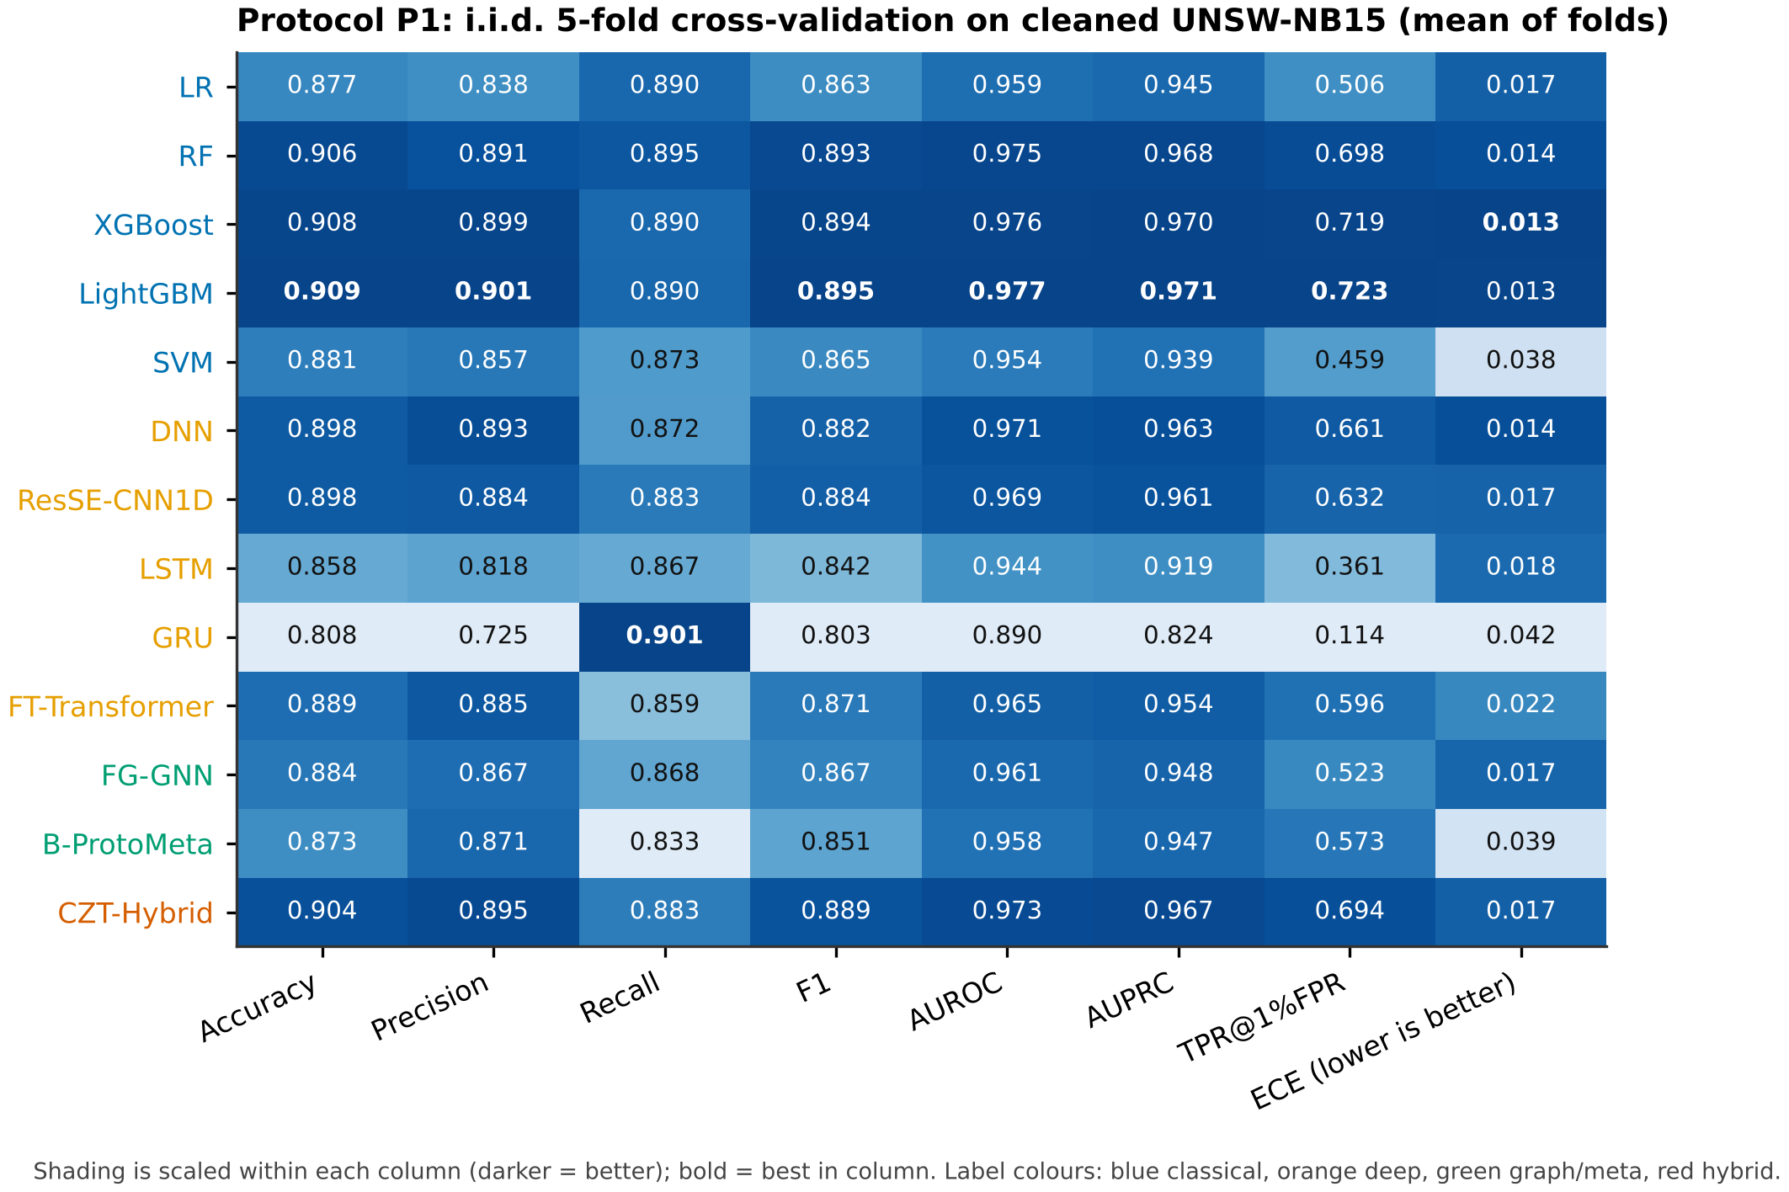
Figure S2. Protocol P1 metrics as a heatmap, shaded within each column (darker is better)
Fig. S2 shows the same P1 means as Table S3. The darkest rows belong to the gradient-boosted trees and the random forest, followed closely by CZT-Hybrid, the DNN and ResSE-CNN1D, while the LSTM and GRU rows are pale on most columns.

S3. Complete family hold-out results
This section gives every detector on every held-out family, together with the distribution of results and the statistical tests summarised in Section 5.3.
Table S5. Protocol P2 per held-out family
Held-out family | Detector | Unseen records | ZDR | AUROC | AUPRC | TPR at 1% FPR | Test FPR | ECE
Generic | LR | 3000 | 0.123 | 0.851 | 0.796 | 0.116 | 0.014 | 0.178
Generic | RF | 3000 | 0.209 | 0.975 | 0.957 | 0.207 | 0.010 | 0.105
Generic | XGBoost | 3000 | 0.731 | 0.993 | 0.990 | 0.769 | 0.008 | 0.050
Generic | LightGBM | 3000 | 0.686 | 0.991 | 0.988 | 0.771 | 0.008 | 0.054
Generic | SVM | 3000 | 0.118 | 0.909 | 0.859 | 0.113 | 0.011 | 0.111
Generic | DNN | 3000 | 0.665 | 0.985 | 0.984 | 0.746 | 0.007 | 0.029
Generic | ResSE-CNN1D | 3000 | 0.147 | 0.971 | 0.946 | 0.151 | 0.008 | 0.097
Generic | LSTM | 3000 | 0.057 | 0.847 | 0.784 | 0.079 | 0.007 | 0.145
Generic | GRU | 3000 | 0.051 | 0.795 | 0.715 | 0.057 | 0.009 | 0.238
Generic | FT-Transformer | 3000 | 0.139 | 0.960 | 0.921 | 0.139 | 0.011 | 0.132
Generic | FG-GNN | 3000 | 0.150 | 0.884 | 0.836 | 0.141 | 0.015 | 0.170
Generic | B-ProtoMeta | 3000 | 0.138 | 0.896 | 0.855 | 0.149 | 0.008 | 0.167
Generic | CZT-Hybrid | 3000 | 0.245 | 0.971 | 0.955 | 0.261 | 0.009 | 0.094
Exploits | LR | 3000 | 0.729 | 0.973 | 0.974 | 0.686 | 0.017 | 0.019
Exploits | RF | 3000 | 0.838 | 0.990 | 0.989 | 0.838 | 0.010 | 0.019
Exploits | XGBoost | 3000 | 0.915 | 0.992 | 0.992 | 0.897 | 0.014 | 0.011
Exploits | LightGBM | 3000 | 0.915 | 0.991 | 0.992 | 0.909 | 0.012 | 0.012
Exploits | SVM | 3000 | 0.460 | 0.966 | 0.960 | 0.435 | 0.012 | 0.033
Exploits | DNN | 3000 | 0.814 | 0.990 | 0.990 | 0.798 | 0.012 | 0.024
Exploits | ResSE-CNN1D | 3000 | 0.746 | 0.984 | 0.983 | 0.719 | 0.012 | 0.020
Exploits | LSTM | 3000 | 0.409 | 0.934 | 0.921 | 0.335 | 0.013 | 0.049
Exploits | GRU | 3000 | 0.089 | 0.820 | 0.812 | 0.081 | 0.011 | 0.081
Exploits | FT-Transformer | 3000 | 0.646 | 0.978 | 0.974 | 0.622 | 0.011 | 0.024
Exploits | FG-GNN | 3000 | 0.641 | 0.978 | 0.975 | 0.550 | 0.015 | 0.026
Exploits | B-ProtoMeta | 3000 | 0.639 | 0.984 | 0.974 | 0.571 | 0.013 | 0.043
Exploits | CZT-Hybrid | 3000 | 0.859 | 0.993 | 0.992 | 0.849 | 0.010 | 0.018
Fuzzers | LR | 3000 | 0.036 | 0.845 | 0.778 | 0.031 | 0.012 | 0.249
Fuzzers | RF | 3000 | 0.079 | 0.858 | 0.808 | 0.084 | 0.010 | 0.352
Fuzzers | XGBoost | 3000 | 0.095 | 0.865 | 0.819 | 0.097 | 0.010 | 0.376
Fuzzers | LightGBM | 3000 | 0.097 | 0.875 | 0.822 | 0.097 | 0.010 | 0.381
Fuzzers | SVM | 3000 | 0.062 | 0.733 | 0.734 | 0.040 | 0.018 | 0.302
Fuzzers | DNN | 3000 | 0.121 | 0.867 | 0.820 | 0.100 | 0.013 | 0.337
Fuzzers | ResSE-CNN1D | 3000 | 0.109 | 0.862 | 0.815 | 0.104 | 0.011 | 0.348
Fuzzers | LSTM | 3000 | 0.091 | 0.771 | 0.732 | 0.070 | 0.015 | 0.270
Fuzzers | GRU | 3000 | 0.066 | 0.758 | 0.710 | 0.060 | 0.017 | 0.226
Fuzzers | FT-Transformer | 3000 | 0.083 | 0.863 | 0.802 | 0.070 | 0.014 | 0.353
Fuzzers | FG-GNN | 3000 | 0.057 | 0.855 | 0.795 | 0.049 | 0.016 | 0.309
Fuzzers | B-ProtoMeta | 3000 | 0.131 | 0.865 | 0.827 | 0.098 | 0.016 | 0.266
Fuzzers | CZT-Hybrid | 3000 | 0.119 | 0.877 | 0.832 | 0.103 | 0.014 | 0.345
DoS | LR | 3000 | 0.611 | 0.964 | 0.966 | 0.548 | 0.014 | 0.018
DoS | RF | 3000 | 0.805 | 0.991 | 0.990 | 0.801 | 0.011 | 0.032
DoS | XGBoost | 3000 | 0.842 | 0.993 | 0.993 | 0.853 | 0.008 | 0.025
DoS | LightGBM | 3000 | 0.881 | 0.994 | 0.993 | 0.878 | 0.010 | 0.025
DoS | SVM | 3000 | 0.428 | 0.973 | 0.967 | 0.430 | 0.010 | 0.038
DoS | DNN | 3000 | 0.780 | 0.987 | 0.987 | 0.763 | 0.011 | 0.030
DoS | ResSE-CNN1D | 3000 | 0.777 | 0.989 | 0.989 | 0.767 | 0.012 | 0.030
DoS | LSTM | 3000 | 0.538 | 0.960 | 0.960 | 0.489 | 0.013 | 0.031
DoS | GRU | 3000 | 0.365 | 0.922 | 0.922 | 0.343 | 0.012 | 0.055
DoS | FT-Transformer | 3000 | 0.785 | 0.988 | 0.987 | 0.740 | 0.014 | 0.019
DoS | FG-GNN | 3000 | 0.649 | 0.981 | 0.979 | 0.664 | 0.009 | 0.021
DoS | B-ProtoMeta | 3000 | 0.675 | 0.980 | 0.976 | 0.622 | 0.014 | 0.024
DoS | CZT-Hybrid | 3000 | 0.864 | 0.992 | 0.992 | 0.841 | 0.012 | 0.024
Reconnaissance | LR | 3000 | 0.228 | 0.969 | 0.956 | 0.332 | 0.009 | 0.045
Reconnaissance | RF | 3000 | 0.632 | 0.983 | 0.978 | 0.604 | 0.011 | 0.041
Reconnaissance | XGBoost | 3000 | 0.738 | 0.989 | 0.987 | 0.708 | 0.013 | 0.043
Reconnaissance | LightGBM | 3000 | 0.706 | 0.991 | 0.989 | 0.715 | 0.009 | 0.043
Reconnaissance | SVM | 3000 | 0.511 | 0.975 | 0.970 | 0.467 | 0.011 | 0.019
Reconnaissance | DNN | 3000 | 0.633 | 0.980 | 0.976 | 0.633 | 0.010 | 0.035
Reconnaissance | ResSE-CNN1D | 3000 | 0.488 | 0.975 | 0.964 | 0.405 | 0.014 | 0.039
Reconnaissance | LSTM | 3000 | 0.242 | 0.953 | 0.937 | 0.233 | 0.011 | 0.040
Reconnaissance | GRU | 3000 | 0.455 | 0.965 | 0.948 | 0.220 | 0.018 | 0.048
Reconnaissance | FT-Transformer | 3000 | 0.509 | 0.975 | 0.969 | 0.489 | 0.012 | 0.049
Reconnaissance | FG-GNN | 3000 | 0.498 | 0.978 | 0.970 | 0.450 | 0.011 | 0.037
Reconnaissance | B-ProtoMeta | 3000 | 0.589 | 0.979 | 0.972 | 0.565 | 0.012 | 0.043
Reconnaissance | CZT-Hybrid | 3000 | 0.661 | 0.986 | 0.982 | 0.630 | 0.012 | 0.038
Analysis | LR | 450 | 0.027 | 0.848 | 0.334 | 0.022 | 0.014 | 0.075
Analysis | RF | 450 | 0.100 | 0.835 | 0.372 | 0.096 | 0.011 | 0.082
Analysis | XGBoost | 450 | 0.149 | 0.835 | 0.396 | 0.144 | 0.011 | 0.083
Analysis | LightGBM | 450 | 0.133 | 0.831 | 0.389 | 0.124 | 0.011 | 0.090
Analysis | SVM | 450 | 0.016 | 0.718 | 0.291 | 0.018 | 0.009 | 0.091
Analysis | DNN | 450 | 0.158 | 0.836 | 0.444 | 0.158 | 0.011 | 0.103
Analysis | ResSE-CNN1D | 450 | 0.153 | 0.846 | 0.448 | 0.151 | 0.011 | 0.078
Analysis | LSTM | 450 | 0.029 | 0.784 | 0.302 | 0.020 | 0.013 | 0.097
Analysis | GRU | 450 | 0.007 | 0.935 | 0.505 | 0.004 | 0.013 | 0.070
Analysis | FT-Transformer | 450 | 0.098 | 0.828 | 0.368 | 0.044 | 0.014 | 0.115
Analysis | FG-GNN | 450 | 0.056 | 0.883 | 0.446 | 0.073 | 0.007 | 0.047
Analysis | B-ProtoMeta | 450 | 0.036 | 0.853 | 0.365 | 0.036 | 0.010 | 0.076
Analysis | CZT-Hybrid | 450 | 0.147 | 0.839 | 0.410 | 0.136 | 0.012 | 0.084
Backdoor | LR | 350 | 0.417 | 0.955 | 0.751 | 0.429 | 0.009 | 0.043
Backdoor | RF | 350 | 0.757 | 0.992 | 0.927 | 0.774 | 0.009 | 0.012
Backdoor | XGBoost | 350 | 0.834 | 0.993 | 0.955 | 0.857 | 0.008 | 0.016
Backdoor | LightGBM | 350 | 0.866 | 0.995 | 0.963 | 0.880 | 0.008 | 0.017
Backdoor | SVM | 350 | 0.471 | 0.975 | 0.826 | 0.463 | 0.011 | 0.064
Backdoor | DNN | 350 | 0.780 | 0.991 | 0.934 | 0.809 | 0.009 | 0.031
Backdoor | ResSE-CNN1D | 350 | 0.686 | 0.988 | 0.907 | 0.680 | 0.013 | 0.026
Backdoor | LSTM | 350 | 0.423 | 0.964 | 0.769 | 0.469 | 0.009 | 0.028
Backdoor | GRU | 350 | 0.123 | 0.896 | 0.543 | 0.211 | 0.007 | 0.052
Backdoor | FT-Transformer | 350 | 0.609 | 0.989 | 0.895 | 0.734 | 0.007 | 0.035
Backdoor | FG-GNN | 350 | 0.666 | 0.987 | 0.891 | 0.637 | 0.011 | 0.054
Backdoor | B-ProtoMeta | 350 | 0.660 | 0.992 | 0.923 | 0.714 | 0.008 | 0.023
Backdoor | CZT-Hybrid | 350 | 0.857 | 0.996 | 0.967 | 0.917 | 0.006 | 0.013
Shellcode | LR | 1446 | 0.084 | 0.965 | 0.873 | 0.104 | 0.009 | 0.024
Shellcode | RF | 1446 | 0.740 | 0.985 | 0.964 | 0.673 | 0.015 | 0.020
Shellcode | XGBoost | 1446 | 0.692 | 0.983 | 0.957 | 0.635 | 0.014 | 0.030
Shellcode | LightGBM | 1446 | 0.632 | 0.982 | 0.956 | 0.528 | 0.015 | 0.029
Shellcode | SVM | 1446 | 0.533 | 0.978 | 0.935 | 0.586 | 0.008 | 0.038
Shellcode | DNN | 1446 | 0.828 | 0.986 | 0.958 | 0.676 | 0.016 | 0.028
Shellcode | ResSE-CNN1D | 1446 | 0.708 | 0.988 | 0.966 | 0.687 | 0.011 | 0.024
Shellcode | LSTM | 1446 | 0.385 | 0.974 | 0.930 | 0.456 | 0.007 | 0.035
Shellcode | GRU | 1446 | 0.280 | 0.935 | 0.825 | 0.278 | 0.012 | 0.093
Shellcode | FT-Transformer | 1446 | 0.656 | 0.985 | 0.963 | 0.679 | 0.009 | 0.028
Shellcode | FG-GNN | 1446 | 0.600 | 0.980 | 0.941 | 0.541 | 0.014 | 0.027
Shellcode | B-ProtoMeta | 1446 | 0.757 | 0.988 | 0.963 | 0.722 | 0.015 | 0.021
Shellcode | CZT-Hybrid | 1446 | 0.828 | 0.991 | 0.978 | 0.814 | 0.013 | 0.022
Worms | LR | 159 | 0.805 | 0.989 | 0.887 | 0.855 | 0.006 | 0.060
Worms | RF | 159 | 0.950 | 0.997 | 0.946 | 0.950 | 0.008 | 0.024
Worms | XGBoost | 159 | 0.962 | 0.998 | 0.954 | 0.962 | 0.011 | 0.023
Worms | LightGBM | 159 | 0.956 | 0.998 | 0.957 | 0.950 | 0.012 | 0.025
Worms | SVM | 159 | 0.774 | 0.990 | 0.869 | 0.780 | 0.009 | 0.075
Worms | DNN | 159 | 0.899 | 0.994 | 0.933 | 0.918 | 0.010 | 0.043
Worms | ResSE-CNN1D | 159 | 0.887 | 0.993 | 0.925 | 0.887 | 0.010 | 0.032
Worms | LSTM | 159 | 0.730 | 0.982 | 0.825 | 0.717 | 0.013 | 0.044
Worms | GRU | 159 | 0.459 | 0.954 | 0.533 | 0.459 | 0.011 | 0.088
Worms | FT-Transformer | 159 | 0.925 | 0.995 | 0.939 | 0.925 | 0.008 | 0.052
Worms | FG-GNN | 159 | 0.887 | 0.995 | 0.917 | 0.881 | 0.012 | 0.057
Worms | B-ProtoMeta | 159 | 0.912 | 0.996 | 0.930 | 0.912 | 0.010 | 0.020
Worms | CZT-Hybrid | 159 | 0.950 | 0.997 | 0.951 | 0.950 | 0.010 | 0.032
Table S5 allows every per-family statement of Section 5.2 to be checked. The number of unseen-family test records is small for Analysis (450), Backdoor (350) and Worms (159), so the estimates for these folds carry more sampling noise than those for the larger families.
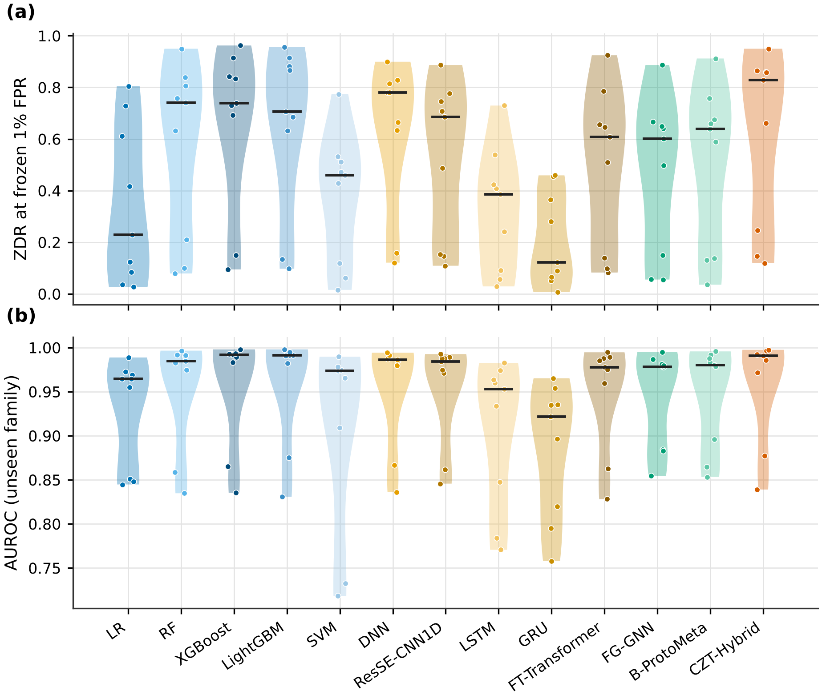
Figure S3. Distribution of zero-day detection rate (a) and unseen-family AUROC (b) over the nine held-out families; black bars are medians
Fig. S3 shows the full distribution behind the means of Table 5. CZT-Hybrid has the highest median detection rate (0.828), followed by the DNN (0.780), the random forest (0.740) and XGBoost (0.738), because its weak folds are concentrated in Fuzzers, Analysis and Generic. The long lower tails of all distributions show that every detector has families on which it nearly fails.
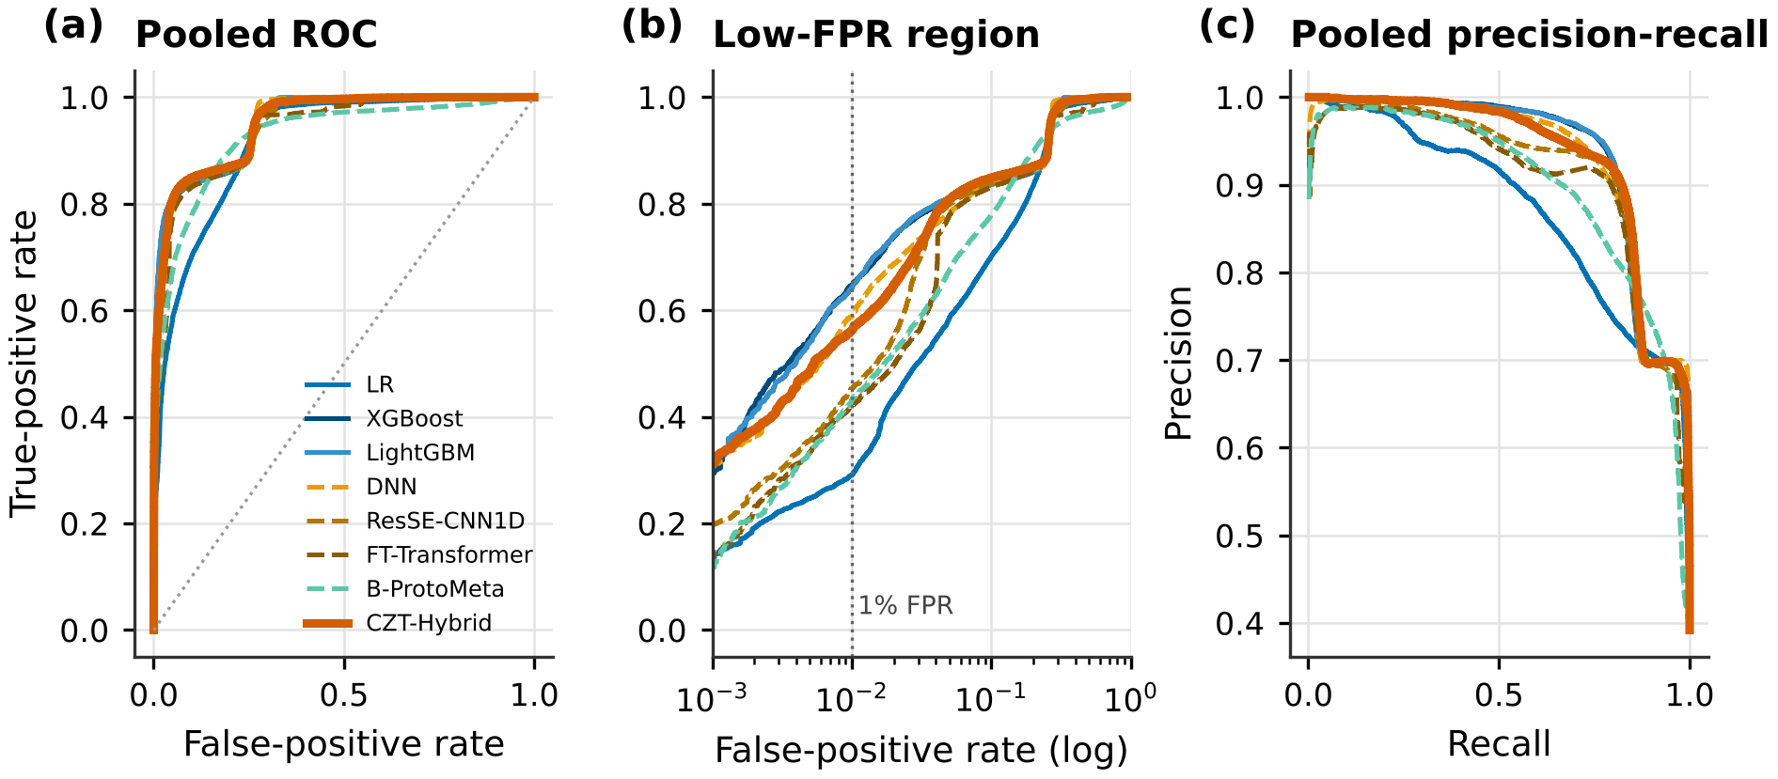
Figure S4. Pooled ROC (a), low-FPR ROC (b) and precision-recall (c) curves on benign and unseen-family records of all nine folds
Fig. S4 pools the unseen-family test records of all folds. At 1% FPR, XGBoost (pooled TPR 0.647), LightGBM (0.642) and the DNN (0.589) lead, followed by CZT-Hybrid (0.563). At 5% FPR the hybrid reaches the same TPR as the tree ensembles (about 0.81), so most of its gap lies between 1% and 5% FPR.
Table S6. Pairwise Wilcoxon tests of CZT-Hybrid against each detector over nine folds (median paired difference, folds won/lost, Holm-adjusted p)
Compared with | AUROC: median diff. | AUROC: W/L | AUROC: Holm p | ZDR: median diff. | ZDR: W/L | ZDR: Holm p
LR | +0.026 | 8/1 | 0.105 | +0.145 | 9/0 | 0.047
RF | +0.003 | 8/1 | 0.312 | +0.040 | 8/0 | 0.047
XGBoost | +0.001 | 5/4 | 1.000 | -0.002 | 4/5 | 1.000
LightGBM | +0.001 | 5/4 | 1.000 | -0.009 | 3/6 | 1.000
SVM | +0.021 | 9/0 | 0.047 | +0.176 | 9/0 | 0.047
DNN | +0.005 | 8/1 | 0.488 | +0.028 | 5/3 | 1.000
ResSE-CNN1D | +0.005 | 8/1 | 0.312 | +0.099 | 8/1 | 0.047
LSTM | +0.033 | 9/0 | 0.047 | +0.326 | 9/0 | 0.047
GRU | +0.071 | 8/1 | 0.312 | +0.491 | 9/0 | 0.047
FT-Transformer | +0.011 | 9/0 | 0.047 | +0.106 | 9/0 | 0.047
FG-GNN | +0.011 | 8/1 | 0.488 | +0.163 | 9/0 | 0.047
B-ProtoMeta | +0.007 | 8/1 | 0.488 | +0.107 | 8/1 | 0.047
Table S6 shows that, on ZDR, the hybrid is significantly better than nine detectors after Holm correction [2], while its differences from XGBoost, LightGBM and the DNN are not significant. With nine folds the smallest attainable adjusted p-value is 0.047, so the tests have limited power to separate the leading models [3].
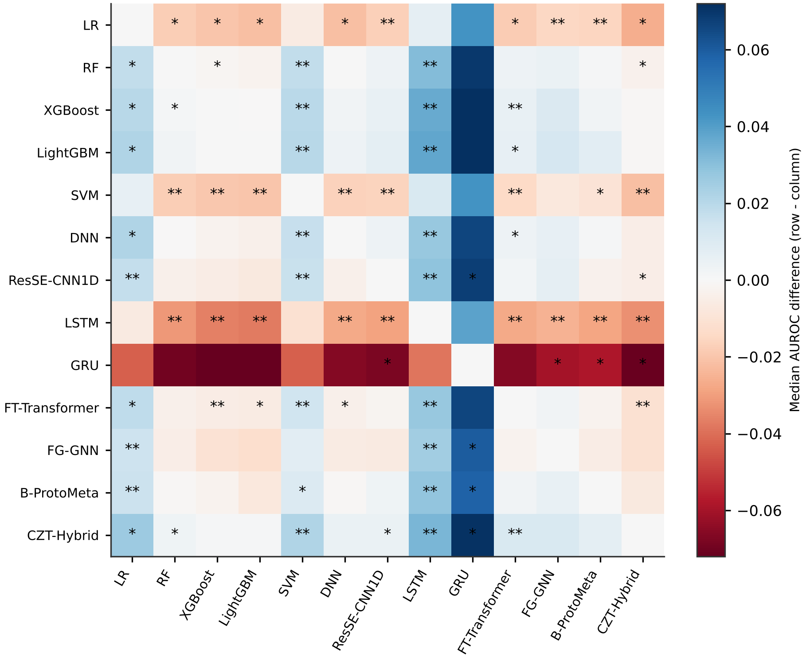
Figure S5. Median paired AUROC difference for every pair of detectors (row minus column); stars mark uncorrected Wilcoxon p below 0.05 (*) and 0.01 (**)
Fig. S5 extends Table S6 to all pairs. The rows of CZT-Hybrid, LightGBM and XGBoost are mainly blue and those of the GRU, LSTM, SVM and LR mainly red. Because the marks are uncorrected, the figure is descriptive; the corrected tests are those in the main paper.

S4. Complete transfer results
This section lists the full adaptation curves summarised in Table 7 and Fig. 7.
Table S7. Protocol P4 target AUROC for every number of labelled target records (mean of three seeds)
Direction | Detector | k = 0 | k = 10 | k = 50 | k = 100 | k = 250 | k = 500 | k = 1000
K→U | B-ProtoMeta | 0.505 | 0.500 | 0.500 | 0.500 | 0.500 | 0.500 | 0.500
K→U | CZT-Hybrid | 0.469 | 0.576 | 0.787 | 0.853 | 0.902 | 0.926 | 0.943
K→U | DNN | 0.458 | 0.519 | 0.556 | 0.693 | 0.776 | 0.820 | 0.864
K→U | LR | 0.493 | 0.540 | 0.569 | 0.596 | 0.606 | 0.597 | 0.596
K→U | LightGBM | 0.457 | 0.585 | 0.816 | 0.864 | 0.904 | 0.931 | 0.947
K→U | RF | 0.487 | 0.616 | 0.820 | 0.862 | 0.900 | 0.922 | 0.937
K→U | ResSE-CNN1D | 0.434 | 0.546 | 0.629 | 0.752 | 0.835 | 0.862 | 0.891
K→U | XGBoost | 0.447 | 0.585 | 0.815 | 0.861 | 0.897 | 0.929 | 0.946
U→K | B-ProtoMeta | 0.417 | 0.485 | 0.557 | 0.579 | 0.568 | 0.567 | 0.554
U→K | CZT-Hybrid | 0.288 | 0.850 | 0.941 | 0.967 | 0.982 | 0.989 | 0.995
U→K | DNN | 0.499 | 0.808 | 0.873 | 0.941 | 0.958 | 0.971 | 0.982
U→K | LR | 0.705 | 0.771 | 0.860 | 0.885 | 0.876 | 0.891 | 0.890
U→K | LightGBM | 0.100 | 0.891 | 0.956 | 0.979 | 0.988 | 0.992 | 0.996
U→K | RF | 0.112 | 0.896 | 0.961 | 0.977 | 0.985 | 0.990 | 0.994
U→K | ResSE-CNN1D | 0.467 | 0.844 | 0.895 | 0.952 | 0.974 | 0.981 | 0.989
U→K | XGBoost | 0.138 | 0.876 | 0.954 | 0.980 | 0.988 | 0.992 | 0.996
Table S7 shows that, in the U→K direction, ten labelled target records lift the tree ensembles from inverted rankings to about 0.88 to 0.90, and that B-ProtoMeta stays close to chance in the K→U direction, as discussed in Section 5.4.

S5. Calibration, cost and overall profile
This section complements Section 5.5 with the full calibration view, the latency trade-off, an overall profile of the detectors and their training curves.
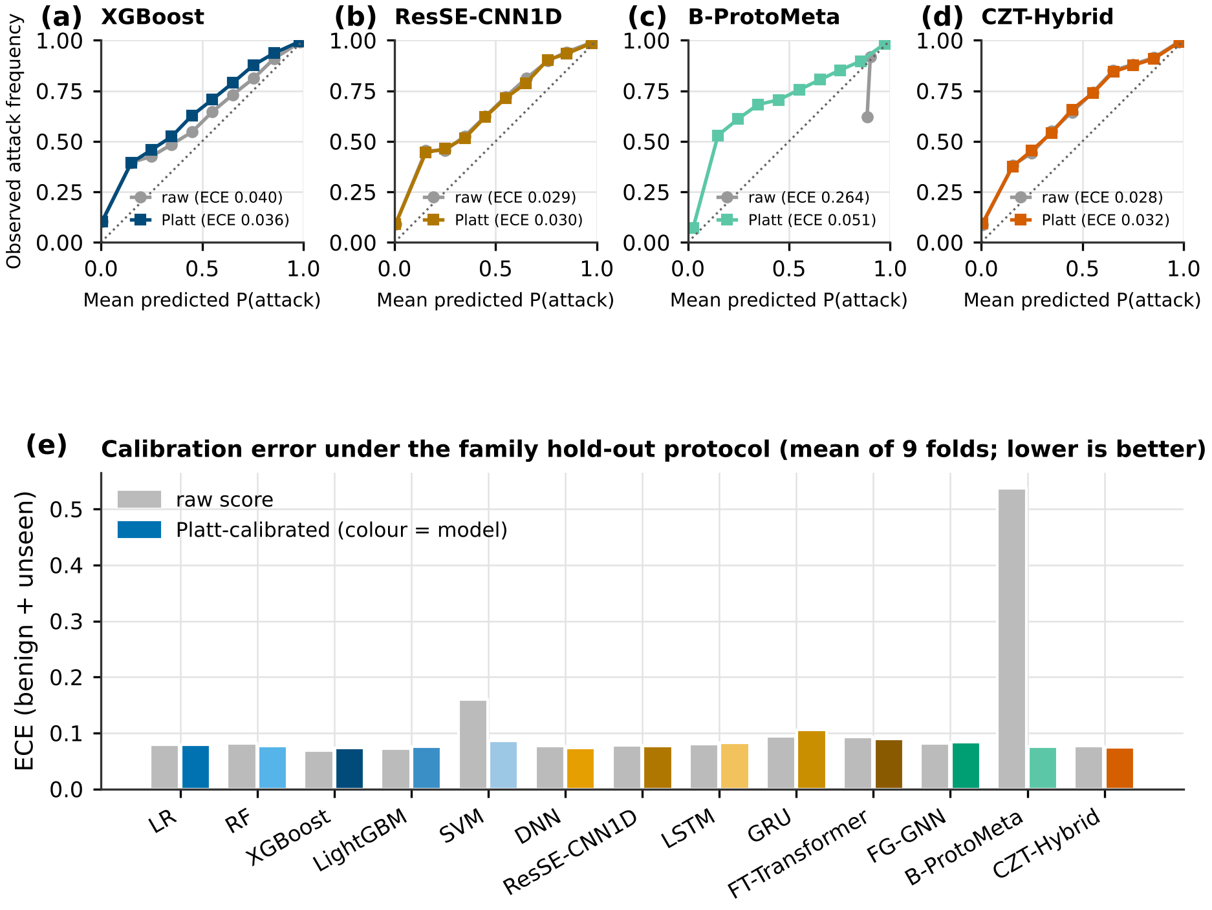
Figure S6. Reliability diagrams (a to d) and mean ECE of every detector on benign and unseen records, raw and after Platt scaling (e)
Fig. S6e shows that, apart from the SVM and B-ProtoMeta, the raw and calibrated ECE bars have nearly the same height under family hold-out. Post hoc calibration fitted on known families therefore does not correct the miscalibration caused by unseen families [4, 5].
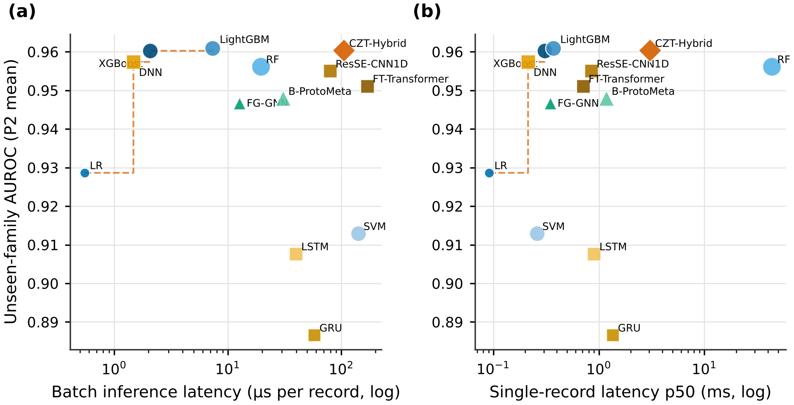
Figure S7. Unseen-family AUROC against batch (a) and single-record (b) latency; the dashed line is the empirical Pareto frontier
Fig. S7 shows that LR, the DNN, XGBoost and LightGBM form the latency-accuracy frontier in batch mode. CZT-Hybrid is among the most accurate models but about fifty times slower per record than XGBoost, and the random forest is slow for single records because of parallel dispatch overhead.
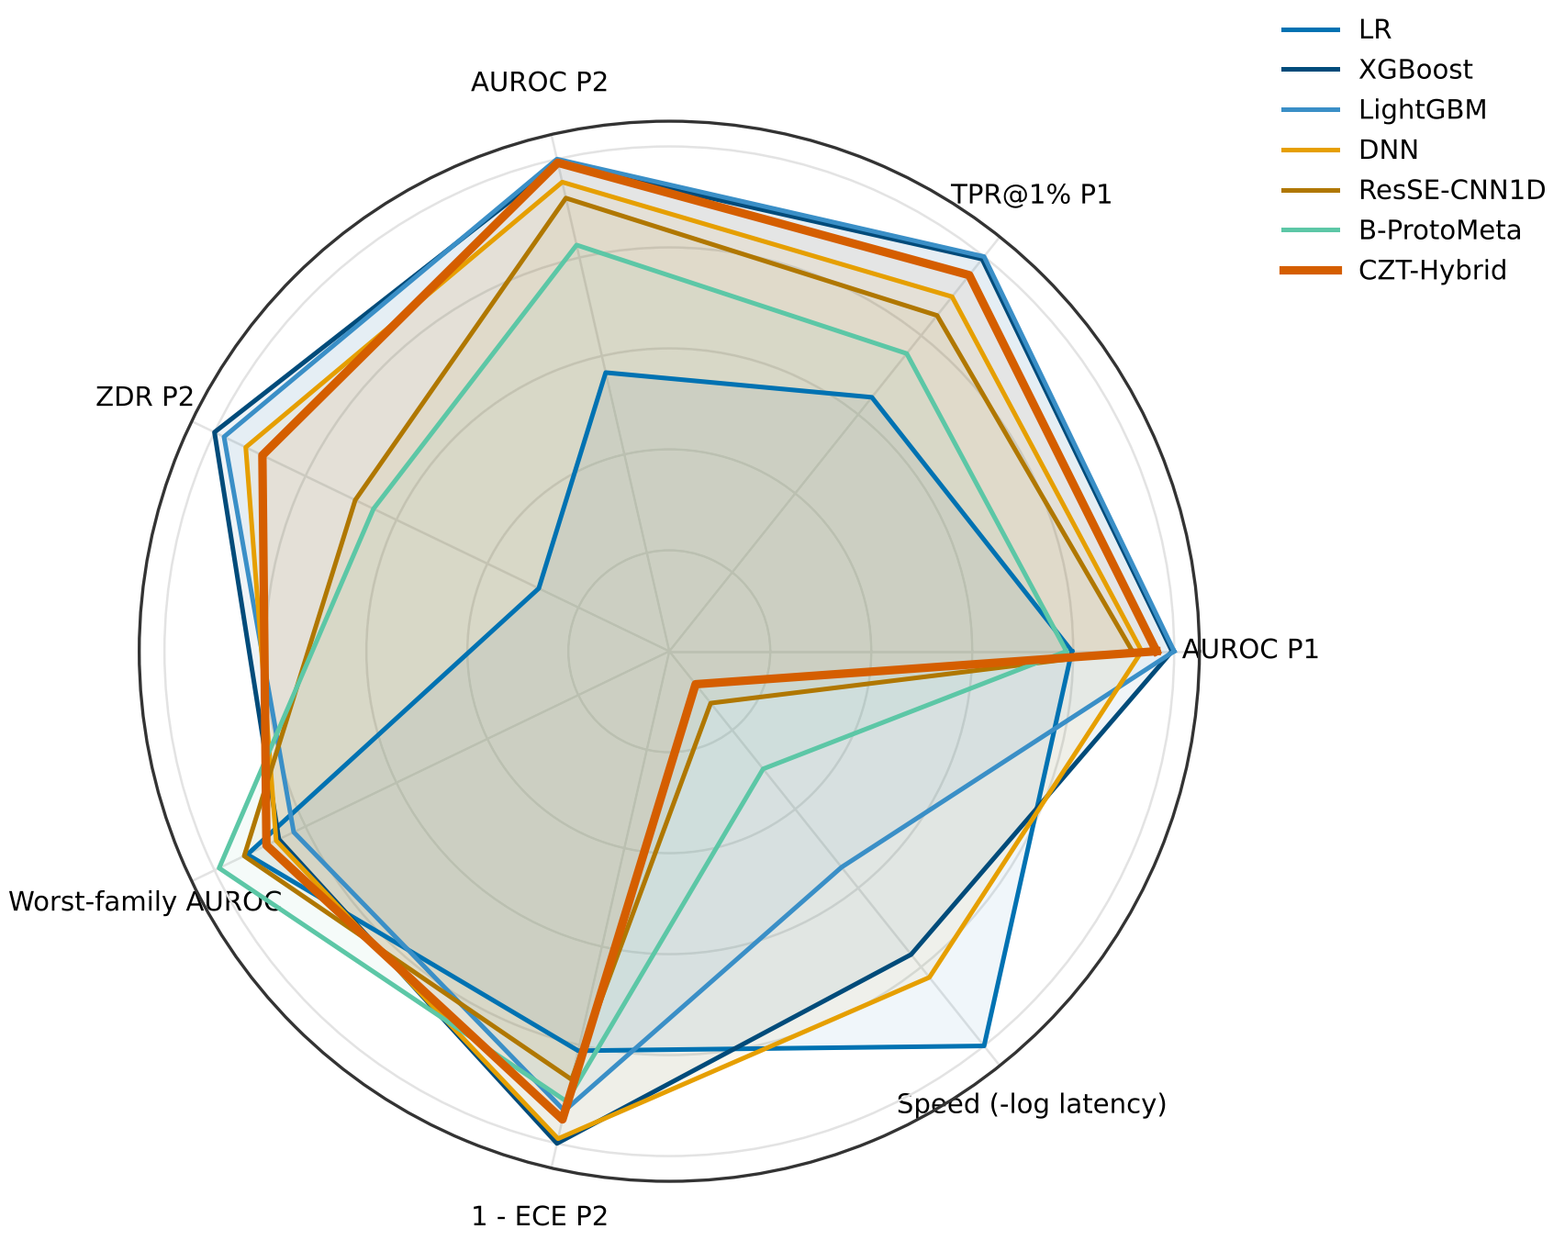
Figure S8. Normalised profile of seven detectors on seven criteria (1 = best among the thirteen detectors)
Fig. S8 summarises the trade-offs. XGBoost and LightGBM cover the largest area, combining accuracy in both protocols with speed. CZT-Hybrid matches them on accuracy and calibration but scores low on speed, while LR is fast but weak on every accuracy axis.
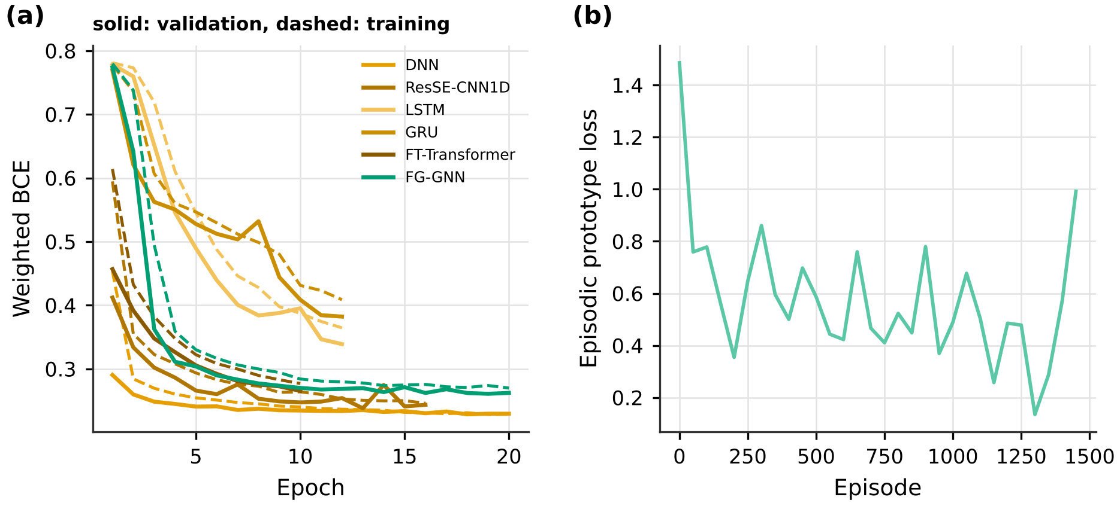
Figure S9. Training curves of the neural detectors in fold 0 of P1 (a) and episodic loss of B-ProtoMeta (b)
Fig. S9 shows that all neural detectors converge within the epoch budget and that early stopping acts before strong over-fitting. The LSTM and GRU converge to clearly higher validation losses than the other networks, which agrees with their weaker results. Validation losses below training losses reflect dropout, which is active only during training.

S6. Additional triage results
This section gives the staffing and half-life sweeps and the NSGA-III fronts discussed in Section 5.6.
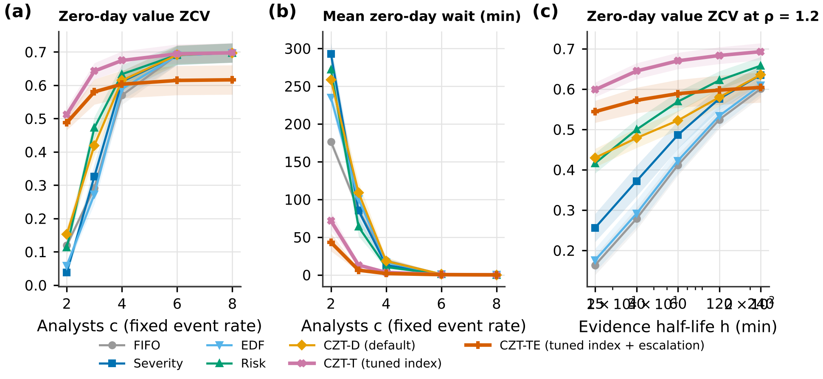
Figure S10. Zero-day value (a) and mean zero-day wait (b) versus the number of analysts at a fixed event rate, and zero-day value versus evidence half-life at load 1.2 (c)
Fig. S10 shows that the tuned indices help most when analysts are scarce and evidence decays quickly. With six or eight analysts all policies except CZT-TE capture the same zero-day value, because the queue is almost always empty, and with long half-lives the policies converge.
Table S8. Triage outcomes by number of analysts at a fixed raw event rate (mean of 40 replications)
Analysts | Policy | CV | ZCV | Zero-day wait (min) | SLA violation
2 | FIFO | 0.129 | 0.119 | 176.6 | 0.480
2 | Severity | 0.372 | 0.038 | 292.7 | 0.333
2 | EDF | 0.261 | 0.059 | 235.0 | 0.440
2 | Risk | 0.402 | 0.113 | 271.9 | 0.326
2 | CZT-D | 0.398 | 0.152 | 258.6 | 0.231
2 | CZT-T | 0.405 | 0.512 | 71.6 | 0.289
2 | CZT-TE | 0.437 | 0.487 | 43.2 | 0.182
3 | FIFO | 0.316 | 0.292 | 86.1 | 0.291
3 | Severity | 0.527 | 0.326 | 85.1 | 0.059
3 | EDF | 0.478 | 0.272 | 100.2 | 0.015
3 | Risk | 0.581 | 0.472 | 63.7 | 0.103
3 | CZT-D | 0.567 | 0.419 | 108.9 | 0.058
3 | CZT-T | 0.574 | 0.642 | 13.0 | 0.105
3 | CZT-TE | 0.584 | 0.580 | 6.2 | 0.028
4 | FIFO | 0.613 | 0.570 | 18.8 | 0.100
4 | Severity | 0.675 | 0.611 | 13.0 | 0.003
4 | EDF | 0.663 | 0.589 | 16.7 | 0.000
4 | Risk | 0.684 | 0.633 | 10.4 | 0.004
4 | CZT-D | 0.682 | 0.614 | 18.2 | 0.004
4 | CZT-T | 0.681 | 0.674 | 3.3 | 0.013
4 | CZT-TE | 0.650 | 0.603 | 1.8 | 0.002
6 | FIFO | 0.739 | 0.691 | 0.9 | 0.000
6 | Severity | 0.740 | 0.690 | 1.0 | 0.000
6 | EDF | 0.740 | 0.690 | 1.0 | 0.000
6 | Risk | 0.741 | 0.691 | 0.9 | 0.000
6 | CZT-D | 0.741 | 0.691 | 0.9 | 0.000
6 | CZT-T | 0.740 | 0.694 | 0.5 | 0.000
6 | CZT-TE | 0.678 | 0.614 | 0.3 | 0.000
8 | FIFO | 0.746 | 0.697 | 0.1 | 0.000
8 | Severity | 0.746 | 0.697 | 0.1 | 0.000
8 | EDF | 0.746 | 0.697 | 0.1 | 0.000
8 | Risk | 0.746 | 0.697 | 0.1 | 0.000
8 | CZT-D | 0.746 | 0.697 | 0.1 | 0.000
8 | CZT-T | 0.746 | 0.697 | 0.1 | 0.000
8 | CZT-TE | 0.680 | 0.616 | 0.0 | 0.000
Table S8 shows, for example, that with two analysts CZT-T captures 0.512 of the zero-day value against 0.113 for Risk and 0.119 for FIFO, and reduces the mean zero-day wait to 72 minutes, while the baselines wait between 177 and 293 minutes.
Table S9. NSGA-III knee solutions (tuning group → evaluation group)
Groups | κ | γ | β | s_u | q | Front size
G2 → G1 | 0.011 | 3.705 | 1.620 | 0.999 | 0.997 | 16
G1 → G2 | 0.104 | 3.519 | 1.625 | 0.972 | 0.993 | 18
Table S9 shows that the two independent runs, tuned on disjoint families, selected nearly the same score exponent, severity exponent, imputed severity and escalation quantile, and differed mainly in the deadline weight.
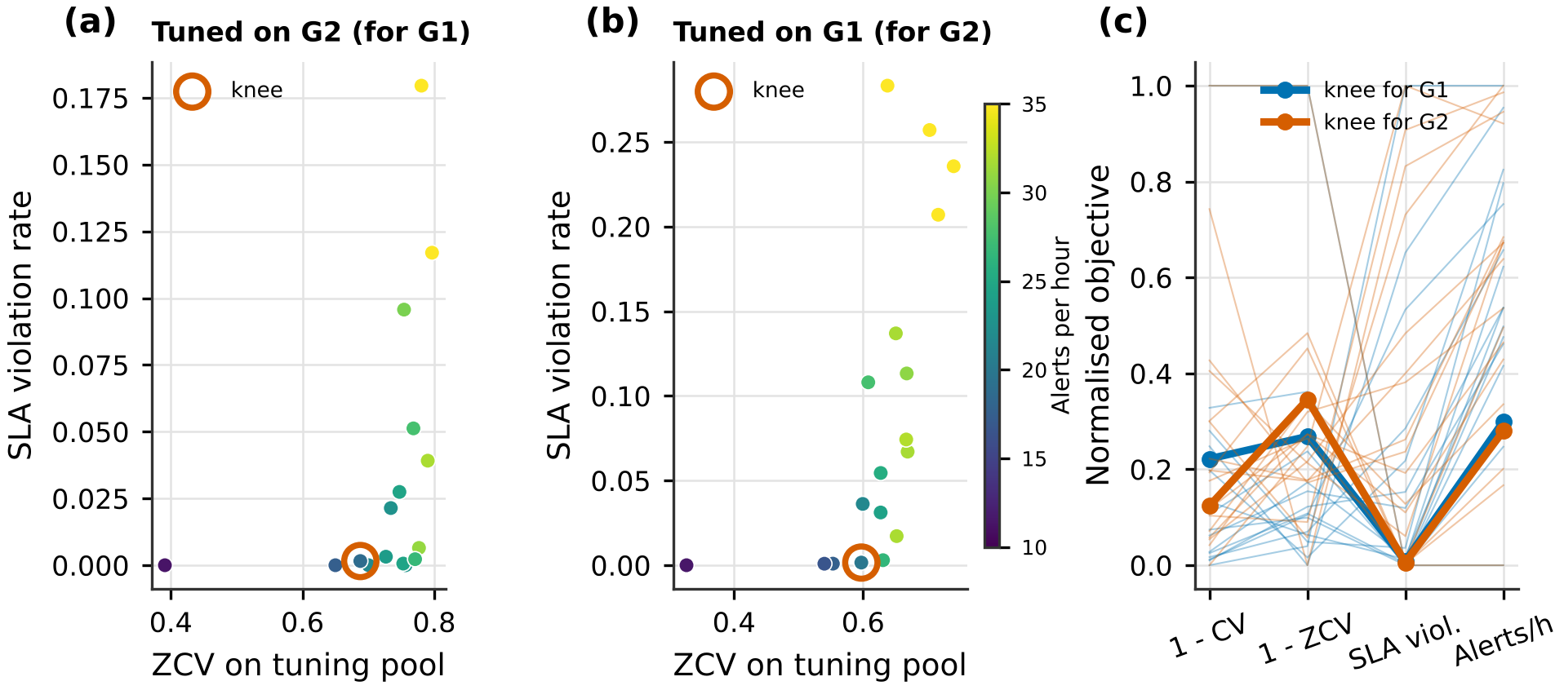
Figure S11. Non-dominated solutions of the two NSGA-III runs (a, b) and their normalised objective profiles (c); circles mark the selected knees
Fig. S11 shows the trade-off between zero-day value, SLA violations and workload on the tuning pools [6, 7]. Solutions with more zero-day value escalate more alerts and violate more SLAs, and the knees sit where SLA violations are still near zero.

S7. Note on the original project results
This section records why the results supplied with the original project were not used. The project configuration named CICAPT-IIoT 2024 as the primary dataset and CyberSOCEval as the secondary dataset. The raw data folders were empty, and both loaders silently generated synthetic stand-in data, namely 1,500 Gaussian records for CICAPT-IIoT, with exactly 125 per class and class means set by hand-coded severity values, and 500 synthetic detonation records for CyberSOCEval. CyberSOCEval is in fact a question-answering benchmark for large language models rather than a feature dataset. All results derived from those stand-ins are artefacts and are not reported anywhere in the paper. Every number in the paper comes from the public UNSW-NB15 and NSL-KDD files [8, 9].

S8. Reproducibility checklist
This checklist maps the reporting items recommended for learning-based security evaluation [10, 11] to the place where each is addressed.
Table S10. Reproducibility checklist
Item | Where addressed
Data sources and versions | Section 3.1; Data Availability; Table S1
Removal of duplicates and label conflicts | Eqs. (1) and (2); Table S4; Fig. S1
Training-only preprocessing statistics | Section 3.1
Split preventing family leakage | Eq. (3); Section 3.2
Hyperparameters without test-set tuning | Table 3
Threshold chosen without test data | Eq. (11)
Operating-point metrics | Tables 4 to 6
Calibration before and after correction | Table 8; Fig. 8; Fig. S6
Statistical tests with multiplicity control | Section 3.7; Fig. 4; Table S6
Latency, throughput and footprint | Table 8; Fig. S7
Separation of tuning and evaluation in triage | Section 3.6
Seeds and replications | Section 4
Code and per-fold outputs | Public repository

References
[1] L. van der Maaten and G. Hinton, “Visualizing Data Using t-SNE”, Journal of Machine Learning Research, Vol. 9, pp. 2579-2605, 2008.
[2] S. Holm, “A Simple Sequentially Rejective Multiple Test Procedure”, Scandinavian Journal of Statistics, Vol. 6, No. 2, pp. 65-70, 1979.
[3] J. Demšar, “Statistical Comparisons of Classifiers over Multiple Data Sets”, Journal of Machine Learning Research, Vol. 7, pp. 1-30, 2006.
[4] C. Guo, G. Pleiss, Y. Sun, and K. Q. Weinberger, “On Calibration of Modern Neural Networks”, In: Proc. of the 34th International Conference on Machine Learning, PMLR 70, pp. 1321-1330, 2017.
[5] Y. Ovadia, E. Fertig, J. Ren, Z. Nado, D. Sculley, S. Nowozin, J. Dillon, B. Lakshminarayanan, and J. Snoek, “Can You Trust Your Model’s Uncertainty? Evaluating Predictive Uncertainty under Dataset Shift”, In: Proc. of Advances in Neural Information Processing Systems 32, 2019.
[6] K. Deb and H. Jain, “An Evolutionary Many-Objective Optimization Algorithm Using Reference-Point-Based Nondominated Sorting Approach, Part I: Solving Problems with Box Constraints”, IEEE Transactions on Evolutionary Computation, Vol. 18, No. 4, pp. 577-601, 2014.
[7] J. Blank and K. Deb, “pymoo: Multi-Objective Optimization in Python”, IEEE Access, Vol. 8, pp. 89497-89509, 2020.
[8] N. Moustafa and J. Slay, “UNSW-NB15: A Comprehensive Data Set for Network Intrusion Detection Systems (UNSW-NB15 Network Data Set)”, In: Proc. of the 2015 Military Communications and Information Systems Conference, pp. 1-6, 2015.
[9] M. Tavallaee, E. Bagheri, W. Lu, and A. A. Ghorbani, “A Detailed Analysis of the KDD CUP 99 Data Set”, In: Proc. of the 2009 IEEE Symposium on Computational Intelligence for Security and Defense Applications, pp. 1-6, 2009.
[10] D. Arp, E. Quiring, F. Pendlebury, A. Warnecke, F. Pierazzi, C. Wressnegger, L. Cavallaro, and K. Rieck, “Dos and Don’ts of Machine Learning in Computer Security”, In: Proc. of the 31st USENIX Security Symposium, pp. 3971-3988, 2022.
[11] A. Al Siam, N. Faruqui, A. Azad, and M. A. Moni, “Securing the Unseen: A Comprehensive Exploration Review of AI-Powered Models for Zero-Day Attack Detection”, Expert Systems, Vol. 43, e70217, 2026.

