JAZB
Judiciary AI Zero-Trust Broker
An Authority-Centric, Human-Sovereign Governance Architecture for Artificial Intelligence
Phase I: Foundational Architecture
Michael Costner
Author and Publisher
Version 1.0 - Publication
September 2026
jazbframework.org
Capability does not constitute Authority.

Publication and Copyright Notice
JAZB Framework Publication 1, Phase I: Foundational Architecture is an original governance architecture authored and published by Michael Costner.
This publication defines foundational JAZB concepts, terminology, authority relationships, and architectural principles. It is intended to support discussion, evaluation, implementation planning, and future specification work concerning human-sovereign governance of artificial intelligence.
JAZB is designed to complement, not replace, established cybersecurity, identity, risk-management, and AI-governance frameworks. References to external standards and guidance are included for context and architectural alignment. Such references do not imply endorsement, certification, conformance, or sponsorship by the referenced organizations.
Copyright © 2026 Michael Costner. All rights reserved.
Publication site: jazbframework.org
DOI: 10.5281/zenodo.22904366

Author's Preface: From JASB to JAZB
JAZB did not begin as an attempt to design a comprehensive artificial intelligence governance framework. It began with a narrower problem: how to grant temporary elevated Authority for a legitimate task without converting temporary need into persistent privilege.
That first architecture became JASB, the Just-in-Time AI Security Broker. JASB centered on purpose-bound elevation, active observation, Point Policy, revocation, least privilege, and restoration to Baseline Authority after the authorized purpose ended.
Continued development exposed a deeper question. Before an AI can evaluate, monitor, restrict, or revoke Authority, the Organization must be able to answer who established the governing rules, by what legitimate human Authority those rules exist, which jurisdiction may interpret them, and how machine action remains traceable to that human source.
That question shifted the work from privileged access to institutional Authority. JAZB, the Judiciary AI Zero-Trust Broker, is the resulting architecture.
JAZB begins with a simple proposition: Capability does not constitute Authority. A machine may possess credentials, network reachability, API permissions, administrative tooling, or the technical ability to perform an action. None of those facts alone establishes legitimate permission to act for a particular purpose.
JAZB therefore roots governance in human sovereignty. The Organization is the governed entity. The Enterprise Domain Authority, or EDA, represents its highest active human Authority within JAZB. Authorized humans may draft and propose Law, but proposed Law has no governing effect until it is validated and authorized through the Organization's predefined human approval process.
No individual may unilaterally establish JAZB Law. Every Human-Established Law Layer requires a predefined authorization threshold of no fewer than two independently authorized humans. The Organization may require a larger quorum, specific roles, or additional conditions based on its structure and the significance of the Law. A single-owner Organization can satisfy this requirement by formally delegating Law-authorization Authority to one or more additional human members in advance.
The Governor contains superior organizational Law. The Judge and Port Authority are AI interpretation and decision layers for Internal and Border Jurisdictions. The Commissioner and Port Director contain subordinate human-established Law. AGENTs and Customs AGENTs operate beneath those layers within bounded Authority.
The architecture follows a deliberate pattern: Human Authority -> Human-Established Law -> AI Interpretation -> Human-Established Law -> AI Operation.
JAZB also distinguishes internal Authority from lawful external passage. Enterprise AI Customs does not replace firewalls, IDS/IPS, DLP, endpoint controls, network segmentation, or other contemporary security mechanisms. Those controls remain at the edge. The Customs AGENT adds intelligent Authority-based inspection at the actual external Organizational Border, normally the ISP-facing ingress and egress path, asking not only whether traffic is technically permitted but whether the transaction and what it carries are lawfully authorized to cross the border.
Changing an internal proxy, service, protocol, route, workload identity, or application does not create a new Port of Entry. A distinct Port exists only where a transaction can actually cross the governed external Organizational Boundary. A genuine alternate external path, such as an unmanaged cellular modem, satellite connection, rogue wireless bridge, or unmanaged secondary circuit, is a Governance Escape condition rather than an internal routing variation.
JAZB further introduces Judicial Instruments, independent Actuation Authority, predefined emergency governance, Governance Escape Resistance, and explicit Chains of Authority and Evidence.
JASB remains relevant inside this broader architecture. Law determines what may be authorized. Point Policy governs behavior while delegated Authority is being exercised.
JASB was the beginning. JAZB is what emerged when the question of access became a question of legitimate Authority, Law, jurisdiction, passage, enforcement, and accountability.

Abstract
Agentic artificial intelligence is moving from informational assistance toward systems capable of initiating actions, calling tools, accessing enterprise resources, interacting with other agents, and operating with increasing autonomy. Existing identity, access-control, Zero Trust, network-security, and AI risk-management practices remain essential, but they do not by themselves define the organizational provenance of machine Authority. JAZB, the Judiciary AI Zero-Trust Broker, is an authority-centric, human-sovereign governance architecture designed to address that problem. JAZB establishes a Chain of Authority from legitimate human governance to bounded machine action while preventing AI from independently creating or expanding its own Authority. The Enterprise Domain Authority represents the highest active human Authority within JAZB. Authorized humans may draft proposed Law, but no proposal becomes authoritative Law without validation and the Organization's predefined multi-human authorization threshold, which may never be fewer than two independently authorized humans. The Governor, Commissioner, and Port Director are non-AI Human-Established Law Layers. The Judge and Port Authority are AI interpretation and decision layers for Internal and Border Jurisdictions. AGENTs and Customs AGENTs operate beneath those layers within delegated Authority. Enterprise AI Customs operates at the actual external Organizational Border alongside conventional edge-security controls, governing lawful passage rather than merely technical reachability. JAZB further separates interpretation from actuation, supports bounded Judicial Instruments and predefined emergency governance, and treats Governance Escape Resistance, Authority provenance, and evidentiary traceability as first-class requirements. Phase I defines the foundational doctrine, vocabulary, organizational Authority model, Law-establishment model, dual-jurisdiction architecture, Enterprise AI Customs, and governance-security principles. JAZB is intended to complement established cybersecurity and AI-governance frameworks rather than replace them.

Keywords
Artificial Intelligence Governance; Agentic AI; AI Agents; AI Security; Zero Trust; Human Sovereignty; Authority Governance; Human-Established Law; Multi-Human Authorization; Least Privilege; Enterprise AI Customs; Organizational Border; AI Authorization; Separation of Powers; Governance Escape Resistance

Table of Contents
1. Introduction 13
1.1 The Rise of Agentic Authority 13
1.2 Capability Is Not Authority 13
1.3 The Governance Gap 13
1.4 From Runtime Authorization to Institutional Governance 14
1.5 Human Sovereignty 14
1.6 JAZB Governance Architecture 14
1.7 Dual Jurisdiction 16
1.8 Separation of Interpretation and Execution 16
1.9 Emergency Governance 17
1.10 Governance Accountability 17
1.11 Purpose of JAZB 17
1.12 Scope of Phase I 17
2. JAZB Doctrine 19
2.1 Human Sovereignty 19
2.2 Authority Must Have Provenance 19
2.3 Capability Does Not Constitute Authority 19
2.4 Technical Permission Does Not Constitute Legitimate Authority 19
2.5 AI Cannot Create Authority 19
2.6 Proposed Law Is Not Law 19
2.7 No Individual May Unilaterally Establish Law 19
2.8 Authority to Draft Does Not Constitute Authority to Establish 19
2.9 AI Cannot Expand Its Own Authority 19
2.10 Authority Must Be Bounded 20
2.11 Authority Must Be Revocable 20
2.12 Interpretation Must Be Separated from Execution 20
2.13 Lawful Possession Does Not Establish Lawful Passage 20
2.14 Independent Jurisdictions Require Independent Authorization 20
2.15 Governance Must Remain Auditable 20
2.16 No Component May Unilaterally Complete the Governance Chain 20
2.17 Superior Law Constrains Subordinate Authority 20
2.18 Authority Is Purpose-Bound 20
2.19 Identity Does Not Inherit Authority by Association 20
2.20 Emergency Authority Remains Governed Authority 21
2.21 Governance Must Resist Circumvention 21
2.22 Security Controls Do Not Become Sovereign 21
2.23 JAZB Governs Authority, Not Intelligence 21
2.24 Foundational Doctrine 21
3. Normative Concepts and Vocabulary 22
3.1 Law 22
3.2 Authority 22
3.3 Rights 22
3.4 Duties 22
3.5 Liberty 22
3.6 Delegation 22
3.7 Jurisdiction 22
3.8 Scope 22
3.9 Judicial Instrument 23
3.10 Actuation 23
3.11 Port of Entry 23
3.12 Trust Boundary 23
3.13 Governance Escape 23
3.14 Governance Escape Resistance 23
3.15 Chain of Authority 23
3.16 Chain of Evidence 24
3.17 Point Policy 24
3.18 Baseline Authority 24
3.19 Elevated Authority 24
3.20 Machine Authority 24
3.21 Human-Established Law Layer 24
3.22 Autonomous Component 24
3.23 Organizational Boundary 25
3.24 Governed Transaction 25
3.25 Proposed Law 25
3.26 Law Establishment 25
3.27 Authorization Threshold 25
3.28 Canonical Interpretation 25
4. Organizational Authority 26
4.1 The Organization 26
4.2 Organizational Sovereignty 26
4.3 Enterprise Domain Authority 26
4.4 Composition of the EDA 27
4.5 Authority of the EDA 27
4.6 Limitations of the EDA 27
4.7 Establishing Law in the Governor 28
4.8 Law Drafting Rights 28
4.9 Multi-Human Law Authorization 28
4.10 Establishment and Activation 28
4.11 Authority Provenance 28
4.12 EDA Decisions 28
4.13 EDA Membership and Change Control 29
4.14 EDA Identity Assurance 29
4.15 EDA Compromise 29
4.16 EDA and Artificial Intelligence 30
4.17 EDA and the Board of Authority 30
4.18 Small and Differently Structured Organizations 30
4.19 Separation of EDA from Operational Administration 30
4.20 Continuity of Authority 31
4.21 Organizational Authority Principle 31
5. The Governor 32
5.1 Purpose of the Governor 32
5.2 Human-Established Law 32
5.3 Establishing Law 33
5.4 Draft and Submit 33
5.5 Validate 33
5.6 Authorize 33
5.7 Establish 33
5.8 Activate 34
5.9 Modify, Suspend, Replace, and Revoke 34
5.10 Form of Governor Law 34
5.11 Rights, Duties, Liberty, and Authority 34
5.12 Delegation 35
5.13 Constraints and Prohibitions 35
5.14 Law Versioning 35
5.15 Effective Law 35
5.16 Integrity and Change Control 36
5.17 Prohibition Against Autonomous AI Modification 36
5.18 Governor as Common Root of Jurisdiction 36
5.19 Establishing Jurisdiction 37
5.20 Subordinate Human-Established Law 37
5.21 Governor Law and Point Policy 37
5.22 Governor Law and Judicial Instruments 37
5.23 Governor Law and Enterprise AI Customs 38
5.24 Governor Law and Emergency Governance 38
5.25 Conflicts of Law 38
5.26 Failure of Governor Availability 39
5.27 Recovery and Restoration of Law 39
5.28 Law Portability and Technology Independence 39
5.29 Governor Accountability 39
5.30 The Governor as a Law Control Plane 39
5.31 Governor Principle 40
6. Separation of Jurisdiction 40
6.1 Why JAZB Divides Authority 40
6.2 Internal Jurisdiction 41
6.3 Border Jurisdiction 41
6.4 Jurisdictional Independence 41
6.5 Concurrent Jurisdiction 41
6.6 Conflict and Escalation 41
6.7 No Cross-Jurisdictional Authority Inheritance 41
7. Internal Jurisdiction: The Judge 42
7.1 Purpose 42
7.2 AI Interpretation of Law 42
7.3 Judicial Authority 42
7.4 Evidence and Context 42
7.5 Authority Determinations 42
7.6 Restrictions 43
7.7 Escalation 43
7.8 Prohibition Against Creation of Law 43
7.9 Prohibition Against Direct Execution 43
8. Judicial Instruments 43
8.1 Purpose of Judicial Instruments 43
8.2 Inquiry 43
8.3 Investigative Warrant 43
8.4 Restriction Order 43
8.5 Containment Warrant 44
8.6 Revocation Order 44
8.7 Cease and Desist Order 44
8.8 Emergency Order 44
8.9 Scope and Duration 44
8.10 Expiration and Renewal 44
8.11 Evidence Preservation 44
8.12 Review and Accountability 44
9. The Commissioner 45
9.1 Human-Established Local Governance 45
9.2 Local Law Establishment 45
9.3 Relationship to Governor Law 45
9.4 Relationship to Judicial Decisions 45
9.5 Local Operational Policy 45
9.6 Delegated Authority 45
9.7 Prohibition Against Weakening Superior Law 45
9.8 Commissioner-to-AGENT Authority 46
10. The AGENT 46
10.1 Operational Role 46
10.2 Protect and Serve 46
10.3 End-User Interaction 46
10.4 Delegated Authority 46
10.5 Requests for Elevated Authority 46
10.6 Observation and Situational Awareness 46
10.7 Documentation 46
10.8 Recommendations 46
10.9 Prohibition Against Self-Authorization 46
10.10 AGENT Accountability 47
Part II. Enterprise AI Customs 48
11. Enterprise AI Customs 48
11.1 Purpose of EAC 48
11.2 The Organizational Border 48
11.3 Trust Boundaries 48
11.4 Ports of Entry 48
11.5 Ingress 49
11.6 Egress 49
11.7 External AI Systems 49
11.8 Agent-to-Agent Communications 49
11.9 Data Import and Export 49
11.10 Lawful Possession versus Lawful Passage 49
12. The Port Authority 49
12.1 Border Jurisdiction 49
12.2 AI Interpretation of Governor Law 50
12.3 Source and Destination 50
12.4 Identity and Authority 50
12.5 Data Classification 50
12.6 Declared Purpose 50
12.7 Trust Relationships 50
12.8 Passage Determinations 50
12.9 Prohibition Against Granting Internal Authority 50
12.10 Escalation 50
13. The Port Director 50
13.1 Human-Established Port Governance 50
13.2 Border Law Establishment 51
13.3 Operational Rules of Passage 51
13.4 Approved Ports 51
13.5 Approved and Prohibited Destinations 51
13.6 Inspection Requirements 51
13.7 Classification Requirements 51
13.8 Local Border Controls 51
13.9 Relationship to Port Authority 51
13.10 Relationship to Customs AGENT 51
13.11 Prohibition Against Weakening Governor Law 52
14. The Customs AGENT 52
14.1 Inspect and Protect 52
14.2 Non-User-Facing Operation 52
14.3 Continuous Inspection 52
14.4 Ingress Inspection 52
14.5 Egress Inspection 52
14.6 Classification 52
14.7 Filtering and Redaction 53
14.8 Quarantine 53
14.9 Denial of Passage 53
14.10 Escalation 53
14.11 Evidence and Logging 53
14.12 Unauthorized Crossings 53
Part III. Authority, Execution, and Emergencies 54
15. Actuation Authority 54
15.1 Decision versus Execution 54
15.2 Independent Actuation 54
15.3 Execution of Judicial Instruments 54
15.4 Temporary Capability 54
15.5 Revocation 54
15.6 Evidence Collection 54
15.7 Actuation Accountability 54
16. Human-AI Separation of Powers 55
16.1 Human Authority → Human-Established Law → AI Interpretation → Human-Established Law → AI Operation 55
16.2 Governor → Judge → Commissioner → AGENT 55
16.3 Governor → Port Authority → Port Director → Customs AGENT 55
16.4 Why Consecutive Autonomous Authority Is Restricted 55
16.5 Separation of Interpretation and Enforcement 55
16.6 Prevention of Self-Governance 55
17. Emergency Governance 56
17.1 The Need for Emergency Authority 56
17.2 Board of Authority 56
17.3 Predefined Membership 56
17.4 Eligible Authority Classes 56
17.5 Acting Executives 56
17.6 Designation Restrictions 56
17.7 Dual Authorization 56
17.8 Minimum Authorization Requirements 56
17.9 Emergency Override 57
17.10 Scope and Duration 57
17.11 Mandatory Audit 57
17.12 Automatic Expiration 57
17.13 Post-Emergency Review 57
Part IV. Security of Governance 58
18. Governance Escape Resistance 58
18.1 Governance Escape 58
18.2 Bypass Attempts 58
18.3 Shadow AI 58
18.4 Unauthorized Ports of Entry 58
18.5 Direct Resource Access 58
18.6 Credential Abuse 58
18.7 Out-of-Band Execution 58
18.8 Governance Control Tampering 59
18.9 Detection 59
18.10 Containment and Escalation 59
19. Compromise and Failure 59
19.1 Compromised AGENT 59
19.2 Compromised Customs AGENT 60
19.3 Compromised Commissioner 60
19.4 Compromised Port Director 60
19.5 Compromised Judge 60
19.6 Compromised Port Authority 60
19.7 Governor Integrity Failure 60
19.8 EDA Credential Compromise 60
19.9 Collusion 60
19.10 JAZB Availability Failure 61
19.11 Fail-Secure Principles 61
20. Chain of Authority and Evidence 61
20.1 Authority Provenance 61
20.2 Decision Provenance 61
20.3 Law Version 61
20.4 Identity 61
20.5 Evidence Considered 61
20.6 Judicial Instrument 61
20.7 Delegation 61
20.8 Actuation 61
20.9 Outcome 62
20.10 Audit Record 62
Part V. Application and Context 62
21. JAZB Operational Scenarios 62
21.1 Routine AGENT Request 62
21.2 Temporary Elevated Authority 62
21.3 Sensitive Information Sent to External AI 63
21.4 Compromised AGENT and Cease and Desist Order 63
21.5 Emergency Board Authorization 63
22. Relationship to Existing Security Architecture 64
22.1 Zero Trust 65
22.2 IAM 66
22.3 PAM 66
22.4 DLP 66
22.5 SIEM, SOAR, and XDR 66
22.6 Network Security 66
22.7 AI Security Gateways 66
22.8 Policy Decision and Enforcement Points 66
22.9 Why JAZB Does Not Replace These Technologies 67
23. Related Work and Architectural Differentiation 67
24. Progressive Adoption 68
24.1 Observe 68
24.2 Govern 68
24.3 Internal Authority 68
24.4 Border Governance 69
24.5 Judicial Enforcement 69
24.6 Resilience 69
24.7 Integrated JAZB 69
25. Relationship Between JASB and JAZB 69
26. Future Work and Publication Roadmap 70
27. Conclusion 71
Appendices 72
Appendix A. Normative Terminology 72
Appendix B. Canonical Governance Tree 73
Appendix C. JAZB Doctrine 73
Appendix D. Judicial Instrument Summary 74
Appendix E. Authority Matrix 75
Appendix F. Board of Authority Requirements 76
Appendix G. Example JAZB Law 76
Appendix H. Example Authority Decision 77
Appendix I. Example Customs Decision 77
Appendix J. Threat Model Summary 78
References 80
Reference and Alignment Note 80

1. Introduction

1.1 The Rise of Agentic Authority
Artificial intelligence is transitioning from systems that primarily generate information to systems capable of initiating and coordinating action.
Agentic systems may call APIs, invoke tools, access enterprise data, interact with applications, initiate workflows, communicate with other agents, and perform multistep tasks with limited direct human involvement.
This transition changes the governance problem. When AI can act, the question is no longer limited to whether the system is accurate, safe, or secure. Organizations must also determine whether the system possesses legitimate Authority for each action it takes.
Established AI risk-management guidance emphasizes governance, accountability, risk identification, measurement, and management across the AI lifecycle. Zero Trust guidance similarly rejects implicit trust and requires explicit authentication and authorization for access to enterprise resources [1][2][3]. JAZB builds on these foundations by focusing specifically on the provenance and bounded exercise of Authority.

1.2 Capability Is Not Authority
JAZB distinguishes technical capability from legitimate Authority.
A system may possess credentials, API access, administrative permissions, tool access, network reachability, or the technical ability to modify a resource. None of those facts independently establishes that the system is authorized to perform a particular action for a particular purpose.
Capability describes what an actor can do.
Authority describes what an actor may legitimately do.
JAZB therefore adopts the foundational principle:
Capability does not constitute Authority.
This distinction applies equally to humans, AI systems, service identities, autonomous agents, and other machine actors.

1.3 The Governance Gap
Conventional security architecture provides essential mechanisms for authentication, authorization, least privilege, policy enforcement, monitoring, segmentation, data protection, and incident response.
Those mechanisms can answer important questions such as who or what is requesting access, which resource is involved, what permissions are assigned, and whether a technical policy allows an action.
Agentic AI introduces an additional governance requirement: the Organization must be able to establish why a machine actor possesses Authority, where that Authority originated, what Law constrains it, which jurisdiction governs the decision, how Authority may be delegated or revoked, and what evidence demonstrates that the resulting action was legitimate.
JAZB addresses this governance layer. It does not replace identity, access control, Zero Trust, or security enforcement. It provides an authority model under which those mechanisms can operate.

1.4 From Runtime Authorization to Institutional Governance
JAZB evolved from JASB, the Just-in-Time AI Security Broker.
JASB focused on a specific runtime problem: temporarily elevating a user's Authority for an authorized purpose, monitoring behavior under Point Policy, and revoking elevated Authority when the task ended or the governing conditions were violated.
That model exposed a larger question. Before an AI can evaluate, monitor, restrict, or revoke Authority, the Organization must establish the Law under which those decisions are legitimate.
JAZB therefore expands the scope from runtime privileged-access governance to an institutional architecture for the provenance, interpretation, delegation, exercise, passage, revocation, and accountability of Authority.

1.5 Human Sovereignty
JAZB is human-sovereign.
Human sovereignty does not require humans to approve every machine action. Such a requirement would eliminate much of the operational value of autonomous systems.
Instead, human sovereignty means that legitimate humans remain the source of organizational Authority and retain control over the establishment of Law and the boundaries of machine Authority. Human sovereignty is protected by requiring independent human authorization for Law establishment rather than allowing one person, one machine, or one compromised identity to become the unilateral source of governing Law.
AI may interpret Law, exercise delegated Authority, monitor governed activity, recommend governance changes, draft non-authoritative proposals when authorized, and perform authorized enforcement functions. AI may not authorize, establish, activate, or independently modify the Law that defines its own Authority, nor may it enlarge that Authority beyond human-established boundaries.
Machine autonomy and machine sovereignty are therefore distinct. JAZB permits the former while rejecting the latter.

1.6 JAZB Governance Architecture
The foundational JAZB architecture separates human Authority, human-established Law, AI interpretation, subordinate human-established Law, and AI operation.
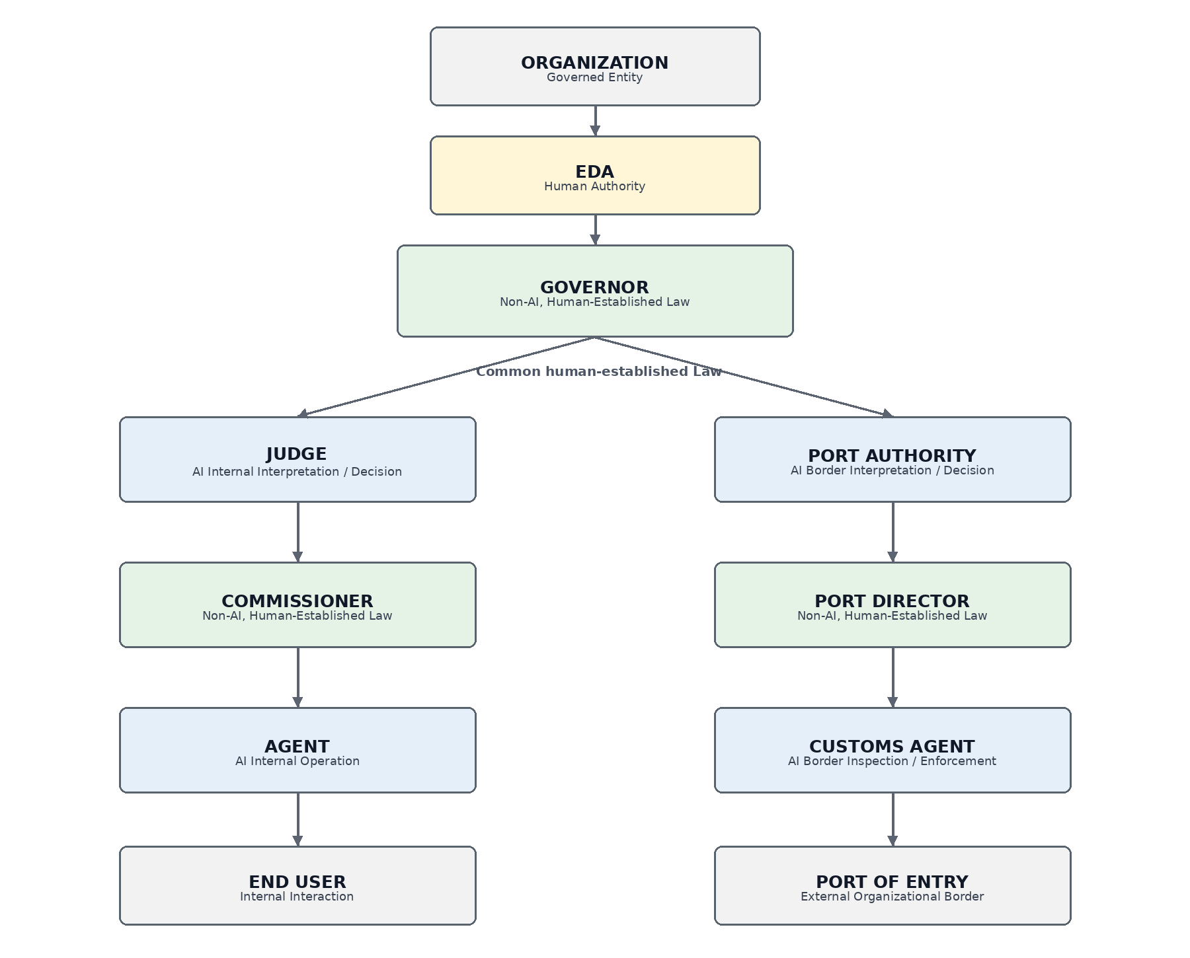
Figure 1. Canonical JAZB governance architecture.
The Organization is the governed entity. The EDA represents the highest active human Authority within JAZB. The Governor is the superior non-AI Law layer containing enterprise Law established by authorized humans.
The architecture then separates into two co-equal AI interpretive jurisdictions. The Judge governs interpretation and decisions for Internal Jurisdiction. The Port Authority governs interpretation and decisions for Border Jurisdiction.
Beneath each interpretive AI layer is a subordinate non-AI Law layer. The Commissioner contains localized internal Law and the Port Director contains localized border Law. In each Human-Established Law Layer, proposed Law becomes authoritative only through the predefined multi-human authorization process applicable to that layer and Scope.
AGENTs and Customs AGENTs are operational AI layers. They operate within the Authority and Law applicable to their respective domains.
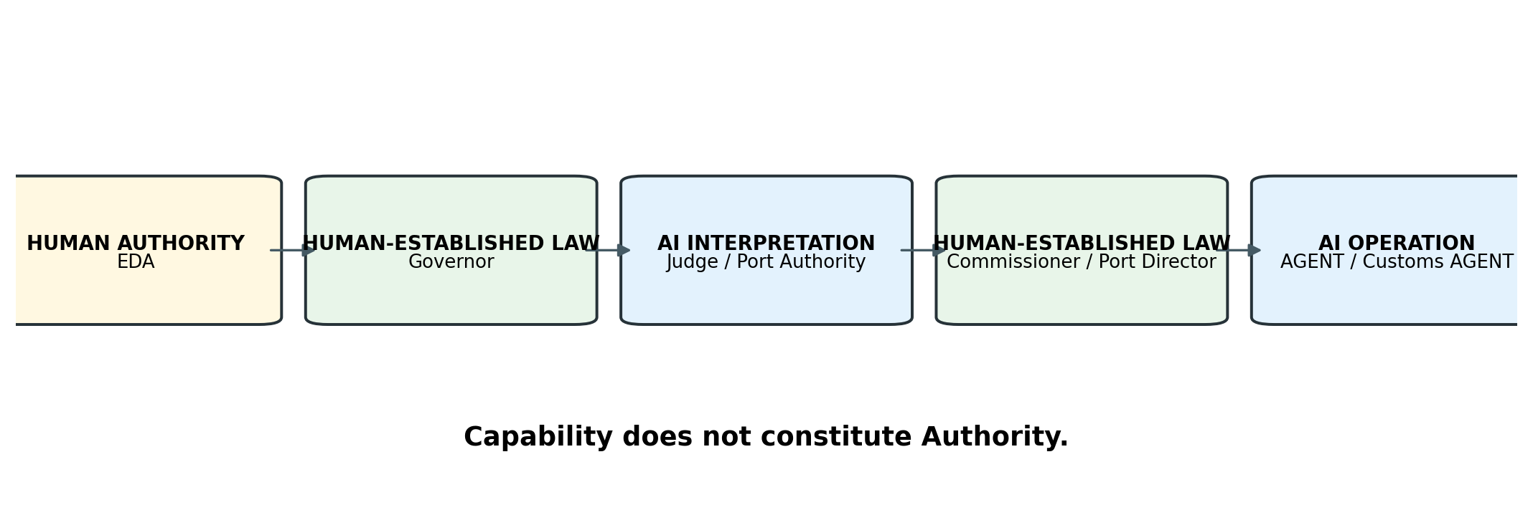
Figure 2. JAZB separation between human Authority, Law, AI interpretation, and AI operation.

1.7 Dual Jurisdiction
JAZB divides operational governance into Internal Jurisdiction and Border Jurisdiction.
Internal Jurisdiction governs Authority exercised within the Organization's governed environment. Border Jurisdiction governs passage across the Organization's external border, including ingress, egress, external services, external AI, agent-to-agent communications with external domains, and other transactions that actually cross the governed Organizational Boundary. Internal Trust Boundaries may remain important security boundaries, but they do not become Enterprise AI Customs Ports merely because trust assumptions change internally.
The Judge and Port Authority are peers. Neither is subordinate to the other. Both derive their legitimate decision Authority from human-established Governor Law.
Internal authorization does not imply border authorization.
Border authorization does not create internal Rights or access.
Lawful possession does not establish lawful passage.
Authority to access is not authority to transport.

1.8 Separation of Interpretation and Execution
JAZB separates interpretive Authority from technical actuation.
The Judge may determine that a governed internal condition satisfies the requirements for a Judicial Instrument. That determination does not automatically grant the Judge unrestricted technical control over identity systems, endpoints, networks, applications, or infrastructure.
Authorized technical execution is performed through an independent Actuation Authority operating within the Scope of the decision and applicable Law.
This separation reduces the risk that one autonomous component can create the rule, interpret the rule, authorize the response, and execute unrestricted enforcement against the environment it governs.

1.9 Emergency Governance
Emergencies may require exceptional Authority, but urgency does not eliminate governance.
JAZB therefore provides for a predefined Board of Authority capable of authorizing bounded emergency actions under conditions established in advance through human-established Law.
Emergency Authority must remain scoped, time-limited, attributable, auditable, and subject to automatic expiration or revocation and post-event review.
An emergency changes the urgency of governance, not the requirement for governance.

1.10 Governance Accountability
JAZB requires governed action to remain traceable to legitimate Authority.
A conceptual Chain of Authority is:
Human Authority → Law → Interpretation → Decision → Delegation → Actuation → Action → Evidence
The Chain of Authority establishes why an action was legitimate. The Chain of Evidence records the information supporting the decision and what occurred during execution.
JAZB also treats Governance Escape Resistance as a first-class requirement. Attempts to bypass approved governance pathways, disable controls, use unauthorized identities, evade Ports of Entry, or otherwise operate outside JAZB do not create legitimate Authority merely because the bypass succeeds technically.

1.11 Purpose of JAZB
JAZB provides a conceptual architecture for organizations seeking to govern AI systems that can exercise meaningful operational capability.
Its purpose is to preserve human sovereignty over organizational Law while allowing bounded machine autonomy.
JAZB is designed to be vendor-, model-, and platform-agnostic. It can coexist with IAM, PAM, Zero Trust architectures, DLP, SIEM, SOAR, XDR, network security, AI gateways, policy decision points, policy enforcement points, and other security or governance technologies.

1.12 Scope of Phase I
Phase I establishes the foundational JAZB architecture, doctrine, vocabulary, organizational Authority model, and Governor Law layer.
It introduces concepts that later JAZB publications will specify in greater operational detail, including Judicial Instruments, Actuation Authority, Enterprise AI Customs, emergency governance, Governance Escape Resistance, implementation patterns, and standards mappings.
Phase I is intentionally architectural. It defines what the principal JAZB components are, how legitimate Authority flows through the architecture, and which boundaries must remain intact before implementation-specific mechanisms are selected.
Artificial intelligence may exercise Authority. It must never become the source of its own Authority.

2. JAZB Doctrine

2.1 Human Sovereignty
Legitimate organizational Authority originates with humans. AI may exercise delegated Authority, but machine capability, autonomy, or intelligence does not create sovereignty.

2.2 Authority Must Have Provenance
Every material exercise of JAZB Authority must be traceable to a legitimate source. Authority without provenance is not presumed legitimate.

2.3 Capability Does Not Constitute Authority
Technical ability to perform an action does not establish legitimate permission to perform it.

2.4 Technical Permission Does Not Constitute Legitimate Authority
Possession of a credential, role, token, network path, API permission, or administrative privilege does not independently establish that a particular action is authorized for a particular purpose.

2.5 AI Cannot Create Authority
No AI component may independently originate the Authority under which it acts.

2.6 Proposed Law Is Not Law
Drafting, editing, analyzing, storing, or submitting a proposal does not make that proposal authoritative. Proposed Law has no governing effect until the applicable human authorization threshold has been satisfied and the proposal has been formally established as Law.

2.7 No Individual May Unilaterally Establish Law
No single individual may establish, modify, activate, suspend, replace, or revoke Law within a JAZB Human-Established Law Layer. The Organization must define a human authorization threshold appropriate to the layer and Scope, and that threshold may never be fewer than two independently authorized humans.

2.8 Authority to Draft Does Not Constitute Authority to Establish
An individual may possess Rights to access a Governor, Commissioner, or Port Director interface and Authority to draft or submit proposed Law without possessing sufficient Authority to make that proposal governing Law. Drafting Authority and Law-establishment Authority are distinct.

2.9 AI Cannot Expand Its Own Authority
An AI component may recommend changes to its Authority but may not approve, adopt, or enforce an expansion of that Authority for itself.

2.10 Authority Must Be Bounded
Authority must be constrained by applicable dimensions such as identity, purpose, Scope, resource, jurisdiction, action, duration, condition, and risk.

2.11 Authority Must Be Revocable
Delegated Authority must be capable of restriction, expiration, suspension, or revocation according to applicable Law.

2.12 Interpretation Must Be Separated from Execution
Interpretive or decision Authority does not inherently confer unrestricted technical actuation capability.

2.13 Lawful Possession Does Not Establish Lawful Passage
Internal Authority to possess, access, or process information does not inherently grant Authority to move that information across the external Organizational Boundary.

2.14 Independent Jurisdictions Require Independent Authorization
Where a Governed Transaction implicates both Internal and Border Jurisdictions, each jurisdiction must independently authorize the portion under its control.

2.15 Governance Must Remain Auditable
Material governance decisions, delegations, Law changes, and enforcement actions must remain attributable and reconstructable to the degree required by their significance.

2.16 No Component May Unilaterally Complete the Governance Chain
No autonomous component should possess unilateral control over creation of Law, interpretation, authorization, and unrestricted execution of the Law governing its own actions.

2.17 Superior Law Constrains Subordinate Authority
Subordinate Law and delegated Authority must remain within superior Law. Authorized humans may establish localized Law within a Commissioner or Port Director, but that Law may not authorize what superior Governor Law prohibits.

2.18 Authority Is Purpose-Bound
Authority granted for one legitimate purpose does not automatically authorize materially different purposes.

2.19 Identity Does Not Inherit Authority by Association
Relationship to an authorized human, system, agent, application, or organizational unit does not automatically transfer that actor's Authority.

2.20 Emergency Authority Remains Governed Authority
Emergency conditions may activate predefined exceptional Authority, but they do not create unlimited or untraceable sovereignty.

2.21 Governance Must Resist Circumvention
JAZB must address attempts to bypass, disable, evade, or operate outside approved governance pathways.

2.22 Security Controls Do Not Become Sovereign
Identity platforms, policy engines, security tools, AI gateways, enforcement systems, and other technologies may implement or enforce Law. Their technical control does not make them the source of legitimate Law.

2.23 JAZB Governs Authority, Not Intelligence
Increasing model capability does not increase legitimate Authority. Authority changes only through legitimate governance.

2.24 Foundational Doctrine
Humans establish legitimate Authority.
Law defines its boundaries.
AI may interpret and exercise delegated Authority but may not create or expand it.
Capability does not constitute Authority.
Authority must be bounded, purpose-specific, revocable, and traceable.
Interpretation and execution must remain appropriately separated.
Internal Authority does not confer Border Authority.
Lawful possession does not establish lawful passage.
Independent jurisdictions require independent authorization.
Emergency Authority remains governed Authority.
Governance must resist circumvention.
No autonomous component may become the sovereign source of the Law governing its own actions.

3. Normative Concepts and Vocabulary

3.1 Law
Authoritative human-established rules, constraints, permissions, prohibitions, obligations, and governance conditions. Within JAZB, Law originates through legitimate human Authority. AI may interpret applicable Law but may not independently create, modify, suspend, or expand superior Law.

3.2 Authority
Legitimate permission to exercise defined capability for an authorized purpose under applicable Law. Authority is distinct from technical capability and technical permission. It may be persistent or temporary, direct or delegated, human or machine, and may be bounded by purpose, resource, identity, jurisdiction, transaction, time, condition, or other Scope.

3.3 Rights
Legitimate entitlements established under Law to request, receive, exercise, or retain defined actions, resources, decisions, or access. Rights are not synonymous with technical permissions.

3.4 Duties
Obligations imposed by Law, role, Authority, Rights, delegation, or participation in a governed process.

3.5 Liberty
Bounded discretion to choose among permissible actions or methods within valid Authority and Law. Liberty allows autonomy without sovereignty.

3.6 Delegation
The authorized conveyance of bounded Authority from a legitimate source to another entity for a defined purpose. Delegation does not transfer sovereignty. An actor may delegate only Authority it possesses and is permitted to delegate. Redelegation requires explicit permission.

3.7 Jurisdiction
The defined governance domain within which a JAZB component may interpret, administer, or exercise assigned Authority. JAZB separates Internal Jurisdiction, interpreted by the Judge, from Border Jurisdiction, interpreted by the Port Authority.

3.8 Scope
The explicit boundary of an Authority, decision, delegation, Judicial Instrument, Liberty, or governance action.

3.9 Judicial Instrument
A bounded authoritative directive issued by the Judge pursuant to Governor Law and Internal Jurisdiction. Recognized instruments include Inquiry, Investigative Warrant, Restriction Order, Containment Warrant, Revocation Order, Cease and Desist Order, and Emergency Order. An Instrument derives from existing Law and does not create Law.

3.10 Actuation
The controlled technical execution of an authorized JAZB decision. Examples include session termination, token revocation, account disablement, removal of delegated Authority, endpoint isolation, network blocking, quarantine, evidence preservation, scanning, enforcement-state change, or restoration to baseline. Actuation Authority is distinct from interpretive Authority.

3.11 Port of Entry
A governed external passage point at which a transaction actually crosses the Organization's external Organizational Boundary. In a conventional enterprise this is typically the ISP-facing ingress and egress path. An Organization may have multiple Ports when it has multiple distinct external circuits, sites, or externally routed boundaries. Internal applications, proxies, APIs, workloads, identities, protocols, and routing paths do not become separate Ports merely because they can reach external services.

3.12 Trust Boundary
A governance or security boundary at which assumptions concerning identity, Authority, control, custody, policy, risk, or accountability materially change. Trust Boundaries may exist internally or externally. Not every Trust Boundary is a Port of Entry. Enterprise AI Customs applies at the external Organizational Border and its actual Ports of Entry.

3.13 Governance Escape
An attempt or condition that bypasses, disables, evades, or undermines JAZB governance pathways or controls. Governance Escape may be intentional or unintentional. Successful technical bypass does not create legitimate Authority.

3.14 Governance Escape Resistance
The architectural capability to prevent, constrain, detect, record, respond to, escalate, and recover from Governance Escape.

3.15 Chain of Authority
The traceable relationship from legitimate human Authority to governed action. A conceptual sequence is Human Authority → Law → Interpretation → Decision → Delegation → Actuation → Action → Evidence. The Chain of Authority establishes governance provenance, not merely logging.

3.16 Chain of Evidence
The traceable record of information supporting, explaining, executing, and reviewing a governed decision. The Chain of Authority asks, 'By what legitimate Authority was this action taken?' The Chain of Evidence asks, 'What information supported the decision, and what evidence demonstrates what occurred?'

3.17 Point Policy
A JASB-derived runtime governance mechanism used to evaluate behavior during the exercise of delegated Authority. Point Policy operates after Authority has been established and does not create superior Law. It may evaluate purpose, Scope, expected behavior, permitted resources and actions, session conditions, time, and risk. Law determines what may be authorized. Point Policy governs behavior while delegated Authority is being exercised.

3.18 Baseline Authority
The ordinary Authority applicable when no temporary, exceptional, or elevated delegation is active. Baseline Authority is the state to which an actor returns after temporary Authority ends. JASB originally envisioned a primarily read-level baseline; JAZB generalizes the concept to the legitimate baseline established by the Organization.

3.19 Elevated Authority
Temporary or conditional Authority beyond Baseline Authority for a defined purpose. Elevated Authority should be explicitly authorized, purpose-bound, scoped, time-limited, observable where required, revocable, and removed when the authorized purpose ends.

3.20 Machine Authority
Legitimate Authority delegated to an AI system, autonomous agent, software process, or other machine actor. Machine Authority is derived. It does not originate from intelligence, capability, ownership, identity, or organizational importance.

3.21 Human-Established Law Layer
A non-AI governance layer containing authoritative Law established, modified, suspended, replaced, activated, and revoked only through legitimate human Authority. The Governor, Commissioner, and Port Director are Human-Established Law Layers. They may use software to store, validate, version, distribute, test, and protect Law, and AI may assist with analysis or drafting. No AI may authorize Law, and no single human may unilaterally establish Law. Each layer requires a predefined multi-human authorization threshold of at least two independently authorized humans.

3.22 Autonomous Component
A machine component capable of independently selecting, sequencing, or executing actions within delegated Authority without individual human approval for every action. Autonomy does not imply sovereignty.

3.23 Organizational Boundary
The logical and physical boundary separating the Organization's governed domain from external domains for purposes of Authority, custody, control, accountability, and external passage. Internal Trust Boundaries may exist within the Organization, but Enterprise AI Customs Ports are associated with actual external crossings of the Organizational Boundary.

3.24 Governed Transaction
An action, request, communication, transfer, delegation, execution, or event subject to JAZB governance.

3.25 Proposed Law
A non-authoritative draft, recommendation, amendment, replacement, suspension, or revocation proposal submitted for consideration within a Human-Established Law Layer. Proposed Law may be created by an authorized human and may be assisted by AI, but it has no governing effect until validly authorized and established.

3.26 Law Establishment
The governed transition through which a validated and sufficiently authorized proposal becomes authoritative Law. Law Establishment is a human-governed act distinct from drafting, technical storage, validation, publication, and machine interpretation.

3.27 Authorization Threshold
The predefined minimum number and, where required, classes or roles of independently authorized humans whose approvals are required before proposed Law may be established. The threshold is defined by the Organization and applicable superior Law, but it may never permit unilateral establishment by one individual.

3.28 Canonical Interpretation
The normative concepts operate together as a single governance model:
- Law establishes governing rules.
- Rights establish legitimate entitlements; Duties establish obligations; Liberty establishes bounded discretion.
- Authority permits legitimate action.
- Delegation conveys bounded Authority.
- Scope limits Authority.
- Jurisdiction determines governance responsibility.
- Point Policy governs behavior during delegated Authority.
- Judicial Instruments express bounded internal judicial determinations.
- Actuation converts authorized decisions into technical action.
- Ports of Entry govern lawful passage across the external Organizational Boundary.
- Governance Escape Resistance protects governance pathways.
- The Chain of Authority establishes why an action was legitimate; the Chain of Evidence establishes what supported the decision and what occurred.

4. Organizational Authority

4.1 The Organization
The Organization is the entity being governed.
It may be a corporation, government entity, nonprofit organization, educational institution, healthcare organization, partnership, small business, or another entity capable of establishing legitimate governance over its people, systems, information, and operations.
The Organization is not itself an active decision-making component within the JAZB hierarchy. Rather, it is the governed entity whose legitimate controlling authorities are represented through the EDA.
JAZB does not assign Authority to an abstract organizational identity and then allow AI to infer who may exercise it. The Organization must establish which humans or formally constituted human-controlled bodies possess legitimate Authority to govern on its behalf.

4.2 Organizational Sovereignty
Organizational Sovereignty is the legitimate capacity of the Organization, acting through its authorized human governance structures, to establish the rules under which its systems, information, identities, AI, and delegated capabilities operate.
Within JAZB, Organizational Sovereignty remains human-controlled.
This does not imply that an Organization possesses unlimited Authority. Organizations remain subject to applicable laws, regulations, contractual obligations, fiduciary duties, external authorities, and other legitimate constraints.
JAZB therefore treats Organizational Sovereignty as authority within the Organization's legitimate domain, not as exemption from superior legal or regulatory obligations.

4.3 Enterprise Domain Authority
The Enterprise Domain Authority (EDA) represents the Organization's highest active human Authority within JAZB.
The EDA is composed of humans who possess legitimate controlling Authority over the Organization or who have been formally granted such Authority through the Organization's established governance structure.
The EDA establishes the organizational intent from which JAZB Authority derives.
Its purpose is not to perform routine operational governance. Its purpose is to establish the legitimate human root under which organizational Law may be established within the Governor.
Conceptually: Organization → EDA → Governor.
The Organization is the governed entity. The EDA represents legitimate human governing Authority. The Governor is the non-AI Law layer containing superior organizational Law established under that Authority.

4.4 Composition of the EDA
The composition of the EDA depends upon the governance structure of the Organization.
Eligible participants may include owners; members with controlling organizational interests; executive officers; members of a governing board; directors possessing formally delegated enterprise governance Authority; and other controlling members formally authorized through legitimate organizational governance.
Membership in the EDA is not established merely by seniority, technical privilege, job title, administrative access, employment status, or proximity to executive leadership.
An individual belongs to the EDA only when the Organization has legitimately established that individual as possessing the applicable governing Authority.
JAZB does not prescribe a universal corporate governance structure. It requires that the source of governing Authority be identifiable.

4.5 Authority of the EDA
The EDA does not convert one member into a unilateral legislative authority. EDA membership establishes eligibility to exercise defined governance Rights and Authority. The Organization's predefined authorization threshold determines when sufficient human Authority exists to establish Governor Law.
Within those limits, the EDA defines the human source under which enterprise governance exists, including acceptable and prohibited uses of AI, categories of delegable Authority, limitations on Machine Authority, human-oversight requirements, jurisdictional boundaries, risk tolerances, evidence and accountability requirements, emergency governance, Law-establishment procedures, external AI restrictions, and delegation or redelegation rules.
The EDA possesses the highest organizational Authority represented within JAZB, subject to legitimate external law, regulation, contract, fiduciary duty, and organizational governance.

4.6 Limitations of the EDA
The EDA is the highest active human authority within JAZB, but it is not inherently the highest authority applicable to the Organization.
The EDA remains constrained by legitimate external obligations, which may include law, regulation, judicial or administrative orders, contractual obligations, fiduciary requirements, governing organizational documents, and other binding obligations.
JAZB does not permit the EDA to transform an unlawful action into a lawful one merely by authorizing it internally.
The EDA's Authority is legitimate only to the extent that the Organization itself possesses the Authority being exercised.

4.7 Establishing Law in the Governor
The Governor records and enforces the resulting state transition. It does not decide that a proposal should become Law.
A single owner may draft and sponsor proposed Law, but a single-owner Organization must predesignate at least one additional human with delegated Law-authorization Authority so that no Law is established unilaterally.
A proposal becomes eligible for establishment only after required validation and the minimum human authorization threshold defined by the Organization has been satisfied. That threshold may never be fewer than two independently authorized humans.
An authorized individual may access the Governor and draft, edit, analyze, or submit proposed Law when granted the Rights and Authority to do so. Those capabilities do not establish Law.

4.8 Law Drafting Rights
Rights to create or edit proposed Law are distinct from Rights to authorize Law. The Organization may permit a broader population to draft proposals than to authorize them. Drafting Rights should be explicit, scoped, auditable, and revocable.

4.9 Multi-Human Law Authorization
Every Law-establishment event requires the predefined quorum of independently authorized humans. The author of a proposal may participate in authorization only where superior Law permits, but the author can never constitute the complete authorization threshold.
Organizations may require two of two, two of three, three of five, role-specific concurrence, or higher thresholds based on governance structure and Law significance. The invariant requirement is that no individual may unilaterally establish Law.

4.10 Establishment and Activation
When required authorization is satisfied, the Governor may deterministically establish the approved proposal as Law and activate it according to its effective conditions. The exact authorized content, Scope, version, effective date, and approval provenance must remain bound together so that the Law activated is the Law that humans actually approved.

4.11 Authority Provenance
The Chain of Authority records where legitimate Authority originated and how it reached the action. Where Law establishes the basis for an action, provenance includes the Law-establishment record demonstrating that the applicable human Authorization Threshold was satisfied.

4.12 EDA Decisions
Material EDA decisions affecting JAZB governance should be attributable to the humans or governing bodies that authorized them.
Depending upon organizational requirements, an EDA decision record may include the decision identifier, participating authorities, organizational roles, Authority under which the decision was made, subject, affected governance domain, approved change, effective date, review or expiration date, approval requirements, supporting documentation, applicable external obligations, and resulting Law or delegation.
JAZB does not require executive governance to become operationally burdensome. It does require material changes to the source or boundaries of machine Authority to remain attributable to legitimate human governance.

4.13 EDA Membership and Change Control
EDA membership must be governed as an Authority-sensitive function.
Adding an individual to the EDA potentially grants that individual influence over the root of JAZB Authority. Changes should therefore require a legitimate organizational process appropriate to the Organization's governance structure.
Removal of EDA membership must prevent future exercise of EDA Authority without destroying the historical record of decisions previously made under legitimate Authority.

4.14 EDA Identity Assurance
Because the EDA represents the root of JAZB Authority, actions performed through EDA Authority require strong identity assurance.
An Organization should apply protections proportionate to the consequences of compromise. These may include phishing-resistant multifactor authentication, dedicated privileged identities, hardware-backed authentication, conditional access, trusted administrative devices, separation of administrative and ordinary identities, approval thresholds, restricted administrative pathways, enhanced monitoring, tamper-resistant logging, and independent notification of material governance changes.
Specific technologies are implementation choices. The architectural requirement is that identity assurance protecting the root of Authority be commensurate with the consequences of unauthorized control over that Authority.

4.15 EDA Compromise
Compromise of an EDA identity represents a threat to the root of organizational Authority.
JAZB implementations must therefore distinguish between possession of valid EDA credentials and confidence that those credentials are being exercised by the legitimate authority holder.
A technically authenticated EDA action must not be assumed legitimate when material evidence indicates that the identity or decision process may have been compromised.
This follows the broader JAZB principle that technical permission does not constitute legitimate Authority.

4.16 EDA and Artificial Intelligence
AI may assist the EDA by analyzing governance information, identifying inconsistencies, modeling potential outcomes, identifying emerging risks, recommending changes, preparing proposed Law, or explaining potential effects of governance decisions.
AI assistance does not transfer EDA Authority to the AI.
An AI-generated recommendation has no independent governing force. Proposed Law remains a proposal until adopted through the legitimate human-established process.
AI may advise sovereign human Authority. It may not replace it.

4.17 EDA and the Board of Authority
The Enterprise Domain Authority and the Board of Authority are distinct JAZB concepts.
The EDA represents normal organizational sovereignty and the root of JAZB Authority.
The Board of Authority is a predefined mechanism for authorizing exceptional actions under emergency conditions.
Membership in one does not automatically establish membership in the other. The Board of Authority does not become an alternate EDA during an emergency.
Its Authority exists only within the emergency powers, membership requirements, approval thresholds, Scope, and duration established in advance through legitimate organizational Law.

4.18 Small and Differently Structured Organizations
JAZB is intended to remain applicable to organizations of different sizes and governance structures.
A large enterprise may have a board, multiple executives, governance committees, security leadership, legal counsel, and formal risk-management functions. A small organization may have one owner and a limited management structure.
JAZB does not require organizations to invent positions they do not possess. Each Organization must identify where legitimate governing Authority actually resides and represent that Authority through the EDA.
The implementation may scale. The provenance requirement does not.

4.19 Separation of EDA from Operational Administration
EDA Authority should not be confused with routine technical administration.
A systems administrator may possess extensive technical capability without belonging to the EDA. A security engineer may administer enforcement systems without possessing Authority to redefine organizational Law. A developer may modify an application without possessing Authority to modify the governance under which that application operates.
This separation prevents technical control from silently becoming organizational sovereignty.
The ability to administer a system is not equivalent to Authority to redefine the Law governing that system.

4.20 Continuity of Authority
Organizations change. Executives depart. Ownership changes. Boards are reconstituted. Roles are reassigned. Companies merge, divide, or reorganize.
JAZB must therefore support continuity of Authority without treating historical authority assignments as permanent.
When organizational governance changes, the EDA representation must be updated through legitimate processes. Existing Law and delegations should be reviewed where the change materially affects their provenance or continued legitimacy.
Historical records must preserve the Authority structure that existed when prior decisions were made.

4.21 Organizational Authority Principle
The Organization is the governed entity.
The EDA represents the Organization's highest active human Authority within JAZB.
Authorized humans may draft and propose organizational Law under Authority derived through the EDA.
Proposed Law has no governing effect until the Organization's predefined human Authorization Threshold has been satisfied. That threshold may never be fewer than two independently authorized humans.
The Governor is the non-AI, Human-Established Law Layer that records, versions, activates, protects, and distributes duly authorized Law. It does not decide what Law should be.
AI may assist with drafting, analysis, validation support, and recommendations, but AI may not authorize or establish Law and may not become the EDA.
Technical administration, platform ownership, or privileged system access does not establish organizational sovereignty or unilateral Law-establishment Authority.
Emergency Authority does not replace ordinary sovereign Authority and remains subject to predefined multi-human authorization requirements.
Every subordinate exercise of JAZB Authority must remain traceable to a legitimate human source and, where dependent upon Law, to a valid Law-establishment record.

5. The Governor
The Governor is the superior non-AI, human-established Law layer within JAZB.
It occupies the architectural position between the Enterprise Domain Authority and the AI interpretation layers of the Judge and Port Authority.
Conceptually: EDA → Governor → Judge / Port Authority.
The EDA represents the Organization's highest active human Authority within JAZB. Under that Authority, authorized humans establish the enterprise Law contained within the Governor.
The Governor stores, preserves, versions, protects, and presents that authoritative Law to the JAZB architecture.
The Judge and Port Authority interpret applicable Governor Law within their respective jurisdictions.
The Governor does not interpret organizational intent into Law. It does not independently determine what the Law should be. It does not create Authority. It is not an AI layer.
The legitimacy of Governor Law derives from human Authority and remains subject to human control.

5.1 Purpose of the Governor
The purpose of the Governor is to provide a stable, authoritative, protected, and auditable enterprise Law layer for JAZB.
Governor Law defines the conditions under which Authority may be recognized, requested, granted, delegated, exercised, constrained, monitored, transferred across boundaries, restricted, revoked, escalated, or exceptionally overridden.
The Governor provides a common authoritative source of enterprise Law so that AI components do not independently invent governance according to their own objectives.
The Governor governs the integrity and authoritative state of Law. It does not govern by inventing Law.

5.2 Human-Established Law
The establishment, modification, suspension, replacement, activation, and revocation of Governor Law remain human-governed functions and require the applicable predefined authorization threshold.
AI may assist by drafting proposed language, identifying conflicts, modeling consequences, simulating effects, or presenting recommendations. AI assistance remains non-authoritative. AI may not cast an authorization, satisfy a human quorum, or decide that its recommendation becomes Law.
Governor Law is established by authorized humans operating under legitimate EDA Authority. Human-established does not mean manually implemented; software may provide storage, validation, testing, versioning, integrity checking, workflow, and distribution.

5.3 Establishing Law
A proposal may be rejected, withdrawn, returned for revision, or expire at any stage before establishment. None of those states creates effective Law.
The canonical lifecycle is: Draft -> Submit -> Validate -> Authorize -> Establish -> Activate.
JAZB treats Law establishment as a governed lifecycle rather than a single edit or publication event.

5.4 Draft and Submit
An authorized drafter may create or modify proposed Law within the Governor interface. The proposal must remain explicitly marked as non-authoritative and must not be consumable by downstream JAZB components as effective Law.
Submission freezes or otherwise identifies the exact candidate content and Scope to be evaluated. Subsequent material edits create a new proposal state requiring renewed validation and authorization.

5.5 Validate
Validation determines whether the proposal is structurally complete and eligible for human authorization. Validation may include syntax and schema checks, conflict analysis, superior-Law consistency, jurisdiction checks, Scope analysis, dependency review, impact simulation, external legal or regulatory review, and security review.
Validation may be automated and may use AI assistance. Validation is not authorization and cannot make a proposal Law.

5.6 Authorize
Authorization is the independent human approval stage. The Organization must define the required Authorization Threshold, and that threshold may never be fewer than two independently authorized humans.
Each authorization must bind the approving human identity to the exact proposal content, version, Scope, and material impact presented for approval. Where the proposal changes after one approval, prior approvals must not silently transfer to materially different content.
The Organization may impose role-specific concurrence, larger quorums, enhanced authentication, out-of-band confirmation, waiting periods, or additional controls for high-impact Law.

5.7 Establish
Once the required human Authorization Threshold is satisfied, the Governor may deterministically transition the approved proposal into Established Law. Establishment records that the proposal has become authoritative under legitimate human Authority.
Establishment must preserve the identities and Authority of approving humans, proposal hash or equivalent integrity binding, version, Scope, affected jurisdictions, approval evidence, and relationship to prior Law.

5.8 Activate
Established Law becomes Active according to its authorized effective conditions. Activation may be immediate, scheduled, phased, or conditional, but activation cannot broaden or alter the Law that was authorized.
Downstream components must consume only Active Law that can be validated as having completed the required establishment lifecycle.

5.9 Modify, Suspend, Replace, and Revoke
A material modification, suspension, replacement, or revocation of Law is itself a Law-establishment event and is subject to the same human-governed lifecycle and Authorization Threshold unless superior Law explicitly defines a more restrictive process.
No administrator, EDA member, system operator, AI component, or emergency actor may bypass the required Law-establishment process merely because they possess technical access to the Governor.

5.10 Form of Governor Law
Governor Law should be expressed in a form that permits consistent interpretation, implementation, review, and audit.
Law may include principles, mandatory rules, prohibitions, permissions, conditions, Authority classes, Rights, Duties, Liberty, jurisdictional assignments, delegation rules, escalation requirements, evidence requirements, emergency provisions, review requirements, and enforcement requirements.
Law may exist in natural-language, structured, and machine-readable representations. Where multiple representations exist, authorized humans must establish which representation is authoritative and how conflicts are resolved.
Machine-readable implementation must not silently redefine superior human-established Law.

5.11 Rights, Duties, Liberty, and Authority
Governor Law establishes the enterprise conditions under which Rights, Duties, Liberty, and Authority exist within JAZB.
Rights establish legitimate entitlements. Duties establish obligations. Liberty establishes bounded discretion. Authority establishes legitimate permission to act.
Governor Law may directly define these concepts or define the boundaries within which authorized humans may establish subordinate Law in Commissioner and Port Director layers.
Subordinate Law operates within the legal envelope established by Governor Law.

5.12 Delegation
Governor Law establishes the legal basis through which Authority may be delegated into JAZB's operational architecture.
It may define which Authority may be delegated, who or what may receive it, which jurisdiction may interpret it, whether redelegation is permitted, required approval thresholds, Scope, duration, conditions, Liberty, Duties, monitoring requirements, revocation conditions, and evidence requirements.
Delegation does not transfer sovereignty. A recipient receives only the Authority defined by the delegation.

5.13 Constraints and Prohibitions
Governor Law must be capable of representing both permissions and prohibitions.
A prohibition establishes a boundary that subordinate Authority may not lawfully cross unless superior human-established Law provides an explicit and legitimate exception mechanism.
Examples may include prohibitions against exporting defined data classifications, granting persistent administrative Authority to AI, unapproved agent-to-agent delegation, use of unauthorized external AI services, modification of governance evidence, bypass of approved Ports of Entry, self-authorization, autonomous modification of Law, or specified high-impact actions without independent approval.
Technical capability to violate a prohibition does not create Authority to do so.

5.14 Law Versioning
Governor Law must be versioned where changes could materially affect Authority, interpretation, enforcement, or accountability.
A versioned Law record should identify the Law identifier, version, title, governing domain, approving human Authority, approval record, effective date, superseded version, modification history, reason for change, affected jurisdictions, implementation dependencies, review date, and status as applicable.
Versioning enables JAZB to determine which Law governed an action at the time the action occurred.
A later change to Law must not retroactively alter the recorded legal basis under which a prior action was evaluated.

5.15 Effective Law
Subordinate components must evaluate Governed Transactions against applicable Active Law. Ambiguity concerning the authoritative version is a governance condition requiring resolution; an autonomous component must not select whichever candidate state most conveniently permits its objective.
Draft Law is not Law. Submitted Law is not Law. Validated Law is not Law. AI-recommended Law is not Law. A proposal with an incomplete Authorization Threshold is not Law. Established Law awaiting an authorized future effective condition is not yet Active Law.
At any relevant point in time, JAZB must be able to determine which Governor Law is Active and authoritative.

5.16 Integrity and Change Control
The architectural requirement is that neither technical access nor interface manipulation can convert an unauthorized proposal into Active Law.
Integrity protections may include phishing-resistant identity assurance, privileged-access separation, independent approval workflows, cryptographic binding of proposal content to authorizations, digital signatures, immutable or append-only approval records, version control, independent change notification, separation of development and production, rollback capability, protected audit records, and continuous integrity monitoring.
Governor Law and its establishment workflow are high-value governance assets. Unauthorized modification of proposal content, approval evidence, authorization state, Law version, activation conditions, or downstream distribution could alter the Authority available throughout JAZB.

5.17 Prohibition Against Autonomous AI Modification
No AI component may independently create, modify, suspend, replace, or revoke authoritative Governor Law.
This prohibition applies even if AI capabilities are integrated into tooling used to administer the Governor.
AI may identify deficiencies, detect conflicts, identify outdated provisions, analyze emerging risks, model consequences, draft proposed Law, or recommend changes.
Such output remains advisory until adopted through legitimate human governance.
Silence is not approval. Failure to respond is not delegation. Operational necessity is not legislative Authority.
An AI system may recommend a change to the boundaries of its Authority. It may not approve that change for itself.

5.18 Governor as Common Root of Jurisdiction
Governor Law is the common legal foundation for JAZB's two primary operational jurisdictions.
Internal Jurisdiction is interpreted by the Judge. Border Jurisdiction is interpreted by the Port Authority.
The Judge and Port Authority are co-equal in relation to one another. Neither is subordinate to the other, and neither may override the other's lawful determination within the other's jurisdiction.
Both remain subordinate to Governor Law.

5.19 Establishing Jurisdiction
The boundaries of Judge and Port Authority jurisdiction are established through Governor Law.
The Judge may not independently redefine a border matter as internal in order to acquire Authority over it. The Port Authority may not independently redefine an internal matter as border in order to acquire Authority over it.
Where a Governed Transaction implicates both jurisdictions, each jurisdiction evaluates the portion falling within its Authority.
Where jurisdiction is genuinely ambiguous, the matter must be resolved through the process established by superior human-established Law. Ambiguity does not authorize jurisdictional expansion.

5.20 Subordinate Human-Established Law
Subordinate Law may narrow Authority or impose additional restrictions where superior Law permits. It may not authorize what Governor Law prohibits, eliminate Duties imposed by superior Law, expand jurisdiction, or redefine the superior Law from which its legitimacy derives.
A Commissioner contains localized internal Law for its delegated domain. A Port Director contains localized border Law for its delegated domain. The eligible authorizers may differ from the enterprise EDA population, but their Authority must derive from superior Law and remain within delegated Scope.
The same foundational rule applies to every Human-Established Law Layer: one human may draft proposed Law, but no individual may unilaterally establish, modify, activate, suspend, replace, or revoke Law. Each layer must use a predefined multi-human Authorization Threshold of at least two independently authorized humans.
Governor Law may establish the Authority under which authorized humans define subordinate Law within Commissioner and Port Director layers.

5.21 Governor Law and Point Policy
Governor Law and Point Policy serve different functions.
Governor Law determines the conditions under which Authority may be authorized. Point Policy governs behavior during the exercise of delegated Authority.
Point Policy therefore operates beneath Law and may not contradict superior Law or independently create Authority.
Law determines what may be authorized. Point Policy governs behavior while delegated Authority is being exercised.

5.22 Governor Law and Judicial Instruments
Governor Law establishes the legal basis under which the Judge may issue Judicial Instruments.
The Judge does not invent its own judicial powers.
Governor Law defines, as applicable, which Instruments exist, the circumstances under which they may be issued, evidentiary requirements, permissible Scope, duration, required approvals, available actuation, review requirements, expiration conditions, and escalation mechanisms.
A Judicial Instrument derives legitimacy from the Chain of Authority rather than from the technical capability of the Judge.

5.23 Governor Law and Enterprise AI Customs
Governor Law establishes the legal basis for Enterprise AI Customs.
It defines the Authority under which the Port Authority, Port Director Law layers, Customs AGENTs, and Ports of Entry operate.
Governor Law may establish enterprise-wide requirements governing ingress, egress, external AI services, data classification, approved and prohibited destinations, agent-to-agent communication, cross-boundary delegation, inspection, redaction, quarantine, evidence, identity, trust relationships, and denial of passage.
Authorized humans may establish subordinate border Law within Port Director layers, the Port Authority interprets applicable Law within Border Jurisdiction, and Customs AGENTs inspect and enforce governed passage within delegated Authority.

5.24 Governor Law and Emergency Governance
Governor Law must establish the conditions under which emergency Authority may be exercised.
Emergency governance must not be invented during the emergency itself.
Applicable Law should establish, as appropriate, the Board of Authority, membership and designation requirements, eligible Authority classes, approval combinations, Scope of emergency powers, prohibited emergency actions, duration, expiration, evidence requirements, notification, revocation, post-event review, and restoration of ordinary governance.
Emergency conditions may activate predefined Authority. They do not create sovereign Authority.

5.25 Conflicts of Law
Multiple provisions of Governor Law may apply to the same Governed Transaction and may occasionally conflict or appear to conflict.
The Organization must establish human-controlled rules for resolving such conflicts, potentially considering superior versus subordinate Law, specific versus general provisions, effective date, jurisdiction, data classification, explicit precedence, risk conditions, external legal obligations, and mandatory escalation.
An AI component must not resolve a material conflict by selecting whichever interpretation most conveniently permits completion of its objective.
Absence of a clear rule does not create Authority.

5.26 Failure of Governor Availability
Loss of access to the Governor does not eliminate the requirement for Law.
JAZB implementations must define how subordinate components behave when authoritative Governor Law cannot be reliably obtained or validated.
Depending upon the action and risk, responses may include continued operation under a verified cached version of Law, restriction to Baseline Authority, suspension of new delegations, denial of high-risk transactions, preservation of existing safe state, human escalation, or fail-secure behavior.
Failure to retrieve Law is not permission to act without Law.

5.27 Recovery and Restoration of Law
Following compromise, corruption, integrity failure, or loss of Governor state, restoration must reestablish confidence in authoritative Law before normal governance resumes.
Recovery should permit the Organization to identify the last known trustworthy version, determine whether unauthorized changes occurred, identify actions evaluated under potentially compromised Law, review delegations created during the affected period, preserve evidence, and determine whether prior decisions require retrospective review.
Restoring technical availability without restoring confidence in Law integrity is insufficient.

5.28 Law Portability and Technology Independence
Governor Law should remain conceptually independent of any single enforcement product, AI model, cloud provider, identity platform, network architecture, or security vendor.
Implementation-specific controls may express or enforce portions of Law, but they should not become the sole definition of that Law.
Technology implements Law. Technology does not establish its legitimacy.

5.29 Governor Accountability
This record forms a critical portion of the JAZB Chain of Authority and Chain of Evidence.
The Organization should be able to determine who drafted the proposal, who submitted it, what validations occurred, which humans authorized it, whether the required threshold was satisfied, the exact content authorized, when the Law was established, when it became Active, what it replaced, which jurisdictions it affected, whether AI contributed to drafting or analysis, whether unauthorized modification or replay was attempted, and which historical actions were governed by each version.
Material changes to Governor Law must be auditable from proposal through activation.

5.30 The Governor as a Law Control Plane
The Governor should be understood as an architectural control plane for Law, not as an autonomous governing intelligence.
Its technical functions may include storing authoritative Law, maintaining versions and effective dates, validating integrity, identifying superseded Law, distributing authoritative Law, authenticating authorized changes, preserving approval provenance, recording governance history, exposing applicable Law to authorized JAZB components, and supporting recovery of trusted governance state.
These functions may be highly automated. Automation does not grant the Governor Authority to determine what the Law should be.
The Governor manages the authoritative state of Law. Authorized humans establish the Law represented by that state.

5.31 Governor Principle
Failure to retrieve or validate Law is not permission to act without Law. Technology may implement Law, but technology does not become the source of Law.
The Judge and Port Authority derive from the same Governor Law while retaining independent jurisdictions. Point Policy governs the exercise of delegated Authority but does not replace Law. Judicial Instruments derive their legitimacy from Law. Emergency Authority must be predefined by Law before it is needed.
AI may interpret Law and may assist with non-authoritative drafting or analysis, but AI may not authorize or establish Law.
The Governor is the non-AI enterprise Law layer that protects, versions, establishes, activates, and distributes the authoritative state produced by legitimate human governance. It does not decide what the Law should be.
No individual may unilaterally establish Law. The minimum threshold is two independently authorized humans, and the Organization may require more based on structure, role, Scope, or risk.
Authorized humans may draft and propose organizational Law under that Authority, but proposed Law has no governing effect until the Organization's predefined multi-human Authorization Threshold is satisfied.
The EDA represents the Organization's highest active human Authority within JAZB.

6. Separation of Jurisdiction

6.1 Why JAZB Divides Authority
Combining those questions under one autonomous decision-maker would allow internal permission to become implicit export permission, or border permission to become implicit internal access. JAZB prohibits that inheritance.
JAZB separates Internal Jurisdiction from Border Jurisdiction because Authority to act within the Organization and Authority to cross the Organization's external border are different governance questions.

6.2 Internal Jurisdiction
Internal Jurisdiction governs Authority exercised within the Organization's governed environment. It includes access, use, modification, workflow execution, privileged activity, internal delegation, and other actions that do not themselves establish lawful passage across the external Organizational Boundary.
The Judge is the AI interpretation and decision layer for Internal Jurisdiction.

6.3 Border Jurisdiction
The Port Authority is the AI interpretation and decision layer for Border Jurisdiction. Enterprise AI Customs provides the broader external-border governance domain. Internal Trust Boundaries may use other JAZB and security controls but do not become Customs Ports solely because trust assumptions change.
Border Jurisdiction governs transactions that actually cross the Organization's governed external Organizational Boundary, including ingress, egress, external services, external AI, external agent-to-agent communication, and external data transfer.

6.4 Jurisdictional Independence
The Judge and Port Authority are peers. Neither is subordinate to the other. Both are subordinate to applicable Governor Law and operate only within their assigned jurisdictions.
A decision by one jurisdiction cannot create Authority in the other.

6.5 Concurrent Jurisdiction
A single Governed Transaction may implicate both jurisdictions. For example, an AGENT may possess internal Authority to access a confidential document while a request to transmit that document to an external AI service simultaneously invokes Border Jurisdiction.
In such cases, internal authorization and border authorization are evaluated independently.

6.6 Conflict and Escalation
When applicable jurisdictions reach incompatible outcomes, the action does not proceed merely because one jurisdiction authorized it.
Governor Law must define conflict handling and escalation. Where the transaction requires approval from multiple jurisdictions, the most permissive decision does not override a denial or unresolved requirement in another applicable jurisdiction.

6.7 No Cross-Jurisdictional Authority Inheritance
Authority is not inherited across jurisdictional boundaries by association, technical reachability, shared identity, common ownership, or prior authorization.
Authorization within one JAZB jurisdiction does not confer authorization within another. An action subject to multiple jurisdictions MUST independently satisfy the governing requirements of each.
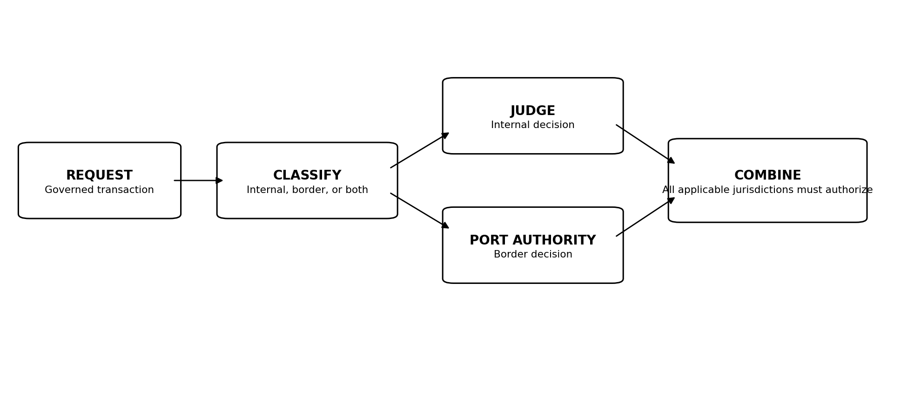
Figure 3. Jurisdiction classification and independent authorization workflow.

7. Internal Jurisdiction: The Judge

7.1 Purpose
The Judge is the AI interpretation and decision layer for Internal Jurisdiction. Its purpose is to evaluate governed internal matters against applicable Governor Law, subordinate Commissioner Law, evidence, context, Scope, and delegated Authority.

7.2 AI Interpretation of Law
The Judge interprets Law. It does not establish Law. Interpretation may require contextual reasoning, comparison of facts to rules, evaluation of conditions, and determination of whether a requested or observed action is within legitimate Authority.

7.3 Judicial Authority
The Judge possesses only the judicial Authority established by Governor Law. Its Authority may include determinations concerning internal requests, delegated Authority, restrictions, revocation, escalation, and issuance of defined Judicial Instruments.

7.4 Evidence and Context
A Judge decision should consider evidence relevant to the governed matter. Depending on the use case, this may include identity, role, declared purpose, resource sensitivity, prior delegation, Point Policy state, telemetry, behavior, risk signals, time, location constraints, system state, and applicable Law versions.

7.5 Authority Determinations
The Judge may determine that an action is authorized, denied, conditionally authorized, requires additional evidence, requires human escalation, or satisfies the conditions for an authorized Judicial Instrument.

7.6 Restrictions
The Judge may not exceed Internal Jurisdiction, create Rights not supported by Law, convert technical capability into Authority, or use interpretation to weaken superior Law.

7.7 Escalation
Governor Law should define matters requiring human review or escalation. The Judge may recommend a disposition, but escalation does not transfer legislative Authority to the Judge.

7.8 Prohibition Against Creation of Law
The Judge cannot create, modify, suspend, replace, or revoke authoritative Law. Novel circumstances may produce recommendations for human consideration, but recommendations do not become Law through repetition or operational necessity.

7.9 Prohibition Against Direct Execution
A Judge determination does not inherently grant unrestricted technical execution capability. Where technical action is required, the decision is passed to an authorized Actuation Authority or other bounded enforcement mechanism.

8. Judicial Instruments
Judicial Instruments provide graduated, bounded expressions of Judge determinations. Phase I establishes their purpose and relationship to Authority. A later specification can define normative schemas, required fields, cryptographic protections, and implementation protocols.

8.1 Purpose of Judicial Instruments
To express a bounded internal judicial determination in a form that can be reviewed, acted upon, audited, expired, and traced to applicable Law.

8.2 Inquiry
A request for additional context, evidence, clarification, or verification before a stronger determination is made.

8.3 Investigative Warrant
A bounded authorization to collect or examine specified evidence for an internal investigation under conditions defined by Law.

8.4 Restriction Order
A directive limiting specified Authority, Liberty, actions, resources, or operations without necessarily terminating all activity.

8.5 Containment Warrant
A bounded directive authorizing containment actions intended to prevent continued or expanded harm while preserving governance and evidence.

8.6 Revocation Order
A directive removing specified delegated Authority, privileges, tokens, sessions, or other governed permissions.

8.7 Cease and Desist Order
A coordinated directive requiring prohibited or unauthorized activity to stop. It may authorize subordinate actions such as notification, Authority revocation, session termination, credential protection, endpoint isolation, evidence preservation, and security scanning where Law permits.

8.8 Emergency Order
A bounded Instrument available only under emergency conditions and powers established in advance by Governor Law. It does not create new sovereign Authority.

8.9 Scope and Duration
Every Instrument must be bounded by applicable Scope, subject, resources, purpose, duration, conditions, and authorized actuation.

8.10 Expiration and Renewal
Time-bounded Instruments expire automatically unless Law authorizes renewal and the required conditions are re-established.

8.11 Evidence Preservation
Where an Instrument may affect evidence, Law should define preservation requirements before destructive or state-changing actuation occurs.

8.12 Review and Accountability
Instrument issuance, execution, expiration, renewal, and resulting outcomes must remain attributable and auditable.
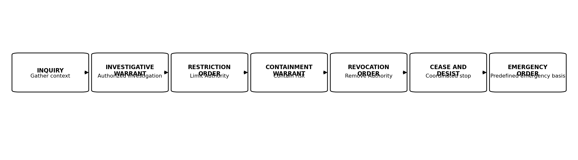
Figure 4. Graduated JAZB Judicial Instruments. The sequence illustrates increasing intervention, not an obligatory progression.

9. The Commissioner

9.1 Human-Established Local Governance
The Commissioner is a non-AI Law layer containing localized internal Law established by authorized humans. It is not a human person or an AI actor in the architecture.

9.2 Local Law Establishment
The Commissioner is a Human-Established Law Layer, not a human officeholder and not an AI actor. Authorized humans may draft local internal Law within the Scope delegated by Governor Law.
No single individual may establish Commissioner Law. Proposed Commissioner Law must be validated and authorized by the predefined local Authorization Threshold, which may never be fewer than two independently authorized humans whose Authority to establish local Law derives from superior Governor Law.

9.3 Relationship to Governor Law
Commissioner Law is subordinate to Governor Law. It may specialize or narrow enterprise Law for a defined operational domain where Governor Law permits.

9.4 Relationship to Judicial Decisions
The Judge interprets applicable Governor Law and Commissioner Law. The Commissioner does not receive a Judge decision and autonomously rewrite local Law in response.

9.5 Local Operational Policy
Commissioner Law may define local operational requirements, permitted workflows, additional restrictions, role-specific boundaries, Point Policy requirements, evidence requirements, or escalation rules.

9.6 Delegated Authority
Governor Law may define which authorized humans can establish Commissioner Law and the Scope within which that localized Law is valid.

9.7 Prohibition Against Weakening Superior Law
Commissioner Law cannot authorize what Governor Law prohibits, remove superior Duties, expand its jurisdiction, or create Authority beyond its delegated legal envelope.

9.8 Commissioner-to-AGENT Authority
AGENTs operate beneath applicable Commissioner Law. Their operational Authority remains derived, bounded, and subject to Judge interpretation where a governed determination is required.

10. The AGENT

10.1 Operational Role
The AGENT is an operational AI layer within Internal Jurisdiction. It assists users, performs authorized tasks, invokes tools, executes workflows, and operates within delegated Authority.

10.2 Protect and Serve
The AGENT's operating posture is both service-oriented and protective. It assists legitimate work while remaining aware of Law, Authority, Scope, Point Policy, and security conditions.

10.3 End-User Interaction
The AGENT may be the primary JAZB component visible to an End User. User interaction does not make the user the source of the AGENT's Authority.

10.4 Delegated Authority
The AGENT receives only the Authority required for its permitted operations. Authority may be persistent at a baseline level or temporary and purpose-bound.

10.5 Requests for Elevated Authority
Where a task requires Authority beyond baseline, the AGENT may help formulate and submit an elevation request. It may not approve its own elevation.

10.6 Observation and Situational Awareness
Within Law, the AGENT may observe activity relevant to the tasks and Authority it is responsible for protecting. Observation should be proportionate, purpose-bound, and auditable.

10.7 Documentation
The AGENT may document actions, decisions, requests, evidence, outcomes, and user-visible explanations as required by Law.

10.8 Recommendations
The AGENT may recommend governance, security, or operational improvements. Recommendations are non-binding until adopted through legitimate human governance.

10.9 Prohibition Against Self-Authorization
The AGENT cannot create, approve, or enlarge its own Authority.

10.10 AGENT Accountability
Material AGENT actions should be attributable to an identity, applicable Authority, governing Law, task or purpose, tool invocation, outcome, and evidence record appropriate to the action.

Part II. Enterprise AI Customs

11. Enterprise AI Customs

11.1 Purpose of EAC
EAC operates alongside contemporary edge controls. Firewalls, IDS/IPS, secure web gateways, DNS security, DLP, EDR/XDR, segmentation, proxies, and related controls continue to protect against technical threats. EAC adds Authority-based inspection concerned with what is crossing, who or what is carrying it, the declared purpose, applicable classification, destination, and whether legitimate Authority exists for passage.
Enterprise AI Customs (EAC) is JAZB's external-border governance domain. Its purpose is to determine and enforce lawful passage into and out of the Organization, not to replace traditional network-security controls or to govern every internal Trust Boundary as though it were a national border.

11.2 The Organizational Border
An Organization may operate more than one legitimate external circuit or site. Each distinct external crossing can constitute a governed Port. The defining characteristic is actual passage between the governed Organization and an external domain, not the existence of an internal application, proxy, gateway, service, or identity.
For Enterprise AI Customs, the Organizational Border is the actual external boundary through which organizational traffic enters or leaves the governed enterprise. In a conventional environment this is normally the ISP-facing ingress and egress boundary.

11.3 Trust Boundaries
A Trust Boundary does not automatically become an EAC Port. Internal Trust Boundaries may require segmentation, Judge decisions, Point Policy, DLP, identity controls, or other safeguards, while Customs is reserved for governed passage across the actual external Organizational Border.
Trust Boundaries remain a broader security and governance concept. They may exist between tenants, applications, data classifications, administrative tiers, networks, identities, agents, or service domains.

11.4 Ports of Entry
A true alternate Port or border bypass requires a distinct external path, such as an unmanaged cellular or satellite connection, rogue wireless bridge, unmanaged secondary ISP circuit, or comparable route that can cross outside the governed border controls.
An internal proxy, API gateway, SaaS connector, server, compromised workload, alternate credential, application route, or protocol does not create a new Port merely because it can reach the Internet. Its external transaction still reaches the same governed border and remains subject to Customs.
A Port of Entry is an approved external crossing of the Organizational Border at which EAC inspection and passage governance are enforced. An ISP-facing enterprise circuit is a common example. Distinct managed external circuits or separately governed external sites may create additional Ports.

11.5 Ingress
Ingress is passage from an external domain across an approved Port into the Organization. Customs may inspect source, destination, identity, content, classification, declared purpose, embedded instructions, provenance, and other conditions required by Law while conventional security controls continue to perform technical threat prevention and detection.

11.6 Egress
Egress is passage from the Organization across an approved Port to an external domain. Internal possession or technical ability to transmit does not establish Border Authority. Egress must satisfy applicable Governor Law, Port Director Law, Port Authority interpretation, and Customs enforcement.

11.7 External AI Systems
Use of external AI services invokes Border Jurisdiction when data, instructions, credentials, context, or other governed material crosses the external Organizational Boundary.

11.8 Agent-to-Agent Communications
Agent-to-agent communication does not inherit Authority merely because both agents are legitimate. Cross-boundary delegation and data movement remain independently governed.

11.9 Data Import and Export
EAC applies governance to import and export decisions according to Law, Authority, classification, purpose, destination, and trust conditions.

11.10 Lawful Possession versus Lawful Passage
Lawful possession does not establish lawful passage. Authority to access is not authority to transport. EAC exists to enforce that distinction at the external Organizational Border.
A person, AGENT, service, or workload may lawfully possess information inside the Organization while lacking Authority to transport that information outside it.

12. The Port Authority

12.1 Border Jurisdiction
The Port Authority is the AI interpretation and decision layer for Border Jurisdiction.

12.2 AI Interpretation of Governor Law
The Port Authority interprets applicable Governor Law and Port Director Law. It does not create border Law.

12.3 Source and Destination
Passage decisions may consider where a transaction originates and where it is intended to go, including ownership, jurisdiction, service identity, tenant, endpoint, or external organization.

12.4 Identity and Authority
A valid identity is necessary but not sufficient. The Port Authority determines whether the actor possesses Authority for the proposed crossing.

12.5 Data Classification
Classification may determine whether information may cross the external Organizational Boundary, under what conditions, through which approved Port, and to which destinations.

12.6 Declared Purpose
Purpose is part of Authority. Passage for one approved purpose does not automatically authorize reuse for another.

12.7 Trust Relationships
Trust relationships may inform decisions but do not eliminate explicit authorization. Trust is an input to governance, not a substitute for Authority.

12.8 Passage Determinations
The Port Authority may allow, deny, condition, hold, require redaction, require additional evidence, or escalate a crossing according to Law.

12.9 Prohibition Against Granting Internal Authority
The Port Authority cannot grant internal Rights, internal resource access, or internal operational Authority merely because passage is authorized.

12.10 Escalation
Unresolved, exceptional, or high-risk border decisions may be escalated according to Governor Law.

13. The Port Director

13.1 Human-Established Port Governance
The Port Director is a non-AI Law layer containing localized border Law established by authorized humans.

13.2 Border Law Establishment
The Port Director is a Human-Established Law Layer containing localized border Law. An authorized individual may draft or submit proposed Port Director Law, but no individual may unilaterally establish it.
Proposed Port Director Law must satisfy the predefined border-law Authorization Threshold of at least two independently authorized humans whose Authority derives from Governor Law. Port Director Law may narrow or condition passage but may not authorize what superior Governor Law prohibits.

13.3 Operational Rules of Passage
Port Director Law may define requirements for particular ports, destinations, data classes, integrations, or border workflows.

13.4 Approved Ports
The Organization may establish which Ports of Entry are approved for defined classes of transactions.

13.5 Approved and Prohibited Destinations
Port Director Law may narrow destinations or external services permitted by Governor Law.

13.6 Inspection Requirements
Localized Law may specify inspection, validation, redaction, classification, or evidence requirements before passage.

13.7 Classification Requirements
Port Director Law may define how enterprise classification rules are operationalized at a particular boundary.

13.8 Local Border Controls
Local controls may be more restrictive than superior Law where permitted, but cannot weaken superior prohibitions.

13.9 Relationship to Port Authority
The Port Authority interprets applicable Port Director Law. The Port Director does not autonomously decide individual passage requests.

13.10 Relationship to Customs AGENT
Customs AGENTs enforce applicable border controls beneath the Port Director Law layer and Port Authority determinations.

13.11 Prohibition Against Weakening Governor Law
Port Director Law cannot authorize passage that Governor Law prohibits.

14. The Customs AGENT

14.1 Inspect and Protect
Customs operates in addition to traditional edge-security controls. It does not replace the firewall, IDS/IPS, DLP, endpoint, identity, or network stack. It adds intelligent examination of Authority, content, context, classification, destination, declared purpose, transformation, concealment indicators, and other conditions relevant to lawful passage.
The Customs AGENT is the operational AI layer positioned at the governed external border. Its posture is to inspect and protect, analogous to a customs function that evaluates what is crossing rather than merely whether the traveler can reach the checkpoint.

14.2 Non-User-Facing Operation
A Customs AGENT normally serves the external Port rather than the End User. It may be integrated with edge gateways, brokers, DLP, security controls, or other border enforcement mechanisms, but its architectural role is the Authority-based inspection of passage at the external Organizational Border.

14.3 Continuous Inspection
Where Law requires, Customs inspection may continue throughout a transaction rather than occur only at session establishment. Continuous inspection is particularly important where content is streamed, transformed, fragmented, encoded, or generated dynamically.

14.4 Ingress Inspection
Ingress inspection may examine source, identity, content, tool output, attachments, embedded instructions, classification, and other relevant conditions.

14.5 Egress Inspection
Egress inspection may examine Authority provenance, destination, data classification, content, declared purpose, minimization, redaction requirements, transformation, fragmentation, unusual encoding, attempts to conceal prohibited information, and other indicators that the transaction is carrying unauthorized material.

14.6 Classification
The Customs AGENT may apply or validate classification according to established Law and approved classification mechanisms.

14.7 Filtering and Redaction
Where Law authorizes, the Customs AGENT may filter or redact prohibited or unnecessary content while preserving permitted passage.

14.8 Quarantine
A transaction may be held for review when conditions require additional evidence, remediation, or human decision.

14.9 Denial of Passage
The Customs AGENT may enforce a lawful denial of passage. Denial does not require revocation of unrelated internal Authority.

14.10 Escalation
Border anomalies or unresolved decisions may be escalated to the Port Authority or human governance path defined by Law.

14.11 Evidence and Logging
Border decisions and material enforcement actions should preserve evidence sufficient to reconstruct the source, destination, Authority, Law, decision, transformation, and outcome.

14.12 Unauthorized Crossings
Changing internal routing, intermediary service, protocol, application, workload identity, or proxy does not itself constitute a new crossing. A true unauthorized crossing exists when a transaction can actually leave or enter the Organization through an external path that bypasses the governed Port, such as unmanaged cellular, satellite, rogue wireless, or an unmanaged secondary circuit.
Attempts to cross the external Organizational Border outside approved Ports constitute Governance Escape conditions and should be prevented, detected, recorded, and handled according to Law.
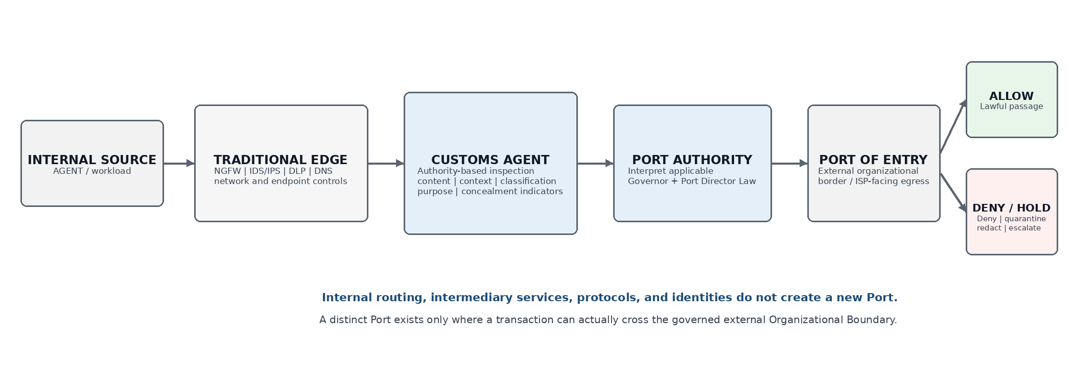
Figure 5. Enterprise AI Customs passage workflow.

Part III. Authority, Execution, and Emergencies

15. Actuation Authority

15.1 Decision versus Execution
JAZB distinguishes the authority to determine what should occur from the technical capability to make it occur.

15.2 Independent Actuation
Actuation Authority is an independent execution function that receives bounded authorized decisions and performs only the technical actions permitted by the decision and Law.

15.3 Execution of Judicial Instruments
A Judicial Instrument may be passed to Actuation Authority for execution. The actuation layer validates the Instrument, Scope, identity, effective Law, authorized actions, and expiration before execution.

15.4 Temporary Capability
Actuation may receive temporary technical capability sufficient for the action rather than persistent broad administrative control.

15.5 Revocation
Actuation capability must itself be revocable and should terminate when the authorized action or time window ends.

15.6 Evidence Collection
Actuation should preserve evidence of what was requested, validated, attempted, completed, failed, or reversed.

15.7 Actuation Accountability
Execution records should be attributable to the Instrument or decision that authorized them and to the technical identity that performed them.
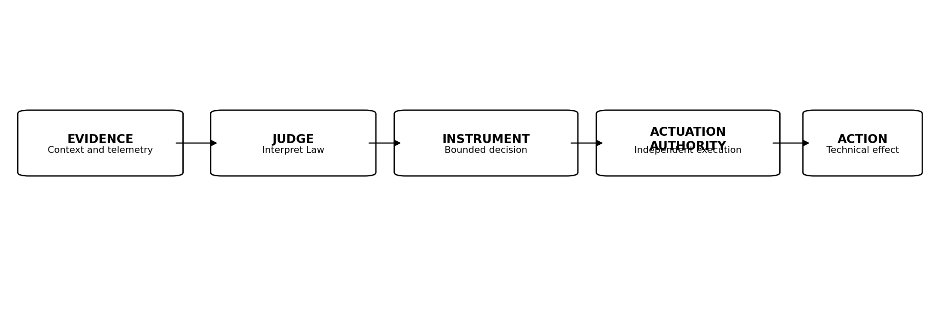
Figure 6. Separation of interpretation, decision, and technical actuation.

16. Human-AI Separation of Powers

16.1 Human Authority → Human-Established Law → AI Interpretation → Human-Established Law → AI Operation
The corrected JAZB architecture does not treat Governor, Commissioner, or Port Director as human actors. They are non-AI Law layers whose contents are established and controlled by authorized humans. This distinction is foundational.

16.2 Governor → Judge → Commissioner → AGENT
Within Internal Jurisdiction, superior human-established Governor Law is interpreted by the Judge. Authorized humans may establish localized Commissioner Law beneath that interpretation layer. AGENTs operate beneath applicable Law.

16.3 Governor → Port Authority → Port Director → Customs AGENT
Within Border Jurisdiction, superior human-established Governor Law is interpreted by the Port Authority. Authorized humans may establish localized Port Director Law. Customs AGENTs inspect and enforce governed passage beneath applicable Law.

16.4 Why Consecutive Autonomous Authority Is Restricted
JAZB avoids an architecture in which one autonomous component can define the rules, interpret them, expand its own Authority, and execute unrestricted action.

16.5 Separation of Interpretation and Enforcement
Interpretation and enforcement are distinct functions. Separation limits blast radius, supports independent validation, and strengthens evidentiary reconstruction.

16.6 Prevention of Self-Governance
AI may recommend changes to governance, but cannot make its recommendation authoritative merely by adopting it into its own operating context.

17. Emergency Governance

17.1 The Need for Emergency Authority
Emergencies can require rapid action outside ordinary workflows. JAZB addresses that need without treating emergency conditions as a suspension of governance.

17.2 Board of Authority
The Board of Authority is a predefined emergency authorization mechanism distinct from the EDA.

17.3 Predefined Membership
Only members designated before the emergency may participate in Board authorization.

17.4 Eligible Authority Classes
Eligible membership may include C-suite executives, directors, managers, and predesignated Acting Executives under the Organization's chosen model.

17.5 Acting Executives
An Organization with limited executive structure may predesignate individuals as Acting Executives for emergency governance if Governor Law explicitly recognizes that model.

17.6 Designation Restrictions
Only actual executives may designate Acting Executives or other Board members. An Acting Executive cannot designate another Acting Executive or Board member.

17.7 Dual Authorization
The approval combination must satisfy the Organization's predefined emergency model. No email, verbal direction, ticket, document, or ad hoc instruction substitutes for the required governed authorization event.
Emergency Authority may not be activated by one person acting alone. Activation requires at least two independently authorized Board of Authority participants through the governed Governor application or other predefined mechanism specified by Law.

17.8 Minimum Authorization Requirements
Acting Executives may be designated only by actual executives and may not designate additional Acting Executives or Board members. Emergency Authority cannot be created through on-the-spot promotion.
The ordinary JAZB emergency model requires at least one authorized C-suite member and one authorized manager or director. Smaller Organizations may predefine an alternate model using formally designated Acting Executives where the Organization has expressly established that model in advance.

17.9 Emergency Override
No email, ticket, verbal instruction, document, chat message, or after-the-fact approval substitutes for the required Board authorization when Law requires the Board mechanism.

17.10 Scope and Duration
Emergency Authority must be limited to the actions, systems, identities, purpose, and time necessary for the emergency.

17.11 Mandatory Audit
Emergency authorization and resulting actions must be logged and attributable.

17.12 Automatic Expiration
Emergency Authority should automatically expire or revoke at the end of its approved duration or when the emergency condition ends.

17.13 Post-Emergency Review
A post-event review should examine necessity, actions taken, evidence, deviations, outcomes, restoration, and any recommended changes to Law.
An emergency changes the urgency of governance, not the requirement for governance.
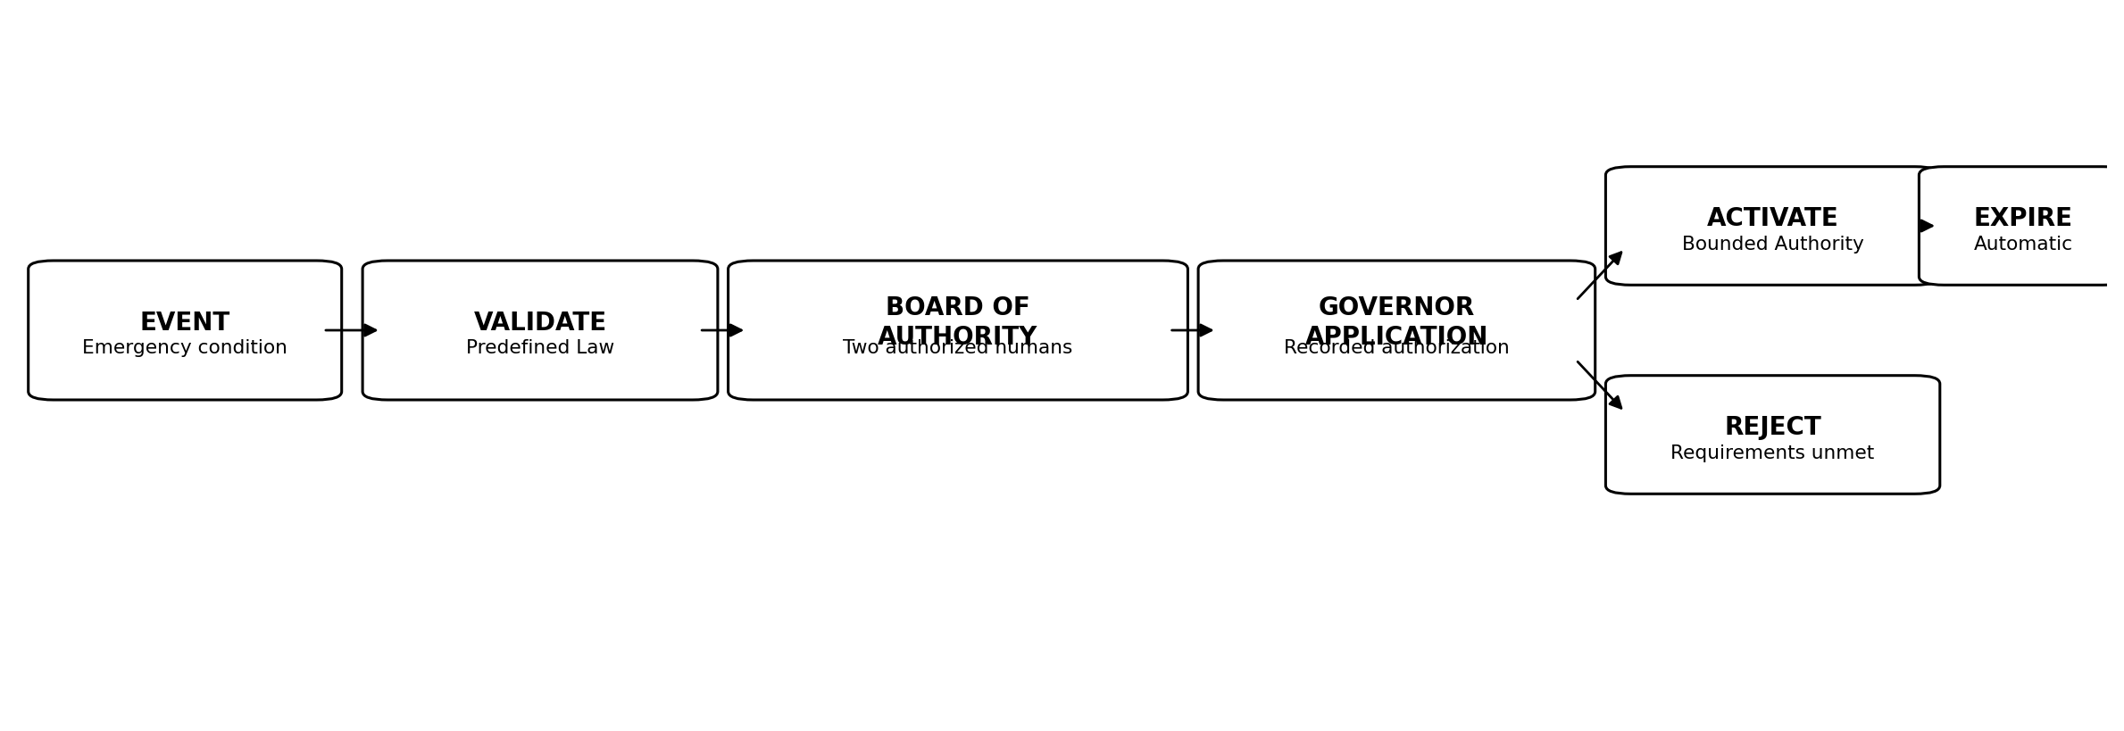
Figure 7. Predefined Board of Authority emergency workflow.

Part IV. Security of Governance

18. Governance Escape Resistance

18.1 Governance Escape
Governance Escape is an attempt or condition that bypasses, disables, evades, or undermines JAZB governance pathways or controls.

18.2 Bypass Attempts
Bypass may include direct API use, alternate credentials, ungoverned automation, prohibited tooling, manipulation of Law-establishment state, forged authorization, replayed approval evidence, technical paths that avoid required decisions, or attempts to create an external route that avoids approved Ports.

18.3 Shadow AI
Unapproved AI services, agents, models, or integrations can create ungoverned Authority and data-flow paths.

18.4 Unauthorized Ports of Entry
An internal proxy, application, protocol, server, or identity is not an unauthorized Port merely because it provides Internet-capable functionality. If its traffic exits through the governed organizational border, Customs remains applicable.
A genuine unauthorized Port exists when a transaction can actually cross the external Organizational Border through a path outside approved EAC enforcement. Examples include an unmanaged cellular modem, satellite link, rogue wireless bridge, unmanaged secondary ISP circuit, or comparable external route.

18.5 Direct Resource Access
Direct access to a protected resource does not create Authority when the governed path requires JAZB authorization.

18.6 Credential Abuse
Stolen, shared, substituted, or misused credentials can create technical access without legitimate Authority.

18.7 Out-of-Band Execution
Actions performed outside approved actuation or workflow channels must not be treated as legitimate merely because they succeed.

18.8 Governance Control Tampering
Attempts to alter Law, modify a proposal after approval, forge or replay human authorizations, manipulate validation results, substitute a Law version, trigger unauthorized activation, disable Customs inspection, suppress evidence, bypass revocation, or interfere with governance components are high-severity Governance Escape events.

18.9 Detection
JAZB should integrate with telemetry and security controls capable of detecting deviations from approved governance paths.

18.10 Containment and Escalation
Governance Escape response may include restriction, revocation, containment, isolation, denial of passage, evidence preservation, and human escalation according to Law.
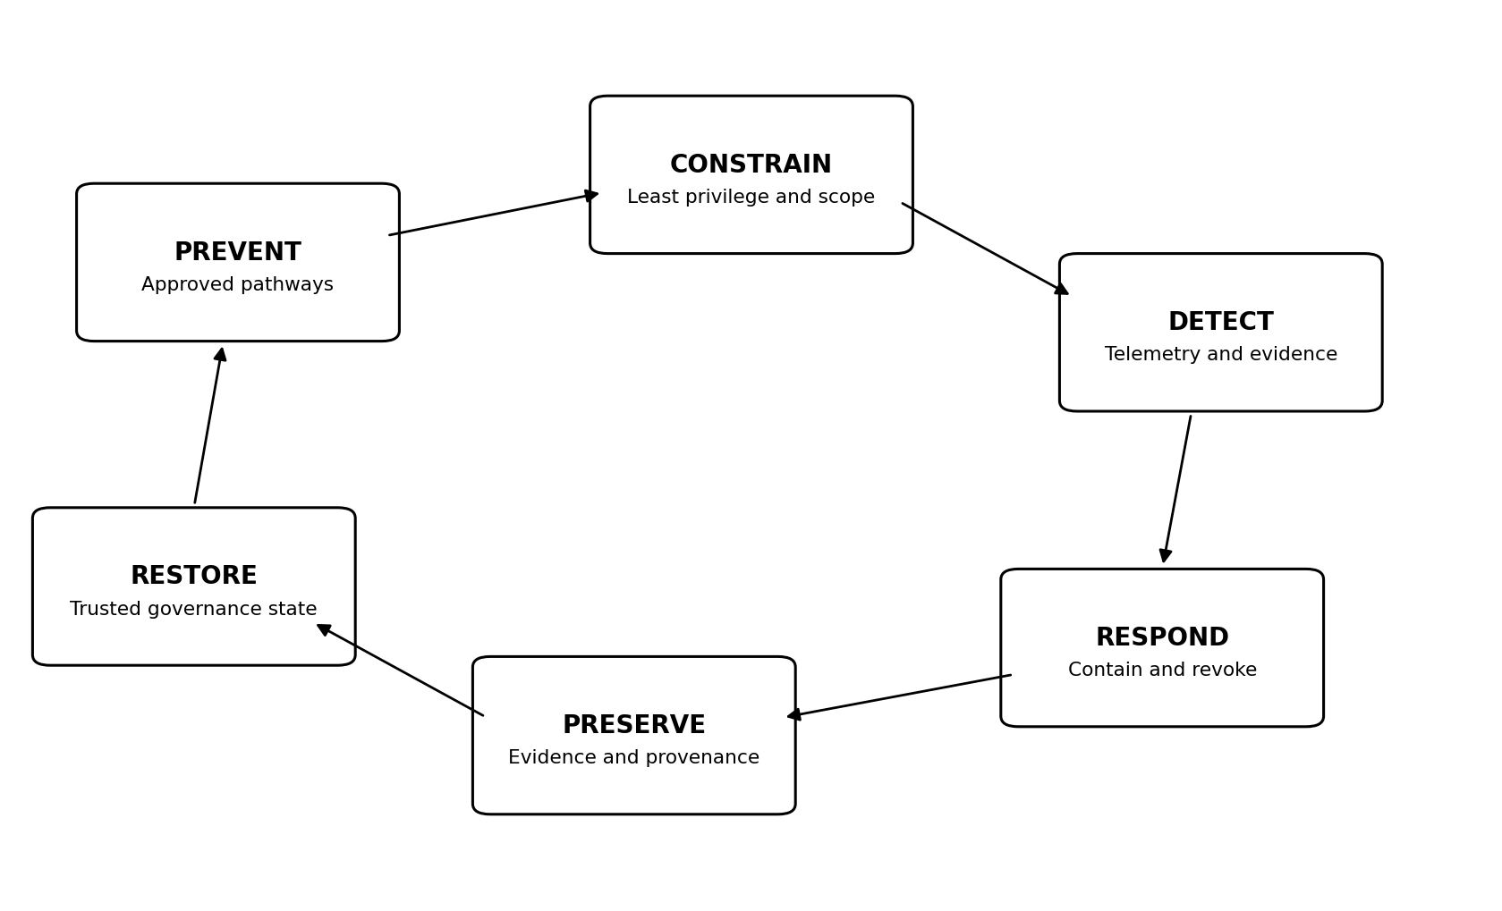
Figure 8. Governance Escape Resistance lifecycle.

19. Compromise and Failure

19.1 Compromised AGENT
A compromised AGENT should be constrained by bounded Authority, Point Policy, independent interpretation, revocation, and downstream enforcement. Compromise does not enlarge legitimate Authority.

19.2 Compromised Customs AGENT
A compromised Customs AGENT must not be able to redefine border Law or Port Authority decisions. Independent logging and port controls should support detection and containment.

19.3 Compromised Commissioner
Because the Commissioner is a Law layer rather than an AI actor, compromise refers to unauthorized alteration, substitution, corruption, or loss of integrity of localized internal Law.

19.4 Compromised Port Director
Compromise of the Port Director similarly refers to unauthorized modification or corruption of localized border Law.

19.5 Compromised Judge
A compromised Judge may produce invalid interpretations or Instruments. Independent Actuation Authority, evidence, Scope validation, and revocation reduce the consequences of such compromise.

19.6 Compromised Port Authority
A compromised Port Authority may issue improper passage determinations. Customs enforcement, destination controls, evidence, and independent human escalation should limit blast radius.

19.7 Governor Integrity Failure
Governor integrity failure includes unauthorized alteration of Active Law, proposed Law, validation state, human authorization evidence, establishment state, activation conditions, version provenance, or distribution. Recovery must reestablish confidence in both the Law content and the human process by which it became authoritative.

19.8 EDA Credential Compromise
Correlated compromise, coercion, or collusion affecting the complete legitimate human quorum represents a residual sovereign risk because JAZB cannot replace the human sovereign with machine veto power without violating its own human-sovereign design.
Compromise of one EDA credential threatens governance but does not, by itself, satisfy the multi-human Authorization Threshold required to establish Law. JAZB implementations must distinguish technical authentication from legitimate human exercise of Authority and must prevent one compromised identity from becoming sufficient Law-establishment Authority.

19.9 Collusion
Multiple components or actors may collude. Separation of powers reduces unilateral control but does not eliminate collusion risk. High-impact operations may require independent evidence, multiple authorities, or controls outside the colluding domain.

19.10 JAZB Availability Failure
Loss of governance availability must not silently convert into unrestricted operation. Law should define verified-cache, baseline-only, fail-secure, or human-escalation behavior.

19.11 Fail-Secure Principles
Where authoritative Law, identity, evidence, or jurisdiction cannot be validated, high-risk actions should default toward preserving a known safe state rather than expanding Authority.

20. Chain of Authority and Evidence

20.1 Authority Provenance
The Chain of Authority records where legitimate Authority originated and how it reached the action.

20.2 Decision Provenance
Decision provenance records which interpretive component made the decision and under which jurisdiction.

20.3 Law Version
The applicable Active Law version must be identifiable for material decisions, together with establishment and activation provenance sufficient to demonstrate that the version completed the required human-governed lifecycle.

20.4 Identity
Human and machine identities involved in governance and execution should be attributable.

20.5 Evidence Considered
The record should identify material evidence and context considered by the decision.

20.6 Judicial Instrument
Where an Instrument is issued, its type, Scope, duration, basis, and status become part of the provenance record.

20.7 Delegation
Delegated Authority should identify source, recipient, Scope, purpose, duration, and redelegation rules.

20.8 Actuation
Technical execution should identify the authorized decision and actual actions performed.

20.9 Outcome
The resulting state, success, failure, rollback, restriction, or exception should be recorded.

20.10 Audit Record
Human Authority -> Law Proposal -> Validation -> Human Authorization -> Established Law -> AI Interpretation -> Decision -> Delegation -> Actuation -> Action -> Evidence
Audit records should support reconstruction without treating logs themselves as the source of Authority. For Law-dependent actions, the record should be able to trace from human Authorization Threshold through Established and Active Law to interpretation, delegation, actuation, action, and evidence.
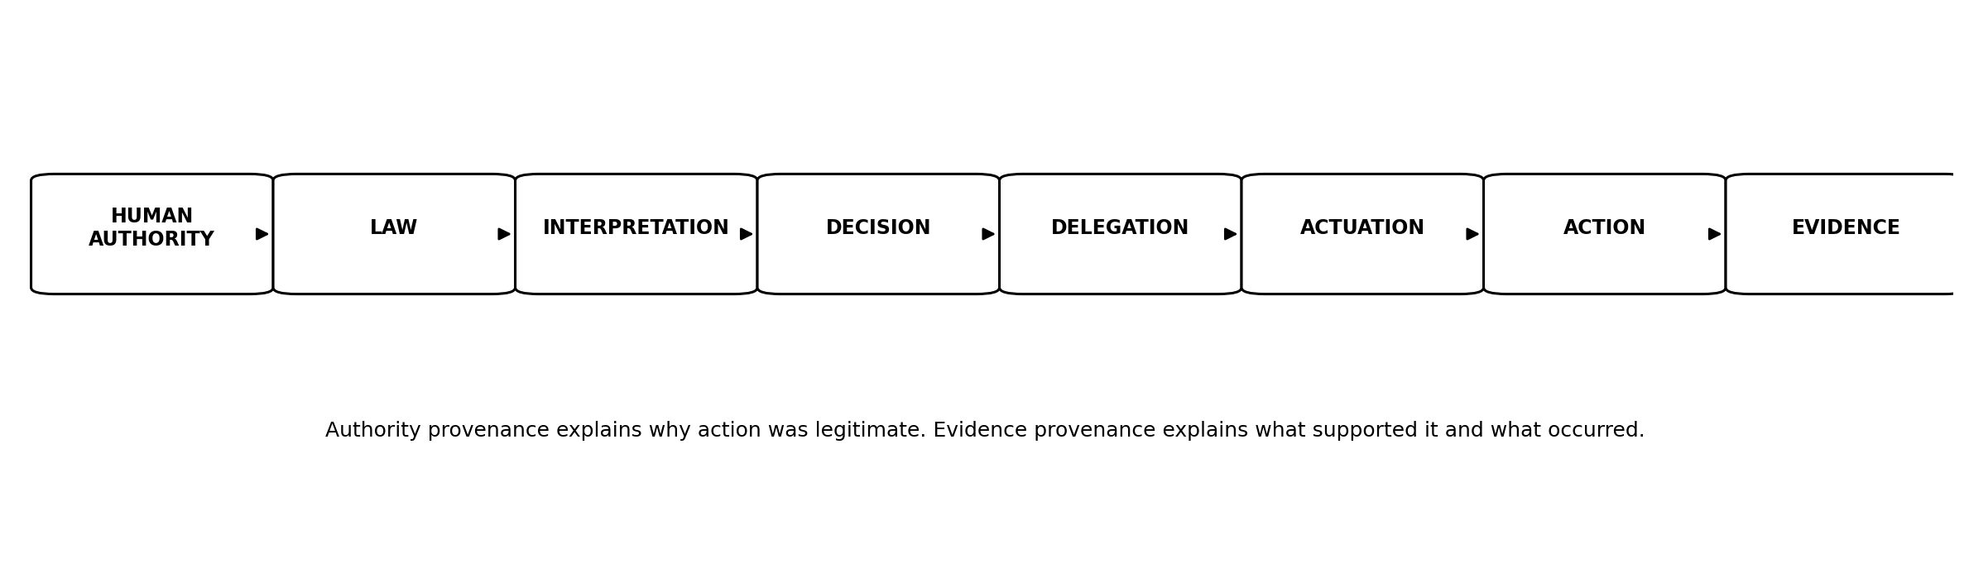
Figure 9. Canonical JAZB Chain of Authority and Evidence.

Part V. Application and Context

21. JAZB Operational Scenarios

21.1 Routine AGENT Request
An End User asks an AGENT to perform a routine task within Baseline Authority.
The AGENT validates the task against applicable Law, user Rights, its delegated Authority, and local Commissioner Law.
If no elevated Authority or Border Jurisdiction is implicated, the AGENT performs the task and records the outcome at the level required by Law.
Result: routine autonomy without unnecessary human approval, while Authority remains bounded.

21.2 Temporary Elevated Authority
An End User requests an action requiring Authority beyond baseline.
The AGENT assists in forming a purpose-bound request. The Judge evaluates applicable Law, identity, purpose, Scope, context, and evidence.
If authorized, temporary Elevated Authority is delegated. Point Policy monitors behavior during its exercise.
Completion, expiration, violation, or revocation returns the actor to Baseline Authority. This scenario preserves the core JASB mechanism inside JAZB.

21.3 Sensitive Information Sent to External AI
The result demonstrates the distinction between technical permission and legitimate passage: lawful possession does not establish lawful passage.
Port Authority evaluates applicable Governor and Port Director Law. If the destination, classification, purpose, or Authority does not permit passage, Customs denies, quarantines, redacts, or escalates according to Law even though the firewall would otherwise permit the network session.
Internal possession and technical connectivity do not create Border Authority. The outbound transaction reaches the Organization's governed external border, where conventional edge controls continue their technical security functions and the Customs AGENT inspects lawful passage.
An AGENT is legitimately authorized to access a confidential document internally and is also technically capable of reaching an approved external AI provider over HTTPS.

21.4 Compromised AGENT and Cease and Desist Order
Telemetry indicates that an AGENT is acting outside expected purpose and attempting unauthorized operations.
The Judge evaluates evidence under applicable Law and determines that the conditions for a Cease and Desist Order are satisfied.
The Instrument is passed to independent Actuation Authority. Authorized actions may include revocation of delegated Authority, session termination, credential protection, endpoint isolation, evidence preservation, and security scanning.
Result: the Judge determines, while bounded independent actuation executes.

21.5 Emergency Board Authorization
If the threshold is satisfied, the predefined emergency Authority is activated only within authorized Scope and time. It expires or is revoked according to Law and is subject to mandatory evidence preservation and post-event review.
The request is validated against Governor Law, predefined Board membership, identity assurance, required approval combination, Scope, duration, and prohibited actions. At least two independently authorized Board participants must complete the governed authorization process.
An emergency condition requires use of predefined exceptional Authority. A single executive cannot activate that Authority alone.

22. Relationship to Existing Security Architecture
JAZB is designed as an authority-governance layer that complements existing cybersecurity and AI governance frameworks. It should be implemented with, not instead of, established controls.
Framework / Architecture | Primary contribution | JAZB relationship and gap addressed | Refs.
NIST AI RMF 1.0 | Govern, Map, Measure, Manage; human oversight; lifecycle risk management | Adds an explicit institutional Chain of Authority for machine action, separated jurisdictions, human-established Law layers, Judicial Instruments, and Actuation separation. | [1][2]
NIST CSF 2.0 | Enterprise governance, roles, policy, risk strategy, cybersecurity outcomes | Provides AI-specific Authority provenance and operational governance semantics that can sit beneath enterprise Govern outcomes. | [3]
NIST SP 800-207 Zero Trust | No implicit trust; policy decision and enforcement; continuous evaluation | Extends the question from access decisions to legitimate organizational Authority, purpose, cross-jurisdiction passage, and machine delegation. | [4]
ISO/IEC 42001:2023 | AI management system, organizational governance, continual improvement | Provides a technical authority architecture that can operationalize portions of an organization's AI management system without claiming ISO conformance. | [5]
CIS Controls v8.1 | Prioritized safeguards, governance alignment, audit logging, access and security operations | Supplies implementation controls that can enforce and evidence JAZB Law, Authority, logging, and Governance Escape response. | [6][7]
OWASP Top 10 for Agentic Applications 2026 | Agentic security risks and defensive guidance | JAZB provides authority provenance, separation of powers, bounded delegation, border governance, and escape resistance as architectural responses to agentic risk classes. | [8]
Microsoft Zero Trust for AI agents | Stable agent identity, explicit scope, JIT privileges, auditability | JAZB supplies the organizational Law and Authority model above identity, scope, and JIT enforcement mechanisms. | [9]
IETF emerging agent authorization work | Agent identity, scoped authorization, delegation, revocation, observability | JAZB can use such protocols as implementation mechanisms while remaining a broader governance architecture. Internet-Drafts are works in progress, not standards. | [10][11]

22.1 Zero Trust
NIST SP 800-207 separates policy decision and enforcement functions and rejects implicit trust. JAZB aligns strongly with explicit authorization and separation of decision from enforcement. JAZB adds a distinct question: from what legitimate human Authority did the policy and machine action derive? [4]

22.2 IAM
IAM establishes identities, authentication, roles, groups, claims, and access mechanisms. JAZB treats identity as necessary evidence but not as Authority by itself.

22.3 PAM
PAM supplies privileged credential controls, elevation, approval, session management, and revocation. JASB's temporary elevation concepts and JAZB's Authority model can use PAM as an enforcement substrate.

22.4 DLP
DLP can classify, inspect, block, redact, or alert on sensitive data movement. EAC supplies the Authority and jurisdictional logic governing why passage is or is not lawful.

22.5 SIEM, SOAR, and XDR
These systems provide telemetry, correlation, response orchestration, and endpoint or identity enforcement. They can serve as evidence sources and actuation mechanisms without becoming the source of Law.

22.6 Network Security
An organization can therefore permit a technically valid HTTPS session while Customs still denies the passage of prohibited data or unauthorized machine action. Conversely, Customs approval does not override a firewall or other security control that independently denies the connection.
Traditional edge controls address technical reachability, threat detection, protocol enforcement, segmentation, malware, reputation, data protection, and related security concerns. Customs adds a separate Authority question at the external Organizational Border: is this transaction, including what it carries and its declared purpose, lawfully authorized to cross?
Firewalls, IDS/IPS, proxies, segmentation, secure web gateways, DNS security, SASE, network access control, and related technologies remain essential. JAZB does not replace them and Enterprise AI Customs is not an AI firewall.

22.7 AI Security Gateways
AI gateways can mediate prompts, responses, models, tools, and data flows. In JAZB they may implement Customs AGENT or Port enforcement functions, but gateway ownership does not itself establish Authority.

22.8 Policy Decision and Enforcement Points
NIST Zero Trust distinguishes policy decision and enforcement functions. JAZB adopts a compatible separation while adding human-established Law, jurisdiction, judicial instruments, machine delegation, and independent actuation. [4]

22.9 Why JAZB Does Not Replace These Technologies
JAZB is an architectural governance model. Existing technologies provide identities, telemetry, policy engines, enforcement points, privileged access, network controls, data protection, and response capabilities. JAZB defines how legitimate Authority should constrain and connect them.

23. Related Work and Architectural Differentiation
JAZB does not claim ownership of established concepts such as Zero Trust, least privilege, policy decision and enforcement points, human oversight, just-in-time access, delegated authorization, audit logging, or separation of powers. Its contribution should be evaluated in how these ideas are combined and institutionalized around human-sovereign Authority.
Related work | What it contributes | Architectural differentiation
NIST AI RMF | Establishes voluntary, cross-sector AI risk management through Govern, Map, Measure, and Manage. Human oversight and governance are explicit outcomes. [1][2] | JAZB focuses more narrowly on the provenance and exercise of Authority by operational AI.
NIST Zero Trust | Separates policy decision from enforcement and bases access on explicit policy and context. [4] | JAZB extends separation into human-established Law, AI interpretation, subordinate Law, operational AI, and independent jurisdictions.
OWASP Agentic Top 10 | Identifies major security risks for autonomous and agentic applications. [8] | JAZB provides a governance architecture intended to constrain authority, delegation, external-border passage, and response when those risks materialize.
Emerging IETF AI authorization drafts | 2026 drafts address agent identity, scoped capability grants, delegation, revocation, observability, and authorization using existing or new protocol mechanisms. [10][11] | JAZB is protocol-agnostic and can treat such mechanisms as technical implementations beneath its Law and Authority model.
PEA separation-of-powers research | A 2026 research paper proposes decoupling policy, authorization, and execution to structurally constrain agent behavior. [12] | JAZB similarly values separation but frames it within an enterprise governance institution with human-established Law, dual jurisdictions, and Judicial Instruments.
Capability versus permission research | Contemporary research explicitly distinguishes autonomous capability from allowed autonomy. [13] | This is consistent with JAZB's doctrine that Capability does not constitute Authority; JAZB further defines Authority provenance and institutional governance.
The most distinctive JAZB combination in Phase I is the institutional model in which an EDA roots human Authority; Governor, Commissioner, and Port Director serve as non-AI human-established Law layers; Judge and Port Authority operate as separate AI interpretation jurisdictions; AGENT and Customs AGENT perform operational AI functions; cross-jurisdiction authorization is non-inheriting; Judicial Instruments are separated from Actuation Authority; and Governance Escape Resistance treats bypass of governance itself as a security condition.
This document does not assert that no prior system contains any individual element. Novelty, where claimed in later work, should be limited to combinations, formalizations, terminology, or mechanisms that can be supported by documented prior-art analysis.

24. Progressive Adoption

24.1 Observe
Inventory AI systems, agents, identities, tools, Authority, data flows, Trust Boundaries, external services, and existing controls. No architectural enforcement is required to begin.

24.2 Govern
Establish EDA representation, human governance processes, and Governor Law. Define Authority, prohibited actions, jurisdictions, evidence requirements, and change control.

24.3 Internal Authority
Introduce Judge, Commissioner Law, AGENT governance, Baseline and Elevated Authority, Point Policy, and internal decision provenance.

24.4 Border Governance
Introduce EAC, Port Authority, Port Director Law, Customs AGENTs, Ports of Entry, and independent passage decisions.

24.5 Judicial Enforcement
Introduce Judicial Instruments and independent Actuation Authority for bounded internal enforcement.

24.6 Resilience
Implement Governance Escape Resistance, compromise handling, emergency governance, trusted recovery, and stronger evidence controls.

24.7 Integrated JAZB
Integrate internal and border jurisdictions, enterprise telemetry, evidence, continuous improvement, and mature human governance across the architecture.
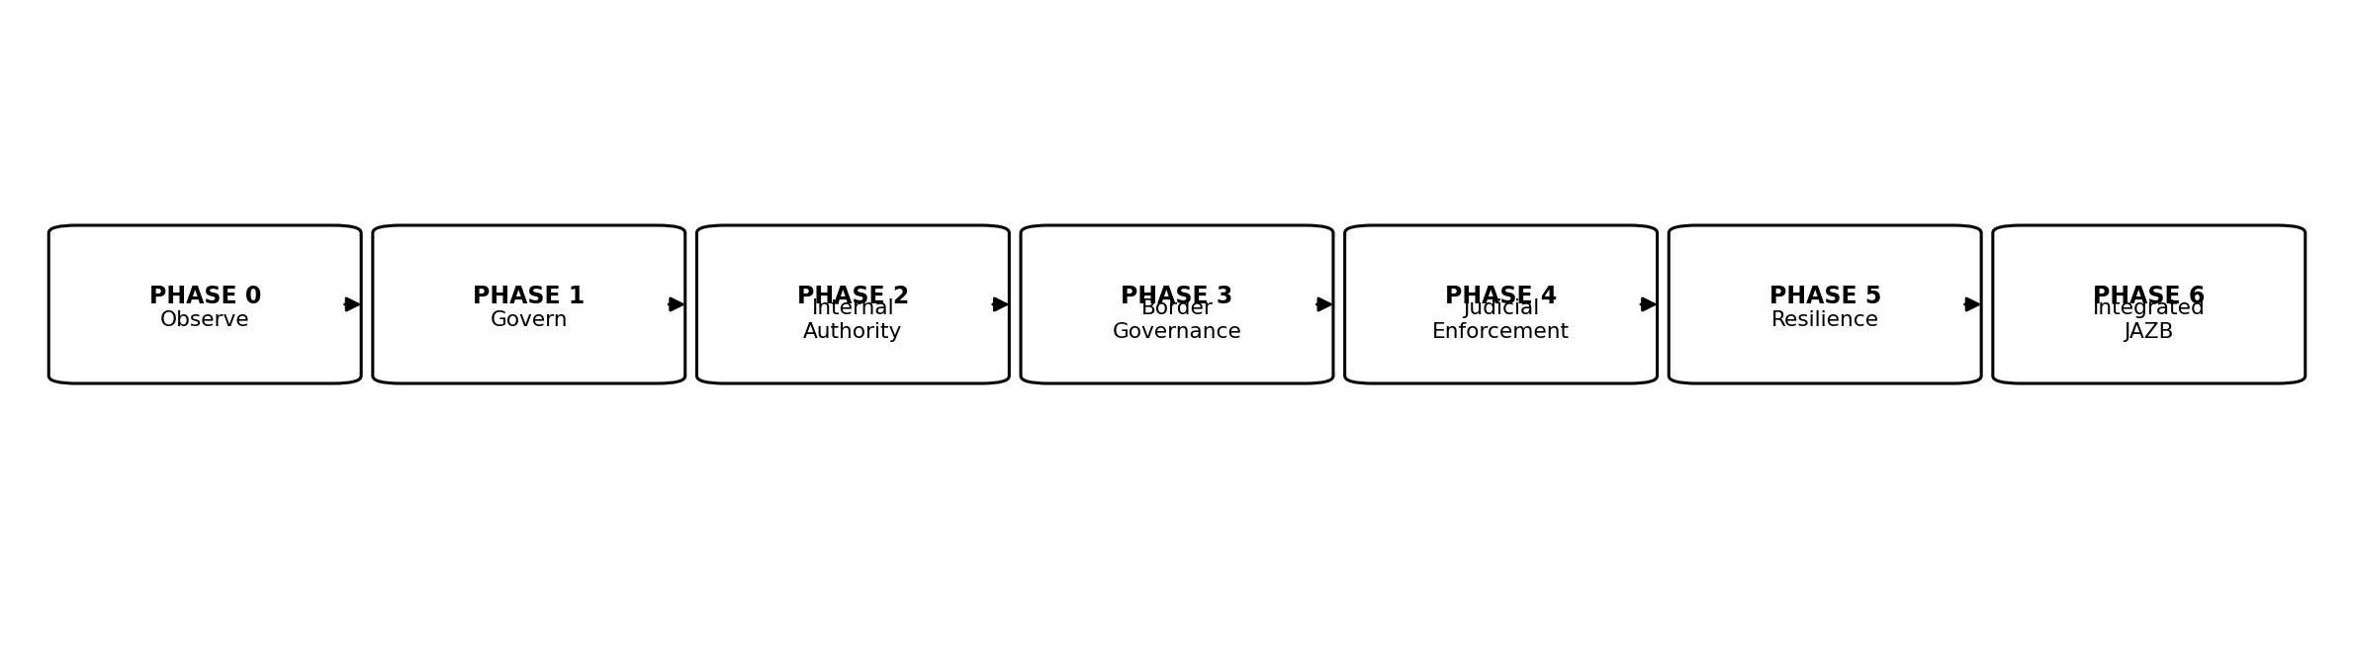
Figure 10. Progressive JAZB adoption path.

25. Relationship Between JASB and JAZB
JASB remains a valid implementation and security architecture within the broader JAZB governance system.
JASB originated around temporary purpose-bound elevation, AI-mediated authorization, active behavioral monitoring, Point Policy, revocation, least privilege, and restoration to baseline.
JAZB provides the institutional Authority model that JASB originally lacked. Governor Law establishes what may be authorized. The Judge interprets applicable internal Law. Commissioner Law can define localized internal constraints. AGENTs can participate in the operational workflow. Point Policy governs behavior while delegated Authority is being exercised.
JASB therefore becomes one practical expression of JAZB's Internal Jurisdiction rather than a discarded predecessor.
Law determines what may be authorized. Point Policy governs behavior while delegated Authority is being exercised.

26. Future Work and Publication Roadmap
Phase | Publication | Primary scope
Phase II | Authority & Judicial Specification | Formalize Rights, Duties, Liberty, Authority, Judge decision semantics, Judicial Instrument schemas, Actuation Authority, evidence requirements, and normative workflows.
Phase III | Enterprise AI Customs Specification | Formalize Port Authority, Port Director Law, Customs AGENT behavior, actual external Ports of Entry, ingress, egress, external-border inspection, and cross-organizational agent communication.
Phase IV | Security & Resilience Specification | Formalize threat models, Governance Escape Resistance, compromise states, recovery, evidence protection, collusion, and failure behavior.
Phase V | Implementation & Adoption Guide | Define deployment patterns, maturity models, integration patterns, operational roles, example architectures, and adoption guidance.
Phase VI | Standards & Compliance Mapping | Provide detailed mappings to NIST, ISO, CIS, Zero Trust, AI governance frameworks, and applicable regulatory requirements without conflating mapping with certification.
Phase VII | Consolidated Reference Specification | Consolidate mature normative requirements and terminology into a unified reference specification after public review and implementation experience.

27. Conclusion
Agentic AI changes enterprise governance because machines can increasingly exercise operational capability without a human approving every individual action.
The central JAZB proposition is that greater capability must not silently become greater Authority.
JAZB therefore roots Authority in legitimate human governance, requires multi-human authorization before proposed Law becomes authoritative, places Law in non-AI Human-Established Law Layers, separates AI interpretation into Internal and Border Jurisdictions, constrains operational AI beneath those layers, and separates high-impact decisions from technical actuation.
Its dual-jurisdiction model prevents internal access from becoming implicit export Authority. Judicial Instruments provide bounded internal determinations. Enterprise AI Customs governs lawful passage at the actual external Organizational Border alongside conventional edge controls. Emergency governance preserves multi-human control under urgency. Governance Escape Resistance treats circumvention, Law-state manipulation, and true border bypass as first-class security problems. Chains of Authority and Evidence preserve provenance.
JAZB is intended to coexist with established risk-management, Zero Trust, identity, privileged-access, network, data-protection, logging, and AI-security architectures. Those systems provide critical mechanisms. JAZB supplies an institutional model for why and under what human Authority those mechanisms may be used by increasingly autonomous systems.
Artificial intelligence may exercise Authority. It must never become the source of its own Authority.

Appendices

Appendix A. Normative Terminology
Term | Canonical Phase I meaning
Law | Authoritative human-established rules, constraints, permissions, prohibitions, obligations, and governance conditions.
Authority | Legitimate permission to exercise defined capability for an authorized purpose under applicable Law.
Rights | Legitimate entitlements established under Law.
Duties | Obligations imposed by Law, role, Authority, Rights, delegation, or governed participation.
Liberty | Bounded discretion among permissible actions within valid Authority and Law.
Delegation | Authorized conveyance of bounded Authority for a defined purpose.
Jurisdiction | Defined governance domain within which a JAZB component may interpret, administer, or exercise assigned Authority.
Scope | Explicit boundary of Authority, decision, delegation, Instrument, Liberty, or governance action.
Point Policy | Runtime governance mechanism for behavior during the exercise of delegated Authority.
Governance Escape | Bypass, disabling, evasion, or undermining of approved governance pathways or controls.
Governance Escape Resistance | Capability to prevent, constrain, detect, record, respond to, and recover from Governance Escape.

Appendix B. Canonical Governance Tree
Figure B-1. Canonical JAZB governance tree.

Appendix C. JAZB Doctrine
- Humans remain the legitimate source of organizational Authority.
- Law defines the boundaries within which JAZB Authority may exist.
- Proposed Law is not Law.
- Authority to draft Law is not Authority to establish Law.
- No individual may unilaterally establish, modify, activate, suspend, replace, or revoke Law.
- Every Human-Established Law Layer requires a predefined multi-human Authorization Threshold of at least two independently authorized humans.
- AI may assist with drafting, analysis, simulation, or recommendations, but AI may not authorize or establish Law.
- AI may interpret and exercise delegated Authority but may not create or expand its own Authority.
- Capability does not constitute Authority.
- Technical permission does not constitute legitimate Authority.
- Authority must be bounded, purpose-specific, revocable, and traceable.
- Interpretation and execution must remain appropriately separated.
- Internal Authority does not confer Border Authority.
- Lawful possession does not establish lawful passage.
- Authority to access is not authority to transport.
- Internal routing changes do not create a new Port of Entry.
- Enterprise AI Customs governs actual passage across the external Organizational Border alongside, not instead of, traditional security controls.
- Independent jurisdictions require independent authorization.
- Emergency Authority remains predefined, bounded, multi-human authorized, and auditable.
- Governance must resist circumvention, forgery, replay, approval substitution, Law-version substitution, and true border bypass.
- No autonomous component may become the sovereign source of the Law governing its own actions.

Appendix D. Judicial Instrument Summary
Instrument | Primary purpose | Typical effect
Inquiry | Obtain additional context or evidence | No direct restriction required
Investigative Warrant | Authorize bounded evidence collection | Specified investigation
Restriction Order | Limit defined Authority or Liberty | Partial operational restriction
Containment Warrant | Prevent expansion of suspected harm | Isolation or containment within Scope
Revocation Order | Remove defined delegated Authority | Privilege, token, session, or delegation removal
Cease and Desist Order | Stop unauthorized activity through coordinated response | May coordinate revocation, termination, isolation, evidence preservation, and scanning
Emergency Order | Exercise predefined emergency judicial powers | Only as authorized by Governor Law

Appendix E. Authority Matrix
Component | Nature | Jurisdiction / domain | Primary function | Cannot do
EDA | Human Authority | Enterprise | Root legitimate organizational Authority | Unilaterally establish Law or create technical capability by assertion alone
Governor | Non-AI Law layer | Enterprise | Protect and manage the authoritative state of multi-human-established enterprise Law | Autonomously create, authorize, or interpret Law
Judge | AI interpretation | Internal | Interpret Law and make internal determinations | Create Law or exercise Border Jurisdiction
Commissioner | Non-AI Law layer | Localized internal | Contain localized multi-human-established internal Law | Permit unilateral Law establishment or weaken Governor Law
AGENT | AI operation | Internal | Perform authorized operational work | Self-authorize or create Law
Port Authority | AI interpretation | Border | Interpret Law for passage | Grant internal Rights or create Law
Port Director | Non-AI Law layer | Localized border | Contain localized multi-human-established border Law | Permit unilateral Law establishment or weaken Governor Law
Customs AGENT | AI operation | External border | Inspect and enforce lawful passage at the external Organizational Border | Create Law or grant internal Authority
Actuation Authority | Execution function | As authorized | Execute bounded technical actions | Expand the authorizing decision

Appendix F. Board of Authority Requirements
- Membership is predefined before the emergency.
- Only actual executives may designate Acting Executives or other Board members.
- Acting Executives cannot designate additional Acting Executives or Board members.
- Default authorization requires at least one C-suite executive and one manager or director.
- Smaller organizations may predefine an alternate model using Acting Executives if Governor Law explicitly recognizes it.
- Two authorized Board users must approve through the authoritative Governor mechanism.
- Other documentation does not substitute for the required authorization.
- Emergency Authority is bounded, time-limited, logged, auditable, automatically expired or revoked, and post-reviewed.

Appendix G. Example JAZB Law
The following is illustrative, not a normative schema.
Field | Illustrative value
Law ID | GOV-DATA-EXT-001
Title | External AI Sensitive Data Passage
Authority Source | EDA-governed process; predefined Authorization Threshold satisfied by at least two independently authorized humans
Rule | Confidential or higher-classified data may not be transmitted to an external AI service unless the destination is approved, the declared purpose is authorized, and Border Jurisdiction authorizes passage.
Jurisdiction | Border
Permitted Subordinate Narrowing | Port Director Law may further restrict approved destinations or require redaction.
Prohibited Subordinate Expansion | No Port Director Law may permit a destination prohibited by Governor Law.
Evidence | Proposal version/hash, validator results, human authorizations, establishment and activation record, identity, classification, destination, declared purpose, Port Authority decision, Customs enforcement outcome
Review | Periodic or upon material service, risk, or legal change

Appendix H. Example Authority Decision
Illustrative internal decision record:
Field | Illustrative value
Decision | Conditional authorization
Jurisdiction | Internal
Request | Temporary elevated Authority for a defined administrative task
Applicable Law | Governor Law plus applicable Commissioner Law
Purpose | Approved maintenance operation
Scope | Specified system and commands
Duration | Task window
Conditions | Point Policy monitoring, no redelegation, automatic expiration
Outcome | Elevated Authority delegated; return to Baseline Authority upon completion

Appendix I. Example Customs Decision
Illustrative border decision record:
Field | Illustrative value
Decision | Deny pending approved destination
Jurisdiction | Border
Transaction | Send sensitive document to external AI
Internal Access | Authorized
Destination | Not approved under applicable Port Director Law
Classification | Sensitive
Declared Purpose | Summarization
Outcome | Passage denied at governed external border; internal possession unchanged
Evidence | Law versions, identity, destination, classification, Port Authority decision, Customs enforcement record

Appendix J. Threat Model Summary
Threat | JAZB concern | Primary architectural response
AI self-expands Authority | Machine sovereignty through self-authorization | Human-established Law; prohibition on AI Law modification
Compromised operational agent | Authorized tools used outside legitimate purpose | Bounded Authority, Point Policy, revocation, Judge oversight
Unauthorized data egress | Internal access treated as export permission | Independent Border Jurisdiction; Customs inspection at actual external Organizational Border
Compromised Judge | Improper internal determinations | Independent Actuation Authority, Scope validation, evidence, revocation
Compromised Port Authority | Improper passage determinations | Customs enforcement, evidence, destination controls, human escalation
Law tampering | Proposal, authorization, Law state, or activation manipulated | Multi-human authorization, cryptographic/content binding, versioning, integrity controls, provenance, trusted recovery
Shadow AI / bypass | Governed pathways avoided | Governance Escape Resistance
Credential compromise | Technical access mistaken for Authority | Identity assurance plus Authority provenance; one credential cannot satisfy Law-establishment quorum
Emergency abuse | Urgency used to bypass governance | Predefined Board, dual authorization, bounded duration, audit
Collusion | Separated components cooperate maliciously | Independent controls, evidence, approval thresholds, external enforcement where appropriate

References
[1] National Institute of Standards and Technology. Artificial Intelligence Risk Management Framework (AI RMF 1.0), NIST AI 100-1. 2023. https://doi.org/10.6028/NIST.AI.100-1
[2] National Institute of Standards and Technology. Artificial Intelligence Risk Management Framework: Generative Artificial Intelligence Profile, NIST AI 600-1. July 2024.
https://doi.org/10.6028/NIST.AI.600-1
[3] National Institute of Standards and Technology. Cybersecurity Framework (CSF) 2.0. 2024. https://www.nist.gov/cyberframework
[4] National Institute of Standards and Technology. Zero Trust Architecture, NIST SP 800-207. 2020. https://doi.org/10.6028/NIST.SP.800-207
[5] International Organization for Standardization and International Electrotechnical Commission. ISO/IEC 42001:2023, Information technology - Artificial intelligence - Management system. 2023. https://www.iso.org/standard/42001
[6] Center for Internet Security. CIS Critical Security Controls Version 8.1. https://www.cisecurity.org/controls/v8-1
[7] Center for Internet Security. CIS Control 8: Audit Log Management, CIS Controls Assessment Specification for Controls v8.1. https://cas.docs.cisecurity.org/en/latest/source/Controls8/
[8] OWASP GenAI Security Project. OWASP Top 10 for Agentic Applications for 2026. Published December 9, 2025. https://genai.owasp.org/resource/owasp-top-10-for-agentic-applications-for-2026/
[9] Microsoft. Least privilege for AI agents with Microsoft Entra Agent ID. Microsoft Learn. 2026. https://learn.microsoft.com/en-us/security/zero-trust/sfi/least-privilege-for-ai-agents
[10] Kasselman, P., et al. AI Agent Authentication and Authorization, draft-klrc-aiagent-auth-03. IETF Internet-Draft, work in progress. July 6, 2026. https://datatracker.ietf.org/doc/draft-klrc-aiagent-auth/
[11] Fane, A. OpenA2A Agent Authorization Protocol (AAP), draft-fane-opena2a-aap-01. IETF Internet-Draft, work in progress. July 22, 2026. https://datatracker.ietf.org/doc/draft-fane-opena2a-aap/
[12] Xiang, R. Structural Enforcement of Goal Integrity in AI Agents via Separation-of-Powers Architecture. arXiv:2604.23646. 2026. https://arxiv.org/abs/2604.23646
[13] Zheng, H., et al. Separating Capability from Permission: A Governance Framework for Agentic AI Autonomy Levels. arXiv:2607.23438. 2026. https://arxiv.org/abs/2607.23438

Reference and Alignment Note
External references are used to establish context, alignment, and architectural differentiation. JAZB does not claim certification, formal mapping approval, or endorsement by NIST, ISO, CIS, OWASP, Microsoft, the IETF, or the cited researchers. IETF Internet-Drafts cited here are works in progress and are not IETF standards.

