JAZB
Judiciary AI Zero-Trust Broker
An Authority-Centric, Human-Sovereign Governance Architecture for Artificial Intelligence
Phase II: Authority & Judicial Specification
Michael Costner
Author and Publisher
Version 1.0 - Publication
September 2026
jazbframework.org
Authority must remain legitimate from origin through action.

Publication and Copyright Notice
JAZB Framework Publication 2, Phase II: Authority & Judicial Specification extends the foundational architecture defined in JAZB Framework Publication 1, Phase I: Foundational Architecture. It is authored and published by Michael Costner.
This publication is architectural and normative in intent. It defines governance relationships and requirements that implementations may realize through different technologies. It does not prescribe a single product, platform, policy engine, identity system, model, or enforcement technology.
Phase II inherits the Phase I doctrine that AI may interpret Law, operate under Law, and recommend changes to Law, but AI may not establish Law. Proposed Law has no governing effect until the applicable Human-Established Law Layer satisfies its predefined multi-human authorization threshold, is formally established, and is activated according to organizational governance.
JAZB is designed to complement, not replace, established cybersecurity, identity, Zero Trust, risk-management, and AI-governance practices. References to external frameworks are included for context and alignment and do not imply certification, endorsement, or formal conformance.
Copyright © 2026 Michael Costner. All rights reserved.
Publication site: jazbframework.org
DOI: 10.5281/zenodo.22904366

Author's Preface: From Architecture to Authority
Phase I established the institution. It defined where legitimate JAZB Authority originates, how Human-Established Law is separated from AI interpretation and operation, why Internal and Border Jurisdictions remain distinct, and why no individual may unilaterally establish JAZB Law.
Phase II moves inside that institution and specifies how legitimate human governance becomes bounded machine Authority without losing provenance, Scope, purpose, revocability, or accountability.
The central problem is not whether an AI system can perform an action. The problem is whether the action is legitimate under established Law, whether the actor possesses the Authority to perform it, whether that Authority was validly delegated, and whether execution remains constrained by the decision that authorized it.
This specification therefore treats the Law Establishment Lifecycle as a prerequisite to judicial interpretation. A single authorized person may draft, edit, or submit proposed Law when granted the Rights to do so. Drafting is not establishment. Proposed, validated, or pending Law does not become authoritative until the predefined authorization threshold is satisfied by no fewer than two independently authorized humans and the Law is formally established and activated.
The Judge never closes that gap on behalf of humans. The Judge interprets applicable established Law, makes bounded determinations, issues Judicial Instruments when Law permits, and may recommend changes. A recommendation can become a proposal, but it cannot become Law through AI action.
Rights, Duties, Liberty, Authority, Delegation, Baseline and Elevated Authority, Point Policy, Judicial Instruments, Actuation Authority, Chain of Authority, and Chain of Evidence must therefore operate as one coherent governance system.
The separation between interpretation and actuation remains deliberate. The Judge determines what the Law permits or requires. Independent Actuation Authority validates the authorizing chain and executes only the bounded technical effects that were actually authorized.
Phase II is intended to make the path from legitimate human governance to machine action explicit, reviewable, revocable, and resistant to substitution, forgery, replay, self-authorization, and Authority laundering.
Phase I asked who governs. Phase II specifies how established Law becomes a bounded decision, how that decision becomes technical action, and how the Organization can prove why the action was legitimate.

Abstract
JAZB Phase II formalizes the Authority and judicial mechanics of the Judiciary AI Zero-Trust Broker within Internal Jurisdiction. Building on the human-sovereign architecture established in Phase I, it specifies the relationships among Rights, Duties, Liberty, Authority, Delegation, Scope, Baseline Authority, Elevated Authority, Point Policy, Judge decisions, Judicial Instruments, independent Actuation Authority, Chains of Authority and Evidence, and failure handling. Phase II also makes the Law Establishment Lifecycle an explicit decision prerequisite: the Judge may interpret only applicable Law that has satisfied the Organization's predefined multi-human authorization threshold, been formally established, and become active. Technical permission, credentials, model capability, drafts, proposals, recommendations, or single-person approval cannot substitute for legitimate Authority. The resulting model permits consequential AI operation while preserving human sovereignty, separation of duties, revocability, provenance, and bounded execution.

Keywords
AI Authority; AI Governance; Agentic AI; Judicial AI; Human Sovereignty; Human-Established Law; Multi-Human Authorization; Law Establishment; Delegated Authority; Least Privilege; Just-in-Time Access; Judicial Instruments; Actuation Authority; Point Policy; Chain of Authority; Chain of Evidence; Zero Trust

Table of Contents
1. Purpose and Scope 10
1.1 Objectives 10
1.2 In Scope 10
1.3 Out of Scope 10
1.4 Architectural Invariants 10
2. Normative Language and Conformance 11
2.1 MUST and MUST NOT 11
2.2 SHOULD and SHOULD NOT 11
2.3 MAY 11
2.4 Conformance Principle 11
3. Phase II Authority Model 11
3.1 Authority Tuple 12
3.2 No Permission Equivalence 12
3.3 Purpose Binding 12
3.4 Scope Binding 12
3.5 Temporal Binding 12
3.6 Established-Law Gate 12
3.7 Law Authorization Provenance 12
3.8 Drafting Is Not Establishment 12
3.9 Active-Version Binding 13
4. Rights 13
4.1 Rights versus Permissions 13
4.2 Conditional Rights 13
4.3 Rights and Requests 13
4.4 Rights Revocation 13
5. Duties 14
5.1 Duty of Purpose 14
5.2 Duty of Scope 14
5.3 Duty of Evidence 14
5.4 Duty to Cease 14
5.5 Duty to Escalate 14
6. Liberty 14
6.1 Liberty Is Not Authority 14
6.2 Method Selection 14
6.3 Liberty Constraints 14
6.4 Autonomous Operation 14
7. Authority 15
7.1 Sources of Authority 15
7.2 Direct and Delegated Authority 15
7.3 Machine Authority 15
7.4 Conditional Authority 15
7.5 Revocability 15
7.6 Non-Inheritance 15
7.7 Governance Authority Is Distinct 15
7.8 Access Does Not Confer Law-Establishment Authority 15
8. Delegation 16
8.1 Delegation Preconditions 16
8.2 Delegation Record 16
8.3 No Authority Amplification 16
8.4 Redelegation 16
8.5 Cascade Revocation 16
8.6 Delegation Acceptance 16
9. Baseline and Elevated Authority 16
9.1 Baseline Authority 17
9.2 Elevated Authority 17
9.3 Just-in-Time Elevation 17
9.4 Restoration 17
9.5 Overlapping Delegations 17
10. Point Policy 17
10.1 Relationship to Law 17
10.2 Inputs 17
10.3 Outcomes 17
10.4 No Legislative Effect 17
10.5 Evidence 18
11. The Judge 18
11.1 Inputs to Interpretation 18
11.2 Law Resolution 18
11.3 No Law Creation 18
11.4 No Jurisdiction Expansion 18
11.5 Recommendations 18
11.6 Explainability 18
11.7 Uncertainty 19
11.8 Unestablished-Law Rejection 19
12. Judicial Decision Semantics 19
12.1 AUTHORIZE 19
12.2 DENY 19
12.3 CONDITIONALLY AUTHORIZE 19
12.4 REQUIRE EVIDENCE 19
12.5 ESCALATE 19
12.6 ISSUE INSTRUMENT 19
12.7 Decision Finality 19
12.8 Decision Record 20
13. Judicial Instruments 20
13.1 Common Required Elements 20
13.2 Authenticity and Integrity 20
13.3 Bounded Actuation 20
13.4 No New Law 20
13.5 No Automatic Unrestricted Capability 21
13.6 Expiration 21
14. Inquiry 21
14.1 Appropriate Use 21
14.2 Scope 21
14.3 Effect 21
14.4 Completion 21
15. Investigative Warrant 22
15.1 Preconditions 22
15.2 Collection Boundary 22
15.3 Minimization 22
15.4 Preservation 22
15.5 Expiration 22
16. Restriction Order 22
16.1 Uses 22
16.2 Least Restrictive Effective Scope 22
16.3 Enforcement 22
16.4 Restoration 22
17. Containment Warrant 23
17.1 Trigger 23
17.2 Effects 23
17.3 Evidence Preservation 23
17.4 Duration 23
18. Revocation Order 23
18.1 Scope 23
18.2 Technical Effects 23
18.3 Dependent Delegations 23
18.4 Baseline Restoration 23
19. Cease and Desist Order 23
19.1 Coordinated Effects 24
19.2 Independence of Actuation 24
19.3 Scope 24
19.4 Restoration 24
20. Emergency Order 24
20.1 No Emergency Legislation 24
20.2 Relationship to Board of Authority 24
20.3 Scope and Time 24
20.4 Expiration 25
21. Actuation Authority 25
21.1 Separation from the Judge 25
21.2 Validation Before Execution 25
21.3 Least Technical Capability 25
21.4 No Decision Expansion 25
21.5 Partial Failure 26
21.6 Idempotence and Replay 26
21.7 Verification 26
21.8 Rollback 26
21.9 Evidence 26
22. Chain of Authority 26
22.1 Required Linkage 26
22.2 Law Version and Establishment Provenance 27
22.3 Delegation Provenance 27
22.4 Instrument Provenance 27
22.5 Actuation Provenance 27
22.6 Broken Chain 27
23. Chain of Evidence 27
23.1 Evidence References 27
23.2 Integrity 27
23.3 Time 27
23.4 Collection Minimization 27
23.5 Retention 28
23.6 Explainability Record 28
24. Conflict, Ambiguity, and Failure Handling 28
24.1 Conflicting Law 28
24.2 Ambiguous Scope 28
24.3 Stale, Superseded, or Unestablished Law 28
24.4 Law Authorization-Provenance Failure 28
24.5 Missing Evidence 28
24.6 Judge Unavailability 28
24.7 Actuation Unavailability 29
24.8 Revocation Failure 29
24.9 Evidence Failure 29
25. Normative Internal Workflows 29
25.1 Routine Baseline Action 29
25.2 Elevated Authority Request 29
25.3 Restriction Workflow 29
25.4 Revocation Workflow 29
25.5 Investigation Workflow 29
25.6 Containment Workflow 30
25.7 Cease and Desist Workflow 30
25.8 Emergency Judicial Workflow 30
25.9 Established-Law Transition Workflow 30
26. Security and Abuse Considerations 30
26.1 Judge Compromise 30
26.2 Instrument Forgery 30
26.3 Replay 31
26.4 Confused Deputy 31
26.5 Delegation Laundering 31
26.6 Evidence Tampering 31
26.7 Prompt and Goal Manipulation 31
26.8 Governance Escape 31
26.9 Law-State Substitution 31
26.10 Authorization-Provenance Forgery 31
26.11 Single-Member Capture 31
26.12 Sovereign Quorum Capture 32
27. Alignment with Existing Frameworks and Mechanisms 32
27.1 NIST AI RMF 32
27.2 NIST Zero Trust Architecture 32
27.3 Least Privilege and JIT 32
27.4 OWASP Agentic Security 32
27.5 Emerging Agent Authorization Protocols 32
27.6 Gap Addressed by Phase II 33
28. Phase II Conformance Model 33
28.1 Required Architectural Properties 33
28.2 Required Decision Properties 34
28.3 Required Instrument Properties 34
28.4 Required Actuation Properties 34
28.5 Recommended Properties 34
28.6 Conformance Claim 34
29. Relationship to JASB 34
29.1 JASB Runtime Model 34
29.2 JAZB Phase II Generalization 34
29.3 Preservation of Point Policy 34
30. Phase III Boundary 35
30.1 Deferred Topics 35
30.2 Cross-Jurisdiction Reminder 35
30.3 Internal Trust Boundaries Are Not Ports 35
31. Conclusion 35
Appendices 36
Appendix A. Normative Authority Record 36
Appendix B. Judge Decision Record 36
Appendix C. Judicial Instrument Minimum Schema 37
Appendix D. Judicial Instrument Matrix 38
Appendix E. Decision-State Matrix 38
Appendix F. Delegation Validation Checklist 38
Appendix G. Actuation Validation Checklist 39
Appendix H. Example Elevated Authority Workflow 39
Appendix I. Example Cease and Desist Workflow 40
Appendix J. Phase II Conformance Checklist 40
Appendix K. Established-Law Validation Checklist 41
References 41
Reference and Alignment Note 42

1. Purpose and Scope
Phase II specifies how Authority is represented, interpreted, delegated, exercised, restricted, revoked, actuated, and evidenced within JAZB Internal Jurisdiction. It also defines the established-Law gate that must be satisfied before the Judge may use a Law record as an authoritative basis for a material decision.
It does not redesign the Phase I governance hierarchy. The EDA remains the highest active human Authority within JAZB. The Governor and Commissioner remain non-AI Human-Established Law Layers. The Judge remains the AI interpretation and decision layer for Internal Jurisdiction. AGENT remains the operational AI layer. Actuation Authority remains separate from judicial determination. No AI component may establish Law or satisfy a human Law-authorization threshold.
Phase II is intentionally narrower than a complete implementation standard. It defines the semantics and required governance relationships that implementations must preserve while allowing technology-specific mechanisms to vary.

1.1 Objectives
Define the Authority model with sufficient precision for consistent implementation; formalize Judge decisions and Judicial Instruments; define delegation, expiration, revocation, and restoration; define independent actuation; preserve Authority and evidence provenance; enforce established-Law prerequisites; and establish normative internal workflows that remain subordinate to legitimate human governance.

1.2 In Scope
Rights, Duties, Liberty, Authority, Scope, Delegation, Baseline Authority, Elevated Authority, Point Policy, Judge interpretation, decision states, Judicial Instruments, Actuation Authority, Chains of Authority and Evidence, conflict handling, internal workflows, and conformance.

1.3 Out of Scope
Enterprise AI Customs and detailed Border Jurisdiction mechanics are reserved for Phase III. Phase II does not prescribe a specific programming language, policy language, token format, database, cryptographic suite, identity provider, PAM platform, EDR product, SIEM, or AI model.

1.4 Architectural Invariants
No requirement in Phase II may be interpreted to convert the Governor or Commissioner into AI actors; treat Draft, Proposed, Validated, or otherwise unestablished content as authoritative Law; allow one individual to unilaterally establish, modify, activate, or revoke Law; allow the Judge to create Law; allow an AGENT to self-authorize; allow Actuation Authority to enlarge the decision it executes; or allow Internal Jurisdiction to confer Border Authority.
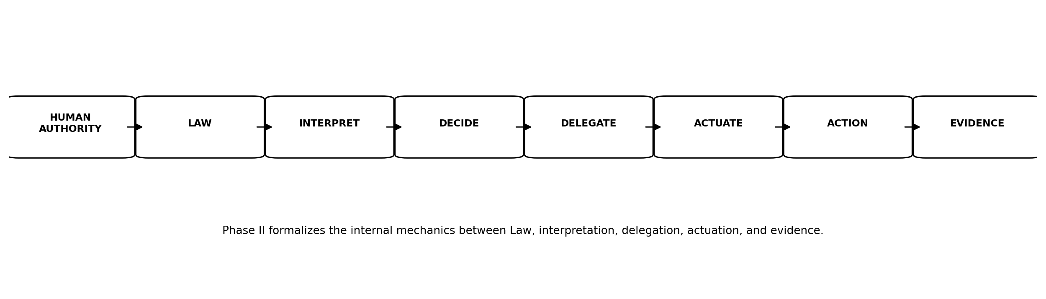
Figure 1. Phase II formalization boundary within the JAZB Chain of Authority.

2. Normative Language and Conformance
The key words MUST, MUST NOT, REQUIRED, SHALL, SHALL NOT, SHOULD, SHOULD NOT, RECOMMENDED, MAY, and OPTIONAL are used in this publication to distinguish mandatory architectural requirements from recommended or optional implementation behavior.
Conformance is architectural. An implementation may use different technical mechanisms while remaining conformant if it preserves the required Authority relationships, separation of powers, provenance, Scope, revocation, and evidence semantics.

2.1 MUST and MUST NOT
MUST and MUST NOT identify requirements necessary to preserve the Phase II governance model.

2.2 SHOULD and SHOULD NOT
SHOULD and SHOULD NOT identify strong recommendations that may be varied when an implementation has a documented reason and preserves the underlying governance objective.

2.3 MAY
MAY identifies an optional mechanism or behavior.

2.4 Conformance Principle
A technical feature is not conformant merely because it uses JAZB terminology. Conformance depends on preserving the Authority model and its required controls.

3. Phase II Authority Model
Phase II treats Authority as a governed relationship rather than a permission bit. Authority exists only when legitimate human provenance, applicable established Law, purpose, Scope, jurisdiction, identity, conditions, and evidence are sufficient for the action being considered. A valid credential or system permission may enable an action technically while still failing the JAZB Authority test.
Rights, Duties, and Liberty describe different dimensions of the legal and operational space in which Authority may be exercised. Delegation conveys bounded Authority. Point Policy governs behavior during its exercise. Revocation and expiration terminate it.

3.1 Authority Tuple
A conformant implementation SHOULD be able to represent, directly or through equivalent linked records, the subject, source, purpose, Scope, jurisdiction, permitted actions, affected resources, conditions, effective time, expiration, delegation rights, applicable established Law, Law version, Law-establishment provenance, Point Policy where applicable, and Chain of Authority references.

3.2 No Permission Equivalence
A role assignment, token, credential, ACL entry, API key, network path, or administrative capability MUST NOT by itself be treated as proof of legitimate JAZB Authority.

3.3 Purpose Binding
Authority granted for one purpose MUST NOT silently become Authority for a materially different purpose.

3.4 Scope Binding
Authority MUST be no broader than the Scope legitimately authorized.

3.5 Temporal Binding
Temporary Authority MUST have an effective period or an objectively determinable terminating condition.

3.6 Established-Law Gate
Before the Judge uses a Law record as the authoritative basis for a material decision, the implementation MUST verify that the record is in an authoritative state defined by the Organization, has satisfied the applicable multi-human authorization threshold, has been formally established, and is effective for the decision being made. Draft, Proposed, Validated, rejected, expired, revoked, or superseded Law MUST NOT silently become a source of Authority.

3.7 Law Authorization Provenance
Material Law used by the Judge SHOULD be linkable to the exact Law version or hash, the Human-Established Law Layer in which it resides, the identities or authorization records of the independently authorized humans who satisfied the required threshold, the establishment event, the activation state, and any later supersession or revocation.

3.8 Drafting Is Not Establishment
Authority to access a Governor or Commissioner interface, draft language, edit a proposal, submit a proposal, or participate in review does not constitute Authority to establish Law. A single authorized human MAY perform drafting activities when permitted, but no Law becomes authoritative through that individual alone. Each Human-Established Law Layer MUST enforce its predefined authorization threshold, which SHALL NOT be fewer than two independently authorized humans.

3.9 Active-Version Binding
A material decision MUST bind to the applicable active Law version. If the governing Law changes materially before execution, renewal, or continued exercise of Authority, the implementation SHOULD reevaluate the affected decision or delegation according to Law rather than assume the previous decision remains valid.
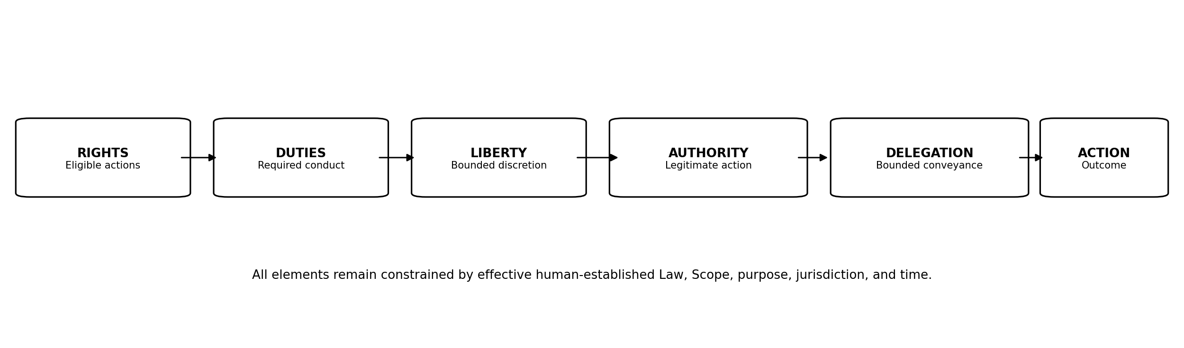
Figure 2. Phase II Authority model: established Law constrains Rights, Duties, Liberty, Authority, Delegation, and action throughout the internal governance lifecycle.

4. Rights
Rights are legitimate entitlements recognized under established Law. A Right may permit an actor to request, receive, access, retain, or exercise a defined action or resource, but a Right does not remove applicable Duties, Scope, conditions, Authority requirements, or jurisdictional boundaries.

4.1 Rights versus Permissions
Rights are governance concepts. Technical permissions are implementation mechanisms. A Right may exist before a technical permission is provisioned, and a technical permission may exist without a legitimate Right.

4.2 Conditional Rights
Rights MAY be conditioned by identity, role, resource, purpose, jurisdiction, Law, time, risk state, or other legitimate governance conditions. A draft or proposal cannot create a Right until it becomes established Law or a valid delegation derives from established Law.

4.3 Rights and Requests
Possessing a Right to request an action does not necessarily create Authority to perform the action.

4.4 Rights Revocation
Where Law permits, Rights may be suspended or revoked through legitimate human-established Law or a bounded judicial determination.

5. Duties
Duties are obligations attached to participation, role, Authority, Rights, delegation, or a governed process. Duties constrain how legitimate Authority is exercised.

5.1 Duty of Purpose
An actor exercising delegated Authority MUST remain within the authorized purpose.

5.2 Duty of Scope
An actor MUST NOT intentionally exceed the Scope of its delegated Authority.

5.3 Duty of Evidence
Where Law requires evidence, the actor and supporting systems MUST preserve the records necessary to reconstruct the governed action.

5.4 Duty to Cease
When Authority expires or is revoked, the actor MUST cease actions dependent on that Authority.

5.5 Duty to Escalate
Where applicable Law requires human or judicial escalation, an actor MUST NOT substitute self-authorization for escalation.

6. Liberty
Liberty is bounded discretion within valid Authority and Law. It permits autonomous systems to choose among permissible methods without requiring human approval for every step.

6.1 Liberty Is Not Authority
Liberty describes discretion inside Authority. It does not enlarge Authority.

6.2 Method Selection
An AGENT MAY select among permitted tools, sequences, or methods when Law and delegated Authority provide that Liberty.

6.3 Liberty Constraints
Law, Point Policy, resource restrictions, risk conditions, time, and Judicial Instruments MAY narrow Liberty without eliminating all underlying Authority.

6.4 Autonomous Operation
JAZB permits meaningful autonomy when the space of legitimate discretion is bounded and observable.

7. Authority
Authority is legitimate permission to exercise defined capability for an authorized purpose under applicable established Law. It is distinct from capability, credential possession, technical permission, or access to a governance interface.

7.1 Sources of Authority
Authority MUST be traceable to legitimate human Authority, applicable established Law, and any valid delegation or decision required by that Law.

7.2 Direct and Delegated Authority
Authority may be directly assigned under Law or delegated through a valid governance process.

7.3 Machine Authority
Machine Authority is always derived. Intelligence, capability, technical ownership, or operational importance MUST NOT be treated as an originating source of Authority.

7.4 Conditional Authority
Authority MAY depend on continuing conditions. If a required condition ceases to be true, the implementation MUST reevaluate, restrict, suspend, or revoke the affected Authority according to Law.

7.5 Revocability
Delegated machine Authority MUST be revocable.

7.6 Non-Inheritance
Authority MUST NOT be inherited merely through identity association, workflow participation, shared credentials, agent relationship, tool invocation, or organizational affiliation.

7.7 Governance Authority Is Distinct
Authority to draft, validate, authorize, establish, activate, modify, or revoke Law is governance Authority. It is distinct from ordinary operational Authority and MUST remain human-controlled. No AI component may cast a human authorization, satisfy a human quorum, or convert machine approval into human Law-establishment Authority.

7.8 Access Does Not Confer Law-Establishment Authority
Possession of credentials, administrative access, interface access, or technical write permission to a Governor or Commissioner implementation MUST NOT be treated as sufficient Authority to establish Law. The applicable human authorization threshold remains controlling.

8. Delegation
Delegation is the authorized conveyance of bounded Authority from a legitimate source to another actor for a defined purpose. Delegation transfers operational Authority, not sovereignty.

8.1 Delegation Preconditions
The delegator MUST possess the Authority being delegated and MUST be permitted to delegate it.

8.2 Delegation Record
Material delegation SHOULD record source, recipient, purpose, Scope, jurisdiction, actions, resources, effective time, expiration, conditions, redelegation status, Law basis, and provenance.

8.3 No Authority Amplification
A delegate MUST NOT receive broader Authority than the delegator is permitted to convey.

8.4 Redelegation
Redelegation MUST be prohibited unless explicitly permitted. Where permitted, each subsequent delegation MUST remain within the remaining Scope and constraints of the upstream Authority.

8.5 Cascade Revocation
Where a parent delegation is revoked, dependent delegations SHOULD be revoked or invalidated unless Law explicitly defines an independent surviving basis.

8.6 Delegation Acceptance
A receiving actor MAY reject a delegation it cannot safely, lawfully, or technically exercise. Acceptance does not enlarge the delegation.
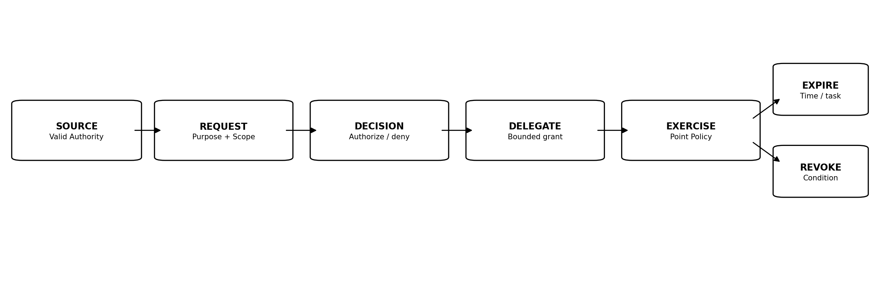
Figure 3. Delegation lifecycle from valid source Authority through expiration or revocation.

9. Baseline and Elevated Authority
Baseline Authority is the ordinary Authority applicable when no temporary, exceptional, or elevated delegation is active. Elevated Authority is temporary or conditional Authority beyond that baseline for a defined purpose.

9.1 Baseline Authority
Baseline Authority SHOULD be the least Authority reasonably necessary for ordinary operation.

9.2 Elevated Authority
Elevated Authority MUST be purpose-bound, scoped, time-limited or condition-limited, attributable, and revocable.

9.3 Just-in-Time Elevation
Implementations SHOULD provision Elevated Authority as close as practical to the time of legitimate need and remove it when the need ends. This aligns with least-privilege and just-in-time access patterns used in modern identity security. [7]

9.4 Restoration
Expiration, completion, or revocation of Elevated Authority MUST return the actor to the applicable Baseline Authority unless another independently valid delegation remains active.

9.5 Overlapping Delegations
Where multiple delegations overlap, removal of one delegation MUST NOT accidentally remove independently valid Authority, and remaining Authority MUST NOT be inferred beyond its own Scope.

10. Point Policy
Point Policy is the JASB-derived runtime governance mechanism used to evaluate behavior while delegated Authority is being exercised.

10.1 Relationship to Law
Law determines what may be authorized. Point Policy governs behavior while delegated Authority is being exercised.

10.2 Inputs
Point Policy MAY evaluate purpose, Scope, commands, resources, sequence, session conditions, time, risk, behavior, tool use, and other runtime context permitted by Law.

10.3 Outcomes
A Point Policy evaluation MAY continue operation, narrow Liberty, require additional evidence, trigger Judge reevaluation, suspend activity, or initiate revocation according to Law.

10.4 No Legislative Effect
Point Policy MUST NOT create superior Law or permanently expand Authority.

10.5 Evidence
Material Point Policy decisions SHOULD be included in the Chain of Evidence when they affect Authority or the outcome of a governed action.
Law determines what may be authorized. Point Policy governs behavior while delegated Authority is being exercised.

11. The Judge
The Judge is the AI interpretation and decision layer for JAZB Internal Jurisdiction. It interprets applicable established Law and makes bounded determinations. It does not create Law, satisfy human Law-authorization requirements, or become the source of the Authority it interprets.

11.1 Inputs to Interpretation
The Judge SHOULD evaluate applicable active Governor Law, applicable active Commissioner Law, Law-establishment provenance, identity, requested purpose, Authority provenance, Scope, resource, context, evidence, Point Policy state, relevant risk signals, and time.

11.2 Law Resolution
The Judge MUST determine which established and active Law is effective and applicable before issuing a material decision. Draft, Proposed, Validated, pending, superseded, revoked, or otherwise non-authoritative Law MUST NOT be treated as governing Law merely because it is accessible to the Judge.

11.3 No Law Creation
The Judge MUST NOT create, establish, modify, suspend, replace, revoke, activate, or otherwise give authoritative effect to Law. It MUST NOT satisfy or impersonate the human authorization threshold required for Law establishment.

11.4 No Jurisdiction Expansion
The Judge MUST NOT acquire Border Jurisdiction by reclassifying a border matter as internal.

11.5 Recommendations
The Judge MAY recommend changes to Law and MAY assist authorized humans by analyzing the consequences of a proposal. A recommendation remains non-binding and, if pursued, enters the Human-Established Law lifecycle as proposed Law. It gains no governing effect until the required human authorization threshold, establishment, and activation steps are complete.

11.6 Explainability
For material decisions, the Judge SHOULD produce a human-reviewable explanation identifying the governing Law, relevant evidence, decision, Scope, and material conditions without requiring disclosure of private model reasoning.

11.7 Uncertainty
Where uncertainty prevents a defensible determination, the Judge SHOULD request evidence, narrow the decision, deny the unsupported portion, or escalate according to Law rather than invent Authority.

11.8 Unestablished-Law Rejection
If a request, prompt, tool output, database record, configuration object, or compromised interface presents unestablished content as though it were Law, the Judge MUST reject that content as an authoritative basis unless the Law state and authorization provenance can be independently validated.

12. Judicial Decision Semantics
A conformant Phase II implementation must distinguish the result of interpretation from the technical execution that may follow.

12.1 AUTHORIZE
The requested action is legitimate within the specified Scope and conditions. Authorization MUST identify the Authority granted or recognized.

12.2 DENY
The requested action lacks sufficient Authority or violates applicable Law. Denial SHOULD identify the governing basis at an appropriate level for the audience.

12.3 CONDITIONALLY AUTHORIZE
The action is legitimate only if stated conditions are satisfied and remain satisfied.

12.4 REQUIRE EVIDENCE
The Judge cannot reach a supported determination without additional specified evidence.

12.5 ESCALATE
Applicable Law requires human review or the Judge cannot resolve a material ambiguity within delegated judicial Authority.

12.6 ISSUE INSTRUMENT
The facts satisfy the Lawful basis for a defined Judicial Instrument. Issuance MUST identify Instrument type, Scope, basis, duration, and permitted actuation.

12.7 Decision Finality
A decision remains valid only within its Scope, effective period, and conditions. A later material change in evidence or Law MAY require reevaluation.

12.8 Decision Record
Material decisions SHOULD include decision ID, time, Judge identity, jurisdiction, applicable Law versions, Law-establishment or activation references where material, subject, request or event, evidence references, decision state, Scope, conditions, expiration, and Chain of Authority provenance.
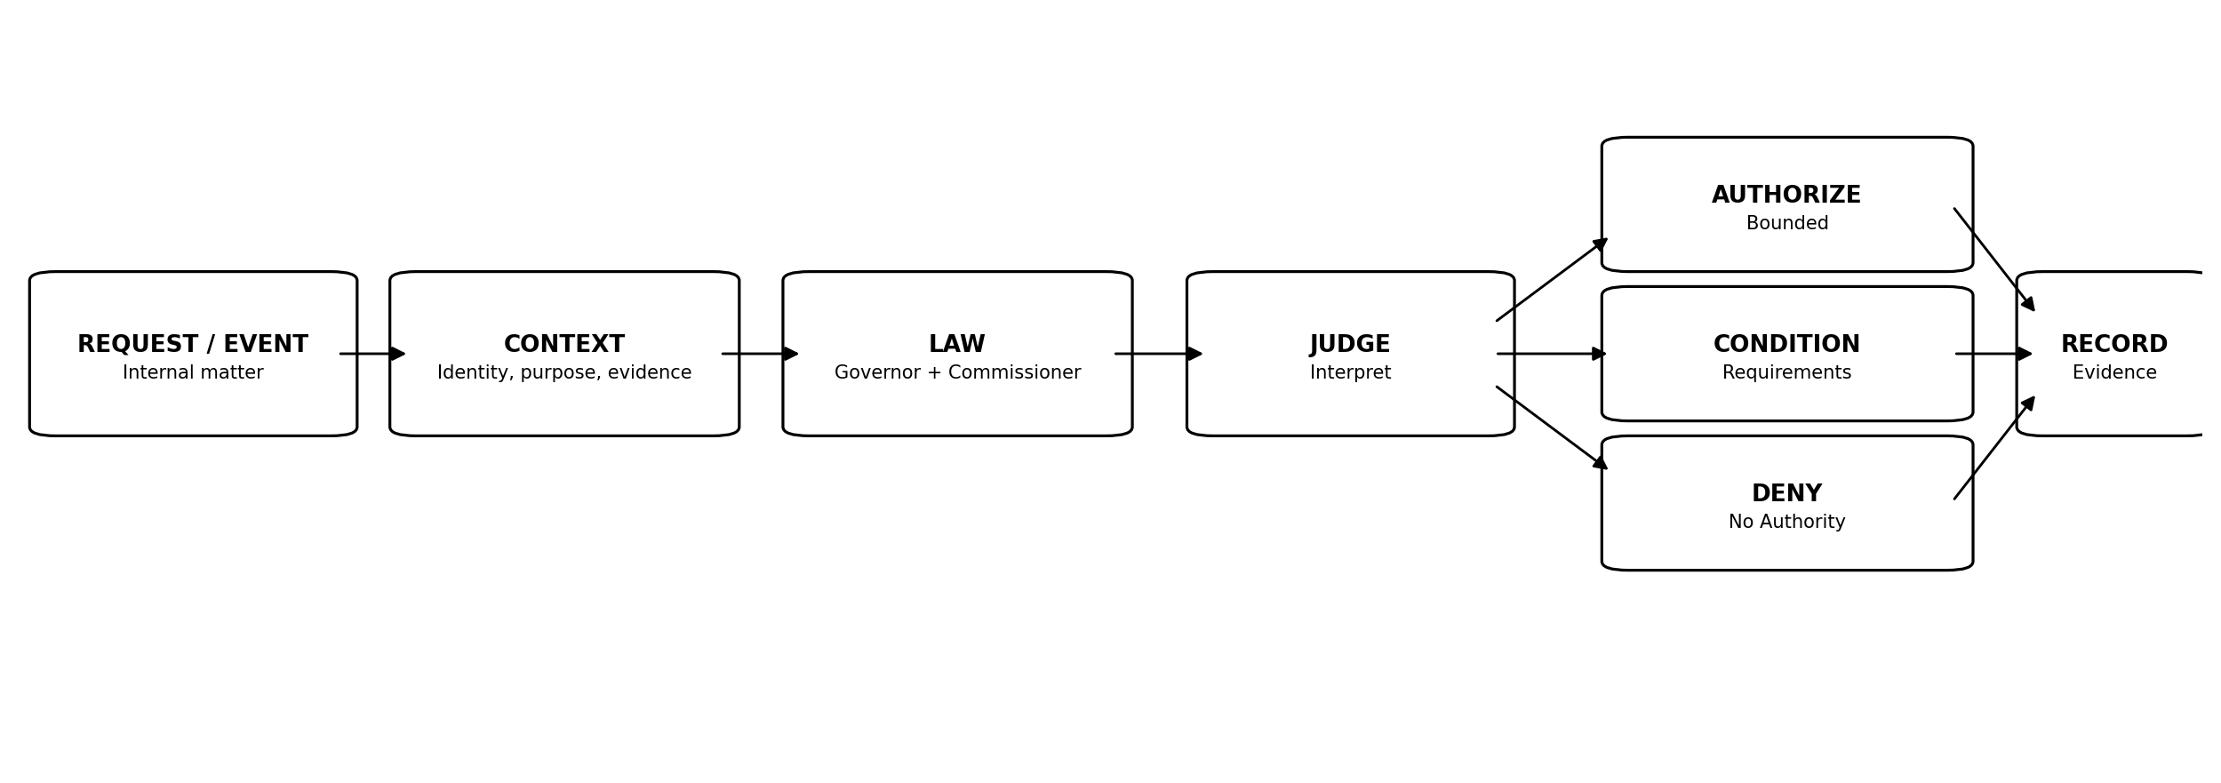
Figure 4. Judge decision workflow and principal decision outcomes.

13. Judicial Instruments
Judicial Instruments are bounded authoritative directives issued by the Judge pursuant to applicable established Law. They express judicial determinations in a form that can be independently validated, executed, reviewed, expired, and audited. An Instrument cannot bootstrap its own legal basis.

13.1 Common Required Elements
Every material Instrument SHOULD identify Instrument ID, type, issuing Judge identity, jurisdiction, legal basis, subject, Scope, evidence references, permitted actuation, safeguards, issue time, effective time, expiration or terminating condition, review requirements, and provenance.

13.2 Authenticity and Integrity
An Instrument MUST be protected against unauthorized alteration. Implementations SHOULD provide a verifiable mechanism to establish origin and integrity.

13.3 Bounded Actuation
An Instrument MUST enumerate or otherwise bound the technical effects it authorizes.

13.4 No New Law
Issuing an Instrument does not create, establish, amend, suspend, or revoke Law. An Instrument may only exercise Authority already permitted by applicable established Law and the facts of the governed matter.

13.5 No Automatic Unrestricted Capability
An Instrument MUST NOT be interpreted as granting the Judge or Actuation Authority unrestricted administrative capability.

13.6 Expiration
An Instrument with a temporary purpose MUST expire automatically at the defined time or terminating condition unless Law permits renewal and the requirements for renewal are satisfied.
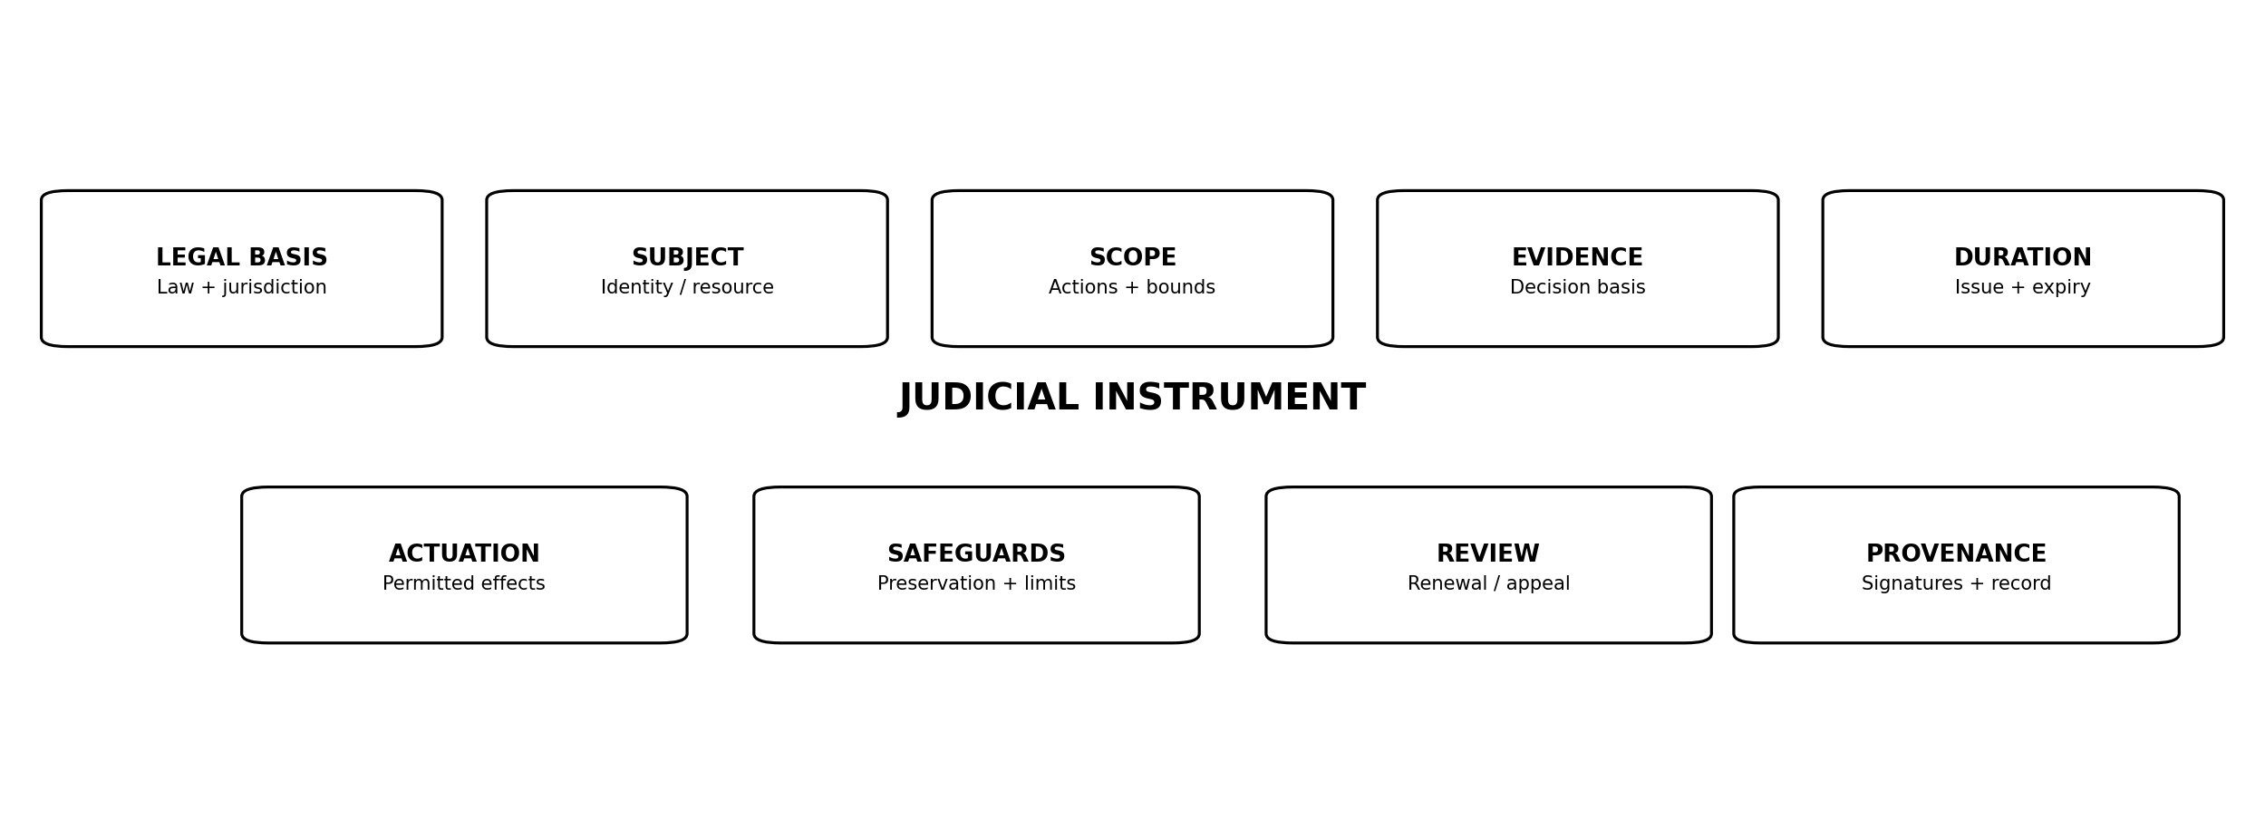
Figure 5. Common Judicial Instrument schema elements.

14. Inquiry
An Inquiry is the least coercive Judicial Instrument. It requests additional context, evidence, verification, or clarification needed for a governed determination.

14.1 Appropriate Use
Use when the Judge lacks sufficient information but does not yet have a Lawful basis for stronger intervention.

14.2 Scope
An Inquiry MUST identify the information or verification requested and SHOULD avoid collecting unrelated information.

14.3 Effect
An Inquiry does not itself revoke Authority unless Law separately requires a temporary hold while the inquiry is resolved.

14.4 Completion
The Inquiry closes when sufficient evidence is obtained, the request is withdrawn, the matter expires, or the Judge determines another disposition.

15. Investigative Warrant
An Investigative Warrant authorizes bounded evidence collection or examination for an internal investigation.

15.1 Preconditions
Governor Law MUST define the conditions under which investigative collection is permitted.

15.2 Collection Boundary
The Warrant MUST specify subjects, systems, data categories, time range, or other Scope sufficient to prevent open-ended collection.

15.3 Minimization
Collection SHOULD be limited to evidence reasonably relevant to the authorized investigation.

15.4 Preservation
Evidence collected under the Warrant SHOULD preserve provenance and integrity sufficient for later review.

15.5 Expiration
Investigative Authority MUST end when the Warrant expires or its authorized purpose is satisfied.

16. Restriction Order
A Restriction Order narrows existing Authority or Liberty without necessarily terminating all legitimate activity.

16.1 Uses
A Restriction Order may limit tools, resources, commands, delegation, data classes, workflows, time windows, or other dimensions of Authority.

16.2 Least Restrictive Effective Scope
Where Law permits, the Judge SHOULD select restrictions proportionate to the condition rather than unnecessarily revoking unrelated Authority.

16.3 Enforcement
Actuation MUST implement only the restrictions specified by the Order.

16.4 Restoration
When the Order expires or is lifted, previously valid Authority MAY be restored only if its independent basis remains valid.

17. Containment Warrant
A Containment Warrant authorizes bounded measures to prevent suspected or confirmed harm from expanding while preserving governance and evidence.

17.1 Trigger
Containment requires the factual and legal conditions established by Governor Law.

17.2 Effects
Authorized effects may include isolation, network restriction, workflow suspension, resource quarantine, or other bounded containment.

17.3 Evidence Preservation
Containment SHOULD preserve relevant evidence before destructive remediation when feasible and Lawful.

17.4 Duration
Containment MUST be reviewed or expire according to Law and MUST NOT silently become permanent Authority.

18. Revocation Order
A Revocation Order removes specified delegated Authority.

18.1 Scope
Revocation MUST identify the Authority being removed and SHOULD avoid ambiguous blanket revocation unless Law and facts support it.

18.2 Technical Effects
Actuation may revoke tokens, sessions, roles, delegations, credentials, or other mechanisms representing the affected Authority.

18.3 Dependent Delegations
Dependent delegations SHOULD be invalidated when their upstream Authority is revoked.

18.4 Baseline Restoration
Where appropriate, revocation of Elevated Authority returns the actor to independently valid Baseline Authority.

19. Cease and Desist Order
A Cease and Desist Order is a coordinated directive requiring prohibited or unauthorized activity to stop and authorizing the bounded actions necessary to enforce that stop.

19.1 Coordinated Effects
Where Law permits, a Cease and Desist Order may coordinate notification, Authority or Liberty revocation, session termination, credential or MFA protection, endpoint isolation, evidence preservation or collection, and EDR or equivalent security scanning.

19.2 Independence of Actuation
The Judge issues the Order. Independent Actuation Authority executes the authorized technical effects.

19.3 Scope
The Order MUST identify the activity to cease, affected subjects or resources, authorized effects, safeguards, and duration.

19.4 Restoration
Restoration of service or Authority requires a valid basis and SHOULD account for remediation and continuing risk.

20. Emergency Order
An Emergency Order is a bounded Judicial Instrument available only where established and active Governor Law has predefined the relevant emergency judicial powers. The existence of an emergency does not allow the Judge or any single human to create new Law or bypass the Human-Established Law process.

20.1 No Emergency Legislation
The Judge MUST NOT invent new emergency powers during an event. A crisis changes urgency, not the requirement for governance.

20.2 Relationship to Board of Authority
Where exceptional emergency override requires Board of Authority authorization, the only valid override is the predefined multi-human authorization mechanism established by Governor Law and executed through the authorized Governor governance process. The approval threshold MUST include at least two independently authorized Board members and MUST preserve any organizational role-composition requirements defined in advance. Ad hoc promotion, improvised designation, or external documentation MUST NOT substitute for the configured authorization process.

20.3 Scope and Time
Emergency Orders MUST remain within the exact Authority granted by established Law and any valid Board of Authority authorization. They MUST be narrowly scoped, time-limited, logged, and subject to review.

20.4 Expiration
Emergency Authority MUST automatically expire or be revoked when its authorized duration or condition ends.
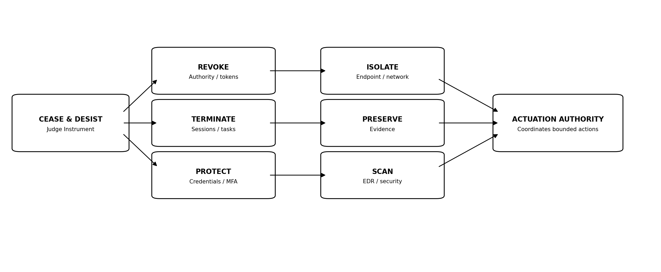
Figure 6. Cease and Desist Order as a coordinated bounded actuation pattern.

21. Actuation Authority
Actuation Authority is the independent function that converts an authorized JAZB decision or Judicial Instrument into bounded technical action.

21.1 Separation from the Judge
The Judge determines. Actuation Authority executes. A conformant implementation MUST preserve this logical separation even when components are technically integrated.

21.2 Validation Before Execution
Before material execution, Actuation Authority MUST validate decision or Instrument authenticity, integrity, effective time, expiration, subject, target, Scope, permitted effects, applicable Law references, required Law-establishment provenance where relevant, and any required approvals or conditions. A technically valid command without a valid Authority chain MUST NOT be treated as sufficient authorization.

21.3 Least Technical Capability
Actuation SHOULD receive only the technical capability necessary to execute the authorized effect and SHOULD avoid persistent broad privilege where temporary capability is practical.

21.4 No Decision Expansion
Actuation Authority MUST NOT broaden targets, duration, resources, or effects beyond the authorizing decision.

21.5 Partial Failure
If only part of an Instrument can be executed, Actuation Authority MUST record the partial result and SHOULD stop or escalate when continuing would create an unauthorized or unsafe state.

21.6 Idempotence and Replay
Implementations SHOULD protect against unauthorized replay or duplicate execution of one-time Instruments.

21.7 Verification
After execution, Actuation Authority SHOULD verify the resulting state when technically feasible.

21.8 Rollback
Where Law and the action permit rollback, the Instrument or implementation SHOULD define conditions for restoration or reversal.

21.9 Evidence
Actuation MUST record the action attempted, technical identity used, target, time, result, errors, and verification outcome at a level proportionate to the action.
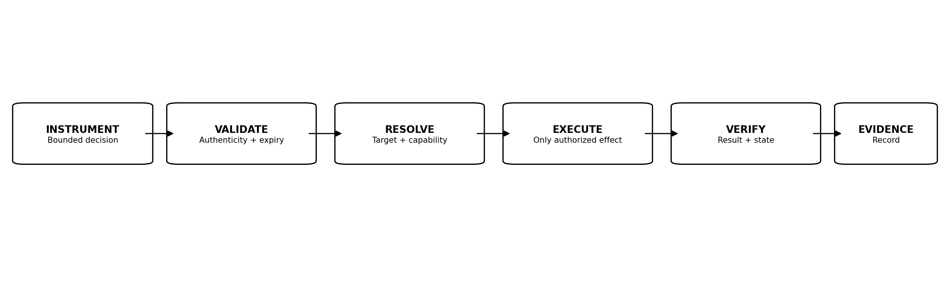
Figure 7. Actuation validation and execution workflow.

22. Chain of Authority
The Chain of Authority establishes why a governed action was legitimate. It is the provenance path from legitimate human Authority through established Law, judicial decision or delegation, independent actuation where applicable, and the resulting action.

22.1 Required Linkage
Material actions SHOULD be linkable to applicable human-established Law, judicial decision or delegation, executing identity, and outcome.

22.2 Law Version and Establishment Provenance
Material actions SHOULD be linkable to the exact applicable Law version and, for high-impact decisions, to the Law-establishment or activation record sufficient to show that the governing Law satisfied the required human authorization threshold before the action was authorized.

22.3 Delegation Provenance
Delegated Authority SHOULD identify its upstream source and any permitted redelegation path.

22.4 Instrument Provenance
A Judicial Instrument SHOULD be linkable to the decision and Law that authorized it.

22.5 Actuation Provenance
Technical execution SHOULD be linkable to the Instrument or decision it implements.

22.6 Broken Chain
If a required provenance link cannot be established, including required Law-establishment provenance, the implementation MUST NOT invent or infer Authority solely from technical capability, model confidence, credential validity, or apparent policy state. The unsupported portion MUST be denied, constrained, preserved, or escalated according to Law.

23. Chain of Evidence
The Chain of Evidence records what information supported a decision and what occurred during execution. It complements but does not replace the Chain of Authority.

23.1 Evidence References
Decision records SHOULD reference relevant evidence rather than duplicating sensitive evidence unnecessarily. Where a material decision depends on a newly established Law version, the evidence record SHOULD reference the applicable establishment and activation artifacts without exposing unnecessary personal or cryptographic secrets.

23.2 Integrity
Evidence material to high-impact decisions SHOULD be protected against unauthorized alteration.

23.3 Time
Evidence SHOULD preserve reliable event ordering and timestamps appropriate to the use case.

23.4 Collection Minimization
Evidence collection SHOULD be proportionate to the governed purpose and applicable obligations.

23.5 Retention
Retention SHOULD be defined by human-established Law, regulatory requirements, investigation needs, privacy obligations, and operational risk.

23.6 Explainability Record
The evidence record SHOULD permit an authorized reviewer to understand the material basis of a decision without requiring disclosure of hidden model chain-of-thought.

24. Conflict, Ambiguity, and Failure Handling
JAZB treats unresolved governance conditions as reasons to narrow, deny, preserve state, or escalate, not as permission to expand Authority.

24.1 Conflicting Law
When applicable Law conflicts, the Judge MUST apply the precedence and conflict-resolution rules established by human governance. If those rules do not resolve the conflict, the matter MUST be escalated or denied within the unresolved Scope.

24.2 Ambiguous Scope
Ambiguity in Scope MUST NOT be interpreted as maximum Authority.

24.3 Stale, Superseded, or Unestablished Law
A Judge MUST NOT knowingly issue a material decision under superseded or revoked Law unless the applicable governance process explicitly requires that historical version. Content that has not completed the required Law Establishment Lifecycle MUST NOT be treated as authoritative Law.

24.4 Law Authorization-Provenance Failure
If the applicable Law record lacks the authorization evidence required to demonstrate that the configured human threshold was satisfied, the Judge MUST NOT treat the record as authoritative. The previously valid active Law remains controlling unless it has been lawfully superseded or revoked. Suspected forgery, replay, substitution, or loss of Law-establishment provenance SHOULD be treated as a governance-security condition.

24.5 Missing Evidence
Where required evidence is unavailable, the Judge SHOULD request evidence, narrow the decision, deny, or escalate.

24.6 Judge Unavailability
Law SHOULD define safe behavior when the Judge is unavailable, including verified cached decisions, Baseline Authority, denial of new elevation, or human escalation.

24.7 Actuation Unavailability
A valid decision that cannot be actuated MUST be recorded as unexecuted or partially executed. Decision validity does not imply technical completion.

24.8 Revocation Failure
Failure to complete revocation is a security condition requiring escalation and continued containment attempts according to Law.

24.9 Evidence Failure
Loss of evidence does not retroactively create or erase Authority. It creates an accountability and investigation condition.

25. Normative Internal Workflows
Phase II defines the following reference workflows. Implementations may vary in technology and orchestration while preserving the Authority relationships and required controls.

25.1 Routine Baseline Action
1. AGENT receives a user request. 2. Identity, applicable Law, Baseline Authority, purpose, and Scope are resolved. 3. If the action is within valid Baseline Authority and no judicial determination is required, the AGENT acts within its Liberty. 4. Required evidence is recorded.

25.2 Elevated Authority Request
1. A task requires Authority beyond baseline. 2. The request identifies purpose, Scope, requested actions, resources, and duration. 3. The Judge evaluates applicable Law and evidence. 4. If authorized, a bounded delegation is created. 5. Point Policy governs runtime behavior. 6. Completion, expiration, or revocation returns the actor to applicable Baseline Authority.

25.3 Restriction Workflow
1. Evidence indicates a condition requiring limitation. 2. The Judge evaluates Law and evidence. 3. A Restriction Order is issued if warranted. 4. Actuation validates and applies only specified restrictions. 5. Outcome and continuing conditions are recorded.

25.4 Revocation Workflow
1. A revocation condition occurs. 2. The Judge determines the affected Authority. 3. A Revocation Order is issued. 4. Actuation invalidates the relevant technical mechanisms and dependent delegations as required. 5. Remaining independently valid Authority is preserved.

25.5 Investigation Workflow
1. An anomaly or allegation requires evidence. 2. The Judge determines whether Inquiry is sufficient or an Investigative Warrant is justified. 3. Collection remains within Scope. 4. Evidence provenance is preserved. 5. The Judge reaches a disposition or issues another Lawful Instrument.

25.6 Containment Workflow
1. Evidence indicates ongoing or expanding risk. 2. The Judge evaluates containment criteria. 3. A Containment Warrant identifies bounded effects. 4. Actuation isolates or restricts only the authorized targets. 5. Evidence is preserved and the condition is reviewed.

25.7 Cease and Desist Workflow
1. Unauthorized activity is established under Law. 2. The Judge issues a Cease and Desist Order. 3. Actuation validates the Order. 4. Authorized coordinated actions stop the activity, protect credentials, contain affected systems, preserve evidence, and perform security scanning as specified. 5. Results are verified and recorded.

25.8 Emergency Judicial Workflow
1. Emergency conditions are validated against preexisting Law. 2. Required Board of Authority approval is obtained where applicable. 3. The Judge issues only the Emergency Order permitted by that Authority. 4. Actuation executes bounded effects. 5. Authority expires automatically. 6. Post-event review occurs.

25.9 Established-Law Transition Workflow
1. An authorized human drafts or submits proposed Law. 2. The proposal is validated for syntax, hierarchy, Scope, conflicts, and organizational requirements without gaining governing effect. 3. Independently authorized humans review the exact proposal and satisfy the predefined authorization threshold. 4. The Human-Established Law Layer records establishment and activation. 5. The Judge recognizes the new active version only after validating state and provenance. 6. Material standing decisions or delegations are reevaluated when the Law change requires it. 7. The prior Law version and establishment evidence remain available for audit and recovery according to organizational retention requirements.

26. Security and Abuse Considerations
Phase II is itself part of the security boundary. Compromise of Authority records, Law-state metadata, human authorization records, Judge decisions, Instruments, actuation, or evidence can create apparent legitimacy for unauthorized action. The architecture therefore assumes that governance provenance is security-sensitive data.

26.1 Judge Compromise
A compromised Judge can issue improper decisions. Separation from Actuation Authority, Law validation, Instrument integrity, Scope checking, and independent evidence reduce unilateral blast radius.

26.2 Instrument Forgery
Actuation MUST reject Instruments whose authenticity or integrity cannot be established.

26.3 Replay
One-time or time-bounded Instruments SHOULD be protected against replay.

26.4 Confused Deputy
An AGENT or actuation component MUST NOT use its own broader technical privileges to satisfy a request whose delegated Authority is narrower.

26.5 Delegation Laundering
Redelegation MUST NOT be used to obscure the original Authority source or evade upstream restrictions.

26.6 Evidence Tampering
Material evidence and audit records SHOULD be protected against unauthorized deletion or modification.

26.7 Prompt and Goal Manipulation
Agentic systems may be manipulated through instructions or tool outputs. Judicial and operational components SHOULD treat untrusted instructions as inputs, not as sources of Authority. This is consistent with current agentic-security concerns around goal hijacking, tool misuse, and identity or privilege abuse. [6]

26.8 Governance Escape
Attempts to bypass Judge decisions, Point Policy, delegation controls, or Actuation Authority are Governance Escape conditions and SHOULD trigger detection, evidence preservation, and response under Phase I doctrine.

26.9 Law-State Substitution
An attacker may attempt to present Draft, Proposed, Validated, revoked, or maliciously altered content as active Law. The Judge and Actuation Authority SHOULD validate authoritative state, version, integrity, and provenance independently of the untrusted request path before relying on the record.

26.10 Authorization-Provenance Forgery
An attacker may attempt to forge, replay, substitute, or transplant a human authorization to satisfy a Law-establishment threshold. Implementations SHOULD bind each authorization to the exact Law version, Scope, and transaction being approved and SHOULD prevent reuse where the authorization is intended to be single-purpose.

26.11 Single-Member Capture
Compromise, coercion, or manipulation of one authorized drafter or one EDA-authorized participant MUST NOT be sufficient to establish Law. The multi-human threshold is a structural control against unilateral Law capture, but it does not eliminate the need for strong identity, device, session, and audit protections around each human participant.

26.12 Sovereign Quorum Capture
If an adversary genuinely captures, coerces, or colludes with the complete legitimate human quorum required to establish Law, JAZB reaches a residual sovereign-risk boundary. The framework may provide evidence, independent notification, role separation, delay, review, and recovery mechanisms, but it MUST NOT grant AI unilateral veto power over a fully satisfied legitimate human sovereign decision merely because the AI considers that decision unwise. Organizations SHOULD mitigate this risk through governance design, threshold selection, separation of duties, identity assurance, conventional cybersecurity, and independent oversight.

27. Alignment with Existing Frameworks and Mechanisms
Phase II is designed to use and complement established security and AI-governance mechanisms rather than replace them.

27.1 NIST AI RMF
NIST AI RMF emphasizes organizational governance, accountability structures, documented human roles and responsibilities, and executive responsibility for AI risk decisions. Phase II operationalizes a narrower Authority problem by specifying how established human Law constrains AI interpretation, delegation, judicial intervention, and technical execution. [1][2]

27.2 NIST Zero Trust Architecture
NIST SP 800-207 separates policy decision and policy enforcement functions and requires explicit authentication and authorization. Phase II aligns with this separation through Judge decision semantics and independent Actuation Authority, while adding human-established Law, Authority provenance, purpose binding, Judicial Instruments, and machine delegation. [3][4]

27.3 Least Privilege and JIT
Modern agent identity guidance emphasizes stable identities, explicit scope, time-limited privileges, and auditability. Phase II Baseline and Elevated Authority provide a governance model under which such technical controls can be used. [7]

27.4 OWASP Agentic Security
OWASP identifies risks including goal hijacking, tool misuse, identity and privilege abuse, insecure inter-agent behavior, and rogue agents. Phase II addresses these through bounded Authority, non-inheritance, Point Policy, independent actuation, revocation, evidence, and Governance Escape handling. [6]

27.5 Emerging Agent Authorization Protocols
Emerging IETF Internet-Drafts describe cryptographic agent identity, scoped grants, delegation, revocation, audit trails, behavioral attestation, and cross-agent authorization. These can become implementation mechanisms beneath JAZB, but Internet-Drafts are works in progress and do not define JAZB Law or organizational sovereignty. [8][9][10]

27.6 Gap Addressed by Phase II
Existing mechanisms can establish identity, access, tokens, policy decisions, and enforcement. Phase II focuses on the institutional provenance of machine Authority: which established Human-Established Law legitimizes the decision, how that Law became authoritative, how Authority is bounded and delegated, how judicial intervention is expressed, and how independent actuation can verify that it is executing a legitimate decision rather than merely a technically valid command.
Framework / mechanism | Existing contribution | Phase II relationship
NIST AI RMF | Governance, accountability, human roles, risk management | Adds explicit internal Authority provenance and judicial mechanics.
NIST SP 800-207 | Policy decision / enforcement separation, explicit authorization | Extends separation to Law, Judge decisions, Instruments, delegation, and actuation.
Least privilege / JIT | Scoped and temporary technical privileges | Places JIT elevation inside a human-sovereign Authority lifecycle.
OWASP Agentic Top 10 | Agentic threat taxonomy and mitigations | Provides Authority controls for misuse, privilege abuse, rogue operation, and bypass.
Emerging IETF agent authorization | Agent identity, scoped grants, delegation, revocation | Potential technical substrate beneath JAZB Authority and evidence semantics.

28. Phase II Conformance Model
A Phase II conformant implementation preserves the normative relationships defined by this specification.

28.1 Required Architectural Properties
A conformant implementation MUST preserve Human-Established Law; MUST prevent any AI component from establishing Law or satisfying a human Law-authorization threshold; MUST enforce a Law Establishment Lifecycle in which no single individual can unilaterally establish, modify, activate, or revoke Law; MUST prevent the Judge from treating unestablished content as authoritative Law; MUST prevent AGENT self-authorization; MUST preserve bounded Authority and delegation; MUST support revocation of delegated machine Authority; MUST separate judicial decision from unrestricted actuation; and MUST preserve sufficient Chain of Authority provenance for material decisions.

28.2 Required Decision Properties
Material Judge decisions MUST identify jurisdiction, applicable active Law, decision state, subject, Scope, and provenance sufficient for authorized review. Where the legitimacy of a Law version is material to the decision, the implementation MUST be able to demonstrate that the applicable authorization threshold and establishment state were satisfied.

28.3 Required Instrument Properties
Material Judicial Instruments MUST be bounded, attributable, integrity-protected, time- or condition-limited where temporary, and independently validatable before actuation.

28.4 Required Actuation Properties
Actuation MUST validate the authorizing decision, MUST NOT expand it, and MUST record material execution results.

28.5 Recommended Properties
Implementations SHOULD support structured Authority records, structured Law-establishment records, cascade revocation, replay protection, authorization binding, verification of execution outcome, evidence integrity, tamper-evident versioning, and human-reviewable decision explanations.

28.6 Conformance Claim
An implementation claiming Phase II conformance SHOULD document how each REQUIRED property is satisfied and identify any intentionally unsupported OPTIONAL or RECOMMENDED behavior.

29. Relationship to JASB
JASB is the practical origin of several Phase II mechanics. Temporary elevation, active monitoring, Point Policy, revocation, least privilege, and restoration to baseline are preserved and generalized.

29.1 JASB Runtime Model
JASB asks how AI can safely govern temporary elevated access while a user performs an authorized task.

29.2 JAZB Phase II Generalization
JAZB Phase II generalizes the JASB runtime model by placing temporary elevation inside a broader human-sovereign Chain of Authority. Elevated Authority is legitimate only when it derives from established Law and valid delegation, and Point Policy governs behavior only after that Authority exists.

29.3 Preservation of Point Policy
Point Policy remains a runtime control and is not absorbed into Governor or Commissioner Law.

30. Phase III Boundary
Phase II intentionally stops at the internal judicial boundary. Phase III formalizes Enterprise AI Customs and Border Jurisdiction at the Organization's actual external boundary while preserving the Internal Jurisdiction rules defined here.

30.1 Deferred Topics
Port Authority decision semantics, Port Director Law, Customs AGENT behavior, actual Ports of Entry and exit at the organizational external boundary, ingress, egress, external AI services, cross-organizational agent communication, lawful passage, border evidence, and border Governance Escape are reserved for Phase III. Internal proxies, services, APIs, segments, or application gateways do not become Ports merely because they participate in a route to the Internet.

30.2 Cross-Jurisdiction Reminder
Nothing in Phase II authorizes internal Judge decisions to confer Border Authority. Lawful possession does not establish lawful passage.

30.3 Internal Trust Boundaries Are Not Ports
Internal Trust Boundaries remain governed security and Authority boundaries, but crossing an internal Trust Boundary does not by itself invoke Enterprise AI Customs or create a Port of Entry. Customs applies when a governed transaction crosses the Organization's external boundary through a governed external path.

31. Conclusion
Phase II converts JAZB Authority from a foundational concept into a formal Internal Jurisdiction lifecycle.
Rights define legitimate entitlements. Duties constrain participation. Liberty defines bounded discretion. Authority permits legitimate action. Delegation conveys only bounded Authority. Baseline and Elevated Authority preserve least privilege. Point Policy governs behavior while delegated Authority is being exercised. The Judge interprets established Law and issues bounded decisions or Judicial Instruments. Independent Actuation Authority validates and executes only the authorized technical effects.
The Law Establishment Lifecycle is now an explicit prerequisite to that process. Drafting is not establishment. Access is not establishment. A proposal is not Law. A single human approval is not enough. The Judge cannot create the missing human Authority, and Actuation cannot infer it from technical capability.
The result is a judicial architecture in which AI may make consequential decisions and exercise substantial autonomy without becoming the source of the Law or Authority governing its own actions.
Authority must remain legitimate from origin through action.

Appendices

Appendix A. Normative Authority Record
Illustrative logical fields. Implementations may use different schemas while preserving equivalent semantics.
Field | Purpose
authority_id | Unique Authority record
subject | Human or machine recipient
source | Upstream Authority source
law_basis | Applicable human-established Law
purpose | Authorized objective
scope | Boundaries of the Authority
jurisdiction | Internal jurisdiction in Phase II
actions | Permitted action classes
resources | Affected resources
conditions | Continuing requirements
effective_at | Start of validity
expires_at / termination | End of validity
redelegation | Whether and how Authority may be redelegated
point_policy | Applicable runtime behavior controls
provenance | Chain of Authority references
law_version | Exact established Law version or hash
law_establishment | Reference to Law-establishment and activation provenance where material

Appendix B. Judge Decision Record
Field | Required meaning
decision_id | Unique decision identifier
judge_identity | AI judicial identity
jurisdiction | Internal
law_versions | Applicable Governor and Commissioner Law
subject | Affected actor
request_or_event | Matter decided
purpose | Declared or established purpose
evidence_refs | Material evidence
decision_state | Authorize, deny, conditional, evidence, escalate, or Instrument
scope | Decision boundary
conditions | Requirements
effective_time | When decision applies
expiration | When temporary decision ends
provenance | Authority chain references
law_establishment_refs | Applicable establishment / activation references where material

Appendix C. Judicial Instrument Minimum Schema
Element | Requirement
Instrument ID | Unique
Type | One of the defined Instrument classes
Issuer | Judge identity
Law basis | Applicable human-established Law
Subject / target | Bounded
Scope | Explicit
Evidence references | Material basis
Permitted actuation | Enumerated or bounded
Safeguards | Required protections
Issue / effective time | Recorded
Expiration / termination | Defined where temporary
Review / renewal | Defined where applicable
Integrity / provenance | Verifiable
Law establishment provenance | Verifiable reference where required for high-impact validation

Appendix D. Judicial Instrument Matrix
Instrument | Primary purpose | Typical intervention | Direct Law creation?
Inquiry | Obtain context | Information request | No
Investigative Warrant | Collect bounded evidence | Authorized investigation | No
Restriction Order | Narrow Authority / Liberty | Partial restriction | No
Containment Warrant | Prevent expansion of harm | Isolation / containment | No
Revocation Order | Remove Authority | Privilege / token / delegation removal | No
Cease and Desist Order | Stop unauthorized activity | Coordinated bounded response | No
Emergency Order | Exercise predefined emergency judicial power | Time-limited emergency response | No

Appendix E. Decision-State Matrix
State | Meaning | May actuate?
AUTHORIZE | Action legitimate within Scope | Yes, if actuation is required and authorized
DENY | Insufficient or prohibited Authority | No, except enforcement of denial if separately authorized
CONDITIONALLY AUTHORIZE | Legitimate only under stated conditions | Only after or while conditions are satisfied
REQUIRE EVIDENCE | Insufficient basis | No material authorization yet
ESCALATE | Human review required | Only preexisting safe-state controls
ISSUE INSTRUMENT | Defined judicial intervention warranted | Only within Instrument Scope

Appendix F. Delegation Validation Checklist
- Source Authority is valid and current.
- Delegator is permitted to delegate.
- Recipient identity is established.
- Purpose is explicit.
- Scope is bounded.
- Actions and resources are defined.
- Jurisdiction is correct.
- Duration or terminating condition is defined.
- Conditions are defined.
- Redelegation is explicitly allowed or denied.
- Point Policy is attached where required.
- Revocation path exists.
- Provenance is recorded.

Appendix G. Actuation Validation Checklist
- Authorizing decision or Instrument is authentic.
- Integrity is intact.
- Instrument is effective and not expired.
- Target matches the authorized subject or resource.
- Requested technical effect is permitted.
- Required approvals and conditions are satisfied.
- Execution capability is no broader than necessary.
- Replay or duplicate execution is prevented where required.
- Evidence collection is active.
- Outcome is verified and recorded.

Appendix H. Example Elevated Authority Workflow
Step | Illustrative record
1 | User requests temporary administrative task through AGENT.
2 | AGENT records purpose, target, requested actions, and duration.
3 | Judge resolves Governor and Commissioner Law and evaluates identity and evidence.
4 | Judge AUTHORIZE decision defines bounded Elevated Authority.
5 | Delegation is provisioned through existing IAM/PAM mechanisms.
6 | Point Policy monitors runtime behavior.
7 | Task completes or Authority expires.
8 | Technical elevation is removed and Baseline Authority remains.
9 | Decision, delegation, runtime events, and outcome are linked in evidence.

Appendix I. Example Cease and Desist Workflow
Step | Illustrative action
1 | Telemetry indicates an AGENT is operating outside authorized purpose.
2 | Judge validates applicable Law and evidence.
3 | Judge issues Cease and Desist Order with bounded targets and effects.
4 | Actuation validates authenticity, Scope, and expiry.
5 | Authorized actions revoke delegated Authority, terminate sessions, protect credentials, isolate affected endpoint, preserve evidence, and initiate security scanning as specified.
6 | Actuation verifies resulting state.
7 | Judge or authorized human review determines restoration or further action.

Appendix J. Phase II Conformance Checklist
- Human-established Law remains authoritative.
- Judge cannot create or modify Law.
- AGENT cannot self-authorize.
- Authority is purpose- and Scope-bound.
- Delegation cannot amplify Authority.
- Redelegation is explicit.
- Elevated Authority is temporary or condition-bound.
- Point Policy remains subordinate to Law.
- Judicial Instruments are bounded and integrity-protected.
- Actuation is independently validated and cannot expand decisions.
- Revocation path exists.
- Authority provenance is reconstructable.
- Evidence is attributable and protected according to Law.
- Ambiguity does not default to expanded Authority.
- Internal decisions do not confer Border Authority.
- Only established and active Law is used as a material judicial basis.
- No single individual can establish, modify, activate, or revoke Law.
- The applicable multi-human Law-authorization threshold is independently verifiable.
- AI recommendations enter the proposal lifecycle and never become Law autonomously.
- Law-establishment provenance is included in the Chain of Authority where material.

Appendix K. Established-Law Validation Checklist
Before a material Judge decision relies on a Law record, a conformant implementation SHOULD be able to validate the following controls directly or through equivalent linked evidence.
Validation item | Required condition
Law state | The record is established and active for the decision being made.
Human threshold | The predefined authorization threshold was satisfied by no fewer than two independently authorized humans.
Exact version binding | Authorizations apply to the exact Law version, text, Scope, or cryptographic digest being established.
Jurisdiction | The authorizers were valid for the Human-Established Law Layer and Scope affected.
Proposal separation | Draft, Proposed, Validated, or rejected material is not treated as active Law.
Establishment event | The formal establishment event is recorded and attributable.
Activation | The Law is effective according to its activation time and conditions.
Supersession / revocation | No later valid event has superseded or revoked the Law for the matter being decided.
Integrity | The Law text and establishment evidence are protected against unauthorized alteration or substitution.
Auditability | An authorized reviewer can reconstruct how the Law became authoritative without relying on hidden model reasoning.

References
[1] National Institute of Standards and Technology. Artificial Intelligence Risk Management Framework (AI RMF 1.0), NIST AI 100-1. 2023. https://doi.org/10.6028/NIST.AI.100-1
[2] National Institute of Standards and Technology. AI RMF 1.0, Appendix C: AI Risk Management and Human-AI Interaction. 2023. https://nvlpubs.nist.gov/nistpubs/ai/nist.ai.100-1.pdf
[3] National Institute of Standards and Technology. Zero Trust Architecture, NIST SP 800-207. 2020. https://doi.org/10.6028/NIST.SP.800-207
[4] National Cybersecurity Center of Excellence. Implementing a Zero Trust Architecture: Architecture and Builds. NIST. https://pages.nist.gov/zero-trust-architecture/VolumeB/architecture.html
[5] National Institute of Standards and Technology. A Zero Trust Architecture Model for Access Control in Cloud-Native Applications in Multi-Cloud Environments, NIST SP 800-207A. 2023. https://doi.org/10.6028/NIST.SP.800-207A
[6] OWASP GenAI Security Project. OWASP Top 10 for Agentic Applications for 2026. 2025. https://genai.owasp.org/resource/owasp-top-10-for-agentic-applications-for-2026/
[7] Microsoft. Least privilege for AI agents with Microsoft Entra Agent ID. Microsoft Learn. 2026. https://learn.microsoft.com/en-us/security/zero-trust/sfi/least-privilege-for-ai-agents
[8] Kumar, S. Delegated Agent Authorization Protocol (DAAP), draft-mishra-oauth-agent-grants-00. IETF Internet-Draft, work in progress. 2026. https://datatracker.ietf.org/doc/html/draft-mishra-oauth-agent-grants-00
[9] Fane, A. OpenA2A Agent Authorization Protocol (AAP), draft-fane-opena2a-aap-01. IETF Internet-Draft, work in progress. 2026. https://www.ietf.org/archive/id/draft-fane-opena2a-aap-01.html
[10] Nelson, R. Delegation Receipt Protocol for AI Agent Authorization, draft-nelson-agent-delegation-receipts-02. IETF Internet-Draft, work in progress. 2026. https://datatracker.ietf.org/doc/html/draft-nelson-agent-delegation-receipts-02

Reference and Alignment Note
External references establish context and alignment. JAZB does not claim certification, formal mapping approval, or endorsement by NIST, OWASP, Microsoft, the IETF, or any cited organization. Internet-Drafts are works in progress and are not IETF standards unless and until separately standardized. JAZB terminology such as Human-Established Law, Judicial Instruments, Actuation Authority, and the Law Establishment Lifecycle is specific to this framework unless otherwise attributed.

