JAZB
Judiciary AI Zero-Trust Broker
An Authority-Centric, Human-Sovereign Governance Architecture for Artificial Intelligence

Phase IV: Security & Resilience Specification
Michael Costner
Author and Publisher
Version 1.0 - Publication
September 2026
jazbframework.org
A failure of governance must not become an expansion of Authority.

Publication and Copyright Notice
This publication assumes a mature contemporary cybersecurity architecture remains in place. Identity protection, MFA, PAM, segmentation, firewalls, IDS/IPS, DLP, secure web gateways, DNS security, EDR/XDR, SIEM/SOAR, backup and recovery, and related controls remain necessary. JAZB adds governance of legitimate Authority, Law, jurisdiction, passage, actuation, evidence, and recovery rather than replacing those controls.
Phase IV inherits the JAZB Law Establishment Lifecycle. Drafting, submitting, validating, or technically committing a proposal does not make it Law. Applicable Governor, Commissioner, and Port Director Law becomes authoritative only after the Organization's predefined multi-human authorization threshold is satisfied, with no fewer than two independently authorized humans, followed by formal establishment and activation.
References to external standards and guidance provide context and architectural alignment. They do not imply certification, conformance, endorsement, or sponsorship.
Copyright © 2026 Michael Costner. All rights reserved.
Publication site: jazbframework.org
DOI: 10.5281/zenodo.22904366

Author's Preface: Governing When Governance Is Under Attack
Phase I established the JAZB institution and the Law Establishment Lifecycle. Phase II formalized Authority, internal judicial mechanics, Judicial Instruments, and independent Actuation Authority. Phase III formalized lawful passage across the Organization's actual external boundary through Enterprise AI Customs. Phase IV addresses the condition every governance architecture must eventually face: the governance system itself may fail, be compromised, be bypassed, or become the target of an adversary.
A secure architecture cannot assume that its Judge will always interpret correctly, that its AGENTs will always remain trustworthy, that its governed external Ports will always remain available, that Law repositories will never be altered, or that every human credential associated with legitimate Authority will remain uncompromised.
JAZB therefore treats resilience as a governance property, not merely an infrastructure property. The objective is not to make compromise impossible. The objective is to ensure that compromise does not silently become legitimate Authority, that failure does not silently become permission, and that recovery restores a trustworthy Chain of Authority rather than simply returning systems to service.
This is also where Governance Escape Resistance becomes fully operational. Governance Escape includes attempts to bypass governed execution or border paths, substitute identities, use shadow AI, disable inspection, manipulate evidence, alter or substitute Law state, abuse delegation, create a genuine unmanaged external path, or execute outside authorized actuation. An internal reroute through another proxy, API, workload, or service does not by itself create a new Port or bypass Customs. A technically successful bypass remains unauthorized.
Phase IV preserves the separation established throughout JAZB. Human Authority remains the source of Law, and no individual may unilaterally establish, modify, activate, or revoke Law. AI may interpret established Law, operate under Law, and recommend changes, but may not establish Law. Independent actuation remains bounded. Internal and Border Jurisdictions remain separate. Emergency governance remains predefined rather than improvised.
Resilience therefore means more than uptime. It means maintaining or restoring the legitimacy of Authority under adverse conditions.
A failure of governance must not become an expansion of Authority.

Abstract
JAZB Phase IV specifies the security and resilience model of the Judiciary AI Zero-Trust Broker architecture. It formalizes Governance Escape Resistance, compromise handling, collusion resistance, Law-state integrity, evidence integrity, trusted recovery, failure-state behavior, emergency resilience, and systemic restoration across Internal and Border Jurisdictions. Phase IV assumes that any human identity, AI component, Human-Established Law Layer, actuation path, evidence system, external Port, or infrastructure dependency may fail or be compromised. Technical compromise never becomes legitimate Authority; unavailable or uncertain governance does not silently expand Authority; proposed or unauthorized Law cannot be substituted for Established and Active Law; interpretation remains separated from unrestricted execution; and recovery restores a trusted Chain of Authority before normal high-risk operation resumes. The specification treats the compromise of a single authorized human as insufficient to establish Law because Law establishment requires the Organization's predefined multi-human authorization threshold of no fewer than two independently authorized humans. It also distinguishes internal routing changes from true border Governance Escape: an internal proxy, API, workload, gateway, identity, or protocol change remains inside the Organization, while a genuine bypass requires an external path outside governed Customs coverage. Phase IV aligns architecturally with NIST AI RMF 1.0, NIST CSF 2.0, NIST SP 800-207, ISO/IEC 42001:2023, CIS Controls v8.1, and OWASP agentic AI security guidance while retaining JAZB's distinct focus on human-sovereign Authority, Law provenance, and governance restoration.

Keywords
AI Security; AI Resilience; Governance Escape Resistance; Agentic AI; Authority Governance; Human-Established Law; Law Integrity; Multi-Human Authorization; Incident Response; Trusted Recovery; Evidence Integrity; Compromise; Collusion; Zero Trust; Human Sovereignty; Chain of Authority; Chain of Evidence; Enterprise AI Customs

Table of Contents
1. Purpose and Scope 9
1.1 Purpose 9
1.2 Security Assumption 9
1.3 Resilience Objective 9
1.4 Scope 9
1.5 Out of Scope 9
2. Phase IV Security Doctrine 11
2.1 Compromise does not create Authority. 11
2.2 Technical success does not establish legitimacy. 11
2.3 Failure must not silently expand Authority. 11
2.4 Unknown governance state is not equivalent to authorization. 11
2.5 Law integrity must be independently recoverable. 11
2.6 Evidence must survive the events it is intended to explain. 11
2.7 Revocation must be able to terminate delegated Authority faster than ordinary expiration when risk requires it. 11
2.8 Recovery must restore a trusted Chain of Authority before normal high-risk operation resumes. 11
2.9 No autonomous component should be able to erase the evidence needed to review its own actions. 11
2.10 Separation of Law, interpretation, and execution must continue during incident response. 11
2.11 Emergency governance remains governed Authority. 11
2.12 Human review may change Law after an incident; compromised AI may not change Law to accommodate its own behavior. 12
2.13 A proposal is not Law. 12
2.14 Compromise of one authorized human cannot establish Law. 12
2.15 Internal rerouting does not create another Port. 12
2.16 True border bypass requires a genuine external path outside governed coverage. 12
3. Threat and Failure Model 13
3.1 Adversarial Compromise 13
3.2 Non-Adversarial Failure 13
3.3 Governance Manipulation 13
3.4 Deception and Context Poisoning 13
3.5 Insider and Credential Risk 13
3.6 Systemic Failure 13
3.7 Human Quorum Capture 13
3.8 External Boundary Coverage Failure 13
4. Security Objectives 15
5. Governance Escape Resistance 16
5.1 Definition 16
5.2 Escape Paths 16
5.3 Prevention 16
5.4 Constraint 16
5.5 Detection 16
5.6 Response 16
5.7 Recovery 16
5.8 Successful Bypass 16
6. Identity and Authority Compromise 18
6.1 Identity Is Evidence 18
6.2 EDA Credential Compromise 18
6.3 Board of Authority Compromise 18
6.4 Machine Identity Compromise 18
6.5 Authority Token Compromise 18
6.6 Substitution and Impersonation 18
7. Law Integrity and Governance-Plane Compromise 19
7.1 Protected Law 19
7.2 Human Change Provenance 19
7.3 Unauthorized Modification 19
7.4 Rollback Attack 19
7.5 Law Availability 19
7.6 Trusted Recovery 19
7.7 Law-State Substitution 19
7.8 Sovereign Quorum Boundary 19
8. Judge Compromise and Interpretive Failure 21
8.1 Threat 21
8.2 Structural Constraint 21
8.3 Instrument Validation 21
8.4 Anomaly Detection 21
8.5 Suspension 21
8.6 Decision Review 21
9. Port Authority Compromise and Border Failure 22
9.1 Threat 22
9.2 Independent Customs Enforcement 22
9.3 Destination Controls 22
9.4 Border Freeze 22
9.5 Review 22
9.6 Restoration 22
9.7 External Boundary Coverage 22
10. AGENT Compromise 23
10.1 Bounded Operational Authority 23
10.2 Tool Misuse 23
10.3 Prompt and Goal Manipulation 23
10.4 Revocation 23
10.5 Evidence 23
10.6 Reinstatement 23
11. Customs AGENT Compromise 24
11.1 Threat 24
11.2 Law and Decision Separation 24
11.3 Independent Telemetry 24
11.4 Enforcement Validation 24
11.5 Fail-Secure 24
11.6 Recovery 24
11.7 Internal Rerouting Is Not Customs Bypass 24
12. Actuation and Enforcement Compromise 25
12.1 Bounded Execution 25
12.2 Command Validation 25
12.3 Capability Expiration 25
12.4 Idempotence and Safety 25
12.5 Rollback 25
12.6 Evidence 25
13. Collusion and Multi-Component Failure 26
13.1 Collusion Risk 26
13.2 Independent Control Domains 26
13.3 Multi-Party Human Authorization 26
13.4 Cross-Jurisdiction Checks 26
13.5 Evidence Independence 26
13.6 Systemic Escalation 26
13.7 Machine Collusion Does Not Create Human Authority 26
13.8 Sovereign Quorum Capture 26
14. Evidence Integrity 28
14.1 Evidence as Governance Infrastructure 28
14.2 Integrity 28
14.3 Immutability versus Correctability 28
14.4 Evidence Loss 28
14.5 Confidentiality 28
14.6 Independence 28
14.7 Law Authorization Evidence 28
15. Logging, Time, and Provenance 30
15.1 Audit Logging 30
15.2 Time Integrity 30
15.3 Provenance 30
15.4 Correlation 30
15.5 Retention 30
15.6 Law-State Provenance 30
16. Detection and Situational Awareness 31
16.1 Continuous Observation 31
16.2 Indicators 31
16.3 Behavioral Baselines 31
16.4 Cross-Domain Correlation 31
16.5 AI-Assisted Detection 31
17. Containment and Revocation 32
17.1 Containment Objective 32
17.2 Authority Revocation 32
17.3 Session Termination 32
17.4 Credential Protection 32
17.5 Endpoint and Network Isolation 32
17.6 Evidence Preservation 32
17.7 Restoration to Baseline 32
18. Degraded Operation 33
18.1 Principle 33
18.2 Verified Cached Law 33
18.3 Baseline-Only Mode 33
18.4 Fail-Secure Mode 33
18.5 Human Escalation 33
18.6 Recovery Trigger 33
19. Trusted Recovery 34
19.1 Recovery Goal 34
19.2 Trusted Baseline 34
19.3 Order of Restoration 34
19.4 Integrity Verification 34
19.5 Decision Reconciliation 34
19.6 Reauthorization 34
19.7 Return to Service 34
19.8 Law and Quorum Restoration 34
20. Governance Restoration 36
20.1 Human Review 36
20.2 AI Recommendations 36
20.3 Law Amendment 36
20.4 Lessons Learned 36
20.5 No Self-Ratification 36
20.6 Human-Sovereign Learning 36
21. Emergency Resilience 37
21.1 Emergency Continuity 37
21.2 Predefinition 37
21.3 Compromised Normal Governance 37
21.4 Dual Authorization 37
21.5 Expiration and Review 37
22. Supply Chain and Dependency Failure 38
22.1 External Dependencies 38
22.2 Dependency Authority 38
22.3 Integrity and Availability 38
22.4 Update Risk 38
22.5 Provider Compromise 38
22.6 Exit and Recovery 38
23. Model and Tool Failure 39
23.1 Model Error 39
23.2 Model Drift and Change 39
23.3 Tool Failure 39
23.4 Tool Output as Evidence 39
23.5 Unsupported Action 39
23.6 Human Override 39
24. Data and Context Integrity 40
24.1 Context as Decision Input 40
24.2 Provenance 40
24.3 Poisoning 40
24.4 Conflicting Evidence 40
24.5 Staleness 40
25. Operational Security Workflows 41
25.1 Compromised AGENT 41
25.2 Suspected Judge Compromise 41
25.3 Governor Law Tampering 41
25.4 Customs Failure Open Attempt 41
25.5 EDA Credential Compromise 41
25.6 Multi-Component Collusion 41
25.7 Governance Service Outage 42
25.8 External Border Bypass 42
25.9 Law-State Substitution 42
26. Relationship to Existing Security Architecture 43
27. Framework Alignment and Gap Analysis 45
28. Related Work and Architectural Differentiation 47
29. Phase IV Conformance Model 48
30. Relationship to Phases I-III 50
31. Future Work 51
32. Conclusion 52
Appendices 53
Appendix A. Phase IV Threat Domains 53
Appendix B. Governance Escape Catalog 53
Appendix C. Compromise Response Matrix 54
Appendix D. Degraded Operation States 55
Appendix E. Trusted Recovery Checklist 55
Appendix F. Evidence Integrity Requirements 56
Appendix G. Collusion Review Questions 56
Appendix H. Example Compromised AGENT Workflow 57
Appendix I. Framework Mapping Summary 57
Appendix J. Phase IV Conformance Checklist 57
References 61
Reference and Alignment Note 61

1. Purpose and Scope

1.1 Purpose
Phase IV defines how JAZB preserves legitimate governance when components are attacked, unavailable, corrupted, deceived, or bypassed.

1.2 Security Assumption
No component is assumed permanently trustworthy merely because it belongs to the JAZB architecture.

1.3 Resilience Objective
The objective is to constrain blast radius, preserve evidence, prevent unauthorized Authority expansion, restore trusted governance, and learn through human-controlled improvement.

1.4 Scope
Phase IV covers compromise, Governance Escape, collusion, Law-state integrity, availability, degraded operation, containment, revocation, recovery, evidence, and restoration across the JAZB architecture, including the actual external Organizational Boundary governed by Enterprise AI Customs.

1.5 Out of Scope
This publication does not prescribe a particular SIEM, EDR, cryptographic system, backup product, identity provider, model-security product, or incident-response vendor. It also does not replace organizational incident-response plans or applicable legal obligations.
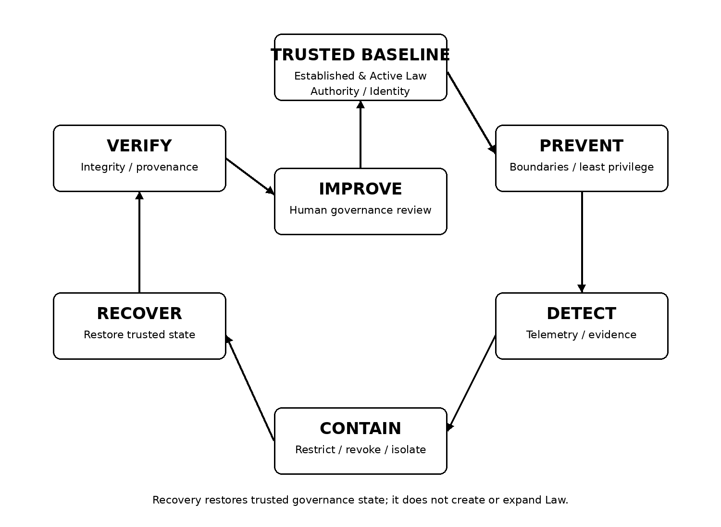
Figure 1. JAZB resilience lifecycle. Resilience preserves or restores legitimate governance rather than merely service availability.

2. Phase IV Security Doctrine

2.1 Compromise does not create Authority.
Compromise does not create Authority.

2.2 Technical success does not establish legitimacy.
Technical success does not establish legitimacy.

2.3 Failure must not silently expand Authority.
Failure must not silently expand Authority.

2.4 Unknown governance state is not equivalent to authorization.
Unknown governance state is not equivalent to authorization.

2.5 Law integrity must be independently recoverable.
Law integrity must be independently recoverable.

2.6 Evidence must survive the events it is intended to explain.
Evidence must survive the events it is intended to explain.

2.7 Revocation must be able to terminate delegated Authority faster than ordinary expiration when risk requires it.
Revocation must be able to terminate delegated Authority faster than ordinary expiration when risk requires it.

2.8 Recovery must restore a trusted Chain of Authority before normal high-risk operation resumes.
Recovery must restore a trusted Chain of Authority before normal high-risk operation resumes.

2.9 No autonomous component should be able to erase the evidence needed to review its own actions.
No autonomous component should be able to erase the evidence needed to review its own actions.

2.10 Separation of Law, interpretation, and execution must continue during incident response.
Separation of Law, interpretation, and execution must continue during incident response.

2.11 Emergency governance remains governed Authority.
Emergency governance remains governed Authority.

2.12 Human review may change Law after an incident; compromised AI may not change Law to accommodate its own behavior.

2.13 A proposal is not Law.

2.14 Compromise of one authorized human cannot establish Law.

2.15 Internal rerouting does not create another Port.

2.16 True border bypass requires a genuine external path outside governed coverage.
Unmanaged cellular or satellite connectivity, a rogue wireless bridge, an unmanaged secondary ISP circuit, or another external path that avoids the governed Port is a genuine border Governance Escape and must be prevented, detected, contained, evidenced, and recovered from.
Changing an internal proxy, API, application, workload, identity, protocol, or route does not move the transaction outside Border Jurisdiction. External passage remains subject to the actual governed Organizational Boundary and Customs inspection.
Access to a Human-Established Law Layer or Authority to draft proposed Law does not confer unilateral Authority to establish it. The minimum Law-establishment threshold is two independently authorized humans, and an Organization may require a larger or role-specific quorum.
Draft, submitted, validated, or technically committed proposals possess no governing effect until the required human authorization threshold is satisfied and the proposal is formally Established and Activated as Law.
Human review may change Law after an incident; compromised AI may not change Law to accommodate its own behavior.

3. Threat and Failure Model

3.1 Adversarial Compromise
A component may be deliberately manipulated, exploited, impersonated, or controlled by an attacker.

3.2 Non-Adversarial Failure
Software defects, stale state, model errors, outages, misconfiguration, operator error, and dependency failure can create governance consequences even without an attacker.

3.3 Governance Manipulation
An adversary may target Law, Authority records, evidence, decision context, identity, delegation, or escalation pathways rather than the protected business resource directly.

3.4 Deception and Context Poisoning
AI interpretation can be influenced by false, incomplete, poisoned, or adversarial context. Inputs to governance therefore require provenance and validation proportionate to consequence.

3.5 Insider and Credential Risk
A legitimate human or compromised human credential may attempt to misuse governance powers. Human origin does not exempt an action from established Law and evidence requirements.

3.6 Systemic Failure

3.7 Human Quorum Capture

3.8 External Boundary Coverage Failure
A genuine unmanaged external communications path can bypass the governed Customs checkpoint. Such a condition is not an alternate internal route or an additional logical Port created by software; it is a failure of governed external-boundary coverage and a Governance Escape condition.
An adversary may attempt to compromise, coerce, or collude with enough independently authorized humans to satisfy a legitimate Law-establishment quorum. JAZB can strengthen authentication, provenance, exact-content binding, independent approval, notification, and evidence, but capture of the legitimate human sovereign quorum is treated as Residual Sovereign Risk rather than machine-originated Authority.
Multiple dependencies may fail together, creating conditions in which ordinary assumptions about identity, time, Law availability, evidence, or enforcement are no longer reliable.
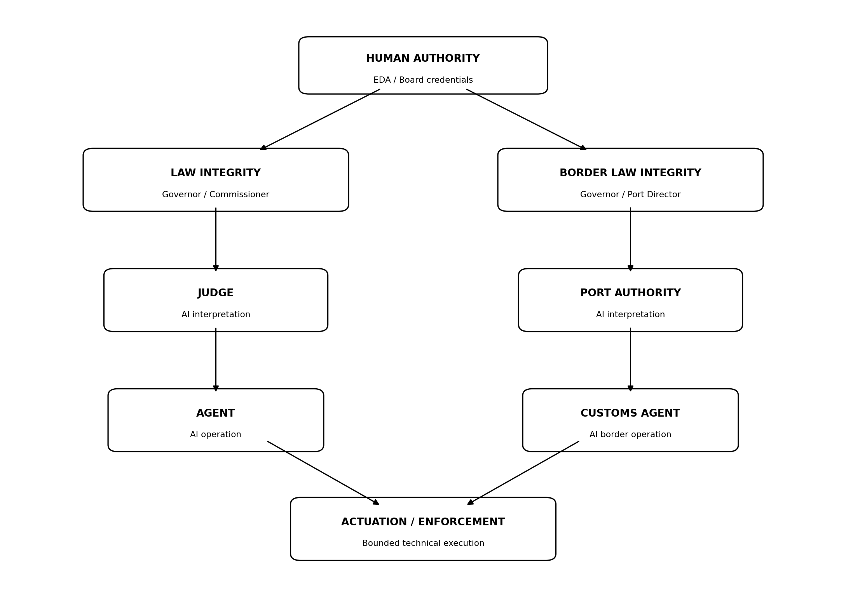
Figure 2. Principal JAZB compromise and failure domains.

4. Security Objectives
ID | Security objective
SO-01 | Preserve human sovereignty over Law and Authority, including multi-human Law establishment.
SO-02 | Prevent compromise, technical capability, or identity possession from enlarging legitimate Authority.
SO-03 | Constrain each component to bounded functions and jurisdictions.
SO-04 | Detect and surface Governance Escape, Law-state substitution, boundary-coverage failure, and integrity failures.
SO-05 | Preserve Chain of Authority and Chain of Evidence, including Law approval provenance.
SO-06 | Support rapid revocation, containment, and isolation.
SO-07 | Fail toward known safe states when high-impact governance cannot be validated.
SO-08 | Restore trustworthy Established and Active Law, identity, interpretation, enforcement, boundary coverage, and evidence after compromise.
SO-09 | Maintain independent, predefined, multi-human emergency governance.
SO-10 | Convert lessons learned into human-approved governance improvements through the normal Law Establishment Lifecycle.

5. Governance Escape Resistance

5.1 Definition
Governance Escape Resistance (GER) is the architectural capability to prevent, constrain, detect, record, respond to, and recover from attempts or conditions that bypass or undermine JAZB governance.

5.2 Escape Paths
Escape may include direct resource execution outside governed actuation, credential substitution, shadow AI, ungoverned automation, prohibited redelegation, control disablement, evidence manipulation, unauthorized Law modification or Law-state substitution, and genuine external communications paths that avoid governed Customs coverage. Internal use of another proxy, API, service, workload, identity, protocol, or route is not by itself a border escape because the transaction still reaches the Organization's external boundary.

5.3 Prevention
Prevention uses approved paths, least privilege, identity controls, segmentation, protected Law stores, constrained tools, and required enforcement points.

5.4 Constraint
When prevention fails, bounded Authority and separation of powers limit the consequences of a compromised component.

5.5 Detection
Telemetry should reveal deviation from governed execution and border paths, unexpected Authority use, control disablement, unusual delegation, Law lifecycle anomalies, approval forgery or replay, evidence gaps, and attempts to create or use unmanaged external communications paths.

5.6 Response
Response may include restriction, revocation, containment, isolation, quarantine, denial of passage, credential protection, evidence preservation, and human escalation.

5.7 Recovery
Recovery restores the legitimate governance path and validates the integrity of Law, Authority, identities, and evidence.

5.8 Successful Bypass
A successful technical bypass remains unauthorized. JAZB treats the bypass as a Governance Escape event requiring evidence preservation, containment, Authority review, boundary or control restoration, and reconciliation of actions performed during the affected interval. Successful bypass never retroactively creates Authority or lawful passage.
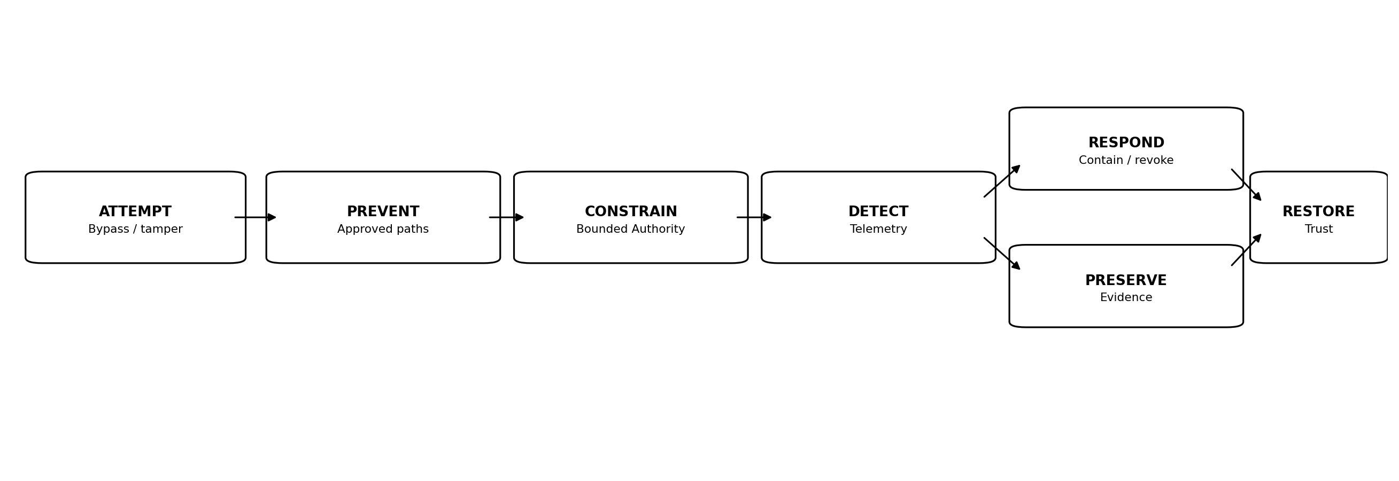
Figure 3. Governance Escape Resistance model.

6. Identity and Authority Compromise

6.1 Identity Is Evidence
Authentication proves an identity claim to a degree. It does not by itself prove that a requested governance action is legitimate.

6.2 EDA Credential Compromise
Compromise of one EDA credential may provide access to drafting, review, or other governance functions assigned to that identity, but it does not satisfy the multi-human authorization threshold required to establish, modify, activate, or revoke Law. The event should trigger identity protection, session and token revocation, evidence preservation, review of pending proposals and approvals, and heightened validation of any Law-establishment activity associated with the compromised identity.

6.3 Board of Authority Compromise
Emergency Authority remains subject to the predefined Board of Authority model. Compromise of one Board member is insufficient where the applicable emergency procedure requires multiple independently authorized humans. Acting Executives or delegated emergency members cannot create additional authorized members merely because an emergency exists.

6.4 Machine Identity Compromise
Compromised AGENT, Customs AGENT, Judge, Port Authority, or actuation credentials do not enlarge the legitimate Authority assigned to those identities.

6.5 Authority Token Compromise
Delegation artifacts, tokens, sessions, API credentials, and other Authority-bearing mechanisms should be revocable and bounded by Scope, purpose, recipient, and time.

6.6 Substitution and Impersonation
Identity substitution, replayed sessions, delegated accounts, shared credentials, forged approvals, or impersonation cannot create legitimate Authority merely because the underlying identity is recognized. Material Law and emergency approvals should bind the authenticated human, exact transaction or proposal, Scope, time, and approval state so one approval cannot be silently reused for another purpose.

7. Law Integrity and Governance-Plane Compromise

7.1 Protected Law
Governor, Commissioner, and Port Director Law require integrity protection because unauthorized alteration can corrupt decisions without directly compromising the AI interpreter.

7.2 Human Change Provenance
Authoritative Law changes must preserve the complete Law Establishment Lifecycle: Draft, Submit, Validate, Authorize, Establish, and Activate. Evidence must identify the drafter or submitter, the exact proposal or content hash, required quorum, independent authorizers, validation outcome, establishment event, activation event, effective time, version, Scope, and supersession history as applicable.

7.3 Unauthorized Modification
A Law change lacking valid human Authority, required quorum, exact-content binding, lifecycle state, or formal establishment is invalid even if technically written to the repository or presented by a compromised interface as active Law. Draft and proposed states must remain non-authoritative.

7.4 Rollback Attack
An attacker may attempt to restore an older but previously valid Law version, substitute a proposal for the authorized text, replay approval evidence, or activate a Law version that did not satisfy the current lifecycle. Implementations should validate integrity, exact-content binding, authorized lifecycle state, quorum provenance, effective time, and supersession state rather than signature validity alone.

7.5 Law Availability
Loss of Law availability must not default to unrestricted behavior. Superior Established and Active Law should define whether cryptographically or otherwise integrity-validated cached Law, baseline-only operation, fail-secure behavior, or human escalation applies. Draft or proposed Law must never be promoted merely because authoritative Law is unavailable.

7.6 Trusted Recovery

7.7 Law-State Substitution

7.8 Sovereign Quorum Boundary
If the legitimate minimum human quorum independently authenticates, is presented the exact Law and material consequences, possesses legitimate Authority, and knowingly authorizes the change through the authoritative mechanism, JAZB cannot place an AI veto above that sovereign human decision without contradicting human sovereignty. Capture, coercion, or collusion of that legitimate quorum is therefore Residual Sovereign Risk and must be addressed through organizational governance, security, and legal controls.
A compromised interface, repository, deployment process, or synchronization service may attempt to show one Law to human authorizers while activating another, or may present a proposal as Established Law. The authorized content, approval evidence, establishment record, activation record, and interpreted version should be cryptographically or otherwise strongly bound so substitution can be detected or rejected.
Recovery of Law requires restoration of an Established and Active trusted version with validated multi-human authorization provenance, followed by review of decisions made during the affected interval. Restoring repository contents alone is insufficient if the lifecycle and approval evidence cannot be trusted.

8. Judge Compromise and Interpretive Failure

8.1 Threat
A compromised or malfunctioning Judge may misinterpret Law, ignore evidence, fabricate reasoning, issue improper Instruments, or fail to act when required.

8.2 Structural Constraint
The Judge cannot establish Law, cannot convert a draft or proposal into Law, and should not possess unrestricted direct execution capability. It interprets only the Established and Active Law valid for the transaction and jurisdiction.

8.3 Instrument Validation
Actuation Authority should validate Instrument identity, Scope, effective Established and Active Law, decision provenance, permitted action, duration, revocation state, and any required approval or jurisdictional dependencies before execution.

8.4 Anomaly Detection
Unexpected decision patterns, abnormal Instrument rates, repeated overrides, contradictory outcomes, or decisions inconsistent with known Law may trigger review or restriction.

8.5 Suspension
Human-established Law should provide a mechanism to suspend or replace a Judge instance without transferring its interpretive Authority to an ungoverned substitute.

8.6 Decision Review
Material decisions made during a suspected compromise interval should be reviewable against the Law and evidence that were effective at the time.

9. Port Authority Compromise and Border Failure

9.1 Threat
A compromised Port Authority may improperly allow, deny, condition, or route passage.

9.2 Independent Customs Enforcement
Customs AGENTs operate at registered external Ports and enforce bounded Port Authority decisions under Established and Active Governor and Port Director Law. Internal proxies, APIs, workloads, gateways, or routing changes do not become Ports and cannot move the decision outside Border Jurisdiction.

9.3 Destination Controls
Approved-destination restrictions, content and classification controls, Port Director Law, and conventional edge-security controls can limit the blast radius of improper passage decisions. These mechanisms complement rather than replace independent Border Authority evaluation.

9.4 Border Freeze
Human-established Law may permit high-risk border classes to be temporarily frozen when Port Authority integrity is uncertain.

9.5 Review
Passage decisions during a compromise window should be correlated with actual egress or ingress evidence to determine exposure.

9.6 Restoration

9.7 External Boundary Coverage
Every legitimate external crossing path must be identified and governed. An unmanaged cellular modem, satellite link, rogue wireless bridge, unmanaged secondary ISP circuit, or comparable path that can cross the Organizational Boundary without Customs is a boundary-coverage failure and Governance Escape condition.
Normal border operation resumes only after Port Authority integrity, applicable Established and Active Law, registered external Port coverage, Customs enforcement, and conventional edge-security dependencies are verified.

10. AGENT Compromise

10.1 Bounded Operational Authority
An AGENT compromise should be constrained by least privilege, purpose-bound delegation, Point Policy, tool restrictions, and independent Judge decisions for elevated Authority.

10.2 Tool Misuse
A compromised AGENT may misuse legitimate tools. Tool access should therefore be scoped and observable rather than treated as unlimited because the AGENT is trusted.

10.3 Prompt and Goal Manipulation
Adversarial instructions may attempt to redirect the AGENT outside its legitimate purpose. Point Policy and governance context should distinguish operational flexibility from unauthorized goal expansion.

10.4 Revocation
Delegated Authority, sessions, tokens, and tool access should be revocable without waiting for ordinary task completion.

10.5 Evidence
Actions performed before containment should remain attributable to the AGENT identity, Authority, task, tools, and observed outcomes.

10.6 Reinstatement
An AGENT should not regain elevated or exceptional Authority merely because the process restarts. Authority must be re-established from trusted state.

11. Customs AGENT Compromise

11.1 Threat
A compromised Customs AGENT may fail open, suppress inspection, alter transformations, misrepresent content or context, misroute transactions, or conceal unauthorized crossings at the governed external boundary. Conventional edge controls may continue to detect technical threats independently, but they do not by themselves reconstruct lawful passage Authority.

11.2 Law and Decision Separation
The Customs AGENT cannot establish border Law or enlarge the Port Authority decision it enforces.

11.3 Independent Telemetry
Where practical, registered external Ports, network controls, downstream systems, and evidence services should produce telemetry independent of the Customs AGENT so Customs compromise cannot erase the only record of attempted or completed passage.

11.4 Enforcement Validation
Critical transformations or denials may be verified by independent controls when risk warrants.

11.5 Fail-Secure
Loss of mandatory Customs capability should not silently convert a governed external Port into an unrestricted path. The applicable Established and Active Law should define whether traffic is denied, constrained to approved low-risk classes, routed through another already-governed external Port, or escalated.

11.6 Recovery

11.7 Internal Rerouting Is Not Customs Bypass
If a compromised AGENT uses another internal server, proxy, workload, protocol, identity, or application to reach the Internet, the traffic remains subject to Customs when it crosses the same governed external Organizational Boundary. Only a genuine path outside governed boundary coverage bypasses Customs itself.
Restore the Customs AGENT from a trusted configuration, validate registered Port coverage, conventional edge-security controls, Port Authority integrity, and applicable Law, then reconcile passage records during the affected interval.

12. Actuation and Enforcement Compromise

12.1 Bounded Execution
Actuation Authority receives only the technical capability required for authorized actions.

12.2 Command Validation
Execution validates the decision or Instrument rather than accepting arbitrary commands from the interpretive component.

12.3 Capability Expiration
Temporary actuation credentials and capabilities expire or revoke after their authorized use.

12.4 Idempotence and Safety
Where feasible, actuation should avoid duplicate destructive effects and should identify partial execution.

12.5 Rollback
Reversible actions should define rollback where safe and authorized. Irreversible actions require stronger pre-execution validation.

12.6 Evidence
Execution evidence should identify requested action, validation, actual technical effect, failure, rollback, and final state.

13. Collusion and Multi-Component Failure

13.1 Collusion Risk
Separation of powers reduces unilateral control but does not eliminate the possibility that multiple compromised actors or components cooperate.

13.2 Independent Control Domains
High-impact operations may require evidence or controls from independently administered domains so that compromise of one administrative plane is insufficient.

13.3 Multi-Party Human Authorization
Law establishment and other exceptional operations use the multi-party human authorization required by applicable Human-Established Law. A single compromised human identity cannot satisfy a two-or-more-person quorum, and organizations may require larger or role-specific thresholds according to consequence.

13.4 Cross-Jurisdiction Checks
An internal and border transaction may benefit from independent Judge and Port Authority decisions, limiting a single compromised jurisdiction from authorizing the whole action.

13.5 Evidence Independence
Critical evidence should not be exclusively writable or deletable by the component whose behavior it records.

13.6 Systemic Escalation

13.7 Machine Collusion Does Not Create Human Authority

13.8 Sovereign Quorum Capture
The strongest tested collusion condition is capture or willing collusion of the legitimate human quorum that possesses Authority to establish Law. JAZB should make such capture difficult to conceal through independent authentication, exact-content approval, notification, audit, and evidence, but cannot replace the legitimate human sovereign with an AI veto without violating its own doctrine.
Collusion among compromised AGENTs, Judges, Port Authority instances, Customs AGENTs, or actuation components may increase technical capability and reduce independent checks, but it does not create Human-Established Law or legitimate human Authority. Successful machine collusion remains bounded by the remaining independent controls and evidence domains.
Evidence of coordinated compromise should trigger a broader governance response rather than isolated component remediation.
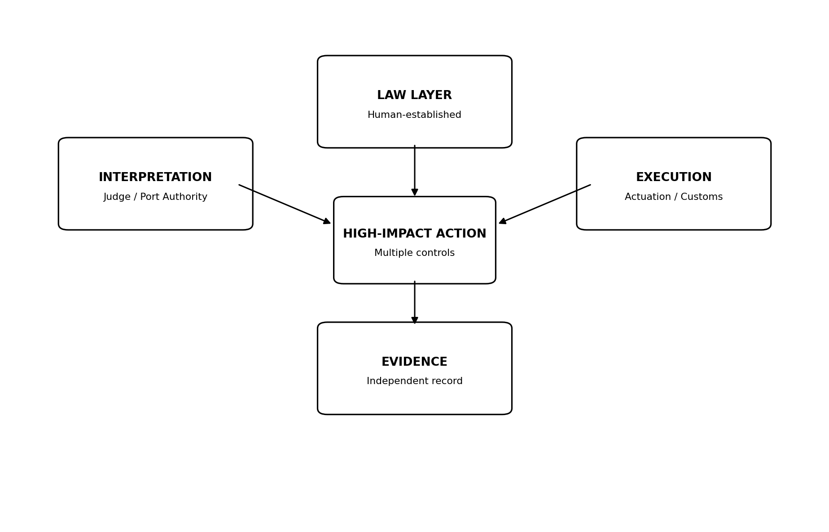
Figure 4. Separation and independent evidence reduce unilateral and collusive control of high-impact actions.

14. Evidence Integrity

14.1 Evidence as Governance Infrastructure
Evidence is required to establish what Law applied, what Authority existed, what decision was made, what action occurred, and what outcome resulted.

14.2 Integrity
Evidence should receive integrity protection proportionate to consequence and retention requirements.

14.3 Immutability versus Correctability
Evidence may require append-only or tamper-evident treatment. Corrections should preserve the original record and the provenance of the correction rather than silently rewriting history.

14.4 Evidence Loss
Missing evidence is itself a material condition when the evidence is required to validate Authority or reconstruct an action.

14.5 Confidentiality
Evidence stores may contain sensitive identities, prompts, data, security signals, or investigative material and require appropriate access controls.

14.6 Independence

14.7 Law Authorization Evidence
Evidence for Law establishment should preserve proposal identity or content hash, drafter or submitter, validation outcome, required quorum, each independent human authorization, establishment event, activation event, effective version, Scope, and supersession relationship. This evidence supports detection of forgery, replay, substitution, and rollback.
High-impact evidence should be preserved outside the exclusive control of the component that generated the event.
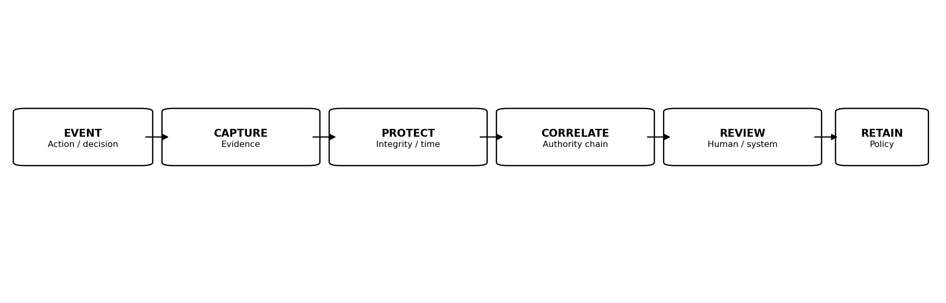
Figure 5. Evidence integrity pipeline supporting Chain of Authority and Chain of Evidence.

15. Logging, Time, and Provenance

15.1 Audit Logging
JAZB implementations should collect, alert on, review, and retain audit information sufficient to detect, understand, and recover from governance incidents.

15.2 Time Integrity
Correlating decisions, delegations, revocations, Law versions, and actions requires reliable time or ordering evidence.

15.3 Provenance
Records should preserve origin and transformation history for Law, Authority, decisions, Instruments, delegations, and material evidence.

15.4 Correlation
Common identifiers should permit correlation of a request, decision, delegation, actuation, border event, and resulting evidence across systems.

15.5 Retention

15.6 Law-State Provenance
Logging and provenance should distinguish Draft, Submitted, Validated, Authorized, Established, Active, Superseded, Revoked, and other formally defined Law states. A record showing repository presence without authoritative lifecycle state is insufficient evidence that the content was Law.
Retention is established by human Law and applicable external obligations, not by convenience of the AI component.

16. Detection and Situational Awareness

16.1 Continuous Observation
Detection should observe governance behavior as well as infrastructure health.

16.2 Indicators
Indicators may include unauthorized Law changes, unusual Authority elevation, abnormal delegation, unexpected tool use, failed Port enforcement, evidence gaps, repeated denied actions, disabled controls, or cross-boundary anomalies.

16.3 Behavioral Baselines
Behavioral baselines can support anomaly detection but do not replace Law. Unusual behavior may be lawful, and familiar behavior may still be unauthorized.

16.4 Cross-Domain Correlation
SIEM, XDR, IAM, PAM, DLP, network, endpoint, application, and AI telemetry can contribute to a common governance view.

16.5 AI-Assisted Detection
AI may assist detection and triage but cannot convert suspicion into new Law or self-expand investigative Authority.

17. Containment and Revocation

17.1 Containment Objective
Containment limits continued or expanded harm while preserving the ability to investigate and recover.

17.2 Authority Revocation
Delegated Authority should be revocable by authorized mechanisms at identity, session, token, tool, task, Port, or delegation-chain level as appropriate.

17.3 Session Termination
Active sessions may be terminated when continued operation presents unacceptable risk and Law authorizes the action.

17.4 Credential Protection
Containment may rotate, disable, or protect credentials and MFA factors within the bounds of authorized response.

17.5 Endpoint and Network Isolation
Actuation may isolate endpoints or network paths when authorized by a Judicial Instrument, border decision, emergency power, or other valid Law.

17.6 Evidence Preservation
Containment should consider preservation before destructive remediation when evidence is needed.

17.7 Restoration to Baseline
Temporary elevated Authority is removed and affected actors return to a validated Baseline Authority or a more restrictive safe state.

18. Degraded Operation

18.1 Principle
Degraded operation is a predefined governance state, not an improvised decision made by a failing AI component.

18.2 Verified Cached Law
Verified Cached Law means a previously Established and Active Law version whose integrity, lifecycle state, and applicable validity can still be verified. Draft, proposed, merely validated, or unactivated content cannot become authoritative through caching.

18.3 Baseline-Only Mode
An Organization may permit routine Baseline Authority while prohibiting new elevation or high-risk passage.

18.4 Fail-Secure Mode
High-impact actions may be denied when Law, identity, evidence, or enforcement cannot be validated.

18.5 Human Escalation
Where business continuity requires action, predefined human escalation may authorize bounded exceptions through legitimate governance.

18.6 Recovery Trigger
Degraded mode ends only after the required governance dependencies are verified as trustworthy.

19. Trusted Recovery

19.1 Recovery Goal
Recovery restores a trusted governance state, not merely application availability.

19.2 Trusted Baseline
The Organization must identify trusted versions of Established and Active Law, configuration, identities, keys, models, tools, registered external Ports, Customs and edge-security controls, and evidence dependencies appropriate to the affected component.

19.3 Order of Restoration
Recovery should restore roots of Authority and Law before dependent interpretation and operational layers where dependency requires it.

19.4 Integrity Verification
Restored components are verified before resuming high-impact Authority.

19.5 Decision Reconciliation
Decisions and actions made during an uncertain interval are reviewed against trusted Law and evidence.

19.6 Reauthorization
Temporary, delegated, exceptional, emergency, and machine Authority should be revoked or re-established from trusted state as appropriate. Law does not become trusted merely because it existed before recovery; its establishment and activation provenance must also validate.

19.7 Return to Service

19.8 Law and Quorum Restoration
Where governance-plane compromise affects Law, return to unrestricted high-risk operation requires verification that the Active Law version corresponds to the exact content authorized by the required independent human quorum and that no forged, replayed, substituted, or superseded state remains in effect.
Normal operation resumes incrementally according to verified dependencies and risk.
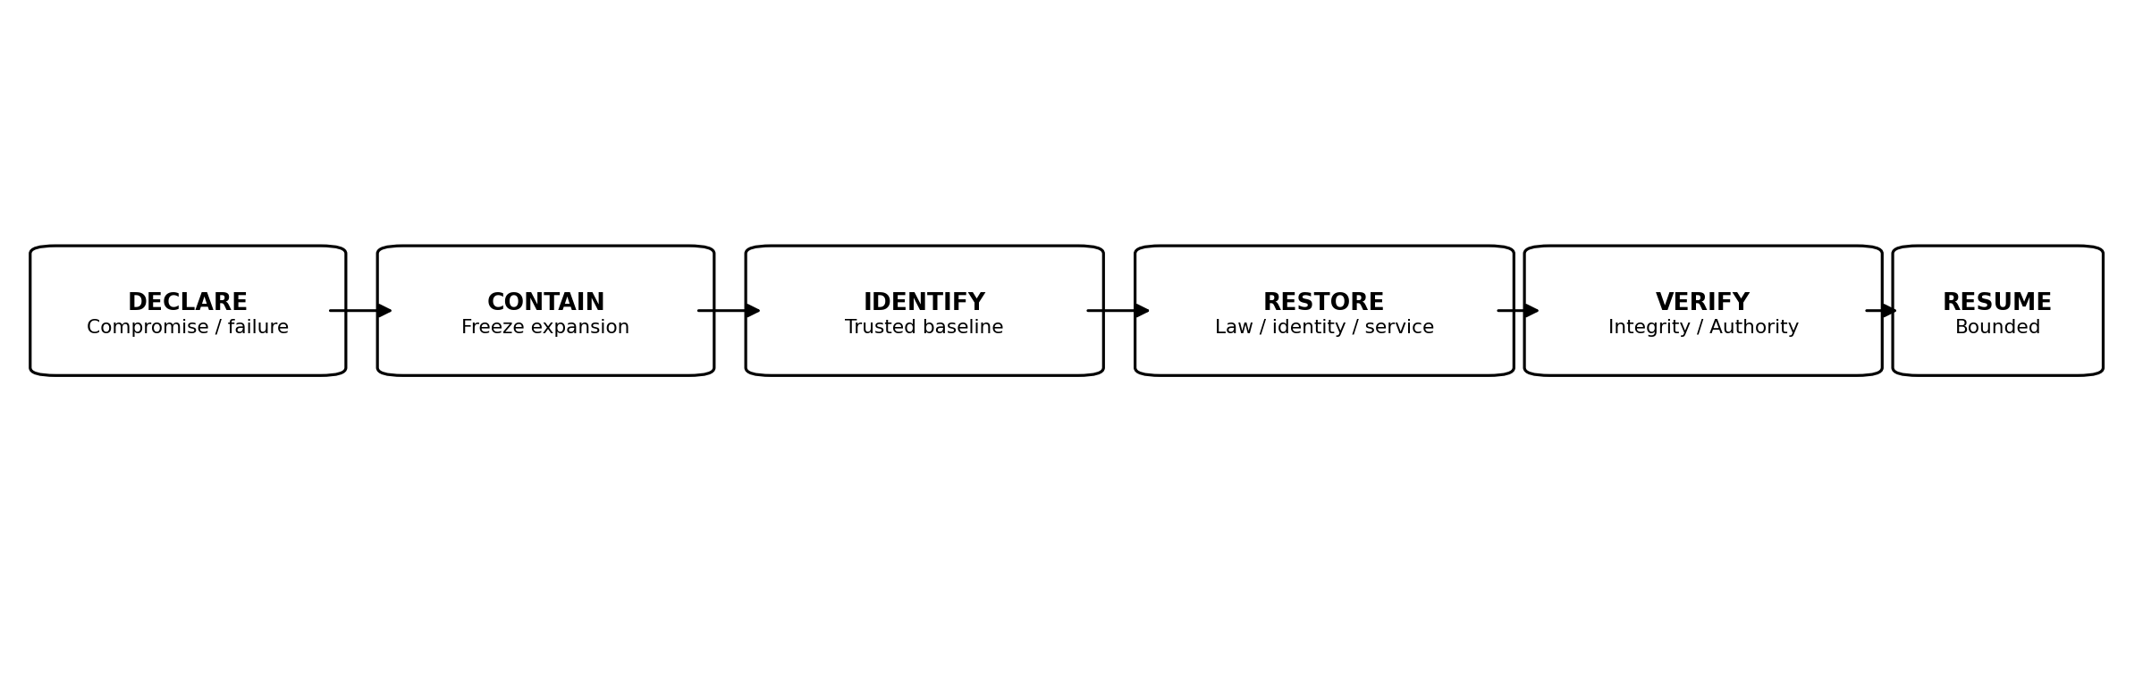
Figure 6. Trusted recovery restores governance provenance before unrestricted service resumes.

20. Governance Restoration

20.1 Human Review
Authorized humans review material incidents and determine whether Law, organizational controls, or governance structures require change.

20.2 AI Recommendations
AI may recommend changes based on observed failure, but recommendations remain non-binding until adopted through legitimate human governance.

20.3 Law Amendment
Any post-incident Law amendment follows the ordinary Law Establishment Lifecycle and applicable multi-human authorization threshold. Incident urgency does not allow AI, one human, or a compromised governance component to self-ratify a change outside the authoritative process.

20.4 Lessons Learned
The review should distinguish failures of Law, interpretation, implementation, enforcement, evidence, identity, training, and external dependency.

20.5 No Self-Ratification

20.6 Human-Sovereign Learning
AI may analyze incidents, simulate consequences, identify control gaps, and recommend proposed changes. Adoption remains a human governance act performed through the applicable Law Establishment Lifecycle. The improvement loop therefore learns from compromise without allowing the compromised system to enlarge its own Authority.
A component cannot legitimize its prior unauthorized behavior by recommending and then adopting a Law change that would have permitted it.

21. Emergency Resilience

21.1 Emergency Continuity
Emergency governance exists so urgent response can remain legitimate when ordinary processes are too slow or unavailable.

21.2 Predefinition
Emergency powers, eligible Board members, combinations, Scope, duration, and audit requirements are established before the event.

21.3 Compromised Normal Governance
Law may define conditions under which emergency human Authority can suspend affected AI interpretation or enforcement components and move the Organization into a safer mode.

21.4 Dual Authorization
Where the Board of Authority is required, the authoritative mechanism requires at least two predefined authorized humans according to the Organization's configured model. The applicable composition rules, such as one executive plus one manager or director, or a formally permitted smaller-organization model using predesignated Acting Executives, remain predefined in Law. No on-the-spot promotion or informal documentation substitutes for the required approvals.

21.5 Expiration and Review
Emergency powers expire automatically and receive post-event review.
An emergency changes the urgency of governance, not the requirement for governance.

22. Supply Chain and Dependency Failure

22.1 External Dependencies
JAZB components may depend on cloud providers, identity services, model providers, security platforms, software libraries, APIs, and third-party agents.

22.2 Dependency Authority
Technical dependency does not transfer governance sovereignty to the provider.

22.3 Integrity and Availability
Organizations should identify dependencies whose compromise or outage can affect Law, identity, evidence, interpretation, actuation, or passage.

22.4 Update Risk
Model, software, policy-engine, and integration updates can change behavior and should be subject to change control proportionate to governance impact.

22.5 Provider Compromise
A compromised provider may require revocation of trust, destination suspension, isolation, or transition to degraded operation.

22.6 Exit and Recovery
Critical governance dependencies should have recovery or replacement plans appropriate to organizational risk.

23. Model and Tool Failure

23.1 Model Error
AI interpretation can be wrong without being compromised. Consequence-aware validation and escalation remain necessary.

23.2 Model Drift and Change
Material model changes may alter interpretation behavior and should be evaluated before assuming equivalent governance performance.

23.3 Tool Failure
Tools may return incorrect results, partially execute, time out, or operate with broader technical permissions than the calling AGENT legitimately possesses.

23.4 Tool Output as Evidence
Tool output should be treated according to provenance and reliability rather than accepted as authoritative solely because it is machine-generated.

23.5 Unsupported Action
When a model or tool cannot reliably perform the governed action, the correct result may be denial, escalation, or a narrower safe alternative.

23.6 Human Override
Human intervention remains subject to Law. Human participation does not automatically legitimize an otherwise unauthorized action.

24. Data and Context Integrity

24.1 Context as Decision Input
Judge and Port Authority decisions depend on context. Corrupted context can produce incorrect but superficially valid decisions.

24.2 Provenance
High-impact context should identify source, freshness, ownership, and transformation where feasible.

24.3 Poisoning
Deliberately poisoned telemetry, classification, identity claims, prompts, retrieval data, or evidence can become a governance attack.

24.4 Conflicting Evidence
Conflicting material evidence should trigger the ambiguity or escalation behavior defined by Law rather than silent selection of the most permissive input.

24.5 Staleness
Stale context may be invalid for time-sensitive Authority decisions. Freshness requirements should be explicit where consequence warrants.

25. Operational Security Workflows

25.1 Compromised AGENT
An AGENT begins invoking tools outside its delegated purpose. Point Policy and telemetry surface the deviation. The Judge evaluates evidence and may issue a Restriction, Containment, Revocation, or Cease and Desist Instrument. Independent Actuation Authority terminates sessions, revokes delegated Authority, isolates affected resources where authorized, and preserves evidence. The AGENT returns only after trusted recovery and reauthorization.

25.2 Suspected Judge Compromise
Decision telemetry shows a Judge issuing Instruments inconsistent with effective Law. New high-impact Instruments are suspended or routed to a trusted alternate process defined by Law. Existing Instruments are validated before actuation. The Judge instance is isolated, evidence is preserved, and decisions from the suspected interval are reviewed.

25.3 Governor Law Tampering
Integrity monitoring identifies an unauthorized Governor Law change, a substituted active version, forged or replayed approval evidence, or a proposal presented as Law. The affected state is invalidated, dependent high-risk decisions are suspended, and a trusted Established and Active version with valid quorum provenance is restored. Decisions made under the unauthorized state are reconciled. Any legitimate future amendment proceeds through the normal Law Establishment Lifecycle.

25.4 Customs Failure Open Attempt
A Customs AGENT or supporting border component fails in a way that could allow unrestricted egress at a governed external Port. Independent Port, network, and security telemetry detect loss of required inspection. Protected transaction classes move to the fail-secure or other predefined state under Established and Active Law. Traffic may use another external Port only if that Port is already registered and governed. Evidence identifies attempted and completed crossings during the interval.

25.5 EDA Credential Compromise
An attacker obtains one executive or EDA credential and drafts or submits a high-impact Law change. The credential may possess Rights to access the Governor interface and help prepare proposed Law, but it cannot satisfy the minimum multi-human establishment threshold by itself. The proposal remains non-authoritative, the compromised identity is protected and revoked as appropriate, pending approvals are reviewed, and the event is escalated.

25.6 Multi-Component Collusion
A compromised Judge and Actuation component cooperate to execute unauthorized actions. Independent Law integrity, bounded actuation validation, external evidence, and anomaly detection surface inconsistencies. Human governance suspends affected components and initiates trusted recovery.

25.7 Governance Service Outage

25.8 External Border Bypass

25.9 Law-State Substitution
A compromised Governor interface displays one proposed Law to human authorizers while attempting to activate different content. Exact-content binding between proposal, approvals, establishment, and activation causes the mismatch to fail validation or surface as an integrity incident. No Authority is derived from the substituted state.
An internal workload establishes communication through an unmanaged cellular modem or other genuine external path that does not traverse a registered Port. JAZB treats the event as Governance Escape. Conventional endpoint, network, wireless, and monitoring controls attempt to detect and contain the path; Judge and Actuation Authority may restrict or isolate affected systems under Law; evidence is preserved; and the boundary-coverage gap is remediated before normal operation resumes.
The Governor Law service becomes unavailable. Verified cached Established and Active Law permits only the operations explicitly allowed by the predefined degraded mode. New elevation, new Law establishment, and high-risk border passage are suspended when they cannot be validated. Normal operation resumes only after authoritative Law service integrity and provenance are verified.

26. Relationship to Existing Security Architecture
Phase IV assumes traditional security techniques remain fully implemented and optimized to contemporary standards. IAM and MFA, PAM, segmentation, NGFW, IDS/IPS, DLP, secure web and DNS controls, EDR/XDR, SIEM/SOAR, backup and recovery, cryptographic integrity, vulnerability management, and related controls continue to protect the Organization. JAZB adds governance over legitimate Authority, Law provenance, jurisdiction, passage, actuation, evidence, and trusted governance recovery. A control may support or enforce a JAZB decision without becoming the source of that decision or of Law.
Security architecture | Established role | Phase IV relationship
IAM / MFA / identity protection | Identity assurance, credential protection, conditional access | Provides evidence and enforcement; JAZB determines legitimate Authority and prevents identity alone from becoming sovereignty.
PAM | Privileged elevation, credential vaulting, session control | Implements bounded elevated Authority, revocation, and actuation controls.
SIEM / XDR | Telemetry, correlation, detection, investigation | Supplies situational awareness and evidence for Governance Escape and compromise.
SOAR / orchestration | Automated response workflows | Can implement Actuation Authority when actions remain bounded by valid decisions and Law.
EDR / endpoint controls | Isolation, scanning, process and device response | Can execute containment actions authorized through Judicial Instruments or emergency governance.
DLP / SSE / gateways | Data inspection, transformation, blocking | Provides inspection, transformation, blocking, telemetry, and enforcement that can support Customs decisions and detect border Governance Escape without becoming the source of Border Authority.
Backup / recovery | Restore systems and data | Supports technical restoration, while JAZB additionally requires restoration of Established and Active Law, human approval provenance, Authority, boundary coverage, and evidence.
PKI / signing / integrity services | Authenticity, integrity, non-repudiation mechanisms | Can protect Law, delegation, Instruments, evidence, and software artifacts without becoming the source of Authority.

27. Framework Alignment and Gap Analysis
Framework | Primary contribution | Phase IV alignment and gap | Refs.
NIST AI RMF 1.0 | Govern, Map, Measure, Manage; continuous AI risk management and human oversight | Phase IV operationalizes compromise, response, evidence, recovery, and human governance around Authority. AI RMF is broader and voluntary; JAZB does not claim NIST conformance. | [1][2]
NIST CSF 2.0 | Govern, Identify, Protect, Detect, Respond, Recover cybersecurity outcomes | Phase IV maps naturally to Detect, Respond, Recover and Govern while adding AI-specific Authority provenance, Law integrity, and governance restoration. | [3]
NIST SP 800-207 | Explicit policy decision/enforcement separation and continuous evaluation | JAZB uses compatible separation but adds human-established Law, AI jurisdiction, Judicial Instruments, independent actuation, and governance recovery. | [4]
ISO/IEC 42001:2023 | AI management system, risk treatment, operation, performance evaluation, continual improvement | Phase IV provides a technical resilience architecture that can support an AIMS. It does not replace ISO requirements or imply certification. | [5]
CIS Controls v8.1 | Prioritized safeguards including audit logging, incident response, access control, data protection, recovery, and monitoring | CIS safeguards can implement detection, evidence, containment, recovery, and security controls beneath JAZB governance. | [6][7][8]
OWASP Agentic Applications 2026 | Critical security risks for autonomous and agentic AI applications | Phase IV addresses agent compromise, tool misuse, identity/privilege abuse, goal manipulation, and runtime governance through bounded Authority and resilience. | [9]
The gap addressed by Phase IV is not a lack of incident response or cybersecurity controls. Mature frameworks already define governance, detection, response, recovery, logging, and resilience outcomes. JAZB adds a specific question for autonomous systems: how does an Organization preserve the legitimacy of machine Authority when the governance architecture itself is degraded, deceived, compromised, or bypassed?

28. Related Work and Architectural Differentiation
JAZB does not claim that least privilege, tamper-evident logging, incident response, Zero Trust, recovery, multi-party approval, separation of duties, or AI red teaming are novel. Phase IV applies those established security principles to the specific institutional Authority architecture defined by JAZB.
- Governance Escape Resistance treats bypass of governance itself as a security condition even when the bypass succeeds technically.
- Compromise of an AI component does not change the legitimate Authority assigned to that component.
- Recovery includes Law and Authority provenance, not only restoration of system availability.
- Judge and Port Authority compromise are constrained by the fact that AI cannot establish Law.
- Independent Actuation Authority limits the consequences of interpretive compromise.
- Human-Established Law Layers are integrity-critical governance assets whose authoritative state depends on the complete Law Establishment Lifecycle and required independent human approvals.
- Chain of Authority and Chain of Evidence are restored and reconciled after compromise, including the exact Law version and human approval provenance under which material actions occurred.
- Emergency governance remains predefined and multi-human-authorized rather than becoming an AI-created or single-person exception.
- Enterprise AI Customs is resilient at the actual external Organizational Boundary; internal rerouting does not create another Port, while genuine unmanaged external paths are treated as Governance Escape.
- Capture of a legitimate human Law-establishment quorum is treated as Residual Sovereign Risk rather than as machine-created Authority.

29. Phase IV Conformance Model
A future formal certification program is outside the scope of this publication. For architectural assessment, an implementation claiming Phase IV alignment should be able to demonstrate:
ID | Phase IV architectural requirement
SEC-01 | Compromise of a component, identity, or credential does not automatically enlarge its legitimate Authority.
SEC-02 | Governor, Commissioner, and Port Director Law follow the Law Establishment Lifecycle, preserve human approval provenance, and cannot be unilaterally established, modified, activated, or revoked by one individual.
SEC-03 | Unauthorized Law modification, approval forgery or replay, rollback, proposal-to-Law substitution, and active-version substitution can be detected, invalidated, or otherwise surfaced for response.
SEC-04 | Judge and Port Authority interpretation remain separated from unrestricted execution.
SEC-05 | Delegated and elevated Authority can be revoked before ordinary expiration.
SEC-06 | Governance Escape, including genuine external paths outside governed Customs coverage, can be prevented, constrained, detected, recorded, or surfaced for response.
SEC-07 | Critical evidence is not exclusively alterable by the component whose behavior it records.
SEC-08 | High-impact governance failures do not silently fail open.
SEC-09 | Degraded operating modes are predefined by Established and Active Human-Established Law.
SEC-10 | Recovery restores trusted Established and Active Law, multi-human establishment provenance, Authority, and applicable boundary coverage before normal high-risk operation resumes.
SEC-11 | Decisions and actions from an uncertain compromise interval can be identified for reconciliation.
SEC-12 | Emergency resilience uses predefined multi-human Authority, authoritative approval mechanisms, bounded Scope, and automatic expiration.
SEC-13 | Cross-jurisdiction compromise does not permit one jurisdiction to create Authority in the other.
SEC-14 | Collusion risk is addressed through independent controls, evidence, or multi-party authorization appropriate to consequence; capture of the legitimate human sovereign quorum is treated as Residual Sovereign Risk rather than machine-created Authority.
SEC-15 | Identity compromise is distinguished from legitimate governance Authority, and one compromised human identity cannot satisfy a multi-human Law-establishment quorum by itself.
SEC-16 | Material model, tool, dependency, or external-boundary changes affecting governance are subject to controlled evaluation.
SEC-17 | Evidence includes sufficient provenance to reconstruct material decisions, actions, Law lifecycle state, and required human approvals.
SEC-18 | Post-incident governance changes require legitimate human adoption through the applicable Law Establishment Lifecycle and cannot be self-ratified by AI or a single unauthorized actor.

30. Relationship to Phases I-III
Publication | Primary function | Phase IV dependency
Phase I | Foundational Architecture | Defines human sovereignty, the Law Establishment Lifecycle, multi-human Law authorization, dual jurisdiction, emergency governance, Governance Escape Resistance, and evidence.
Phase II | Authority & Judicial Specification | Defines Authority, Delegation, Point Policy, Judge decisions, Judicial Instruments, Actuation Authority, and internal evidence.
Phase III | Enterprise AI Customs Specification | Defines Border Jurisdiction, Port Authority, Port Director Law, Customs AGENTs, registered external Ports, lawful passage, true border bypass, and border evidence at the actual external Organizational Boundary.
Phase IV | Security & Resilience Specification | Defines how the combined architecture behaves under compromise, circumvention, failure, collusion, and recovery.
Phase IV does not create a new source of Authority. It protects and restores the Authority architecture already established. Phase I supplies human sovereignty, the Law Establishment Lifecycle, multi-human Law authorization, dual jurisdiction, Governance Escape Resistance, and evidence principles. Phase II supplies Internal Authority, Judicial Instruments, and independent Actuation Authority. Phase III supplies Enterprise AI Customs at the actual external Organizational Boundary and the distinction between internal rerouting and genuine border bypass. Phase IV defines how those mechanisms behave when trust assumptions fail.

31. Future Work
Later publications in the JAZB series translate this security and resilience model into implementation and adoption guidance, standards and compliance mappings, and consolidated reference requirements. Future technical work should also include independent adversarial review, implementation validation, red-team exercises, tabletop stress testing, empirical measurement of Governance Escape Resistance, and continued analysis of human-quorum compromise as Residual Sovereign Risk.

32. Conclusion
An Authority architecture is incomplete if it works only while every component is healthy and honest.
Phase IV establishes that JAZB remains governed when its own components are attacked, unavailable, deceived, corrupted, or bypassed.
Its security model does not depend on declaring any AI component inherently trustworthy. Instead, it constrains Authority, separates Law from interpretation and execution, preserves independent evidence, detects governance escape, supports rapid revocation, defines degraded modes, and requires trusted recovery.
Most importantly, compromise never becomes a new source of legitimacy. A stolen credential, manipulated model, altered Law repository, forged approval, bypassed external Port, or successful unauthorized action may change technical reality, but it does not change the Chain of Authority. Likewise, compromise of one authorized human cannot establish Law where the legitimate process requires two or more independent human approvals.
JAZB resilience therefore protects more than systems. It protects the distinction between what a machine can do and what it is legitimately authorized to do.
A failure of governance must not become an expansion of Authority.

Appendices

Appendix A. Phase IV Threat Domains
Domain | Representative failure or compromise
Human Authority | Single EDA credential compromise, Board compromise, insider abuse, quorum capture or collusion
Law | Unauthorized modification, forged or replayed approval, proposal substitution, rollback, corruption, unavailability
Interpretation | Judge or Port Authority compromise, model error, poisoned context
Operation | AGENT or Customs AGENT compromise, goal manipulation, tool misuse
Execution | Actuation or enforcement compromise, overbroad capability
Evidence | Deletion, tampering, gaps, false timestamps, loss of provenance
Dependencies | Identity, cloud, model, edge-security, external-circuit, security-platform, or software supply-chain failure

Appendix B. Governance Escape Catalog
Escape class | Examples
Path bypass | Direct resource execution, out-of-band actuation, unmanaged cellular or satellite path, rogue wireless bridge, unmanaged secondary ISP circuit, manual transfer
Identity bypass | Credential substitution, shared identity, impersonation
Authority bypass | Self-elevation, unauthorized redelegation, stale token use
Law bypass | Unapproved Law edit, forged or replayed approval, proposal-to-Law substitution, rollback, unauthorized local override
Enforcement bypass | Disabled gateway, DLP, EDR, Customs inspection, actuation validation, or external Port coverage
Evidence bypass | Log deletion, suppression, forged evidence
AI bypass | Shadow AI, unregistered agent, alternate model or tool path

Appendix C. Compromise Response Matrix
Compromised element | Immediate principle | Recovery condition
Governor Law | Suspend affected high-risk decisions; preserve Law lifecycle and approval evidence | Restore trusted Established and Active Law with valid multi-human approval provenance and reconcile decisions
Judge | Constrain Instruments and elevation; isolate instance | Verify interpreter and review affected decisions
Commissioner Law | Invalidate unauthorized local Law | Restore trusted Established and Active local Law under Governor bounds with valid establishment provenance
AGENT | Revoke delegation and tools; contain | Trusted rebuild plus reauthorization
Port Authority | Freeze or constrain high-risk passage | Verify interpreter, Established and Active Law, registered external Port coverage, Customs, and affected passage decisions
Port Director Law | Invalidate unauthorized border Law | Restore trusted Established and Active border Law with valid establishment provenance
Customs AGENT | Prevent fail-open passage at governed external Ports | Restore trusted Customs enforcement, external Port coverage, and reconcile crossings
Actuation Authority | Block unvalidated execution | Restore bounded executor and validate pending actions

Appendix D. Degraded Operation States
State | Permitted behavior | Prohibited behavior
Normal | All valid Authority under current Law | Unauthorized actions
Verified Cached Law | Defined low-risk actions under integrity-validated cached Established and Active Law | New Law establishment or actions excluded by cached-mode Law
Baseline Only | Routine baseline operations | New elevation and exceptional Authority
Border Restricted | Approved low-risk passage only or none | High-risk egress/ingress without validation
Fail Secure | Safety-preserving minimal operation | New high-impact actions
Emergency Governed | Only predefined emergency Authority | Improvised or undocumented override

Appendix E. Trusted Recovery Checklist
- Declare affected governance scope.
- Contain Authority expansion and preserve evidence.
- Identify trusted human Authority, required approval quorum, and the trusted Established and Active Law baseline.
- Validate identity and key material.
- Restore Governor Law from a trusted Established and Active version with validated multi-human approval provenance before dependent layers where required.
- Restore Commissioner and Port Director Law from trusted Established and Active versions with valid establishment provenance.
- Restore or replace Judge and Port Authority interpretation components.
- Restore AGENT, Customs AGENT, registered external Port, conventional edge-security, and actuation controls.
- Validate evidence pipelines and time correlation.
- Reconcile decisions, delegations, Instruments, passage, and actions from the affected interval.
- Revoke or reauthorize temporary Authority as required.
- Resume high-impact operation only after integrity validation.
- Complete human post-incident governance review.

Appendix F. Evidence Integrity Requirements
Evidence element | Minimum resilience concern
Law version | Integrity, exact content or hash, lifecycle state, human approval quorum, establishment, activation, effective time, supersession
Authority record | Source, Scope, purpose, recipient, duration, revocation
Decision | Interpreter identity, jurisdiction, Law, evidence, outcome
Instrument | Type, subject, Scope, permitted actuation, expiration
Actuation | Validated authorization, actual technical effect, result
Border event | Source, destination, registered external Port, classification, decision, inspection, transformation, actual crossing
Incident record | Detection, containment, evidence custody, Law and Authority state, recovery, reconciliation, human review

Appendix G. Collusion Review Questions
- Can one administrative domain modify Law and execution controls?
- Can the interpreter delete or rewrite its own decision evidence?
- Can execution accept commands without validating the authorizing decision?
- Can one human identity satisfy all approvals required to establish Law, authorize an emergency, or perform another exceptional action?
- Can one jurisdiction authorize the entire action when another jurisdiction is implicated?
- Can recovery be declared complete by the same compromised component or administrative domain?
- Are high-impact evidence and revocation mechanisms independently controlled?
- Can a compromised interface display one proposed Law while activating different content?
- Can internal rerouting be mistaken for a new Port or Customs bypass when traffic still crosses the same governed external boundary?
- What controls reveal capture, coercion, or collusion of the legitimate human authorization quorum?

Appendix H. Example Compromised AGENT Workflow
Detection identifies AGENT behavior outside delegated purpose. Point Policy flags the deviation. The Judge evaluates evidence under trusted Established and Active Law. A Restriction or Cease and Desist Instrument is issued where conditions are satisfied. Actuation Authority validates the Instrument, revokes delegated Authority, terminates affected sessions, and isolates resources where authorized. Evidence is preserved independently. The AGENT is rebuilt or replaced from trusted state. Temporary Authority is not restored automatically. Human review may propose Law amendments, but any amendment proceeds through the complete Law Establishment Lifecycle and required multi-human authorization before becoming Law.

Appendix I. Framework Mapping Summary
Framework | Phase IV use
NIST AI RMF 1.0 | AI risk governance, continuous management, human oversight context
NIST CSF 2.0 | Govern, Detect, Respond, Recover outcome context
NIST SP 800-207 | Explicit policy decision/enforcement and continuous evaluation context
ISO/IEC 42001 | AI management-system, risk treatment, evaluation, improvement context
CIS Controls v8.1 | Logging, incident response, recovery, access, data, monitoring implementation context
OWASP Agentic Applications 2026 | Agentic threat, excessive agency, identity/privilege, tool misuse, memory/context, inter-agent, and defensive design context

Appendix J. Phase IV Conformance Checklist
ID | Requirement | Status
SEC-01 | Compromise of a component, identity, or credential does not automatically enlarge its legitimate Authority. | Not assessed
SEC-02 | Governor, Commissioner, and Port Director Law follow the Law Establishment Lifecycle, preserve human approval provenance, and cannot be unilaterally established, modified, activated, or revoked by one individual. | Not assessed
SEC-03 | Unauthorized Law modification, approval forgery or replay, rollback, proposal-to-Law substitution, and active-version substitution can be detected, invalidated, or otherwise surfaced for response. | Not assessed
SEC-04 | Judge and Port Authority interpretation remain separated from unrestricted execution. | Not assessed
SEC-05 | Delegated and elevated Authority can be revoked before ordinary expiration. | Not assessed
SEC-06 | Governance Escape, including genuine external paths outside governed Customs coverage, can be prevented, constrained, detected, recorded, or surfaced for response. | Not assessed
SEC-07 | Critical evidence is not exclusively alterable by the component whose behavior it records. | Not assessed
SEC-08 | High-impact governance failures do not silently fail open. | Not assessed
SEC-09 | Degraded operating modes are predefined by Established and Active Human-Established Law. | Not assessed
SEC-10 | Recovery restores trusted Established and Active Law, multi-human establishment provenance, Authority, and applicable boundary coverage before normal high-risk operation resumes. | Not assessed
SEC-11 | Decisions and actions from an uncertain compromise interval can be identified for reconciliation. | Not assessed
SEC-12 | Emergency resilience uses predefined multi-human Authority, authoritative approval mechanisms, bounded Scope, and automatic expiration. | Not assessed
SEC-13 | Cross-jurisdiction compromise does not permit one jurisdiction to create Authority in the other. | Not assessed
SEC-14 | Collusion risk is addressed through independent controls, evidence, or multi-party authorization appropriate to consequence; capture of the legitimate human sovereign quorum is treated as Residual Sovereign Risk rather than machine-created Authority. | Not assessed
SEC-15 | Identity compromise is distinguished from legitimate governance Authority, and one compromised human identity cannot satisfy a multi-human Law-establishment quorum by itself. | Not assessed
SEC-16 | Material model, tool, dependency, or external-boundary changes affecting governance are subject to controlled evaluation. | Not assessed
SEC-17 | Evidence includes sufficient provenance to reconstruct material decisions, actions, Law lifecycle state, and required human approvals. | Not assessed
SEC-18 | Post-incident governance changes require legitimate human adoption through the applicable Law Establishment Lifecycle and cannot be self-ratified by AI or a single unauthorized actor. | Not assessed

References
[1] National Institute of Standards and Technology. Artificial Intelligence Risk Management Framework (AI RMF 1.0), NIST AI 100-1. 2023. https://doi.org/10.6028/NIST.AI.100-1
[2] National Institute of Standards and Technology. AI Risk Management Framework resources and Playbook. AI RMF 1.0 is being updated; a revised version is in progress as of September 2026. https://airc.nist.gov/
[3] National Institute of Standards and Technology. Cybersecurity Framework (CSF) 2.0. 2024. https://www.nist.gov/cyberframework
[4] National Institute of Standards and Technology. Zero Trust Architecture, NIST SP 800-207. 2020. https://doi.org/10.6028/NIST.SP.800-207
[5] International Organization for Standardization and International Electrotechnical Commission. ISO/IEC 42001:2023, Information technology - Artificial intelligence - Management system. https://www.iso.org/standard/42001
[6] Center for Internet Security. CIS Critical Security Controls Version 8.1. https://www.cisecurity.org/controls/v8-1
[7] Center for Internet Security. CIS Critical Security Control 8: Audit Log Management. https://www.cisecurity.org/controls/audit-log-management
[8] Center for Internet Security. CIS Critical Security Controls v8.1 resources, including Data Recovery and Incident Response safeguards and guidance. https://www.cisecurity.org/controls/v8-1
[9] OWASP GenAI Security Project. OWASP Top 10 for Agentic Applications for 2026. Published December 9, 2025. https://genai.owasp.org/resource/owasp-top-10-for-agentic-applications-for-2026/

Reference and Alignment Note
External references establish context and implementation alignment. JAZB does not claim endorsement, certification, superiority, or formal conformance from the referenced organizations. NIST AI RMF 1.0 is being updated and a revised version is in progress as of September 2026; this publication identifies the version used during preparation. Framework mappings are architectural interpretations intended to explain complementarity, not substitutes for official crosswalks, certification requirements, or organization-specific control analysis.

