JAZB
Judiciary AI Zero-Trust Broker
An Authority-Centric, Human-Sovereign Governance Architecture for Artificial Intelligence

Phase V: Implementation & Adoption Guide
A Progressive Operating Model for Implementing Human-Sovereign AI Governance
Michael Costner
Author and Publisher
Version 1.0 - Publication
September 2026
jazbframework.org
Adopt governance progressively. Preserve Authority continuously.

Publication and Copyright Notice
JAZB Framework Publication 5, Phase V: Implementation & Adoption Guide is an original implementation guide authored and published by Michael Costner.
This publication translates the architecture established in Phases I through IV into a progressive organizational adoption model. It does not redesign JAZB. It provides a structured path for inventory, governance, pilot implementation, integration, measurement, expansion, and operationalization while preserving the canonical human-sovereign Authority model.
Phase V inherits the canonical JAZB Law Establishment Lifecycle. An authorized individual may draft or submit proposed Law, but proposed Law has no governing effect until the applicable predefined authorization threshold is satisfied by no fewer than two independently authorized humans, followed by formal establishment and activation. The same principle applies to Governor, Commissioner, and Port Director Law within their respective jurisdictions.
Phase V also inherits the corrected Enterprise AI Customs boundary model. Internal Trust Boundaries, applications, proxies, API gateways, workloads, and service meshes do not become Ports merely because they handle traffic. Customs governs actual ingress and egress across the Organization's external boundary, normally through ISP-facing edge paths, while conventional security controls remain fully in place.
References to external standards and frameworks provide implementation context and alignment. They do not imply certification, endorsement, sponsorship, or formal conformance.
Copyright © 2026 Michael Costner. All rights reserved.
Publication site: jazbframework.org
DOI: 10.5281/zenodo.22904366

Author's Preface: From Architecture to Adoption
Phases I through IV establish what JAZB is, how legitimate Authority is represented, how internal and border jurisdictions operate, and how the governance system resists compromise and failure. Phase V addresses the practical question that follows: how does an Organization implement that architecture progressively without confusing adoption with a product deployment or weakening the invariants established in the canonical framework?
JAZB does not require an Organization to replace mature security, identity, data, network, or AI platforms, nor does it require every JAZB capability to be deployed at once. The intended path is progressive, but progressive adoption never makes partially implemented governance equivalent to full JAZB conformance.
An Organization may begin by observing AI systems, identities, technical capabilities, Authority relationships, data flows, internal Trust Boundaries, and the actual external Organizational Boundary. It can then establish human governance and Governor Law through the JAZB Law Establishment Lifecycle before introducing AI interpretation. Internal Authority can follow, then Border Governance, Judicial Enforcement, resilience, and integrated operation.
The sequence matters because JAZB is not a collection of security products. Its central dependency is legitimate human Authority. Drafting Law, configuring a policy engine, or creating technical permissions does not establish Law or Authority. Technology implements decisions that derive from legitimate Authority; it does not become the source of that Authority.
Phase V therefore treats adoption as an operating transformation. It addresses governance ownership, inventories, current and target states, pilot selection, Law development and multi-human authorization, identity and data dependencies, the external boundary and Ports, deployment patterns, existing-control integration, testing, VTT-informed resilience exercises, metrics, training, exceptions, third parties, maturity, and implementation roadmaps.
The objective is not to make governance effortless. The objective is to make adoption deliberate, bounded, measurable, and achievable.
JAZB does not require an Organization to become fully mature before it begins. It requires the Organization to know which Authority it is delegating before it delegates it.

Abstract
JAZB Phase V provides the implementation and adoption model for the Judiciary AI Zero-Trust Broker architecture. It translates the human-sovereign governance concepts established in Phases I through IV into a progressive organizational program that can be adopted without replacing mature identity, cybersecurity, data, network, or AI platforms. The guide defines a seven-phase adoption path: Observe, Govern, Internal Authority, Border Governance, Judicial Enforcement, Resilience, and Integrated JAZB. It operationalizes the JAZB Law Establishment Lifecycle, the minimum multi-human authorization requirement for Human-Established Law, the distinction between internal Trust Boundaries and the actual external Organizational Boundary, and the requirement that Enterprise AI Customs operate at governed external crossing points rather than at every internal intermediary. It also addresses readiness, architecture gaps, pilot design, technology integration, validation, failure exercises, metrics, training, exceptions, third parties, maturity, and controlled expansion.

Keywords
JAZB; AI Governance Implementation; Agentic AI; Adoption Model; Authority Governance; Zero Trust; AI Risk Management; Maturity Model; Human Sovereignty; AI Operations; AI Security; Enterprise Architecture; Governance Engineering

Table of Contents
Publication and Copyright Notice 2
Author's Preface: From Architecture to Adoption 2
Abstract 3
Keywords 3
1. Introduction 7
1.1 Purpose 7
1.2 Progressive Adoption 7
1.3 Technology Neutrality 7
1.4 Organizational Scope 7
1.5 Implementation versus Conformance 7
2. Phase V Implementation Doctrine 7
2.1 Begin with Authority, not tooling. 7
2.2 Inventory before delegation. 7
2.3 Human governance precedes autonomous governance. 7
2.4 Implement the minimum JAZB capability required for the selected Scope. 8
2.5 Proposed Law has no governing effect until it is established and active. 8
2.6 Use existing controls where they can faithfully implement JAZB functions. 8
2.7 Separate pilot Scope from enterprise-wide Authority. 8
2.8 Measure governance outcomes, not only technical availability. 8
2.9 Preserve rollback and revocation throughout adoption. 8
2.10 Treat exceptions as governed states, not informal bypasses. 8
2.11 Expand only after evidence demonstrates that the previous Scope is understood and controlled. 8
2.12 Adoption speed does not override human sovereignty. 8
3. Adoption Principles 8
3.1 Business-Driven Scope 8
3.2 Least Architectural Disruption 8
3.3 Explicit Ownership 9
3.4 Reversible Change 9
3.5 Observable Operation 9
3.6 Bounded Autonomy 9
3.7 Continuous Improvement 9
4. JAZB Adoption Model 9
5. Phase 0: Observe 10
5.1 Objective 10
5.2 AI Inventory 10
5.3 Identity Inventory 11
5.4 Authority Observation 11
5.5 Data and Tool Flows 11
5.6 Existing Controls 11
5.7 Deliverable 11
6. Phase 1: Govern 11
6.1 Objective 11
6.2 EDA Representation 11
6.3 Governance Ownership 11
6.4 Governor Law 11
6.5 Change Control 12
6.6 Initial Boundaries 12
6.7 Deliverable 12
7. Phase 2: Internal Authority 12
7.1 Objective 12
7.2 Judge Introduction 12
7.3 Commissioner Law 12
7.4 AGENT Governance 12
7.5 Elevated Authority 12
7.6 Point Policy 12
7.7 Deliverable 12
8. Phase 3: Border Governance 13
8.1 Objective 13
8.2 External Organizational Boundary 13
8.3 Ports of Entry 13
8.4 Port Authority 13
8.5 Port Director Law 13
8.6 Customs AGENT 13
8.7 Deliverable 13
9. Phase 4: Judicial Enforcement 13
9.1 Objective 13
9.2 Judicial Instruments 13
9.3 Actuation Authority 14
9.4 Tool Integration 14
9.5 Safety Controls 14
9.6 Deliverable 14
10. Phase 5: Resilience 14
10.1 Objective 14
10.2 Governance Escape Resistance 14
10.3 Trusted Recovery 14
10.4 Emergency Governance 14
10.5 Failure Modes 14
10.6 Deliverable 14
11. Phase 6: Integrated JAZB 15
11.1 Objective 15
11.2 Cross-Jurisdiction Coordination 15
11.3 Enterprise Evidence 15
11.4 Common Governance 15
11.5 Continuous Improvement 15
11.6 Deliverable 15
12. Readiness Assessment 16
13. Current-State and Target-State Architecture 16
13.1 Current State 16
13.2 Target State 17
13.3 Gap Analysis 17
13.4 Prioritization 17
13.5 Iteration 17
14. Governance and Operating Model 17
15. AI System and AGENT Inventory 18
15.1 Inventory Scope 18
15.2 Minimum Attributes 19
15.3 Agent Capabilities 19
15.4 Shadow AI 19
15.5 Lifecycle 19
16. Authority Inventory 19
17. Trust Boundary and Data-Flow Mapping 20
17.1 Internal Trust Boundary Identification 20
17.2 External Organizational Boundary Identification 20
17.3 Transaction and Data-Flow Mapping 20
17.4 Governed Ports of Entry 20
17.5 Governance Escape and Alternate External Paths 20
18. Law Development and Management 20
18.1 Start with Existing Governance 20
18.2 Separate Law from Implementation 20
18.3 Law Hierarchy 20
18.4 Law Establishment Lifecycle 21
18.5 Multi-Human Authorization 21
18.6 Versioning, Activation, Revocation, and Rollback 21
18.7 Testing and Impact Review 21
18.8 AI Recommendations 21
19. Pilot Selection 21
20. Deployment Patterns 22
20.1 Centralized Governance 22
20.2 Federated Local Law 22
20.3 Embedded Enforcement 22
20.4 Shared Evidence Plane 22
20.5 Hybrid and Multi-Cloud 22
20.6 Managed Components 22
21. Identity, IAM, and PAM Integration 23
21.1 Stable Identity 23
21.2 Workload and Agent Identity 23
21.3 Baseline Authority 23
21.4 Elevated Authority 23
21.5 Revocation 23
21.6 Separation of Identity and Authority 23
22. Data Governance, DLP, and Classification Integration 24
22.1 Classification 24
22.2 DLP as Supporting Enforcement 24
22.3 Data Minimization 24
22.4 Derived Data 24
22.5 Destination Governance 24
23. SIEM, XDR, SOAR, and Evidence Integration 24
23.1 Evidence Sources 24
23.2 SIEM 24
23.3 XDR / EDR 24
23.4 SOAR 24
23.5 Evidence Integrity 25
23.6 Avoiding Tool Sovereignty 25
24. Network, API, and AI Gateway Integration 25
24.1 External Boundary and Edge Controls 25
24.2 Internal Network Segmentation 25
24.3 API Mediation 25
24.4 AI Gateways 25
24.5 Customs and Enforcement Feedback 25
25. Testing and Validation 26
25.1 Positive Testing 26
25.2 Negative Testing 26
25.3 Boundary Testing 26
25.4 Expiration Testing 26
25.5 Revocation Testing 26
25.6 Evidence Testing 26
25.7 Law Lifecycle and Conflict Testing 26
25.8 Human Escalation Testing 26
26. Failure and Resilience Exercises 27
27. Metrics and Measurement 27
28. Training and Change Management 28
28.1 Executive and EDA Training 28
28.2 Governance Owner Training 28
28.3 Technical Team Training 28
28.4 End-User Training 28
28.5 Incident Team Training 29
28.6 Communication 29
29. Exceptions and Transitional States 29
29.1 Transitional Reality 29
29.2 Explicit Exceptions 29
29.3 No Silent Grandfathering 29
29.4 Temporary Manual Controls 29
29.5 Sunset 29
30. Multi-Business-Unit and Multi-Tenant Adoption 29
30.1 Enterprise Law 29
30.2 Local Law 29
30.3 Shared Services 30
30.4 Tenant Boundaries 30
30.5 Consistency 30
31. Third Parties and Managed Services 30
31.1 Outsourcing Does Not Transfer Sovereignty 30
31.2 Contractual Requirements 30
31.3 External AI Providers 30
31.4 Evidence Access 30
31.5 Exit Planning 30
32. Small and Resource-Constrained Organizations 30
33. Maturity Assessment 31
34. Implementation Anti-Patterns 31
35. Framework Alignment and Gap Analysis 32
36. Phase V Conformance Model 34
37. Example Implementation Roadmaps 35
37.1 Ninety-Day Bounded Pilot 35
37.2 Six-Month Department Adoption 36
37.3 Enterprise Program 36
37.4 Expansion Gate 36
38. Relationship to Phases I-IV 36
39. Future Work 37
40. Conclusion 37
Appendices 39
Appendix A. Phase V Readiness Checklist 39
Appendix B. Current-State Inventory Template 39
Appendix C. Authority Inventory Template 40
Appendix D. Law Implementation Record 40
Appendix E. Pilot Charter 41
Appendix F. Expansion Gate Checklist 41
Appendix G. Integration Mapping Worksheet 42
Appendix H. Metrics Catalog 42
Appendix I. Implementation Anti-Pattern Checklist 43
Appendix J. Phase V Adoption Summary 43
References 45
Reference and Alignment Note 45

1. Introduction

1.1 Purpose
Phase V converts the JAZB architecture into an adoption program without changing the canonical roles, jurisdictions, Law lifecycle, or Authority relationships defined in earlier publications. Its purpose is to help an Organization move from observation to bounded production operation while preserving human sovereignty at every adoption stage.

1.2 Progressive Adoption
Organizations may implement JAZB progressively. Partial adoption is expected during transition, but every adopted Scope must preserve the framework invariants: AI may not establish Law, machine capability does not constitute Authority, no individual may unilaterally establish Human-Established Law, internal authorization does not create Border Authority, and failure must not expand Authority.

1.3 Technology Neutrality
JAZB does not require a specific identity provider, SIEM, AI platform, network architecture, gateway, model, cloud, or policy engine.

1.4 Organizational Scope
Adoption may begin with a single AI use case, business unit, agent platform, data domain, or internal Trust Boundary and expand through measured implementation. Border Governance is introduced only when the adopted Scope includes actual ingress or egress across the Organizational external boundary.

1.5 Implementation versus Conformance
An implementation can be incomplete without being architecturally incorrect, provided it does not misrepresent unimplemented capabilities as governed, does not route governed activity through ungoverned substitutes, and does not claim full JAZB conformance before applicable requirements are operating and evidenced.

2. Phase V Implementation Doctrine

2.1 Begin with Authority, not tooling.
Begin with Authority, not tooling.

2.2 Inventory before delegation.
Inventory before delegation.

2.3 Human governance precedes autonomous governance.
Human governance precedes autonomous governance.

2.4 Implement the minimum JAZB capability required for the selected Scope.
Implement the minimum JAZB capability required for the selected Scope.

2.5 Proposed Law has no governing effect until it is established and active.
Drafted, submitted, or validated Law remains non-authoritative. AI and automated controls may evaluate proposals, but they must not treat proposed Law as governing until the required independent human authorization threshold is satisfied and the Law is formally established and activated.

2.6 Use existing controls where they can faithfully implement JAZB functions.
Use existing controls where they can faithfully implement JAZB functions.

2.7 Separate pilot Scope from enterprise-wide Authority.
Separate pilot Scope from enterprise-wide Authority.

2.8 Measure governance outcomes, not only technical availability.
Measure governance outcomes, not only technical availability.

2.9 Preserve rollback and revocation throughout adoption.
Preserve rollback and revocation throughout adoption.

2.10 Treat exceptions as governed states, not informal bypasses.
Treat exceptions as governed states, not informal bypasses.

2.11 Expand only after evidence demonstrates that the previous Scope is understood and controlled.
Expand only after evidence demonstrates that the previous Scope is understood and controlled.

2.12 Adoption speed does not override human sovereignty.
Adoption speed does not override human sovereignty.

3. Adoption Principles

3.1 Business-Driven Scope
Select implementation Scope from real business use cases, Authority requirements, and risk rather than from a particular AI product.

3.2 Least Architectural Disruption
Prefer integration with existing mature controls when those controls can satisfy the required JAZB function.

3.3 Explicit Ownership
Every implemented Law layer, AI interpretation function, operational AGENT, governed external Port, and material evidence path requires an accountable organizational owner. Ownership does not permit unilateral Law establishment.

3.4 Reversible Change
Early implementations should be capable of being disabled, rolled back, or returned to Baseline Authority.

3.5 Observable Operation
A pilot that cannot produce evidence sufficient to understand decisions and actions is not ready for expanded Authority.

3.6 Bounded Autonomy
Increase autonomy only after Authority, Law, evidence, failure, and revocation paths have been validated.

3.7 Continuous Improvement
Implementation should evolve through measured experience, incident learning, changing Law, changing AI capability, and changing organizational risk.

4. JAZB Adoption Model
The canonical adoption path contains seven phases. The phases describe increasing architectural capability rather than mandatory calendar stages.
Phase | Name | Primary outcome
0 | Observe | Understand AI, Authority, identities, data flows, boundaries, and existing controls.
1 | Govern | Establish EDA representation, governance process, Law Establishment Lifecycle, authorization quorum, and active Governor Law.
2 | Internal Authority | Introduce Judge, Commissioner Law, AGENT governance, Baseline/Elevated Authority, and Point Policy where applicable.
3 | Border Governance | Introduce EAC, Port Authority, Port Director Law, Customs AGENT, and governed external Ports at the actual Organizational Boundary.
4 | Judicial Enforcement | Introduce Judicial Instruments and independent Actuation Authority.
5 | Resilience | Implement Governance Escape Resistance, Law-integrity defenses, compromise handling, trusted recovery, emergency governance, and evidence protections.
6 | Integrated JAZB | Operate the architecture across jurisdictions with mature evidence, measurement, governance, and continuous improvement.
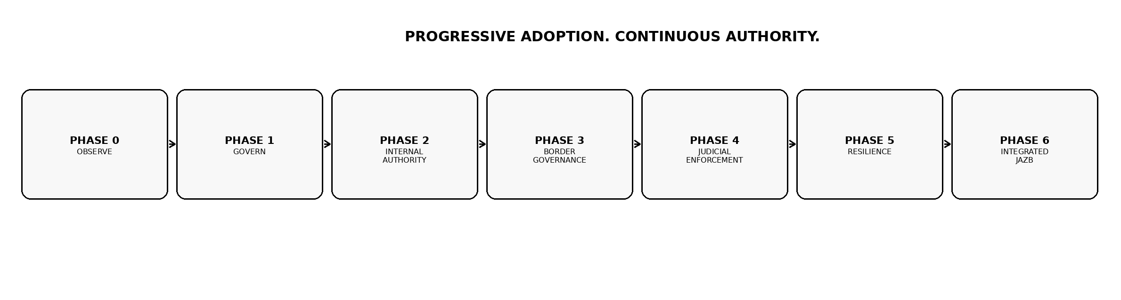
Figure 1. Canonical JAZB progressive adoption model.

5. Phase 0: Observe

5.1 Objective
Create a defensible picture of the environment before assigning or expanding machine Authority.

5.2 AI Inventory
Identify models, copilots, agents, automation, AI-enabled applications, external AI services, embedded AI functions, and shadow AI where discoverable.

5.3 Identity Inventory
Identify human, service, workload, agent, application, and privileged identities relevant to AI operations.

5.4 Authority Observation
Document what AI systems can technically do and distinguish that capability from what the Organization has actually authorized.

5.5 Data and Tool Flows
Map data sources, tools, APIs, repositories, destinations, credentials, internal Trust Boundary crossings, and actual external ingress and egress paths. Do not classify every internal intermediary as a Port.

5.6 Existing Controls
Identify IAM, PAM, DLP, SIEM, XDR, SOAR, gateways, network controls, data classification, logging, ticketing, and governance processes.

5.7 Deliverable
The primary Phase 0 output is a current-state inventory and gap register, not an enforcement platform.

6. Phase 1: Govern

6.1 Objective
Establish legitimate human governance before autonomous Authority is expanded.

6.2 EDA Representation
Define how the Organization's highest active human Authority is represented for JAZB governance.

6.3 Governance Ownership
Designate authorized human owners and stewards responsible for drafting, reviewing, authorizing, establishing, activating, and revoking Law. Define the applicable authorization population and quorum. No Law layer may permit a single individual to establish Law unilaterally.

6.4 Governor Law
Codify superior organizational Law governing AI Authority, prohibited actions, delegation, evidence, jurisdictions, emergency powers, subordinate Law, external passage, and the integrity requirements of the Law Establishment Lifecycle.

6.5 Change Control
Implement the lifecycle Draft -> Submit -> Validate -> Authorize -> Establish -> Activate, with immutable provenance. The predefined authorization threshold must require no fewer than two independently authorized humans. A single-owner Organization therefore requires at least one additional delegated authorized member for Law establishment.

6.6 Initial Boundaries
Define which decisions remain human-only and which may later be delegated to AI interpretation.

6.7 Deliverable
The Organization can explain who may draft Law, who may authorize it, the minimum quorum required to establish it, where Law is represented, how active versions are proven, how Law is revoked or recovered, and what AI is prohibited from deciding for itself.

7. Phase 2: Internal Authority

7.1 Objective
Govern AI operations inside Internal Jurisdiction.

7.2 Judge Introduction
Implement a bounded AI interpretation function for selected internal decisions.

7.3 Commissioner Law
Establish localized non-AI Law for the pilot domain where superior Governor Law permits. Commissioner Law follows the same Human-Established Law lifecycle and cannot be established by one individual acting alone.

7.4 AGENT Governance
Bind selected AGENTs to explicit identity, Baseline Authority, Scope, purpose, evidence, and revocation.

7.5 Elevated Authority
Introduce purpose-bound temporary elevation only where approval, monitoring, expiration, and revocation can be validated.

7.6 Point Policy
Use Point Policy where runtime behavior during delegated Authority requires active governance.

7.7 Deliverable
Selected internal AI actions can be traced from human-established Law through interpretation and delegated Authority to operational action.

8. Phase 3: Border Governance

8.1 Objective
Separate lawful internal possession from lawful passage.

8.2 External Organizational Boundary
Identify the actual external Organizational Boundary through which the selected Scope reaches or is reached by the external world. Internal Trust Boundaries remain important for Internal Jurisdiction but are not automatically Ports of Entry.

8.3 Ports of Entry
Establish approved governed external crossing points for ingress and egress. In a typical enterprise this is the ISP-facing edge. A distinct Port exists only where traffic can actually cross the governed external Organizational Boundary.

8.4 Port Authority
Implement AI interpretation for selected Border Jurisdiction decisions.

8.5 Port Director Law
Establish localized non-AI border Law for selected external crossing paths or transaction classes. Port Director Law remains subordinate to Governor Law and requires the applicable predefined multi-human authorization threshold before establishment.

8.6 Customs AGENT
Implement Customs AGENT inspection and enforcement at the governed external boundary, using conventional edge controls and purpose-built mechanisms where appropriate. Internal proxies, applications, APIs, identities, and service meshes can support policy enforcement or telemetry, but they do not become separate Ports merely because traffic traverses them.

8.7 Deliverable
Selected cross-boundary transactions are independently authorized, inspected, enforced, and evidenced.

9. Phase 4: Judicial Enforcement

9.1 Objective
Enable bounded internal enforcement without granting the Judge unrestricted technical power.

9.2 Judicial Instruments
Implement only Instrument types required for selected use cases and supported by established Law.

9.3 Actuation Authority
Separate technical execution from Judge interpretation and validate Scope before actuation.

9.4 Tool Integration
Map authorized actions to IAM, endpoint, network, security, or workflow controls capable of executing them.

9.5 Safety Controls
Require expiration, revocation, evidence, and rollback where technically applicable.

9.6 Deliverable
High-impact internal determinations can be executed through bounded independent actuation.

10. Phase 5: Resilience

10.1 Objective
Protect the governance system against bypass, compromise, collusion, failure, and loss of integrity.

10.2 Governance Escape Resistance
Detect and respond to unauthorized paths, shadow AI, credential substitution, disabled controls, direct resource access, Law-state substitution, authorization replay or forgery, and genuine external paths that bypass the governed Organizational Boundary.

10.3 Trusted Recovery
Define how Law, identities, evidence, interpretation, enforcement, and dependent Authority are restored to a trustworthy state.

10.4 Emergency Governance
Implement the predefined Board of Authority mechanism where the Organization elects to use emergency override.

10.5 Failure Modes
Exercise unavailable Judge, unavailable Port Authority, stale or unproven Law, failed Customs enforcement, evidence outage, compromised AGENT, forged Law authorization, and genuine external-boundary bypass scenarios such as unmanaged cellular, satellite, rogue wireless, or secondary unmanaged ISP connectivity.

10.6 Deliverable
Failure of governance does not silently become expanded Authority.

11. Phase 6: Integrated JAZB

11.1 Objective
Operate JAZB as a mature enterprise governance architecture rather than isolated pilots.

11.2 Cross-Jurisdiction Coordination
Internal and Border Jurisdictions independently authorize their portions of multi-jurisdiction transactions.

11.3 Enterprise Evidence
Chain of Authority and Chain of Evidence are available across material governed workflows.

11.4 Common Governance
Law development, exception management, metrics, recovery, and change control operate consistently across adopted domains.

11.5 Continuous Improvement
Operational evidence, incidents, recommendations, audits, and business changes inform human governance updates.

11.6 Deliverable
JAZB becomes part of normal enterprise AI operations while human sovereignty over Law and Authority remains intact.

12. Readiness Assessment
Readiness should be evaluated before selecting an implementation Scope. Its purpose is to expose dependencies that must be addressed before greater Authority is delegated.
Domain | Readiness question
Governance | Can the Organization identify legitimate human owners for AI Law and Authority, including the minimum authorization quorum for Law establishment?
Identity | Can human, service, workload, and relevant AI identities be distinguished and authenticated?
Access | Can privileges be bounded, granted, expired, and revoked?
Data | Can sensitive information and important flows be identified with sufficient reliability?
Telemetry | Can material AI actions and security events be observed?
Enforcement | Are there technical controls capable of implementing selected decisions?
Evidence | Can decisions and actions be reconstructed after the fact?
Recovery | Can trusted governance state be restored after failure?
Operations | Are owners available to handle exceptions, escalation, and incidents?
Change | Can Law and configuration changes be versioned and authorized?

13. Current-State and Target-State Architecture
A JAZB implementation should begin with a documented Current State and a bounded Target State. NIST CSF 2.0 Organizational Profiles similarly use Current and Target Profiles to support gap analysis, prioritization, and communication. [1]

13.1 Current State
Document existing AI use, technical capabilities, identities, access, data flows, controls, governance, evidence, and known exceptions.

13.2 Target State
Define the selected JAZB phase, use cases, components, Law, Authority, integrations, evidence, and operational outcomes.

13.3 Gap Analysis
Identify missing governance, identity, control, evidence, technical, and operational capabilities.

13.4 Prioritization
Prioritize gaps according to Authority impact, business need, risk, dependency, implementation effort, and reversibility.

13.5 Iteration
The Target State should evolve as evidence is gathered.
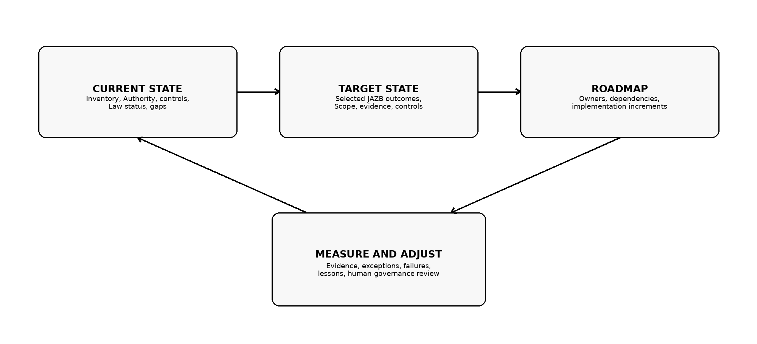
Figure 2. Current State, Target State, roadmap, and measurement cycle.

14. Governance and Operating Model
JAZB adoption is cross-functional because Authority, AI operation, identity, security, data, privacy, infrastructure, and business ownership intersect.
Role / function | Primary responsibility
EDA | Root legitimate enterprise Authority; define the authorized human population and quorum through which organizational Law is established.
JAZB governance owner | Coordinate Law lifecycle, architecture, exceptions, evidence, and adoption.
Business owner | Define legitimate business purpose, acceptable outcomes, and operational constraints.
Security / IAM | Implement identity, privilege, monitoring, revocation, incident response, and enforcement integrations.
AI / platform engineering | Implement agents, models, tools, decision interfaces, and technical guardrails without assuming legislative Authority.
Data / privacy | Define classification, handling, retention, destination, and privacy obligations represented in Law.
Infrastructure / network | Implement the external Organizational Boundary, connectivity, conventional edge controls, governed Ports, internal segmentation, and supporting enforcement paths.
Operations / service owner | Own availability, escalation, support, exception handling, and restoration.
Audit / risk / compliance | Assess evidence, control operation, obligations, and governance effectiveness.
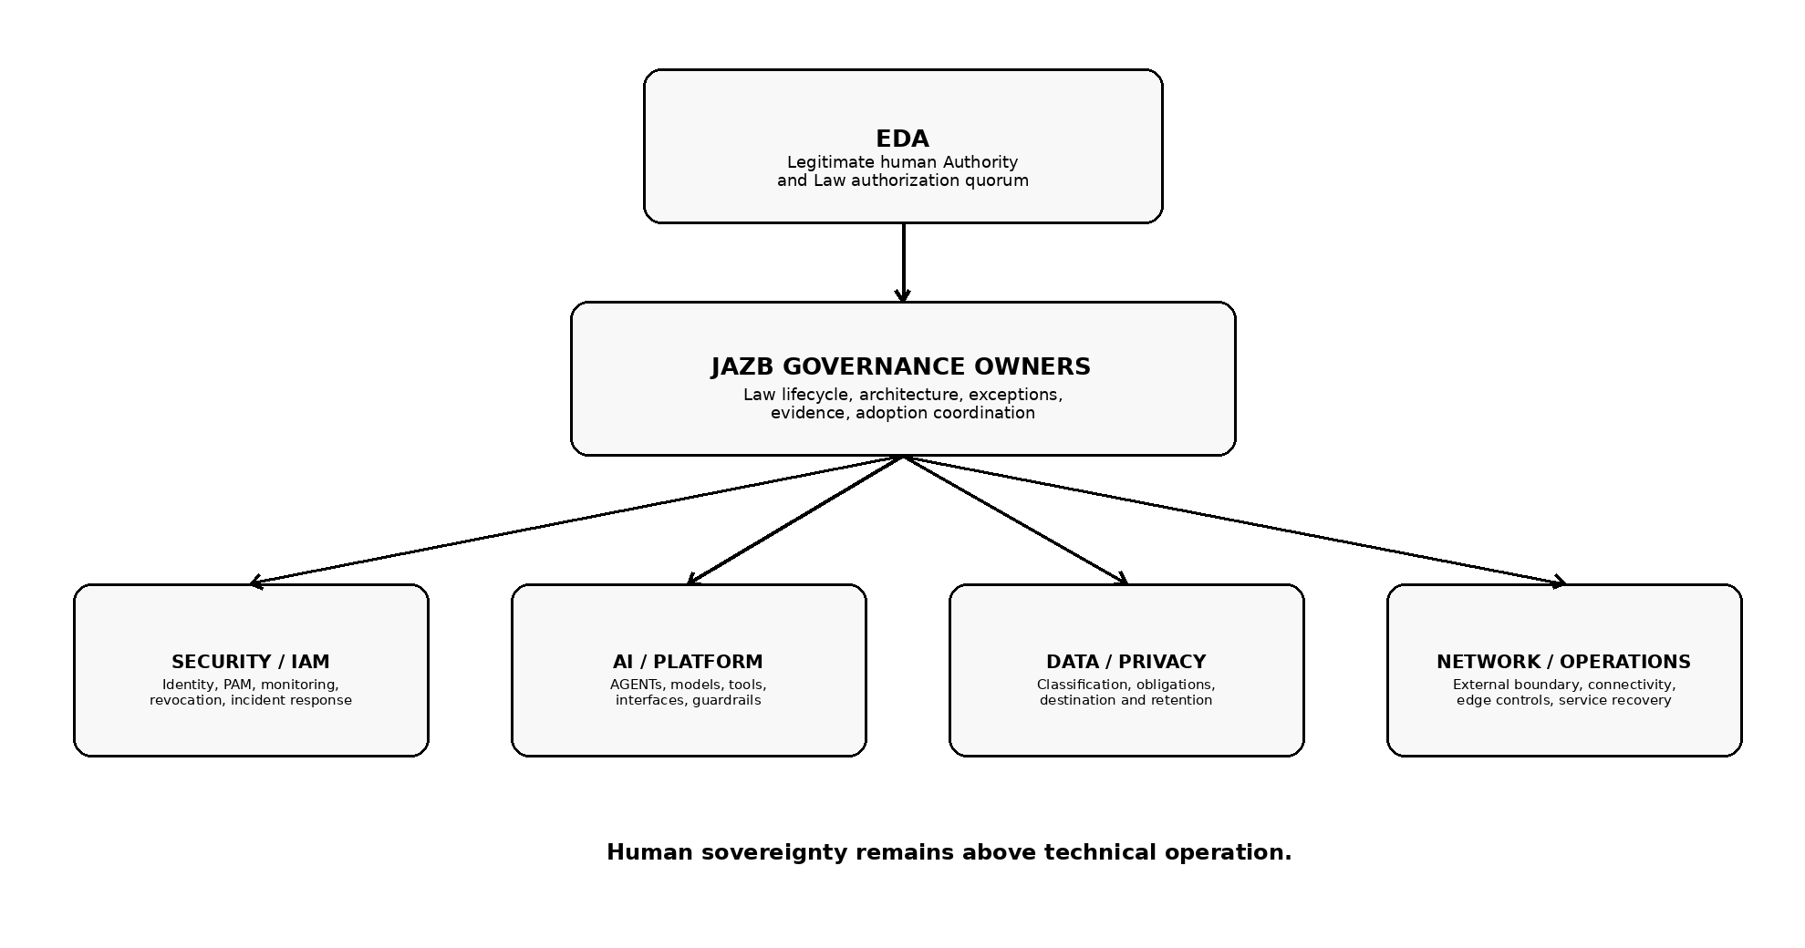
Figure 3. Illustrative JAZB implementation operating model.

15. AI System and AGENT Inventory

15.1 Inventory Scope
Inventory both obvious AI systems and AI functions embedded in business applications.

15.2 Minimum Attributes
Record owner, purpose, model or service, identities, tools, data sources, destinations, privileges, external dependencies, user population, and current controls.

15.3 Agent Capabilities
Document what each AGENT can read, write, invoke, create, delete, transmit, approve, or delegate.

15.4 Shadow AI
Identify unsanctioned AI use where possible and treat it as an observation and governance problem.

15.5 Lifecycle
Update the inventory when systems, models, tools, integrations, ownership, or Authority materially change.

16. Authority Inventory
Attribute | Implementation question
Actor | Who or what exercises the capability?
Capability | What can the actor technically do?
Authority source | By what legitimate human-established Law or delegation is it permitted?
Purpose | For what business purpose?
Scope | Which resources, actions, systems, users, or transactions?
Duration | Persistent baseline, temporary, conditional, or one-time?
Delegation | May it be delegated or redelegated?
Jurisdiction | Internal, Border, or both?
Revocation | How is it removed?
Evidence | What proves the Authority existed when the action occurred?

17. Trust Boundary and Data-Flow Mapping

17.1 Internal Trust Boundary Identification
Map internal boundaries where Authority, custody, control, policy, risk, or accountability materially change. These Trust Boundaries inform Internal Jurisdiction and implementation design but do not automatically invoke Enterprise AI Customs.

17.2 External Organizational Boundary Identification
Identify each real path through which traffic can enter or leave the Organization, including primary and secondary ISP circuits, remote-access paths, managed cloud egress, wireless, cellular, satellite, or other external connectivity relevant to the Scope.

17.3 Transaction and Data-Flow Mapping
Map prompts, files, API calls, tool results, credentials, model context, AGENT messages, and derived data through internal systems to their ultimate external destination or source. Record the technical path separately from the jurisdictional Port at the external boundary.

17.4 Governed Ports of Entry
Define the external crossing points at which Border Jurisdiction is enforced. A Port may be implemented across multiple technical devices at the edge, but its jurisdiction is defined by actual external passage, not by the mere presence of an API gateway or proxy.

17.5 Governance Escape and Alternate External Paths
Identify unmanaged or alternate external connectivity capable of bypassing the governed border. Treat such paths as Governance Escape risks requiring prevention, detection, containment, evidence, and recovery. Assign accountable owners for both internal Trust Boundaries and governed external Ports.

18. Law Development and Management

18.1 Start with Existing Governance
Translate legitimate existing policy, risk decisions, access rules, data handling requirements, contractual restrictions, and operational standards into JAZB Law where appropriate.

18.2 Separate Law from Implementation
Law states the authoritative rule and conditions. Implementation mappings identify which technologies enforce or evidence it.

18.3 Law Hierarchy
Governor Law remains superior. Commissioner and Port Director Law may specialize or narrow only within delegated Authority, may not contradict or weaken superior Governor Law, and are not authoritative until their applicable multi-human authorization threshold has been satisfied and the Law has been formally established and activated.

18.4 Law Establishment Lifecycle
Implement the canonical lifecycle: Draft -> Submit -> Validate -> Authorize -> Establish -> Activate. Each state transition must be explicit. A proposal remains non-authoritative until the applicable human authorization threshold is satisfied and the Law is formally established and activated.

18.5 Multi-Human Authorization
Define the authorization population and threshold for each Human-Established Law Layer. The threshold may be greater than two and may impose role, Scope, or classification requirements, but it may never be fewer than two independently authorized humans. The drafter may participate in authorization only where organizational Law permits.

18.6 Versioning, Activation, Revocation, and Rollback
Every established Law version requires identifiable provenance, content integrity, authorization evidence, effective and activation state, predecessor relationship, and recovery or rollback treatment. Revocation and rollback must not silently reactivate a version whose Authority is no longer valid.

18.7 Testing and Impact Review
Test proposed Law against representative positive, negative, conflict, delegation, passage, failure, and rollback cases where feasible. AI may analyze proposed effects, identify gaps, or recommend changes, but its analysis remains advisory and cannot satisfy any human authorization requirement or establish Law.

18.8 AI Recommendations
AI may draft suggested language, model impact, identify conflicts, or recommend changes to Law. Such output is non-binding. It enters the same proposal workflow as human-drafted material and does not become Law until the applicable independent human authorization threshold is satisfied, followed by formal establishment and activation.

19. Pilot Selection
A strong first pilot is bounded enough to understand but meaningful enough to exercise the architecture.
Prefer | Avoid initially
Clear business owner and purpose | Unowned experimental automation
Known data and systems | Unknown or highly dynamic data flows
Limited user population | Enterprise-wide deployment
Reversible actions | Irreversible high-impact actions
Existing identity and logging | Anonymous or poorly attributable operation
Defined Baseline Authority | Broad administrative privileges
Observable outcomes | Black-box operation with little evidence
Existing enforcement options | Use cases requiring custom enforcement everywhere

20. Deployment Patterns
JAZB functions can be implemented centrally, federated, or through a hybrid model. The requirement is preservation of Authority provenance and separation of responsibilities, not a single physical topology.

20.1 Centralized Governance
Governor Law and common decision services may be centrally managed while local domains consume them.

20.2 Federated Local Law
Commissioner and Port Director Law may be maintained for delegated internal or border domains. Local ownership does not alter the requirement for multi-human establishment, and Port Director Law applies to governed external passage rather than every internal application or gateway.

20.3 Embedded Enforcement
AGENT enforcement may be embedded in applications, endpoint controls, identity systems, or workflow platforms. Customs enforcement may use edge gateways, DLP, secure web gateways, SSE/CASB, DNS, network controls, or purpose-built inspection at the actual external Organizational Boundary. The placement of a control does not make it a source of Law.

20.4 Shared Evidence Plane
Organizations may centralize evidence and audit records while preserving source and jurisdiction.

20.5 Hybrid and Multi-Cloud
JAZB components may span environments if identity, Law, decisions, evidence, and enforcement remain trustworthy.

20.6 Managed Components
A third party may operate technical components, but outsourced operation does not transfer organizational sovereignty over Law.
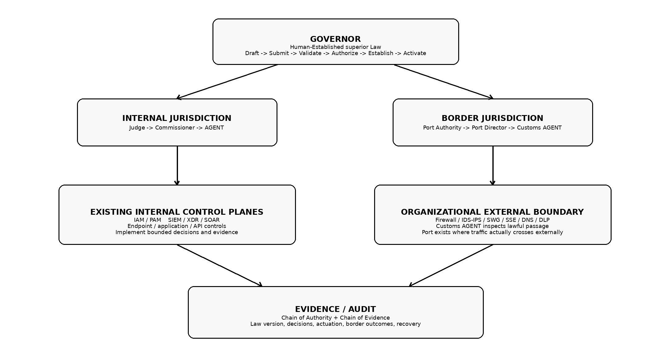
Figure 4. Illustrative integration pattern using existing enterprise control planes.

21. Identity, IAM, and PAM Integration

21.1 Stable Identity
Material human and machine actors should have identities sufficient to support attribution and policy evaluation.

21.2 Workload and Agent Identity
Where supported, use dedicated workload or agent identities rather than shared human credentials.

21.3 Baseline Authority
Map persistent permissions to the minimum Baseline Authority required for normal operation.

21.4 Elevated Authority
Use JIT, temporary groups, privileged access, tokens, roles, or equivalent mechanisms to implement bounded elevation.

21.5 Revocation
Validate that temporary Authority, sessions, tokens, and credentials can actually be revoked within the required time.

21.6 Separation of Identity and Authority
Authentication establishes identity. It does not establish legitimate Authority for every action.

22. Data Governance, DLP, and Classification Integration

22.1 Classification
Reuse established classification systems where they are reliable enough for the governed decision.

22.2 DLP as Supporting Enforcement
DLP can support Customs inspection, blocking, redaction, classification, and evidence functions under EAC. DLP remains a technical control; it does not independently determine legitimate Border Authority and it is not itself the Port merely because it inspects traffic.

22.3 Data Minimization
Represent minimization requirements in Law where only a subset of information is authorized for the purpose.

22.4 Derived Data
Define how summaries, embeddings, model outputs, and transformed content inherit or change governance requirements.

22.5 Destination Governance
Connect approved destinations and provider conditions to Port Director Law or supporting data-governance systems.

23. SIEM, XDR, SOAR, and Evidence Integration

23.1 Evidence Sources
Use existing telemetry to support Judge, Port Authority, Governance Escape, and post-event reconstruction.

23.2 SIEM
Central logging can correlate identities, decisions, tools, network events, data movement, and security detections.

23.3 XDR / EDR
Endpoint and identity detections can supply evidence and actuation mechanisms for restriction, containment, isolation, and investigation.

23.4 SOAR
Automation can execute bounded Actuation Authority workflows when each action remains traceable to the authorizing decision.

23.5 Evidence Integrity
Protect material governance evidence from unauthorized modification and preserve time, identity, source, and Law context.

23.6 Avoiding Tool Sovereignty
Security platforms provide evidence and enforcement. They do not become the source of JAZB Law.

24. Network, API, and AI Gateway Integration

24.1 External Boundary and Edge Controls
Identify the devices and services through which the Organization actually reaches its external networks. Firewalls, routers, secure web gateways, SSE/CASB, DNS security, DLP, IDS/IPS, and related edge controls protect and mediate that path. They may implement portions of a governed Port, but the Port is the jurisdictional external crossing, not the product itself.

24.2 Internal Network Segmentation
Segmentation can constrain reachability, isolate workloads, and reduce Governance Escape opportunities, but internal segmentation does not create additional Customs Ports and network location does not replace Authority evaluation.

24.3 API Mediation
API gateways can validate identities, scopes, destinations, transaction classes, and policy decisions inside or near the edge. When an API gateway is internal, it remains an internal enforcement mechanism. If it participates directly in actual external passage, it may implement part of a Port without redefining the boundary.

24.4 AI Gateways
AI gateways can mediate prompts, model access, tool use, data inspection, and approved external AI destinations. They may supply inspection or enforcement signals to Customs, but an internal AI gateway is not a Port and cannot independently grant Border Authority.

24.5 Customs and Enforcement Feedback
Customs, edge controls, gateways, and supporting enforcement systems should report passage decisions, denials, transformations, anomalies, and failures into the Chain of Evidence. Border evidence should preserve the Port, originating Authority, destination, classification, Law version, decision, and enforcement outcome.

25. Testing and Validation

25.1 Positive Testing
Verify that authorized actions complete under intended Scope and conditions.

25.2 Negative Testing
Verify that prohibited actions, destinations, delegations, and privilege expansions are denied.

25.3 Boundary Testing
Verify that internal authorization does not bypass Border Jurisdiction and that changes in internal route, intermediary, protocol, workload, or identity still encounter Customs before actual external passage.

25.4 Expiration Testing
Verify that temporary Authority and emergency powers actually expire.

25.5 Revocation Testing
Verify that revoked Authority ceases to work in practice.

25.6 Evidence Testing
Reconstruct selected transactions from Law through decision, delegation, enforcement, action, and outcome.

25.7 Law Lifecycle and Conflict Testing
Verify that Draft, Submitted, or Validated proposals cannot be consumed as active Law; required authorization quorum is enforced; established versions are integrity-bound; and superior Governor Law prevails over conflicting subordinate Law.

25.8 Human Escalation Testing
Verify that unresolved decisions reach the intended authorized human process and that escalation does not allow one human to establish Law, bypass a required quorum, or create an undocumented exception.
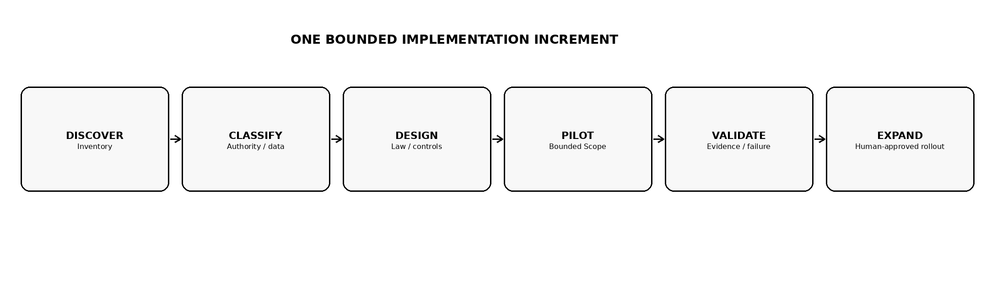
Figure 5. Recommended implementation workflow for each bounded adoption increment.

26. Failure and Resilience Exercises
Phase IV defines the resilience architecture. Phase V requires organizations to exercise relevant failure modes rather than assume resilience from design alone.
- Judge unavailable or inconsistent.
- Port Authority unavailable during a required crossing.
- Governor or subordinate Law integrity, authorization-provenance, or active-version failure.
- Stale Law or failed Law distribution.
- Compromised AGENT attempting out-of-Scope activity.
- Compromised Customs AGENT attempting to misclassify, conceal, or permit passage without valid Border Authority.
- Actuation Authority unavailable or partially successful.
- Evidence store unavailable or integrity uncertain.
- Identity or privileged-access dependency unavailable.
- Destination trust materially degraded.
- Governance Escape through an actual alternate external path, including unmanaged cellular, satellite, rogue wireless, or secondary unmanaged ISP connectivity.
- Emergency Authority expiration, failed multi-human authorization, Board member unavailability, or attempted ad hoc substitution of unauthorized approvers.

27. Metrics and Measurement
Measurement should demonstrate whether governance is functioning, not merely whether AI is available. NIST AI RMF's Measure function similarly emphasizes selecting and applying methods and metrics for significant AI risks, while the AI RMF Playbook is voluntary and adaptable rather than a mandatory checklist. [2][3]
Metric domain | Illustrative measures
Authority | Material AI actions attributable to valid Authority; expired Authority still active; excessive baseline privileges.
Law | Proposal-to-activation traceability; quorum satisfaction; unauthorized changes; stale or unproven active Law; rollback integrity.
Decision | Allow/deny/condition/escalate rates; decision latency; human escalation backlog.
Border | Unauthorized passage attempts; Customs denials; classification/deception findings; actual alternate external-path detections.
Evidence | Sampled transactions reconstructable end-to-end; missing decision or Law context.
Escape | Governance Escape attempts, successful bypasses, time to detect, time to contain.
Resilience | Revocation time; recovery time to trusted state; failed recovery tests.
Operations | Task completion, exception rate, false positive burden, governance-caused failures.
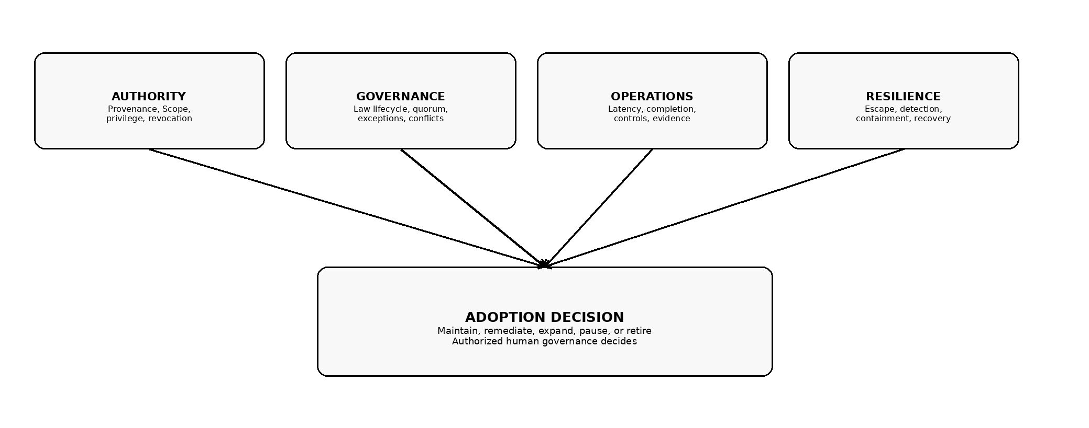
Figure 6. Phase V measurement model.

28. Training and Change Management

28.1 Executive and EDA Training
Focus on Authority, the difference between drafting and establishing Law, multi-human authorization, emergency governance, risk acceptance, Residual Sovereign Risk, and the prohibition against delegating sovereignty to AI.

28.2 Governance Owner Training
Focus on Draft -> Submit -> Validate -> Authorize -> Establish -> Activate, quorum and provenance, Law hierarchy, evidence, exceptions, internal Trust Boundaries, and the actual external Organizational Boundary.

28.3 Technical Team Training
Focus on identity, integration, decision interfaces, enforcement, evidence, failure behavior, and recovery.

28.4 End-User Training
Explain what AGENTs may do, how elevation works, why external AI passage may be restricted, and how to request legitimate exceptions.

28.5 Incident Team Training
Exercise Judicial Instruments, Actuation Authority, evidence preservation, Governance Escape, and trusted recovery.

28.6 Communication
Describe JAZB as a governance model for legitimate AI Authority, not simply another security blocking layer.

29. Exceptions and Transitional States

29.1 Transitional Reality
Organizations may operate with incomplete JAZB coverage during adoption.

29.2 Explicit Exceptions
Document material exceptions with owner, rationale, Scope, risk, compensating controls, expiration, and review.

29.3 No Silent Grandfathering
Legacy access or existing AI integrations should not be treated as permanently authorized merely because they predate JAZB.

29.4 Temporary Manual Controls
Manual human review may temporarily substitute for automated interpretation or enforcement where established Law is clear and evidence is preserved. Manual operation does not waive multi-human Law-establishment requirements and does not convert informal email, chat, ticket, or verbal approval into Law.

29.5 Sunset
Exceptions should expire or be reviewed rather than becoming permanent through neglect.

30. Multi-Business-Unit and Multi-Tenant Adoption

30.1 Enterprise Law
Common Governor Law should establish enterprise invariants.

30.2 Local Law
Business units may maintain Commissioner or Port Director Law only within delegated Authority and only through the applicable multi-human Law-establishment process. Local administration cannot weaken superior Governor Law.

30.3 Shared Services
Central identity, evidence, decision, or enforcement services may support multiple domains while preserving jurisdiction and ownership.

30.4 Tenant Boundaries
Separate tenants may constitute Trust Boundaries even under common ownership when control or accountability materially changes.

30.5 Consistency
Enterprise adoption should distinguish legitimate local variation from unauthorized weakening of superior Law.

31. Third Parties and Managed Services

31.1 Outsourcing Does Not Transfer Sovereignty
A managed service provider may operate JAZB technology but does not become the source of organizational Law.

31.2 Contractual Requirements
Contracts may require identity, logging, data handling, revocation, evidence, incident notification, recovery, and support for organizational Authority.

31.3 External AI Providers
Approved provider conditions should be represented in border governance and reviewed when service terms or controls materially change.

31.4 Evidence Access
The Organization should retain access to evidence required to reconstruct material governed actions.

31.5 Exit Planning
Adoption should account for provider change, loss of service, data export, Law portability, and recovery of governance state.

32. Small and Resource-Constrained Organizations
- Begin with one governed AI use case.
- Use existing identity, logging, endpoint, and cloud controls before purchasing specialized technology.
- Keep Governor Law concise and focused on real Authority decisions.
- Use manual human review for exceptional decisions until automation is justified.
- Define a small number of approved external AI destinations and governed external crossing paths. Do not treat every internal proxy or API as a Port.
- Prioritize revocation, evidence, and backup of Law before advanced automation.
- Predesignate emergency Board membership if emergency override is adopted.
- Do not collapse Law establishment and autonomous AI interpretation merely because staff is limited. A single-owner Organization must delegate at least one additional authorized human so that no Law is established unilaterally.

33. Maturity Assessment
JAZB maturity describes the extent to which the Organization has implemented and institutionalized the architecture. It is not a certification score and should not be confused with NIST CSF Implementation Tiers. NIST's Tiers characterize cybersecurity risk governance and management rigor from Partial through Adaptive; JAZB's phases describe architectural adoption capability. [4]
JAZB maturity | Characteristic
Observed | AI and Authority environment is inventoried; major gaps are visible.
Governed | Human governance and Governor Law are established for the adopted Scope.
Controlled | Internal and/or border Authority decisions are technically enforced and evidenced.
Enforced | Judicial Instruments and independent actuation are implemented where required.
Resilient | Governance Escape, compromise, recovery, emergency governance, and evidence integrity are exercised.
Integrated | JAZB is embedded across adopted enterprise domains with measurement and continuous improvement.

34. Implementation Anti-Patterns
Anti-pattern | Why it fails
Tool-First Governance | Purchasing an AI gateway or policy engine and treating its configuration as the source of organizational Law.
AI-Written Law Without Human Establishment | Allowing AI-generated policy or analysis to become authoritative automatically, or treating AI recommendation as satisfaction of human authorization requirements.
Shared Super-Agent | Giving one AI component unrestricted ability to define policy, interpret it, execute action, and suppress evidence.
Permanent Elevation | Converting temporary convenience into persistent excessive Authority.
Internal Equals External | Assuming access to information implies permission to transmit it, or treating an internal proxy, API, gateway, or service as a separate Customs Port instead of tracing passage to the actual external Organizational Boundary.
Logging Equals Governance | Treating the presence of logs as proof that an action was legitimately authorized.
Pilot Becomes Production by Accident | Expanding users, data, tools, or privileges without a deliberate governance decision.
Exception by Conversation | Using email, chat, ticket comments, verbal approval, or one authorized individual as a substitute for required Law-establishment or emergency-authorization mechanisms.
Fail Open by Default | Allowing high-impact action when Law, identity, decision, or enforcement cannot be validated.
Compliance Substitution | Assuming alignment with another framework automatically establishes JAZB Authority provenance.

35. Framework Alignment and Gap Analysis
Framework / guidance | Implementation concept | JAZB Phase V relationship | Refs.
NIST CSF 2.0 Organizational Profiles | Current and Target Profiles support gap analysis, prioritization, and communication. | JAZB uses a comparable current/target discipline specifically for AI Authority architecture. | [1]
NIST CSF 2.0 Tiers | Tiers characterize rigor of cybersecurity risk governance and management from Partial to Adaptive. | JAZB maturity is distinct: it describes architectural adoption phases rather than scoring cybersecurity governance rigor. | [4]
NIST AI RMF Playbook | Voluntary suggested actions organized around Govern, Map, Measure, and Manage; not a checklist. | JAZB can use AI RMF practices for risk governance while supplying an explicit Authority architecture and implementation sequence. | [2][3]
NIST SP 800-207 Zero Trust | Resource-focused explicit authorization and abstract deployment models. | JAZB can use Zero Trust mechanisms for identity, policy decision, enforcement, and resource protection while adding human-established Authority provenance. | [5]
ISO/IEC 42001:2023 | Requirements for establishing, implementing, maintaining, and continually improving an AI management system. | JAZB can provide technical governance architecture beneath an AIMS. JAZB adoption does not itself establish ISO/IEC 42001 conformity. | [6]
The implementation gap addressed by Phase V is the path from governance architecture to operational adoption. Existing frameworks provide risk-management structures, management-system requirements, cybersecurity outcomes, and Zero Trust principles. Phase V supplies a JAZB-specific sequence for identifying Authority, establishing Law, attaching existing controls, piloting bounded autonomy, validating evidence and failure behavior, and expanding only when governance is demonstrably functioning.

36. Phase V Conformance Model
ID | Phase V implementation requirement
IMP-01 | A bounded adoption Scope and accountable owner are identified.
IMP-02 | AI systems, relevant identities, Authority, data flows, internal Trust Boundaries, and the external Organizational Boundary within Scope are inventoried.
IMP-03 | Human governance is established before AI receives material interpretive Authority.
IMP-04 | Governor Law follows Draft -> Submit -> Validate -> Authorize -> Establish -> Activate, is versioned and integrity-protected, and requires a predefined authorization threshold of no fewer than two independently authorized humans.
IMP-05 | Commissioner and Port Director Law are human-established, subordinate to Governor Law, and subject to applicable multi-human authorization before establishment or activation.
IMP-06 | AI interpretation functions cannot create or expand their own Authority.
IMP-07 | AGENT and Customs AGENT capabilities are mapped to explicit Authority and Scope.
IMP-08 | Existing technical controls are treated as enforcement or evidence mechanisms rather than sovereign sources of Law.
IMP-09 | Temporary or Elevated Authority can expire and be revoked.
IMP-10 | Material external transactions are independently governed by Border Jurisdiction at actual external Organizational Boundary crossings; internal routing or intermediary changes do not create alternate Ports.
IMP-11 | Material governed actions preserve sufficient Chain of Authority and Chain of Evidence for reconstruction.
IMP-12 | Pilot expansion requires deliberate review of evidence, exceptions, failures, and control effectiveness.
IMP-13 | Material exceptions are documented, owned, scoped, and reviewed or expired.
IMP-14 | Relevant failure and recovery paths are tested rather than assumed.
IMP-15 | Governance Escape paths, including genuine alternate external connectivity that bypasses the governed boundary, are identified, constrained, monitored, and exercised as adoption matures.
IMP-16 | Emergency Authority, if implemented, follows predefined multi-human authorization, bounded Scope, evidence requirements, and automatic expiration; ad hoc promotion is not permitted.
IMP-17 | Third-party operation does not transfer organizational sovereignty over JAZB Law.
IMP-18 | Metrics include governance and Authority outcomes, not only availability or task success.
IMP-19 | Training addresses human governance, technical operators, and End Users.
IMP-20 | The Organization can state its current JAZB adoption phase without representing unimplemented capabilities as operational or partial adoption as full conformance.

37. Example Implementation Roadmaps

37.1 Ninety-Day Bounded Pilot
Period | Primary activities
Days 1-30 | Inventory selected use case; identify owner, identities, capabilities, Authority, data, boundaries, existing controls; establish initial Governor Law and current/target state.
Days 31-60 | Implement bounded identity and Authority; configure selected Judge or border decision path; integrate evidence; test positive, negative, expiration, revocation, and boundary cases.
Days 61-90 | Operate controlled pilot; review exceptions and evidence; exercise failure path; measure outcomes; remediate; decide whether to maintain, pause, or expand.

37.2 Six-Month Department Adoption
A department may extend a successful pilot to multiple AGENTs, introduce Commissioner Law, formalize temporary elevation, add selected EAC controls for external AI use, and establish regular governance review and evidence sampling.

37.3 Enterprise Program
An enterprise program may operate multiple adoption tracks by business domain, with common Governor Law, identity and evidence services, federated Commissioner and Port Director Law, standardized Ports, resilience exercises, and central measurement.

37.4 Expansion Gate
- Law completed the required lifecycle, including independent multi-human authorization, establishment, activation, and versioning.
- Authority and Scope are explicit.
- Identities and enforcement are reliable.
- Revocation and expiration have been tested.
- Sampled Chain of Authority is reconstructable.
- Customs and conventional edge controls passed applicable passage, deception, failure, and actual external-bypass tests.
- Governance Escape findings are understood.
- Failure exercise completed for relevant dependencies.
- Exceptions have owners and expiration/review.
- Authorized human governance approves expansion through the Organization's predefined governance process; expansion does not alter Law-establishment quorum requirements.

38. Relationship to Phases I-IV
Publication | What it establishes | Phase V implementation use
Phase I | Foundational architecture and doctrine | Defines the institution that must be preserved during adoption.
Phase II | Authority and Judicial Specification | Supplies internal Authority, Judge, Judicial Instruments, Actuation, Point Policy, and evidence semantics.
Phase III | Supplies Border Jurisdiction, the actual external Organizational Boundary, Ports of Entry, passage, Port Authority, Port Director, and Customs governance. | Supplies Border Jurisdiction, Ports, passage, Port Authority, Port Director, and Customs governance.
Phase IV | Security & Resilience Specification | Supplies Governance Escape Resistance, compromise handling, trusted recovery, collusion, and evidence integrity.
Phase V | Implementation & Adoption Guide | Provides the progressive path for deploying and operating those capabilities.

39. Future Work
Phase VI will provide detailed Standards & Compliance Mapping. It will map JAZB concepts and implementation outcomes to external frameworks and standards while preserving a clear distinction between architectural alignment and formal compliance or certification. Phase VII will consolidate mature normative requirements into a JAZB Reference Specification after public review and implementation experience.

40. Conclusion
JAZB adoption begins before the first Judge, Port Authority, or AGENT is deployed. It begins when the Organization identifies the legitimate human source of Authority, defines who may draft and who may authorize Law, establishes the required quorum, and distinguishes machine capability from legitimate Authority.
Phase V treats implementation as a progression from observation to governance, from governance to bounded internal and border Authority, from Authority to enforcement, and from enforcement to resilience and integration.
IAM, PAM, DLP, SIEM, XDR, SOAR, gateways, firewalls, network controls, data governance, and AI platforms can implement JAZB functions. They do not replace the human Authority and established Law that make those functions legitimate, and they do not redefine where Border Jurisdiction exists.
Organizations do not need every JAZB capability on day one. They do need to preserve the architecture's invariants at every stage: humans establish Law through predefined multi-human authorization; proposed Law is not Law; AI interprets and operates under established Law; Authority remains bounded and traceable; Internal and Border Jurisdictions remain distinct; Customs governs actual external passage; and governance failure does not become expanded Authority.
That progression allows JAZB to grow with the Organization rather than requiring the Organization to surrender control in order to gain autonomy.
Adopt governance progressively. Preserve Authority continuously.

Appendices

Appendix A. Phase V Readiness Checklist
- Named business owner
- Named governance owner
- Defined pilot purpose
- AI/AGENT inventory
- Identity inventory
- Authority inventory
- Data-flow map
- Internal Trust Boundary map and external Organizational Boundary map
- Existing control inventory
- Initial Governor Law proposal, authorization quorum, established version, and activation evidence
- Evidence destination
- Revocation path
- Rollback plan
- Exception process
- Success and failure metrics

Appendix B. Current-State Inventory Template
Field | Example content
System / AGENT | Name and owner
Purpose | Business task
Identity | Human/workload/agent identity
Capabilities | Read/write/tool/API/execute/transmit
Current permissions | Technical access
Known Authority | Documented legitimate purpose and Scope
Data | Sources and classifications
Destinations | Internal/external
Boundaries | Internal Trust Boundaries and external Organizational Boundary / crossing paths
Controls | IAM/PAM/DLP/gateway/SIEM/etc.
Evidence | Logs and decision records
Known gaps | Unclear Authority, excessive access, missing evidence, bypass path

Appendix C. Authority Inventory Template
Field | Description
Actor | Human, AGENT, service, workload
Authority source | Applicable Law or delegation
Purpose | Authorized business purpose
Scope | Resources/actions/systems
Jurisdiction | Internal/Border/both
Duration | Baseline/temporary/conditional
Delegation | Allowed/prohibited/conditions
Revocation | Mechanism
Evidence | Required proof

Appendix D. Law Implementation Record
Field | Description
Law ID | Unique identifier
Authority source | Authorized human governance source and authorization population
Statement | Authoritative rule
Layer | Governor / Commissioner / Port Director
Jurisdiction | Enterprise/Internal/Border
Scope | Affected systems or transactions
Implementation mappings | Controls that implement, enforce, or evidence established Law
Effective version | Version and date
Owner | Authorized human steward
Review | Review condition or schedule
Lifecycle state | Draft / Submitted / Validated / Authorized / Established / Active / Revoked
Content integrity | Hash or equivalent binding of the exact Law authorized and activated
Authorization evidence | Identities, independent approvals, required quorum, satisfied quorum, timestamps, and exact proposal version authorized
Establishment / activation | Formal establishment event, active version, activation time or condition, and acknowledgement/distribution evidence

Appendix E. Pilot Charter
Field | Description
Use case | Bounded business task
Owner | Business accountable owner
Governance owner | JAZB governance accountable owner
Users / AGENTs | Pilot population
Authority | Baseline and any elevation
Data | Permitted classes
Boundaries | Applicable internal Trust Boundaries and external Organizational Boundary/Ports
Controls | Identity, enforcement, evidence
Excluded scope | Explicitly out of pilot
Success criteria | Governance and business outcomes
Stop conditions | Conditions requiring pause or rollback

Appendix F. Expansion Gate Checklist
- Pilot Scope remained bounded.
- No unresolved Law integrity issue exists.
- Revocation and expiration tests passed.
- Sampled Chain of Authority is reconstructable.
- Customs and conventional edge controls passed applicable passage, deception, failure, and actual external-bypass tests.
- Governance Escape findings are understood.
- Failure exercise completed.
- Exceptions have owners and expiration/review.
- Metrics meet defined acceptance criteria.
- Authorized human governance approves expansion through the Organization's predefined governance process.

Appendix G. Integration Mapping Worksheet
JAZB function | Potential existing technology
Identity | IdP, workload identity, agent identity
Baseline / Elevated Authority | IAM, PAM, JIT role systems
Judge evidence | SIEM, XDR, application telemetry
Actuation | SOAR, IAM, EDR/XDR, network controls
External Port implementation | ISP-facing edge route using firewall/router/SWG/SSE/CASB/proxy/DLP or equivalent controls at actual external passage
Customs inspection | Customs AGENT plus DLP/content inspection/AI gateway/edge telemetry as supporting mechanisms
Chain of Evidence | SIEM, audit store, integrity-protected logging
Law store | Policy repository, configuration system, governance application
Recovery | Backup, version control, configuration recovery, identity recovery

Appendix H. Metrics Catalog
Domain | Example metric
Authority | Material actions with attributable Authority
Privilege | Temporary elevation remaining after expiration
Law | Proposal-to-activation traceability; quorum satisfaction; stale, unknown, or unproven active Law
Evidence | Sampled transactions reconstructable end-to-end
Border | Unauthorized passage attempts; Customs denials; alternate external-path detections
Escape | Governance Escape attempts and successful bypasses
Recovery | Time to restore trusted governance state
Operations | Governance-caused task failure and escalation backlog
Adoption | Use cases meeting expansion gate

Appendix I. Implementation Anti-Pattern Checklist
Tool-First Governance: Purchasing an AI gateway or policy engine and treating its configuration as the source of organizational Law.
AI-Written Law Without Human Establishment: Allowing AI-generated policy or analysis to become authoritative automatically, or treating AI recommendation as satisfaction of human authorization requirements.
Shared Super-Agent: Giving one AI component unrestricted ability to define policy, interpret it, execute action, and suppress evidence.
Permanent Elevation: Converting temporary convenience into persistent excessive Authority.
Internal Equals External: Assuming access to information implies permission to transmit it, or treating an internal proxy, API, gateway, or service as a separate Customs Port rather than tracing the transaction to the actual external Organizational Boundary.
Logging Equals Governance: Treating the presence of logs as proof that an action was legitimately authorized.
Pilot Becomes Production by Accident: Expanding users, data, tools, or privileges without a deliberate governance decision.
Exception by Conversation: Using email, chat, ticket comments, verbal approval, or a single authorized individual as substitutes for required Law-establishment or emergency-authorization mechanisms.
Fail Open by Default: Allowing high-impact action when Law, identity, decision, or enforcement cannot be validated.
Compliance Substitution: Assuming alignment with another framework automatically establishes JAZB Authority provenance.

Appendix J. Phase V Adoption Summary
Phase | Minimum evidence of adoption
0 Observe | Inventories and gap register
1 Govern | EDA representation, governance ownership, Law lifecycle, authorization quorum, established and active Governor Law
2 Internal Authority | Bounded Judge/Commissioner/AGENT implementation
3 Border Governance | Actual external Organizational Boundary mapped; governed Ports, Port Authority, Port Director Law, Customs AGENT, and edge-control integration operating
4 Judicial Enforcement | Defined Instruments and independent Actuation
5 Resilience | GER, recovery, failure tests, emergency governance where used
6 Integrated JAZB | Cross-domain operation, enterprise evidence, metrics, continuous improvement

References
[1] National Institute of Standards and Technology. NIST Cybersecurity Framework 2.0: Quick-Start Guide for Creating and Using Organizational Profiles, NIST SP 1301. 2024. https://doi.org/10.6028/NIST.SP.1301
[2] National Institute of Standards and Technology. NIST AI Risk Management Framework Playbook. https://airc.nist.gov/airmf-resources/playbook/
[3] National Institute of Standards and Technology. AI RMF Playbook, Measure function. https://airc.nist.gov/airmf-resources/playbook/measure/
[4] National Institute of Standards and Technology. NIST Cybersecurity Framework 2.0: Quick-Start Guide for Using the CSF Tiers, NIST SP 1302. 2024. https://doi.org/10.6028/NIST.SP.1302
[5] National Institute of Standards and Technology. Zero Trust Architecture, NIST SP 800-207. 2020. https://doi.org/10.6028/NIST.SP.800-207
[6] International Organization for Standardization and International Electrotechnical Commission. ISO/IEC 42001:2023, Information technology - Artificial intelligence - Management system. https://www.iso.org/standard/42001

Reference and Alignment Note
External references provide implementation context and alignment. JAZB does not claim endorsement, certification, or formal conformance from NIST, ISO, or any referenced organization. The NIST AI RMF Playbook is voluntary and is not intended as a mandatory checklist. NIST states that AI RMF 1.0 is being revised and that the Playbook will be updated after that revision.

