Here is the project, with 21 pending changes (last build 23 hours ago):



Here are the VCS settings for the project:

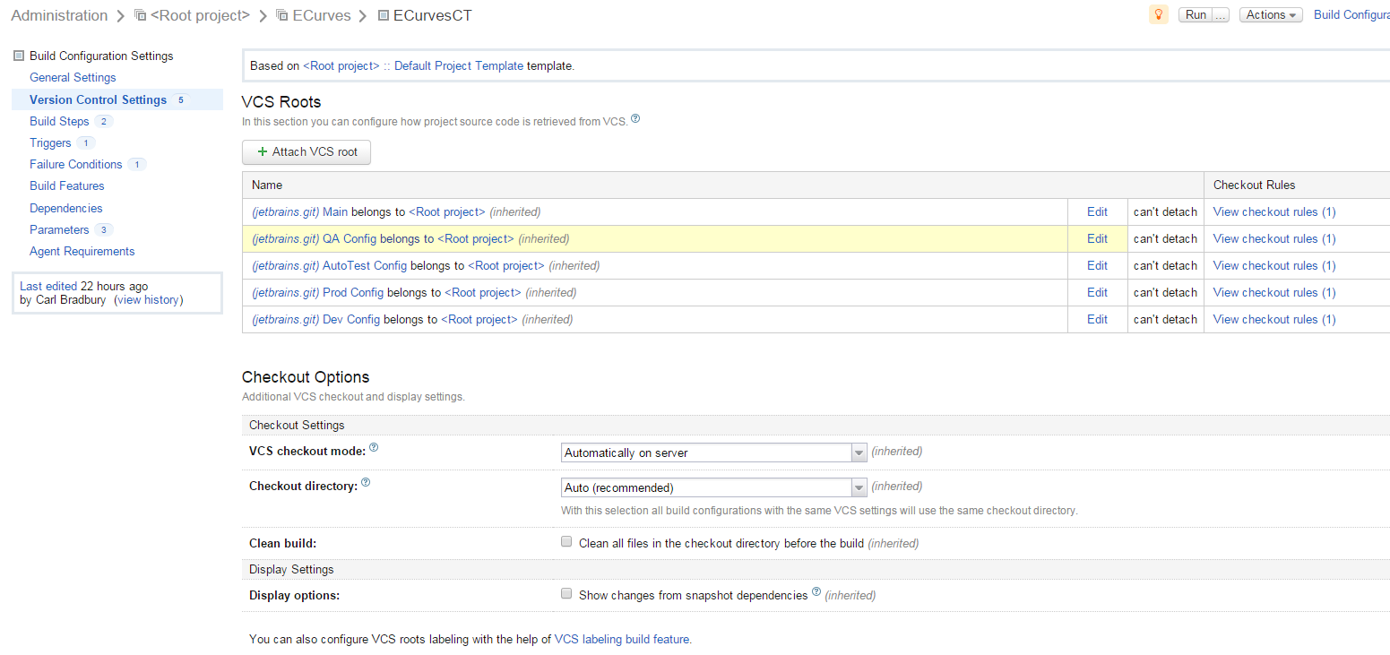

Here is the VCS checkout rule for our ‘Main’ VCS root:

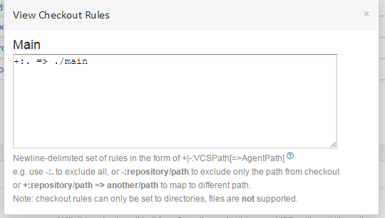

Here are the VCS Trigger settings for out ECurvesCT project:

