**Proposal for ELEG5491 Final Project 2017**

**Name:** Zhizhong Li

**Title:** Visualizing the Training Dynamics of GAN

**TA-in-charge:** Chu Xiao

**Paper ID:** 1155070507

**Description:**

Generative Adversarial Networks (GANs) are notoriously known as hard to train. The problems include oscillation, mode collapse, counting bug, etc., to name a few. The training on large scale and high dimensional datasets (ImageNet/LSUN/CIFAR etc.) is like doing a practice of art which is full of magic. However, by experimenting on synthesized, low-dimensional datasets, we can have a good visualization on what going on under the hood. We want to note that one should not overlook the value of these toy models. By visualizing the training dynamics of GAN, they can bring us insights to this complex system and thus facilitate our understanding why they are troublesome in training. In fact, many recent papers also defend their ideas by demonstrating on low-dimensional experiments. See the figures below to get some sense.

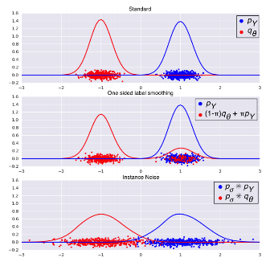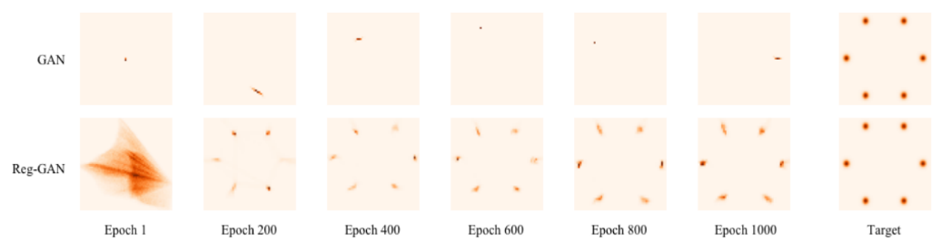

Figure 1 (Sønderby, 2016)

Figure 2 (Che, 2016)

There are two goals of this research. One is to identify and visualize the training problems by designing proper low-dimensional experiments. We may expect to discover new types of training problems as well. The second goal is to understand why they fail. We hope to propose new methods on stabilizing the training process. And we would verify their effectiveness by applying them to these toy models.

The chosen deep learning framework is Parrots (Parrots Team, 2017), which is developed and maintained by MMLAB, CUHK. The main programming language will be in Julia (JuliaLang, 2017).

**Tentative Timeline/To-do lists:**

* Mar 4 – Mar 24: Investigation
* Mar 25-31: Build up codebase on GAN (using Parrots) and visualization (using Julia)
* Apr 1-14: develop various toy models and verify ideas
* Apr 15-21: paper draft
* Apr 22-26: make up experiments and revise paper

**Reference**

JuliaLang. (2017). *http://julialang.org/.*

Parrots Team. (2017). *http://www.parrotsdnn.org/.*

Sønderby, Casper Kaae, Jose Caballero, Lucas Theis, Wenzhe Shi, and Ferenc Huszár. "Amortised MAP Inference for Image Super-resolution." *arXiv preprint arXiv:1610.04490* (2016).

Che, Tong, Yanran Li, Athul Paul Jacob, Yoshua Bengio, and Wenjie Li. "Mode Regularized Generative Adversarial Networks." *arXiv preprint arXiv:1612.02136* (2016).