NFCU DataPower OpenShift Deployment Lab Guide
Version: 3.2.4
Last Updated: July 9, 2026
Lab Format: Hands-on

Lab goal
In this lab, students deploy IBM DataPower Gateway on OpenShift, expose the web management interface and a Multi-Protocol Gateway route, validate the deployment, and extend the deployment with a Git-based configuration workflow.

Learning outcomes
By the end of this lab, students should be able to:
- Log in to an OpenShift cluster.
- Create or select the target project.
- Install the IBM DataPower Operator.
- Create the secrets and ConfigMaps required for a base deployment.
- Deploy a DataPowerService instance.
- Expose the Web UI (for POT only) and MPG endpoint.
- Validate that the platform is working.
- Update the deployment to pull configuration from Git.

Lab inputs
Before you begin, collect the following information from your instructor or lab environment:
Item | Value
OpenShift console URL | https://console-openshift-console.apps.<cluster-name>.<domain>
OpenShift API endpoint | https://api.<cluster-name>:6443
OpenShift username | kubeadmin or the username provided to you
OpenShift password or token | Provided by your instructor or administrator
IBM entitlement key | Provided before the lab starts
Email for entitlement secret | Your email address
Cluster apps domain | Determine during the lab if needed
Github repo | https://github.com/innessrg/NFCU_DataPower_MVP1

Getting your OpenShift login command
- In the OpenShift console, open the user menu and select Copy login command.
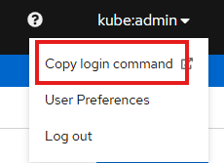
- Select Display Token.
Example token login command:
Command:
oc login --token=<token> --server=https://api.<cluster-name>:6443

Files used in this lab
Download the lab files from the GitHub repository before starting: NFCU_DataPower_MVP1.
Files referenced in this lab include:
- Datapower.yaml
- web-mgmt.cfg
- webgui-service.yaml
- webgui-route.yaml
- route.yaml
- service.yaml
- pull-from-git.cfg
- github.com.cer
- pot-additionalDomainConfig.yaml

Lab 1: Log in to OpenShift

Prerequisites
Complete the following before the lab begins:
- Access to an OpenShift cluster.
- The oc CLI installed and working.
- The IBM entitlement key.
- Access to the GitHub lab repository.
- Permission to create resources in the target namespace.

Objective
Authenticate the cluster and confirm that CLI access works.
Steps
- Get your login command from the OpenShift console, or use the username and password provided by your instructor.
- Run the login command.
Command:
oc login --token=<token> --server=https://api.<cluster-name>:6443
- Confirm that authentication succeeded.
Command:
oc whoami
oc cluster-info
- Record the current user and cluster details for your lab notes.
Checkpoint
- oc whoami returns your username.
- oc cluster-info returns cluster details.

Lab 2: Create or select the project

Objective
Use the target namespace for the operator and DataPower deployment.
Steps
- Create the project if it does not already exist.
Command:
oc new-project nfcu-demo
- If the project already exists, switch to it.
Command:
oc project nfcu-demo
- Confirm the active project.
Command:
oc project
Checkpoint
- The current project is nfcu-demo.

Lab 3: Install the DataPower Operator

Objective
Install the catalog source and the IBM DataPower Operator.
Steps
- Open datapower-catalog-source-latest.yaml and copy its contents.
- In the OpenShift console, Click the “+” to open Import YAML and paste the file contents.
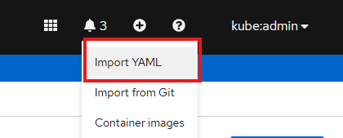
- Set the namespace to openshift-marketplace, then create the resource.
- Review the created catalog source in the console and confirm it was applied successfully.
- Go to Operators > OperatorHub and search for IBM DataPower Gateway.
- Select the operator and click Install.
- Choose the installation mode, update channel, and approval strategy required for your lab environment.
- Click Subscribe and wait for the installation to complete.
- Open Operators > Installed Operators and confirm the operator appears without errors.
Checkpoint
- The subscription exists.
- The DataPower ClusterServiceVersion is installed.
- The operator pod is running.

Lab 4: Prepare secrets and ConfigMaps

Objective
Create the resources required for the base DataPower deployment.
Steps
- Confirm that you are in the nfcu-demo project.
Command:
oc project nfcu-demo
- Create the admin password secret.
Command:
oc create secret generic dp-admin-password --from-literal=password=admin -n nfcu-demo
- Create the GitHub certificate secret referenced by Datapower.yaml.
Command:
oc create secret generic github.com.cer --from-file=github.com.cer -n nfcu-demo
- Create the IBM entitlement secret so the operator can pull the DataPower image from the IBM Container Registry.
Command:
oc create secret docker-registry ibm-entitlement-key --docker-server=cp.icr.io --docker-username=cp --docker-password=<YOUR_IBM_ENTITLEMENT_KEY> --docker-email=<YOUR_EMAIL> -n nfcu-demo
- Link the entitlement secret to the default service account for image pulls.
Command:
oc secrets link default ibm-entitlement-key --for=pull -n nfcu-demo
- Create the web management ConfigMap from web-mgmt.cfg.
Command:
oc create configmap web-mgmt-cfg --from-file=web-mgmt.cfg -n nfcu-demo
- Verify that the required resources exist.
Command:
oc get configmap web-mgmt-cfg -n nfcu-demo
oc get secret dp-admin-password -n nfcu-demo
oc get secret github.com.cer -n nfcu-demo
oc get secret ibm-entitlement-key -n nfcu-demo
Checkpoint
- web-mgmt-cfg exists.
- dp-admin-password exists.
- github.com.cer exists.
- ibm-entitlement-key exists.
- The entitlement key is linked to the default service account.

Lab 5: Deploy DataPower

Objective
Create the DataPowerService resource and wait for it to become ready.
Steps
- Review Datapower.yaml and confirm the namespace, version, deployment name, and domain configuration are correct for your environment.
- In the OpenShift console, go to Operators > Installed Operators.
- Open IBM DataPower Gateway.
- Under Provided APIs, select DataPowerService.
- Click Create Instance.
- In Form view, review the key fields such as name, namespace, version, users, domains, and replicas.
- Switch to YAML view, paste the contents of Datapower.yaml, and click Create.
- Wait for the DataPowerService status to reach Running.
- Optionally monitor progress from the CLI.
Command:
oc get pods -w
oc get datapowerservice quickstart
oc logs quickstart-0
Checkpoint
- The pod reaches Running.
- The DataPowerService becomes ready.
- Base startup completes successfully.

Lab 6: Expose the web UI and MPG

Objective
Create the services and routes required to access the web UI and the Multi-Protocol Gateway.
Steps
- Open webgui-route.yaml.
- Update spec.host field using the pattern <route-or-service-name>-<namespace>.<apps-domain>.
- If needed, determine the cluster apps domain.

Command:
oc get ingresses.config/cluster -o jsonpath='{.spec.domain}'
Copy output of command in the <hostname>
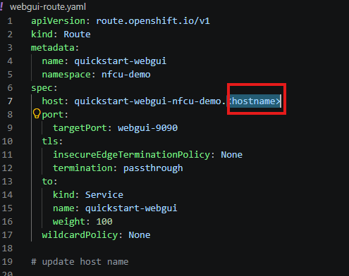
- Save webgui-route.yaml after updating the host name.
- Apply the web UI service.
Command:
oc apply -f webgui-service.yaml
- Apply the web UI route.
Command:
oc apply -f webgui-route.yaml
- Apply the MPG service.
Command:
oc apply -f service.yaml
- Apply the MPG route.
Command:
oc apply -f route.yaml
- List the routes.
Command:
oc get route
- Get the web UI route hostname.
Command:
oc get route quickstart-webgui -o jsonpath='{.spec.host}'
- Get the MPG route hostname.
Command:
oc get route route-latin-bonobo -o jsonpath='{.spec.host}'
Note: You can also Validate in the Openshift Console – NetworkingRoutes
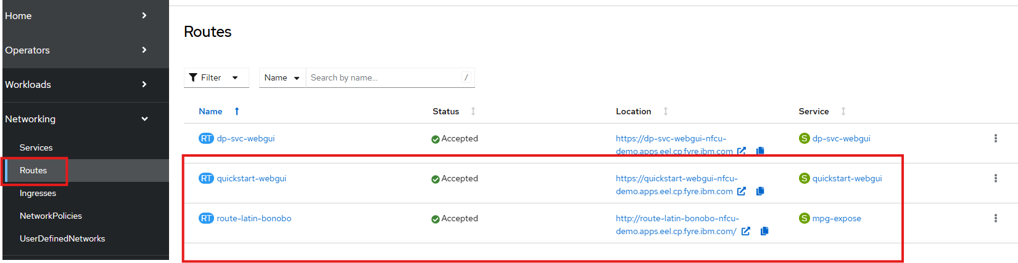
Checkpoint
- The web UI route exists.
- The MPG route exists.

Lab 7: Validate the deployment

Objective
Confirm that the deployment works from both the administrative and API perspectives.
Steps
- Open the DataPower web UI in a browser using the quickstart-webgui route hostname or click on the Location:
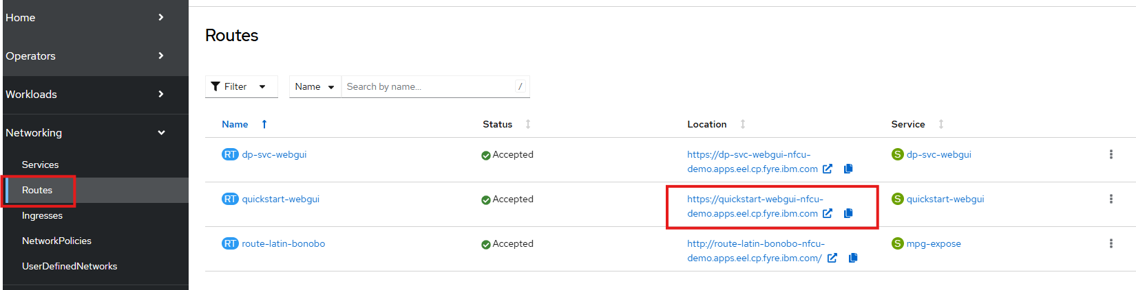
- Log in with the lab credentials below.
Field | Value
Username | admin
Password | admin

- Confirm that the default and demo domains are available.
- Import mpg-expose.zip into the demo domain.
- Select the Link below to Test the mpg-expose MPGW
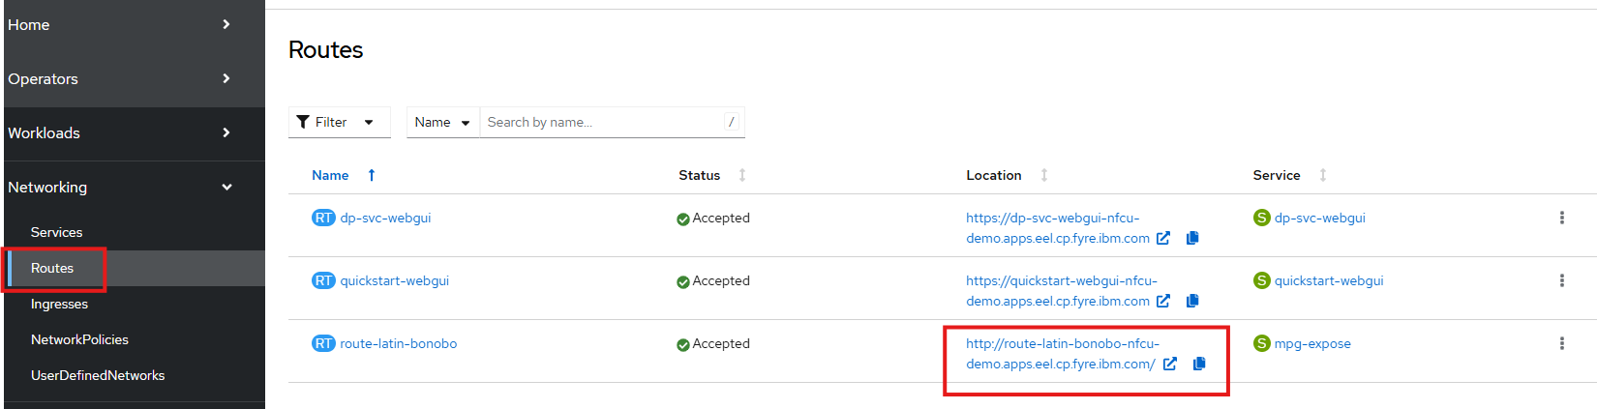
- Confirm that the service returns a JSON response.
- Review the related OpenShift objects.
Command:
oc get pods
oc get datapowerservice
oc get route
Checkpoint
- Web UI login works.
- The default domain is up.
- The MPG route responds successfully.
- The base platform is ready for the Git-based extension lab.
- Note – at this point if you delete the POD the MPGW imported into the DataPower Service will be deleted.

Lab 8: Pull configuration from Git

Objective
Add a new DataPower domain that uses the GitOps feature to pull configuration from GitHub, then confirm the configuration is visible in the web UI and written back to the repository.

Part A: Create required resources
- Confirm that you are in the nfcu-demo project.
Command:
oc project nfcu-demo
- Create the ConfigMap from pull-from-git.cfg.
Command:
oc create configmap pull-from-git-cfg --from-file=pull-from-git.cfg -n nfcu-demo
- Recreate the GitHub certificate secret to ensure the correct certificate file is being used.

Command:
oc delete secret github.com.cer -n nfcu-demo
oc create secret generic github.com.cer --from-file=github.com.cer -n nfcu-demo
- Create the GitHub personal access token secret. Use a token with repository access.
- IBM Team will provide PAT token.
Command:
oc create secret generic pat --from-literal=password=<YOUR_GITHUB_PAT_TOKEN> -n nfcu-demo
- Verify the resources.
Command:
oc get configmap pull-from-git-cfg -n nfcu-demo
oc get secret github.com.cer -n nfcu-demo
oc get secret pat -n nfcu-demo

Part B: Update the DataPowerService
- In the OpenShift console, open Operators > Installed Operators > IBM DataPower Gateway > DataPowerService.
- Click to open the quickstart DataPowerService.
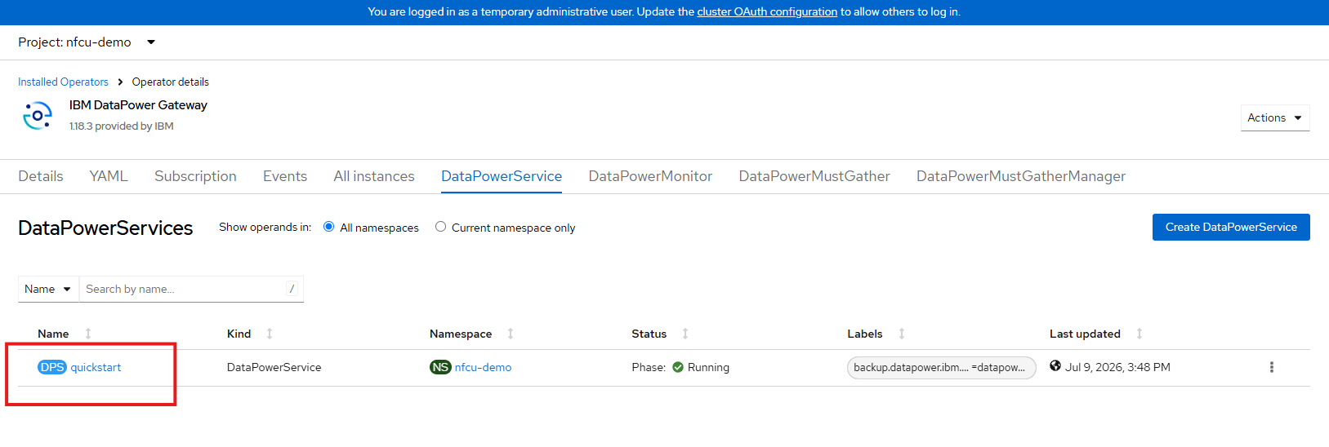
- Download the current YAML definition (Download in the Bottom Corner).
- It will should be named datapowerservice-quickstart.yaml
- Open the (datapowerservice-quickstart.yaml) downloaded file in a text editor.
- Download and open pot-additionalDomainConfig.yaml in a text editor from the lab repository.
- Select All the contents from the pot-additionalDomainConfig.yaml
- Replace the existing domains: section in the downloaded DataPowerService YAML (datapowerservice-quickstart.yaml ) with the updated domain configuration.

Before:
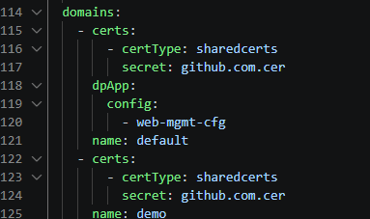
After:
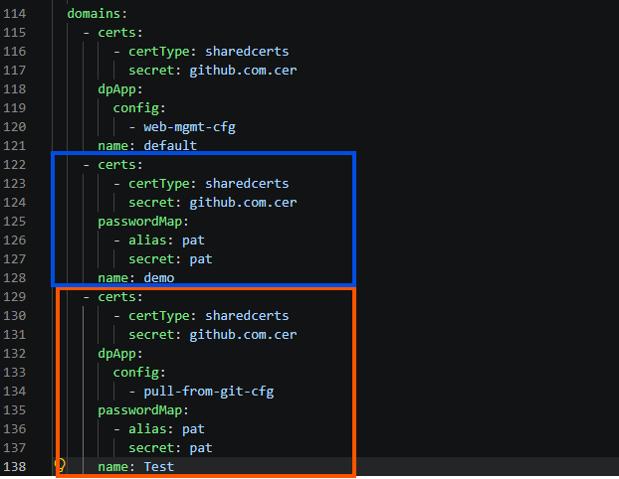
- Save the updated YAML (datapowerservice-quickstart.yaml).

- In the OpenShift console select the YAML tab of the quickstart DataPowerService
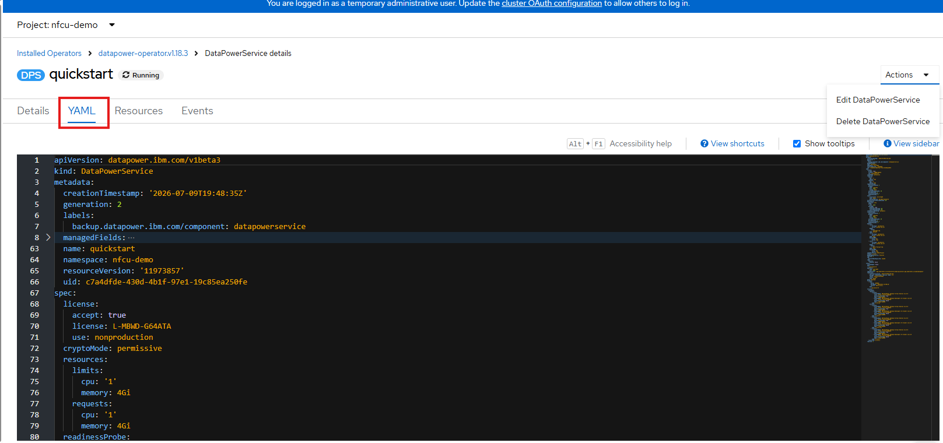
- Click Edit DataPowerService
- Paste the updated YAML (datapowerservice-quickstart.yaml ) with the additional configuration
- Click Save
- Click Reload
- Optional Watch the pod restart and return to Running.
Command:
oc get pods -w
- Confirm that the updated DataPowerService includes the new Test domain configuration.
Command:
oc get datapowerservice quickstart -o yaml

Part C: Validate in the web UI
- Open the DataPower web UI using the quickstart-webgui route.

- Log in as admin with password admin.
- Confirm that a new Test domain appears alongside default and demo.
- Switch to the Test domain.
- Search for the GitOps object and open it.
- Confirm that the repository URL points to https://github.com/innessrg/NFCU_MVP1_Source_Files.git.
- Open Multi-Protocol Gateway in the Test domain and review the services pulled from the repository.

Part D: Confirm GitHub
- Open the repository lab repository in a browser.
- Confirm that the expected DataPower domain configuration files are present.
Checkpoint
- pull-from-git-cfg exists.
- github.com.cer exists.
- pat exists.
- The DataPowerService was updated successfully.
- The pod restarted and returned to Running.
- The Test domain appears in the web UI.
- The GitOps object points to the correct repository.
- The expected services appear in the Test domain.
- Configuration is visible in the GitHub repository.
- Note- if you delete the POD the service will peresist

Troubleshooting
If the DataPowerService does not start correctly, use the following checks.
Check pod status and events
oc get pods -n nfcu-demo
oc describe pod quickstart-0 -n nfcu-demo
Review the Events section for pull errors, scheduling failures, or configuration issues.
Check DataPowerService status
oc describe datapowerservice quickstart -n nfcu-demo
Review the Status section for conditions or error messages.
Check operator logs
oc logs -n openshift-operators -l name=datapower-operator
Use the operator logs to identify reconciliation failures.
Check image pull configuration
If the pod is stuck in ImagePullBackOff or ErrImagePull, verify the entitlement secret and its service account link.
oc get secret ibm-entitlement-key -n nfcu-demo
oc get serviceaccount default -n nfcu-demo -o yaml | grep ibm-entitlement-key
Check for missing secrets or ConfigMaps
oc get secret,configmap -n nfcu-demo
Use this command to confirm that all referenced resources from Lab 4 exist.
Check namespace events
oc get events -n nfcu-demo --sort-by='.lastTimestamp'
Namespace events often provide the fastest explanation for a failed deployment.

Lab 9: Configure Persistent Storage for IBM DataPower on OpenShift
Objective
Configure persistent local storage for IBM DataPower on Red Hat OpenShift so the DataPower pod can use separate persistent mounts for /config and /local on the same worker node.
Lab Overview
This lab demonstrates how to use the Red Hat Local Storage Operator to provide node-local persistent storage for an IBM DataPower deployment on OpenShift. The design uses two partitions on the same secondary disk to model independent persistent volumes for the two DataPower storage paths listed below.
- /opt/ibm/datapower/drouter/config
- /opt/ibm/datapower/drouter/local
This separation is useful in a lab because it creates a clear one-to-one relationship between disk partitions, persistent volumes, persistent volume claims, and DataPower mount targets.
Important Design Note
This lab uses node-local storage, not shared cluster storage. The persistent volumes created from local partitions are tied to the worker node that owns the disk, so this design preserves data across pod recreation on that node but does not provide cross-node storage failover by itself.
Persistent storage is not a requirement for DataPower containers, nor is it generally best practice. Depends on the use case.. but generally speaking configuration should be managed and mounted via configMaps, secrets and repos, not mutated within the container and persisted to disk.
Any services/configuration that relies on DataPower's RAID capability would utilize persistent storage in k8s to back the file system

Learning Objectives
In this lab, you will:
- Retrieve node details to identify the target deployment node.
- Partition a raw secondary block device (/dev/vdb) on Red Hat Enterprise Linux CoreOS.
- Install and configure the Red Hat Local Storage Operator.
- Provision the local-file-sc storage class and bind node partitions to local persistent volumes.
- Deploy IBM DataPower with deleteClaim: false to preserve persistent state.
- Validate that configuration persists across pod recreation.
Prerequisites
Before starting, ensure the following requirements are met:
- Cluster-admin access to OpenShift is available.
- The oc CLI is installed and already logged in to the target cluster.
- A secondary block device is attached to the worker node and available as /dev/vdb.
Required DataPower images, entitlement credentials, secrets, and ConfigMaps from earlier labs are already present.
Files referenced in this lab include:
- Datapower.yaml
- Datapower-lso.yaml
Reference Documents
Use the following references during the lab:
- Red Hat OpenShift Local Storage Operator documentation.
- Local Storage Operator OLM deployment guidance.
- IBM DataPower Operator storage documentation.
- IBM DataPower initialization and ConfigMap reference documentation.
- IBM architectural guidance for DataPower on OpenShift.
Exercise 1: Clean the Cluster Environment
Delete any existing DataPower custom resource before creating the new storage-backed deployment.
oc delete datapowerservice quickstart -n nfcu-demo --ignore-not-found
Exercise 2: Identify and Partition Host Worker Storage
Step 2.1: Locate the Target Node
Get the node where the DataPower pod is scheduled.
oc get pod quickstart-0 -n nfcu-demo -o wide
Locate the host name under the NODE column.

Because this lab uses local storage, the DataPower pod must run on the worker node that owns the local partitions and persistent volumes.
Step 2.2: Access the Host Shell
Start a debug session on the target worker node.
oc debug node/[UPDATE HOST FROM COMMAND IN STEP 2.1]
for example
oc debug node/worker2.eel.cp.fyre.ibm.com
Switch to the host filesystem.
chroot /host
Step 2.3: Partition /dev/vdb
Partition the disk using fdisk.
(
echo g
echo n
echo 1
echo
echo +100G
echo n
echo 2
echo
echo
echo w
) | fdisk /dev/vdb
Verify the partitions were created.
lsblk /dev/vdb
Expected result: /dev/vdb1 and /dev/vdb2 exist and are available for local PV creation.
Exit the debug session.
exit
exit
Exercise 3: Install the Local Storage Operator
In the OpenShift web console, go to Operators > OperatorHub and search for Local Storage. Select the Red Hat Local Storage Operator tile and install it with the following settings.
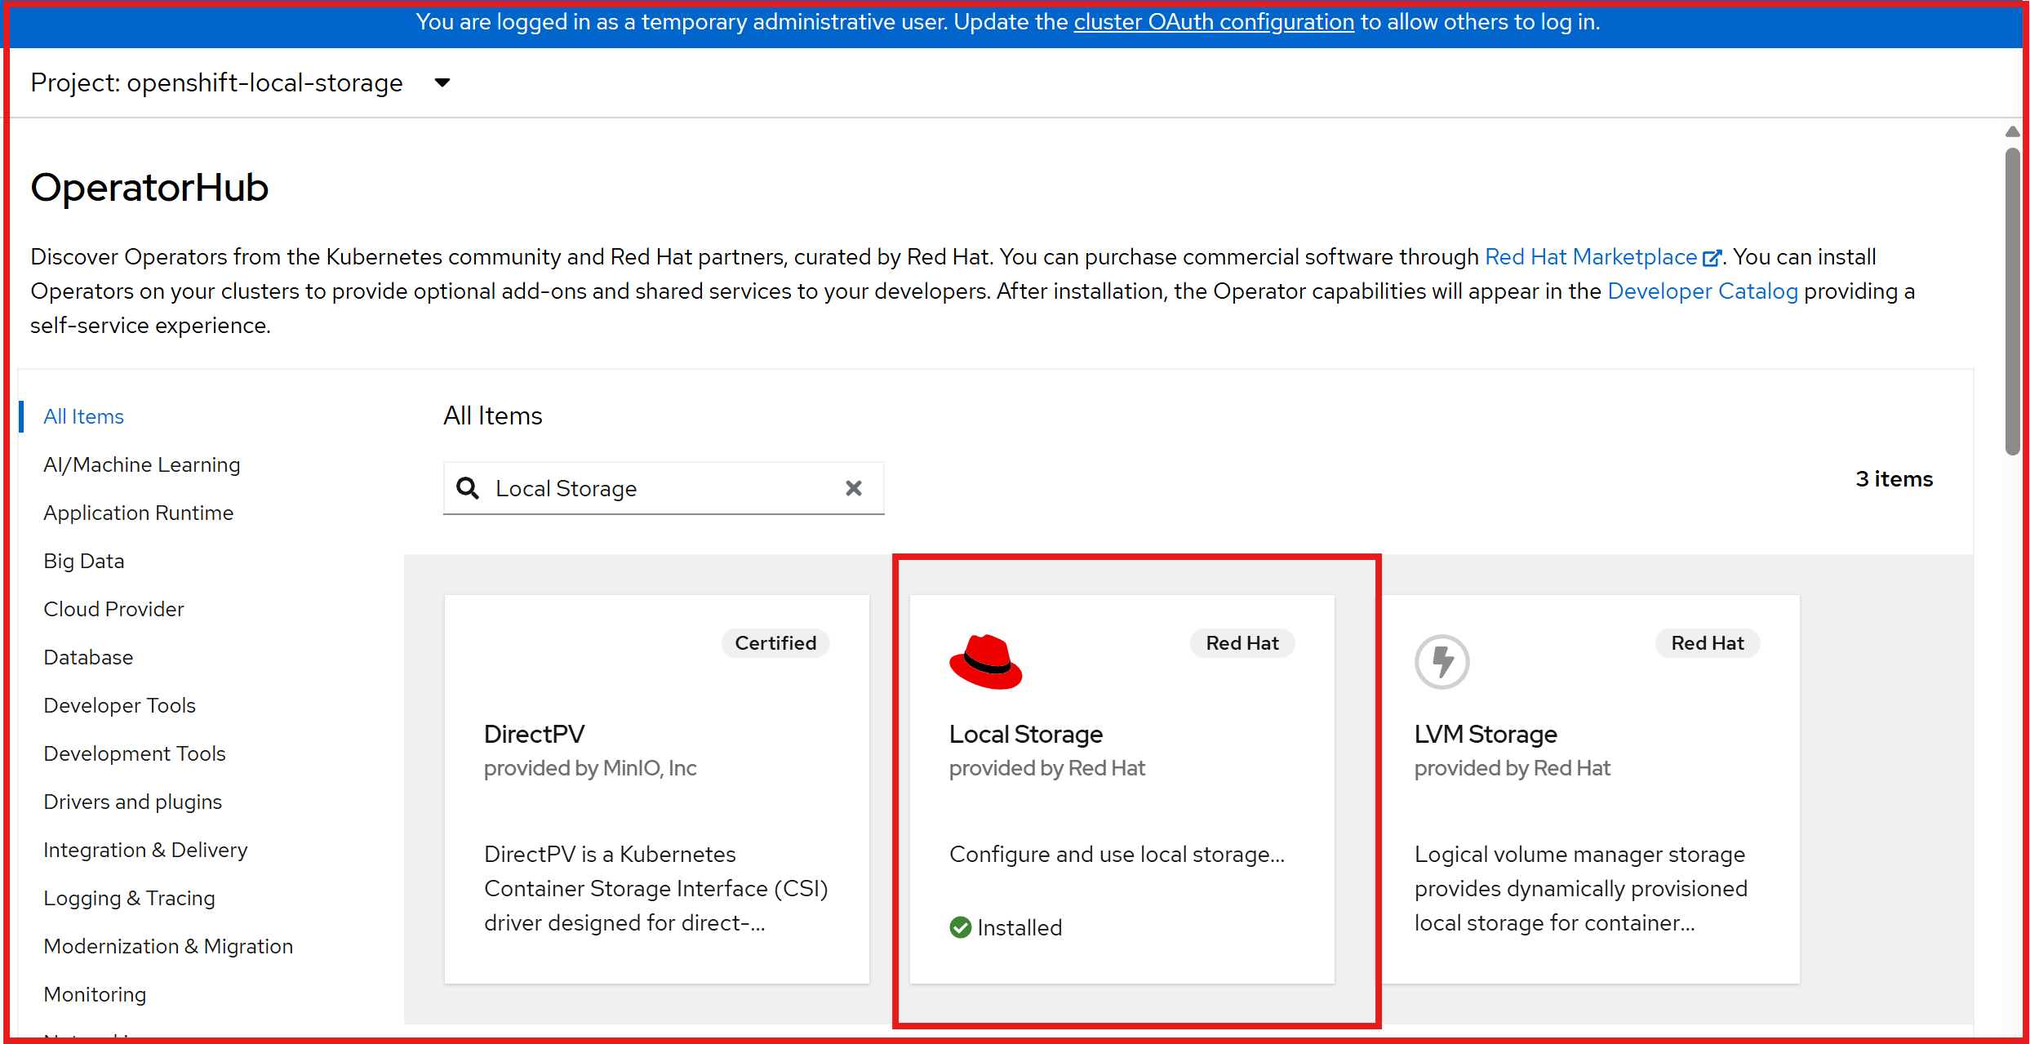
- Update Channel: stable
- Installation Mode: A specific namespace on the cluster
- Installed Namespace: openshift-local-storage
- Update Approval: Automatic
Wait until the operator status shows Succeeded under Operators > Installed Operators.
Exercise 4: Provision the StorageClass and Persistent Volumes
Review datapower-localvolume.yaml from the repository before applying it. This manifest should define the local storage resources that discover and expose the partitions as local persistent volumes.
Apply the LocalVolume configuration.
oc apply -f datapower-localvolume.yaml
Verify that the storage class exists.
oc get sc local-file-sc
Verify the local persistent volumes.
oc get pv | grep local-file-sc
Ensure both entries are associated with local-file-sc and show as Available before moving forward.
Exercise 5: Deploy DataPower with Local Storage
Review Datapower-lso.yaml carefully before applying it. Confirm that the manifest contains two storage definitions, that the storage is mapped to the correct DataPower mount paths, that the storage class references are correct, and that deleteClaim: false is configured on the persistent storage entries.
Apply the DataPower manifest.
oc apply -f Datapower-lso.yaml
Exercise 6: Validate and Test Persistence
Step 6.1: Verify Pod and PVC Binding
Verify the persistent volume claims are bound.
oc get pvc -n nfcu-demo
Verify the DataPower pod is running.
oc get pods -n nfcu-demo
Step 6.2: Write and Commit Test Configurations
Open the DataPower WebGUI in your browser. Import your configuration assets, for example pull-from-git-object.zip, then click Save Configuration in the top-right corner of the WebGUI to commit changes to disk.
Step 6.3: Run the Pod Recreation Test
Delete the running DataPower pod.
oc delete pod quickstart-0 -n nfcu-demo
Watch the replacement pod come back.
oc get pods -n nfcu-demo -w
After the new quickstart-0 pod is running, log back in and confirm that the imported configuration is still present.
Checkpoint
At this stage, confirm the following:
- Existing DataPower resources and stale storage mappings were cleaned up.
- The target worker node was identified.
- /dev/vdb1 and /dev/vdb2 were created successfully.
- The Local Storage Operator is installed and running.
- local-file-sc exists.
- Local persistent volumes are available.
- DataPower deployed successfully with deleteClaim: false.
- PVCs are bound.
- The WebGUI is reachable.
- Imported configuration persists after pod recreation.
Troubleshooting: DataPowerService Failed to Create
If the DataPowerService does not come up, use the following checks.
1. Check pod status and events
oc get pods -n nfcu-demo
oc describe pod quickstart-0 -n nfcu-demo
Review the Events section at the bottom of the describe output for image pull errors, scheduling failures, and configuration problems.
2. Check the DataPowerService resource status
oc describe datapowerservice quickstart -n nfcu-demo
Review any status conditions or error messages under Status.
3. Check the operator logs
oc logs -n openshift-operators -l name=datapower-operator
The operator is responsible for creating the pod, so reconciliation failures often appear here first.
4. Check for image pull errors
If the pod is stuck in ImagePullBackOff or ErrImagePull, verify that the IBM entitlement secret exists and is linked correctly.
oc get secret ibm-entitlement-key -n nfcu-demo
oc get serviceaccount default -n nfcu-demo -o yaml | grep ibm-entitlement-key
5. Check for missing secrets or ConfigMaps
If the pod fails with a mount error, verify that all referenced secrets and ConfigMaps from earlier labs are present.
oc get secret,configmap -n nfcu-demo
6. Review namespace events
oc get events -n nfcu-demo --sort-by='.lastTimestamp'
This command provides a useful event timeline and is often the quickest way to identify the immediate cause of a failed deployment.
Lab Notes for Production Design
This lab is intentionally designed for visibility and learning rather than for a production-ready storage architecture. In production, teams often use resilient shared storage or platform-native block storage instead of node-local partitions, but the separation of persistent DataPower storage concerns remains a useful design principle.

