NFCU DataPower OpenShift Deployment Lab Guide
Version: 3.2.6
Last Updated: July 22, 2026
Lab Format: Hands-on

Table of Contents
Contents
NFCU DataPower OpenShift Deployment Lab Guide 1
Table of Contents 1
Lab Goal 2
What You Will Complete 2
Lab Inputs You Need Before Starting 3
How to Get Your OpenShift Login Information 4
Files Used in This Lab 5
Lab Prerequisites 6
Lab 1: Log in to OpenShift 6
Objective 6
Steps 6
Checkpoint 7
Lab 2: Create or Select the Project 7
Objective 7
Steps 7
Checkpoint 7
Lab 3: Install the DataPower Operator 8
Objective 8
Steps 8
Checkpoint 9
Lab 4: Prepare Base Deployment Secrets and ConfigMaps 9
Objective 9
Steps 9
Checkpoint 11
Lab 5: Deploy DataPower 11
Objective 11
Steps 11
Checkpoint 13
Lab 6: Expose the Web UI and MPG 13
Objective 13
Steps 13
Checkpoint 15
Lab 7: Validate the Deployment 15
Objective 15
Steps 16
Checkpoint 18
Lab 8: Pull Configuration from Git 18
Objective 18
Steps 18
Checkpoint 23
Troubleshooting: DataPowerService Failed to Create 26
Lab 9: Configure Persistent Storage for IBM DataPower on OpenShift 28
Objective 28
Steps Exercise 2: Identify the Target Worker Node — Do This First 30

Lab Goal
Deploy IBM DataPower Gateway on OpenShift with the web management UI (for demo only).

What You Will Complete
By the end of this lab, you will:
1. Log in to OpenShift
2. Create or switch to the nfcu-demo project
3. Install the IBM DataPower Operator
4. Create the required secrets and ConfigMaps for the base deployment
5. Deploy the DataPower service
6. Expose the web UI and MPG route
7. Validate that the deployment is working
8. Pull configuration from a Git repository using the DataPower GitOps feature

Lab Inputs You Need Before Starting
You may now access your OpenShift portal here:

OpenShift Console URL:
https://console-openshift-console.apps.<cluster-name>.<domain>

Credentials for OpenShift Portal:

Field | Value
Username | kubeadmin
Password | <openshift-password>

Infrastructure Node:

Field | Value
API / Infrastructure Node | api.<cluster-name>.<domain>
Infrastructure Public IP | <public-ip>

Credentials for Infrastructure Node:

Field | Value
Username | root
Password | <root-password>

Additional Lab Inputs:

Variable | Your Value
IBM entitlement key
Email for entitlement secret

How to Get Your OpenShift Login Information
Use one of these methods:
- Open the OpenShift web console and use Copy login command from the top-right menu.

- Ask your OpenShift cluster administrator or lab instructor for your cluster credentials.

From the OpenShift console:
1. Log in to the OpenShift web console.
2. In the top-right corner, click your user menu.
3. Select Copy login command.
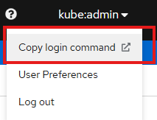
4. Choose Display Token if prompted.
5. Copy the provided oc login command.
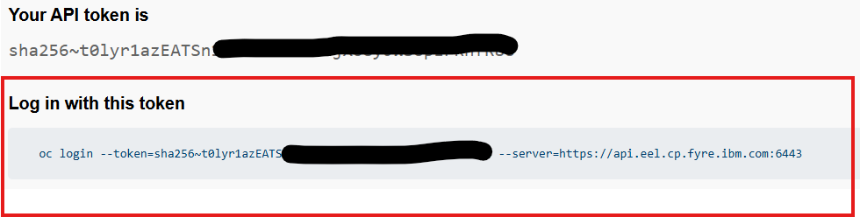
Example username/password login:

Command: oc login https://api.<cluster-name>:6443 -u <username> -p <password>

Files Used in This Lab
Download the lab files from the following GitHub repository before starting:

GitHub Repo

The following files from that repository are used in this lab:
- Datapower.yaml
- web-mgmt.cfg
- webgui-service.yaml
- webgui-route.yaml
- route.yaml
- service.yaml
- pull-from-git.cfg
- github.com.cer

Lab Prerequisites
Complete these before the lab:
- Have access to an OpenShift cluster
- Have the oc CLI installed
- Obtain your IBM entitlement key
- Know the OpenShift apps domain for your cluster

Lab 1: Log in to OpenShift

Objective
Authenticate to the cluster and confirm your CLI access works.

Steps
1. Get your login command from the OpenShift console using Copy login command, or use the username and password provided by your administrator.
2. Run the token-based login command:

Command: oc login --token=<token> --server=https://api.<cluster-name>:6443

3. Confirm your login:

Command: oc whoami

Command: oc cluster-info

4. Record the current user and cluster information.

Checkpoint
- oc whoami returns your username
- oc cluster-info returns cluster details

Lab 2: Create or Select the Project

Objective
Use the target namespace for the operator and DataPower instance.

Steps
1. Create the project if needed:

Command: oc new-project nfcu-demo

2. If it already exists, switch to it:

Command: oc project nfcu-demo

3. Confirm the current project:

Command: oc project

Checkpoint
- Current project is nfcu-demo

Lab 3: Install the DataPower Operator

Objective
Install the catalog source and operator subscription.

Steps
1. Open the datapower-catalog-source-latest.yaml file and copy the contents.
2. Open the OpenShift console and use Import YAML (the + icon in the top-right toolbar).
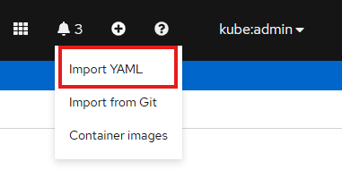
3. Paste the contents of the datapower-catalog-source-latest.yaml YAML into the editor.
4. Make sure the namespace is set to openshift-marketplace for this POT, then click Create.
5. After the resource is created, open the catalog source in the console and select the YAML tab to review the applied resource definition.
6. Open the IBM DataPower Operator.
  - Confirm the operator is available from the expected catalog source before continuing.
7. Install the DataPower Operator from the OpenShift console:
  - In Operators > OperatorHub, search for DataPower.
  - Select the IBM DataPower Gateway tile.
  - In the panel on the right, click Install.
  - Under Installation Mode, select your desired installation mode.
  - Select the desired Update Channel.
  - Select the desired Approval Strategy.
    - If Automatic is selected, operator updates in the chosen channel are applied automatically when available.
    - If Manual is selected, an administrator must approve each operator update through OLM.
  - Click Subscribe to install the DataPower Operator.
  - Make sure Operator Installs Successfully
8. Go to Operators > Installed Operators.
  - View installed operators in the openshift-operators namespace.
  - Confirm IBM DataPower Gateway appears in the list with no installation errors.
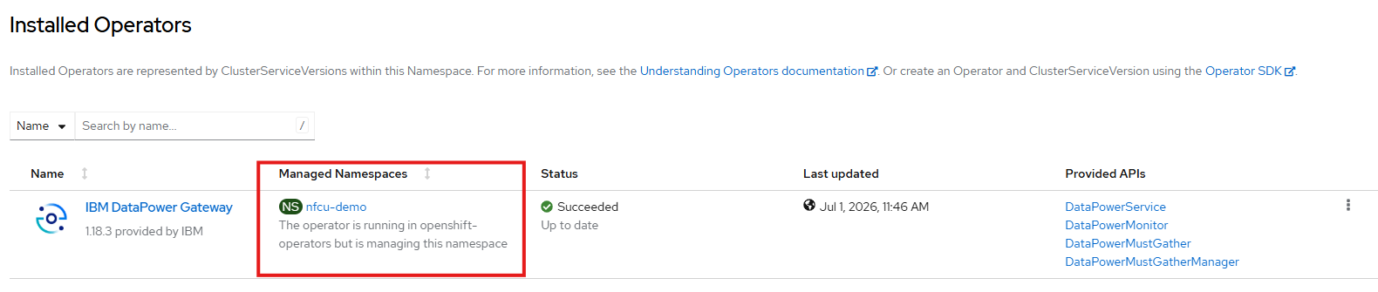

Checkpoint
- Subscription exists
- ClusterServiceVersion (CSV) for DataPower is installed
- Operator pod is running

Lab 4: Prepare Base Deployment Secrets and ConfigMaps

Objective
Create the resources required for the base DataPower deployment.

Steps
1. Make sure you are in the nfcu-demo project:

Command: oc project nfcu-demo

2. Create the admin password secret:

Command: oc create secret generic dp-admin-password --from-literal=password=admin -n nfcu-demo

3. Create the GitHub certificate secret referenced by Datapower.yaml:

Command: oc create secret generic github.com.cer --from-file=github.com.cer -n nfcu-demo

4. Create the IBM entitlement secret:
**Note:** This step allows the DataPower Operator to pull the DataPower image from the IBM Container Registry.
If you do not yet have an entitlement key, retrieve one here:
https://myibm.ibm.com/products-services/containerlibrary
Run the following command to create the secret:

Command: oc create secret docker-registry ibm-entitlement-key --docker-server=cp.icr.io --docker-username=cp --docker-password=<YOUR_IBM_ENTITLEMENT_KEY> --docker-email=<YOUR_EMAIL> -n nfcu-demo

5. Link the secret to the default service account for image pulls:

Command: oc secrets link default ibm-entitlement-key --for=pull -n nfcu-demo

6. Create the web management ConfigMap from the web-mgmt.cfg file:

Command: oc create configmap web-mgmt-cfg --from-file=web-mgmt.cfg -n nfcu-demo

7. Verify each resource:

Command: oc get configmap web-mgmt-cfg -n nfcu-demo

Command: oc get secret dp-admin-password -n nfcu-demo

Command: oc get secret github.com.cer -n nfcu-demo

Command: oc get secret ibm-entitlement-key -n nfcu-demo

Checkpoint
- web-mgmt-cfg exists
- dp-admin-password exists
- github.com.cer exists
- ibm-entitlement-key exists
- Entitlement key is linked to the default service account

Lab 5: Deploy DataPower

Objective
Create the DataPowerService resource and wait for readiness.

Steps
1. Review Datapower.yaml and confirm:
  - namespace is nfcu-demo
  - version matches your operator-supported version
  - deployment name is quickstart
  - the default domain includes the web-mgmt-cfg ConfigMap
  - the configured domains are default and demo
2. In the OpenShift console, go to Operators > Installed Operators.
3. Open IBM DataPower Gateway.
4. Under Provided APIs, click DataPowerService.

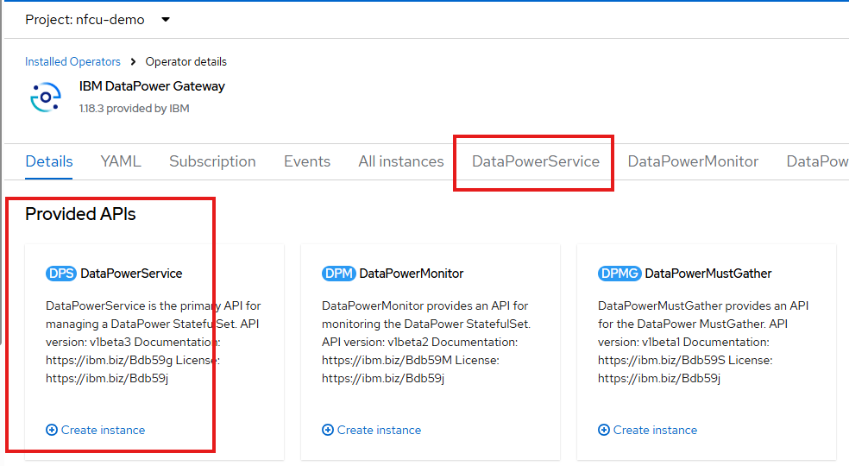

5. Click Create Instance.
Note: Make sure Project is nfcu-demo
6. Open the Form view first and review what is there by default the main fields that map to Datapower.yaml, including:
  - DataPowerService name
  - namespace
  - license acceptance
  - license ID
  - license use
  - version
  - users
  - domains
  - replicas
7. Switch to the YAML view, paste the content from Datapower.yaml, then click Create. Note - wait for Status of "Running".

8. Optional: Watch the deployment progress:

Command: oc get pods -w

9. Optional: In another terminal, verify service status:

Command: oc get datapowerservice quickstart

Command: oc logs quickstart-0

Checkpoint
- Pod reaches Running
- DataPowerService becomes ready
- Base DataPower startup completes successfully

Lab 6: Expose the Web UI and MPG

Objective
Create the services and routes needed for access.

Steps
- Open webgui-route.yaml
- You will update spec.host before applying it.
- The spec.host, uses this pattern:
<route-or-service-name>-<namespace>.<hostname>
- See below:
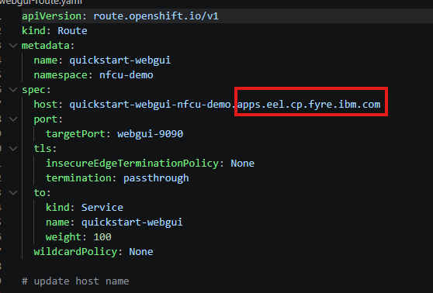
- To find your cluster apps domain, run:
Command: oc get ingresses.config/cluster -o jsonpath='{.spec.domain}'
- Replace <hostname> with output from the above command.
- Save webgui-route.yaml after updating the host name

2. Apply the updated web UI service:

Command: oc apply -f webgui-service.yaml

3. Apply the web UI route to expose port 9090:

Command: oc apply -f webgui-route.yaml

4. Apply the MPG service:

Command: oc apply -f service.yaml

5. Apply the MPG route to expose port 6000:

Command: oc apply -f route.yaml

6. List all routes:

Command: oc get route

7. Validate that the Web UI and MPGW route exists via the Openshift Console as well

from Console: OpenShift Console-->Networking--Routes--Select The quickstart-webgui-->Select Location
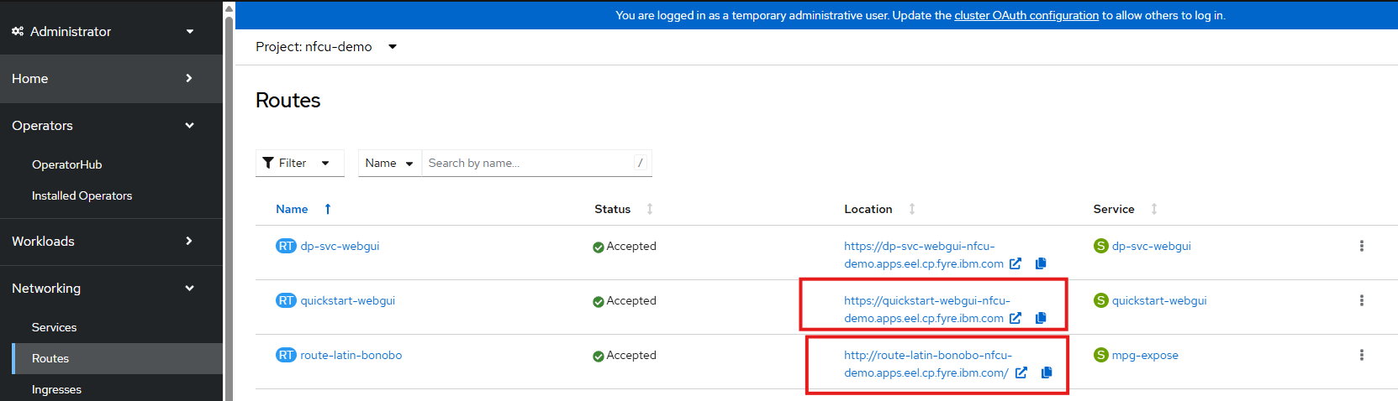

Checkpoint
- Web UI route exists
- MPG route exists

Lab 7: Validate the Deployment

Objective
Confirm the deployment works from both the admin and API sides.

Steps
- Open the web UI in a browser using the quickstart-webgui route hostname.
- From Console: OpenShift Console-->Networking--Routes--Select quickstart-webgui-->Select Location link
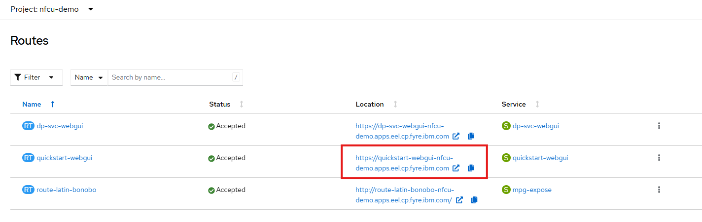

2. Log in with:
  - Username: admin
  - Password: admin
3. Confirm the default and demo domains are up.
4. Test the MPG route:
a. Download mpg-expose.zip from Git Hub Repo - Multiprotocol Gateway
b. Import into the demo domain.
c. Test the service
d. Go to OpenShift Console-->Networking->-RoutesSelect Location Link for route-latin-bonobo.
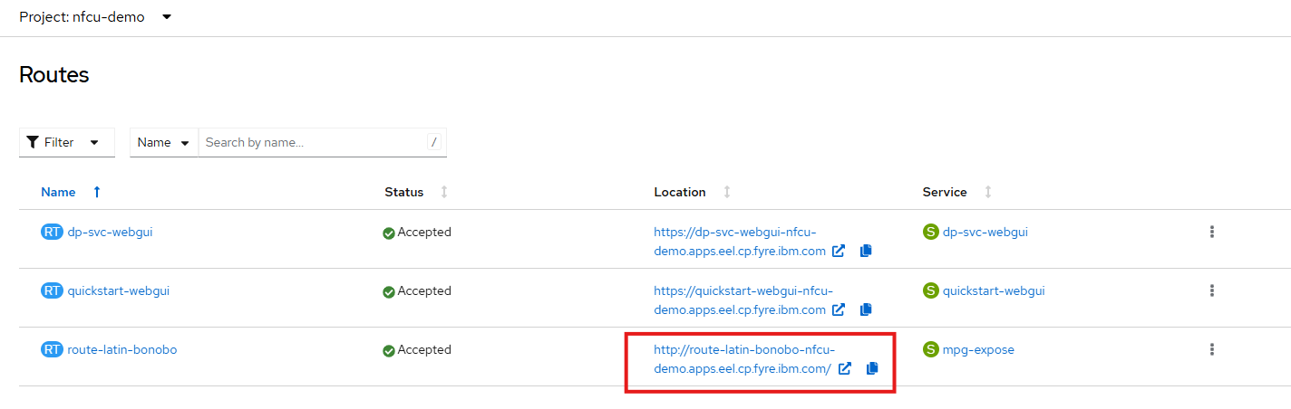
e. This is hitting the mpg-expose MPGW defined in the demo domain listening on port 6000. It should return a json object
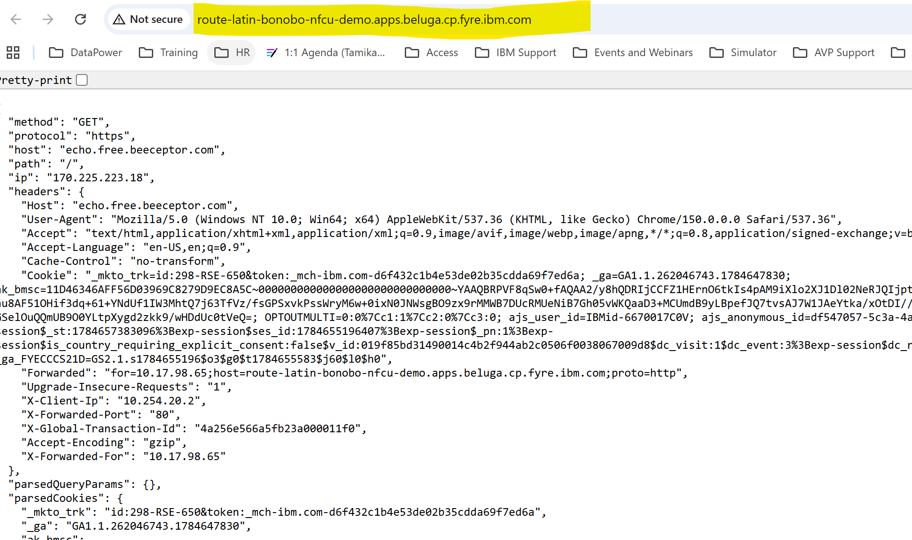

5. Review cluster objects:

Command: oc get pods

Command: oc get datapowerservice

Command: oc get route
8. Demonstrate the Impact of Missing Persistence
In this step, we will delete the DataPower pod and retest the route to observe that the previously imported service is no longer available. This illustrates what happens when there is no persistence configured and no Git repository set up to automatically restore the configuration.
Steps:
a. Delete the DataPower pod:
Command oc delete pod quickstart-0
b. Wait for the pod to restart:
Command oc get pods -w
Wait until quickstart-0 returns to Running status.
c. Retest the MPG route:
- Navigate to OpenShift Console → Networking → Routes
- Select the Location link for route-latin-bonobo
d. Observe the result:
- The route will fail — the service that was previously imported no longer exists
- This is because the DataPower configuration was not persisted to a volume or pulled from a Git repository on startup

Key Takeaway: Without persistence or a GitOps repository, any configuration loaded into DataPower is lost when the pod is deleted or restarted. This demonstrates the importance of the GitOps approach covered in Lab 9.

Checkpoint
- Web UI login works
- Default domain is up
- MPG route responds
- Base platform is ready for the GitOps lab

Lab 8: Pull Configuration from Git

Objective
Add a new DataPower domain that uses the GitOps feature to pull configuration directly from a GitHub repository.
You will create the required secrets and ConfigMap, update the DataPowerService resource, validate the new domain in the DataPower web UI, and confirm that configuration was written back to GitHub.

Steps

Part A: Create Required Resources
1. Make sure you are in the nfcu-demo project:

Command: oc project nfcu-demo

2. Create the ConfigMap from the pull-from-git.cfg.

Command: oc create configmap pull-from-git-cfg --from-file=pull-from-git.cfg -n nfcu-demo

Note: This file contains the gitops object from DataPower
4. Create the GitHub Personal Access Token (PAT) secret:
(IBM Team Will provide Token Details)

Command: oc create secret generic pat --from-literal=password=<YOUR_GITHUB_PAT_TOKEN> -n nfcu-demo

Note: Replace <YOUR_GITHUB_PAT_TOKEN> with your GitHub PAT. The PAT must have repo scope so DataPower can read from and write to the repository.

5. Verify the ConfigMap exists:

Command: oc get configmap pull-from-git-cfg -n nfcu-demo

6. Verify the certificate secret exists:

Command: oc get secret github.com.cer -n nfcu-demo

7. Verify the PAT secret exists:

Command: oc get secret pat -n nfcu-demo

Part B: Update the DataPowerService
8. In the OpenShift console, go to Operators > Installed Operators.
9. Open IBM DataPower Gateway.
10. Click DataPowerService.
11. Click the quickstart DataPowerService to open it.
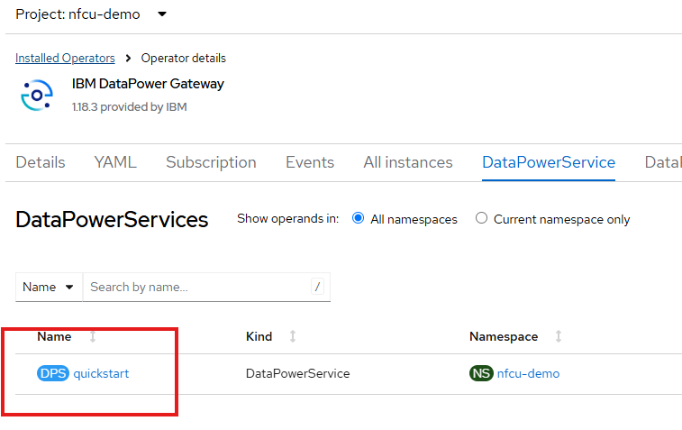
12. Select YAML Tab
13. In the far right hand corner select Download.
14. datapowerservice-quickstart.yaml is downloaded to your local file system.
14. Open the datapowerservice-quickstart.yaml in text editor
14. Fine the line the where the domain definitions start – this where we will make an update.
1. Download the pot-additionalDomainConfig.yaml
2. Open pot-additionalDomainConfig.yaml
3. Select All the contents
4. Paste the into the datapowerservice-quickstart.yaml
5. You should replace the domains: to name: demo section

Before:
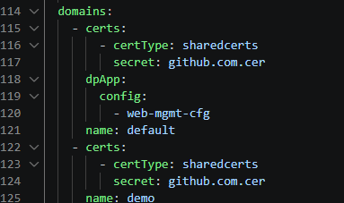

After:
We have added a config map to demo domain to pull contents from github
We have also added a new Test domain to pull contents from github
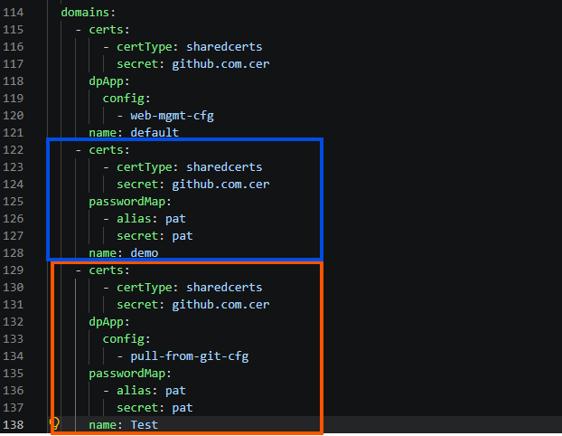

15. Save datapowerservice-quickstart.yaml
16. Copy all Contents from the datapowerservice-quickstart.yaml file
17. Go back to quickstart yaml and replace with the contents from updated datapowerservice-quickstart.yaml
18. Click Save
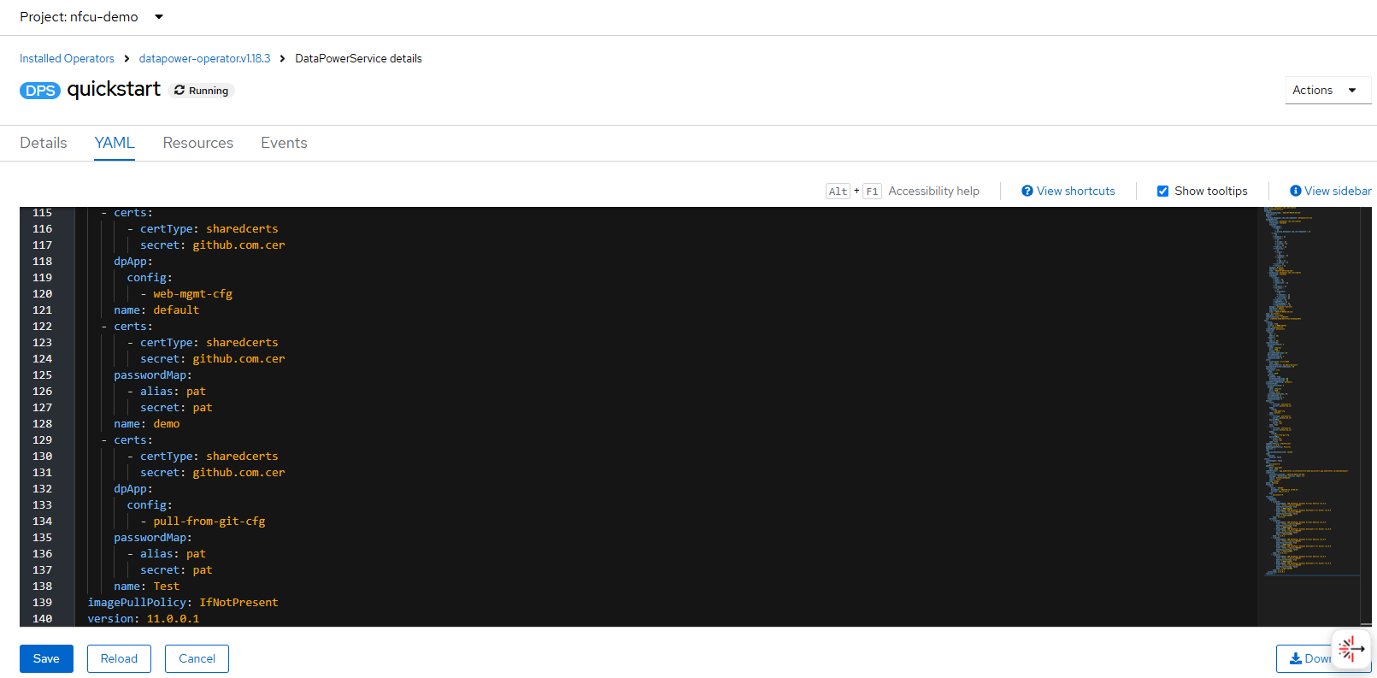
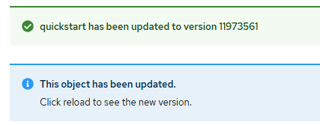
18. Click Reload
Optional: Watch the pod restart and reach Running:

Command: oc get pods -w

Part C: Validate in the DataPower Web UI
17. Login to Web UI:
- Navigate to OpenShift Console → Networking → Routes
- Select the Location link for quickstart-webgui

18. Log in with:
  - Username: admin
  - Password: admin
19. Notice the new Test domain listed alongside default and demo.
20. Switch to the Test domain.
21. In the search bar, type GitOps and open the GitOps object.
  - Review the GitOps configuration — confirm the repository URL points to: GitHub Repository URL:
https://github.com/innessrg/NFCU_MVP1_Source_Files.git

  - Navigate to Multi-Protocol Gateway in the Test domain and review the new services that were pulled from the repository.

Retest the MPG route:
- Navigate to OpenShift Console → Networking → Routes
- Select the Location link for route-latin-bonobo

Part D: Confirm Configuration Written Back to GitHub
24. Open the following repository in a browser:

GitHub Repository URL:
https://github.com/innessrg/NFCU_MVP1_Source_Files.git

25. Confirm that the DataPower domain configuration files are present in the repository, confirming that the GitOps write-back completed successfully.

Checkpoint
- pull-from-git ConfigMap exists
- github.com.cer secret exists
- pat secret exists
- DataPowerService updated with Datapower-NewDomain.yaml
- Pod restarted and reached Running
- Test domain appears in the DataPower web UI
- GitOps object is visible and points to the correct repository
- Multi-Protocol Gateway services are visible in the Test domain
- DataPower configuration is visible in the GitHub repository
Key Takeaway: Without persistence or a GitOps repository, any configuration loaded into DataPower is lost when the pod is deleted or restarted. The GitOps approach — develop locally with Podman Desktop, Virtual DP, commit to Git, deploy via pipeline — eliminates the need for persistent storage in OpenShift while guaranteeing configuration consistency across every environment.

Looking Ahead — Lab 9: Developing in OpenShift with Persistent Storage

In the previous example, we saw how a GitOps workflow allows you to develop locally and deploy to OpenShift without ever needing persistent storage — Git and a pipeline handle everything.

However, there are scenarios where you may want or need to develop directly within OpenShift — for example, when iterating quickly on a live cluster, troubleshooting in-place, or working in an environment where local tooling is not available.

In Lab 9, we will demonstrate this approach by:

Configuring persistent storage for the DataPower pod in OpenShift

Making configuration changes that survive pod restarts

Exploring how persistent storage can serve as an alternative to a fully automated GitOps pipeline during active development

Note: Persistent storage in this context is not a replacement for GitOps — it is a tool for in-cluster development. Best practice is still to commit finalized configuration.

Troubleshooting: DataPowerService Failed to Create
If the DataPowerService does not come up, check the following:

1. Check the pod status and events:

Command: oc get pods -n nfcu-demo

Command: oc describe pod quickstart-0 -n nfcu-demo

Look at the Events section at the bottom of the describe output — it will show pull errors, scheduling failures, or config issues.

2. Check the DataPowerService resource status:

Command: oc describe datapowerservice quickstart -n nfcu-demo

Look for any status conditions or error messages under Status.

3. Check the operator logs:

Command: oc logs -n openshift-operators -l name=datapower-operator

The operator is responsible for creating the pod — its logs will show any reconciliation errors.

4. Check for image pull errors:

If the pod is stuck in ImagePullBackOff or ErrImagePull, the IBM entitlement secret is likely missing or not linked. Verify with:

Command: oc get secret ibm-entitlement-key -n nfcu-demo

Command: oc get serviceaccount default -n nfcu-demo -o yaml | grep ibm-entitlement-key

5. Check for missing secrets or ConfigMaps:

If the pod fails with a mount error, a referenced secret or ConfigMap may not exist. Verify all required resources from Lab 4 are present:

Command: oc get secret,configmap -n nfcu-demo

6. View events across the namespace:

Command: oc get events -n nfcu-demo --sort-by='.lastTimestamp'

This shows a timeline of all recent events and is often the fastest way to identify what went wrong.

Lab 9: Configure Persistent Storage for IBM DataPower on OpenShift

Objective
Configure persistent local storage for IBM DataPower on Red Hat OpenShift so the DataPower pod can use separate persistent mounts for /config and /local on the same worker node.

Lab Overview
This lab demonstrates how to use the Red Hat Local Storage Operator to provide node-local persistent storage for an IBM DataPower deployment on OpenShift. The design uses two partitions on the same secondary disk to model independent persistent volumes for the two DataPower storage paths listed below.
- /opt/ibm/datapower/drouter/config
- /opt/ibm/datapower/drouter/local
This separation is useful in a lab because it creates a clear one-to-one relationship between disk partitions, persistent volumes, persistent volume claims, and DataPower mount targets.
Important Design Note
This lab uses node-local storage, not shared cluster storage. The persistent volumes created from local partitions are tied to the worker node that owns the disk, so this design preserves data across pod recreation on that node but does not provide cross-node storage failover by itself.
Persistent storage is not a requirement for DataPower containers, nor is it generally best practice. Depends on the use case.. but generally speaking configuration should be managed and mounted via configMaps, secrets and repos, not mutated within the container and persisted to disk.
Any services/configuration that relies on DataPower's RAID capability would utilize persistent storage in k8s to back the file system

Learning Objectives
In this lab, you will:
- Retrieve node details to identify the target deployment node.
- Partition a raw secondary block device (/dev/vdb) on Red Hat Enterprise Linux CoreOS.
- Install and configure the Red Hat Local Storage Operator.
- Provision the local-file-sc storage class and bind node partitions to local persistent volumes.
- Deploy IBM DataPower with deleteClaim: false to preserve persistent state.
- Validate that configuration persists across pod recreation.
Prerequisites
Before starting, ensure the following requirements are met:
- Cluster-admin access to OpenShift is available.
- The oc CLI is installed and already logged in to the target cluster.
- A secondary block device is attached to the worker node and available as /dev/vdb.
Required DataPower images, entitlement credentials, secrets, and ConfigMaps from earlier labs are already present.
Files referenced in this lab include:
- Datapower.yaml
- Datapower-lso.yaml
- datapower-localvolume.yaml
Reference Documents
Use the following references during the lab:
- Red Hat OpenShift Local Storage Operator documentation.
- Local Storage Operator OLM deployment guidance.
- IBM DataPower Operator storage documentation.
- IBM DataPower initialization and ConfigMap reference documentation.
- IBM architectural guidance for DataPower on OpenShift.

Steps
Exercise 2: Identify the Target Worker Node — Do This First
While quickstart-0 is still running from Lab 8, record the worker node:
oc get pod quickstart-0 -n nfcu-demo -o wide

NAME READY STATUS RESTARTS AGE IP NODE
quickstart-0 1/1 Running 0 16m 10.0.0.12 worker1.beluga.cp.fyre.ibm.com

Exercise 2: Partition Host Worker Storage
Step 2.1: Locate the Target Node
Because this lab uses local storage, the DataPower pod must run on the worker node that owns the local partitions and persistent volumes.
For Example:
worker1.beluga.cp.fyre.ibm.com

Step 2.2: Access the Host Shell
Start a debug session on the target worker node.
oc debug node/[UPDATE NODE FROM COMMAND IN STEP 2.1]
for example
oc debug node/worker1.beluga.cp.fyre.ibm.com
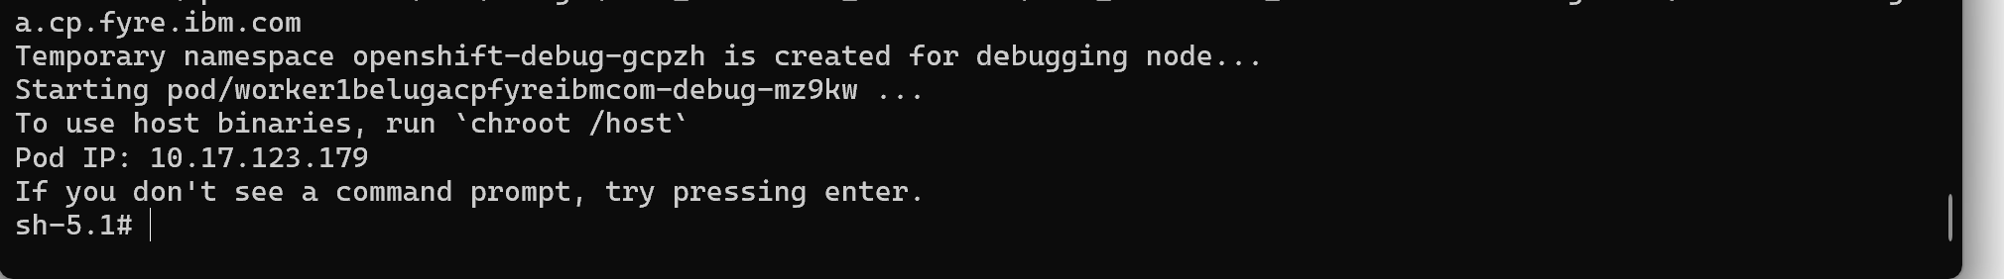
Switch to the host filesystem.
chroot /host
Step 2.3: Partition /dev/vdb
Partition the disk using fdisk.
Copy and Paste the Following text into the debug session:
(
echo g
echo n
echo 1
echo
echo +100G
echo n
echo 2
echo
echo
echo w
) | fdisk /dev/vdb
Verify the partitions were created.
lsblk /dev/vdb
Expected result: /dev/vdb1 and /dev/vdb2 exist and are available for local PV creation.
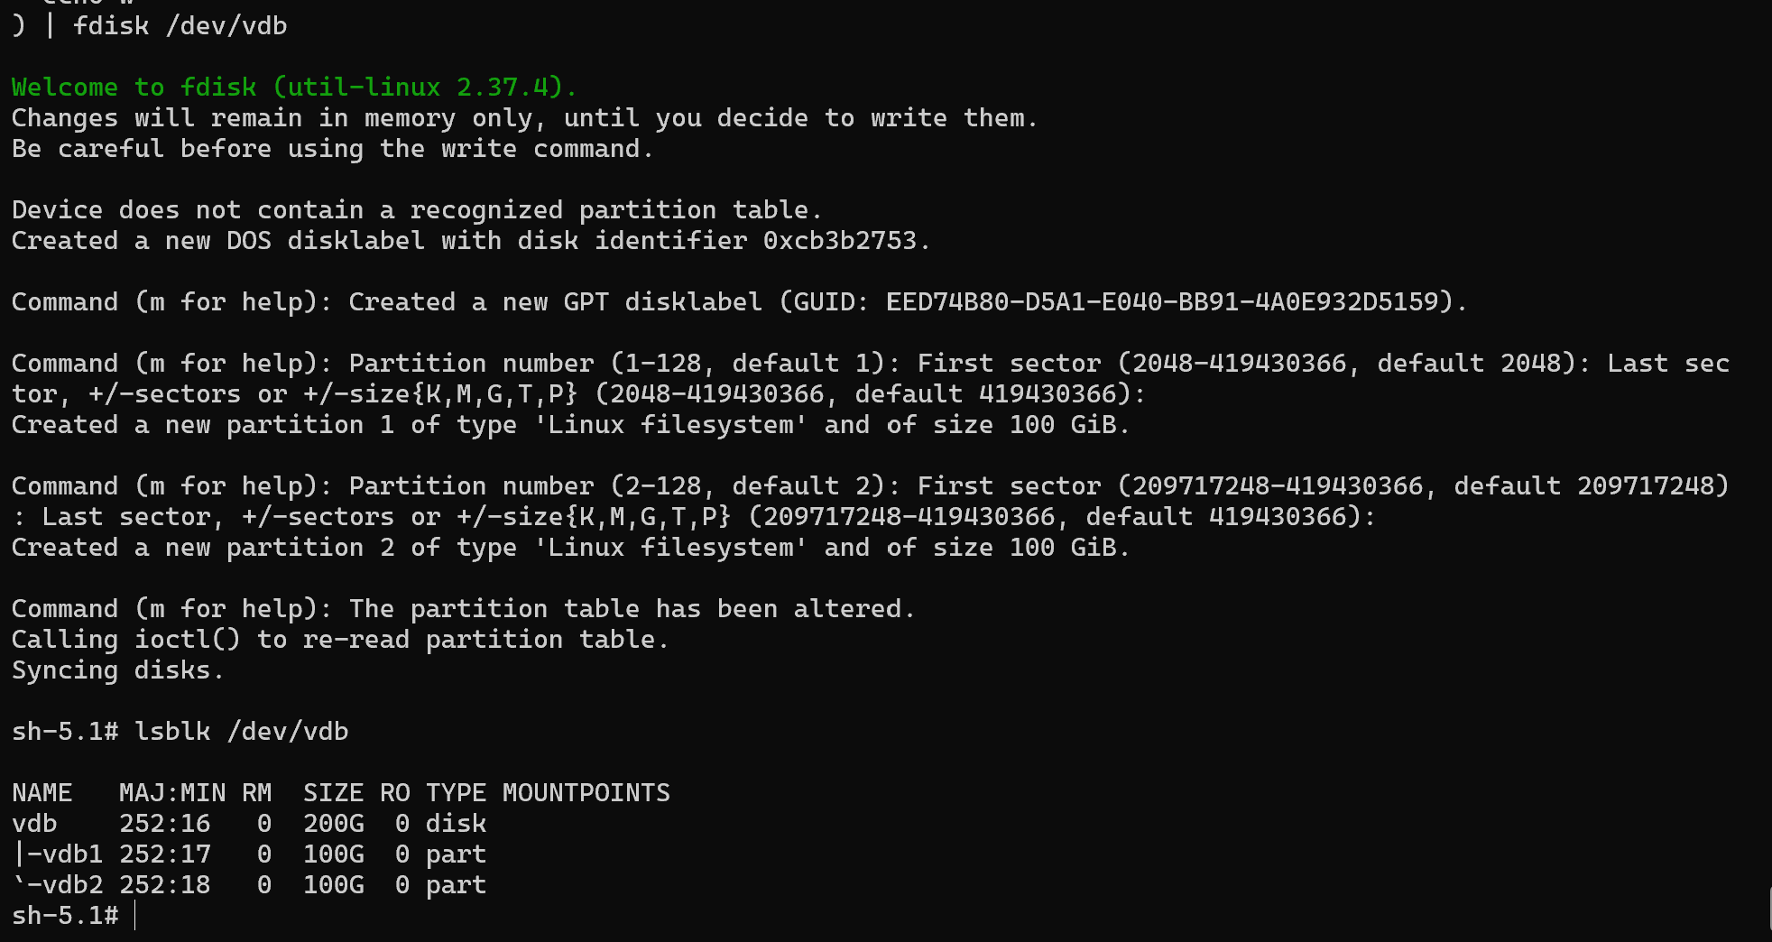
Exit the debug session.
exit
exit
Exercise 3: Install the Local Storage Operator
In the OpenShift web console, go to Operators > OperatorHub and search for Local Storage. Select the Red Hat Local Storage Operator tile and install it with the following settings.
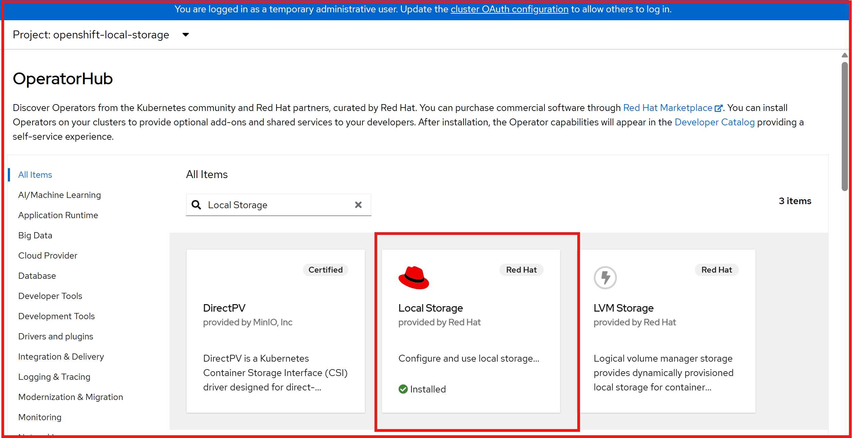
- Update Channel: stable
- Installation Mode: A specific namespace on the cluster
- Installed Namespace: openshift-local-storage
- Update Approval: Automatic
Wait until the operator status shows Succeeded under Operators > Installed Operators.
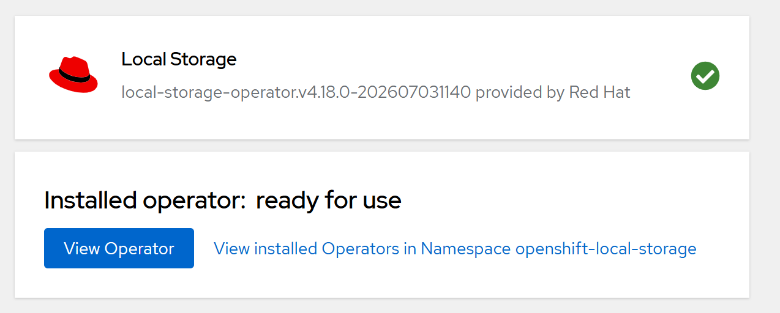
Exercise 4: Provision the StorageClass and Persistent Volumes
Step 4.1: Review datapower-localvolume.yaml file
Review datapower-localvolume.yaml from the repository before applying it. This manifest should define the local storage resources that discover and expose the partitions as local persistent volumes.
Step 4.2: Update datapower-localvolume.yaml with the correct node. (Recorded from Exercise 1)
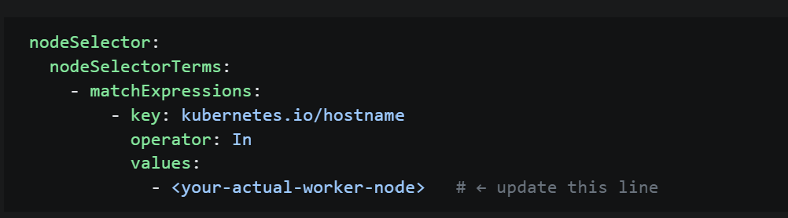
For Example:
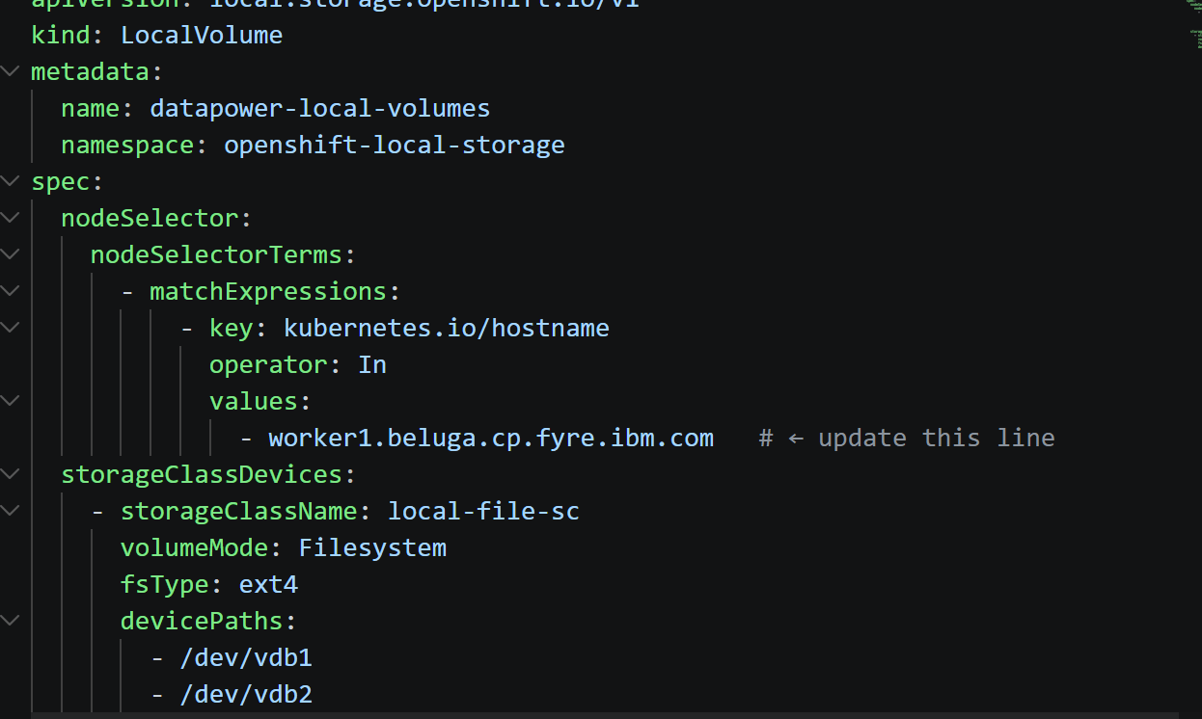
Step 4.3: Save File
Apply the LocalVolume configuration.
oc apply -f datapower-localvolume.yaml
Verify that the storage class exists.
oc get sc local-file-sc
Verify the local persistent volumes.
oc get pv | grep local-file-sc
Ensure both entries are associated with local-file-sc and show as Available before moving forward.
Exercise 5: Clean the Cluster and Redeploy DataPower with Local Storage
Step 5.1: Review Datapower-lso.yaml carefully before applying it.
Confirm that the manifest contains two storage definitions, that the storage is mapped to the correct DataPower mount paths, that the storage class references are correct, and that deleteClaim: false is configured on the persistent storage entries.
Step 5.2 Delete the previous DataPower Service that contained the github configuration.
Apply the new DataPower Service that references the Local Storage.
oc delete datapowerservice quickstart -n nfcu-demo --ignore-not-found
oc apply -f Datapower-lso.yaml -n nfcu-demo
Exercise 6: Validate and Test Persistence
Step 6.1: Verify Pod and PVC Binding
Verify the persistent volume claims are bound.
oc get pvc -n nfcu-demo
Note: oc get pvc -n nfcu-demo shows that both PersistentVolumeClaims required by the DataPower instance have been successfully created and bound to PersistentVolumes. The claims quickstart-datapower-drouter-config-quickstart-0 and quickstart-datapower-drouter-local-quickstart-0 are in Bound status, confirming that storage has been allocated correctly using the local-file-sc storage class.
Verify the DataPower pod is running.
oc get pods -n nfcu-demo
Step 6.2: Write and Commit Test Configurations
Open the DataPower Web UI in your browser.
Login to Web UI:
- Navigate to OpenShift Console → Networking → Routes
- Select the Location link for quickstart-webgui
- Go to the demo domain
- Import your configuration assets, for example mpg-expose.zip,
- Then click Save Configuration in the top-right corner of the WebGUI to commit changes to disk.
Retest the MPG route:
- Navigate to OpenShift Console → Networking → Routes
- Select the Location link for route-latin-bonobo
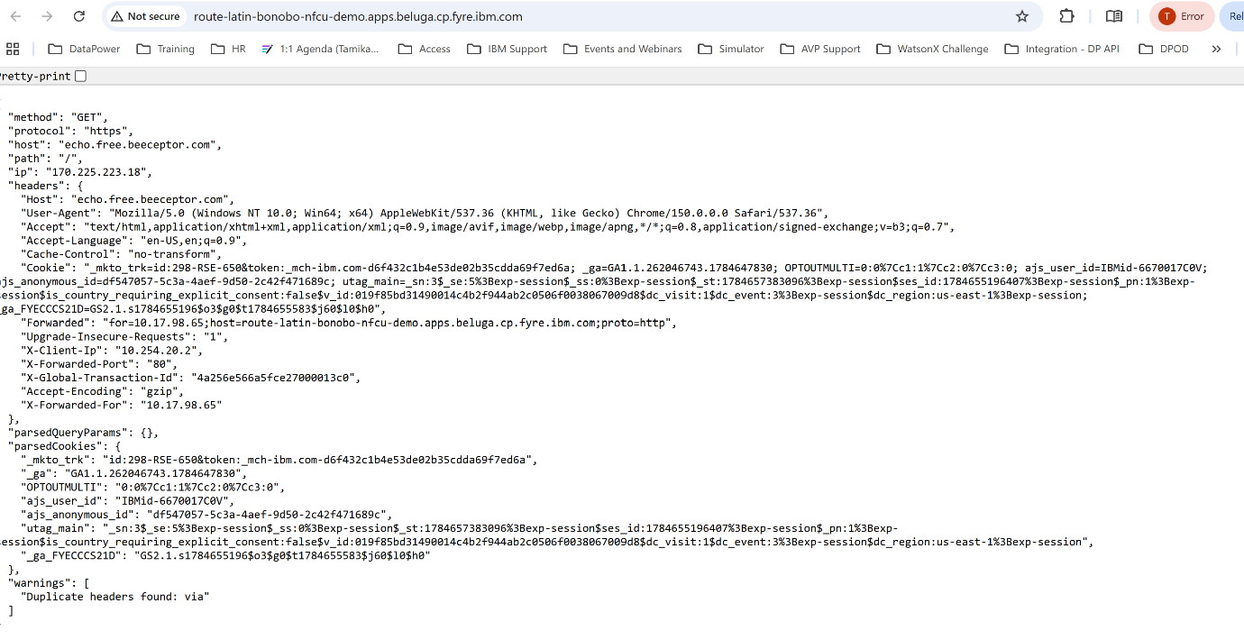
- Verify it returns Valid json
Step 6.3: Run the Pod Recreation Test
Delete the running DataPower pod.
oc delete pod quickstart-0 -n nfcu-demo
Watch the replacement pod come back.
oc get pods -n nfcu-demo -w
After the new quickstart-0 pod is running, log back in and confirm that the imported configuration is still present.
Retest the MPG route:
- Navigate to OpenShift Console → Networking → Routes
- Select the Location link for route-latin-bonobo
- Verify it returns Valid Json

Checkpoint
At this stage, confirm the following:
- Existing DataPower resources and stale storage mappings were cleaned up.
- The target worker node was identified.
- /dev/vdb1 and /dev/vdb2 were created successfully.
- The Local Storage Operator is installed and running.
- local-file-sc exists.
- Local persistent volumes are available.
- DataPower deployed successfully with deleteClaim: false.
- PVCs are bound.
- The WebGUI is reachable.
- Imported configuration persists after pod recreation.
Troubleshooting: DataPowerService Failed to Create
If the DataPowerService does not come up, use the following checks.
1. Check pod status and events
oc get pods -n nfcu-demo
oc describe pod quickstart-0 -n nfcu-demo
Review the Events section at the bottom of the describe output for image pull errors, scheduling failures, and configuration problems.
2. Check the DataPowerService resource status
oc describe datapowerservice quickstart -n nfcu-demo
Review any status conditions or error messages under Status.
3. Check the operator logs
oc logs -n openshift-operators -l name=datapower-operator
The operator is responsible for creating the pod, so reconciliation failures often appear here first.
4. Check for image pull errors
If the pod is stuck in ImagePullBackOff or ErrImagePull, verify that the IBM entitlement secret exists and is linked correctly.
oc get secret ibm-entitlement-key -n nfcu-demo
oc get serviceaccount default -n nfcu-demo -o yaml | grep ibm-entitlement-key
5. Check for missing secrets or ConfigMaps
If the pod fails with a mount error, verify that all referenced secrets and ConfigMaps from earlier labs are present.
oc get secret,configmap -n nfcu-demo
6. Review namespace events
oc get events -n nfcu-demo --sort-by='.lastTimestamp'
This command provides a useful event timeline and is often the quickest way to identify the immediate cause of a failed deployment.
Lab Notes for Production Design
This lab is intentionally designed for visibility and learning rather than for a production-ready storage architecture. In production, teams often use resilient shared storage or platform-native block storage instead of node-local partitions, but the separation of persistent DataPower storage concerns remains a useful design principle.

