NFCU DataPower OpenShift Deployment Lab Guide
Version: 3.2.2
Last Updated: July 9, 2026
Lab Format: Hands-on

Lab goal
In this lab, students deploy IBM DataPower Gateway on OpenShift, expose the web management interface and a Multi-Protocol Gateway route, validate the deployment, and extend the deployment with a Git-based configuration workflow.

Learning outcomes
By the end of this lab, students should be able to:
- Log in to an OpenShift cluster.
- Create or select the target project.
- Install the IBM DataPower Operator.
- Create the secrets and ConfigMaps required for a base deployment.
- Deploy a DataPowerService instance.
- Expose the Web UI (for POT only) and MPG endpoint.
- Validate that the platform is working.
- Update the deployment to pull configuration from Git.

Lab inputs
Before you begin, collect the following information from your instructor or lab environment:
Item | Value
OpenShift console URL | https://console-openshift-console.apps.<cluster-name>.<domain>
OpenShift API endpoint | https://api.<cluster-name>:6443
OpenShift username | kubeadmin or the username provided to you
OpenShift password or token | Provided by your instructor or administrator
IBM entitlement key | Provided before the lab starts
Email for entitlement secret | Your email address
Cluster apps domain | Determine during the lab if needed

Getting your OpenShift login command
- In the OpenShift console, open the user menu and select Copy login command.
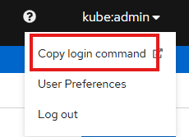
- Select Display Token.
Example token login command:
Command:
oc login --token=<token> --server=https://api.<cluster-name>:6443

Files used in this lab
Download the lab files from the GitHub repository before starting: NFCU_DataPower_MVP1.
Files referenced in this lab include:
- Datapower.yaml
- web-mgmt.cfg
- webgui-service.yaml
- webgui-route.yaml
- route.yaml
- service.yaml
- pull-from-git.cfg
- github.com.cer
- pot-additionalDomainConfig.yaml

Prerequisites
Complete the following before the lab begins:
- Access to an OpenShift cluster.
- The oc CLI installed and working.
- The IBM entitlement key.
- Access to the GitHub lab repository.
- Permission to create resources in the target namespace.

Lab 1: Log in to OpenShift

Objective
Authenticate the cluster and confirm that CLI access works.
Steps
- Get your login command from the OpenShift console, or use the username and password provided by your instructor.
- Run the login command.
Command:
oc login --token=<token> --server=https://api.<cluster-name>:6443
- Confirm that authentication succeeded.
Command:
oc whoami
oc cluster-info
- Record the current user and cluster details for your lab notes.
Checkpoint
- oc whoami returns your username.
- oc cluster-info returns cluster details.

Lab 2: Create or select the project

Objective
Use the target namespace for the operator and DataPower deployment.
Steps
- Create the project if it does not already exist.
Command:
oc new-project nfcu-demo
- If the project already exists, switch to it.
Command:
oc project nfcu-demo
- Confirm the active project.
Command:
oc project
Checkpoint
- The current project is nfcu-demo.

Lab 3: Install the DataPower Operator

Objective
Install the catalog source and the IBM DataPower Operator.
Steps
- Open datapower-catalog-source-latest.yaml and copy its contents.
- In the OpenShift console, Click the “+” to open Import YAML and paste the file contents.
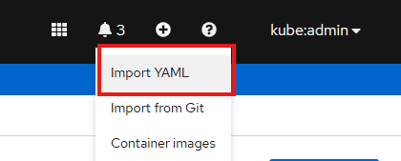
- Set the namespace to openshift-marketplace, then create the resource.
- Review the created catalog source in the console and confirm it was applied successfully.
- Go to Operators > OperatorHub and search for IBM DataPower Gateway.
- Select the operator and click Install.
- Choose the installation mode, update channel, and approval strategy required for your lab environment.
- Click Subscribe and wait for the installation to complete.
- Open Operators > Installed Operators and confirm the operator appears without errors.
Checkpoint
- The subscription exists.
- The DataPower ClusterServiceVersion is installed.
- The operator pod is running.

Lab 4: Prepare secrets and ConfigMaps

Objective
Create the resources required for the base DataPower deployment.
Steps
- Confirm that you are in the nfcu-demo project.
Command:
oc project nfcu-demo
- Create the admin password secret.
Command:
oc create secret generic dp-admin-password --from-literal=password=admin -n nfcu-demo
- Create the GitHub certificate secret referenced by Datapower.yaml.
Command:
oc create secret generic github.com.cer --from-file=github.com.cer -n nfcu-demo
- Create the IBM entitlement secret so the operator can pull the DataPower image from the IBM Container Registry.
Command:
oc create secret docker-registry ibm-entitlement-key --docker-server=cp.icr.io --docker-username=cp --docker-password=<YOUR_IBM_ENTITLEMENT_KEY> --docker-email=<YOUR_EMAIL> -n nfcu-demo
- Link the entitlement secret to the default service account for image pulls.
Command:
oc secrets link default ibm-entitlement-key --for=pull -n nfcu-demo
- Create the web management ConfigMap from web-mgmt.cfg.
Command:
oc create configmap web-mgmt-cfg --from-file=web-mgmt.cfg -n nfcu-demo
- Verify that the required resources exist.
Command:
oc get configmap web-mgmt-cfg -n nfcu-demo
oc get secret dp-admin-password -n nfcu-demo
oc get secret github.com.cer -n nfcu-demo
oc get secret ibm-entitlement-key -n nfcu-demo
Checkpoint
- web-mgmt-cfg exists.
- dp-admin-password exists.
- github.com.cer exists.
- ibm-entitlement-key exists.
- The entitlement key is linked to the default service account.

Lab 5: Deploy DataPower

Objective
Create the DataPowerService resource and wait for it to become ready.
Steps
- Review Datapower.yaml and confirm the namespace, version, deployment name, and domain configuration are correct for your environment.
- In the OpenShift console, go to Operators > Installed Operators.
- Open IBM DataPower Gateway.
- Under Provided APIs, select DataPowerService.
- Click Create Instance.
- In Form view, review the key fields such as name, namespace, version, users, domains, and replicas.
- Switch to YAML view, paste the contents of Datapower.yaml, and click Create.
- Wait for the DataPowerService status to reach Running.
- Optionally monitor progress from the CLI.
Command:
oc get pods -w
oc get datapowerservice quickstart
oc logs quickstart-0
Checkpoint
- The pod reaches Running.
- The DataPowerService becomes ready.
- Base startup completes successfully.

Lab 6: Expose the web UI and MPG

Objective
Create the services and routes required to access the web UI and the Multi-Protocol Gateway.
Steps
- Open webgui-route.yaml.
- Update spec.host field using the pattern <route-or-service-name>-<namespace>.<apps-domain>.
- If needed, determine the cluster apps domain.

Command:
oc get ingresses.config/cluster -o jsonpath='{.spec.domain}'
Copy output of command in the <hostname>
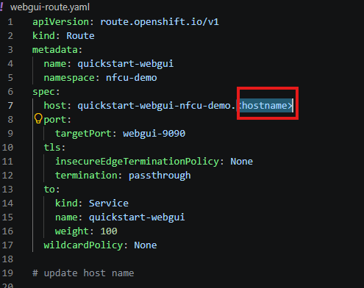
- Save webgui-route.yaml after updating the host name.
- Apply the web UI service.
Command:
oc apply -f webgui-service.yaml
- Apply the web UI route.
Command:
oc apply -f webgui-route.yaml
- Apply the MPG service.
Command:
oc apply -f service.yaml
- Apply the MPG route.
Command:
oc apply -f route.yaml
- List the routes.
Command:
oc get route
- Get the web UI route hostname.
Command:
oc get route quickstart-webgui -o jsonpath='{.spec.host}'
- Get the MPG route hostname.
Command:
oc get route route-latin-bonobo -o jsonpath='{.spec.host}'
Note: You can also Validate in the Openshift Console – NetworkingRoutes
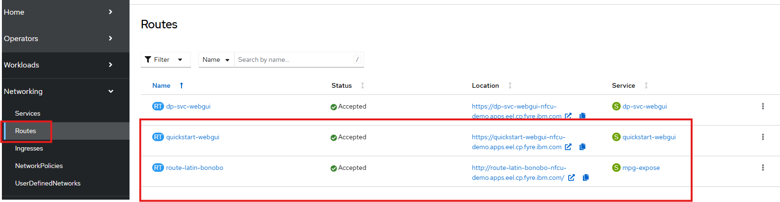
Checkpoint
- The web UI route exists.
- The MPG route exists.

Lab 7: Validate the deployment

Objective
Confirm that the deployment works from both the administrative and API perspectives.
Steps
- Open the DataPower web UI in a browser using the quickstart-webgui route hostname or click on the Location:
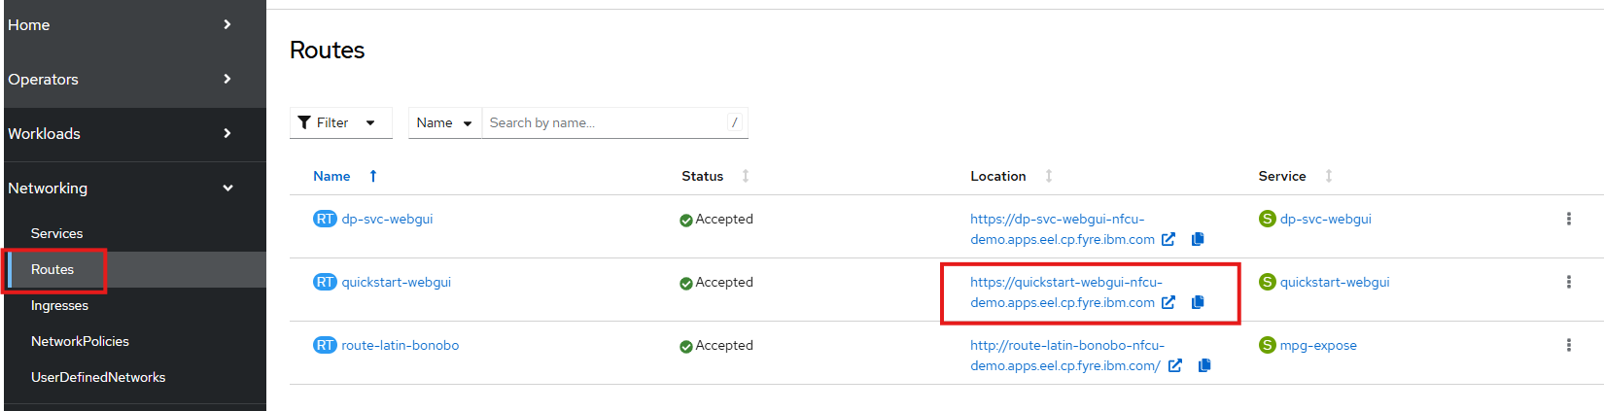
- Log in with the lab credentials below.
Field | Value
Username | admin
Password | admin

- Confirm that the default and demo domains are available.
- Import mpg-expose.zip into the demo domain.
- Select the Link below to Test the mpg-expose MPGW
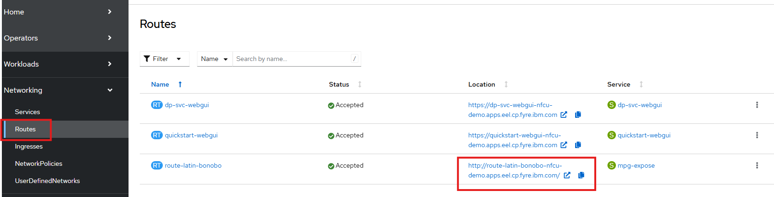
- Confirm that the service returns a JSON response.
- Review the related OpenShift objects.
Command:
oc get pods
oc get datapowerservice
oc get route
Checkpoint
- Web UI login works.
- The default domain is up.
- The MPG route responds successfully.
- The base platform is ready for the Git-based extension lab.

Lab 8: Pull configuration from Git

Objective
Add a new DataPower domain that uses the GitOps feature to pull configuration from GitHub, then confirm the configuration is visible in the web UI and written back to the repository.

Part A: Create required resources
- Confirm that you are in the nfcu-demo project.
Command:
oc project nfcu-demo
- Create the ConfigMap from pull-from-git.cfg.
Command:
oc create configmap pull-from-git-cfg --from-file=pull-from-git.cfg -n nfcu-demo
- Recreate the GitHub certificate secret to ensure the correct certificate file is being used.

Command:
oc delete secret github.com.cer -n nfcu-demo
oc create secret generic github.com.cer --from-file=github.com.cer -n nfcu-demo
- Create the GitHub personal access token secret. Use a token with repository access.
- IBM Team will provide PAT token.
Command:
oc create secret generic pat --from-literal=password=<YOUR_GITHUB_PAT_TOKEN> -n nfcu-demo
- Verify the resources.
Command:
oc get configmap pull-from-git-cfg -n nfcu-demo
oc get secret github.com.cer -n nfcu-demo
oc get secret pat -n nfcu-demo

Part B: Update the DataPowerService
- In the OpenShift console, open Operators > Installed Operators > IBM DataPower Gateway > DataPowerService.
- Click to open the quickstart DataPowerService.
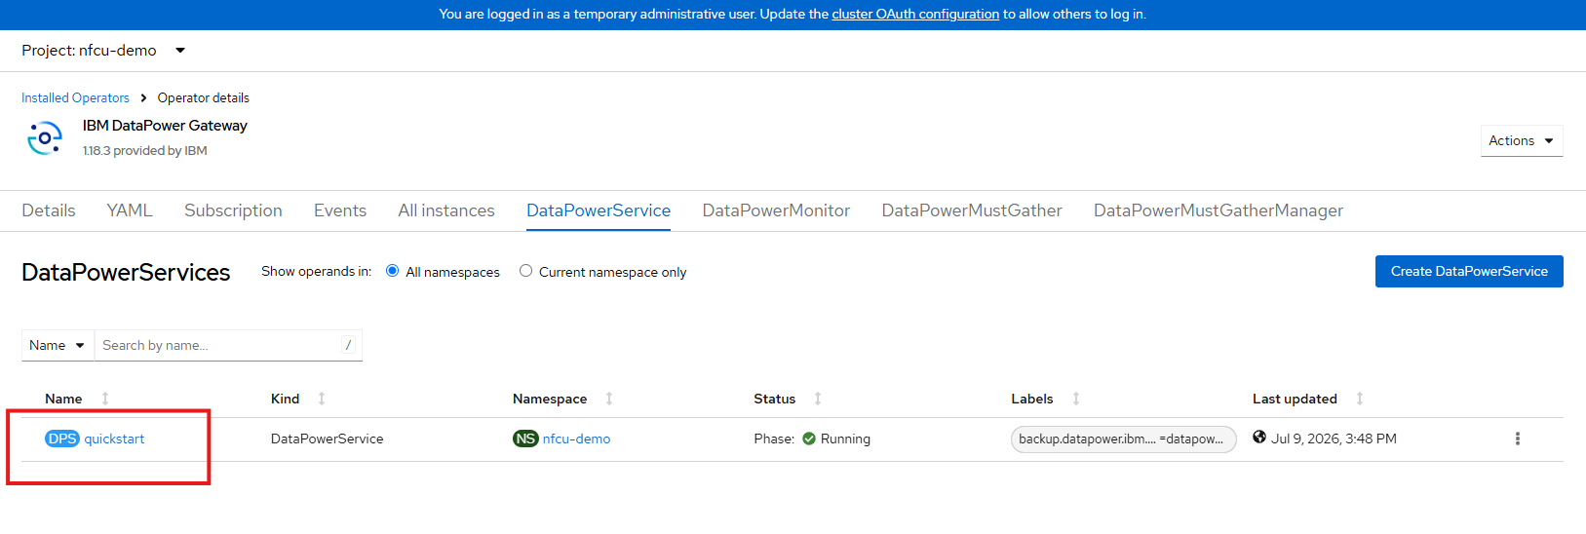
- Download the current YAML definition (Download in the Bottom Corner).
- It will should be named datapowerservice-quickstart.yaml
- Open the (datapowerservice-quickstart.yaml) downloaded file in a text editor.
- Download and open pot-additionalDomainConfig.yaml in a text editor from the lab repository.
- Select All the contents from the pot-additionalDomainConfig.yaml
- Replace the existing domains: section in the downloaded DataPowerService YAML (datapowerservice-quickstart.yaml ) with the updated domain configuration.

Before:
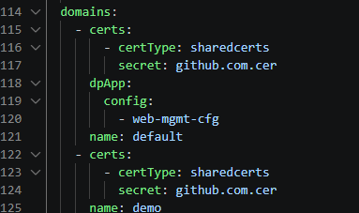
After:
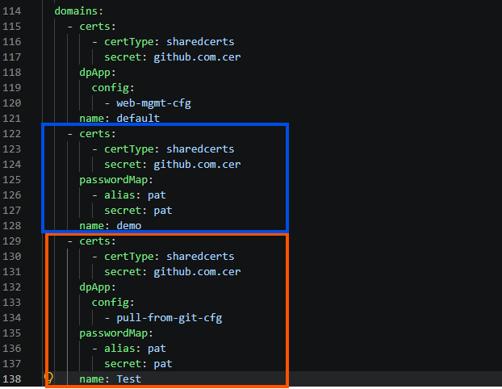
- Save the updated YAML (datapowerservice-quickstart.yaml).

- In the OpenShift console select the YAML tab of the quickstart DataPowerService
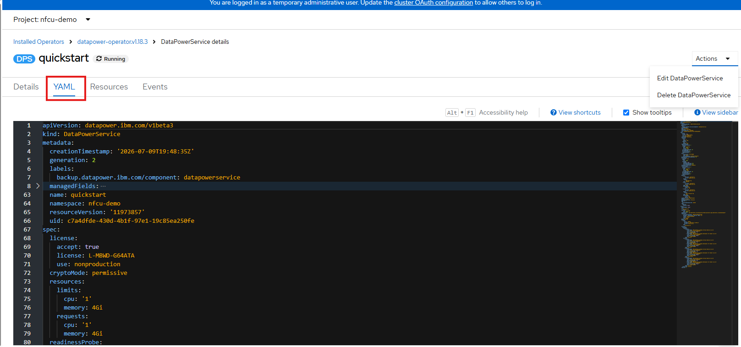
- Click Edit DataPowerService
- Paste the updated YAML (datapowerservice-quickstart.yaml ) with the additional configuration
- Click Save
- Click Reload
- Optional Watch the pod restart and return to Running.
Command:
oc get pods -w
- Confirm that the updated DataPowerService includes the new Test domain configuration.
Command:
oc get datapowerservice quickstart -o yaml

Part C: Validate in the web UI
- Open the DataPower web UI using the quickstart-webgui route.

- Log in as admin with password admin.
- Confirm that a new Test domain appears alongside default and demo.
- Switch to the Test domain.
- Search for the GitOps object and open it.
- Confirm that the repository URL points to https://github.com/innessrg/NFCU_MVP1_Source_Files.git.
- Open Multi-Protocol Gateway in the Test domain and review the services pulled from the repository.

Part D: Confirm GitHub
- Open the repository lab repository in a browser.
- Confirm that the expected DataPower domain configuration files are present.
Checkpoint
- pull-from-git-cfg exists.
- github.com.cer exists.
- pat exists.
- The DataPowerService was updated successfully.
- The pod restarted and returned to Running.
- The Test domain appears in the web UI.
- The GitOps object points to the correct repository.
- The expected services appear in the Test domain.
- Configuration is visible in the GitHub repository.

Troubleshooting
If the DataPowerService does not start correctly, use the following checks.
Check pod status and events
oc get pods -n nfcu-demo
oc describe pod quickstart-0 -n nfcu-demo
Review the Events section for pull errors, scheduling failures, or configuration issues.
Check DataPowerService status
oc describe datapowerservice quickstart -n nfcu-demo
Review the Status section for conditions or error messages.
Check operator logs
oc logs -n openshift-operators -l name=datapower-operator
Use the operator logs to identify reconciliation failures.
Check image pull configuration
If the pod is stuck in ImagePullBackOff or ErrImagePull, verify the entitlement secret and its service account link.
oc get secret ibm-entitlement-key -n nfcu-demo
oc get serviceaccount default -n nfcu-demo -o yaml | grep ibm-entitlement-key
Check for missing secrets or ConfigMaps
oc get secret,configmap -n nfcu-demo
Use this command to confirm that all referenced resources from Lab 4 exist.
Check namespace events
oc get events -n nfcu-demo --sort-by='.lastTimestamp'
Namespace events often provide the fastest explanation for a failed deployment.

