**Easy Class**

Project Proposal

By

|  |  |
| --- | --- |
| **Pichet Potha** | **542115041** |
| **Sittipong Borripan** | **542115066** |

Department of Software Engineering

College of Arts, Media and Technology

Chiang Mai University

Project Adviser

______________________________

Ms. Yun Rim Park

**Table of contents**

**Revision History**……………………………………………………...........................................................1

**Abstract**….....................................................................................................................................................3

**Chapter I: Introduction and Background**………………………………………………………………..4

**Chapter II: Literature Review**……………………………………...……………………………………..5

2.1 Business Review……………………………………………………………..…………………5

2.2 Alternative Business related…………………………………………………..………………..6

2.3 Technology Review…………………………………………………………..……………......9

2.4 Development Tools Review………………………………………………….……………….15

**Chapter III: Quality Standard**…………………………………………………………...………..…16

3.1 ISO29110 for Very Small Entity (VSE)……………………………………..………………..16

3.1.1 Project Management process………………………………………………..………………16

3.1.2 Software Implementation process…………………………………….….………………….16

**Chapter IV: Project Plan**...........................................................................................................................17

4.1 Motivation……………………………………………………………….……………………17

4.2 Aims and Objectives………………………………………………………….………………17

4.3 Deliverables and Limits……………………………………………………………..………...18

4.3.1 Deliverables…………………………………………………………….…………..18

4.3.1.1 Architecture Overview………………………………………………..…18

4.3.1.2 Documents……………………………………………………...……….19

4.3.2 Limits………………………………………………………………………………19

4.4 Future Work…………………………………………………………………………..……….19

4.5 Schedule and Milestone……………………………………………………………………...19

4.5.1 Features…………………………………………………………………………….19

4.5.2 Software Development process ……….……………………………….…………...21

4.5.3 Milestone……………………..…………………………………………………….22

4.5.4 Schedule …………………………………………………………………………...23

4.5.4.1 Proposal……………………………………………...…………………..23

4.5.4.2 Progress report I………………………………………...……………….24

4.5.4.3 Progress report II………………………………………...………………25

4.5.4.4 Progress report III………………………………………….…………….26

**Chapter V: Reference** …………………………………………………………………………………..27

**Revision History**

|  |  |  |  |  |  |  |  |  |
| --- | --- | --- | --- | --- | --- | --- | --- | --- |
| **Document Name** | **Version** | | **Status** | | **Date** | **Viewable** | **Reviewer** | **Responsible** |
| Easy_Class_Proposal_Version0.1 | Add | * Change the title to “Easy Class” * Technology Review * Motivation * Aims and Objectives * system architecture * Feature | | Draft | 13/03/2014 | PP,SB,YP | PP,SB | PP,SB |
| Easy_Class_Proposal_Version0.2 | Edit  Add | * Technology Review * Motivation * Aims and Objectives * Features * Reference | | Draft | 14/03/2014 | PP,SB,YP | PP,SB | PP,SB |
| Easy_Class_Proposal_Version0.3 | Edit  Add | * Deliverables and limits * Features * Reference * Document in Deliverables and limits * Limits in Deliverables and limits * Schedule & Milestones | | Draft | 15/03/2014 | PP,SB,YP | PP,SB | PP,SB |
| Easy_Class_Proposal_Version0.4 | Edit  Add | * Features * Reference * Business Review * Alternative Business Related | | Draft | 15/03/2014 | PP,SB,YP | PP,SB | PP,SB |
| Easy_Class_Proposal_Version0.5 | Edit  Add | * Business Review * Alternative Business Related * Deliverables * Features * Reference * ISO29110 for Very Small Entity (VSE) in Chapter III | | Draft | 16/03/2014 | PP,SB,YP | PP,SB | PP,SB |
| Easy_Class_Proposal_Version0.6 | Edit  Add | * Chang version form x.x.x to x.x * Technology Review * Reference * Business Review * Development Tool Review * Limits * Future Work | | Draft | 18/03/2014 | PP,SB,YP | PP,SB | PP,SB |
| Easy_Class_Proposal_Version0. | Edit  Add | * Technology Review * Software development process. | | Draft | 18/03/2014 | PP,SB,YP | PP,SB | PP,SB |
| Easy_Class_Proposal_Version0.8 | Edit  Add | * Technology Review * Development Tools * Motivation * Reference * Abstract * Introduction and Background | | Draft | 19/03/2014 | PP,SB,YP | PP,SB | PP,SB |
| Easy_Class_Proposal_Version0.9 | Edit | * Technology Review * Development Tools * Motivation * Aim and Objective * Limits * Future Work * Feature * Software Development Process * Reference | | Draft | 19/03/2014 | PP,SB,YP | PP,SB | PP,SB |
| Easy_Class_Proposal_Version0.10 | Edit | * Technology Review * Development Tools * Aim and Objective * Limits * Future Work * Feature * Milestone * Reference | | Draft | 22/03/2014 | PP,SB,YP | PP,SB | PP,SB |
| Easy_Class_Proposal_Version1.0 | Edit | * Abstract * Introduction and Background * Technology Review * Aim and Objective * Feature * Milestone * Schedule | | Release | 26/03/2014 | PP,SB,YP | PP,SB | PP,SB |

**Abstract**

The Smart Class is a new way or a new choice for teaching in school, university, or other academies. It is a teaching environment which uses new technology devices and software in the process of teaching and learning. The Smart Class software usually has features to control and manage those technology devices. Teachers can control the devices to make students pay more attention and have fun in class. But there are only a few features that support teaching in class. Teachers may have difficulty creating class activities to make students have fun and get a better understanding of the class content.

“Easy Class” is a Web Application that aims to help teachers create class activities easily. Teachers can create and design activities to make students get more involved in class activities and feel more fun in the class. The system is implemented in HTML5 and CSS3 that provide appropriate, modern user interface and help create more interesting and interactive contents and also more collaborative learning environment for students. For example, screen broadcasting allows teachers to share the screen of their own device with students. Teachers can use the collaboration board for supports collaborative search and mind mapping. The system also provides teachers with the convenience such as checking students’ attendance and getting their attention with pop up messages, which makes managing a classr easier and teaching more efficient and effective.

**Chapter I: Introduction and Background**

Education is one of the most important things that any countries emphasize to improve and upgrade themselves. Education has a direct impact to students who will be the key personnel in administrative roles and developing the country in the future. In addition, the educational measurement points are also an indication of the quality of education and the development of the country. That is why many countries try to improve their education policies, course contents, and teaching equipment or learning styles to elevate the quality of education.

One of solutions for solving these problems is using a new technology in the learning process in the classes, which is often referred to as “Smart Class”. Smart Class uses the technologies and devices that many people always use in daily lives such as tablets, smartphones, computers, smart TVs, or projectors. In addition, it may also integrate some new technologies that are not yet widespread because they are not quite wide area (i.e. still in development or testing phases) or require expensive software or hardware. Some of good examples are smart table, smart projector, smart board, etc.

Many Smart Class software used in school or university always includes the software that helps control and manage the overall smart class system. Each software may also include features for teachers to create teaching materials and contents.

There are many applications that are designed to support teaching and learning in schools and universities. They usually support the core feature, which allows teachers to create, update, and delete assignments and study materials for their students. Teachers may also share their screen by displaying it on their students’ devices and monitor the students' screens, etc. Those applications support students also by providing them with access to the assignments and learning materials anytime and anywhere They can also submit their assignments and homework using the system features,

In this project, we propose “Easy Class”, a system that helps change our classes ‘smarter’. The system provides a set of features that support teaching and learning activities in class. These features allow teachers to design and create their own class activities. Teachers can adapt each feature appropriately to suit their teaching plan and style. For example, Mind Map is a feature that supports teachers and students creating a mind map collaboratively. Teachers may assign students to make a conclusion with the mind map in group work, pair work, or individual work. In addition, it is easy and convenient for teachers and students to use this system. As the system is a web application, teachers and students can use all features via a web browser and do not need to install anything on their device to use the system.

This system will offer a new experience in class with technology devices and the features that come with the system.

**Chapter II: Literature Review**

**2.1 Business Review**

The Smart Class is a new alternative to traditional teaching environment today. Every day, many new technology devices are released in the market. Those devices come to participating in our daily lives more than in the past. Tablet, smartphone, and laptop are the devices that many of us use daily. And now, The Internet network systems are improved so much. People can access the Internet everywhere and every time at fairly high speed. In addition, there are many companies that produce and develop the devices such as projector, smart board, smart table, etc., which can support the services in many business areas. The Smart Class is a general name for those classes that use such devices and other technologies to improve teaching and learning. Using tablets, laptops, projectors, or personal computers connected to the wired or wireless Internet, the Smart Class tries to take advantage of the advancement of technology and make the process of teaching and learning more suitable for the new generation of students.

The Smart Class uses technology devices and Internet network in class. Teachers have a lot of choices for instructional media that can be used in class such as photos, video clips, games, animations, etc. These things can help the teachers to create and conduct class activities more easily. They can also help students get a better understanding of the class contents. Students can see what they are reading or learning visually, instead of just relying on their imagination from the content and a few photos in the book. In addition, they can search more information by themselves from the Internet. They can see the model of the things that are difficult to see in the real world such as planets. The Smart Class will provide students with a new experience in class. Students will feel more fun and be more curious and collaborative. And they may understand more and participate more in class activities.

Besides, the Smart Class can provide more convenience to teachers and students. It can reduce paper usage because teachers and students can save lesson materials or exercises in the form of electronic files and each file type and keep them on the server or in their own device memory. Teachers and students may not need to bring too many books or documents when they come to class. During the class session, teachers do not need to worry that students may not pay attention to the lesson because there is software that helps the teachers to monitor and control the class.

The Smart Class does not specify how its components and features are used in class. Each school, university, or other academies can decide how to use the Smart Class appropriately with their own courses. The benefit and quality will up to the design of the courses and the ideas of teachers or schools on to use the system.

**2.2 Alternative Business Related**

**2.2.1 Radix SmartClass** [1]

Radix SmartClass is the class management software that supports teachers and students doing activities in the class with their devices such as PC, tablet, or smartphone. Teachers and students use the Wi-Fi network to connect with each other without a middleware server or hardware. All study abilities students perform can be monitored and controlled from the teachers’ tablet or PC.

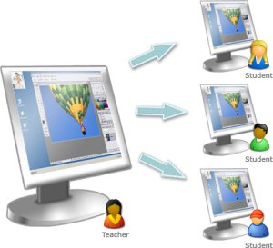

##### **Figure 1: The example of feature in Radix SmartClass:**

##### **Broadcast the teacher’s screen to all or selected student screens**

**Feature:**

* Screen Sharing
* Screen Monitoring
* Collaborative whiteboard
* Screen locking
* Chat

**Pros:**

* Does not require extra hardware or servers to be the middleware for connection, which reduces the cost and makes it easier to set up and maintain the system
* Supports multiple languages (e.g. English, Spanish, French, Italian, Thai, Chinese, etc.)
* Supports major platforms such as Android, IOS, and Window

**Cons:**

* Focuses mostly on class management and control and provides few features for supporting teaching and learning activities in the class.
* Does not provide storage space for teaching materials and the artifacts of learning activities.

**2.2.2 Classteacher Learning Systems [2]**

Classteacher Learning Systems is one of the very first interactive class technologies developed in India (Classteacher is one of the foremost education companies in India). It provides solutions such as Digital Interactive Class Program, Classpad, Assessment Program, Digital Math Program, Digital Science Program, Online Program and Digital Language Program. It offers a wide set of technologies and tools to support schools and improve their teaching and learning process.

**Feature:**

* Digital Interactive Class
* Virtual Learning Environment
* 3D library
* Class Management Software
* Science Worksheets for Kids

**Pros:**

* Provides many tools and technologies to support schools and students such as Class Management Software, 3D Library, Computer, LED, Interactive Whiteboard, tablet, etc.
* Provides frequent updates for the application and resource to support teaching and learning because they have a developer team dedicated to maintenance

**Cons:**

* Requires costs high for service, software, and tools
* Does not allow teachers to design and create their own class activities
* Requires devices with high specification

# 2.2.3 Samsung Smart School [3]

The Samsung Smart Class is the software that incorporates the Samsung GALAXY Note 10.1 tablet, e-board, Personal Computer, and a network environment in each class. The schools will have their own central server in the school to store course contents and user information. They can use these devices to make the Interactive Teaching and Learning Management, which allows b teachers to use a tablet or PC to share their screen with students as well as the e-board. Students can participate in the class using their tablets.

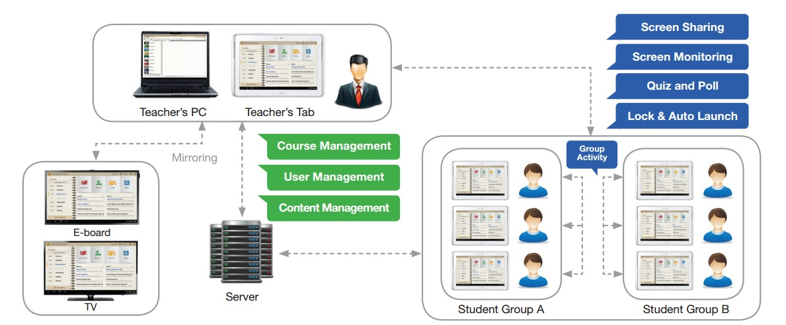

**Figure 2: Samsung Smart School solution structure**

**Feature:**

* Screen Sharing
* Group Activity
* Quiz and Poll
* Whiteboard and S Note
* Learning Management (Course Management, User Management, Content Management, Communication, Notice Board)

**Pros:**

* Make users get the full efficiency in using the system, because the software features and device features support each other.

**Cons:**

* Supports specific devices only (Samsung GALAXY Note 10.1).
* Requires the other device which can support the connection with Samsung GALAXY Note 10.1

**2.3 Technology Review**

**2.3.1 HTML5 [4]**

**Overview**

HTML is the main markup language for creating webpages and other information that can be displayed in a web browser.So HTML5 is the latest standard of HTML. It was specially designed to deliver rich content without the need for additional plugins. HTML5 is also cross-platform. It is designed to work whether you are using a PC, or a Tablet, a Smartphone, or a Smart TV.

**The interesting features in HTML5 are following list**

* The <canvas> element for 2D drawing
* The <video> and <audio> elements for media playback

**The selection of this technology**

* Supports a systemacross platforms and across browsers
* Can use JavaScript to increase performance

**2.3.2 JavaScript [5]**

**Overview**

JavaScript (JS) is a dynamic computer programming language. It is most commonly used as part of web browsers, whose implementations allow client-side scripts to interact with the user, control the browser, communicate asynchronously, and alter the document content that is displayed Now JS have the ability about real time communication (WebRTC) supporting on the latest browser.

**The selection of this technology**

* Supports validating input forms
* Supports interactivity create on web application
* Supports look the same in every browser
* Supports JavaScript code directly into a text editor

**2.3.3 JSON [6]**

**Overview**

JSON (JavaScript Object Notation) is a lightweight data-interchange format, which is readable for humans. It is easy for machines to generate and parse based on a subset of the JavaScript Programing Language. JSON has a short sentence and a small size of data. So transferring data takes less time. JSON is a good way to transfer synchronous data for web applications and increase performance.

**The selection of this technology**

* Better compact and can be easily loaded in JavaScript
* Better smaller message size of data
* Better easy consumed by JavaScript

**2.3.4 CSS3 [7]**

**Overview**

CSS or Cascading Style Sheets is a style sheet language used for defines layout of HTML such as covers fonts, colors, margins, lines, height, etc. CSS3 is a new standard of CSS and also has interesting advantages as follows:

* Flexibility as it separates presentation from content.
* Processing of multiple background images

**The selection of this technology**

* Better work with HTML5
* Better easy to define layouts on HTML

**2.3.5 Node.js & Express.io [8]**

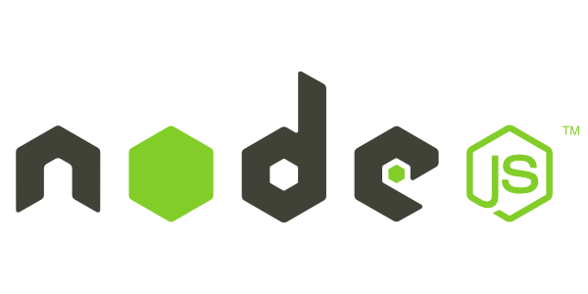

**Overview**

Node.js is the platform that defines a standard around which a system can be developed. Node.js platform is a standard of software platform for server-side JavaScript environment and networking applications based on the *V8 JavaScript engine. It extends JavaScript API to offer usual server-side functionalities. Express.io is the real-time web application framework for node.js. It has many libraries for web application to developers can use.

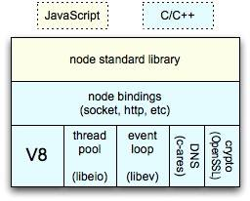

**Figure 3: node architecture**

**The selection of this technology**

* Has high performance, scalable web application and network programs in JavaScript
* Has enables the use of JavaScript on the server-side
* Has a driver for support MySQL
* Has many libraries for developers

* The V8 JavaScript Engine is an open source JavaScript engine developed by Google for the Google Chrome web browser.

**2.3.6 WebRTC [9]**

**Overview**

WebRTC is the API that allows the developer to write real-time multimedia applications on the web, without requiring plugins, download or installs. It works across multiple web browsers and across multiple platforms.

The interesting API of WebRTC is a MediaStream. The MediaStream interface of the WebRTC API describes a stream of audio or video data.

**The selection of this technology**

* Can allows devices to communication without plugins
* Can works the across platforms and browsers
* Can supports JavaScript

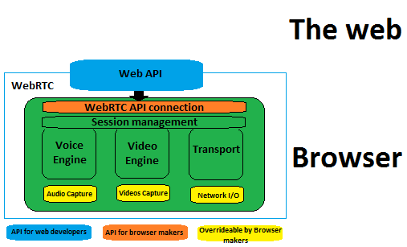

**Figure 4: Architecture of WebRTC**

**2.3.7 MySQL [10]**

**Overview**

MySQL is an open-source relational database management system (RDBMS). It allows the user to create a relational database structure on a web-server to store data or automate procedures.

**The selection of this tool**

* Has many users of MySQL and it is open source
* Has many interacting tools online
* Has good recommending from user in DBMS reviewed*

*According to the “Top 10 Enterprise Database System to Consider” by Kenneth Hess, the recommended are Oracle, SQL Server, DB2, Sybase, MySQL, PostgreSQL, Teradata, Informix, Ingres, Amazon’s SimpleDB.[15]

According to the “Top 5 Databases for Web Developers” by Curties Dicken, the recommended are MSQL, MicrosoftAcess, Microsoft SQL Server Express, Oracle Express, DB2 Express-C.[15]

According to “Top 10 Most Popular DB Engines(SQL and NoSQL)” by Java, SQL and jOOQ the recommended are Oracle, MySQL, Microsoft SQL Server, PostgreSQL, DB2, MongoDB, MicrosoftAcess, SQLite, Sybase, Teradata.[16]

*Relational database refer to database that has a collection of tables of data items, all of which is formally described and organized according to the relational model. Data in a single table represents a relation, from which the name of the database type comes.

**2.3.8 Google Maps API [11]**

**Overview**

Google Maps is a web mapping service application and technology provided by Google, powering many map-based services. The Google Maps API provides several ways of embedding Google Maps into web pages, and allows either simple use or extensive customization for developers.

**There are several APIs offered:**

* Google Maps JavaScript API
* Google Maps API for Flash
* Google Static Maps API

**The selection of this technology**

* It open source
* It supports JavaScript

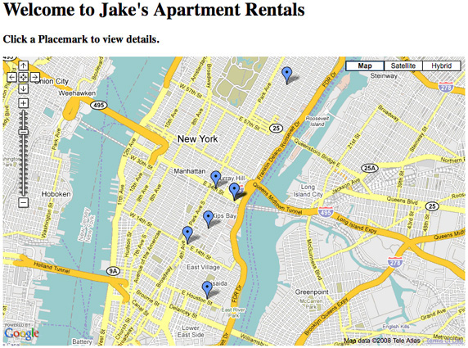

**Figure 5: Example of Google Maps**

**2.3.9 Apache Tomcat [12]**

**Over view**

Apache tomcat is an open source web server developed by Apache Software Foundation (ASF). Tomcat implements the Java *Servlet and the **JavaServer Pages (JSP) specifications from Sun Microsystems, and provides a "pure Java" HTTP web server environment for Java code to run.

**The selection of this technology**

* It Open source
* Supports execute dynamic pages (.jsp, .js, etc.)
* Supports execute servlets
* Supports access control over directories and files in server root

*Servlet is a Java programming language class used to extend the capabilities of a server.

**\*\***JavaServer Pages or JSP is a technology that helps software developers create dynamically generated web pages based on HTML, XML, or other document types.

* 1. **Development Tool Review**

**2.4.1 Aptana [13]**

**Overview**

Aptana is the open source development tool for the open web, which supports developing and testing the entire web application using a single environment. It provides support for the latest browser technology specs such as HTML5, CSS3, JavaScript, Ruby, Rails, PHP and Python.

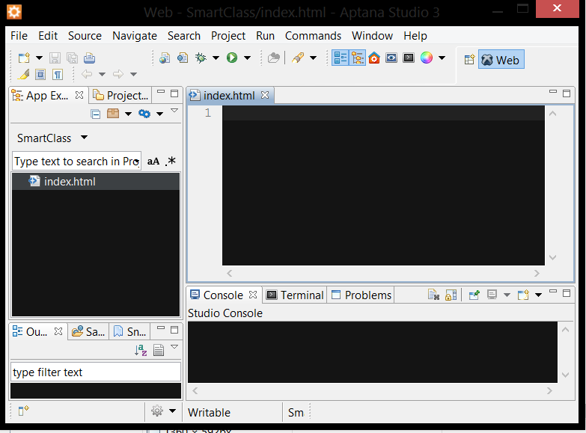

**Figure 6: Interface of Aptana**

**The selection of this tool**

* It supports HTML5, JavaScript and CSS3 writing
* It open source software
* It supports testing web applications

**Chapter III: Quality Standard**

**3.1 ISO29110 for Very Small Entity (VSE)**

ISO29110 is a guide applies to a Very Small Entity (VSE), enterprise, organization, department or project up to 25 people, dedicated to software development. The Guide provides Project Management and Software Implementation processes which integrate practices based on the selection of ISO/IEC 12207- Systems and Software Engineering —Software Life Cycle Processes and ISO/IEC 15289 Software Engineering – Software Life Cycle Process – guidelines for the content of software life cycle process information products (documentation) standards elements.

**3.1.1 Project Management process**

The purpose of the Project Management process is to establish and carry out in a systematic way the tasks of the software implementation project, which allows complying with the project’s objectives in the expected quality, time and cost.

**Selected process**

1. Project Planning Process
2. Project Plan Execution Process
3. Project Assessment and Control Process
4. Project Closer Process

**3.1.2 Software Implementation process**

The purpose of the Software Implementation process is the systematic performance of the analysis, design, construction, integration and tests activities for new or modified software products according to the specified requirements.

**Selected process**

1. Software Implementation Initiation Process
2. Software Requirements Analysis Process
3. Software Architectural Design Process
4. Software Construction Process
5. Software Integration and Test Process
6. Software Delivery Process

**CHAPTER IV: PROJECT PLAN**

**4.1 Motivation**

The traditional class setup may be no longer the best environment for teaching and learning in schools because new technologies have grown quickly, which can support both teachers and students in various ways. So the challenge and motivation of this project come from how to use new technologies in order to improve and support teaching and learning in schools. We want to change our traditional classes to be “smarter” by introducing some new technologies into teaching and learning activities. We have to focus on impossible to use in every classes. And we propose to develop a web application that lets teachers and students make use of tablets in classes.  Nowadays, tablets are used for many purposes such as entertainment, news, communication, and so on. More and more people are now looking into their potential value in education.

**4.2 Aims and Objectives**

This is aim and objectives of project.

* **Develop the software system that can foster student participation in class activities and promote the interaction between teachers and students.**
  + Provide the collaboration board that can support collaboration activities in class such as collaborative search (i.e. students can search information using their tablets individually and the information can be gathered in one place and shared with the entire class).
* Provide the group chat feature that can support communication in class. For example, when the teacher needs to get more attention from students, he/she can send a pop-up message to the students.
* Provide the mind map on which students can freely put their own ideas and teachers can gather the ideas and share with the class.
* **Develop the software system that can make teaching and learning more fun and interesting.**
  + Support using visual media such as and materials including more graphical representations.
  + Provide features that encourage students to learn by doing (e.g. collaborative search, collaborative mind mapping).
  + Support class activities that make teaching/learning more dynamic and spontaneous (e.g. group chat, pop-up quiz, quick poll).
* **Develop the software system that reduces the amount of manual work and paper used in classes.**
* Support using the Class Board and tablets to share study materials and take notes.
  + Support capturing the Class Board in pdf format and store it on the server.
  + Support saving the student’s screen in pdf format and store it in the tablet.
  + Support sharing the teaching/learning artifacts via social network (e.g. Facebook).

**4.3 Deliverables and Limits**

**4.3.1 Deliverables**

**4.3.1.1 Architecture Overview**

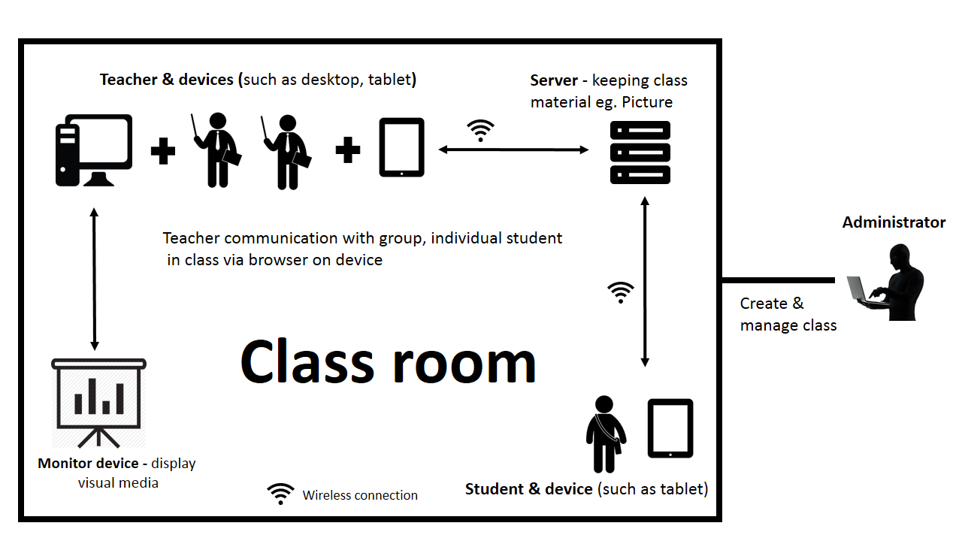

**Figure 7: The architecture of the Easy Class.**

**The architecture consists of two parts:**

* Server (Administrator)
* Class (Teacher, Students)
* Personal Computer(PC)
* Tablet
* Projector

Administrator is a person who manages and controls the server. He can create and manage a classroom (e.g. add, edit, and delete a teacher and students). Teacher can use his PC or tablet to use the system. He can show his screen on the projector and share his screen with student tablets. He can use his tablet to control the class. Student can use the service using his tablet, which allows him to see the class content participate in activities in class. Every activity in class requires Wireless connection to connect with the server.

**4.3.1.2 Document**

* Proposal
* Project plan
* Software requirement specification
* Software design document
* Testing document
* Traceability record
* Software quality assurance document
* Video clips for demo program
* Poster A1 for presentation

**4.3.2 Limits**

* Requires an Internet connection for using this system.
* Supports English language only.
* Requires the browser that supporting HTML5 to run this system (e.g. Chrome, Firefox).
* Requires the registration to get an account before starting to use the system.

**4.4 Future work**

This project is about supporting teaching and learning with the concepts of the Smart Class. The Smart Class works with many technology devices. So, this project can be improved by adding more features that can be supported by new technologies, for example, Smart Wall, Smart Table, etc.

The license can be implemented for business. This system can use in any school, university, or other academies. Teachers or personnel can adapt this system to serve their courses. This can provide more benefits to a larger group of people and contribute to enhancing the quality of education in educational institutions and organizations.

This system can be improved to support remote education (i.e. e-learning). It will make the students who cannot attend the class be able to learn and do class activities with his friends that are in class.

**4.5 Schedule and Milestone**

**4.5.1 Features**

Easy Class supports the features as follows:

**Feature 1. User management**

* User registration: Administrator, Teacher and Student can register to the system.
* User authentication: Administrator, Teacher and Student can login to system and log out with his/her account.

**Feature 2. Class Management**

* Class registration: Administrator can register a class to the system by adding Teacher and Students.
* Classbook management: Teacher can view the list of Students in the class and check their attendance.

**Feature 3. White board for Teacher**

* White board: Teacher can write things down as he does in a regular white board.
* Screen Broadcast: Teacher can broadcast his own screen to Students tablets.
* Subscreen partitioning: Teacher can split his screen into two partitions to display information on one side while using the other side as a white board for writing.

**Feature 4. Monitor Students.**

* Screen monitor: Teacher can see the screen of students

**Feature 5. Collaboration Board**

**A board which gathers input from individual students and displays it, which can be used for survey, drawing and information gathering.**

* Activity creation and management: Teacher can create a collaboration board for survey, drawing and gather information, also can edit or close a board.
* Activity participation: Students can drawing or filling information to collaboration board.
* Student attention: Teacher can automatically check attention of a student by activity participation.
* Gather learning artifact: Student can send activities/teaching, studies material (PDF, Image, pined map and text) to the teachers.

**Feature 6. Grouping communication**

* Group chat: Teacher can chat with all Students in real time.
* Pop-up message: Teacher can create and send an alert or warning message to Students.
* Pop-up quiz: Teacher can create and send a quiz interface to Students.

**Feature 7. Mind map**

* Mind map creation and management: Teacher can create& provide mind map board for student to put ideas (image, text, pin map etc.).
* Collaborative mind mapping: Students can create mind maps of the collaboration or individually for input own ideas (text or image).

**Feature 8. Geographic Map**

* Map Interface: Teacher can open and provide the map interface to students for allows them pin the map.
* Collaboration using map: Students can using the map for searching information and pin the map.

**Feature 9. Uploading/downloading study materials**

* Teacher’s slide: teacher can upload/download any learning artifacts to the server.
* Teacher’s note: teacher can upload/download note on white board to the server.
* Collaboration outputs: Teacher/students can upload/download collaboration output (image, pdf, etc.) to the server.

**Feature 10. Share learning artifact**

* Sending via e-mail: User can send the activities/teaching, studies material (PDF, Image and text) via e-mail.
* Sharing via Facebook: User can share activities/teaching, studies material (PDF file, Image and text) via Facebook timeline for date tracking.

**Feature 11. Note for student**

* Note paper: Student can taking note in to note paper and save it(PDF)

**4.5.2 Software Development process**

**Iterative Software Development Process [14]**

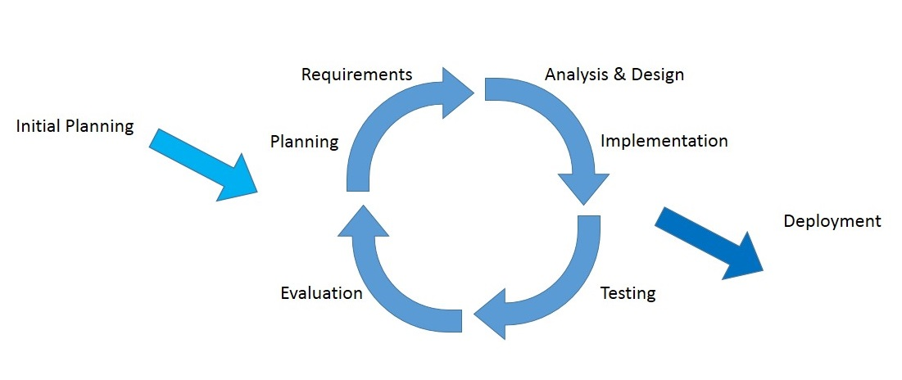

**Figure 8: The diagram of the iterative software development process**

The idea of the iterative software development model is to divide the development process into phases. As shown in Figure 8, the iterative process begins by implementing and specifying a portion of the software instead of specifying the full requirements. It is then reviewed along the way to find and add more requirements as needed. The model is broken down into increments containing a number of smaller life cycle stages with each part including a new function to the product. And each phase must be completed before the start of the next phase and the iterations continues until the entire product is built. Some of the advantages of the iterative development model include: more flexible to accommodate feedback from customers in each cycle, easy to implement sub-systems (or components) that satisfy user requirements, easy to fix errors that occur in the implementation process.

**4.5.3 Milestone**

|  |  |  |  |
| --- | --- | --- | --- |
| **Milestone** | **Task** | **Milestone Criteria** | **Planned date** |
| 1 | Proposal | Topic defined | February |
| 2 | Proposal | - Proposal reviewed  - Proposal submitted  - Proposal presentation | March |
| 3 | Progress Report I | - Software requirement specification  - Feature# 1, 2, 3, 4, 6  - Feature designed  - Test planned  - Feature implemented  - Feature tested  - Review Feature  - Progress report submitted  - Progress report presentation | Mid May |
| 4 | Progress Report II | - Software requirement specification  - Feature# 5, 7, 8  - Feature designed  - Test planned  - Feature implemented  - Feature tested  - Review Feature  - Progress report submitted  - Progress report presentation | Mid July |
| 5 | ShowPro | About 80% of the overall project | Beginning of September |
| 6 | Progress Report III | - Software requirement specification  - Feature# 9, 10  - Feature implemented  - Feature designed  - Test planned  - Feature tested  - Review Feature  - Integrate and review all documents.  - Tests all features.  - Reviews documents are completed.  - Progress report submitted  - Progress report presentation | End of September |

**4.5.4 Schedule**

**4.5.4.1 Proposal**

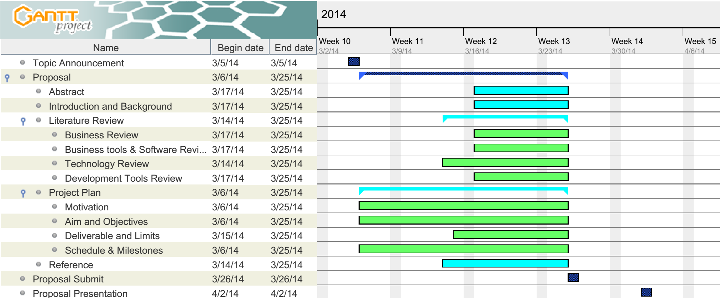

**4.5.4.2 Progress Report I**

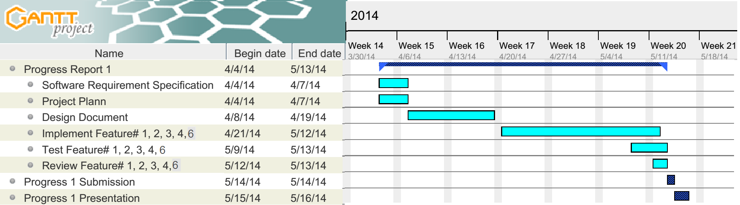

**4.5.4.3 Progress Report II**

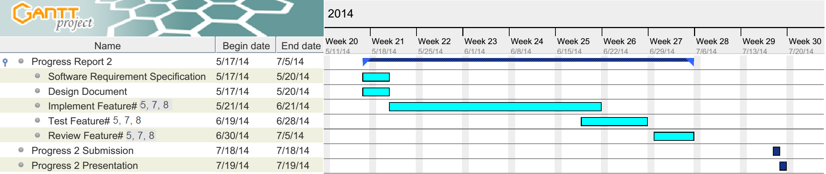

**4.5.4.4 Progress Report III**

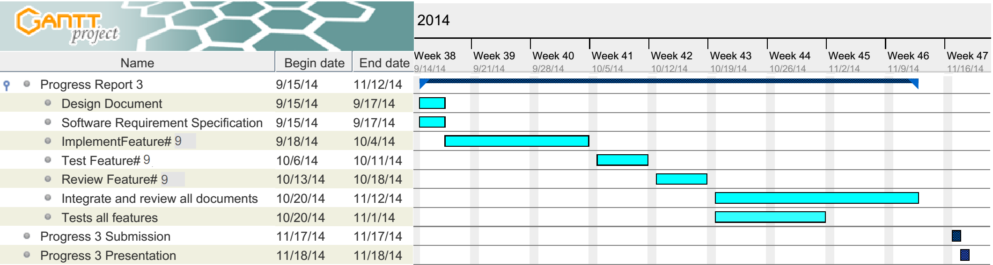

**Chapter V | References**

[1] Tablet Classroom Management Software: Radix Technologies Ltd.

<http://www.radix-int.com/Classroom-Management/Tablet-Classroom-Management-Software.html> [Accessed 16th March 2014]

[2] Classteacher Learning: Systems Classteacher

<http://www.classteacher.com> [Accessed 16th March 2014]

[3] Samsung Smart School: Samsung

<http://www.samsung.com/global/business/business-images/resource/case-study/2013/02/Samsung_Smart_School_Brochure-0.pdf> [Accessed 19th March 2014]

[4] HTML5: Wikipedia

<http://en.wikipedia.org/wiki/HTML5> [Accessed 19th March 2014]

[5] JavaScript: Wikipedia

<http://en.wikipedia.org/wiki/JavaScript> [Accessed 19th March 2014]

[6]JSON: Wikipedia

<http://en.wikipedia.org/wiki/JSON> [Accessed 18th March 2014]

[7]Cascading Style Sheets: Wikipedia

<http://en.wikipedia.org/wiki/Cascading_Style_Sheets> [Accessed 18th March 2014]

[8] Node.js: Joyent, Inc

<http://nodejs.org> [Accessed 18th March 2014]

[9] WebRTC API: Webplatform*Available from*: <http://docs.webplatform.org/wiki/apis/webrtc> [Accessed 19th March 2014]

[10] MySQL:

<http://en.wikipedia.org/wiki/MySQL> [Accessed 18th March 2014]

[11] Google Developers:

[https://developers.google.com/*maps*](https://developers.google.com/maps) [Accessed 18th March 2014]

[12] Apache Tomcat: Wikipedia

<https://en.wikipedia.org/wiki/Apache_Tomcat>

[13] Aptana: Wikipedia

<http://en.wikipedia.org/wiki/Aptana> [Accessed 25th March 2014]

[14] Iterative and incremental development: Wikipedia

<http://en.wikipedia.org/wiki/Iterative_and_incremental_development> [Accessed 25th March 2014]

[15] Kenneth Hess. Top 10 Enterprise Database Systems to Consider.

<http://www.serverwatch.com/article.php/3883441/Top-10-Enterprise-Database-Systems-to-Consider.htm> [Accessed 25th March 2014]

[15] Curties Dicken. Top 5 Databases for Web Developers.

<http://www.htmlgoodies.com/primers/database/top-5-databases-for-web-developers.html> [Accessed 25th March 2014]

[16] Java, SQL and jOOQ. Top 10 Most Popular DB Engines (SQL and NoSQL)**.**

<http://blog.jooq.org/2013/10/03/the-10-most-popular-db-engines-sql-and-nosql/> [Accessed 25th March 2014]