**Easy Class**

Software Requirement Specification

By

|  |  |
| --- | --- |
| **Pichet Potha** | **542115041** |
| **Sittipong Borripan** | **542115066** |

Department of Software Engineering

College of Arts, Media and Technology

Chiang Mai University

Project Adviser

______________________________

Ms. Yun Rim Park

**Table of contents**

**Revision History………………………………………………………………………...…………………1**

**Introduction……………………...……………………….………………………......………………........2**

**Document Purpose………………………………………………...……………………………...2**

**Project Scope……………………………………………………………………………………...2**

**User Characteristics……………………………………………………………………………...2**

**Operation Environment………………………………………………………………………….2**

**Acronyms and Definition…………....………………………………………………….…………………3**

**Overall Description……………………………………...……………………………….…………….….3**

**Product Perspective………………………………………………………………………………..**

**Product Functions………………………………………………………………………………….**

**Requirement Specification……………………………………………………….…………..…….……..3**

**User Requirements ………………………….…………………………...…...…………...……...3**

**Software Requirements Specification ……………….….…………..…………...………….…...5**

**Use case Diagram ……………….…………………………………..………………...………......8**

**Use Case Description.…………………………………………………………………………11**

**Activity Diagram….………….………………………………….……..……………...………...42**

**Revision History**

|  |  |  |  |  |  |  |  |  |
| --- | --- | --- | --- | --- | --- | --- | --- | --- |
| **Document Name** | **Version** | | **Status** | | **Date** | **Viewable** | **Reviewer** | **Responsible** |
| Easy_Class_Software_Requirement_Specification_Version0.1 | Add | * Introduction * Acronyms and Definition * Overall Description * Requirement Specification | | Draft | 24/05/2014 | PP,SB,YP | PP,SB | PP,SB |
| Easy_Class_Software_Requirement_Specification_Version0.2 |  | * Change the document form * Chapter I: Introduction * Document Purpose * Project Scope * User Characteristics * Operation Environment * Acronyms and Definition * Chapter II: Chapter II: Specific Requirement * Use Case Scenarios * Chapter III: Software Requirement Specification * Add more detail in Characteristics. | | Draft | 30/05/2014 | PP,SB,YP | PP,SB | PP,SB |

**Chapter I: Introduction**

**1.1 Document Purpose**

The purpose of software requirements specification (SRS) document is to provide the detailed description of the functionalities of Easy Class system. This document was gathering the requirement that relate with user to use in this system. The requirements will be sorted out to each type (URS, SRS, etc.). This document will be used with design the system in the design document and implement the system.

**1.2 Project Scope**

Easy Class is the real time web application that run on the web browser. It will help the teacher to create the class activities to do with students in the class. Teacher and student will registered by administrator. Teacher and student will do the class activity by using Easy Class. Teacher is a people who control the class to make the student pay attention and enjoin with the class by this system.

**1.3 User Characteristics**

Easy Class is the web application which help teacher can design and create own class activities to make the class smarter. It can help teachers and students enjoin with the class activity to get more fun and knowledge. Then the meanings of all characters are:

**Administrator**: Administrator is the people who manage the class and user requirement.

**Teacher**: Teacher is the people who teaching and control the class.

**Student**: Student is the learner that attend and use the device in class under teacher’s control.

**1.4 Operation Environment**

Easy Class is the web application that run on web browser, so all of character need the internet connection to run this system. Easy Class is implemented by using HTML5, user must use the web browser that support HTML5 to run the system.

**1.5 Acronyms and Definition**

|  |  |
| --- | --- |
| Acronyms | Explanation |
| SRS | Software Requirement Specification |
| URS | User Requirement Specification |
| Users | Administrator, Teacher, Student |
| User | Teacher, Student |
| Definition | **Explanation** |
| Use case | The scenario to describe overall system, relation with users and sub  System. |
| Requirement Specification | Document to specify requirement from customer or users. It can describe relation between user and system. And it can describe what developer will develop. |

**Chapter II: Specific Requirement**

**2.1 Use Case Scenarios**

**Administrator Use Case**

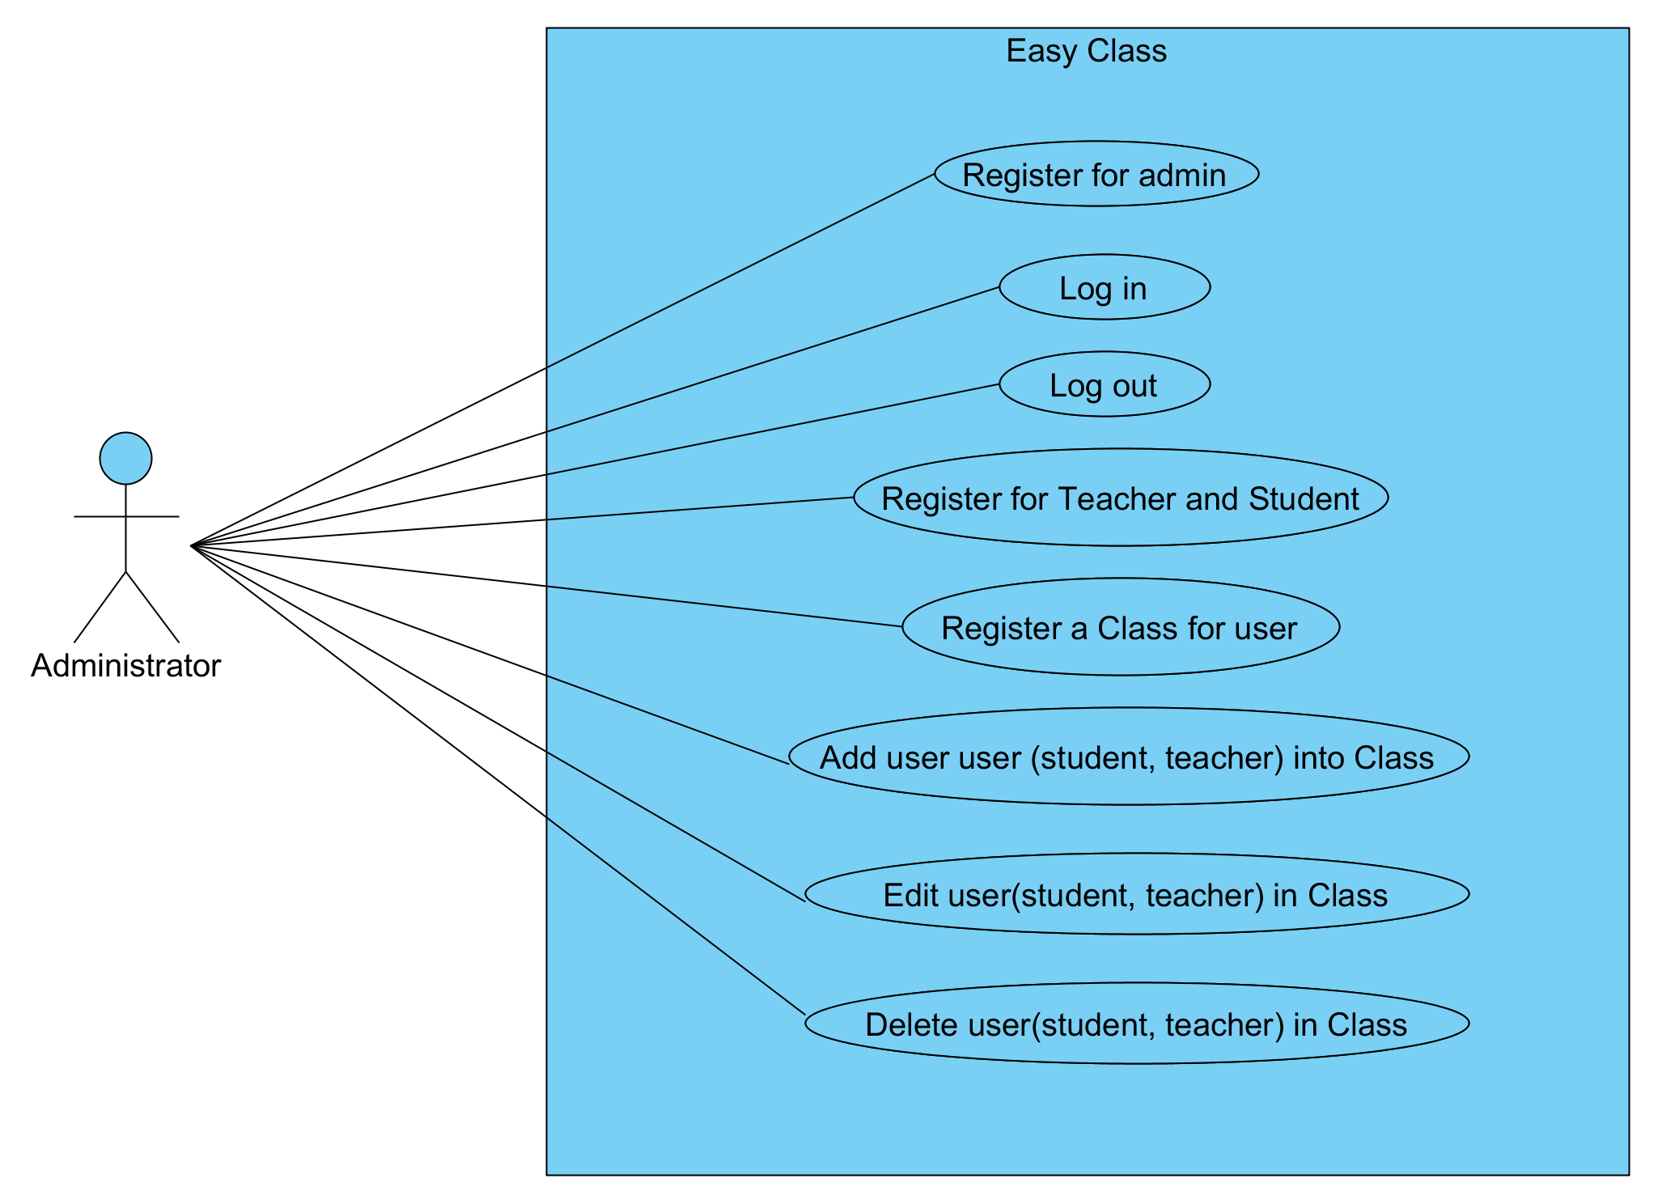

Figure 1: Use case for Administrator

**Teacher Use Case**

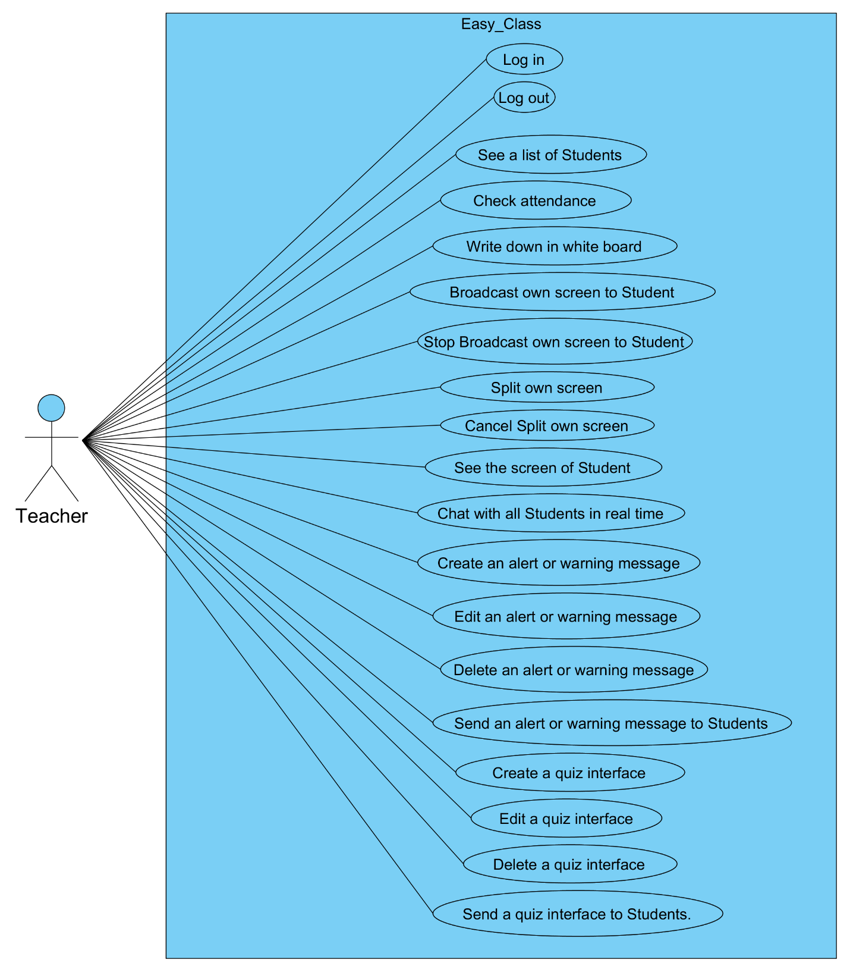

Figure 2: Use case for Teacher

**Student Student**

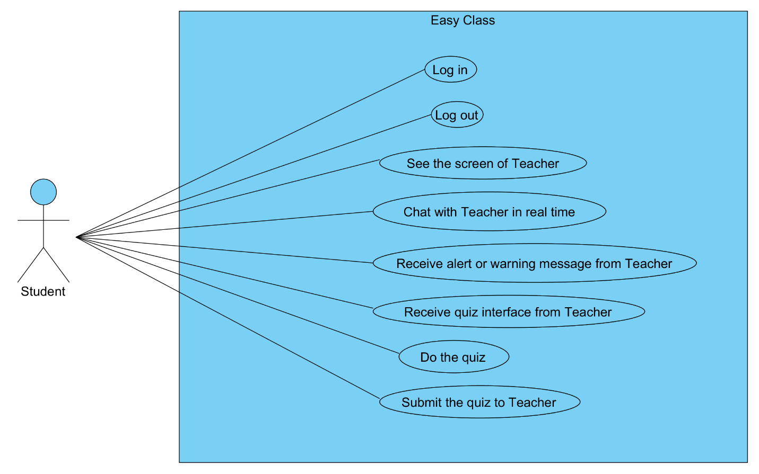

Figure 3: Use case for Student

**Chapter III: Software Requirement Specification**

**3.1 UC001: Register for Administrator**

|  |  |  |  |  |
| --- | --- | --- | --- | --- |
| **Use Case ID:** | UC-001 | | | |
| **Use Case Name:** | Register for Administrator | | | |
| **Created By:** | Pichet Potha  Sittipong Borripan | | **Last Updated By:** |  |
| **Date Created:** | 12/5/2014 | | **Last Revision Date:** |  |
| **Actors:** | | Administrator | | |
| **Description:** | | This use case describe how to register Administrator to easy class web application. | | |
| **Trigger:** | | The system display interface to receive username and password | | |
| **Pre-conditions:** | | 1. Administrator has not logged into easy class web application.  2. Administrator stay on “Administrator sign up” page. | | |
| **Post-conditions:** | | 1. Administrator be able to login to easy class web application with he/she account and stay on “administrator profile” page. | | |
| **Normal Flow:** | | 1. The system shall interface to receive username and  password.  2. Administrator enter he/she username and password  3. Administrator selects “sing up” on he/she screen.  4. The system shall validation username.  5. The system shall save information into database  6. Administrator be able to login to easy class web application with he/she account and stay on “administrator profile” page. | | |
| **Alternative Flows:** | | 5a. In the step of 5 of Normal Flow, if Administrator input wrong type of username  1. System display warning message.  2. Go back to step 3 in Normal Flow again. | | |
| **Exceptions:** | | 4b. In the step 4 of the Normal Flow, if no internet connection  1. The system check the internet connection. 2. The system alerts the user that the internet connection does not exist. 3. Use case ends. | | |
| **Priority::** | | High. | | |

**Use Case:** Register for Administrator (UC001)

**URS1-01:** The web application shall allow the Administrator register to the system.

Administrator register to the Easy Class system.

**Input:**

|  |  |  |  |
| --- | --- | --- | --- |
| Input | Description | Constraints | Example |
| Username | The name for Administrator use to log in to the system | In the username must contain ‘@’ and ‘.’ | Easy_Class@camt.com |
| Password | The character that Administrator use for user authentication to prove identity or access approval to gain access to a resource | Allow any special character to use in password. | Easy@Class01 |

**Action:**

**AC-01: Register for Administrator**

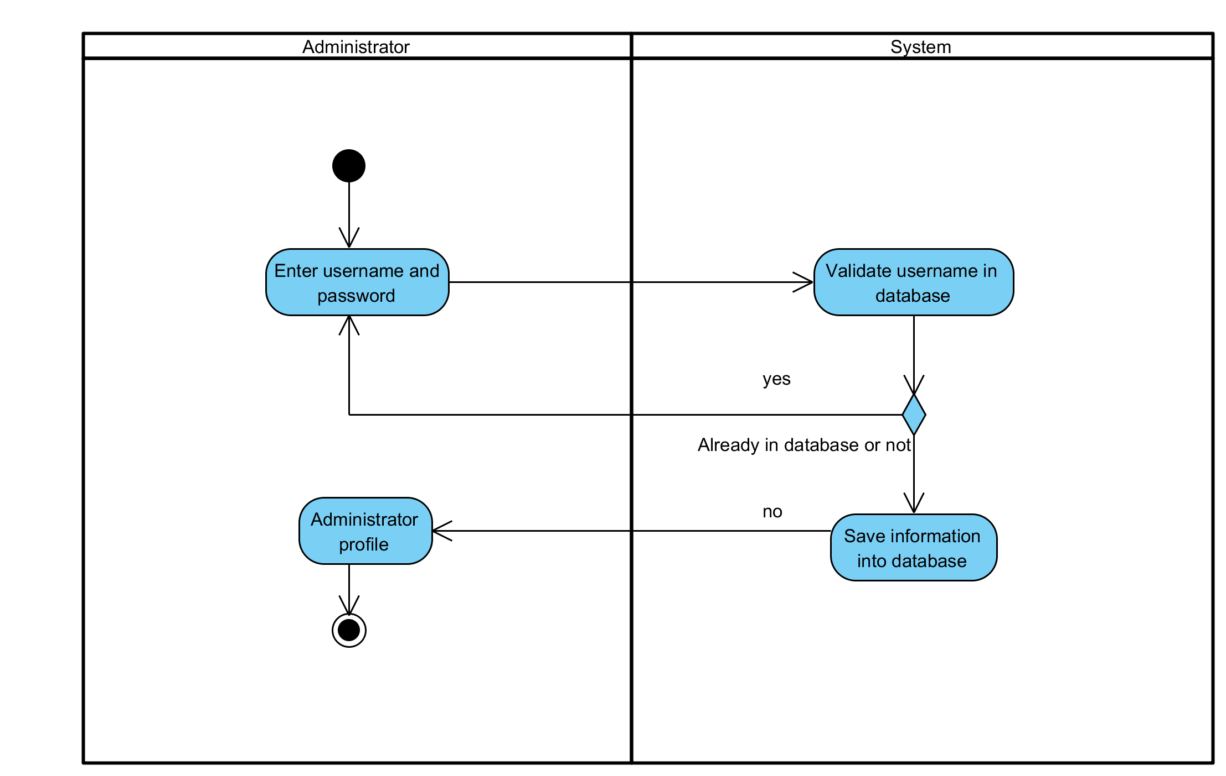

**Output:** Username and password has been saved in the database.

**System Requirements Specifications:**

* **SRS1-1.1:** The system shall interface to receive username and password.
* **SRS1-1.2:** The system shall validation username.
* **SRS1-1.3:** The system shall save information into database

**3.2 UC002: Log in**

|  |  |  |  |  |
| --- | --- | --- | --- | --- |
| **Use Case ID:** | UC-002 | | | |
| **Use Case Name:** | Log in | | | |
| **Created By:** | Pichet Potha  Sittipong Borripan | | **Last Updated By:** |  |
| **Date Created:** | 12/5/2014 | | **Last Revision Date:** |  |
| **Actors:** | | Administrator, Teacher, Student | | |
| **Description:** | | This use case describe how users log in to system. | | |
| **Trigger:** | | Users selects “log in” button on the screen. | | |
| **Pre-conditions:** | | 1. Users has not already logged in to the system.  2. Users has already registered to system and have an account.  3. Users stay on index page. | | |
| **Post-conditions:** | | 1. The system shall display users profile and feature menu. (The result depend on type of user) and be able to use system feature. | | |
| **Normal Flow:** | | 1. User selects appropriate log in type to their own account and selects “log in” button on the screen.  2. The system shall display interface for users to log in.  3. Users enter he/she username and password.  4. Users select “log in” button.  5. The system validation username and password.  6. The system shall display users profile and feature menu. | | |
| **Alternative Flows:** | | 5a. In step 5 of the Normal Flow, if username and password of users has not correct type or not available in database  1. Go back to step 3 of Normal Flow | | |
| **Exceptions:** | | 2b. In the step 2 of the Normal Flow, if no internet connection  1. The system check the internet connection.  2. The system alerts the user that the internet connection does not  exist.  3. Use case ends. | | |
| **Priority::** | | High. | | |

**Use Case:** Log in (UC002)

**URS1-02:** The web application shall allow the User (Student, Teacher, and Administrator) log in to the system.

Users in put username and password to log in to use the Easy Class system.

**Input:**

|  |  |  |  |
| --- | --- | --- | --- |
| Input | Description | Constraints | Example |
| Username | The name for Administrator use to log in to the system | In the username must contain ‘@’ and ‘.’ | Easy_Class@camt.com |
| Password | The character that Administrator use for user authentication to prove identity or access approval to gain access to a resource | Allow any special character to use in password. | Easy@Class01 |

**Action:**

**AC-02: Log in**

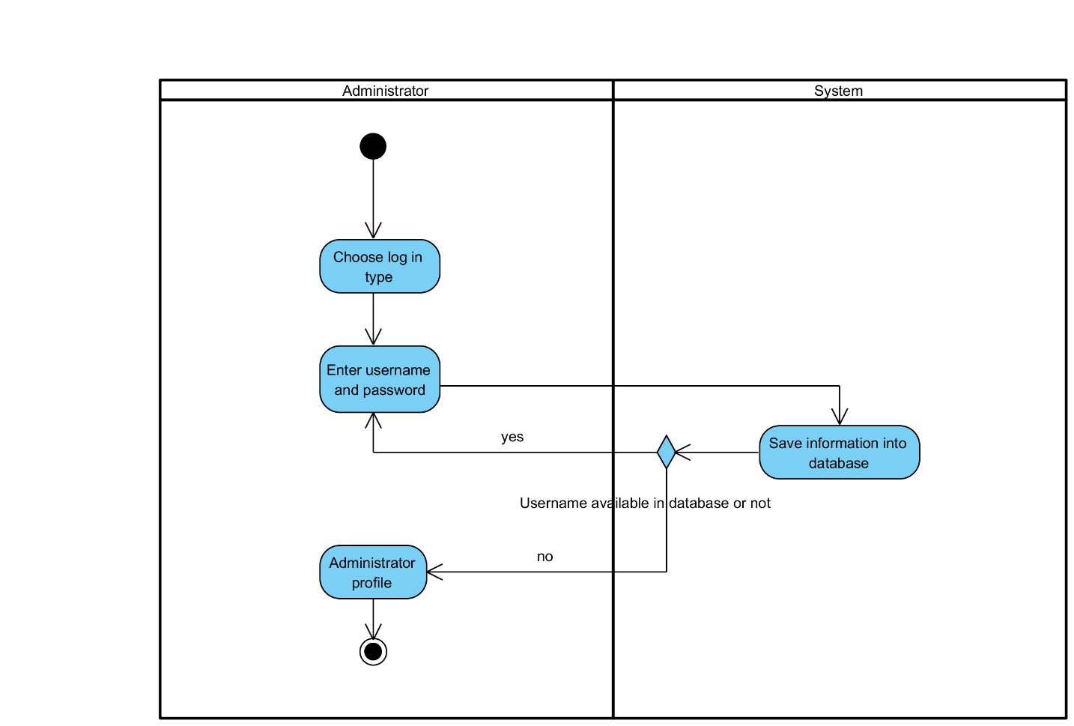

**Figure 5: Log in**

**Output:** Users have been logged in to the system.

**System Requirements Specifications:**

* **SRS2-2.1:** The system shall display interface for users to log in.
* **SRS2-2.2:** The system validation username and password.
* **SRS2-2.3:** The system shall display users profile and feature menu.

**3.3 UC003: Log out**

|  |  |  |  |  |
| --- | --- | --- | --- | --- |
| **Use Case ID:** | UC-003 | | | |
| **Use Case Name:** | Log out | | | |
| **Created By:** | Pichet Potha  Sittipong Borripan | | **Last Updated By:** |  |
| **Date Created:** | 12/5/2014 | | **Last Revision Date:** |  |
| **Actors:** | | Administrator, Teacher, Student | | |
| **Description:** | | This use case describe how users log out to system. | | |
| **Trigger:** | | Users selects “log out” button on the screen. | | |
| **Pre-conditions:** | | 1. Users has already logged in to the system on own device.  2. Users stay on “profile page”. | | |
| **Post-conditions:** | | 1. Users stay on index page and already log out. | | |
| **Normal Flow:** | | 1. Users selects “log out” button on the screen.  2. The system shall disconnect session of that user.  3. Users stay on index page and already log out. | | |
| **Alternative Flows:** | | n/a | | |
| **Exceptions:** | | 1a. In the step 1 of the Normal Flow, if no internet connection  1. The system check the internet connection.  2. The system alerts the user that the internet connection does not  exist.  3. Use case ends. | | |
| **Priority::** | | High. | | |

**Use Case:** Log out (UC003)

**URS1-03:** The web application shall allow the User (Student, Teacher, and Administrator) log out from the system.

Users select “log out” button to log out from the system.

**Input:**

|  |  |  |  |
| --- | --- | --- | --- |
| Input | Description | Constraints | Example |
|  |  |  |  |

**Action:**

**AC-03: Log out**

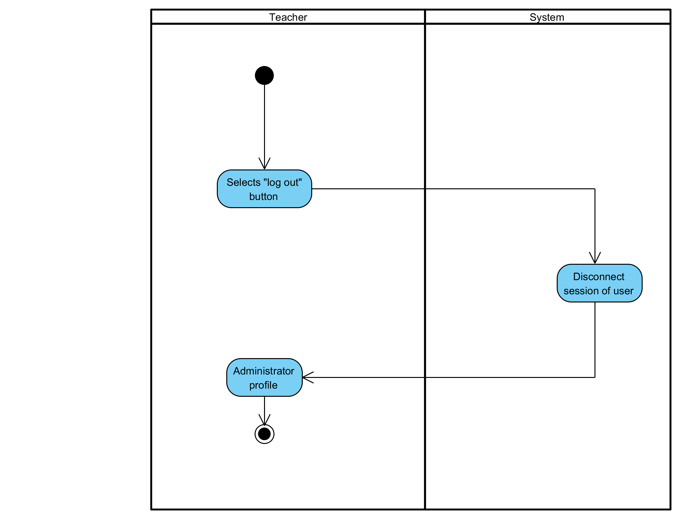

**Figure 6: Log out**

**Output:** Users have been logged out from the system.

**System Requirements Specifications:**

* **SRS3-3.1:** The system shall disconnect session of that user.

**3.4 UC004: Register for Teacher and Student**

|  |  |  |  |  |
| --- | --- | --- | --- | --- |
| **Use Case ID:** | UC-004 | | | |
| **Use Case Name:** | Register for Teacher and Student | | | |
| **Created By:** | Pichet Potha  Sittipong Borripan | | **Last Updated By:** |  |
| **Date Created:** | 12/5/2014 | | **Last Revision Date:** |  |
| **Actors:** | | Administrator | | |
| **Description:** | | This use case describe how to administrator register teacher and student to system. | | |
| **Trigger:** | | Administrator selects “sign up for user” button. | | |
| **Pre-conditions:** | | 1. Administrator already logged in to the system on own device.  2. Administrator stay on profile page. | | |
| **Post-conditions:** | | 1. Administrator complete to register for teacher and student. | | |
| **Normal Flow:** | | 1. Administrator selects “sign up for user” button.  2. The system shall display interface for receive information.  3. Administrator enter information and selects “submit” button.  4. The system shall validation information and save into database.  5. Administrator stay on  6. Administrator complete to register for teacher and student. | | |
| **Alternative Flows:** | | 5a. In the step 5 of Normal Flow, if username type is not correct and it already in database  1. Go back to step 4 again | | |
| **Exceptions:** | | 5b. In the step 3 of the Normal Flow, if no internet connection  1. The system check the internet connection.  2. The system alerts the user that the internet connection does not  exist.  3. Use case ends. | | |
| **Priority::** | | High. | | |

**Use Case:** Register for Teacher and Student (UC004)

**URS1-04:** The web application shall allow the Administrator register for Teacher and Student.

Administrator input user information to register for Teacher and Student.

**Input:**

|  |  |  |  |
| --- | --- | --- | --- |
| Input | Description | Constraints | Example |
| Username | The name for Administrator use to log in to the system | In the username must contain ‘@’ and ‘.’ | Easy_Class@camt.com |
| Password | The character that Administrator use for user authentication to prove identity or access approval to gain access to a resource | Allow any special character to use in password. | Easy@Class01 |
| Name | The real name of user. It consist of first name and surname. | Not allow to use special character. | Pichet Potha  Sittipong Borripan |

**Action:**

**AC-04: Register for Teacher and Student**

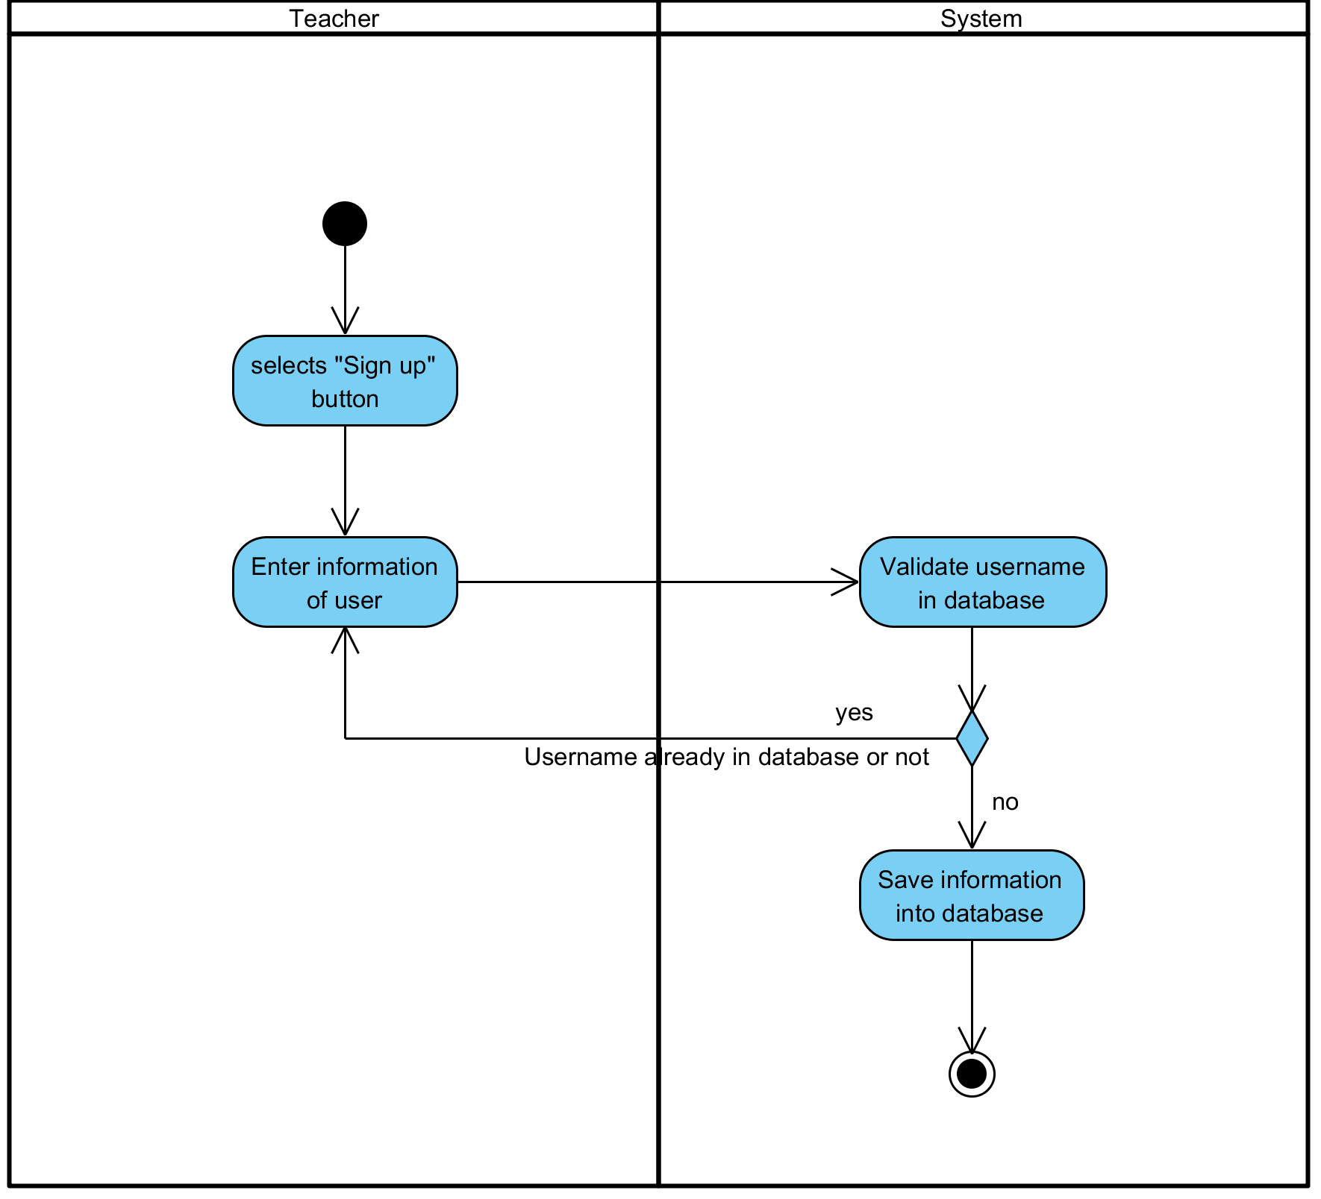

**Figure 7: Register for Teacher and Student**

**Output:** User information have been saved in the database.

**System Requirements Specifications:**

* **SRS4-4.1:** The system shall display interface for receive information.
* **SRS4-4.2:** The system shall validation information and save into database.

**3.5 UC005: Register a class for user**

|  |  |  |  |  |
| --- | --- | --- | --- | --- |
| **Use Case ID:** | UC-005 | | | |
| **Use Case Name:** | Register a class for user | | | |
| **Created By:** | Pichet Potha  Sittipong Borripan | | **Last Updated By:** |  |
| **Date Created:** | 12/5/2014 | | **Last Revision Date:** |  |
| **Actors:** | | Administrator | | |
| **Description:** | | This use case describe how administrator register a class for user. | | |
| **Trigger:** | | Administrator selects “create class” button on the screen on administrator page. | | |
| **Pre-conditions:** | | 1. Administrator already logged in to the system on own device.  2. Administrator stay on administrator profile. | | |
| **Post-conditions:** | | 1. Administrator complete register a class to database. | | |
| **Normal Flow:** | | 1. Administrator selects “create class” button on profile page.  2. The system shall display interface to receive class name.  3. Administrator enter class name and selects “create class” button.  4. The system shall save that register class into database  5. Administrator return to profile page and selects “manage class” button.  6. The system shall display class list interface with that registered class.  7. Administrator complete register a class to database. | | |
| **Alternative Flows:** | | 4a. In the step 4 of the Normal Flow, if class already in database  1. Go back to step 3 in Normal Flow. | | |
| **Exceptions:** | | 1b. In the step 1 of the Normal Flow, if no internet connection  1. The system check the internet connection.  2. The system alerts the user that the internet connection does not  exist.  3. Use case ends. | | |
| **Priority::** | | High. | | |

**Use Case:** Register a class for user (UC005)

**URS1-05:** The web application shall allow the Administrator register a class for user.

Administrator create the class for add user to use it.

**Input:**

|  |  |  |  |
| --- | --- | --- | --- |
| Input | Description | Constraints | Example |
| Class name | The name of the class. | Allow any special character to use in class name. | SE212  Grade 9-12 |

**Action:**

**AC-05: Register a class for user**

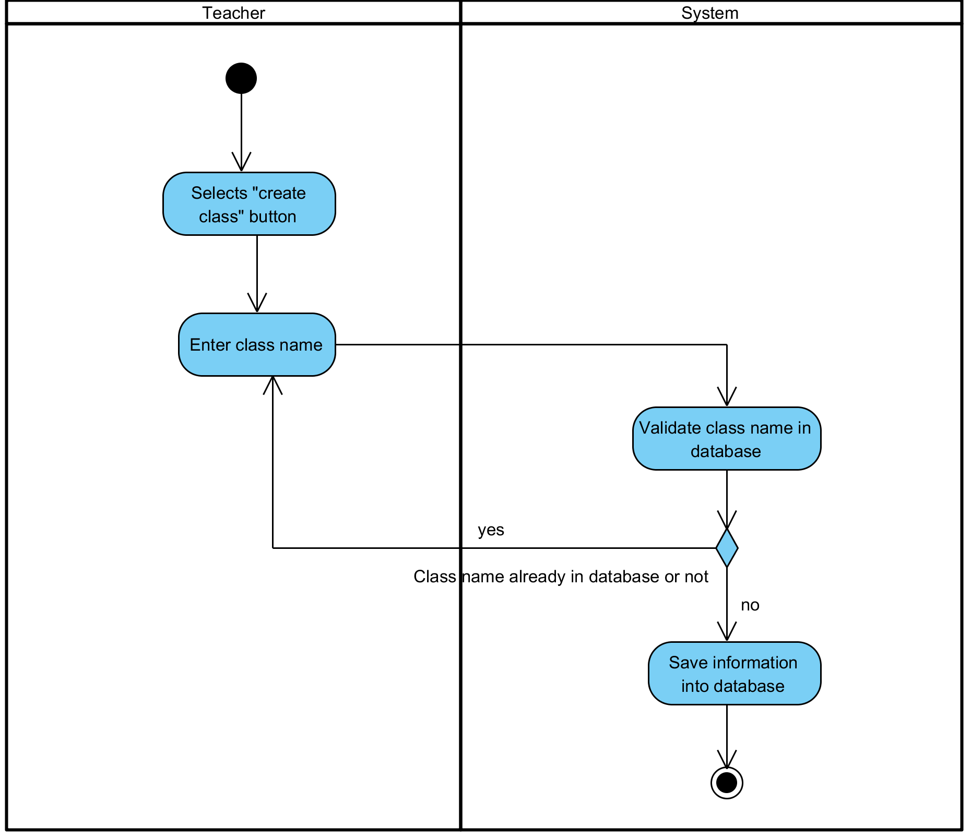

**Figure 8: Register a class for user**

**Output:** Class has been created.

**System Requirements Specifications:**

* **SRS5-5.1:** The system shall display interface to receive class name.
* **SRS5-5.2:** The system shall save that register class into database
* **SRS5-5.3:** The system shall display class list interface with that registered class.

**3.6 UC006: Register a class for user**

|  |  |  |  |  |
| --- | --- | --- | --- | --- |
| **Use Case ID:** | UC-006 | | | |
| **Use Case Name:** | Add user (student, teacher) into Class | | | |
| **Created By:** | Pichet Potha  Sittipong Borripan | | **Last Updated By:** |  |
| **Date Created:** | 12/5/2014 | | **Last Revision Date:** |  |
| **Actors:** | | Administrator | | |
| **Description:** | | This use case describe how administrator add user into class. | | |
| **Trigger:** | | Administrator selects “manage class” button. | | |
| **Pre-conditions:** | | 1. Administrator already logged in to the system on own device.  2. Class for add user already created in database.  3. Administrator stay on administrator page. | | |
| **Post-conditions:** | | 1. Administrator complete to add user into class. | | |
| **Normal Flow:** | | 1. Administrator selects “manage class” button.  2. The system shall pull class information in database to display interface list of “class”.  3. Administrator selects the class that already created.  4. The system shall display interface for administrator to add teacher, student to class and class information.  5. Administrator enter information of teacher, student and selects “submit” button.  6. The system shall validation class information and save it on database.  7. Administrator complete to add user into class. | | |
| **Alternative Flows:** | | 5a. In the step 5 if user already in that class selected  1. Go back to step 4 in Normal Flow. | | |
| **Exceptions:** | | 1a. In the step 1 of the Normal Flow, if no internet connection  1. The system check the internet connection.  2. The system alerts the user that the internet connection does not  exist.  3. Use case ends. | | |
| **Priority::** | | High. | | |

**Use Case:** Add user (student, teacher) into Class (UC006)

**URS1-06:** The web application shall allow the Administrator add user (Student, Teacher) into Class.

Administrator add user into the class to make the user can start using class.

**Input:**

|  |  |  |  |
| --- | --- | --- | --- |
| Input | Description | Constraints | Example |
|  |  |  |  |

**Action:**

**AC-06: Add user (student, teacher) into Class**

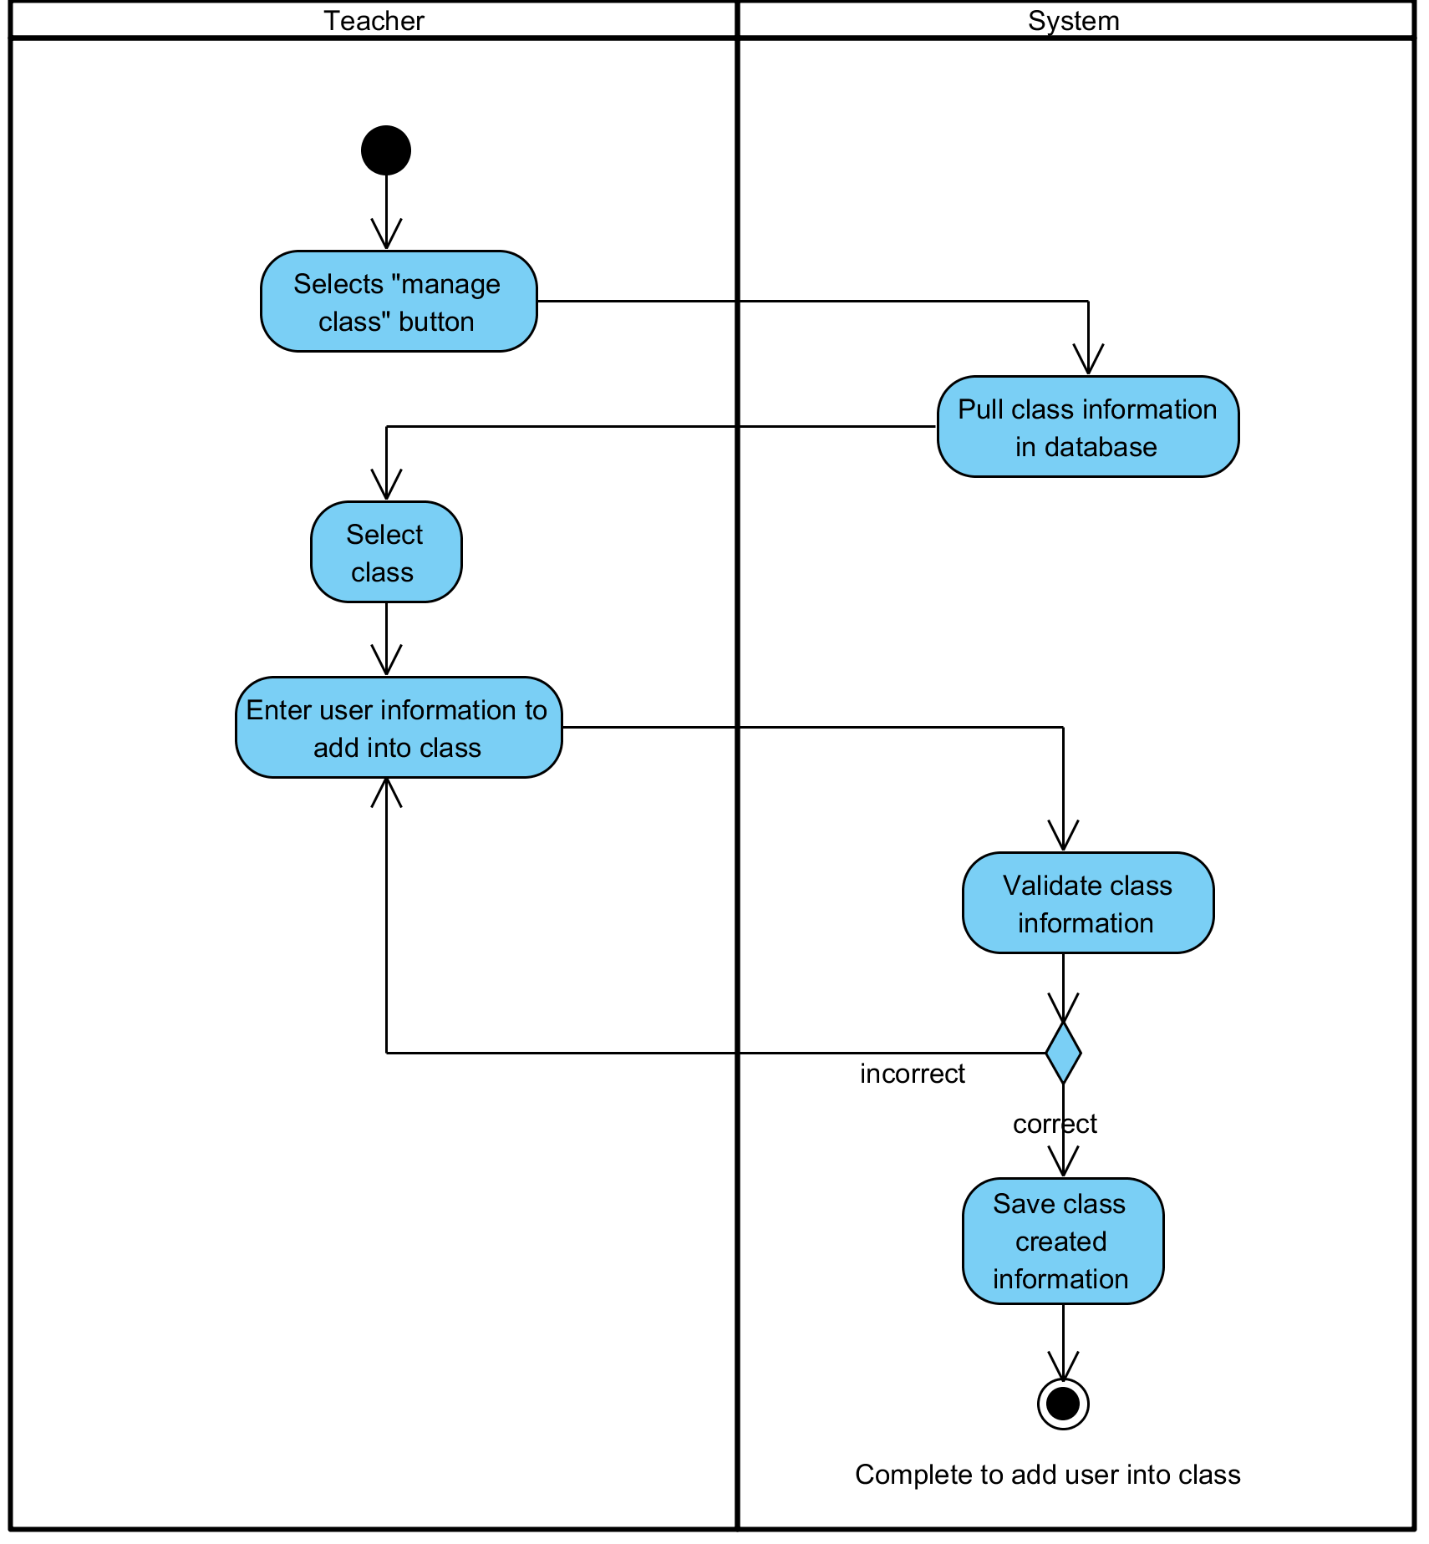

**Figure 9: Add user (student, teacher) into Class**

**Output:** User has been added to the class.

**System Requirements Specifications:**

* **SRS5-5.1:** The system shall display interface to receive class name.
* **SRS5-5.2:** The system shall save that register class into database
* **SRS5-5.3:** The system shall display class list interface with that registered class.

**3.7 UC007: Edit user in Class**

|  |  |  |  |  |
| --- | --- | --- | --- | --- |
| **Use Case ID:** | UC-007 | | | |
| **Use Case Name:** | Edit user in Class | | | |
| **Created By:** | Pichet Potha  Sittipong Borripan | | **Last Updated By:** |  |
| **Date Created:** | 12/5/2014 | | **Last Revision Date:** |  |
| **Actors:** | | Administrator | | |
| **Description:** | | This use case describe how administrator edit user in class. | | |
| **Trigger:** | | Administrator selects “manage class” button in profile page. | | |
| **Pre-conditions:** | | 1. Administrator already logged in to the system on own device. | | |
| **Post-conditions:** | | 1. Administrator complete to edit user in class. | | |
| **Normal Flow:** | | 1. Administrator selects “manage class” button in profile page.  2. The system shall pull class list with class information in database.  3. The system shall display interface list of “class”.  4. Administrator selects the class that already created.  5. The system shall display interface for administrator to edit teacher, student in that class.  6. Administrator selects “edit” button behind name of teacher/student in list.  7. The system shall allow administrator edit information.  8. Administrator edit information and selects “edit” button.  9. Administrator complete to edit user in class. | | |
| **Alternative Flows:** | |  | | |
| **Exceptions:** | | 4a. In the step 4 of the Normal Flow, if no internet connection  1. The system check the internet connection.  2. The system alerts the user that the internet connection does not  exist.  3. Use case ends. | | |
| **Priority::** | | High. | | |

**Use Case:** Edit user in Class (UC007)

**URS1-07:** The web application shall allow the Administrator edit user (Student, Teacher) in Class.

Administrator edit user information in the class.

**Input:**

|  |  |  |  |
| --- | --- | --- | --- |
| Input | Description | Constraints | Example |
| Class name | The name of the class. | Allow any special character to use in class name. | SE212  Grade 9-12 |

**Action:**

**AC-07: Edit user in Class**

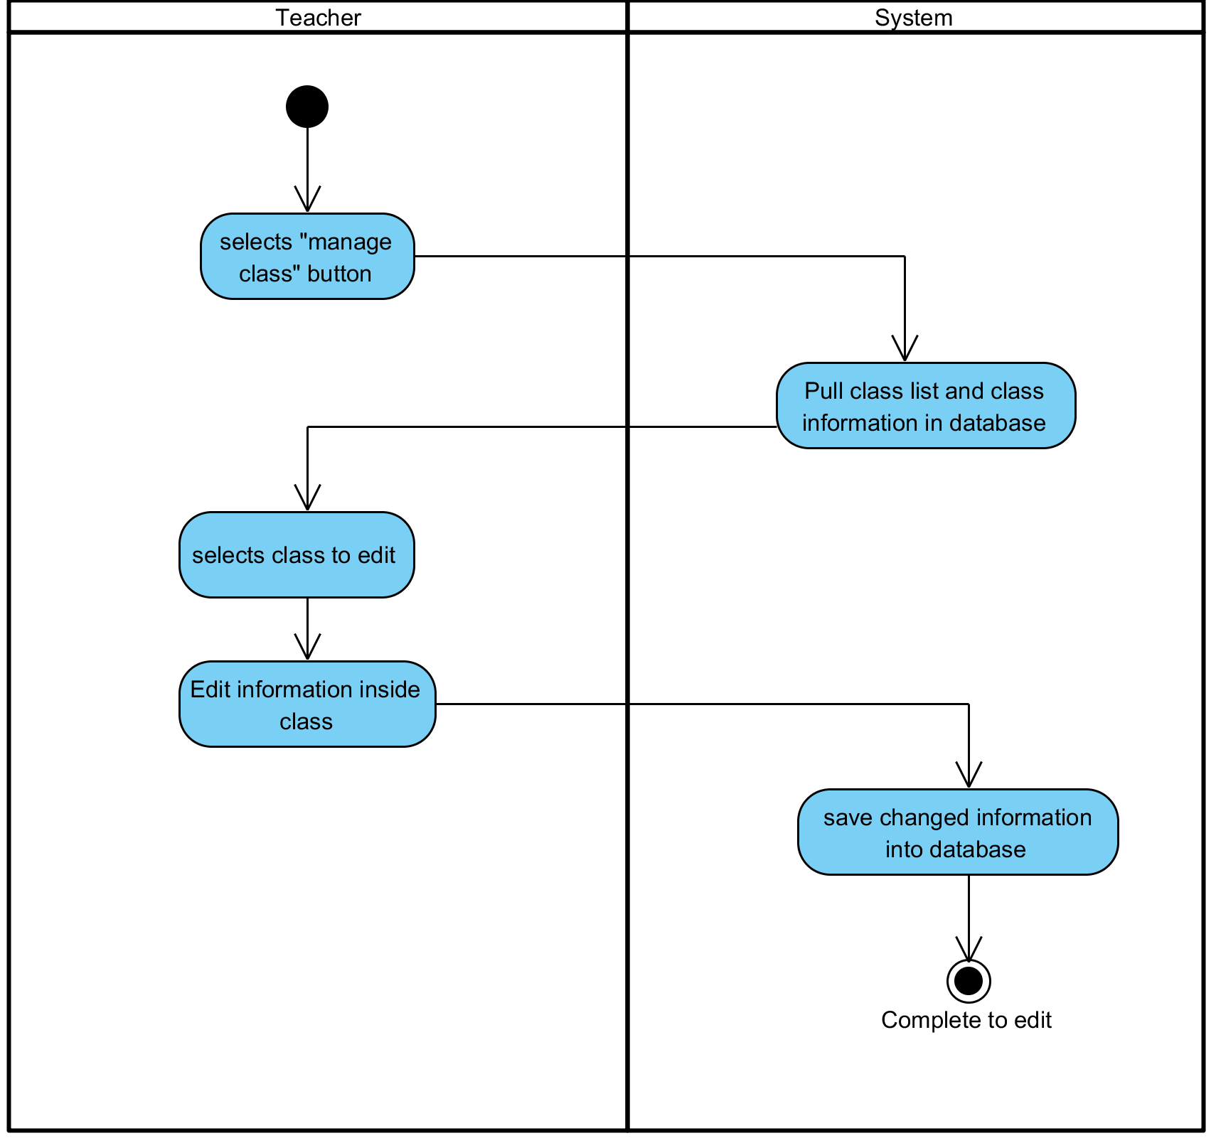

**Figure 10: Edit user in Class**

**Output:** User has been edited and changed.

**System Requirements Specifications:**

* + **SRS7-7.1:** The system shall pull class list with class information in database.
  + **SRS7-7.1:** The system shall display interface list of “class”.
  + **SRS7-7.1:** The system shall display interface for administrator to edit teacher, student in that class.
  + **SRS7-7.1:** The system shall allow administrator edit information

**3.8 UC008: Delete user (student, teacher) in Class**

|  |  |  |  |  |
| --- | --- | --- | --- | --- |
| **Use Case ID:** | UC-008 | | | |
| **Use Case Name:** | Delete user (student, teacher) in Class | | | |
| **Created By:** | Pichet Potha  Sittipong Borripan | | **Last Updated By:** |  |
| **Date Created:** | 12/5/2014 | | **Last Revision Date:** |  |
| **Actors:** | | Administrator | | |
| **Description:** | | This use case describe how administrator delete user in class. | | |
| **Trigger:** | | Administrator selects “manage class” button in profile page. | | |
| **Pre-conditions:** | | 1. Administrator already logged in to the system on own device. | | |
| **Post-conditions:** | | 1. Administrator complete to delete teacher/student in class. | | |
| **Normal Flow:** | | 1. Administrator selects “manage class” button in profile page.  2. The system shall display interface list of “class”  3. Administrator selects the class that already created.  4. The system shall pull information in database to display interface for administrator to edit teacher, student in that class.  5. Administrator selects “delete” button behind name of teacher/student in list.  6. The system save data into database.  7. Administrator edit information and selects “delete” button.  8. Administrator complete to delete teacher/student in class. | | |
| **Alternative Flows:** | |  | | |
| **Exceptions:** | | 1b. In the step 1 of the Normal Flow, if no internet connection  1. The system check the internet connection.  2. The system alerts the user that the internet connection does not  exist.  3. Use case ends. | | |
| **Priority::** | | High. | | |

**Use Case:** Delete user (student, teacher) in Class (UC008)

**URS1-08:** The web application shall allow the Administrator delete user (Student, Teacher) from Class.

Administrator delete user and user information from the class.

**Input:**

|  |  |  |  |
| --- | --- | --- | --- |
| Input | Description | Constraints | Example |
|  |  |  |  |

**Action:**

**AC-08: Delete user (student, teacher) in Class**

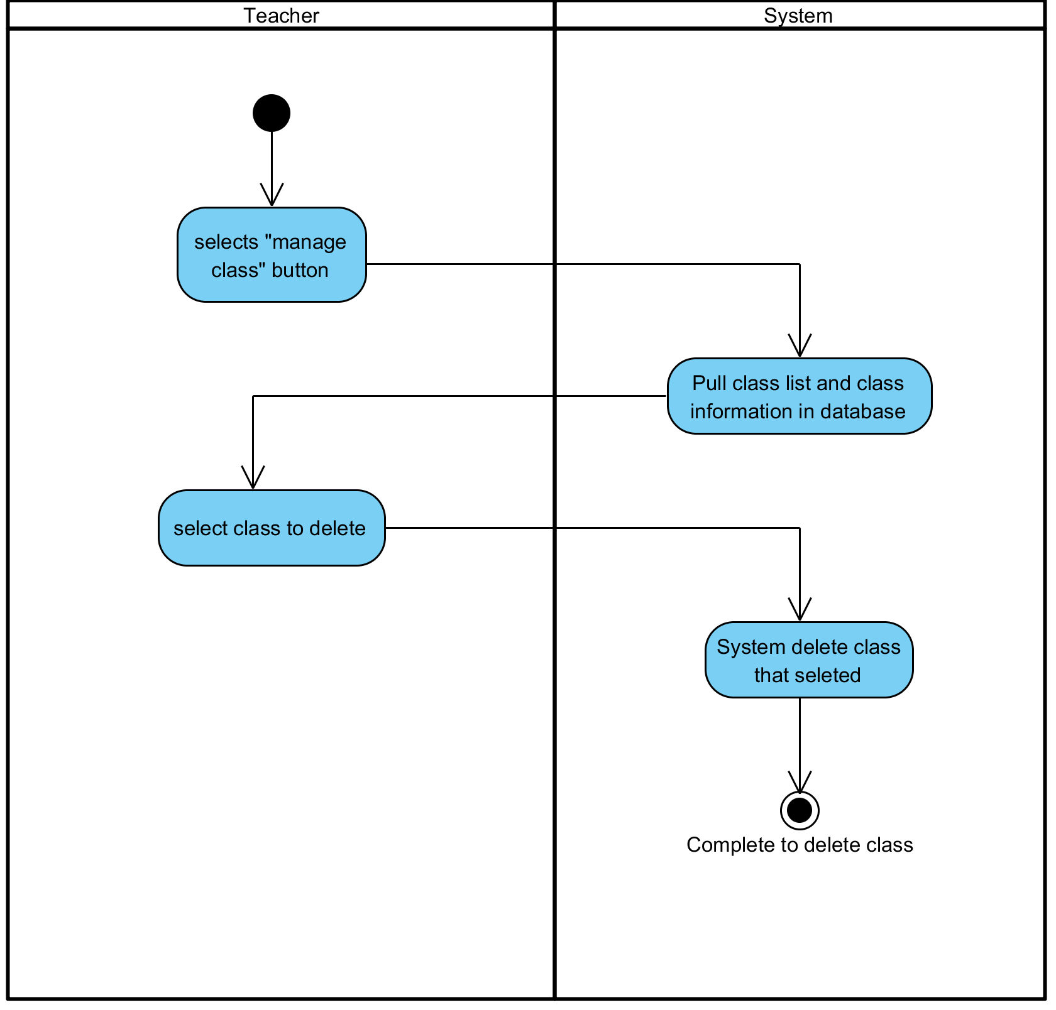

**Figure 11: Delete user (student, teacher) in Class**

**Output:** User has been deleted from the class.

**System Requirements Specifications:**

* **SRS8-8.1:** The system shall display interface list of “class”
* **SRS8-8.1:** The system shall pull information in database to display interface for administrator to edit teacher, student in that class.
* **SRS8-8.1:** The system save data into database.

**3.9 UC009: See a list of Students**

|  |  |  |  |  |
| --- | --- | --- | --- | --- |
| **Use Case ID:** | UC-009 | | | |
| **Use Case Name:** | See a list of Students | | | |
| **Created By:** | Pichet Potha  Sittipong Borripan | | **Last Updated By:** |  |
| **Date Created:** | 12/5/2014 | | **Last Revision Date:** |  |
| **Actors:** | | Teacher | | |
| **Description:** | | This use case describe how teacher see student list of class | | |
| **Trigger:** | | Teacher selects “view student list” button in profile page. | | |
| **Pre-conditions:** | | 1. Teacher already logged in to the system on own device. | | |
| **Post-conditions:** | | 1. Teacher be able to see list of student in class. | | |
| **Normal Flow:** | | 1. Teacher selects “view student list” button in profile page.  2. The system shall validation student list in database  3. The system shall display interface list of student of that class.  4. Teacher be able to see list of student in class. | | |
| **Alternative Flows:** | | n/a | | |
| **Exceptions:** | | 1a. In the step 1 of the Normal Flow, if no internet connection  1. The system check the internet connection.  2. The system alerts the user that the internet connection does not  exist.  3. Use case ends. | | |
| **Priority::** | | High. | | |

**Use Case:** See a list of Students (UC009)

**URS1-09:** The web application shall allow the Teacher see a list of students.

Teacher see a list of Students that attend to the class on own device.

**Input:**

|  |  |  |  |
| --- | --- | --- | --- |
| Input | Description | Constraints | Example |
|  |  |  |  |

**Action:**

**AC-09: See a list of Students**

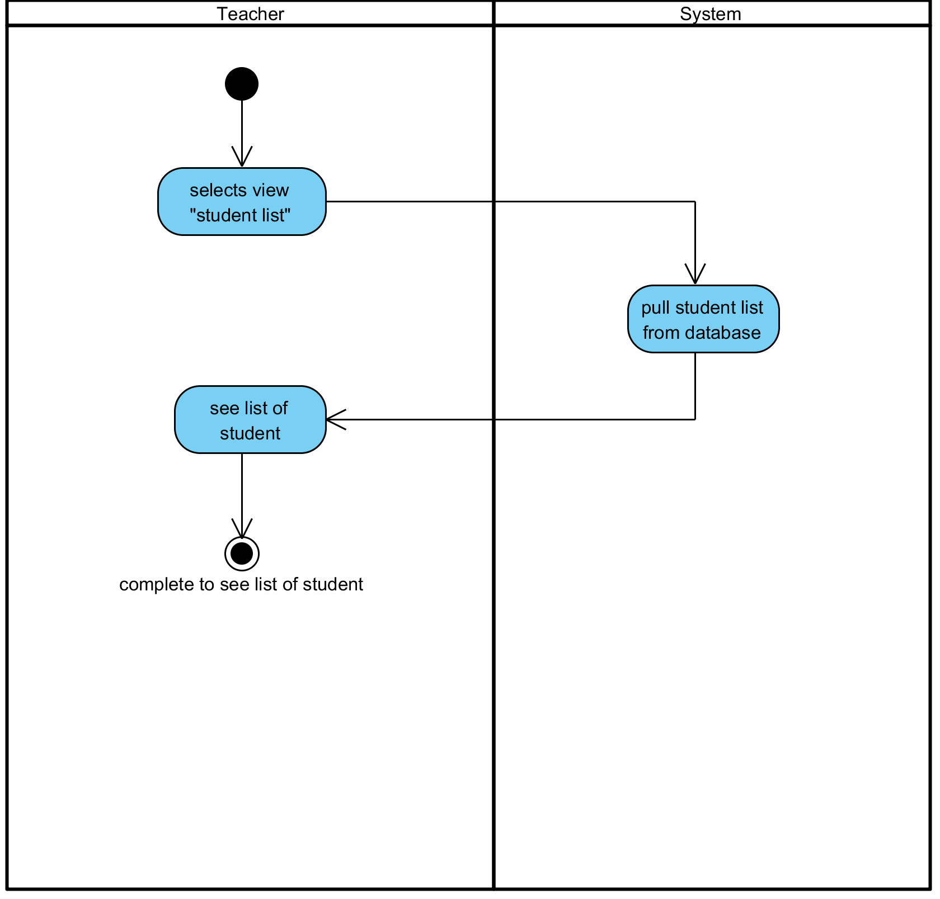

**Figure 12: See a list of Students**

**Output:** Teacher has been seen the list of Students on own device.

**System Requirements Specifications:**

* **SRS9-9.1:** The system shall validation student list in database
* **SRS9-9.1:** The system shall display interface list of student of that class.

**3.10 UC010: Check attendance**

|  |  |  |  |  |
| --- | --- | --- | --- | --- |
| **Use Case ID:** | UC-0010 | | | |
| **Use Case Name:** | Check attendance | | | |
| **Created By:** | Pichet Potha  Sittipong Borripan | | **Last Updated By:** |  |
| **Date Created:** | 12/5/2014 | | **Last Revision Date:** |  |
| **Actors:** | | Teacher | | |
| **Description:** | | This use case describe how teacher check attendance by student list. | | |
| **Trigger:** | | Teacher selects “view student list” button in profile page. | | |
| **Pre-conditions:** | | 1. Teacher already logged in to the system on own device. | | |
| **Post-conditions:** | | 1. Teacher complete check attendance. | | |
| **Normal Flow:** | | 1. Teacher selects “view student list” button in profile page.  2. The system shall validation student list in database.  3. The system shall display interface list of available student who connected of that class.  4. Teacher selects “check attendance” button in student list page.  5. Teacher complete check attendance. | | |
| **Alternative Flows:** | | n/a | | |
| **Exceptions:** | | 1a. In the step 1 of the Normal Flow, if no internet connection  1. The system check the internet connection.  2. The system alerts the user that the internet connection does not  exist.  3. Use case ends. | | |
| **Priority::** | | High. | | |

**Use Case:** See a list of Students (UC010)

**URS1-10:** The web application shall allow the Teacher check attendance.

Teacher see a list of Students that attend to the class on own device.

**Input:**

|  |  |  |  |
| --- | --- | --- | --- |
| Input | Description | Constraints | Example |
|  |  |  |  |

**Action:**

**AC-10: Check attendance**

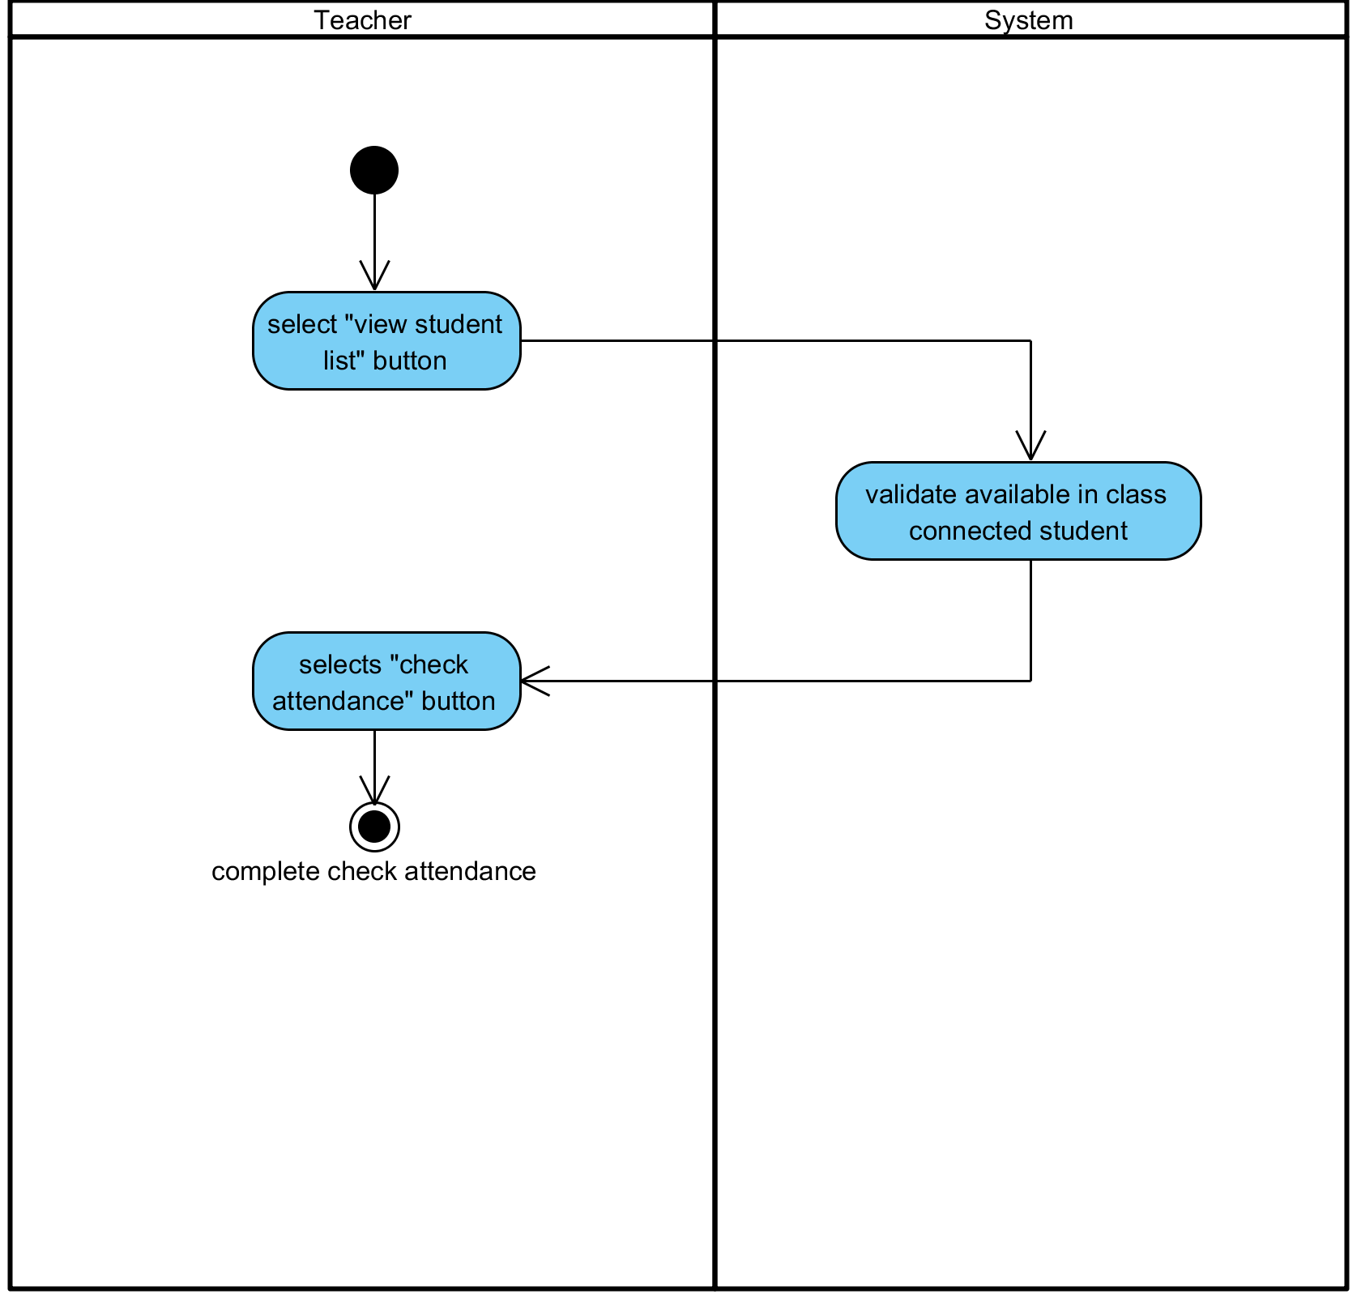

**Figure 13: Check attendance**

**Output:** Teacher has been checked attendance.

**System Requirements Specifications:**

* **SRS10-10.1:** The system shall validation student list in database.
* **SRS10-10.1:** The system shall display interface list of available student who connected of that class.

**Use Case:** Write down in white board (UC011)

**Use Case:** Broadcast own screen to Student (UC012)

**Use Case:** Stop Broadcast own screen to Student (UC013)

**Use Case:** Split own screen (UC014)

**Use Case:** Cancel Split own screen (UC015)

**Use Case:** See the screen of Teacher (UC016)

**Use Case:** Se See the screen of Student (UC017)

**Use Case:** Chat with all Students in real time (UC018)

**Use Case:** Create an alert or warning message (UC019)

**Use Case:** Edit an alert or warning message (UC020)

**Use Case:** Delete an alert or warning message (UC021)

**Use Case:** Send an alert or warning message to Students (UC022)

**Use Case:** Create a quiz interface (UC023)

**Use Case:** Edit a quiz interface (UC024)

**Use Case:** Delete a quiz interface (UC025)

**Use Case:** Send a quiz interface to Students. (UC026)

**Use Case:** Chat with Teacher in real time (UC027)

**Use Case:** Receive alert or warning message from Teacher (UC028)

**Use Case:** Receive quiz interface from Teacher (UC029)

**Use Case:** Do the quiz (UC030)

**Use Case:** Submit the quiz to Teacher (UC031)