**Easy Class**

Software Requirement Specification

By

|  |  |
| --- | --- |
| **Pichet Potha** | **542115041** |
| **Sittipong Borripan** | **542115066** |

Department of Software Engineering

College of Arts, Media and Technology

Chiang Mai University

Project Adviser

______________________________

Ms. Yun Rim Park

**Table of contents**

**Revision History………………………………………………………………………...…………………1**

**Introduction……………………...……………………….………………………......………………........2**

**Document Purpose………………………………………………...……………………………...2**

**Project Scope……………………………………………………………………………………...2**

**User Characteristics……………………………………………………………………………...2**

**Operation Environment………………………………………………………………………….2**

**Acronyms and Definition…………....………………………………………………….…………………3**

**Overall Description……………………………………...……………………………….…………….….3**

**Product Perspective………………………………………………………………………………..**

**Product Functions………………………………………………………………………………….**

**Requirement Specification……………………………………………………….…………..…….……..3**

**User Requirements ………………………….…………………………...…...…………...……...3**

**Software Requirements Specification ……………….….…………..…………...………….…...5**

**Use case Diagram ……………….…………………………………..………………...………......8**

**Use Case Description.…………………………………………………………………………11**

**Activity Diagram….………….………………………………….……..……………...………...42**

**Revision History**

|  |  |  |  |  |  |  |  |  |
| --- | --- | --- | --- | --- | --- | --- | --- | --- |
| **Document Name** | **Version** | | **Status** | | **Date** | **Viewable** | **Reviewer** | **Responsible** |
| Easy_Class_Software_Requirement_Specification_Version0.1 | Add | * Introduction * Acronyms and Definition * Overall Description * Requirement Specification | | Draft | 24/05/2014 | PP,SB,YP | PP,SB | PP,SB |
| Easy_Class_Software_Requirement_Specification_Version0.2 |  | * Change the document form * Chapter I: Introduction * Document Purpose * Project Scope * User Characteristics * Operation Environment * Acronyms and Definition * Chapter II: Chapter II: Specific Requirement * Use Case Scenarios * Chapter III: Software Requirement Specification * Add more detail in Characteristics. | | Draft | 30/05/2014 | PP,SB,YP | PP,SB | PP,SB |
| Easy_Class_Software_Requirement_Specification_Version0.3 |  | * Add more detail in Chapter III: Software Requirement Specification | | Draft | 30/05/2014 | PP,SB,YP | PP,SB | PP,SB |

**Chapter I: Introduction**

**1.1 Document Purpose**

The purpose of software requirements specification (SRS) document is to provide the detailed description of the functionalities of Easy Class system. This document was gathering the requirement that relate with user to use in this system. The requirements will be sorted out to each type (URS, SRS, etc.). This document will be used with design the system in the design document and implement the system.

**1.2 Project Scope**

Easy Class is the real time web application that run on the web browser. It will help the teacher to create the class activities to do with students in the class. Teacher and student will registered by administrator. Teacher and student will do the class activity by using Easy Class. Teacher is a people who control the class to make the student pay attention and enjoin with the class by this system.

**1.3 User Characteristics**

Easy Class is the web application which help teacher can design and create own class activities to make the class smarter. It can help teachers and students enjoin with the class activity to get more fun and knowledge. Then the meanings of all characters are:

**Administrator**: Administrator is the people who manage the class and user requirement.

**Teacher**: Teacher is the people who teaching and control the class.

**Student**: Student is the learner that attend and use the device in class under teacher’s control.

**1.4 Operation Environment**

Easy Class is the web application that run on web browser, so all of character need the internet connection to run this system. Easy Class is implemented by using HTML5, user must use the web browser that support HTML5 to run the system.

**1.5 Acronyms and Definition**

|  |  |
| --- | --- |
| Acronyms | Explanation |
| SRS | Software Requirement Specification |
| URS | User Requirement Specification |
| Users | Administrator, Teacher, Student |
| User | Teacher, Student |
| Definition | **Explanation** |
| Use case | The scenario to describe overall system, relation with users and sub  System. |
| Requirement Specification | Document to specify requirement from customer or users. It can describe relation between user and system. And it can describe what developer will develop. |

**Chapter II: Specific Requirement**

**2.1 Use Case Scenarios**

**Administrator Use Case**

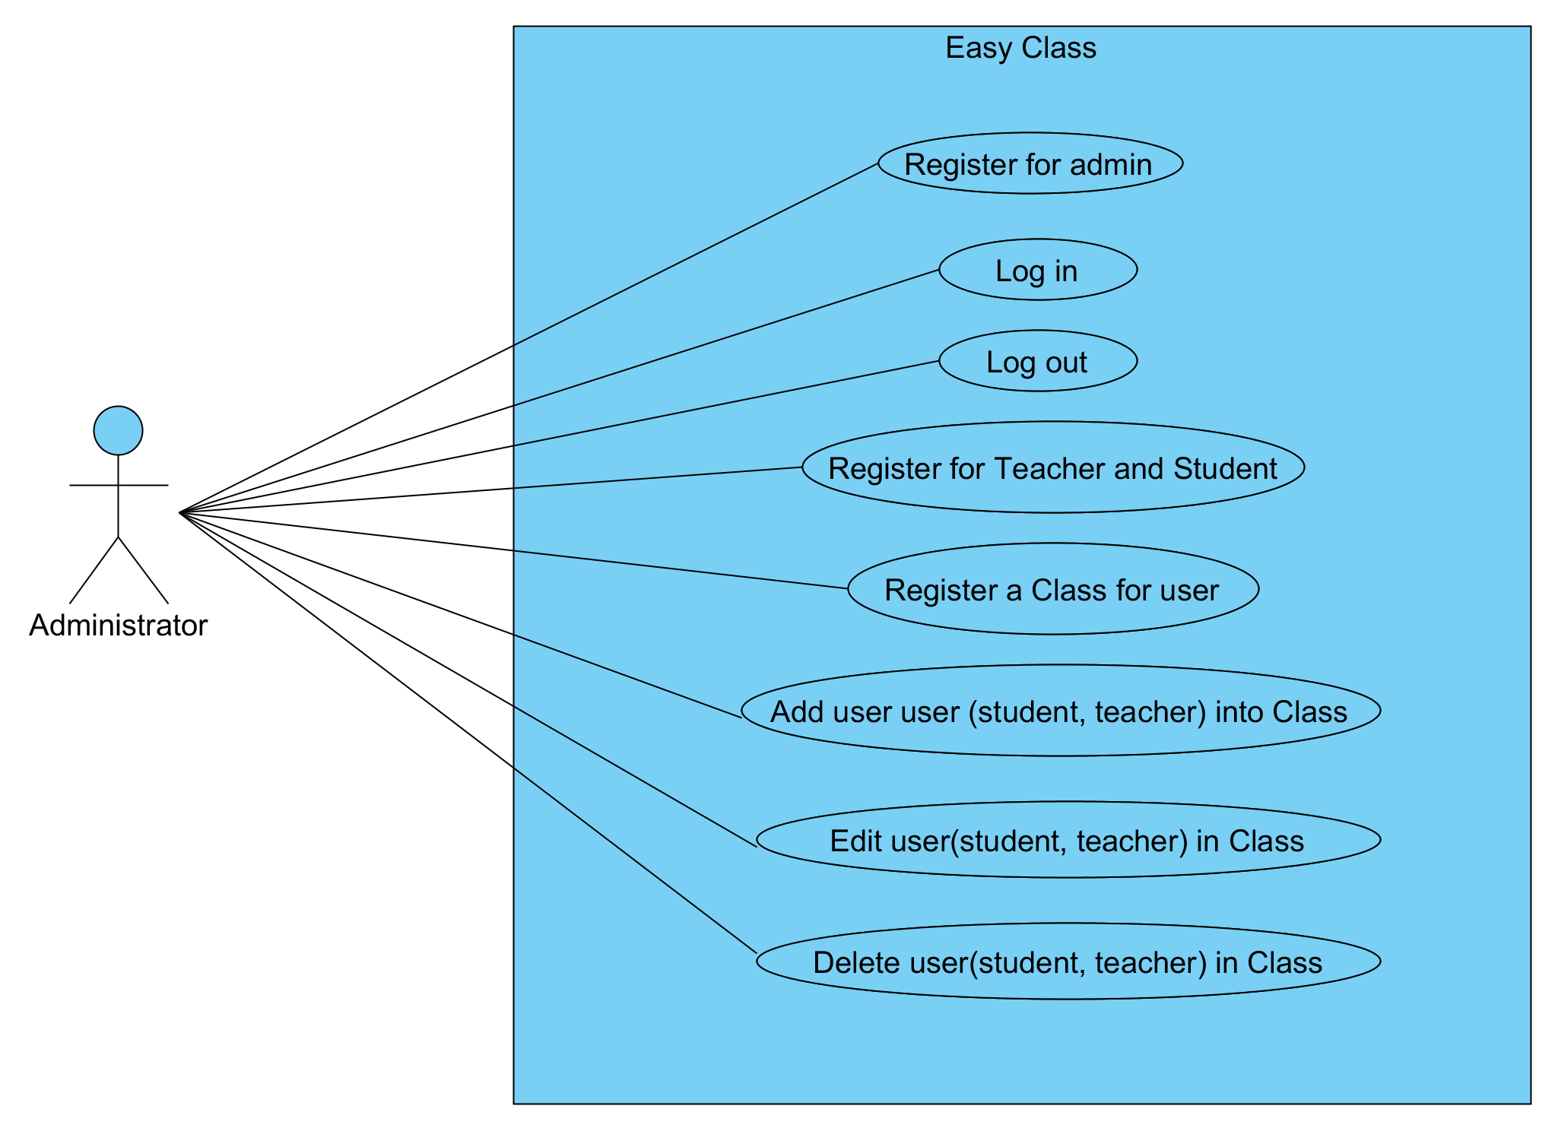

Figure 1: Use case for Administrator

**Teacher Use Case**

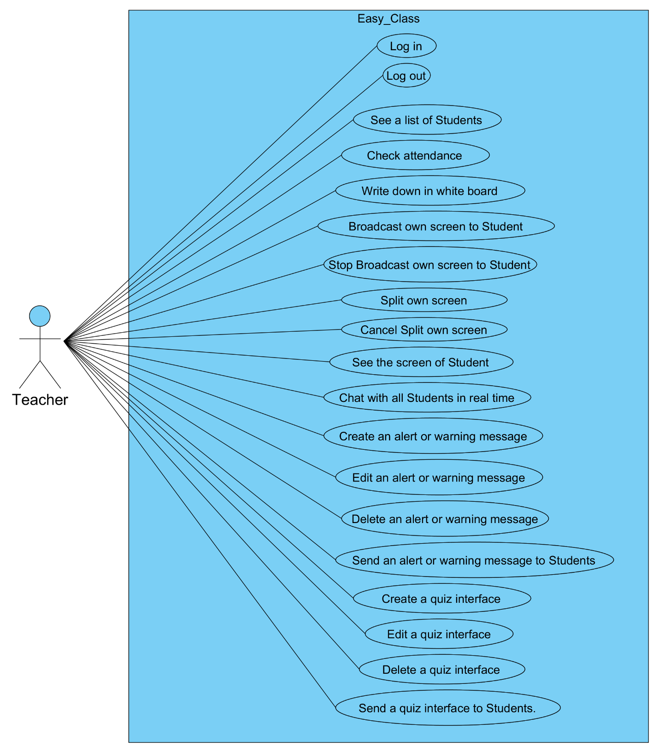

Figure 2: Use case for Teacher

**Student**

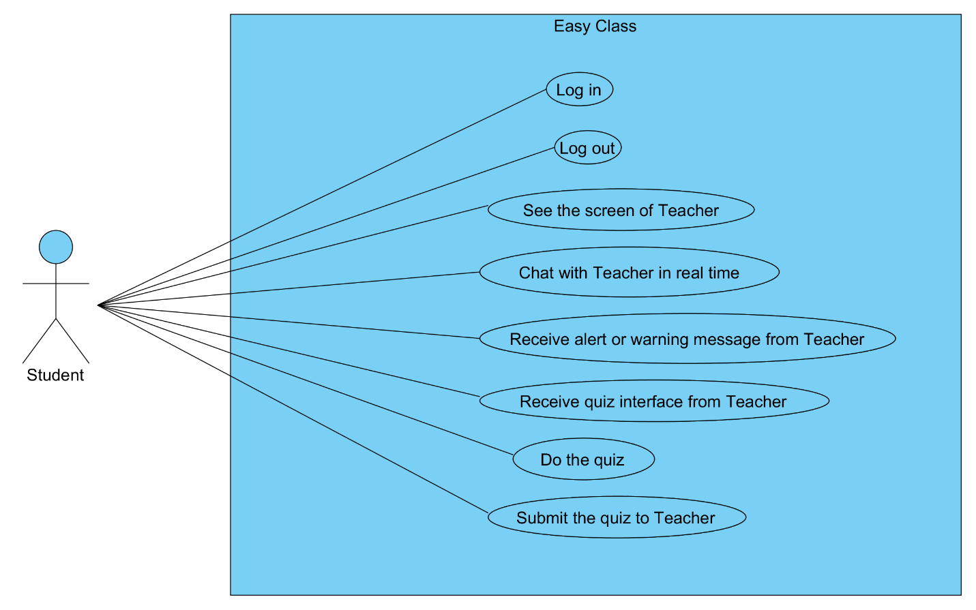

Figure 3: Use case for Student

**Chapter III: Software Requirement Specification**

**3.1 UC001: Register for Administrator**

|  |  |  |  |  |
| --- | --- | --- | --- | --- |
| **Use Case ID:** | UC-001 | | | |
| **Use Case Name:** | Register for Administrator | | | |
| **Created By:** | Pichet Potha  Sittipong Borripan | | **Last Updated By:** |  |
| **Date Created:** | 12/5/2014 | | **Last Revision Date:** |  |
| **Actors:** | | Administrator | | |
| **Description:** | | This use case describe how to register Administrator to easy class web application. | | |
| **Trigger:** | | The system display interface to receive username and password | | |
| **Pre-conditions:** | | 1. Administrator has not logged into easy class web application.  2. Administrator stay on “Administrator sign up” page. | | |
| **Post-conditions:** | | 1. Administrator be able to login to easy class web application with he/she account and stay on “administrator profile” page. | | |
| **Normal Flow:** | | 1. The system shall interface to receive username and  password.  2. Administrator enter he/she username and password  3. Administrator selects “sing up” on he/she screen.  4. The system shall validation username.  5. The system shall save information into database  6. Administrator be able to login to easy class web application with he/she account and stay on “administrator profile” page. | | |
| **Alternative Flows:** | | 5a. In the step of 5 of Normal Flow, if Administrator input wrong type of username  1. System display warning message.  2. Go back to step 3 in Normal Flow again. | | |
| **Exceptions:** | | 4b. In the step 4 of the Normal Flow, if no internet connection  1. The system check the internet connection. 2. The system alerts the user that the internet connection does not exist. 3. Use case ends. | | |
| **Priority::** | | High. | | |

**Use Case:** Register for Administrator (UC001)

**URS1-01:** The web application shall allow the Administrator register to the system.

**Input:**

|  |  |  |  |
| --- | --- | --- | --- |
| Input | Description | Constraints | Example |
| Username | The name for Administrator use to log in to the system | In the username must contain ‘@’ and ‘.’ | Easy_Class@camt.com |
| Password | The character that Administrator use for user authentication to prove identity or access approval to gain access to a resource | Allow any special character to use in password. | Easy@Class01 |

**Action:**

**AC-01: Register for Administrator**

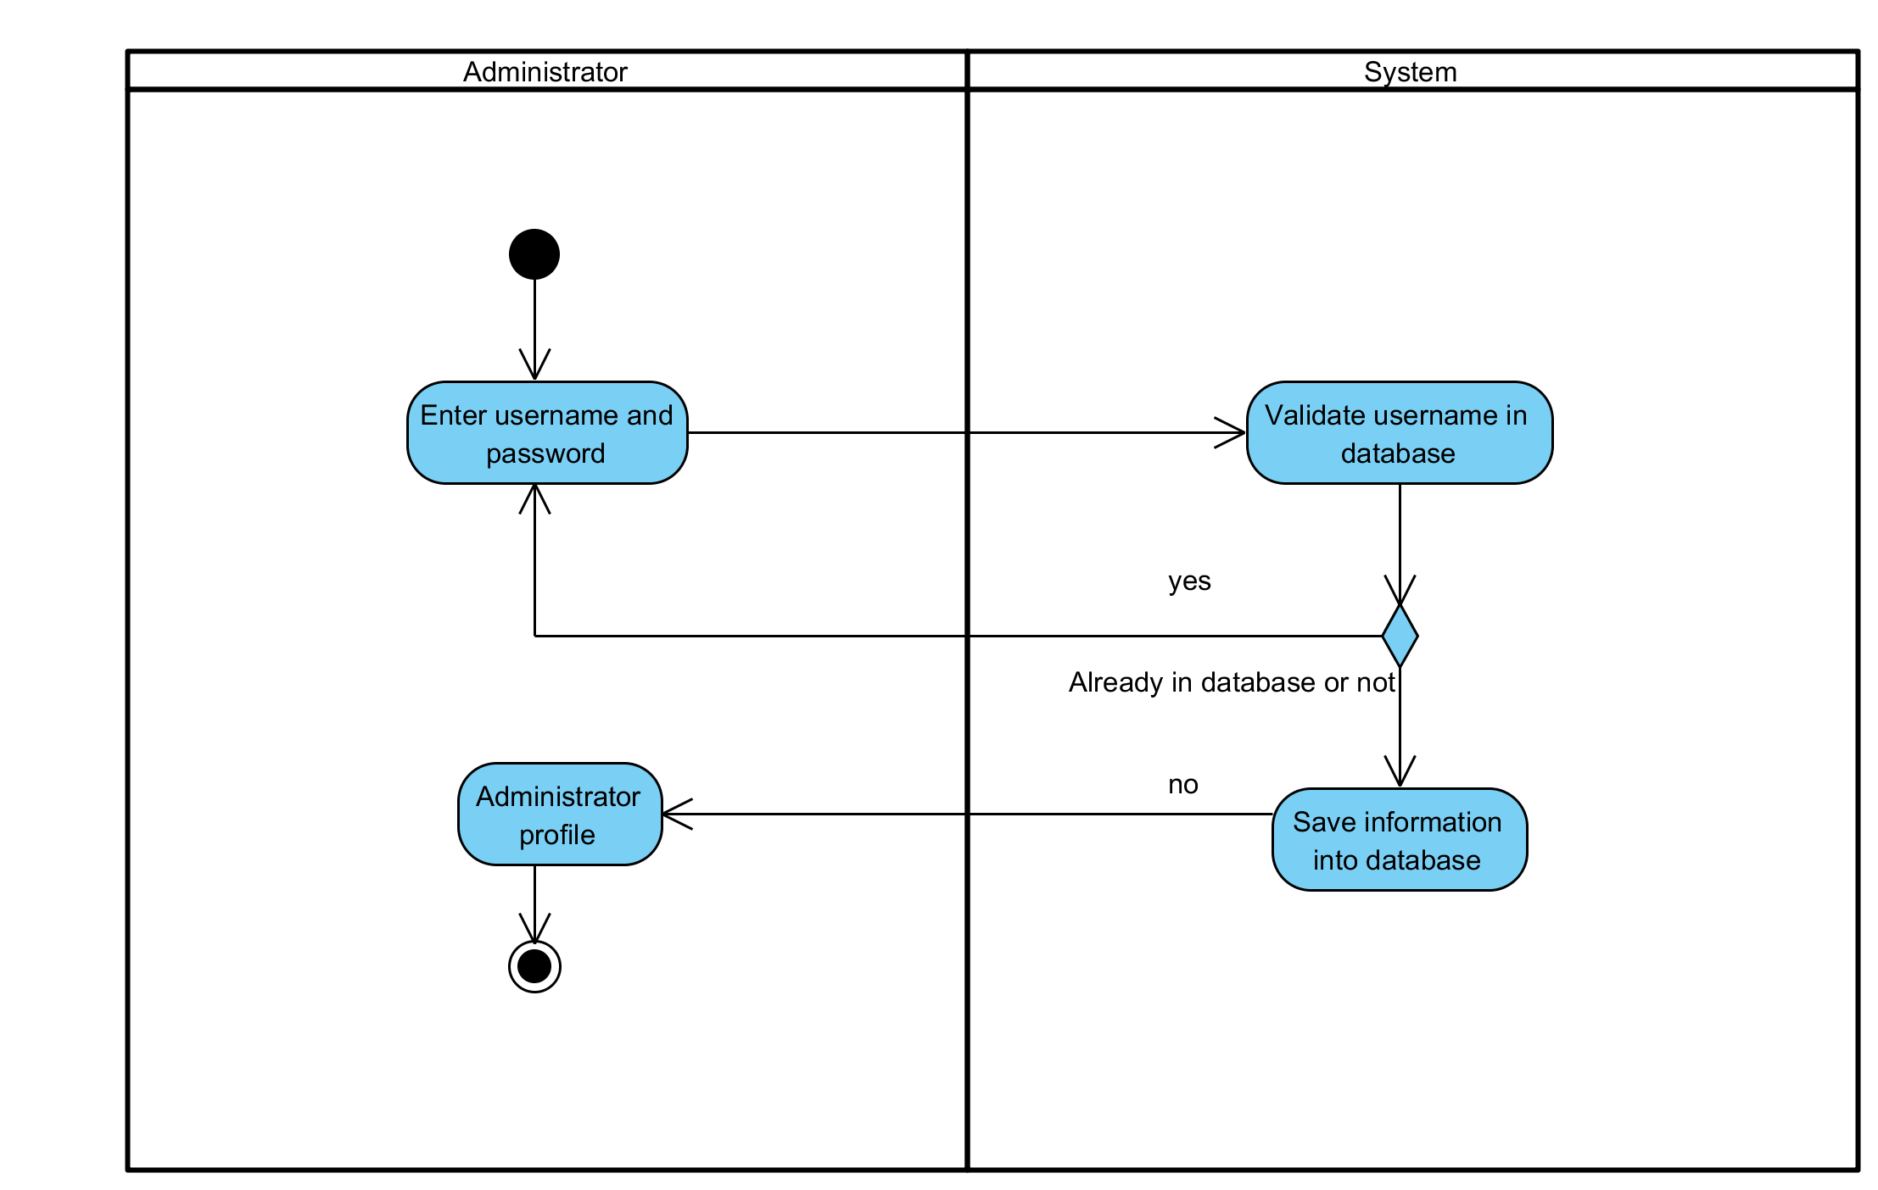

**Figure 4: Register for Administrator**

**Output:** Username and password has been saved in the database.

**System Requirements Specifications:**

* **SRS1-1.1:** The system shall interface to receive username and password.
* **SRS1-1.2:** The system shall validation username.
* **SRS1-1.3:** The system shall save information into database

**3.2 UC002: Log in**

|  |  |  |  |  |
| --- | --- | --- | --- | --- |
| **Use Case ID:** | UC-002 | | | |
| **Use Case Name:** | Log in | | | |
| **Created By:** | Pichet Potha  Sittipong Borripan | | **Last Updated By:** |  |
| **Date Created:** | 12/5/2014 | | **Last Revision Date:** |  |
| **Actors:** | | Administrator, Teacher, Student | | |
| **Description:** | | This use case describe how users log in to system. | | |
| **Trigger:** | | Users selects “log in” button on the screen. | | |
| **Pre-conditions:** | | 1. Users has not already logged in to the system.  2. Users has already registered to system and have an account.  3. Users stay on index page. | | |
| **Post-conditions:** | | 1. The system shall display users profile and feature menu. (The result depend on type of user) and be able to use system feature. | | |
| **Normal Flow:** | | 1. User selects appropriate log in type to their own account and selects “log in” button on the screen.  2. The system shall display interface for users to log in.  3. Users enter he/she username and password.  4. Users select “log in” button.  5. The system validation username and password.  6. The system shall display users profile and feature menu. | | |
| **Alternative Flows:** | | 5a. In step 5 of the Normal Flow, if username and password of users has not correct type or not available in database  1. Go back to step 3 of Normal Flow | | |
| **Exceptions:** | | 2b. In the step 2 of the Normal Flow, if no internet connection  1. The system check the internet connection.  2. The system alerts the user that the internet connection does not  exist.  3. Use case ends. | | |
| **Priority::** | | High. | | |

**Use Case:** Log in (UC002)

**URS1-02:** The web application shall allow the User (Student, Teacher, and Administrator) log in to the system.

Users in put username and password to log in to use the Easy Class system.

**Input:**

|  |  |  |  |
| --- | --- | --- | --- |
| Input | Description | Constraints | Example |
| Username | The name for Administrator use to log in to the system | In the username must contain ‘@’ and ‘.’ | Easy_Class@camt.com |
| Password | The character that Administrator use for user authentication to prove identity or access approval to gain access to a resource | Allow any special character to use in password. | Easy@Class01 |

**Action:**

**AC-02: Log in**

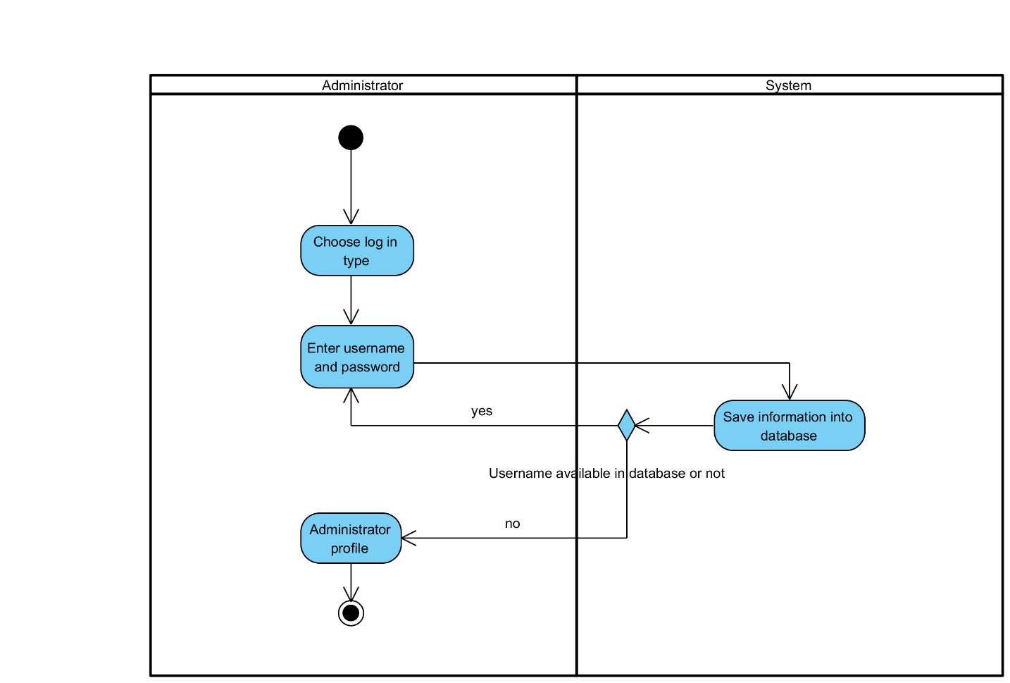

**Figure 5: Log in**

**Output:** Users have been logged in to the system.

**System Requirements Specifications:**

* **SRS2-2.1:** The system shall display interface for users to log in.
* **SRS2-2.2:** The system validation username and password.
* **SRS2-2.3:** The system shall display users profile and feature menu.

**3.3 UC003: Log out**

|  |  |  |  |  |
| --- | --- | --- | --- | --- |
| **Use Case ID:** | UC-003 | | | |
| **Use Case Name:** | Log out | | | |
| **Created By:** | Pichet Potha  Sittipong Borripan | | **Last Updated By:** |  |
| **Date Created:** | 12/5/2014 | | **Last Revision Date:** |  |
| **Actors:** | | Administrator, Teacher, Student | | |
| **Description:** | | This use case describe how users log out to system. | | |
| **Trigger:** | | Users selects “log out” button on the screen. | | |
| **Pre-conditions:** | | 1. Users has already logged in to the system on own device.  2. Users stay on “profile page”. | | |
| **Post-conditions:** | | 1. Users stay on index page and already log out. | | |
| **Normal Flow:** | | 1. Users selects “log out” button on the screen.  2. The system shall disconnect session of that user.  3. Users stay on index page and already log out. | | |
| **Alternative Flows:** | | n/a | | |
| **Exceptions:** | | 1a. In the step 1 of the Normal Flow, if no internet connection  1. The system check the internet connection.  2. The system alerts the user that the internet connection does not  exist.  3. Use case ends. | | |
| **Priority::** | | High. | | |

**Use Case:** Log out (UC003)

**URS1-03:** The web application shall allow the User (Student, Teacher, and Administrator) log out from the system.

Users select “log out” button to log out from the system.

**Input:**

n/a

**Action:**

**AC-03: Log out**

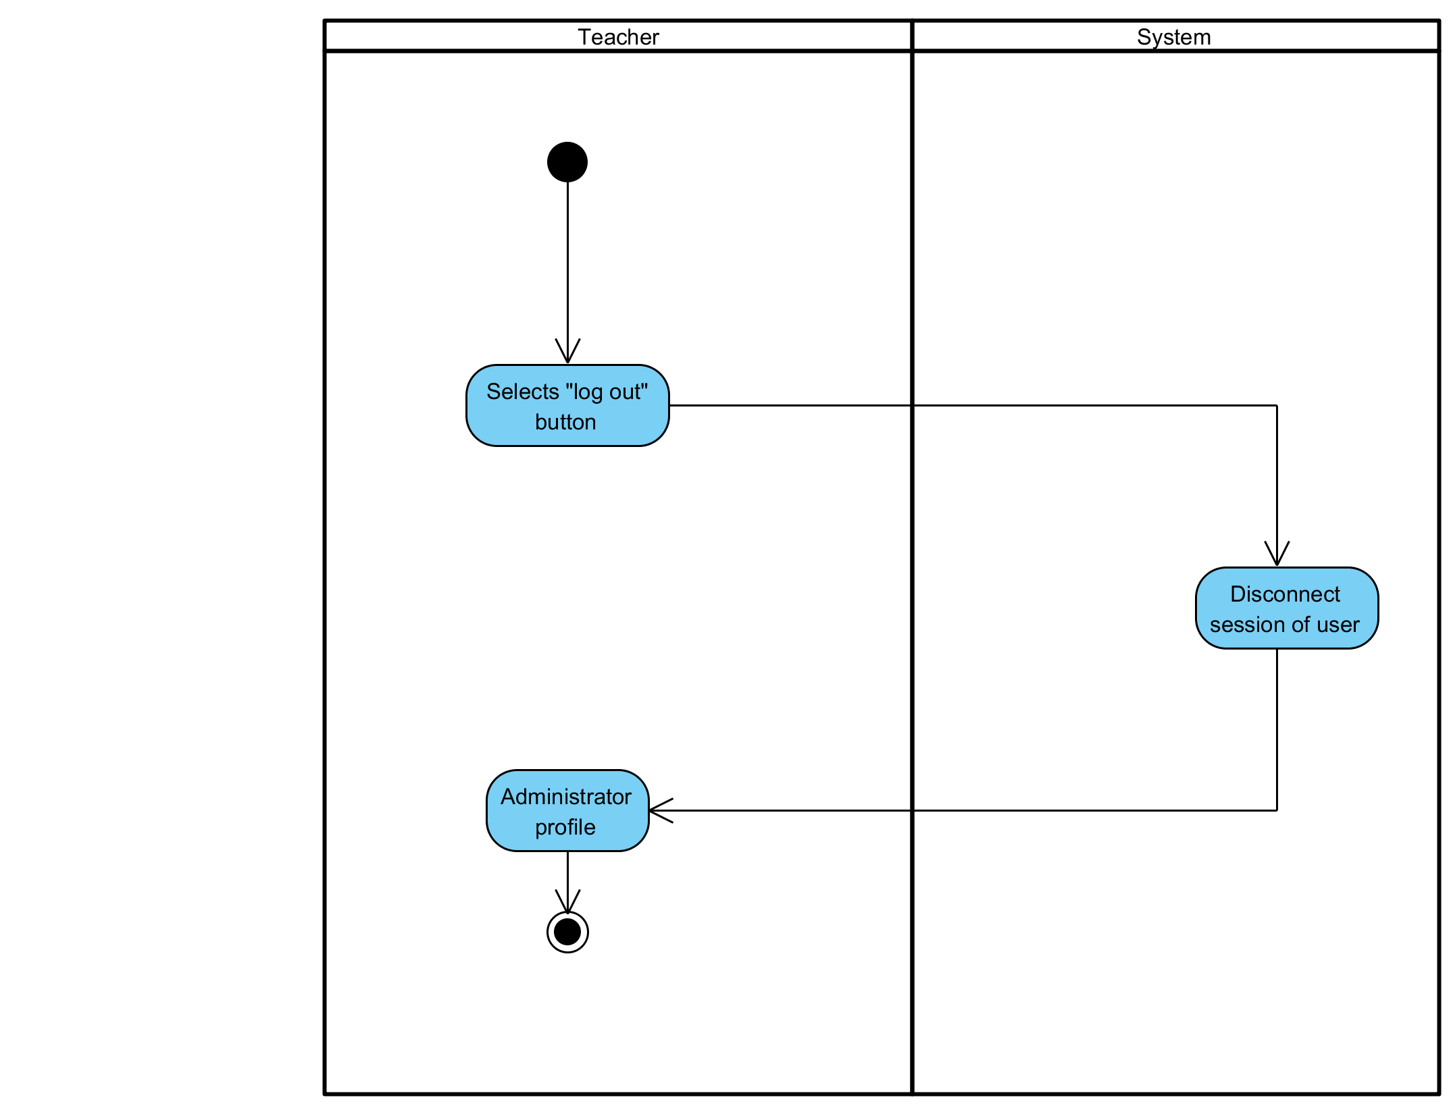

**Figure 6: Log out**

**Output:** Users have been logged out from the system.

**System Requirements Specifications:**

* **SRS3-3.1:** The system shall disconnect session of that user.

**3.4 UC004: Register for Teacher and Student**

|  |  |  |  |  |
| --- | --- | --- | --- | --- |
| **Use Case ID:** | UC-004 | | | |
| **Use Case Name:** | Register for Teacher and Student | | | |
| **Created By:** | Pichet Potha  Sittipong Borripan | | **Last Updated By:** |  |
| **Date Created:** | 12/5/2014 | | **Last Revision Date:** |  |
| **Actors:** | | Administrator | | |
| **Description:** | | This use case describe how to administrator register teacher and student to system. | | |
| **Trigger:** | | Administrator selects “sign up for user” button. | | |
| **Pre-conditions:** | | 1. Administrator already logged in to the system on own device.  2. Administrator stay on profile page. | | |
| **Post-conditions:** | | 1. Administrator complete to register for teacher and student. | | |
| **Normal Flow:** | | 1. Administrator selects “sign up for user” button.  2. The system shall display interface for receive information.  3. Administrator enter information and selects “submit” button.  4. The system shall validation information and save into database.  5. Administrator stay on  6. Administrator complete to register for teacher and student. | | |
| **Alternative Flows:** | | 5a. In the step 5 of Normal Flow, if username type is not correct and it already in database  1. Go back to step 4 again | | |
| **Exceptions:** | | 5b. In the step 3 of the Normal Flow, if no internet connection  1. The system check the internet connection.  2. The system alerts the user that the internet connection does not  exist.  3. Use case ends. | | |
| **Priority::** | | High. | | |

**Use Case:** Register for Teacher and Student (UC004)

**URS1-04:** The web application shall allow the Administrator register for Teacher and Student.

Administrator input user information to register for Teacher and Student.

**Input:**

|  |  |  |  |
| --- | --- | --- | --- |
| Input | Description | Constraints | Example |
| Username | The name for Administrator use to log in to the system | In the username must contain ‘@’ and ‘.’ | Easy_Class@camt.com |
| Password | The character that Administrator use for user authentication to prove identity or access approval to gain access to a resource | Allow any special character to use in password. | Easy@Class01 |
| Name | The real name of user. It consist of first name and surname. | Not allow to use special character. | Pichet Potha  Sittipong Borripan |

**Action:**

**AC-04: Register for Teacher and Student**

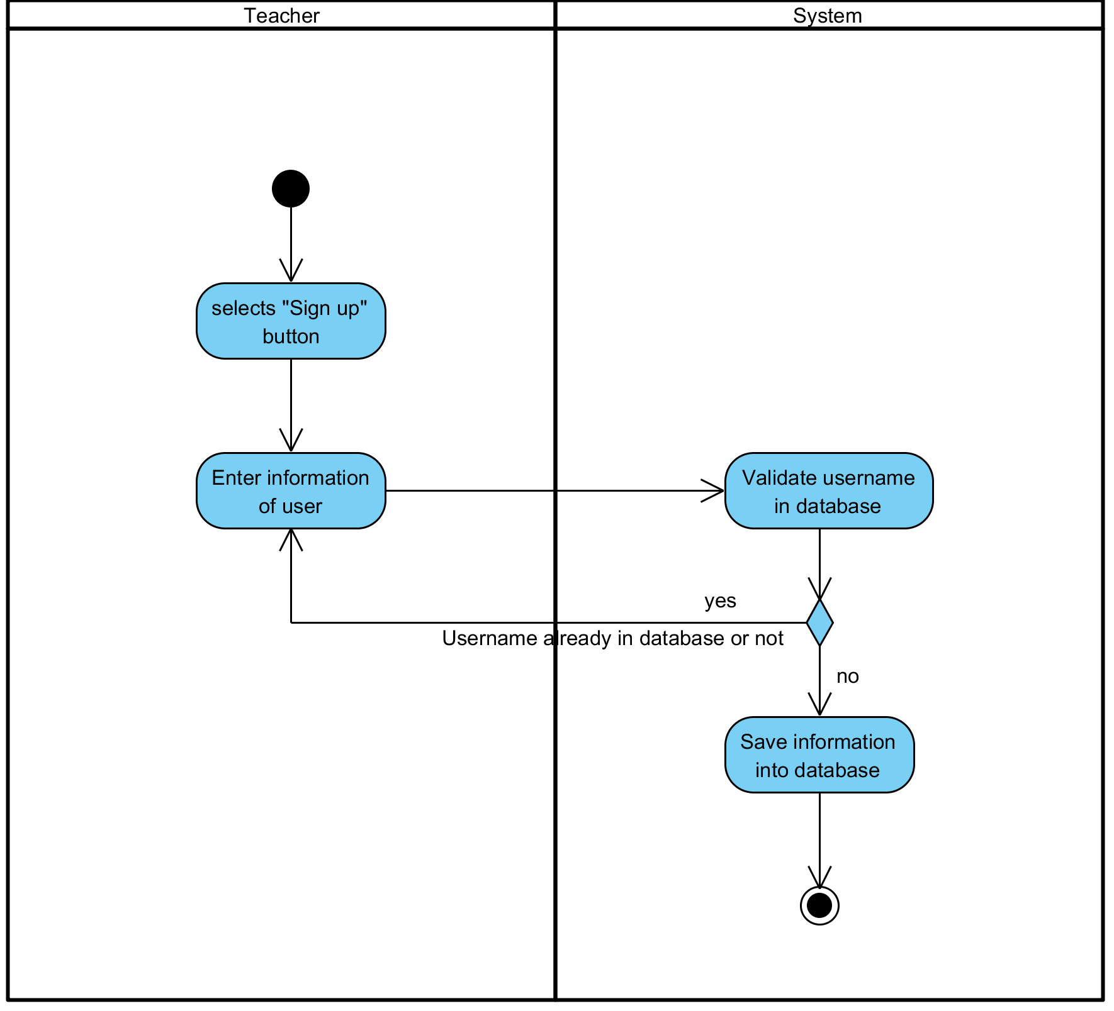

**Figure 7: Register for Teacher and Student**

**Output:** User information have been saved in the database.

**System Requirements Specifications:**

* **SRS4-4.1:** The system shall display interface for receive information.
* **SRS4-4.2:** The system shall validation information and save into database.

**3.5 UC005: Register a class for user**

|  |  |  |  |  |
| --- | --- | --- | --- | --- |
| **Use Case ID:** | UC-005 | | | |
| **Use Case Name:** | Register a class for user | | | |
| **Created By:** | Pichet Potha  Sittipong Borripan | | **Last Updated By:** |  |
| **Date Created:** | 12/5/2014 | | **Last Revision Date:** |  |
| **Actors:** | | Administrator | | |
| **Description:** | | This use case describe how administrator register a class for user. | | |
| **Trigger:** | | Administrator selects “create class” button on the screen on administrator page. | | |
| **Pre-conditions:** | | 1. Administrator already logged in to the system on own device.  2. Administrator stay on administrator profile. | | |
| **Post-conditions:** | | 1. Administrator complete register a class to database. | | |
| **Normal Flow:** | | 1. Administrator selects “create class” button on profile page.  2. The system shall display interface to receive class name.  3. Administrator enter class name and selects “create class” button.  4. The system shall save that register class into database  5. Administrator return to profile page and selects “manage class” button.  6. The system shall display class list interface with that registered class.  7. Administrator complete register a class to database. | | |
| **Alternative Flows:** | | 4a. In the step 4 of the Normal Flow, if class already in database  1. Go back to step 3 in Normal Flow. | | |
| **Exceptions:** | | 1b. In the step 1 of the Normal Flow, if no internet connection  1. The system check the internet connection.  2. The system alerts the user that the internet connection does not  exist.  3. Use case ends. | | |
| **Priority::** | | High. | | |

**Use Case:** Register a class for user (UC005)

**URS1-05:** The web application shall allow the Administrator register a class for user.

Administrator create the class for add user to use it.

**Input:**

|  |  |  |  |
| --- | --- | --- | --- |
| Input | Description | Constraints | Example |
| Class name | The name of the class. | Allow any special character to use in class name. | SE212  Grade 9-12 |

**Action:**

**AC-05: Register a class for user**

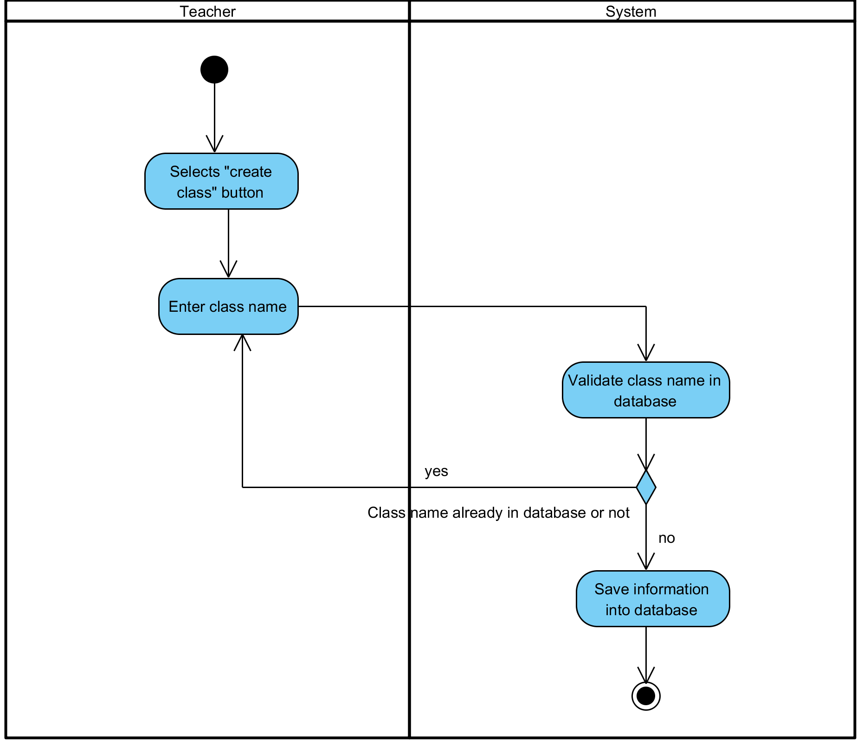

**Figure 8: Register a class for user**

**Output:** Class has been created.

**System Requirements Specifications:**

* **SRS5-5.1:** The system shall display interface to receive class name.
* **SRS5-5.2:** The system shall save that register class into database
* **SRS5-5.3:** The system shall display class list interface with that registered class.

**3.6 UC006: Register a class for user**

|  |  |  |  |  |
| --- | --- | --- | --- | --- |
| **Use Case ID:** | UC-006 | | | |
| **Use Case Name:** | Add user (student, teacher) into Class | | | |
| **Created By:** | Pichet Potha  Sittipong Borripan | | **Last Updated By:** |  |
| **Date Created:** | 12/5/2014 | | **Last Revision Date:** |  |
| **Actors:** | | Administrator | | |
| **Description:** | | This use case describe how administrator add user into class. | | |
| **Trigger:** | | Administrator selects “manage class” button. | | |
| **Pre-conditions:** | | 1. Administrator already logged in to the system on own device.  2. Class for add user already created in database.  3. Administrator stay on administrator page. | | |
| **Post-conditions:** | | 1. Administrator complete to add user into class. | | |
| **Normal Flow:** | | 1. Administrator selects “manage class” button.  2. The system shall pull class information in database to display interface list of “class”.  3. Administrator selects the class that already created.  4. The system shall display interface for administrator to add teacher, student to class and class information.  5. Administrator enter information of teacher, student and selects “submit” button.  6. The system shall validation class information and save it on database.  7. Administrator complete to add user into class. | | |
| **Alternative Flows:** | | 5a. In the step 5 if user already in that class selected  1. Go back to step 4 in Normal Flow. | | |
| **Exceptions:** | | 1a. In the step 1 of the Normal Flow, if no internet connection  1. The system check the internet connection.  2. The system alerts the user that the internet connection does not  exist.  3. Use case ends. | | |
| **Priority::** | | High. | | |

**Use Case:** Add user (student, teacher) into Class (UC006)

**URS1-06:** The web application shall allow the Administrator add user (Student, Teacher) into Class.

Administrator add user into the class to make the user can start using class.

**Input:**

n/a

**Action:**

**AC-06: Add user (student, teacher) into Class**

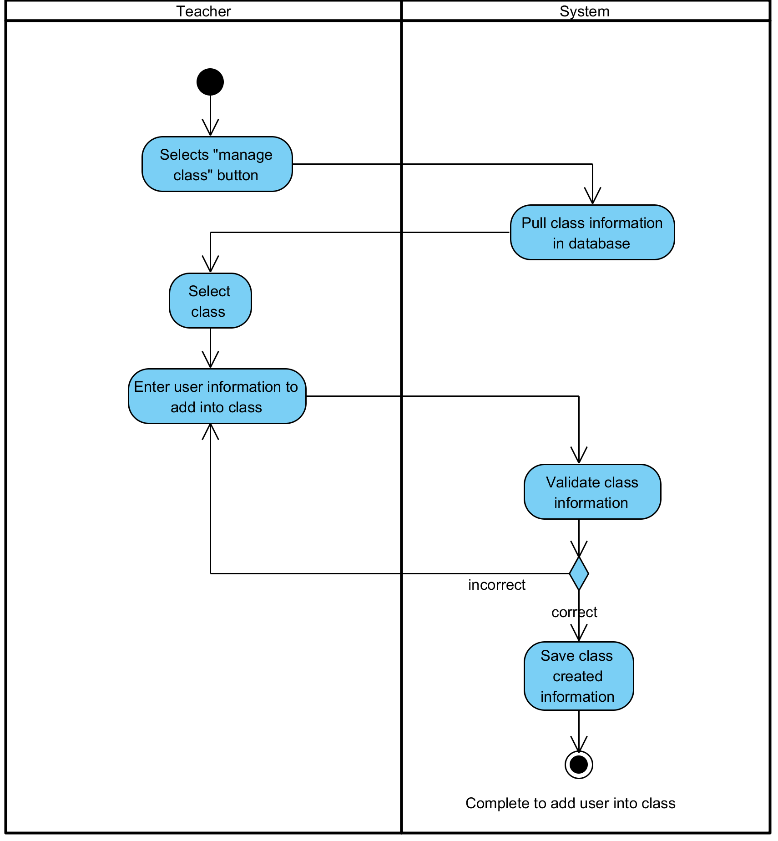

**Figure 9: Add user (student, teacher) into Class**

**Output:** User has been added to the class.

**System Requirements Specifications:**

* **SRS5-5.1:** The system shall display interface to receive class name.
* **SRS5-5.2:** The system shall save that register class into database
* **SRS5-5.3:** The system shall display class list interface with that registered class.

**3.7 UC007: Edit user in Class**

|  |  |  |  |  |
| --- | --- | --- | --- | --- |
| **Use Case ID:** | UC-007 | | | |
| **Use Case Name:** | Edit user in Class | | | |
| **Created By:** | Pichet Potha  Sittipong Borripan | | **Last Updated By:** |  |
| **Date Created:** | 12/5/2014 | | **Last Revision Date:** |  |
| **Actors:** | | Administrator | | |
| **Description:** | | This use case describe how administrator edit user in class. | | |
| **Trigger:** | | Administrator selects “manage class” button in profile page. | | |
| **Pre-conditions:** | | 1. Administrator already logged in to the system on own device. | | |
| **Post-conditions:** | | 1. Administrator complete to edit user in class. | | |
| **Normal Flow:** | | 1. Administrator selects “manage class” button in profile page.  2. The system shall pull class list with class information in database.  3. The system shall display interface list of “class”.  4. Administrator selects the class that already created.  5. The system shall display interface for administrator to edit teacher, student in that class.  6. Administrator selects “edit” button behind name of teacher/student in list.  7. The system shall allow administrator edit information.  8. Administrator edit information and selects “edit” button.  9. Administrator complete to edit user in class. | | |
| **Alternative Flows:** | |  | | |
| **Exceptions:** | | 4a. In the step 4 of the Normal Flow, if no internet connection  1. The system check the internet connection.  2. The system alerts the user that the internet connection does not  exist.  3. Use case ends. | | |
| **Priority::** | | High. | | |

**Use Case:** Edit user in Class (UC007)

**URS1-07:** The web application shall allow the Administrator edit user (Student, Teacher) in Class.

Administrator edit user information in the class.

**Input:**

|  |  |  |  |
| --- | --- | --- | --- |
| Input | Description | Constraints | Example |
| Class name | The name of the class. | Allow any special character to use in class name. | SE212  Grade 9-12 |

**Action:**

**AC-07: Edit user in Class**

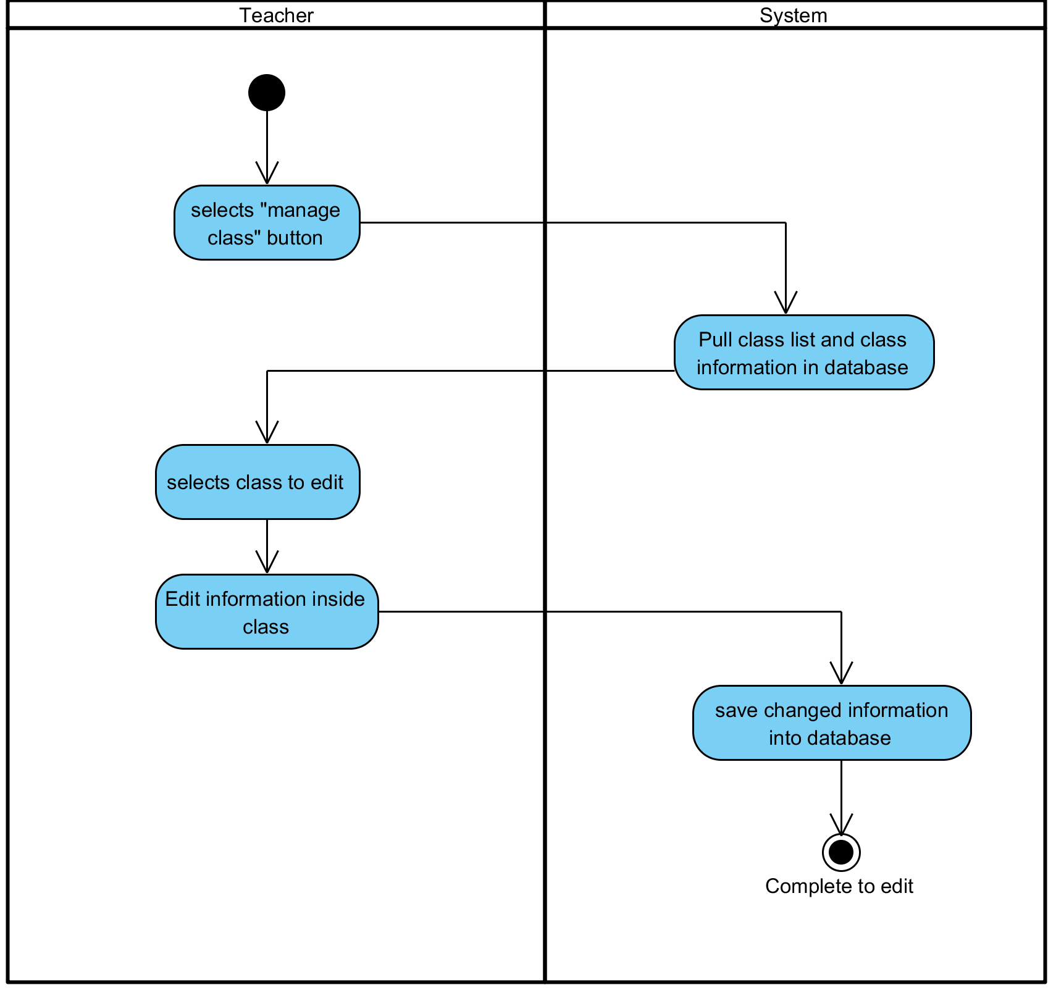

**Figure 10: Edit user in Class**

**Output:** User has been edited and changed.

**System Requirements Specifications:**

* + **SRS7-7.1:** The system shall pull class list with class information in database.
  + **SRS7-7.1:** The system shall display interface list of “class”.
  + **SRS7-7.1:** The system shall display interface for administrator to edit teacher, student in that class.
  + **SRS7-7.1:** The system shall allow administrator edit information

**3.8 UC008: Delete user (student, teacher) in Class**

|  |  |  |  |  |
| --- | --- | --- | --- | --- |
| **Use Case ID:** | UC-008 | | | |
| **Use Case Name:** | Delete user (student, teacher) in Class | | | |
| **Created By:** | Pichet Potha  Sittipong Borripan | | **Last Updated By:** |  |
| **Date Created:** | 12/5/2014 | | **Last Revision Date:** |  |
| **Actors:** | | Administrator | | |
| **Description:** | | This use case describe how administrator delete user in class. | | |
| **Trigger:** | | Administrator selects “manage class” button in profile page. | | |
| **Pre-conditions:** | | 1. Administrator already logged in to the system on own device. | | |
| **Post-conditions:** | | 1. Administrator complete to delete teacher/student in class. | | |
| **Normal Flow:** | | 1. Administrator selects “manage class” button in profile page.  2. The system shall display interface list of “class”  3. Administrator selects the class that already created.  4. The system shall pull information in database to display interface for administrator to edit teacher, student in that class.  5. Administrator selects “delete” button behind name of teacher/student in list.  6. The system save data into database.  7. Administrator edit information and selects “delete” button.  8. Administrator complete to delete teacher/student in class. | | |
| **Alternative Flows:** | |  | | |
| **Exceptions:** | | 1b. In the step 1 of the Normal Flow, if no internet connection  1. The system check the internet connection.  2. The system alerts the user that the internet connection does not  exist.  3. Use case ends. | | |
| **Priority::** | | High. | | |

**Use Case:** Delete user (student, teacher) in Class (UC008)

**URS1-08:** The web application shall allow the Administrator delete user (Student, Teacher) from Class.

Administrator delete user and user information from the class.

**Input:**

N/A

**Action:**

**AC-08: Delete user (student, teacher) in Class**

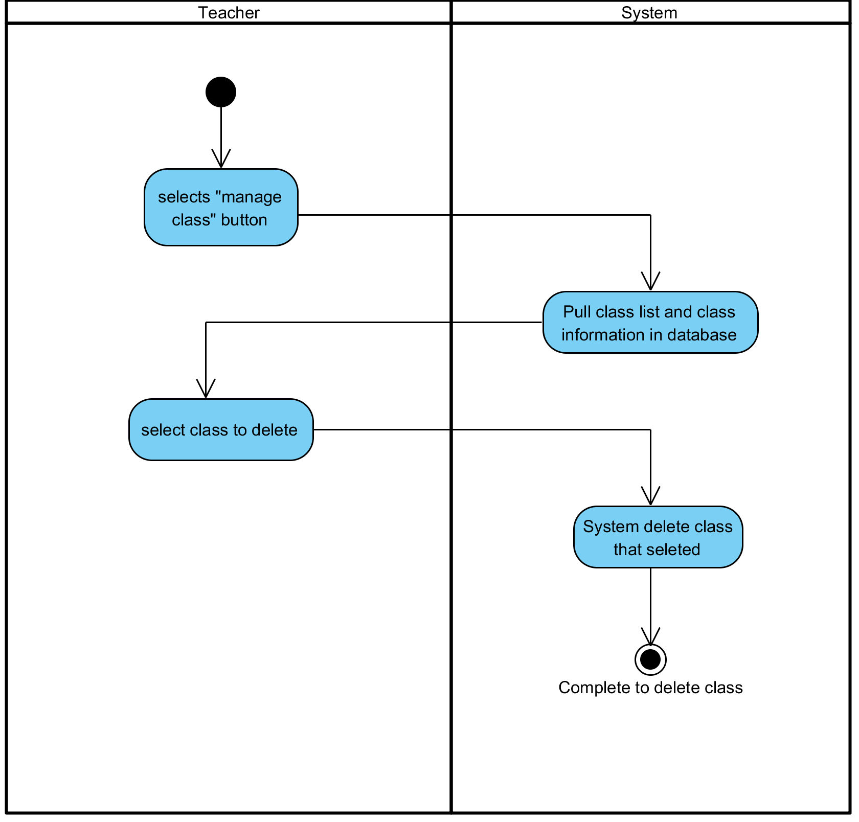

**Figure 11: Delete user (student, teacher) in Class**

**Output:** User has been deleted from the class.

**System Requirements Specifications:**

* **SRS8-8.1:** The system shall display interface list of “class”
* **SRS8-8.1:** The system shall pull information in database to display interface for administrator to edit teacher, student in that class.
* **SRS8-8.1:** The system save data into database.

**3.9 UC009: See a list of Students**

|  |  |  |  |  |
| --- | --- | --- | --- | --- |
| **Use Case ID:** | UC-009 | | | |
| **Use Case Name:** | See a list of Students | | | |
| **Created By:** | Pichet Potha  Sittipong Borripan | | **Last Updated By:** |  |
| **Date Created:** | 12/5/2014 | | **Last Revision Date:** |  |
| **Actors:** | | Teacher | | |
| **Description:** | | This use case describe how teacher see student list of class | | |
| **Trigger:** | | Teacher selects “view student list” button in profile page. | | |
| **Pre-conditions:** | | 1. Teacher already logged in to the system on own device. | | |
| **Post-conditions:** | | 1. Teacher be able to see list of student in class. | | |
| **Normal Flow:** | | 1. Teacher selects “view student list” button in profile page.  2. The system shall validation student list in database  3. The system shall display interface list of student of that class.  4. Teacher be able to see list of student in class. | | |
| **Alternative Flows:** | | n/a | | |
| **Exceptions:** | | 1a. In the step 1 of the Normal Flow, if no internet connection  1. The system check the internet connection.  2. The system alerts the user that the internet connection does not  exist.  3. Use case ends. | | |
| **Priority::** | | High. | | |

**Use Case:** See a list of Students (UC009)

**URS1-09:** The web application shall allow the Teacher see a list of students.

Teacher see a list of Students that attend to the class on own device.

**Input:**

N/A

**Action:**

**AC-09: See a list of Students**

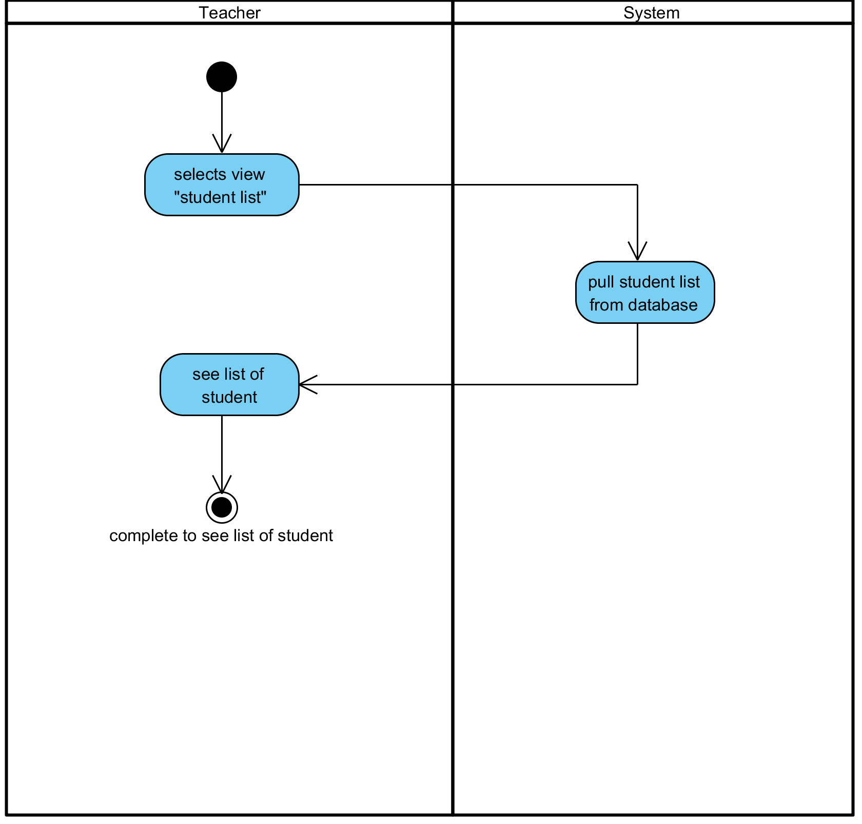

**Figure 12: See a list of Students**

**Output:** Teacher has been seen the list of Students on own device.

**System Requirements Specifications:**

* **SRS9-9.1:** The system shall validation student list in database
* **SRS9-9.1:** The system shall display interface list of student of that class.

**3.10 UC010: Check attendance**

|  |  |  |  |  |
| --- | --- | --- | --- | --- |
| **Use Case ID:** | UC-0010 | | | |
| **Use Case Name:** | Check attendance | | | |
| **Created By:** | Pichet Potha  Sittipong Borripan | | **Last Updated By:** |  |
| **Date Created:** | 12/5/2014 | | **Last Revision Date:** |  |
| **Actors:** | | Teacher | | |
| **Description:** | | This use case describe how teacher check attendance by student list. | | |
| **Trigger:** | | Teacher selects “view student list” button in profile page. | | |
| **Pre-conditions:** | | 1. Teacher already logged in to the system on own device. | | |
| **Post-conditions:** | | 1. Teacher complete check attendance. | | |
| **Normal Flow:** | | 1. Teacher selects “view student list” button in profile page.  2. The system shall validation student list in database.  3. The system shall display interface list of available student who connected of that class.  4. Teacher selects “check attendance” button in student list page.  5. Teacher complete check attendance. | | |
| **Alternative Flows:** | | n/a | | |
| **Exceptions:** | | 1a. In the step 1 of the Normal Flow, if no internet connection  1. The system check the internet connection.  2. The system alerts the user that the internet connection does not  exist.  3. Use case ends. | | |
| **Priority::** | | High. | | |

**Use Case:** See a list of Students (UC010)

**URS1-10:** The web application shall allow the Teacher check attendance.

Teacher see a list of Students that attend to the class on own device.

**Input:**

N/A

**Action:**

**AC-10: Check attendance**

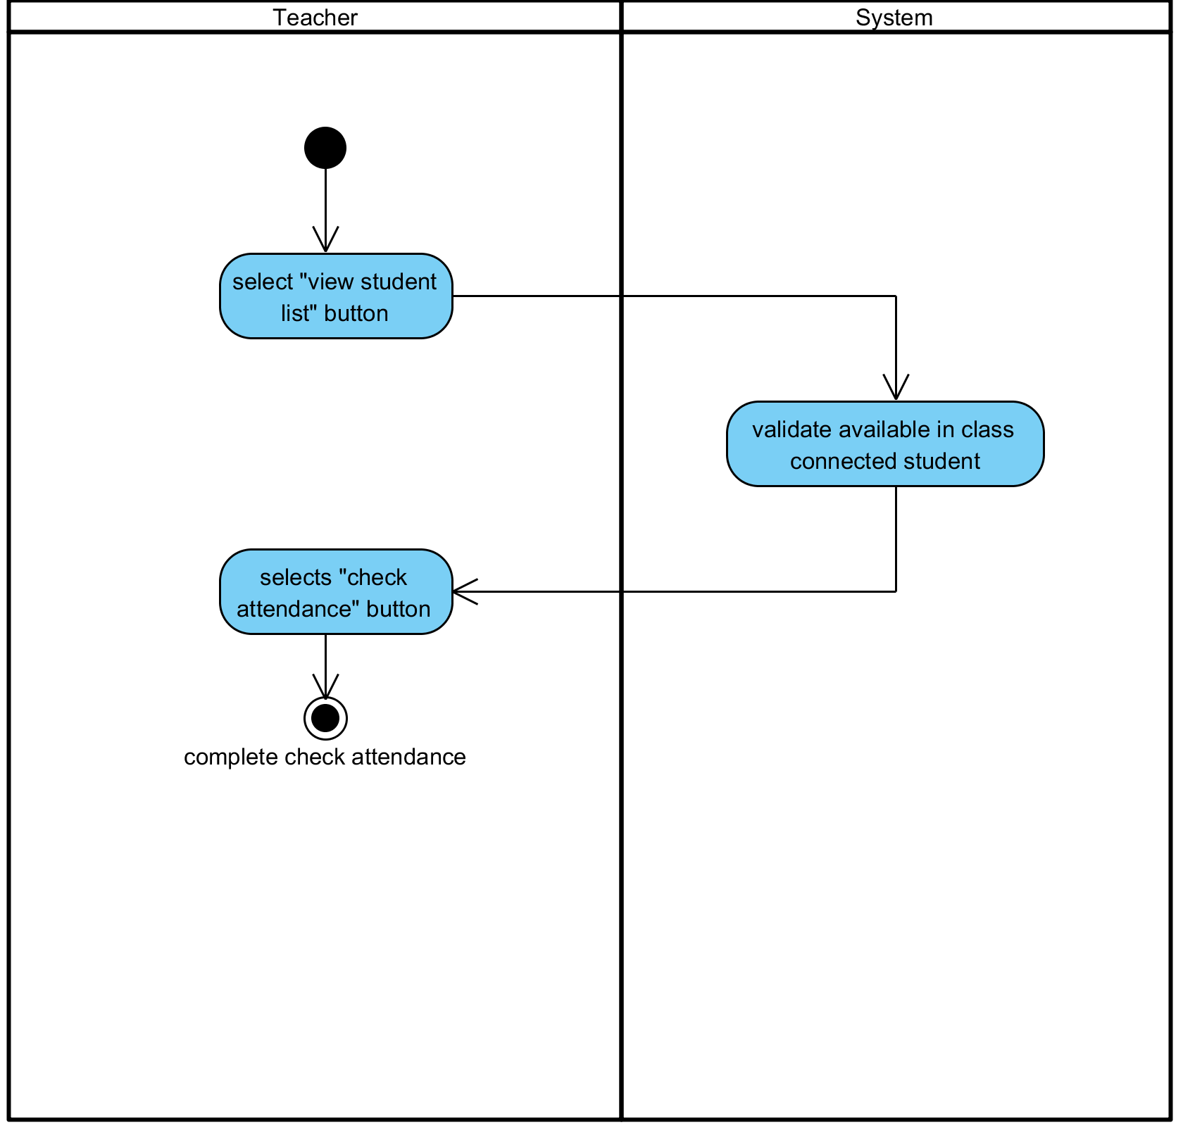

**Figure 13: Check attendance**

**Output:** Teacher has been checked attendance.

**System Requirements Specifications:**

* **SRS10-10.1:** The system shall validation student list in database.
* **SRS10-10.1:** The system shall display interface list of available student who connected of that class.

**3.11 Write down in white board**

|  |  |  |  |  |
| --- | --- | --- | --- | --- |
| **Use Case ID:** | UC-011 | | | |
| **Use Case Name:** | Write down in white board | | | |
| **Created By:** | Pichet Potha  Sittipong Borripan | | **Last Updated By:** |  |
| **Date Created:** | 12/5/2014 | | **Last Revision Date:** |  |
| **Actors:** | | Teacher | | |
| **Description:** | | This use case describe how teacher write down in white board. | | |
| **Trigger:** | | Teacher selects “white board” in profile page. | | |
| **Pre-conditions:** | | 1. Teacher already logged in to the system on own device. | | |
| **Post-conditions:** | | 1. Teacher write down in write board. | | |
| **Normal Flow:** | | 1. Teacher selects “white board” in their profile page.  2. The system shall display interface of white board for teacher to write down.  3. Teacher write down in write board. | | |
| **Alternative Flows:** | | n/a | | |
| **Exceptions:** | | 1a. In the step 1 of the Normal Flow, if no internet connection  1. The system check the internet connection.  2. The system alerts the user that the internet connection does not  exist.  3. Use case ends. | | |
| **Priority::** | | High. | | |

**Use Case:** Write down in white board (UC011)

**URS1-11:** The web application shall allow the Teacher write down in white board.

Teacher writes something or attaches some files on the whiteboard.

**Input:**

|  |  |  |  |
| --- | --- | --- | --- |
| Input | Description | Constraints | Example |
| Detail or any information | The things that teacher want to write down in the whiteboard. | Allow to type any special characters. |  |
| Document file | Any file that want to attach on the whiteboard |  |  |

**Action:**

**AC-11: Write down in white board**

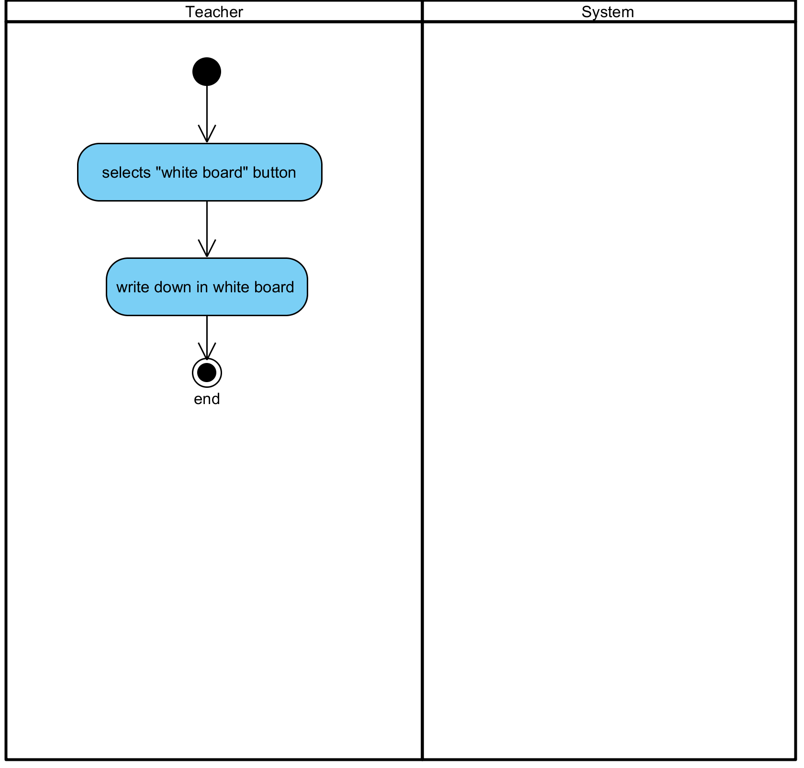

**Figure 14: Write down in white board**

**Output:** The web application shows the things that were written down on the white board.

**System Requirements Specifications:**

* **SRS11-11.1:** The system shall display interface of white board for teacher to write down.

**3.12 Broadcast own screen to Student**

|  |  |  |  |  |
| --- | --- | --- | --- | --- |
| **Use Case ID:** | UC-012 | | | |
| **Use Case Name:** | Broadcast own screen to Student | | | |
| **Created By:** | Pichet Potha  Sittipong Borripan | | **Last Updated By:** |  |
| **Date Created:** | 12/5/2014 | | **Last Revision Date:** |  |
| **Actors:** | | Teacher | | |
| **Description:** | | This use case describe how Teacher broadcast their own screen to student. | | |
| **Trigger:** | | Teacher selects “broadcast now” button on their screen. | | |
| **Pre-conditions:** | | 1. Teacher already logged in to the system on own device.  2. Teacher has not already broadcast screen. | | |
| **Post-conditions:** | | 1. Teacher complete to broadcast screen. | | |
| **Normal Flow:** | | 1. Teacher select “broadcast now” button on their screen.  2. The system shall validation list of student in class.  3. The system shall broadcast screen of teacher to student in that class and show broadcast status.  4. Teacher complete to broadcast screen. | | |
| **Alternative Flows:** | | n/a | | |
| **Exceptions:** | | 1a. In the step 1 of the Normal Flow, if no internet connection  1. The system check the internet connection.  2. The system alerts the user that the internet connection does not  exist.  3. Use case ends. | | |
| **Priority::** | | High. | | |

**Use Case:** Broadcast own screen to Student (UC012)

**URS1-12:** The web application shall allow the Teacher broadcast own screen to Student.

Teacher shares own screen to make the student can see the content on their own screen.

**Input:**

N/A

**Action:**

**AC-12: Broadcast own screen to Student**

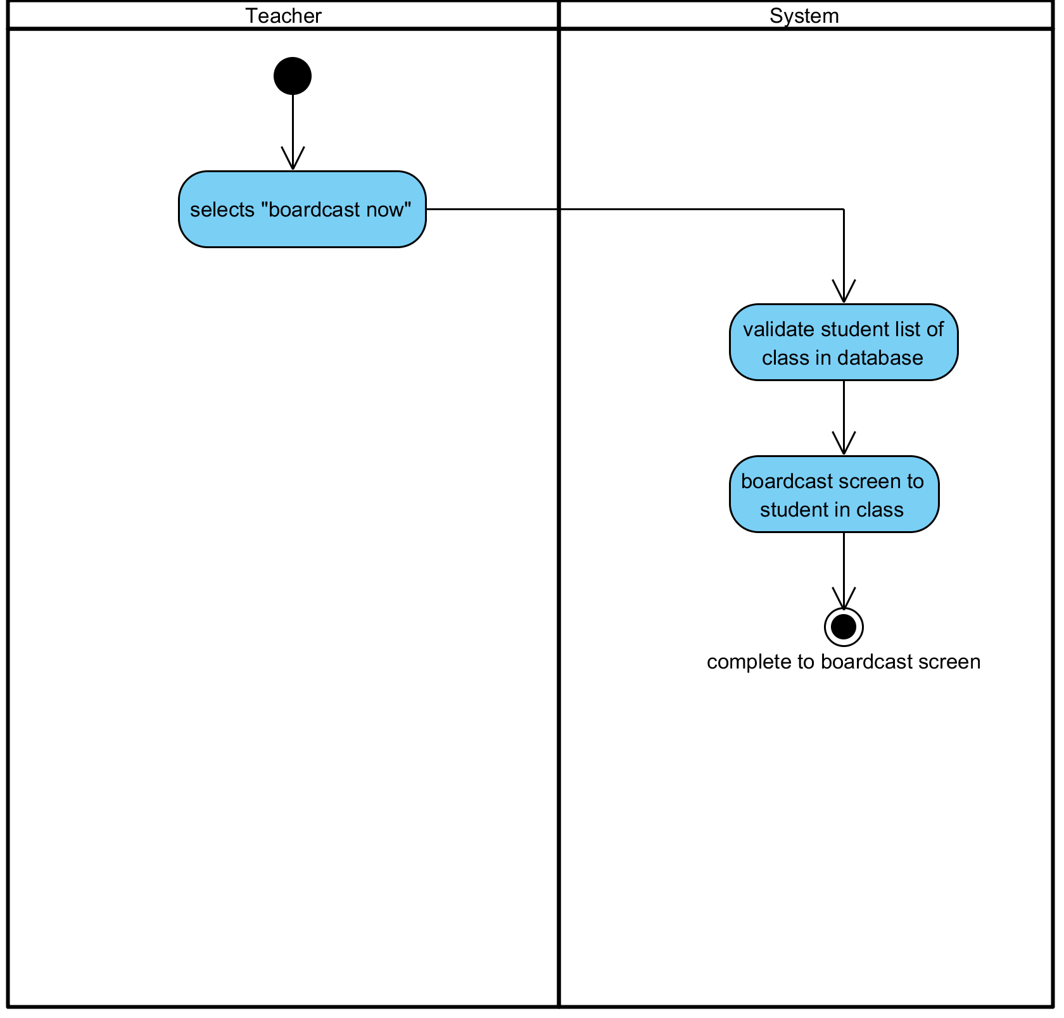

**Figure 15: Broadcast own screen to Student**

**Output:** The content from the teacher has been shown on the screen of the student.

**System Requirements Specifications:**

* **SRS12-12.1:** The system shall validation list of student in class.
* **SRS12-12.1:** The system shall broadcast screen of teacher to student in that class and show broadcast status.

**3.13 Stop Broadcast own screen to Student**

|  |  |  |  |  |
| --- | --- | --- | --- | --- |
| **Use Case ID:** | UC-013 | | | |
| **Use Case Name:** | Stop Broadcast own screen to Student | | | |
| **Created By:** | Pichet Potha  Sittipong Borripan | | **Last Updated By:** |  |
| **Date Created:** | 12/5/2014 | | **Last Revision Date:** |  |
| **Actors:** | | Teacher | | |
| **Description:** | | This use case describe how teacher stop broadcast screen. | | |
| **Trigger:** | | Teacher select “stop broadcast” button on their screen. | | |
| **Pre-conditions:** | | 1. Teacher already logged in to the system on own device. | | |
| **Post-conditions:** | | 1. Teacher complete to stop broadcast screen. | | |
| **Normal Flow:** | | 1. Teacher select “stop broadcast” button on their screen.  2. The system shall stop broadcast screen of teacher and show broadcast status.  3. Teacher complete to stop broadcast screen. | | |
| **Alternative Flows:** | | n/a | | |
| **Exceptions:** | | 1a. In the step 1 of the Normal Flow, if no internet connection  1. The system check the internet connection.  2. The system alerts the user that the internet connection does not  exist.  3. Use case ends. | | |
| **Priority::** | | High. | | |

**Use Case:** Stop Broadcast own screen to Student (UC013)

**URS1-13:** The web application shall allow the Teacher stop broadcast own screen to Student.

Teacher cancel to share own screen to the student

**Input:**

N/A

**Action:**

**AC-13: Stop Broadcast own screen to Student**

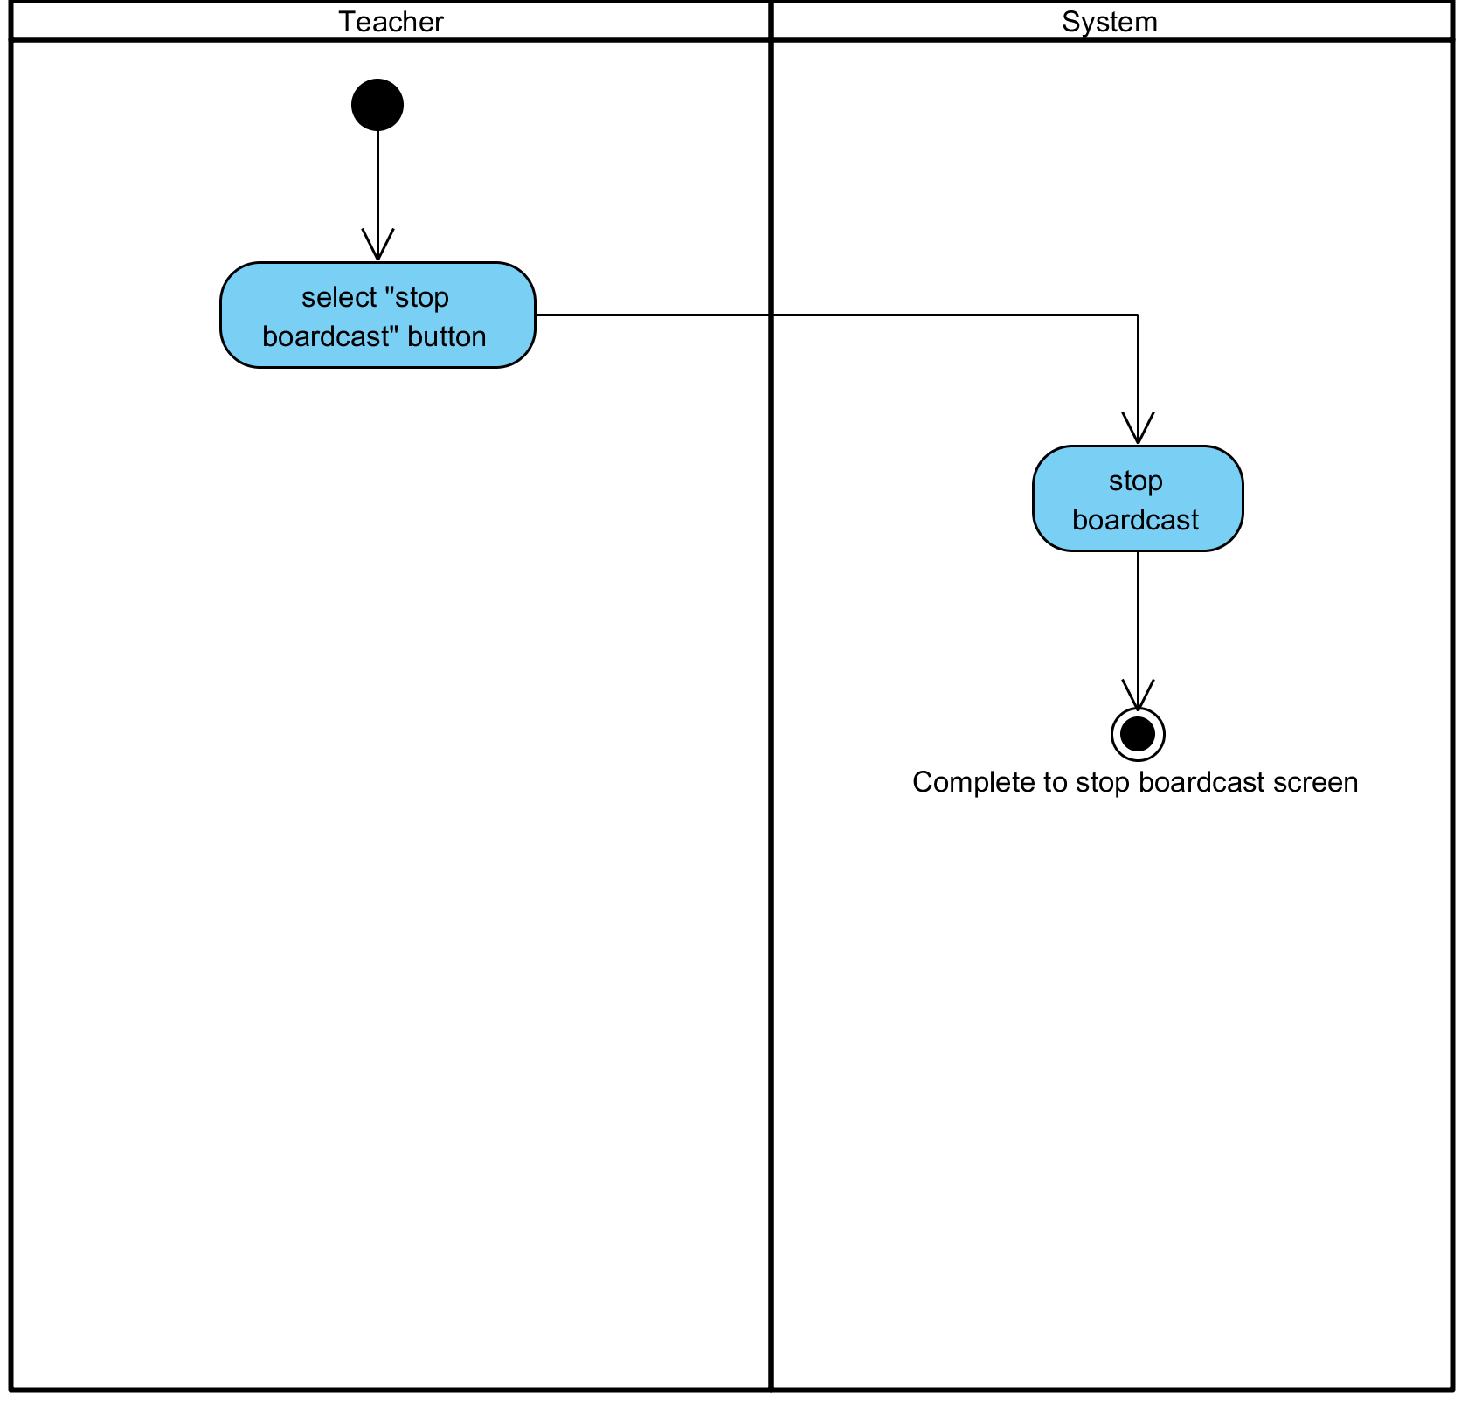

**Figure 16: Stop Broadcast own screen to Student**

**Output:** The content that share from the teacher has been stopped sharing.

**System Requirements Specifications:**

* **SRS13-13.1:** The system shall stop broadcast screen of teacher and show broadcast status.

**3.14 Split own screen**

|  |  |  |  |  |
| --- | --- | --- | --- | --- |
| **Use Case ID:** | UC-014 | | | |
| **Use Case Name:** | Split own screen | | | |
| **Created By:** | Pichet Potha  Sittipong Borripan | | **Last Updated By:** |  |
| **Date Created:** | 12/5/2014 | | **Last Revision Date:** |  |
| **Actors:** | | Teacher | | |
| **Description:** | | This use case describe how teacher split screen. | | |
| **Trigger:** | | Teacher selects “split now” button on their screen. | | |
| **Pre-conditions:** | | 1. Teacher already logged in to the system on own device.  2. Screen of teacher has not already to split. | | |
| **Post-conditions:** | | 1. Teacher complete to split screen and be able to use other feature. | | |
| **Normal Flow:** | | 1. Teacher selects “split now” button on their screen.  2. The system shall split screen into two page.  3. Teacher complete to split screen and be able to use other feature. | | |
| **Alternative Flows:** | | n/a | | |
| **Exceptions:** | | 1a. In the step 1 of the Normal Flow, if no internet connection  1. The system check the internet connection.  2. The system alerts the user that the internet connection does not  exist.  3. Use case ends. | | |
| **Priority::** | | High. | | |

**Use Case:** Split own screen (UC014)

**URS1-14:** The web application shall allow the Teacher split own screen.

Teacher split the screen into two partitions to display information on one side while using the other side as a white board for writing.

**Input:**

N/A

**Action:**

**AC-14: Split own screen**

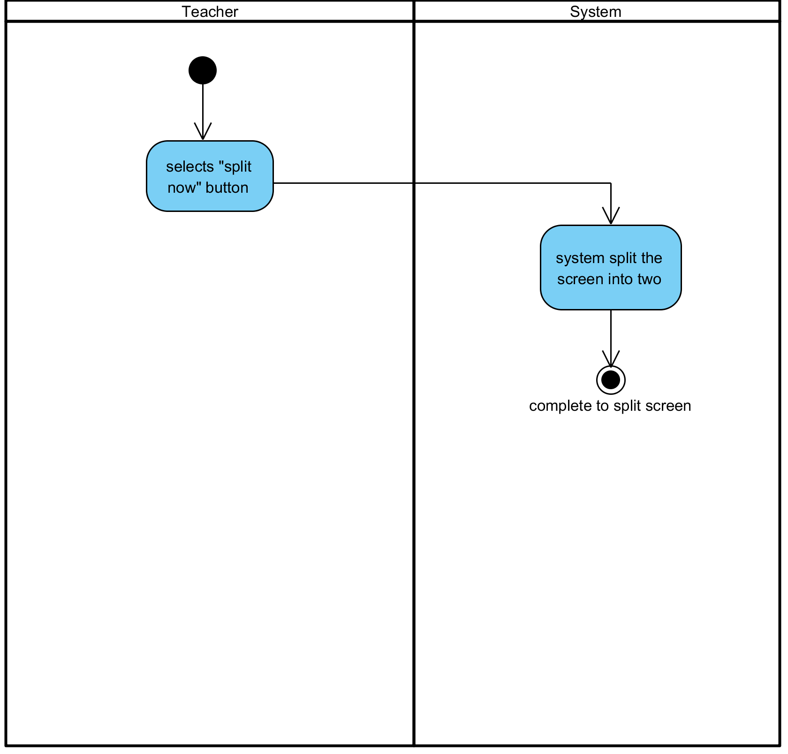

**Figure 16: Split own screen**

**Output:** The screen has been split into two partitions.

**System Requirements Specifications:**

* **SRS14-14.1:** The system shall split screen into two page.

**3.15 Cancel Split own screen**

|  |  |  |  |  |
| --- | --- | --- | --- | --- |
| **Use Case ID:** | UC-015 | | | |
| **Use Case Name:** | Cancel Split own screen | | | |
| **Created By:** | Pichet Potha  Sittipong Borripan | | **Last Updated By:** |  |
| **Date Created:** | 12/5/2014 | | **Last Revision Date:** |  |
| **Actors:** | | Teacher | | |
| **Description:** | | This use case describe how teacher cancel split screen. | | |
| **Trigger:** | | Teacher selects “cancel split” button. | | |
| **Pre-conditions:** | | 1. Teacher already logged in to the system on own device.  2. Screen of teacher already to split. | | |
| **Post-conditions:** | | 1. Teacher complete to cancel split screen. | | |
| **Normal Flow:** | | 1. Teacher selects “cancel split” button.  2. The system shall close that split screen.  3. Teacher complete to cancel split screen. | | |
| **Alternative Flows:** | | n/a | | |
| **Exceptions:** | | 1a. In the step 1 of the Normal Flow, if no internet connection  1. The system check the internet connection.  2. The system alerts the user that the internet connection does not  exist.  3. Use case ends. | | |
| **Priority::** | | High. | | |

**Use Case:** Cancel Split own screen (UC015)

**URS1-15:** The web application shall allow the Teacher stop split own screen.

Teacher cancel to split the screen to display information in full screen.

**Input:**

N/A

**Action:**

**AC-15: Cancel Split own screen**

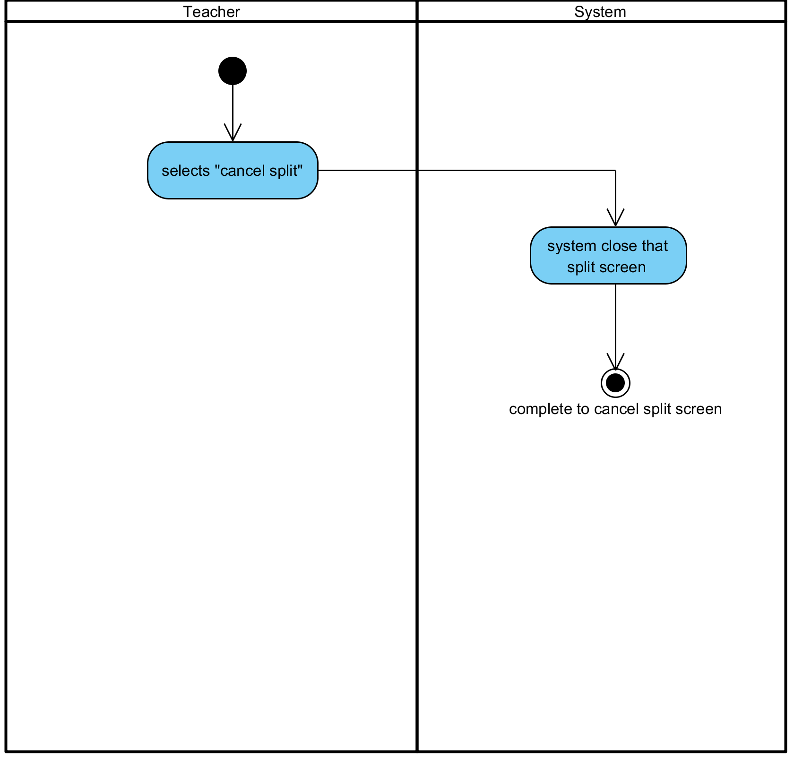

**Figure 17: Cancel Split own screen**

**Output:** The screen has been stopped split the screen.

**System Requirements Specifications:**

**URS1-15:** The web application shall allow the Teacher stop split own screen.

**3.16 See the screen of Teacher**

|  |  |  |  |  |
| --- | --- | --- | --- | --- |
| **Use Case ID:** | UC-016 | | | |
| **Use Case Name:** | See the screen of Teacher | | | |
| **Created By:** | Pichet Potha  Sittipong Borripan | | **Last Updated By:** |  |
| **Date Created:** | 12/5/2014 | | **Last Revision Date:** |  |
| **Actors:** | | Student | | |
| **Description:** | | This use case describe how student see screen of teacher. | | |
| **Trigger:** | | Student already logged in to system. | | |
| **Pre-conditions:** | | 1. Student already logged in to the system on own device.  2. Teacher already broadcast screen to student. | | |
| **Post-conditions:** | | 1. Student be able to see screen of teacher. | | |
| **Normal Flow:** | | 1. The system shall display interface of teacher on student device.  2. Student be able to see screen of teacher. | | |
| **Alternative Flows:** | | n/a | | |
| **Exceptions:** | | 1a. In the step 1 of the Normal Flow, if no internet connection  1. The system check the internet connection.  2. The system alerts the user that the internet connection does not  exist.  3. Use case ends. | | |
| **Priority::** | | High. | | |

**Use Case:** See the screen of Teacher (UC016)

**URS1-16:** The web application shall allow the Student see the screen of Teacher.

Student sees the screen of the teacher after the sharing the screen.

**Input:**

N/A

**Action:**

**AC-16: See the screen of Teacher**

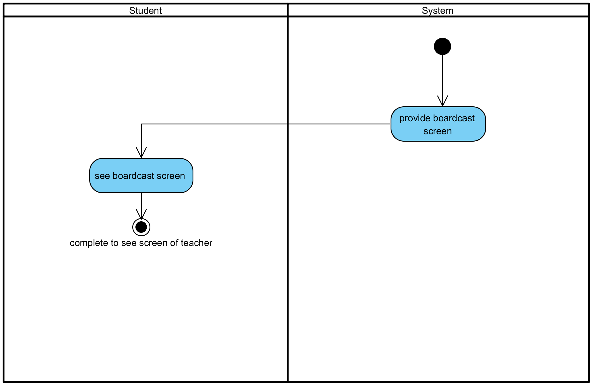

**Figure 18: See the screen of Teacher**

**Output:** Student sees the screen of the teacher on their device.

**System Requirements Specifications:**

* **SRS16-16.1:** The system shall display interface of teacher on student device.

**3.17 See the screen of Student**

|  |  |  |  |  |
| --- | --- | --- | --- | --- |
| **Use Case ID:** | UC-017 | | | |
| **Use Case Name:** | See the screen of Student | | | |
| **Created By:** | Pichet Potha  Sittipong Borripan | | **Last Updated By:** |  |
| **Date Created:** | 12/5/2014 | | **Last Revision Date:** |  |
| **Actors:** | | Teacher | | |
| **Description:** | | This use case describe how teacher see screen of student. | | |
| **Trigger:** | | Teacher selects “see” button in student list page. | | |
| **Pre-conditions:** | | 1. Teacher already logged in to the system on own device.  2. Student stay on student list page. | | |
| **Post-conditions:** | | 1. Teacher be able to see screen of student. | | |
| **Normal Flow:** | | 1. Teacher selects “see” button behind name of students in student list page.  2. The system shall validation connection status of student list.  3. The system shall display list of being connected student in class.  4. Teacher selects that need to see screen.  5. The system shall display screen of selected student on screen of teacher.  6. Teacher be able to see screen of student. | | |
| **Alternative Flows:** | | n/a | | |
| **Exceptions:** | | 1a. In the step 1 of the Normal Flow, if no internet connection  1. The system check the internet connection.  2. The system alerts the user that the internet connection does not  exist.  3. Use case ends. | | |
| **Priority::** | | High. | | |

**Use Case:** Se See the screen of Student (UC017)

**URS1-17:** The web application shall allow the Teacher see the screen of Student.

Teacher can see the screen of all students on own screen

**Input:**

N/A

**Action:**

**AC-17: See the screen of Student**

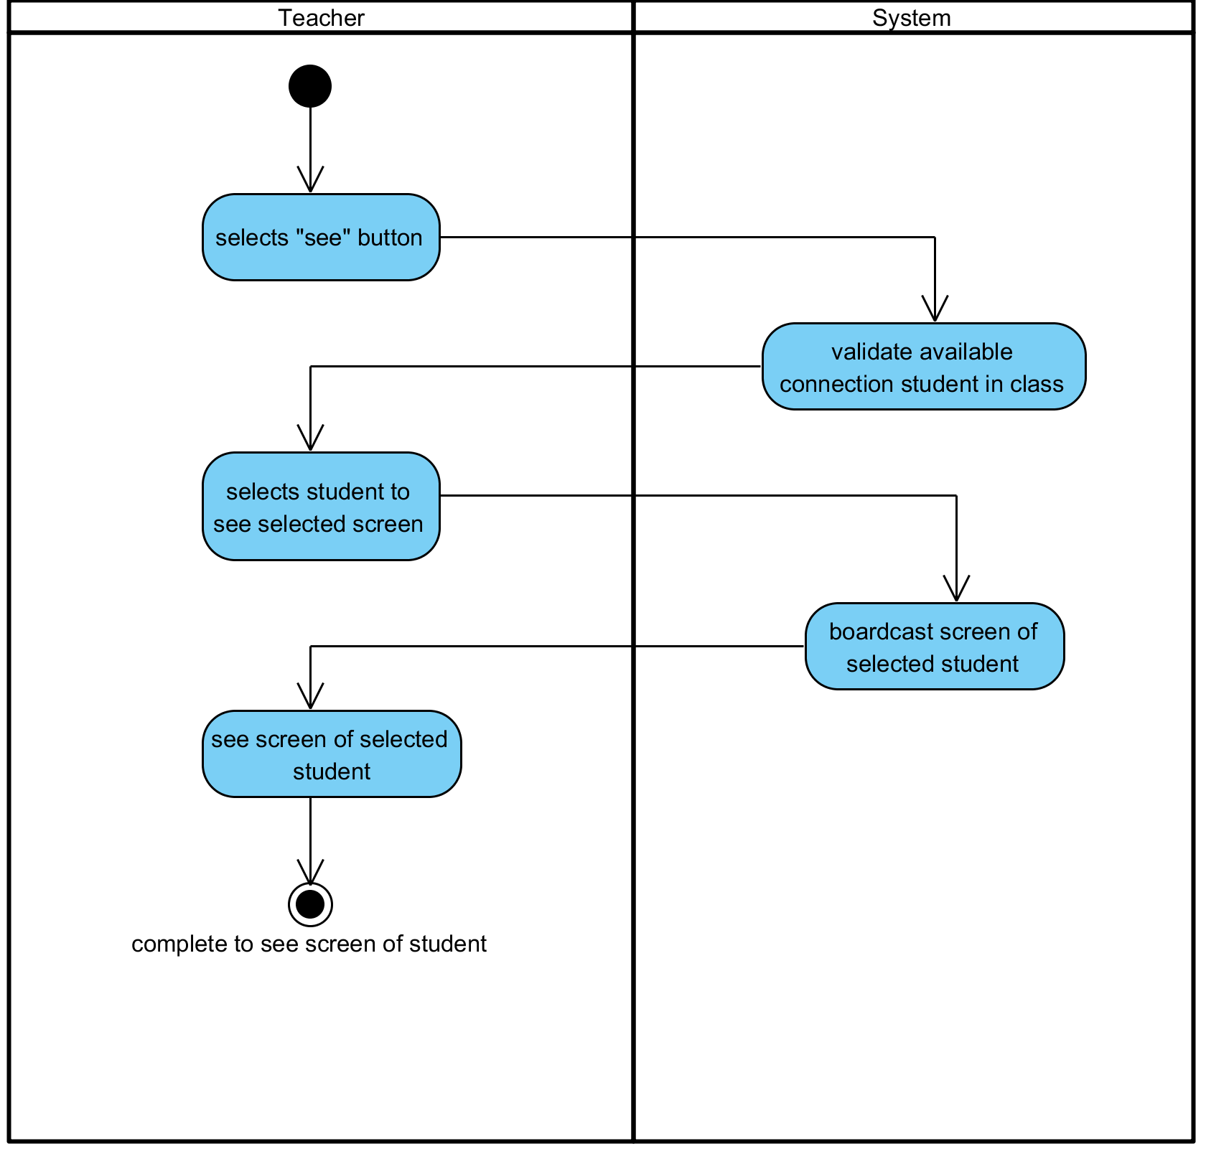

**Figure 19: See the screen of Student**

**Output:** Teacher be able to see screen of student.

**System Requirements Specifications:**

* **SRS17-17.1:** The system shall validation connection status of student list.
* **SRS17-17.1:** The system shall display list of being connected student in class.
* **SRS17-17.1:** The system shall display screen of selected student on screen of teacher.

**3.18 Chat with all Students in real time**

|  |  |  |  |  |
| --- | --- | --- | --- | --- |
| **Use Case ID:** | UC-018 | | | |
| **Use Case Name:** | Chat with all Students in real time | | | |
| **Created By:** | Pichet Potha  Sittipong Borripan | | **Last Updated By:** |  |
| **Date Created:** | 12/5/2014 | | **Last Revision Date:** |  |
| **Actors:** | | Teacher, Student | | |
| **Description:** | | This use case describe how teacher chat to student in class. | | |
| **Trigger:** | | Teacher selects “chat now” button on profile page. | | |
| **Pre-conditions:** | | 1. Teacher already logged in to the system on own device.  2. Student already logged in to the system on own device. | | |
| **Post-conditions:** | | 1. Teacher chat with student. | | |
| **Normal Flow:** | | 1. Teacher selects “chat now” button on profile page.  2. The system shall load student list of that class.  3. The system shall display chat interface for chat to Teacher and student of that class.  4. Teacher chat with student. | | |
| **Alternative Flows:** | | n/a | | |
| **Exceptions:** | | 1a. In the step 1 of the Normal Flow, if no internet connection  1. The system check the internet connection.  2. The system alerts the user that the internet connection does not  exist.  3. Use case ends. | | |
| **Priority::** | | High. | | |

**Use Case:** Chat with all Students in real time (UC018)

**URS1-18:** The web application shall allow the user (Student, Teacher) chat in real time.

**Input:**

|  |  |  |  |
| --- | --- | --- | --- |
| Input | Description | Constraints | Example |
| Message | The message that teacher want to send to the student. | Allow any special characters. | Hello, student. |

**Action:**

**AC-18: Chat with all Students in real time**

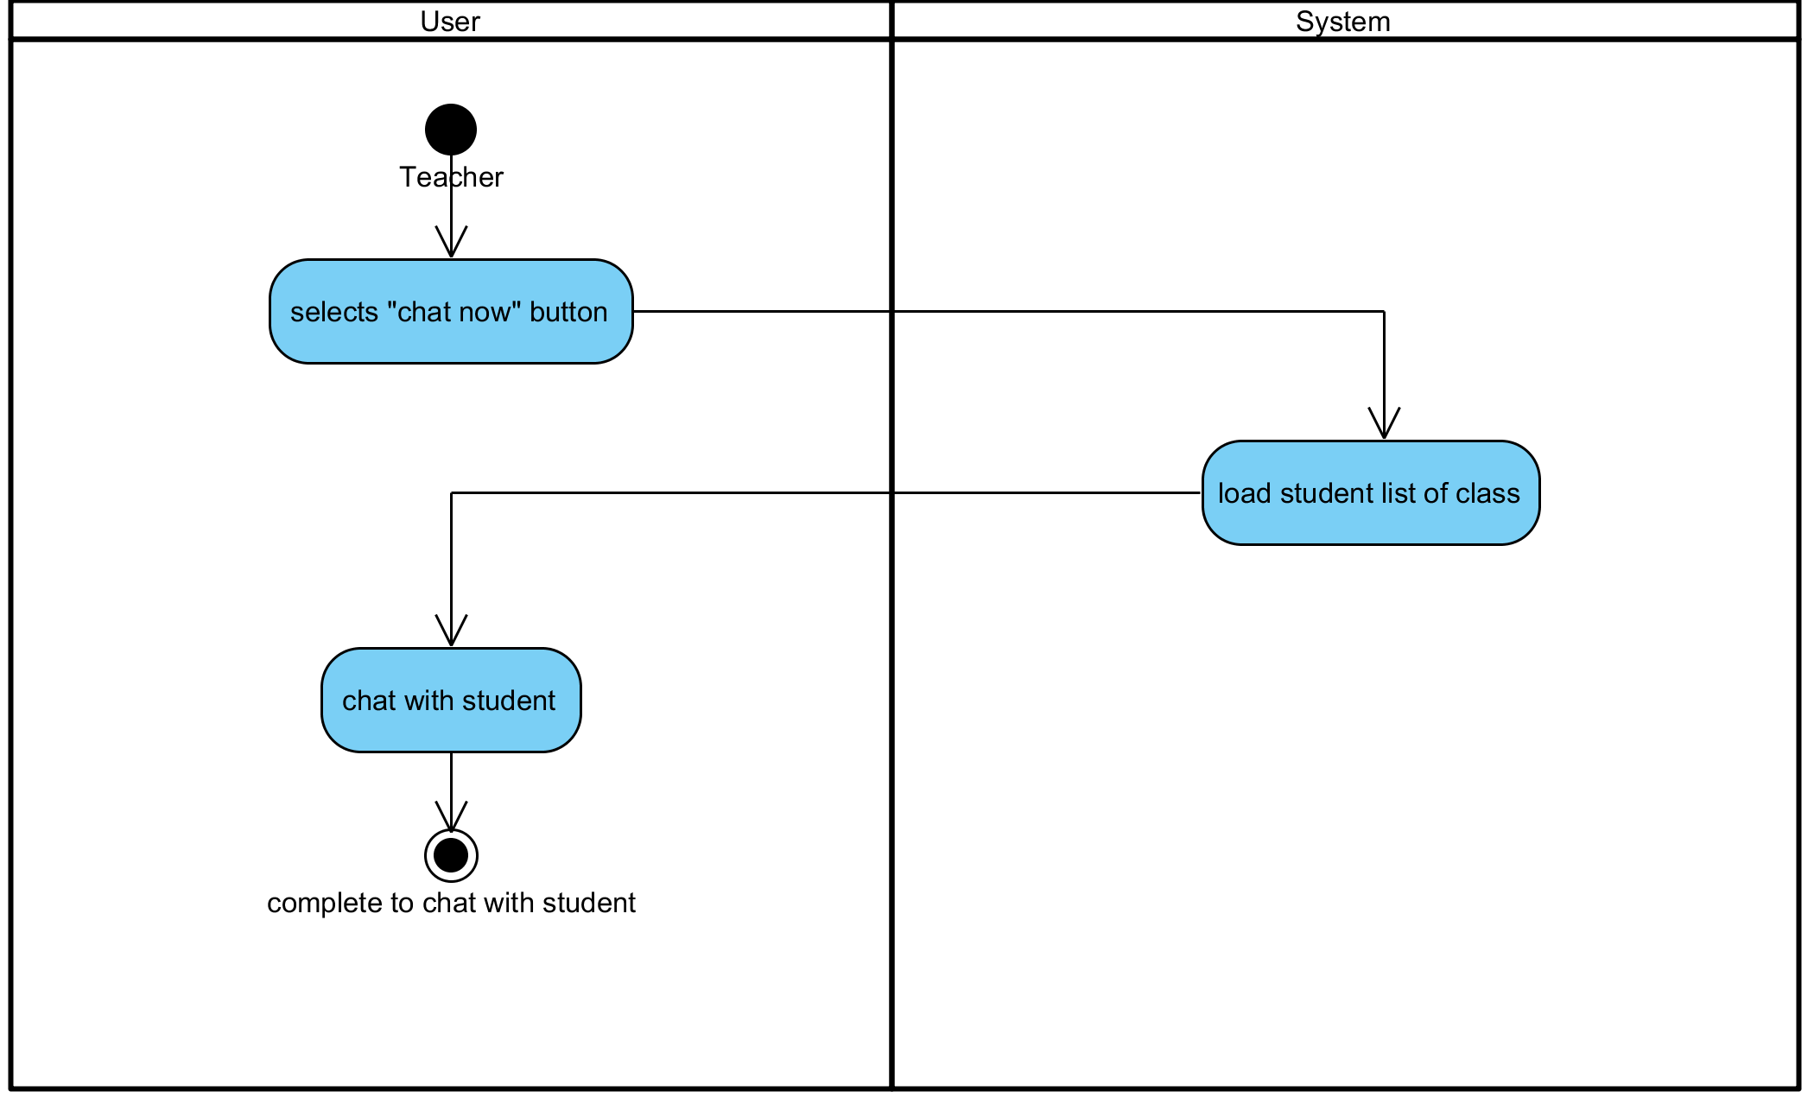

**Figure 20: Chat with all Students in real time**

**Output:** Teacher chat with student.

**System Requirements Specifications:**

* **SRS21-21.1:** The system shall load student list of that class.
* **SRS21-21.1:** The system shall display chat interface for chat between Teacher and student of that class.

**3.19 Create an alert or warning message**

|  |  |  |  |  |
| --- | --- | --- | --- | --- |
| **Use Case ID:** | UC-019 | | | |
| **Use Case Name:** | Create an alert or warning message | | | |
| **Created By:** | Pichet Potha  Sittipong Borripan | | **Last Updated By:** |  |
| **Date Created:** | 12/5/2014 | | **Last Revision Date:** |  |
| **Actors:** | | Teacher | | |
| **Description:** | | This use case describe how teacher create an alert or warning message. | | |
| **Trigger:** | | Teacher selects “warning” button on profile page. | | |
| **Pre-conditions:** | | 1. Teacher already logged in to the system on own device. | | |
| **Post-conditions:** | | 1. Teacher write warning message. | | |
| **Normal Flow:** | | 1. Teacher selects “warning” button on profile page.  2. The system shall pull student list of that class from database.  3. The system shall display student list and interface for teacher to write warning message.  4. Teacher write warning message. | | |
| **Alternative Flows:** | | n/a | | |
| **Exceptions:** | | 1a. In the step 1 of the Normal Flow, if no internet connection  1. The system check the internet connection.  2. The system alerts the user that the internet connection does not  exist.  3. Use case ends. | | |
| **Priority::** | | High. | | |

**Use Case:** Create an alert or warning message (UC019)

**URS1-19:** The web application shall allow the Teacher create an alert or warning message.

**Input:**

|  |  |  |  |
| --- | --- | --- | --- |
| Input | Description | Constraints | Example |
| Message | The message that teacher want to send to the student. | Allow any special characters. | Stop talking |

**Action:**

**AC-19: Create an alert or warning message**

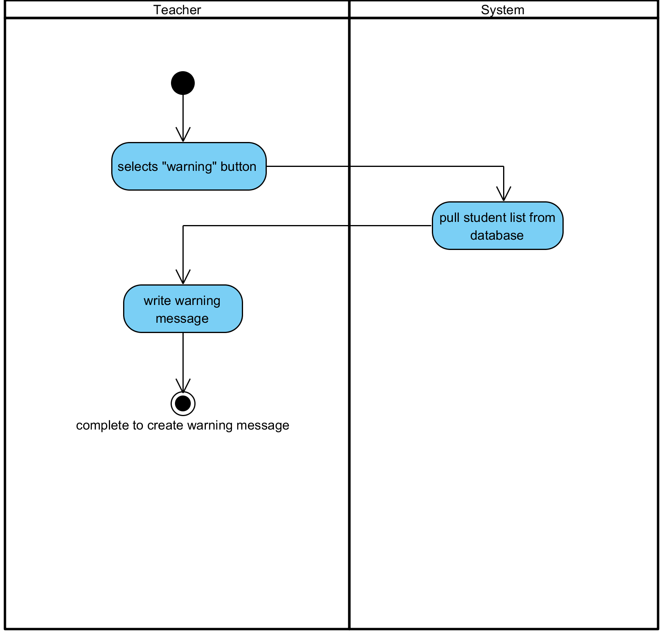

**Figure 21: Create an alert or warning message**

**Output:** A warning message has been created by teacher.

**System Requirements Specifications:**

* **SRS22-22.1:** The system shall pull student list of that class from database.
* **SRS22-22.1:** The system shall display student list and interface for teacher to write warning message.

**3.20 Edit an alert or warning message**

|  |  |  |  |  |
| --- | --- | --- | --- | --- |
| **Use Case ID:** | UC-020 | | | |
| **Use Case Name:** | Edit an alert or warning message | | | |
| **Created By:** | Pichet Potha  Sittipong Borripan | | **Last Updated By:** |  |
| **Date Created:** | 12/5/2014 | | **Last Revision Date:** |  |
| **Actors:** | | Teacher | | |
| **Description:** | | This use case describe how teacher edit an alert or warning message. | | |
| **Trigger:** | | Teacher selects “warning” button on profile page. | | |
| **Pre-conditions:** | | 1. Teacher already logged in to the system on own device. | | |
| **Post-conditions:** | | 1. Teacher complete to edit warning message. | | |
| **Normal Flow:** | | 1. Teacher selects “warning” button on profile page.  2. System pull student list in database to validate.  3. System shall display student list interface to select and space for teacher to write warning message.  4. Teacher write warning message.  5. Teacher edit the message.  6. Teacher complete to edit warning message. | | |
| **Alternative Flows:** | | n/a | | |
| **Exceptions:** | | 4a. In the step 4 of the Normal Flow, if no internet connection  1. The system check the internet connection.  2. The system alerts the user that the internet connection does not  exist.  3. Use case ends. | | |
| **Priority::** | | High. | | |

**Use Case:** Edit an alert or warning message (UC020)

**URS1-20:** The web application shall allow the Teacher edit an alert or warning message.

**Input:**

|  |  |  |  |
| --- | --- | --- | --- |
| Input | Description | Constraints | Example |
| Message | The message that teacher want to send to the student. | Allow any special characters. | Stop talking |

**Action:**

**AC-20: Edit an alert or warning message**

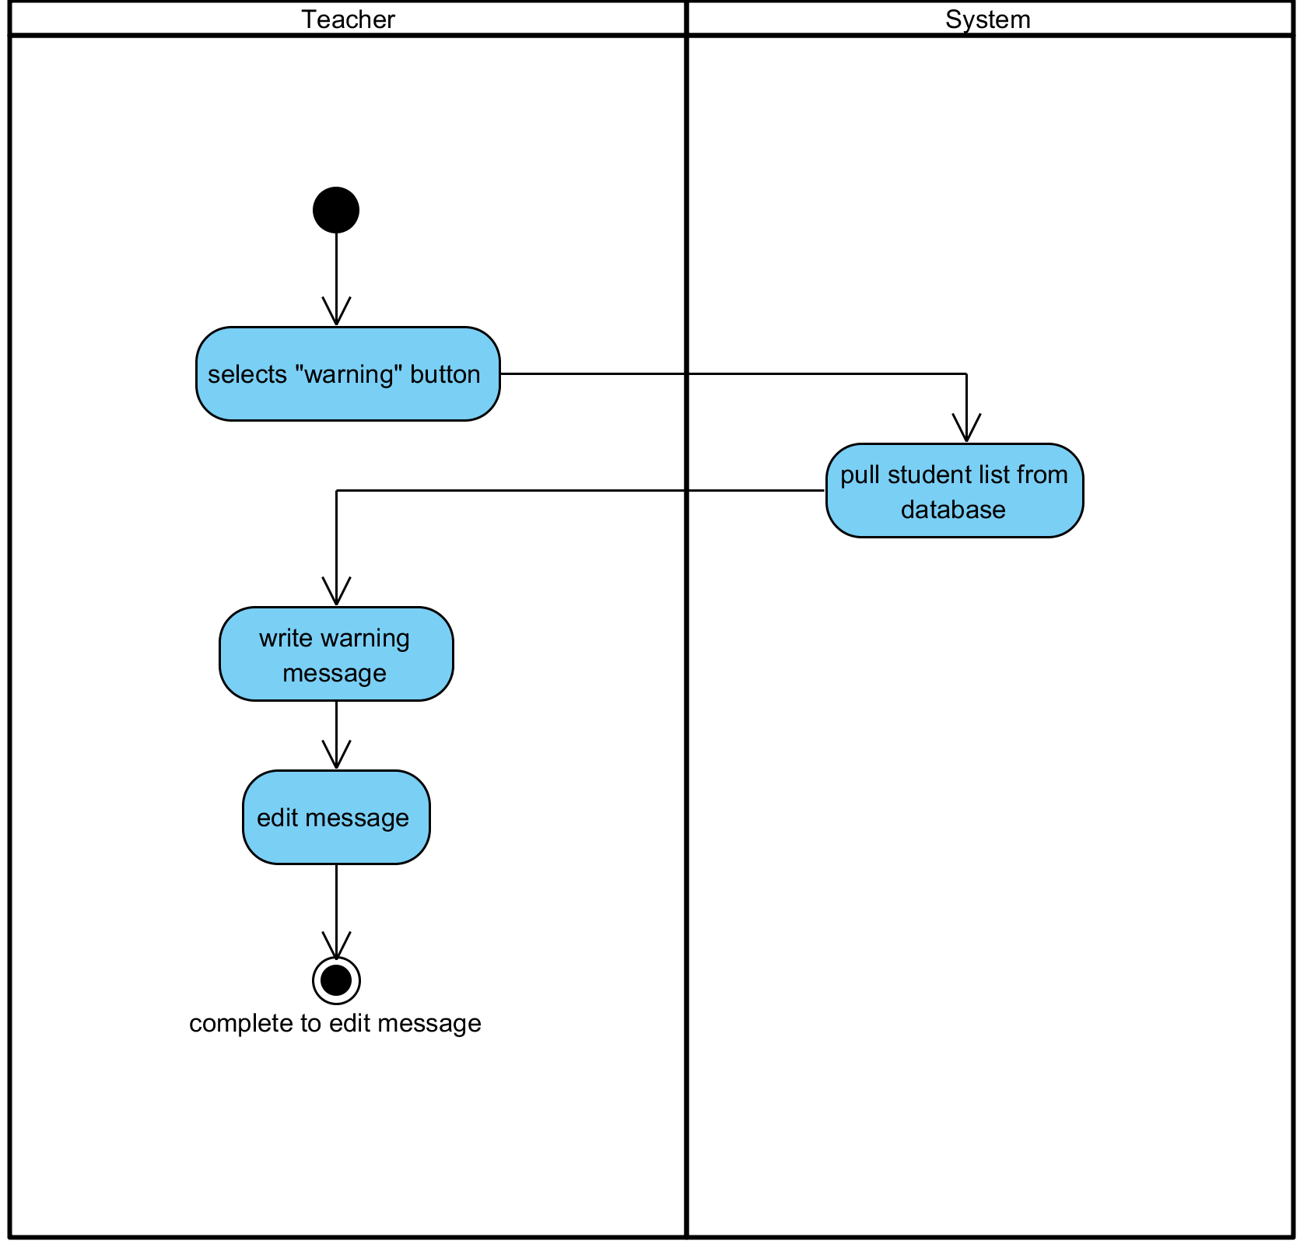

**Figure 22: Edit an alert or warning message**

**Output:** A warning message has been edited by teacher.

**System Requirements Specifications:**

* **SRS23-23.1:** System pull student list in database to validate.
* **SRS23-23.1:** System shall display student list interface to select and space for teacher to write warning message.

**3.21 Delete an alert or warning message**

|  |  |  |  |  |
| --- | --- | --- | --- | --- |
| **Use Case ID:** | UC-021 | | | |
| **Use Case Name:** | Delete an alert or warning message | | | |
| **Created By:** | Pichet Potha  Sittipong Borripan | | **Last Updated By:** |  |
| **Date Created:** | 12/5/2014 | | **Last Revision Date:** |  |
| **Actors:** | | Teacher | | |
| **Description:** | | This use case describe how teacher delete an alert or warning message. | | |
| **Trigger:** | | Teacher selects “warning” button on profile page. | | |
| **Pre-conditions:** | | 1. Teacher already logged in to the system on own device. | | |
| **Post-conditions:** | | 1. Teacher complete to delete warning message. | | |
| **Normal Flow:** | | 1. Teacher selects “warning” button on profile page.  2. System pull student list in database to validate.  3. System shall display student list to select and interface for teacher to write.  4. Teacher write warning message.  5. Teacher delete the message.  6. Teacher complete to delete warning message. | | |
| **Alternative Flows:** | | n/a | | |
| **Exceptions:** | | 4a. In the step 4 of the Normal Flow, if no internet connection  1. The system check the internet connection.  2. The system alerts the user that the internet connection does not  exist.  3. Use case ends. | | |
| **Priority::** | | High. | | |

**Use Case:** Delete an alert or warning message (UC021)

**URS1-21:** The web application shall allow the Teacher delete an alert or warning message.

**Input:**

|  |  |  |  |
| --- | --- | --- | --- |
| Input | Description | Constraints | Example |
| Message | The message that teacher want to send to the student. | Allow any special characters. | Stop talking |

**Action:**

**AC-21: Delete an alert or warning message**

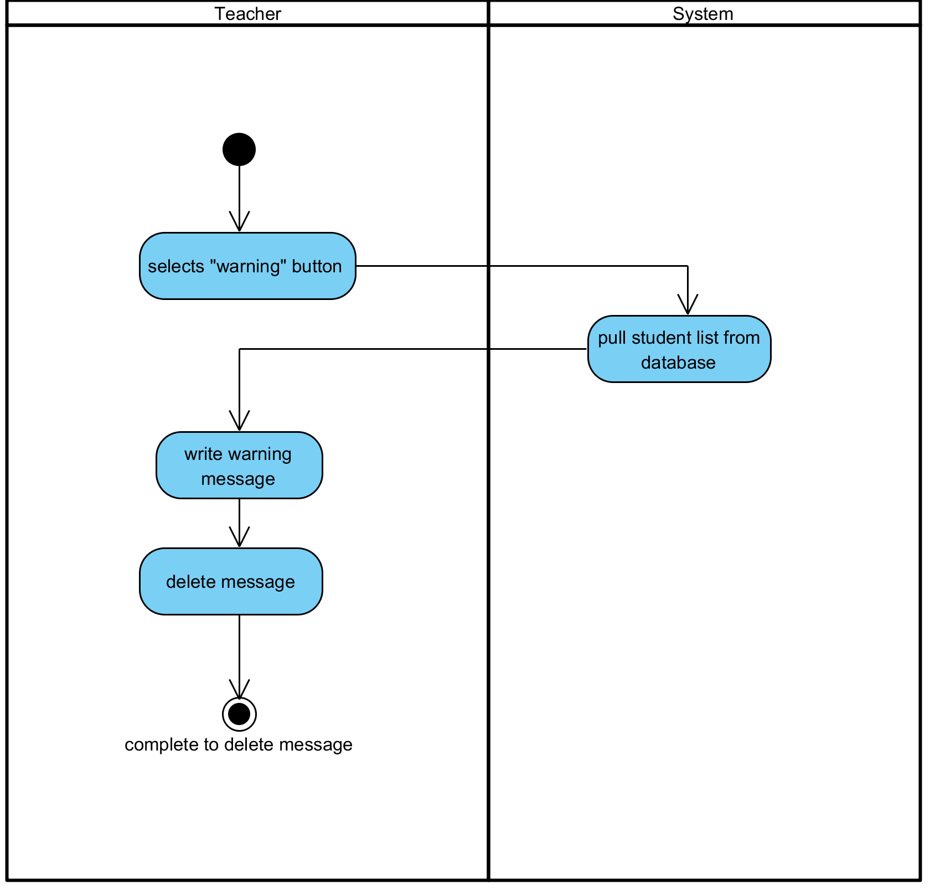

**Figure 23: Delete an alert or warning message**

**Output:** A warning message has been deleted by teacher.

**System Requirements Specifications:**

* **SRS24-24.1:** System pull student list in database to validate.
* **SRS24-24.1:** System shall display student list to select and interface for teacher to write.

**3.22 Send an alert or warning message to Students**

|  |  |  |  |  |
| --- | --- | --- | --- | --- |
| **Use Case ID:** | UC-022 | | | |
| **Use Case Name:** | Send an alert or warning message to Students | | | |
| **Created By:** | Pichet Potha  Sittipong Borripan | | **Last Updated By:** |  |
| **Date Created:** | 12/5/2014 | | **Last Revision Date:** |  |
| **Actors:** | | Teacher, Student | | |
| **Description:** | | This use case describe how teacher send alert or warning message to student. | | |
| **Trigger:** | | Teacher select student in student list. | | |
| **Pre-conditions:** | | 1. Teacher already logged in to the system on own device.  2. Student already logged in to the system on own device.  3. Teacher complete to write warning message. | | |
| **Post-conditions:** | | 1. Student shall be able to see message on their screen. | | |
| **Normal Flow:** | | 1. Teacher select student in student list.  2. Teacher selects “send” button on screen.  3. The system shall send warning message to that student.  4. Student shall be able to see message on their screen. | | |
| **Alternative Flows:** | | n/a | | |
| **Exceptions:** | | 4a. In the step 4 of the Normal Flow, if no internet connection  1. The system check the internet connection.  2. The system alerts the user that the internet connection does not  exist.  3. Use case ends. | | |
| **Priority::** | | High. | | |

**Use Case:** Send an alert or warning message to Students (UC022)

**URS1-22:** The web application shall allow the Teacher send an alert or warning message to Students.

**Input:**

|  |  |  |  |
| --- | --- | --- | --- |
| Input | Description | Constraints | Example |
| Message | The message that teacher want to send to the student. | Allow any special characters. | Stop talking |

**Action:**

**AC-22: Send an alert or warning message to Students**

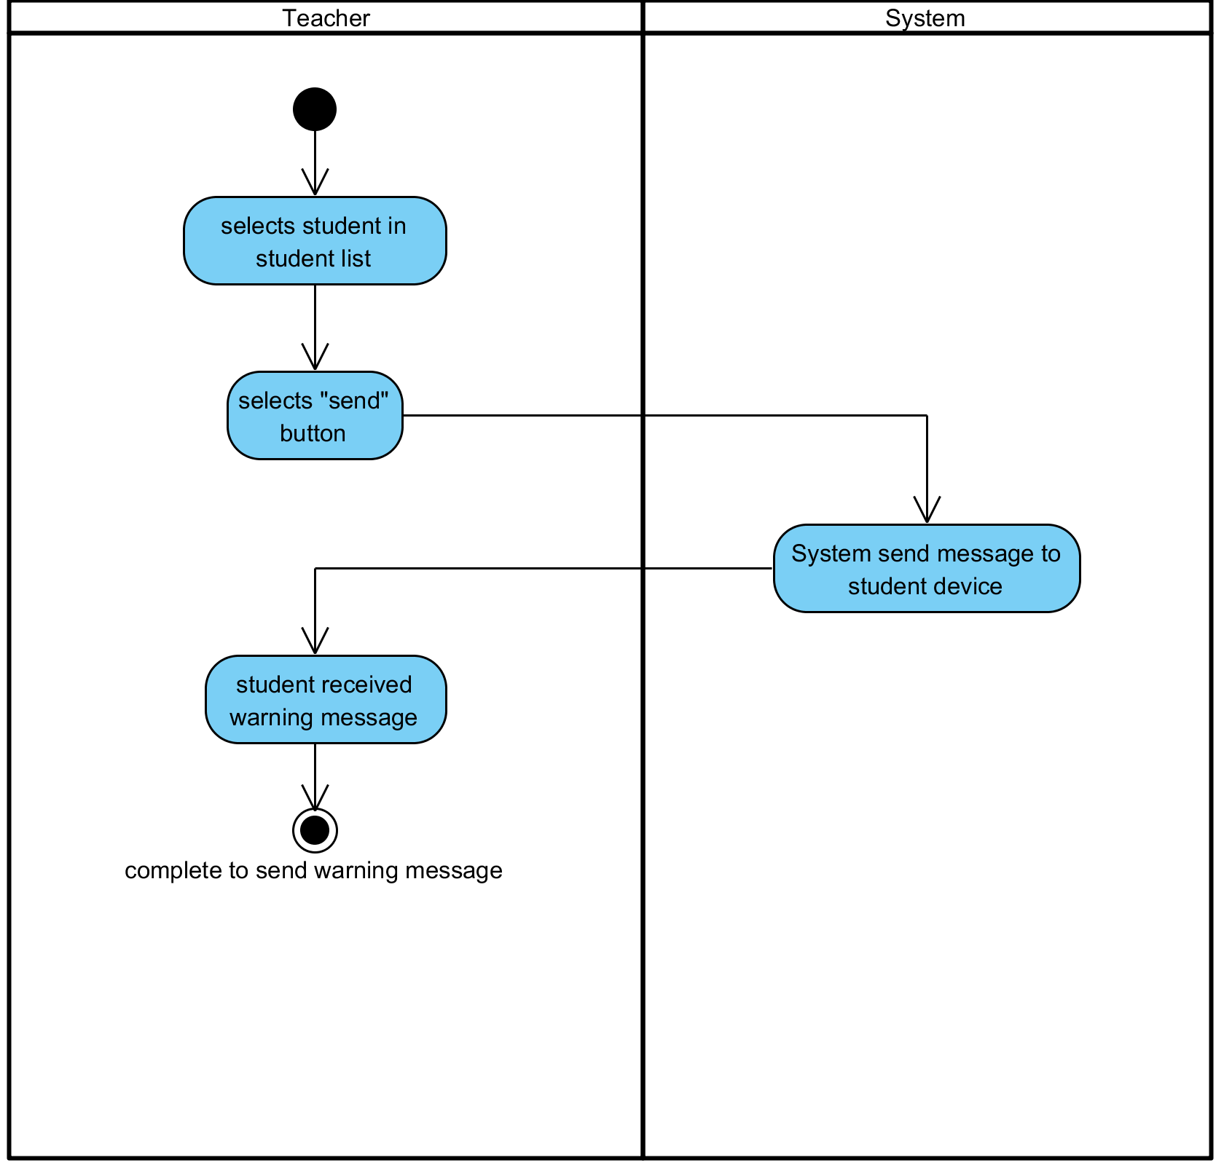

**Figure 24: Send an alert or warning message to Students**

**Output:** A warning message has been sent to the student.

**System Requirements Specifications:**

* **SRS25-25.1:** The system shall send warning message to that student.

**3.23 Create a quiz interface**

|  |  |  |  |  |
| --- | --- | --- | --- | --- |
| **Use Case ID:** | UC-023 | | | |
| **Use Case Name:** | Create a quiz interface | | | |
| **Created By:** | Pichet Potha  Sittipong Borripan | | **Last Updated By:** |  |
| **Date Created:** | 12/5/2014 | | **Last Revision Date:** |  |
| **Actors:** | | Teacher | | |
| **Description:** | | This use case describe how teacher create a quiz interface. | | |
| **Trigger:** | | Teacher selects “create quiz” button on profile page. | | |
| **Pre-conditions:** | | 1. Teacher already logged in to the system on own device. | | |
| **Post-conditions:** | | 1. Teacher complete to create quiz | | |
| **Normal Flow:** | | 1. Teacher selects “create quiz” on profile page  2. The system shall display interface for teacher to put question or picture.  3. Teacher input question.  4. Teacher complete to create quiz | | |
| **Alternative Flows:** | | n/a | | |
| **Exceptions:** | | 1a. In the step 1 of the Normal Flow, if no internet connection  1. The system check the internet connection.  2. The system alerts the user that the internet connection does not  exist.  3. Use case ends. | | |
| **Priority::** | | High. | | |

**Use Case:** Create a quiz interface (UC023)

**URS1-23:** The web application shall allow the Teacher create a quiz interface

**Input:**

N/A

**Action:**

**AC-23: Create a quiz interface**

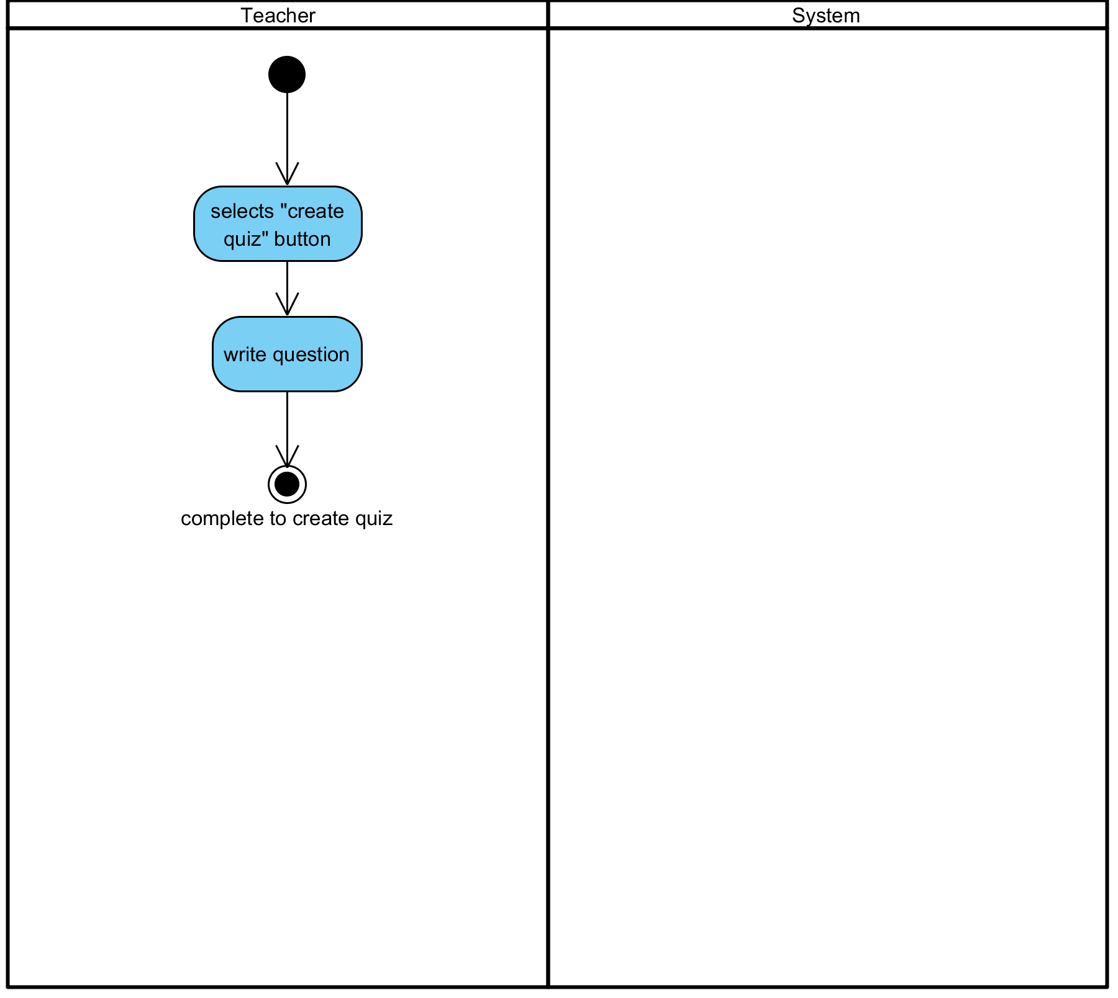

**Figure 25: Create a quiz interface**

**Output:** The quiz interface has been created by teacher.

**System Requirements Specifications:**

* **SRS26-26.1:** The system shall display interface for teacher to put question or picture.

**3.24 Edit a quiz interface**

|  |  |  |  |  |
| --- | --- | --- | --- | --- |
| **Use Case ID:** | UC-024 | | | |
| **Use Case Name:** | Edit a quiz interface | | | |
| **Created By:** | Pichet Potha  Sittipong Borripan | | **Last Updated By:** |  |
| **Date Created:** | 12/5/2014 | | **Last Revision Date:** |  |
| **Actors:** | | Teacher | | |
| **Description:** | | This use case describe | | |
| **Trigger:** | | System show display interface for teacher to put question or picture. | | |
| **Pre-conditions:** | | 1. Teacher already logged in to the system on own device. | | |
| **Post-conditions:** | | 1. Teacher complete to edit quiz  2. Teacher already to create quiz. | | |
| **Normal Flow:** | | 1. System show display interface for teacher to put question or picture.  2. Teacher input question.  3. Teacher edit question.  4. Teacher complete to edit quiz | | |
| **Alternative Flows:** | | n/a | | |
| **Exceptions:** | | 1a. In the step 1 of the Normal Flow, if no internet connection  1. The system check the internet connection.  2. The system alerts the user that the internet connection does not  exist.  3. Use case ends. | | |
| **Priority::** | | High. | | |

**Use Case:** Edit a quiz interface (UC024)

**URS1-24:** The web application shall allow the Teacher edit a quiz interface.

**Input:**

|  |  |  |  |
| --- | --- | --- | --- |
| Input | Description | Constraints | Example |
| Question | The question that teacher input | Allow any special characters. | Please answer this 1+1=?   1. 0 2. 1 3. 2 4. 3 |

**Action:**

**AC-24: Edit a quiz interface**

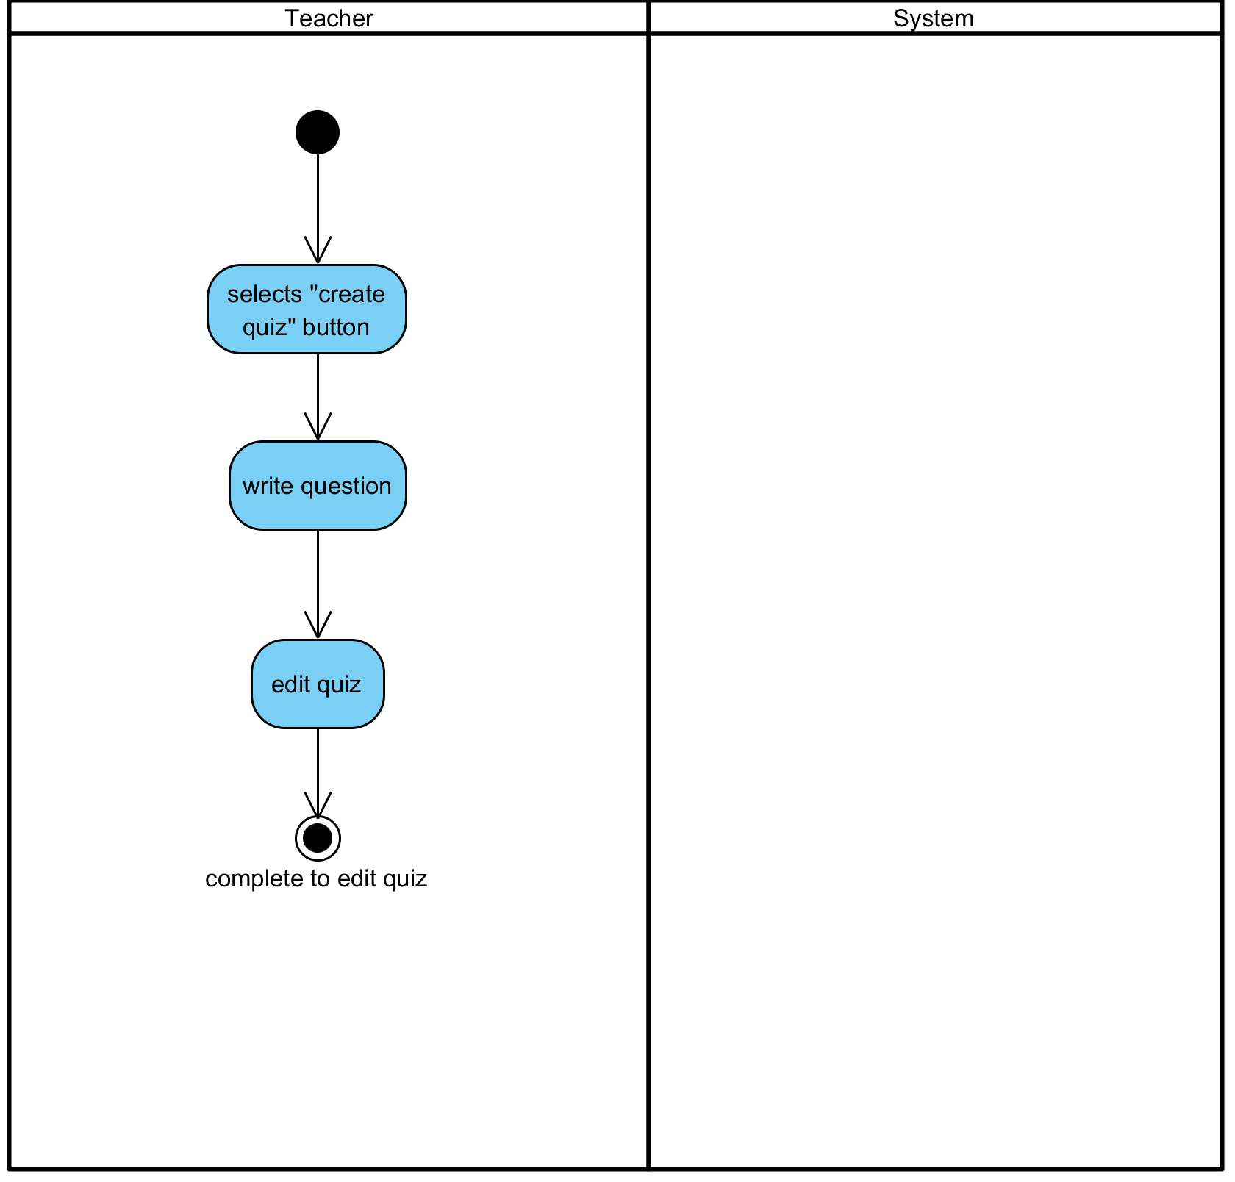

**Figure 26: Edit a quiz interface**

**Output:** A quiz interface has been edited by teacher.

**System Requirements Specifications:**

* **SRS27-27.1:** The system show display interface for teacher to put question or picture.

**3.25 Delete a quiz interface**

|  |  |  |  |  |
| --- | --- | --- | --- | --- |
| **Use Case ID:** | UC-025 | | | |
| **Use Case Name:** | Delete a quiz interface | | | |
| **Created By:** | Pichet Potha  Sittipong Borripan | | **Last Updated By:** |  |
| **Date Created:** | 12/5/2014 | | **Last Revision Date:** |  |
| **Actors:** | | Teacher | | |
| **Description:** | | This use case describe | | |
| **Trigger:** | | System show display interface for teacher to put question or picture. | | |
| **Pre-conditions:** | | 1. Teacher already logged in to the system on own device.  2. Teacher already to create quiz. | | |
| **Post-conditions:** | | 1. Teacher complete to delete quiz | | |
| **Normal Flow:** | | 1. System show display interface for teacher to put question or picture.  2. Teacher input question.  3. Teacher delete question.  4. Teacher complete to delete quiz | | |
| **Alternative Flows:** | | n/a | | |
| **Exceptions:** | | 1a. In the step 1 of the Normal Flow, if no internet connection  1. The system check the internet connection.  2. The system alerts the user that the internet connection does not  exist.  3. Use case ends. | | |
| **Priority::** | | High. | | |

**Use Case:** Delete a quiz interface (UC025)

**URS1-25:** The web application shall allow the Teacher delete a quiz interface

**Input:**

|  |  |  |  |
| --- | --- | --- | --- |
| Input | Description | Constraints | Example |
| Question | The question that teacher input | Allow any special characters. | Please answer this 1+1=?   1. 0 2. 1 3. 2 4. 3 |

**Action:**

**AC-25: Delete a quiz interface**

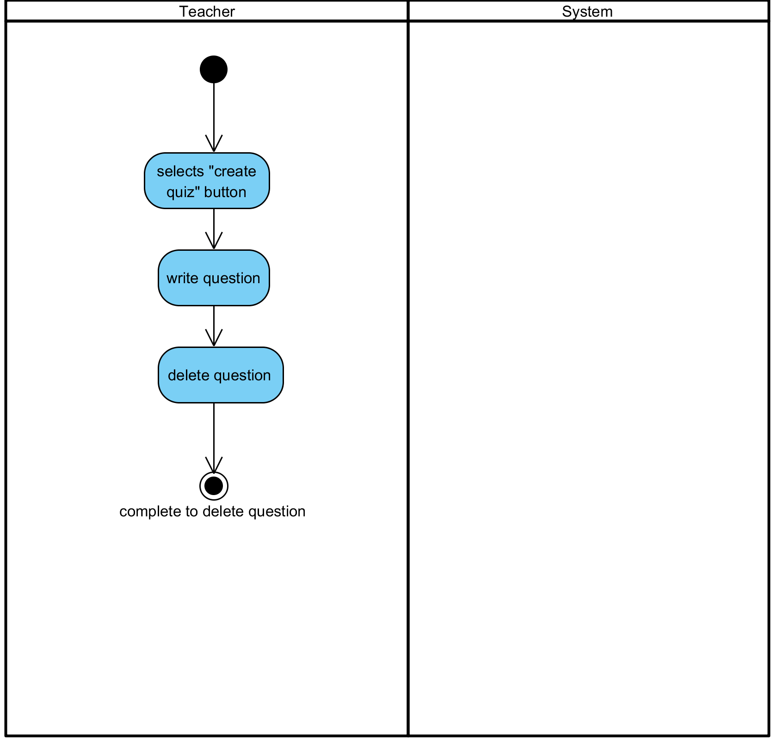

**Figure 27: Delete a quiz interface**

**Output:** A quiz interface has been deleted by teacher.

**System Requirements Specifications:**

* **SRS28-28.1:** The system show display interface for teacher to put question or picture.

**3.26 Send a quiz interface to Students**

|  |  |  |  |  |
| --- | --- | --- | --- | --- |
| **Use Case ID:** | UC-026 | | | |
| **Use Case Name:** | Send a quiz interface to Students. | | | |
| **Created By:** | Pichet Potha  Sittipong Borripan | | **Last Updated By:** |  |
| **Date Created:** | 12/5/2014 | | **Last Revision Date:** |  |
| **Actors:** | | Teacher | | |
| **Description:** | | This use case describe how teacher send quiz interface to student. | | |
| **Trigger:** | | System show display interface for teacher to put question or picture. | | |
| **Pre-conditions:** | | 1. Teacher already logged in to the system on own device.  2. Teacher already to create quiz | | |
| **Post-conditions:** | | 1. Student be able to see quiz from teacher. | | |
| **Normal Flow:** | | 1. System show display interface for teacher to put question or  picture.  2. Teacher input question.  3. Teacher selects “send” button on their screen.  4. The system shall validation student list in database.  5. The system shall send quiz interface to student in that class.  6. Student be able to see quiz from teacher. | | |
| **Alternative Flows:** | | n/a | | |
| **Exceptions:** | | 1a. In the step 1 of the Normal Flow, if no internet connection  1. The system check the internet connection.  2. The system alerts the user that the internet connection does not  exist.  3. Use case ends. | | |
| **Priority::** | | High. | | |

**Use Case:** Send a quiz interface to Students. (UC026)

**URS1-26:** The web application shall allow the Teacher send a quiz interface to Students.

**Input:**

|  |  |  |  |
| --- | --- | --- | --- |
| Input | Description | Constraints | Example |
| Question | The question that teacher input | Allow any special characters. | Please answer this 1+1=?   1. 0 2. 1 3. 2 4. 3 |

**Action:**

**AC-26: Send a quiz interface to Students.**

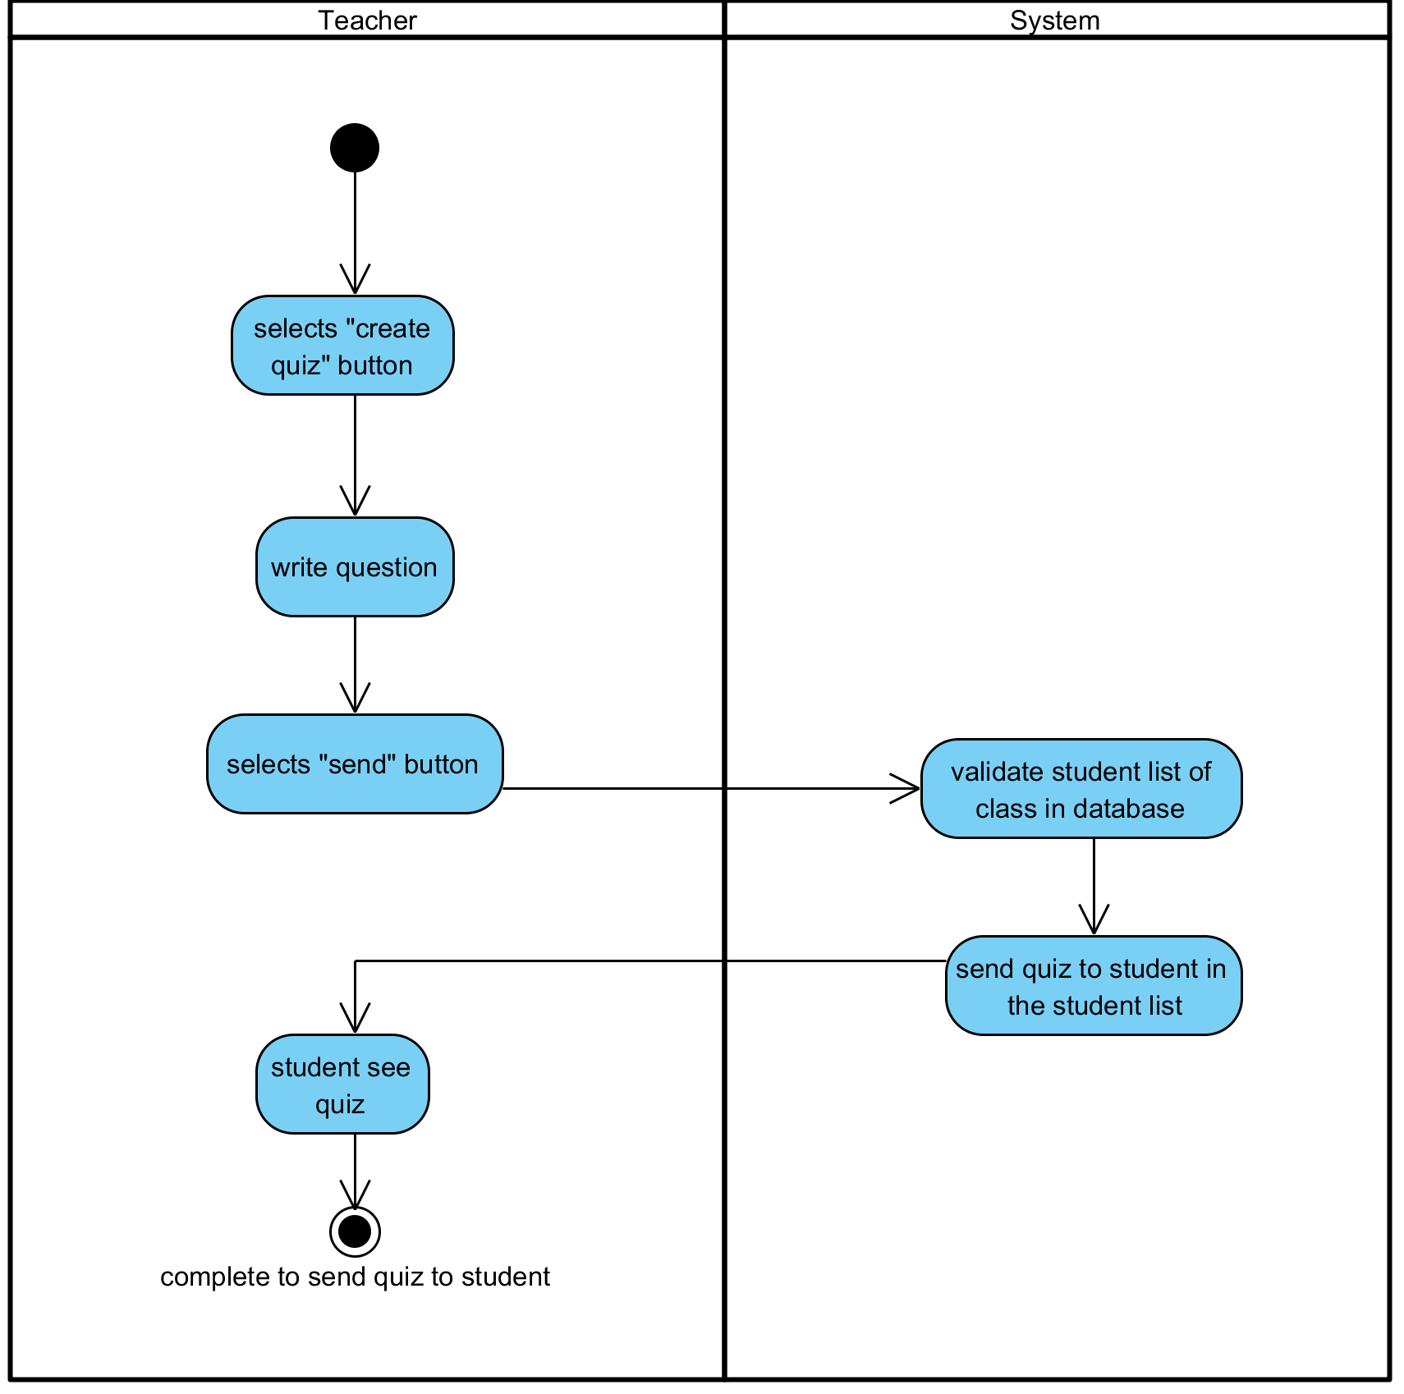

**Figure 28: Send a quiz interface to Students.**

**Output:** A quiz interface has been sent to Students.

**System Requirements Specifications:**

* **SRS29-29.1:** The System show display interface for teacher to put question or picture.
* **SRS29-29.1:** The system shall validation student list in database.
* **SRS29-29.1:** The system shall send quiz interface to student in that class.

**3.27 Chat with Teacher in real time**

|  |  |  |  |  |
| --- | --- | --- | --- | --- |
| **Use Case ID:** | UC-027 | | | |
| **Use Case Name:** | Chat with Teacher in real time | | | |
| **Created By:** | Pichet Potha  Sittipong Borripan | | **Last Updated By:** |  |
| **Date Created:** | 12/5/2014 | | **Last Revision Date:** |  |
| **Actors:** | | Student | | |
| **Description:** | | This use case describe how student chat with teacher in real time. | | |
| **Trigger:** | | Teacher request to chat with student in that class. | | |
| **Pre-conditions:** | | 1. Student already logged in to the system on own device.  2. Teacher request to chat with student in that class. | | |
| **Post-conditions:** | | 1. Student see chat interface and be able to chat with teacher. | | |
| **Normal Flow:** | | 1. The system shall display interface for student to chat.  2. Student see chat interface and be able to chat with teacher. | | |
| **Alternative Flows:** | | n/a | | |
| **Exceptions:** | | 1a. In the step 1 of the Normal Flow, if no internet connection  1. The system check the internet connection.  2. The system alerts the user that the internet connection does not  exist.  3. Use case ends. | | |
| **Priority::** | | High. | | |

**Use Case:** Chat with Teacher in real time (UC027)

**URS1-27:** The web application shall allow the Student chat with Teacher in real time.

**Input:**

|  |  |  |  |
| --- | --- | --- | --- |
| Input | Description | Constraints | Example |
| Message | The message that teacher want to send to the student. | Allow any special characters. | Stop talking |

**Action:**

**AC-27: Chat with Teacher in real time**

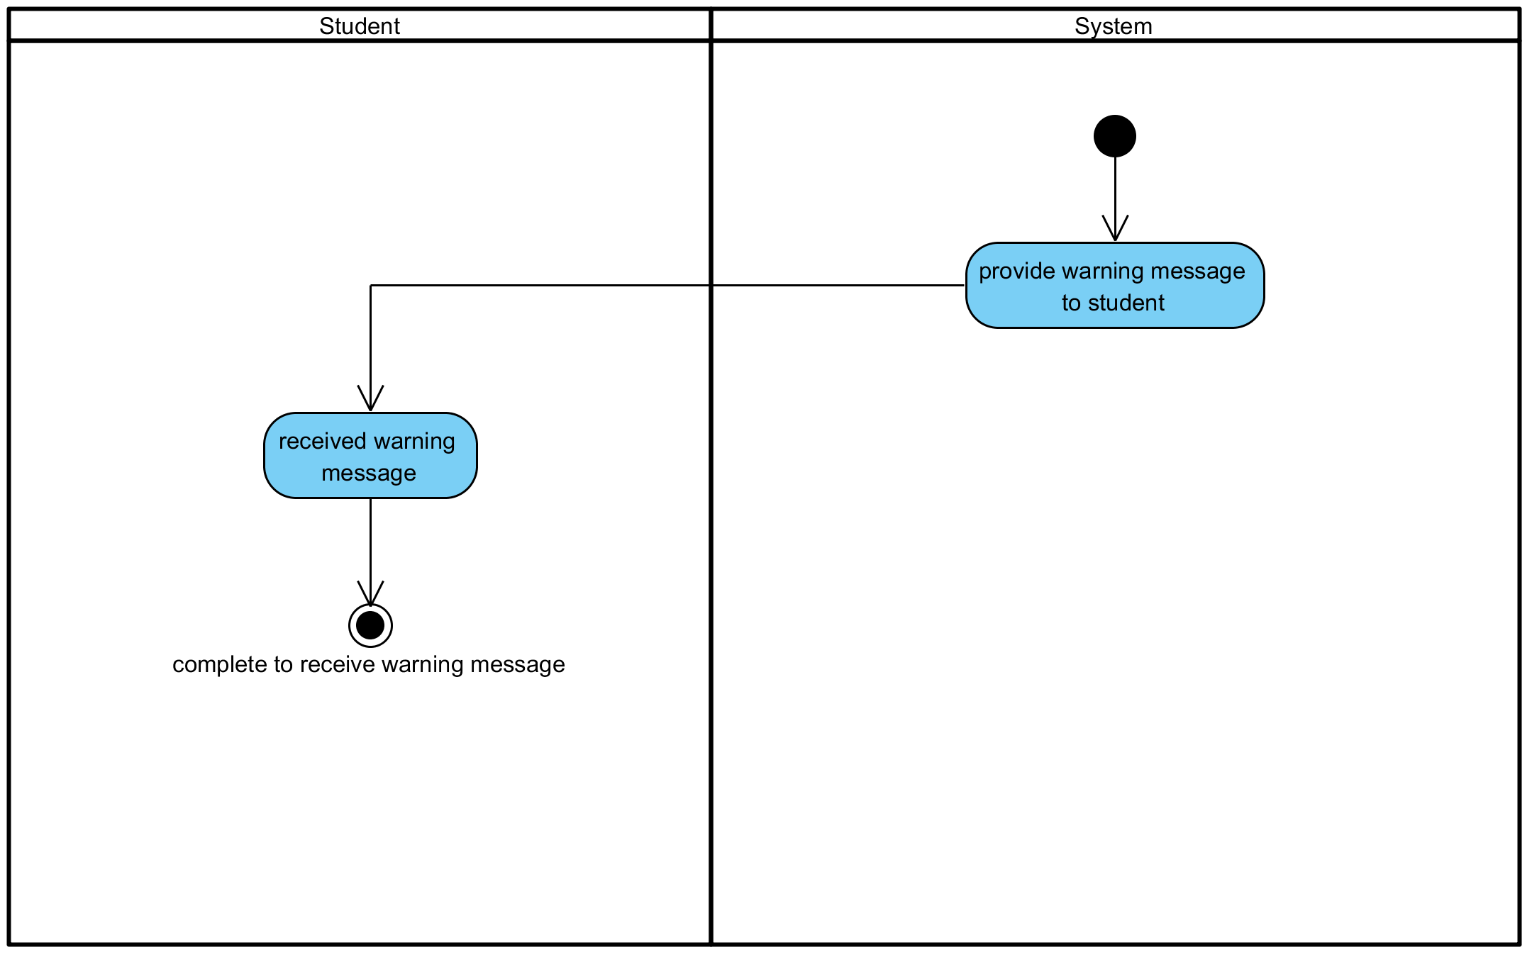

**Figure 29: Chat with Teacher in real time**

**Output:** Student chat with teacher.

**System Requirements Specifications:**

* **SRS34-34.1:** The system shall display interface for student to chat.

**3.28 Receive alert or warning message from Teacher.**

|  |  |  |  |  |
| --- | --- | --- | --- | --- |
| **Use Case ID:** | UC-028 | | | |
| **Use Case Name:** | Receive alert or warning message from Teacher. | | | |
| **Created By:** | Pichet Potha  Sittipong Borripan | | **Last Updated By:** |  |
| **Date Created:** | 12/5/2014 | | **Last Revision Date:** |  |
| **Actors:** | | Student | | |
| **Description:** | | This use case describe how student receive alert or warning message. | | |
| **Trigger:** | | Teacher send quiz interface to student in that class. | | |
| **Pre-conditions:** | | 1. Student already logged in to the system on own device.  2. Teacher send quiz interface to student in that class. | | |
| **Post-conditions:** | | 1. Student see warning interface and be able to see message from teacher. | | |
| **Normal Flow:** | | 1.The system shall display interface for student in that class to see warning message  2. Student see warning interface and be able to see message from teacher. | | |
| **Alternative Flows:** | | n/a | | |
| **Exceptions:** | | 3a. In the step 3 of the Normal Flow, if no internet connection  1. The system check the internet connection.  2. The system alerts the user that the internet connection does not  exist.  3. Use case ends. | | |
| **Priority::** | | High. | | |

**Use Case:** Receive alert or warning message from Teacher (UC028)

**URS1-28:** The web application shall allow the Student receive alert or warning message from Teacher.

**Input:**

|  |  |  |  |
| --- | --- | --- | --- |
| Input | Description | Constraints | Example |
| Message | The message that teacher want to send to the student. | Allow any special characters. | Stop talking |

**Action:**

**AC-28: Receive alert or warning message from Teacher.**



**Figure 30: Receive alert or warning message from Teacher.**

**Output:** Student see warning interface and be able to see message from teacher.

**System Requirements Specifications:**

* **SRS28-28.1:** The system shall display interface for student in that class to see warning message

**3.29 Receive quiz interface from Teacher.**

|  |  |  |  |  |
| --- | --- | --- | --- | --- |
| **Use Case ID:** | UC-029 | | | |
| **Use Case Name:** | Receive quiz interface from Teacher. | | | |
| **Created By:** | Pichet Potha  Sittipong Borripan | | **Last Updated By:** |  |
| **Date Created:** | 12/5/2014 | | **Last Revision Date:** |  |
| **Actors:** | | Student | | |
| **Description:** | | This use case describe how student receive alert or warning message. | | |
| **Trigger:** | | Student logged in to system. | | |
| **Pre-conditions:** | | 1. Student already logged in to the system on own device.  2. Teacher already to send quiz to student. | | |
| **Post-conditions:** | | 1. Student see quiz interface and be able to chat with teacher. | | |
| **Normal Flow:** | | 1. The system shall display interface for student to see quiz.  2. Student see quiz interface and be able to chat with teacher. | | |
| **Alternative Flows:** | | n/a | | |
| **Exceptions:** | | 2a. In the step 2 of the Normal Flow, if no internet connection  1. The system check the internet connection.  2. The system alerts the user that the internet connection does not  exist.  3. Use case ends. | | |
| **Priority::** | | High. | | |

**Use Case:** Receive quiz interface from Teacher (UC029)

**URS1-29:** The web application shall allow the Student receive quiz interface from Teacher.

**Input:**

|  |  |  |  |
| --- | --- | --- | --- |
| Input | Description | Constraints | Example |
| Question | The question that teacher input | Allow any special characters. | Please answer this 1+1=?   1. 0 2. 1 3. 2 4. 3 |

**Action:**

**AC-29: Receive quiz interface from Teacher.**

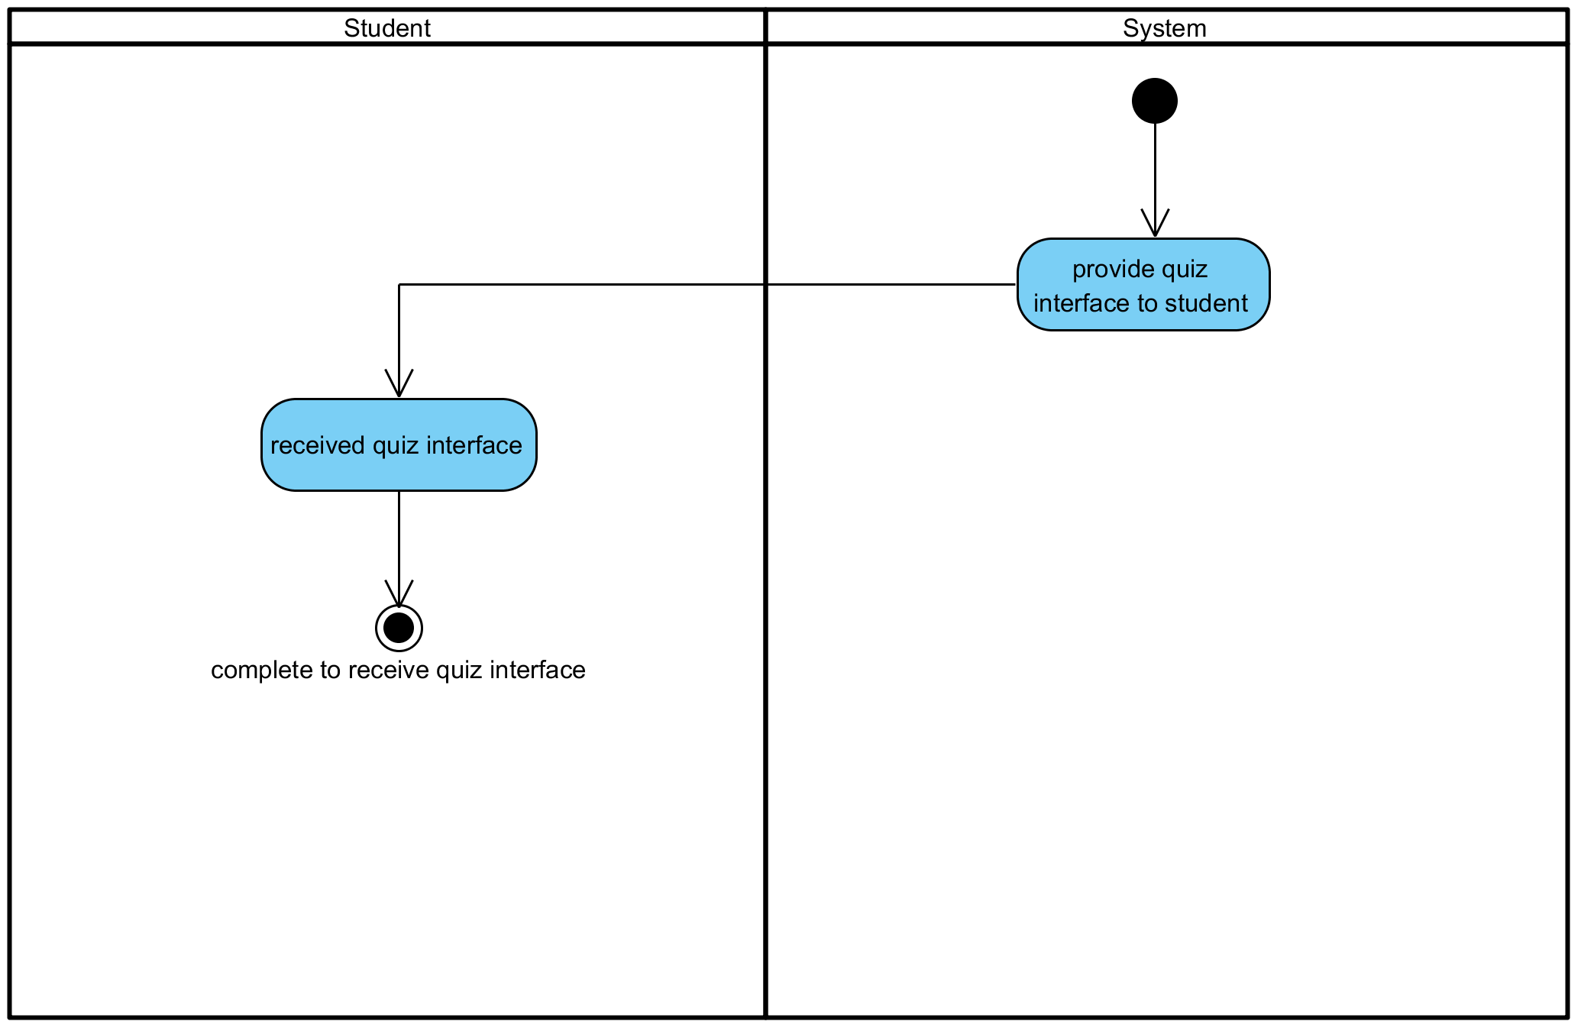

**Figure 30: Receive alert or warning message from Teacher.**

**Output:** Student see an alert or warning message.

**System Requirements Specifications:**

* **SRS29-29.1:** The system shall display interface for student to see quiz.

**3.30 Do the quiz.**

|  |  |  |  |  |
| --- | --- | --- | --- | --- |
| **Use Case ID:** | UC-030 | | | |
| **Use Case Name:** | Do the quiz. | | | |
| **Created By:** | Pichet Potha  Sittipong Borripan | | **Last Updated By:** |  |
| **Date Created:** | 12/5/2014 | | **Last Revision Date:** |  |
| **Actors:** | | Student | | |
| **Description:** | | This use case describe how student do the quiz. | | |
| **Trigger:** | | The system display interface for student to do quiz. | | |
| **Pre-conditions:** | | 1. Student already logged in to the system on own device.  2. Student already receive quiz. | | |
| **Post-conditions:** | | 1. Student complete to do the quiz. | | |
| **Normal Flow:** | | 1. The system display interface for student to do quiz.  2. Student write down answer to quiz interface.  3. Student complete to do the quiz. | | |
| **Alternative Flows:** | | n/a | | |
| **Exceptions:** | | 1a. In the step 1 of the Normal Flow, if no internet connection  1. The system check the internet connection.  2. The system alerts the user that the internet connection does not  exist.  3. Use case ends. | | |
| **Priority::** | | High. | | |

**Use Case:** Do the quiz (UC030)

**URS1-30:** The web application shall allow the Student do the quiz.

**Input:**

|  |  |  |  |
| --- | --- | --- | --- |
| Input | Description | Constraints | Example |
| Question | The question that teacher input | Allow any special characters. | Please answer this 1+1=?   1. 0 2. 1 3. 2 4. 3 |

**Action:**

**AC-30: Do the quiz.**

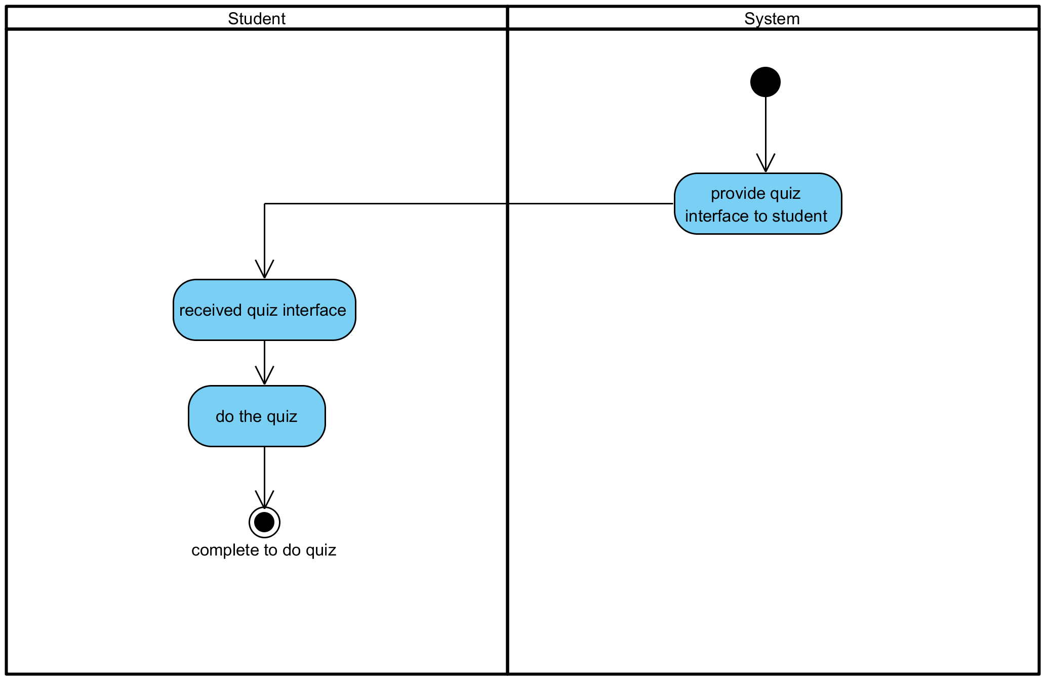

**Figure 31: Do the quiz.**

**Output:** Student complete to do the quiz.

**System Requirements Specifications:**

* **SRS30-30.1:** The system display interface for student to do quiz.

**3.31 Submit the quiz to Teacher**

|  |  |  |  |  |
| --- | --- | --- | --- | --- |
| **Use Case ID:** | UC-031 | | | |
| **Use Case Name:** | Submit the quiz to Teacher | | | |
| **Created By:** | Pichet Potha  Sittipong Borripan | | **Last Updated By:** |  |
| **Date Created:** | 12/5/2014 | | **Last Revision Date:** |  |
| **Actors:** | | Student | | |
| **Description:** | | This use case describe how student do the quiz. | | |
| **Trigger:** | | Student selects “submit” button on their own screen. | | |
| **Pre-conditions:** | | 1. Student already logged in to the system on own device.  2. Student already receive quiz  3. Student already complete doing quiz. | | |
| **Post-conditions:** | | 1. Student complete to submit the quiz to teacher. | | |
| **Normal Flow:** | | 1. Student selects “submit” button on their own screen.  2. The system shall send quiz answer to teacher.  3. Student complete to submit the quiz to teacher. | | |
| **Alternative Flows:** | | n/a | | |
| **Exceptions:** | | 1a. In the step 1 of the Normal Flow, if no internet connection  1. The system check the internet connection.  2. The system alerts the user that the internet connection does not  exist.  3. Use case ends. | | |
| **Priority::** | | High. | | |

**Use Case:** Submit the quiz to Teacher (UC031)

**URS1-31:** The web application shall allow the Student submit the quiz to Teacher.

**Input:**

|  |  |  |  |
| --- | --- | --- | --- |
| Input | Description | Constraints | Example |
| Question | The question that teacher input | Allow any special characters. | Please answer this 1+1=?   1. 0 2. 1 3. 2 4. 3 |

**Action:** The quiz has been submitted to teacher.

**AC-31: Submit the quiz to Teacher**

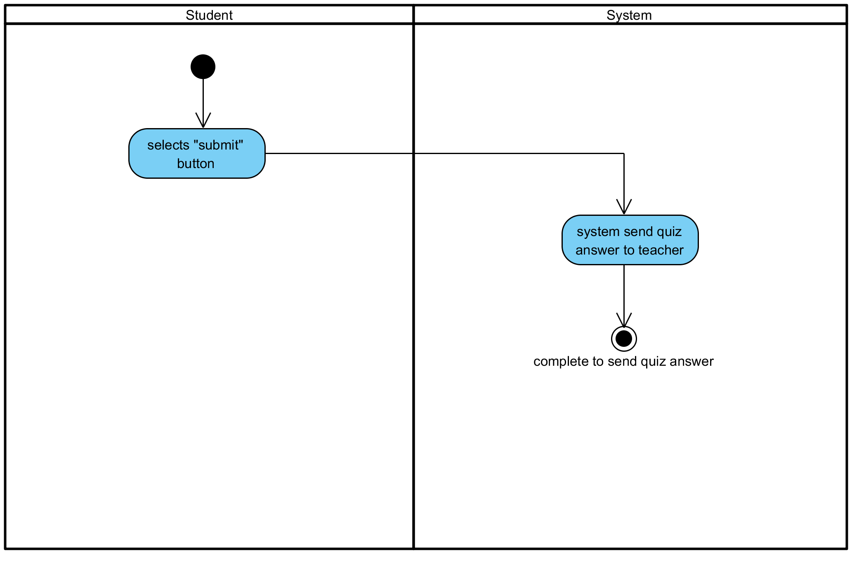

**Figure 32: Submit the quiz to Teacher**

**Output:** The quiz has been submitted to the teacher.

**System Requirements Specifications:**

* **SRS31-31.1:** The system shall send quiz answer to teacher.