**Easy Class**

Project Plan

By

|  |  |
| --- | --- |
| **Pichet Potha** | **542115041** |
| **Sittipong Borripan** | **542115066** |

Department of Software Engineering

College of Arts, Media and Technology

Chiang Mai University

Project Adviser

______________________________

Ms. Yun Rim Park

**Table of contents**

**Revision History………………………………………………………………………...…………………1**

**Chapter I | Introduction………………………………….………………………......………………........7**

**Chapter II | Infrastructure..…………………………………………………………….………………..13**

**Chapter III | Management Procedures………………...……………………………….…………….…14**

**Chapter IV | Quality Planning [V&V] ………………………………………….…………..…….……..16**

**Chapter V | Estimate Duration of Task……….………....………………………………….…...………18**

**Proposal………………………….……………………………………...…...…………...…….19**

**Progress report I……………….….…………. .……………………..…………...………….….20**

**Progress report II……………….…………………………………..………………...………....21**

**Progress report III………….………………………………….……..……………...………...22**

**Chapter VI | Estimated Effort and Cost………………………………………….……………………..23**

**Chapter VII | Identification of Project Risks……………...…………………….……….……..……….23**

**Chapter VIII | Version Control Strategy…………...……...………………………..…….…………….24**

**Chapter IX | Reference …………...……...…………………………….……………………………..….24**

**Revision History**

|  |  |  |  |  |  |  |  |  |
| --- | --- | --- | --- | --- | --- | --- | --- | --- |
| **Document Name** | **Version** | | **Status** | | **Date** | **Viewable** | **Reviewer** | **Responsible** |
| Easy_Class_Project_Plan_Version0.1 | Add | * **Introduction** * **Infrastructure** * **Management Procedures** * **Quality Planning [V&V]** * **Estimate Duration of Task** * **Estimated Effort and Cost** * **Identification of Project Risks** * **Version Control Strategy** | | Draft | 05/06/2014 | PP,SB,YP | PP,SB | PP,SB |

**Chapter I: Introduction**

* 1. **Project Overview**

**Project name: Easy Class**

Smart Classroom is a new way to teach now. There are many software to support and help teacher to control the device in class, but these software just have a few feature to support the class activity. From these problem, we provide the features to help the Teacher create the own class activity to use in Smart Classroom.

* + 1. **Purpose**

The software project management plan is a document for plan project and evaluate the project. The project plan can help to reduce cost and risk from project. The project plan is the plan that used to tracking and control project follow the plan after start the project.

* + 1. **Scope**
    2. **Objective**
    3. **Document Overview**
  1. **Work Product to be developed**
     1. **Deliverables**

|  |  |  |  |
| --- | --- | --- | --- |
| No. | Document | Software | Date |
| 1. | Project Proposal   * Proposal v.1.0 | - | 26/03/2014 |
| 2. | The progress report I   * Software Requirement * Specification v1.1 * Project Plan v1.1 * Software Design * Document v1.3 * Test Plan v1.2 * Test Record v1.1 * Traceability Record v1.2 * Progress status report | **Feature**   * Feature 1. User management * Feature 2. Class Management * Feature 3. White board for Teacher * Feature 4. Monitor Students * Feature 6. Grouping communication |  |
| 3. | The progress report II | **Feature**   * Feature 5. Collaboration Board * Feature 7. Mind map * Feature 8. Geographic Map |  |
| 4. | The progress Show Pro | About 80% of the overall project |  |
| 5. | The progress report III | **Feature**   * Feature 9. Uploading/downloading study materials * Feature 10. Share learning artifact * Feature 11. Note for student |  |

**Chapter II: Infrastructure**

**2.1 Software Resource**

|  |  |
| --- | --- |
| Software Topic | Details |
| Web Browser | * Google Chrome version 25.0 * Firefox version 20.0 |
| Database | * MongoDB 2.6 |
| Tools | * Aptana * Robomongo |
| Technology | * HTML5 * CSS3 * WebRTC * Node.js & Express.io * JavaScript * JSON * Google Maps API |

**2.2 Hardware Resource**

|  |  |
| --- | --- |
| Hardware Topic | Details |
| Pichet’s laptop | Operating System : Window 8.1 Pro  Processor : Intel® Core™ i3 2.53 GHz  RAM : 4GB  Hard Disk : 320GB |
| Sittipong’s laptop | Operating System : Window 8.1 Pro  Processor : Intel® Core™ i5 2.5 GHz  RAM : 4GB  Hard Disk : 700GB |
| Tablet |  |

**Chapter III: Management Procedures**

**3.1 Project Team Structure**

|  |  |
| --- | --- |
| **Staff** | **Activity** |
| Mr.Pichet Potha  Mr. Sittipong Borripan | Research project |
| Project Proposal |
| Project Requirement |
| Project Plan and Design |
| Implement |
| Testing |
| Review |

**3.2 Monitoring and Controlling Mechanisms**

**3.2.1 Software Development Models**

**Iterative Software Development Process [14]**

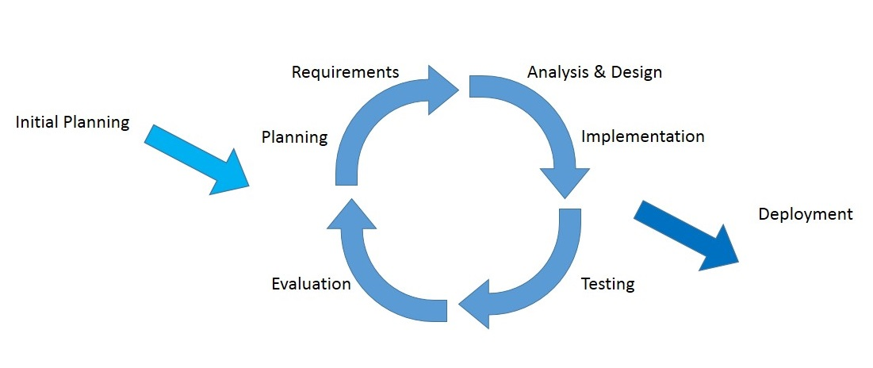

**Figure 8: The diagram of the iterative software development process**

The idea of the iterative software development model is to divide the development process into phases. As shown in Figure 8, the iterative process begins by implementing and specifying a portion of the software instead of specifying the full requirements. It is then reviewed along the way to find and add more requirements as needed. The model is broken down into increments containing a number of smaller life cycle stages with each part including a new function to the product. And each phase must be completed before the start of the next phase and the iterations continues until the entire product is built. Some of the advantages of the iterative development model include: more flexible to accommodate feedback from customers in each cycle, easy to implement sub-systems (or components) that satisfy user requirements, easy to fix errors that occur in the implementation process.

**3.3 Change Management**

Change control procedure

1. Admit the change.

2. Analyze the reason for the change.

3. Send change form to project advisor.

3.1 If accept: make a change in project from change request form.

3.2 If reject: Continue in the project and find the way to solve a problem.

4. Analyze the result from changing and modify the document or system to match with change.

**Chapter IV | Quality Planning [V&V]**

**4.1 Quality Factors**

According to McCall’s factor model, the Easy Class should meet these quality factor after complete:

**Product operation factors**

* **Correctness**
* The software be tested 10 times, all of 10 times must correct
* **Reliability**
* The failure rate of software should be less than 10%.
* **Integrity**
* The user should register and login to the system every time.
* The system should show the limit function for unregister user.
* Product revision factors
* **Maintainability**
* The software should be updated when new failures occur in the future.
* Testability
* The system should able to test all function.
* Product revision factors
* Portability
* The software should support at least 2 devices.
* Reusability
* The software should able to further development.

**4.2 Review/Responsibility**

|  |  |  |  |
| --- | --- | --- | --- |
| Stage Exit Review | | | |
| No. | **Stage** | **Review Item** | **Responsibility** |
| 1. | Requirements gathering and analysis | Project Proposal | PP, SB |
| 2. | Requirements gathering and analysis | Development Plan | PP, SB |
| 3. | Requirements gathering and analysis | Software Requirement  Specifications | PP, SB |
| 4. | Requirements gathering and analysis | Traceability Record | PP, SB |
| 5. | System Design | Software Design  Document | PP, SB |
| 6. | Implementation | Code | PP, SB |
| 7. | Testing | System test Record | PP, SB |
| 8. | Testing | Unit test Record | PP, SB |

**4.3 Testing**

|  |  |  |
| --- | --- | --- |
| Test Process | | |
| No. | **Test** | **Responsibility** |
| 1. | Unit test | Pichet Potha, Sittipong Borripan |
| 2. | System Testing | Pichet Potha, Sittipong Borripan |
| 3. | Acceptance Testing | Pichet Potha, Sittipong Borripan |

**4.4 Software Development Standard**

**ISO29110 for Very Small Entity (VSE)**

ISO29110 is a guide applies to a Very Small Entity (VSE), enterprise, organization, department or project up to 25 people, dedicated to software development. The Guide provides Project Management and Software Implementation processes which integrate practices based on the selection of ISO/IEC 12207- Systems and Software Engineering —Software Life Cycle Processes and ISO/IEC 15289 Software Engineering – Software Life Cycle Process – guidelines for the content of software life cycle process information products (documentation) standards elements.

**Project Management process**

The purpose of the Project Management process is to establish and carry out in a systematic way the tasks of the software implementation project, which allows complying with the project’s objectives in the expected quality, time and cost.

**Selected process**

Project Planning Process

Project Plan Execution Process

Project Assessment and Control Process

Project Closer Process

**Software Implementation process**

The purpose of the Software Implementation process is the systematic performance of the analysis, design, construction, integration and tests activities for new or modified software products according to the specified requirements.

**Selected process**

Software Implementation Initiation Process

Software Requirements Analysis Process

Software Architectural Design Process

Software Construction Process

Software Integration and Test Process

Software Delivery Process

**Chapter V | Estimate Duration of Task**

**Estimate Duration of Task**

|  |  |  |
| --- | --- | --- |
| Task and Estimate Duration | | |
| No. | **Phase** | **Estimate Duration(Days)** |
| 1. | Project Proposal | 17 |
| 2. | Progress report I | 36 |
| 3. | Progress report II | 47 |
| 4. | Progress report III | 47 |

**Proposal**



**Progress report I**



**Progress report II**



**Progress report III**



**Chapter VI | Estimated Effort and Cost**

Most of the cost will come from reference or learning textbook and hard copy document. Because of this project use only open source language and freeware tool for development, so most costs from this project use for buying some textbook and printing document.

**Chapter VII | Identification of Project Risks**

**Project Risk**

|  |  |  |
| --- | --- | --- |
| **Risk** | **Solution** | **Priority** |
| **Human Risks** | | |
| Group members are lack of skill and Knowledge. | Learn from a textbook, websites and ask someone who can help to solve the problem. | Medium |
| There is bad communication between group members. | Try to understand each other  and exchanges more  information together | Medium |
| **Technology Risks** | | |
| Problem with server connection. | Give the extra time to connect with the server or change the network. | Medium |
| File is crash | Use repository to keep file. | High |
| **Process Risks** | | |
| Date for submitting changed, the plan is also changed. | Try to finish all the works before plan. | High |
| Some Feature cannot complete follow with the defined plan. | Change the plan to implement that feature in the next phase. | Medium |

**Chapter VIII | Version Control Strategy**

**Naming Conversion and Project Repository**

Easy Class using GitHub to keep and shared file. GitHub can help to keeping track of changes for any file in the project. It make each member can do the **collaboration** work with each other from anywhere because we store any file about the project on GitHub. After complete implement the source code or document, the version number will increase for example:

From “Project_Plan_Version1.0” to “Project_Plan_Version1.1”.

GitHub can show the history of each file and quickly comparing changes.

**Configuration Item Table**

|  |  |  |  |  |  |  |
| --- | --- | --- | --- | --- | --- | --- |
| No. | Item | File Name | File Type | Owner | Path | Baseline ver. |
| 1. | Project Proposal | Easy_Class_Proposal_Version1.00 | .docx | PP, SB | E:\งาน\Senoir Project\GitHub\Easy-Class\Easy-Class | 1.00 |
| 2. | Development and Quality Plan | Easy_Class_Project_Plan_Version0.1 |  | PP, SB |  |  |
| 3. | Software Requirement Specification |  |  | PP, SB |  |  |
| 4. | Traceability Record |  |  | PP, SB |  |  |
| 5. | Software Design  Document |  |  | PP, SB |  |  |
| 6. | Software Source Code |  |  | PP, SB |  |  |
| 7. | Test Plan |  |  | PP, SB |  |  |
| 8. | Test Record |  |  | PP, SB |  |  |

**Chapter IX | Reference**