Low Level Design

**NBA DRAFT PICK**

|  |  |
| --- | --- |
| **Written By** | Mohammed Hasan Khan |
| **Document Version** | 0.2 |
| **Last Revised Date** |  |

# DOCUMENT CONTROL

**Reviews:**

|  |  |  |  |  |  |  |  |  |
| --- | --- | --- | --- | --- | --- | --- | --- | --- |
| **VERSION** | **DATE** |  | **REVIEWER** |  | **COMMENTS** | | |  |
| 0.2 | 15-12-2022 |  | Mohammed Hasan Khan |  | Unit test cases to be added | | |  |
| **Approval Status:** | |  |  |  |  | | |  |
| **VERSION** | **REVIEW DATE** |  | **REVIEWED BY** |  |  | **APPROVED BY** |  | **COMMENTS** |
|  |  |  | |  | |  |  | |

# Contents

## 1. Introduction………………………………………………………………………………………………………… 04

**1.1 What is Low-Level Design Document? …………………………………………………….. 04 1.2 Scope ……………………………………………………………………………………………………... 04**

## 2. Architecture ……………………………………………………………………………………………………….. 05 3.Architecture Description …………………………………………………………………………………… 08

**3.1 Data Description ……………………………………………………………………………………… 08**

**3.2 Data source ………………………………………………………………………………………………..**

**3.3 Data insertion into database …………………………………………………………………... 08 3.4 Make the SQL connection and set up the data** **source** **………………………………………………. 08**

# 1. Introduction

**1.1 What is Low-Level design document?**

The goal of the LDD or Low-level design document (LLDD) is to give the internal logic design of the actual program code for the House Price Prediction dashboard. LDD describes the class diagrams with the methods and relations between classes and programs specs. It describes the modules so that the programmer can directly code the program from the document.

## 1.2 Scope

Low-level design (LLD) is a component-level design process that follows a step-by-step refinement process. The process can be used for designing data structures, required software architecture, source code and ultimately, performance algorithms. Overall, the data organization may be defined during requirement analysis and then refined during data design work.

# 2. Architecture

# Power Bi server Architecture

|  |
| --- |
| Power BI architecture is a service built on top of Azure. There are multiple data sources that Power BI can connect to. Power BI Desktop allows you to create reports and data visualizations on the dataset. Power BI gateway is connected to on-premise data sources to get continuous data for reporting and analytics |

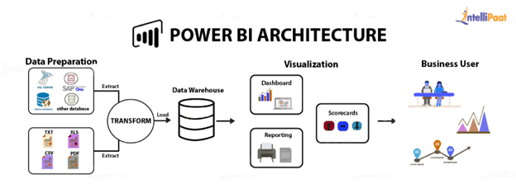

## 1. Gateway/Load Balancer

It acts as an Entry gate to the Power BI Server and also balances the load to the Server if multiple Processes are configured.

## 2) Application Server:-

Application Server processes handle browsing and permissions for the Power BI Server web and mobile interfaces. When a user opens a view in a client device, that user starts a session on Power Bi Server. This means that an Application Server thread starts and checks the permissions for that user and that view.

# 3. Architecture Description

## 3.1 Data Description

The Dataset contains NBA DRAFT PICK

1. Player : Player Name .
2. Year : which Year Player Pick .
3. Draft_Pick : how many times Player pick .
4. Height (No Shoes) : Player Height without Shoes.
5. Height (With Shoes) : Player Height With Shoes .
6. Wingspan : Player arm length from fingertip to fingertip .
7. Standing Reach : Player stand reach .
8. Vertical (Max) : measure player vertical jump .
9. Vertical (Max reach ) : measure player max vertical jump .
10. Vertical (No step) :
11. Vertical (No Step reach) :
12. Weight : player Weight .
13. Body Fat : Player Body Fat Level ,
14. Hand (Length) : Measure Player Hand Length .
15. Hand (width) : Measure Player Hand Width .
16. Bench :
17. Agility :
18. Sprint :

## 3.2. Data Source

I am get Data from Ineuron Internship Portal .

## 3.3. Data Insertion into Database

1. Database Creation and connection - Create a database with name passed. If the database is already created, open the connection to the database.
2. Table creation in the database.
3. Insertion of files in the table

## 3.4 Make the SQL connection and set up the data source

**Step 1: Configuring Power Bi**

Launch Power BI on your Workstation and select MySQL Server from the connect column on the left. This will open a dialogue box where you need to provide the connection details for MySQL Server.

To connect with Power BI, you will need to provide information about the server which hosts your database. If you want to connect to a contained database, you can also specify the name of the database.

To connect with a port other than the default port, you need to specify the port and server .

**Step 2: Configuring Data Source**

The data source page loads up after configuring the Power BI connector and successfully signing in.