|  |  |
| --- | --- |
| **CORE** | Metadata, citation and similar papers at core.ac.uk |

|  |
| --- |
| Provided by AUT Scholarly Commons |

**KEYS to Academic Writing Success:**   
**A six-stage process account**

Quentin Allan1   
Auckland University of Technology   
New Zealand

**Abstract**

This paper was originally conceived as a position paper arguing for the retention of *KEYS to Academic Writing Success* (KAWS), a successful undergraduate writing programme which had been developed by AUT University’s unit for Learning Development and Success: Te Tari Awhina. However, AUT’s approach to developing academic literacies has recently been reviewed; therefore this revised version merely seeks to document the approach taken in KAWS, which may be of pedagogical interest to colleagues considering adopting a genre-based approach to academic writing programmes. This approach aims to empower first year undergraduate students with the confidence and skills to tackle their first writing assignment, which is typically an essay, due in the first few weeks of the first semester. As a coherent writing development programme, KAWS has received positive endorsements from colleagues teaching on the programme and by faculty staff members whose students’ writing improves as a result of having attended the programme, and overwhelmingly positive feedback from the students themselves.

**Introduction**

One essential quality of a university writing programme is that it works. Simply put, this implies that students emerge, not only with a better understanding of the writing process, but with a repertoire of strategies which enable them to produce good assignments – with concomitantly high grades. In the real world, the first assignment given to an undergraduate student is typically an essay, due in the first few weeks of the first semester. Unfortunately, not all students enter university with either the confidence or the skills to tackle such a task, and support is not always available from subject lecturers. First-year students who are faced with the challenge of writing their first assignment need a writing programme which is both practical and effective, and which provides a solid foundation on which to further develop academic literacies. This paper outlines such a programme: *KEYS to Academic Writing Success* (KAWS) – a long-running and successful programme which has been developed by AUT University’s unit for Learning Development and Success: Te Tari Awhina.

This paper argues that when students develop a clear sense of where they are (at any

1 Allan, Q. (2012). Keys to Academic Writing Success: A six-stage process account. In M. Protheroe (Ed.) *Navigating the River: Proceedings of the 2011 Annual International Conference of the Association of Tertiary Learning Advisors of Aotearoa/New Zealand (ATLAANZ)* (pp. 82 - 106). Auckland, New Zealand: ATLAANZ.

82

given point) in the writing process, they are more likely to produce a well-argued, tightly structured essay, with fewer surface errors in spelling and grammar. This self-awareness can best be cultivated through a contextualised teaching programme in which each stage of the process is systematically explored through class discussion, demonstrated by an effective practitioner, experienced by the student and evaluated at the end of the process. This paper is organised in seven sections: the first   
section provides an overview of the KAWS introductory writing programme. Each subsequent section explores a key component of the six-stage programme: the second section outlines a systematic approach to question analysis; the third section considers effective ways of generating ideas; the fourth section explores the role of reading in the writing process; the fifth section outlines strategies for devising a logical plan; the sixth section commends the ‘framing’ approach which is used to model the drafting of paragraphs; the final section reviews a straightforward approach to proofreading and editing.

**AUT’s writing programme**

AUT University provides a free 50-hour academic writing programme for first year undergraduates (KAWS)2. The programme provides students with 10 hours of classroom teaching, over two days, with the balance comprising guided self-study and interactive on-line activities; in recognition of their coursework requirements, students have the remainder of the semester in which to complete the self-study component3. KAWS is offered in two forms: where possible, the programme is customised for specific papers with materials adapted for the needs of the subject discipline and the actual written assignment. For further discussion of how KAWS works as an embedded literacy development programme, see McWilliams and Allan (2011). The second form is the generic model, which is the approach outlined in this paper. The teaching approach adopted by KAWS lecturers is informed by genre literacy pedagogy, especially as it has been developed by literacy specialists in Australia; see, for example, Cope and Kalantzis (1993); Kress (1993); Martin and Rose (2005). Genre literacy pedagogy is closely allied with Michael Halliday’s (1985) functional model of language with its emphasis on context and awareness of register variables. This approach encourages literacy specialists to focus on whole texts, paying particular attention to text structure and lexico-grammatical patterning

2 Grateful acknowledgement is hereby made to my colleagues at Te Tari Awhina for their enthusiastic support in team-teaching *Keys to Academic Writing Success*; in particular, I wish to pay tribute to the previous paper leader, Sue Bretherton, for her role in developing many of the materials, including some online activities. I also wish to thank Rainie Yu for her cheerful assistance in formatting the initial unedited figures for this paper.

3 Students are able to choose from a suite of on-line activities. These are available under 10 headings: academic writing context; writing process; analyzing essay questions; introductions; body paragraphs; conclusions; reading and research; referencing; proof-reading; academic vocabulary. These online activities are a requirement of the programme and students’ online presence is monitored as one of the assessment criteria. Work is in progress to improve the interactivity of the online component. Students who require further guidance are always welcome to visit the twice daily LDS: Te Tari Awhina ‘drop-in’ sessions, or to make an appointment for an hour-long consultation with a lecturer.

83

within distinct stages of a given text. Through a carefully selected series of hands-on activities and expert demonstrations, students are scaffolded towards the point where they can confidently tackle an academic assignment, secure in the knowledge that they know what they are doing, and where they are in the writing process. For further information on scaffolding learners, see Wood, Bruner and Ross (1976) and Vygotsky (1986). For a fuller discussion of the theoretical underpinning of the KAWS approach, with particular reference to genre literacy pedagogy, see Allan (Forthcoming).

In conjunction with an exploration of the academic writing process in very general terms, the programme begins with a needs analysis activity, adapted from Cottrell (1999). See Figure 1.

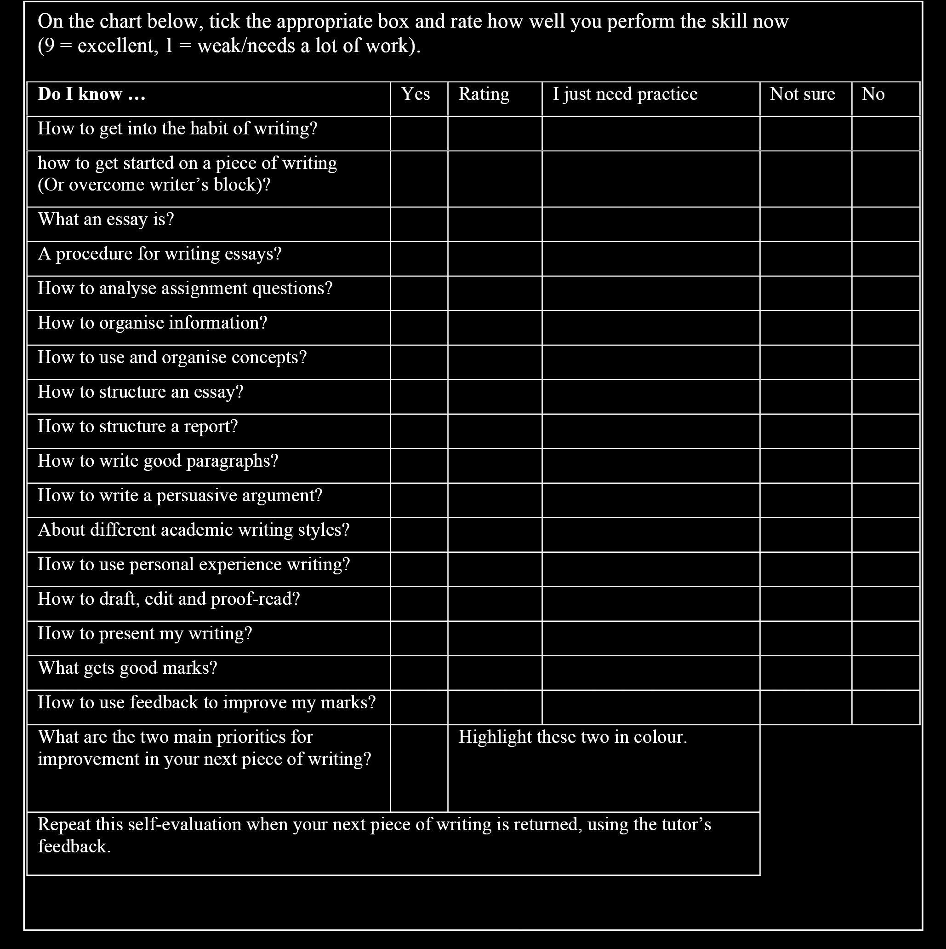

*Figure 1*. Needs Analysis Self Evaluation: How good am I at managing writing tasks?

84

The importance of this self-appraisal questionnaire cannot be overstated: not only does the activity provide students with some of the meta-language associated with academic writing, it also highlights aspects of the writing process which are typically ignored or neglected by students. This is followed by a peer-activity in which students design an action plan. See Figure 2.

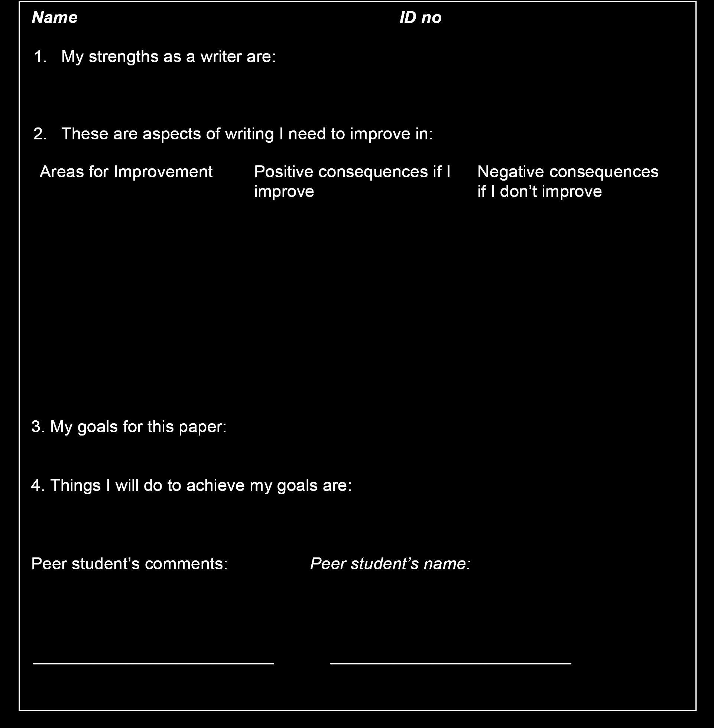

*Figure 2*. Action Plan

85

In their personalised action plan, each student is encouraged to identify specific goals which are specific, measurable, achievable, realistic and timely; working through this process also helps students to begin considering some of the key concepts which they will be engaging with over the next 10 hours. For further information about goal setting, see Covey (1990). One of the most problematic issues identified by students is inefficient time management. This then, is both a starting point and an orienting device for the entire writing programme. As a class, students brainstorm the key stages of the writing process which are mapped onto a timeline, see Figure 3.

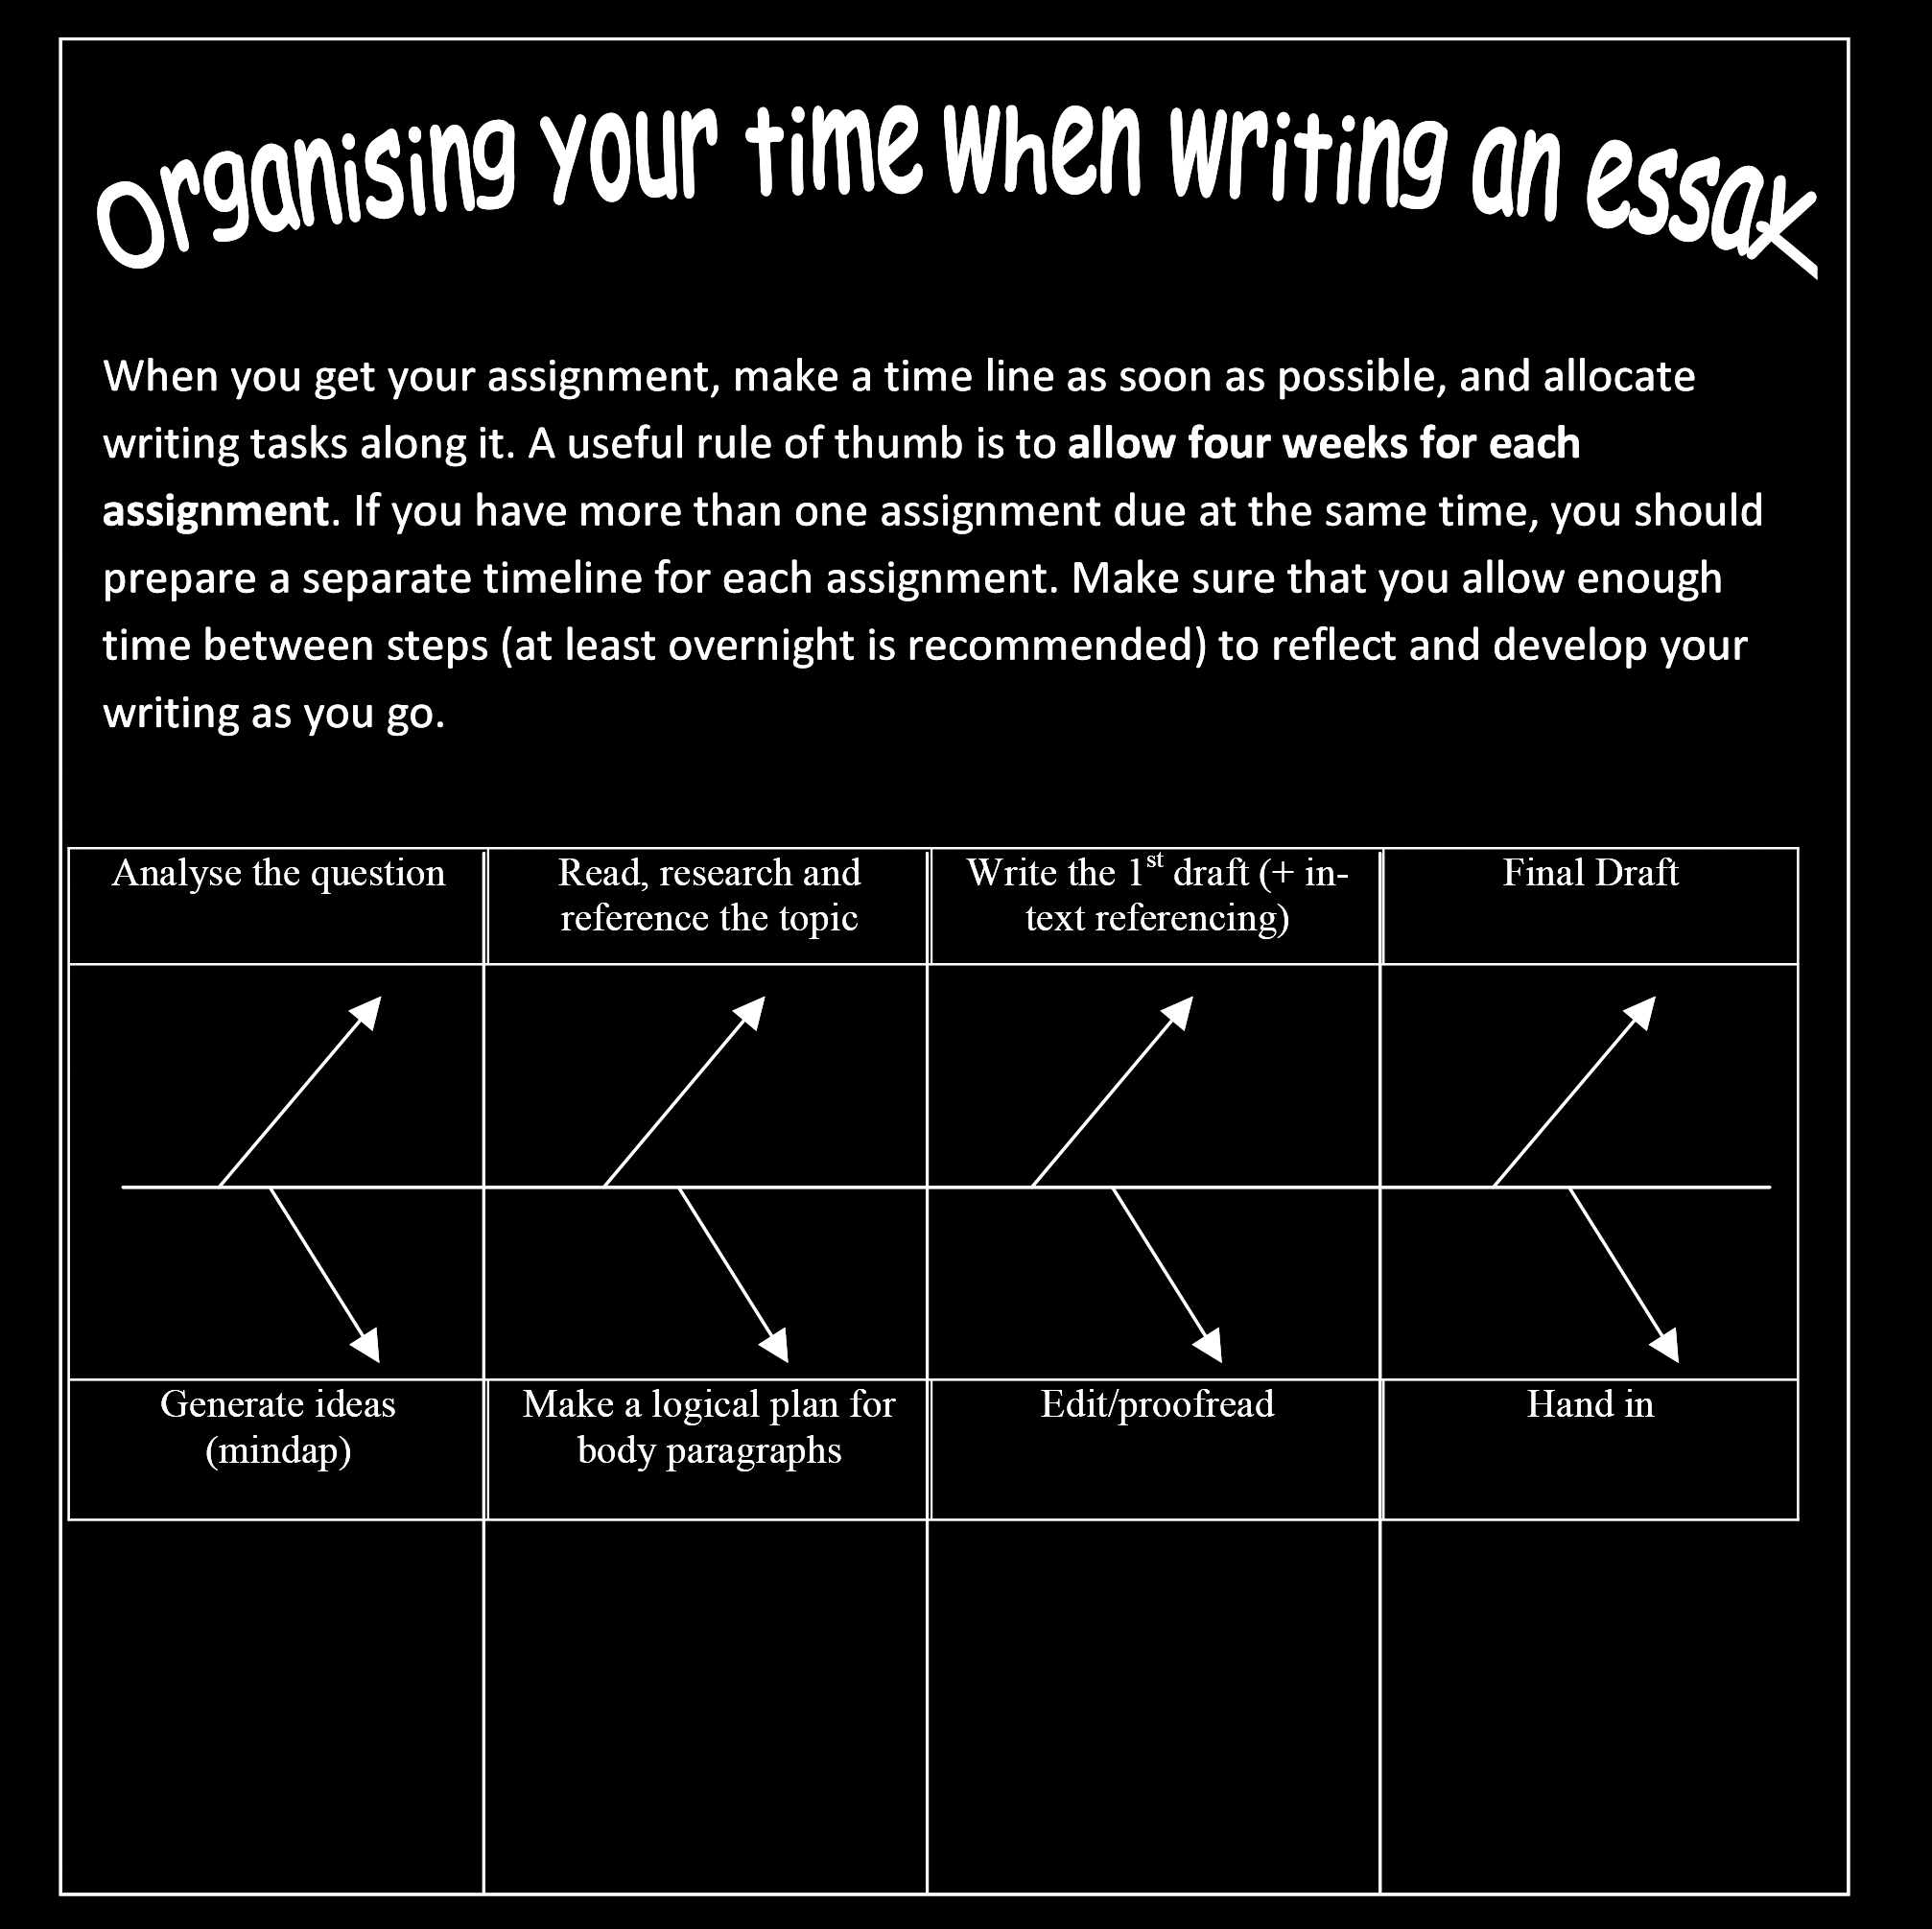

*Figure 3*. Timeline

This timeline is invoked regularly throughout the 10 hours of classroom teaching and two key messages are emphasised: firstly, knowing where one is in the writing

86

process is essential; and secondly, the objective is to get to the drafting stage as early as possible, *without neglecting any of the previous four stages.*



The first stage focuses on the assignment question: close questioning of students about their approach to question analysis confirms our suspicion that, too often, questions are given little more than a cursory reading. With reference to Figure 4, students are led through a consideration of assignment requirements from both their own perspective and that of their lecturers.

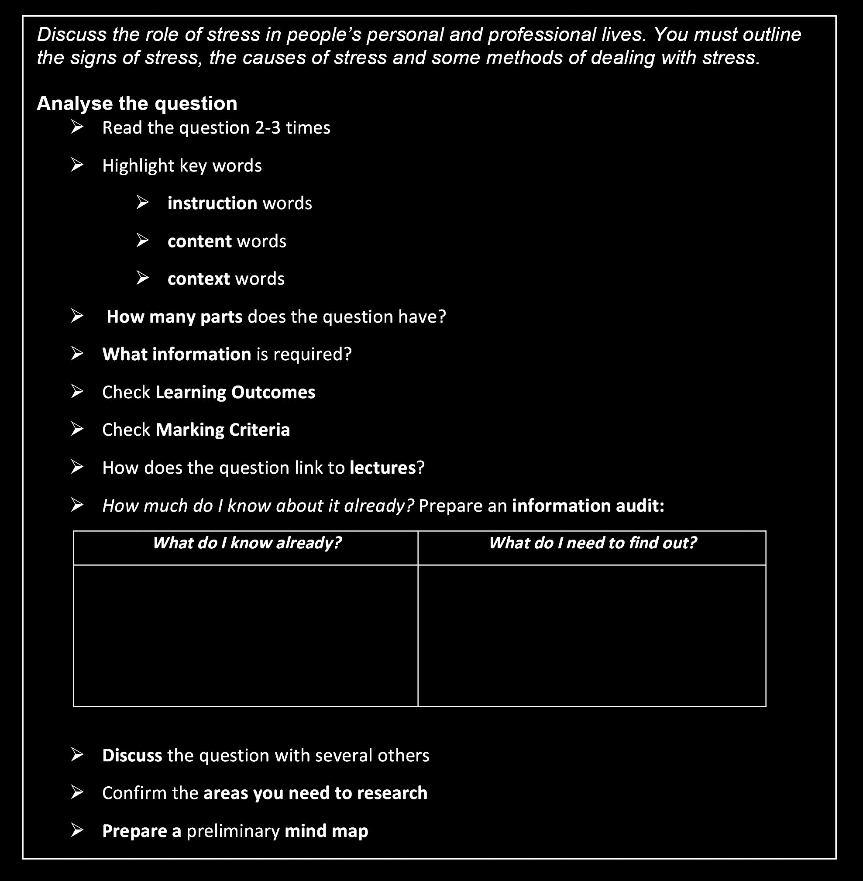

*Figure 4*. Question Analysis

87

Particular attention is drawn to the need for systematic identification and analysis of key words, not only in the question itself, but also in the Learning Outcomes.

Useful discussion of key words as used in academic contexts can be found in Biber, Johansson, Leech, Conrad, and Finegan (1999); Coxhead (2000); Leech, Rayson, and Wilson (2001); Nation (2001); and Hinkel (2004) . Key words are explained as follows: ‘instruction words’ are directive verbs (such as *discuss, analyse, justify, critique*); ‘content words’ are typically abstract nouns – often extended noun groups; ‘context words’ refer to time, location and manner (ideas such as where, when, to what extent). These terms are explored with the introduction of a sample essay question relating to stress: *Discuss the role of stress in people’s personal and professional lives. Outline the signs of stress, the causes of stress and some methods of dealing with stress*.

Having identified these key words, students’ attention is drawn to the advantages of preparing an ‘information audit’ – basically, a rough sketch of what they already know about the topic contrasted with a summary of identifiable lacunae. An explicit statement of these gaps in their knowledge provides a focus to the reading which follows on from the generation of ideas.



Most writers will, at some point in their life, have experienced the frustration of writer’s block. This problem is one of the difficulties typically identified by students in their needs analysis, hence the attention paid to developing strategies for generating ideas at this stage of the programme. With reference to the key concepts identified in the question analysis, various approaches are discussed, including free-writing, brainstorming and mind-mapping. One of the problems associated with free-writing is related to coherence and structure; in practice, what begins as a free-writing activity often ends up being submitted as the final assignment – a painful and   
tedious experience for the marker who must struggle to make sense of the text, and a disappointing result for the writer when the assignment is returned with the predictably low grade. Given the incoherence associated with free-writing, students are encouraged instead to adopt a sequenced approach involving brainstorming and mind-mapping along the lines suggested by Buzan (1993)4. The first rule of brainstorming is that (within reason) anything goes, so all ideas are jotted down. The crucial next step is to impose some sort of order on the initial brainstorm. Sometimes an order will suggest itself: possibilities include hyponomy (hierarchy), metonymy (association), meronymy (part-whole), chronology, cause and effect, pros and cons; however, experience suggests that not all students are immediately aware of the productive potential of sense relations and other categorising options. Therefore, a basic heuristic is suggested whereby multiple questions are asked, using the standard

4 Students who feel more comfortable using a free-writing approach are alerted to the dangers as outlined above, and invited to consider using this approach as an idea-generating strategy, to be followed by deconstruction, reordering and eventual reassembly at the drafting stage.

88

prompts: who, what, where, when, why, how, and the answers deployed clockwise around the central organising idea. The point is made that more than one attempt is necessary in order to arrange ideas satisfactorily and to identify connections. This process is demonstrated in class and students are able to see how the initial brainstorm morphs into a more thematically oriented mind-map. With respect to the stress question, the initial mind-map emerges structured something along the lines of that depicted in Figure 5.

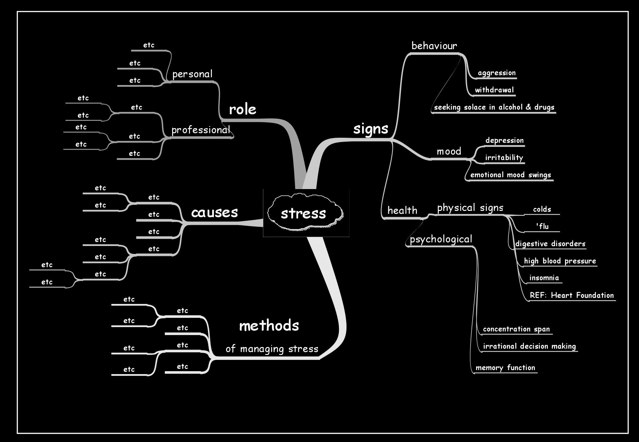

*Figure 5*. Mind Map

Brainstorms and mind-maps are modelled on the whiteboard and students are encouraged to adopt this strategy in approaching all future assignments. The simple power of pen and paper is acknowledged and celebrated, typically with either presentations or wall displays of students’ group work; the class is also invited to explore the potential of commercial mind-mapping software such as *Inspiration©*, which has the added advantage of enabling writers to convert mind-maps to essay outlines.

89



Now that the question has been analysed and ideas generated, students are ready to embark on the reading. However, a common problem expressed by students is knowing where to start. General advice is provided with reference to the library catalogue and databases, and the multiple entry-points available5. The reading list, if provided, is a useful starting point and students are alerted to the potential of identifying additional sources from the reference section in each of the readings. Reading is an activity which all students have been doing for years without having given it much, if any, conscious thought. Our aim at this point is to encourage metacognitive awareness of the different reading strategies available at different stages of the reading and writing process. Emphasis is placed on the importance of reading strategically: it is not possible to read everything, so students need to skim read first to decide if the text is useful. Having selected a text, then they need to read it carefully, and make notes for the essay. Key concepts of scanning for detail, skimming for gist and annotating texts are introduced and discussed in general terms leading in to a discussion of the sorts of texts which are appropriate for citing in academic essays. Students are led to explore key criteria for selecting appropriate texts and provided with a checklist containing five ‘quality control’ questions to ask before selecting a text:

1. What is the source? Is it from a reputable organisation such as a university or a government department? Knowing where a piece of writing comes from helps you to place it in context, and decide how reliable it is.

2. How current is it? Unless there is an historical reason to do so, a good rule of thumb is to use more recently published sources.

3. Who is the author? Do they have any expertise in the topic?

4. What sort of writing is it? What is the text structure? newspaper, magazine, academic journal, website, book, encyclopaedia, press release...

5. What is the purpose? Is it to inform, to argue for a point of view or to advocate change? Look beneath the surface. What is the writer’s agenda?

Having identified appropriate texts, students are alerted to seven critical reading questions to ask as they are reading:

1. What are the ideas and key points? Work out what they mean to you.

2. What is the writer’s perspective? Think about the cultural and social implications of this perspective.

5 Time is not available during this programme to address database searching in depth; however, students are advised to enrol on the library courses which are also available free of charge to all students at AUT University.

90

3. What is the writer’s position? For, against, neutral...

4. Is there adequate evidence for the conclusions?

5. Is the writing grounded in robust theory and research?

6. Is the information factually correct?

7. What assumptions does the writer make?

For further information about reading within an academic context, see Cope and Kalantzis (2000); Brick (2009); and Godfrey (2009). The importance of notetaking is emphasised and various approaches are outlined. The familiar and useful mnemonic ‘SQ3R’ is introduced as a practical heuristic to aid retention and recall of complex information (Robinson, 1970); see Figure 6.

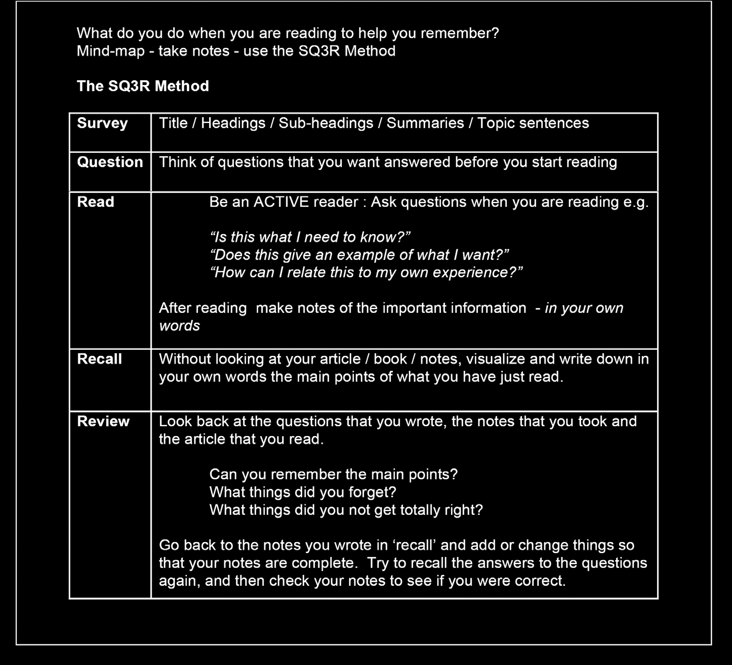

*Figure 6*. Readings: Active Reading

91

Having covered theoretical aspects of reading, an opportunity is provided at this point for students to apply appropriate reading skills to a carefully selected collection of readings from a range of sources (newspapers, academic journals, Heart Foundation, websites); before starting the reading, students are invited to devise a coding device to help them keep track of key themes as identified from the question analysis. A group reading activity is followed by feedback on the whiteboard using a reading synthesis grid, a simple but highly effective strategy for keeping on top of complex and extensive reading matter. A reading synthesis grid enables students to organise the notes from their readings in a systematic manner, and to view at a glance the themes covered in the readings. Later, in the drafting stage, it becomes an essential resource for quickly and accurately locating statistics, definitions, other quotes and text which has been earmarked for paraphrasing. Students have the option of orienting the reading synthesis grid concept-centrically, as in Figure 7, or author-centrically (Godfrey, 2009; Webster & Watson, 2002).

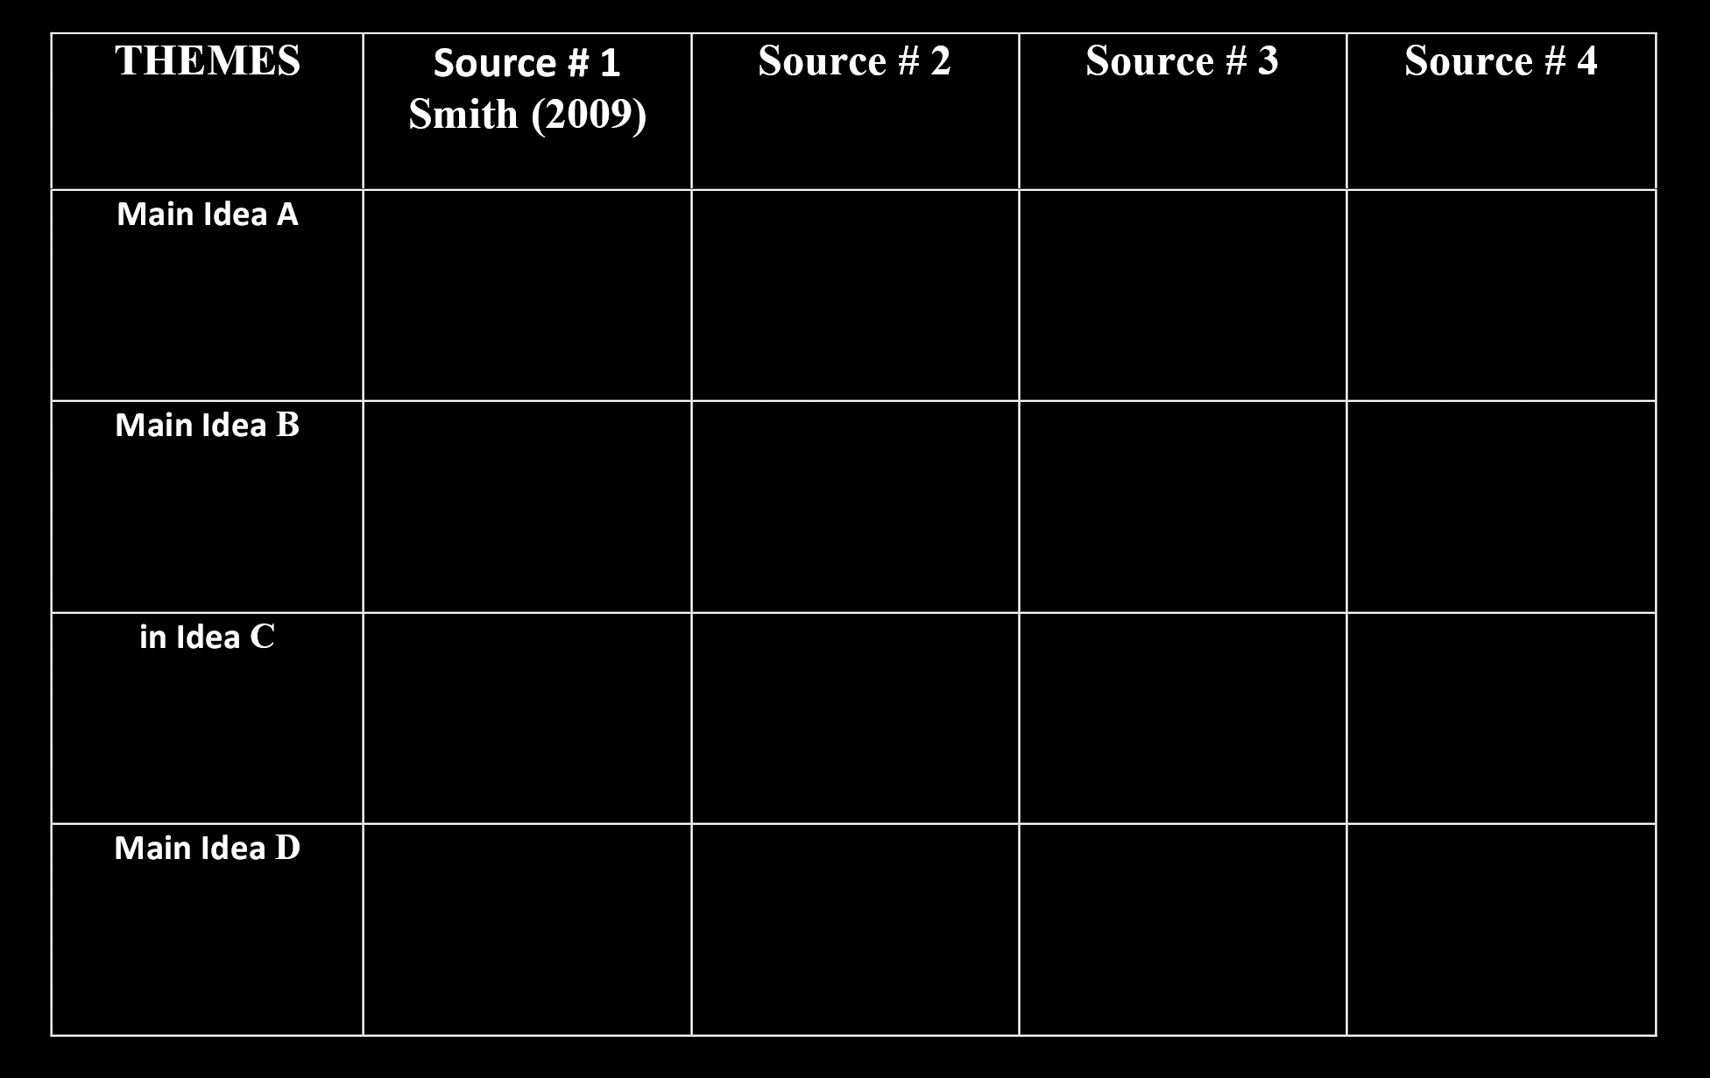

*Figure 7*. Synthesis Grid

Reading copious amounts of academic text presents a number of challenges to anyone, which the strategies outlined here address to some extent; however, one of the perennial difficulties (and not just for first year students) is knowing when to stop reading. The advice we give is closely tied in with time management – specifically with reference to the time-line. Students are alerted to the likelihood that reading will quickly subsume time which would be better spent on drafting; therefore, it is in their interests to move on from reading to the plan formulation stage as soon as a representative coverage of the literature has been achieved.

92

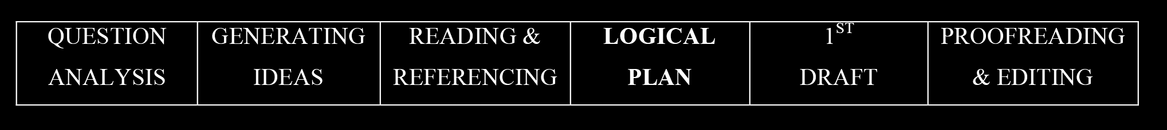

The planning stage is absolutely essential and the old adage ‘fail to plan: plan to fail’ is explored through class discussion and illustrated with the appropriate cautionary tales. A surprisingly high number of students are unaware, not only of the importance of planning, but of how to go about formulating a workable plan. Numerous sources provide advice about planning; see, for example, Cottrell (1999); Brick (2009); de Luca and Annals (2009); Godwin (2009); and Oshima and Hogue (2007). Standard procedure is to refer back to the assignment question, specifically to the key words which were identified, and to the actual requirements of the question, then to the themes which are used to organise the reading synthesis grid. These themes very often form the basis of the body paragraphs. The next step is to check the word count followed by a quick demonstration of the economics of essay structure. Assume the word limit is 1500 words; if 10% of the word limit is assigned to the introduction and 10% to the conclusion, that leaves 1200 words for the body; if four salient themes or issues emerge from the question and reading synthesis grid, then each body paragraph will have 300 words, with some flexibility allowed. The structure of each paragraph is not outlined until the next stage, as a preliminary to drafting the body paragraphs; instead, at this point the emphasis is on identifying and articulating the main idea for each body paragraph, then deciding on the sub-points [*How many? In what order?*], then on the nature of elaboration for each sub-point.

93

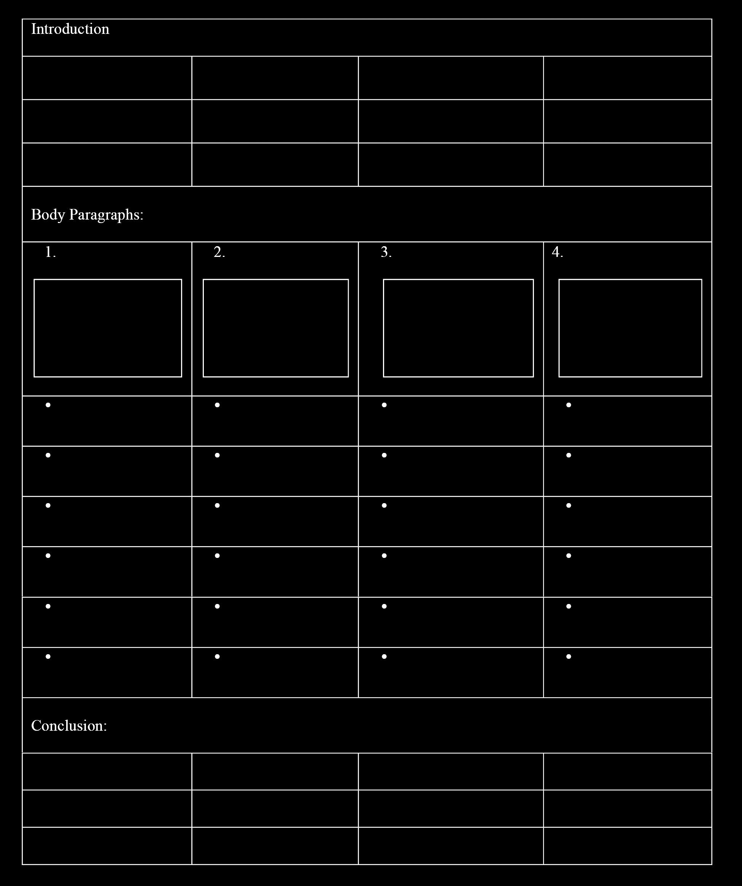

*Figure 8*. Essay Plan

With reference to Figure 8, approaches to developing the main idea are discussed, with a rule of thumb being at least one in-text citation for each paragraph. The reading synthesis grid is invoked again at this point to provide a sense of which sources are appropriate to illustrate or elucidate a point. This provides a short-list which can be narrowed down at the point of actually drafting each paragraph.

94



From the perspective of an English lecturer who has marked thousands of student essays, it is evident that too many students submit what is essentially a first draft, typically written without reference to a carefully devised plan and with only cursory attention given to the assignment question. The approach we have adopted with the KAWS programme is designed to highlight the importance of each stage in the writing process and to emphasise the point that it is counter-productive for the student to begin drafting until each of the previous four stages has been adequately addressed. The drafting stage is promoted as the most exciting stage, when ‘it all comes together’; the use of the word ‘draft’ in preference to ‘write’ underlines the point that the emphasis is on getting words down on paper, not on getting it right. Drafting is a recursive activity, with the possibility of numerous reformulations, each resulting in an increasingly well-constructed and nuanced essay. The key point is made that the first draft is simply that – a tentative attempt to create linear text in which an argument is developed and points elaborated.

From the very beginning of the KAWS writing programme, students are assured that they will not have to do any actual writing until the process has been demonstrated by their lecturers. This assurance results in a more relaxed frame of mind with which to identify and consider each discrete stage as the programme unfolds. In order to demystify the composition process, each stage in the process has been explored with reference to the writing task (the essay on stress). The question is analysed on the white board, ideas generated in plenary discussion and mapped out in real time for students to see how themes and concepts coalesce visually and how connections between ideas can be depicted diagrammatically; the set of readings is explored individually and in groups, then possible in-text references identified and noted on the reading synthesis grid; this then helps to inform the logical plan from which the essay can be drafted.

The stage is almost set for the lecturer to demonstrate, using ‘think-aloud’ protocols, how a confident, sophisticated writer might approach the first draft of an academic essay. However, an essential preliminary step involves deciding on the structural composition of three paragraph types, starting with the Introduction. This is presented as having six components, as in Figure 9.

95

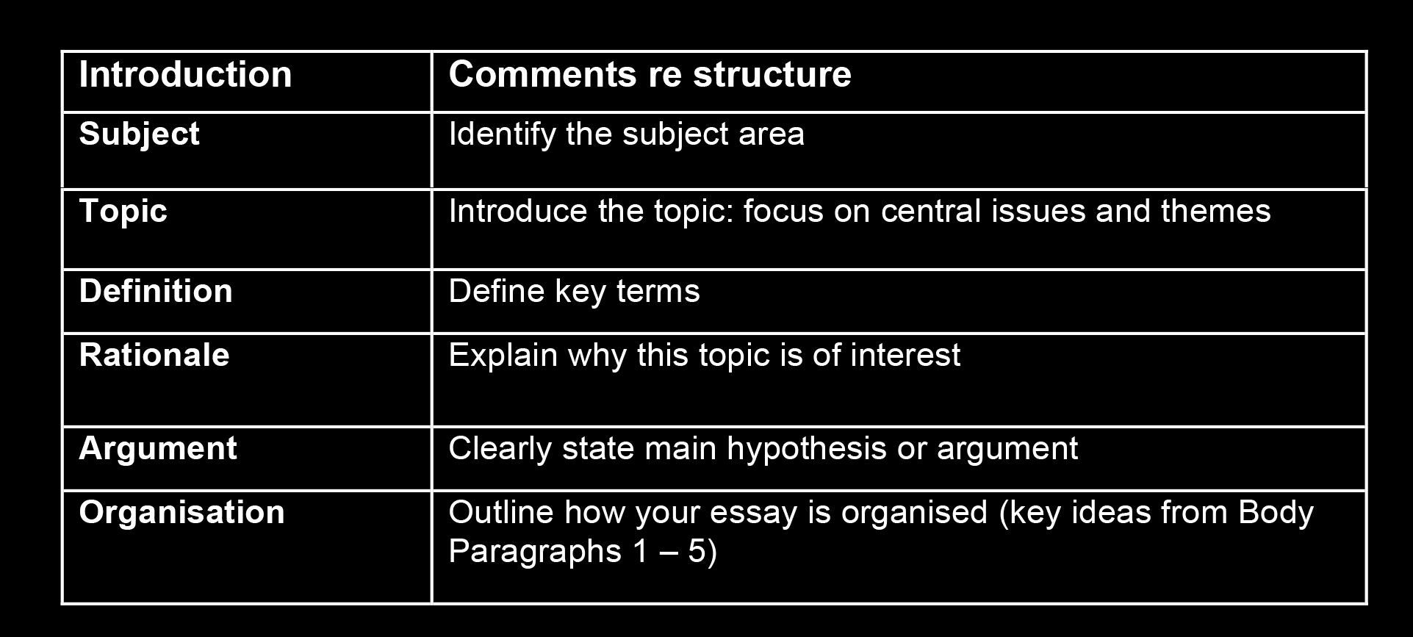

*Figure 9*. Introduction

The different components of each paragraph are explored through a guided analysis of a model essay, written from a Health Sciences perspective, on the subject of teenage alcohol abuse. The approach taken has been informed by some of the earliest advocates of genre analysis: Hoey (1983); Swales (1990); Bhatia (1993); and Dudley-Evans (1994). The point is made that tremendous variety on paragraph structure is possible in practice, but that a neophyte writer (unsure of what belongs in an introduction, and in what order) will produce a tightly structured paragraph if this schematic structure is followed. Discussion follows about the function of the introduction and students’ attention is drawn to the following prompts and advice:

• What is your purpose? Are you writing to inform, educate, persuade or evaluate an issue?

• What is the issue?

• Move from the general to the specific.

• Who is your reader?

• What’s the central problem or question that your writing is going to address?

• Bold statements, controversial quotations or rhetorical questions are good opening gambits for your opening sentence.

• Most reading is voluntary. By the end of your introduction you should have convinced your reader that it is worthwhile continuing. You have got something important to say, and they should keep reading.

Although it is the first paragraph of the essay, students are encouraged to consider drafting the introduction after they have drafted the body. This makes sense in practical terms as it means that they are more likely to have formulated an argument and they will have a clearer sense of how the body is organised.

The introduction is then contrasted with the conclusion, which is presented as having three components, as in Figure 10.

96

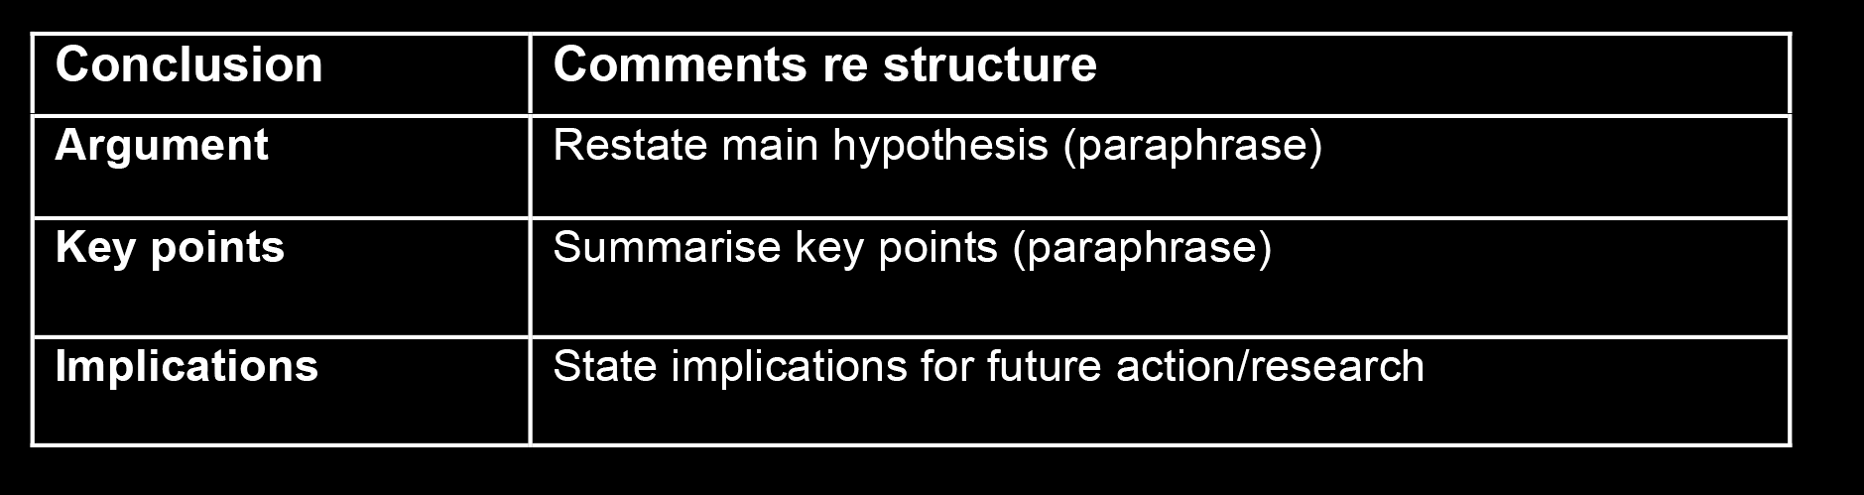

*Figure 10*. Conclusion

Discussion follows about the function of the conclusion and students’ attention is drawn to the following prompts and advice:

• Have you answered the question?

• Do not include new material in the conclusion.

• Re-read your introduction to remind yourself what it is you were promising to deliver to your reader.

• Use the conclusion as a means to reinforce your main idea or points of view.

• If there is nothing more to be said on your topic, it is time to finish. You do not have to write a ‘thank you and goodnight’ final sentence.

With respect to body paragraphs, the point is made that the structure used will depend on the ideas being developed. At school, students are often taught the SEX structure: Statement, Example, eXplanation. At tertiary level, common acronyms include TEER: Topic sentence, Explanation, Example, Relevance, and PERL: Point, Elaboration, Relevance, Link. In Business, a common paragraph structure is ITAC: Issue, Theory, Application, Concluding statement. In Law, a common paragraph structure is   
ILAC: Issue, Law, Application, Concluding statement. Some colleagues teaching on KAWS like to introduce students to Toulmin’s model of argumentation as outlined in Toulmin, Rieke, and Janik (1984) and further developed in Toulmin (2001). A general-purpose structure that many students find useful at university is outlined in Figure 11.

97

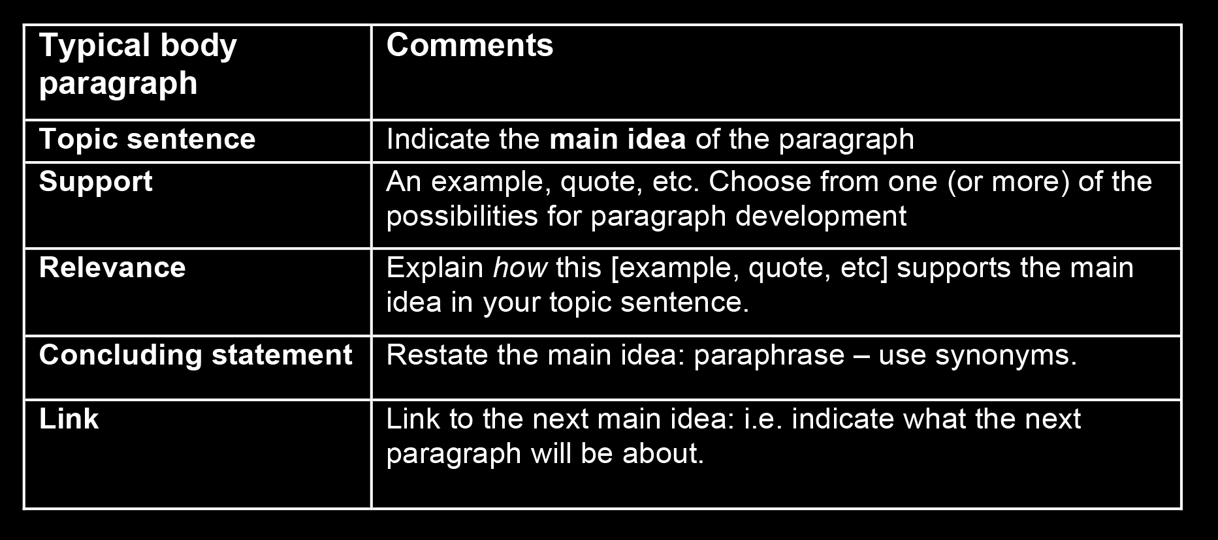

*Figure 11*. Body Paragraph

Because of the greater potential for variation in structure and function in body paragraphs, students’ attention is drawn to the following prompts and advice:

• **Unity** – each paragraph should have one clear focus. If you were asked to explain what the paragraph was about, you should be able to summarise the main idea in just a few words.

• **Coherence** – this is achieved when all of the concepts, propositions and examples within the paragraph are clearly related to each other and consistent with the main idea of the paragraph, as indicated in the topic sentence. People will find your essay easy to read if each paragraph is well developed, and clearly about one main idea, as indicated in its topic sentence.

• Each **topic sentence** should be clearly identifiable. Topic sentences can be used by the reader to skim through the essay and easily follow the logical ‘flow’ of ideas. This makes the whole essay coherent.

Students sometimes appear to be confused by the terms ‘coherence’ and ‘cohesion’.

The term ‘**cohesion**’ refers to the ways that sentences are linked together grammatically and through vocabulary (Halliday & Hasan, 1976). Students are encouraged to enhance their paragraphs’ cohesion by focusing on word choice.

Practical ways to achieve cohesive text include:

• Repeat key words and ideas – use synonyms and paraphrase

• Use pronouns (*she, it, this*) to refer to people, ideas and units of text

• Use ordering words to sequence your ideas (*firstly, secondly, finally*)

• Use transition markers to indicate the relationship between different ideas (*however, therefore, moreover*)

• Use contrast (*national—global; liberal—repressive*)

98

Having established the characteristic structural and functional components of paragraphs, the next step is for the lecturer to model for students the drafting of a body paragraph, the introduction and the conclusion, in that order. Keeping track of the different pieces of paper in the process of tackling a writing assignment poses a huge challenge for many students, and advice is provided at this point that the following documents need to be at hand:

• Assignment question

• Reading synthesis grid

• Readings

• Essay plan

• APA reference guide

• KAWS writing guide: paragraph structure

The first body paragraph is the starting point, and in order to ensure that each structural component is addressed in turn, a drafting frame is used, developed according to the principles of genre pedagogy as outlined in Cope and Kalantzis (1993). See Figure 12 for a first draft paragraph which was co-constructed by a lecturer and a class of students in 2011.

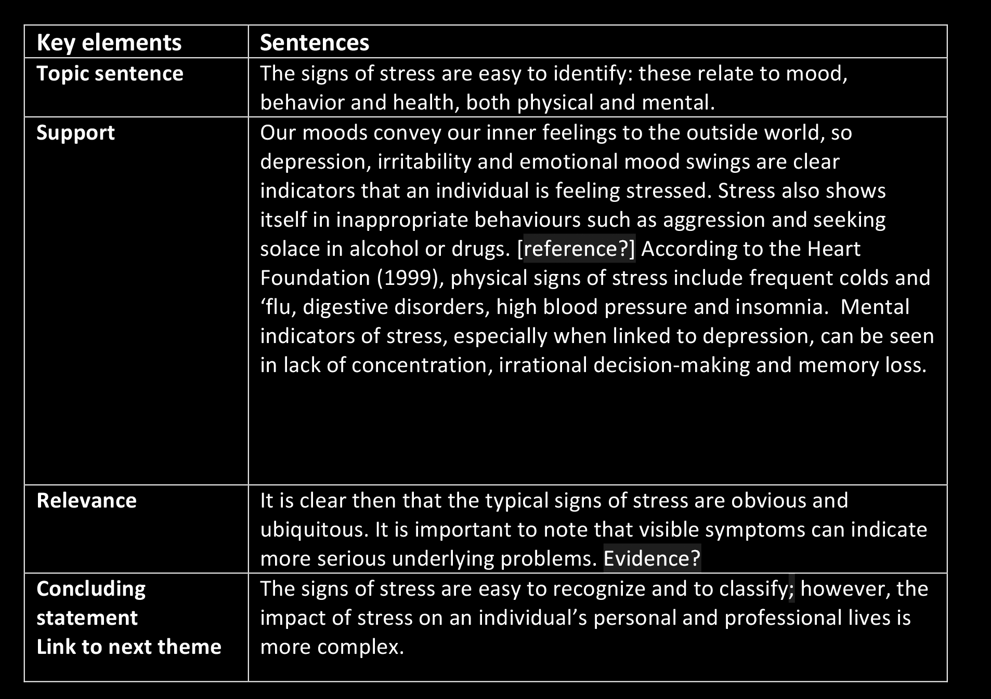

*Figure 12*. Model: 1st body paragraph – drafted with input from students

99

The lecturer asks questions and uses responses to build up the paragraph. For   
example, the lecturer might say *‘What are the key words that we need for our topic sentence?’* Students refer to their essay plan and reply something like: *‘Signs of stress*. The lecturer might then invite the students to formulate a sentence. This is typed up while the lecturer is speaking and the text appears on the overhead screen; the class is then invited to evaluate this text and suggest any changes. The classroom atmosphere is typically warm and collegial and students supportive of each other. As the paragraph grows, the lecturer moves backwards and forwards through the text, commenting, prompting, evaluating, highlighting key words, and making the point at frequent intervals that *‘this is just a first draft – we can go back and fine tune it later’*. This is a critical teaching point, because it is easy to get stuck on details and lose sight of the need to maintain onward movement of the drafting process. If we get stuck for a word or identify an infelicitous phrase, we simply put ‘xxx’ in as a placeholder or highlight the words in yellow and return to that section later. At the end of each paragraph, we read through what has been written in order to add, delete or amend as appropriate. At the end of twenty minutes, or so, a reasonably well-developed paragraph has emerged. The lecturer takes this opportunity to point out the structural components which give the paragraph integrity, coherence and cohesiveness; with reference to the essay plan, students’ attention is then drawn to ‘linking sentences’ which clearly orient the reader to the position of this paragraph within the essay and which help the reader to navigate their way through the text.

Having drafted the first body paragraph, attention is turned to the essay plan and students invited to imagine the moment when all body paragraphs have been drafted.

This is the appropriate time to start thinking about the introduction, and again, a drafting frame is used to ensure that all components are included, in the appropriate order. See Figure 13 for a draft introduction which was co-constructed in a typical class.

100

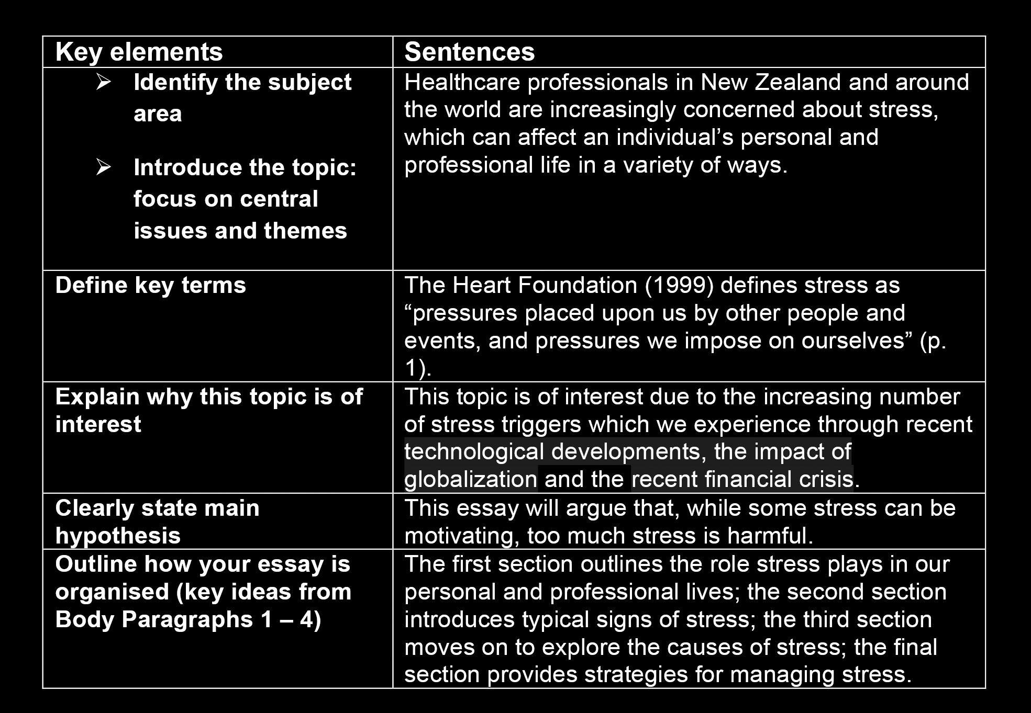

*Figure 13*. Model: Introduction - drafted with input from students

When writing an introduction to an academic essay, it is useful to imagine the reader, not as the lecturer who has assigned the question, but as an educated, intelligent non-specialist. This mindset encourages the writer to start with a clear indication of the subject area before narrowing in to introduce the topic, using key words from the assignment question. The next step is to anticipate questions from the ‘non-specialist reader’ and define any key words. The definition will ideally be sourced from a dictionary, a text book or a peer-reviewed journal article. Having visualised the ideal reader, students are then encouraged to put themselves in that reader’s shoes and ask the question: ‘Why should anyone invest time to read this’? ‘Because it’s the lecturer’s job’ is a common response, but misses the point: there should be some inherently motivating reason for reading the essay so students are invited to identify and state the reasons why this topic and these issues need to be explored. The next component is the argument or hypothesis. This may not be immediately obvious during the planning process, in fact, it often only becomes clear while drafting the body. Therefore, it makes sense to defer writing the introduction until the end of the drafting process.

At this point, it is useful to point out the value of adopting a deductive approach to the essay; in other words, reading the essay should not be a magical mystery tour, with the main point hidden away, waiting to be discovered at the end of the reading process. Rather, the reader will find the whole essay easier to process if the argument is stated at the beginning. The final component of the introduction is an outline of the

101

essay structure; interestingly, many students react in surprise to the suggestion that the main themes be foreshadowed in the introduction. Their concern appears to be related to the misconception that this is unnecessary repetition. Important then to point out that indicating the structure at this point assists the reader to put in place a mental schema with which to process the development of the writer’s argument. With the introduction now in place, it only remains to draft the conclusion. See Figure 14 for a draft conclusion co-constructed in class.

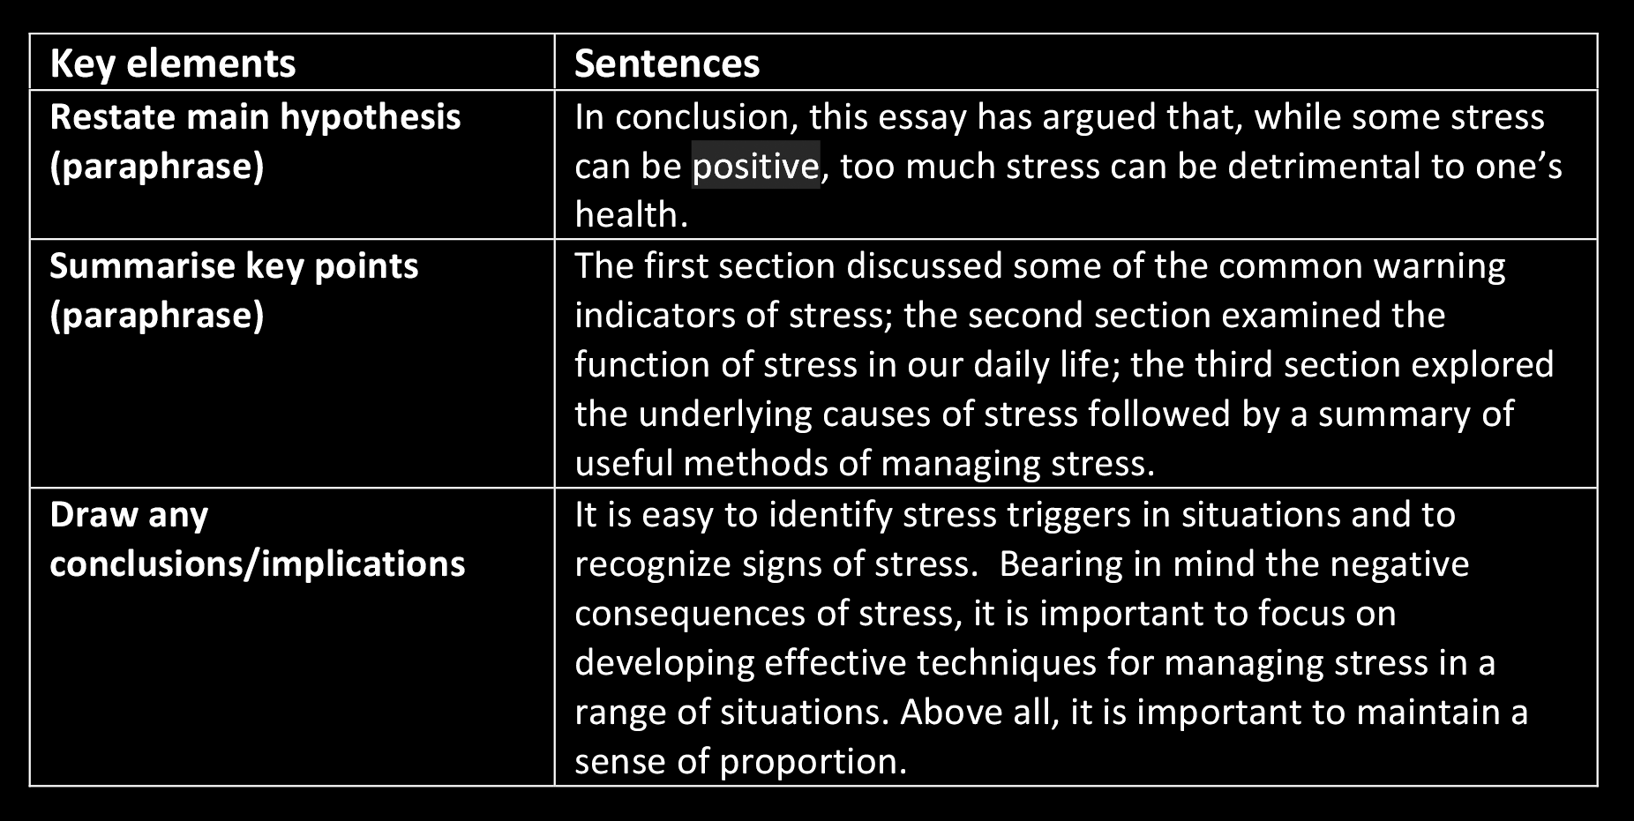

*Figure 14*. Model: Conclusion [1st draft] - drafted with input from students

In the interests of assisting the reader at all possible points, attention is drawn to the desirability of reiterating the argument; this is easily achieved by copying and pasting the sentence from the introduction to the first row of the conclusion writing frame. The tense is adjusted, from future to present perfect, and the point made that reminding the reader of the argument at the close of the essay provides an essential unity. A recapitulation of the main themes and key points is demonstrated by copying the ‘structure’ component from the introduction writing frame and pasting the text into the ‘key themes’ row. This trick enables the writer to modify the syntax and vocabulary whilst retaining the original sense and the order of key points. The final component is elicited with reference to the ‘shape’ of the essay – widening out again to connect with the real world. By the end of the essay an argument has been introduced and developed, the question has been answered and it is now appropriate to consider implications for further action or necessary research. By the time the conclusion has been drafted, students have observed a lecturer demonstrating the drafting process through ‘think-aloud’ protocols and they can observe, in real time, the creation of text which is now ready to be set aside and returned to later, for proof-reading, editing, enhancing content and stylistic fine-tuning.

102



Perhaps the greatest psychological hurdle to overcome during the drafting stage is the sense that the writing should be ‘perfect’; in practice, however, attempts to fix problems during the actual drafting process tend to impede creative progress. The point was made in the previous section that it is far better to allow oneself permission as a writer to permit imperfections of grammar, spelling, style and referencing in the interests of maintaining a forward momentum in the production of linear text.

Then, after each section has been drafted it is good practice to develop the habit of systematic checking, bearing in mind that revision of draft text occurs as both a micro and a macro activity: at the micro level this involves a careful read through of each paragraph immediately after it has been drafted, and any obvious problems fixed on the spot; macro level revision involves systematic proofreading of the body first, then of the entire essay. Whether editing is taking place on a micro or macro scale, neophyte writers find the following four prompts helpful:

• Electronic checks

• Academic honesty checks

• Academic writing style checks

• Marking criteria checks

Firstly, electronic checks can assist writers in identifying text which is grammatically questionable, with spell check tools allowing speedy replacement of incorrect spellings. Attention is also drawn to the word count tool to ensure that each section is the appropriate length. Secondly, academic honesty checks focus attention on referencing conventions for direct quotes and/or paraphrasing and the extent to which appropriate evidence or illustrative examples have been presented to substantiate the argument6. Thirdly, academic writing style checks involve questions of formality, writer intrusion into the text and appropriate lexis. Notions of style also encompass sentence length and variety: in many cases students will identify sentences which are too long and could usefully be reduced to make their meaning clearer. One useful tip is for the student to read the essay out loud and consider how it sounds.

Another strategy is to have someone else read and comment upon the draft. This can be extremely helpful to students who are still unsure of what precisely they should be looking for; however, in the interests of promoting autonomy, students are encouraged to take ultimate responsibility for developing their own proof-reading and editing protocols. Academic writing requires a professional standard of presentation:

6 At an appropriate point in teaching, usually towards the end of the first day in class, students are given a presentation on APA 6th Edition referencing conventions. This is followed by hands-on activities and a homework task: to prepare the reference section for the set of assigned texts. At the drafting stage, students explore different approaches to in-text citation. Contextualising the referencing component in this way helps students to understand the principles of referencing, and to engage at a practical level with the formatting of bibliographic components and arcane details of punctuation.

103

students are reminded that that the essay must be presented in accordance with the department’s style requirements. Which brings us to the final prompt, a reminder to revisit the marking criteria; it is also worth checking the essay against the paper’s stated learning outcomes to ensure that key concepts are addressed in the development of the essay’s argument. The point has been made previously that drafting and editing is a recursive activity. Each cycle should result in improved clarity and style; however, this is only possible if sufficient time is allocated, and, in practice, students seldom leave themselves enough time for this very important stage. The possibility of gaining 5% for each revision cycle may be difficult to measure empirically, but telling students that they are likely to improve their final grade is undoubtedly psychologically motivating. It is important to reiterate the point that the earlier the first draft is completed, the more time is available for redrafting and editing.

**Conclusion**

My opening gambit for this paper was the observation that the test of a university writing programme is whether it works. Do students emerge with a better   
understanding of the writing process? Have they acquired a repertoire of strategies which will enable them to produce good assignments which are well-argued, tightly structured, and contain fewer surface errors in spelling and grammar? Do students report higher grades? Feedback from students and faculty staff members indicate affirmative answers to each of these questions. A class survey (n=49) which was conducted independently in Semester 1, 2011, asked students whether they found the KAWS programme effective and practical: an overwhelmingly positive 92% of the class surveyed agreed, or strongly agreed, that they “would recommend this paper to others”. Furthermore, students regularly report improved grades which they attribute to the KAWS programme. From a faculty perspective, the KAWS programme is highly regarded. Anecdotally, staff regularly report improvements in their students’ writing, again which can be attributed to the KAWS programme. Along with other KEYS papers it is on public record that “KEYS demonstrably makes a difference to retention and performance” (Reid, 2011). KAWS has also had endorsement from an Ako Aotearoa publication, with statistical evidence supporting the programme’s claims to effectiveness (Manalo, Mashall, & Fraser, 2009).

In conclusion, this paper has argued that academic literacies can be usefully   
developed through a contextualised teaching programme in which each stage of the writing process is systematically explored through class discussion, demonstrated by an effective practitioner, experienced by the student and evaluated at the end of the process. When students develop a clear sense of their progress through the writing process, they are more likely to produce a well-argued, tightly structured essay, written in an appropriate academic style. Such an approach is grounded in robust pedagogic theory, and is in line with AUT University’s stated aim to improve student success and retention.

104

**References**   
Allan, Q. (Forthcoming). Academic writing development: A ‘drafting frames’ approach. *Higher Education Research and Development Australasia*.

Bhatia, V. (1993). *Analysing genre: Language use in professional settings*. Harlow, England: Longman.

Biber, D., Johansson, S., Leech, G., Conrad, S., & Finegan, E. (1999). *Longman*  *grammar of spoken and written English*. Harlow, England: Pearson.

Brick, J. (2009). *Academic culture: A student’s guide to studying at university*. Sydney, NSW: Macmillan Education.

Buzan, T. (1993). *The mind map book*. London, England: BBC Books.

Cope, B., & Kalantzis, M. (Eds.). (1993). *The powers of literacy: A genre approach to*  *teaching writing*. Pittsburgh, PA: University of Pittsburgh Press.

Cope, B., & Kalantzis, M. (Eds.). (2000). *Multiliteracies: Literacy learning and the*  *design of social futures*. London, England: Routledge.

Cottrell, S. (1999). *The study skills handbook*. Basingstoke, England: Palgrave.

Covey, S. (1990). *The seven habits of highly effective people: Restoring the character*  *ethic*. New York, NY: Fireside Books.

Coxhead, A. (2000). The new academic word list. *TESOL Quarterly, 34*(2), 213-238. de Luca, R., & Annals, A. (2009). *Writing that works: A guide for tertiary students* (2nd ed.). Auckland, New Zealand: Pearson Education.

Dudley-Evans, T. (1994). Genre analysis: An approach to text analysis for ESP. In M. Coulthard (Ed.), *Advances in written text analysi*s (pp. 219-228). London, England: Routledge.

Godfrey, J. (2009). *How to use your reading in your essays*. Basingstoke, England: Palgrave Macmillan.

Godwin, J. (2009). *Planning your essay*. Basingstoke, England: Palgrave Macmillan. Halliday, M. (1985). *An introduction to functional grammar*. London, England: Edward Arnold.

Halliday, M., & Hasan, R. (1976). *Cohesion in English*. London, England: Longman. Hinkel, E. (2004). *Teaching academic ESL writing: Practical techniques in vocabulary*  *and grammar*. Mahwah, NJ: Lawrence Erlbaum Associates.

Hoey, M. (1983). *On the surface of discourse*. London, England: George Allen & Unwin.

105

Kress, G. (1993). Genre as social process. In B. Cope & M. Kalantzis (Eds.), *The powers of literacy: A genre approach to teaching writing* (pp. 22-37). Pittsburgh, PA: University of Pittsburgh Press.

Leech, G., Rayson, P., & Wilson, A. (2001). *Word frequencies in written and spoken*  *English*. London, England: Longman.

Manalo, E., Marshall, J., & Fraser, C. (2009). *Student learning support programmes*  *that demonstrate tangible impact on retention, pass rates & completion*.

Retrieved from www.atlaanz.org   
Martin, J., & Rose, D. (2005). Designing literacy pedagogy: Scaffolding asymmetries.

In J. Martin, C. Matthiessen, & R. Hasan (Eds.), *Continuing discourse on language* (pp. 251-280). London, England: Continuum.

McWilliams, R., & Allan, Q. (2011). *Navigating the rapids:Embedding an academic writing programme in a faculty paper*. Paper presented at the 2011 Association of Tertiary Learning Advisors of Aotearoa New Zealand (ATLAANZ)   
conference, WelTec, Petone, New Zealand.

Nation, P. (2001). *Learning vocabulary in another language*. New York, NY: Newbury House.

Oshima, A., & Hogue, A. (2007). *Introduction to academic writing*. New York, NY: Pearson Education.

Reid, J. (2011). *AUT School of Education: KEYS position paper*. Auckland, New Zealand: AUT University.

Robinson, F. P. (1970). *Effective study*. New York, NY: Harper and Row.

Swales, J. (1990). *Genre analysis: English in academic and research settings*.

Cambridge, England: Cambridge University Press.

Toulmin, S. (2001). *Return to reason*. Cambridge, MA: Harvard University Press.

Toulmin, S., Rieke, R., & Janik, A. (1984). *An introduction to reasoning*. New York, NY: Macmillan.

Vygotsky, L. (1986). *Thought and language*. Cambridge, MA: The MIT Press.

Webster, J., & Watson, R. (2002). Analyzing the past to prepare for the future: Writing a literature review. *MIS Quarterly, 26* (2), xiii-xxiii.

Wood, D., Bruner, J., & Ross, G. (1976). The role of tutoring in problem solving. *Journal of Child Psychology and Child Psychiatry, 17*, 89-100.

106