Te Deum E

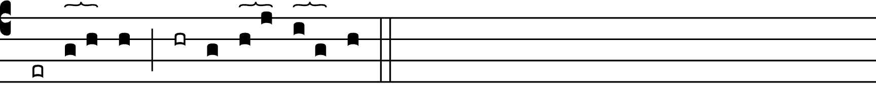

You are God: ’ we / praise you; \*  
You are / the Lord, we ac-claim you;

You are the e- / ter-nal Father; \*  
All / cre-a-tion wor-ships you.

To you all angels, ’ all the / pow’rs of heaven, \*  
Cherubim and Sera- / phim, sing in end-less praise:

Holy, ’ holy, ’ holy, ’ Lord, God of / pow’r and might, \*  
Heaven and earth / are full of your glory.

The glorious company of apostles praise you. ’

The noble fellowship of / prophets praise you. \*  
The white-robed army / of martyrs praise you.

Throughout the world the holy / Church acclaims you: \*  
Father, / of majesty unbounded,

your true and only Son, worthy / of all worship, \*  
and the Holy Spir– / it, advocate and guide.

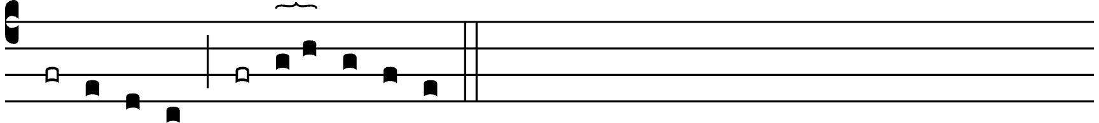

You, Christ, are the / king of glory, \*  
the eternal / Son of the Father.

When you became man to / set us free \*  
you did not / spurn the Virgin’s womb.

You overcame the / sting of death, \*  
and opened the kingdom of / heav’n to all believers.



You are seated at God’s right / hand in glory. \*  
We believe that you / will come, and be our judge.

Come then, Lord, and / help your people, \*  
bought with / the price of your own blood,

and bring us / with your saints \*  
– / to glory everlasting.