Comparing Automated Dynamic UI Verification to Static Walkthroughs in Asynchronous Systems
Innocent Onwukanjo (202487225), Kelechukwu Innocent Ede (202580616)
ENGI 9839, Software Verification and Validation, Memorial University of Newfoundland
System Under Test: Uptime Kuma 1.23.9 (real, unmodified)
20 July 2026

Abstract
Real-time dashboards mutate their user-interface state asynchronously in response to WebSocket events, which makes verification difficult: updates may arrive late, arrive out of order, be lost on reconnect, or leave the interface showing stale state. This case study compares three implementation-phase verification techniques, a manual static walkthrough, automated dynamic end-to-end testing with Playwright, and session-based exploratory testing, by their ability to detect user-interface state anomalies in the real, unmodified Uptime Kuma 1.23.9. Rather than seeding artificial faults, we apply all three techniques to the genuine application and record every real defect each technique finds, together with the effort spent, in a shared defect log. The static walkthrough detected seven genuine defects by reasoning about the source code; exploratory testing detected three user-facing faults spanning layout, data flow, and reconnect behaviour; and the automated Playwright suite confirmed one defect while primarily providing repeatable, objective verification of correct behaviour, executed continuously through a continuous-integration pipeline. No single technique dominated. Static review discovered the most subtle asynchronous-logic faults, exploratory testing found user-facing faults the others missed, and dynamic testing uniquely provided re-runnable regression protection. The techniques are complementary, which directly answers the research question and yields a concrete recommendation for verifying asynchronous user interfaces.
Keywords: software verification, static walkthrough, code inspection, end-to-end testing, Playwright, exploratory testing, asynchronous user interface, WebSocket, continuous integration.

1. Introduction
Uptime Kuma is a widely used open-source monitoring dashboard that presents a live view whose state is driven by WebSocket (Socket.io) events rather than by synchronous request and response. The backend periodically probes each monitored target and pushes the result, an up or down status with a timestamp, called a heartbeat, to the browser over a persistent connection. A single front-end module, src/mixins/socket.js, receives those pushes and mutates all reactive interface state. Because data can arrive at any moment, and especially because a connection can drop and reconnect, the ordering guarantees that a normal request-and-response page relies on no longer hold [1], [2].
Faults in such systems are therefore often timing and ordering dependent, a race on reconnect, a list that grows without bound, a value that is momentarily wrong, and they are notoriously hard to find by ordinary means [1], [2]. This property motivates our central question: when the interface itself behaves asynchronously, which verification technique is most effective at catching the resulting anomalies, and what does each technique uniquely contribute?
Research question. How effective is automated dynamic user-interface verification, using Playwright end-to-end testing, at detecting user-interface state anomalies in an asynchronous, real-time dashboard, compared to a manual static walkthrough and, as added by the course, session-based exploratory testing?
Because the course requires the system under test to remain high quality and unmodified, we deliberately do not seed faults. We instead apply the three techniques to the real application and record the genuine defects each finds. This design keeps the comparison honest: the code the walkthrough reads is byte-identical to the code the tests execute, and every reported defect is a real property of shipping software.
Contributions. (1) A controlled, side-by-side application of static, dynamic, and exploratory verification to the same asynchronous interface of a real system; (2) a catalogue of ten investigated findings with anomaly class, severity, and precise source locations; (3) an automated Playwright suite wired into a continuous-integration pipeline that serves as the single source of truth for the dynamic results; and (4) an evidence-based recommendation on how the three techniques should be combined.
Terminology and notation. Throughout, we label the three techniques T1, the static walkthrough (a manual reading of the source code, without executing it); T2, the automated dynamic end-to-end testing with Playwright (driving the running app in a real browser and asserting on what the user sees); and T3, the session-based exploratory testing (a person exploring the running app in time-boxed, chartered sessions). Every finding is given an identifier of the form D-NNN, a sequential number in the shared defect log; for example, D-005 is the fifth logged item. The same identifier is reused in every table and in the discussion so a reader can trace a finding across the report, and where a defect was found by more than one technique we list each one (for example, D-005 was found by both T1 and T2).
The remainder of this report is organised as follows. Section 2 reviews the relevant background and literature. Section 3 describes the system under test and the protocol for each technique. Section 4 presents the results, including the full defect catalogue. Section 5 discusses what each technique contributed and answers the research question. Section 6 states the threats to validity, Section 7 reflects on the challenges faced and areas for improvement, and Section 8 concludes.

2. Background and Literature Review

2.1 Verification techniques: static, dynamic, and exploratory
Software verification techniques split broadly into static techniques, which examine an artifact without executing it, and dynamic techniques, which execute the software and observe its behaviour. A static walkthrough is a human, behavioural review of source code in which reviewers reason about how the program will act at runtime; it is a long-established inspection technique, and is distinct from automated static analysis such as a linter, which checks syntax and style but does not reason about asynchronous runtime behaviour. Dynamic testing runs the program against inputs and checks outputs, and automated end-to-end testing is a dynamic technique that drives the real user interface. Exploratory testing is a third, human-driven dynamic technique in which learning, test design, and execution proceed concurrently; we discipline it here with Session-Based Exploratory Testing and Whittaker's City Tours. Each class targets different fault types, which is precisely what motivates an empirical comparison rather than an assumption that one is universally superior.

2.2 Asynchronous, WebSocket-driven interfaces
A conventional web page follows a request-and-response rhythm: the client asks and the server answers. A WebSocket interface inverts this, letting the server push data at any time over a persistent connection. In Uptime Kuma the resulting data flow is a pipeline: a heartbeat event arrives, it updates a heartbeat list, that feeds a last-heartbeat list, which feeds a derived status list, which finally paints the coloured status indicator the user sees. Every hand-off in that pipeline is a place where late, missing, duplicated, or out-of-order data can produce a wrong or transient interface state [1], and the reconnect path, where the client tears down and rebuilds its state, concentrates that risk. Understanding this pipeline is essential to reasoning about where the interface can break, and it structures our walkthrough.

2.3 End-to-end testing and the Playwright framework
End-to-end testing exercises a running application from the user's perspective, driving a real browser and asserting on the rendered result. Playwright is the framework that automates this: it controls a real browser engine, offers web-first assertions, and provides built-in auto-waiting intended to reduce flakiness [3]. Throughout this study we keep the distinction that end-to-end is the type of testing and Playwright is the tool that performs it.
Recent literature evaluates Playwright chiefly by performance and by comparison with competing frameworks. Tymoshchuk [4] traces the evolution of browser automation from Selenium to Playwright and reports Playwright as the best-performing option for dynamic web applications. Gosik and Milosz [5] empirically compare Cypress and Playwright on Angular applications and find Playwright advantageous in execution speed, memory footprint, and cross-browser support. Talakola [6] provides an applied methodology for building reliable and maintainable Playwright end-to-end suites for JavaScript-based user interfaces. A consistent theme across these works is that Playwright is well suited to dynamic, JavaScript-heavy interfaces, exactly the category into which our real-time dashboard falls.

2.4 Test reliability and flakiness
A second, cross-cutting theme in the literature is the reliability of the tests themselves. Hashemi et al. [7] systematically evaluate environmental flakiness in JavaScript tests, showing how the operating system, the Node.js version, and the browser can cause the same test to pass or fail non-deterministically. This is directly relevant to our study for two reasons. First, an automated dynamic test is only as valuable as it is trustworthy; a result that flips with the environment cannot be used as evidence. Second, and more subtly, a green test is not proof of correctness. We observed this first-hand when an early reconnect test passed incorrectly until an explicit wait was added, a point we return to in Section 5.

2.5 Research gap
The prior work above measures Playwright's performance or the reliability of JavaScript tests. Comparatively little of it measures the fault-detection effectiveness of automated end-to-end testing against static and exploratory techniques on a real system's asynchronous interface. That is the gap this case study addresses: not whether Playwright is fast, but what it, a static walkthrough, and exploratory testing each actually find, and miss, on the same asynchronous code.

3. Methodology

3.1 System under test
The system under test is Uptime Kuma 1.23.9, built as a Vue 3, Node.js, and Socket.io application. We run it unmodified from source, and we pin the exact version so that the code reviewed in the walkthrough is byte-identical to the running application the tests exercise. The asynchronous state layer under study is src/mixins/socket.js, the Socket.io client that receives every push and mutates reactive state, together with the components that consume that state, chiefly HeartbeatBar.vue and PingChart.vue. Concentrating on this layer keeps all three techniques aimed at the same target, which is a precondition for a fair comparison. Figure 1 shows the running system as all three techniques saw it, with the two seeded monitors and the live heartbeat bars.
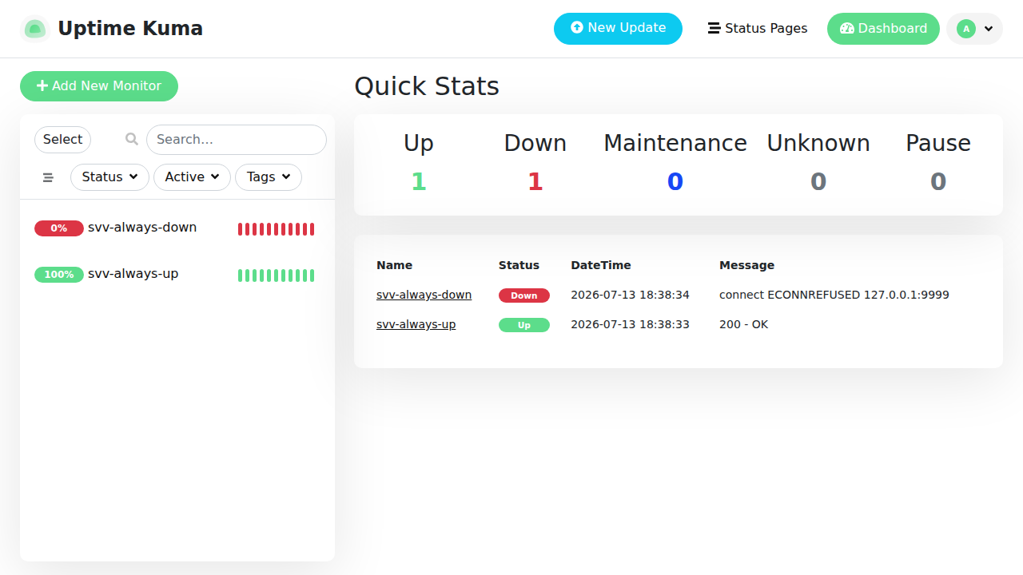
Figure 1. The system under test in use. The two seeded monitors, one reachable and one pointed at a dead port, produce the live heartbeat bars and the Quick-Stats event table that the study examines.

3.2 Technique T1: static walkthrough
Two reviewers performed a structured walkthrough of the asynchronous state layer in two paired sessions, swapping the Reader and Recorder roles between sessions, for a total of 135 person-minutes. No tests were run and no linter was used; every finding comes from reasoning about the code. The reviewers read src/mixins/socket.js line by line along the heartbeat pipeline, asking at each hand-off a fixed set of questions: is there an asymmetry between two lists that are updated together, is there a missing guard on external data, is there a clear-then-refill window with no data, can the list grow without bound, and can events arrive duplicated or out of order. Each confirmed finding was logged with a file-and-line location, an anomaly class, a severity, and the one-sentence static reasoning that produced it. Findings that survived scrutiny were recorded as defects; a candidate that was investigated and dismissed was retained in the log as a false alarm, because false-alarm rate is itself a comparison metric and its retention is honest inspection evidence.

3.3 Technique T2: automated dynamic end-to-end testing
A Playwright suite drives a real Chromium browser against the running system under test. The suite is organised into a setup project that authenticates once and stores the session, a seed project that provisions two deterministic monitors (one pointed at a reliably reachable target and one at a dead local port, so no external network is required), and the dynamic tests themselves, which verify live status behaviour and probe the reconnect path. Authentication is asserted against a stable interface landmark rather than a URL, because the application redirects to the dashboard even when logged out, which would otherwise produce a false pass. A GitHub Actions continuous-integration pipeline starts Uptime Kuma and runs the suite on every commit, uploading the HTML report as an artifact; that pipeline run is the single source of truth for the dynamic results, while the shared spreadsheet documents the findings for comparison.

3.4 Technique T3: session-based exploratory testing
Exploratory testing was conducted as time-boxed, charter-driven sessions following the Session-Based method, each with a mission, a charter, and a session report. Coverage was organised using Whittaker's City Tours across the Business, Tourist, Hotel, and Seedy districts. The Guidebook Tour exercised core create, read, update, and delete flows; the Fed-Ex Tour traced a heartbeat's data from the check through to the coloured indicator and validated each hand-off; the Supermodel Tour ignored function and scrutinised the interface under very long and very short content; and the Rained-Out Tour interrupted operations and forced reconnects. A one-hour sweep covered these tours, with deeper tours such as Saboteur and All-Nighter deferred and noted as follow-up work.

3.5 Measurement
Every finding is recorded exactly once in a shared defect log with the technique or techniques that found it, its anomaly class, its severity, a precise location, reproduction steps, and, for exploratory findings, the tour that exposed it. A separate effort log records the time spent per technique, and a summary sheet computes the per-technique defect counts, the severity mix, and, for the walkthrough, a detection efficiency. Where a defect was found by more than one technique it is marked as an overlap, which lets us distinguish unique from shared detections.

4. Results
Across the three techniques we investigated ten items, of which nine are genuine defects and one, D-008, was investigated and dismissed as a false alarm. Table 1 summarises the count and observed strength of each technique, and Table 2 catalogues every investigated item.
Table 1. Genuine defects detected by technique on the real, unmodified system under test.
Technique | Defects | Primary strength observed
T1 Static walkthrough | 7 | Discovery of subtle async-logic faults
T3 Exploratory testing | 3 | User-facing faults the others miss
T2 Automated E2E (Playwright) | 1 | Repeatable verification and regression
Table 1. Per-technique defect counts and the primary strength each technique demonstrated.
Table 2. Full catalogue of investigated items.
ID | Anomaly class | Severity | Location (file:line) | Found by
D-001 | unbounded-growth | Minor | socket.js:199-203 | Static
D-002 | race | Major | socket.js:256-257, 588-592 | Static
D-003 | incorrect-derived | Major | socket.js:652-698 | Static, Exploratory
D-004 | duplicate/ordering | Minor | socket.js:207-213 | Static
D-005 | stale-state | Minor | socket.js:780-784 | Static, Dynamic
D-006 | stale-state | Trivial | socket.js:768-776 | Static
D-007 | error-handling | Minor | socket.js:223-224 | Static
D-008 | reactivity (false alarm) | n/a | socket.js:171-172 | none (dismissed)
D-009 | ui-layout | Minor | DashboardHome events table | Exploratory
D-010 | data-flow | Minor | Monitor clone to heartbeat bar | Exploratory
Table 2. Anomaly class, severity, source location, and detecting technique for each item. D-008 is a documented false alarm and is not counted as a defect.
The walkthrough accounted for the deepest findings. D-001 is an un-trimmed important-heartbeat list that grows without bound, found by spotting that within a single handler the live list is capped at 150 entries while the parallel important list is only ever prepended to. D-002 is a reconnect that empties both lists before refilling them, leaving a window in which the whole dashboard has no data; D-003 is the visible symptom of that window, in which a genuinely healthy monitor briefly renders grey as Unknown because an empty list yields an undefined latest beat. D-004 is a duplicate-or-reorder hazard when reconnect history is concatenated without de-duplication or re-sorting; D-005 is a silent full-page reload triggered by a change in the server version string, which discards unsaved interface state; D-006 is a favicon badge debounced by one second so that it briefly disagrees with the in-page count; and D-007 is an unguarded JSON.parse on socket data that would throw on a malformed payload.
Exploratory testing contributed the user-facing findings the walkthrough was not aimed at. The Supermodel Tour exposed D-009, a very long monitor name that the sidebar truncates but the Quick-Stats events table does not, so the table overflows its card. The Fed-Ex Tour exposed D-010, a cloned monitor whose heartbeat bar stays frozen because the clone does not begin beating promptly and the interface gives no cue as to why. The Rained-Out Tour independently re-surfaced D-003 live, confirming at runtime the transient Unknown flash that the walkthrough had predicted from the code.
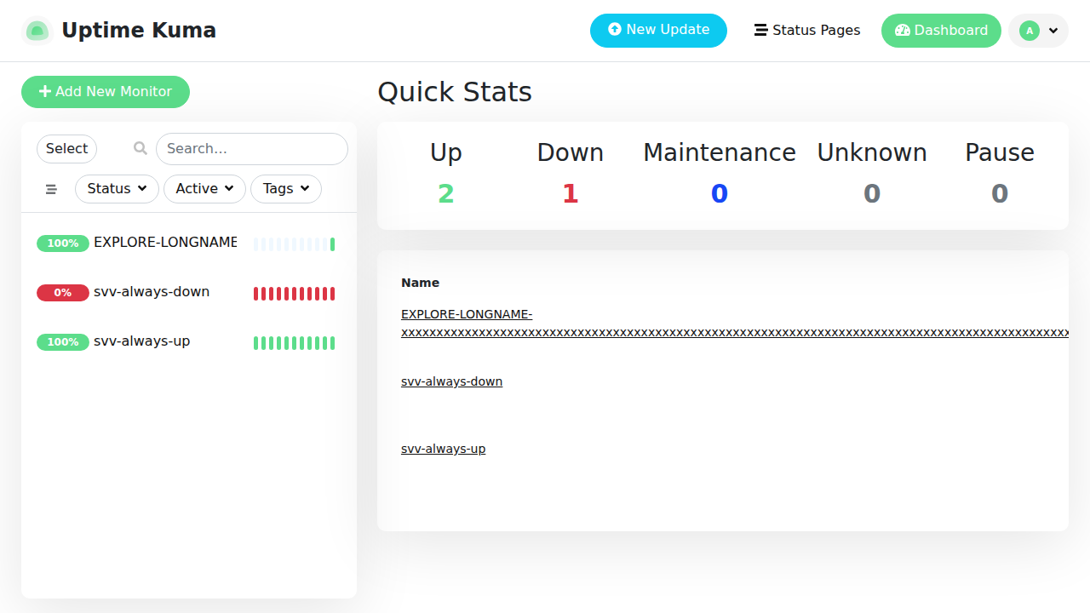
Figure 2. Defect D-009 as captured during the Supermodel Tour. A monitor with a very long name is truncated safely in the sidebar, but the same name overflows the Quick-Stats event table and runs off the edge of the card.
The automated suite played the verification role. Against a high-quality application the tests mostly pass, objectively confirming that live status behaviour is correct and guarding against regressions on every commit. The suite confirmed D-005 by reproducing the reload behaviour, giving the overlap between static and dynamic detection. The two overlaps in the catalogue are therefore D-003, found by both static and exploratory, and D-005, found by both static and dynamic.

4.1 The automated pipeline in operation
The dynamic results are not produced by a manual run on one developer machine. They come from a continuous-integration workflow, so that anyone can reproduce them. On every push, GitHub Actions starts Uptime Kuma 1.23.9 in a container, waits until it is reachable, runs the Playwright suite against it, and uploads the HTML test report as a downloadable artifact. The workflow itself is version controlled with the rest of the project at .github/workflows/dynamic-tests.yml, and the run history is available in the project repository at https://github.com/innocious/SVV-Project/actions. This matters for the comparison: the pass or fail state recorded there is the same evidence summarised in Table 1, it is timestamped, and it is regenerated automatically whenever the code changes, which is precisely the property the walkthrough and the exploratory sessions cannot offer.
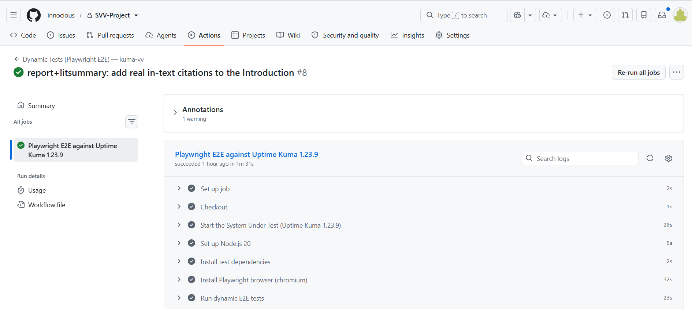
Figure 3. A completed run of the Dynamic Tests (Playwright E2E) workflow. The job checks out the project, starts the system under test, installs Node.js 20 and the Chromium browser, and runs the dynamic suite, finishing green in 1 minute 31 seconds. Every step is timestamped and the HTML report is retained as an artifact.
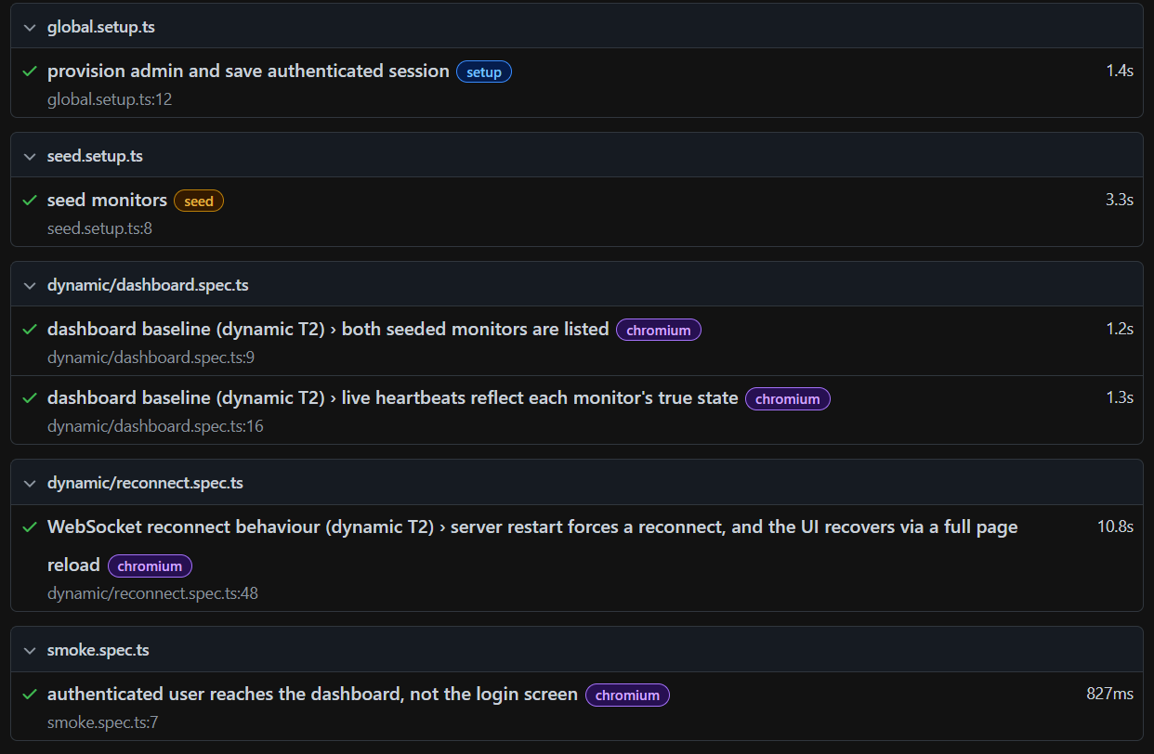
Figure 4. Sample output from the automated suite. Each entry is a check executed against the running system: the setup provisions an account and seeds two monitors, the dashboard tests assert that both monitors are listed and that live heartbeats reflect each monitor's true state, and the reconnect test confirms that a server restart forces a reconnect and the interface recovers through a full page reload, which is the behaviour recorded as D-005. Every pipeline run publishes this report as an artifact; the full report is included with the implementation.

4.2 Effort and efficiency
Effort is recorded per session in the shared effort log. The static walkthrough took 135 person-minutes across two paired sessions and produced seven defects, a detection efficiency of roughly 3.1 defects per hour, with a severity mix of two Major, four Minor, and one Trivial. The exploratory tour sweep was a single time-boxed session of 60 minutes and produced three defects, roughly 3.0 defects per hour. Effort for the automated suite is not recorded as a comparable figure, because building it was spread across the project rather than confined to a session, and much of that time is a one-off cost that later runs do not repeat. For this reason we do not rank the three techniques by efficiency. The more useful observation is qualitative: the walkthrough reasoned out in seconds faults such as D-001 that would take hours of runtime to surface, while the automated suite, once written, re-runs in about ninety seconds without any human time at all.

5. Discussion

5.1 Static walkthrough: most effective at discovery
Reading socket.js let the reviewers reason directly about asynchronous races, unbounded growth, and missing guards, including defects that are nearly impossible to trigger on demand at runtime. This is the classic strength of inspection, and it explains why, for a mature application, the walkthrough found the most defects. Crucially, the walkthrough found defects of kinds the other techniques structurally cannot: a slow memory leak and an unguarded parser are internal properties invisible to a black-box observer of the interface. The technique's limit is equally clear: it reviewed the front-end state layer only, and it produces suspected defects that a running technique must then confirm.

5.2 Automated dynamic testing: most effective at repeatable verification
Against a high-quality application the Playwright suite mostly passes, and that is the point. Its value here is not raw discovery but repeatable, objective confirmation that behaviour is correct, together with regression protection on every commit through the continuous-integration pipeline. It confirmed D-005, but being black-box and limited to what is observable in the interface, it cannot see the internal asynchronous faults the walkthrough reasoned about, and it struggles to catch transient anomalies such as D-003 reliably, a difficulty consistent with the known hardness of detecting asynchronous races by ordinary testing [2]. Our own early experience sharpened this point: a reconnect test passed incorrectly until we added an explicit wait, echoing the environmental-flakiness concerns of Hashemi et al. [7] and reinforcing that a green test is evidence only when the test is sound.

5.3 Exploratory testing: most effective at user-facing faults
Human tours found faults the other two techniques missed because they were neither in the reviewed code layer nor encoded as an assertion. The Supermodel Tour's layout overflow (D-009) and the Fed-Ex Tour's frozen clone (D-010) are user-facing defects discovered by a tester following a charter with an inquisitive eye, and the Rained-Out Tour re-surfaced D-003 live. Exploratory testing also produced valuable negative results, confirming that create-read-update-delete flows, input validation, and two-tab synchronisation all behaved correctly, which the walkthrough could not assert and the automated suite did not target.

5.4 Answer to the research question
For asynchronous user-interface state anomalies, the static walkthrough was the most effective at detecting defects because it reasons about the code rather than only observing the interface; automated dynamic verification with Playwright was the most effective at repeatable, objective confirmation and regression protection but discovered few new faults in a mature application; and exploratory testing was the most effective at catching user-facing faults the other two miss. No single technique was sufficient. Each detected a class of defect the others could not, and two defects were caught by more than one technique, so the techniques are complementary. This is the study's central and defensible finding, and it answers the research question directly: automated dynamic verification is highly effective for what it is designed to do, continuous and repeatable confirmation, but it is not a substitute for the discovery power of a code walkthrough or the human insight of exploratory testing.

5.5 Practical recommendation
The practical consequence for a team building an asynchronous interface is to combine the three techniques by their strengths: use a static walkthrough of the asynchronous state layer to discover deep logic faults early, encode the confirmed behaviours as automated end-to-end tests that run in continuous integration to prevent regressions, and schedule periodic exploratory sessions to catch the user-facing surprises that neither of the first two is shaped to find.

6. Threats to Validity
We consider four categories of threat. As a construct-validity threat, our headline measure, defects detected, deliberately excludes the regression value of a passing test, and so it understates the practical worth of the dynamic technique; we mitigate this by discussing that value explicitly rather than reducing the comparison to a single count. As an internal-validity threat, the same two people performed all three techniques and were not blind to one another's findings, which may inflate the observed overlaps; running the walkthrough before the dynamic tests reduces, but does not remove, this bias. As an external-validity threat, the study uses a single system, a single pinned version, and a single browser engine, so the specific counts should not be generalised beyond this setting, although the qualitative pattern of complementarity is consistent with the broader literature. As a conclusion-validity threat, the effort figures are self-reported and are precise only for the walkthrough, so we avoid ranking the techniques by efficiency and confine efficiency claims to the qualitative observation that reasoning surfaced certain faults far faster than runtime could.

7. Challenges and Improvement Areas
The main challenge was time. The project compressed three full verification techniques, a defect catalogue, a written report, and a working continuous-integration pipeline into a short window before the defense, which limited how many exploratory tours we could run and how much we could iterate on the dynamic suite. The second challenge was the scale of the system under test: Uptime Kuma is a real, industry-standard codebase rather than a small teaching example, so its asynchronous state layer took substantial effort to read and reason about, and standing up a faithful, reproducible environment, a pinned version with authenticated sessions, seeded monitors, and a green pipeline, was itself non-trivial. Finally, the transient nature of the reconnect anomalies made them genuinely hard to reproduce on demand with an automated test.
Several improvements follow from these challenges. A socket-level fault-injection harness that intercepts the WebSocket, rather than restarting the server, would let the dynamic suite reproduce the transient reconnect anomalies deterministically and recover some of the discovery power the walkthrough currently holds. Spreading the work earlier and time-boxing each technique would reduce the end-of-project crunch and allow a second exploratory session for the deferred tours. Broadening coverage with cross-browser runs, the deeper tours such as Saboteur and All-Nighter, and a second system under test would test how far the complementarity result generalises. Finally, having the two testers work more independently, so that each technique is applied without knowledge of the others' findings, would reduce the risk of bias in the overlap counts.

8. Conclusion and Future Work
Comparing a static walkthrough, automated dynamic end-to-end testing, and session-based exploratory testing on the real, unmodified Uptime Kuma 1.23.9, we found the walkthrough most effective at discovering subtle asynchronous defects (seven), exploratory testing best at user-facing faults (three), and Playwright most valuable for repeatable verification and regression (one confirmed, run continuously in a pipeline). The clearest result is complementarity: for a high-quality asynchronous system, a code-reading technique, an automated runtime technique, and a human exploratory technique cover different, overlapping classes of defect, and a sound verification process combines all three rather than choosing among them.
Future work follows directly from the threats. A socket-level fault-injection harness, intercepting the WebSocket rather than restarting the server, would let the dynamic suite reproduce the transient reconnect anomalies that are currently hard to catch, and would let us measure how much of the walkthrough's advantage a better-instrumented dynamic technique can recover. Cross-browser runs and a second, independent system under test would test how far the complementarity pattern generalises.

References
[1] J. Wang, W. Dou, Y. Gao, C. Gao, F. Qin, K. Yin, and J. Wei, “A comprehensive study on real world concurrency bugs in Node.js,” in Proc. 32nd IEEE/ACM Int. Conf. Automated Software Engineering (ASE), 2017, pp. 520–531, doi: 10.1109/ASE.2017.8115663.
[2] C. Q. Adamsen, A. Møller, S. Alimadadi, and F. Tip, “Practical AJAX race detection for JavaScript web applications,” in Proc. 26th ACM Joint European Software Engineering Conf. and Symp. Foundations of Software Engineering (ESEC/FSE), 2018, pp. 38–48, doi: 10.1145/3236024.3236038.
[3] Microsoft, “Playwright: Fast and reliable end-to-end testing for modern web apps,” Playwright Documentation, 2024. [Online]. Available: https://playwright.dev
[4] A. Tymoshchuk, “The Evolution of Test Automation: From Selenium to Playwright. A Comparison of Automation Tools: Selenium vs. Playwright vs. Cypress,” International Journal of Computer (IJC), vol. 54, no. 1, pp. 37–45, 2025.
[5] P. Gosik and M. Milosz, “Comparative analysis of Cypress and Playwright frameworks in end-to-end testing for applications based on Angular,” Journal of Computer Sciences Institute, vol. 36, pp. 320–327, 2025, doi: 10.35784/jcsi.7662.
[6] S. Talakola, “Automated End to End Testing with Playwright for React Applications,” International Journal of Emerging Research in Engineering and Technology (IJERET), vol. 5, no. 1, pp. 38–47, 2024, doi: 10.63282/3050-922X.IJERET-V5I1P106.
[7] N. Hashemi, A. Tahir, A. Shi, S. Rasheed, and R. Blagojevic, “A Systematic Evaluation of Environmental Flakiness in JavaScript Tests,” arXiv preprint arXiv:2602.19098, 2026.

