Gesture Recognition (HPS-Integrated Orientation and Pitch/ Roll Detection System)

ENGI 9865: Advanced Digital Systems

Winter 2026

Instructor: Dr. Hamed Nasiri
Date: April 8, 2026

Group Members
Onwukanjo Innocent O. (202487225)
Avijit Hazra (202580731)

1. Project Overview and Concept
This project involves the design and implementation of a real-time orientation and gesture recognition system using the DE10-Standard board. The system utilizes an ARM Hard Processor System (HPS) interfaced with custom VHDL hardware. The primary goal is to translate raw 3D acceleration(ADXL345) data into human-readable orientation states (UP, DOWN, LEFT, RIGHT, FRONT, BACK) and the pitch and roll of the board.

The accelarometer sensor gives data related to each of the three axis. The system utilizes the Inter-Integrated Circuit serial communication protocol to facilitate data transfer between the HPS and the ADXL345. The ADXL345, attached to the board, by default checks data from -2g to +2g where g is the gravitational acceleration. As g works directly downwards, if the board / the sensor tilts, the pull on each axis changes. As a result we can find the orientation of the board from these values and use for different purpose like sign language recognition and drone control.

The pitch is the angle the board generates when it is tilted forward or backward compared to the XY plane. The roll is the angle of side tilt of the board (figure 1). When the board is in a neutral position of a flat surface the pitch and roll is 0°. It’s assumed that when the board is in front state when facing the audience.

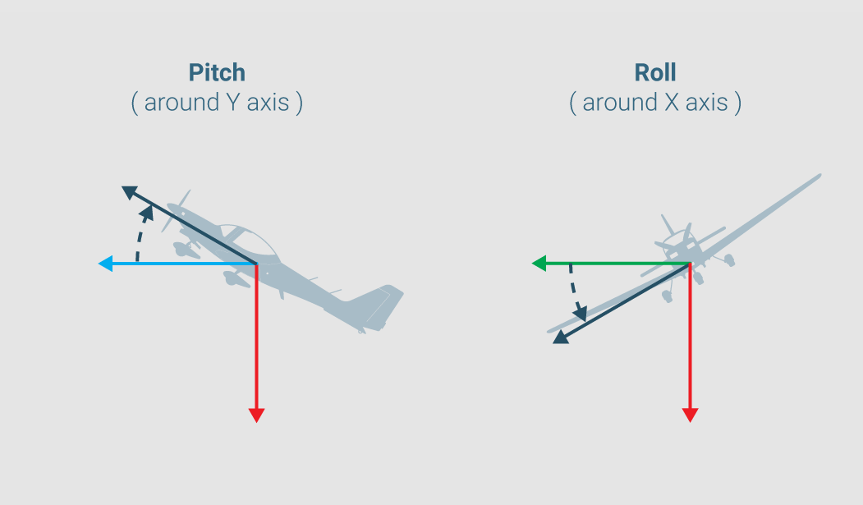

Figure 1: Pitch and Roll a Aeroplane

2. System Architecture
The system is divided into two distinct processing domains as the accelerometer is hardwired to the HPS. The raw data is received by the ARM hard processor system and the sent to the FPGA where it is processed and converted to corresponding directions and shown as HEX outputs.

2.1 Hard Processor System (C Implementation)
The HPS acts as the primary computational engine. The processor performs the following:

- Data Acquisition: Reads raw X, Y, Z axis data from the ADXL345 via the I2C interface.
- Trigonometric Processing: Uses atan2 from the math library to calculate Pitch and Roll angles in degrees. We used tangent instead of sine (or cosine) as the sine values are much less sparse near the 90° region (.99 at 80°). Again sine has a sysmetric curve around 0° - 90° and 90° - 180° range.

tan (pitch) = x / z
tan (roll) = y / z

- FPGA Communication: Writes the resulting integer angles to the FPGA using parallel input/output via the HPS-to-FPGA Bridge.

2.2 FPGA (VHDL Implementation)
The FPGA handles the concurrent logic required for display and gesture detection:
- axis.vhd & HPS.vhd: Manage the sync logic for receiving data from the HPS.
- seg_7_ang.vhd: Implements the Binary Coded Decimal (BCD) conversion to display angles on the 7-segment displays.
- seg_7.vhd: A decoder that maps directions to the physical pins of the HEX displays.

3. VHDL Design Modules

3.1 Gesture Recognition Logic
The axis entity implements a threshold-based state machine. It evaluates incoming 16-bit signed data against pre-defined constants to determine the board's orientation. The data is store by HPS in registers that update every .05s. The data is then sampled for 8 cycles and after doing a mathematical average, FPGA decides on the orientation of the board.
- Inputs: accel_x, accel_y, accel_z (16-bit signed vectors).
- Output: status string (e.g., "UP", "DO", "RI", "LE").

3.2 Angle Display Logic
This module utilizes a slow_clk process to refresh the HEX displays without flickering. It performs integer division and modulo operations to extract individual digits from the HPS angle data for real-time decimal viewing.

4. ASM Chart and State Table
The default range of accelarometer is -2g to +2g. And this device maintains a constant scale factor of 3.9mg/LSB. So for 1g value:

Value = 1000 mg / 3.9 mg / LSB = 256.41

The threshold here was thought as 200 for this. The primary control flow for the gesture detection is captured in the following state table:

Input Condition | Detected Orientation | VHDL Status Output
Z > 200 | Upright / Flat | “UP”
Z < -200 | Inverted | “DO”
X > 200 | Tilted Right | “RI”
X < -200 | Tilted Left | “LE”
Y > 200 | Tilted Front | “FR”
Y < -200 | Tilted Back | “BA”
Default | Idle / Undetermined | “ID”

ASM chart

5. Simulation and Verification
As required by the project guidelines, the system was verified using ModelSim. A self-checking testbench was implemented to simulate the HPS writing different angle values to the PIO ports. A different top level was used as the main top level design requires data directly from the bridge of HPS.

- Verification: The testbench verifies that for an input of -45 degrees, the seg_7_ang module correctly identifies the negative sign and drives the appropriate BCD values to the HEX units.
- Result: All simulation traces confirmed that the hardware responds correctly to the HPS-driven signals within the 50 MHz clock domain.

6. Synthesis
The design was synthesized using Quartus Prime for the Cyclone V device. Resource Efficiency: By offloading atan2 to the HPS, the design avoided the "Can't fit design" error (11802) associated with floating-point VHDL math.
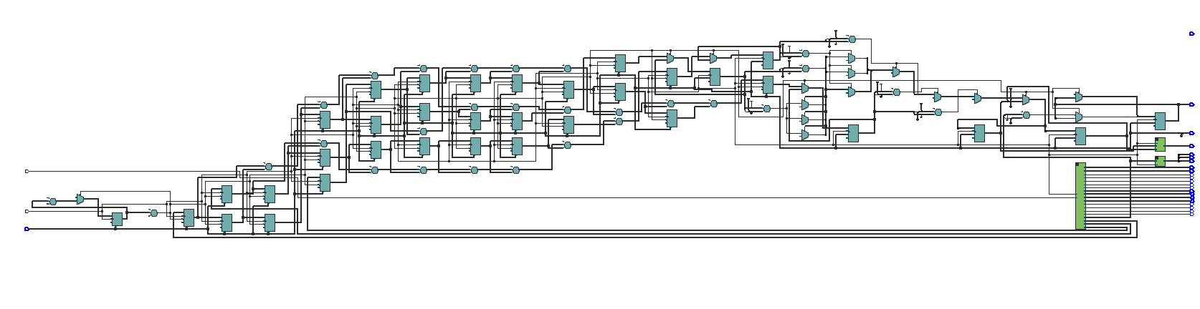
Figure 2: RTL View of Design

7. Conclusion
This project demonstrates a robust integration of HPS and FPGA domains. It successfully leverages the ARM processor for complex math while utilizing the FPGA for deterministic, real-time peripheral control. The modular VHDL design ensures scalability for future features such as sign language recognition and unmanned drone control.

8. Contribution List
- Onwukanjo Innocent O. : Intial top level design and datapath design, Platform designer bridge, HPS C-code development, final report, final presentation.
- Avijit Hazra: Platform designer bridge, gesture logic design and ASM charts, Makefile configuration, implementing VHDL and DE-10 sysnthesis, final report, final presentation.

