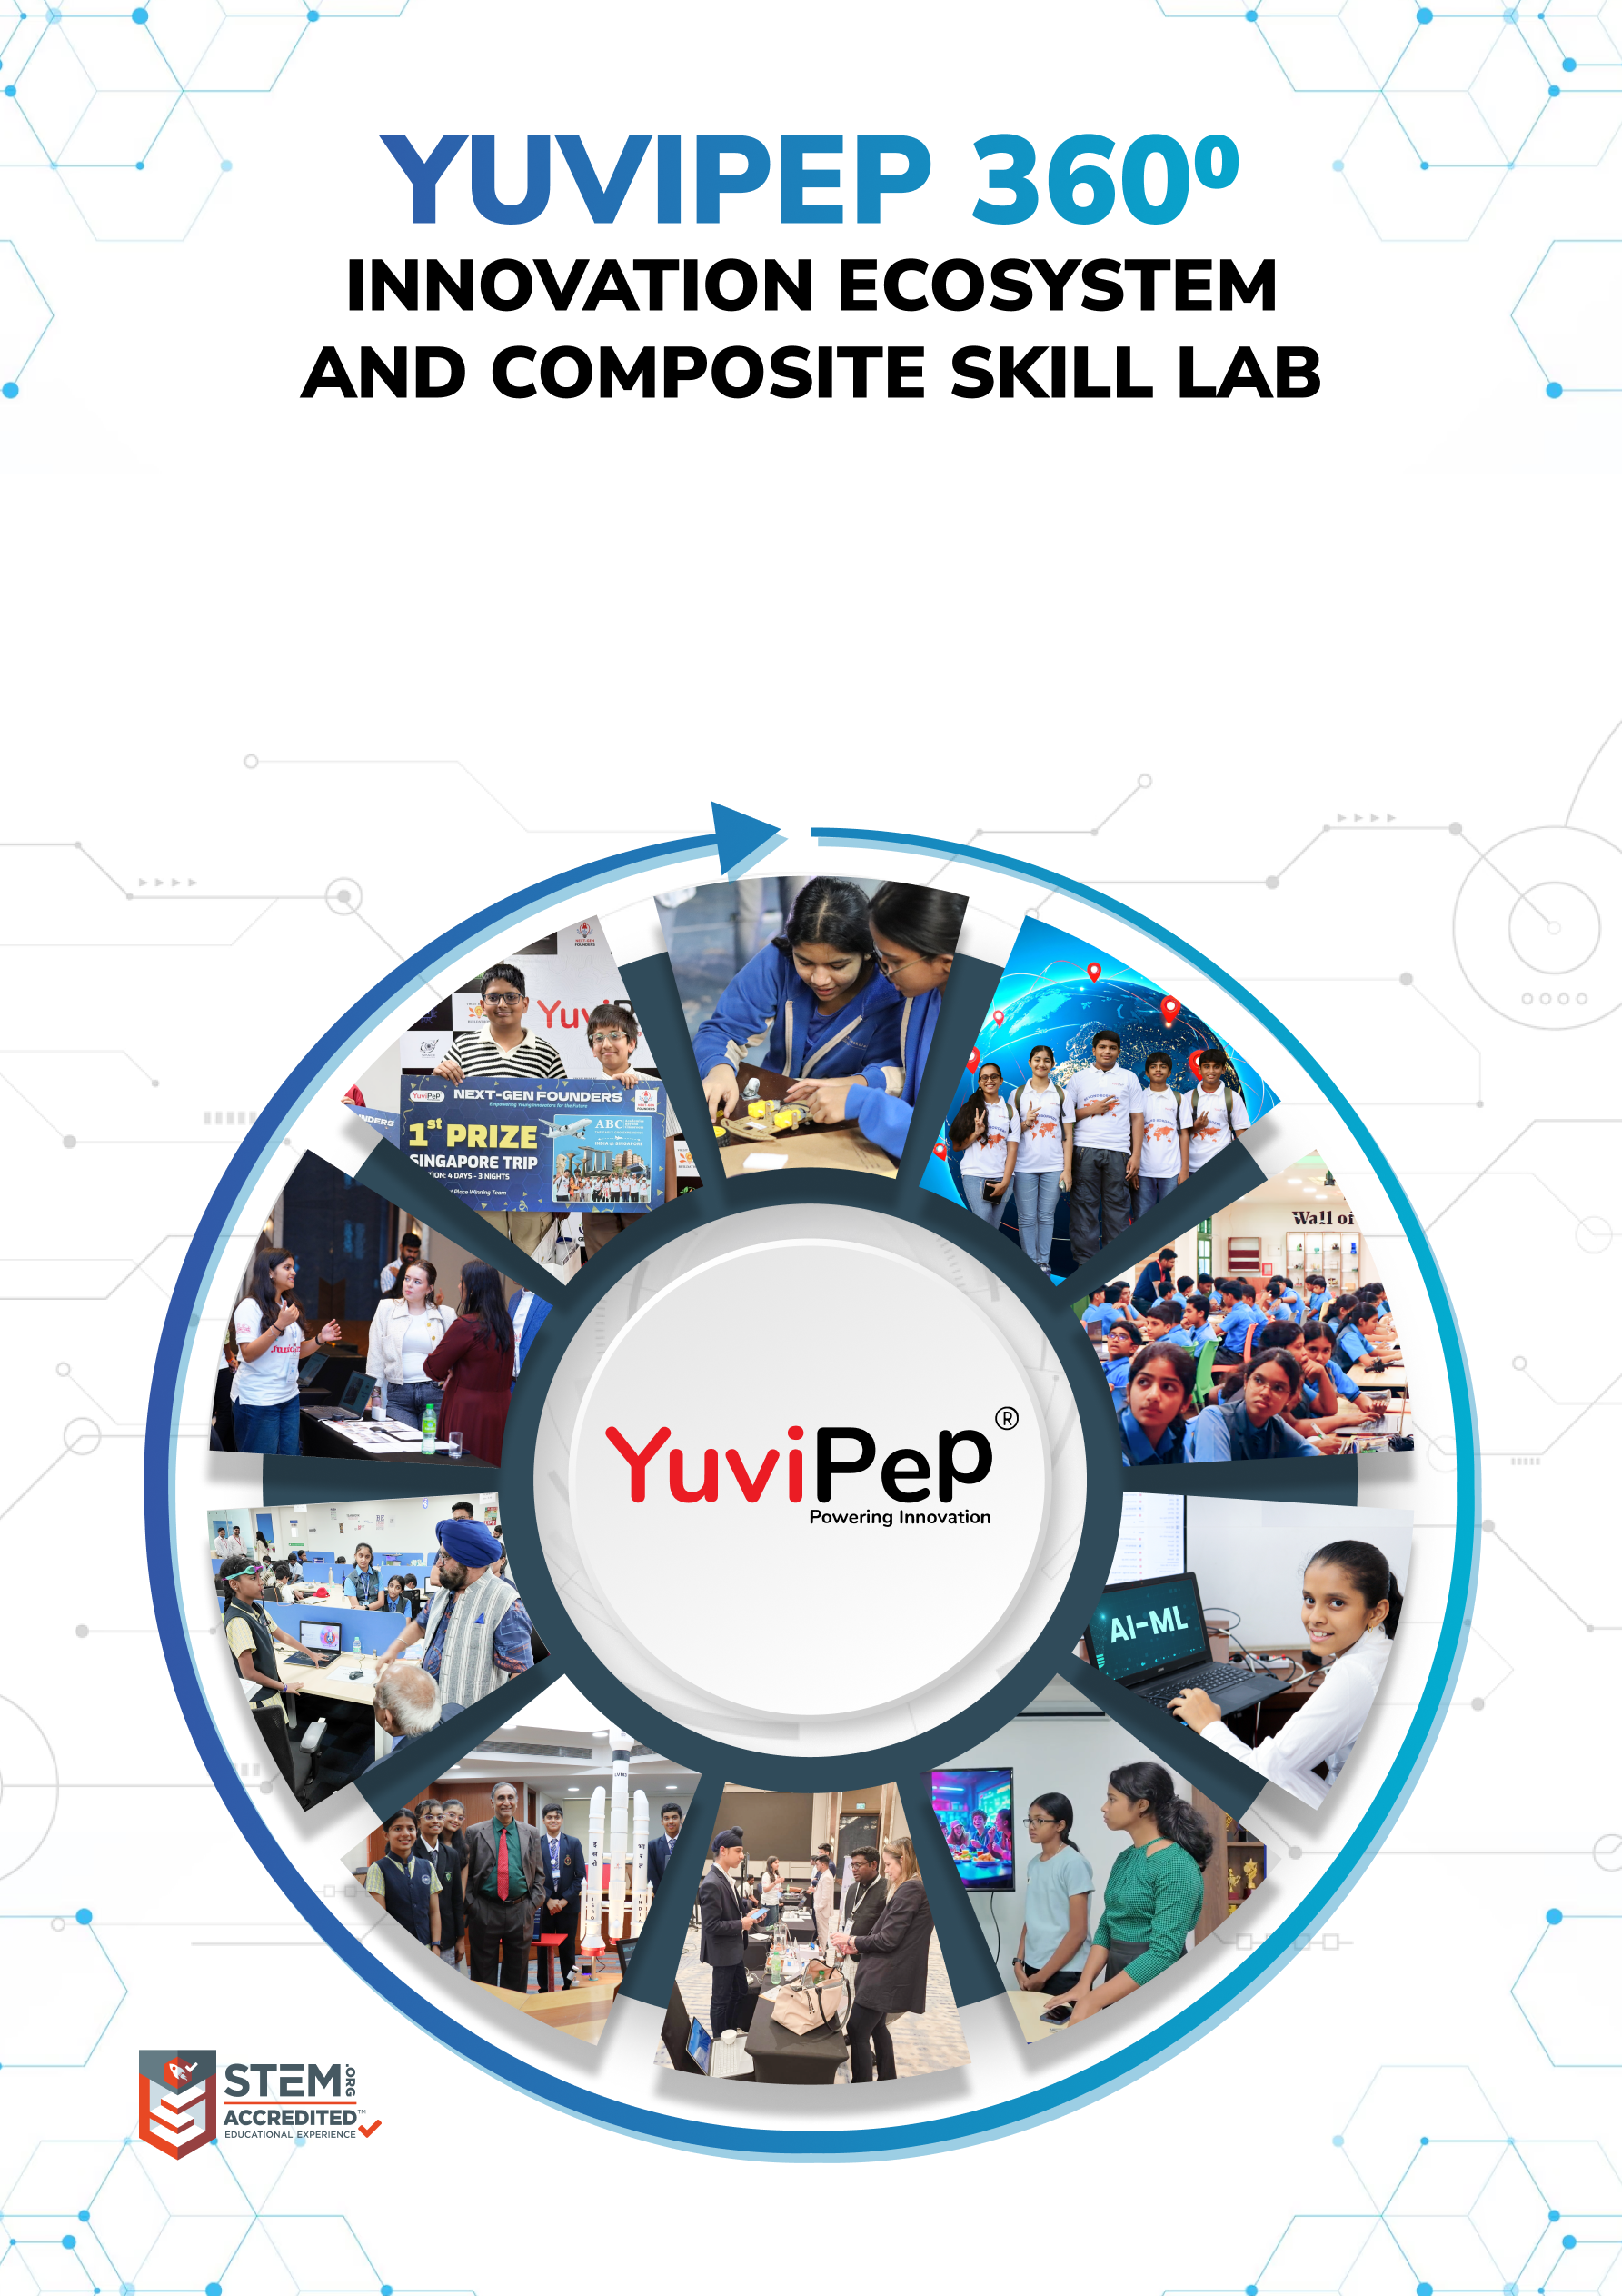
Bookmarks: status: New; author:Sunila Johnson; acceptor: C C; modified: 28.9.2026
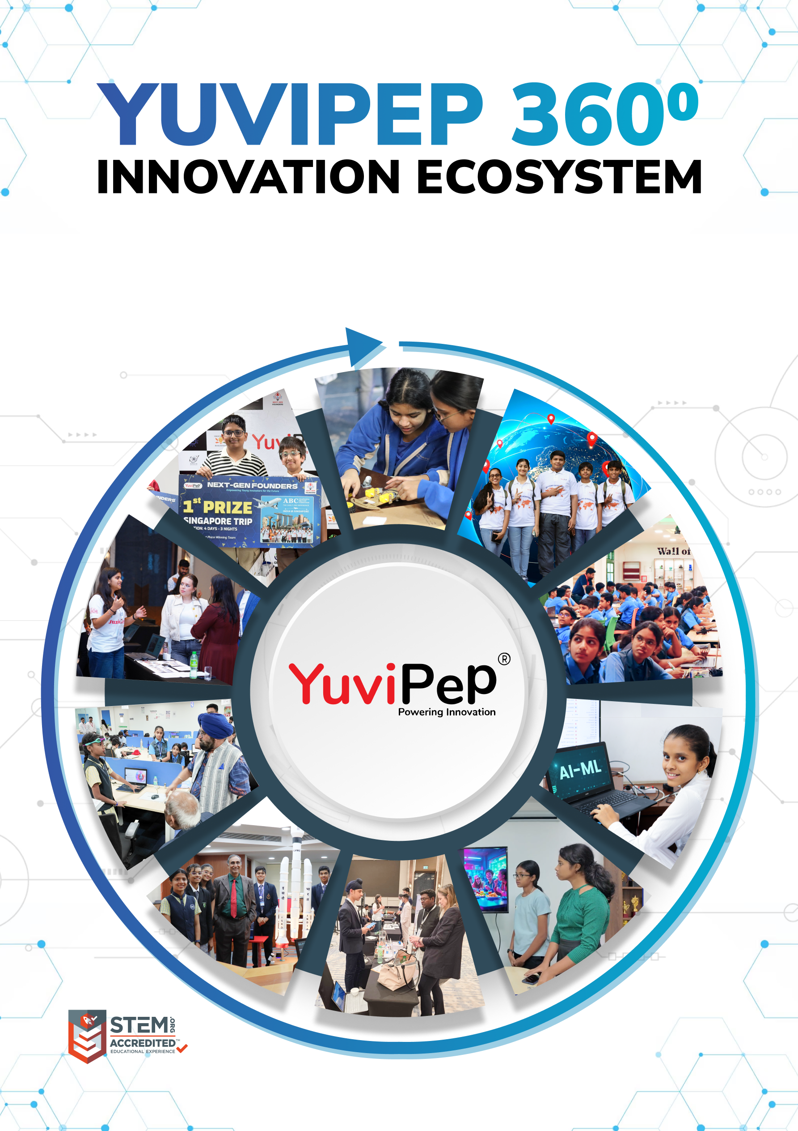
<School Name>
Table of Contents
YUVIPEP 360° INNOVATION ECOSYSTEM 2
Building India’s first School-to-Startup Innovation Pipeline 2
The YuviPep 360° Advantage 2
YuviPep 360° Programme 3
Glimpses of Students Achievements 4
Gateway to Global Opportunities 5
Mentorship, Recognition and Appreciation 5
YuviPep’s Knowledge Portals 6
What Makes YuviPep the Right Choice? 7
YuviPep’s Growing Impact Across India 8
Grade-Wise Learning – IBC 9
Programme Structure and Investment 14
Programme Deliverables – IBC 14
Investment Framework – IBC 14

YUVIPEP 360° INNOVATION ECOSYSTEM

Building India’s first School-to-Startup Innovation Pipeline
The YuviPep 360° Innovation Ecosystem is a full-stack platform embedded directly within academic environments. It creates a structured pathway in which students move from foundational innovation learning to advanced technology application, industry immersion, prototype development, incubation, and investor readiness.
YuviPep 360° is a future-focused, integrated platform designed to transform how students learn, create, and lead. It operates as a comprehensive, interconnected framework rather than a standalone programme—strengthening academic environments, enhancing student outcomes, and creating a clear pathway from learning to leadership.
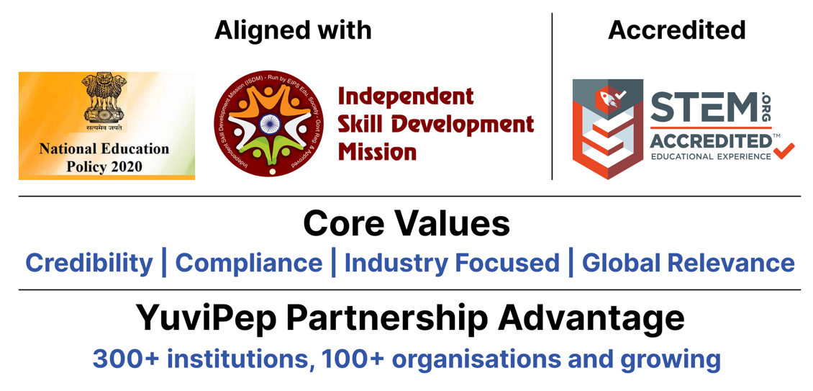

The YuviPep 360° Advantage
Built on ten strategic pillars, the YuviPep 360° Advantage creates a powerful ecosystem that connects learning with industry, innovation and global opportunity.
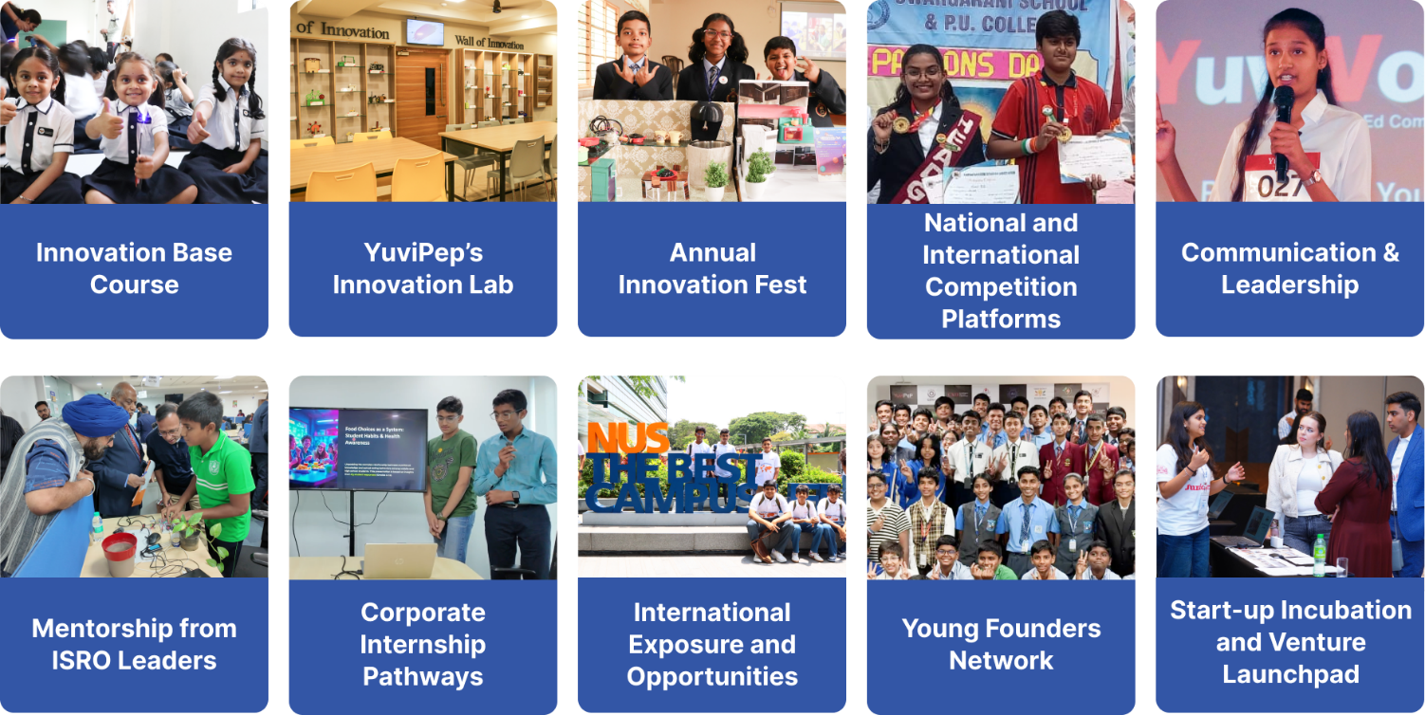

YuviPep 360° Programme
The YuviPep 360° Programme creates a continuous progression of skills across Grades 1–12. Younger students begin with observation, experimentation, materials, movement, circuits and simple problem-solving. As they advance, they work with coding, sensors, motors, systems, data, automation, AI and robotics, gradually taking on more complex projects and complete system planning. The learning grows with the student.
Core Learning Areas
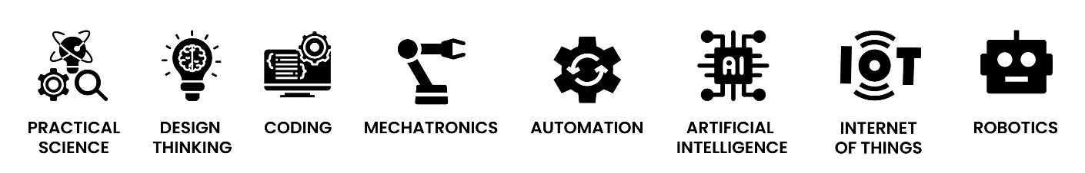

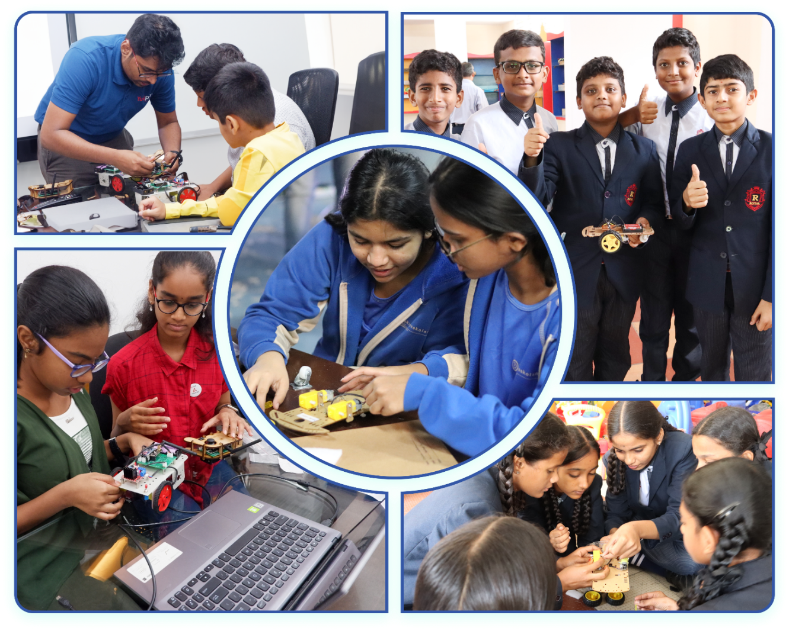

Glimpses of Students Achievements

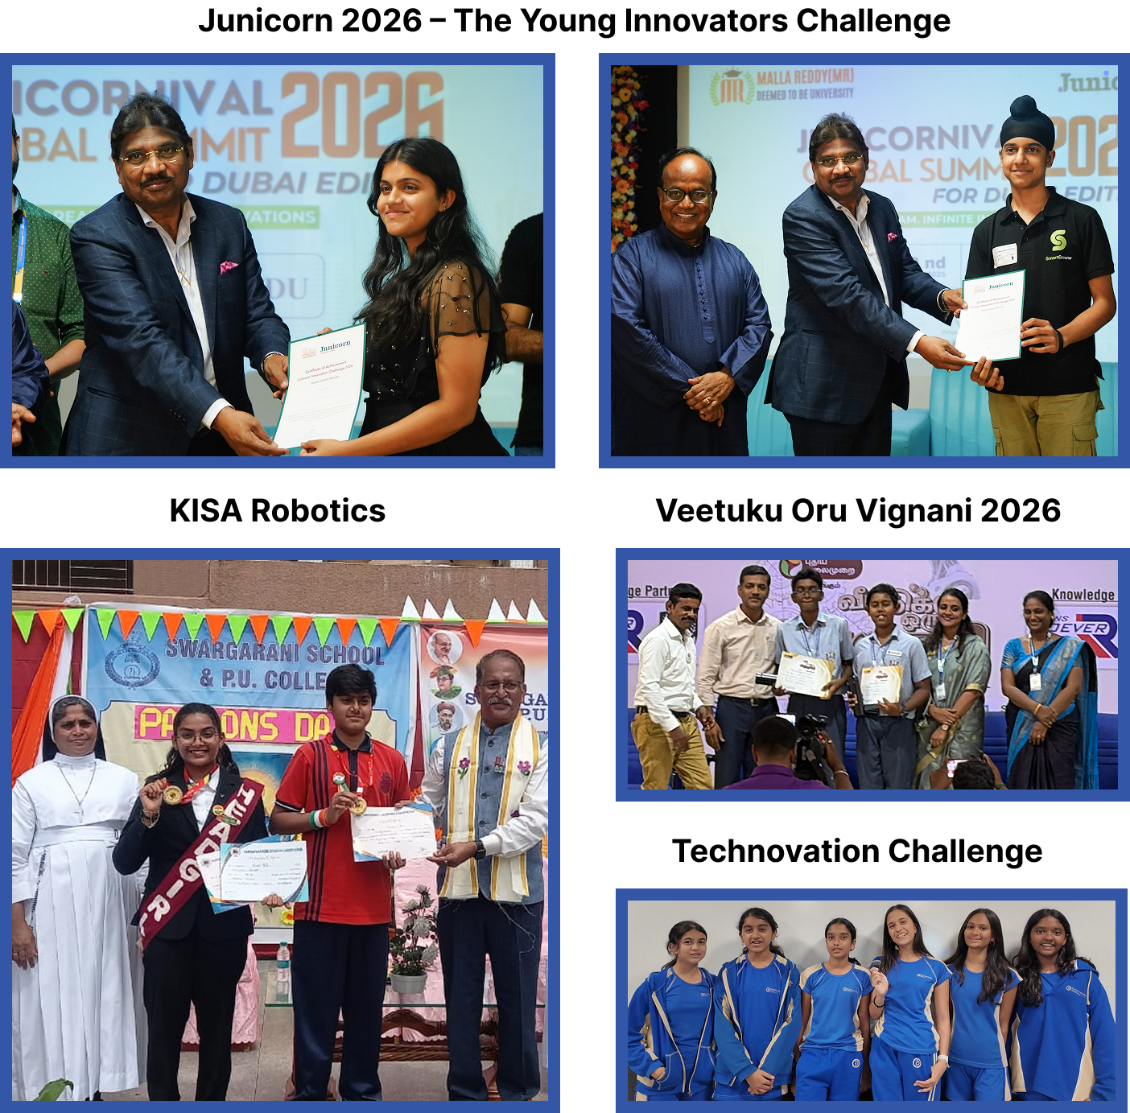

Gateway to Global Opportunities
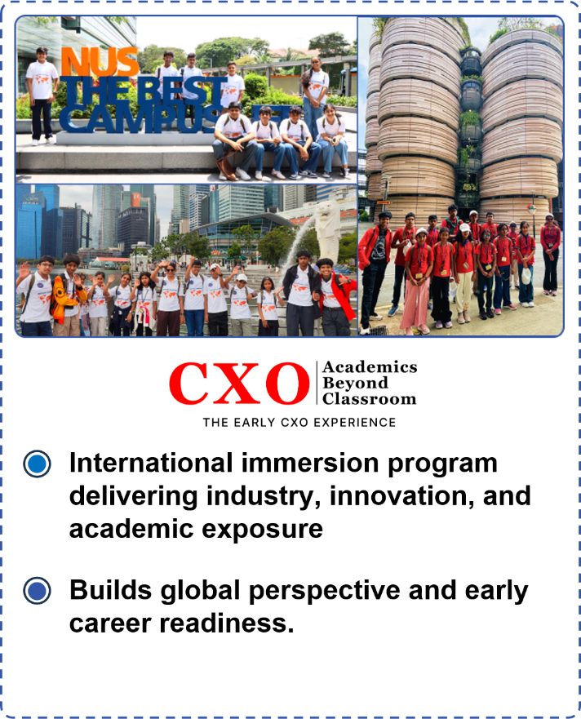 | 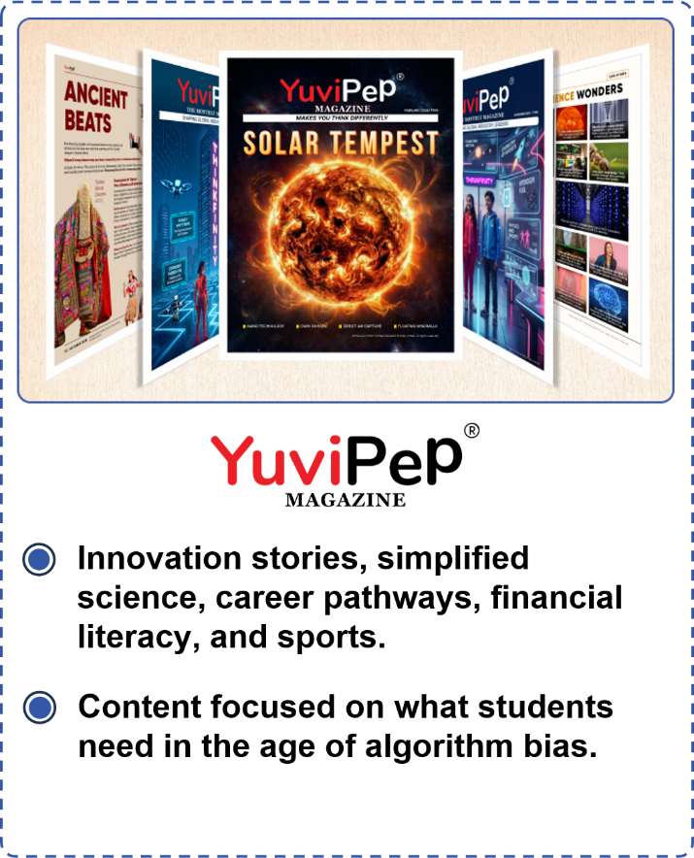

Mentorship, Recognition and Appreciation
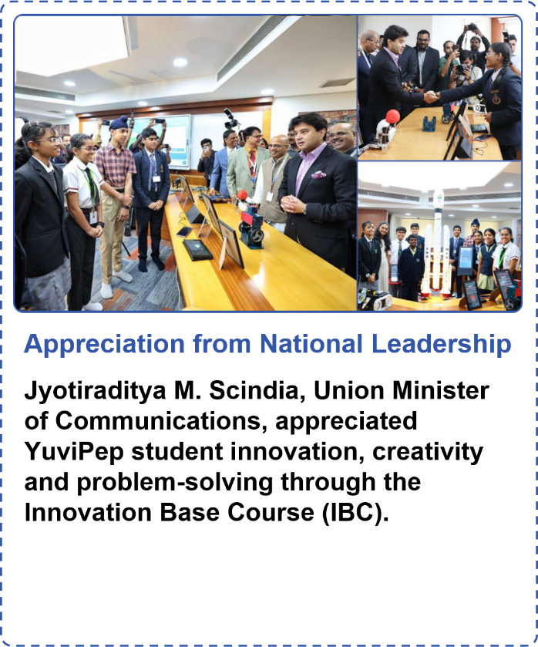 | 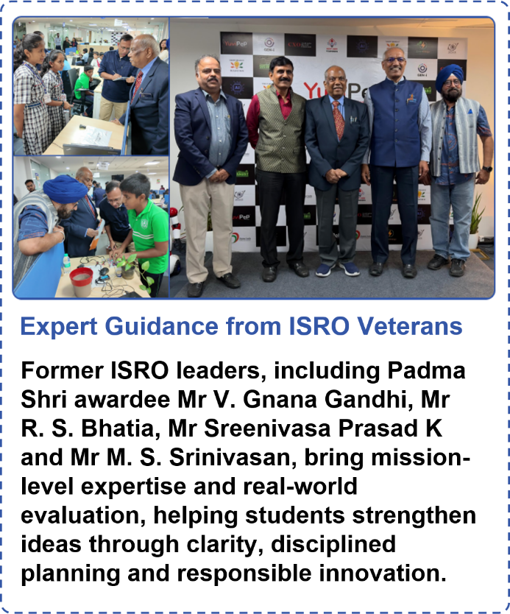

YuviPep’s Knowledge Portals

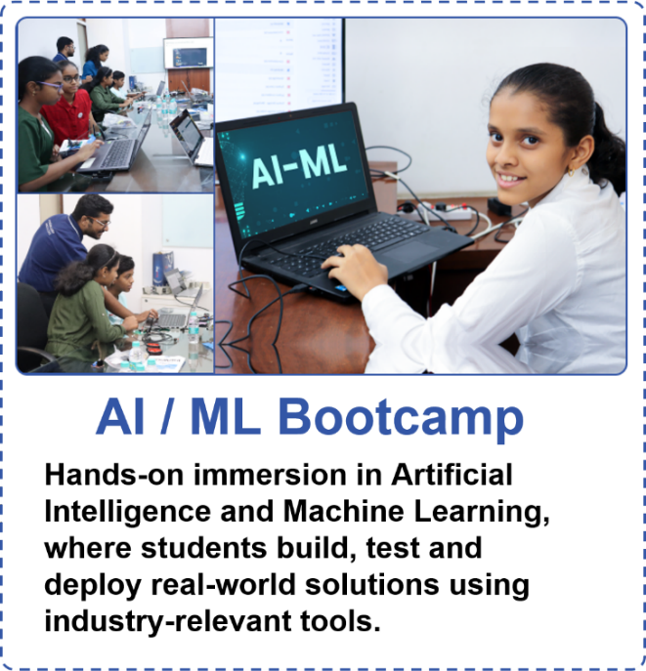 | 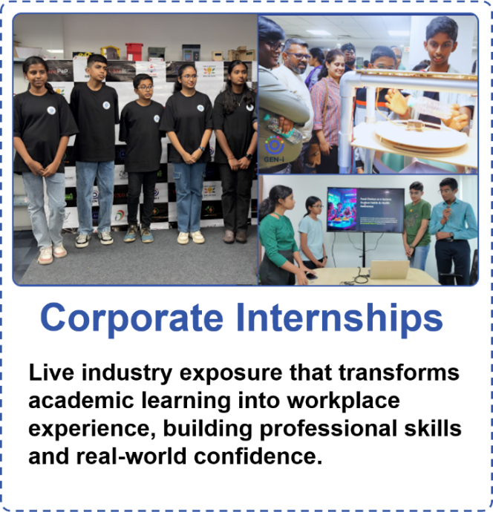
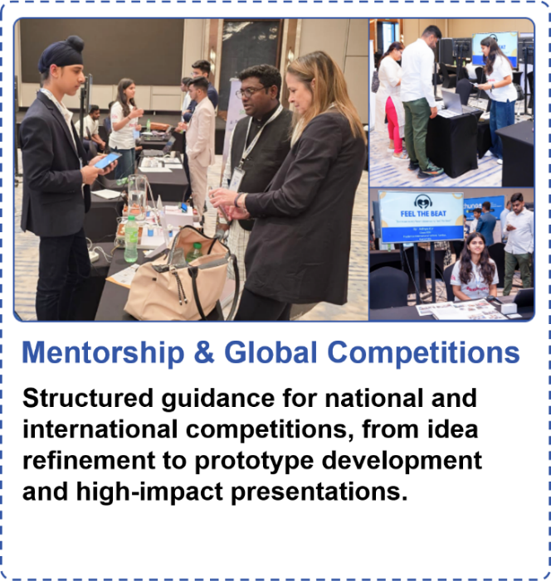 | 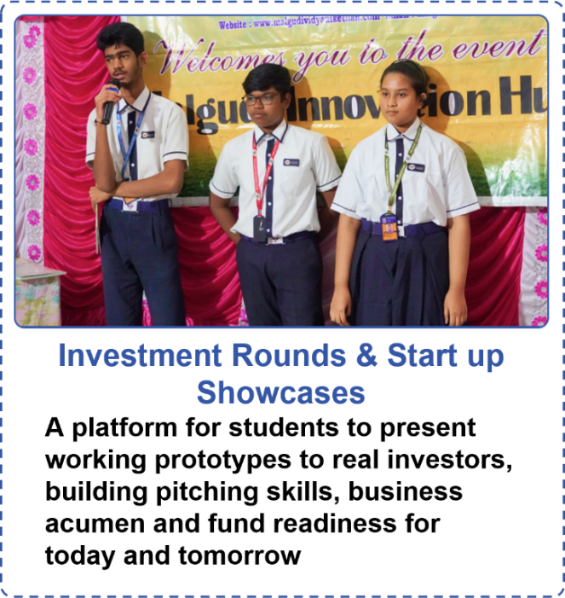
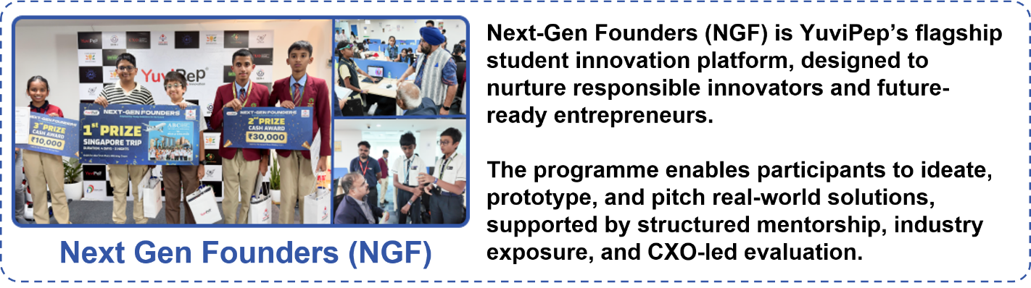

What Makes YuviPep the Right Choice?

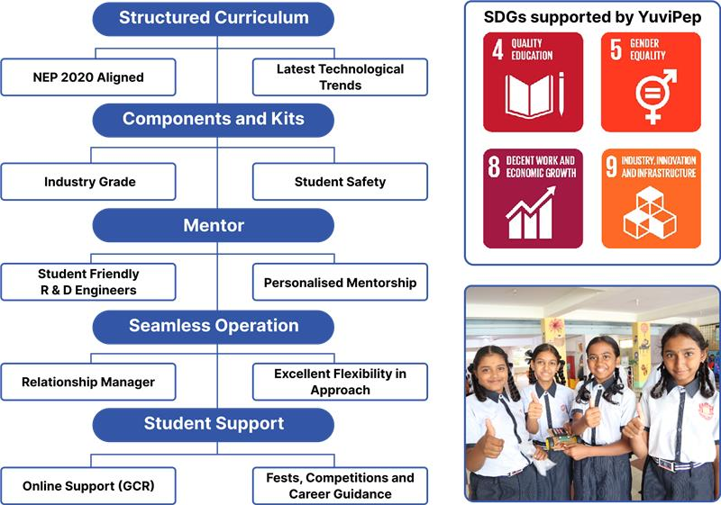

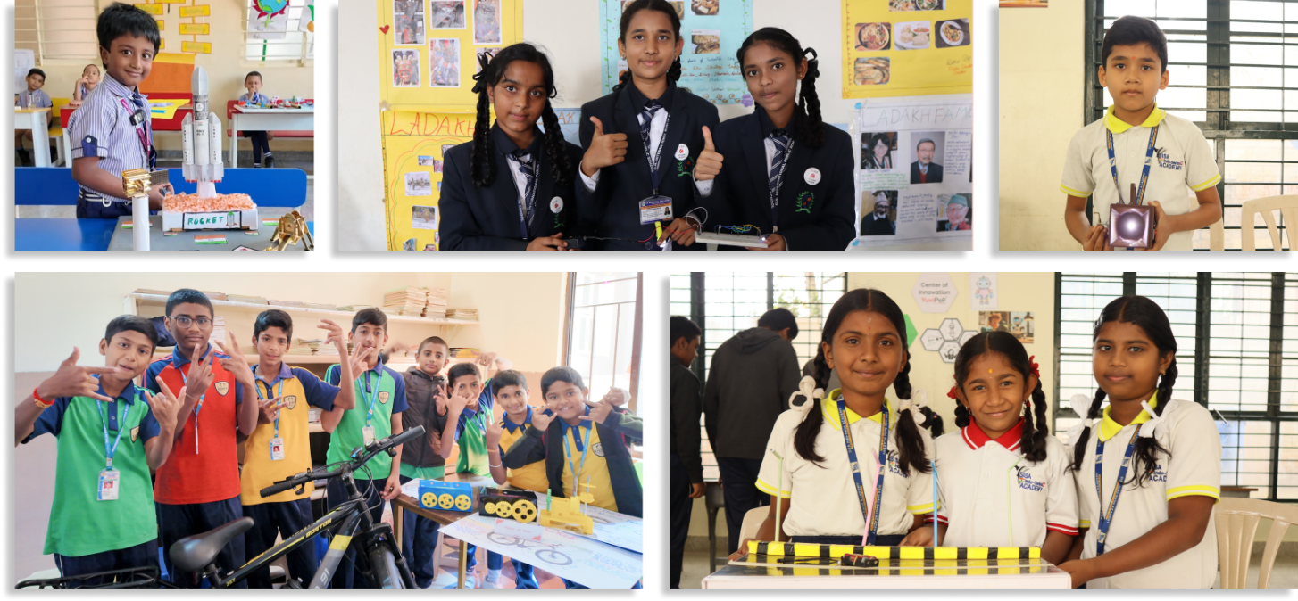

YuviPep’s Growing Impact Across India
A rapidly expanding national presence driving innovation, skill development and future-ready learning across institutions in India.
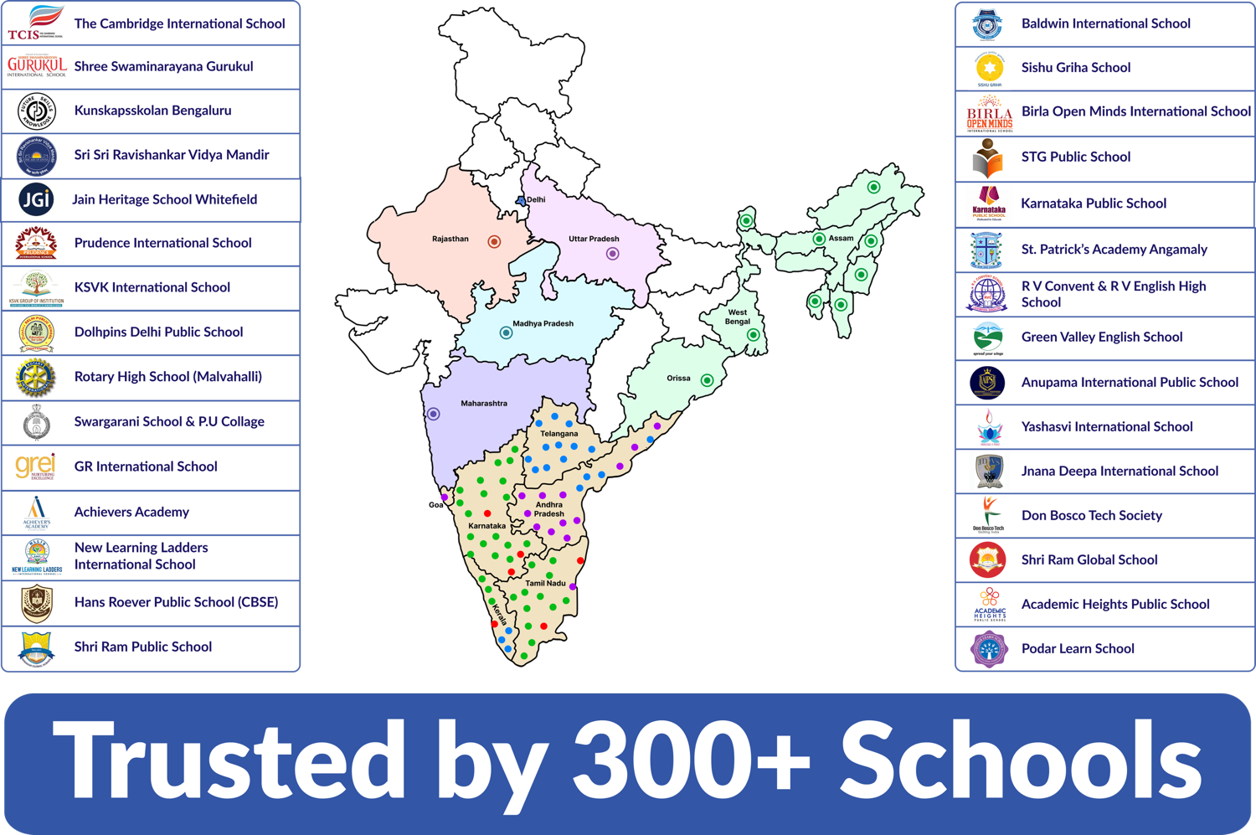

Grade-Wise Learning – IBC
The IBC learning journey is designed to progress across grades, with students building on their skills and concepts as they move from one level to the next. The overview below provides a high-level glimpse of the learning journey. A detailed syllabus, including specific projects, activities and learning outcomes, can be provided upon request.
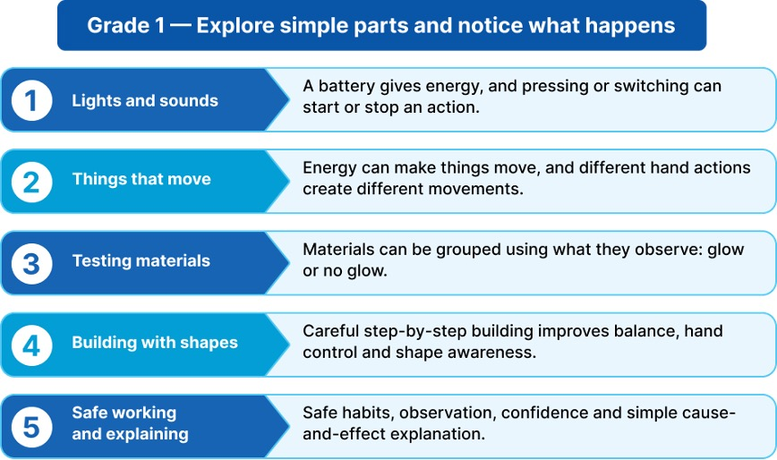

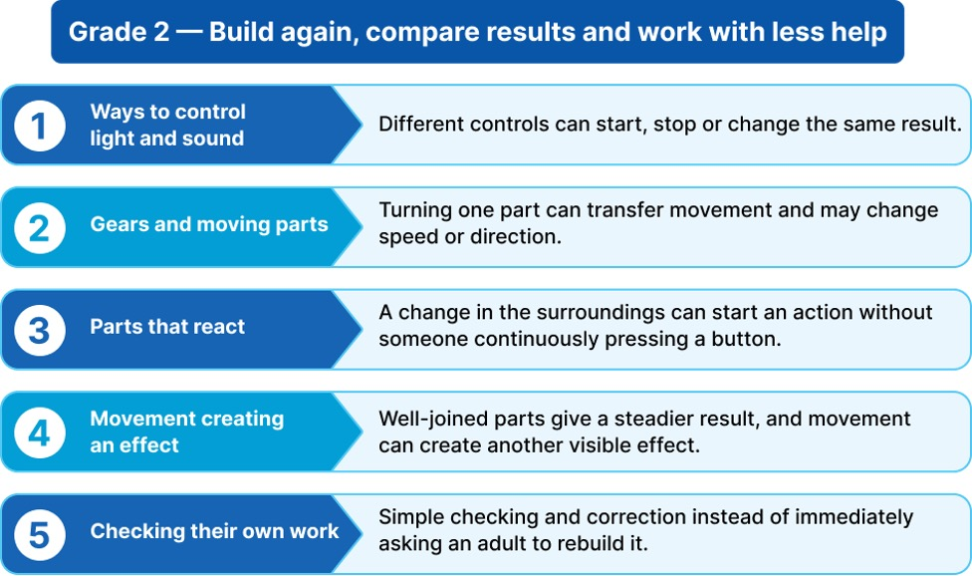
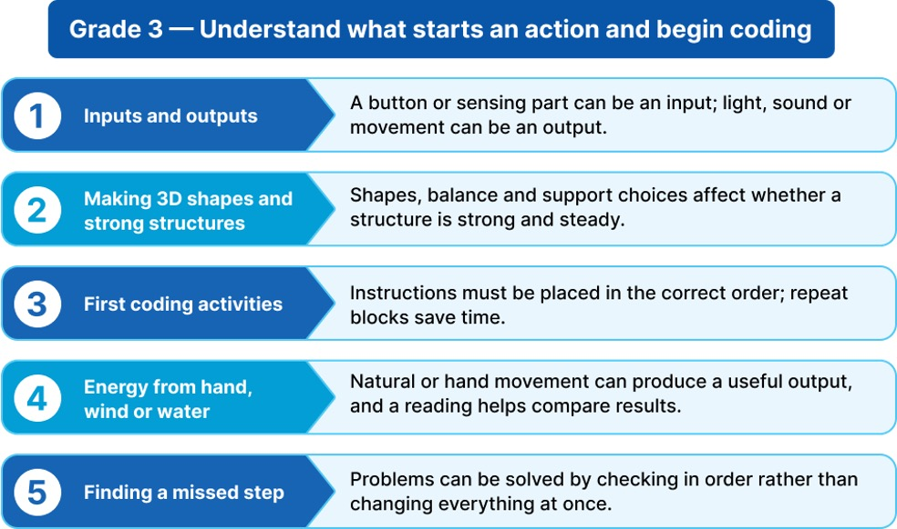

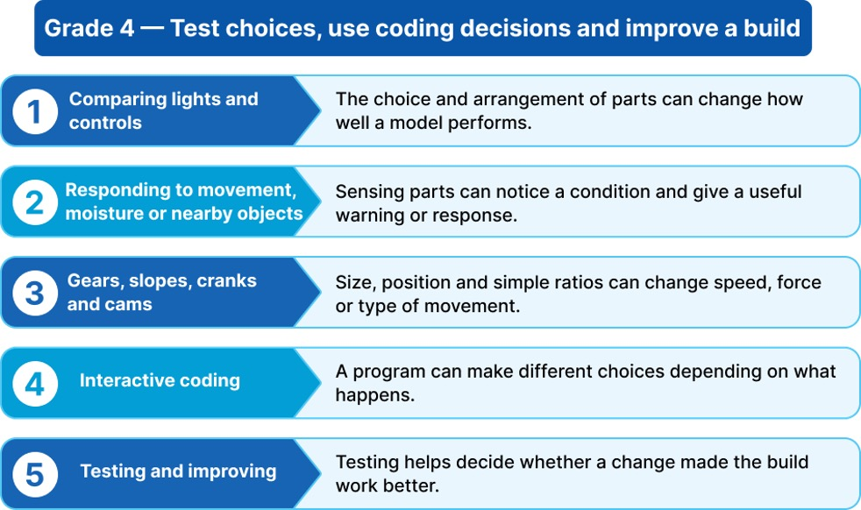

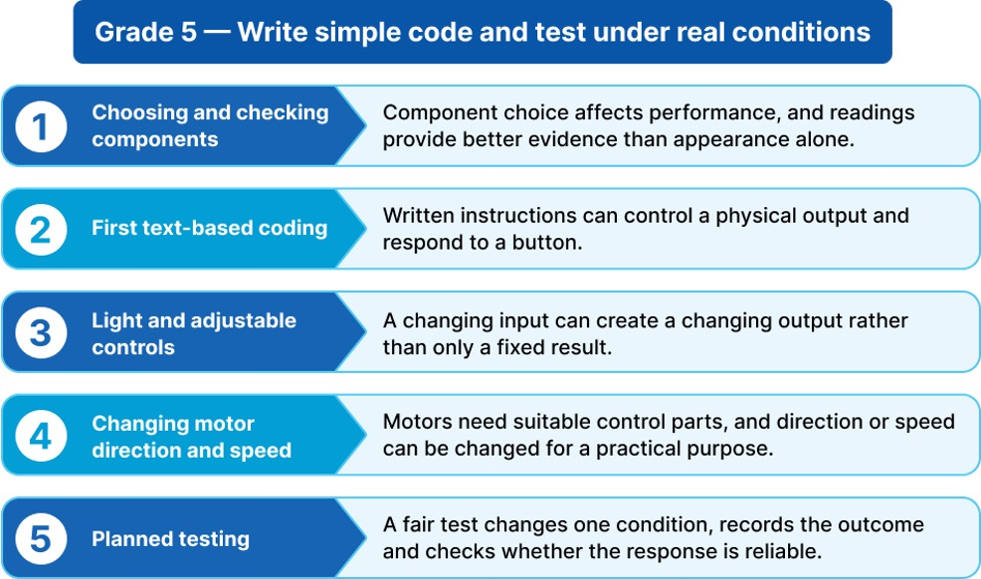

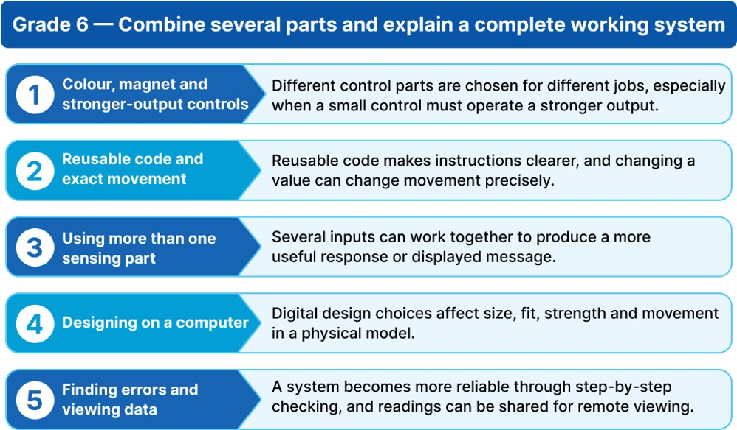

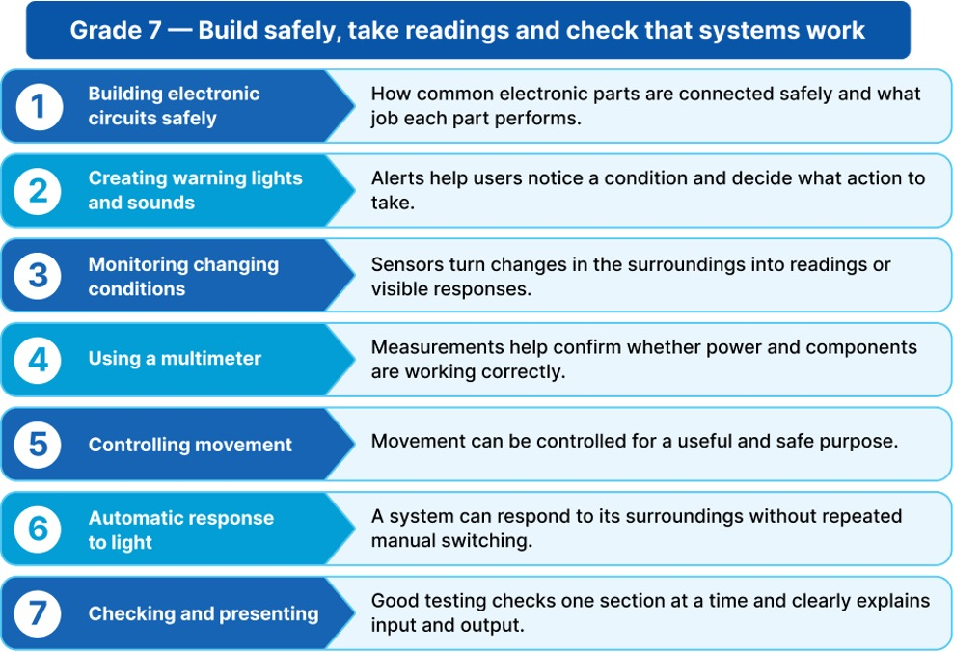

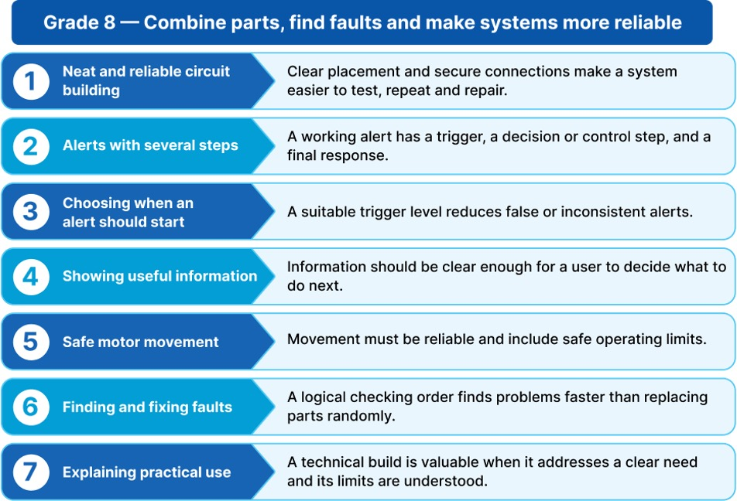
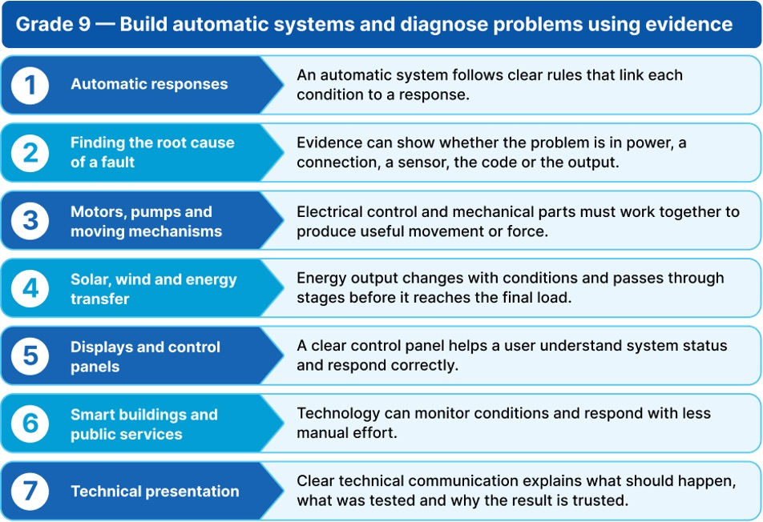

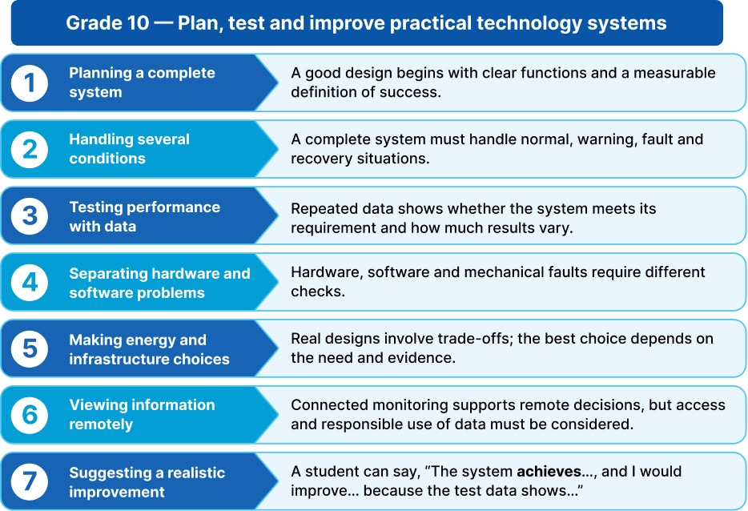
Note: This is a broad learning overview. Specific project and activity names will be finalised as part of the detailed syllabus rollout.

Programme Structure and Investment

Programme Deliverables – IBC
Deliverable | Provision
Innovation Base Course | Yes
R&D Engineer | Yes
GEN-i Internship | Yes
Study Materials and Workbooks | Yes
Kits and Components for Experiments | Yes
Innovation Fest | Eligible
Timely Assessments with Revisions | Yes
Project Assistance | Yes
IBC Certificates | Yes
Parent Orientation Support | Yes
Exclusive Account Manager | Yes

Investment Framework – IBC
Parameter | Details
Annual Price Per Student | <ask:₹2,800 net>
Programme Duration | <ask:10 months>
Workshop Frequency | <ask:Once a week>
Number of Students | <ask:1200>
Grades | <ask:1 to 10>
Note: All required IBC materials and kits will be securely stored in a designated classroom to ensure smooth and organised programme execution.

Disclaimer: This document and its contents are the exclusive property of YuviPep Education Private Limited and are strictly confidential. No part of it may be disclosed, copied, reproduced, distributed, or used without prior written consent from YuviPep Education Private Limited. Unauthorised use or disclosure may lead to legal action.

