Bookmarks: status: New; author:Sunila Johnson; acceptor: C C; modified: 8.10.2026
<School Name>
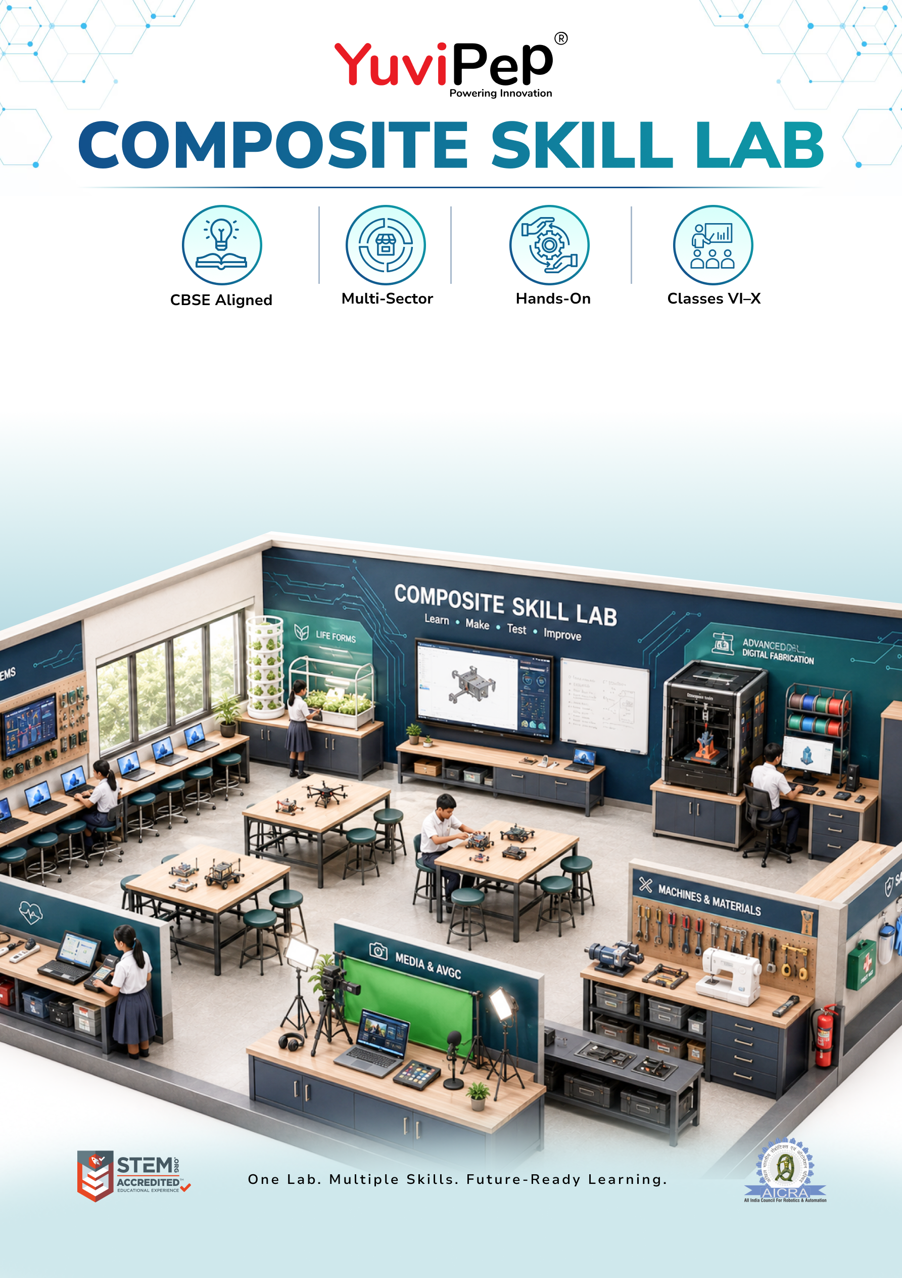
Composite Skill Lab – Advanced
Table of Contents
About YuviPep 360° Innovation Ecosystem 2
Building India’s first School-to-Startup Innovation Pipeline 2
About Advanced Composite Skill Lab (CSL) 2
Learning & Application Areas 3
Advanced Composite Skill Lab 4
INVESTMENT AT A GLANCE 6
School Scope 6
Payment Terms 6
Implementation and Next Steps 7

About YuviPep 360° Innovation Ecosystem

Building India’s first School-to-Startup Innovation Pipeline
The 360° Innovation Ecosystem is a full-stack platform embedded within academic environments. It creates a structured pathway that moves students from foundational innovation learning to advanced technology application, industry immersion, prototype development, incubation, and investor readiness.
YuviPep 360° Innovation Ecosystem is a future-focused, integrated platform designed to transform how students learn, create and lead. It operates as a comprehensive, interconnected framework rather than a standalone programme, strengthening academic environments, enhancing student outcomes and creating a clear pathway from learning to leadership.
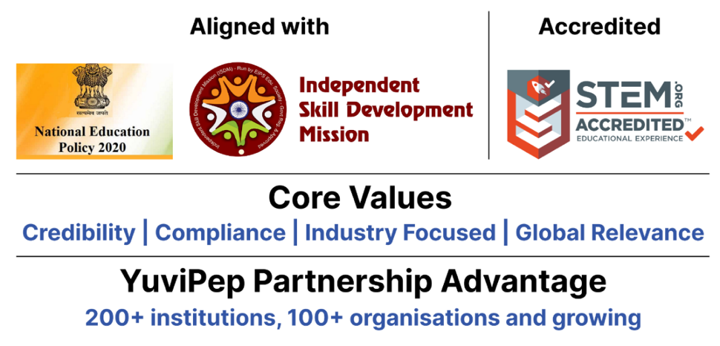

About Advanced Composite Skill Lab (CSL)
The YuviPep Advanced Composite Skill Lab provides schools with a comprehensive environment for advanced, technology-driven learning across electronics, IoT & AI, digital fabrication, agriculture & life systems, mechanical & textile work, healthcare & wellness, retail & enterprise, and media & communication.
Equipped with advanced electronics and IoT systems, edge AI and computer vision technologies, premium digital fabrication tools, advanced fabrication and instrumentation equipment, educational drones, healthcare training resources and professional media resources, the lab enables students to take on complex, technology-enabled projects. Students can design, build, test and refine prototypes while applying technology to real-world challenges.
It provides an advanced platform for developing innovation and problem-solving capability, helping students integrate multiple technologies, work on complex projects and move towards higher-level technical and career-oriented learning.

Learning & Application Areas
The Advanced Composite Skill Lab enables students to explore a range of practical applications through a common learning environment.
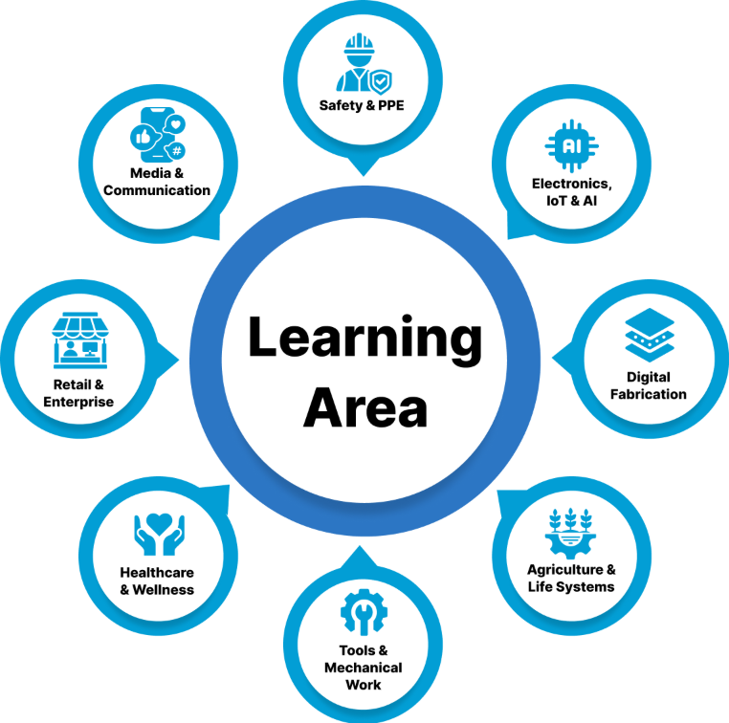

Learning Area | Student Applications | Learning Area
Electronics, IoT & AI | Advanced electronics, IoT systems, edge AI, computer vision, automation and intelligent systems | Electronics, IoT & AI
Digital Fabrication | Advanced 3D modelling, precision fabrication, rapid prototyping and product development | Digital Fabrication
Agriculture & Life Systems | Smart agriculture, automated growing systems, environmental monitoring, precision cultivation and life-system applications | Agriculture & Life Systems
Tools & Mechanical Work | Advanced tools, mechanical fabrication, assembly, instrumentation and engineering projects | Tools & Mechanical Work
Healthcare & Wellness | Advanced healthcare training, health monitoring, first-aid and emergency response practice | Healthcare & Wellness
Retail & Enterprise | Product development, retail technology, point-of-sale systems, enterprise applications and entrepreneurship | Retail & Enterprise
Media & Communication | Professional content creation, digital media production, documentation, presentation and communication | Media & Communication
Safety & PPE | Safe operation of advanced equipment, personal protective equipment, workplace practices and lab safety | Safety & PPE

Advanced Composite Skill Lab
The following table outlines the core infrastructure, equipment and tools included in the Advanced Composite Skill Lab.

Zone | Item / Equipment & Capability | Quantity
Furniture & Workstations | Durable 5 × 4 ft Modular Group Worktable | 5
Furniture & Workstations | Robust Stackable Student Stool | 40
Furniture & Workstations | Lockable Teacher Worktable | 1
Furniture & Workstations | Ergonomic Teacher Chair | 1
Storage & Organisation | Lockable Tool, Kit & Consumables Cabinet | 1
Storage & Organisation | Heavy-Duty Open Storage Shelf | 2
Storage & Organisation | Labelled Small-Parts Storage Set | 20
Storage & Organisation | Wall-Mounted Tool Pegboard with Hooks | 2
IT & Digital Infrastructure | Performance Laptop for Advanced Coding, AI & Design | 1
IT & Digital Infrastructure | Office-Specification Laptop for Lab Operations | 1
IT & Digital Infrastructure | Interactive Touch Teaching, Dashboard & Project Display | 1
Electronics, IoT & AI | Full-Capacity Wi-Fi IoT Project Group Kit | 10
Electronics, IoT & AI | Sensor, Motor & Actuator Expansion Set | 5
Electronics, IoT & AI | Digital Circuit-Testing Multimeter | 8
Electronics, IoT & AI | High-Accuracy Digital Multimeter | 2
Electronics, IoT & AI | Dual Precision Temperature-Controlled Soldering Station | 2
Electronics, IoT & AI | Supervised Electronics Soldering Kit | 5
Electronics, IoT & AI | Raspberry Pi + Jetson Nano Real-Time AI Vision Station | 1
Digital Fabrication | Premium Enclosed Multicolour FDM 3D Printer | 1
Digital Fabrication | Handheld 3D Model-Making Pen | 5
Agriculture & Life Systems | Gardening & Cultivation Group Kit | 5
Agriculture & Life Systems | Automated Hydroponics Station with Pump, Controller & Monitoring | 1
Agriculture & Life Systems | Digital pH & Nutrient-Strength Meter Set | 1
Agriculture & Life Systems | App-Monitored Smart Vertical Farming Tower | 1
Electronics, IoT & AI | Arduino Circuit, Sensor & Coding Group Kit | 10
Tools, Mechanical & Textiles | Shared Hand-Tool Project Station | 2
Tools, Mechanical & Textiles | Power & Hand-Tool Fabrication Station | 1
Tools, Mechanical & Textiles | Corded Drill Station with Bit Set | 2
Tools, Mechanical & Textiles | Advanced Fabrication & Oscilloscope Instrumentation Station | 1
Tools, Mechanical & Textiles | Basic Stitching & Textile Project Machine | 1
Tools, Mechanical & Textiles | Motorised Textile Project Machine | 1
Tools, Mechanical & Textiles | Educational Drone for Flight, Control & Project Activities | 3
Healthcare & Wellness | BP, Oxygen, Temperature & First-Aid Practice Kit | 1
Healthcare & Wellness | Contact-Free Temperature Screening Device | 1
Healthcare & Wellness | Feedback-Enabled CPR & AED Emergency Training System | 1
Retail & Enterprise | Barcode, RFID & Retail Billing Simulation Kit | 1
Media & Communication | Webcam, Microphone, Lighting & Tripod Media Kit | 1
Media & Communication | Complete Camera, Audio, Lighting & Green-Screen Studio Kit | 1
Safety & PPE | Institutional Safety, PPE & First-Aid Kit | 1
Lab Infrastructure | Educational & Safety Lab Wall Posters | 1

INVESTMENT AT A GLANCE
Proposed Innovation Lab Type | Advanced Composite Skill Lab
Lab Positioning | Core Composite Skill Lab
Space | <ask:600 to 800 sq ft>  Minimum requirement: one room of 800 sq ft or two rooms of 600 sq ft each.
Core Forms of Work | ✓
Electronics, IoT & AI | ✓
CBSE Skill Modules | ✓ (Covers 11 skills)
Total Investment incl. GST | <ask:₹15,86,297>

School Scope
To ensure smooth installation and operation of the Composite Skill Lab, the school will provide the required infrastructure and room readiness, including:
- Room Size: a lab room of the dimensions noted for your chosen package, made available before installation.
- Internet: stable Wi-Fi/LAN connectivity for IoT, AI and content-creation stations.
- Painting: wall and ceiling painting of the lab room before installation.
- Electrical: power points, wiring, lighting and earthing for lab equipment.
- Plumbing: water supply and drainage for the hydroponics/wash area.
- Lab Readiness: general civil readiness — workbench base points, exhaust/ventilation as needed.
- IT Support: a local IT support or network administrator point of contact for setup and maintenance.
- Interior: flooring, false ceiling (if any), and general room finishing.

Payment Terms
- Advance payment is applicable upon signing of the MoU.
- Remaining payment terms will be confirmed in the final agreement.
- Payment can be made through NEFT, cheque, credit card or debit card.
- The proposal is valid for 30 days, unless extended.

Implementation and Next Steps
The implementation process will follow four key stages:



