Bookmarks: status: New; author:Sunila Johnson; acceptor: C C; modified: 8.10.2026
<School Name>
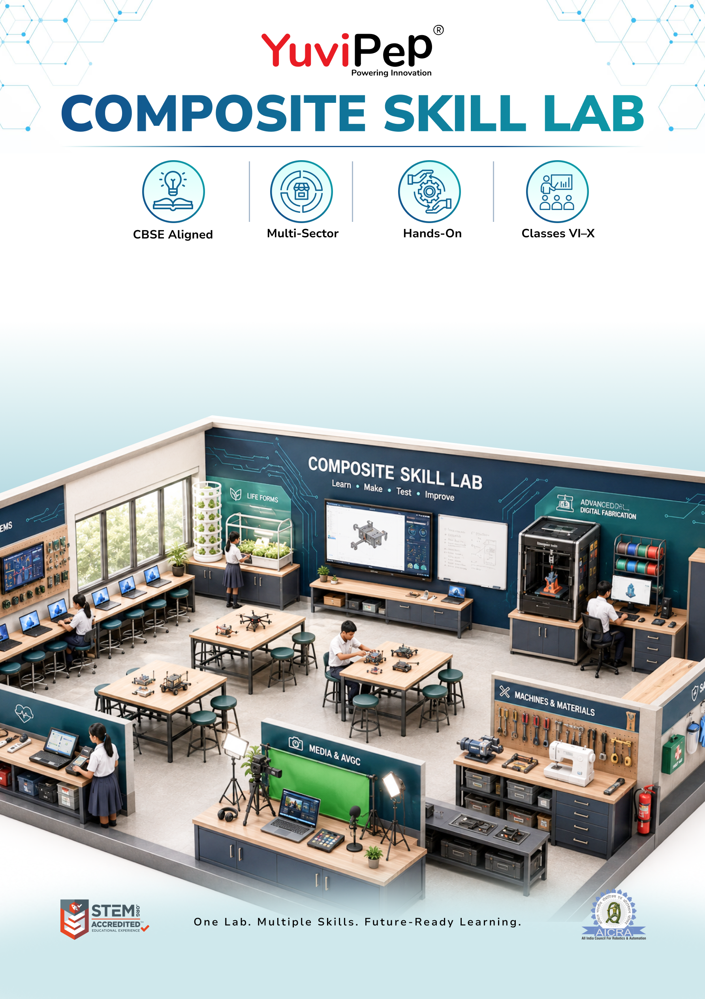
Foundation Composite Skill Lab
Table of Contents
About YuviPep 360° Innovation Ecosystem 2
Building India’s first School-to-Startup Innovation Pipeline 2
About Foundation Composite Skill Lab (CSL) 2
Learning & Application Areas 3
Foundation Composite Skill Lab 4
INVESTMENT AT A GLANCE 5
School Scope 5
Payment Terms 5
Implementation and Next Steps 6

About YuviPep 360° Innovation Ecosystem

Building India’s first School-to-Startup Innovation Pipeline
The 360° Innovation Ecosystem is a full-stack platform embedded within academic environments. It creates a structured pathway that moves students from foundational innovation learning to advanced technology application, industry immersion, prototype development, incubation, and investor readiness.
YuviPep 360° Innovation Ecosystem is a future-focused, integrated platform designed to transform how students learn, create and lead. It operates as a comprehensive, interconnected framework rather than a standalone programme, strengthening academic environments, enhancing student outcomes and creating a clear pathway from learning to leadership.
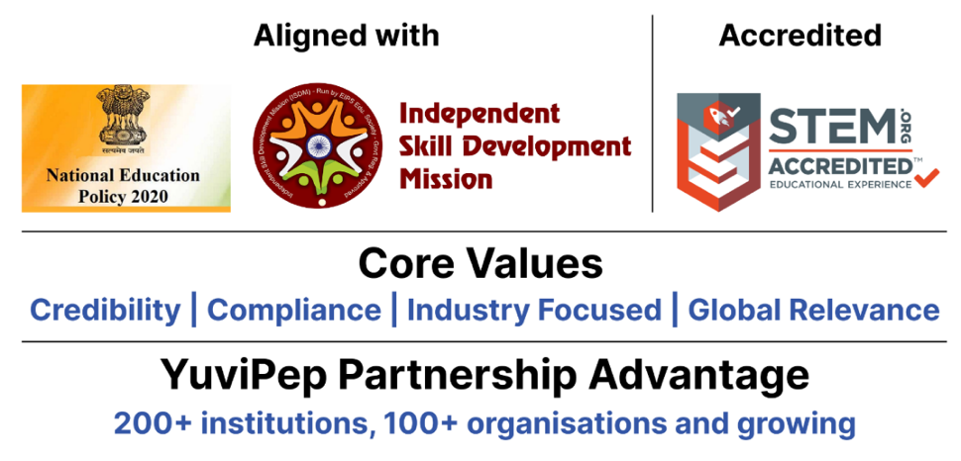

About Foundation Composite Skill Lab (CSL)
The YuviPep Foundation Composite Skill Lab provides schools with a structured, hands-on environment for developing practical skills across electronics, IoT & AI, digital fabrication, agriculture & life systems, tools & mechanical work, textiles, and healthcare & wellness.
Equipped with collaborative workstations, essential tools, digital resources, safety provisions and organised storage, the lab enables students to move beyond theory and learn through practice. Students can build models, conduct experiments, test ideas and apply their learning through real-world projects.
It provides a strong foundation for experiential, skill-based education, helping students develop practical skills while learning to explore, create and solve problems.

Learning & Application Areas
The Foundation Composite Skill Lab enables students to explore a range of practical applications through a common learning environment.
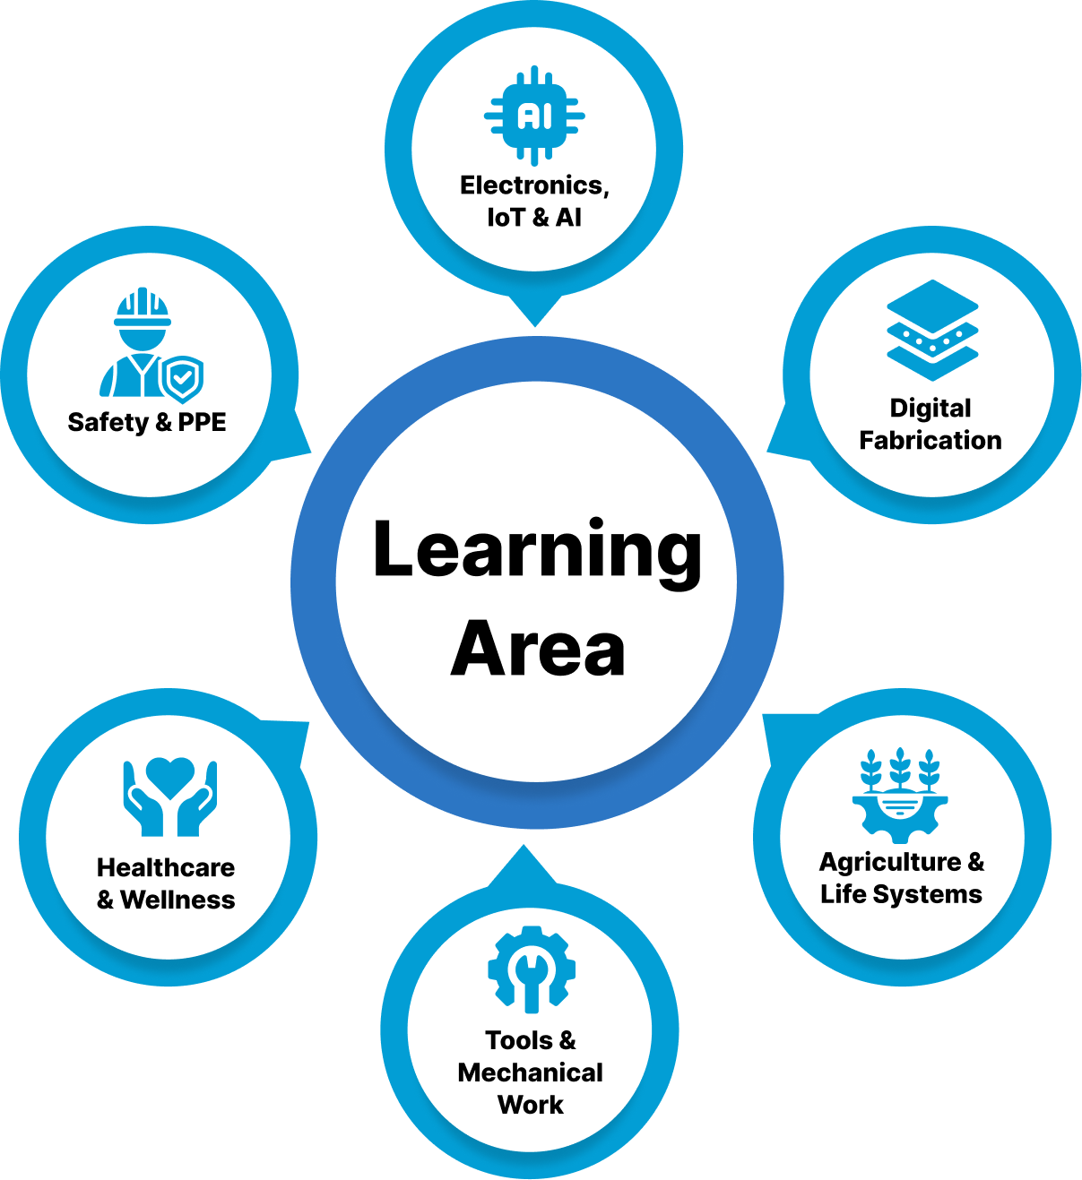

Learning Area | Student Applications
Electronics, IoT & AI | Circuits, sensors, coding, IoT projects, testing and basic automation
Digital Fabrication | 3D model-making, prototyping and creative fabrication
Agriculture & Life Systems | Gardening, cultivation, soil-free growing and plant monitoring
Tools & Mechanical Work | Hand tools, fabrication, drilling and basic mechanical projects
Healthcare & Wellness | Basic health measurements, first-aid practice and wellness awareness
Safety & PPE | Safe use of equipment, personal protective equipment and lab safety practices

Foundation Composite Skill Lab
The following table outlines the core infrastructure, equipment and tools included in the Foundation Composite Skill Lab.

Zone | Item / Equipment & Capability | Quantity
Furniture & Workstations | Durable 5 × 4 ft Modular Group Worktable | 4
Furniture & Workstations | Robust Stackable Student Stool | 40
Furniture & Workstations | Lockable Teacher Worktable | 1
Furniture & Workstations | Ergonomic Teacher Chair | 1
Storage & Organisation | Lockable Tool, Kit & Consumables Cabinet | 2
Storage & Organisation | Heavy-Duty Open Storage Shelf | 1
Storage & Organisation | Labelled Small-Parts Storage Set | 10
Storage & Organisation | Wall-Mounted Tool Pegboard with Hooks | 2
IT & Digital Infrastructure | Office-Specification Desktop Computer | 1
IT & Digital Infrastructure | Teaching & Project Planning Whiteboard | 1
Electronics, IoT & AI | Foundation Arduino Circuit, Sensor & Coding Group Kit | 10
Electronics, IoT & AI | Starter Wi-Fi IoT Project Group Kit | 5
Electronics, IoT & AI | Shared Sensor & Actuator Starter Set | 1
Electronics, IoT & AI | Digital Circuit-Testing Multimeter | 8
Electronics, IoT & AI | Shared High-Accuracy Digital Multimeter | 1
Electronics, IoT & AI | Supervised Electronics Soldering Kit | 5
Digital Fabrication | Creative Handheld 3D Model-Making Pen | 2
Agriculture & Life Systems | Gardening & Cultivation Group Kit | 5
Agriculture & Life Systems | Basic Soil-Free DWC Growing Station | 1
Agriculture & Life Systems | Digital pH & Nutrient-Strength Meter Set | 1
Tools, Mechanical & Textiles | Shared Hand-Tool Project Station | 1
Tools, Mechanical & Textiles | Enhanced Shared Fabrication Tool Station | 1
Tools, Mechanical & Textiles | Corded Drill Station with Bit Set | 1
Tools, Mechanical & Textiles | Basic Stitching & Textile Project Machine | 1
Healthcare & Wellness | BP, Oxygen, Temperature & First-Aid Practice Kit | 1
Safety & PPE | Institutional Safety, PPE & First-Aid Kit | 1
Lab Posters | Educational Lab Interior Posters | 1

INVESTMENT AT A GLANCE
Proposed Innovation Lab Type | Foundation Composite Skill Lab
Lab Positioning | Core Composite Skill Lab
Space | <ask:400 to 600 sq ft>  Note: Minimum requirement: one room of 600 sq ft or two rooms of 400 sq ft each.
Core Forms of Work | ✓
Electronics, IoT & AI | ✓
CBSE Skill Modules | ✓ (Covers 11 skills)
Total Investment incl. GST | <ask:₹5,46,057>

School Scope
To ensure smooth installation and operation of the Composite Skill Lab, the school will provide the required infrastructure and room readiness, including:
- Room Size: a lab room of the dimensions noted for your chosen package, made available before installation.
- Internet: stable Wi-Fi/LAN connectivity for IoT, AI and content-creation stations.
- Painting: wall and ceiling painting of the lab room before installation.
- Electrical: power points, wiring, lighting and earthing for lab equipment.
- Plumbing: water supply and drainage for the hydroponics/wash area.
- Lab Readiness: general civil readiness — workbench base points, exhaust/ventilation as needed.
- IT Support: a local IT support or network administrator point of contact for setup and maintenance.
- Interior: flooring, false ceiling (if any), and general room finishing.

Payment Terms
- Advance payment is applicable upon signing of the MoU.
- Remaining payment terms will be confirmed in the final agreement.
- Payment can be made through NEFT, cheque, credit card or debit card.
- The proposal is valid for 30 days, unless extended.

Implementation and Next Steps
The implementation process will follow four key stages:



