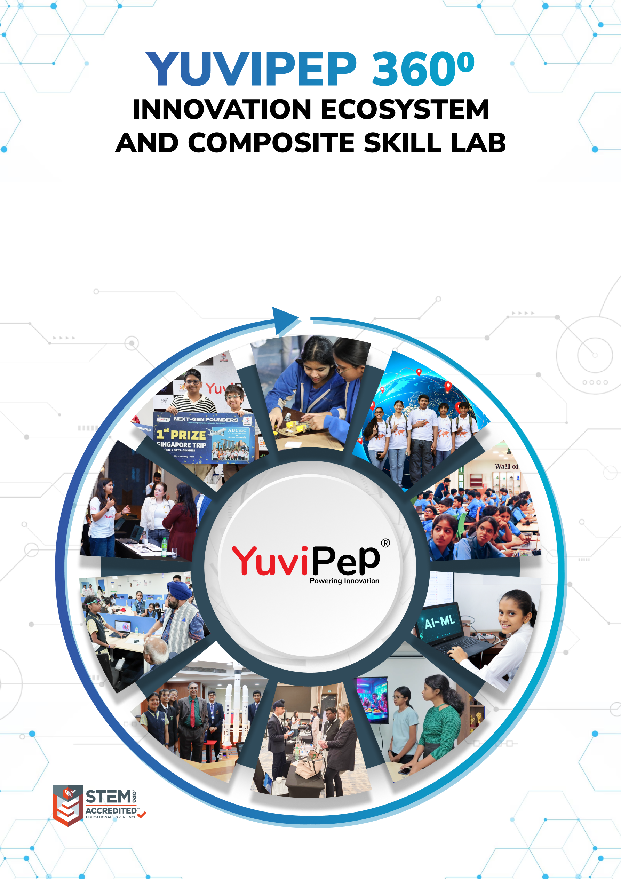
Bookmarks: status: New; author:Sunila Johnson; acceptor: C C; modified: 12.10.2026
Test School Sunrise
Table of Contents
YUVIPEP 360° INNOVATION ECOSYSTEM 2
Building India’s first School-to-Startup Innovation Pipeline 2
The Two Offerings 2
YuviPep 360° Programme 3
The YuviPep 360° Advantage 4
Innovation Pipeline 4
Glimpses of Students Achievements 5
Gateway to Global Opportunities 6
Mentorship, Recognition and Appreciation 6
YuviPep’s Knowledge Portals 7
What Makes YuviPep the Right Choice? 8
YuviPep’s Growing Impact Across India 9
Grade-Wise Learning Journey - IBC 10
Programme Framework - Composite Skill Lab 15
How the Two Offerings Work Together 15
Composite Skill Lab Infrastructure 16
Programme Structure and Investment 17
Programme Deliverables 17
Investment Framework 17
Innovation Framework – Composite Skill Lab 17
Composite Skill Lab – School Requirements 18

YUVIPEP 360° INNOVATION ECOSYSTEM

Building India’s first School-to-Startup Innovation Pipeline
The YuviPep 360° Innovation Ecosystem is a full-stack platform embedded directly within academic environments. It creates a structured pathway in which students move from foundational innovation learning to advanced technology application, industry immersion, prototype development, incubation, and investor readiness.
YuviPep 360° is an integrated framework that strengthens learning environments, builds student capabilities and creates a clear pathway from learning to leadership. The ecosystem is designed to complement the evolving CBSE skill education structure, including Kaushal Bodh and Kaushal Vikas, while extending opportunities for students to explore technology, innovation and applied learning across the wider school journey.
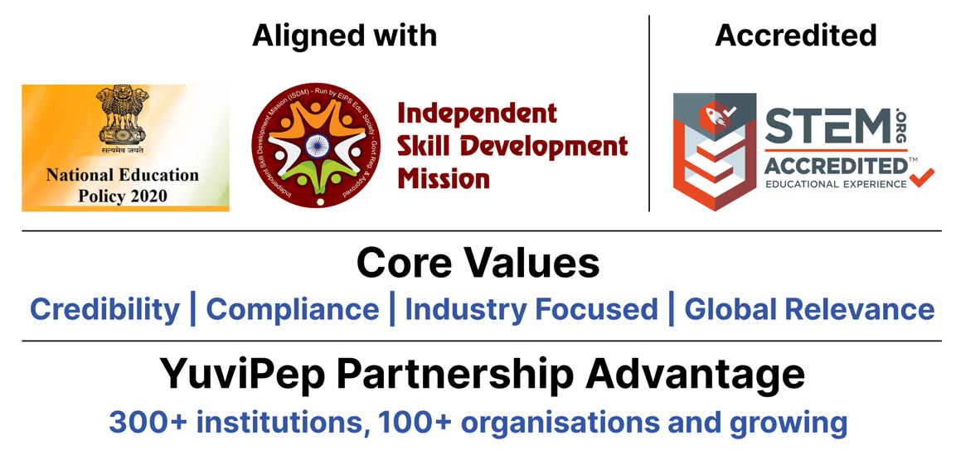

The Two Offerings
The school partnership brings together two complementary offerings that work as one ecosystem. The YuviPep 360° Programme builds capability progressively from Grades 1–12, while the Composite Skill Lab provides the tools, technologies and workspace where students can experiment, create and build. Together, they create a visible, hands-on innovation environment within the school.
Offering | Description
YuviPep 360° Programme | A school-wide innovation and future-skills programme for Grades 1–10, integrating Practical Science, Design Thinking, Coding, Mechatronics, Automation, IoT, AI and Robotics through a progressive learning journey.
Composite Skill Lab | A multi-disciplinary, hands-on lab bringing together Electronics, IoT and AI, Digital Fabrication, Agriculture and Life Systems, Tools and Mechanical Skills, Healthcare and Wellness, Retail and Enterprise, Media and Communication, and Safety.
The result is a school environment in which innovation becomes part of the student journey, not a one-time activity. Students learn, experiment, build, improve and present, while the school develops a sustained platform for technology, creativity and student achievement.

YuviPep 360° Programme
The YuviPep 360° Programme creates a continuous progression of skills across Grades 1–12. Younger students begin with observation, experimentation, materials, movement, circuits and simple problem-solving. As they advance, they work with coding, sensors, motors, systems, data, automation, AI and robotics, gradually taking on more complex projects and complete system planning. The learning grows with the student.
Core Learning Areas
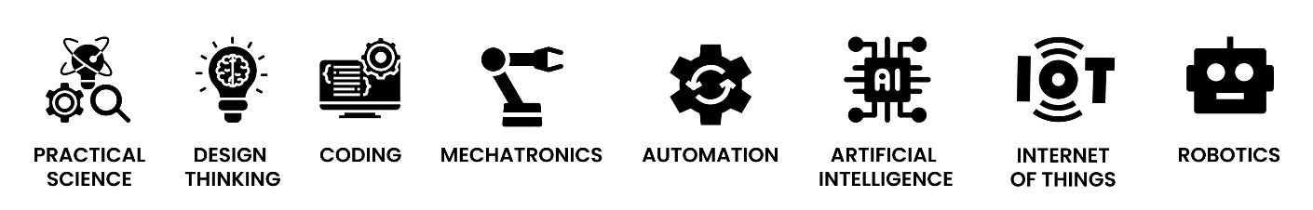

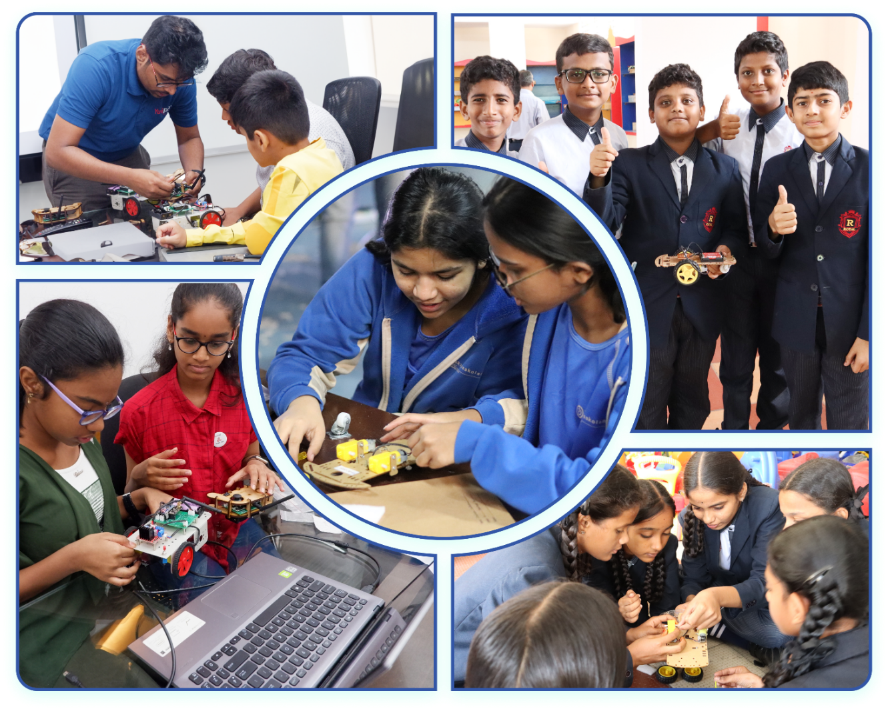

The YuviPep 360° Advantage
Learning is extended beyond the classroom through projects, innovation events, competitions, mentorship and real-world exposure. Students are encouraged to take an idea from concept to creation: identify a challenge, explore possibilities, develop a solution, build a prototype, refine it and communicate the result. This gives students a meaningful reason to apply the skills they learn.
Built on ten strategic pillars, the YuviPep 360° Advantage creates a powerful ecosystem that connects learning with industry, innovation and global opportunity.
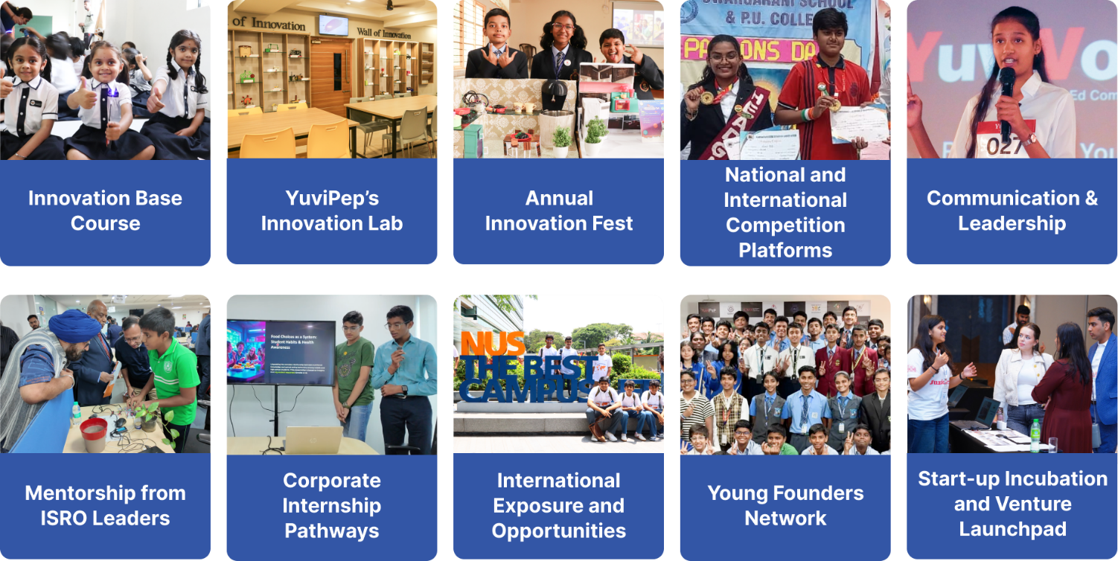

Innovation Pipeline

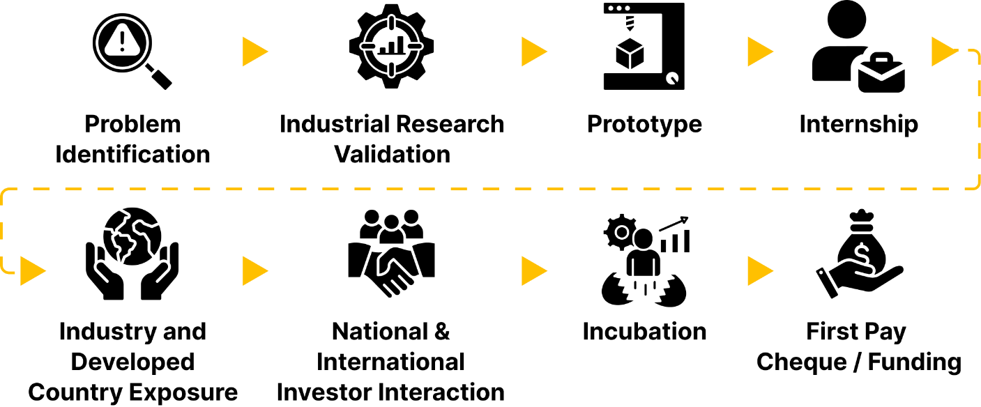

Glimpses of Students Achievements

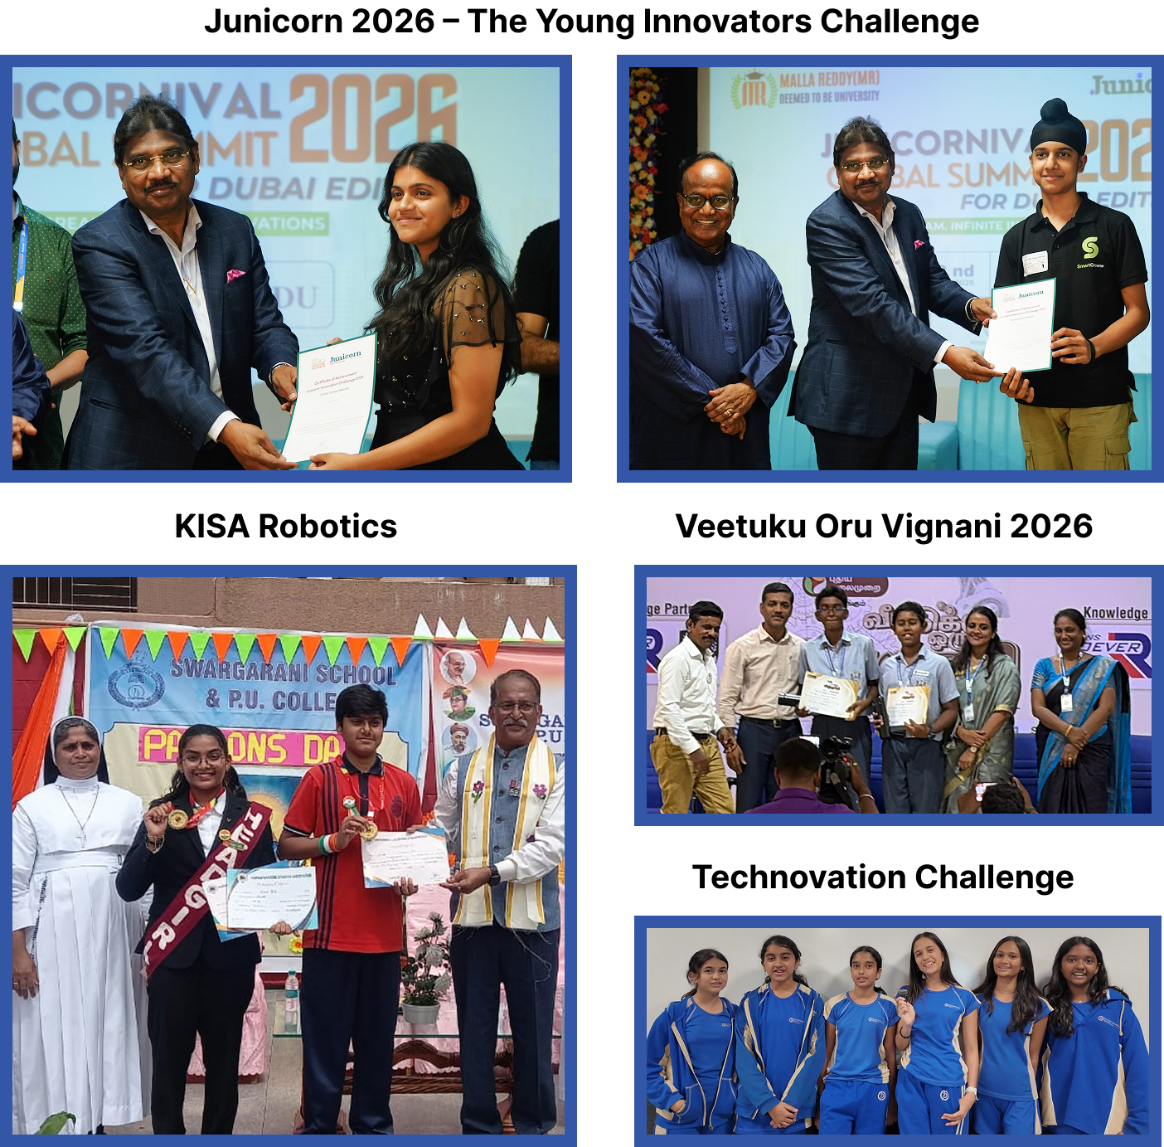

Gateway to Global Opportunities
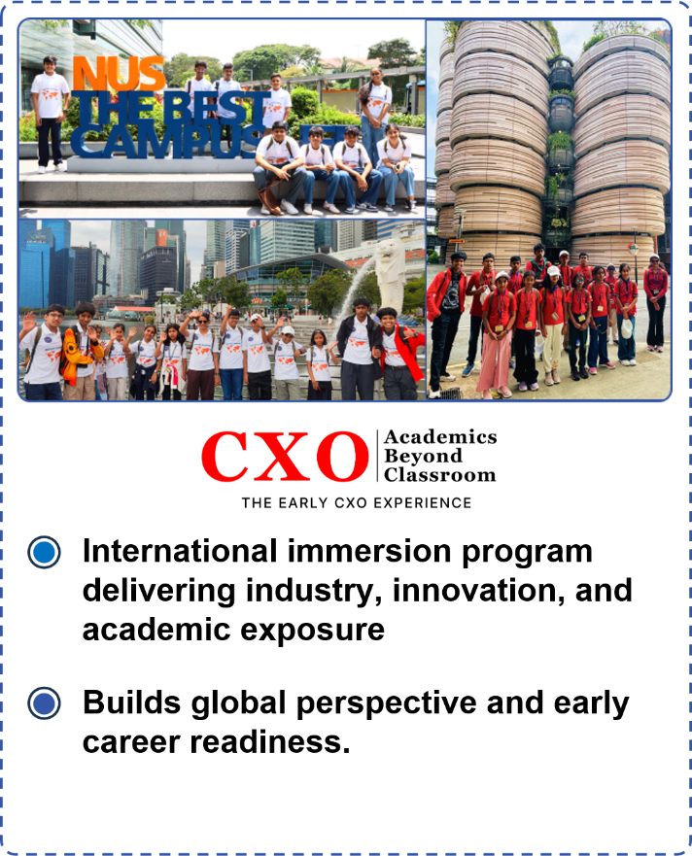 | 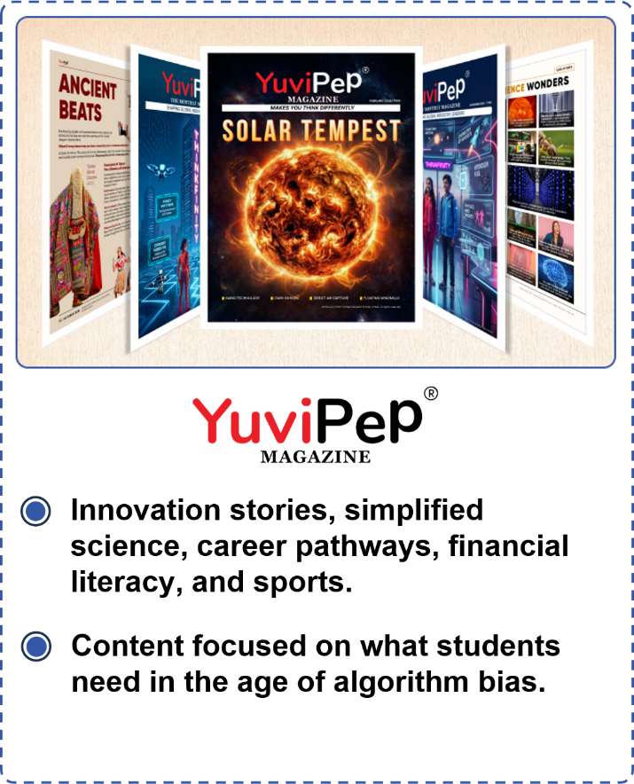

Mentorship, Recognition and Appreciation
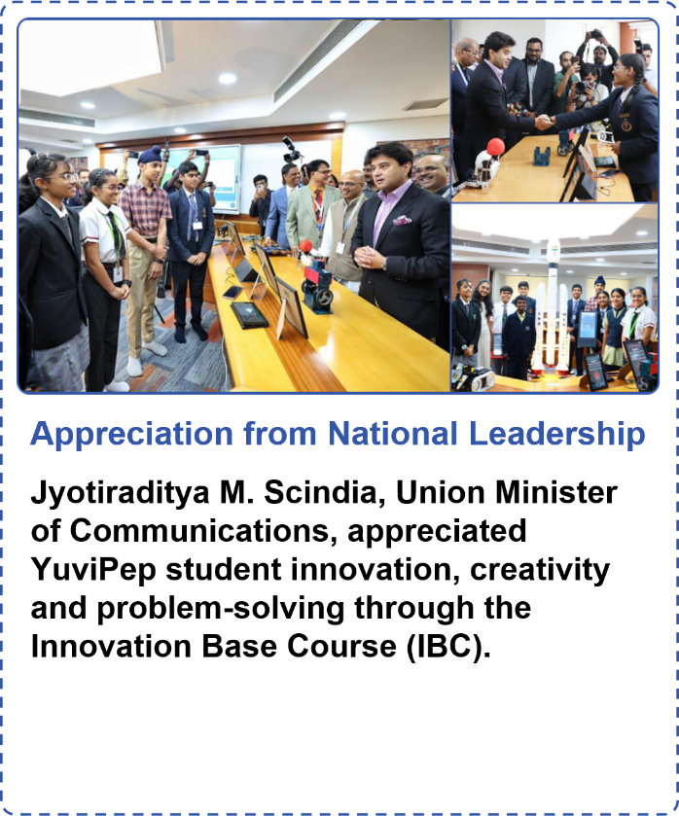 | 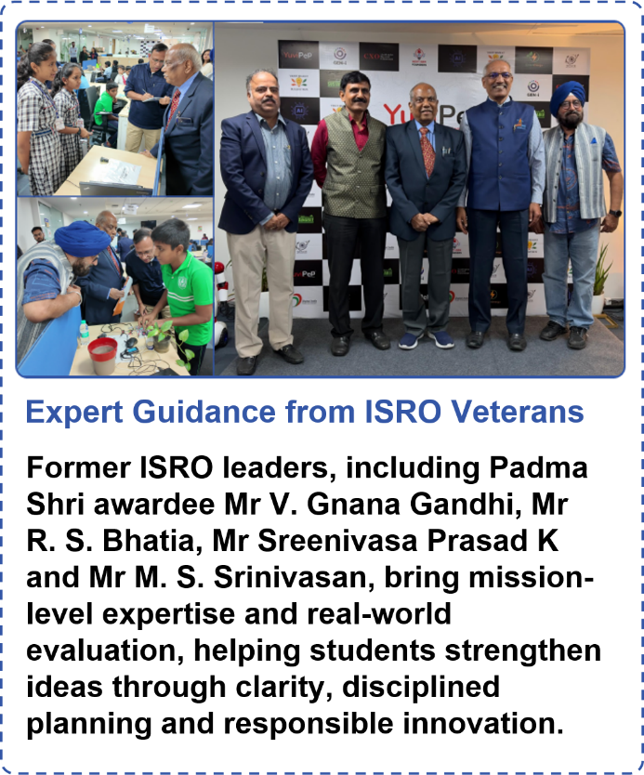

YuviPep’s Knowledge Portals

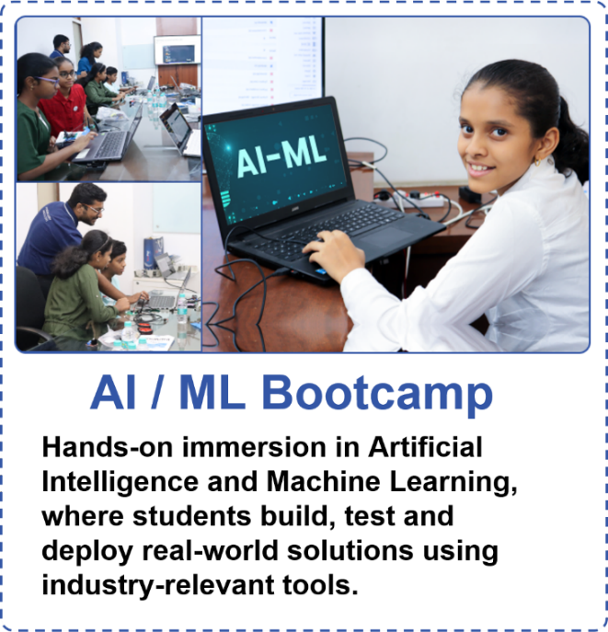 | 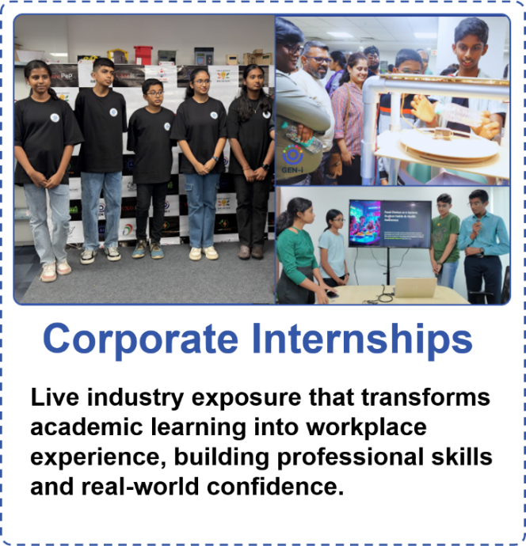
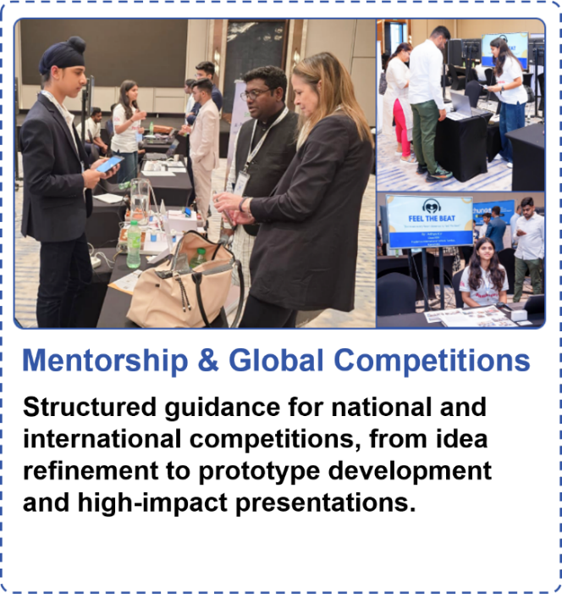 | 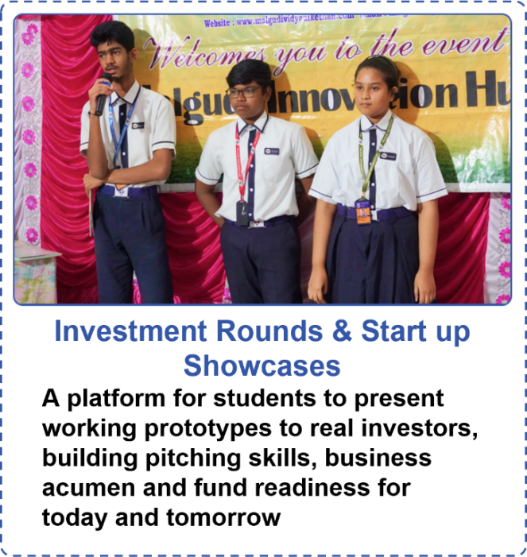
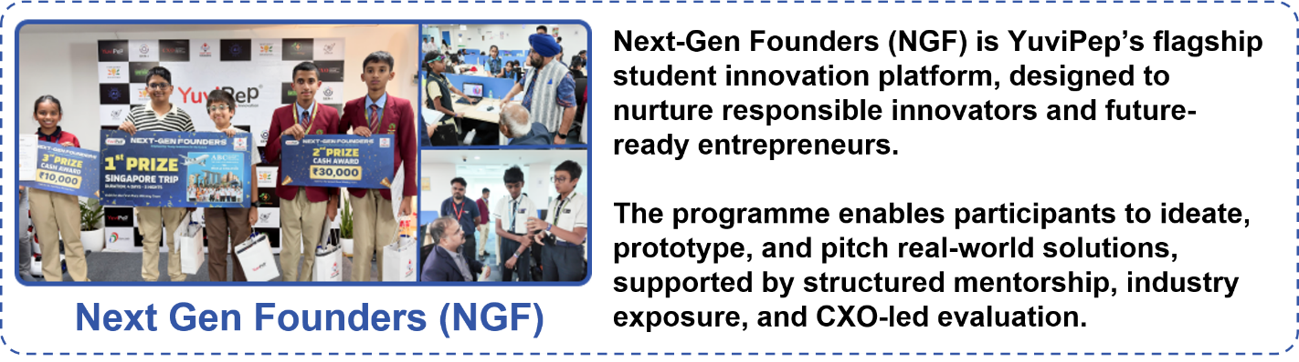

What Makes YuviPep the Right Choice?

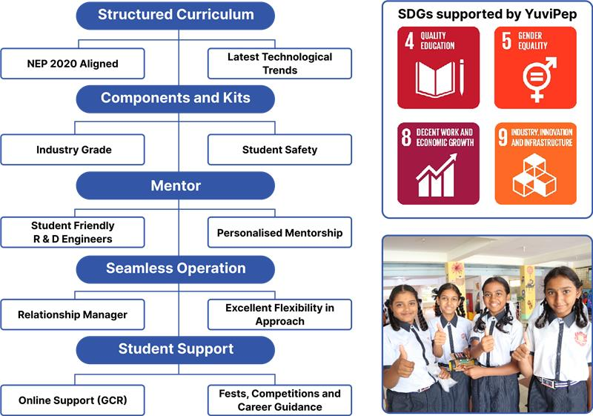

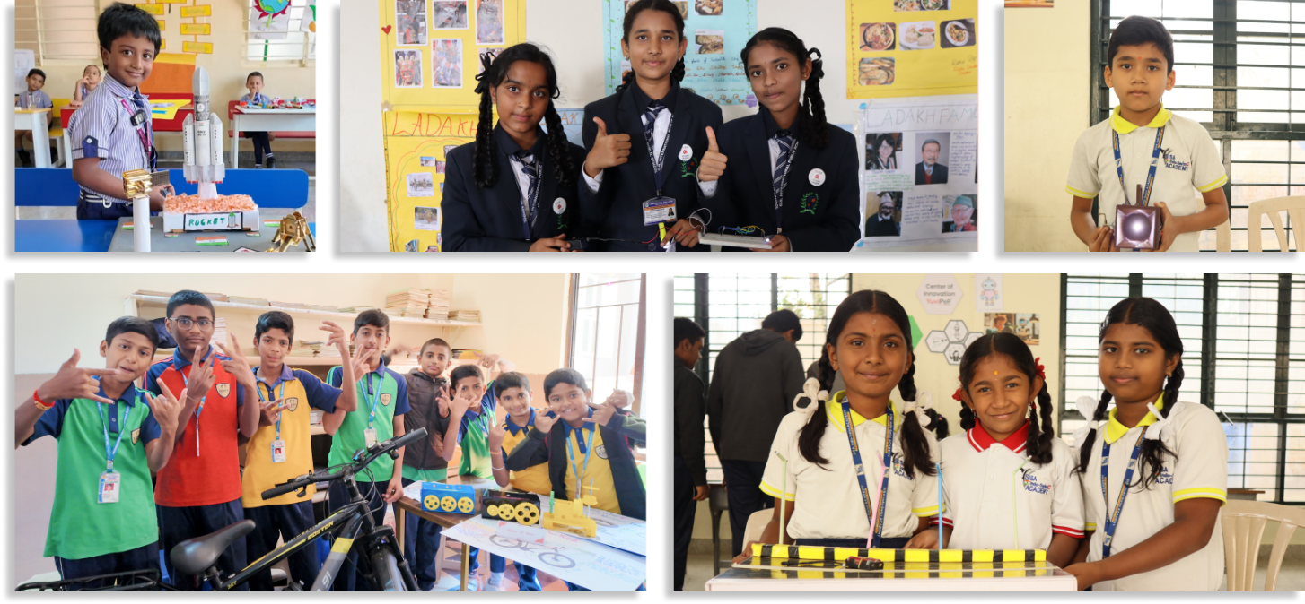

YuviPep’s Growing Impact Across India
A rapidly expanding national presence driving innovation, skill development and future-ready learning across institutions in India.
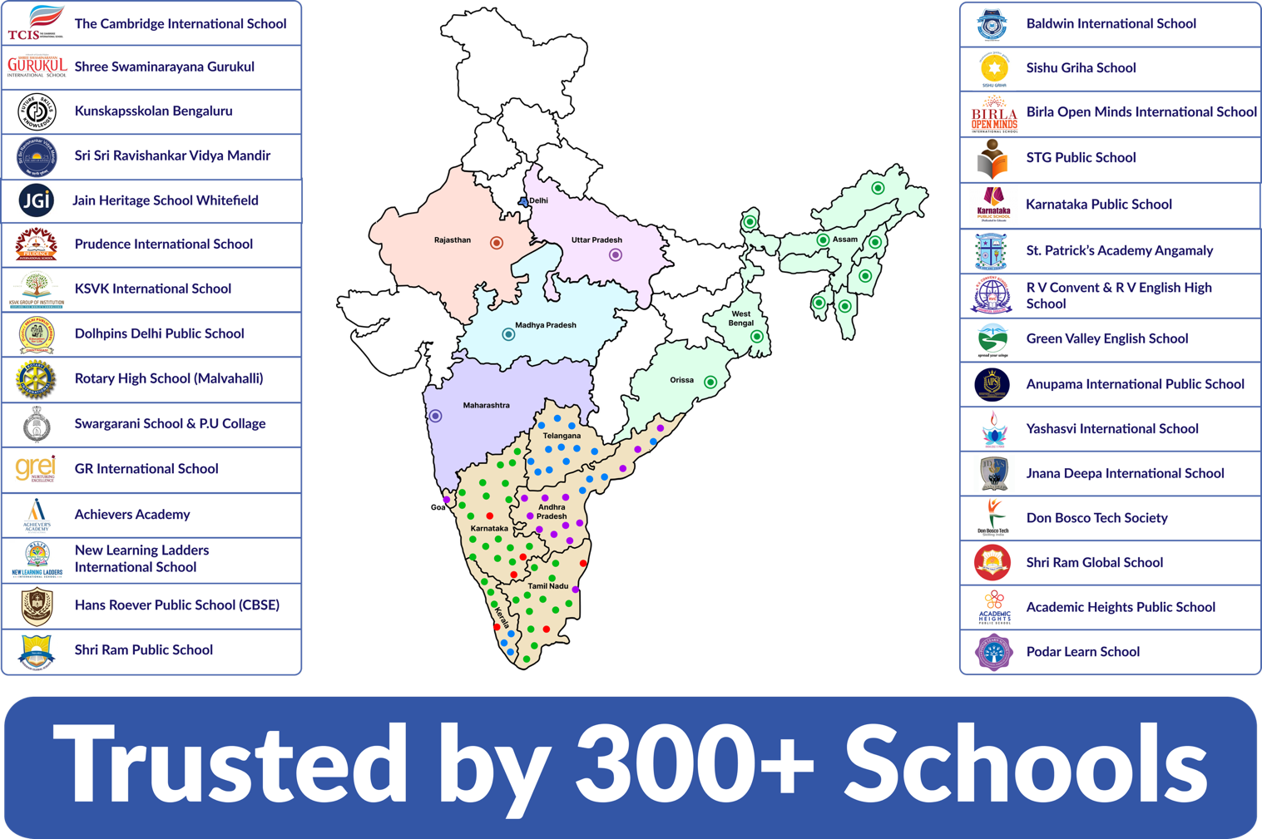

Grade-Wise Learning Journey - IBC
The IBC learning journey is designed to progress across grades, with students building on their skills and concepts as they move from one level to the next. The overview below provides a high-level glimpse of the learning journey. A detailed syllabus, including specific projects, activities and learning outcomes, can be provided upon request.
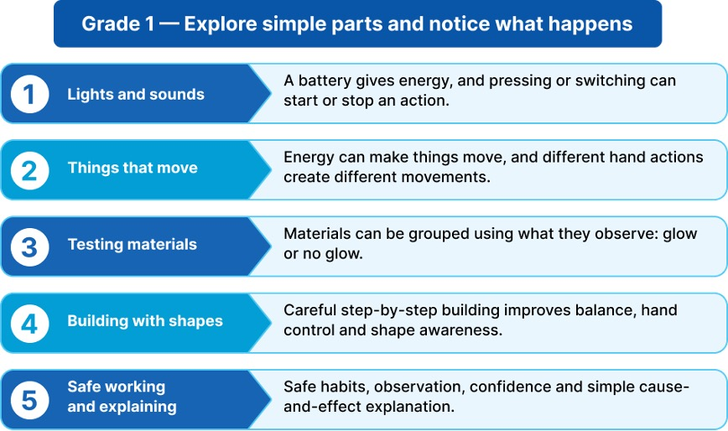

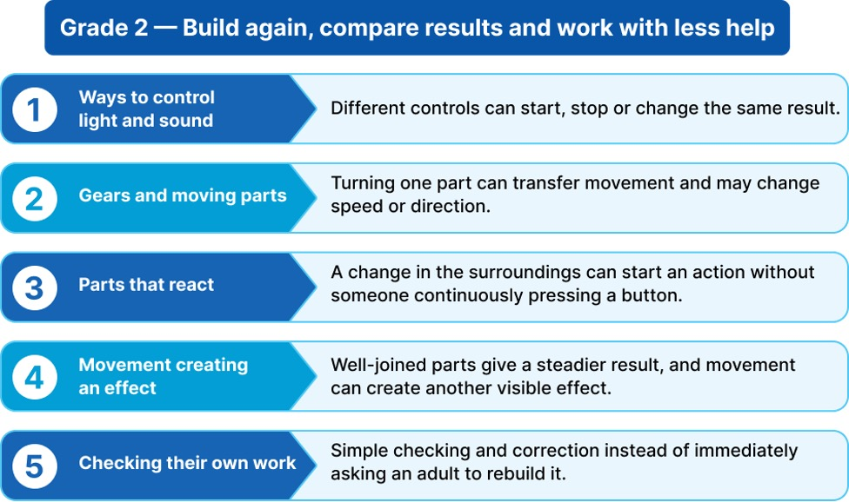
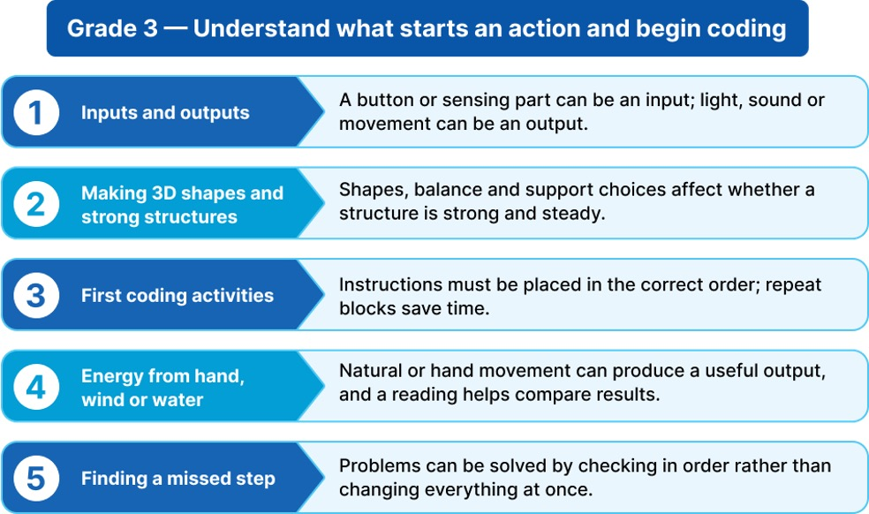

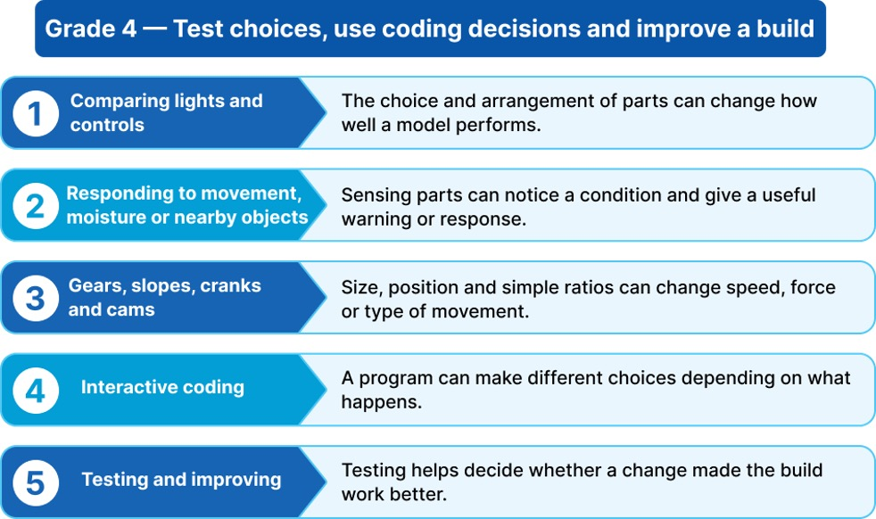

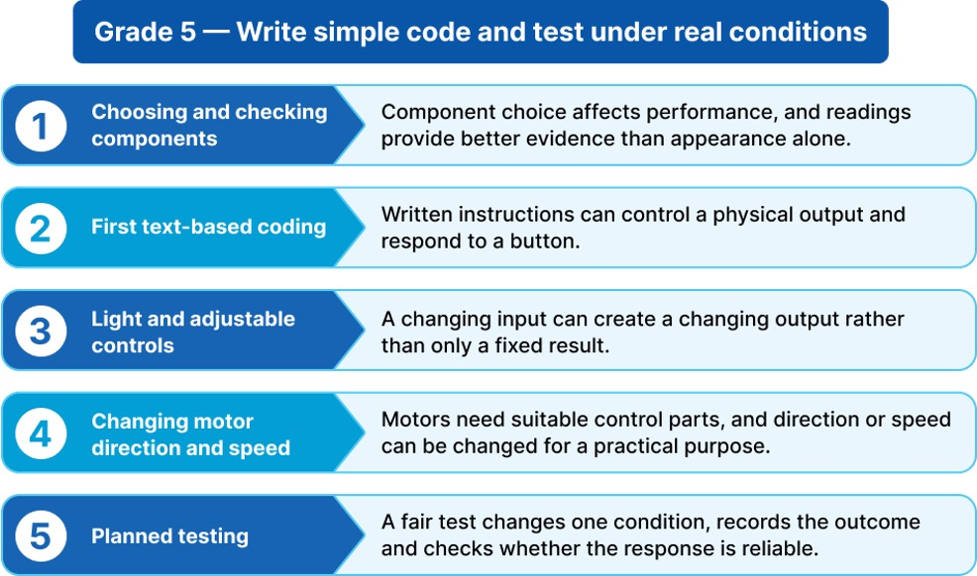

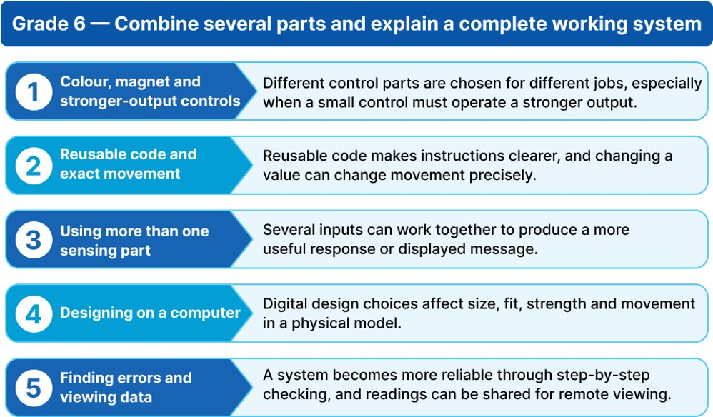

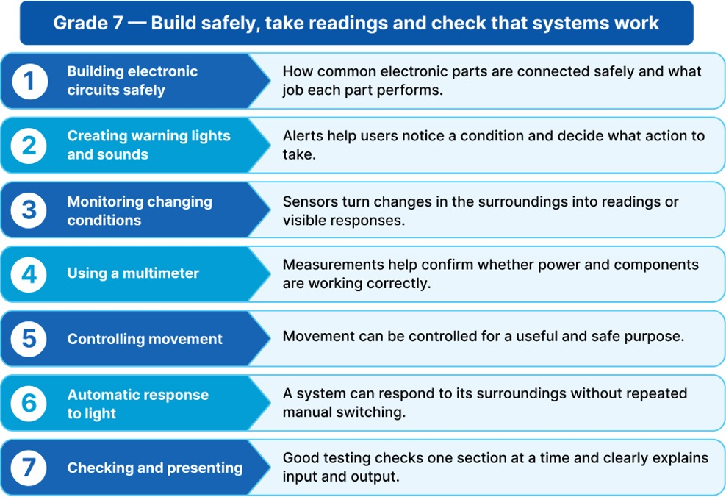

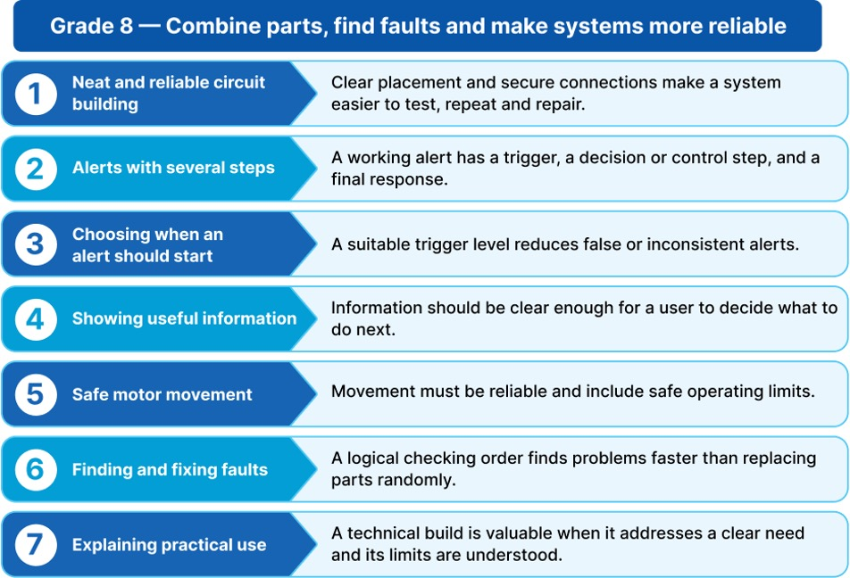
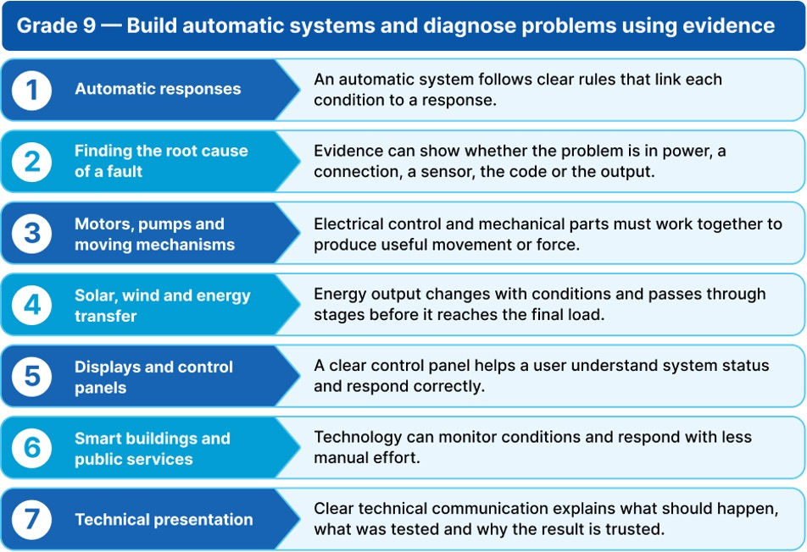

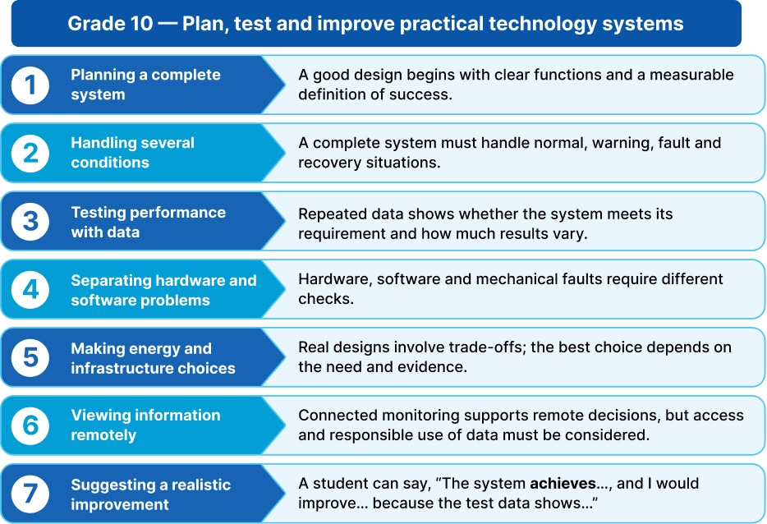

Programme Framework - Composite Skill Lab
The Composite Skill Lab is the physical engine of the innovation programme. It brings multiple technology and application areas into one practical environment, allowing students to move from an idea or classroom concept to experimentation, prototyping and testing. Instead of only discussing how technology works, students get the opportunity to work with it.
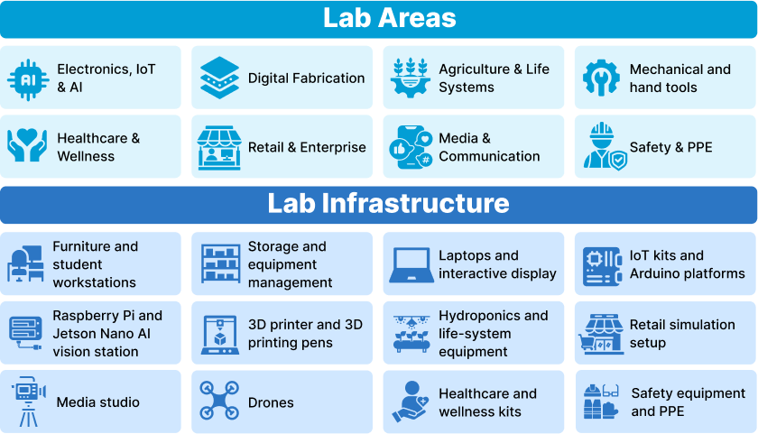

How the Two Offerings Work Together
Together, the two offerings create a complete innovation pathway. The programme develops the student's knowledge and capability. The lab provides the environment in which that capability becomes visible through practical work. The student journey therefore moves naturally from learning a concept to applying it, building something, testing it, improving it and presenting it.
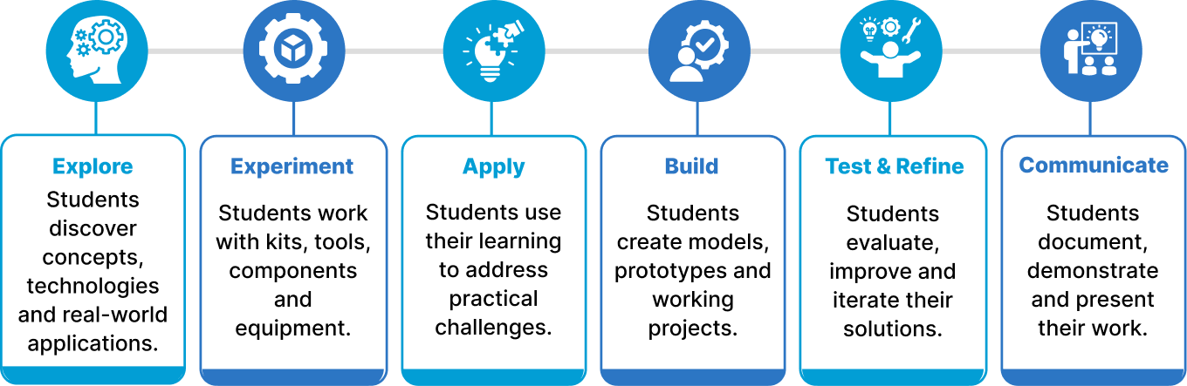

Composite Skill Lab Infrastructure
The proposed Composite Skill Lab includes the following infrastructure, equipment and tools.

Furniture and Workstations | Quantity
Durable 5 x 4 ft Modular Group Worktable | 5
Robust Stackable Student Stool | 40
Lockable Teacher Worktable | 1
Ergonomic Teacher Chair | 1
Tools, Mechanical and Textiles | Quantity
Shared Hand-Tool Project Station | 2
Power & Hand-Tool Fabrication Station | 1
Corded Drill Station with Bit Set | 1
Basic Stitching & Textile Project Machine | 1
Motorised Textile Project Machine | 1

Storage and Organisation | Quantity
Lockable Tool, Kit and Consumables Cabinet | 2
Heavy Duty Open Storage Shelf | 2
Labelled Small Parts Storage Set | 15
Wall Mounted Tool Pegboard with Hooks | 2
Healthcare and Wellness | Quantity
BP, Oxygen, Temperature and First Aid Practice Kit | 1
Contact-Free Temperature Screening Device | 1
Feedback-Enabled CPR and AED Emergency Training System | 1
Digital Fabrication | Quantity
Standard FDM 3D Printer for CAD Prototypes | 1
Handheld 3D Model-Making Pen | 2

Media and Communication | Quantity
Digital Content-Creation Kit with Webcam, Mic, Light & Tripod | 1

IT and Digital Infrastructure | Quantity
Technology Laptop for Coding, Design & Project Work | 2
Office-Specification Desktop Computer | 1
Classroom Projector for Demonstrations & Presentations | 1
Large 8 × 4 ft Teaching & Project Whiteboard | 1
Safety and PPE | Quantity
Institutional Safety, PPE and First Aid Kit | 1

Retail and Enterprise | Quantity
Barcode, RFID & Retail Billing Simulation Kit | 1

Lab Infrastructure | Quantity
Educational and Safety Lab Wall Posters | 1
Electronics, IoT and AI | Quantity
Arduino Circuit, Sensor & Coding Group Kit | 10
Expanded Wi-Fi IoT Project Group Kit | 8
Expanded Sensor, Motor & Actuator Set | 5
Digital Circuit-Testing Multimeter | 8
High-Accuracy Digital Multimeter | 2
Precision Temperature-Controlled Soldering Station | 1
Supervised Electronics Soldering Kit | 5
Raspberry Pi Edge AI & Camera-Vision Station | 1

Agriculture and Life Systems | Quantity
Gardening and Cultivation Group Kit | 5
Basic Soil-Free DWC Hydroponics Station | 1
Digital pH & Nutrient-Strength Meter Set | 1

Programme Structure and Investment

Programme Deliverables
Deliverable | Provision
R&D Engineer | Yes
GEN-i Internship | Yes
Study Materials and Workbooks | Yes
Kits and Components for Experiments | Yes
Innovation Fest | Eligible
Timely Assessments with Revisions | Yes
Project Assistance | Yes
IBC Certificates | Yes
Parent Orientation Support | Yes
Exclusive Account Manager | Yes

Investment Framework
Parameter | Details
Annual Price Per Student | ₹2,500 net
Programme Duration | 10 months
Workshop Frequency | Once a week
Number of Students | 700
Grades | 6 to 10
Note: All required Innovation materials and kits will be securely stored in a designated classroom to ensure smooth and organised programme execution.

Innovation Framework – Composite Skill Lab
Parameter | Details
Lab Type | Composite Skill Lab
Lab Positioning | Core Composite Skill Lab
Space | 400 to 800 sq ft
Core Forms of Work | Electronics, IoT and AI
CBSE Skill Modules | Covers 11 skills
Total Investment including GST | ₹10,63,758

Composite Skill Lab – School Requirements
To ensure smooth installation and operation of the Composite Skill Lab, the school will provide the required infrastructure and room readiness.
Parameters | Description
Room | A lab room meeting the dimensions specified for the chosen package must be made available before installation.
Internet | Stable Wi Fi or LAN connectivity for IoT, AI and content creation stations.
Painting | Wall and ceiling painting of the lab room before installation.
Electrical | Power points, wiring, lighting and earthing for lab equipment.
Plumbing | Water supply and drainage for the hydroponics or wash area.
Lab Readiness | General civil readiness including workbench base points and exhaust or ventilation as required.
IT Support | A local IT support or network administrator point of contact for setup and maintenance.
Interior | Flooring, false ceiling if any and general room finishing.

Disclaimer: This document and its contents are the exclusive property of YuviPep Education Private Limited and are strictly confidential. No part of it may be disclosed, copied, reproduced, distributed, or used without prior written consent from YuviPep Education Private Limited. Unauthorised use or disclosure may lead to legal action.

