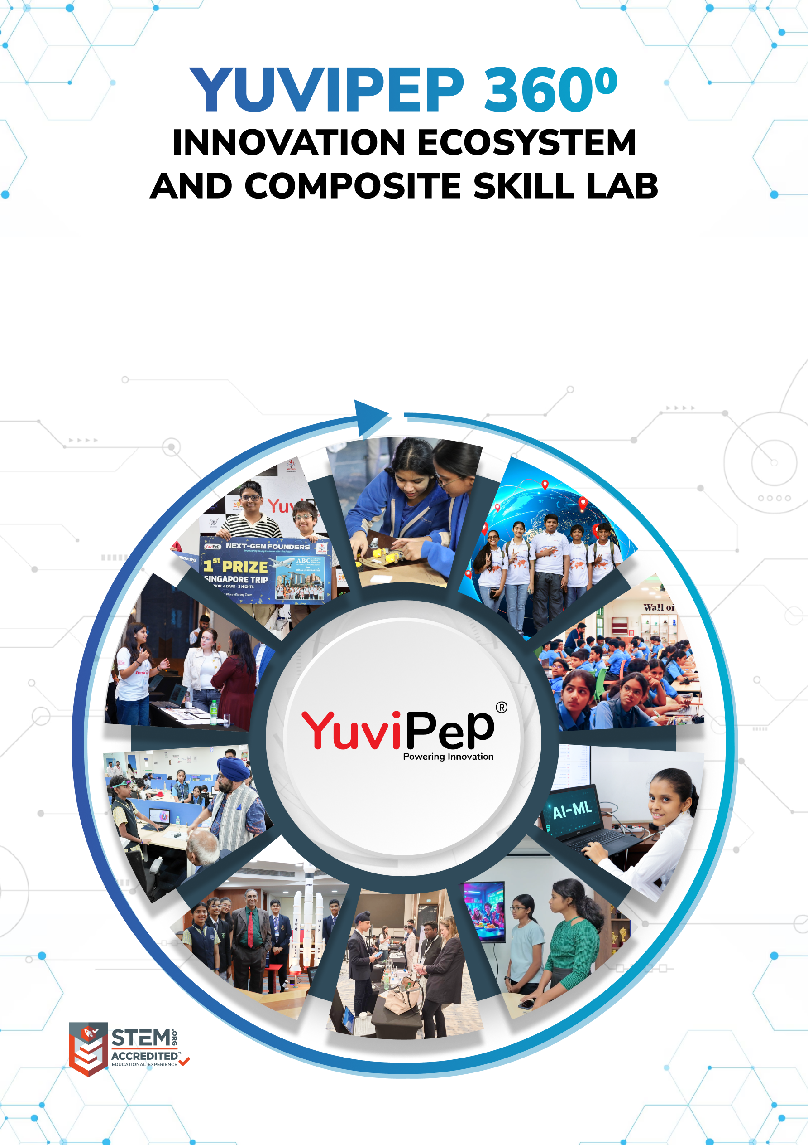
Bookmarks: status: New; author:Sunila Johnson; acceptor: C C; modified: 29.9.2026
<School Name>
Table of Contents
YUVIPEP 360° INNOVATION ECOSYSTEM 2
Building India’s first School-to-Startup Innovation Pipeline 2
The Two Offerings 2
YuviPep 360° Programme 3
The YuviPep 360° Advantage 4
Innovation Pipeline 4
Glimpses of Students Achievements 5
Gateway to Global Opportunities 6
Mentorship, Recognition and Appreciation 6
YuviPep’s Knowledge Portals 7
What Makes YuviPep the Right Choice? 8
YuviPep’s Growing Impact Across India 9
Grade-Wise Learning Journey - IBC 10
Programme Framework - Composite Skill Lab 15
How the Two Offerings Work Together 15
Composite Skill Lab Infrastructure 16
Programme Structure and Investment 17
Programme Deliverables 17
Investment Framework 17
Innovation Framework – Composite Skill Lab 17
Composite Skill Lab – School Requirements 18

YUVIPEP 360° INNOVATION ECOSYSTEM

Building India’s first School-to-Startup Innovation Pipeline
The YuviPep 360° Innovation Ecosystem is a full-stack platform embedded directly within academic environments. It creates a structured pathway in which students move from foundational innovation learning to advanced technology application, industry immersion, prototype development, incubation, and investor readiness.
YuviPep 360° is an integrated framework that strengthens learning environments, builds student capabilities and creates a clear pathway from learning to leadership. The ecosystem is designed to complement the evolving CBSE skill education structure, including Kaushal Bodh and Kaushal Vikas, while extending opportunities for students to explore technology, innovation and applied learning across the wider school journey.
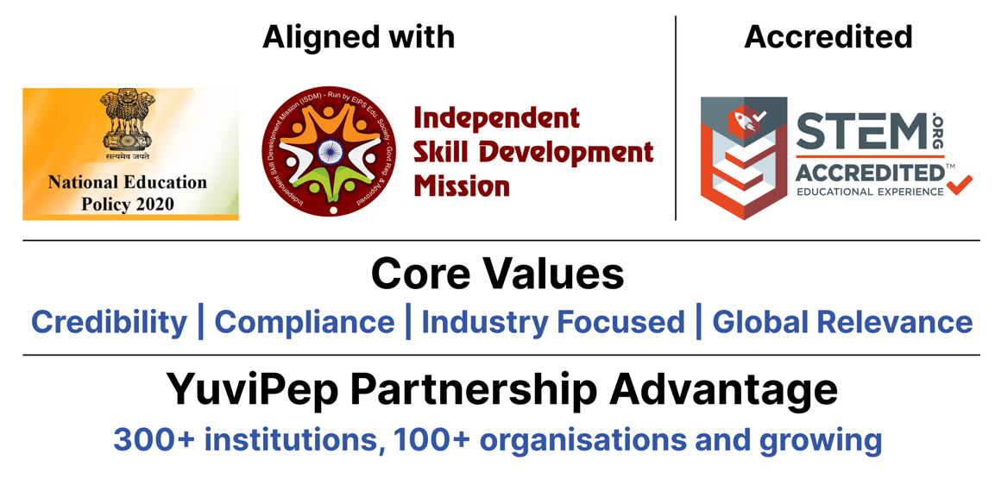

The Two Offerings
The school partnership brings together two complementary offerings that work as one ecosystem. The YuviPep 360° Programme builds capability progressively from Grades 1–12, while the Composite Skill Lab provides the tools, technologies and workspace where students can experiment, create and build. Together, they create a visible, hands-on innovation environment within the school.
Offering | Description
YuviPep 360° Programme | A school-wide innovation and future-skills programme for Grades 1–10, integrating Practical Science, Design Thinking, Coding, Mechatronics, Automation, IoT, AI and Robotics through a progressive learning journey.
Composite Skill Lab | A multi-disciplinary, hands-on lab bringing together Electronics, IoT and AI, Digital Fabrication, Agriculture and Life Systems, Tools and Mechanical Skills, Healthcare and Wellness, Retail and Enterprise, Media and Communication, and Safety.
The result is a school environment in which innovation becomes part of the student journey, not a one-time activity. Students learn, experiment, build, improve and present, while the school develops a sustained platform for technology, creativity and student achievement.

YuviPep 360° Programme
The YuviPep 360° Programme creates a continuous progression of skills across Grades 1–12. Younger students begin with observation, experimentation, materials, movement, circuits and simple problem-solving. As they advance, they work with coding, sensors, motors, systems, data, automation, AI and robotics, gradually taking on more complex projects and complete system planning. The learning grows with the student.
Core Learning Areas
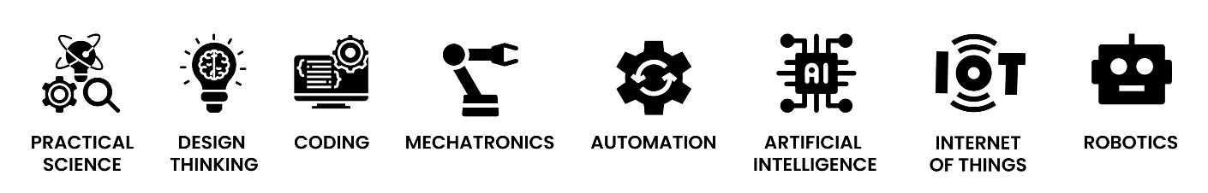

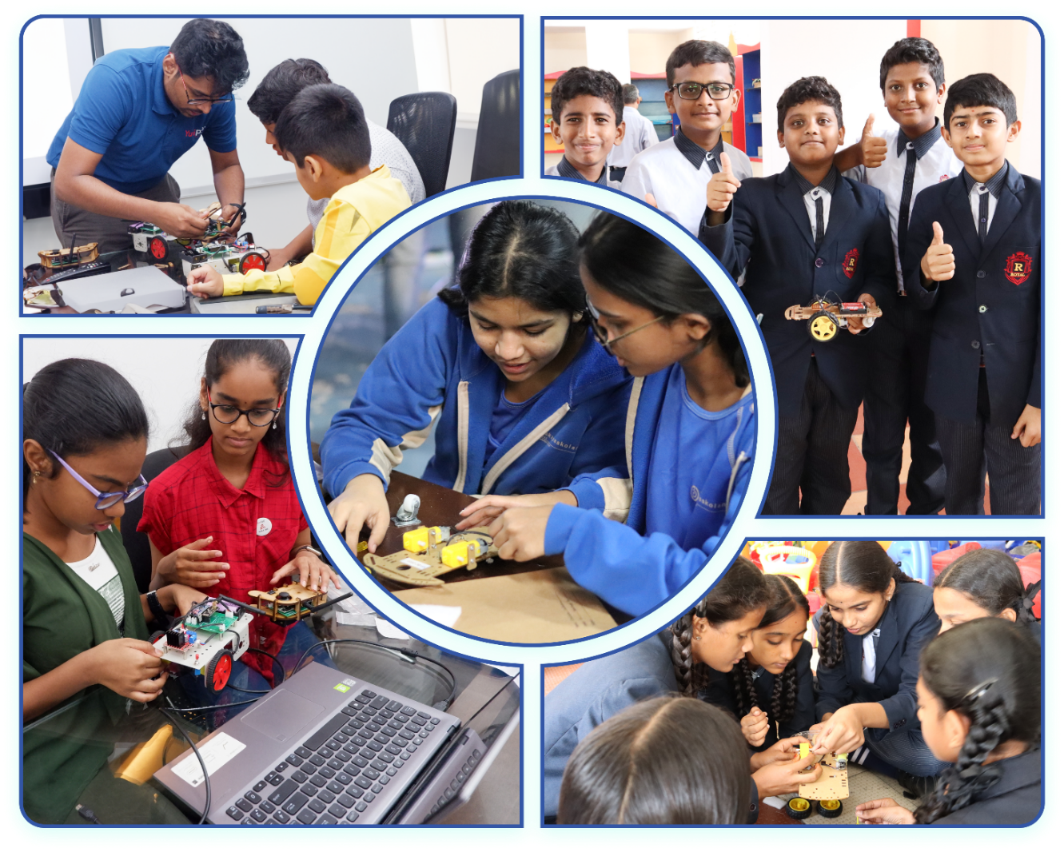

The YuviPep 360° Advantage
Learning is extended beyond the classroom through projects, innovation events, competitions, mentorship and real-world exposure. Students are encouraged to take an idea from concept to creation: identify a challenge, explore possibilities, develop a solution, build a prototype, refine it and communicate the result. This gives students a meaningful reason to apply the skills they learn.
Built on ten strategic pillars, the YuviPep 360° Advantage creates a powerful ecosystem that connects learning with industry, innovation and global opportunity.
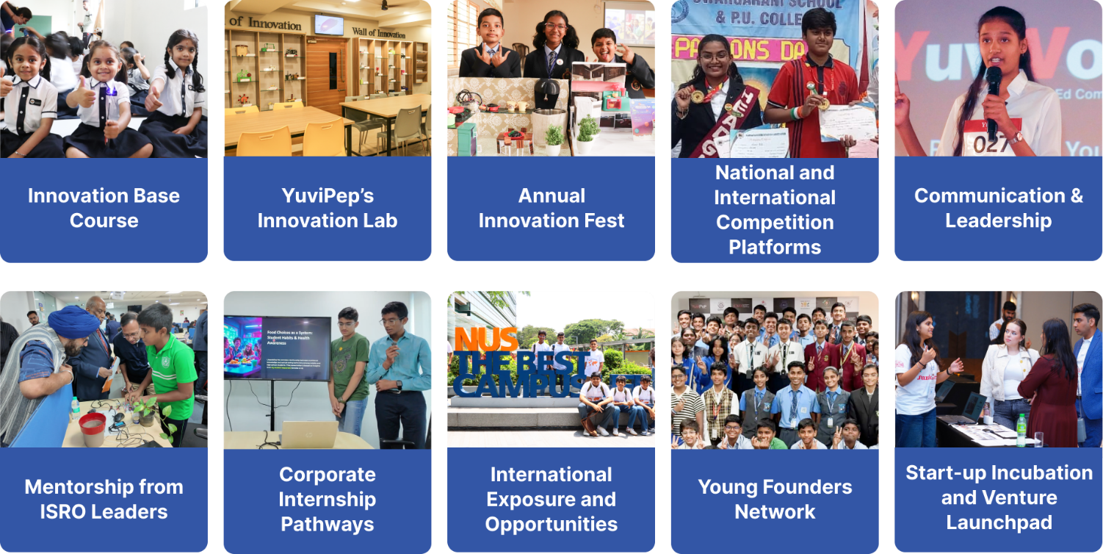

Innovation Pipeline

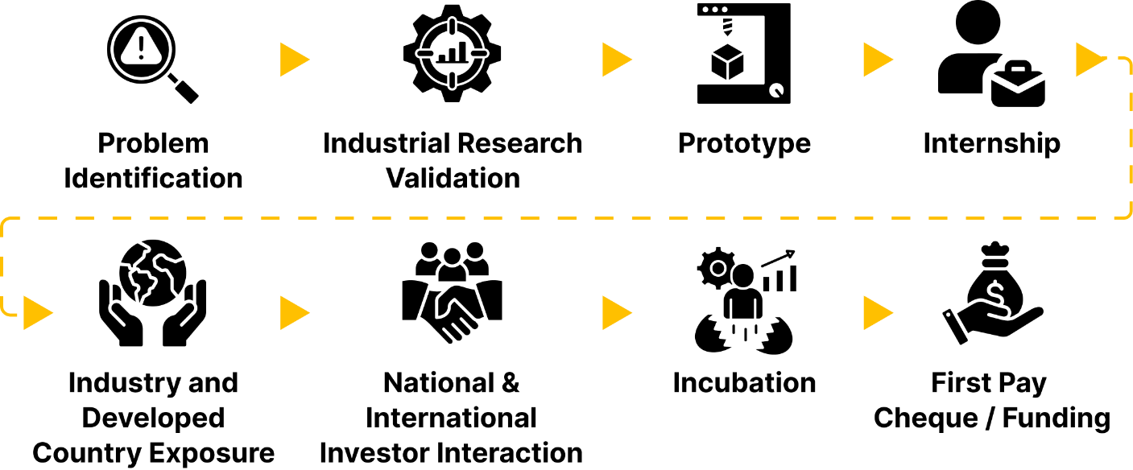

Glimpses of Students Achievements

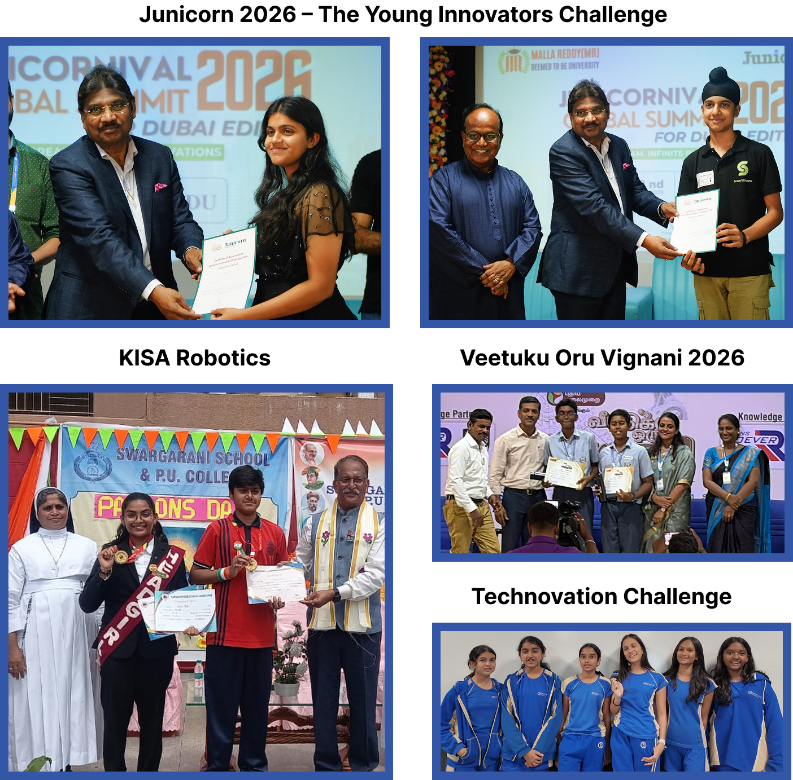

Gateway to Global Opportunities
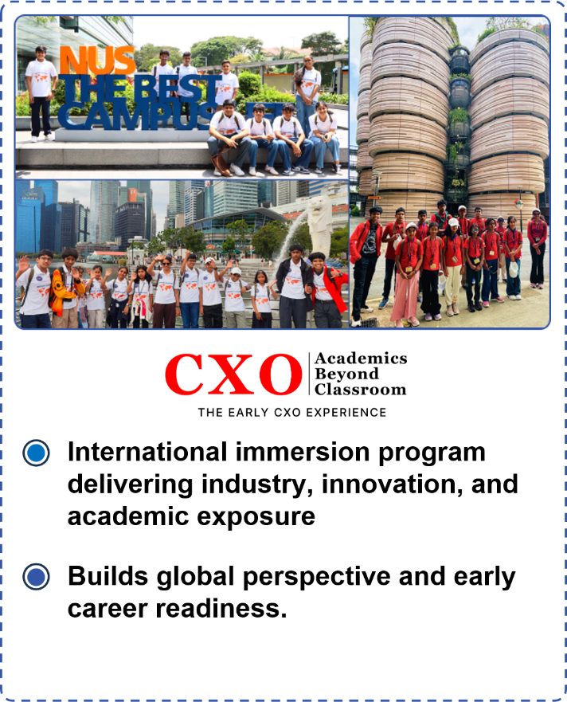 | 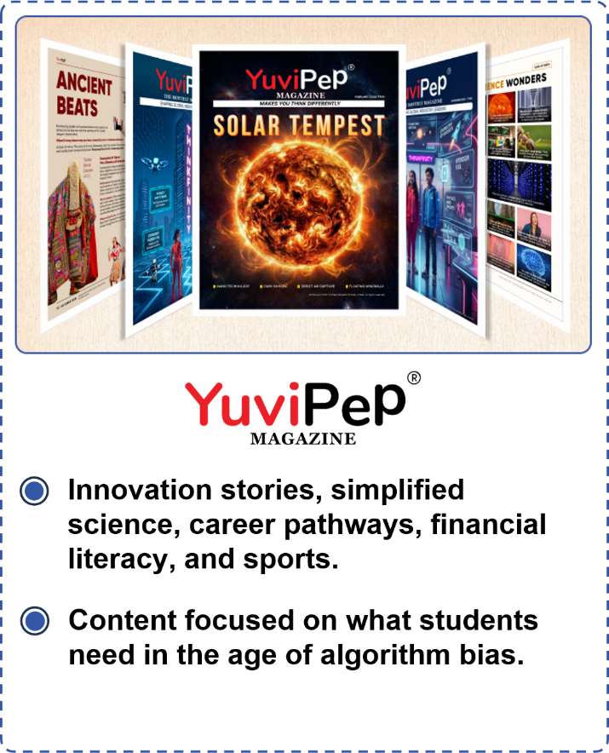

Mentorship, Recognition and Appreciation
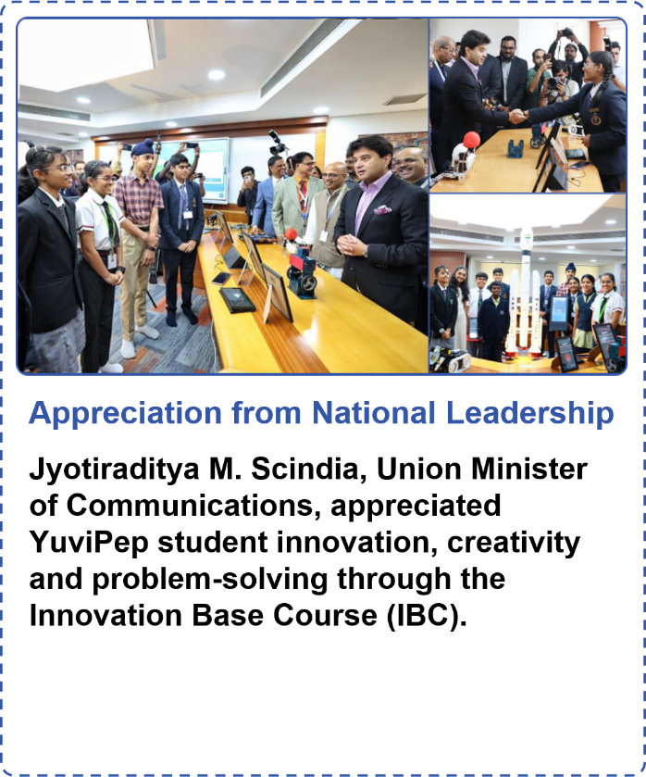 | 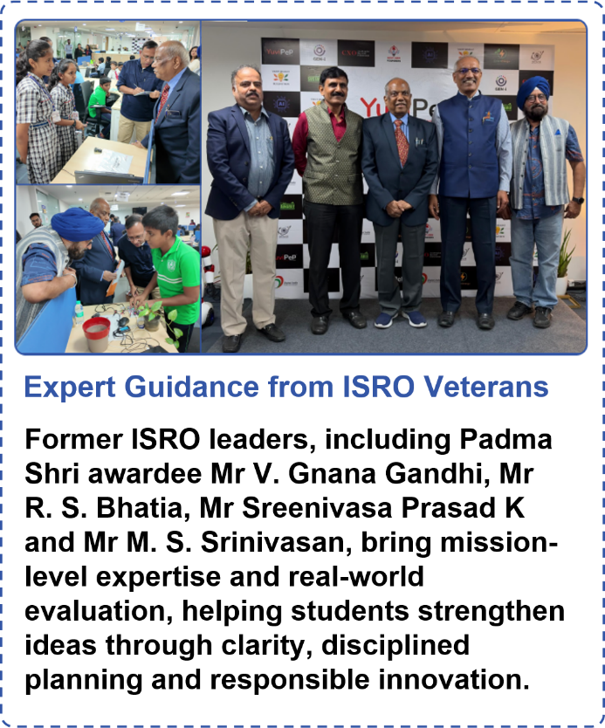

YuviPep’s Knowledge Portals

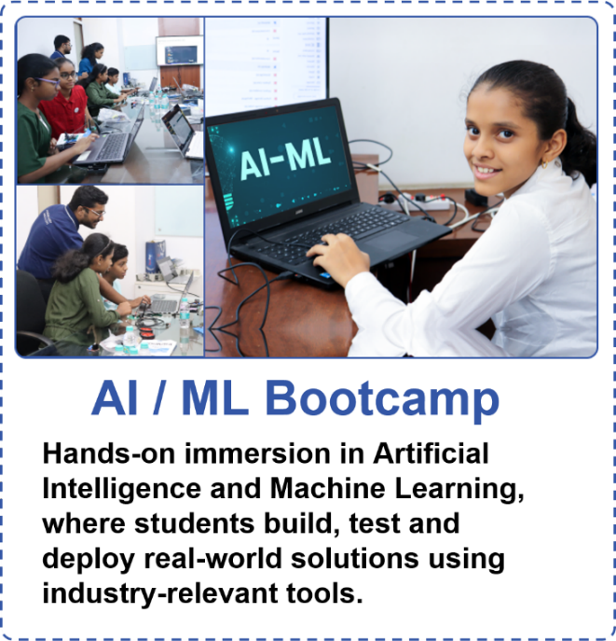 | 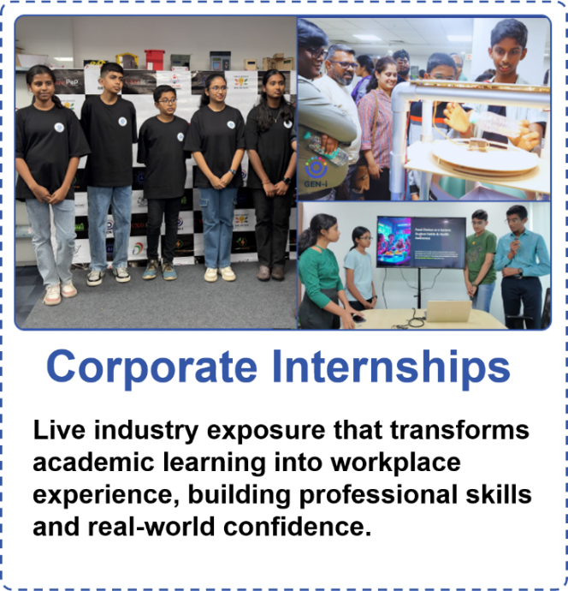
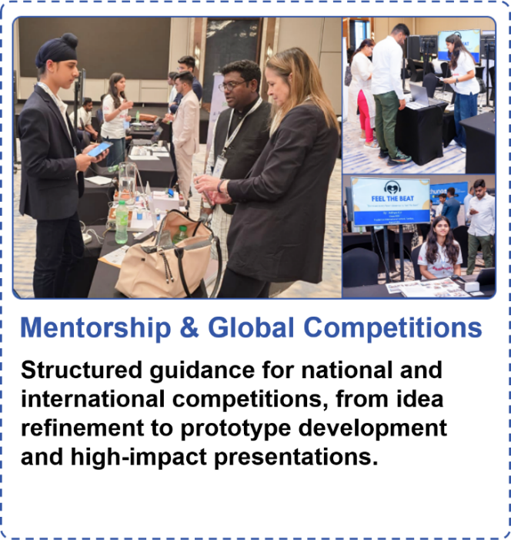 | 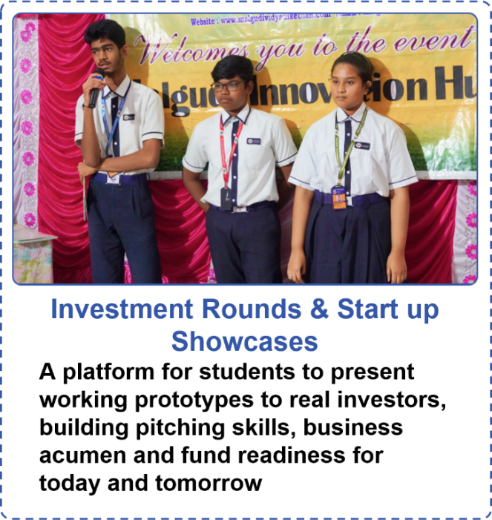
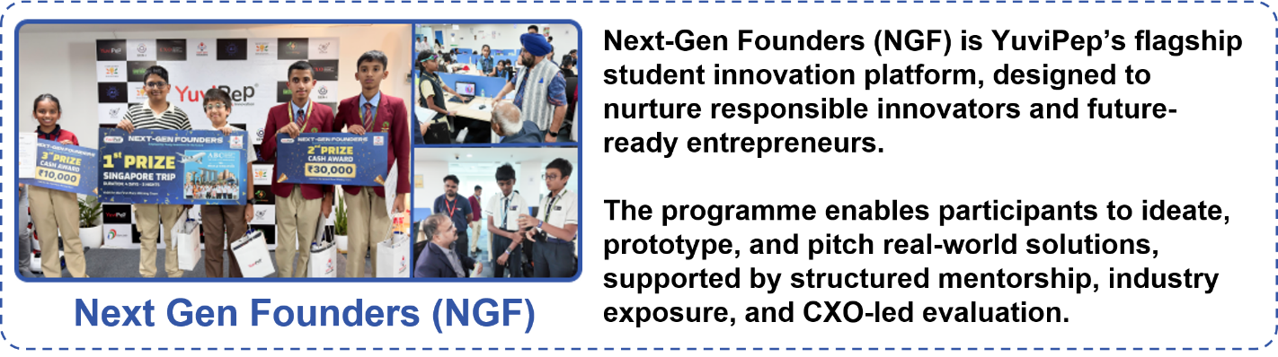

What Makes YuviPep the Right Choice?

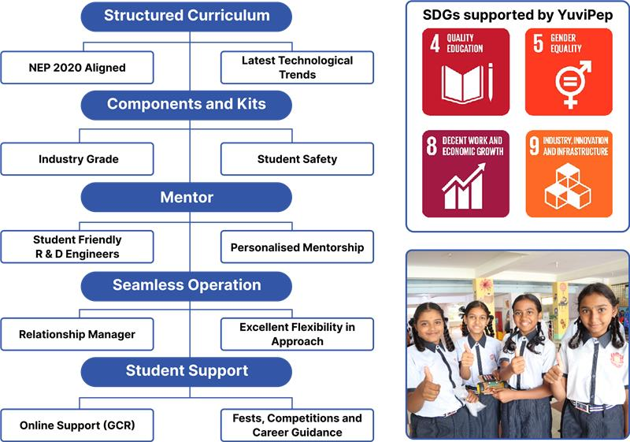

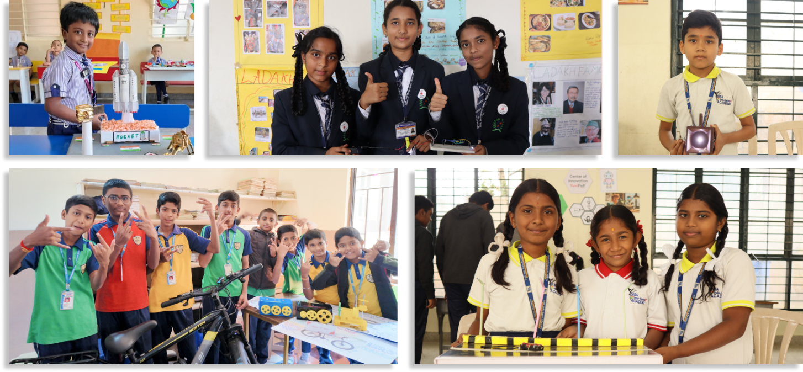

YuviPep’s Growing Impact Across India
A rapidly expanding national presence driving innovation, skill development and future-ready learning across institutions in India.
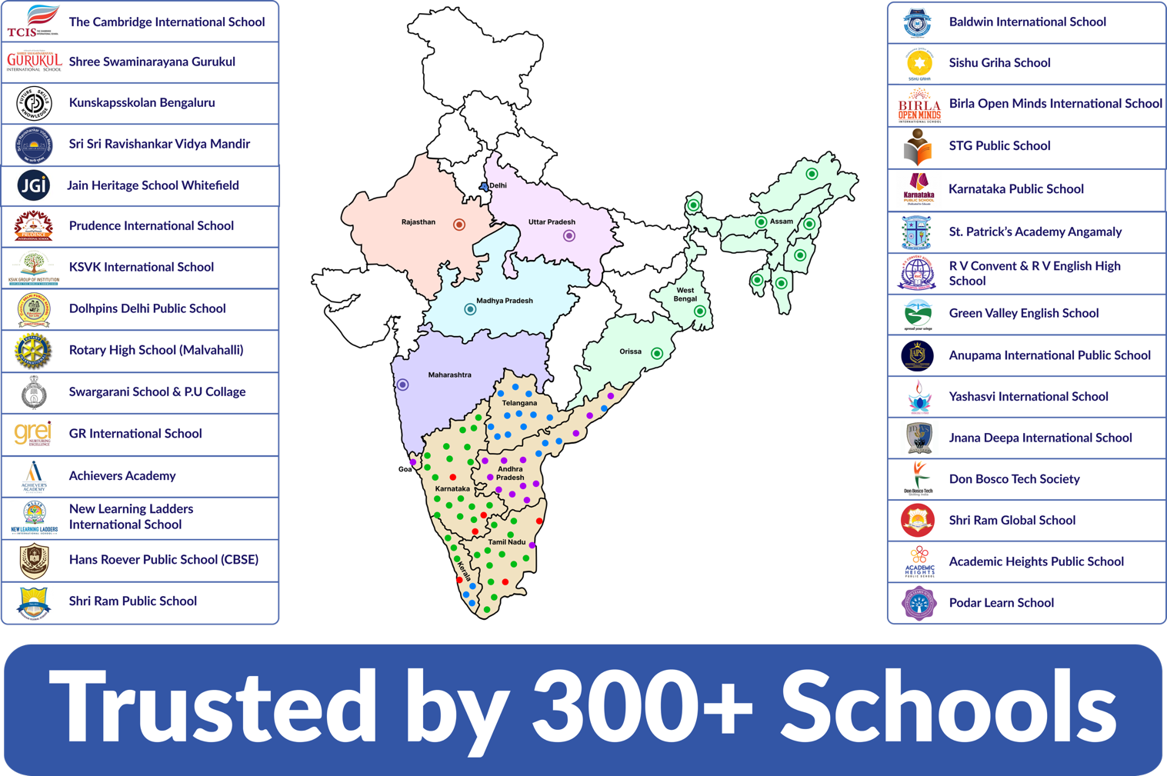

Grade-Wise Learning Journey - IBC
The IBC learning journey is designed to progress across grades, with students building on their skills and concepts as they move from one level to the next. The overview below provides a high-level glimpse of the learning journey. A detailed syllabus, including specific projects, activities and learning outcomes, can be provided upon request.
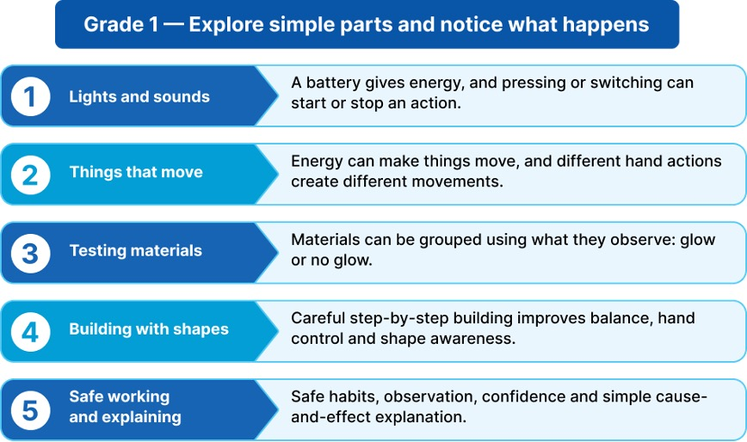

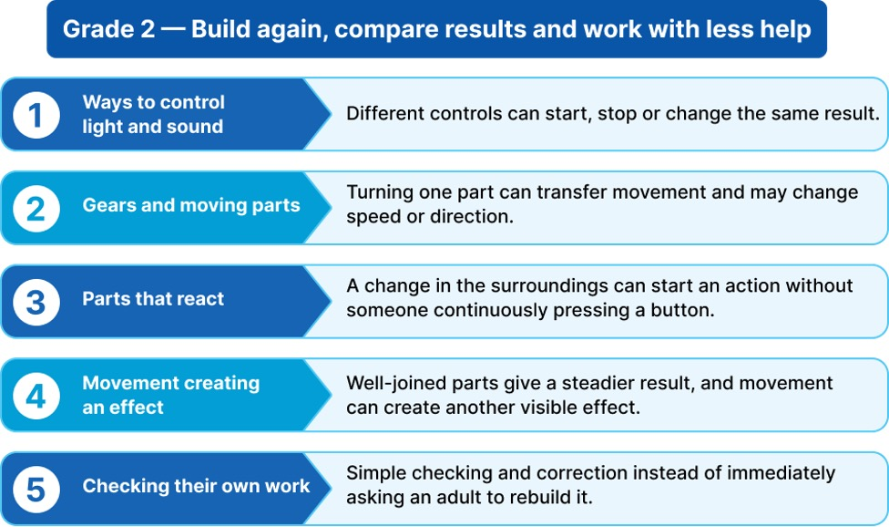
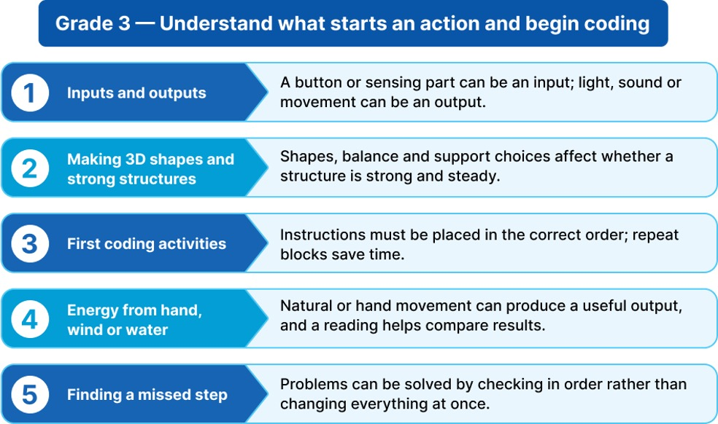

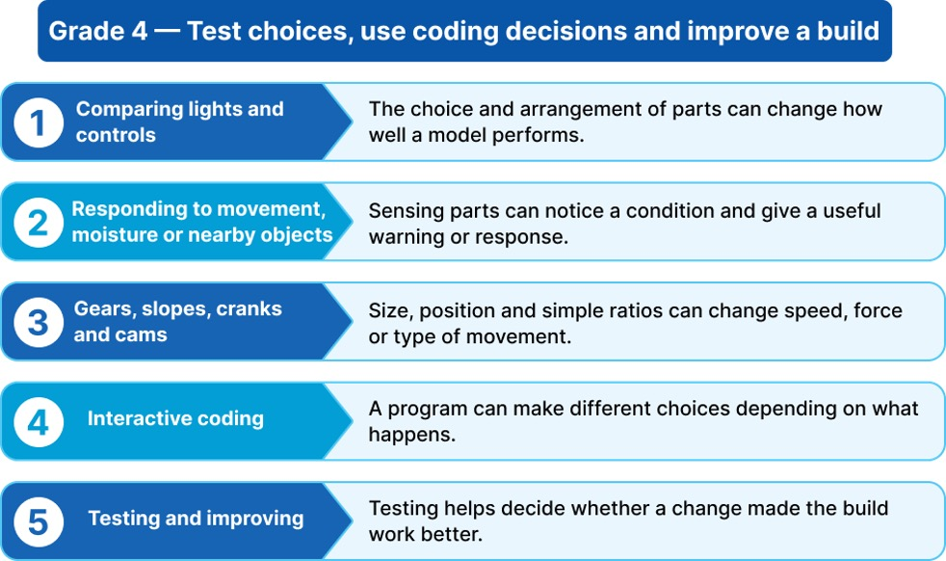

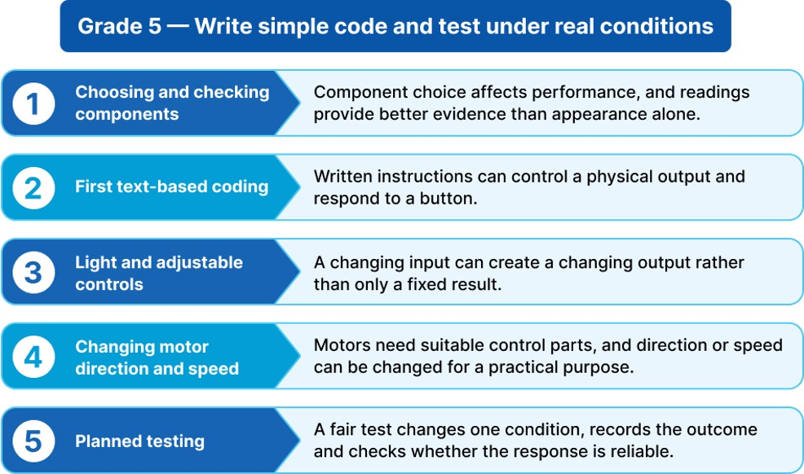

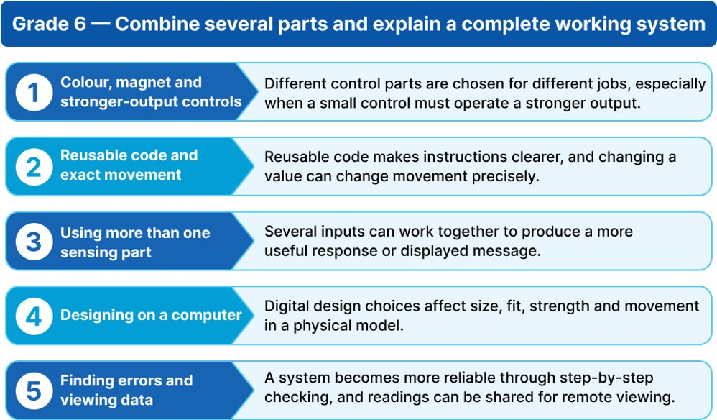

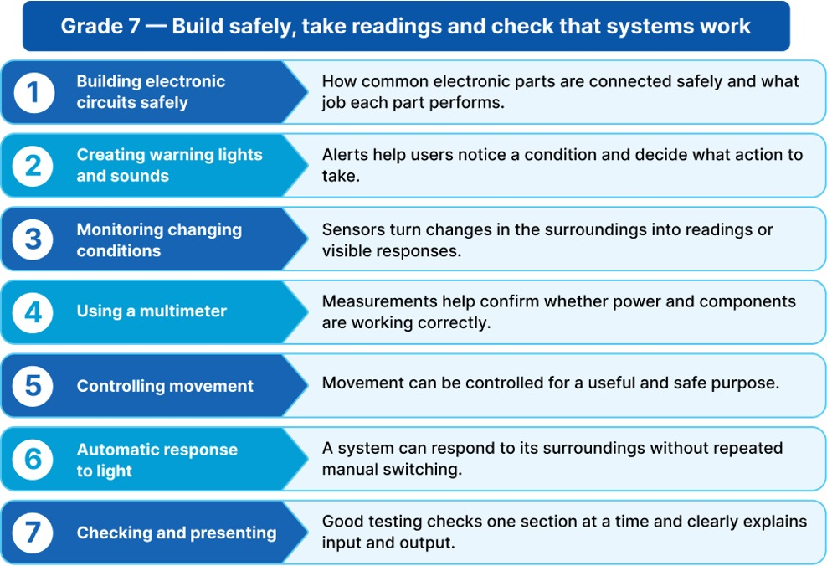

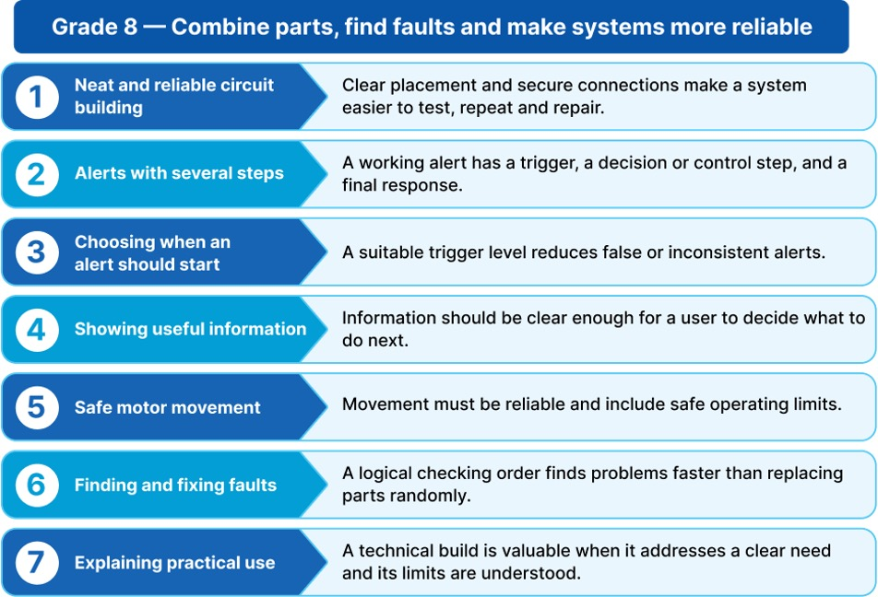
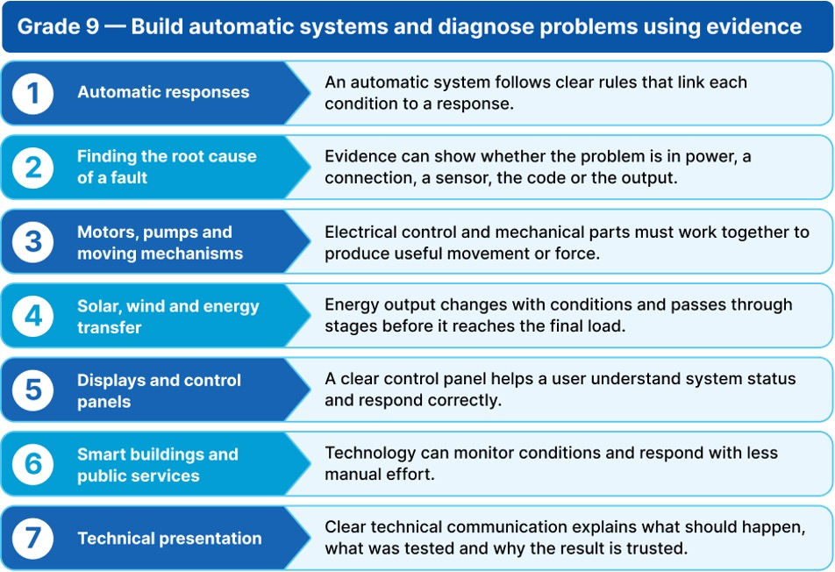

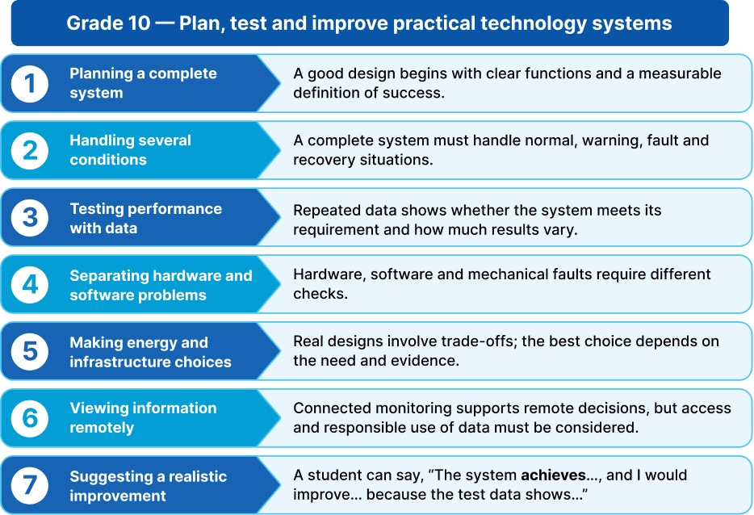

Programme Framework - Composite Skill Lab
The Composite Skill Lab is the physical engine of the innovation programme. It brings multiple technology and application areas into one practical environment, allowing students to move from an idea or classroom concept to experimentation, prototyping and testing. Instead of only discussing how technology works, students get the opportunity to work with it.
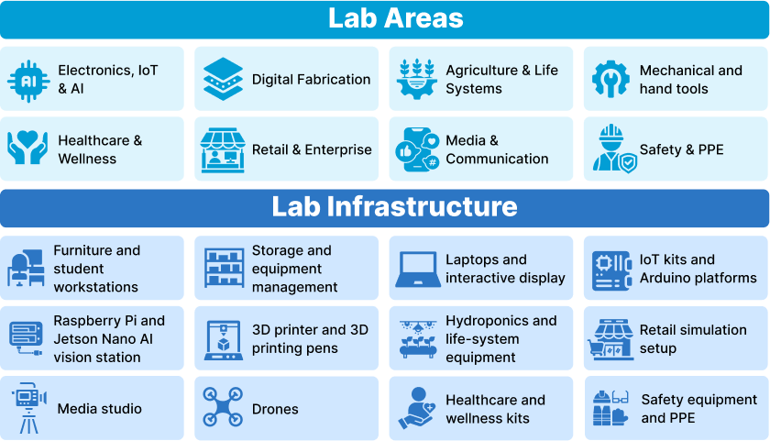

How the Two Offerings Work Together
Together, the two offerings create a complete innovation pathway. The programme develops the student's knowledge and capability. The lab provides the environment in which that capability becomes visible through practical work. The student journey therefore moves naturally from learning a concept to applying it, building something, testing it, improving it and presenting it.
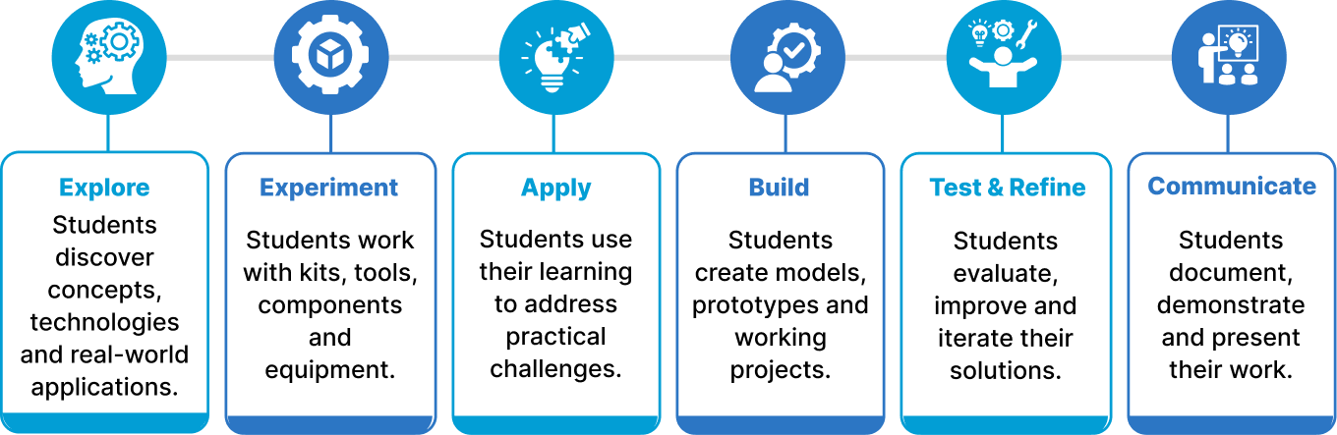

Composite Skill Lab Infrastructure
The proposed Composite Skill Lab includes the following infrastructure, equipment and tools.

Furniture and Workstations | Quantity
Durable 5 x 4 ft Modular Group Worktable | 5
Robust Stackable Student Stool | 40
Lockable Teacher Worktable | 1
Ergonomic Teacher Chair | 1
Tools, Mechanical and Textiles | Quantity
Shared Hand Tool Project Station | 2
Power and Hand Tool Fabrication Station | 1
Corded Drill Station with Bit Set | 2
Advanced Fabrication and Oscilloscope Instrumentation Station | 1
Basic Stitching and Textile Project Machine | 1
Motorised Textile Project Machine | 1
Educational Drone for Flight, Control and Project Activities | 3

Storage and Organisation | Quantity
Lockable Tool, Kit and Consumables Cabinet | 1
Heavy Duty Open Storage Shelf | 2
Labelled Small Parts Storage Set | 20
Wall Mounted Tool Pegboard with Hooks | 2
Healthcare and Wellness | Quantity
BP, Oxygen, Temperature and First Aid Practice Kit | 1
Contact-Free Temperature Screening Device | 1
Feedback-Enabled CPR and AED Emergency Training System | 1

IT and Digital Infrastructure | Quantity
Performance Laptop for Advanced Coding, AI and Design | 1
Office Specification Laptop for Lab Operations | 2
Interactive Touch Teaching, Dashboard and Project Display | 20
Performance Laptop for Advanced Coding, AI and Design | 2
Retail and Enterprise | Quantity
Barcode, RFID and Retail Billing Simulation Kit | 1
Media and Communication | Quantity
Webcam, Microphone, Lighting and Tripod Media Kit | 1
Complete Camera, Audio, Lighting and Green Screen Studio Kit | 1

Electronics, IoT and AI | Quantity
Full Capacity Wi Fi IoT Project Group Kit | 10
Sensor, Motor and Actuator Expansion Set | 5
Digital Circuit Testing Multimeter | 8
High Accuracy Digital Multimeter | 2
Dual Precision Temperature Controlled Soldering Station | 2
Supervised Electronics Soldering Kit | 5
Raspberry Pi + Jetson Nano Real Time AI Vision Station | 1
Arduino Circuit, Sensor and Coding Group Kit | 10
Safety and PPE | Quantity
Institutional Safety, PPE and First Aid Kit | 1
Digital Fabrication | Quantity
Premium Enclosed Multicolour FDM 3D Printer | 1
Handheld 3D Model Making Pen | 5

Agriculture and Life Systems | Quantity
Gardening and Cultivation Group Kit | 5
Automated Hydroponics Station with Pump, Controller and Monitoring | 1
Digital pH and Nutrient Strength Meter Set | 1
App-Monitored Smart Vertical Farming Tower | 1

Lab Infrastructure | Quantity
Educational and Safety Lab Wall Posters | 1

Programme Structure and Investment

Programme Deliverables
Deliverable | Provision
R&D Engineer | Yes
GEN-i Internship | Yes
Study Materials and Workbooks | Yes
Kits and Components for Experiments | Yes
Innovation Fest | Eligible
Timely Assessments with Revisions | Yes
Project Assistance | Yes
IBC Certificates | Yes
Parent Orientation Support | Yes
Exclusive Account Manager | Yes

Investment Framework
Parameter | Details
Annual Price Per Student | <ask:₹2,500 net>
Programme Duration | <ask:10 months>
Workshop Frequency | <ask:Once a week>
Number of Students | <ask:2,700>
Grades | <ask:1 to 10>
Note: All required Innovation materials and kits will be securely stored in a designated classroom to ensure smooth and organised programme execution.

Innovation Framework – Composite Skill Lab
Parameter | Details
Lab Type | Composite Skill Lab
Lab Positioning | Core Composite Skill Lab
Space | <ask:600 to 800 sq ft>
Core Forms of Work | Electronics, IoT and AI
CBSE Skill Modules | Covers 11 skills
Total Investment including GST | <ask:₹15,86,297>

Composite Skill Lab – School Requirements
To ensure smooth installation and operation of the Composite Skill Lab, the school will provide the required infrastructure and room readiness.
Parameters | Description
Room | A lab room meeting the dimensions specified for the chosen package must be made available before installation.
Internet | Stable Wi Fi or LAN connectivity for IoT, AI and content creation stations.
Painting | Wall and ceiling painting of the lab room before installation.
Electrical | Power points, wiring, lighting and earthing for lab equipment.
Plumbing | Water supply and drainage for the hydroponics or wash area.
Lab Readiness | General civil readiness including workbench base points and exhaust or ventilation as required.
IT Support | A local IT support or network administrator point of contact for setup and maintenance.
Interior | Flooring, false ceiling if any and general room finishing.

Disclaimer: This document and its contents are the exclusive property of YuviPep Education Private Limited and are strictly confidential. No part of it may be disclosed, copied, reproduced, distributed, or used without prior written consent from YuviPep Education Private Limited. Unauthorised use or disclosure may lead to legal action.

