Bookmarks: status: New; author:Sunila Johnson; acceptor: C C; modified: 8.10.2026
<School Name>
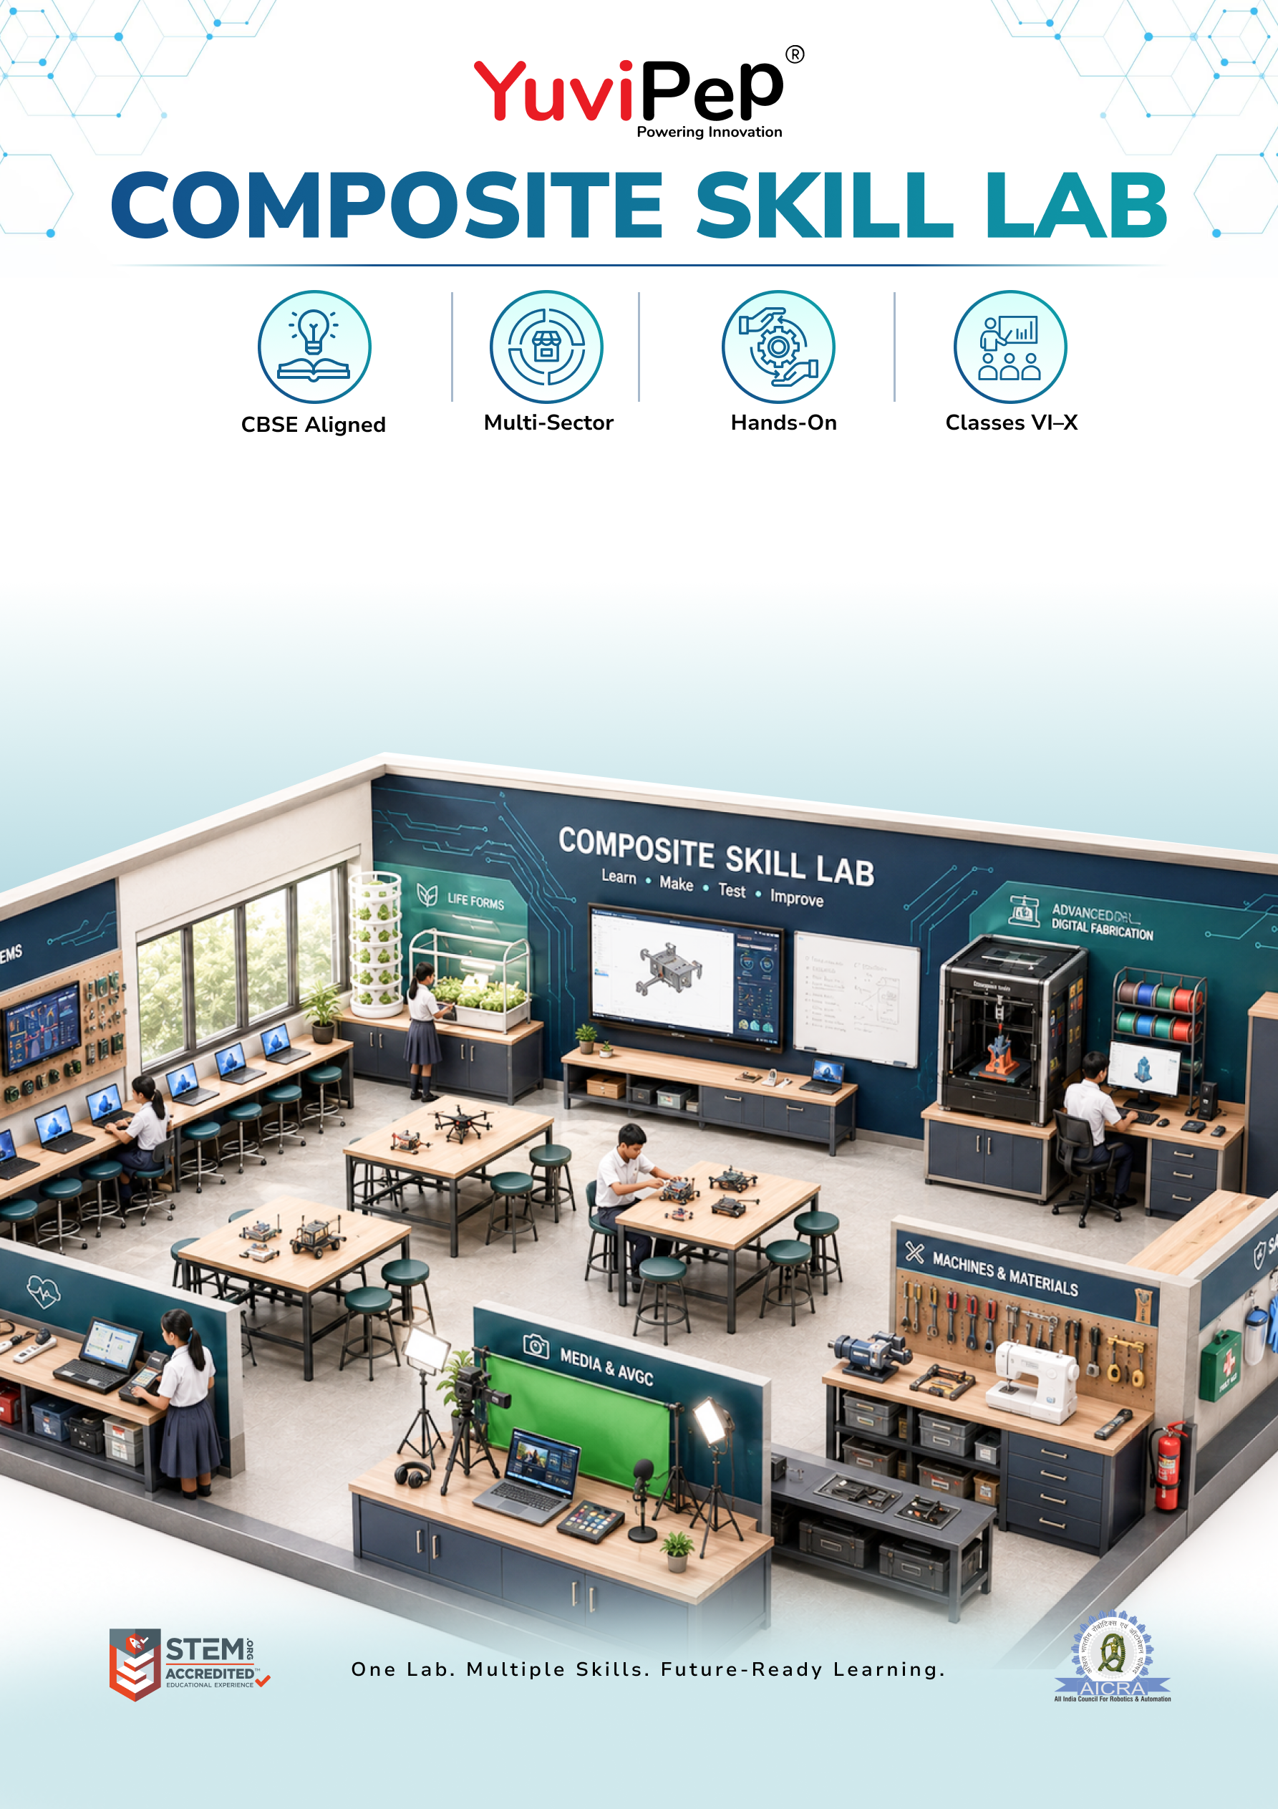
Composite Skill Lab – Intermediate
Table of Contents
About YuviPep 360° Innovation Ecosystem 2
Building India’s first School-to-Startup Innovation Pipeline 2
About Intermediate Composite Skill Lab (CSL) 2
Learning & Application Areas 3
Intermediate Composite Skill Lab 4
INVESTMENT AT A GLANCE 6
School Scope 6
Payment Terms 6
Implementation and Next Steps 7

About YuviPep 360° Innovation Ecosystem

Building India’s first School-to-Startup Innovation Pipeline
The 360° Innovation Ecosystem is a full-stack platform embedded within academic environments. It creates a structured pathway that moves students from foundational innovation learning to advanced technology application, industry immersion, prototype development, incubation, and investor readiness.
YuviPep 360° Innovation Ecosystem is a future-focused, integrated platform designed to transform how students learn, create and lead. It operates as a comprehensive, interconnected framework rather than a standalone programme, strengthening academic environments, enhancing student outcomes and creating a clear pathway from learning to leadership.
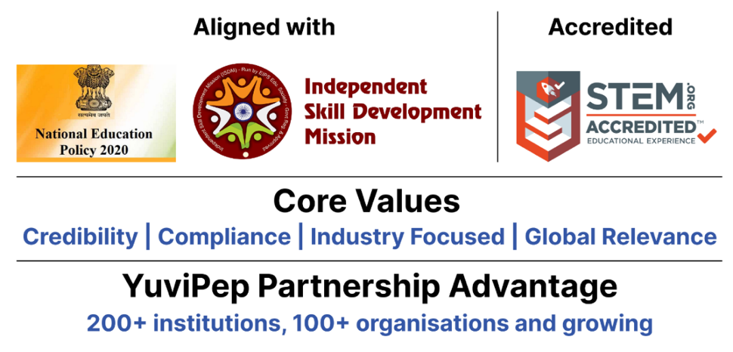

About Intermediate Composite Skill Lab (CSL)
The YuviPep Intermediate Composite Skill Lab provides schools with a structured, hands-on environment for developing applied technology skills across electronics, IoT & AI, digital fabrication, agriculture & life systems, tools & mechanical work, textiles, healthcare & wellness, retail & enterprise, and media & communication.
Equipped with collaborative workstations, computing and digital resources, electronics and IoT systems, fabrication tools, agriculture resources, healthcare equipment and enterprise-oriented learning resources, the lab enables students to move beyond basic practice and apply their skills to practical challenges. Students can design, build, test and communicate solutions through hands-on projects and real-world applications.
It provides a progression from foundational skill development to applied technology learning, helping students strengthen their ability to use technology, apply practical knowledge, solve problems and develop career-oriented skills.

Learning & Application Areas
The Intermediate Composite Skill Lab enables students to explore a range of practical applications through a common learning environment.
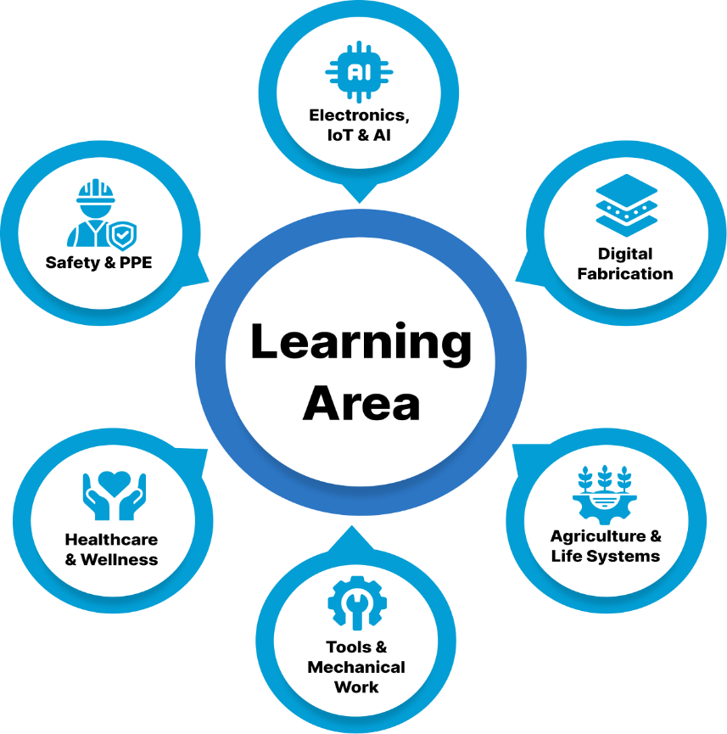

Learning Area | Student Applications
Electronics, IoT & AI | Circuit design, sensors, coding, IoT systems, AI applications, automation and testing
Digital Fabrication | 3D modelling, prototyping, fabrication and product development
Agriculture & Life Systems | Cultivation, soil-free growing, plant monitoring, environmental sensing and smart agriculture
Tools & Mechanical Work | Hand and power tools, drilling, fabrication, assembly and mechanical projects
Healthcare & Wellness | Health measurements, first-aid practice, wellness applications and healthcare awareness
Retail & Enterprise | Product planning, costing, retail processes, point-of-sale applications and basic business skills
Media & Communication | Content creation, digital media, presentation, documentation and communication
Safety & PPE | Safe equipment use, personal protective equipment, workplace practices and lab safety

Intermediate Composite Skill Lab
The following table outlines the core infrastructure, equipment and tools included in the Intermediate Composite Skill Lab.

Zone | Item / Equipment & Capability | Quantity
Furniture & Workstations | Durable 5 × 4 ft Modular Group Worktable | 5
Furniture & Workstations | Robust Stackable Student Stool | 40
Furniture & Workstations | Lockable Teacher Worktable | 1
Furniture & Workstations | Ergonomic Teacher Chair | 1
Storage & Organisation | Lockable Tool, Kit & Consumables Cabinet | 2
Storage & Organisation | Heavy-Duty Open Storage Shelf | 2
Storage & Organisation | Labelled Small-Parts Storage Set | 15
Storage & Organisation | Wall-Mounted Tool Pegboard with Hooks | 2
IT & Digital Infrastructure | Technology Laptop for Coding, Design & Project Work | 2
IT & Digital Infrastructure | Office-Specification Desktop Computer | 1
IT & Digital Infrastructure | Classroom Projector for Demonstrations & Presentations | 1
IT & Digital Infrastructure | Large 8 × 4 ft Teaching & Project Whiteboard | 1
Electronics, IoT & AI | Arduino Circuit, Sensor & Coding Group Kit | 10
Electronics, IoT & AI | Expanded Wi-Fi IoT Project Group Kit | 8
Electronics, IoT & AI | Expanded Sensor, Motor & Actuator Set | 5
Electronics, IoT & AI | Digital Circuit-Testing Multimeter | 8
Electronics, IoT & AI | High-Accuracy Digital Multimeter | 2
Electronics, IoT & AI | Precision Temperature-Controlled Soldering Station | 1
Electronics, IoT & AI | Supervised Electronics Soldering Kit | 5
Electronics, IoT & AI | Raspberry Pi Edge AI & Camera-Vision Station | 1
Digital Fabrication | Standard FDM 3D Printer for CAD Prototypes | 1
Digital Fabrication | Handheld 3D Model-Making Pen | 2
Agriculture & Life Systems | Gardening & Cultivation Group Kit | 5
Agriculture & Life Systems | Basic Soil-Free DWC Hydroponics Station | 1
Agriculture & Life Systems | Digital pH & Nutrient-Strength Meter Set | 1
Tools, Mechanical & Textiles | Shared Hand-Tool Project Station | 2
Tools, Mechanical & Textiles | Power & Hand-Tool Fabrication Station | 1
Tools, Mechanical & Textiles | Corded Drill Station with Bit Set | 1
Tools, Mechanical & Textiles | Basic Stitching & Textile Project Machine | 1
Tools, Mechanical & Textiles | Motorised Textile Project Machine | 1
Healthcare & Wellness | BP, Oxygen, Temperature & First-Aid Practice Kit | 1
Healthcare & Wellness | Contact-Free Temperature Screening Device | 1
Healthcare & Wellness | Feedback-Enabled CPR Training Mannequin | 1
Retail & Enterprise | Barcode, RFID & Retail Billing Simulation Kit | 1
Media & Communication | Digital Content-Creation Kit with Webcam, Mic, Light & Tripod | 1
Safety & PPE | Institutional Safety, PPE & First-Aid Kit | 1
Lab Infrastructure | Educational & Safety Lab Wall Posters | 1

INVESTMENT AT A GLANCE
Proposed Innovation Lab Type | Intermediate Composite Skill Lab
Lab Positioning | Core Composite Skill Lab
Space | <ask:600 to 700 sq ft>  Minimum requirement: one room of 700 sq ft or two rooms of 500 sq ft each.
Core Forms of Work | ✓
Electronics, IoT & AI | ✓
CBSE Skill Modules | ✓ (Covers 11 skills)
Total Investment incl. GST | <ask:₹10,63,758>

School Scope
To ensure smooth installation and operation of the Composite Skill Lab, the school will provide the required infrastructure and room readiness, including:
- Room Size: a lab room of the dimensions noted for your chosen package, made available before installation.
- Internet: stable Wi-Fi/LAN connectivity for IoT, AI and content-creation stations.
- Painting: wall and ceiling painting of the lab room before installation.
- Electrical: power points, wiring, lighting and earthing for lab equipment.
- Plumbing: water supply and drainage for the hydroponics/wash area.
- Lab Readiness: general civil readiness — workbench base points, exhaust/ventilation as needed.
- IT Support: a local IT support or network administrator point of contact for setup and maintenance.
- Interior: flooring, false ceiling (if any), and general room finishing.

Payment Terms
- Advance payment is applicable upon signing of the MoU.
- Remaining payment terms will be confirmed in the final agreement.
- Payment can be made through NEFT, cheque, credit card or debit card.
- The proposal is valid for 30 days, unless extended.

Implementation and Next Steps
The implementation process will follow four key stages:



