**Fax to : +65 6636 3179**

**RSVP**

**ROXUL Golf Invitational 2013**

**25 October | Jurong Country Club**

I **will be** participating in the golf event

I **will not be** participating in the golf event

|  |  |
| --- | --- |
| Name |  |
| Company |  |
| Address |  |
| Office Tel |  |
| Mobile |  |
| Email Address |  |
| Golf Handicap |  |
| Will you be attending the Dinner and Prize Presentation? Please indicate dietary preference if any _________ | (Please indicate your most recent golf handicap index) |

Yes  No

Are you a member of Jurong Country Club?

Yes  No

If yes, please indicate membership no: _______

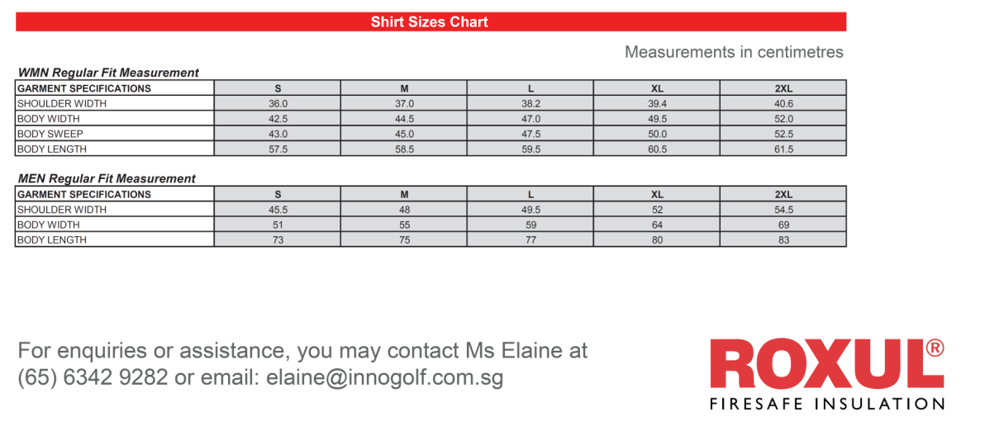

**For enquiries or assistance, you may contact Ms Elaine**

**at +65 6342 9282 or email to elaine@innogolf.com.sg**