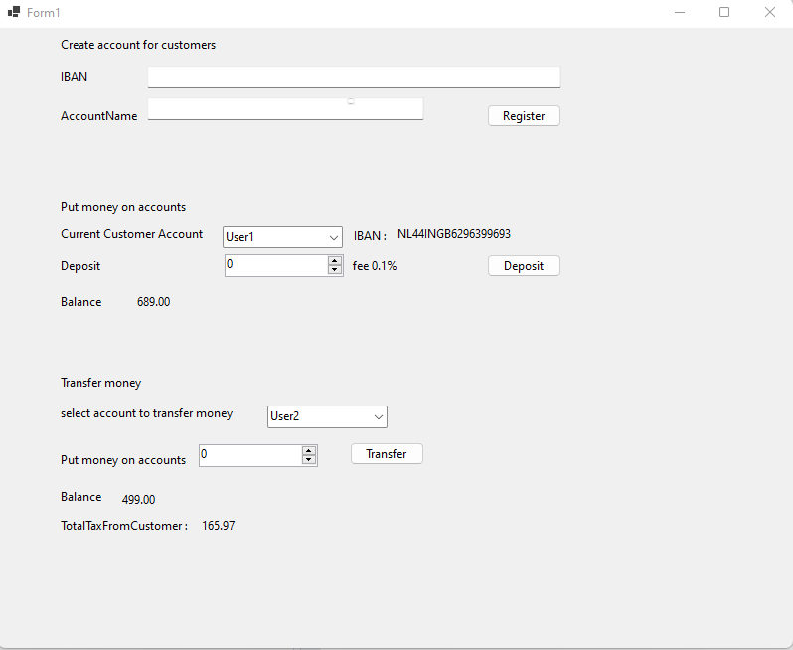

Window Application + SQL Database by visual studio 2022 (C# .net6)

I embed the database in VSStudio for easy opening.

1. Create accounts for customers. As it is a bank account, it has to be identified with an IBAN number. To generate that IBAN, use this website http://randomiban.com/?country=Netherlands to get a random IBAN.

Database  
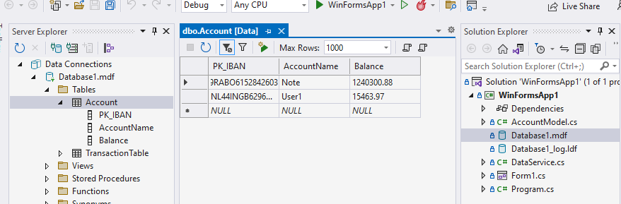

GUI  
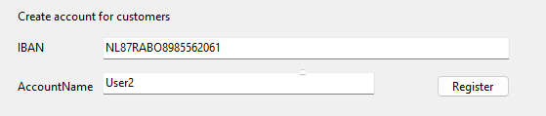

Insert IBAN And AccountName (AccountName for communicate with customer)then click Register

1. Put money on accounts (when they deposit it in the bank) a. for each deposit, a 0.1% fee is charged (eg. 1000 is deposited, then put only 999 on the target account)

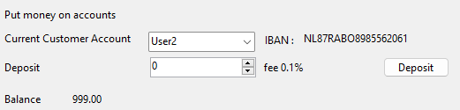

GUI: in This Pic: selects the current customer account on combobox and then click the deposited button to deposit 1000 fee0.1% =Balance is 999.00.

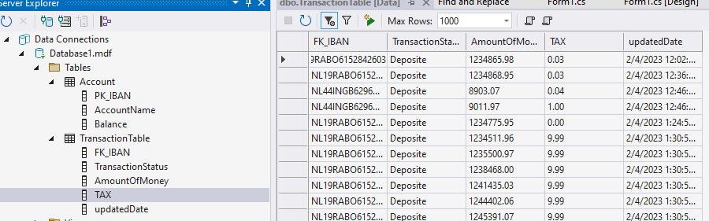

Database : I design to keep all TAX data in TransactionDB.

3.Transfer money from one account to another one (within our system, between our customers’ accounts) 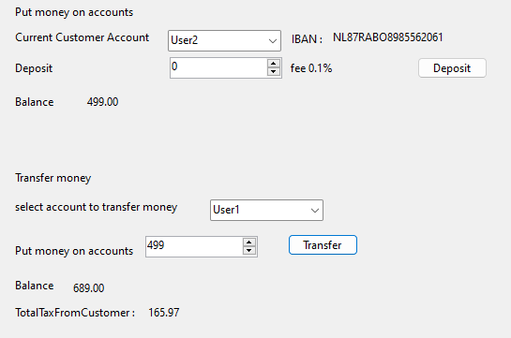

Select the account to transfer money on comboBox,

then put money on the transfer to another account on numeric (that customer can input data to transfer not over a balance from Customer Account in Example Max is 499 )

, After that click Transfer.

Problem :

1. Create accounts for customers. As it is a bank account, it has to be identified with an IBAN number. To generate that IBAN, use this website http://randomiban.com/?country=Netherlands to get a random IBAN.

In my design, I plan to get IBAN data from <http://randomiban.com> automatically.

But I can’t get IBAN data.

This picture has data on the website.

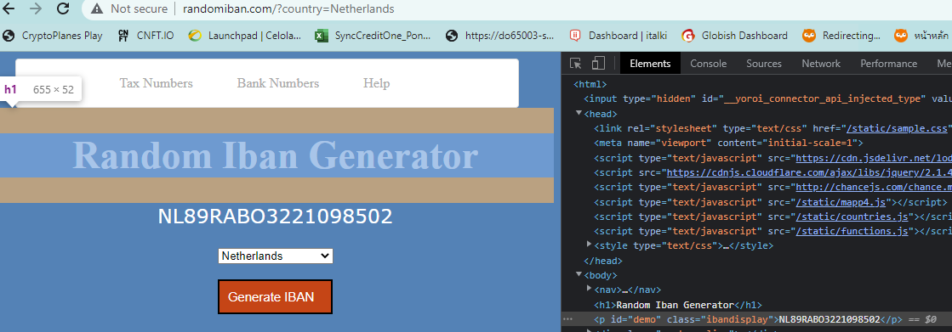

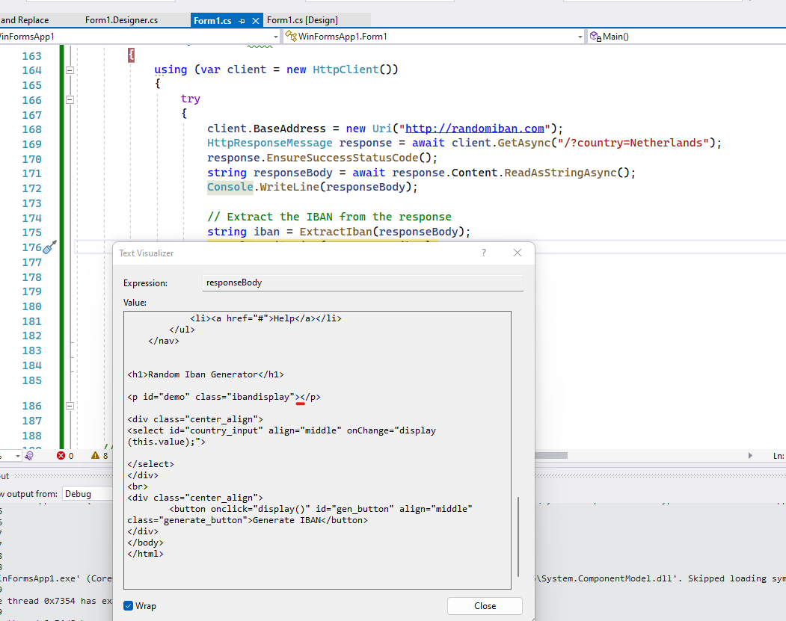

I can’t access to get IBAN from <http://randomiban.com> .

This picture is from a real website.