# General Solution

# 



**Cloud**

**Services**



Payments



**Blockchain**

Registration Portal

List

of Leads

Sales reports



**Authors**

Search

Portal

Product & IP Marketplace

Augmented

Reality

App



**Users:**

**Consumers**

**Investors**



Image storage

**WEBSITE**

Smart contracts

Rest API

The solution is designed with an array of servers in the cloud that we called as cloud services. This cloud services includes database server, storage server, applications server and web services.

The access will be made through a rest API that will facilitate the implementation of new applications and distribution for other developers. In the cloud will be hosted the database of authors and works, the storage of images, videos, audio and pdf, registration portal, DAPP, search portal, marketplace and integration with Blockchain and payment gateways.

The augmented reality application will be distributed in the App Store and Google Play but all information will be in cloud services.

# Blockchain implementation

Image storage

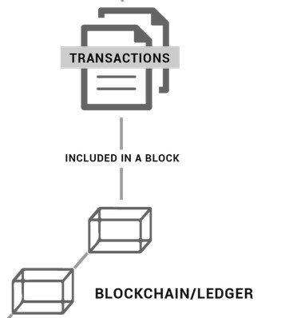

Author

Investor



WebSite

Record

evidence

Query evidence

Save User

Query user

Smart Contracts

(operations)

Save image an

return token

# Roles within a Hyperledger Fabric Network

There are three different types of roles within a Hyperledger Fabric network:

## Clients

Clients are applications that act on behalf of a person to propose transactions on the network.

## Peers

Peers maintain the state of the network and a copy of the ledger. There are two different types of peers: **endorsing** and **committing** peers. However, there is an overlap between endorsing and committing peers, in that endorsing peers are a special kind of committing peers. All peers commit blocks to the distributed ledger.

* *Endorsers* simulate and endorse transactions.
* *Committers* verify endorsements and validate transaction results, prior to committing transactions to the blockchain.

## Ordering Service

The ordering service accepts endorsed transactions, orders them into a block, and delivers the blocks to the committing peers.

# How to Reach Consensus

In a distributed ledger system, **consensus** is the process of reaching agreement on the next set of transactions to be added to the ledger. In Hyperledger Fabric, consensus is made up of three distinct steps:

o Transaction endorsement o Ordering o Validation and commitment.

In this project we user the Transaction endorsement

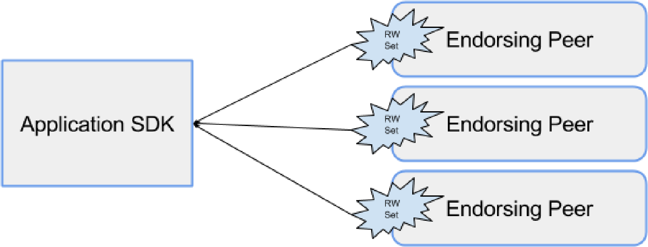

# Hyperledger Fabric v1.0

Hyperledger Fabric was the first proposal for a codebase, combining previous work done by Digital Asset Holdings, Blockstream's libconsensus, and IBM's OpenBlockchain. Hyperledger Fabric provides a modular architecture, which allows components such as consensus and membership services to be plug-and-play.

Hyperledger Fabric is revolutionary in allowing entities to conduct confidential transactions without passing information through a central authority. This is accomplished through different channels that run within the network, as well as the division of labor that characterizes the different nodes within the network. Lastly, it is important to remember that, unlike Bitcoin, which is a public chain, Hyperledger Fabric supports permissioned deployments.