**ACADEMIC TASK-2**

**INT428: Artificial Intelligence COMPUTER SCIENCE AND ENGINEERING**

**Submitted by:**

Kishlay Kumar

Saurabh Singh

Koushik Ghosh

**Section: K23SF**

Submitted to: **Salil Batra**

# Annexure 3b- Complete filing

# INVENTION DISCLOSURE FORM

Details of Invention for better understanding:

**1. TITLE:** AIoT-Driven Smart Water Management & Leak Prevention

**2. INTERNAL INVENTOR(S)/ STUDENT(S):** All fields in this column are mandatory to be filled

|  |  |
| --- | --- |
| Full name | Kishlay Kumar |
| Mobile Number | 9508360148 |
| Email (personal) | [kishlay141@gmail.com](mailto:kishlay141@gmail.com) |
| UID/Registration number | 12314194 |
| Address of Internal Inventors | Lovely Professional University, Punjab-144411, India |
| Signature (Mandatory) |  |

|  |  |
| --- | --- |
| Full name | Saurabh Singh |
| Mobile Number | 8299826799 |
| Email (personal) | saurabhsinghrs8@gmail.com |
| UID/Registration number | 12315536 |
| Address of Internal Inventors | Lovely Professional University, Punjab-144411, India |
| Signature (Mandatory) |  |

|  |  |
| --- | --- |
| Full name | Koushik Ghosh |
| Mobile Number | 8436939331 |
| Email (personal) | [ghoshkoushik9434@gmail.com](mailto:ghoshkoushik9434@gmail.com) |
| UID/Registration number | 12314158 |
| Address of Internal Inventors | Lovely Professional University, Punjab-144411, India |
| Signature (Mandatory) |  |

|  |  |
| --- | --- |
| Full name | Mr. Salil Batra |
| Mobile Number | 8054872678 |
| Email (personal) | salilbatra40@gmail.com |
| UID/Registration number | 16836 |
| Address of Internal Inventors | Lovely professional University , Phagwara, Punjab |
| Signature (Mandatory) |  |

***For External Inventors*, NOC (No Objection Certificate) from the affiliated institute/university/Industry/lab etc. is mandatory for each individual inventor and their respective topic. For NOC, format is attached below.**

DESCRIPTION:

**3. DESCRIPTION OF THE INVENTION:** This invention concerns a smart leak detection and water monitoring system targeted for Indian families. It leverages a lone main inlet sensor placed at the main water ingress point to monitor total water intake in real time. Unlike in conventional systems calling for numerous sensors, this financially friendly option cuts down on install costs and capital outlay.The system real-time monitors flow of water and detects anomalies via AI-driven pattern detection. On identification of unfamiliar usage, leakages, and bursts in the pipes, instant notification is delivered to users as well as regulates the flow with the help of a smart valve in order to stop wastage. Cloud computing facilitates data processing while remote viewing through a smartphone application is permitted. Moreover, analytics from the system can complement city-scale management of water resources.

**A.** **PROBLEM SOLVED BY THE INVENTION**: Silent leakages and water leakage are big issues in Indian homes, causing undue usage of water, water shortages, and excessive water bills. Conventional monitoring systems normally require several sensors for various outlets, which is costly and difficult to fit. In addition, customers frequently lack live information regarding their water consumption, which makes it difficult to spot leaks or aberrant usage rates. The present invention addresses these issues by providing a cost-effective smart water monitoring and leak detection system that is based on one main inlet sensor. Our system tracks the amount of water that is being consumed and determines unusual flow patterns by the assistance of AI and machine learning techniques and then it regulates the flow of water in real time to minimize the wastage of water.In real-time alerts with the assistance of cloud intelligence, ultimately assists user to manage their water usage and promotes improved water conservation practices.

**B. OBJECTIVE OF THE INVENTION**

1. **To Design an AI-Based System for Real-Time Water Monitoring and Detection of Leaks:**

This goal targets developing a smart water monitoring system to monitor residential water usage in real-time based on one central inlet sensor. Based on sensor information, the system identifies irregular patterns of water usage, for instance, leaks or high consumption, and anticipates any upcoming issues prior to them resulting in wastage of water. The model with AI keeps learning the pattern of usage within homes constantly, making it possible for automated adjustments in flows and prompt notification to consumers to prevent wasteful water use.

**2. Applying Machine Learning Algorithms to Smart Water Use Optimization:**

The technology employs machine learning programs to monitor the amount of water every household consumes, including daily trends, peak usage, and flow rate variations. Analyzing this information allows the system to automatically detect leaks, excessive consumption, or irregular use. The AI model, as it learns with time, becomes more precise, and automated adjustments can be made to water flow and personalized recommendations for water savings, which optimizes water consumption in an efficient and cost-effective way.

**3. To Improve Water Usage Efficiency with Sensor-Based Feedback Loops:**

This system contains a permanent master inlet water flow sensor, which helps to monitor the home in real-time to find out the flow rate, pressure change, and any irregularities that might indicate some leakages or excessive consumption. Data collected is analyzed in real-time; therefore, it pinpoints possible glitches and gets to manage water supply in a perfect way. With continuous monitoring and automated control, dynamic water valves can be adjusted to minimize waste. The system can alert the owner of the home to any leakages or unusual rates of consumption, and it will ensure that water is used efficiently. Not only would this stop water from wasting; it would promote ways of responsible water use. In this way, both people and communities would benefit through the conservation of this precious resource.

**4. To Enhance Water Conservation and Leakage Prevention through Predictive Analytics:**

This system is powered by advanced predictive analytics with AI capabilities and aims to optimize sustainable management of the water resources. While continuously assessing real-time and historical data from household and community water usages, the system can proactively spot potential leaks soon enough to stop them from turning into big issues, thereby helping to prevent malevolent water loss. Apart from identifying leaks, the system studies past consumption trends to project future demand for water. With these insights, it makes personalized recommendations to homeowners, businesses, and even the municipality to effect water conservation: optimal scheduling of irrigation, spotting inefficiencies in plumbing systems, and urging habits of mindful usage. The combination of predictive analytics acting with real-time monitoring not only minimizes wastage, but also helps individuals and communities in making informed decisions about using water. All this will result in more sustainable and resource-efficient future scenarios, where the water is to be made available for many generations of human beings.

**C. STATE OF THE ART/ RESEARCH GAP/NOVELTY:** Describe your invention fulfil the research gap?

|  |  |  |  |  |
| --- | --- | --- | --- | --- |
| Sr. No. | Patent ID | Abstract | Research Gap | Novelty |
|  | US11000449B2 (Official USPTO link) | This patent by Moen Inc. describes an IoT-based water monitoring system that uses flow sensors and smart valves to detect leaks and dynamically adjust water pressure instead of fully shutting off supply. It includes a cloud-based AI module to analyze usage patterns and optimize flow in real time. | Limited Scope – Focuses only on individual fixtures (e.g., faucets, showers) rather than whole-house water management.  Delayed Response – AI analysis happens in the cloud, causing a slight delay in leak response.  No Preventive Action – Reacts to leaks but does not prevent them (e.g., pipe bursts due to | Dynamic Flow Adjustment – Unlike traditional shutoff systems, this adjusts water pressure proportionally to the severity of a leak.  AI-Powered Learning – Uses historical data to predict leaks before they occur.  User Customization – Homeowners can set water usage thresholds via a mobile app |
| 2 | EP3816784A1 (European Patent Office) | This European patent by Grohe AG uses AI-based flow analysis to detect leaks and partially close valves to reduce water wastage. It employs edge computing for faster decision-making and integrates with smart home systems. | No Usage Optimization – Only reacts to leaks, does not optimize daily water usage.  High Cost – Requires professional installation (not DIY-friendly).  No Cloud Backup – If local system fails, no remote override exists. | Proportional Valve Control – Reduces flow instead of complete shutoff.  Local AI Processing – Faster response than cloud-dependent systems.  Smart Home Integration – Works with Alexa/Google Home for voice alerts. |
| 3 | CN110926556A (CNIPA) | This Chinese patent by Haier Group describes an IoT-based system that regulates water flow based on real-time demand (e.g., reduces pressure at night). It uses low-cost sensors and a centralized controller. | No AI or Machine Learning – Uses fixed thresholds, not adaptive learning.  No Leak Prediction – Only reacts to abnormal flow, not early signs of leaks.  Limited to Urban Homes – Not optimized for rural/low-infrastructure areas. | Demand-Based Flow Control – Adjusts pressure dynamically (not just leak response).  Low-Cost IoT Sensors – Designed for mass-market adoption.  Energy Efficient – Uses LoRaWAN for long-range, low-power communication. |
| 4 | [US20210325156A1](https://patents.google.com/patent/US20210325156A1/) (USPTO Application) | This US patent application by Phyn LLC proposes a whole-house water management system that uses machine learning to detect leaks and adjust flow. It targets high-end smart homes with professional installation. | Expensive & Pro-Install – Not feasible for average homeowners. Over-Engineering – Complex for basic leak prevention needs.  No User Customization – Fully automated (users can’t set preferences). | Whole-House Optimization – Monitors all water points (not just fixtures).  Advanced ML Models – Detects micro-leaks (e.g., dripping faucets).  Pressure Wave Analysis – Identifies pipe bursts within seconds. |
|  |  |  |  |  |
|  |  |  |  |  |

**D. DETAILED DESCRIPTION:**

**System Design for AI-Powered Digital Twins in AIoT-Driven Smart Water Management & Leak Prevention**

This innovative system provides AI-powered Digital Twins for smarter, more efficient water management. This assures an active and preventive strategy toward conserving water and minimizing leak problems via the current responsible monitoring, establishing responsive analytics, and automatic optimization. At the base of this system, there are either multilayered connecting points that handle different functions of data collection, data analysis, and intelligent decision-making. The main components include:

**Advanced sensor networks:** for continuous data collection, collecting data on flow rate, pressure conditions, and other anomalies.

**Robust data management systems:** for storage, processing, and analyses of water usage that was ordinarily vast.

**SCADA-based Control and oversee:** for efficient operations and system reliability.

**AI-based machine learning models:** that present predictive insights pinpointing potential leaks, modeling water forecast, and evolving quintessence models for consumption.

**Expert-thinking frameworks** that promote the filtering of data insights and transforming it into active actions for more significant water efficiency.

When tightly combined, these components help provide intelligent-automated decision making, allowing for Community or Organization detection of early leaks, predictions over future water needs, and other conservation matters. This whole picture will always restrain water losses and sustain for the future.

The coming sections provide a detailed definition for the various designs and Analytical components of this system with a weather-eye solely focused on the five most substantial layers in its architecture.

### **Sensing Layer**

Acting as the eyes and ears of the smart water monitoring system, the Sensing Layer sits on top of the core philosophy of water conservation. Different high-tech sensors help monitor a few core aspects of water flow, pressure, temperature, and quality by observing water use on a continuous basis and preempting any wider problems. Some key sensors that contribute in terms of duty and water quality monitoring are as follows:

**Flow sensors**: enable the volume of the water flowing through the pipes to be determined. If they notice an unusual high rise, a leak or very high water consumption could be the culprit;

**Pressure sensors**: indicate any drop in water pressure and that this should be looked at, as it could be due to leakages, blockages, or other plumbing-related problems;

**Temperature sensors**: are for monitoring water temperature. Water that is too hot or too cold could damage pipes;

**PH and turbidity sensors**: These test water quality and do so by measuring their pH and turbidity in transparency. Clean and safe water is assured with this. High-frequency and adaptive sampling based on the detection of unique characteristics ensures that most accurate insights are captured for highly effective monitoring of the system under normal runtime performance. High-frequency sampling occurs when the system detects abnormal water use that would typically be displayed as constant high flow length detection for a suspected leak. Low-frequency sampling occurs when water use is stable, hence less resources will be consumed for data processing and limit unnecessary data accumulation. By enabling real-time tracking and intelligent analysis, the layer helps to avoid water waste, detect leaks early, and guarantee water use at its best. Each drop of water counts!

**Data Transmission and Acquisition Layer**

Here to optimize water use, avoid leakage, and render optimistic consumption, the system depends on the data from sensors to cloud-based platforms. Data is obtained through Wi-Fi and IoT connectivity with intelligent analysis and actively adapts to make the system optimistic and avoid any possible loss of water.

Smooth, Real-Time Data Transfer

Always Connected, Always Aware: The intelligent water-monitoring system guarantees the smooth transfer of real-time data from in-pipe sensors to cloud servers using Wi-Fi and IoT connectivity. Live Monitoring & Leakage Detection: Flow rate, pressure, temperature, and other possible anomalies being monitored allow the system to leak such information at much higher speed and accuracy so that they cannot grow into issues. Maximized System Performance: Constant flow of sensor data maintains all the parts in optimal working conditions, and minimizes downtime and optimizes water conservation efforts.

**AI-Powered Cloud Processing for Smarter Water Management**

Data-Driven Decision Making: The system doesn’t only collect the data but also it actively analyzes water consumption in real time , therefore any inefficiencies in water consumption will recommend and offer smart suggestions to conserve.

Preventive Leak Detection: AI algorithms will identify the leaks beforehand and also give future trends in water usage therefore users will be alerted before the water wastage.

Secure & Scalable Data Management: Sending data to the cloud gives secure storage, easily remote access and scalability for residential or for larger applications.

**Smart Water Usage: Engaging with Anticipation**

**Predictive maintenance:** AIoT-Driven Smart Water Management & Leak Prevention

System, you'll not only be able to react to problems but also, more importantly, foresee them. Such an approach allows you to avoid expensive repairs along with conserving water waste.

Sure peace of mind through preventive maintenance.

Instead of simply waiting for your life to be disrupted from a leak or faulty plumbing, this system keeps an eye on your water usage habits. It catches even the minor wear and tear giving you advanced notice on what could turn into expensive repairs. Think of it as an advance warning system for your plumbing-a head of all repairs incurred by lost time, money, and frustration.

**Automated Leak Protection**: Leaking water can cause serious damage if not taken care of right away. That's why this system not only detects a leak but also takes action. If there's a real leak, it can turn off your water supply immediately to prevent flooding or further damage. Instantaneous notifications keep you in control, at all times, at any location.

With smart water usage tech, not only are you monitoring your water; you're protecting your home and conserving resources with hardly any effort.

### **Digital Twin Core**

The Digital Twin Core is being developed as the central intelligence of the system. It will create a virtual replica of the water distribution network, allowing for real-time monitoring, simulation, and optimization. This core consists of two major subsystems:

#### 1. Water Flow Modeling and Simulation Subsystem

**Pipeline Network Model Creation:** 3D modeling of the water pipeline system will be developed from sensor data and the Geographic Information System (GIS) mapping of highways. Such digital reflection will therefore lend itself to monitoring the real-time water flow by means of simulation.

**Finite Element Analysis (FEA):** The system will use Finite Element Analysis (FEA) for simulation of the pressure distribution, stress on the pipes, and possible weak points in the water supply network; this will allow early detection of possible leakages or breakdowns of pipes before they happen.

**Hydraulic and Flow Dynamics Analysis:**The system will simulate movement of water through pipes; in this case flows will vary, pressures will vary, certain leak scenarios will be simulated. Simulation with the use of AI will also predict excess water usage, pipeline bursts, and areas with low pressure before they affect the system.

2. **AI and Machine Learning Subsystem**

This subsystem is being designed to process real time data using AI and ML techniques, for effective insights and optimized water distribution

**Predictive Maintenance:** Ai models, like Support Vector Machines and Neural Network will analyze the data of water flow and pressure data coming from sensors to predict leakage or any anomalies getting created. This will help actively to eliminate any critical failures occur beforehand.

**Adaptive Learning Algorithms:** System will keep learning patterns from daily water consumption patterns to automatically adjust the flow of water and to minimize wastage.By continuous learning it will also detect unusual water usage then to either notify the user or shut off valves to prevent water loss.

**Personalized Water Usage Insights:**Ai will continuously monitor individual water consumption and provide real time recommendations for more effective usage.Also will predict future water needs based on historical trends and weather conditions.

**SCADA System Integration**

**Data Acquisition Module**

**Cloud-Based Data Aggregation:** All sensor data is transmitted through Wi-Fi directly to the cloud, where SCADA collects and processes it for real-time analysis.

**Remote Real-Time Visualization:** The system provides cloud-hosted dashboards accessible from any device, displaying key metrics like pressure distribution, motion dynamics, and temperature variations.

**Control and Monitoring Module:**

**Alert System:** The SCADA system continuously monitors prosthetic functioning, sending notifications for any abnormality like irregular pressure distribution, excessive tension, or heating. In the event of a problem, an alert is sent automatically via the cloud, providing medical professionals sufficient time to react and enhance patient comfort and safety.

**User Interface:** The user interface is cloud-based and is intended to be user-friendly for clinicians and patients alike, with real-time performance data and AI-generated insights at their fingertips. Patients can monitor key metrics, get tailored recommendations, and make prosthetic setting adjustments remotely, with the experience being more adaptive and user-focused.

**Material and Design Optimization**

**Material Testing via Digital Twins:** The system simulates and evaluates different prosthetic materials based on patient-specific requirements. It assesses factors like durability, comfort, and biocompatibility to ensure optimal interaction with the patient’s limb. Lightweight polymers and flexible materials are tested to enhance user experience and minimize strain.

**Iterative Design Process:** Simulation insights guide continuous improvements in prosthetic design. The system analyzes real-world usage data to refine structural integrity, ensuring the prosthetic remains comfortable and functional during daily activities like walking, standing, and other movements specific to the patient’s needs.

**Application Layer**

The application layer of the smart water monitoring and leak detection system is made to help users, admins, and the system itself work better for saving water and stopping waste.

**User Interface (Mobile App)**

A mobile app gives real-time updates on how much water a house is using.Users can check daily water use, they will get alerts if there is a leak, and can see past usage records. Users can set limits on water uses as well and get a warning or reminder if they are using more than normal. Also, the system has a reward program where people who save water get points. These points can be used for discounts on electricity bills, tax relaxation, or any other benefits given by the local government..

**Administrator & Municipal Interface**

For city officers and housing societies, a dashboard which shows whole combined water use data from many homes. It helps to know the overall water consumption pattern in any area moreover, find high-use time, and spot leaks or problems in water supply. Authorities can use this data to make better planning for water supply, they can find leaks, and also can manage water saving efforts. The system also gives tools to handle reward programs, so admins can track which house saves more water and follow an optimistic approach to save water and give them benefits.

**Automation & Control Module**

The system has AI-powered automation features that check water use in real-time and find problems. If any leak or sudden change in usage then our smart valve automatically controls or stops the water supply to stop waste. Users and admins can also manually control the system if needed using the mobile app.. The reward system also motivates people to use water properly and gets benefits accordingly.

**System Design**

The System uses AI,machine learning techniques, IoT enabled sensors and cloud based digital twin technology for smart monitoring and automation in water flow control. Sensors are integrated into the main inlet which continuously monitor water flow, pressure, and daily consumption pattern, leading to quickly leak detection, any type of anomalies or overuse of water. AI-driven models analyze the previous water usage data to predict the leaks beforehand or pipeline stress, which eliminates any major failure early. Also the system dynamically adjusts valves and flow rates optimizing the water distribution. A continuous feedback will refine the Ai model, improving the accuracy in finding the anomalies and adapting to individual consumption habits. SCADA integration allows large scale monitoring and digital twin helps in finding anomalies and optimizing water flow. Ultimately this makes the system an intelligent water management system and more reliable for sustainable and cost effective use cases.

**SCADA Integration and Architecture**

**SCADA Integration:**

##### The smart SCADA monitoring and leak detection system does real-time monitoring of water consumption, leaks and other anomalies on the distribution and storage systems.

1. **Sensor Layer (S):**This is an important step towards the self-directed water management system. This main body sensor layer can provide continuous monitoring on water flow and the possibility to detect problems before they escalate into a greater problem: flowmeter-The first checkpoint. It should monitor the amount of flow into the system as well as the amount of water leaving the system. Pressure sensors indicate that there may be a leak or burst problems, as these inform the SCADA system with sudden changes in pressure as abnormalities take place within the LDSTS.

**2. Communication Layer (C):**

We have attached a communication layer for monitoring the water system, which is flexible and perfectly enough for ensuring the monitoring process regardless of size, from a small household to an entire city. Wi-Fi connection ideally works for homes and small companies because it allows monitoring of water consumption along with sending alerts in real-time..

**3. Storage Layer (S):**

Edge Storage (Local Device)**:** Microcontrollers store data in real-time.

Cloud Database: This cloud storage safeguards historical analyses of water usage patterns and maintenance services, providing unlimited long-term access to data.

**4. Data Processing Layer (D):**

**Real-time Processing**:

Data generated by sensors is processed using AI models to detect anomalies.Prediction analytics uses learned patterns to identify anomalies while monitoring through machine learning , decision trees , clusters or neural networks. Real time monitoring helps to visualize changes in water flow and provide instant leak alerts.

**The following is the Diagrams Overview, depicting the brief of the system:**

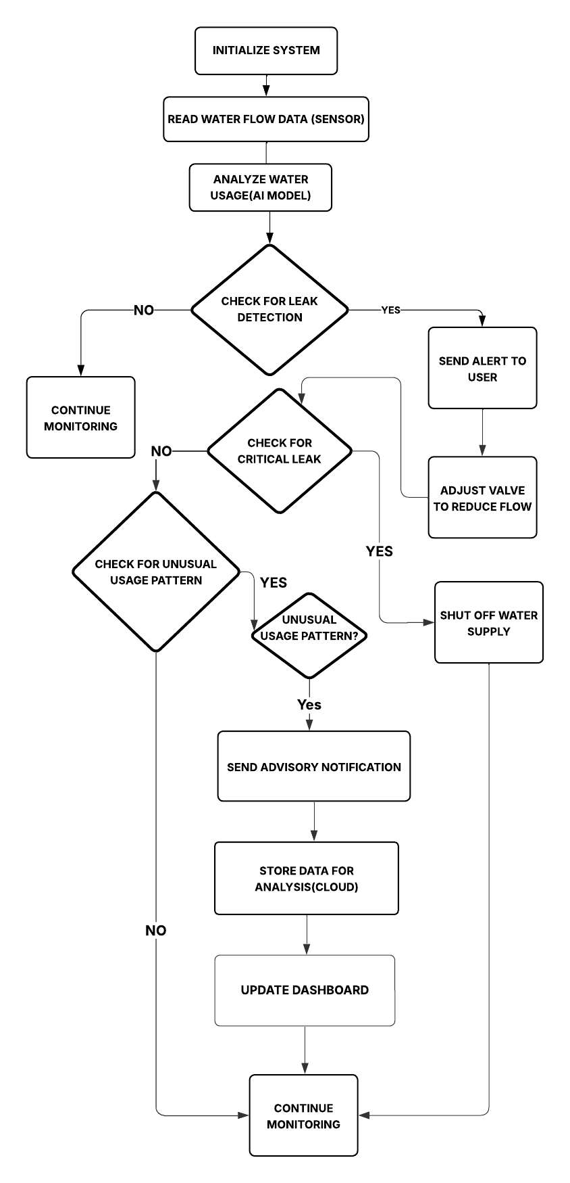

***Figure 1: Flow Chart of***  ***AIoT-Driven Smart Water Management & Leak Prevention***

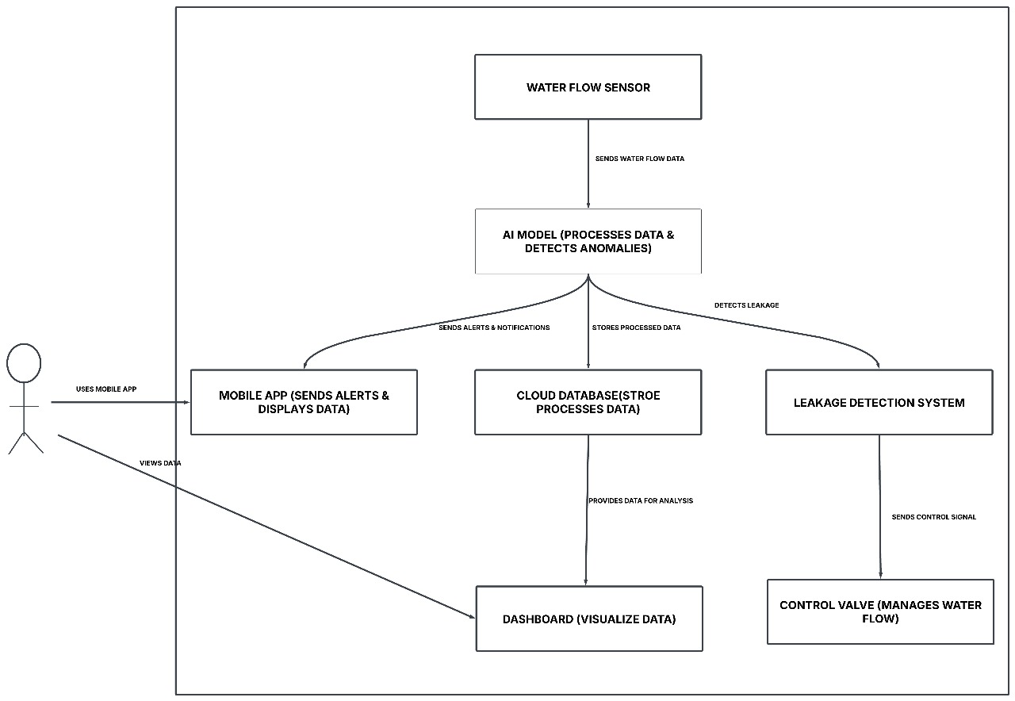***Figure 2: System architecture diagram for***  ***AIoT-Driven Smart Water Management & Leak Prevention***

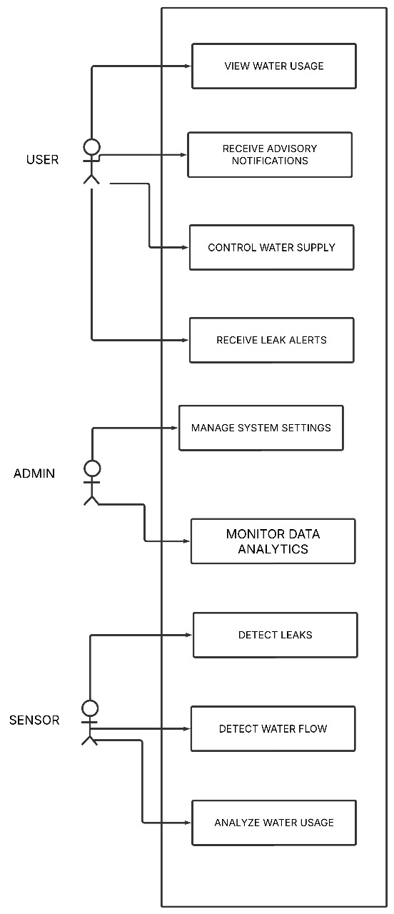

***Figure 3: Use case diagram for***  ***AIoT-Driven Smart Water Management & Leak Prevention***

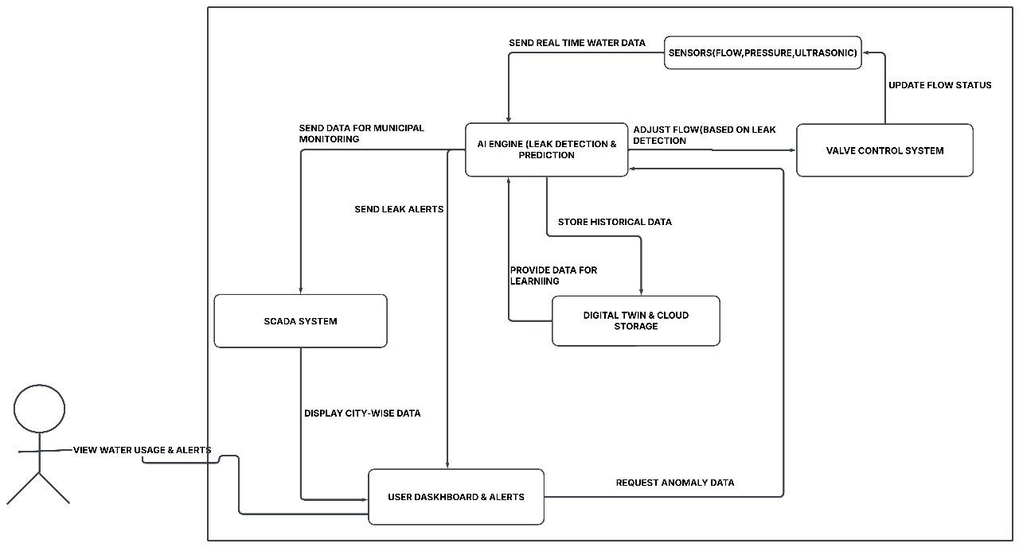

***Figure 4: Data Flow Diagram for***  ***AIoT-Driven Smart Water Management & Leak Prevention***

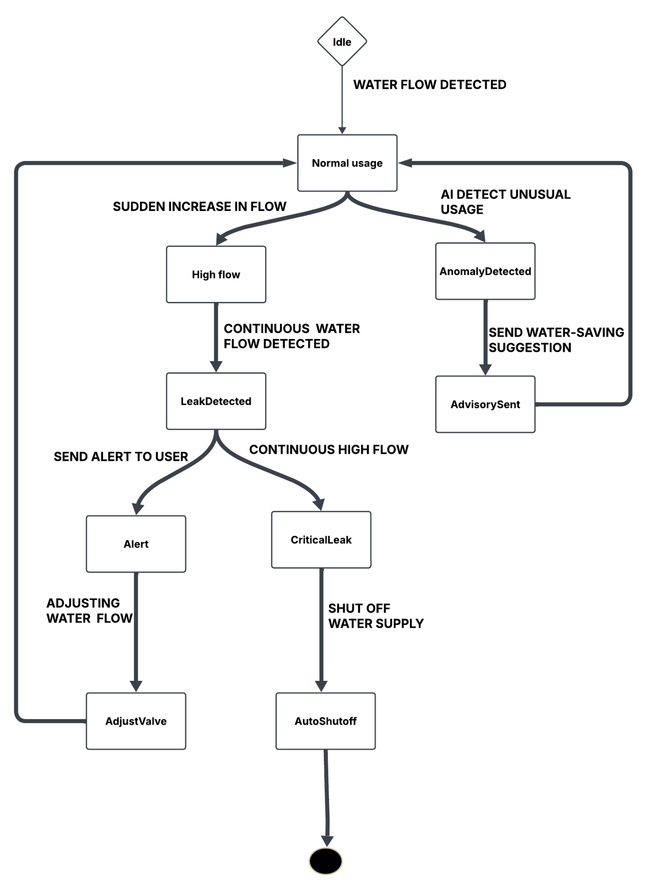

***Figure 5: State flow diagram for***  ***AIoT-Driven Smart Water Management & Leak Prevention***

The above state diagram for AIoT-Driven smart water management & Leak Prevention, shows how the state changes while detecting water usage, finding anomalies and taking proactive steps.

#### 1. Idle

**Initial State:** The system starts as an idle state where no water flow is detected.

#### 2. Normal Usage

**Action:** When water flow is detected, the system assumes normal usage and continues monitoring.

#### 3. Sudden Increase in Flow

**Action:** If the system detects a sudden rise in flow of water, then the system takes it as high flow and steps forward to check for continuous water flow.

#### 4. AI Detects Unusual Usage

**Action:** AI keeps comparing water consumption patterns to the general pattern. If any unusual pattern or anomaly gets detected then the system sends an advisory or better way to conserve water.

#### 5. Continuous Water Flow Detected

**Action:** If water keeps flowing at a high rate,then the system checks for there is any leak detected.

#### 6. Send Alert to User

**Action:**After a leak is detected, the system sends an alert message to the user for instant action.

#### 7. Continuous High Flow

**Action:** If water flow remains excessively high, then the system checks for critical leaks which may need immediate interruption.

#### 8. Adjusting Water Flow

**Action:** The system takes action to regulate water flow by adjusting valves to eliminate the water wastage.

#### 9. Shut Off Water Supply

**Action:**If the leak is critical and not getting controlled, the system does an auto shutoff mechanism to minimize further water loss.

### **10. System Optimization**

**Action:** The system keeps improving its leakage detection and prediction algorithms based on past water usage data and user feedback, ultimately improving leak detection and water conservation action.

### **11. Normal Operation**

**Action:**The system gets back to normal monitoring state where water flow is stable, and everything is functioning as expected.

### **12. End of Process**

**Action:** If no further anomalies or leakage are detected, then the system continues normal monitoring. If any previous issue was solved then process resets and return to normal operation.

### **Transition Flow (AIoT-Driven Smart Water Management & Leak Prevention)**

The System is made to continuously monitor water flow and to take any proactive steps if any unusual or any anomalies are found. Getting real-time events like sensing water flow, identifying unusual or unexpected patterns, or taking necessary adjustments to ensure efficient water use, it alters between multiple states. If the system gets an unusual spike in water usage or an odd usage pattern, it takes immediate action. The level of the issue will decide whether the user gets notifications or the smart valve is adjusted to adjust the water flow, or even the water supply is shut off to prevent any harm from leaks. This proactive approach minimizes the water wastage.

### **E. RESULTS AND ADVANTAGES:**

Our AIoT-Driven Smart Water Management & Leak Prevention System offers several advantages over existing solutions. Unlike traditional systems that only detect leaks and notify users, our system automatically prevents water wastage by adjusting water flow dynamically..

### **Results of Our System:**

1. **Real-Time Water Monitoring:**

Keeps track of water usage, pressure and flow rate to find any abnormal activities or patterns.

1. **Automated Leak Prevention:**

After detection of a leak , the system dynamically adjusts and controls the valve instead of just sending an alert. This helps in minimizing water wastage without any manual interruption.

1. **AI-Based Predictive Maintenance:**Uses past history or past data to predict possible leaks beforehand, this approach helps in preventing major pipeline failures and also helps to reduce the repair cost.
2. **Smart Water Conservation at City Level:**

Data from multiple households to analyze city-wide water usage trends, also creating a ranking system to bring curiosity among people to save water, also it can be integrated with government incentives to reward water efficient homes.

### **Advantages Over Existing Solutions**

1. **Leak Detection** – Most existing systems can only detect leaks and send alerts to users, which means the user has to take action manually. Our system goes one more step to automatically controlling water flow when a leak is found or any anomalies are found. This saves water wastage without requiring manual shut off the water.
2. **Water Flow Control** – In many current solutions, when a leak is detected, the user has to manually turn off the water to prevent further wastage. We solve these issues by using an AI-Powered Valve system that can adjust water flow dynamically, ensuring minimal water loss and reducing the need for physical and constant care.
3. **Predictive Analysis** – Most leak detection systems only work after a leak has already occurred. Our system is different because it uses past water usage patterns and with the help of AI it predicts potential leaks before they really happen. This allows homeowners to take preventive measures and avoid bigger problems in the future.
4. **City-Wide Monitoring** – Current solutions are mostly designed for individual households and do not provide a way to compare or track water consumption on a larger scale. Our system takes this a step further by analyzing data from multiple homes and identifying city-wide trends in water usage. This information can be useful for both residents and municipal authorities in planning better water management strategies.
5. **Government Collaboration** – Existing systems focus only on monitoring water usage and detecting leaks, but they do not encourage people to save water. Our system can collaborate with government agencies to create incentive programs that reward households for responsible water usage. This approach helps to promote water conservation in a way that benefits both users and the environment.

### **F. Expansion:**

In the future, the system can be expanded to city-level monitoring, where data from individual households will be sent to analyze water consumption patterns across different areas. This will help to find regions with high or low water usage, it helps better resource allocation. Encourage water conservation by creating awareness among people about their consumption compared to others in the city. Work with the governmen**t** to provide benefits or incentives to households that actively reduce water waste. Enable smart city integration and optimized water supply management.

**G. WORKING PROTOTYPE/ FORMULATION/ DESIGN/COMPOSITION:**

Currently, the working prototype is not yet established, as the project is in the planning and design phase. The idea has been properly formulated, with emphasis on AI-driven water monitoring, leak detection through automation, and real-time flow control through IoT sensors and machine learning algorithms.To build a functional prototype, the following steps need to be carried out:

1. Selection of Components (Approx. 2-3 months)

Choosing the right water flow sensors, pressure sensors, and AI-enabled microcontrollers to collect and process data effectively.

1. Development of Software & AI Model (Approx. 3-4 months)

Training the AI model to detect abnormal water usage patterns and predict leaks before they occur.Setting up cloud storage and designing a real-time monitoring dashboard for user access.

1. Hardware Integration & Testing (Approx. 4-6 months)**:**

Fow Assembling all hardware components, including sensors, valves, and controllers.We need to conduct multiple testing phases to ensure accuracy in detecting leaks and optimizing water flow control.

Considering these stages, the estimated time to develop a working prototype is around **9-12 months**, which includes improvement and testing to ensure efficiency and reliability before real-world implementation.

**H. EXISTING DATA:** NA

**4. USE AND DISCLOSURE (IMPORTANT):** please answer the following questions:

|  |  |  |
| --- | --- | --- |
| 1. A. Have you described or shown your invention/ design to anyone or in any conference? | YES ( ) | NO ( ) |
| B. Have you made any attempts to commercialize your invention (for example, have you approached any companies about purchasing or manufacturing your invention)? | YES ( ) | NO ( ) |
| C. Has your invention been described in any printed publication, or any other form of media, such as the Internet? | YES ( ) | NO ( ) |
| D. Do you have any collaboration with any other institute or organization on the same? Provide name and other details. | YES ( ) | NO ( ) |
| E. Name of Regulatory body or any other approvals if required.   1. Drugs Controller General of India (DCGI) 2. Central Drugs Standard Control Organization (CDSCO) 3. Indian Council of Medical Research (ICMR) 4. Ethics Committees (ECs) 5. Clinical Trials Registry of India (CTRI) | YES ( ) | NO ( ) |
|  |  |  |

**5.Provide links and dates for such actions if the information has been made public** (Google, research papers, YouTube videos, etc.) **before sharing with us.** NA

**6**. **Provide the terms and conditions of the MOU also if the work is done in collaboration within or outside university** (Any Industry, other Universities, or any other entity). NA

**7**. **Potential Chances of Commercialization.**

**I. Growing Demand for Water Management Solutions**

**II. Market of IoT-Enabled Water Monitoring Systems:**

With increasing attention globally toward management of water resources sustainably, AI-enabled intelligent water monitoring and distribution networks are gaining prominence. Our technology aims at real-time data, forecast-based analytics, and intelligent adaptation of water supply, thereby it is an impressive system for urban municipalities, industry, and farms seeking optimized data-driven strategies in water savings.

The water management market is growing rapidly, as climate change is now a common phenomenon, increased water scarcity, and urbanization. With sensor-based analytics, AI-powered forecasting, and automated water management systems, our system can reduce water waste, optimize supply, and improve usage of resources which makes our system an essential solution for smart cities and industrial water networks.

**III. Strategic Collaborations with Municipalities, Industries, and Smart City Initiatives**

Our technology can be licensed or co-developed with government agencies, private water utilities, real estate developers, and industrial water users. By incorporating real-time leakage detection, consumption tracking, and AI-driven water distribution optimization, we can establish a scalable commercial model suitable for urban infrastructure, industrial facilities, and irrigation systems.

**IV. Integration with IoT, AI, and Cloud-Based Water Management Platforms**

The emergence of AI-driven IoT ecosystems presents an opportunity to seamlessly incorporate our AIoT-Driven Smart Water Management & Leak Prevention system into existing digital frameworks. With features like automated pipeline monitoring, smart irrigation scheduling, and cloud-based water consumption analytics, our technology can broaden commercialization prospects in smart city initiatives, industrial water management, and residential smart water solutions.

**V. Accessibility Through Government Regulations and Water Conservation Initiatives.**

### 

### **8. List of Companies for Commercialization along with the website link.**

**I Tata Projects**

**Overview**: **Tata Projects** is a top infrastructure company in India, specializing in water management solutions like treatment plants, distribution systems, and smart water technologies. Their expertise in large-scale projects helps in advancing water management systems.

**Website**: [tataprojects.com](https://www.tataprojects.com/)

**II. VA Tech Wabag**

**Overview**: VA Tech Wabag is a multinational company headquartered in Chennai, specializing in water treatment and management. They provide sustainable solutions for water recycling, desalination, and wastewater treatment, aligning with the goals of efficient water resource management.

**Website**: [wabag.com](https://www.wabag.com/)

**III. Fluid Robotics**

**Overview**: Fluid Robotics is a startup focused on using robotics and data analytics for water infrastructure management. They specialize in mapping and diagnosing water pipelines and sewer networks, helping to detect leaks and blockages efficiently.

**Website**: [fluidrobotics.com](https://www.fluidrobotics.com/)

**iV. Jal Jeevan Mission**

**Overview**: An initiative by the Government of India aiming to provide safe and adequate drinking water to rural households by 2024. The mission emphasizes community-based water management and could benefit from advanced monitoring and management technologies.

**Website**: [jaljeevanmission.gov.in](https://jaljeevanmission.gov.in/)

**V. India Smart Cities Mission**

**Overview**: A government initiative to promote sustainable and inclusive cities that provide core infrastructure and a clean and sustainable environment. Collaborating with this mission can facilitate the integration of smart water management solutions into urban planning.

**Website**: [smartcities.gov.in](https://smartcities.gov.in/)

**VI. NITI Aayog's Atal Innovation Mission (AIM)**

**Overview**: AIM is a flagship initiative by NITI Aayog to promote innovation and entrepreneurship across India. Engaging with AIM can provide support for scaling innovative water management solutions and accessing a broader network of stakeholders.

**Website**: [aim.gov.in](https://aim.gov.in/)

**VII. OptiRTC:**

**Overview**: OptiRTC is a technology company that has developed a cloud-native platform integrating sensors, forecasts, and environmental contexts to actively control stormwater infrastructure. Their platform leverages the Internet of Things (IoT) to predictively manage distributed water systems.

**Website**: [optirtc.com](https://www.optirtc.com/)

**VII. Hydrific**

**Overview**: Hydrific is a startup that developed "Droplet," a sensor providing real-time data on household water usage and leak detection. Utilizing ultrasonic sensors and machine learning, Droplet captures precise water flow data to identify usage patterns and potential issues.

**Website**: [hydrific.com](https://www.hydrific.com/)

**VII. Praetorian Aeronautics**

**Overview**: Praetorian Aeronautics specializes in manufacturing drones designed to counteract other drones. While their primary focus is on security, their expertise in drone technology could be adapted for monitoring large-scale water infrastructure.

**Website**: [praetorianaeronautics.com](https://www.praetorianaeronautics.com/)

**IX. Spiral Data**

**Overview**: Spiral Data offers AI solutions in various sectors, including water management. Their expertise in data analytics can be leveraged to optimize water distribution and detect anomalies in water systems.

**Website**: [spiraldata.com](https://www.spiraldata.com/)

**X. Seonix Bio**

**Overview**: Seonix Bio has developed genetic tests for early disease detection. While their primary focus is on healthcare, their proficiency in biosensing technology could be applied to monitor water quality parameters.

**Website**: [seonixbio.com](https://www.seonixbio.com/)

**XI. Cropify**

**Overview**: Cropify utilizes AI to grade grains, ensuring quality in agriculture. Their AI expertise can be extended to analyze data from water management systems, particularly in agricultural settings.

**Website**: [cropify.com](https://www.cropify.com/)

**XII. Seed Terminator**

**Overview**: Seed Terminator addresses herbicide-resistant weeds through innovative technology. Their solutions contribute to sustainable agriculture, which aligns with efficient water management practices.

**Website**: [seedterminator.com](https://www.seedterminator.com/)

**XIII. Prepd Hydration**

**Overview**: Prepd Hydration focuses on enhancing sports hydration. Their research into fluid intake and retention can provide insights into human-water interaction, relevant for consumer-focused water management solutions.

**Website**: [prepd.com](https://www.prepd.com/)

9. **Any basic patent which has been used and we need to pay royalty to them.** NA

10**. FILING OPTIONS:** Complete filing

11. **KEYWORDS:**

I. AI-based Smart Water Management

II. IoT-enabled Water Distribution Monitoring

III. Leakage Detection and Automated Valve Control

IV. Real-time Water Flow and Pressure Analysis

V. Predictive Maintenance for Pipeline Health

VI. Machine Learning for Water Consumption Patterns

VII. Automated Leak Prevention and Control System

VIII. Digital Twin for Smart Water Infrastructure

IX. SCADA-Integrated Water Management System

X. Continuous Feedback Loop for Water Optimization

XI. Dynamic Adaptation of Water Supply Based on Demand

XII. AI-driven Water Conservation and Efficiency

XIII. Remote Water Infrastructure Monitoring and Alerts

XIV. Cloud-Based Water Data Processing and Analysis

XV. Digital Twin-Enhanced Leak Detection and Prevention

XVI. User Feedback-Driven AI Learning for Water Systems

XVII. Smart Water Grid with AI-Powered Optimization

XVIII. Real-Time Water Quality and Contamination Alerts

XIX. Wireless Water Sensor Network for Leak Detection

XX. Sustainable Water Management using AI and IoT

(Letter Head of the external organization)

NO OBJECTION CERTIFICATE This is to certify that University/Organization Name or its associates shall have no objection if Lovely Professional University files an IPR (Patent/Copyright/Design/any other…….) entitled "…………………." including the name(s) of,...........…as inventors who is(are) student(s)/employee(s) studying/ working in our University/ organization. Further Name of the University/Organization shall not provide any financial assistance in respect of said IPR nor shall raise any objection later with respect to filing or commercialization of the said IPR or otherwise claim any right to the patent/invention at any stage.

(Authorised Signatory)

