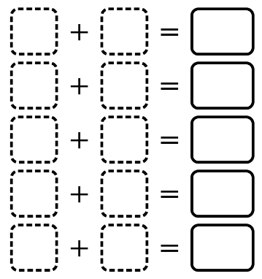
Digit Pairs
Digit Pairs is a number puzzle where you use each digit from 0 to 9 exactly once to create pairs that add up to the given values. Each puzzle contains five addition problems, each with a fixed number on the right. Your goal is to fill in the boxes on the left. Select one of the sets below to use for the numbers on the right.

01. (4, 5, 7, 14, 15)
02. (4, 6, 9, 11, 15)
03. (6, 7, 8, 10, 14)
04. (4, 7, 9, 10, 15)
05. (4, 6, 8, 13, 14)
06. (5, 6, 10, 11, 13)
07. (3, 4, 11, 12, 15)
08. (3, 7, 10, 12, 13)
09. (4, 7, 9, 11, 14)
10. (4, 5, 9, 12, 15)
11. (3, 7, 8, 13, 14)
12. (3, 5, 11, 12, 14)
13. (3, 6, 7, 14, 15)
14. (3, 9, 10, 11, 12)
15. (5, 8, 9, 10, 13)
16. (3, 5, 8, 14, 15)
17. (4, 7, 8, 12, 14)
18. (3, 6, 11, 12, 13)
19. (5, 6, 8, 11, 15)
20. (3, 4, 9, 14, 15)
21. (4, 6, 8, 12, 15)
22. (4, 7, 9, 12, 13)
23. (3, 6, 9, 12, 15)
24. (4, 6, 9, 12, 14)

25. (3, 7, 9, 12, 14)
26. (6, 7, 8, 9, 15)
27. (7, 8, 9, 10, 11)
28. (3, 5, 10, 13, 14)
29. (3, 8, 9, 12, 13)
30. (4, 6, 10, 12, 13)
31. (4, 6, 7, 13, 15)
32. (5, 6, 9, 11, 14)
33. (3, 5, 10, 12, 15)
34. (3, 7, 10, 11, 14)
35. (4, 7, 8, 11, 15)
36. (3, 6, 10, 12, 14)
37. (5, 6, 8, 12, 14)
38. (3, 4, 10, 13, 15)
39. (3, 7, 8, 12, 15)
40. (5, 7, 8, 11, 14)
41. (6, 8, 9, 10, 12)
42. (3, 5, 9, 13, 15)
43. (5, 7, 10, 11, 12)
44. (5, 6, 7, 13, 14)
45. (4, 5, 11, 12, 13)
46. (4, 7, 10, 11, 13)
47. (5, 6, 9, 12, 13)
48. (4, 6, 10, 11, 14)

49. (3, 8, 9, 10, 15)
50. (3, 4, 11, 13, 14)
51. (4, 8, 9, 10, 14)
52. (6, 7, 9, 10, 13)
53. (5, 8, 9, 11, 12)
54. (6, 7, 9, 11, 12)
55. (4, 5, 10, 12, 14)
56. (3, 8, 10, 11, 13)
57. (5, 7, 8, 12, 13)
58. (5, 7, 8, 10, 15)
59. (3, 8, 9, 11, 14)
60. (6, 7, 8, 11, 13)
61. (5, 7, 9, 11, 13)
62. (4, 8, 9, 11, 13)
63. (3, 6, 10, 11, 15)
64. (4, 8, 10, 11, 12)
65. (5, 6, 9, 10, 15)
66. (3, 6, 8, 13, 15)
67. (4, 5, 8, 13, 15)
68. (4, 5, 9, 13, 14)
69. (3, 6, 9, 13, 14)
70. (3, 7, 9, 11, 15)
71. (5, 7, 9, 10, 14)
72. (4, 5, 10, 11, 15)

