

**New functionalities added to the questionnaire interface**

Figure 1 shows the new monitoring tool, which builds upon the 2017 STIP survey interface used to gather responses to the 2017 STIP Survey.

Figure 1. The new monitoring tool built on top of the questionnaire interface

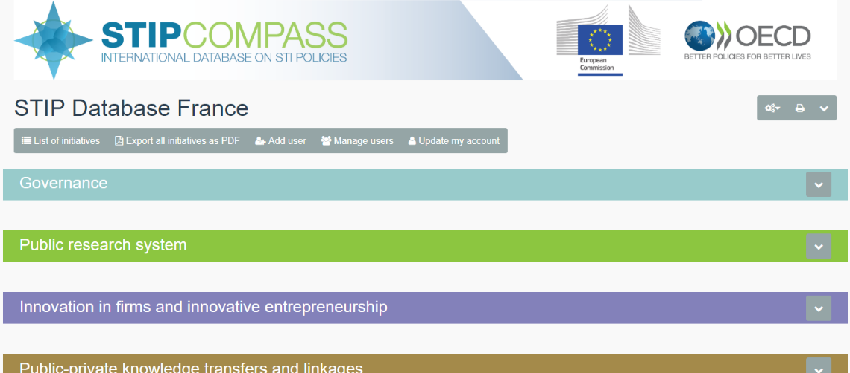

Clicking on the “Tools” icon (enclosed in a circle in the figure) provides access to new features (enclosed in a dashed rectangle in the figure), described below.

* **List of initiatives** switches to a different interface for browsing and editing the initiatives included in the country’s database. While the “questionnaire” interface shown in Figure 1 allows users to update the database using the same interface they have worked with previously, the “list view” may be better suited for managing the database. This view is described in more detail below.
* **Export all initiatives as PDF** generates a PDF document that includes all of the country initiatives’ details.
* **Add user** (available only to NCPs and the OECD Secretariat) allows a new account to be created that an individual may use to access and edit the database. After entering basic information on the person who will have access (name, organisation and email), a dedicated, personal link is associated to the account. This link, composed of a long and complex combination of characters acting as the user’s personal password, is sent together by email with basic instructions on accessing the database. The NCP may also use the interface to provide specific instructions, e.g. on which question(s) the user should focus on.
* **Manage users** (available only to NCPs and the OECD Secretariat) provides options to manage the accounts that have been created for the country’s database, i.e. i) edit users’ basic information; ii) sending an additional email to the user; and, iii) deleting the account. If an account is deleted, the associated link will no longer provide access to the database. Deleting an account does not delete or undo changes that the account has made to the database.
* **Update my account** allows updating the personal basic information (name, organisation and email).

Figure 2 depicts the “list view” which is accessed upon clicking the “list of initiatives” button described above. As its name indicates, this interface lists all initiatives in the database, providing a quick view to most important fields, i.e. name in English and in original language, start and end date, name of responsible organisation, estimated budget and internet link(s). It also displays the account authoring the last change to the initiative (i.e. in the “Last name” and “Organisation” fields to the right in the interface) and the date of most recent update (i.e. Date stamp to the left of the interface). It also indicates whether the initiative has been submitted as complete with a green tick mark or if it is incomplete with a red cross (enclosed in an oval in the figure). Users can edit an initiative by clicking on the left-most button in the corresponding row (enclosed in a dashed rectangle in the figure).

Figure 2. The new “list view” interface for better database management

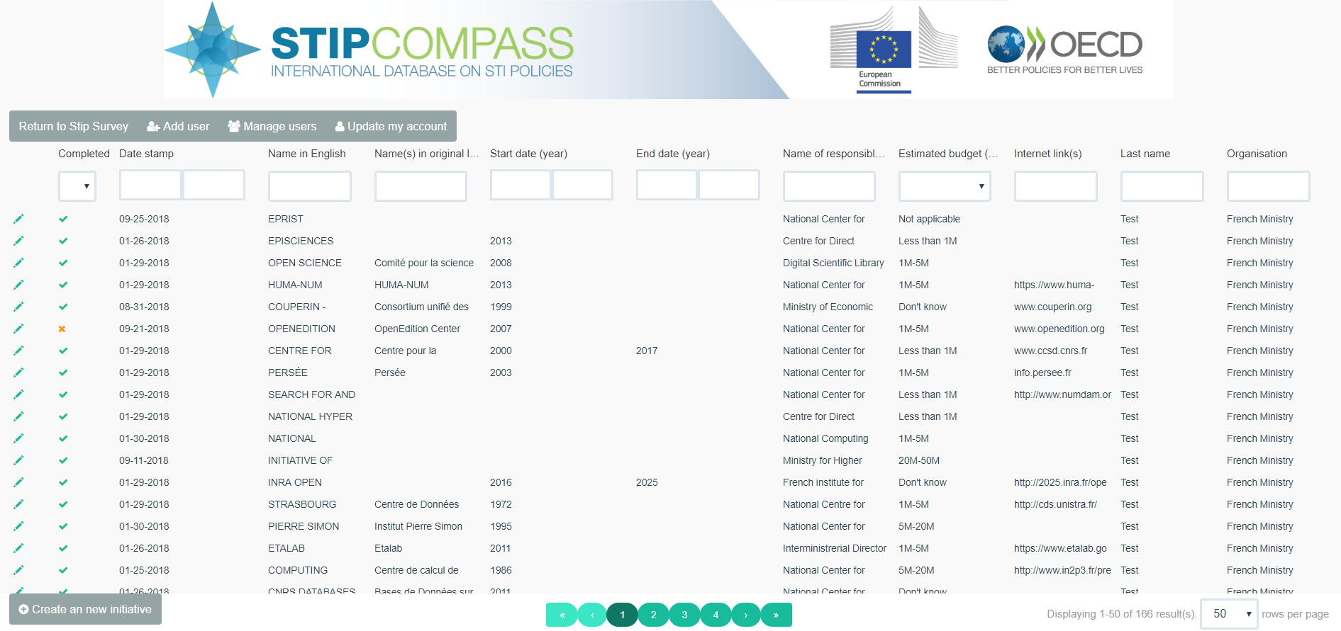

The vertical arrow in Figure 2 shows a button allowing to return to the classic “questionnaire” interface, together with the other account management options described above. Users can also create new initiatives (see button enclosed by the continuous rectangle in the figure). Users may filter initiatives by entering data in this fields (see dashed arrow in the figure). The list view interface thus allows users to easily identify and edit sets of initiatives that require editing. For instance, users may select incomplete initiatives to be displayed in the interface, show only those having unknown budgets or look for a specific initiative using the ‘name’ field.[1]

1. Within filtering fields that require typing, note that one has to press the ‘enter’ keyboard key for the filtering to be applied.