Architectural Flow

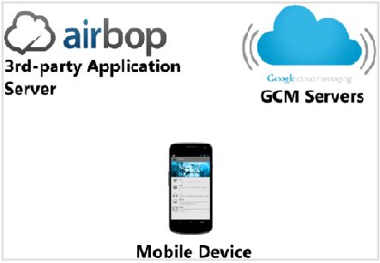

Step 1-

Your application attempts to register with the Google Cloud messaging (GCM) servers.

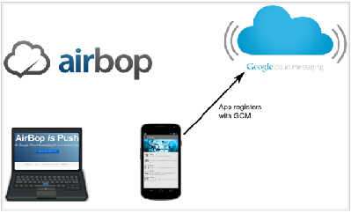

Step 2-

### GCM registers your device and generates a registration Id for your application.

### 

### Step 3-

### Your app sends the registration Id (plus optional additional information) to the AirBop servers.

### Step 4-

### You compose a message on the AirBop website.

### 

### Step 5-

### The AirBop servers send the message to GCM using the registration Id to target the app and device.

### 

### Step 6- GCM sends the message to the apps and devices that match the registration Id(s

### Step 7-

### Your app opens the message and handles the data appropriately.

### 

### Lifecycle Flow

* [Enable GCM](http://developer.android.com/google/gcm/gcm.html#register). An Android application running on a mobile device registers to receive messages.
* [Send a message](http://developer.android.com/google/gcm/gcm.html#push-process). A 3rd-party application server sends messages to the device.
* [Receive a message](http://developer.android.com/google/gcm/gcm.html#receiving). An Android application receives a message from a GCM server.

### Before getting started with GCM implementation make sure that you have to create Google API project to obtain API key.