**Camera plugin documentation**

**Objective:**

Camera Phonegap application allows any agent to capture Image and upload it to server. This plugin is compatible with PhoneGap 2.8.1.

**Steps:**

**Before you start to look at the functionality of camera plugin make sure that you have following software’s installed.**

* android-sdk
* phonegap-2.8.1
* sencha touch 2.0.1.1.

Apart from above mentioned prerequisites, we also must have a url where we can upload our image file.

**Steps for camera plugin functionality**

1. **create a new application with the help of following command in cmd:**

**C:\apache-tomcat-7.0.30\webapps\touch>** **sencha generate app <appname> ../<appname>**

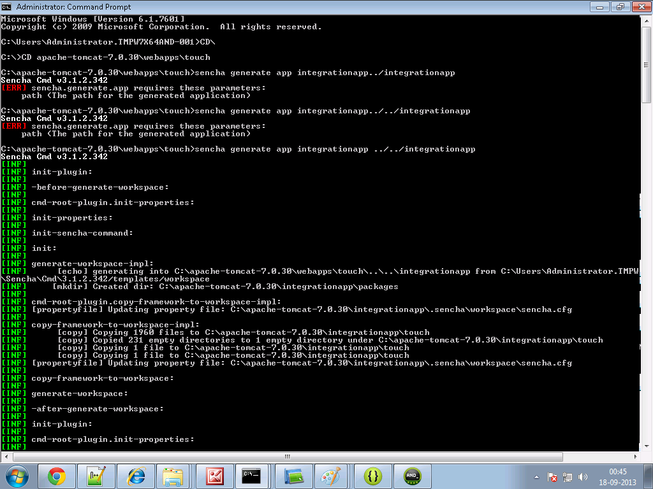

1. **Create a folder and name it as cordova in your sencha <appname> directory. For example**

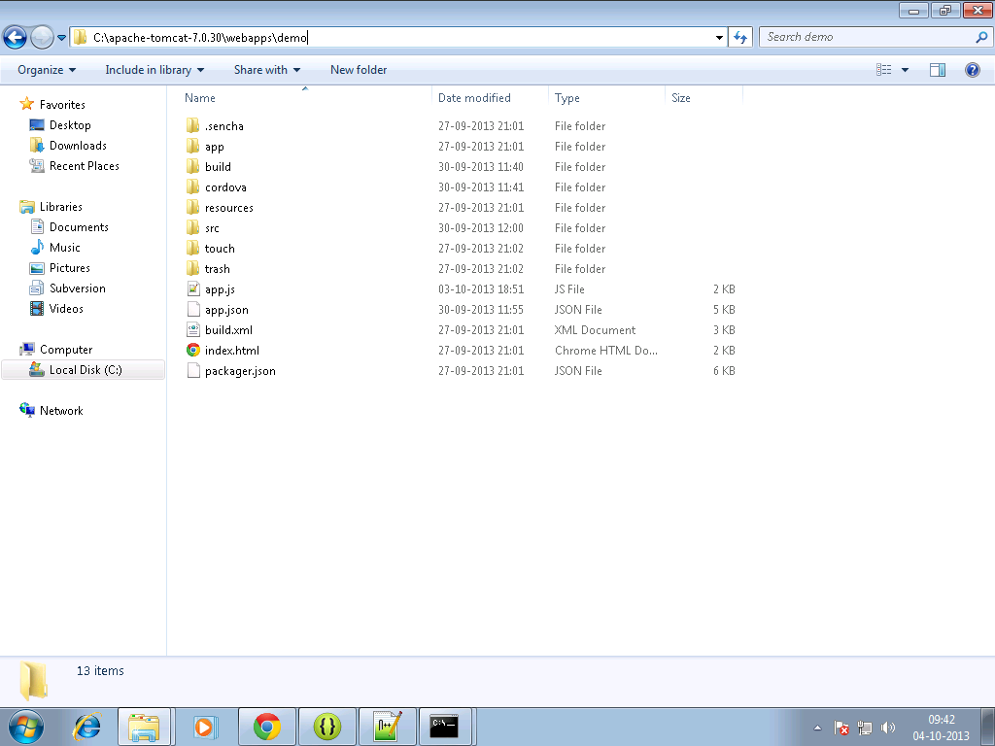

**3.Copy the cordova.js ,cordova.js_android, cordova.js_ios and cordova.js_plugins in them.**

**4.Make an entry in the js tag of app.json file residing in your<appname> directory as follows:**

js": [  
  {  
            "path": "cordova/cordova.js",  
            "update": "delta"  
        }

]

**5. Write the sencha code for view and controller in your sencha <appname>.**

**Cameraview.js**

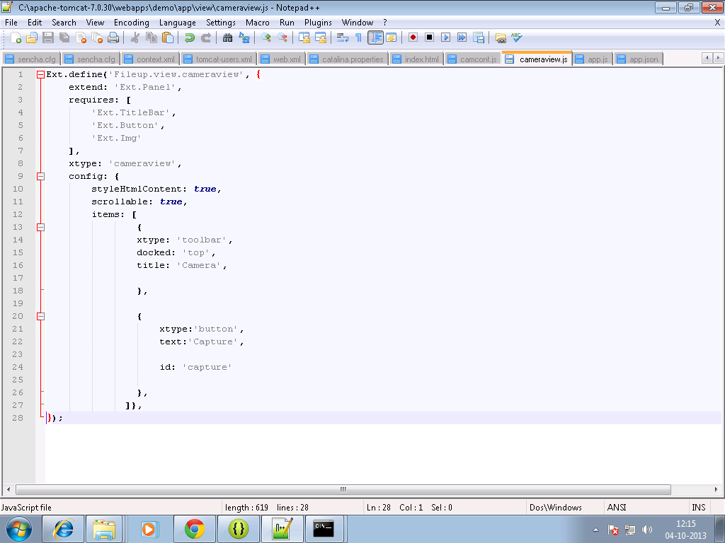

**Camcontroller.js**

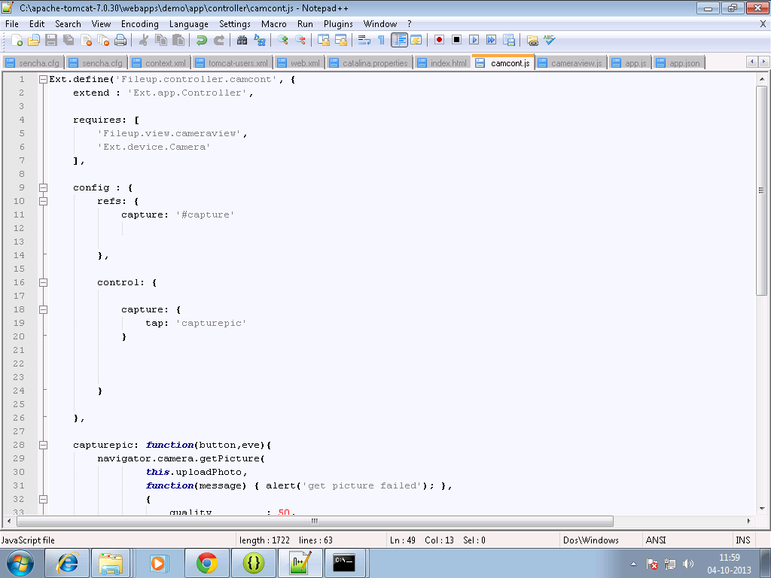

**To capture the picture we have used the following syntax in our controller:**

navigator.[camera.getPicture](http://docs.phonegap.com/en/3.0.0/cordova_camera_camera.md.html#camera.getPicture)( [cameraSuccess](http://docs.phonegap.com/en/3.0.0/cordova_camera_camera.md.html#cameraSuccess), [cameraError](http://docs.phonegap.com/en/3.0.0/cordova_camera_camera.md.html#cameraError), [ [cameraOptions](http://docs.phonegap.com/en/3.0.0/cordova_camera_camera.md.html#cameraOptions) ] );

On success we have called the upload method:

**Syntax for upload:**

var ft = new [FileTransfer](http://docs.phonegap.com/en/3.0.0/cordova_file_file.md.html#FileTransfer)();  
ft.upload(fileURI, encodeURI("http://some.server.com/upload.php"), win, fail, options);

**For code you can refer:**

<http://docs.phonegap.com/en/3.0.0/cordova_camera_camera.md.html#Camera>

<http://docs.phonegap.com/en/3.0.0/cordova_file_file.md.html#File>

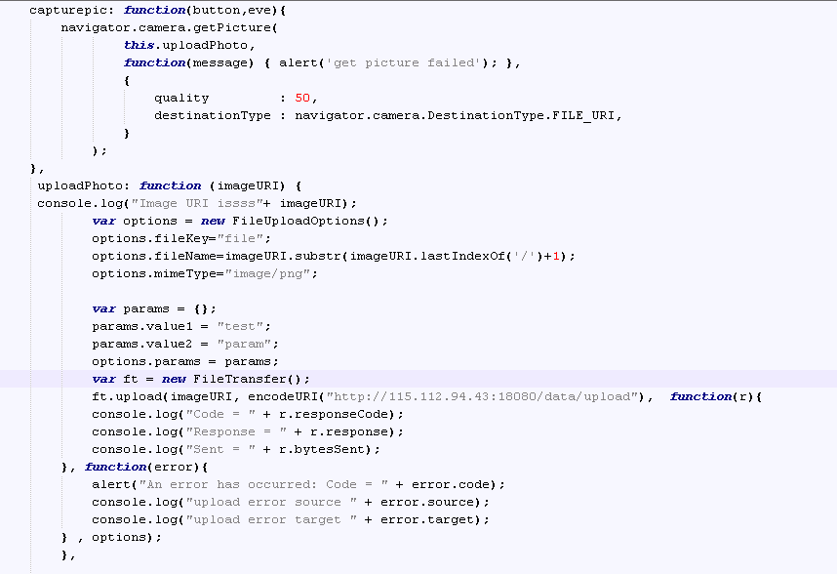

**6.** **In command prompt go to your sencha <appname> directory first, then Build the package of your sencha app by typing the following command :**

**Sencha app build package**

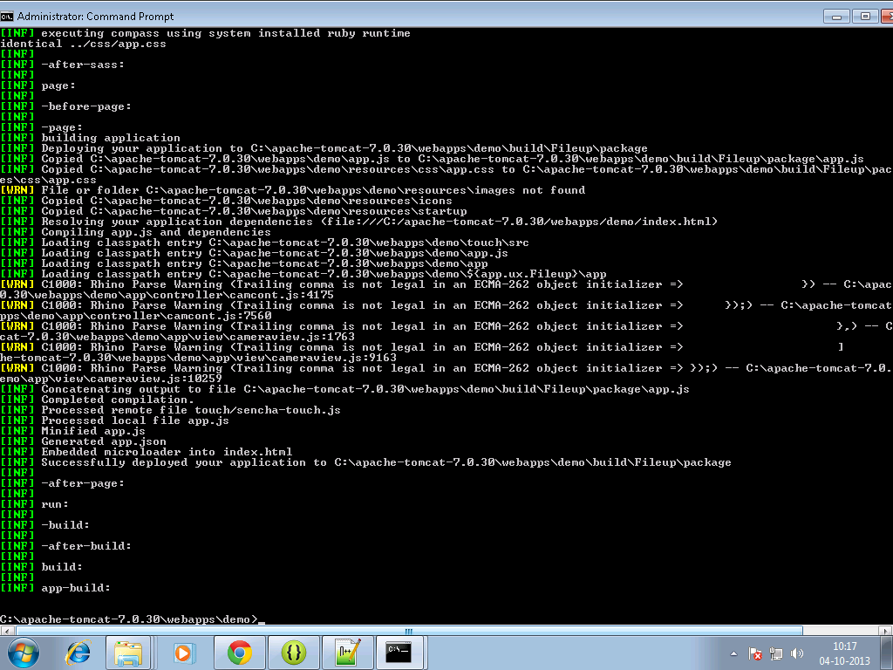

**7. Move to your sench<app> directory ,there a build folder will get created.**

**8. Copy files from package folder under <sencha appname>/build/ sencha < appname> to your www folder of android project for example:**

**C:\temp\TempAndroid\assets\www**

**9. build it - > apkk will be in bin folder**

**Output Screenshots:**

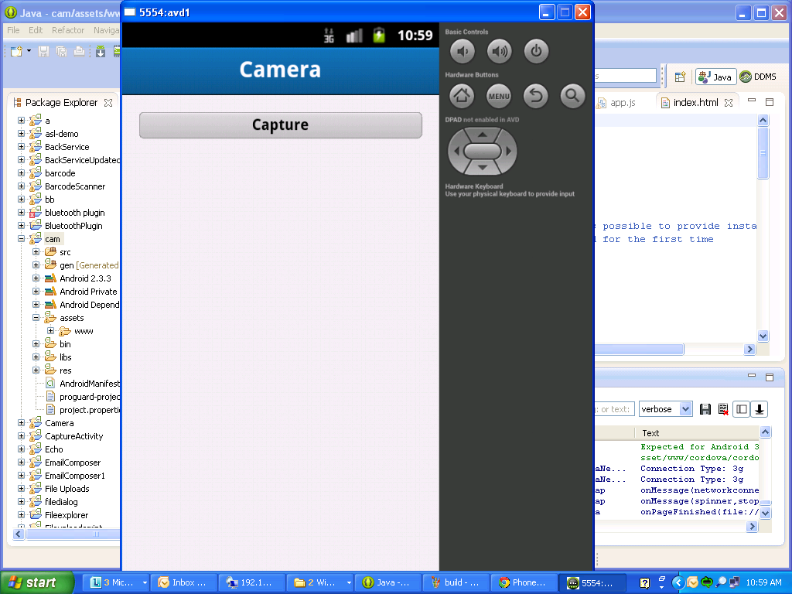

**On click at capture button:**

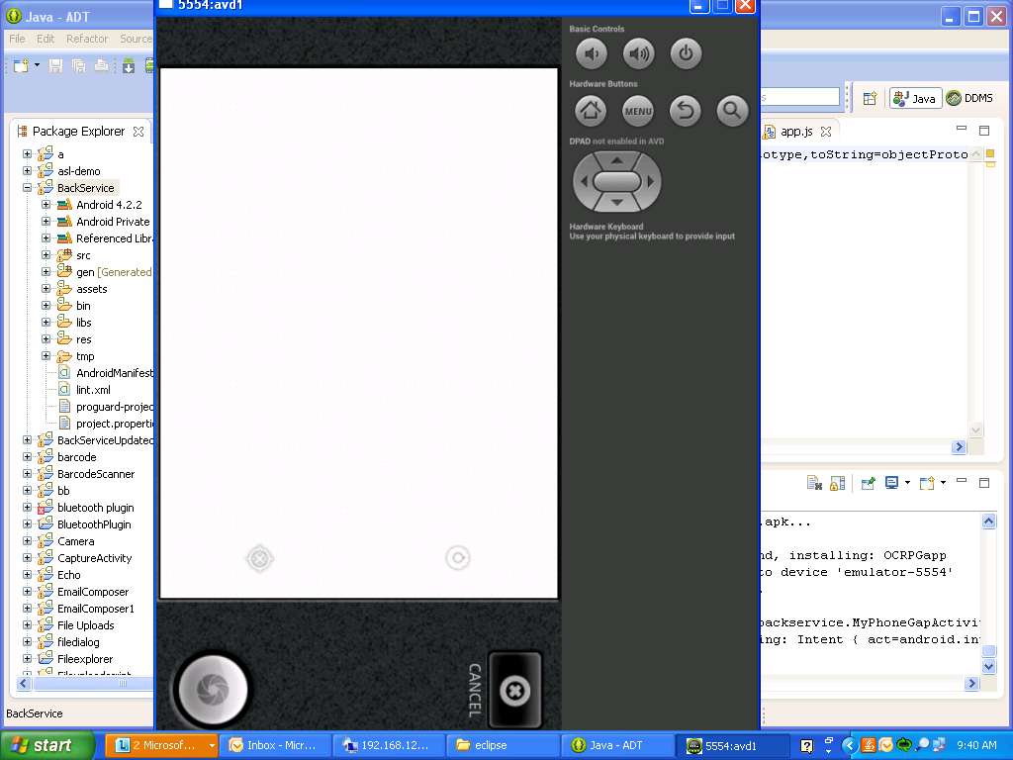

**10. We can check whether the file is successfully uploaded or not in the logcat messages of eclipse.**

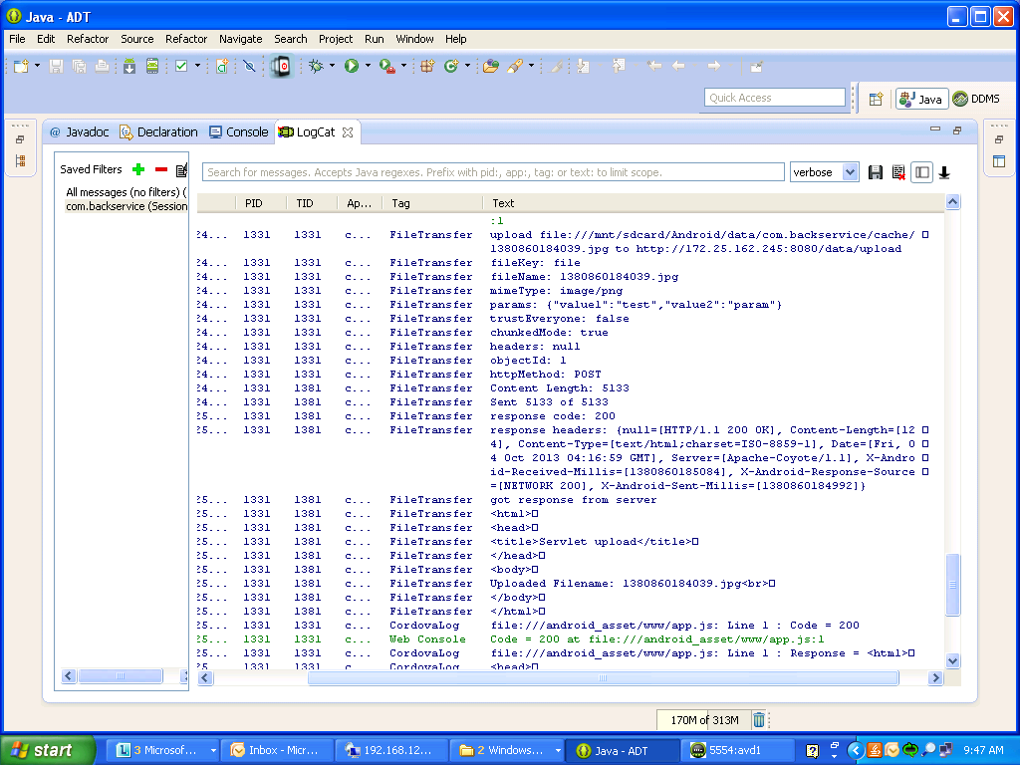

**Reference:**

<http://docs.phonegap.com/en/3.0.0/cordova_camera_camera.md.html#Camera>

<http://docs.phonegap.com/en/3.0.0/cordova_file_file.md.html#File>