Client Side

Integration of

Master Syndication

Version 1.0

Prepared by Jaydeep, Dipankar and Sonal

ATOS

3rd Nov 2013

Revision History

|  |  |  |  |
| --- | --- | --- | --- |
| **Name** | **Date** | **Reason For Changes** | **Version** |
| Jaydeep, Dipankar & Sonal | 03/12/13 | New Version | 1.0 |
|  |  |  |  |

**Client Side Integration Of Master Syndication**

* Directory structure of the app directory of sencha project is shown in the fig. 1.1
* Create a new directory with name util in app folder of the sencha project if not exist.
* Directory structure of app folder with util folder is shown in the figure 1.2

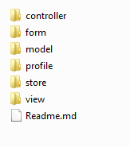 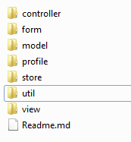

Fig. 1.1 Fig. 1.2

* Copy the files AtosSQLProxy.js, Config.js and MasterSyndication.js in util.
* Make the entry of all these files in app.js as shown in the figure 1.3

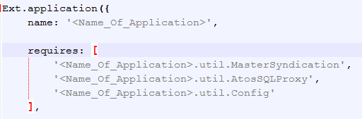

Fig. 1.3

* Config.js file is used to initialize the constant’s.
* Following are the constants declared in the Config.js

1. dbName: Name of the Database
2. dbFileName: Name of the Database file
3. dbVersion: Version of the Database
4. dbSize: Size of the Database
5. mvnNumberInfoTableName: Table that stores MVN number
6. masterSyndicationInfoTableName: Table that stores info about Master Syndication
7. masterSyndicationFinalCRCTableName: Table that stores info about CRC,
8. chunkedDataSize: Size of records
9. serverURLForSyncInfo: URL of server
10. isProcessedFalse: Not Processed
11. isProcessedTrue: Processed
12. chunkedDataSizeMasterSync: Size of records to be processed
13. actionGetSyncInfo: Constant which refer to GETSYNCINFO
14. actionGetSyncData: Constant which refer to GETSYNCDATA
15. httpPOSTMethod: Http Method

* To refer these constants in our code we can use the following syntax.

<Name_Of_Application>.util.Config.<function ()>;

* For Example:

SyncApp.util.Config.getMasterSyndicationInfoTableName();

SyncApp.util.Config.getMasterSyndicationFinalCRCTableName();

* Similarly we can use other constants as well.
* MasterSyndication.js File contains all the functions related to master sync.
* There are five exposed functions for master syndication.

1. isConnectionAlive(SuccessFunction,FailureFunction)

* This function is used to find internet connection is available or not.
* Figure 1.4 shows the example for using this function.

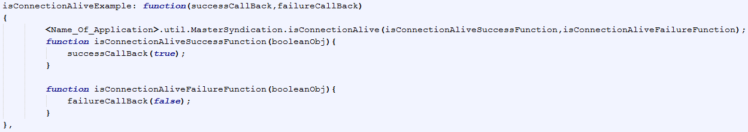

Fig. 1.4

1. getSyncInfo(SuccessFunction,FailureFunction):

* This function will get Sync Information from server.
* Figure 1.5 shows the example for using this function.

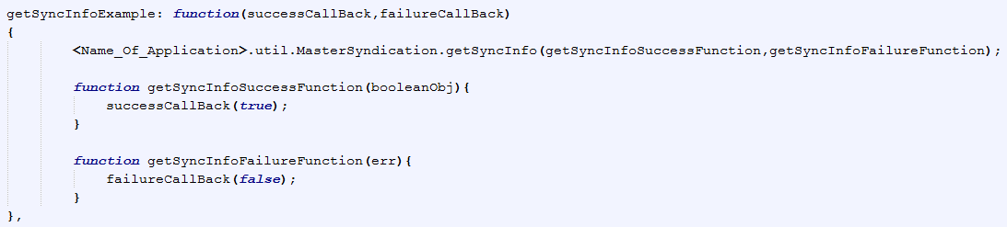Fig. 1.5

1. isSyncRequired(SuccessFunction,FailureFunction):

* This function is used to check if sync is required or not**.**
* Figure 1.6 shows the example for using this function.

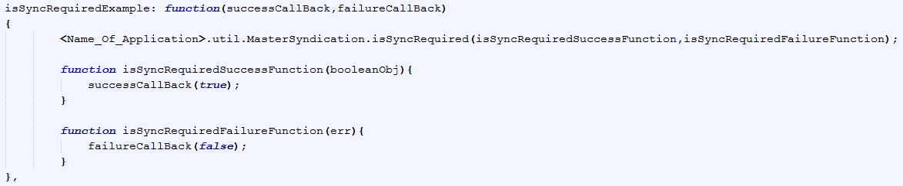

Fig. 1.6

1. performSync(SuccessFunction,FailureFunction):

* This function is used to performSync of Master data to Mobile**.**
* Figure 1.7 shows the example for using this function.

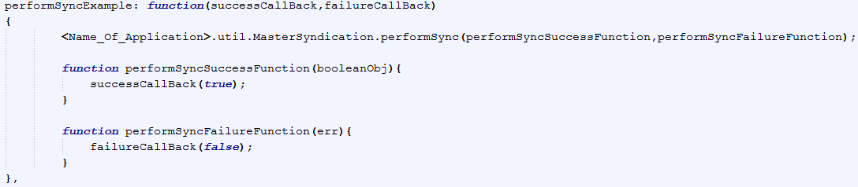Fig. 1.7

1. getMVNNumber(SuccessFunction,FailureFunction):

* This function is used to find mvn number**.**
* Figure 1.8 shows the example for using this function.

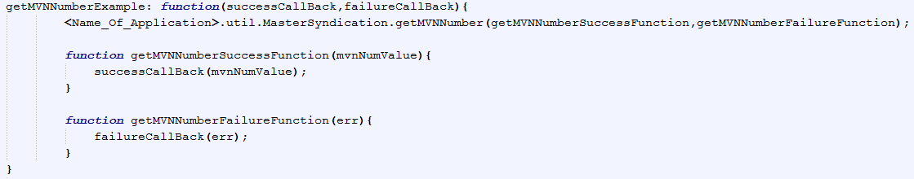Fig. 1.8

* Syntax for calling these functions is as follows.

<Name_Of_Application>.util.MasterSyndication.<function()>

* For example:

SyncApp.util.MasterSyndication.isConnectionAlive(SuccessFunction, FailureFunction);

SyncApp.util.MasterSyndication.getSyncInfo(SuccessFunction, FailureFunction);

* Similarly we can call other functions in our application as required.