**Twitter plug-in documentation**

**Objective:**

Twitter Phonegap plugin allows any agent to compose and post tweet of the sencha app itself.

This plugin is compatible with PhoneGap 2.8.1.

**Getting Started :**

**Before you start to look at the functionality of twitter plug-in make sure that you have following softwares installed:**

* android-sdk
* phonegap-2.8.1
* sencha touch 2.0.1.1.

Apart from above mentioned prerequisites, we also must have twitter application already installed on to the device. Secondly user must be logged in to twitter account.

**Part 1: Write Plugin In Eclipse Standalone**

**Prerequisite**: Twitter is already installed and logged in on your phone

**Steps for plugin functionality**

1. Create a phone gap project in the eclipse of the android sdk. For that we must have android sdk installed.

You can download the android sdk (ADT BUNDLE) form the following link:

<http://developer.android.com/sdk/index.html>

1. **To install the plugin, move www/twitter.js to your project's www folder and include a reference to it in your html file after phonegap.js.**  
     
       <script type="text/javascript" charset="utf-8" src="phonegap.js"></script>  
       <script type="text/javascript" charset="utf-8" src="twitter.js"></script>
2. Create a directory within your project called "src/com/phonegap/plugins/twitter" and move Twitter.java into it.
3. In the assets folder there exist a folder named as www, there is a js file there(twitter.js) with the help of this file we will call the above two methods.
4. In your res/xml/plugins.xml file add the following line:  
     
       <plugin name="Twitter" value="com.phonegap.plugins.twitter.Twitter"/>
5. **## Using the plugin ##**

You can call the methods in Twitter.java using following available methods from script tag of your index.html  
  
The plugin creates the object `window.plugins.twitter`. To use, call one of the following, available methods:

**Index.html:**  
  
<button onclick="checktwitter()">is twitter available</button>  
<button onclick="dotweet()">Composer Text Email</button>

<script>  
    function checktwitter(){  
            cordova.require('cordova/plugin/emailcomposer').isTwitterAvailable(  
                function() { console.log( 'successfully called twitter' ); },  
                function() { console.log( 'failed to call twitter' ); }  
                  
            );  
        }  
  
        function dotweet(){  
            cordova.require('cordova/plugin/emailcomposer').composeTweet(  
                function() { console.log( 'successfully called composeTweet' ); },  
                function() { console.log( 'failed to call composeTweet' ); },  
                "hi"

  );  
        }

**Directory Structure:**

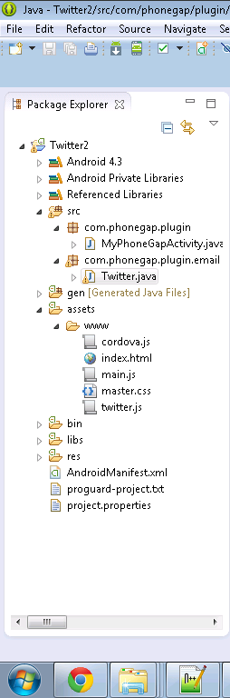

1. In the same www folder a file named as index .html exists which helps in rendering the view.

**Methods in Twitter.java:**

8. Screen shot showing the content of Istwitteravailable() function .This function determines whether the twitter is available at your device or not.

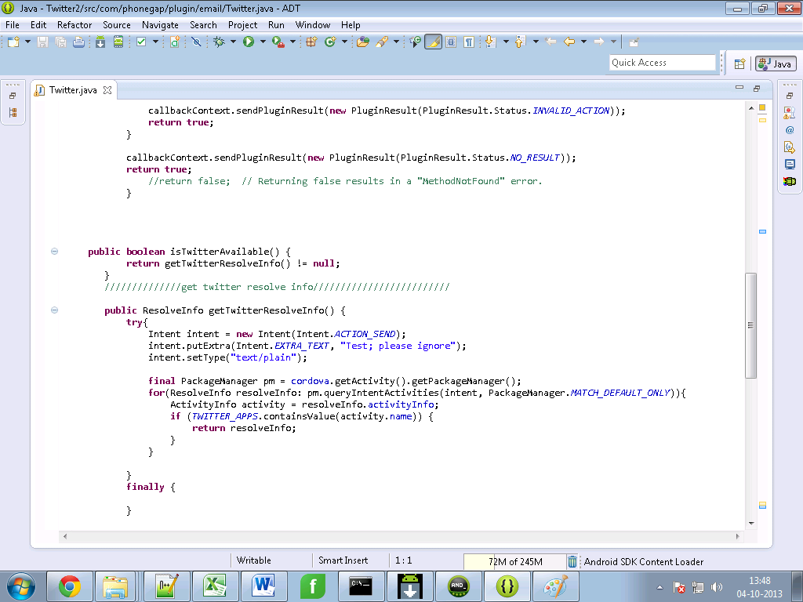

1. Composetweet() function allow you to compose the tweet and send.

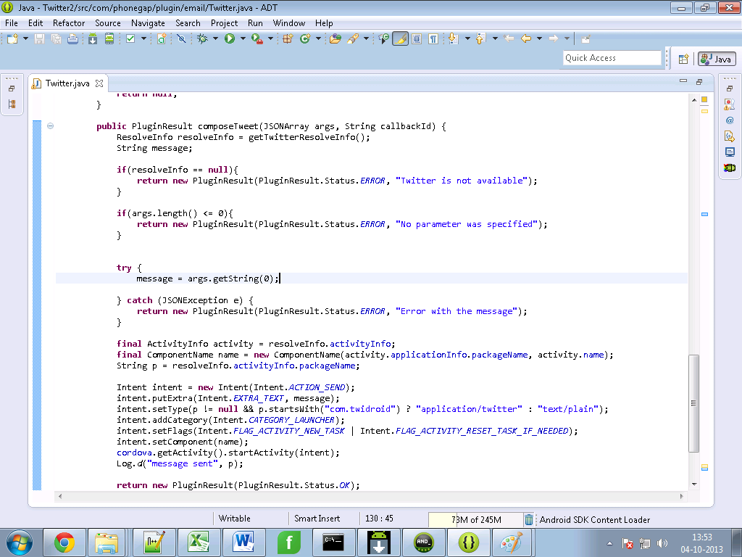

1. You can now run the project.

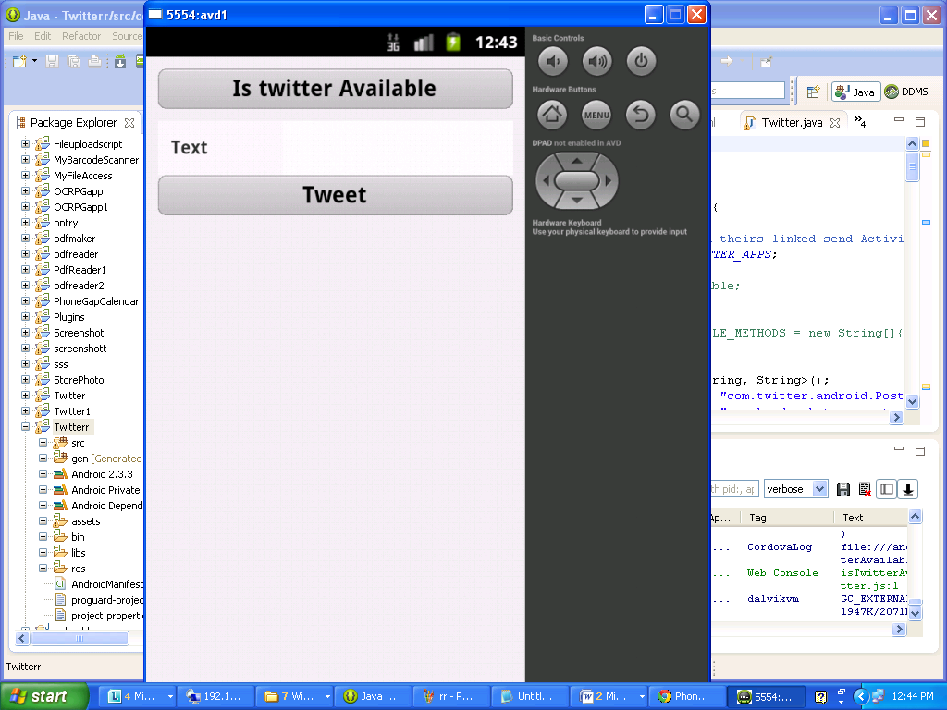

**Part2.**

**Creating Twitter Plugin in sencha and Integrating it with eclipse**

**Steps for twitter plugin functionality**

1. **create a new application with the help of following command in cmd:**

**C:\apache-tomcat-7.0.30\webapps\touch>** **sencha generate app <appname> ../<appname>**

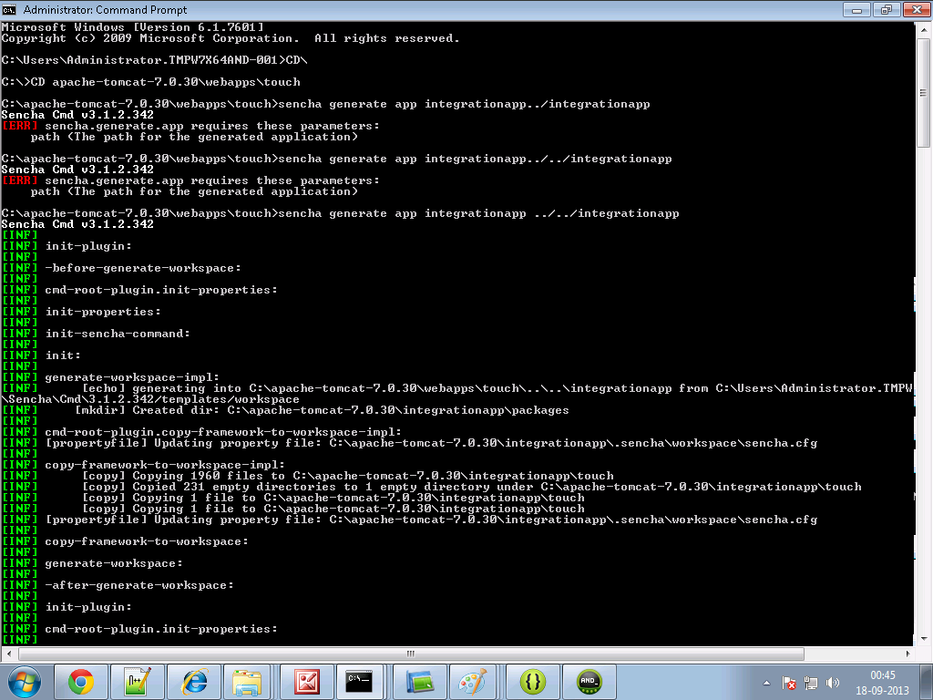

1. **Create a folder and name it as cordova in your sencha <appname> directory. For example**

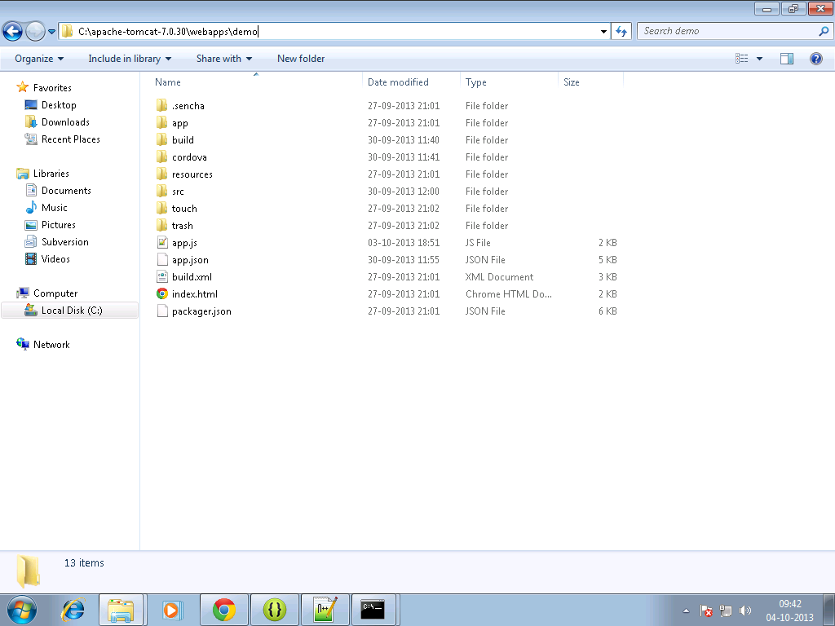

**3.Copy the cordova.js ,cordova.js_android, cordova.js_ios , cordova.js_plugins**

**and also twitter.js in the cordova folder.**

**4.Make an entry in the js tag of app.json file residing in your<appname> directory as follows:**

js": [  
  {  
            "path": "cordova/cordova.js",  
            "update": "delta"  
        },

{  
            "path": "cordova/twitter.js",  
            "update": "delta"

]

**5. Write the sencha code for view and controller in your sencha <appname>.**

**twitterview.js**

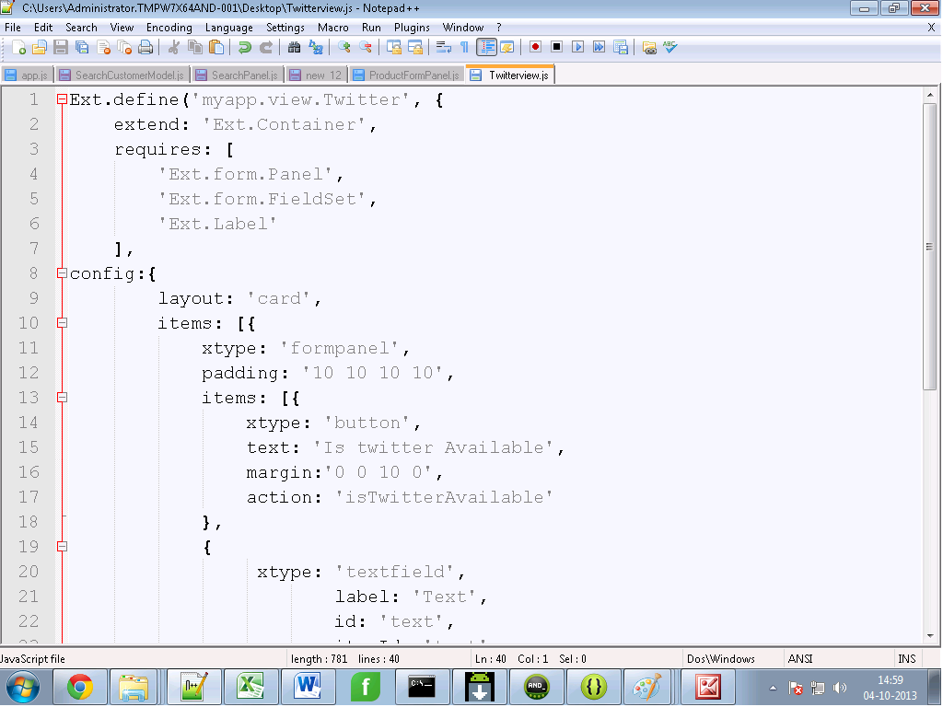

**Twittercontroller.js**

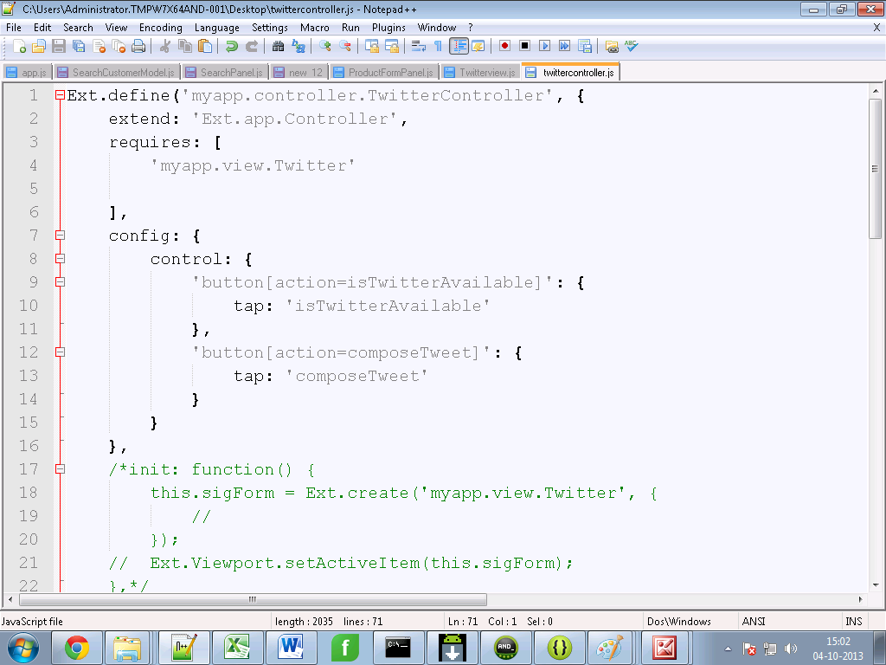

**6.** **In command prompt go to your sencha <appname> directory first, then Build the package of your sencha app by typing the following command :**

**Sencha app build package**

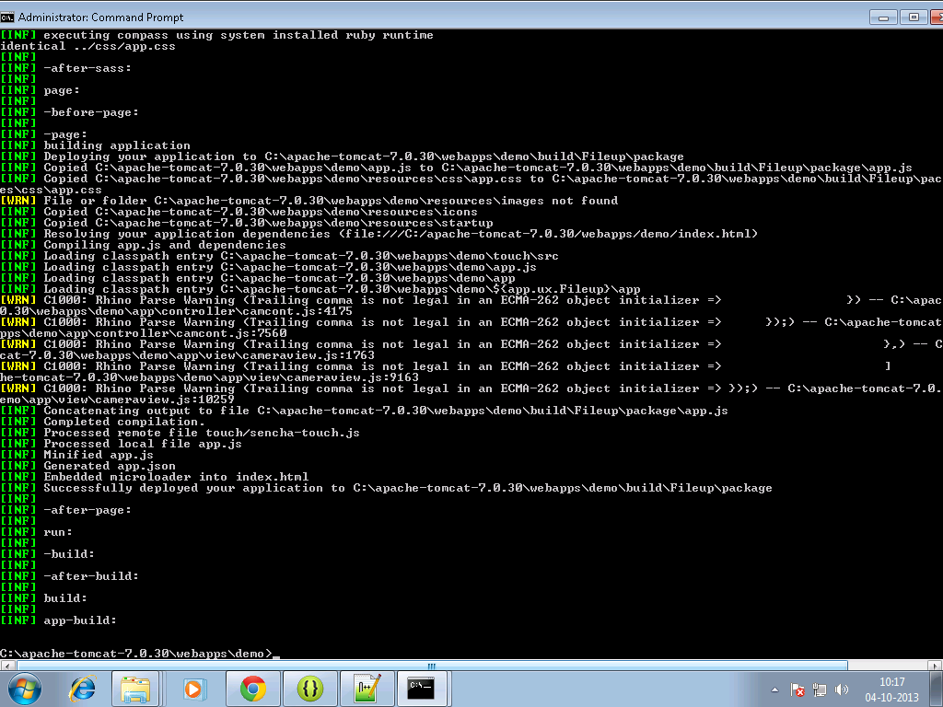

**7. Move to your sench<app> directory ,there a build folder will get created.**

**8. Copy files from package folder under <sencha appname>/build/ sencha < appname> to your www folder of android project for example:**

**C:\temp\TempAndroid\assets\www**

**9. build it - > apk will be in bin folder**

**Output on Device:**



